Candidate Assessment of Performance
Using the CAP Rubric

Workshop for Program Supervisors and Supervising Practitioners

Facilitator’s Guide
Massachusetts Department of Elementary and Secondary Education
75 Pleasant Street, Malden, MA 02148-4906
Phone 781-338-3000 TTY: N.E.T. Relay 800-439-2370
www.doe.mass.edu
Contents
Preparing for the Workshop 1
Overview 1
Context 1
Intended Outcomes 1
Equipment and Materials 1
Facilitator’s Guide 2
I. Warming Up (10 minutes) 2
II. Learning (30 minutes) 3
III. Practicing (45 minutes) 11
IV. Calibrating (45 minutes) 13
V. Recapping (5 minutes) 15

Preparing for the Workshop

Overview
This workshop is designed to provide program supervisors and supervising practitioners with an overview of the rubric used in the Candidate Assessment of Performance (CAP), as well as opportunities to practice applying the rubric to evidence and calibrating judgments based on evidence with colleagues. The goal of this workshop is to build capacity for using the CAP Rubric to delivering high-quality, targeted, and actionable feedback to teacher candidates grounded in evidence collected during the CAP process.

Context
This facilitator’s guide is designed to assist educator preparation program staff in delivering a rich and engaging training experience for program supervisors and/or supervising practitioners. The content of this workshop is based on the CAP Guidelines. Given that participants will have varying levels of knowledge about the CAP and a range of experience using a performance rubric, ESE recommends that participants be familiar with the following resources prior to engaging in the workshop:
- CAP Flyover
- Pages 10-23 of the CAP Guidelines

Intended Outcomes
At the end of this session:
- Participants will have a clear understanding of the architecture of the CAP Rubric.
- Participants will know how to effectively use the CAP Rubric to analyze evidence and provide high-quality, targeted, and actionable feedback to teacher candidates.
- Participants will have practiced applying the CAP Rubric to a body of evidence.
- Participants will have a clear understanding of calibration and have engaged in a calibration activity to begin to develop a common set of expectations for practice, grounded in the language of the CAP Rubric.

Equipment and Materials
- Equipment: Laptop computer with an internet connection and a copy of the workshop PowerPoint slides and a projector.
- Materials: Chart paper and markers
- Handouts packet, which includes:
  - CAP Rubric
  - A collection of sample evidence provided by the program (see facilitator notes for slides 27 and 31):
    - Completed observation forms for Unannounced Observations #s 1 and 2.
    - Completed observation forms for Announced Observation #s 1 and 2
    - Results from a measure of student learning.
    - Student survey results.
    - Candidate artifacts (1-2 recommended)

Facilitator Guide
This workshop is divided into five sections and has a total time of 1 hours and 45 minutes:

Warming Up (7 minutes)

Learning (34 minutes)

Practicing (34 minutes)

Calibrating (25 minutes)

Recapping (5 minutes)
Slides are provided to facilitate each section and this corresponding guide includes facilitator notes, as well as italicized talking points for each slide.

I. Warming Up (10 minutes)
Title slide  - This workshop is designed to be delivered to a group of program supervisors and/or supervising practitioners. | 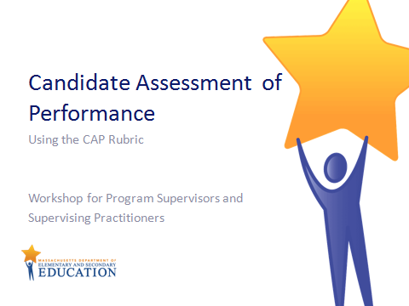  Slide 1  Quick transition
Agenda slide  - This workshop is broken up into the following sections Warming Up, Learning, Practicing, Calibrating, and Recapping. | 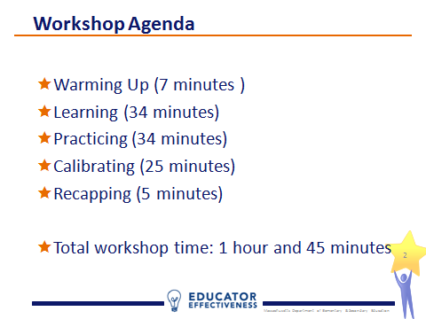  Slide 2  Quick transition
Warming Up:  - The Warm-Up activity is designed to get participants thinking about the rubric as a tool that can support each step of the 5-step cycle that anchors the CAP process. | Slide 3  Quick transition
Warming Up:  - Rubrics are often thought of solely as scoring tools. However through the warm-up, participants should be able to identify opportunities to use the CAP Rubric at points other than the formative and summative assessment steps, in which ratings are determined. For example, the rubric performance descriptors should guide the candidate’s self-assessment, both in terms of helping him/her to establish a baseline of practice, as well as signaling what expected practice looks like.  - Push participants to be specific about how they use the rubric to analyze evidence and inform the feedback they provide to candidates. | 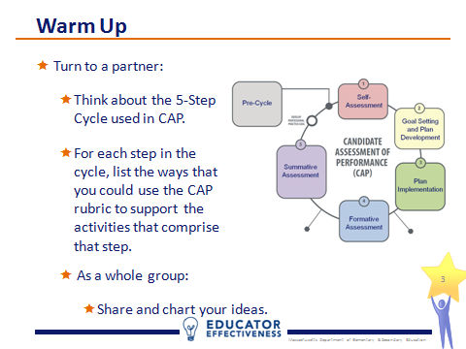  Slide 4  7 minutes

II. Learning (34 minutes)
Learning:  - In this section, participants will learn about the purpose of the CAP Rubric, its architecture, and how it is used at each step of the 5-step cycle. | Slide 5  Quick Transition
Learning:  - Review the goals of CAP to ground the workshop.  - Note the responsibility of program supervisors and supervising practitioners to support candidates’ growth and development through feedback. Feedback should be informed by the CAP Rubric. | 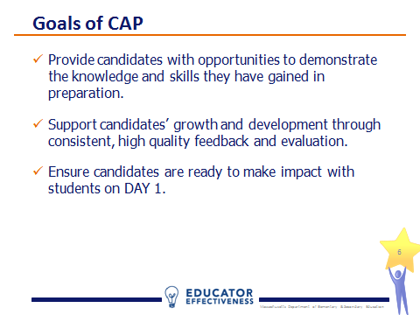  Slide 6  1 minute
Learning:  - Introduce the threefold purpose of the CAP Rubric.  - Notice the phrases “shared understanding” and “common terminology.”The CAP rubric promotes consistent implementation of CAP across all educator preparation programs because the elements of practice and associated descriptors at the core of CAP are the same statewide. | 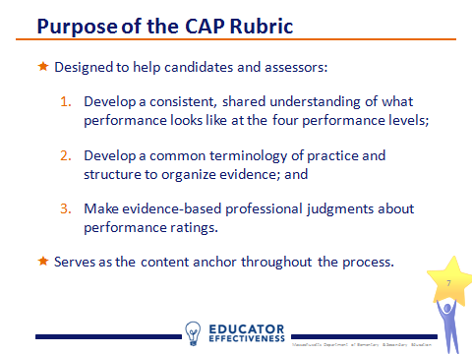  Slide 7  1 minute
Learning:  - Note that this slide focuses on the three points of the CAP process when the CAP Rubric is used to determine ratings. However, as discussed during the Warm Up and covered later on, the CAP Rubric is also used to analyze evidence and provide feedback. | Slide 8  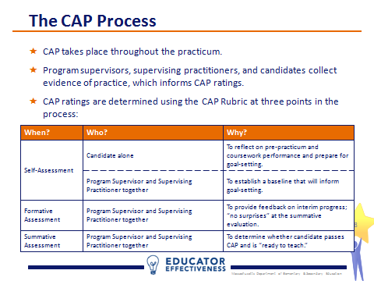  3 minutes
Learning:  - One of the hallmarks of CAP is the intentional alignment to the MA Educator Evaluation Framework. Candidates who pass CAP will enter the teaching profession with a deep understanding of the evaluation process they’ll participate in for the rest of their careers as Massachusetts educators.  - One of the key points of alignment between CAP and the Evaluation Framework is content. CAP measures 6 essential elements:  - Well-structured lessons  - Adjustments to practice  - Meeting diverse needs  - Safe learning environment  - High expectations  - Reflective practice  - These elements are a subset of the 33 elements that are included in the Evaluation Framework’s model rubrics and they cut across Standards I, II, and IV. Elements under Standard III, Family and Community Engagement, were omitted from CAP due to inconsistent opportunities for candidates to practice and assessors to observe interactions with families.  - The 6 essential elements were selected because they met two criteria:  - The absence of a teacher’s competency in the skill is likely to put students at risk  - The element serves as an umbrella for skills outlined in other elements; in most cases other elements were pre-requisite skills to those outlined in the essential element. | 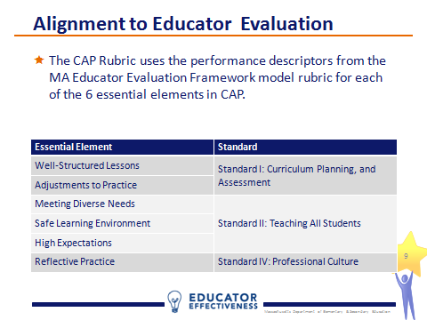  Slide 9  2 minutes
Learning:  - Each of the rubric descriptors can be unpacked into three dimensions: quality, scope, and consistency.  - As you move across the rubric from left to right the descriptors reveal expectations of high quality, broader scope, and more consistency. | 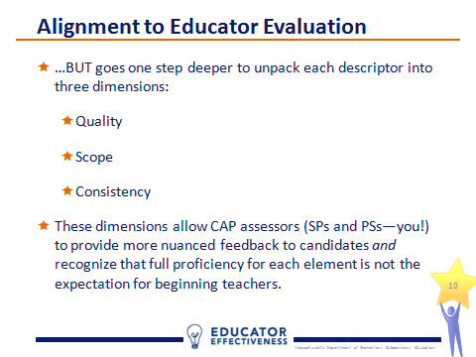  Slide 10  1 minutes
Learning:  - Quality is about whether the candidate is able to demonstrate practice at the proficient level for a given element.  - Quality is a gatekeeper, in that a candidate cannot be rated on scope or consistency until the quality of practice is at least proficient. Therefore, candidates who fail to achieve quality at the proficient level for all 6 essential elements, do not pass CAP.  - Notice the example. If the candidate is not yet able to demonstrate the skill at a proficient level, it does not make sense to evaluate whether he/she is applying the skill with breadth (scope) or regularity (consistency). | 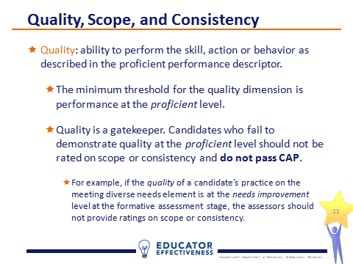  Slide 11  3 minutes
Learning:  - Scope is about whether the candidate is able to demonstrate the practice with quality at scale. In other words, the breadth of impact; from one or two students to the whole class.  - The minimum threshold here is at the needs improvement level. CAP recognizes that candidates are unlikely to be able to demonstrate practice with a high degree of quality at scale for all 6 essential elements. | 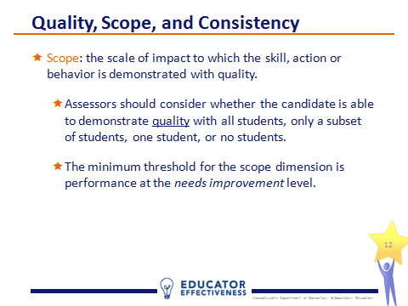  Slide 12  2 minutes
Learning:  - The consistency dimension is about whether the candidate is able to demonstrate the practice with quality and regularity. In other words, does the candidate achieve quality at the proficient level every time he/she practices the skill or only sometimes?  - The minimum threshold for consistency, like scope, is at the needs improvement level, signaling that candidates are not expected to be able to demonstrate practice with a high degree of quality all of the time for all 6 essential elements in order to pass CAP. | 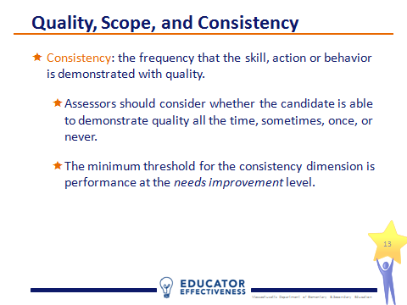  Slide 13  2 minutes
Learning:  - Refer participants to the CAP Rubric included in the handouts packet.  - Now that we’ve covered the content of CAP and looked at the dimensions of quality, scope, and consistency, let’s turn to the CAP Rubric.  - You’ll notice that for each of the 6 essential elements, there are four descriptions of practice that correspond to four performance levels. | 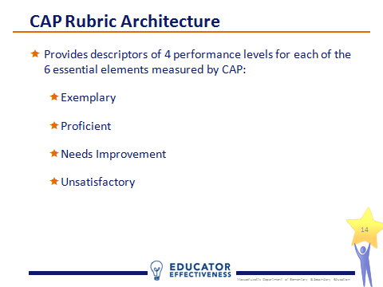  Slide 14  1 minute
Learning:  - The rubric is read left to right. The descriptors form a continuum of practice for each element, from unsatisfactory, to needs improvement, to proficient, and then exemplary.  - Here is an example for the well-structured lessons element.  - Prompt participants to look at the descriptors and identify key words that they can connect back to one of the dimensions (quality, scope, consistency). An example might be the phrase “only some elements” in the needs improvement descriptor, which could connect to the scope dimension. | 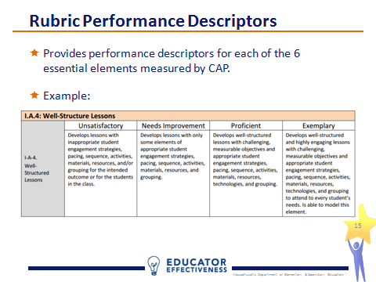  Slide 15  3 minutes
Learning:  - In a moment we’ll look at the space beneath the performance descriptors, which provides space for assessors to document ratings and record a summary of evidence to support each rating.  - You will also notice that the minimum threshold for each dimension is highlighted as a reminder. | 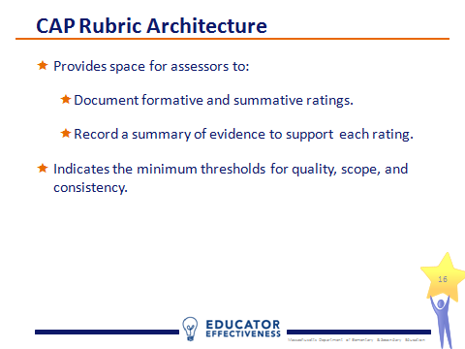  Slide 16  1 minute
Learning:  - Review the rubric fields on the slide.  - Facilitators may wish to provide copies of a an excerpt completed rubric (with personally identifiable information redacted) to provide a model of the type of evidence summaries the program expects from its assessors. | Slide 17  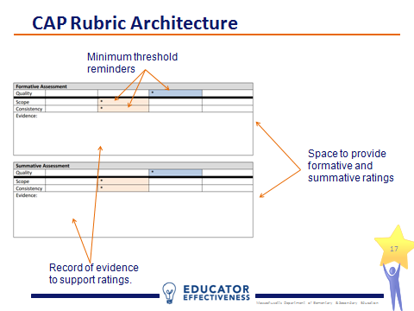  1 minute
Learning:  - Slides 18-23 revisit the Warm-Up activity and describe how the candidate and assessors use the rubric throughout the 5-step cycle. | 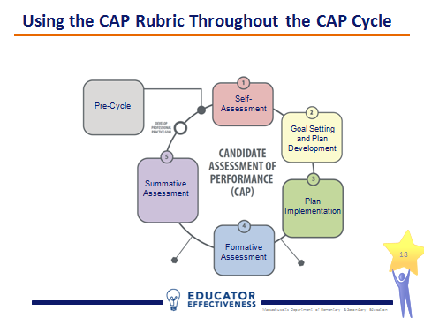  Slide 18  Quick Transition
Learning:  - At the self-assessment step, the CAP Rubric is used diagnostically in order to place the candidate’s practice on the continuum for each of the 6 essential elements. | 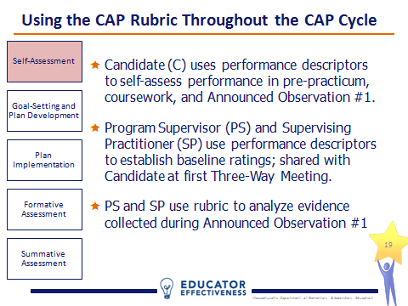  Slide 19  2 minutes
Learning:  - At the goal-setting stage the CAP Rubric s used to help define the level of practice necessary to attain the goal. In other words, if the candidate’s ability to meet the needs of a diverse group of learners begins at the unsatisfactory level, his/her professional practice goal might target this area in an effort to move his/her practice to the proficient level. The proficient descriptor for the meeting diverse needs element will help the candidate understand how his/her practice needs to change. | 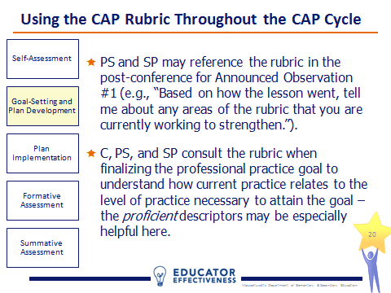  Slide 20  2 minutes
Learning:  - Implementing the plan is all about evidence collection. Here the CAP Rubric is used both analyze evidence and inform the feedback given to the candidate.  - Note that the evidence statements recorded on Observation Forms should not simply restate the rubric performance descriptors. | 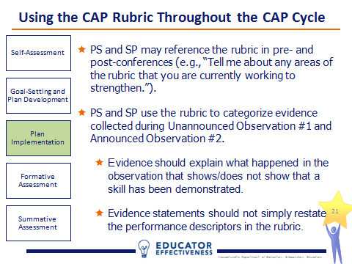  Slide 21  2 minute
Learning:  - During the formative assessment step the assessors use the rubric to provide formative assessment rating to the candidate.  - Remind participants that calibration is key. The program supervisor and supervising practitioner must be on the same page about the candidate’s ratings and the evidence used to inform them prior to sharing the ratings with the candidate at the second Three-Way Meeting. | 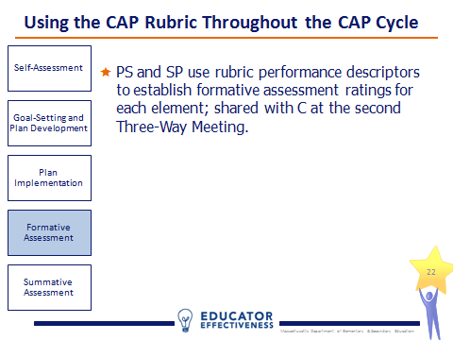  Slide 22  1 minute
Learning:  - The final step of the 5-step cycle is the summative assessment. Like at the formative step, the assessors use the CAP Rubric to determine ratings for each of the 6 essential elements. The difference is at this step, a determination is made about whether the candidate has passed CAP and is therefore “Ready to Teach.”  - The summative ratings and determination are shared with the candidate at the third Three-Way Meeting. | 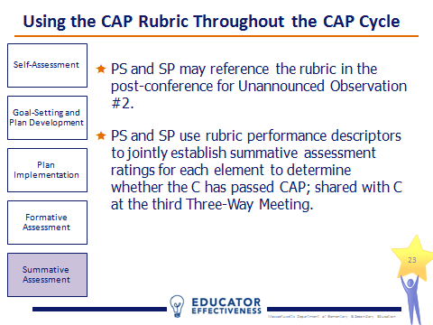  Slide 23  1 minute
Learning:  - Evidence should be collected throughout the 5-step cycle and the CAP Rubric should be used to analyze the quality of the evidence.  - At the formative assessment step, assessors should identify places where the evidence is weak (i.e., where it is harder to make a judgment of the candidate’s practice) and plan accordingly to bolster the evidence.  - Leading up to the summative assessment, assessors should review the minimum evidence requirements for each element and make sure all required evidence is collected and of sufficiently high quality to make a judgment about the candidate’s practice.  - The last thing assessors want is to find themselves without the necessary evidence when it is too late to collect more. | 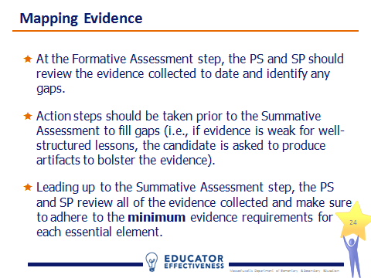  Slide 24  2 minutes
Learning:  - Review the minimum evidence requirements. | 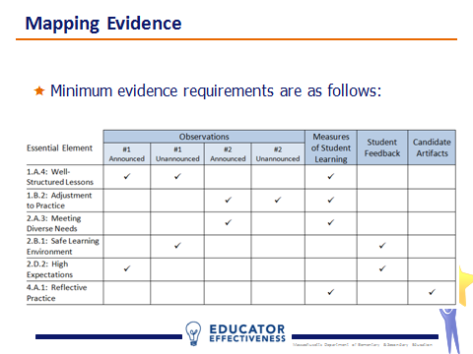  Slide 25  2 minutes
Learning:  - Like in the MA Educator Evaluation Framework, the professional judgment of the assessors is the final determinant of ratings.  - There are no weights or algorithms used in the scoring of CAP.  - Ratings are based on the body of evidence as analyzed against the CAP Rubric. | 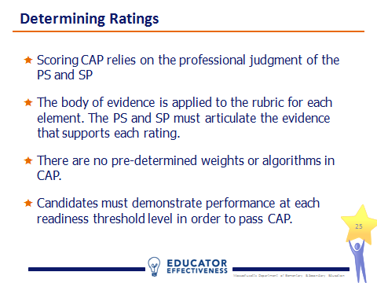  Slide 26  1 minute

III. Practicing (34 minutes)
Practicing:  - In this section, participants will review a sample set of evidence and practice conducting a formative assessment using the CAP Rubric.  - Facilitators will need to create a sample evidence packet for participants in order for them to complete the practice activity. Sample evidence can be from a single CAP completer or a composite. All personally identifiable information should be redacted.  - Programs are encouraged to use this activity as an opportunity to model the type of high-quality evidence they expect assessors and candidates to collect during CAP. Remember, the quality of evidence is related to how much information it provides related to the candidate’s practice on one or more of the 6 essential elements, not the quality of the candidate’s practice. In other words, an assessor may collect very high quality evidence of very poor candidate practice.  - For the purposes of this activity, facilitators are encouraged to use a collection of evidence that illustrates a range of practice. Doing so will foster more engaging conversations among participants. | Slide 27  Quick Transition
Practicing:  - In the interest of time, this simulated formative assessment will look at only 2 of the 6 essential elements: well-structured lessons and safe learning environment.  - Refer participants to the sample evidence collection provided by the program and comprised of at least:  - A completed Unannounced Observation #1 form  - A completed Announced Observation #1 form  - A completed Announced Observation #2 form  - A summary of results from a measure of student learning.  - A summary of results from a student survey.  - Refer participants to the excerpts from CAP Rubric included on pages 11-12 of the handouts packet. Each participant should work independently for 10 minutes using the CAP Rubric and sample evidence to complete the formative assessment section of the rubric for the two elements. Cap the activity at 10 minutes and inform participants that it’s ok if they do not complete the process in the time allotted. | 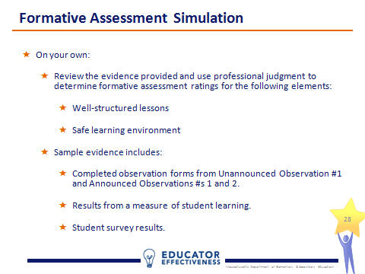  Slide 28  10 minutes
Practicing:  - Break participants into groups of 2 and provide each pair with chart paper and a marker.  - Ask participants to share their ratings and rationales with each other for both elements.  - If their ratings match, they chart an evidence statement to support their shared rating for each element.  - If their ratings do not match, they review the evidence against the Rubric together. If they then reach consensus, they chart an evidence statement. If they do not reach consensus, they chart two separate ratings and two separate evidence statements.  - Each pair’s chart should be clear about where there was immediate ratings agreement, where discrepant ratings were resolved, and where discrepant ratings remained discrepant. | 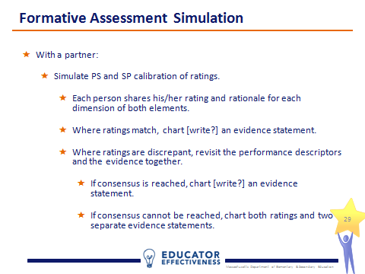  Slide 29  12 minutes
Practicing:  - Lead a whole-group share. Focus first on the ratings that resulted in the most matches (at the dimension – quality, scope, consistency – level). Push participants to explain why they think these ratings were best calibrated across the group (e.g., the amount/quality of the evidence). Ask the group to identify examples of particularly strong evidence statements. What makes them strong?  - Next move to the ratings that resulted in the most discrepancies and prompt participants to consider whether the amount/quality of evidence was weaker for these dimensions or whether the participants actually differ in their expectations of performance in these areas. Be sure to ground the conversation in the language of the performance descriptors. | 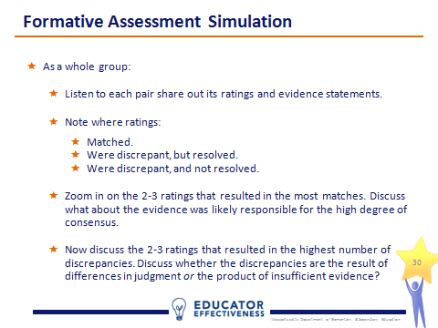  Slide 30  12 minutes

IV. Calibrating (25 minutes)
Calibrating:  - In this section, participants will review additional sample evidence and practice conducting a summative assessment using the CAP Rubric.  - As in the Practicing section of the workshop, facilitators will need to provide participants with sample evidence in order for them to complete the calibration activity. Sample evidence can be from a single CAP completer or a composite. All personally identifiable information should be redacted  - The calibration activity builds on the practice activity, so participants will use the sample evidence provided earlier in the workshop, as well as the supplemental evidence provided here. | Slide 31  Quick Transition
Calibrating:  - This definition of calibration is used by ESE’s educator evaluation team and reflects the importance of consistency in any evaluation process. | 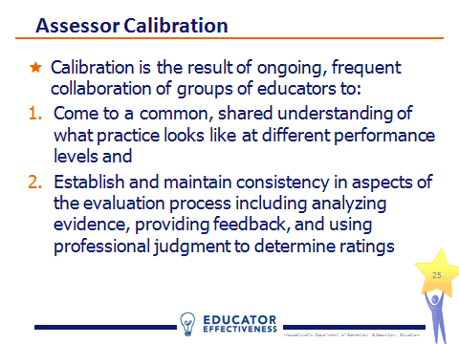  Slide 32  1 minute
Calibrating:  - In CAP, calibration is important in two ways. First, program supervisors and supervising practitioners must be calibrated to ensure that candidates receive consistent feedback. Second, calibration across all program supervisors will ensure that a program’s rigorous expectations for candidate performance are reinforced with each observation. | 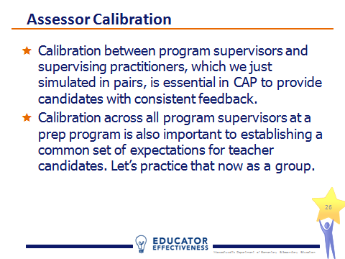  Slide 33  2 minutes
Calibrating:  - As with the practice activity, in the interest of time, this simulated summative assessment will look at only 2 of the 6 essential elements: this time it is adjustments to practice and reflective practice.  - Refer participants to the additional sample evidence provided by the program and comprise d of at least:  - A completed Unannounced Observation #2 form  - Candidate artifacts (1-2 are recommended)  - Point out to participants that they now have all of the required evidence for determining a summative assessment in CAP. However, the evidence collected in practice is likely to be more robust or abundant (especially the candidate artifacts), than would be feasible to process in the time allotted in the workshop.  - Refer participants to the excerpts from the CAP Rubric included on pages 19-20 of the handouts packet. Each participant should work independently for 10 minutes using the CAP Rubric and full sample evidence collection to complete the summative assessment section of the rubric for the two elements. Cap the activity at 10 minutes and inform participants that it’s ok if they do not complete the process in the time allotted. | 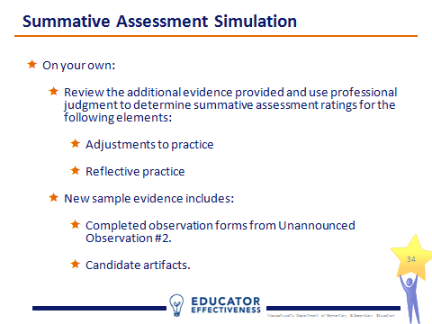  Slide 34  10 minutes
Calibrating:  - Break participants into teams of 3-4 and conduct a peer review of a group member’s summative assessment. This process is based on a model developed and used by the administrative team of the Revere Public Schools.  - Each team identifies a subject who is willing to read aloud his/her ratings and evidence statements to the group. (2 minutes)  - Next, the remaining group members critique the subject’s ratings and evidence statements and make suggestions for improvement while the subject listens quietly. (4 minutes)  - Then the subject has a chance to respond to the team. (1 minute)  - Finally, the team works together to brainstorm ways to make the subject’s evidence statements stronger. (3 minutes)  - Depending on the time allotted for the workshop, facilitators may wish to let teams choose a second subject and repeat the process. | 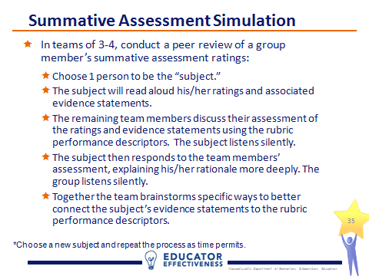  Slide 35  12 minutes
Calibrating:  - Lead a whole-group share. Ask participants for their ideas about how the sample evidence collection could be supplemented with other pieces of evidence to better support ratings. How could specific pieces of sample evidence be strengthened? Facilitators may find it helpful to chart responses.  - As a group, develop one new strategy for promoting consistent ratings across all of the program supervisors and supervising practitioners supporting candidates in the program. | 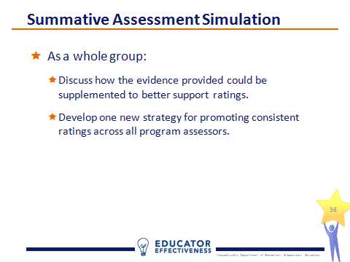  Slide 36  12 minutes

V. Recapping (5 minutes)
Recapping  - In this final section, the facilitator will recap key takeaways and take questions. | Slide 37  Quick Transition
Recapping  - Review the purpose of the CAP rubric and how it is used in the CAP process. | 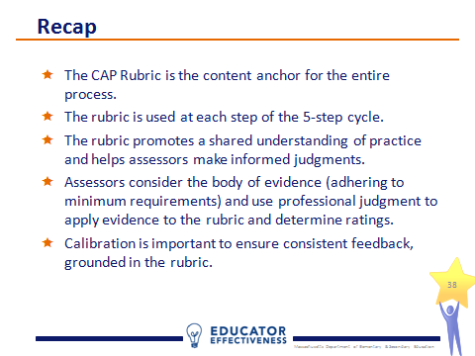  Slide 38  2 minutes
Recapping  - Provide participants an opportunity to ask questions. | Slide 39  3 minutes

