Introduction
The Candidate Assessment of Performance (CAP) assesses teacher candidate readiness using multiple categories of evidence, including observations, measures of student learning, student feedback, progress towards a professional practice goal, and candidate artifacts. This document outlines the Department of Elementary and Secondary Education’s (DESE) expectations for retention and submission of data collected through CAP.

CAP is a statewide assessment and, as such, DESE must monitor the implementation of this assessment to determine its efficacy. The data collected informs DESE research about the validity of CAP. Additionally, the data is used for accountability purposes. Finally, collecting this data allows us to provide more meaningful data to Sponsoring Organizations for continuous improvement through the CAP Data Dashboard.

Record Retention
All required forms, as identified in the CAP Implementation Handbook and listed below, should be retained on file by the Sponsoring Organization for all teacher candidates enrolled during the three (3) most recent academic years. Records may be maintained electronically or in the CAP Online Platform 2.0, provided they are readily available for review by program reviewers and DESE staff.
- CAP Form
- Observation Forms
- Student Feedback Data
- Formative Assessment Form
- Summative Assessment Form
In addition to the required documents above, other forms and artifacts, such as those listed as Recommended in the Implementation Handbook, may also be kept on file if they are useful in demonstrating that criteria are met during a DESE formal review. For more information, please refer to the Candidate Record Retention Advisory.
Data Reporting
The following table lists the CAP data points that are reported to DESE on an annual basis. For SOs using the Online Platform, this data will be input in the system by completing the candidate cycles. SOs not using the Online Platform will submit this information using the template provided via the CAP Online Platform 2.0.
Required Data | Definition
Organization Name | Name of Sponsoring Organization.
TC-MEPID | Teacher Candidate’s 8-digit MEPID identification number.
TC-FirstName | Teacher Candidate’s first name. This must be formatted exactly as it is in the candidate’s early ID.
TC-LastName | Teacher Candidate’s last name. This must be formatted exactly as it is in the candidate’s early ID.
TC-Email Address | Teacher Candidate’s email address.
SP-FullName | Supervising Practitioner’s full name.
SP-MEPID | Supervising Practitioner’s 8-digit MEPID identification number. You may not use their license number.
SP-Email | Supervising Practitioner’s email address.
PracticumDistrict | District location of the practicum. This must be formatted exactly as it is in profiles.
PracticumSchool | School site location of the practicum. This must be formatted exactly as it is in profiles without the district name.
PS-FullName | Program Supervisor’s full name.
PS-Email Address | Program Supervisor’s email address.
SchoolYear | Academic year of the practicum.
Program | Program type and grade-level. Ex) Academic: Teacher, Elementary, 1-6, Initial, Baccalaureate. This must be formatted exactly as it is in the candidate’s early ID.
Formative Ratings | Formative assessment ratings for quality, scope, and consistency of each of the six essential elements.
Summative Ratings | Summative assessment ratings for quality, scope, and consistency of each of the six essential elements.
Ready to Teach | A determination of whether the readiness thresholds have been met for all six essential elements.

CAP Data Submission
All required CAP data must be submitted to DESE by July 15th of each year. Incomplete data may limit SOs’ ability to access data in Edwin.
- SOs using the CAP Online Platform for the full CAP 5-Step Cycle:
SOs using the CAP Online Platform 2.0 should complete the following process to ensure that all required CAP data is entered correctly (see User Guide for more information):
- Program Supervisors must mark all completed CAP cycles as “Complete”.
- The CAP Manager should ensure that all cycles are complete by checking Reports > Annual Reports within the Platform.
- If a cycle is incomplete, incomplete information (blank or marked “i”) must be corrected by the Program Supervisor, Supervising Practitioner, or Teacher Candidate through the candidate’s CAP Cycle page.
- Annually, after July 15th, DESE will extract the data from the Online Platform to be used in Edwin.

- SOs NOT using the CAP Online Platform for the full CAP 5-Step Cycle:
SOs administering a paper-based version of the CAP must identify a CAP Manager to submit data annually to DESE by July 15 using the following process:
- Ensure that an individual from your Sponsoring Organizations has CAP Manager permissions within the DESE Security Portal. You can email edprep@doe.mass.edu to verify that someone from your Sponsoring Organization has these permissions. If you do not immediately see the CAP Online Platform within your Recently Used Applications List, please select Applications List for your full list of applications.
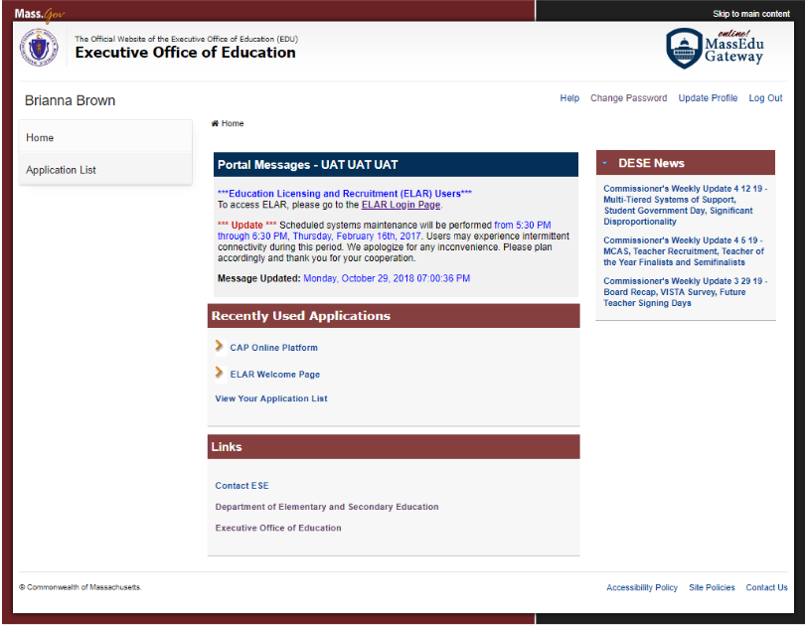
- Log in to the CAP Online Platform 2.0 and select “Reports” (See Figure 1 below).
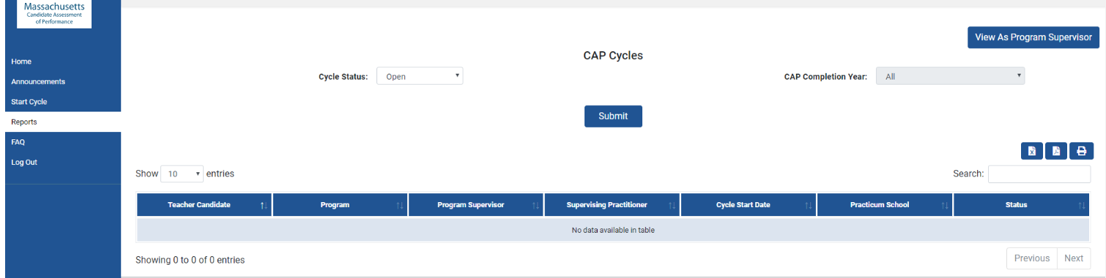
- Under “Reports,” select “Upload Cycles” and then select “Download Template.” Please ensure that the template remains in a .csv format, or it will not be able to be uploaded.
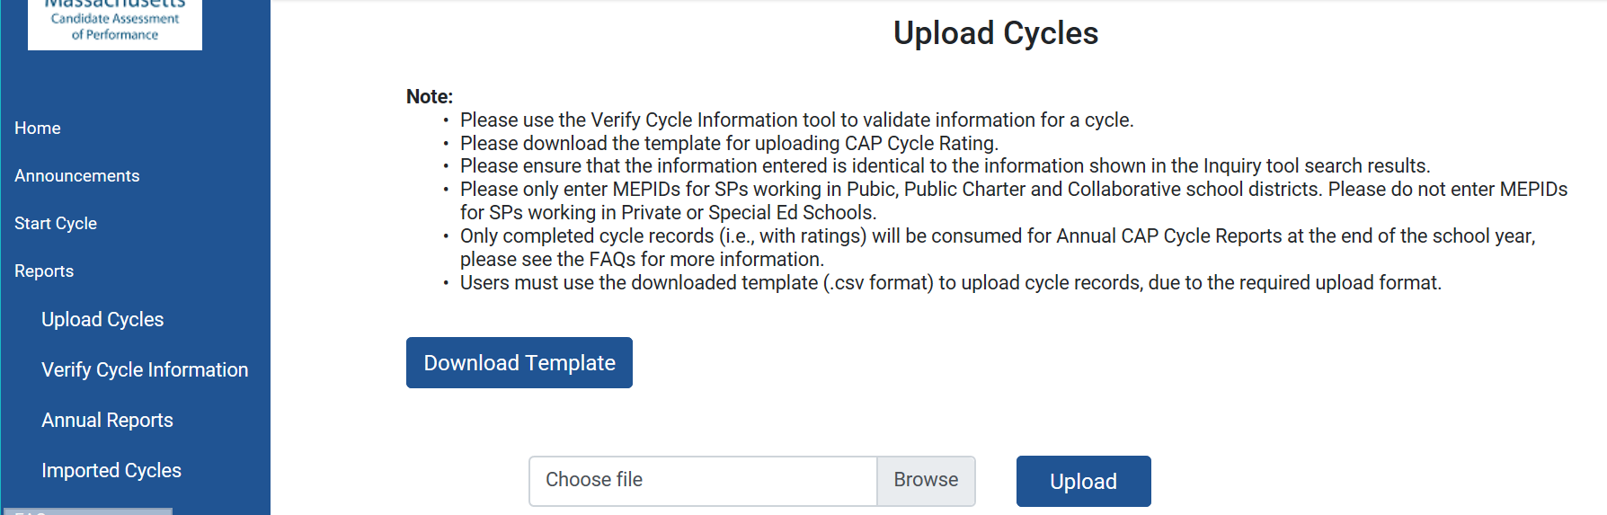
- Within the template, complete all fields for each cycle, using single lower-case letters for ratings (e for Exemplary, p for Proficient, n for Needs Improvement, u for Unsatisfactory). The formatting for each field must be specific.
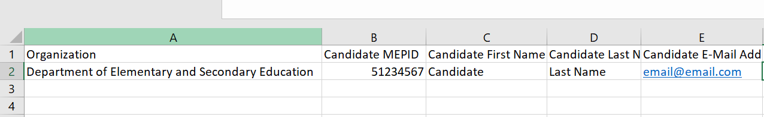
- For Private, Special Education School, or Out of State placements, do NOT include the SP MEPID number as it will cause formatting issues. Instead, leave the cell blank.
- Save as a .CSV file.
- Choose the file and click “Upload” to upload the file into the system.
- If your file uploads, you will be able to see your imported cycles under “Imported Cycles”. This means there are no errors in your file. 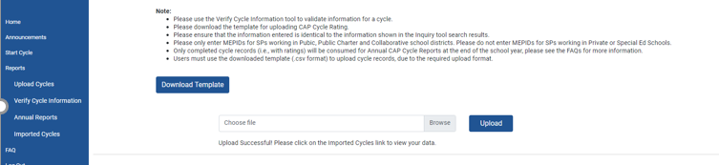
- If there are errors in your file, you will receive an error message and a link to download an Error Log. The Error Log will have two tabs. The first tab will provide the Error Codes for your upload. The second tab is the Error Index which will help you determine how to correct the issue. You will need to correct all errors in the template and re-upload the document until your file uploads. You can elect to separate out the errors from the cycles without errors into two separate documents so that you can continue to work on the errors. You do not have to upload all of the cycles in one batch.
Ex. Error = PROGRAM_NAME
PROGRAM_NAME-The Program information does not exist in the database. Please ensure that the information is correct. | An incorrect Program name leads to no match in the DB. | Verify information from the 'Verify Cycle Information" page and update.  Please ensure that spelling and format are correct.  Check in Early ID for correct program name.  Contact Ed Prep for more information.

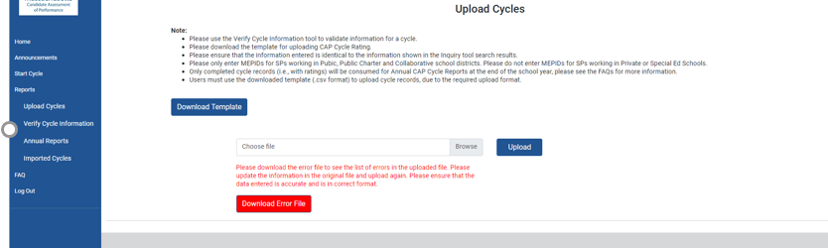
- Some errors require you to identify the correct information about your teacher candidate, program information, supervising practitioner information, or practicum information. You can use the Verify Cycle page to find the information that will allow you to correct the errors identified.
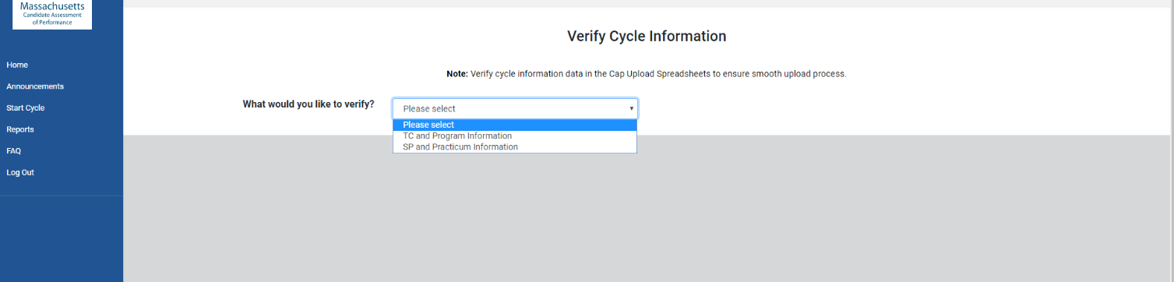
- If you need to look up Teacher Candidate or Program Information, you can select “TC and Program Information.”
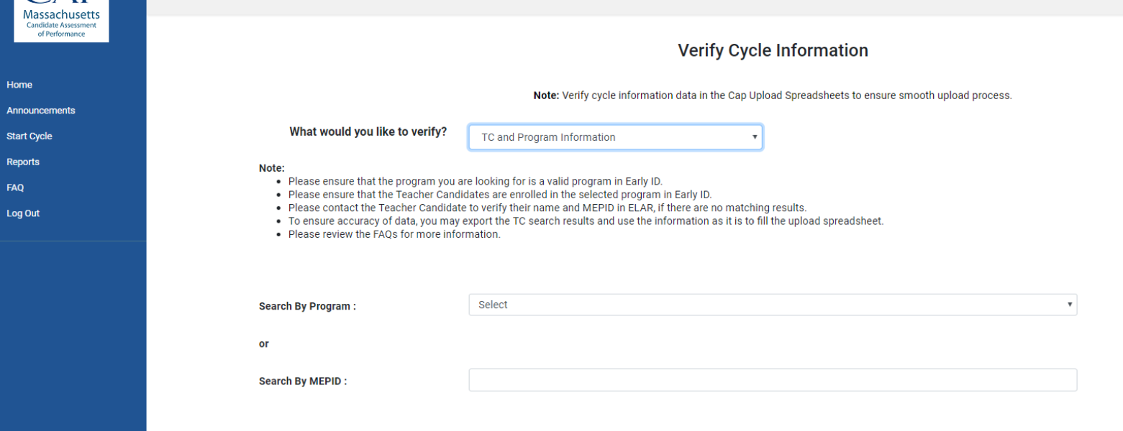
- If you need to look up Supervising Practitioner or Practicum Information, you can select “SP and Practicum Information.”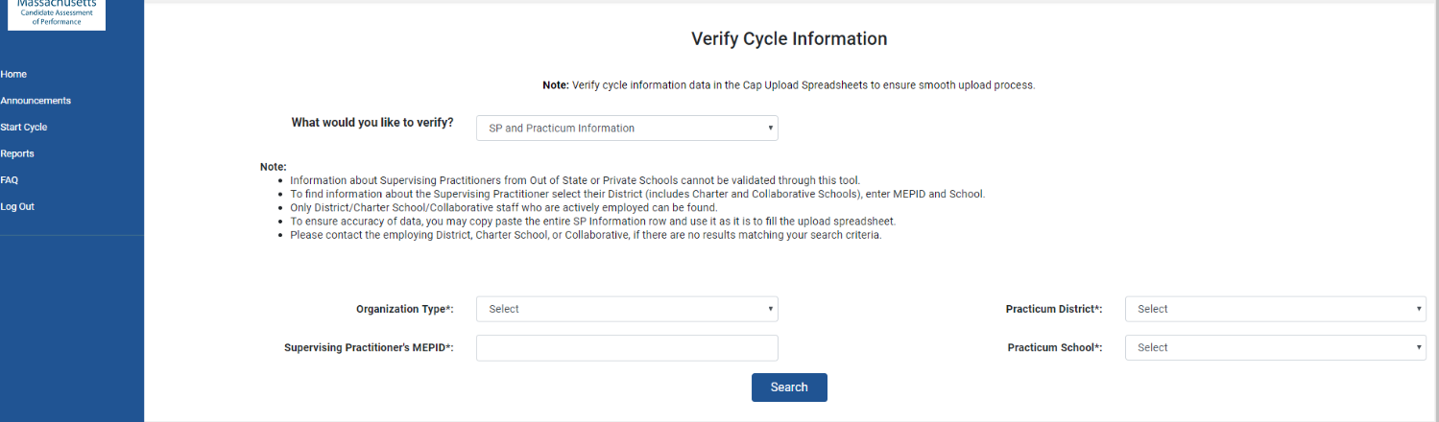
- You will be able to copy and paste the information you find directly into your .csv template. Please correct the information directly in that spreadsheet.
- If you are unable to find a supervising practitioner within the system, please ask them if they were reported in their district’s most recent reporting. The CAP data is tied to the most recent district EPIMs or SIF data collections, meaning that if the district has not recently reported their data, the teacher may be miscoded or absent from the district roster.
- Once you have corrected all errors directly in the spreadsheet, re-upload the document (refer to step 7, above).

Troubleshooting tips and tricks

Formatting Program Names | Program names must be formatted exactly as they are in Early ID.  Example:  Incorrect - Teacher English 5-12 Initial Post-Bacc  Correct - Academic: Teacher, English, 5-12, Initial, Post-Baccalaureate  The incorrect example is missing “Academic:” from the start of the program name, missing commas, and post-baccalaureate is abbreviated.
Formatting District Name | District names must appear as they do in profiles.  Example:  Incorrect – Berlin Boylston  Correct – Berlin-Boylston  The incorrect example is missing the hyphen.
Formatting School Name | School names must appear as they do in profiles without the district names.  Example:  Incorrect – Boston: Charles Sumner  Correct – Charles Sumner  The incorrect example includes the district name.  Example:  Incorrect – Olmsted  Correct – Richardson Olmsted School  The incorrect example is missing the first part of the school’s name and the word school from the end.
SP MEPID Numbers | SPs must have MEPID numbers and not License numbers. MEPID numbers begin with “5”.  For SPs who are from private schools, special education schools, or who are out of state, do NOT include their MEPID numbers even if they have them, as this will prompt the system to look for a recognized public school or district name.
SP not included in most recent district reporting | Please email edprep@doe.mass.edu with the response provided by the district about the situation for further guidance.
Ratings | Ratings must be in the format of single lower-case letters (e for Exemplary, p for Proficient, n for Needs Improvement, u for Unsatisfactory
Isolate Errors | If you only have a few cycles with errors in your spreadsheet that you are having issues with, we recommend saving them to a separate template and uploading your correct cycles before continuing to work on the isolated cycles.
Overall | The Error Log will only return the first error that the system encounters. For example, if there is a mismatch between the MEPID number and candidate first name because a nickname was used, then that is the error that would be provided. However, that does not mean that there are not further errors in the cycle. We recommend checking all of the information for the cycle if an error is found.

MEPIDs can be found using the administrative inquiry tool in ELAR.
MEPIDs can be found using the administrative inquiry tool in ELAR.
When a Program Supervisor ends a cycle in the Online Platform, they are prompted to select a reason, which may be successful completion of CAP, a candidate exiting the program, or that the cycle was created in error. Ensuring that cycles are formally “ended” in the system will help ensure that the data reported to DESE is complete and accurate.
To upload the file into the Online Platform 2.0, you will need to ensure the template is a .csv file (the file name ends in .csv). To do that, click on “File” or the Microsoft windows icon in the top left menu and select “Save As.” Name the file and for “Save as Type” and choose “CSV (Comma delimited).”

