This Quick Guide is intended to facilitate easy access to the CAP online platform. The Quick Guide does not cover all requirements of a CAP cycle, but it highlights some critical details. For more information, please see our CAP Online Platform 2.0 User Guide.

Getting Started
The CAP Online Platform is embedded within the Education Security Portal. The log-in page appears below:
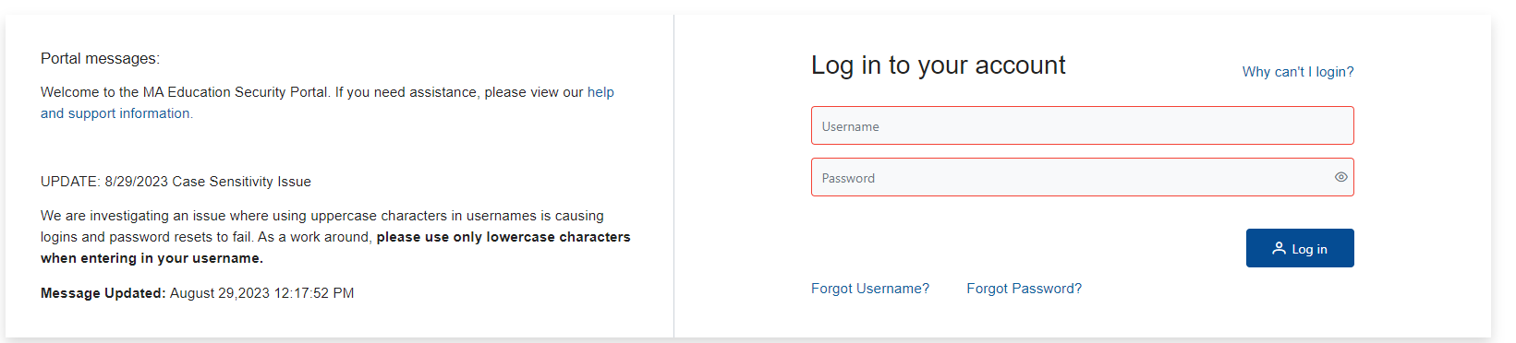
To begin using the system:
- When logging in for the first time, please use the “Forgot Password” feature with your username and the email associated with your account to set up a password. Additional resources can be found here.
- If you do not already have an account affiliated with your Sponsoring Organization separate from your personal ELAR account, contact the CAP Manager (CM) to request an account. If you are able to see CAP, but not the candidate cycle assigned to you, you have likely logged in through your personal ELAR account and not the account affiliated with your Sponsoring Organization. Please reach out to the CM for information about your username. If you log in with the correct username and are still having issues, please log out and try clearing your web browser’s cache, opening an incognito browser, or use another browser.
- Select the CAP Online Platform from the list of applications. If the application is not listed, please contact your organization’s CM.

Role of the Program Supervisor
The PS has primary responsibility for managing CAP cycles in the Online Platform. The PS has the ability to:
- Start CAP Cycles  - View candidate progress  - Edit candidate and cycle information  - View and complete forms | - Unlock forms  - Upload evidence  - End CAP cycles in communication with the CM  - Communicate with the triad
If you are also serving as the CM, you can toggle between the PS and CM accounts by clicking on the link to “View as Program Supervisor” on the home page on the top right.

Registering a New Candidate CAP Cycle
Both the PS and the CMs can start cycles. To start a cycle, select “Start Cycle” from the home page. You can then search by a Teacher Candidate’s (TC) program or MEPID number. If the candidate does not appear, they may not yet be enrolled in Early ID. Candidates must be enrolled in Early ID in order to start a cycle. You will only be able to create one cycle for each candidate enrolled in a program. If a candidate is enrolled in two programs, you will be able to create two cycles. If a candidate is enrolled in one program and doing a split practicum, you will only be able to create one cycle. If the PS is starting the cycle, they will automatically be assigned as the PS.
After assigning the PS, you will be asked to select the TC’s SP. To do this, you will first need to select the SP’s Organization Type from the drop down menu (Charter District, Collaborative, Public School District, Private (Non-Public, Non-Special Ed Schools, Out-of-State School).

Once you enter the required information, you will be able to search for the SP and “Assign” them to the TC. Click on the SP name to select them and then enter their email if one is not provided. Adding an SP to a cycle will generate a new CAP-specific account for them, separate from their personal ELAR account. They will receive an email notifying them of how to sign into the new account. Placements in schools other than MA public schools will require the PS to collaborate with the SP and then the PS will need to complete the forms.. Private school and out-of-state SPs will not be able to fill out the forms on their own; the CM and/or PS will need to complete the forms on their behalf. If the SP does not appear, please contact the CM for support.

Completing the Observation Forms
First, collaborate with the SP to determine whether you are completing the joint version or the individual version of each form. You will be able to type in the “Program Supervisor Feedback” box and the “Calibrated Feedback” box. Only the “Calibrated Evidence” box needs to be complete in order to finalize the joint version of the form. If only the PS is filling out the form, one field per element will be shown. Make sure that you use the “Save” buttons to save your work prior to completing the forms.

Joint form (showing the Supervising Practitioner Evidence, the Program Supervisor Evidence, and the Calibrated Evidence):
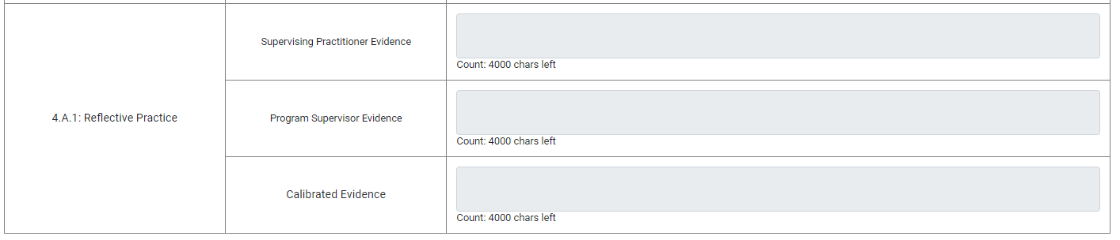
Individual form (showing the singular cell to input evidence:
Complete these forms per the CAP Guidelines. If the PS is completing the form individually, only the PS needs to select “Complete.” For the joint version of the form, both the PS and SP need to select “Complete” to finalize the form and make it available to the TC. If a PS completes the form and can no longer edit it, and the CM cannot unlock it for editing, it means that the SP has not yet completed the form.
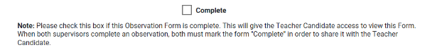
Important Note: Toggling back and forth between who completes the form may result in the deletion of work. If the SP attempts to fill out a form that has been completed by a PS, it will override the original observation. If both the PS and SP are completing an observation, the calibrated evidence will reflect whoever saved last. In order to avoid the deletion of work, please communicate well with the SP about who will enter the calibrated evidence.
For information about completing other forms, please see the CAP Online Platform 2.0 User Guide.

