Editing Educator Preparation Program Characteristics in Directory Administration

Sponsoring organizations can now enter information about their educator preparation programs through the Directory Administration system. In Directory Administration, organizations can update their information at any time and changes are automatically reflected in the organization’s online profiles. Below are instructions for accessing and entering information in Directory Administration.

Accessing Directory Administration

- Log in to the ESE Security Portal here: https://gateway.edu.state.ma.us/. Use the log-in name and password provided to the Contact Person by ESE to access your sponsoring organization’s account.
- Scroll down to “Organization Administration” and click on “Directory Administration”. If you do not see a link for “Directory Administration”:
  - Educator Preparation Program Providers and Higher Education Organizations should contact ESE at sar_titleII_report@doe.mass.edu
  - School districts, charter schools, collaboratives and private schools should contact their directory administrator to be assigned the “Characteristics Administrator” security role. You can find your Directory Administrator here: http://www.doe.mass.edu/infoservices/data/diradmin/list.aspx
- From the Directory Administration welcome page, click “Organizations” on the left hand side.

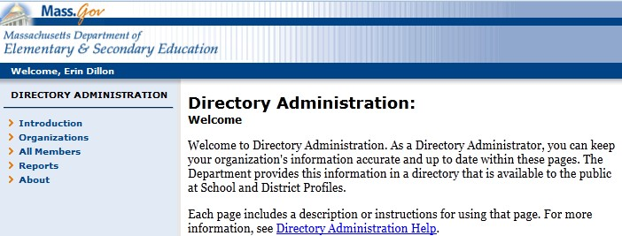Select Organizations

- On the next screen, expand the list under your organization type (e.g., Higher Education Institution, Public School District, etc.) and click on your organization name.

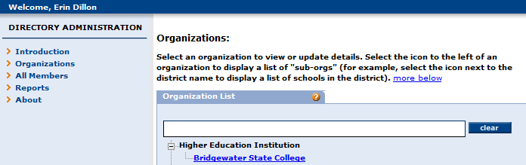Select your organization

- On the next screen, select “Characteristics” on the left hand side. This will take you to the page where you can enter information on your organization’s admissions requirements, partnerships with districts, and educator preparation mission and vision statement.

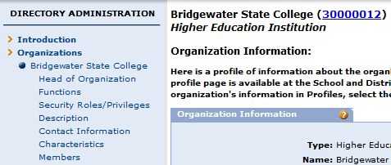Select Characteristics

Entering Information in Directory Administration

Educator Preparation Mission & Vision: Under “Ed Prep: Mission/Vision Statement” you can enter a mission/vision statement specific to the educator preparation programs within your organization. If your organization already had an organization-wide mission/vision statement in Directory Administration, that statement has been copied to this space and can be edited for the educator preparation programs.

The mission/vision statement will be displayed on the General Information page of the profile under your organization’s contact information.
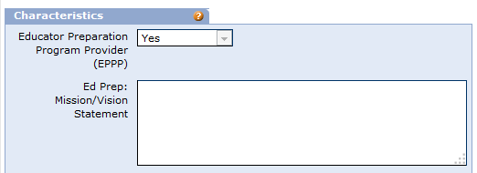

Admissions Requirements: You can also enter information about your organization’s admissions requirements. There are two spaces available – one for admissions requirements specific to baccalaureate programs and the other for requirements specific to post-baccalaureate programs. You can enter text and HTML links in this space (see the helpful hints below for instructions on making web links active links).

Admissions information will be displayed on its own page in the profiles beginning in Fall 2013.

Partnerships Description: In this space, organizations can provide a description of their partnerships with districts, charter schools or collaboratives. This description should include an overview of the types of partnerships your organization has with districts (for example, collaboration on program design to meet the needs of the PreK-12 community, joint responsibility for the induction of newly hired teachers, or in-depth, extended field experiences). It can also include web links for more information on partnerships (see the helpful hints below for instructions on making web links active links).

The description of partnerships will be displayed on the ‘Partnerships’ page of the profiles along with the partnerships list.

Partnerships List: Organizations can check off the public school districts, charter schools, or collaboratives with which they have partnerships. This information will be displayed on the online profiles and can be updated at any time in Directory Administration. These should be partnerships that go beyond placements for practicum or pre-practicum work by also informing the effectiveness of the educator preparation programs and supporting the needs of school districts.

The list of partnerships will be displayed on the ‘Partnerships’ page of the profiles along with the description of partnerships.

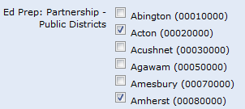

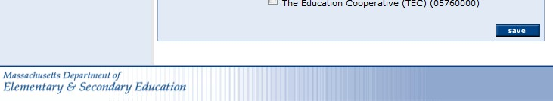When you are done, click “Save” at the bottom of the page to save your changes.

Helpful Hints
- To allow users to click on a web link, type the link in quotes as shown in the example below:
<a href=”http://www.TheLink.edu”>www.TheLink.edu</a>
  - Before the link text, type: <a href=
  - Add the link in quotes and finish with >: for example, <a href="http://www.TheLink.edu">
  - After the link, enter the text as you would like it to display on the profiles page: www.TheLink.edu
  - Following the link text, type: </a>
Important:
  - http:// must be included.
  - Double quotes around the URL are required.
  - Closing the link with </a> is required.
  - Failure to properly format the link will yield unexpected results!

- Check your spelling and grammar. The text you enter in Directory Administration will show up on your organization’s profile exactly as you enter it.
- Avoid acronyms. The information entered in Directory Administration will be available to the general public and acronyms may be confusing to those who are not familiar with educator preparation programs.
- If you use spacing or special characters, check your organization’s profile after you save your changes to ensure the formatting translates well from the text box to the web.
- Limit the amount of text you enter. Shorter, more concise, descriptions display better on the profiles website.

