What is the Bachelor’s Verification feature?
Bachelor’s Verification is part of the Early ID System in the Educator Licensure and Recruitment (ELAR) System. The Bachelor’s Verification feature allows Sponsoring Organizations (SOs) to inform the Massachusetts Department of Elementary and Secondary Education (DESE) that candidates in their educator preparation programs have received a bachelor’s degree from their institution. Candidates for educator licensure are required to possess a bachelor’s degree from an accredited college or university. The Bachelor’s Verification feature allows SOs to verify that a candidate in their educator preparation program received a bachelor’s degree from their institution, in place of the candidate submitting an official transcript or other documentation to verify their bachelor’s degree in ELAR. This guide provides an overview of the Bachelor’s Verification process and the circumstances under which it can be used.

When can SOs use the Bachelor’s Verification feature?

A Sponsoring Organization may use the Bachelor’s Verification feature only for candidates who 1) earned their bachelor’s degree at the SO’s institution and 2) are completing an educator preparation program at their institution. In other words, the candidate must earn their bachelor’s degree and their initial licensure endorsement from the same institution. For example:
- Candidate A earned her bachelor’s degree from Example University and also completed a baccalaureate educator preparation program at Example University
- Candidate B earned his bachelor’s degree from Sample University and is completing a post-baccalaureate educator preparation program at Sample University.
Please note that a SO must endorse a candidate for bachelor’s verification at the same time that the candidate is endorsed for program completion.

A SO may not use the Bachelor’s Verification feature if:
- A candidate is currently enrolled in your institution’s ed prep program, but earned a bachelor’s degree at a different institution.
- A candidate earned a bachelor’s degree at your institution, but is enrolled in a different SO’s educator preparation program.
- Your institution does not confer bachelor’s degrees.
- A candidate has already been electronically endorsed for program completion.

If the Bachelor’s Verification feature cannot be used, candidates must follow the traditional process to demonstrate they have met the bachelor’s degree requirement by submitting an official undergraduate transcript or other documentation to verify their bachelor’s degree. If you have questions about whether you may use the Bachelor’s Verification feature in Early ID, please contact edprep@doe.mass.gov

Step 1: ELAR Welcome Page
- Log in to your ELAR account at https://gateway.edu.state.ma.us/elar
- On the ELAR Welcome page, under administrative functions, click on the Early ID/Endorsement link.

Step 2: Find the Candidate in Early ID
- In the Search Criteria section, enter the candidate’s MEPID.
- Press Search.
*Note: The candidate must be enrolled in an educator preparation program at your SO in order for you to continue with the Bachelor’s Verification feature. For more information about enrolling a candidate in the Early ID system, please visit http://www.doe.mass.edu/edprep/earlyID/.

Step 3: Edit the Candidate’s Record to Add Bachelor’s Verification
- Locate the candidate’s search record. In the Search Results section, select the check box next to the candidate’s record.  - In the Action column on the far right, click Edit. | 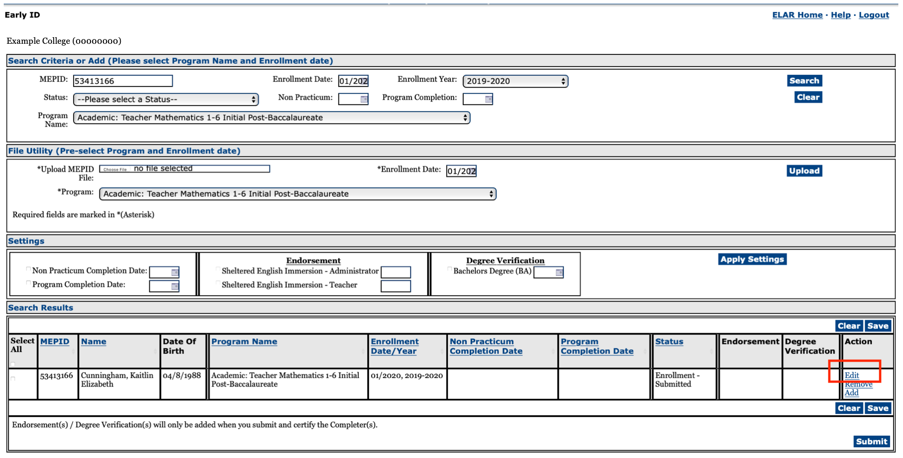  Doe, Jane
- Update the Non Practicum Completion Date and Program Completion Date as normal, as well as the SEI Endorsement (if applicable)  - Under Degree Verification, select the check box next to “Bachelors Degree.”  *Note: This option will appear for any SO that grants bachelor’s degrees.  - Enter the educator preparation program completion date to the right of “Bachelors Degree.” For example, if the candidate will complete the educator preparation program in May 2020, the Bachelor’s Verification date should also be entered as May 2020.  - Click Update. | 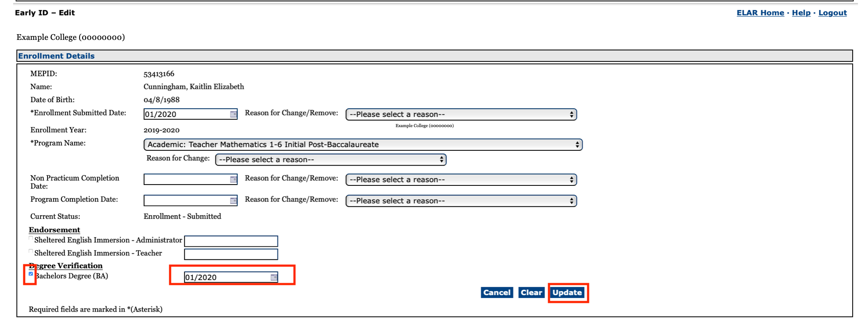  05/2020  05/2020  04/2020  Doe, Jane

Step 4: Bachelor’s Verification
The system will return to the Early ID search page. In the Search Results section, Bachelor’s Verification will be specified in the Degree Verification column for the candidate.  - In the Search Results section, select the check box next to the candidate’s record.  - Certify that the candidate received a bachelor’s degree from your institution by selecting the check box in the Endorsements/Degree Verification section near the bottom of the screen.  - Press Submit. | 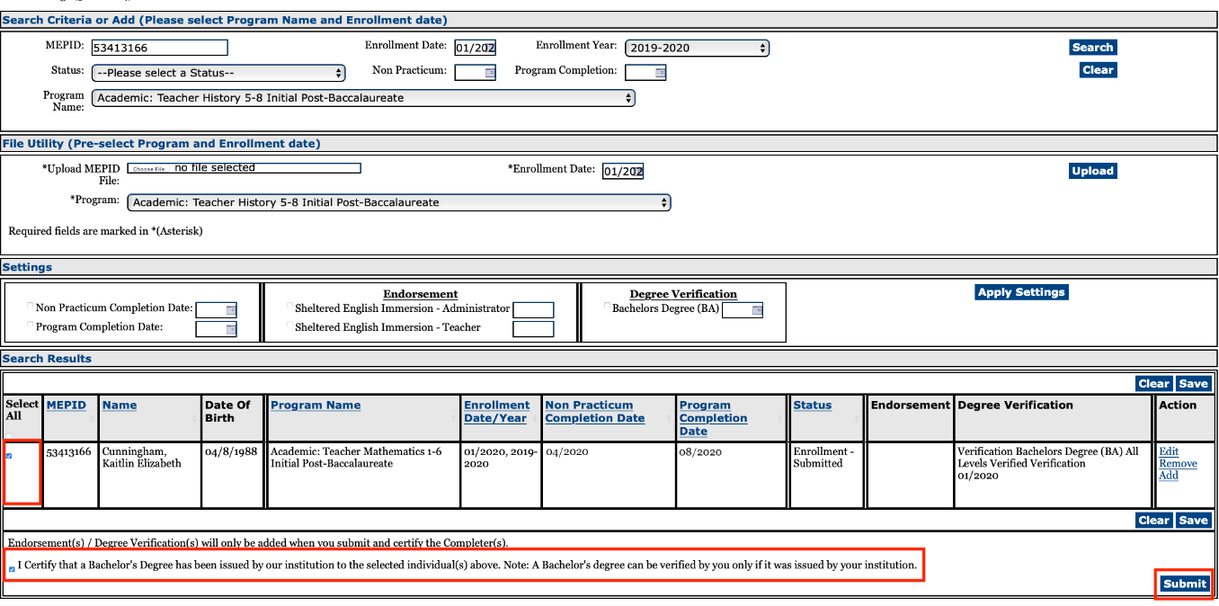  Doe, Jane
- Check that all of the information on the Certification page is accurate.  - If the information is accurate, click Certify. By clicking Certify, you are verifying that the displayed record is accurate and the candidate is eligible for licensure should all other requirements be satisfied. | 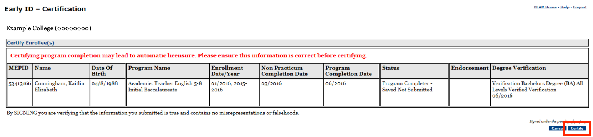  Doe, Jane
Step 5: Review Bachelor’s Verification
The system will return to the Early ID search page. In the Search Results section, a new record for the candidate will appear.  Under Program Name, Bachelor’s Verification will be specified in addition to the licensure program for which the individual was endorsed. Under Status, Program Completer - Submitted will be specified. | Doe, Jane  Doe, Jane

