Entering Information in Directory Administration
ESE provides sponsoring organizations the ability to enter information about their educator preparation programs through the Directory Administration system. Unlike the once-a-year annual report, Directory Administration allows organizations to update their information at any time and changes will be automatically reflected in the organization’s online profiles. Below is information on accessing and using Directory Administration to update your organization’s information. ESE will continue to enhance this system and will provide updated guidance as this system develops.

- Access the ESE Security Portal using the following URL: https://gateway.edu.state.ma.us/elar/common/EducatorWelcomePagePageControl.ser. Use the log-in name and password provided to the Contact Person by ESE to access your sponsoring organization’s account (do not confuse with your own personal account, or your organization’s Pearson site and password).
- Scroll down to “Organization Administration” and click on “Directory Administration”. If you do not see a link for “Directory Administration”, please contact ESE at sar_titleII_report@doe.mass.edu
- From the Directory Administration welcome page, click “Organizations” on the left hand side.

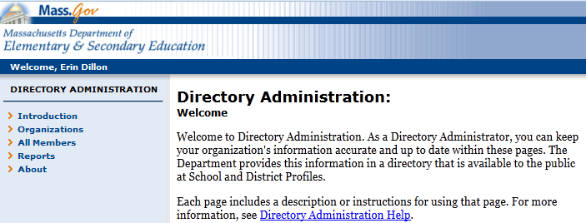
Select Organizations

- On the next screen, expand the list under your organization type (e.g., Higher Education Institution, Public School District, etc.) and click on your organization name.

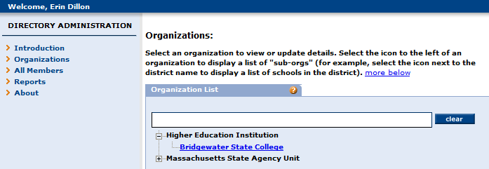
Select your organization

- On the next screen, select “Characteristics” on the left hand side.
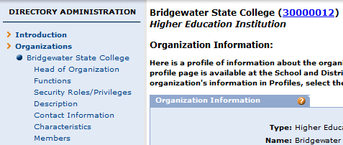
Select Characteristics

- This will bring you to the “Characteristics” page. On this page, you can edit information about your organization’s admission requirements for undergraduate and post-graduate programs, describe your organization’s partnerships and select the public school districts, charter schools, or collaboratives with which your organization has a partnership. See below for more guidance on entering information about partnerships. The only characteristics you can edit on this page begin with the prefix “Ed Prep”.
You can insert a link to your website here along with a description of admissions requirements.
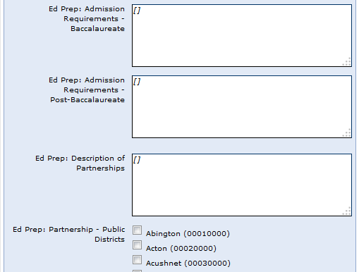
Provide a description of partnerships your organization has with school districts, charter schools or collaboratives.
Check all districts with which your organization has a partnership. All public school districts, charter school districts, and collaboratives are listed in this section.

District Partnerships
Organizations are able to report on their partnerships with public school districts, collaborative, and charter school districts. These should be partnerships that go beyond placements for practicum or pre-practicum work and should also inform the effectiveness of the educator preparation programs and support the needs of school districts.

There is space for organizations to provide a description of their partnerships, which should include an overview of the types of partnerships they have with districts (for example, collaboration on program design to meet the needs of the PreK-12 community, joint responsibility for the induction of newly hired teachers, or in-depth, extended field experiences). Organizations should also check off the districts, collaborative, or charter schools with which they have partnerships. This information will be displayed on the online profiles and can be updated at any time in Directory Administration.

- When you are done making changes, click “Save” at the bottom of the screen.

