In order to complete the Educator Preparation State Annual Report (SAR), The Massachusetts Department of Elementary and Secondary Education (ESE) requires that all Sponsoring Organizations verify candidate enrollment and completion data. Verification of this data serves two main purposes:
- Ensures that information reported to the federal U.S. Department of Education for Title II reporting (as required by the Higher Education Act) is accurate.
- Ensures that data linkages ESE makes (e.g., to employment, evaluation ratings, student performance, etc.) are also accurate.

The directions below provide guidance on how to verify this information for the 2017-2018 State Annual Report.

Important to note: the 2019 Annual report covers program information from September 1, 2017 - August 31, 2018.

Please email edprep@doe.mass.edu with questions.

Verifying Data
- Log in to the ESE security portal
- On the left hand side, select “Application List”
- Choose “ELAR REPORTS”
- Click the “EdPrep” folder. You should see this:

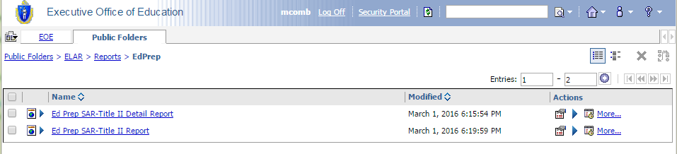

- Select the “Ed Prep SAR-Title II Report” (not the “Detail Report”)
- Enter in the following information:
Year: 2017-2018
Org: Select the Name of your Organization (should be the only one available)

- The report will be contain the following column headers:
Program Name of program as defined by ESE.
# Candidates Enrolled This is the number of candidates ENROLLED in the program as of August 31, 2018. It does not include candidates that were moved onto non-practicum coursework or program completers. Individual providers determine the point of enrollment.
# Non-Practicum Coursework Completers This is the number of candidates at the Non-Practicum Coursework Completion stage of your program as of August 31, 2018.
# Program Completers This is the number of candidates who COMPLETED the program (meaning they were endorsed by your organization in Early ID) at any point between September 1, 2017 and August 31, 2018.

Below is a screen shot of what you may expect to see:

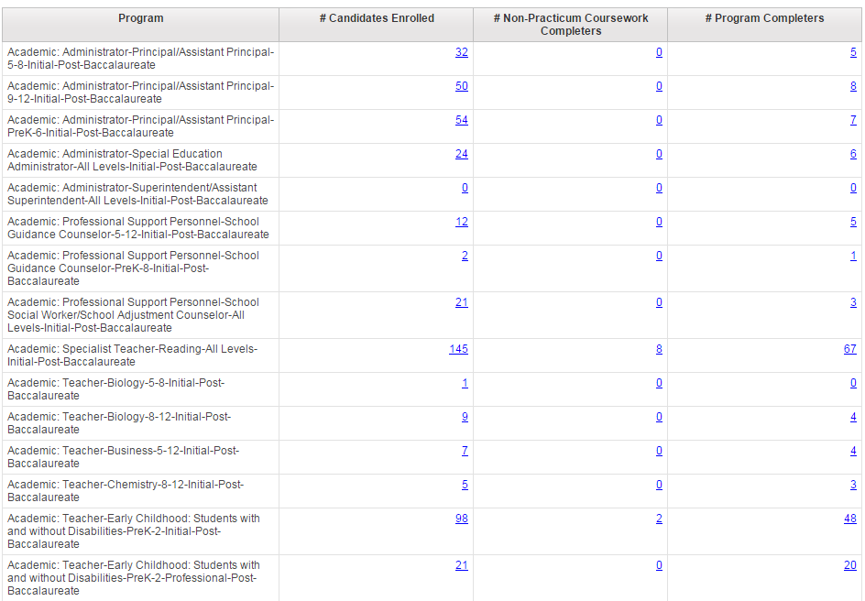

- Begin by reviewing the numbers in each row/column to see if the data here matches the data kept by your organization.
  - If the data is accurate, use the Survey Link to verify the data and complete the remainder of the State Annual Report.
  - If the data appears to be inaccurate, click on any of the numbers in the table to be taken to a detailed version of the report. This detailed version of the report provides the candidate-specific information (including Name, MEPID, Date of Birth and status) used to calculate the number populated in the chart.

Correcting Inaccurate Data
In most cases, you can correct any inaccurate data using the Early ID system. There is one exception:
- Program Completers: If you incorrectly endorsed a candidate for a program that they did not in fact complete, ESE must manually remove them. Before submitting names of candidates that must have their endorsements removed, please verify data for all programs. This will allow you to submit the names of all candidates at once rather than in one off requests and will ultimately help streamline the process for ESE.

