Subject Matter Knowledge Matrix
Instructional Technology Specialist, All

Students in Massachusetts must meet rigorous academic standards. To do so, they must have access to educators with strong content knowledge and pedagogical skills, the building blocks of effective instructional practice.

In support of this, the Subject Matter Knowledge Guidelines set forth the content knowledge expectations for educator licensure in Massachusetts. Through these expectations, the Massachusetts Department of Elementary and Secondary Education (DESE) seeks to ensure that educators entering the workforce have sufficient content knowledge in their licensure area to support students in mastering academic standards.

Educators must move beyond basic or functional knowledge to a level of fluency or expertise with the academic standards such that they can teach and support students in mastering the content. The figure below shows a steady progression, not in the amount of information one knows, but in the depth and ability to use that information for a specific purpose. The boxes below the continuum outline some assessments used to determine varying levels of content knowledge. The depth at which the knowledge and application of content knowledge must be demonstrated is dependent on the stage of development for an individual educator (i.e. Basic, Functional, Fluent, or Expert) and/or license type (Provisional, Initial, or Professional).

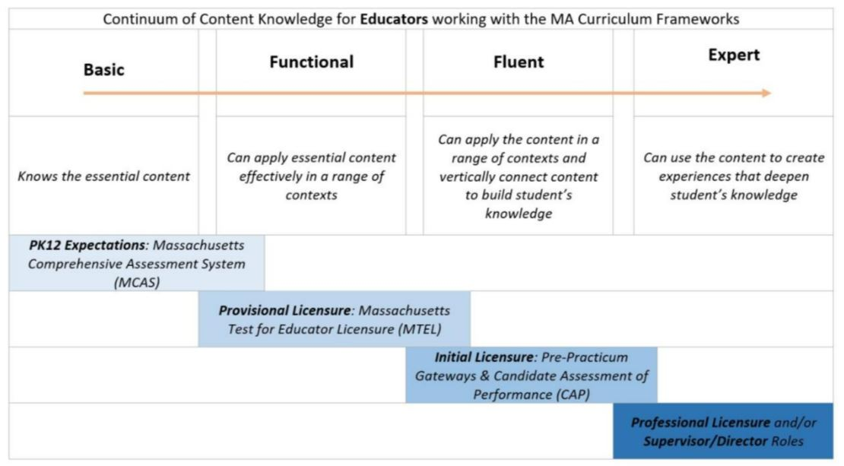

Instructions: Please list the numbers/abbreviations/titles of the sponsoring organization’s required courses where each indicator is targeted, explicit, and coherently addressed. Course identifiers should match the numbers/abbreviations/titles of submitted syllabi to support DESE’s review. Indicators should not be spread across too many courses.

Initial licensure program candidates must reach the fluent level to be endorsed. They must be able to apply content in a range of contexts and vertically connect content to build students’ knowledge. Sponsoring Organizations must have at least one course at the fluent level for each practice.

Then, briefly describe where in the syllabus the content is covered (i.e., unit name, week number, objective number).

Subject Matter Knowledge  Instructional Technology Specialist | Fluent  Initial  Licensure
Example Row | EDU 101 – Weeks 5-7
- Understand safety and security concepts, security and recovery strategies, and how to support students to deal with cyberbullying and peer pressure.
- Understand, analyze impact of, and apply technology laws and license agreements and permissions.

- Recognize, analyze, and evaluate the impact of technology, including cybercrime and assistive technology, in people's lives, commerce, and society.
- Understand what it means to be a good digital citizen.

- Select and use appropriate digital tools and varied input techniques, such as keyboards and speech recognition software, to publish multimedia artifacts or to communicate, collaborate, or exchange information.
- Use online research skills to gather relevant information from multiple digital sources, evaluate the credibility and accuracy of sources, and appropriately attribute sources.
- Understand that computing devices can take different forms and have different components.

- Select and use a variety of computing devices and digital tools to troubleshoot and solve simple problems.

- Differentiate between tasks that are best done by computing systems and humans.

- Understand the components of a network and network authentication.

- Possess basic understanding of the relationship among computing systems, networks, and services.

- Understand binary and Boolean logic and how these are implemented in computer hardware and software.

- Understand how graphics and text are represented in a computer system.

- Possess basic understanding of abstractions, computer programs (such as block-based programs), algorithms, and databases.
- Understand how information can be collected, used, and presented with computing devices or digital tools.

- Understand how to create a model and use data from a simulation.

- Understand how to decompose tasks/problems into sub-problems to plan solutions.

- Understand how to write and analyze algorithms and block-based computer programs using an iterative design process.
- Collaborate with school and district leaders, content specialists and other stakeholders to identify the appropriate uses of technology resources to support the development, communication, and implementation of plans for improving student performance under M.G.L. c. 69, § 1I.
- Coach, mode, observe, and provide feedback for teachers in the integration of in-person learning and technology to improve, facilitate, and extend learning and instruction within and beyond the classroom; continuously monitor student progress to inform tailoring of instruction; individualize learning for each student; and allow students to advance to new content based upon mastery.
- Develop strategies for achieving equitable access to digital resources outside the classroom and connecting educators, students, and parents/guardians.
- Coach teachers and instruct students in the safe, healthy, legal, and ethical uses of digital information and technologies in people's lives, commerce, and society.
- Understand the impact of technology on instructional practice, student learning, and resource allocation at the school and district level.
- Select, support, and evaluate the use of assistive and adaptive technology and accessible educational materials for students and adults.

