Subject Matter Knowledge Matrix
Reading Specialist, All

Students in Massachusetts must meet rigorous academic standards. To do so, they must have access to educators with strong content knowledge and pedagogical skills, the building blocks of effective instructional practice.

In support of this, the Subject Matter Knowledge Guidelines set forth the content knowledge expectations for educator licensure in Massachusetts. Through these expectations, the Massachusetts Department of Elementary and Secondary Education (DESE) seeks to ensure that educators entering the workforce have sufficient content knowledge in their licensure area to support students in mastering academic standards.

Educators must move beyond basic or functional knowledge to a level of fluency or expertise with the academic standards such that they can teach and support students in mastering the content. The figure below shows a steady progression, not in the amount of information one knows, but in the depth and ability to use that information for a specific purpose. The boxes below the continuum outline some assessments used to determine varying levels of content knowledge. The depth at which the knowledge and application of content knowledge must be demonstrated is dependent on the stage of development for an individual educator (i.e. Basic, Functional, Fluent, or Expert) and/or license type (Provisional, Initial, or Professional).

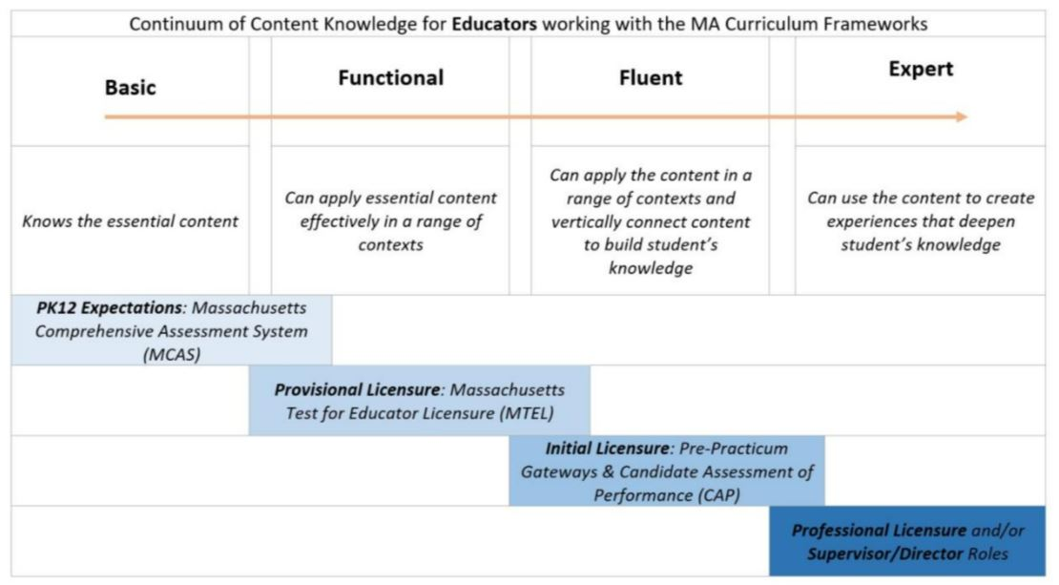

Instructions: Please list the numbers/abbreviations/titles of the sponsoring organization’s required courses where each indicator is targeted, explicit, and coherently addressed. Course identifiers should match the numbers/abbreviations/titles of submitted syllabi to support DESE’s review. Indicators should not be spread across too many courses.

Initial licensure program candidates must reach the fluent level to be endorsed. They must be able to apply content in a range of contexts and vertically connect content to build students’ knowledge. Sponsoring Organizations must have at least one course at the fluent level for each practice.

Then, briefly describe where in the syllabus the content is covered (i.e., unit name, week number, objective number).

Subject Matter Knowledge  Reading Specialist, All | Fluent  Initial  Licensure
Example Row | EDU 101 – Weeks 5-7
Reading Specialist candidates must demonstrate knowledge of the 2017 Massachusetts English Language Arts and Literacy Framework, specifically, the Guiding Principles for English Language Arts and Literacy Programs and the College and Career Readiness Anchor Standards.
- Evidenced-based concepts of language and literacy (i.e., supported by evidence presented in peer- reviewed literature).

- Components of language: phonology, syntax, semantics, morphology, discourse, pragmatics.

- Components of reading (National Reading Panel, 2000): concepts of print, phonological awareness (including phonemic awareness), phonics, word recognition, fluency, vocabulary, oral language, and comprehension.
- The reciprocal relationships among:
  - Phonemic awareness, phonological awareness, rapid automatic naming speed, decoding, word recognition, and spelling.
  - Decoding, fluency, and reading comprehension.
  - Background knowledge, vocabulary, decoding, and reading comprehension.
  - Reading comprehension and writing/composition.
  - Listening comprehension and reading comprehension.
  - Reading, writing, language, viewing, speaking, and listening in service of building knowledge.
- Brain science research related to reading, including how the brain learns to read and neurobiological impacts on reading development.
- Characteristics of diverse learner profiles, including the strengths and needs commonly demonstrated by multilingual students and students with reading disabilities including dyslexia.
- Aspects of texts to consider when evaluating and selecting curriculum and print/digital texts, including: dimensions of text complexity, alignment with grade-level topics; curriculum topics, diversity in literacy genres and forms; cultural relevance of text to students; the representation of diverse cultures and perspectives in texts.
- Aspects of learners to consider when evaluating and selecting curriculum and print/digital texts, including: text quality, a student’s current literacy strengths and needs, background knowledge, interests, stamina and motivation, and reading difficulties and disabilities.
- Elements of composition, including:
  - Craft and structure of texts in various genres and forms.
  - Composition process.
- Evidence-based practices for explicit, systematic, and cumulative instruction in the following topics, aligned to grade specific standards in the 2017 Massachusetts English Language Arts and Literacy Framework and the digital literacy standards of the 2016 Massachusetts Standards for Digital Literacy and Computer Science:
  - Concepts of print, including the alphabetic principle.
  - Phonological and phonemic awareness, including the progression of phonological awareness skills and of phoneme skill development.
  - Phonics for word recognition and spelling, including the systematic, cumulative progression of phonics concepts, syllabication, and spelling rules/generalizations.
  - Oral reading fluency at the word, sentence, and passage levels, including reading sight words with automaticity.
  - Comprehension, including vocabulary, word knowledge, text structures, summarizing, monitoring for understanding, and integration of content presented in diverse formats.
  - Vocabulary, including approaches for selecting words to teach in-depth and word learning strategies such as the use of context and word parts (morphology).
  - English grammar and usage, and conventions of English.
  - Progressions of writing skills, including: letter formation, encoding/spelling, conventions, sentence structure, paragraph formation.
  - Writing, including idea development, the organization and purpose of arguments, informative/explanatory texts, and narratives; using the writing process; and awareness of task, audience, and purpose.
  - Handwriting and developmentally appropriate keyboarding.
  - Speaking and listening skills, including skills required for collaborative conversations and presentations.
  - Digital/media literacies, with particular emphasis on online research and the evaluation of online information for accuracy and bias.
- Evidence-based practices for literacy across content areas, including disciplinary literacy.

- Purposes, attributes, strengths/limitations and administration of various types of assessments including valid, reliable and scientifically based screening and diagnostic assessments; curriculum-based measurements (CBM); and assessments used for formative, progress monitoring, and summative purposes.
- Approaches to using assessment data to identify students at risk for reading difficulties and to inform instruction.

- Structure and purpose of flexible multi-tiered systems that support academic and behavioral needs of all students in a school, including consideration of executive function, self-regulation, working memory, and metacognition.
- Collaborative leadership and adult learning theories and strategies related to:
  - Effective mentorship and coaching.
  - Planning and leading professional development.
  - Developing a school-based plan for literacy instruction and assessment that integrates evidence- based strategies.
  - The evaluation and selection of core and intervention instructional materials for literacy.

