Tips for Clearing Browser Cache

Google Chrome

1. Click the **Tools menu** (three dotted lines in the upper-right corner)
2. Select **History.**

screenshot of chrome "history" menu


3. Select **Clear Browsing Data**from the left-hand side. Check-mark **Cookies and other site data**and **Cached images and files**and select **Clear Data.**

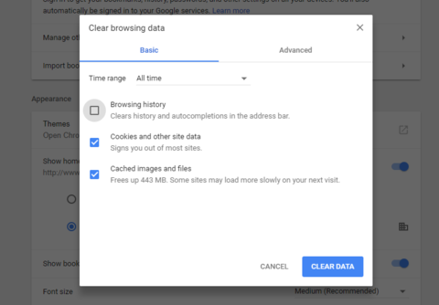

1. Close your browser (or quit the program if you're on Mac) for changes to take affect.

Mozilla Firefox

1. Click on your **tools bar**
2. Click on **preferences** (On PC, it's called settings)
3. On the menu to the right, select "**privacy**"
4. Under the history option, there is a shortcut titled "**clear your recent history**" - click that

General 
Search 
Content 
Applications 
Privacy 
Security 
o 
Sync 
•b Advanced 
Privacy 
Tracking 
s/ use Tracking Protection in Private Windows 
You can also manage your Do Not Track settings. 
History 
Firefox will: Remember history 
Learn more 
Change Block List 
Firefox will remember your browsing, download, form and search history, and keep cookies from websites 
you visit. 
You may want to lear our recent histor or remove individual cookies. 
Location Bar 
When using the location bar, suggest: 
v' History 
Bookma rks 
Open tabs 
Change preferences for search engine suggestions... 

1. Select only the top four options and hit clear now

**Note**: you can deselect the top two options if you don't want to clear browsing, download and search history.

Time range to clear: 
Clear All History 
Everything 
o 
n 
n 
n 
All selected items will be cleared. 
This action cannot be undone. 
Details 
Browsing & Download History 
Form & Search History 
Cookies 
Cache 
Active Logins 
Offline Website Data 
Site Preferences 
Cancel 
Clear Now 

1. Close out of your browser (PC) or quit the application (Mac) for changes to take effect

Safari

1. Click on **Safari** in the top left corner of the finer bar
2. Click **Preferences**

View 
Web 
Safari 
File Edit 
About Safari 
Safari Extensions.„ 
Preferences... 
Clear History.„ 
Services 
Hide Safari 
Hide Others 
Show All 
Quit Safari 
History 
SYK)pping 

1. Click the **Privacy** tab
2. Click **Manage Website Data...**

General 
Tabs 
AutoFill Passwords Search Securi 
Cookies and website data: 
Website use of location services: 
Website tracking: 
Apple Pay: 
Privacy 
otifications Extensions Advanced 
Always block 
Allow from current website only 
Allow from websites I visit 
Alwa s allow 
Manage Website Data... 
Prompt for each website once each day 
O 
Prompt for each website one time only 
O 
Deny without prompting 
Ask websites not to track me 
Allow websites to check if Apple Pay is set up 
Safari allows you to make purchases on the web 
using Apple Pay from your Apple Watch or iPhone. 

1. Click **Remove All**
2. Click **Remove Now**

000 
General Tabs 
Privacy 
AutoFill Passwords Search Security Privacy Notifications Extensions Advanced 
These webs 
may reduce 
facebo 
Cache, 
G google 
Cache, 
uiowa.edu 
Cache, Cookies 
yahoo.com 
Cache, Cookies 
e youtube.com 
Cache, Cookies, Local Storage 
Are you sure you want to remove all data 
stored by the 6 displayed websites on your 
computer? 
You can't undo this action. 
Cancel 
Remove Now 
e ytimg.com 
Cache 
ad 
Remove 
Remove All 
the data 
Done 

1. Quit Safari (don't just close it) and reopen for your changes to take place.

Internet Explorer

1. Click on the **Settings menu** in the upper-right corner
2. Click **Internet options**

x 
Print 
File 
site 
Zoom (100%) 
pport 
Add site to Apps 
View downloads 
Manage add- ons 
F12 Developer Tools 
Go to pinned sites 
Compatibility View settings 
Internet options 
o 
Ctrl*J 

1. Under the General tab on the upper-left hand side, scroll down to Browsing history.
2. Select

puue•'•pv SURJ50Jd 芒 凵 LeAIJd leæua9 
· 2 ; , , pe 乇 2 , & “ 32 d , u0q 2 01 
• pe 山 sa6edqaM 
LJO 艹 一 山 45q 一 SC) 
1 28 5 「 MO “ q 2 一 囗 
& au.JOL4 1-四S@ 
5u0 一 1d0 
abed aunH 

1. Check the "**Temporary Internet files and website files**," "**Cookies and website data**," "**History**," and "**Download History**" boxes
2. Click **Delete**

Delete Browsing History 
Preserve Favorites website data 
Keep cookies and temporary Internet files that enable your favorite 
websites to retain 'references and diSay faster. 
emporary Internet Nes and website files 
Copies of webpages, mages, and meda that are saved for faster 
00kies and website data 
Files or databases stored on your computer by websites to save 
ences or irrvove website performance. 
of websites you have viSted. 
of Nes you have downloaded. 
Form data 
Saved information hat you have typed into forms. 
Passwords 
Saved passwcrds that automabcaly filed in when you Sigl 
to e website you've previously vlsited, 
Tracking Protectk»n, ActiveX FiRering and Do Not T rack 
A list of webstes exduded from filtering, data used by Tradang 
Protection to detect where sites might automabcally be sharing details 
üut your Viet, and exceptions to Do Not Tra& requests. 
About deletjnq browsinq historv 
Delete 

1. Close out of Internet Explorer and reopen it for changes to take affect.

Microsoft Edge

1. Click the **Tools** menu (three dotted lines in the upper-right corner)
2. Then **Settings**

New window 
New lnPrivate window 
Zcam 
Cast media to device 
Find on page 
Print 
Pin this page to Start 
F12 Developer Tools 
Open with Internet Explorer 
Send feedback 
Settings 

1. Scroll down until you see "Browsing data"
2. Click **Choose what to clear**

SETTINGS 
Choose a theme 
Light 
Open with 
@ Start page 
C) New tab page 
O Previous pages 
O A specific page or pages 
Open new tabs with 
Top sites 
Favorites settings 
View favorites setti 
Clear browsing data 
Choose what to clear 

1. Select the top four boxes
2. Click **clear**

Clear browsing data 
Browsing history 
Cookies and saved website data 
Cached data and files 
Download history 
Form data 
Passwords 
Show more 
Clear 
Clear Bing search history 
Learn more 

1. Close out of Microsoft Edge completely for changes to take affect

Safari for iOS

1.  Go to Settings

2.  Scroll down to the option for Safari

3.  Scroll down and select Clear Cookies and Data

Verizon 
< Settings 
Do Not Track 
11:26 AM 
Safari 
Block Cookies 
From third parties... > 
Smart Search Field 
Fraudulent Website Warning 
More about Safari and privacy... 
Clear History 
Clear Cookies and Data 
READING UST 
Use Cellular Data 
use cellular network to save Reading List 
items from iCloud for offline reading. 

4.  A pop-up will come up verifying that you want to clear the Cookies and Data. Select Clear.

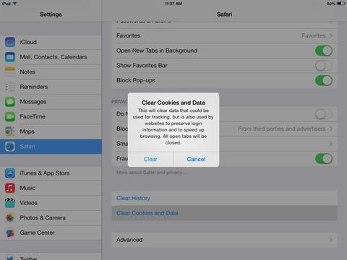

5.  The button for Clear Cookies and Data should turn gray.

Chrome for iOS

1. Open Google Chrome on your iOS.

2. Click on the menu toolbar in the top right corner.

ЛНП 
арооэ 

3. Select settings.

Search 
Search Or 
8:32 AM 
New Tab 
New Incognito Tab 
Recent Tabs 
History 
Report an Issue 
Find in Pagen 
Request Desktop Site 
Settings 

4. Under advanced, select privacy.

8:32 AM 
Settings 
to C r. 
Get mslwy. paßwords, 
on all your devices 
Search Eng 
Google 
Autofd I 
Gwgle Apps 
ChtMne 

5. Select Clear Browsing Data.

Search w, 
privacy 
Devices 
Web S 
Data 
8:32 AM 
C'. my web to 
You may disaü 
services. Leam 
clear Browsing Data 

Search w, 
privacy 
Devices 
Web S 
Data 
8:32 AM 
C'. my web to 
You may disaü 
services. Leam 
clear Browsing Data 

6. Select the top three options - browsing history, cookies and site data, and cached images and files.

7. Once you've chosen the settings you want to clear, select Clear Browsing Data in red.

Search E, 
8:32 AM 
Clear Browsing Data 
Browsing H istory 
Site 
Fees 
Clear Browsing O ata 
Saved site settings will not be deleted may 
o 

**Keyboard Shortcut for Most Browsers**

IMPORTANT: Be sure and close/quit the browser and restart it after clearing the cookies & cache.

**Chrome:**

Quick hard refresh can be done by using the following short cut keys

**Windows/Linux:**

1. Hold down Ctrl and click the Reload button.
2. Or, Hold down Ctrl and press F5.
3. just open the Chrome Dev Tools by pressing F12. Once the chrome dev tools are open, just right click on the refresh button and a menu will drop down. This menu gives you the option of doing a hard refresh, or even clearing the cache and do a hard refresh automatically.

[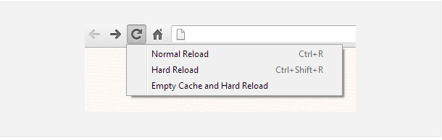](https://www.getfilecloud.com/blog/wp-content/uploads/2015/03/Hardrefresh-chrome.png)

**Mac:**

1. Hold ⇧ Shift and click the Reload button.
2. Or, hold down ⌘ Cmd and ⇧ Shift key and then press R.

**Mozilla Firefox and Related Browsers:**

**Windows/Linux:**

1. Hold the Ctrl key and press the F5 key.
2. Or, hold down Ctrl and ⇧ Shift and then press R.

**Mac:**

1. Hold down the ⇧ Shift and click the Reload button.
2. Or, hold down ⌘ Cmd and ⇧ Shift and then press R.

**Internet Explorer:**

1. Hold the Ctrl key and press the F5 key.
2. Or, hold the Ctrl key and click the Refresh button