Log in to Edwin Analytics
You need a username and password for the ESE Security Portal and an Edwin Analytics security role to log in to Edwin Analytics. (Note: In most cases, your login to access Edwin in the security portal is different from your ELAR login for the security portal). If you have a Security Portal login, skip to Step 6 on the next page. If you have a username and password for the Security Portal but do not have access to Edwin Analytics, find your Edwin Analytics contact and ask that person about your district’s policy for granting access to Edwin Analytics.
As an alternate to the link above, Steps 1 – 4 below walks through how to get to the list of Edwin Analytics Contacts in K-12 districts.
- Go to the ESE website at http://www.doe.mass.edu and locate School Profiles in the upper right corner  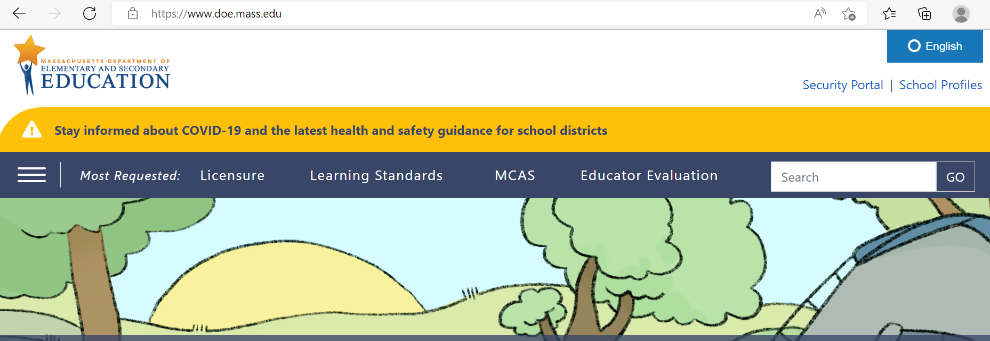 | - Select People Search on the right hand side.  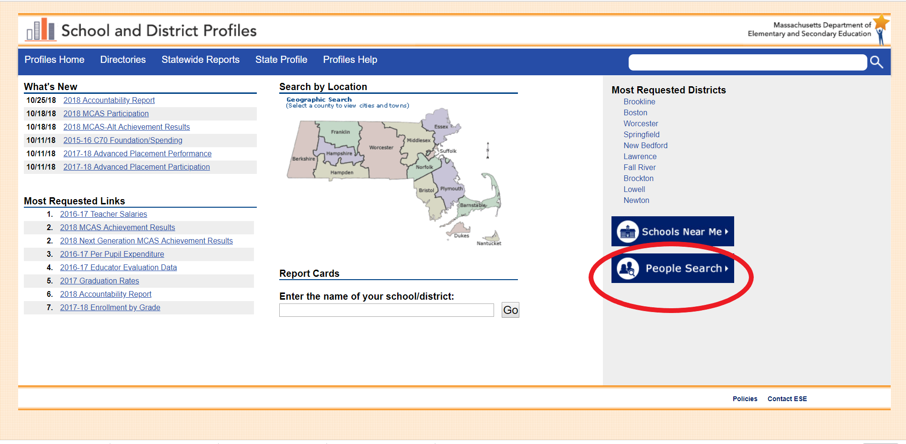
- Click the down arrow beside the Function field, select Edwin Analytics Contact, and click Get Results.  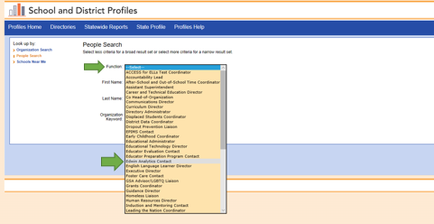 | - Locate your district in the Search Results list provided. Your Edwin Analytics Contact person is listed with your district’s information.  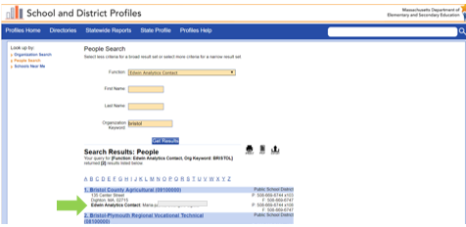

- In the event that your district does not list an Edwin Analytics Contact person, you will need to contact your local Directory Administrator (DA) to get set up. A list of Directory Administrators can be found directly at http://www.doe.mass.edu/infoservices/data/diradmin/list.aspx. DAs for collaboratives and approved private special education schools are listed here too. You may also use People Search and select Directory Administrator to access this list.

- Once you have a login ID and a security role, open a new browser session and go to the ESE website at http://www.doe.mass.edu. You can select security portal in top right corner.

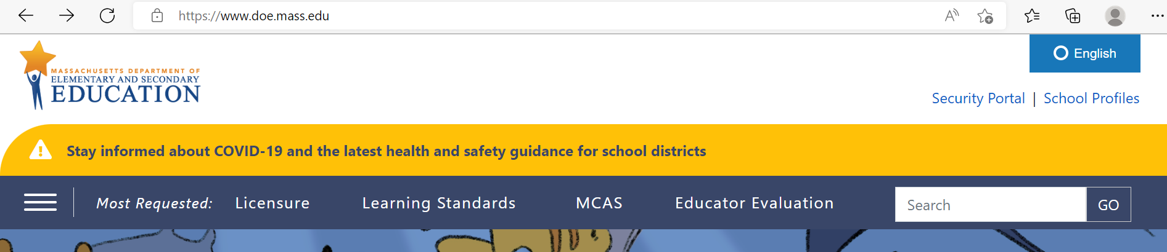

- When the Education Security Portal (ESP) Login page displays, enter your Username and Password and click Login. The ESP was updated in August 2023; if users logging in after the upgrade are having difficulty, try to reset your password using the Forgot Password link on the ESP Login page. If you are unsuccessful, please contact your local Directory Administrator or the ESP help desk at 781-338-MESP(6377) for assistance. You may need to reactivate your account. Additional guidance can be found at ESP Online Help for Users.

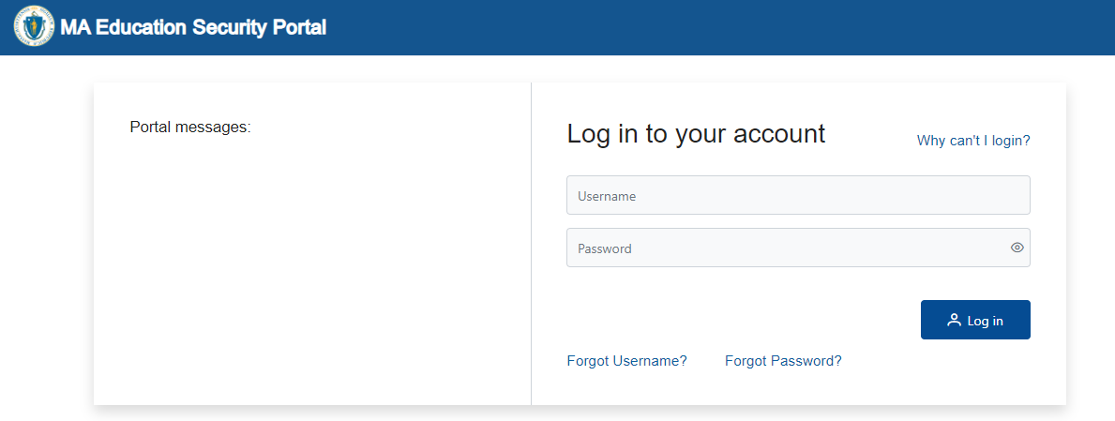

- You will be asked to confirm your email for the multi-factor authentication process. You will then receive a code to enter

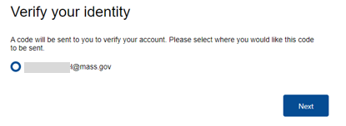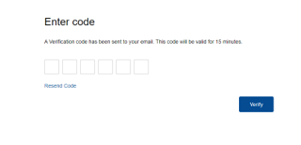

- The When the ESE Security Portal Welcome page displays, look for the Edwin Analytics link under Edwin.
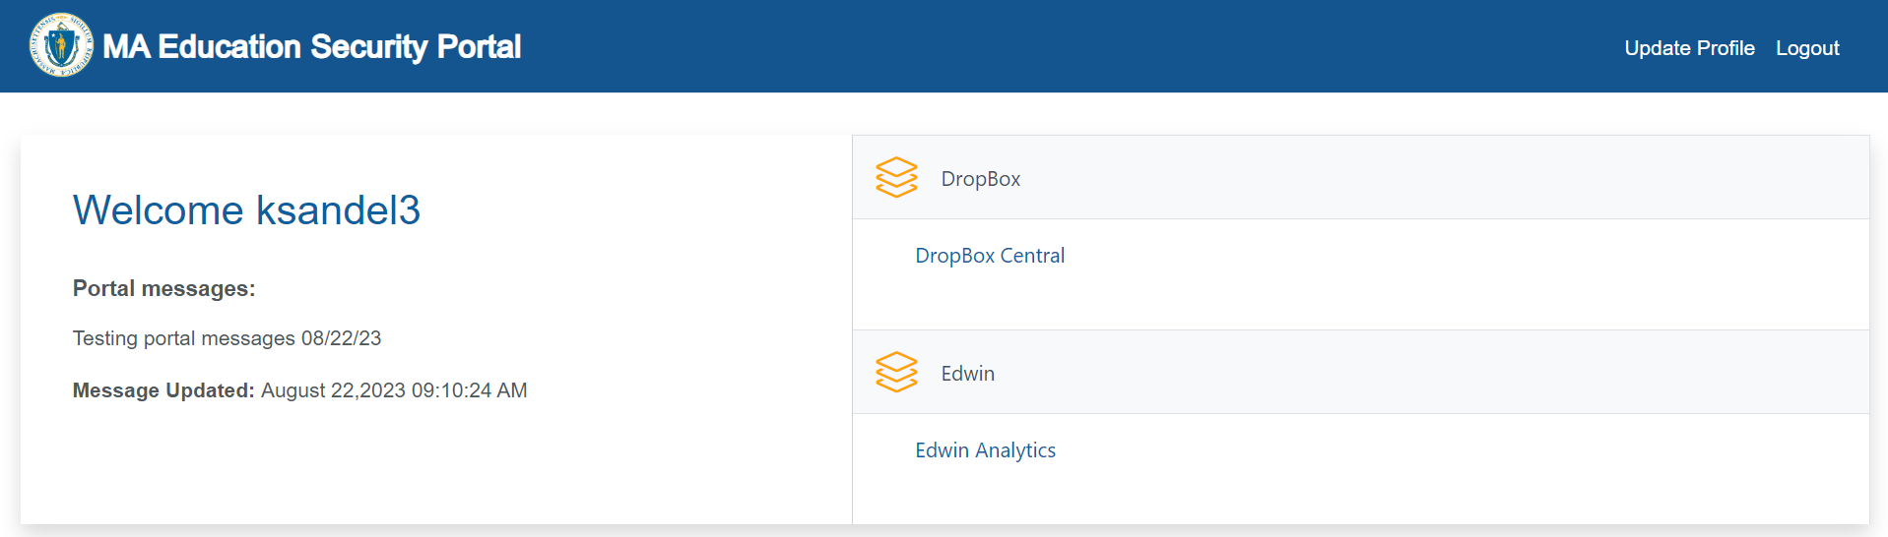

IMPORTANT: If you do not see the link for Edwin Analytics, contact your district’s Directory Administrator to confirm that the role was assigned. If there is still a problem, your Directory Administrator should select go to the Help Desk web form and select Security Portal: Access/Password and include your user ID to request assistance.

Additional Help and Contact Information
For technical support issues, contact the Edwin Analytics Help Desk

