Edwin Analytics: Finance

FN214 District Expenditures Comparison

Provides information on a district or multiple districts’ expenditures (Schedule 1 End of the Year Report data), alongside teacher staffing information, student population characteristics, and MCAS results for the purpose of single district analysis or multi-district benchmarking and comparison.
Includes data on  District expenditures (Schedule 1, EOY)  - School committee expenditures by object codes  - Other fund expenditures by fund group  - Total function expenditures  - Per student expenditures  - Total in-district operating expenditures  - % of in-district operating expenditures  Staffing (EPIMS)  - Teacher FTEs  Student population (SIMS)  - # enrolled  - % low income, ELL, SWD  ELA, Math & Science MCAS  - # tested  - % advanced, proficient, needs improvement, warning/failing  - # Student Growth Percentile, SGP | Allows filtering by  District  District size  Student demographics (% low income, ELL, SWD)  Expenditures per student  Local wealth (combined effort yield – CEY – as a % of foundation budget)
Report Footnotes
- Includes districts for the selected year which meet all the selected parameters.
- Expenditures information reflects the most recent EOYR information for the selected year.
- Staffing reports cumulative FTEs for individuals who were active in October in the selected year. Teachers include all teaching classifications - teachers, co teachers, virtual teachers, and teachers-support content instruction.
- "Per Student Expenditures", "Total In-District Operating Expenditures", and "% of In-District Operating Expenditures" are only displayed for in-district expenditure functions.
- "In District Operating Expenditures" is defined as the total spending from Schedule 1 from all funds and functions, excluding functions in the 6000, 7000, 8000, 9000 series, indirect cost transfers (5990), short term interest BANs (5450), and all out of district transportation costs.
- The "Functional Area Total" within "Total In-District Functions" excludes out of district transportation expenditures from Schedule 7. The in-district transportation expenditures are grouped within the "No Objects Defined" objects code.
- Student demographics are based on the October collection for the selected year. Low Income indicates students eligible for either free or reduced lunch; ELL (English Language Learner) indicates students who do not speak English or whose native language is not English, and who are not currently able to perform ordinary classroom work; and SWD (student with disabilities) indicates students receiving special education services.
- MCAS results are the officially reported results for the selected year.
- Information for enrollments of fewer than 6, performance results fewer than 10, and growth results fewer than 20 are suppressed. Suppressed values are displayed as dashes (-).

- Select the report. Report will open in a new tab.

Figure 1
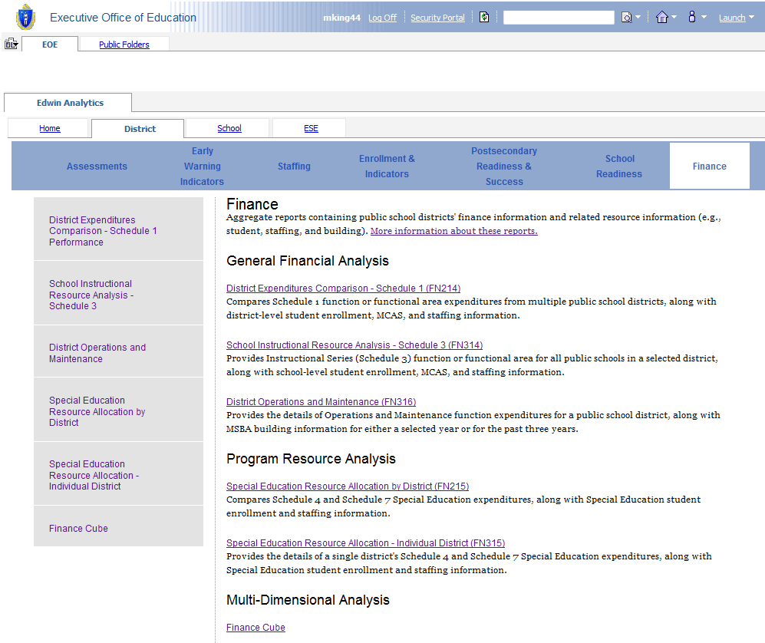

- Prompt page will launch. Select the desired parameters.
  - Fiscal year, functional area, function code, and “measures to include” are all required fields so those selections must be made to run the report. Note: You must select a functional area and a function code. To see the entire functional area, choose “Functional Area Total” in the function code drop-down menu.
  - Selecting districts is optional. “District” defaults to the list of all active public districts in the chosen fiscal year. The number of returned districts can be pared down by either selecting individual districts from the list or by selecting one or more optional filters (district size, %low income, %ELL, %SWD, expenditure per student and/or current CEY%). Note: When applying one of the filters, you may enter an upper and lower bound, an upper bound only, or a lower bound only. Entering an upper bound will return all districts that are less than that number, and entering a lower bound will return all districts that are greater than that number.
Figure 2
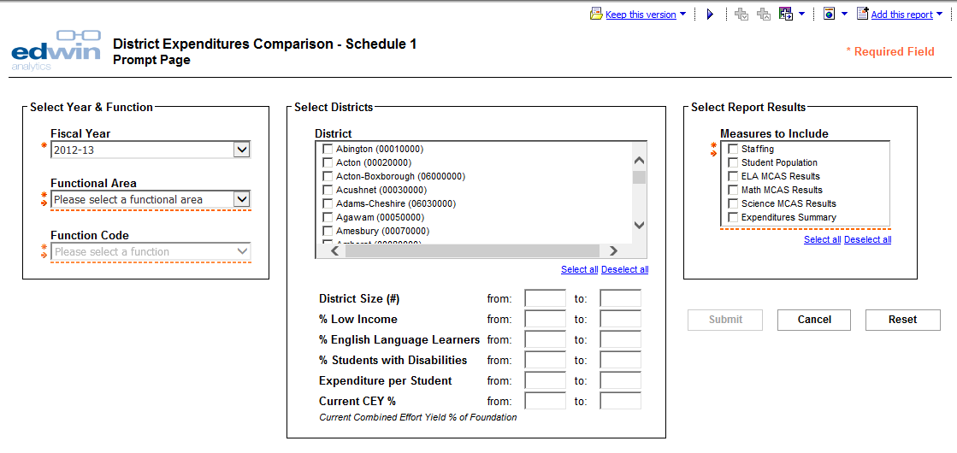

Figure 3
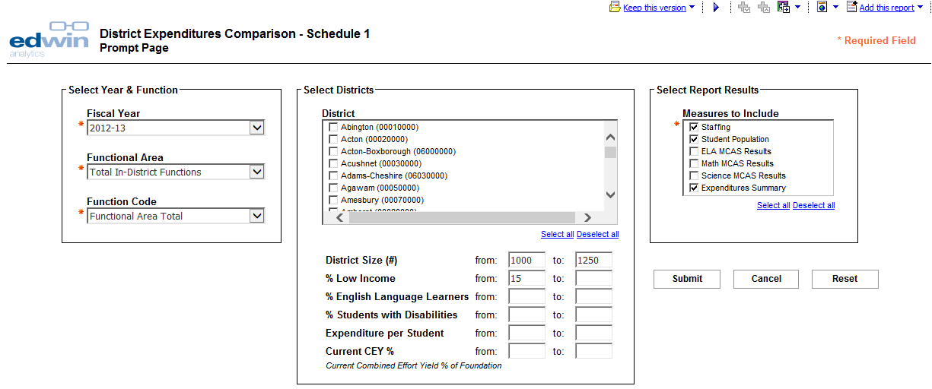
- This report returns a list of district that meets the specified criteria. From the report page you may:
  - Select a different functional area and/or function code.
  - Choose which measures (sections of the displayed report) to include. To re-run the report with these selections, click submit. To return to the prompt page, select the play button in the upper right corner.
Figure 4
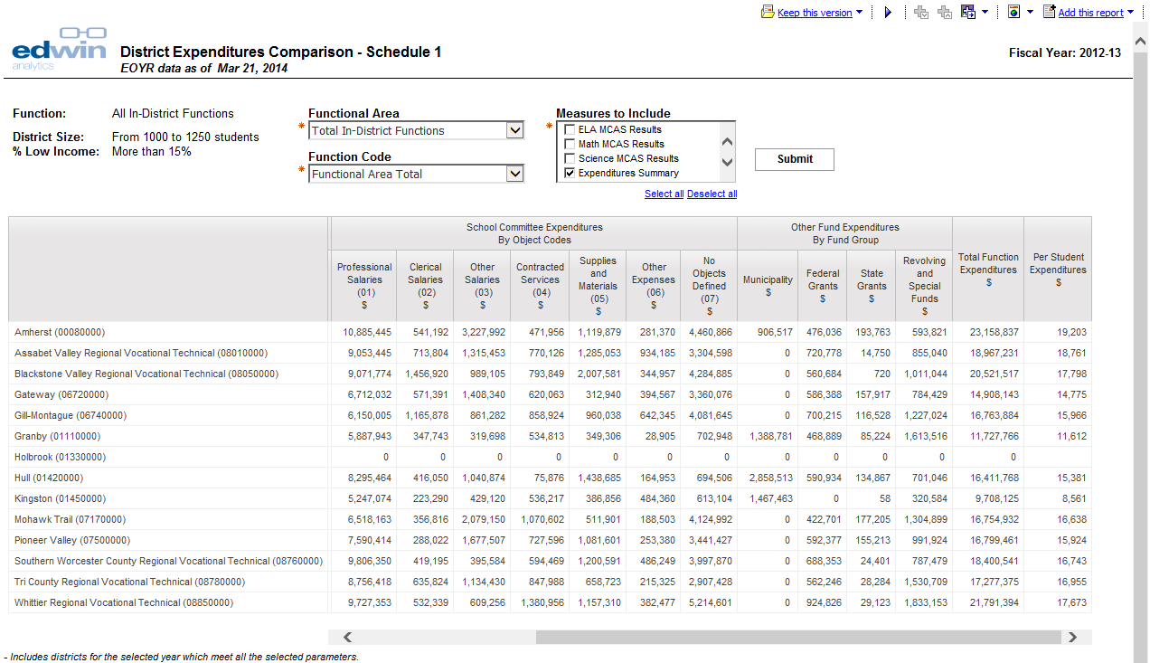

- From this report page, you may drill through to FN314 – School Instructional Resource Analysis – Schedule 3 by clicking one of the displayed districts. This capability is only available for aggregate functions/functions in the Instruction (2000) series. Districts will be highlighted in blue.

Figure 5
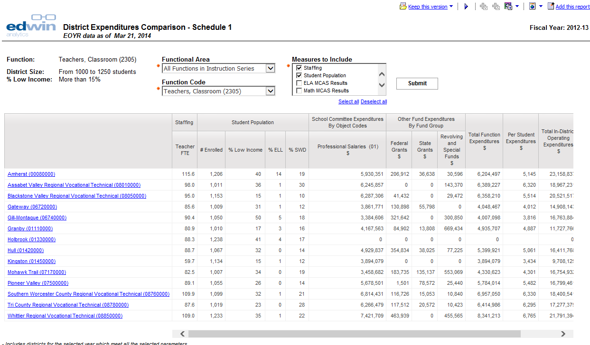

- To export this report to another format (i.e., PDF, XML, Excel or HTML) select the output format icon in the upper right corner.

Figure 6
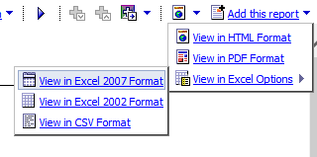

FN314 School Instructional Resource Analysis

Provides information on a school level instructional expenditures (Schedule 3 End of the Year Report data), alongside staffing information, student population characteristics, MCAS results, and classroom size information for the purpose of single district analysis.
Includes data on  District/school instructional expenditures (Schedule 3, 2000 series, EOY)  - School committee expenditures by object code  - Other fund expenditures by fund group  - Total function expenditures  - Per student expenditures  Staffing (EPIMS)  - Teacher FTEs, by age, by years from 1st license  - Instructional coach FTEs, instructional support FTEs, SPED instructional support FTEs, paraprofessional FTEs  Student population (SIMS)  - # enrolled  - % low income, ELL, SWD  Class size  ELA, Math & Science MCAS  - # tested  - % advanced, proficient, needs improvement, warning/failing  - # Student Growth Percentile, SGP | Allows filtering by  District  School level type (elementary, middle, secondary)
Report Footnotes
- Includes the selected district's expenditures information as of the most recent EOYR information for the selected year.
- Staffing reports cumulative FTEs for individuals who were active in October in the selected year. Teachers include all teaching classifications - teachers, co teachers, virtual teachers, and teachers-support content instruction.
- Expenditures information reflects the most recent EOYR information for the selected year.
- "District-Wide" includes staff assigned at the district level and expenditures reported at the district-level.
- Student demographics are based on the October collection for the selected year. Low Income indicates students eligible for either free or reduced lunch; ELL (English Language Learner) indicates students who do not speak English or whose native language is not English, and who are not currently able to perform ordinary classroom work; and SWD (student with disabilities) indicates students receiving special education services.
- MCAS results are the officially reported results for the selected year.
- Information for enrollments of fewer than 6, performance results fewer than 10, and growth results fewer than 20 are suppressed. Suppressed values are displayed as dashes (-).

- Select the report. Report will open in a new tab.
Figure 7
- Prompt page will launch. Select the desired parameters.
  - Fiscal year, functional area, function code, district and “measures to include” are all required fields and therefore selections must be made to run the report. This report is can display only one district at a time. Note: You must select a functional area, and a function code. To see the entire functional area, choose “Functional Area Total” in the function code drop-down menu.
  - School level type is optional. This parameter defaults to the list of all schools in the district in the chosen fiscal year.
Figure 8
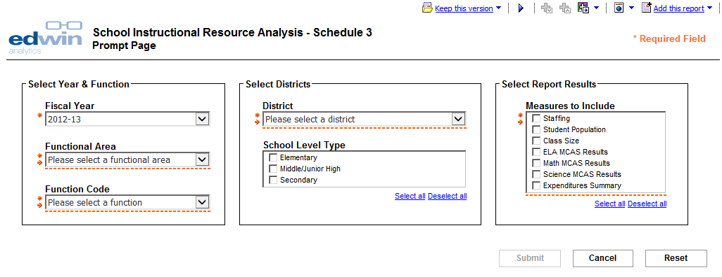
- FN314 returns your selected district. From the report page you may:
- Select a different district, functional area and/or function code.
- Choose which measures (sections of the displayed report) and/or which school level type to include. To re-run the report with these selections, click submit. To return to the prompt page, select the play button in the upper corner.

Figure 9
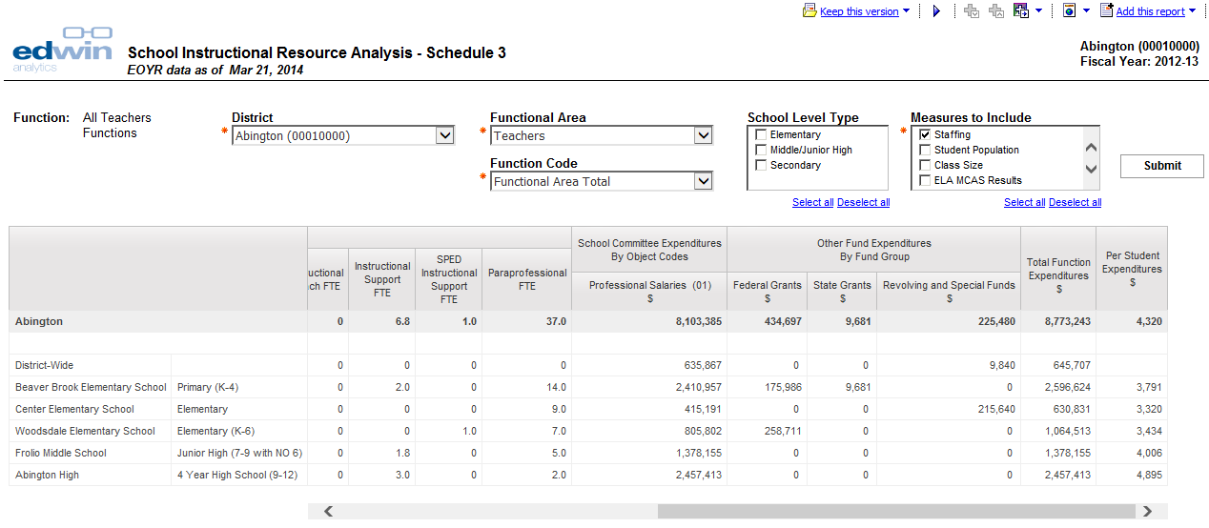

- To export this report to another format (i.e. PDF, XML, Excel or HTML) select the output format icon in the upper right corner.
Figure 10

FN316 District Operations and Maintenance

Provides information on a district’s operations and maintenance expenditures (Schedule 1 End of Year Report data), alongside school building and student enrollment information for the purpose of single district analysis over one or three years.
Includes data on  District operations & maintenance expenditures (Schedule 1, 4000 series, EOY)  - School committee expenditures by object code  - Other fund expenditures by fund group  - Total ops & maintenance expenditures  - Per student expenditures  - Per square footage expenditures  Enrollment (SIMS) - # students  School buildings  - Grade range  - # students  - Year built/last renovation year  - Systems condition  - Surveyed as of date | Allows filtering by  District  1-year snapshot or 3-year trend
Report Footnotes
- Includes the selected district's expenditures information as of the most recent EOYR information for the selected year or the most recent three years.
- Building information reflects the most recent MSBA survey information.
- Building condition is defined as: Good = building is in good condition with few or no building systems needing attention; Generally Good = building is in generally good condition with a few building systems that may need some attention; Fair to Poor = building is in fair to poor condition with some building systems needing repair or replacement; Poor = building is in poor condition, many building systems require attention, and further study is required to determine the extent of renovations or potential replacement.

- Select the report. Report will open in a new tab.

Figure 11

- Select report type. This report can either be displayed as a 1-year snapshot, or as a 3-year trend.
  - When a single year is chosen, select a fiscal year, a district, and which report sections to display (operations and plant maintenance, and building details.)
  - When a three year trend is chosen, select a year sort order (ascending or descending), a district and which report sections to display.

Figure 12
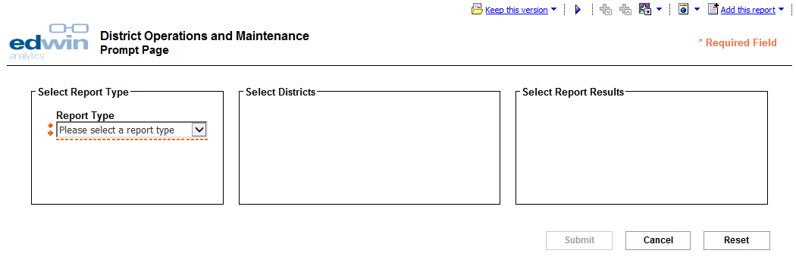
Figure 13
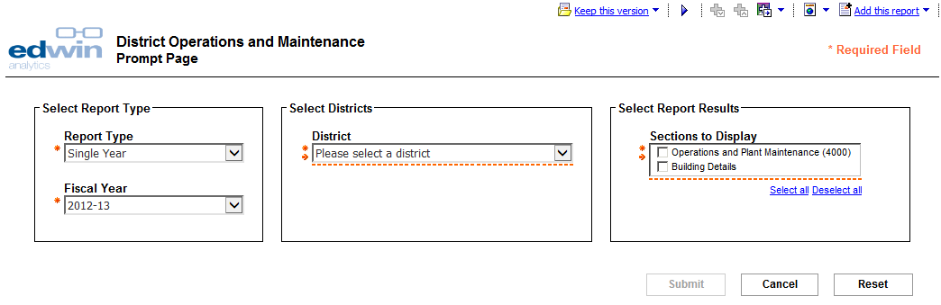
Figure 14
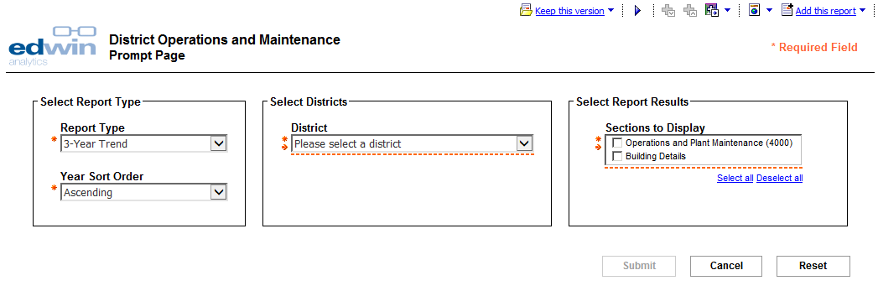
- The 1-year snapshot report returns your selected district for the selected year. From the report page you may change the district or sections to display. This report has three sections.
  - A district overview, including student count, operations and maintenance expenditures, and school building information.
  - Operations and maintenance expenditure details, including spending by object code and fund, per student and per square foot expenditures.
  - Details for school buildings from the last MSBA school building survey.
Figure 15
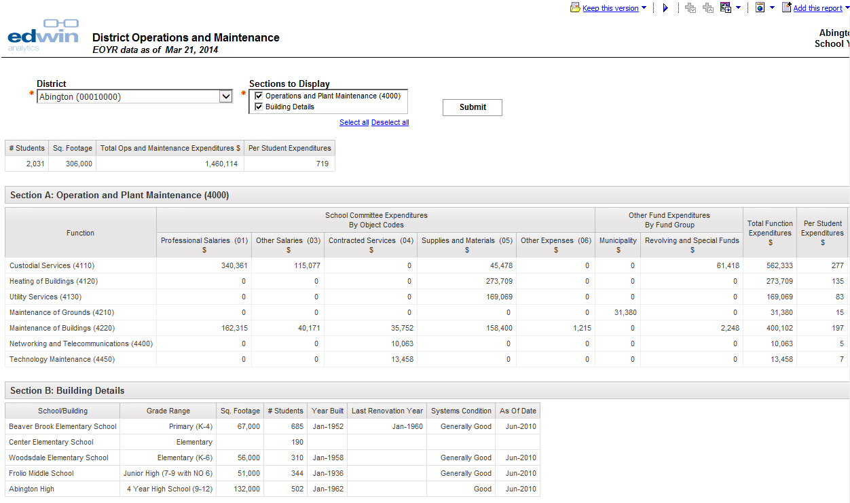

- The 3-year trend report returns your selected district for the last three years. Like the 1-year snapshot, this report has the same three sections. From the report page you may change the district or sections to display. To return to the prompt page, select the play button in the upper corner.
Figure 16
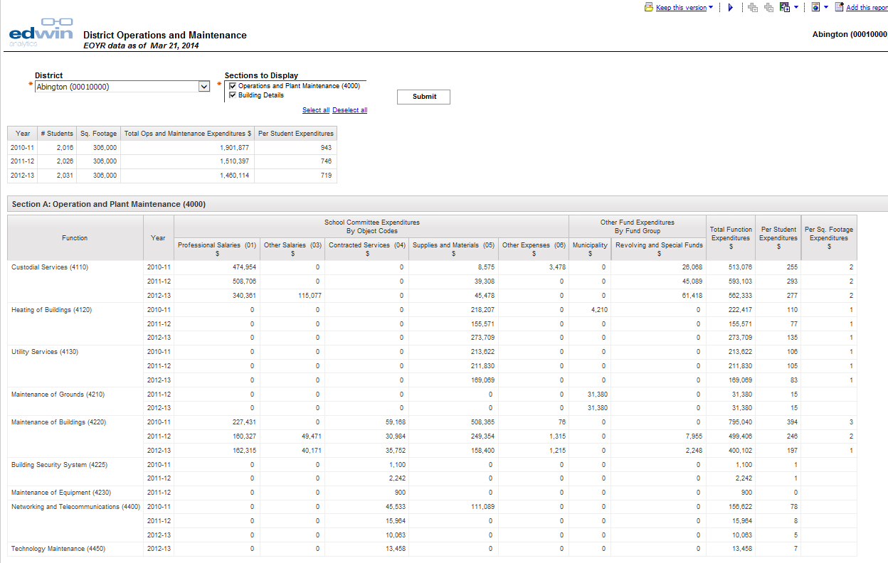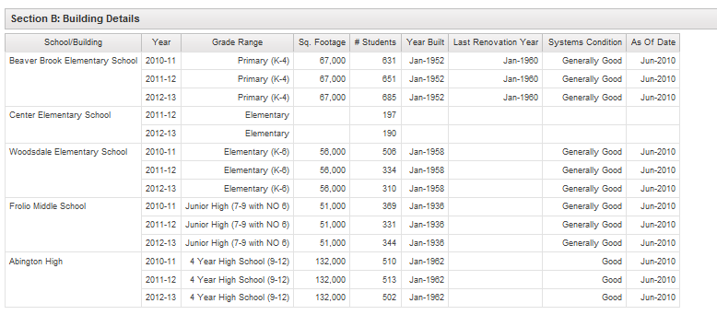
- To export this report to another format (i.e. PDF, XML, Excel or HTML) select the output format icon in the upper right corner.
Figure 17

FN215 Special Education Resource Allocation by District

Provides information on special education student enrollment, staffing, and expenditures (Schedule 4 and 7 End of Year Report data) for the purpose of single district analysis or multi-district benchmarking and comparison.
Includes data on  District special education expenditures (Schedules 4 and 7, EOY)  - In-district expenditures (teacher and para salaries paid from school committee and Circuit Breaker), instructional expenditures, transportation expenditures  - Out of district expenditures (payments to other districts, transportation expenditures, % of SPED expenditures  - Other SPED expenditures (non-public health services, grants & revolving, total spending, and % total operating expenditures)  Students with disabilities (SWD) enrollment (SIMS)  - Total students  - Total SWD students, % SWD students  - In-district and out-of-district SWD students, # and level of need  - % of students by placement, in- and out-of-district  Special education staffing (EPIMS)  - Teacher and paraprofessional FTEs  - Student to staff ratios | Allows filtering by  District  District size  % SWD
Report Footnotes
- Includes districts for the selected year which meet all the selected parameters.
- Expenditures information reflects the most recent EOYR information for the selected year.
- Staffing reports cumulative FTEs for individuals who were active in October in the selected year. Teachers include all teaching classifications - teachers, co teachers, virtual teachers, and teachers-support content instruction.
- SWD (student with disabilities) information is based on the October collection for the selected year.
- Special Education placement is an indication of the educational environment of a student with disabilities at the specific time of reporting (October 1st); Full Inclusion indicates special education services outside the general education classroom less than 21% of the time, Partial Inclusion indicates special education services outside the general education classroom 21% to 60% of the time, and Substantially Separate indicates special education services outside the general education classroom more than 60% of the time.
- Tuitioned students that the district is no longer accountable for in terms of performance are not submitted by the home district, and are therefore not included any student counts in the report.
- Salaries expenditures are calculated from the Schedule 1 School Committee fund under the Special Education program as well as from the Circuit Breaker fund.
- Instructional Services (2000), Payments to Other Districts (9000), Non-Public Health Services (6800), and Grants and Revolving Funds is the total expenditures in each category from Schedule 4.
- In and Out of District Transportation are the total expenditures in each category from the Special Education section of Schedule 7, excluding Depreciation.
- Percent of Total Operating Expenditures is calculated as the percentage of the Total Special Education Expenditures out of the district’s total operating expenditures. Total Operating Expenditures is defined as the total spending from Schedule 1 from all funds and functions excluding functions in the 6000, 7000, and 8000 series, indirect cost transfers (5990), and short term interest BANs (5450).
- Information for enrollments of fewer than 6 is suppressed. Suppressed values are displayed as dashes (-).

- Select the report. Report will open in a new tab.

Figure 18

- Prompt page will launch. Select the desired parameters.
- Fiscal year is a required field and must be selected to run the report.
- Selecting districts is optional. District defaults to the list of all active public districts in the chosen fiscal year. The number of returned districts can be pared down by either selecting individual districts from the list or by selecting one or more optional filters (district size, %SWD).
- You may opt to show the percent of students by special education placements. The report defaults to “No.”
Figure 19
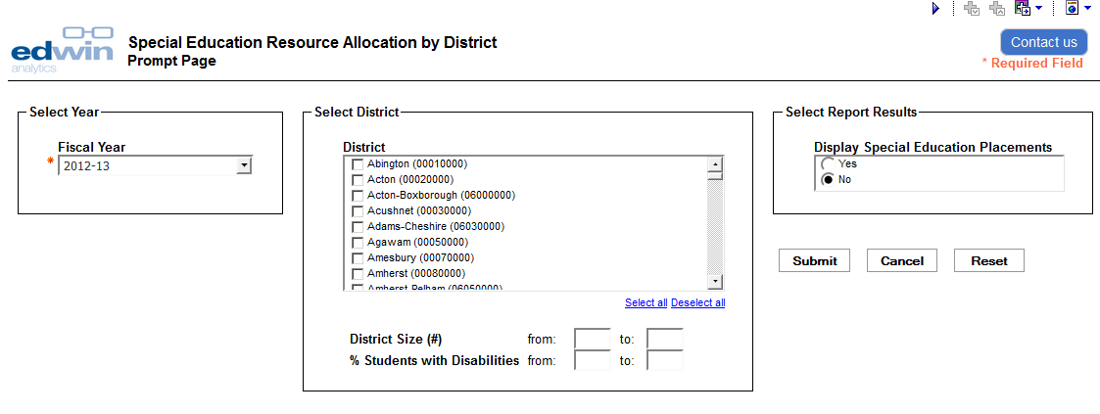
- FN215 returns your selected districts. From the report page you may select a particular district, and/or change the optional parameters. To re-run the report with these selections, click submit. To return to the prompt page, select the play button in the upper corner.
- From this report page, you may drill through to FN315 – Special Education Resource Allocation – 1 District by clicking one of the displayed districts.
Figure 20
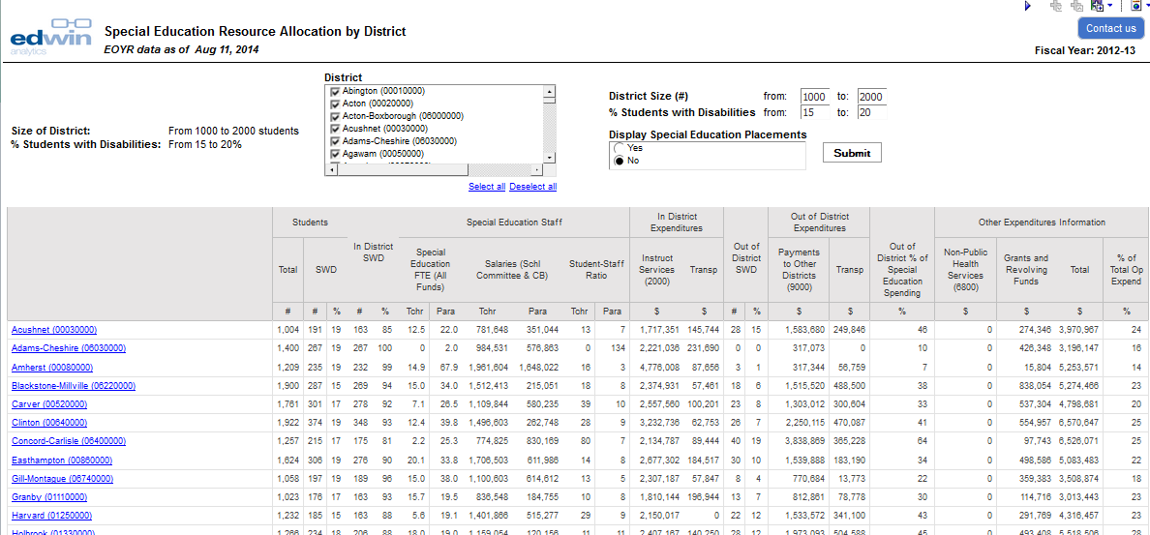
- To export this report to another format (i.e. PDF, XML, Excel or HTML) select the output format icon in the upper right corner.
Figure 21

FN315 Special Education Resource Allocation – Individual District

Provides information on a district’s SWD population, special education teachers, special education salaries, and special education expenditures (Schedule 4 and 7 End of Year Report data), including school level drilldown, for the purpose of single district analysis.
Includes data on  District/school special education expenditures (Schedules 1 and 3)  - Teacher and paraprofessional salaries (school committee and Circuit Breaker)  District special education expenditures (Schedules 4 and 7, EOY)  - Expenditures by placement  - Expenditures per student (by placement and total)  Students with disabilities (SWD) enrollment (SIMS), by placement  Special education staffing (EPIMS) by district and schools, including FTEs and student-staff ratios | Allows filtering by  District
Report Footnotes
- Includes the selected district’s expenditures information as of the most recent EOYR information for the selected year.
- Staffing reports cumulative FTEs for individuals who were active in October in the selected year. Teachers include all teaching classifications - teachers, co teachers, virtual teachers, and teachers-support content instruction.
- SWD (student with disabilities) information is based on the October collection for the selected year.
- Special Education placement is an indication of the educational environment of a student with disabilities at the specific time of reporting (October 1st); Full Inclusion indicates special education services outside the general education classroom less than 21% of the time, Partial Inclusion indicates special education services outside the general education classroom 21% to 60% of the time, and Substantially Separate indicates special education services outside the general education classroom more than 60% of the time.
- Tuitioned students that the district is no longer accountable for in terms of performance are not submitted by the home district, and are therefore not included any student counts in the report.
- Salaries expenditures are calculated from the Schedule 3 School Committee fund under the Special Education program as well as from the Circuit Breaker fund.
- In and Out of District Transportation are the total expenditures in each category from the Special Education section of Schedule 7, excluding Depreciation.
- Special Education Expenditures are the expenditures in each Special Education type from Schedule 4.
- Information for enrollments of fewer than 6 is suppressed. Suppressed values are displayed as dashes (-).

- Select the report. Report will open in a new tab.
Figure 22
- Prompt page will launch. Select the desired parameters. Fiscal year, district, “show school details”, and “sections to display” are all required fields and therefore those selections must be made to run the report. This report is can display only one district at a time.

Figure 23
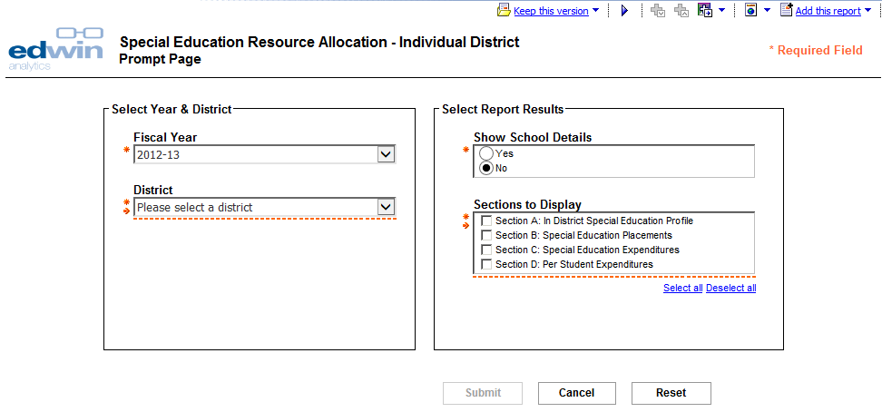

- FN315 returns your selected district. From the report page you may:
- Select a different district, show or hide school details, and/or select which districts to display. To re-run the report with these selections, click submit. To return to the prompt page, select the play button in the upper corner.

Figure 24
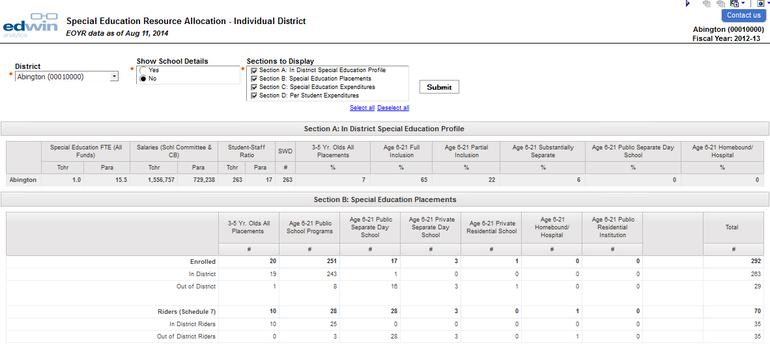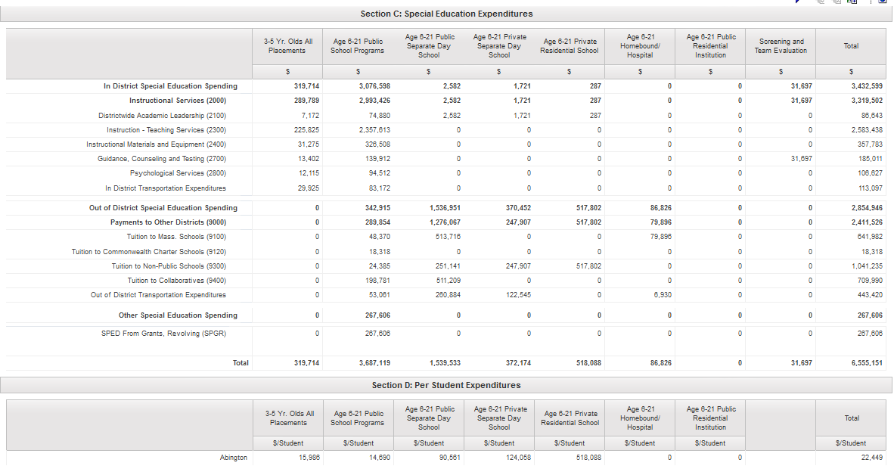

- To export this report to another format (i.e. PDF, XML, Excel or HTML) select the output format icon in the upper right corner.
Figure 25

For more information on these and other resources in Edwin,
visit www.doe.mass.edu/edwin, email edwin@doe.mass.edu, or follow us on Twitter @Edwin_DESE.

Per student expenditures used in this report is not the same as per pupil expenditures published on the ESE website. Per student expenditures uses October 1 SIMS headcount. Per pupil expenditures uses student FTEs based on year-end SIMS.
Per square footage calculations are only made where applicable.

