Accessing and Using The Student Learning Experience (SLE) Report

The Summary Report (SE321)
Step | Instructions | What’s on Screen
Entering Edwin | Only those with Edwin administrator logins can access the SLE Report, and can only see data for their own district.  Users can access the ESE Security Portal at https://gateway.edu.state.ma.us/, or you can click this link to directly access the SLE Summary Report.  If you do not know your login information, please contact your district’s directory administrator. | 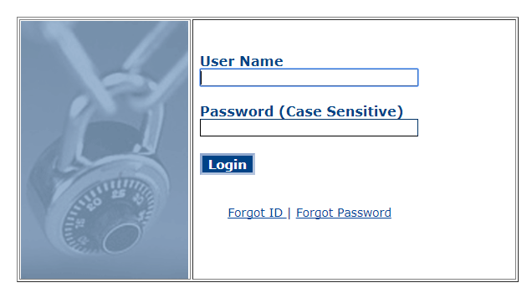
Accessing the report | From the Edwin homepage, you can access the Summary Report by clicking on “Search” on the left panel and then typing in “SE321” into the search bar. Click on “SE321 Student Learning Experience Summary Report.”  From the Edwin homepage, you can also access the report by clicking on “Edwin Analytics” on the left panel (the folder with the star), followed by “Educators,” followed by “Equitable Access,” and finally clicking on “SE321 Student Learning Experience Summary Report.” | 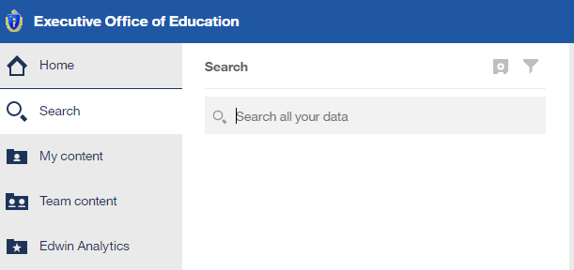  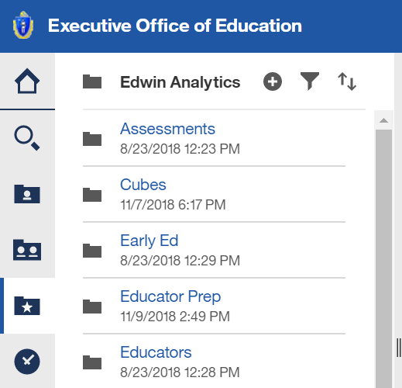
Filter Selection | The top portion of the report asks you to select from various filters.  Report View: You can select if you would like to view district or school-level results. Note: the report includes multiple pages, and if you choose “District,” you can still see a school-by-school breakdown on page 4 of the report.  School Year: The selected school year will determine the cohort of students being used. For example, if you select  “2018-19,” this means the students represented in the report will be those enrolled in the district in October 2018.  Years of History to Include: You may select 1, 3 or 5 years of history, and the years of history determined the years of historical data to include based on the selected cohort of students. For example, if you select “3 Years,” for the 2018-19 school year, this means the report will use the students learning experiences from 2016-17, 17-18, and 18-19. The report defaults to 3 years, which is the number of years used for determining equity gaps for purposes of the ESSA application.  Show/Hide Columns: Select whether to show the number of educators and/or number of learning experiences. The report defaults to hiding these columns.  School Results: Select whether you would like to “list school results,” which will show information in a table, or graph school result, which will show school information in bar charts. This information is on page 4 of the report. | 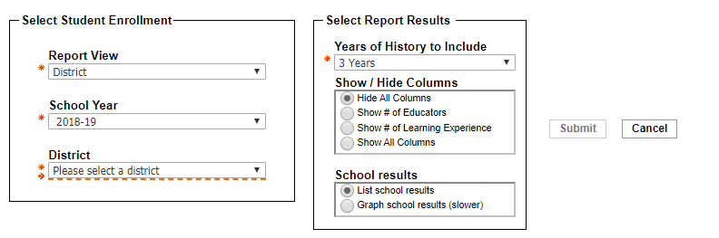  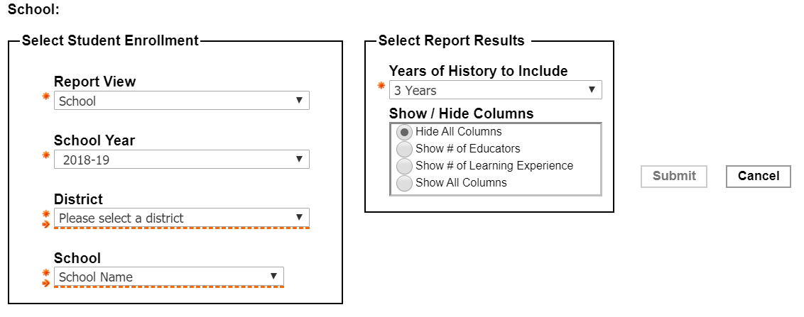  District:
All students in district by comparison groups | The “Educator Experience” column reflects how often students had learning experiences with an experienced teacher (3+ years of teaching experience in MA public schools) as opposed to an inexperienced teacher (0-2 years of teaching experience in MA public schools).  The “Educator Qualifications” column reflects how often students were assigned to a class with a teacher who held the appropriate license for that particular class as opposed to those who did not. For more information on teachers who are out-of-field, see Out of Field Teacher Assignments (SE821) in Edwin.  The “Educator Effectiveness” column reflects how often students had learning experiences with a teacher who was highly rated (Exemplary/Proficient) or not highly rated (Needs Improvement/Unsatisfactory)  Looking at the portion of the table highlighted in yellow, 85.9% means that when you add up all the learning experiences of non-economically disadvantaged students from the last 3 years (assuming “3 Years” was selected as a filter), 85.9% of their learning experiences were with a teacher who had 3 or more years of teaching experiences. | 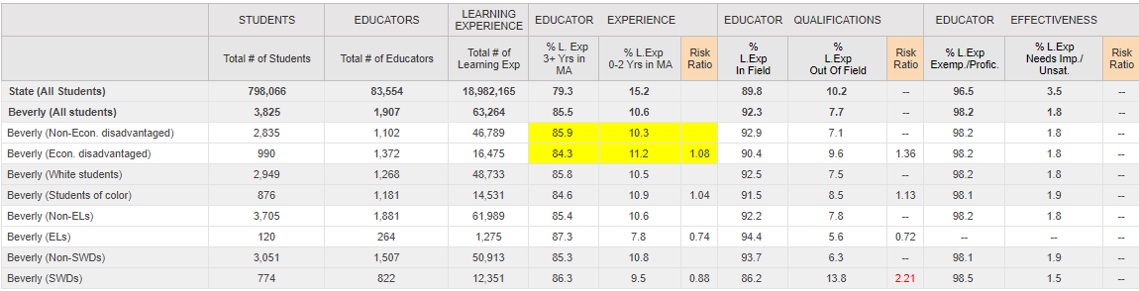
Identifying Risk ratios and Equity Gaps | The “risk ratio” columns compare the likelihood that one group of students will be assigned to a teacher with a certain characteristic, versus the likelihood for students not in that group from the same district.  Looking at the first risk ratio column, we see that in District A, economically disadvantaged students are 1.08 times more likely, or 8% more likely, than non-economically disadvantaged students to be assigned to a teacher with fewer than 3 years of experience.  When a risk ratio for a school or district is greater than or equal to 1.5, the risk ratio will be red, indicating an equity gap. For example, The risk ratio in red of 2.21 in the “Educator Qualification” means that students with disabilities are 2.21 times, or 221% more likely to have had learning experiences with a teacher who did not hold the appropriate license for that particular class.  Click “Page down” at the bottom of the report to view additional graphs and information.
Learning experiences for all students enrolled in the district compared to all students in the state | The graph “Learning experiences for all students enrolled in the district” provides a visual of the first two rows of the summary report table for “State (All Students)” and “District (All Students)”  In the sample district, 6% of students’ learning experiences in the district are with teachers rated NI (needs improvement/U (unsatisfactory), while only 3% of students’ learning experiences across the state are with teachers rated NI/U. | 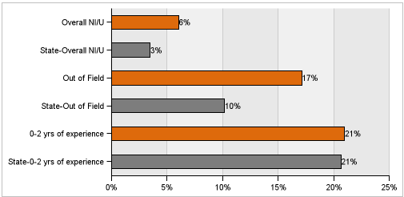
Learning Experiences for students Enrolled in the District over Time | This graph represents the change over time in equity gaps at the selected district or school.  Please note that the scale on the Y-axis of the charts below may be different from one another. The oldest year of data included on this chart is 2017-18, so if you select 2017-18 in the initial filters, you will not be able to make a comparison over time. | 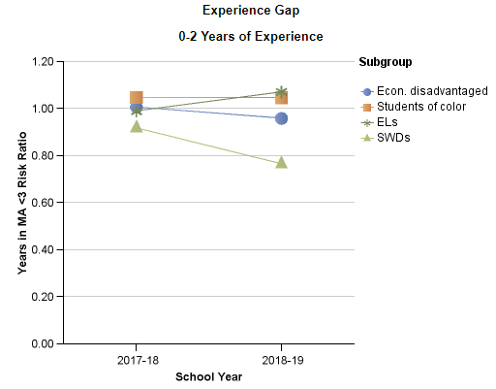
Learning Experiences for All Students Enrolled in the District | These graphs show shows the differences between the sizes of risk ratios across student subgroups and teacher characteristics.  The bars show the sizes of risk ratios. By hovering the mouse over one of the bars, you can see the data behind the risk ratio. | 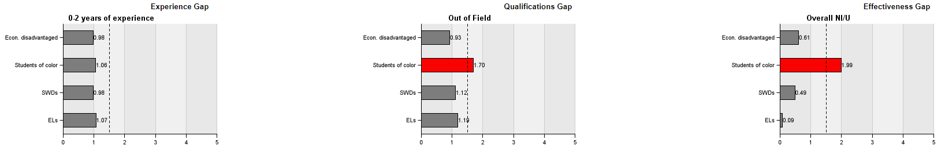
Comparison risk ratios between student subgroups for schools in the district | This chart shows risk ratios for student subgroups at each school. If you selected “Graph school results” in the filters, then this section will appear as bar charts. This section is useful for making comparisons and looking for trends across schools.  If you wish to see more detailed information about a school, you can click on the school’s name for the individual school's summary report. The names of the schools have been blacked out for anonymity for purposes of this user guide.  You can continue clicking “page down” to view all schools in your district if they do not fit on one page. | 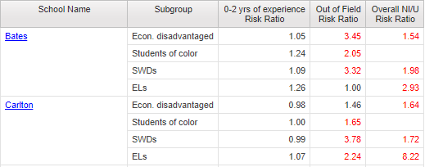
Definitions of Key Terms and Data Suppression Rules | The final page of the report includes the definition of key terms and data suppression rules.  You can find further information about the sources of data used to create the report on page 1. | 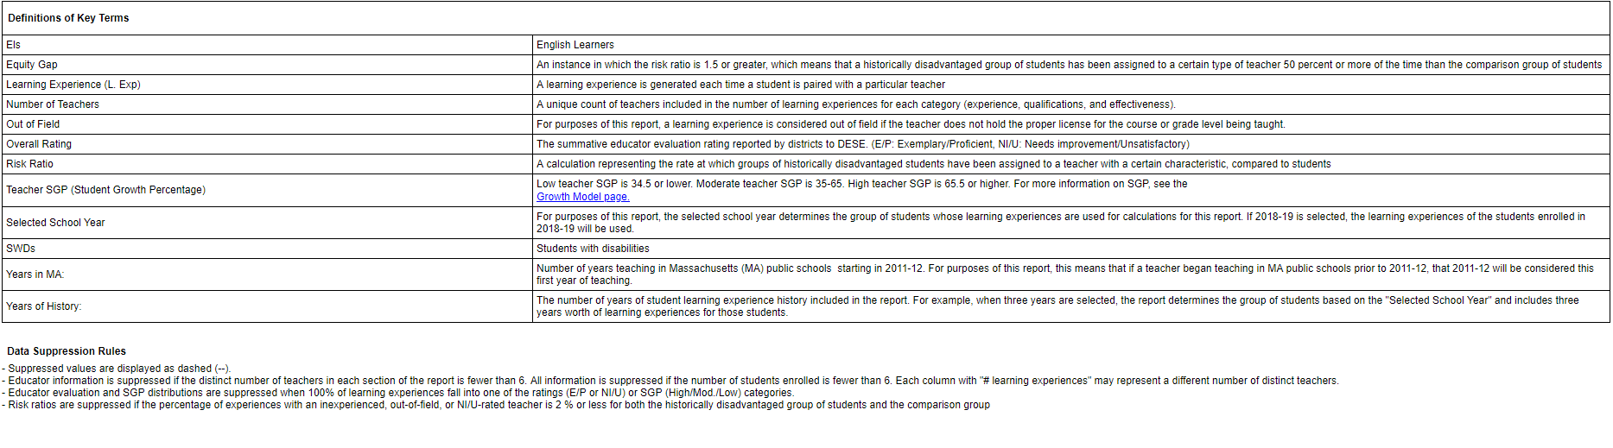

The Detailed Report (SE322) Please note the SLE Detailed Report is under construction as of 07/01/19 and does not yet contain 2018-19 data.
Step | Instructions | What’s on Screen
Accessing the report | See the first two rows of instructions for the Summary Report to learn how to access the Detailed Report.
Filters: student enrollment | In the “Select Student Enrollment” column, the “Report View” allows you to decide how far to drill down. Selecting “district view” and “all schools” will yield data for students at all schools put together, but selecting “school view” and “all schools” will provide data with separate rows for each school. “Student-level” view allows you to see data for individual students. | 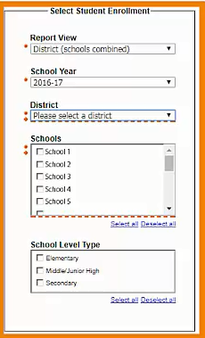
Filters: select students | The middle column allows you to select specific subgroups of students.  Think of the choices within the same box as “or,” and the choices across or outside of boxes as “and.” For example, selecting “Asian” and “Hispanic or Latino” in the Race/Ethnicity box provides data for students in one or the other group. Selecting “Asian” and “EL” provides data for students who are identified as both Asian and ELs. Similarly, selecting “EL” and “SWD” generates data for students who are ELs and students with disabilities. | 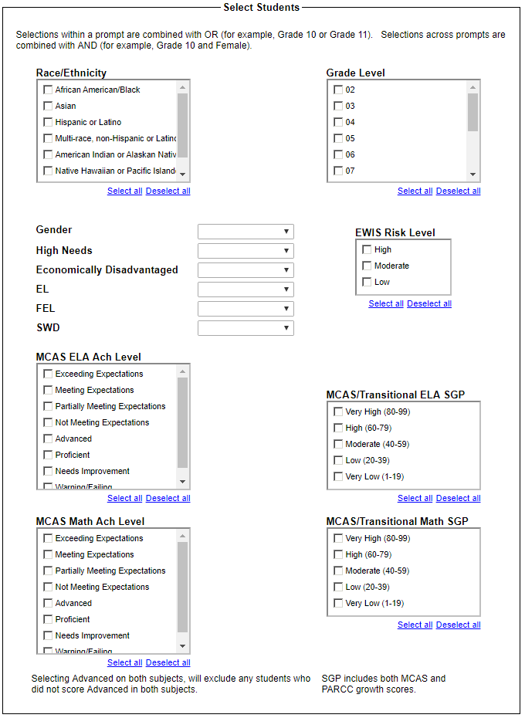
Filters: select report results | In the last column, “Select Report Results,” you’ll be able to select subgroups of teachers.  In “Measures to Include” you’ll see the teacher characteristics included in the Summary Report. Under “Course Subject,” you can select one, some, or all course subjects.  For “Years of History to Include,” you can choose how many previous years of data you’d like to see. Under “Student Experiences at,” the report shows data about the previous experiences of students who are currently enrolled in your district. By selecting “current and past districts,” the report will generate data that includes students’ past learning experiences in any Massachusetts public school. Selecting “current district only” will limit the data to learning experiences that occurred in your district. Under “Student Enrollment View,” you may want to select “ever in school year” when using the report during summer vacation.  Selecting “Yes” under “Include Long Term Substitute” provides data that includes student learning experiences with substitute teachers who spent at least 30 consecutive calendar days in a specific classroom.  Selecting “Yes” under “Show # Teacher Experiences,” provides additional columns of data for those who wish to see the n-value of total student learning experiences, from which the rates in the table were calculated. | 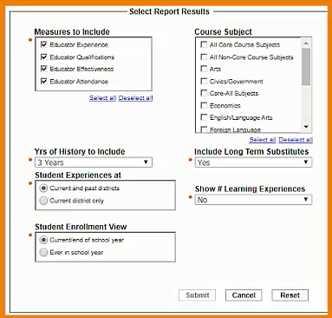
Submit report | Before clicking “submit,” make sure that you’ve filled out all filters with a red asterisk. It may take a short time for your report to load.
Detailed report output | The Detailed Report table looks similar to the table at the top of the Summary Report, but with some additional columns of information. This example looks at the school report level, and at data specifically for ELs.  Because only ELs are represented in this particular output, you can also see Sheltered English Immersion (SEI) Endorsement data. These columns show how often ELs were assigned to SEI-endorsed teachers, among their assignments to core academic content teachers, since July 2016.  The example district may want to compare data for ELs and non-ELs side-by-side. The easiest way to do this in the SLE Report is to simply highlight the table, press Control C, and paste it into an Excel spreadsheet – and then do the same after running the report for non-ELs. | 