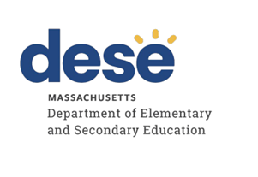

Guidance for Implementing Dual Language Education Programs

June 2023

Table of Contents
Introduction 4
Audience 4
Purpose 4
Why Implement DLE? 6
Educator Diversity Outcomes 6
Sound Educational Theory 7
Quality Dual Language Education Programs Are Successful 7
Students’ Assets 7
Transfer 8
Teaching for Bilingual Learning 8
Conditions for Success and Sustainability of DLE Programs 9
Shared Leadership and the Importance of Collaboration 9
Community and Family Engagement 10
Building K–12 Bilingual Pathways for Multilingual Learners 12
Continuous Learning in Two Languages for K–12 DLE 12
Innovative Collaboration toward K–12 Pathways 12
Conditions for Success of DLE Programs 13
Enrollment, Assessment, and Placement 13
District Commitment and Resources 14
District Commitment 14
School Leadership 15
Program Model Planning and Structure 16
DLE Program Models at the Elementary Level 17
DLE Program Models at the Secondary Level 18
Curriculum and Materials 19
Partner Language Curriculum and Instructional Materials 19
Cross-Language Curricular Planning 20
Biliteracy Approach 20
English as a Second Language (ESL) in Dual Language Education Programs 23
Instruction 24
Integrating Language and Literacy with Content Instruction 25
Differentiated Instruction 25
Teaching for Transfer 26
Teaching for Holistic Bilingual Learning 26
Teaching for Sociocultural Competence Development Across the Curriculum 26
Staffing and Professional Development 27
Endorsement Requirements 27
Ongoing Professional Learning 28
Family and Community Engagement 28
Measuring Student Growth and Success 29
Assessment and Accountability: Develop Strong Assessment Plans 29
Multiple Valid Measures 30
Assessing Bilingual Trajectories 30
Cycle of Reflection and Improvement 30
Starting a DLE Program 31
Conclusion 31
Appendices 32
Appendix A. Research on DLE Programs 32
Appendix B. Outreach to Potential Families 33
Appendix C. More Examples of District Commitment 34
Appendix D. Considerations Once a District Has Decided to Implement a DLE Program 35
Appendix E. Comparison of Initial Literacy Development in Spanish and English 35
Appendix F. Instructional Strategies 38
Appendix G. Defining Holistic Bilingualism 42
Appendix H. Regional and National Conferences 42
Appendix I. DLE Teacher Preparation Programs in Massachusetts 42
Appendix J. Family and Community Engagement 43
Appendix K. Formative Assessment Examples 43
Acknowledgements 45

Introduction
Dual Language Education (DLE) has emerged as a research-based model of schooling providing an opportunity for excellence to all students, including students designated as English learners. DLE is an evidence-based education program that aims for bilingualism, biliteracy, and sociocultural competence capitalizing on language and culture as assets.

Audience
The intended audience for this guidance document includes all stakeholders who communicate about, design, implement, evaluate, and sustain DLE programs. These stakeholders include but are not limited to parents, teachers, paraprofessionals, instructional coaches, student support personnel, family liaisons, parent information center and student enrollment personnel, school administrators, district administrators, community leaders, and school committee members.

Purpose
Following the adoption of the Language Opportunities for Our Kids Act (LOOK Act), school districts in Massachusetts are better able to expand their capacity to provide bilingual education and programs for English learners (ELs). This document will use the phrase multilingual learners (MLs) to describe both ELs and other students enrolled in DLE programs and who are learning more than one language.

Decades of longitudinal research continue to yield evidence regarding the effectiveness of DLE for MLLs, including students with disabilities and students from economically disadvantaged backgrounds. The purpose of this guidance is to support districts with expanding educational opportunities for MLLs through DLE. To achieve this goal, this document builds on previous guidance documents and aims to meet districts where they are in terms of exploring, developing, and expanding DLE programs, as well as enhancing the quality of existing programs. This guidance aligns to the Blueprint for English Learner Success, but expands and refines the guidance as needed for DLE contexts.

As reflected in the vision statement of the Blueprint for English Learner Success,
English Learners in Massachusetts…

- attend schools in which all educators share responsibility for their success, engage effectively with their families, and value and nurture their linguistic and cultural assets.
- are taught by effective, well-prepared, and culturally responsive educators who hold them to high standards and have the resources and professional learning they need to advance students’ academic and linguistic development simultaneously.
- have equitable access to meaningful and rigorous learning opportunities that build on their cultural and linguistic assets and the academic, linguistic, social, and emotional supports they need to excel.
- thrive in high school and graduate with the knowledge, skills, and abilities necessary to be successful in college and/or a career of their choice, and to contribute to civic life in a global community.

Source: Massachusetts Blueprint for English Learner Success

The statement above describes the PK–12 experiences and outcomes that schools and districts strive to provide to all MLLs. In essence, it outlines the opportunity presented by bilingual programs, where MLLs have equitable access to meaningful and rigorous learning experiences that build on their cultural and linguistic backgrounds, as well as the academic, linguistic, social, and emotional support they need to excel.

This document provides information and tools to plan, implement, and evaluate DLE programs. It also provides recommendations to ensure sustainability and long-term success, and ultimately to improve the education of MLLs. More specifically, this guidance has the following purposes:

- To build and enhance understanding of DLE in the spectrum of bilingual education program offerings;
- To provide information for successful program design and identify the conditions for fidelity of implementation;
- To identify the multilingual populations equitably served by DLE, including information to support strategic decision making regarding the implementation of DLE programs;
- To identify essential biliteracy linguistic and instructional features of DLE programs;
- To guide improvement of DLE program design, delivery, and ongoing evaluation to support MLLs to meet college, career, and civic standards as described in the Massachusetts Curriculum Frameworks, WIDA Language ELD Standards Framework (2020 Edition), and Massachusetts 2021 World Languages Curriculum Framework.

Why Implement DLE?
Research has consistently documented the cultural, linguistic, educational, cognitive, economic, and political benefits of bilingualism in a globalized economy. In addition, for students who come from homes where languages other than English are used, home language maintenance is important for family cohesion and healthy identity development.
DLE has proven to be one of the most impactful and effective ways of realizing the benefits of bilingualism and school success for students enrolled in the program. Studies conducted over the last two decades in the United States have consistently shown positive academic, language and literacy, and cognitive outcomes for the students in DLE programs in both English and the partner language. These results hold true for emergent multilingual students who speak a language other than English at home, or perhaps two or more languages at home, one of which may be English, as well as students who are growing up with English as their sole language. More information about the research conducted about the outcomes of DLE can be found in Appendix A.
A wide range of research studies regarding students’ successes in DLE have been conducted over the decades. MLs in DLE programs, including ELs, consistently outperform their monolingual peers in a wide range of contexts. The studies in the Appendix A are illustrative of this large body of research on DLE.

Educator Diversity Outcomes
DLE programs can also increase educator diversity. Large urban districts typically have high percentages of students of color.

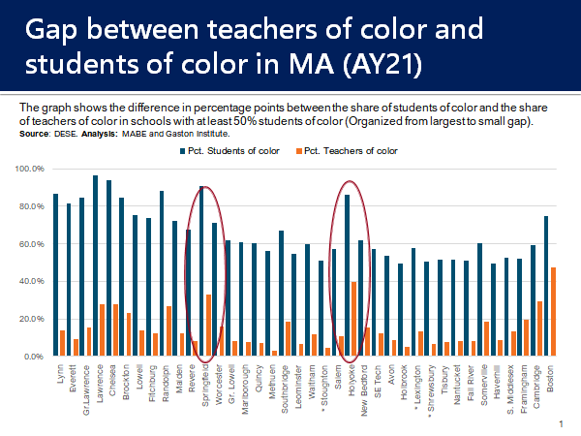
Source: MABE Pre-Conference Roundtable Discussion March 18, 2022

For example, in Massachusetts, a study by the Gastón Institute found that of 350 districts, the largest populations of students of color (defined as 50% or greater of the student population) were concentrated in only 32 school districts. These districts would therefore benefit by opening DLE programs, increasing their educator diversity and, as a result, helping improve the academic achievement of their students.

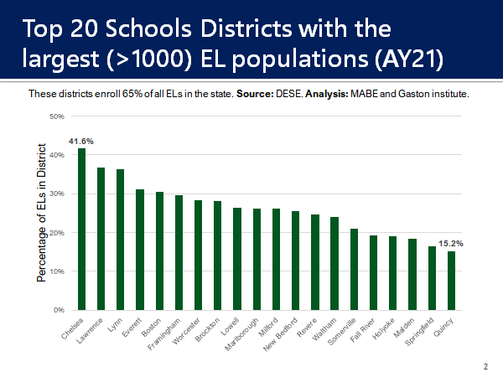
Source: MABE Pre-Conference Roundtable Discussion March 18, 2022.

In an analysis by the Multistate Association for Bilingual Education (MABE) and the Gaston Institute (UMass Boston), 65% of all ELs in the state are enrolled in the 20 school districts with the highest percentages of students of color and the highest percentage of “High Needs Students”. (Note: For purposes of this analysis, a student was considered “High Needs” if the student was designated as economically disadvantaged or an EL or former EL or a student with disabilities.)

Sound Educational Theory

Quality Dual Language Education Programs Are Successful
DLE programs effectively address ELs’ and MLs’ academic, language, and sociocultural needs in ways that lead to long-term school success. Specifically, DLE educators accomplish this goal by engaging in three core practices: 1) leveraging students’ assets; 2) understanding language transfer; and 3) applying methods for holistic bilingual learning.

Students’ Assets
DLE educators typically take an asset-based approach when working with MLLs and showcase the strengths and “funds of knowledge” the students and families bring. They not only embrace the diversity of experiences that their students contribute to the classroom, but effectively leverage these experiences within the instructional layers of pedagogy, curriculum, and assessments. Learning becomes more effective when students have opportunities to build on and connect to experiences and then integrate their existing knowledge and experiences into new learning and understanding.
Using this asset-based lens also affirms students’ cultural and learner identities, fosters their sense of belonging, and encourages them to be more engaged and do better academically. Utilizing instructional routines that honor students’ languages and backgrounds is a vital part of MLLs’ educational experiences and growth.

Transfer
Linguistic and conceptual integration or transfer are integral to the process of becoming bilingual and biliterate and learning content in and through two languages. Neuroscience finds that bilingual learners’ languages are always activated across a continuum from monolingual to bilingual modes. Additionally, students’ brain function is rapid when determining which language(s) should be drawn upon, which should be activated, and which should be completely deactivated if required to communicate in monolingual mode. A recent study noted that bilingual individuals process bilingual text (words) without any interruption—their brains process it as one “language.” This is quite different from those individuals growing up with only one language. DLE educators recognize that becoming bilingual is both similar and different from monolingual language and literacy development. The idea of transfer underscores that learning an additional language does not mean starting “from scratch”; rather, new learning experiences are added to and integrated within a continuously developing conceptual reservoir. As Güilamo (2022) notes, this kind of “transfer is a non-negotiable for biliteracy.” Rather than repeating the same content taught in one language in the partner language, DLE educators typically build on, extend, and complement instruction across the two languages of instruction, a pedagogical shift that is unique to a holistic approach to bilingual learning.

Teaching for Bilingual Learning
In a DLE program, teachers typically teach for bilingualism rather than teaching two (separate) languages. DLE teachers understand that bilingual learners are not simply two monolingual individuals in one person, but will exhibit unique behaviors as bilingual individuals including the concurrent use of both languages (code-switching, translanguaging). Recognizing that the two languages being learned in DLE are always activated in the brain, DLE teachers can strategically leverage this by planning for language transfer and facilitation of students’ opportunities to connect the program languages. They can seek out opportunities for students to develop an awareness about the two languages of instruction (metalinguistic awareness). Assessments reflect this holistic view of bilingualism as well where students' performance is considered not just in one language but simultaneously across languages. Ultimately, teaching for holistic bilingual learning implies that teachers design their instruction in such a way that literacy instruction in both languages is not postponed or omitted. Through meaningful, authentic communicative tasks, students’ linguistic repertoire can grow and expand as they co-develop literacy in English and the partner language. When students are afforded frequent opportunities and encouraged to draw on one language to help them with the other, and when they are explicitly taught about similarities and differences between languages, students develop increased metalinguistic awareness, bilingualism, and biliteracy.

Conditions for Success and Sustainability of DLE Programs
While the research is clear that quality DLE programs are highly successful, choosing to implement a DLE program model is merely the beginning. In order to increase the likelihood of positive program outcomes, districts should consider specific structural criteria beginning with an in-depth examination of equity and distinct resource allocations. Although local practices will naturally vary, effective DLE programs share several features that make a positive difference to student success. Three core evidence-based practices create system-wide conditions for DLE program success and sustainability. They are: 1) shared leadership; 2) collaboration; and 3) community stakeholders’ engagement (see figure on next page).

Shared Leadership and the Importance of Collaboration
English learners in Massachusetts attend schools in which all educators share responsibility for their success, engage effectively with their families, and value and nurture their linguistic and cultural assets.
Source: Massachusetts Blueprint for EL Success, Pillar 1

DLE program sustainability depends upon collaborative, structured services. When district, school, and community stakeholders form collaborative partnerships that are proactive and equity-based, the shared decision-making results are dynamic and appropriate for the program’s specific context. Such a comprehensive approach increases the likelihood of success of DLE programs. Please also see the MA Blueprint for EL Success, Pillar 1, Building Block 1 to learn more about the importance of shared responsibility.
Sustainability and collaboration go hand in hand in DLE programs. Given the complexities throughout the DLE instructional cycle, the “heavy lifting” associated with designing, delivering, and assessing DLE instruction for program success and sustainability is better addressed when collaboration among educators is in place. Authentic assessment practices in DLE classrooms include genuine and multidimensional data. DLE programs should be attentive to capturing students’ rich, descriptive language within the DLE classrooms, their communities, and beyond. Such practices may include rubrics to capture classroom evidence of the influence languages have on each other, collective interpretations of translanguaging, and attention to specific manifestations of biliteracy across the dimensions of language (discourse, sentence, and word/phrase).

Community and Family Engagement
When families feel welcomed at school and are encouraged to be more actively engaged with home-to-school connections, communities are increasingly empowered from a strength-based approach. Effective DLE shared leadership teams critically analyze the community and the program participants’ needs to then develop clear, actionable, and shared goals to serve the community and to provide equitable access to DLE programs.
Conditions for Success and Sustainability: The Core Premises
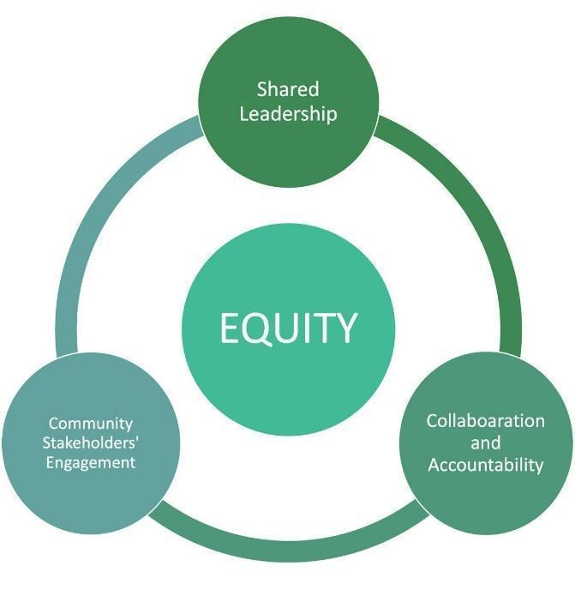
DLE programs share three additive goals, which are bilingualism/biliteracy, academic achievement, and sociocultural competence. All students can participate in and benefit from DLE. However, based on a student's profile, some program models may be more appropriate than others. Nationally, the main DLE program models used are two-way immersion (TWI) programs and one-way immersion (OWI) programs.
Two-Way Immersion (TWI) programs typically include approximately equal numbers of students who, at the time of enrollment, are monolingual or dominant in English and students who are monolingual or dominant in the partner language. TWI programs may also serve students who are bilingual at the time of enrollment. Typically, the student population in TWI programs is no less than one third and no more than two thirds monolingual or dominant in either English or the partner language at the time of enrollment.
One-Way Immersion (OWI) programs often serve more linguistically homogeneous groups of students. OWI programs in which all students are proficient in the partner language but not in English at the time of enrollment have historically been called developmental bilingual programs. They use both languages to teach content, and they help students develop proficiency in English while maintaining and continuing to develop their skills in their home language.
Note: OWI programs in which all students are monolingual and proficient in English at the time of enrollment have historically been called “Foreign Language” or “World Language” programs, and are not subject to the same requirements as English Learner Education programs serving English learners.
The chart below was adapted from the U.S. Department of Education and describes the typical student populations in various DLE models used nationally.

Table 1: Overview of the Key Attributes of Dual Language Education Programs by Program Type
 | Two-Way Dual Language Programs | One-Way Dual Language Programs
 | Two-Way Immersion/Dual Language Education | World Language Immersion Programs | Developmental Bilingual Education Programs | Heritage Language Immersion  Programs
Student Population Typically  Served | ELs and non-Els (ideally 50 percent in each group or a minimum of 33 percent) | Primarily English speakers; may  include ELs and heritage speakers | ELs and former ELs only | Student whose families’ heritage language is/was the partner language
Languages | English and the ELs’ home (partner) language | English and a partner language | English and ELs’ home (partner) language | English and the heritage (partner language)
Source: Table adapted from U.S. Department of Education, Office of English Language Acquisition, Dual Language Education Programs: Current State Policies and Practices, Washington, D.C., 2015.

Building K–12 Bilingual Pathways for Multilingual Learners
In order for students to realize the maximum benefit from DLE programs, district planning should begin with a K–12 focus. Districts can support such an additive approach from early childhood to high school through a variety of DLE pathways.

Continuous Learning in Two Languages for K–12 DLE
The most consistent way to provide continuous learning in two languages is to envision DLE programs from elementary through high school from the start. They will look different at the K–5, 6–8, and 9–12 levels regardless of how schools are organized, but a long-term articulation will allow for students to achieve high levels of proficiency in both English and the partner language and facilitate coherence in the student learning experience. In addition to the cognitive, academic, and sociocultural benefits, students will also be eligible to potentially receive the Massachusetts State Seal of Biliteracy award, given to graduating seniors who demonstrate high levels of proficiency in English and another language.

Innovative Collaboration toward K–12 Pathways

Connecting World Languages and DLE
World Language (formerly commonly referred to as Foreign Language) programs provide high potential for collaboration with DLE programs. World Language teachers are often proficient in partner languages used in DLE programs and use effective instructional strategies for language acquisition including the “5 C’s” (Communication, Culture, Connections, Comparisons, Communities) in ACTFL’s World-Readiness Standards for Learning Languages. At the high school level, for example, DLE students may take advanced Spanish World Language classes to continue their growth in Spanish.

Connecting Transitional Bilingual Education and DLE
Transitional Bilingual Education (TBE) is a type of a bilingual education program that usually aims to transition students into English-only programs within a certain time frame (often 3 to 5 years, depending on the model used). Students in TBE programs may lose proficiency in their home language as they learn English. Districts that have both TBE and DLE programs that use the same partner language may be able to help students keep their proficiency in the partner language by allowing students exiting from TBE programs to enroll in DLE in subsequent years. Good communication between the school and the family as well as between TBE teachers and DLE teachers is essential to support such a transition.

Conditions for Success of DLE Programs
Massachusetts state law specifies that English learner programs shall be based “on best practices in the field and the linguistic and educational needs and the demographic characteristics of English learners in the school district” G.L. c. 71, § 4. The sections below build on the Guiding Principles for Dual Language Education, CAL 2017 and The Massachusetts’ Blueprint for English Learner Success to outline the conditions for high-quality, sustainable DLE program design and implementation.

Enrollment, Assessment, and Placement
Quality program implementation begins with a comprehensive intake and placement process that aligns student needs with program models and goals. DLE programs are generally distinguished by student populations that they are designed to serve. For more information, please see Table 1.

Students in DLE programs are typically expected to stay in them for the duration of the program. For instance, students entering DLE programs in kindergarten are ordinarily expected to remain in such programs through at least the sixth grade. This is also true for ELs in DLE programs. In Massachusetts, ELs in DLE programs are annually assessed using ACCESS for ELLs testing to determine their progress in acquiring English proficiency and whether they are ready to be exited from EL status. Such reclassification affects the students’ EL status but does not necessarily impact their continued participation in the DLE program.

Another good practice during the enrollment process for DLE programs is to assess the students’ proficiency in the partner language. It is critically important to know which students are more proficient in the partner language, which students are more proficient in English, and which students may be bilingual. Initial screening results in both languages provide program teachers and leaders with baseline data from which to measure students’ progress and growth in each language.

It is also vitally important that families of students enrolled in DLE programs understand the goals and methodologies of the program, as well as the need for long-term commitment to achieve the positive results of proficiency in two languages, high academic achievement, sociocultural competence, and access to the Seal of Biliteracy. School districts are required to notify parents or guardians of ELs of their child’s ACCESS for ELLs results and the programmatic options available for their child.

Knowledgeable enrollment personnel should provide families with information about DLE programs that may be available in the district, as well as the process for enrolling a student in such programs in the language that the families understand. It is helpful for families to receive this information multiple times and in multiple formats. This will allow families to make an informed choice for their child and allow them to support their child’s successful participation in the program of their choice. For DLE programs, a higher level of understanding and commitment from families helps create program stability.

Significant effort and attention should therefore be given to outreach to potential families.
See Appendix B for examples of outreach.

District Commitment and Resources
The implementation of a DLE program requires an infrastructure from the district level down to the school level that provides the necessary DLE expertise and equitable allocation of resources to facilitate quality program implementation.

District Commitment
District-level commitment to supporting DLE programs is essential for their long-term success. This commitment may be demonstrated by establishing policies that are inclusive of the goals and essential elements of the DLE program. Districts assess and develop the necessary district capacity and infrastructure to support, evaluate, and sustain bilingual programs and schools. A vision for a K–12 pipeline is integral to this commitment, including a strategic alignment of DLE with recognized national and state awards, such as the Massachusetts State Seal of Biliteracy.

English learners are taught by effective, well-prepared, and culturally responsive educators who hold them to high standards and have the materials and professional learning they need to advance students' academic and linguistic development simultaneously.

Source: Massachusetts Blueprint for English Learner Success, Pillar 2

One key element of this is investment in recruiting and retaining highly qualified, credentialed staff for DLE programs. Successful recruitment and retention efforts often require close collaboration among the district office for EL or MLL education, the office of human resources and school-based building principals. Collectively, they recognize that recruitment is an important endeavor. Districts may also consider pipeline initiatives to train staff members who have been employed as paraprofessionals or family liaisons. Building relationships with Institutions of Higher Education (IHEs) or visiting teacher programs could be other ways to support recruitment of educators for DLE programs.

The table below is one example of how districts can use a DLE lens when making decisions on staffing.

Table 2: Example of District Commitment:
The district is committed to hiring bilingual staff.
The district hires bilingual staff for the family information center to assist with a systematic and systemic process for effective two-way communication in the program’s partner language around enrollment, choice, and placement in DLE programs. | The district’s Special Education Department hires bilingual liaisons with knowledge about special education procedures, assessments, and bilingual language development to effectively communicate with families of students who have IEPs. | The school hires bilingual office staff and family liaisons to communicate with families regarding general school issues and to translate communications from the school.
See Appendix C for more examples of district commitment.

School Leadership
It is important to establish clear and effective processes for collaboration and communication among district leaders, school leaders, and community stakeholders embracing the new and existing bilingual programs by addressing questions and concerns, and formulating adjustments of policies and practices that directly impact DLE program goals and operations. District-wide departments and initiatives collaborate closely with school leadership and staff to align commitment to DLE with the district’s strategic and equity plans and support the feasibility and successful operation of DLE programs by allocating appropriate resources for successful program implementation.

Districts develop strategic procedures to provide access to DLE programs for as many MLLs as possible. For example, districts may consider:

- Where should the DLE program be geographically located?
- Which school should house the DLE program?
- Will the student population served by that school benefit the most from the DLE program?
- Is the school easily accessible to the student population that most needs the DLE program?
- Does the physical building have enough space to house an expanding DLE program?
- Does the chosen school have leadership and staff who are bilingual?

Examples of additional strategic considerations include, but are not limited to:

- How will community members be invited to actively participate in programmatic decisions?
- How will the district arrange for translation or interpretation services for families whose primary language is not English?
- How do students enter into the DLE program? What does the process look like?
- What are program expectations for second language acquisition? How will this be assessed? How will it be documented?

A more complete list of considerations is found in Appendix D.

Program Model Planning and Structure
Program planning is ongoing and continuous. Besides a long-term commitment to establishing and sustaining a DLE program, it requires understanding of the needs of students and the essentials of the program, and requires allocating appropriate funds and resources for sustaining the DLE program.

When working on establishing a DLE program, a district may choose to convene a planning team that includes representatives of different stakeholders. The planning team may collaboratively develop an action plan to include:

- Communication about the program and rationale for implementation to multiple stakeholders (students, parents, teachers, building level administrators, district level administrators, community businesses and organizations);
- Identifying and building staffing capacity through ongoing professional development opportunities and partnerships with teacher preparation programs;
- Purchasing linguistically and culturally relevant materials to support expanded curriculum development;
- Developing a program model and language allocation plan;
- Creating clear, measurable data collections for evaluation of program success.

Planning teams at the secondary level may want to be particularly mindful of the fact that the majority of students from the elementary DLE program may be entering as balanced intermediate proficient speakers of the program's languages. Given that secondary DLE programs are usually continuing from the elementary setting, they are often positioned to develop more complex, cross-curricular language and literacy with greater depth and breadth.

Specific action steps for the planning team may include:

- Strategic recruitment to expand the DLE program into the secondary level;
- Revising and enhancing the courses/programs of study to include DLE-specific courses;
- Developing a schedule with DLE course offerings that does not conflict with high-demand courses in other programs;
- Establish processes for students to earn the Seal of Biliteracy Award.

DLE Program Models at the Elementary Level
In choosing a DLE program model, consideration is given to the ratio between the use of English and use of the partner language for instruction. The choice of ratio should be informed by who enrolls in the program and by community and school resources. When designing their DLE program model, schools may want to consider how to incorporate DLE programming into the entire school day and not only instruction in the core academic content areas.

There are two main DLE program models that schools typically use. They are generally referred to as “80/20” and “50/50” models. In an 80/20 model, students ordinarily receive approximately 80% of instruction in the first year in the partner language and 20% in English. In DLE programs that serve ELs, a qualified core academic teacher holding a Massachusetts bilingual endorsement delivers instruction in the partner language. In this model the core academic teacher is a model speaker of the partner language and also observes the bilingual development of the students. English Language Arts (ELA), English as a Second Language (ESL), and specials, such as gym, music, and art, often represent the remaining 20% of instruction in English. In DLE programs that serve ELs, qualified core academic teachers responsible for the instructional component provided in English hold the bilingual endorsement or the SEI endorsement. ESL and ELA could include developing oral proficiency, building academic vocabulary, and extending the learning at the end of a unit bridging content and literacy knowledge from the partner language into English.

Over time, in such programs, the proportion of instruction in the partner language gradually decreases while the percentage of instruction in English gradually increases, until a proportion of approximately 50% instructional time in each language is achieved. By third or fourth grade, DLE programs typically reach a ratio of approximately 50% instructional time in each language.

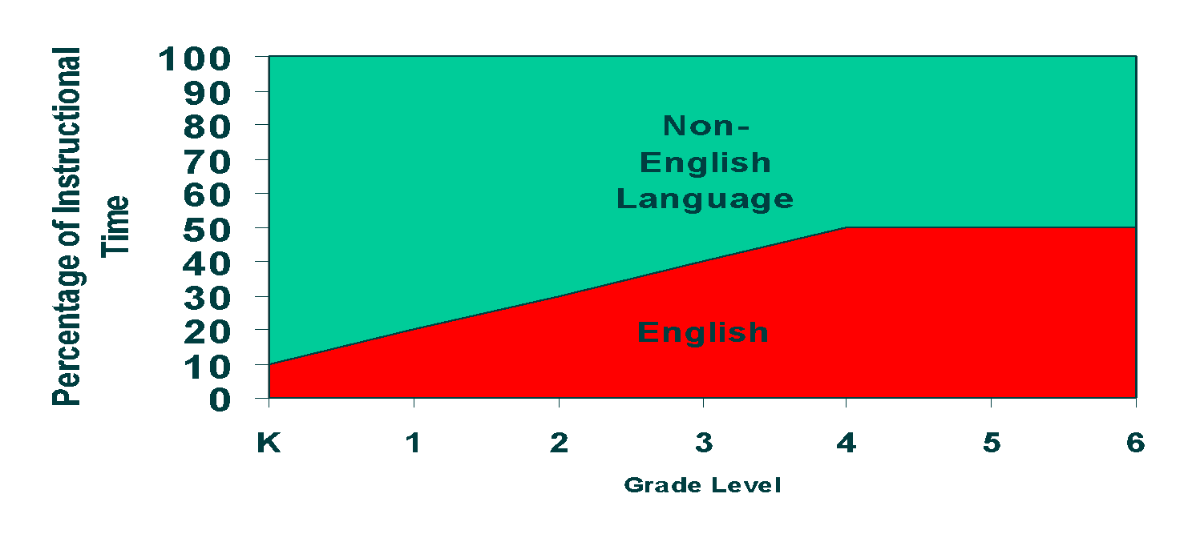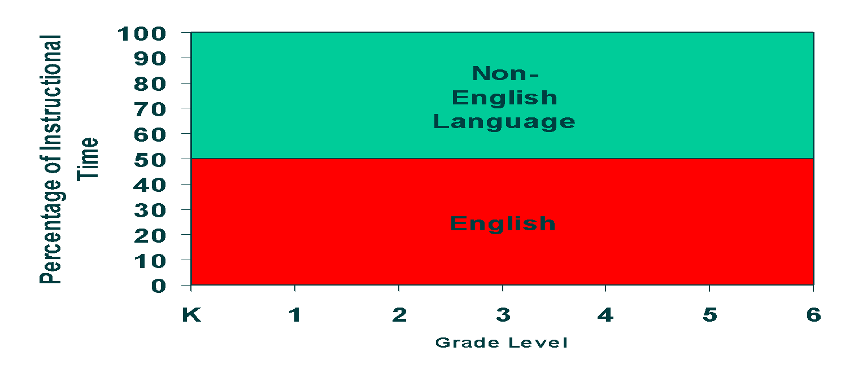

In the 50/50 model, instructional time in English and the partner language is ordinarily divided evenly, meaning that content and literacy instruction occur in both languages. The most common approach is to provide instruction through one language in the morning and through the other language in the afternoon. This approach is frequently, but not always, combined with the use of partner teachers, a separate teacher for each language, as well as the division of content (e.g., math in one language and science in the other). The teacher prepares lessons in one language and there is greater fidelity to the language and content allocation plan as determined by the instructional schedule.

The decision on which program model to implement depends upon a number of factors, including student needs, language proficiency of available teachers and staff, parent and community preferences, and availability of instructional materials in the partner language.

DLE Program Models at the Secondary Level
DLE programs are effective when students have the opportunity to remain in the program throughout their entire K–12 schooling. Extending the DLE program into secondary grade levels allows students in elementary programs to continue developing and reaching higher levels of bilingualism and biliteracy as well as sociocultural competence. Ongoing bilingual development also helps promote adolescents’ continued development of abstract thinking, cognitive abilities, and creative capacities. The pedagogical practices of DLE are well-positioned to support adolescent cognitive, socio-emotional, and identity development (Bishop & Harrison, 2020).

DLE program models at the secondary level typically maintain a 50/50 model, providing 50% of the instruction in English and the other 50% in the partner language. In middle school, at a minimum, a language arts course and a content-area course in the partner language are recommended for each. In high school, it is recommended that approximately half of the content-area courses (such as math, science, or social studies) be taught in the partner language. In addition to courses taught in the partner language and courses required for graduation, DLE programs may provide electives, summer opportunities, career and technology courses, secondary program leadership opportunities, and dual enrollment in local universities to help students achieve higher levels of proficiency in English and the partner language.

One approach for potentially expanding the secondary DLE program is to increase language learning opportunities through a secondary education “course of study” that utilizes staff from different language education programs (e.g., DLE, TBE) and provides opportunities for MLLs from different programs to learn together. The school creates opportunities for continued development of academic language, increasing the opportunity for a wider number of MLLs from different programs to earn the Massachusetts Seal of Biliteracy and the Seal of Biliteracy with Distinction upon graduation.

It is important for DLE programs to identify, recruit, and prepare highly proficient bilingual staff who can collaborate and teach content and elective classes in the partner language.

Table 3: Sample Considerations for DLE Programs
Elementary School | Middle School | High School
Ordinarily, a minimum of 50% to a maximum of 90% of instruction in the partner language; 80/20 or 50/50 models are often used. | Typically, students take language arts in the partner language from 6th to 8th grade in addition to at least one other core content course taught in the partner language each year from 6th to 8th grade. | Ordinarily, a minimum of 8 credits in the partner language over the course of 9th to 12th grade with a minimum of 4 credits in core content areas (math, science, social studies, or language arts).
SOURCE: Soleado, Fall 2008, Dual Language Education of New Mexico

Curriculum and Materials
DLE programs should utilize high-quality, rigorous curriculum and instructional materials in both English and the partner language. DLE curricula carefully consider MLs’ cultural and linguistic backgrounds and embed language development throughout lessons and units. Academic coursework is aligned to the Massachusetts Learning Standards and WIDA ELD Standards Framework (2020 Edition), and utilizes partner language standards such as the WIDA Spanish Language Development Standards. Teachers, paraprofessionals, interventionists, DLE administrators, and coaches collaborate to create alignment through the clear articulation of content and language objectives across grade levels. Staff also collaborate on developing a scope-and-sequence curriculum map that is sensitive to the bilingual development of the students in the program, captures their learning of content and language learning over time, gauges curriculum effectiveness, and assesses students’ learning trajectories as they go through the program.

Educators have and use curricular materials that advance ELs' academic and linguistic development simultaneously and align fully to the content and rigor of grade-level standards.

Source: Massachusetts Blueprint for EL Success, Pillar 2, Building Block 3, Classroom Level

Partner Language Curriculum and Instructional Materials
DLE programs typically utilize partner language curricula and resources that are originally written for and are intended to be used for instruction in the partner language. While districts or school leaders may choose to purchase a math or literacy curriculum resource that matches the English version used in non-DLE classes, these resources should be thoroughly vetted to ensure that they are not weak translations or inaccurate in the approach to the content in partner language. Phonics or foundational skills programs in the partner language reflect the orthography and structure of the partner language and are not a transposed approach from English.

DLE educators typically have a deep assets-based understanding of how students’ prior knowledge, prior schooling experience, worldviews, and behaviors may affect teaching and learning. They may use these understandings to help guide their curriculum and materials selection. DLE educators purposefully include cross-cultural competence development and embed it in units and lessons.

DLE programs adopt and implement instructional materials in ways that are culturally sustaining and flexible to meet the needs of the students in the program. Such examples include:

- Texts, activities, events, and speakers that reflect students’ culture and life experiences;
- Linguistically and culturally authentic bilingual books of many genres as well as other
materials and technology in the partner language as well as in English;
- Multi-modal materials in different languages and instruction that allows students to actively engage with the curriculum in different ways from different points of view;
- Coordinating and collaborating on curricular mapping, integrating culturally relevant materials across grade levels and content areas;
- Community-based learning projects that require students to propose solutions to real world problems.

Cross-Language Curricular Planning
DLE programs ordinarily do not duplicate teaching the same content standards across both languages, because students learn concepts once and transfer knowledge to the other language. Therefore, DLE programs usually cover different content standards in different languages depending on the content allocation plan. Moreover, DLE teachers strategically designate time for contrastive and metalinguistic analysis across the program languages. The timing of when different standards are taught may vary from one DLE program to another. DLE programs cover power or primary standards deeply across two languages and support students in applying and transferring their knowledge from one language to the other. Students’ progression and mastery of content may therefore also be demonstrated at different times during the year. The ESL (English as a Second Language) teacher is a key instructional partner in creating the language development trajectories in both program languages.

Biliteracy Approach
Biliteracy curricula in DLE programs use literacy approaches that reflect the authentic acquisition of language in each partner language. Students in DLE programs learn literacy in two languages and the curricular approach takes into account the differences in structure and morphology between English and the partner language. For example, in the case of Spanish, there is a one-to-one correspondence between the phonemes and the graphemes. Each written letter almost always corresponds to the same sound. As a result, Spanish literacy instruction begins with vowels and then moves to consonants grouped by sound (continuous consonants such as s/f/l/m/n first). Students learn how to divide words into syllables and how to decode multisyllabic words quickly after mastering the relatively straightforward vowel, consonant, and syllable sounds.

Given that in English a variety of sounds may be connected with a letter, the approach to teaching English literacy has to be different than in Spanish. There is a diverse range of vowel sounds that go beyond the number of vowels. For example, the “a” produces a different sound in the following words: cat and cake. Through phonics instruction, students learn the rules to decode English words. This involves learning consonant sounds first, then vowels, then vowel and consonant combinations such as CVC (consonant-vowel-consonant) and CVVC (consonant–vowel-vowel-consonant). This approach is very different from teaching phonics in Spanish.

Table 4: Comparison of Initial Literacy Development Skills Between Spanish and English

Spanish | Literacy Element | English
The building blocks of Spanish literacy begin with the vowels and then move to consonants to form syllables. Understanding that there are strong vowels (a-e-o) and weak vowels (i-u) determines accent rules and the separation of words into syllables and impacts comprehension.  Students first write vowels and then consonants as emergent writers because the vowels are constant and regular (5 vowels make 5 sounds). | Vowels and consonants | The building blocks of English literacy are the names and sounds of each letter, which are taught very systematically.  Students first write consonants and then vowels as emergent writers because the consonants are constant and regular (5 vowels make 15 sounds).
Letter names are not taught in Spanish initially as they only confuse students (la “ese” for “s” sounds as though it is the “e” and not the “s”). Names of letters are learned formally once students have learned the letter sounds and can form syllables. | Alphabet and initial sound | Knowing initial letter names and sounds are predictors of reading success in English. This is such an important skill that students are taught and tested over time to see if they have mastered it.
The concept of the accent is very important in Spanish, not only as it relates to writing and spelling (the orthographic accent as in papá) but also the diacritic accent (mí vs. mi) and the prosodic accent. Understanding how vowels and syllables are formed is fundamental to being able to use accents correctly in Spanish. | Accents | In English the concept of the accent is phonological, as in understanding the difference between ímport and impórt.
Phonological awareness occurs through writing, not through oral language development. In Spanish, if you can say it, you can write it, because of the tight relationship between sound and symbol.  The importance of rhyming in Spanish occurs at the end of the word when studying word families as in flor – florería and –florero, not at the beginning of the word as in English. | Rhyming and word Families | Understanding and developing onset and rime is fundamental in English to be able to decode and understand the relationship between sound and symbol as it appears at the beginning of the words and this skill is learned and taught orally.
Source: Beeman, K. & Urow, C. (2013). Teaching for Biliteracy: Strengthening Bridges between Languages. Baltimore, MD: Brookes Publishing.

See Appendix E for the full table, Comparison of Initial Literacy Development in Spanish and English.

English as a Second Language (ESL) in Dual Language Education Programs
ESL teachers bring expertise at multiple points during the planning, instruction, and assessment processes. ESL teachers often share responsibility with content teachers for EL students’ language development and engage in shared decision making with content teachers on objectives, scaffolds, and the interpretation of data. While ESL teachers may not be fully proficient in the partner language, ESL teachers ordinarily have expertise and input about students’ holistic biliteracy and bilingualism and are able to collaborate closely with partner language teachers to support the understanding of students’ bilingual trajectories. ESL and DLE teachers may engage in the collaborative instructional cycle of co-planning, co-teaching, co-assessing, and shared goal-setting for all students.

All teachers including general education, bilingual education and ESL teachers communicate and collaborate regularly to provide effective instruction for ELs.
Source: Massachusetts Blueprint for EL Success, Pillar 1, Building Block 1, Classroom Level.

As DLE is a DESE-recognized program for ELs, there is an intentional component of ESL that an ESL-certified teacher provides to ELs in DLE programs. It is the responsibility of the school district and its DLE program to meet the needs of ELs that it serves. The instructional delivery approach may vary based on opportunities for collaboration, co-teaching configurations, the number of students identified as ELs, and any specific needs the students may have. For example, the ESL teacher may instruct the entire class of students using accessible and differentiated language learning techniques. Or, the ESL teacher may co-teach with the DLE teacher whereby both teachers deliver equal amounts of instruction to all students daily. Another option may be more specialized ESL programming for EL newcomers, or any students with particular needs, whereby the ESL teacher works in a smaller group configuration for portions of the lessons within the DLE classroom.

The role of the ESL teacher will typically vary based on the DLE program model and the needs of the students served. The nature and the focus may be unique based on variables that include the factors as language allocation plan, grade level, language proficiency of the students, content area, and biliteracy development needs.

The Office of Language Acquisition has developed the Next Generation ESL Toolkit to support educators in promoting EL success in keeping with the Massachusetts Vision for English Learner Education and the Blueprint for English Learners Success. It includes tools and resources related to key education areas educators can use to develop, maintain, and improve learning experiences for ELs across the state.

In any configuration, the principal and program leaders set the direction and create ongoing and regular times for collaboration among content and language teachers for planning, instruction, and assessment.

Instruction
DLE teachers are generally knowledgeable about DLE pedagogy. They know how children acquire two languages and what instructional strategies are critical to helping students develop proficiency in two languages. They understand that biliteracy is different from monolingual literacy development and can structure their instructional units and lessons to help their students attain high levels of biliteracy. DLE teachers select culturally relevant materials and content to facilitate their students’ acquisition of the knowledge outlined in the state curriculum standards. They design and implement instructional activities that promote the transfer of learning across languages, building their students’ metalinguistic understanding and skills. They ordinarily possess a specialized skill set which is developed through formal university programs and/or professional development. All teachers, including ESL and special education teachers in DLE programs, work collaboratively to meet the variety of language proficiencies of the students in their classes, coordinate instruction across the languages, and intentionally plan for students to meet the goals of DLE. Elements of effective instruction in DLE include: language and content integration, differentiated instruction, teaching for transfer, and approaches to holistic bilingualism and biliteracy. (The section below describes these terms in more detail.)

Educators provide targeted support to ELs in addition to English language development and other core content instruction.

Source: Massachusetts Blueprint for EL Success, Pillar 3, Building Block 2, Classroom Level

Integrating Language and Literacy with Content Instruction
In order to provide access to critical thinking, to meet grade-level standards and learning, and to develop proficiency in two languages, ESL teachers often utilize an interdisciplinary approach to embed language instruction within the authentic context of content learning. This occurs using a thematic approach such as integrating language arts with science where students engage in application of both science and literacy standards together.

Another way that DLE teachers may support students’ language and literacy development is by devoting significant instructional planning to the development of oracy, or listening and speaking skills, in their students. DLE teachers make explicit connections between students’ spoken and written skills through the use of a variety of instructional strategies. Some of these oracy strategies may include:

- Readers’ Theatre
- Interactive Writing
- Interviewing
- Student-Led Seminars

Differentiated Instruction
At each grade level, students in DLE programs may be at varying levels of proficiency in English and the partner language. DLE teachers often utilize sheltering techniques to make content accessible for MLLs and provide differentiated instruction to meet the needs of the students.

The following are examples of strategies that teachers may utilize:

- Total Physical Response (TPR)
- Use of Realia
- Peer Interactive Strategies
- Explicit Modeling

Differentiation strategies for students at different proficiency levels while maintaining grade-level content expectations may include:

- Creating units that begin lessons by building on background knowledge or that accesses students’ prior knowledge for longer periods in the unit and then transitioning to new content.
- Use supports for different proficiency levels, such as adding visuals to the labels in graphic organizers, providing word walls with vocabulary needed for the content theme, providing sentence starters and sentence frames, practicing routines for discussion with peers.
- Providing students with varied options for demonstrating what they have learned (for example, verbal, written or visual presentation; use of technology, music, poetry; use of both languages and/or cultural resources).
- Allow time for peers to work together, process and verbally practice in pairs or small groups prior to responding in a large group setting or through writing.

See Appendix F for more resources and examples of instructional strategies.

Teaching for Transfer
DLE programs utilize the concept of linguistic and conceptual transfer, where students learn a concept deeply in one language and then apply their learning to the other language. An example is The Bridge, which is a specific instructional time at the conclusion of a unit of study where students review and extend the concepts learned, create bilingual anchor charts, and then apply and extend their learning in the partner language. The Bridge solidifies student learning across languages and helps students apply their learning in both languages, without relearning or repeating content.

Students engage in the four domains of language (reading, listening, speaking, and writing) in each unit, as well as develop metalinguistic awareness, or the intentional consideration of language use. Students consider how the languages are similar to and different from each other and create cross-language connections between the two languages.

The following are examples of metalinguistic tools and strategies that students may engage in:
- Anchor charts and instruction of cognates
- Contrastive analysis
- Bilingual word/concept walls

See Appendix F for more resources and examples of instructional strategies.

Teaching for Holistic Bilingual Learning
In addition to curriculum coordination across languages and creating spaces for separate language use, teachers may provide spaces for students to use their full linguistic repertoire across languages, rather than always holding students to speaking and writing in one language. This holistic use of languages is referred to as translanguaging. Depending on the time of day, instructional goals, and language of instruction, DLE teachers make careful decisions regarding when instruction in the two languages should remain separate and when it is appropriate to use both languages together, e.g., provide instruction in the partner language with primary sources in the original language or utilize the study of bilingual literature or instruct using translanguaging purposes and strategies.

Teaching for Sociocultural Competence Development Across the Curriculum
DLE teachers are ordinarily committed to culturally sustaining pedagogy and seek out opportunities to learn from students and their families about different cultures and experiences. They also create instructional activities that support the development of sociocultural competence. Examples of strategies that support sociocultural competence development include:

- Expose students to authentic and relevant culturally and linguistically diverse content, through literature, visual and performing arts, music, and trades;
- Encourage critical thinking, problem posing, and problem solving through the selection of events that are historically relevant for the partner culture;
- Create tasks, performance-assessments, and academic routines specifically designed to increase students’ ability to work effectively within and navigate across cultural and other differences;
- Develop classroom routines that include dialogue about current events and perspective taking around culturally relevant topics related to the students’ experiences.

Staffing and Professional Development
Administrators, teachers, and staff in DLE programs typically understand and support the mission and goals of the DLE program. It is vital to have culturally and linguistically knowledgeable school leaders (e.g., principal, assistant principal, instructional coach, teacher leaders) who are responsible for the day-to-day decision making and operation of the DLE program. The principal, program coordinator, instructional coaches, and teacher leaders typically have knowledge of second language development as well as bilingualism and biliteracy development; they understand the theory and pedagogy of DLE to develop a comprehensive professional development plan. They also have the ability to navigate cross-cultural differences and intergroup experiences, awareness of how to build equity across languages, and familiarity with the unique instructional methodologies and effective classroom practices in a DLE setting.

Endorsement Requirements
Massachusetts has endorsement requirements that apply to certain personnel who work with ELs in bilingual education programs, such as DLE programs, or supervise or evaluate such personnel. For example, “a principal, assistant principal, or supervisor/director who supervises or evaluates a core academic teacher assigned to provide instruction to an English learner in a bilingual education setting, such as dual language education or two-way immersion program, or transitional bilingual education program, must hold the Bilingual Education Endorsement or the SEI Endorsement.” 603 CMR 7.15(9)(c)2. Similarly, “a core academic teacher assigned to provide instruction to an English learner in a bilingual education setting, such as dual language education or two-way immersion program … must be properly qualified in the field and grade level of the assignment, and hold the appropriate endorsement.” 603 CMR 7.15(9)(c)1. The Department’s regulations specify that in DLE programs, “[a] core academic teacher responsible for the instructional component provided in a language other than English must hold the Bilingual Education Endorsement” and “a core academic teacher responsible for the instructional component provided in English must hold the Bilingual Education Endorsement or the SEI Endorsement.” 603 CMR 7.15(9)(c)1.

The Massachusetts Bilingual Education Endorsement (BEE) is aligned with the National Dual Language Teacher Preparation Standards, and also requires that the applicant demonstrate proficiency in a language other than English.

Ongoing Professional Learning
Effective professional development for new and experienced DLE teachers and leaders continually enhances the expertise at the program, school, and district. The district may provide or arrange for professional development opportunities in areas relevant to DLE programs and offer such opportunities not only to administrators and teachers, but also to other staff working with DLE programs, e.g., paraprofessionals, interventionists, specialists, office staff, and family liaisons.

Professional Development for Dual Language Education
The Department of Elementary and Secondary Education provides support to districts with a self-paced course available for administrators working with DLE programs.

Bilingual Education Online School Course for School Leaders
- Bilingual Education Course for School Leaders (1): Why BDL Education Programs?
- Bilingual Education Course for School Leaders (2): Cultural Competency
- Bilingual Education Course for School Leaders (3): Principles of Bilingual Education
- Bilingual Education Course for School Leaders (4): How do I start a Bilingual Education program?
- Bilingual Education Course for School Leaders (5): Families and Communities Involvement
See Appendix H for Regional and National Conferences and Appendix I for DLE Teacher Preparation Programs in Massachusetts.

Family and Community Engagement
Fostering effective partnerships between schools, families, and the communities where they live and work improves the sustainability and success of DLE programs. Such partnerships are built when districts and schools are intentional in creating a welcoming environment where culture and language assets are integrated and where a sense of belonging is promoted. Effective partnerships are also created when schools authentically seek and consider parental input. Effective DLE programs create an environment where it is evident that bilingualism and different cultural experiences are valued. In addition to consistently communicating the value of bilingualism for cognitive, cultural, educational, and economic reasons to parents, schools can expand exposure and meaningful use of the partner language after school, on weekends, during school vacation weeks, and in the summer months. Such partnerships provide more opportunities for interaction between schools and families within spaces where the partner culture and language are connected with real-life experiences.

Districts that successfully implement DLE programs often develop strategic plans around embracing multilingualism and cultural competency as assets. Examples from the field that have led to the strengthening and sustainability of DLE programs through family engagement are listed below.

- Implementation of positive campaigns about bilingualism and multilingualism and the benefits of DLE, including for students with disabilities. Effective campaigns may include celebrations of language and culture that validate the maintenance of partner languages and cultures in students’ experiences through their family lives and community activities.
- Informational materials and website content that describe DLE and its benefits, and that promote bilingualism and multilingualism within the context of learning and development.
- Community workshops, curriculum and instructional nights, and provision of specific parent and community trainings in areas such as dual language acquisition in the primary grades.
- Explicit collaboration with families to orient them to the formal structures of communication connected to school improvement, such as parent advisory councils.
- Open door policies for families interested in volunteering, and integration of their input and perspectives as members of the school with knowledge about school life.

See Appendix J for other suggestions for Family and Community Engagement.

Measuring Student Growth and Success

Assessment and Accountability: Develop Strong Assessment Plans
Assessment and accountability for DLE programs take place at the state, district, program, and student levels. The focus of assessment at each of these levels varies, but overall assessment is essential for promoting the quality of programs, for growth of student learning, for guiding instruction, for providing academic and linguistic support, for planning professional development, and for accountability. DLE programs assess and monitor students’ oral and written language development, literacy development, and content learning in two languages over time by utilizing both formative and summative assessments to provide a complete picture of student learning.

Students in DLE programs are expected to participate in statewide assessments, such as MCAS and ACCESS for ELLs. The selection of additional assessment instruments, the management of data results, and the interpretation of data from assessments should all take place within the context of students learning two languages. In addition to statewide assessments, districts with DLE programs may use:
- Multiple valid measures in both instructional languages for formative and summative purposes.
- Assessments that assess students’ progress along a bilingual language and literacy development trajectory.
- A plan for implementation of a consistent cycle of data collection, analysis, reflection, and strategic improvement planning.

Multiple Valid Measures
School districts may use multiple measures in both languages to formatively and summatively assess students’ progress toward meeting bilingualism and biliteracy goals as well as content-related goals. Teachers may utilize formative assessments such as checklists, rubrics, analysis of student work, running records, observational notes, and exit tickets. Districts and school leaders may identify additional tools for assessment in English and the partner language for academic content learning and language proficiency, which includes language development in the four domains (listening, speaking, reading, and writing).

Assessing Bilingual Trajectories
DLE students are working toward establishing biliteracy and academic skills in English and the partner language, and these skills should be assessed and aligned with the goals and expectations of the DLE program. In addition to assessing content knowledge and skills, DLE programs assess and monitor students’ oral and written academic language development in two languages over time to provide a complete picture of student learning. This is one of the most important yet also most challenging areas for assessment because it requires the capturing of a holistic and comprehensive picture of students’ language repertoire in both languages. DLE teachers look at development of the two languages as complementary, not in terms of what students can do in separate languages. Because MLs use their knowledge and skills in both languages, educators with a multilingual perspective view biliteracy development as a dynamic and holistic process. DLE programs typically collect their own data to identify students’ biliteracy development along a biliteracy continuum and identify benchmarks particular to their program.

Cycle of Reflection and Improvement
Effective DLE programs engage in a continuous cycle of data collection, analysis, reflection, and action. Importantly, the interpretation of data should be informed by a knowledge base about second language acquisition bilingual and biliteracy development.

At the classroom level, teachers use a variety of formative assessments to document the language and literacy development of their students, identify ways to differentiate future instruction, and provide immediate feedback to students. Collaboration among ELD teachers, special education teachers, literacy interventionists, and the DLE teachers is key to provide an assets-based approach to students’ strengths and areas for further development.
See Appendix K for formative assessment examples.

At the program or school level, districts and schools provide an infrastructure and management system so that data teams can analyze standardized and formative assessment data that lead to changes in delivering and differentiating instruction, ongoing professional development for aligning program goals with improvement in instruction, and selection of interventions for struggling learners. When considering interventions, DLE educators take into consideration the differential developmental patterns of bilingualism and biliteracy development of their students, including those of monolingual English speakers learning another language as well as simultaneous and sequential bilingual students. A simultaneous language learner is one who is developing proficiency in both languages at the same time. A sequential language learner is one who has initial proficiency in one language and adds proficiency in a second language. The bilingual trajectories of these students may be different and may call for different interpretations of assessment data.

District and school leaders balance the time dedicated to assessment for program evaluation and accountability with the time necessary for instruction. Districts maintain data on DLE students throughout their school career in the district to allow for an analysis of long-term program success.

Starting a DLE Program
The LOOK Act requires districts interested in offering a new ELE program to submit their proposal to the Department and to the district’s Parent Advisory Council for review. After consulting with the Parent Advisory Council, if applicable, districts should submit their proposal to the PQA Web-Monitoring/Web-Based Monitoring System (WBMS), an application link available in the Security Portal, the official website of the Commonwealth of Massachusetts, Executive Office of Education. The Department will review the proposal in two steps and determine whether the proposed program is well-designed, resourced, and is likely to be effective in supporting ELs linguistically and academically.

Conclusion

The research makes clear that academic outcomes of DLE programs are strong, both for ELs and native English speakers.
Educators value bilingualism, biliteracy, and programs in their school that lead to proficiency in English and other languages.
Source: Massachusetts Blueprint for EL Success, Pillar 1, Building Block 3, Classroom Level

Appendices

Appendix A. Research on DLE Programs
V. Collier & W. Thomas, (2020): Drs. Virginia Collier and Wayne Thomas have conducted many large-scale studies nationwide regarding student outcomes in dual language programs. In their 2020 publication Why Dual Language Works for Everyone, PK-12 they emphasized findings from the states of North Carolina and Texas with data from several student subgroups, illustrating ELs’ results at the forefront. Specifically, their findings show that ELs benefit dramatically from dual language education. In fact, their statistical analyses of state-level math and English end-of-grade assessments revealed that these students’ scores were, at a minimum, one grade level above their non-DLE peers, with some scores approaching two grades above grade level by the middle-school years. Furthermore, the North Carolina research resulted in affirming that other student groups such as African-American students, economically disadvantaged students, and students with special needs also scored significantly higher than their peers who were not in dual language programs. Ultimately the Thomas and Collier studies indicate that dual language programs benefit ELs, new immigrants, indigenous groups, English speakers, and others.

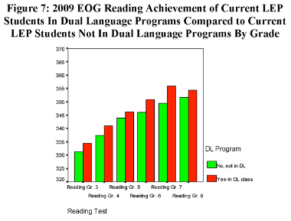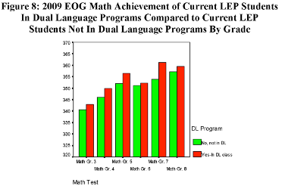
Source: W. P. Collier and V. P. Thomas. (2012) Dual Language Education For a Transformed World. DLeNM Fuente Press.

J. Steele, J. Watzinger-Tharp, R. Slater, G. Roberts, & K. Bowman, (2019): In the research brief titled “Student Performance Under Dual Language Immersion Scale-Up in Utah,” these investigators presented the student outcome data from an impactful, federally funded project called Partnership to Study Dual Language Immersion in Utah. The state-level study was constructed to measure the academic performance of dual language immersion students in Utah’s two-way and one-way programs. The research design specifically names the state’s accountability tests in the core content areas for dual language instruction as mathematics, science, and language arts in Grades 3 through 6 as the points for data analyses for 2009–2016. The published summary of the study’s findings indicates, consistent with studies in other states, that students in DL programs in the study’s seven Utah school districts academically outperformed students from the same school who were not in DL programs. The statistical analyses published in the research brief show:
… [the participating districts’] English speakers enrolled in DLE outperformed their peers by about 16% to 18% of a standard deviation in one-way programs and by up to 30% of a standard deviation in two-way programs. English learners in DLE programs outperformed their peers by 20% to 23% of a standard deviation in one-way programs and by 14% to 21% of a standard deviation in two-way programs.

J. Steele, R. Slater, G. Zamarro, T. Miller, J. J. Li, S. Burkhause, & M. Bacon (2017); Valentino & Reardon (2014, 2015); Lindholm-Leary & Block (2010): The research titled “Effects of Dual-Language Immersion Programs on Student Achievement: Evidence from Lottery Data” examines whether or not dual language learner outcomes had some relationship with whether or not families actually elected to participate in the educational program versus those students that were “lotteried” in by random selection in cohorts from 2004 to 2011 with academic monitoring through 2013. As such, the published findings confirmed that the dual language learners who were randomly assigned to the programs outperformed their peers on state reading tests by 13% of a standard deviation in Grade 5 and by 22% of a standard deviation in Grade 8.

In conclusion, DLE students, including EL-designated students, who were enrolled in quality DLE programs outperform non-DLE students on a variety of measures in English. In addition, they demonstrate strong competencies in the partner language.

Appendix B. Outreach to Potential Families
The following activities and strategies support the development of a strong foundation around bilingualism and multicultural competence.
- Partnerships with community-based providers to maintain ongoing informational campaigns about bilingualism and its advantages, including offering the families’ perspectives about the benefits of bilingualism.
- Offering of family information nights where explicit information about bilingualism and its advantages are integrated in the content provided to families.
- Collaboration efforts with bilingual community-based providers to engage in individual outreach to inform parents about Dual Language Education Programs and their advantages.
- Informational sessions to inform families and the community about the Seal of Biliteracy.
- Advanced scheduling of school tours at schools that offer Dual Language Education Programs.
- Development of informational flyers about Dual Language Education Programs and the benefits of bilingualism.
- Strategic use of social media outlets for information sharing providing messaging in multiple languages.
- Showcasing events such as panel presentations by bilingual/multilingual individuals about current topics of interest, as well as opportunities to speak with current students and their families and students who have graduated from the program.

Appendix C. More Examples of District Commitment
The following are actions that districts can take to intentionally plan and commit to the development of a well-researched and viable Dual Language Education program:
Initial Planning and Enrollment
- Carefully reviewing demographic and achievement data to consider trends and changes in linguistic populations to determine the program partner language and model that best meets the needs of students;
- Appointing district and school leaders who have the training, expertise, and decision-making authority to develop and articulate a clear vision for the program;
- Creating policies and processes that address a variety of topics related to DLE programs;
- Creating a well-established parent information center to meet with parents to discuss and explain program options;
- Making written materials about DLE programs available to parents in partner languages.
Staff and Professional Development
- Hiring linguistically and culturally diverse staff who meet any applicable license or endorsement requirements;
- Developing partnerships with institutions of higher education, consulates, community-based organizations, and teacher professional organizations to increase capacity for program implementation and sustainability;
- Hiring bilingual interventionists, special education teachers, and other personnel needed to help meet the learning needs of students with disabilities.
- Providing professional development specific to DLE pedagogical and student needs (including students with disabilities) on an ongoing basis;
- Fostering commitment by staff to the DLE program goals at the district and school levels;
- Establishing procedures for promoting sociocultural competence, such as trainings related to equity.

Curriculum, Instruction, and Assessment
- Developing targeted and thematic bilingual/biliteracy curricula that map out the content standards across English and the partner language in all content areas;
- Implementing a cohesive set of instructional principles and expectations for multilingual learners that are shared and communicated with teachers around student learning and achievement;
- Implementing an assessment tool to assess students’ language proficiency in the partner language;
- Assess and monitor students’ growth in both languages of instruction.

Appendix D. Considerations Once a District Has Decided to Implement a DLE Program
Enrollment and Outreach:
- How are community members invited to actively participate in programmatic decisions?
- Is communication sent in languages of the families represented in the district?
- How do students enter into the program? What does the process look like?

Program Design:
- How many minutes a day/week does each student spend learning in English? In the partner language?
- Are other student services available in both English and the partner language?

Assessment:
- Are students assessed in both program languages? When and how?
- Are assessment results reported out in program languages? When and how?
- What are program expectations for second language acquisition? How will this be assessed? How will it be documented?

Appendix E. Comparison of Initial Literacy Development in Spanish and English
The following is a metalinguistic comparison of two common DLE program languages, Spanish and English. Programs with other partner languages such as Portuguese, Haitian Creole, and Mandarin complete their own metalinguistic analysis to use while planning the biliteracy approach in their DLE programs.

Spanish | Literacy Element | English
The building blocks of Spanish literacy begin with the vowels and then move to consonants to form syllables. Understanding that there are strong vowels (a-e-o) and weak vowels (i-u) determines separation of words into syllables, accent rules, and impacts comprehension.  Students first write vowels and then consonants as emergent writers because the vowels are constant and regular (5 vowels make 5 sounds). | Vowels and consonants | The building blocks of English literacy begin with sounds in spoken language and the understanding that specific letters or combinations of letters represent those sounds.  The 26 letters in English make 44 sounds. So, instruction in sound-symbol correspondence needs to be carefully planned and build from simple to more complex, such as starting with predictable consonants, short vowels, and certain digraphs and blends.
Letter names are not taught in Spanish initially as they only confuse students (la “ese” for “s” sounds as though it is the “e” and not the “s”). Names of letters are learned formally once students have learned the letter sounds and can form syllables. | Alphabetic Principle | Awareness of phonemes is most important for reading ability, because in an alphabetic language like English, words are made of letter patterns that correspond to individual sounds. Instruction that begins with sounds and then attaches those sounds to spellings will support students in understanding the English code.
The concept of the accent is very important in Spanish, not only as it relates to writing and spelling (the orthographic accent as in papá) but also the diacritic accent (mí vs. mi) and the prosodic accent. Understanding how vowels and syllables are formed is fundamental to being able to use accents correctly in Spanish. | Accents | In English the concept of the accent is phonological, as in understanding the difference between ímport and impórt.
Phonological awareness occurs through writing, not through oral language development. In Spanish, if you can say it, you can write it, because of the tight relationship between sound and symbol.  The importance of rhyming in Spanish occurs at the end of the word when studying word families as in flor – florería – and florero, not at the beginning of the word as in English. | More about Phonological Awareness | Phonological awareness is developed orally and is fundamental in English literacy to be able to decode. Early phonological skills include awareness of syllables and onset-rime segments. Later, children develop the ability to blend and segment individual phonemes. Advanced phonemic awareness includes the ability to manipulate phonemes by substituting, reversing, and deleting phonemes and continues to develop into third grade and beyond.
Understanding how to chunk words into syllables is the most important skill in Spanish emergent literacy and it is the strongest predictor of long-term reading success in Spanish. | Syllables | The ability to hear syllables in words is an important early phonological skill that supports overall development of phonological and phonemic awareness. Direct instruction in multisyllabic words generally begins in grade 2 and moves on to advanced phonics in grades 3 and above for English.
Walls are categorized by the aspects of Spanish that are challenging. For example: b/v/ (barro) and v (vaso); c /s/z (césped), s (salsa) and z (zapato); silent h (hermano, húmedo); words with the gender-specific article (el problema and la mano). | Word Walls | Sound walls support phonemic awareness. They are organized by speech sounds, often show how the mouth is positioned when articulating specific sounds and can also be used to support sound-letter correspondences. See here and here for more.
No need for this list since all words can be decoded. A list of words that are challenging to write, and that match the word walls could be effective, but they would be very different words than those used in English. | Sight words | High-frequency words are words that show up often in lots of different texts, making automatic recognition of them important for fluent reading. Most high-frequency words are regular or have just one irregular spelling pattern. High-frequency words should be taught using their sound-spelling correspondences, not memorized as wholes.
Because it is so transparent and regular, the dictado is used to teach spelling along with punctuation and other grammar skills. Word lists are not used because they are not needed and they are limiting. | Spelling | Spelling instruction and decoding instruction should be integrated and aligned to a shared scope and sequence. Decoding and encoding “pull on” a similar set of phonological and phonics skills.  (29 letters in Spanish produce 26 phonemes whereas in English, 26 letters produce 40-56 phonemes).
Source: Beeman, K. and Urow, C. (2013). Teaching for Biliteracy: Strengthening Bridges between Languages. Baltimore, MD: Brookes Publishing, available at: http://www.teachingforbiliteracy.com/wp-content/uploads/2014/09/Comparing-initial-literacy-in-English-and-Spanish.pdf
The information in the English column was adapted from and informed by the evidence-based practices for early literacy in DESE’s Mass Literacy Guide.

Appendix F. Instructional Strategies

- Cross-linguistic Instruction
Cross-linguistic instruction includes strategies that focus on teaching students the metalanguage skills of cross-language expression in reading and writing. They may be formally and strategically planned or implemented when children need clarifications to help their understanding of lessons. The idea is to extend student’s knowledge from one language to the other and to make differences explicit to children through direct instruction.

- Cognates anchor charts and instruction
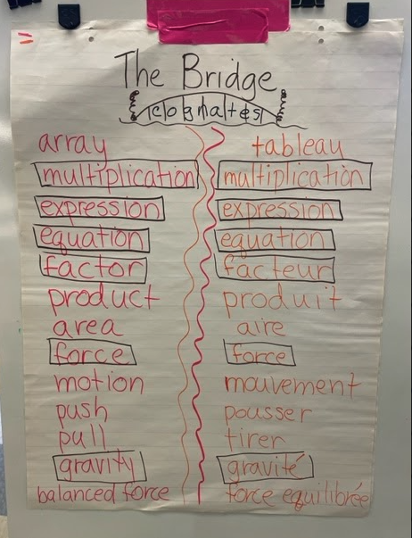
Source: George School Dual Language Education Program, Brockton, MA

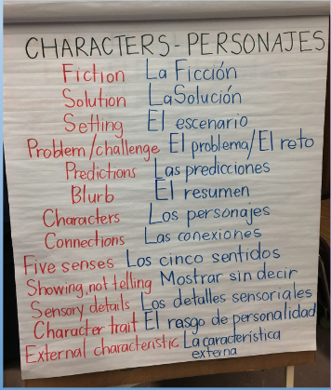
Source: Katie Brophy, 2nd grade, Amigos School, Cambridge, MA

- Contrastive analysis
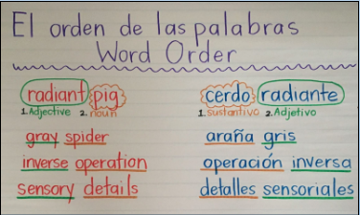
Source: Katie Brophy, 2nd grade, Amigos School, Cambridge, MA

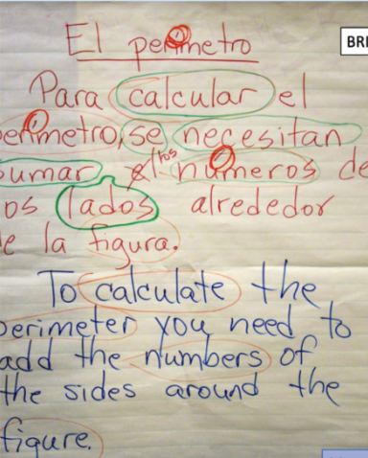
Source: George School, Brockton MA

- Bilingual word/concept walls
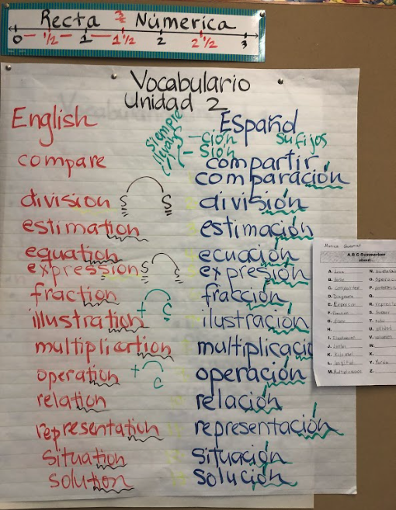
Source: George School Dual Language Education Program, Brockton, MA

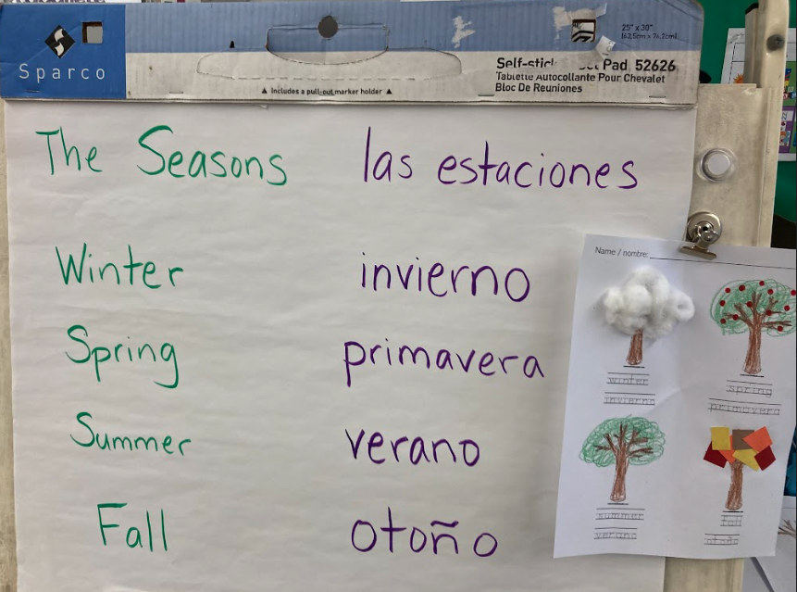
Source: George School Dual Language Education Program, Brockton, MA

- Así Se Dice
Así Se Dice is a cross linguistic strategy that validates translation as a constructive and worthwhile endeavor that engages students in complex, sophisticated scrutiny of language and emphasizes the subtleties and nuances of communicating messages across cultures and languages.

- El Dictado
The Dictado is a method used for teaching students writing conventions, reading fluency, spelling, grammar, and other features of language arts in an integrated way. Through use of The Dictado (dictation), multiple features of language arts; writing conventions, reading fluency, spelling, and grammar are taught and reinforced.

- Cognates
Cognates are words in two languages that share a similar meaning, spelling, and pronunciation, such as “information” in English and “información” in Spanish.

- Total Physical Response (TPR)
Total Physical Response is a language-learning approach based on the relationship between language and its physical representation or execution. TPR emphasizes the use of physical activity for increasing meaningful learning opportunities and language retention. A TPR lesson involves a detailed series of consecutive actions accompanied by a series of commands or instructions given by the teacher. Students respond by listening and performing the appropriate actions.

- The Bridge
The Bridge is the instructional moment when, after students have learned a concept well in the language of instruction, the teacher strategically and purposefully brings the two languages together to transfer content from one language to the other and to engage the students in contrastive analysis of the two languages. After the Bridge, extension activities in the other language allow students to use and apply the new labels. The Bridge is an effective instructional strategy for teaching for biliteracy.

Appendix G. Defining Holistic Bilingualism

Holistic Bilingualism | Parallel Monolingualism
Languages are viewed as mutually reinforcing; children are acknowledged to be capable of bidirectional transfer. | Languages must be strictly separated. They are thought to develop independently.
Literacy assessment is administered separately, but analyzed in both languages concurrently, for cross-language comparison and to document students’ biliteracy trajectories. | Literacy assessment in both languages is administered and analyzed separately, denying teachers opportunities to see how children work across languages.
Literacy assessment instruments are authentic, taking into consideration features of language organization and discourse styles that are unique to each language. | Literacy assessment instruments are a translation of English literacy skills and strategies, rather than authentic to the language assessed.
Students are expected to show different strengths in performance of tasks in different languages. | Bilingual students are expected to perform all linguistic tasks equally well in both languages.
Bilingual strategies are seen as part of the process of learning to read and write in two languages. | Bilingual strategies such as code-switching, lexical borrowing and bidirectional transfer (phonetic, syntactic, semantic and rhetorical structure) are viewed as markers of low language proficiency in both languages.
Biliteracy development is measured against development standards created for emerging bilinguals. | Bilingual students are compared to the performance expectations established for monolingual speakers of each language.
Source: Escamilla, K,. Hopewell, S., Butvilofsky, S, Sparrow, W., Soltero-Gonzalez, L, Ruiz-Figueroa, O., & Escamilla, M. (2014). Biliteracy from the Start, Literacy Squared in Action. Caslon Publishing

Appendix H. Regional and National Conferences
- MABE’s Regional Annual DLE Conference
- Dual Language Education New Mexico La Cosecha
- CABE
- NABE
- TESOL

Appendix I. DLE Teacher Preparation Programs in Massachusetts
- Boston College
- Bridgewater State College
- Framingham State University (program likely to start in Fall 2023)
- Lesley University
- U Mass Amherst
- U Mass Boston

Appendix J. Family and Community Engagement
- Implementation of positive campaigns about bilingualism and multilingualism and the benefits of DLE, including for students with disabilities. Effective campaigns may include celebrations of language and culture that validate the maintenance of partner languages and cultures in students’ experiences through their family lives and community activities.
- Informational materials and website content that describe DLE and its benefits, and that elevates bilingualism and multilingualism within the context of learning and development.
- Community workshops, curriculum and instructional nights, provision of DLE school materials and specific parent and community trainings in areas such as dual language acquisition in the primary grades.
- Explicit collaboration with families to orient them to the formal structures of communication connected to school improvement, such as parent advisory councils.
- Open door policies for families interested in volunteering, and integration of their input and perspectives as members of the school with knowledge about school life.
- Providing interpretation and translation services as needed. For example, providing an interpreter for IEP Team meetings.

Appendix K. Formative Assessment Examples
Formative assessments provide day-to-day information that teachers can use to guide their instruction and gain insights into their students’ language, literacy, and content learning progressions or trajectories. They can include performance tasks, written tasks, personal communication, tests, and curriculum-embedded assessments (Bailey & Heritage, 2008).

The list below is not intended to be exhaustive but may serve as a guide.

Oral language (Listening Comprehension and oral output)
- Read aloud or video viewing follow-up: verbal retell, picture drawing, questions, visual arts, play/dance; story retelling
- Turn-and-Talk
- Conferencing or oral interview
- Barrier Task (information gap activity)
- Rubrics
- Checklist (teacher and/or self-assessment “I can…”)
- Picture-cued descriptions or stories
- Audio files (listening for specific purposes)
- Oral reports
- Debates
- Observational notes
- Book talks
- Think alouds
Reading (comprehension, word/sentence/text level understandings)
- Retelling
- Literature response journals
- Anecdotal records
- Literature discussion groups
- Reading logs
- Interviews
- Exit tickets
Writing (word/sentence/text level; genre)
- Analysis of student work using rubrics
- Holistic writing rubric
- Analytic writing rubric
- Writing conferences
- Student self-assessment using checklist
- Analysis for translanguaging/cross-linguistic transfer

Resources:
Bailey, A. & Heritage, M. (2008), Formative Assessment for Literacy, Grades K-6), Thousand Oaks: Corwin Press;
Gottlieb, M. (2006). Assessing English Language Learners: Bridges from Language Proficiency to Academic Learning. Thousand Oaks: Corwin.
Gottlieb, M. (2021) Assessing English Language Learners: Bridges to Educational Equity. Thousand Oaks: Corwin Press.
O’Malley, J. M. & Valdez Pierce, L. (1996). Authentic Assessment for English Language Learners. New York: Longman.

Acknowledgements
The Department of Elementary and Secondary Education wishes to thank all individuals and groups who contributed to the development of this project.

Phyllis Hardy, MABE
Susan McGilvray-Rivet
Rebecca Westlake
Bertha-Elena Rojas
Michael Gary
Joan Lachance
Ester deJong
Allison Balter
Sibel Hughes
David Valade

State law defines the term “English Learner” as a student who does not speak English or whose native language is not English, and who is not currently able to perform ordinary classroom work in English. Please see G.L. c. 71A, § 2. See also 20 U.S.C. § 7801(20).
“MLLs” refers to students who regularly interact with and use several languages. The term encompasses a variety of student groups including dual-language learners, newcomers, students with interrupted formal schooling, long-term ELs, ELs with disabilities, gifted and talented ELs, heritage language learners, and students who speak non-dominant/non-standard and indigenous varieties of English (Source: WIDA English language development standards framework, 2020 edition).
Thomas & Collier (2017). Why Dual Language Schooling. Fuente Press.
Fortune, T. https://carla.umn.edu/immersion/documents/ImmersionResearch_Fortune.pdf; Lindholm-Leary, K. & Genesee, F. (2014), Student outcomes in one-way, two-way, and indigenous language immersion education, Journal of Immersion and Content-Based Language Education 2:2: 165-180; Goldenberg, C. & Wagner, K. (2014), Bilingual Education. Reviving an American Tradition. American Federation of Teachers. Retrieved June 1st, 2019 from https://www.aft.org/ae/fall2015/goldenberg_wagner
Thomas & Collier (2012). Dual language education for a transformed world. Fuente Press.
Grosjean, F. & Li, P. (2013). The Psycholinguistics of Bilingualism. Wiley-Blackwell.
Ibid.
https://www.nyu.edu/about/news-publications/news/2021/february/Code-Switching_and_Bilingual_Brain.html
Miramontes, O.B., Nadeau, A. & Commins, N.L. (2011). Restructuring Schools for Linguistic Diversity: Linking Decision Making to Effective Programs. 2nd Edition. NY: Teachers College Press.
Güilamo, A. (2022) - https://www.languagemagazine.com/2022/07/11/the-science-of-the-bilingual-reading-brain-2/
From Escamilla, K., Olsen, L., & Slavik, J. (2022). Toward Comprehensive Effective Literacy Policy and Instruction for English Learner/Emergent Bilingual Students. National Committee for Effective Education.
Howard, et al. (2018). The Guiding Principles for Dual Language Education, 3rd ed. Center for Applied Linguistics. Reference in this document to any specific commercial products, processes, materials, or services, or the use of any trade, firm, or corporation name is for the information and convenience of the public, and does not constitute endorsement or recommendation by DESE. Our office is not responsible for and does not in any way guarantee the accuracy of information in other materials referenced or accessible through links herein. DESE may supplement this list with other services, materials, and products that meet the specified criteria. For more information contact: sibel.hughes@mass.gov or 781-338-3569.
Lachance, J. & Honigsfeld, A. (in press). Collaboration and Co-Teaching for Dual Language Learners: Transforming Programs for Multilingualism and Equity.
A pedagogical process of utilizing more than one language within a classroom lesson or it can be used to describe the way bilinguals use their linguistic resources to make sense of and interact with the world around them. (Wikipedia)
U.S. Department of Education, Office of English Language Acquisition, Dual Language Education Programs: Current State Policies and Practices, Washington, D.C., 2015, available at: https://files.eric.ed.gov/fulltext/ED601041.pdfz.
ibid. See also G.L. c. 71A, § 2 (definition of DLE and TWI).
For more information about world languages, please see https://www.doe.mass.edu/worldlanguages/
G.L. c. 71A, § 2.
Please see Guidance on English Learner Education Services and Programming.
V. P. Collier and W. P. Thomas. (2018). Transforming Secondary Education: Middle and High School Dual Language Programs. DLeNM Fuente Press.
603 CMR 7.15(9)(c); see also 603 CMR 4.13(8)(c)(requirements relating to career vocational technical teachers).
603 CMR 7.15(9)(c); see also 603 CMR 4.13(8)(c) (requirements relating to career vocational technical teachers). For more information about licensure and endorsement requirements, please see the Department’s Guidance on English Learner Education Services and Programming, or contact the Department’s Office of Educator Licensure.
For further guidance on selecting a program model, please refer to Howard, E., Olague, N., & Rogers, D. (2003). The DualLlanguage Program Planner: A Guide for Designing and Implementing Dual Language Programs. Center for Research on Education, Diversity & Excellence.
Lindholm-Leary, K. Secondary Dual Language Education, In the Starlight, Research and Resources for EL Achievement, Issue 12, March 2015, http://www.elresearch.org
See also G.L. c. 71A, § 2.
As defined in G.L. c. 71A, § 2.
G.L. c. 71A, § 2.
Beeman, K. & Urow, C. (2013). Teaching for Biliteracy: Strengthening Bridges between Languages. Baltimore, MD: Brookes Publishing.
G.L. c. 71A, § 10; 603 CMR 4.00; 603 CMR 7.00.
MA DESE Blueprint, Pillar 2 Access to Educators and Pillar 3 Opportunity and Support
http://www.ccsso.org/resource-library/formative-assessment-examples-practice
Guiding Principles of Dual Language Education, 2017, CAL
http://www.ccsso.org/resource-library/formative-assessment-examples-practice
Beeman, K. & Urow, C. (2013). Teaching for Biliteracy: Strengthening Bridges between Languages. Baltimore, MD: Brookes Publishing.
Escamilla, K,, Hopewell, S., Butvilofsky, S, Sparrow, W., Soltero-Gonzalez, L, Ruiz-Figueroa, O., & Escamilla, M. (2014). Biliteracy from the Start, Literacy Squared in Action. Caslon Publishing
References in this document to any specific commercial products, materials, processes, or services, or the use of any trade, firm, or corporation name is for the information and convenience of the public, and does not constitute endorsement or recommendation by DESE. Our office is not responsible for and does not in any way guarantee the accuracy of information in other materials referenced or accessible through links herein. DESE may supplement this list with other services, products, and materials that meet the specified criteria. For more information contact: sibel.hughes@mass.gov or 781-338-3569.
Escamilla, K,, Hopewell, S., Butvilofsky, S, Sparrow, W., Soltero-Gonzalez, L, Ruiz-Figueroa, O., & Escamilla, M. (2014). Biliteracy from the Start, Literacy Squared in Action. Caslon Publishing, p. 69
Escamilla et al. Biliteracy from the Start
Beeman & Urow, C. Teaching for Biliteracy; Escamilla et al. Biliteracy from the Start.

