ESL: Animals and Where They Live
Language of Science Grades 1–2—English Language Proficiency Levels 2 and 3
For more information on the design process for the ESL MCUs, please see the Next Generation ESL Project: Curriculum Resource Guide.
This unit is intended to deliver systematic, explicit, and sustained English language development in the context of the Massachusetts Curriculum Frameworks. The purpose of this unit is to help ELs develop the language necessary for academic success in the content area of science. They will also learn language that will be used recurrently in and across various academic and social contexts.
The embedded language development of this unit centers on three of the Key Uses of Academic Language:
- Discuss by inquiring in order to build and present knowledge gathered through research.
- Explain by elaborating to build and present knowledge on a substantive topic.
Recount to summarize and record research findings.
These unit-level Focus Language Goals were created through an analysis of the driving language demands of the existing Model Curriculum Unit on content literacy/science for grade 1: “Informational Text, Research, and Inquiry Circles: Animals and Habitats.” However, this ESL unit is not the same as a sheltered English language arts/science unit. It is intended to be taught by an ESL teacher, and collaboration with the content teacher is essential. It is also important to keep in mind that in addition to the dedicated, language-focused instruction outlined in this unit, English learners (ELs) must also have access to all core academic content.
This unit offers students contextualized, extended practice with discourse, sentence, and word/phrase dimensions of academic language targeted in the unit. While learning about animals and where they live, students will develop language they can use to describe the world around them. By the end of the unit, students are equipped with the language resources needed to pose a research question, conduct research related to this question, and present findings from research.
This document was prepared by the Massachusetts Department of Elementary and Secondary Education, Mitchell D. Chester, Ed.D., Commissioner.
The Massachusetts Department of Elementary and Secondary Education, an affirmative action employer, is committed to ensuring that all of its programs and facilities are accessible to all members of the public. We do not discriminate on the basis of age color, disability, national origin, race, religion, sex, or sexual orientation.
© 2016 under the terms of the Creative Commons Attribution-NonCommercial-ShareAlike 3.0 Unported License. Additionally, the unit may also contain other third party material used with permission of the copyright holder. Please see Image and Text Credits for specific information regarding third copyrights.
Every effort has been made to acknowledge copyright. Any omissions brought to our attention will be corrected in subsequent editions.
Image and Text Credits:
Page 19 | "The Inquiry Process" from "Inquiry-Based Learning: an approach to educating and inspiring kids, http://youthlearn.org/. Copyright 2016 Educational Development Center, Inc. Reprinted with permission with all other rights reserved: http://www.edc.org/.
Page 20 | Forthcoming from The Permissions Group
Page 21 | welcomia/123RF LLC
Page 22 | Courtesy Diane S. Maehr.
Page 23 | Source: Steve Canipe
Page 24 | Source: City-Data.com
Page 25 | © Sheri Amsel, www.exploringnature.org. Used with permission.
Page 27 | Source: Cultural-China.com
Page 27 | Source: http://boowakwala.uptoten.com/
Page 29 | Forthcoming from The Permissions Group
Page 30 | amenic181/Shutterstock
Page 32 | Source: Alley Kids
Page 34 | Courtesy Cat Holloway.
Page 35 | Source: Earth Times
Page 36 | Forthcoming from The Permissions Group
Page 38 | Permission granted under Creative Commons License Attribution 2.0 Generic.
Page 39 | Source: http://zondade.top/sea-animals-for-kids/
Page 40 | © Sheri Amsel, www.exploringnature.org. Used with permission.
Page 41 | Forthcoming from The Permissions Group
Page 42 | Jan Daly/iStock by Getty Images
 | Source: Center for Biological Diversity
Page 44 | Forthcoming from The Permissions Group
Page 45 | Forthcoming from The Permissions Group
Page 46 | Forthcoming from The Permissions Group
Page 47 | Courtesy Tucson Audubon Society.
Page 48 | Courtesy McDowell Sonoran Conservancy.
Page 50 | Courtesy Robert Shantz.
Page 51 | Todd Gipstein/National Geographic Creative
Page 53 | Forthcoming from The Permissions Group
Page 54 | Forthcoming from The Permissions Group
Page 55 | Forthcoming from The Permissions Group
Page 56 | Courtesy Ian Joughin, http://bigice.apl.washington.edu/.
Page 58 | Joel Garlich-Miller/U.S. Fish and Wildlife Service via AP
Page 59 | Source: Sea Shepard Conservation Society
Page 60 | Courtesy John P. Parke.
Page 61 | © Nature Kenya
Page 62 | Courtesy Martin Harvey Productions.
Page 64 | © Americanspirit | Dreamstime.com
Page 64 | Forthcoming from The Permissions Group
Page 64 | Forthcoming from The Permissions Group
Page 64 | Joseph Sohm/Shutterstock
Page 74 and 106 | Bubble Map Graphic Organizer, courtesy Student Handouts, http://www.studenthandouts.com/.
Page 83 | Courtesy Totschooling, www.totschooling.net.
Page 84 | Source: Easy Pace Learning
Page 85 | Source: Simon Thomas
Page 87 | Courtesy Aquarium Care Basics, www.aquariumcarebasics.com.
Page 88 | Nikita Rogul/123RF LLC
Page 89 | Courtesy Danielle Dixson.
Page 90 | Forthcoming from The Permissions Group.
Page 91 | Source: SeaWorld San Diego
Page 122 | Source: http://letscolorit.com/

The contents of this Model Curriculum Unit were developed under a grant from the U.S. Department of Education. However, those contents do not necessarily represent the policy of the U.S. Department of Education, and you should not assume endorsement by the federal government.
Massachusetts Department of Elementary and Secondary Education, 75 Pleasant St, Malden, MA 02148-4906. Phone 781-338-3300, TTY: N.E.T. Relay 800-439-2370, www.doe.mass.edu

Table of Contents
Lesson 1 14
Lesson 2 65
Lesson 3 75
Lesson 4 91
Lesson 5 97
Lesson 6 105
Lesson 7 112
Lesson 8 117
Lesson 9 127
Lesson 10 135
Lesson 11 143
Lesson 12 150
Lesson 13 155

Unit Plan
Stage 1—Desired Results
ESTABLISHED FOCUS GOALS G  Focus Language Goals/Standards  G.1 Discuss by inquiring in order to build and present knowledge gathered through research.  G.2 Explain by elaborating to build and present knowledge on a substantive topic.  G.3 Recount to summarize and record research findings.  Content Connections  The student is building toward…  CCSS.ELA-LITERACY.L.1.6—Use words and phrases acquired through conversations, reading and being read to, and responding to texts, including using frequently occurring conjunctions to signal simple relationships.  CCSS.ELA-LITERACY.SL.1.4—Describe people, places, things, and events with relevant details, expressing ideas and feelings clearly.  CCSS.ELA-LITERACY.W.1.8—With guidance and support from adults, recall information from experiences or gather information from provided sources to answer a question.  CCSS.ELA-LITERACY.W.1.7—Participate in shared research and writing projects.  CCSS.ELA-LITERACY.SL1.5—Add drawings or other visual displays to clarify ideas, thoughts, and feelings. | Transfer
Students will be able to independently use their learning to…
T.1 Communicate for social and instructional purposes within the school setting.
T.2 Communicate information, ideas, and concepts necessary for academic success in the content area of language arts.
T.3 Communicate information, ideas, and concepts necessary for academic success in the content area of science.
 | Meaning
 | UNDERSTANDINGS U  Students will understand that…  U.1 Using language precisely can help them learn.  U.3 Asking questions can lead to new knowledge.  U.4 Learning is acquired from multiple sources.  U.5 Animals that live in the same region may share some characteristics. | ESSENTIAL QUESTIONS Q  Q.1 How can you use language in different ways?  Q.2 How do we use language to learn about new things?  Q.3 How do we learn about where animals live?
 | Language Acquisition in the Four Domains
 | KNOWLEDGE K  Students will know…  K.1.a Writing conventions for paragraphs composed of simple sentences that include content-specific vocabulary. (L2)  K.1.b Writing conventions for paragraphs composed of compound sentences that include content-specific vocabulary. (L3)  K.2.a Structure of simple questions that include content-specific vocabulary. (L2)  K.2.b Structure of compound questions that include content-specific vocabulary. (L3)  K.3 Meaning, purpose, and appropriate use of frequently occurring modifiers such as prepositions/prepositional phrases (e.g., on, in, above, under) and adjectives (e.g., color, temperature).  K.4 Meaning, purpose, and appropriate use of wh- question words (why, what, when, where, who).  K.5 How to give an oral summary of information.  K.6 How inquiring leads to learning new knowledge.  K.7 Content-specific language related to the topic of animals, including characteristics of animals and the habitats/regions where they live.  K.8 Components of oral and/or written summaries of multiple, related simple sentences and/or paragraphs from content area texts. | SKILLS S  Students will be skilled at…  S.1 Summarizing orally by recounting main ideas and supporting details.  S.2 Summarizing most important/relevant information from multiple, related simple sentences and/or paragraphs from content area texts orally and in writing.  S.3 Describing key details of animal habitats/regions where animals live using frequently occurring modifiers orally and in writing.  S.4 Elaborating on animal habitats using frequently occurring linking words/conjunctions to share information learned through inquiry.  S.5 Acquiring information through inquiry from multiple related simple sentences/paragraphs from content area texts and various media.  S.6 Asking simple and compound questions using wh- question words.
Stage 2—Evidence
EVALUATIVE CRITERIA | ASSESSMENT EVIDENCE: Language Development
- Individual ability to participate in the process of inquiry as evidenced by creation of questions using wh- question words and identification of most relevant information from sources.  - Ability to effectively summarize information orally and/or in writing by recounting main ideas and supporting details.  - Accurate use of prepositions (e.g., on, in, under, above) and adjectives (e.g., color, temperature) when describing orally and in writing.  - Use of conjunctions (and, or, but, because) orally and in writing.  - Accurate use of content vocabulary (e.g., habitat, region, forest, arctic, grasslands, desert, ocean, need) orally and in writing.  - Appropriate use of language from discourse, sentence, and word/phrase dimensions. | CURRICULUM EMBEDDED PERFORMANCE ASSESSMENT (Performance Tasks) PT  Students will prepare an oral presentation about an animal and its habitat for zoo experts looking to create a new zoo exhibit that answers questions students their age may have about animals. Working in small groups, students will first pose questions about an animal that lives in a specific region (polar, forest, grasslands, desert, and ocean), then research this specific region to answer posed questions. Finally, each individual student will get a chance to present his or her proposed question(s) about an animal that lives in the region, along with an image or picture of the animal and where it lives, as presenters to a panel of zoo experts.
OTHER EVIDENCE OE
thumbs up/down; exit tickets; turn-and-talks; think-pair-shares; oral discussion; teacher observation; participation; daily check-ins; oral identification; oral descriptions; oral retelling; orally asked questions; written questions, including adjectives, prepositions, and conjunctions; animal “Guess Who?” game; headbands-like game; sentences created orally and in writing; graphic organizer with reading ideas; summary graphic organizer; editing with teacher
Stage 3—Learning Plan
SOCIOCULTURAL IMPLICATIONS
Register:
Delivering an oral presentation in front of the whole class may be a new concept for some students.
Topic:
Animals are valued differently in different cultures. Some students may not know that animals, zoos, and information about animal habitats are interesting topics to children in the United States.
Task/situation:
Some students may be more comfortable expressing themselves in words or short phrases rather than complete sentences.
Some students may need explicit instruction in classroom culture/climate and common instructional activities, such as partner work, small group work, whole class discussion, and individual presentations.
Identity and social role:
Being a presenter (especially presenting on their own) may be a new role for some students. Students may also be new to being an active listener during class presentations.
SUMMARY OF KEY LEARNING EVENTS AND INSTRUCTION

Lesson 1: Days 1 and 2—Introduction to Inquiry and Essential Questions
- Language objective: Students will be able to discuss animals and their habitats by identifying and using key content vocabulary (e.g., habitat, need, inquiry).
Brief overview of lesson: Students will be introduced to the process of inquiry as a method for conducting research. Students will also develop their understanding that animals live in certain areas by watching a video that will introduce different animals and different habitats. Students will take part in a formative assessment that will evaluate their ability to form questions on their own. Students will begin to develop inquiry skills that they will use to build and present knowledge gathered through research.
Lesson 2: Days 3 and 4—Creating Simple Wh- + H- Questions
- Language objective: Students will be able to inquire by asking and answering questions using wh- + h- question words (e.g., what, where, when, who, why, how).
Brief overview of lesson: Students will develop their understanding of question words, question formation, and how to inquire about a topic using questions. They will be introduced to the characteristics and inhabitants of a forest. Students will also begin learning about the inquiry process by using step 1: “Pose Real Questions,” from “The Inquiry Process” chart. Students will further develop their ability to Discuss by inquiring in order to build and present knowledge gathered through research.
Lesson 3: Days 5 and 6—Creating Simple Wh- + H- Questions and Using Prepositions
- Language objective: Students will be able to describe oceans and ocean animals using prepositions of place (e.g., on, in, between, under).
Brief overview of lesson: Students will continue to work with wh- + h- question words, developing their ability to inquire about a topic by asking questions and practicing step 1 of the inquiry process: “Pose Real Questions.” They will begin learning prepositions of place and continue building background knowledge about animals and their habitats by learning about the characteristics and inhabitants of oceans. Student knowledge of prepositions will be used in the culminating performance assessment to Explain by elaborating to build and present knowledge on a substantive topic. Students will also continue learning about summaries by co-creating a summary about oceans with the teacher.
Lesson 4: Day 7—Using Wh- + H- Questions and Prepositions to Discuss the Desert
- Language objectives:
- Students will be able to inquire about deserts and desert animals by asking and answering questions.
- Students will be able to discuss deserts and desert animals using prepositions of place (e.g., on, in, between, under).
Brief overview of lesson: Students will continue to develop their understanding of and ability to use question words and prepositions of place. They will continue building background knowledge about animals and their habitats, and expand their ability to inquire by practicing step 1 of the inquiry process: “Pose Real Questions.” Students will also be introduced to the characteristics and desert inhabitants, and continue learning about summaries by co-creating a summary about deserts with the teacher. Student knowledge of questions and prepositions of place will be used in the culminating performance assessment to Explain by elaborating to build and present knowledge on a substantive topic.
Lesson 5: Days 8 and 9—Adjectives and Questioning
- Language objective: Students will be able to describe animals and habitats orally and in writing using adjectives.
Brief overview of lesson: Students will learn about adjectives that describe forest, ocean, desert, and polar animals. They will continue building background knowledge about animals and their habitats, and will continue learning about the inquiry process by using step 1: “Pose Real Questions,” a core skill of the CEPA. Students will also begin learning how to elaborate, a skill which will be applied in the CEPA, about a specific topic using adjectives to provide more details. In addition, students will be introduced to the skill of conducting detailed research. Finally, students will continue expanding their knowledge about summaries by co-writing a summary about animals that live in the polar region with the teacher.
Lesson 6: Day 10—Elaborating, Categorizing, and Questioning
- Language objective: Students will be able to describe animals orally and in writing using adjectives.
Brief overview of lesson: Students will learn about adjectives that relate to forest, ocean, desert, polar, and grasslands animals. Students will continue to develop their ability to elaborate by using adjectives, and they will continue building background knowledge about animals and their habitats. Students will also continue learning about the inquiry process by practicing step 1: “Pose Real Questions.” Finally, students will begin categorizing animals introduced in previous lessons into their natural habitats to develop their ability to summarize information, a skill necessary for communicating research findings.
Lesson 7: Day 11—Elaboration, Categorizing, and Questioning
- Language objective: Students will be able to describe animals orally and in writing using adjectives.
Brief overview of lesson: In this lesson, students will practice using adjectives describing forest, ocean, desert, polar, and grasslands animals and continue learning how to elaborate using adjectives. Students will continue building background knowledge about animals and their habitats by categorizing animals into their natural habitats, and they will continue practicing the inquiry process by using step 1: “Pose Real Questions.” In addition, students will continue to develop an understanding of how to summarize text and how to conduct research, skills central to the CEPA.
Lesson 8: Day 12—Language Checkpoint
- Language objective: Students will be able to inquire about and discuss animals and their habitats using academic language learned so far in the unit (e.g., prepositions of place, adjectives, and question words).
Brief overview of lesson: Students will have an opportunity to demonstrate academic language they have learned in the unit so far. This lesson provides an opportunity to assess student learning in relation to the Focus Language Goals.
Lesson 9: Days 13 and 14— Creating Simple and Compound Sentences
- Language objective: Students will be able to describe animals and their habitats orally and in writing using simple and/or compound sentences.
Brief overview of lesson: Students will review the structure of a simple sentence and practice writing them. As students conduct research to learn more about animals and where they live, they will learn and use step 2 of the inquiry process: “Find Resources.” They will summarize information gathered from leveled readers using simple sentences, and will practice saying them using puppets. Students will continue to develop the skills needed to Discuss by inquiring in order to build and present knowledge gathered through research.
Lesson 10: Days 15 and 16—Planning for the CEPA
- Language objective: Students will be able to summarize and discuss information gathered through research using academic language (e.g., adjectives, prepositions of place) and content vocabulary introduced in the lesson.
Brief overview of lesson: This lesson provides an overview of the CEPA. Students will learn about the CEPA instructions, have opportunities to ask clarifying questions about it, and be assigned a region/habitat to research. Students will practice using step 3 of the inquiry process, “Interpret Information,” by gathering information for their CEPA using class anchor charts and other teacher-provided resources and recording this information on the CEPA planning sheet. Students will also practice step 4 of the inquiry process, “Report Findings,” by creating an illustration to share what they have learned through research. Finally, students will have opportunities to monitor their work with a small group and apply academic language learned throughout the lesson. Students will apply learned language in preparation for the final culminating performance assessment.
Lesson 11: Days 17 and 18—Drafting Summaries
- Language objective: Students will be able to summarize information collected from research by writing simple and/or compound sentences.
Brief overview of lesson: Students will continue to work on the CEPA by researching individual question(s) for their proposed zoo exhibit using information collected as a class and other resources provided by the teacher. Students will practice completing step 3 (“Interpret Information”) and step 4 (“Report Findings”) of the inquiry process, summarizing and reporting their research findings. Students will have a chance to work with their groups to check their work and ensure it is aligned with what they have learned.
Lesson 12: Day 19—Editing, Revising, and Composing Final Drafts
- Language objective: Students will be able to summarize information gathered through research using simple and/or compound sentences.
Brief overview of lesson: Students will continue to work on the CEPA, using step 4, “Report Findings,” of the inquiry process. Students will also edit and revise their presentation materials with support from the teacher. Students will develop an understanding of how to prepare and present research findings.
Lesson 13: Day 20—Completing the CEPA
Language objectives:
- Students will be able to discuss information researched by orally presenting their summaries and illustrations.
- Students will be able to describe animals and their habitats using content vocabulary, prepositions of place, and complete sentences.
Brief overview of lesson: Students will use step 4, “Report Findings,” of the inquiry process. They will also complete the CEPA by giving an oral presentation to show what they have learned throughout the unit and assessing their own performance.
Adapted from Understanding by Design®. © 2012 Grant Wiggins and Jay McTighe. Used with permission.

Lesson 1  Days 1 and 2 | Introduction to Inquiry and Essential Questions | Estimated Time: 60 minutes per day

Brief overview of lesson: Students will be introduced to the process of inquiry as a method for conducting research. Students will also develop their understanding that animals live in certain areas by watching a video that will introduce different animals and different habitats. Students will take part in a formative assessment that will evaluate their ability to form questions on their own. Students will begin to develop inquiry skills that they will use to build and present knowledge gathered through research. As you plan, consider the variability of learners in your class and make adaptations as necessary.
What students should know and be able to do to engage in this lesson:
- Look at an image and identify some of its details.
- Watch a video and learn new information from it.
- Participate in pair and group discussions.
- Listen to and follow simple directions.
- List names and habitats or homes of common animals, such as dogs, fish, birds, water, nests, etc.
- Contribute to the creation of webs or semantic maps.
Write a simple sentence (or at least have some exposure to the process of writing simple sentences).
LESSON FOUNDATION
Unit-Level Focus Language Goals to Be Addressed in This Lesson |  | Unit-Level Salient Content Connections to Be Addressed in This Lesson
G.1 Discuss by inquiring in order to build and present knowledge gathered through research. |  | CCSS.ELA-LITERACY.L.1.6—Use words and phrases acquired through conversations, reading and being read to, and responding to texts, including using frequently occurring conjunctions to signal simple relationships.
Language Objective |  | Essential Questions Addressed in This Lesson
Students will be able to discuss animals and their habitats by identifying and using key content vocabulary (e.g., habitat, need, inquiry). |  | Q.2 How do we use language to learn about new things?  Q.3 How do we learn about where animals live?
Assessment
- Formative assessment: Ask students to view images of different animal habitats. Have them orally identify what they see in the images and attempt to orally formulate questions to identify what they want to know about animals and where they live.
- Formative assessment: Ask students to identify and describe what makes a good habitat for an animal, orally and/or in writing.
- Self-assessment: Students will reflect on and summarize what they learned in the lesson.
Thinking Space: What Academic Language Will Be Practiced in This Lesson?
Discourse Dimension | Sentence Dimension |  | Word Dimension
Social instructional language; non-fiction informational text and/or short videos containing content area vocabulary and simple sentences; stating thoughts and opinions | Simple sentences with present tense verbs |  | Content vocabulary (habitat, animal, home, inquiry/inquire); additional academic vocabulary pertaining to texts/videos used in the lesson
Instructional Tips/Strategies/Suggestions for Teacher
- Use images and drawings when making charts with students.
- Display one column of “The Inquiry Process” chart at a time.
- Consider providing students with sentence frames to facilitate the turn-and-talk.

STUDENT CONSIDERATIONS
Sociocultural Implications
- Various cultures place different levels of significance on animals. Some cultures consider animals sacred.
- Some students may be unfamiliar with zoos, or may think that confining animals in a zoo is not right. Consider providing students with additional time to develop background knowledge about zoos.
- Some students may be unfamiliar with the various temperature regions in the world.
- Some students may not realize the importance of habitats for animals. They may also realize for the first time that animals are an important part of our world and that people should be aware/respect animals and their habitats.
Anticipated Student Pre-Conceptions/Misconceptions
- Some students may think that all dogs/cats/common pets live in houses and not out in the wild, while others may think that all animals only live outdoors and not in houses.
- Students may think that any animal can live in any region or habitat.
- Students may think that the climate in their home community represents the climate for the entire world.
- Students may think that all animals are friendly and/or that any animal could be a pet.
- Students may think that all animals live together in groups.

THE LESSON IN ACTION

Day 1 Lesson Opening

Post and explain the lesson language objective: “Students will be able to discuss animals and their habitats by identifying and using key content vocabulary (e.g., habitat, need, inquiry).” To promote student ownership and self-monitoring of learning, consider having students record the objective in their notebooks or having students summarize the objective in their own words. At the end of the lesson, students can reflect on their learning in relation to the objective.

Post the title of the unit on the board: “Animals and Where They Live.” Ask students to think about what they know about animals and where they live. Allow some time for quiet reflection before inviting students to share with a partner.
Provide options for perception, such as having students view the title on a computer or providing students with a printed version.
Provide options for physical action, such as using Post-Its or a whiteboard to record thoughts before sharing.

After students have had a chance to share with their partners, invite them to a class discussion. Consider starting a know–want to know–learned (K-W-L) anchor chart that can be revisited throughout the unit. If using a K-W-L chart, record student responses on it as students share.
Provide options for perception, such as using a shared file so students can view the chart on a computer.

During the Lesson

Let students know that this lesson marks the beginning of a new unit where they will have the opportunity to learn academic language needed to discuss different types of animals and where they live.

Ask students to think about what they would need to do to learn about where animals live.

Say: “If we want to learn about where animals live, what can we do to learn about it?” Also, consider asking: “Have you ever wanted to learn more about an animal and where it lives? What did you do to learn more about the animal?” These questions can help personalize learning for students and heighten engagement.

Provide students with some time for quiet reflection. Ask them to write, draw, or orally describe their response.

Then have them share with a partner or small group before discussing as a whole class. Provide students with sentence frames, such as: “We learn about where animals live by _____”; “We can learn about where animals live by _____”; “I think _____”; “I have learned about animals by _____.” Record student responses during the whole group discussion on chart paper and save for later.

Introduce the CEPA. Explain how at the end of the unit students will be asked to demonstrate their learning by orally presenting information about an animal and its habitat, or where it lives. Go over task details, including student roles. For example, say: “Our class has been asked by zoo experts to help create some exhibits for a new zoo. The zoo experts want to make an exhibit about animals and where they live for each of these regions: polar, forest, grasslands, desert, and ocean. The zoo experts will listen to presentations from our class about the animals that live in each region. The zoo experts really want to know what information children your age want to know about the animals that live in these regions. You will research one of the regions with a small group. Your small group will focus on one region and will summarize key information about it. Then each one of you will get a chance to present a question(s) about an animal that lives in the region your group researched. The zoo experts want each presenter to pose, or ask, a question that students your age would ask, provide information answering the question, and an image showing the animal and where it lives.”
Provide options for perception, such as projecting the information about the CEPA on an overhead, providing a printed version of the CEPA details, or displaying a sample CEPA.

Let students know that throughout the unit they will learn the language needed to research about an animal and present to the zoo experts. Depending upon student familiarity with zoos, you may wish to activate and/or build background knowledge about them. Consider showing students a video of a zoo, such as “Brief Tour of San Diego Zoo” or “We’re Going to the Zoo/Children Love to Sing Kids Animal Song.” You may wish to offer a video viewing station so that students may view these videos independently, pausing to ask for clarification as needed.

Explain how students will use the inquiry process to learn about animals and where they live and make recommendations to zoo experts at the end of the unit. Post “The Inquiry Process” chart and point to it while explaining.

Pre-teach key content vocabulary: habitat, animal, home, inquiry/inquire, need. Use the seven-step vocabulary teaching method or another similar vocabulary teaching strategy that includes more than just a verbal discussion of new words. Word walls, native language translations, and images can be used to support exploration of this vocabulary.

Introduce the gallery walk by telling students how they will look at some of the animals that will be studied throughout the unit and where they live.

Post images of animals from a variety of regions, grouping animals together in their respective habitats. Label each region, animal, and habitat.

Explain how students will get up and walk around the room to see all the animals and habitats. Provide students with a focus question to think about while they walk. For example, ask students to think about what they notice in the images and orally identify what they see in them. Ask students to also create questions about what they want to know about animals and where they live.

Have students walk around the room to look at all the animals and habitats in a gallery walk.
Provide options for perception, such as viewing the images on a computer, providing students with print outs of the images, or showing the images in a PowerPoint.

As students are reviewing the images circulate and ask questions to prompt student thinking such as: “What do you notice in this image?” “What do you see in this image?” “What would you like to know about this habitat?” “What would you like to know about this animal?” This can serve as a formative assessment of an individual student’s ability to describe images, formulate questions, and use key vocabulary.

Lesson Closing

Ask students to share with a partner what they noticed during the gallery walk or one thing that they want to learn more about.

Have students complete an exit ticket where they state one thing they noticed in the gallery walk or one thing that they want to learn more about. Record what students would like to know more about on the class K-W-L chart, if using one.

Day 2 Lesson Opening

Begin by having the term habitat posted on the board. Ask students to quietly think about a definition of the term and then share it with a partner. Invite students to share their definitions with the whole class. This can serve as a quick formative assessment of student understanding of this key term. At this point, students should bring up how a habitat is a home for an animal and that it meets an animal’s needs.

Debrief the opening by building on students’ responses. Liken a habitat to a home and ask students to think about what makes something a home (such as food, shelter, etc.). Through this discussion, students can begin to develop an understanding of what makes a good habitat for an animal.

During the Lesson

Introduce the next activity (reading a book or watching a video about animal habitats).

Provide students with a question to consider before reading or watching the video. For example, if watching the “Magic School Bus Hops Home” video or reading the book, ask students to think about why the pond is a good habitat for a frog beforehand. Then have them listen for two to three things that make the pond a good place for the frog to live in while they watch the video or listen while the book is read aloud. Consider offering a video viewing station where students can watch this video independently, use translated captions, or pause and ask clarifying questions as needed. During the video or while reading, pause periodically to ask questions, model metacognitive or metalinguistic strategies (such as using context clues to figure out unknown words, or how to identify the main idea and supporting details), and summarize information. This teacher modeling of summarization can help students begin to learn about what a summary sounds like and what a summary consists of. Through teacher modeling of summarization, students will begin to see what a summary looks like. Encourage students to ask questions, informally assessing student use of question words.

After watching the video or reading the book, ask students to think about what made the pond a good habitat for the frog. Students can record two to three things that made the pond a good place for the frog to live.
Provide options for physical action, such as writing, drawing, or orally describing.

Have students share their responses with a partner or small group, then invite them to share with the whole class. Record student responses.

Debrief the reading or video by asking students to share with a partner or small group: “What makes a good habitat?”
Provide options for physical action, such as writing, drawing, or orally sharing their response.

After students have had the opportunity to share, invite them to a class discussion about the characteristics of good habitats. Record student responses and connect the discussion back to the lesson opening conversation about what makes a good home. This discussion can provide a formative assessment of students’ ability to use content area vocabulary.

Lesson Closing

Ask students to draw one thing that they learned from the video and/or book. Ask them to label the image with words, phrases, and/or sentences.
Provide options for physical action, such as dictation, writing, using a computer to label the image, or using pre-made labels.

Have students do a think-pair-share about one thing they learned from the video and/or book. Provide sentence frames, such as: “In the book ____”; “In the video____”; “I learned that ____.”

Lesson 1 Resources
- Chart paper for anchor chart
- Paper/Clipboard to record student-generated questions during the gallery walk (use as pre-assessment)
- Markers
- Videos:
- “Magic School Bus Hops Home” (or book)
- “Brief Tour of San Diego Zoo”
- “We’re Going to the Zoo/Children Love to Sing Kids Animal Song”
- “The Inquiry Process” chart (available below)
- Images of animals, habitats, and ecosystems, such as those at DK Find Out! (sample images also available below)

The Inquiry Process
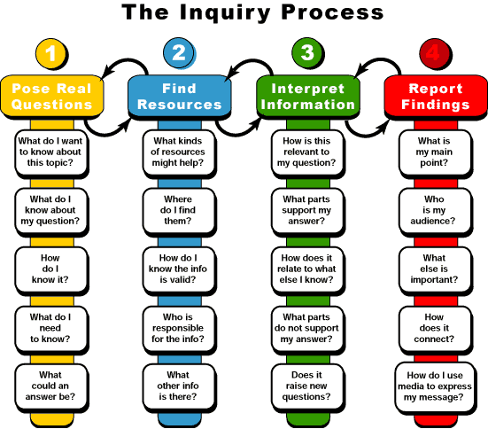
Source: https://s00077474.files.wordpress.com/2011/08/the-inquiry-process.gif
Sample Images for Gallery Walk and for Use with Each Region
- FOREST
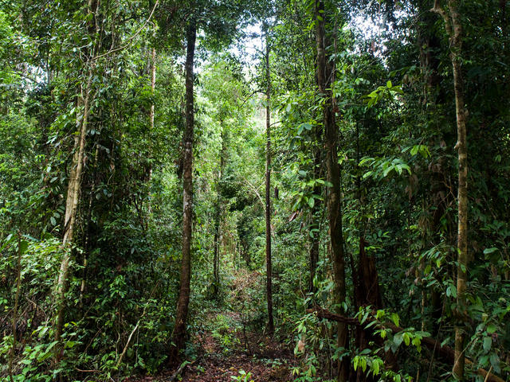
Source: http://www.worldwildlife.org/habitats/forest-habitat
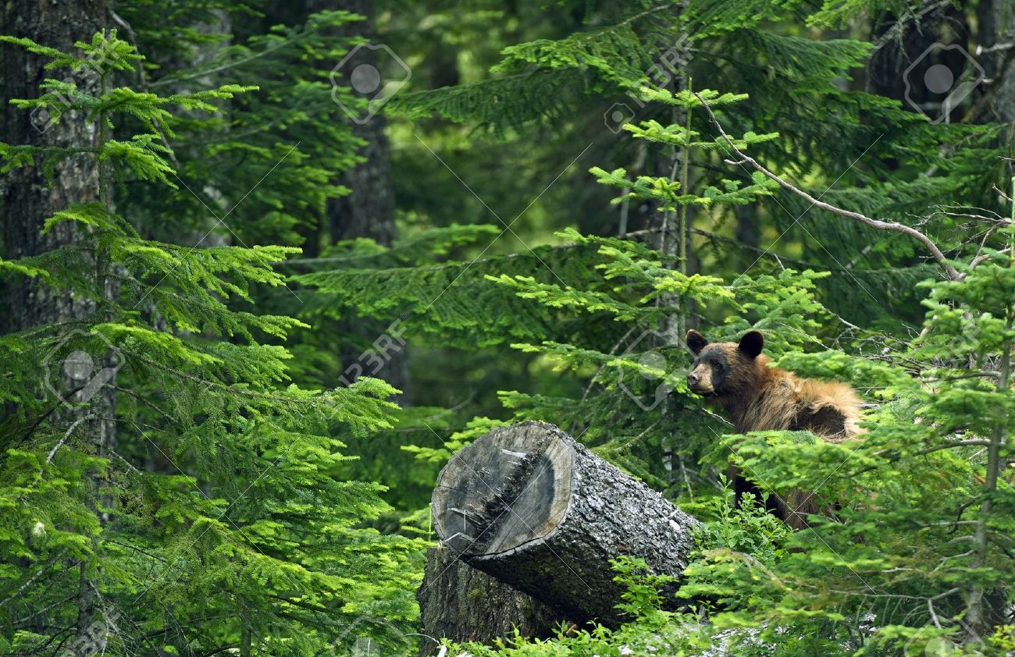
Source: http://www.123rf.com/photo_14699536_black-bear-in-forest--british-columbia-canada-black-bear-in-his-habitat-canadian-wildlife-photograph.html
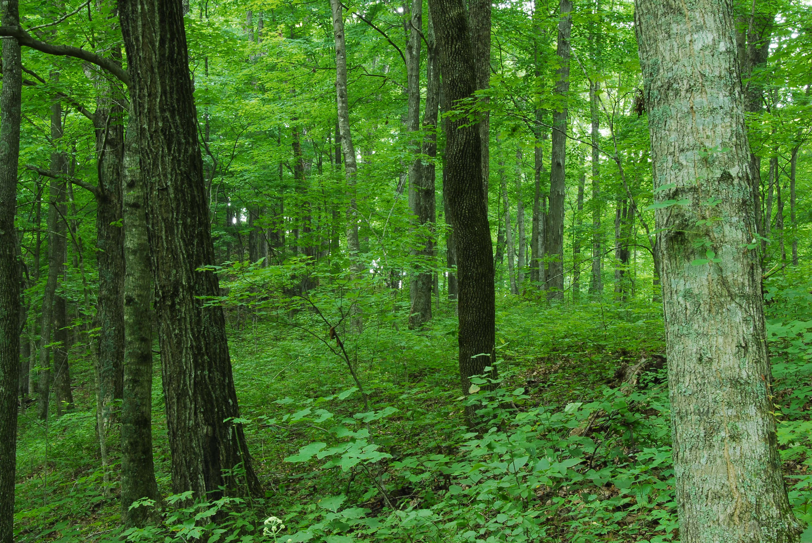
Source: http://www2.ca.uky.edu/forestry/maehrbearky.php
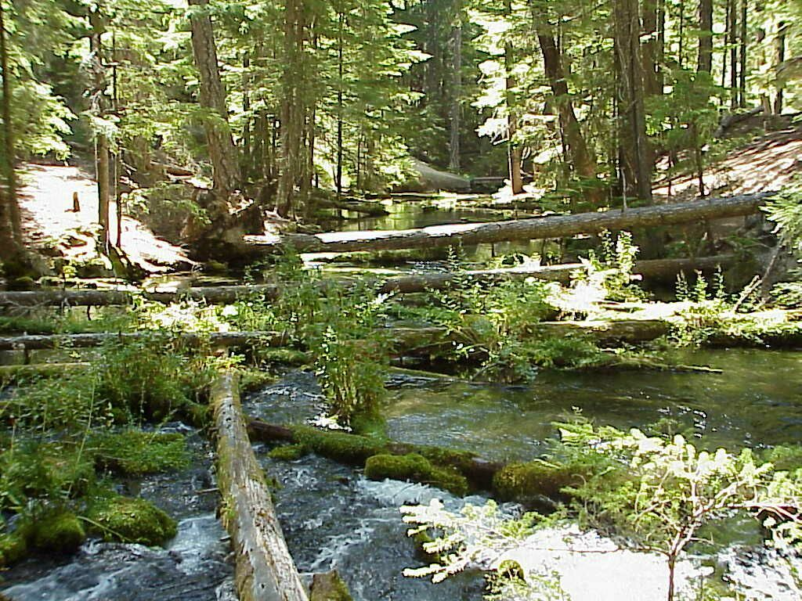
Source: https://www.pics4learning.com/details.php?img=stream.jpg
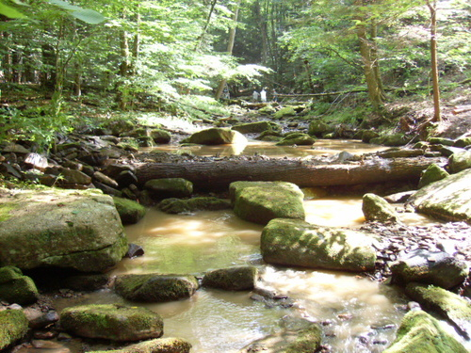
Source: http://www.city-data.com/picfilesv/picv33822.php
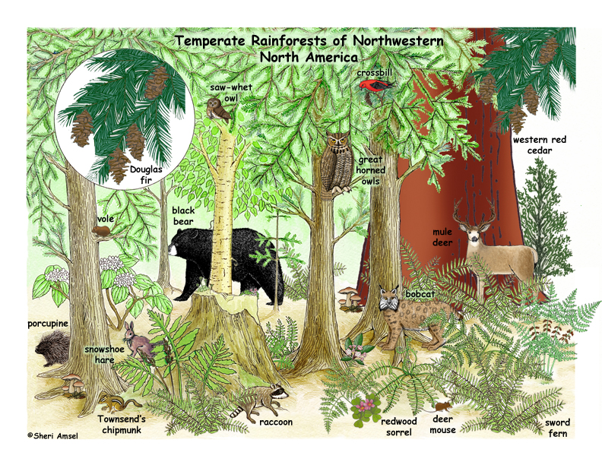
Source: https://www.exploringnature.org/db/view/1745
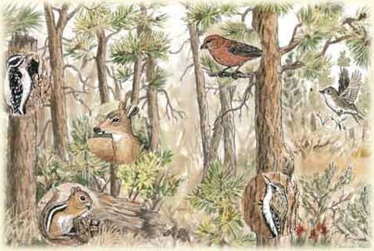
Source: United States Department of Agriculture: Forest Service
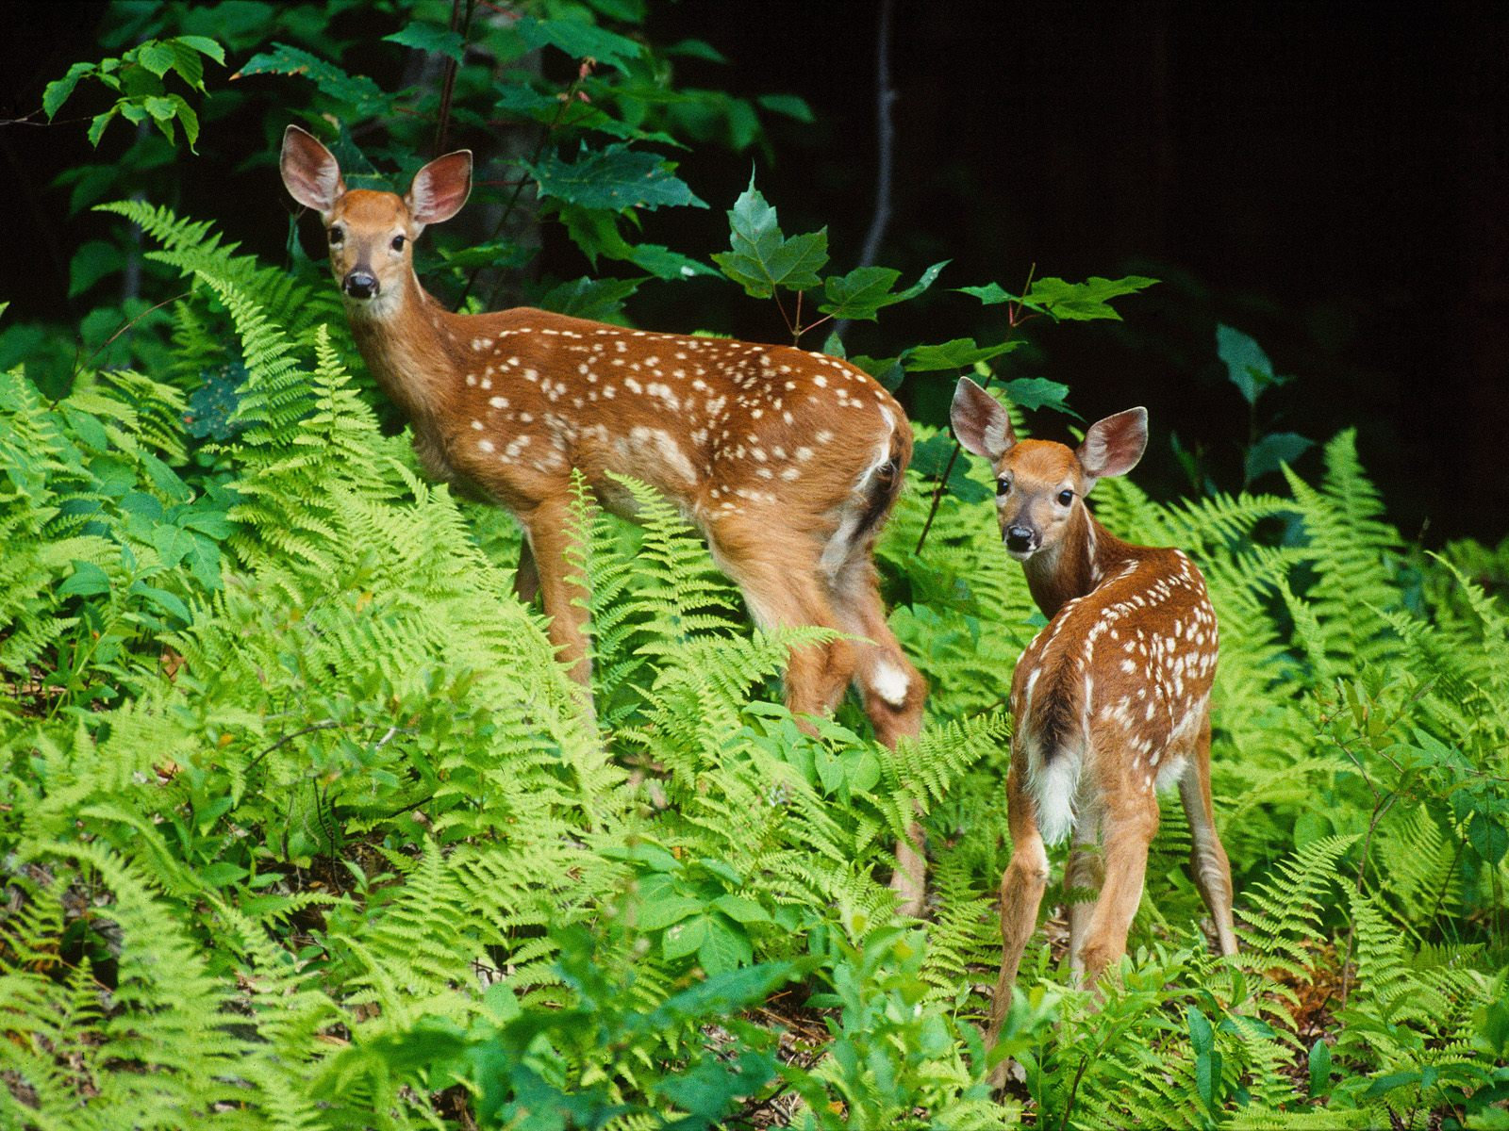
Source: http://www.pageresource.com/wallpapers/22929/animals-high-quality-pictures-forest-animal-2-hd-wallpaper.html
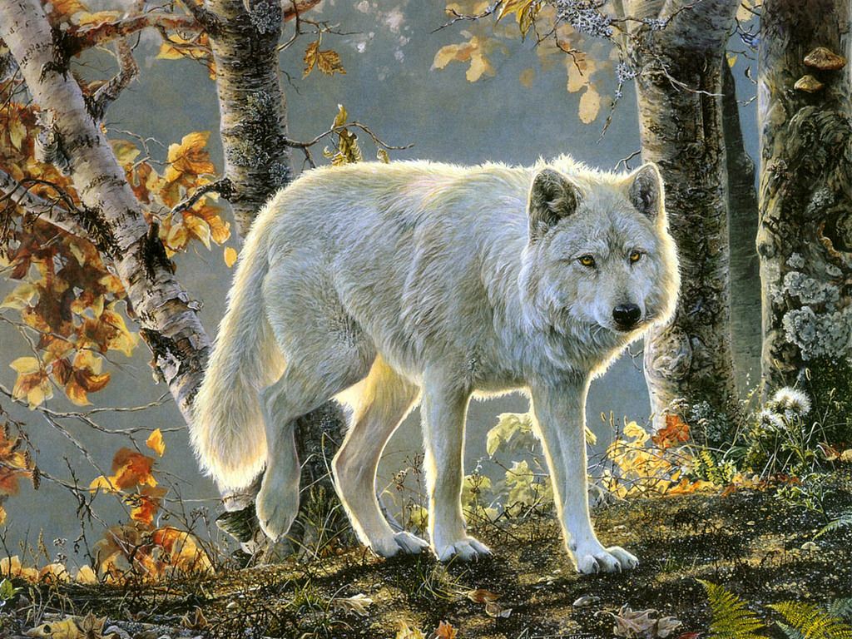
Source: https://dvirfixler.wordpress.com/forest-animals/
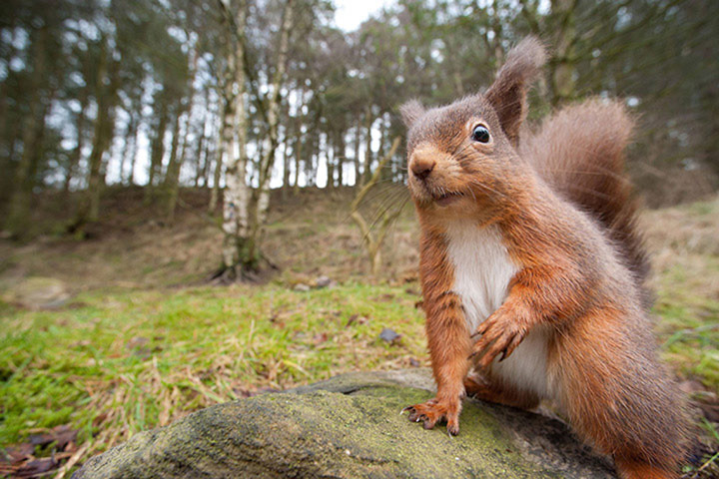
Source: Photograph, Red Squirrel, Will Nicholls Photography
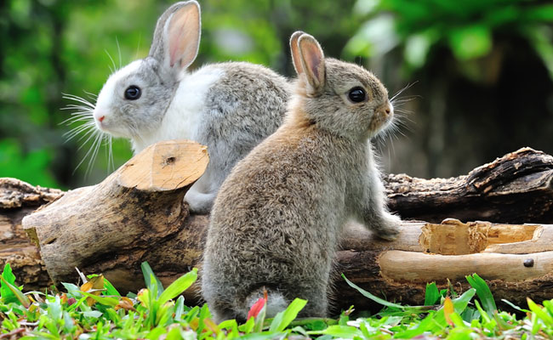
Source: Photograph, Two Bunnies in the Garden, Amenic181/Shutterstock
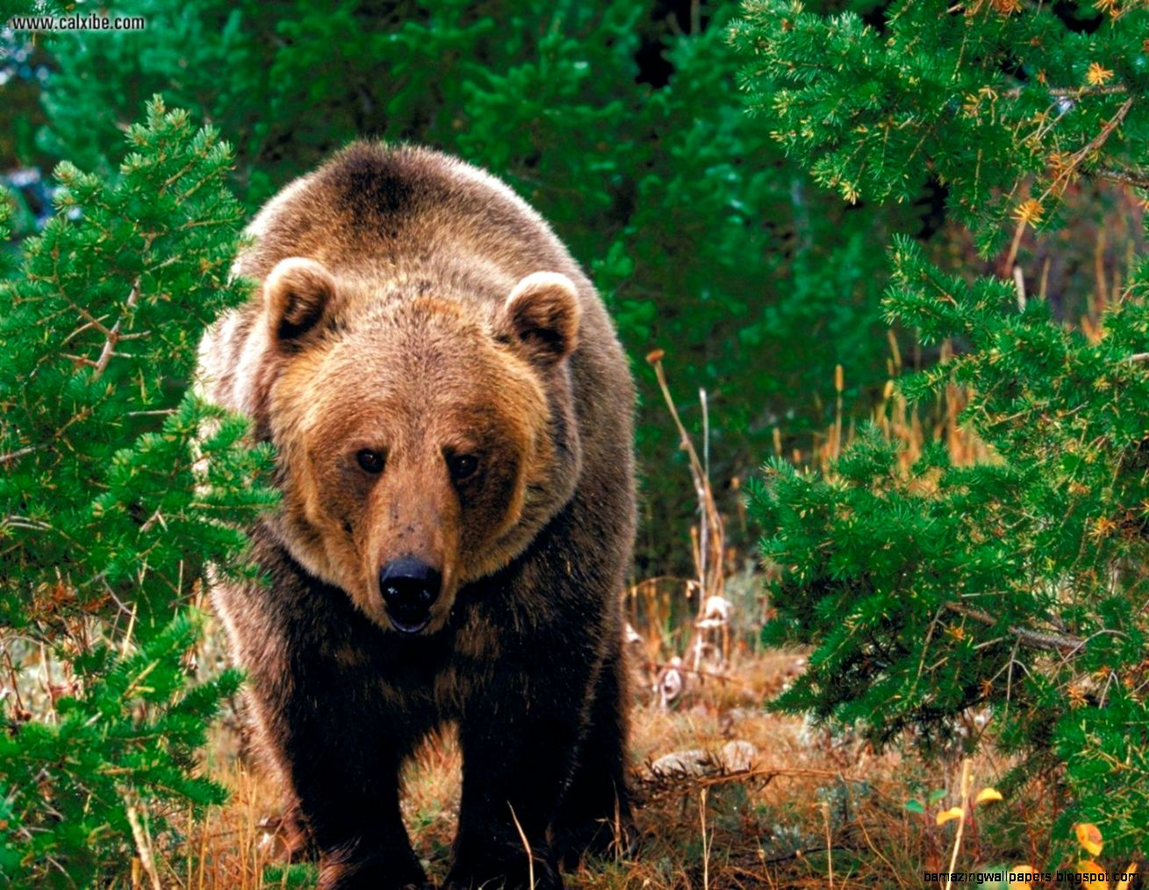
Source: http://99volo.com/wild-animals-in-forest/
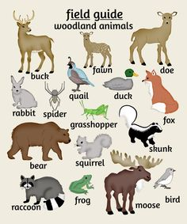
Source: https://www.pinterest.com/loriboyle15/animal-tracks/

- OCEAN
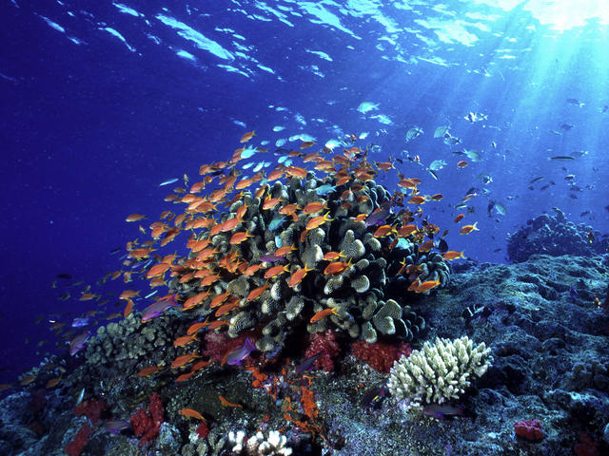
Source: http://www.worldwildlife.org/habitats/ocean-habitat
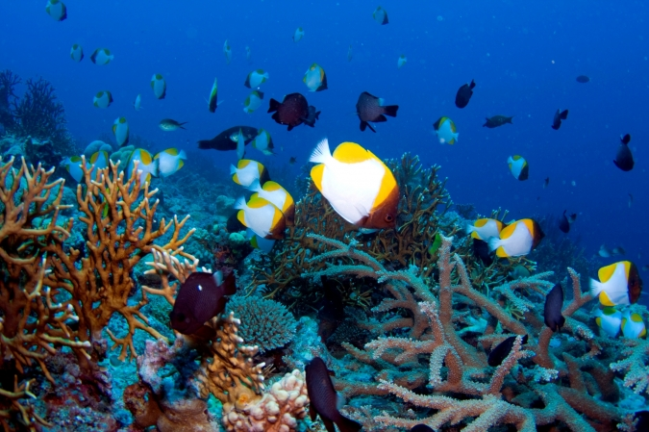
Source: http://www.earthtimes.org/politics/coral-sea-marine-reserve-dying-oceans/2039/
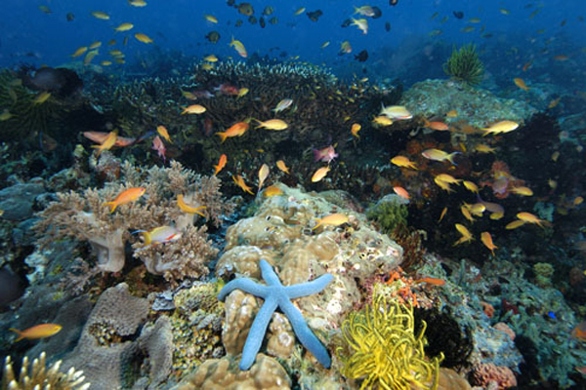
Source: https://www.thinglink.com/scene/725403072024543232
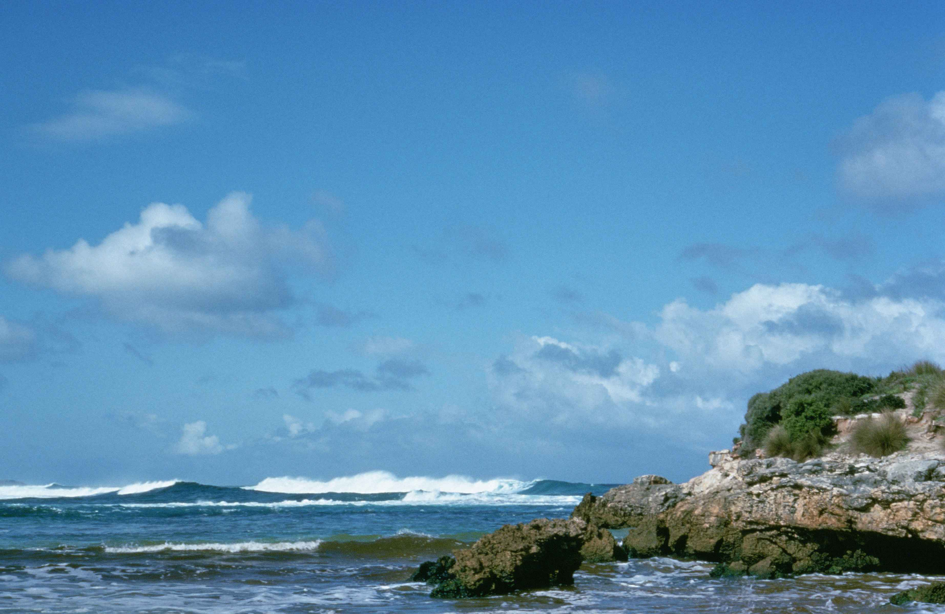
Source: https://commons.wikimedia.org/wiki/File:Ocean_habitat_coastline_of_Kangaroo_island_south_Australia.jpg
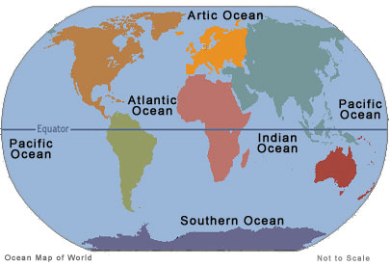
Source: http://theworldsoceans.com/

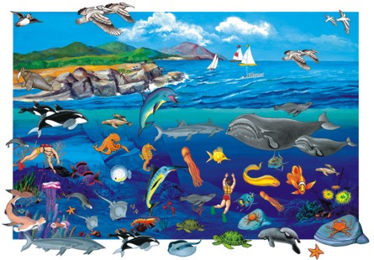
Source: http://ulriccruzcoby.blogspot.com/2011/01/sea-animal-wallpaper.html
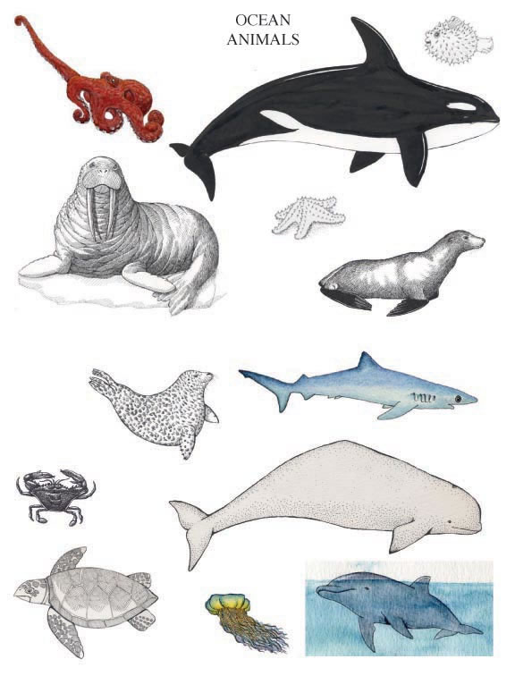
Source: http://www.makingtrackschallenge.com/inquiry-based_detail.php?reference=36
Source: http://wonderville.com/samplegallery/animal-kingdom/ocean-life/ocean-habitats
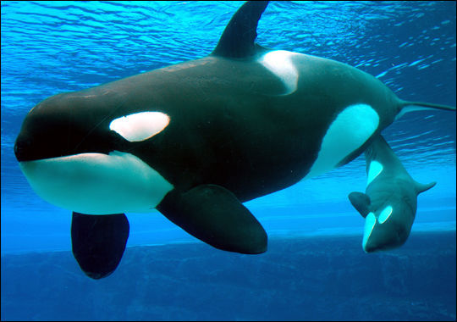Source: http://www.searchitfast.com/index.php?page=search/images&search=ocean+habitat+animals&type=images&startpage=3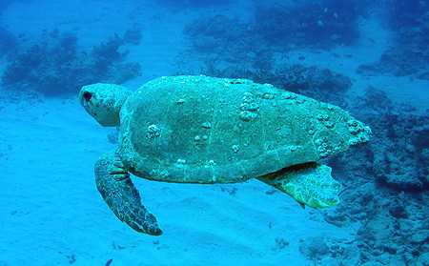
Source: http://marinebio.org/species.asp?id=163

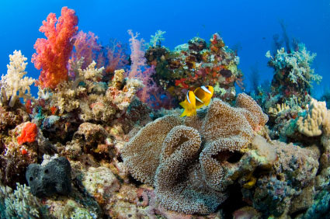
Source: http://www.worldanimalfoundation.net/aquatic_animals.html

- DESERT
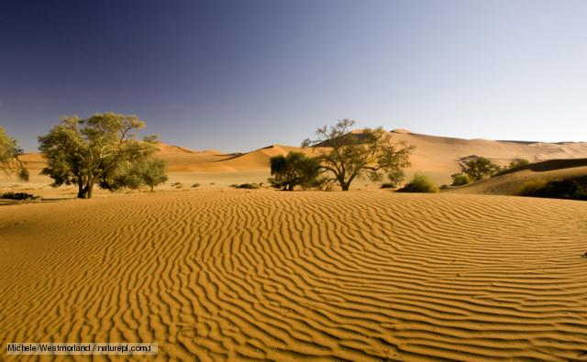
Source: https://www.google.com/url?sa=i&rct=j&q=&esrc=s&source=images&cd=&ved=0ahUKEwjJgJexsLvLAhWGSCYKHfDQDT0QjxwIAw&url=http%3A%2F%2Fwww.bbc.co.uk%2Fnature%2Fhabitats%2FDeserts_and_xeric_shrublands&bvm=bv.116636494,d.eWE&psig=AFQjCNFqNpgPRPTcXKjGS3wMjNNKf9tHhw&ust=1457880002440305
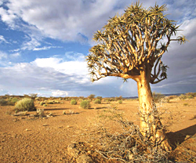
Source: www.gettyimages.co.uk/detail/photo/richtersveld-national-park-south-africa-a-high-res-stock-photography/71306808
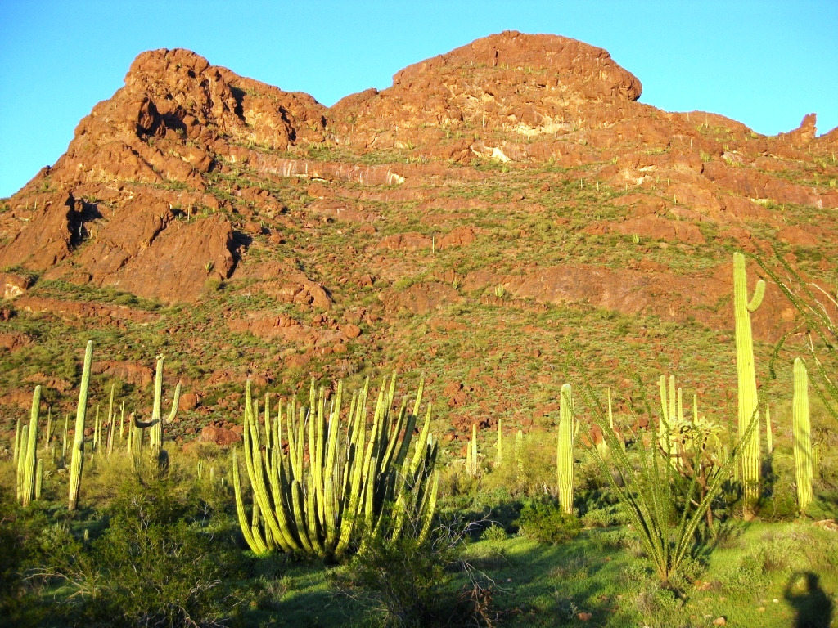
Source: http://aziba.org/?page_id=586
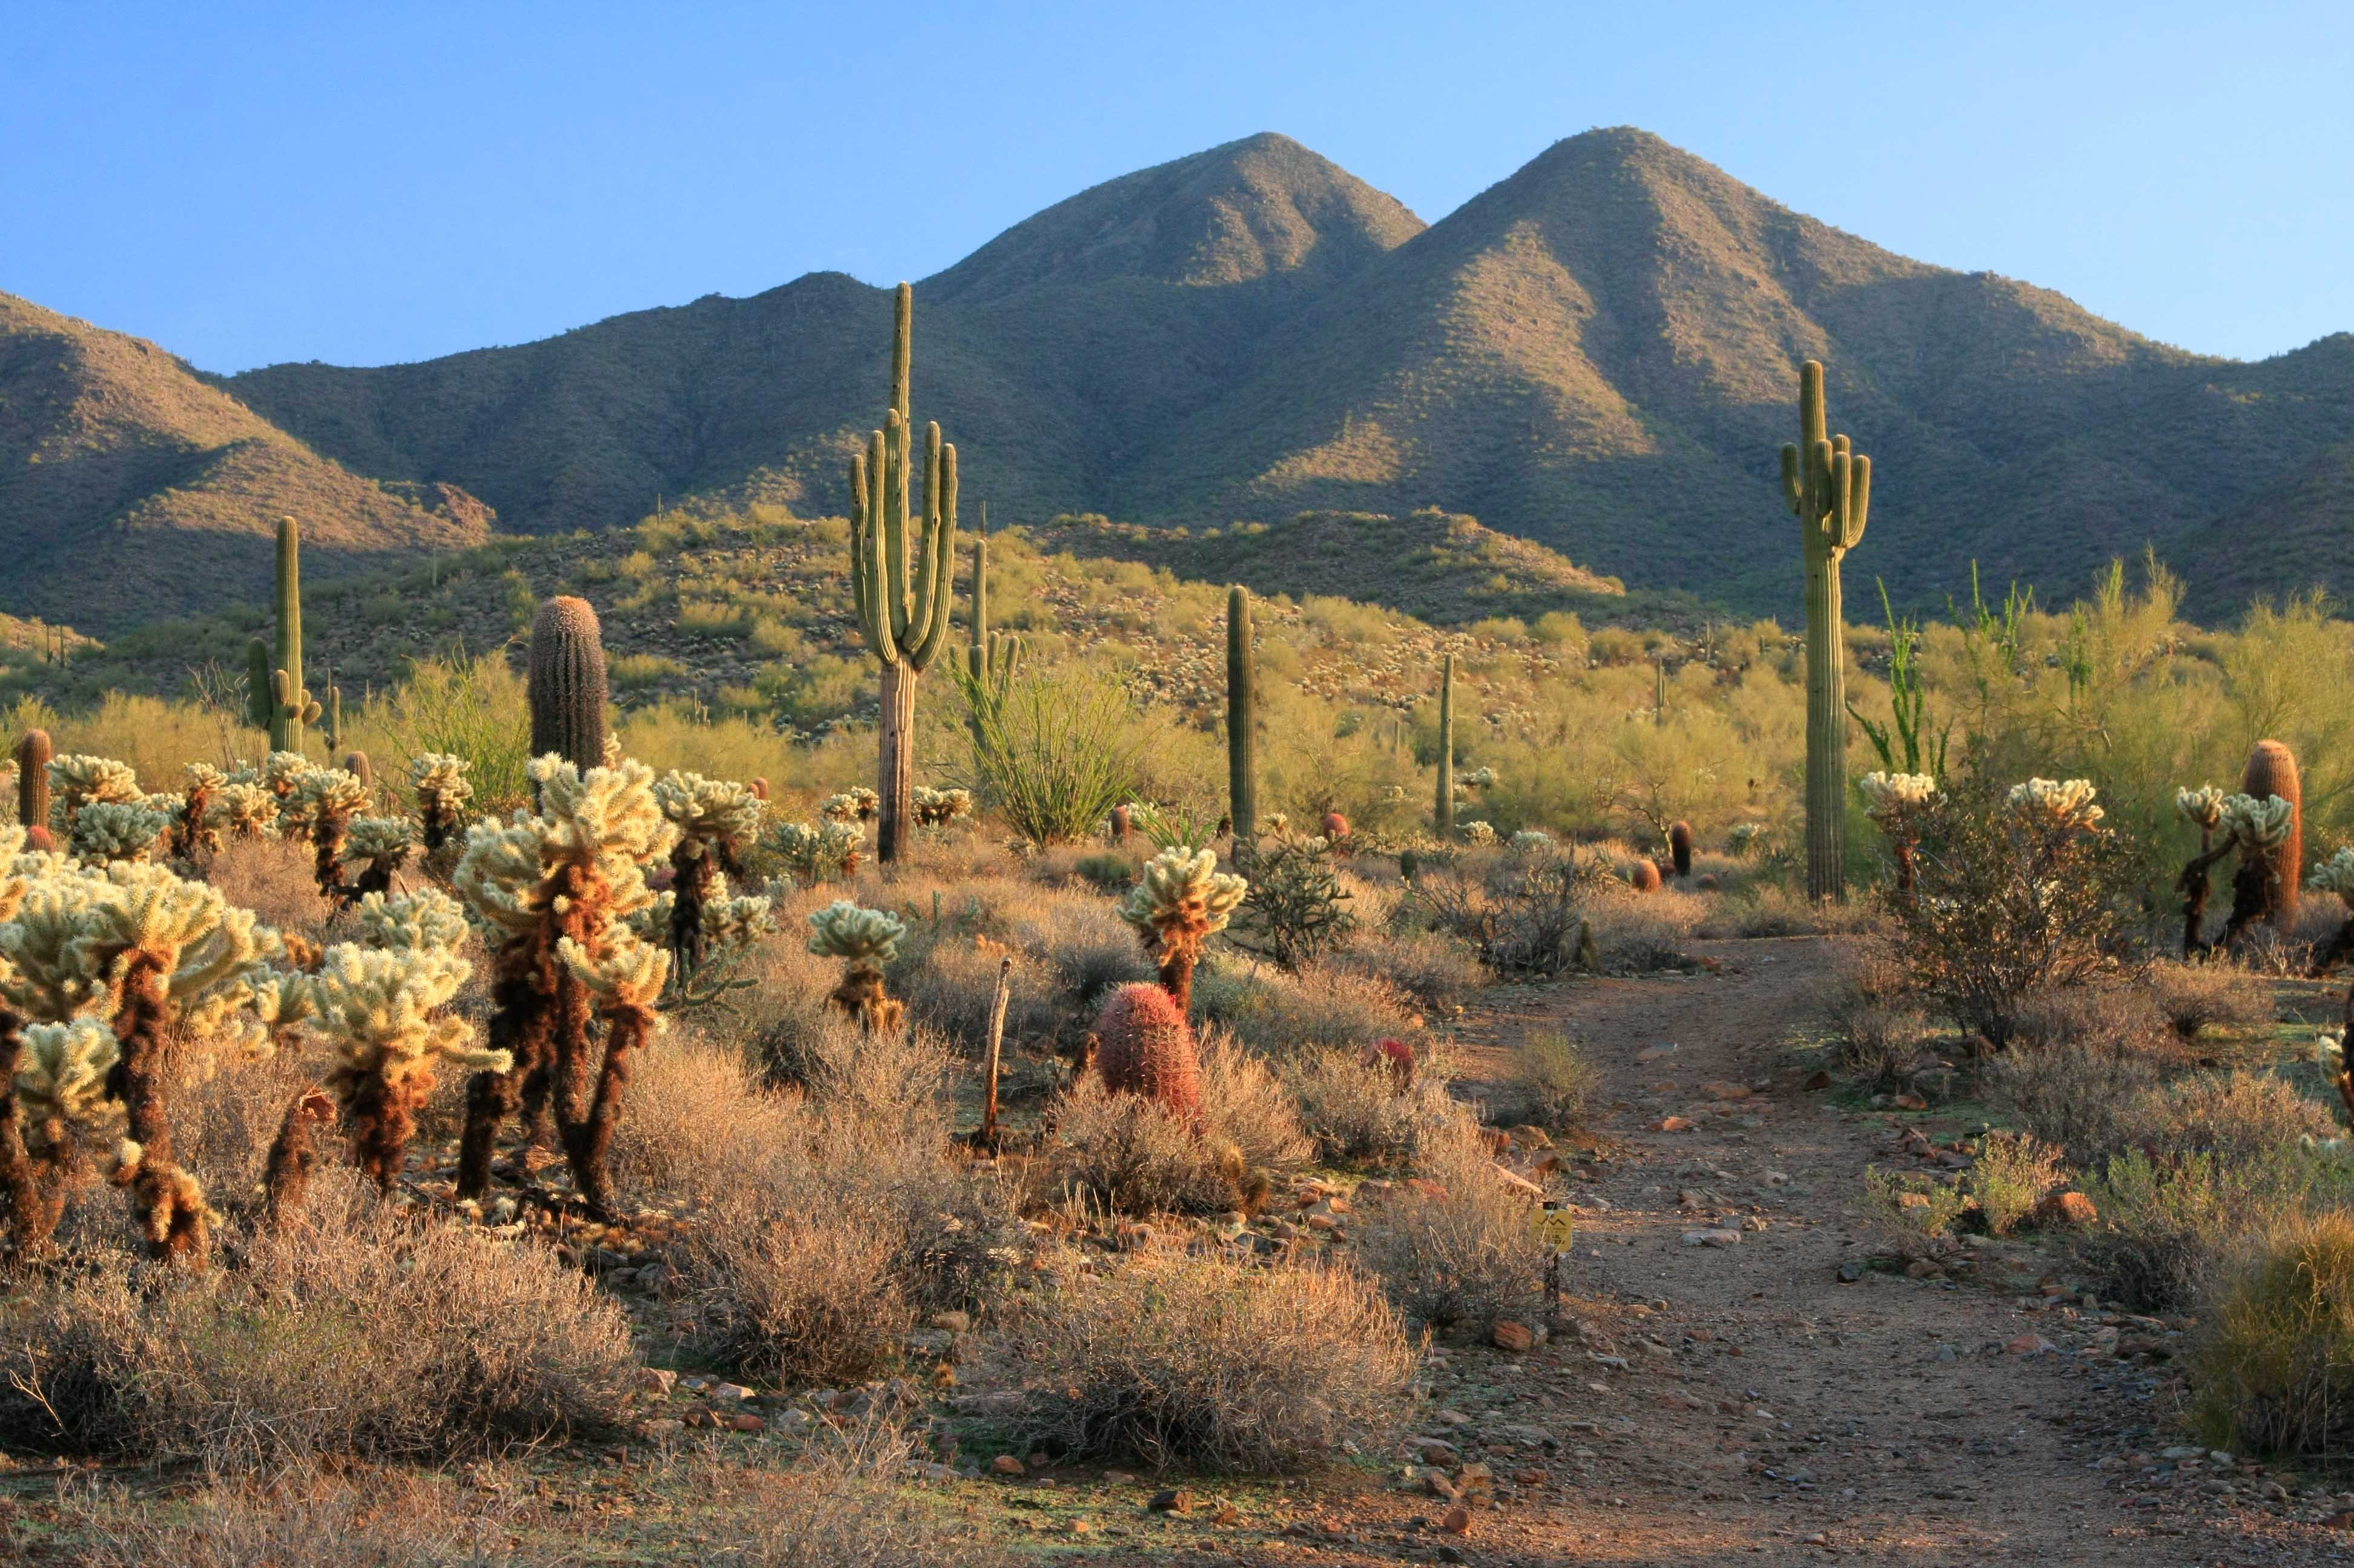
Source: http://www.mcdowellsonoran.org/content/pages/aboutUs#sthash.deEQvNYk.dpbs
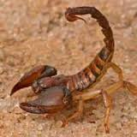
Source: www.vtaide.com/png/habitats/deserts/animals.htm
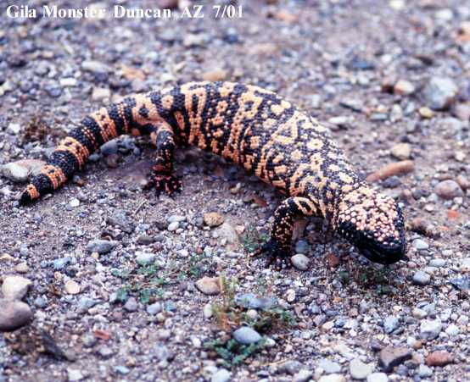
Source: http://www.arizonensis.org/sonoran/fieldguide/vertibrata/heloderma.html
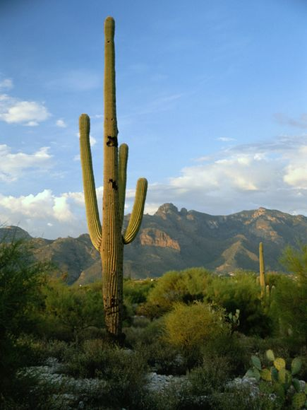
Source: http://environment.nationalgeographic.com/environment/habitats/sonoran-desert/

- POLAR
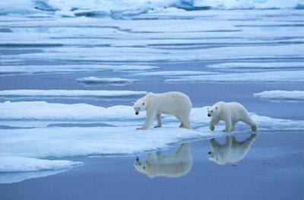
Source: http://animals.howstuffworks.com/mammals/polar-bear1.htm
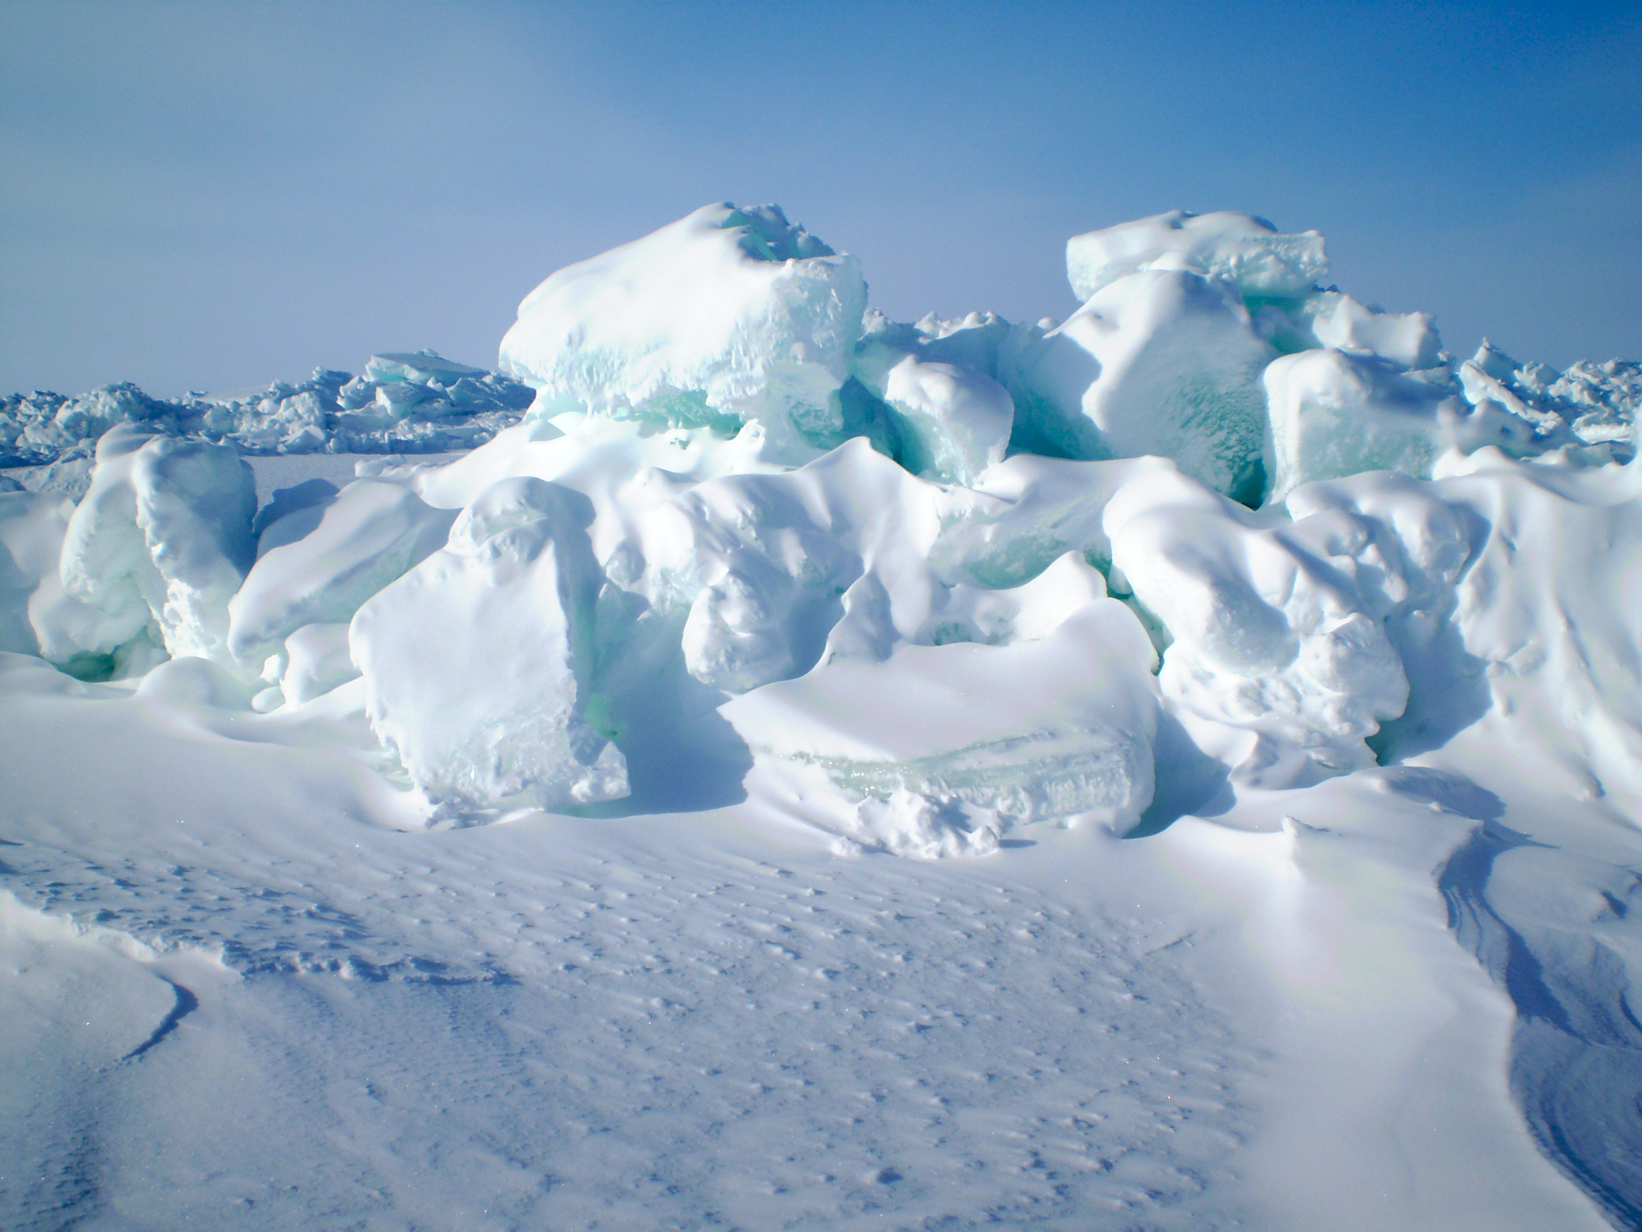
Source: http://www.polarbearsinternational.org/news-room/scientists-and-explorers-blog/sense-snow-mapping-suitable-habitat-polar-bear-dens
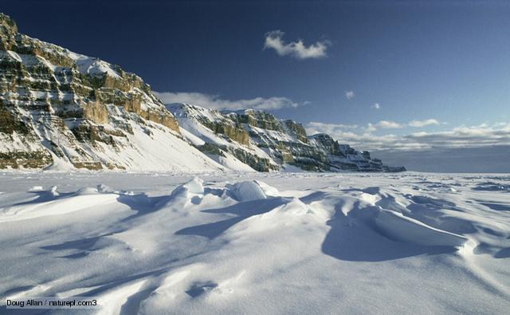
Source: http://room211projects.weebly.com/polor-habitats.html
Source: http://www.livescience.com/43046-greenland-glacier-new-speed-record.html

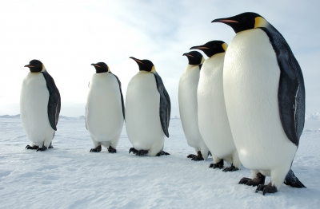
Source: https://www2.ucar.edu/atmosnews/news/7352/emperor-penguins-threatened-antarctic-sea-ice-loss

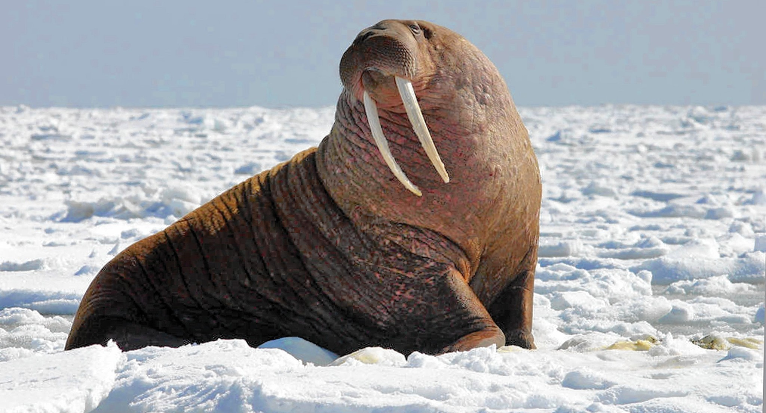
Source: http://www.chicagotribune.com/news/opinion/huppke/ct-obama-alaska-walrus-huppke-20150831-story.html
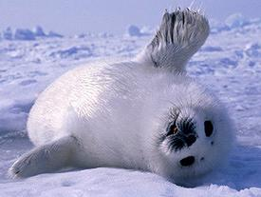
Source: http://www.harpseals.org/resources/index.php

- GRASSLANDS
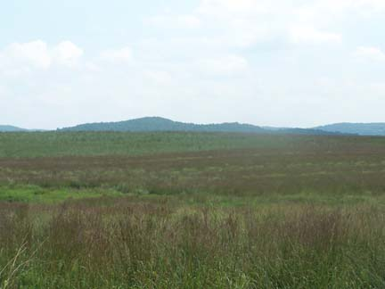
Source: http://www.njaudubon.org/SectionIBBA/IBBASiteGuide.aspx?sk=3123

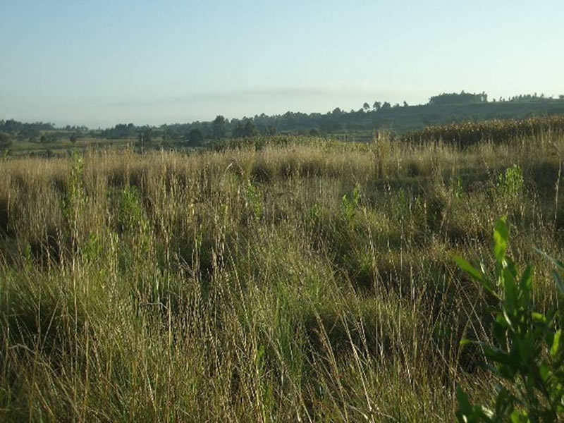
Source: http://www.fws.gov/southwest/es/arizona/Habitat.htm
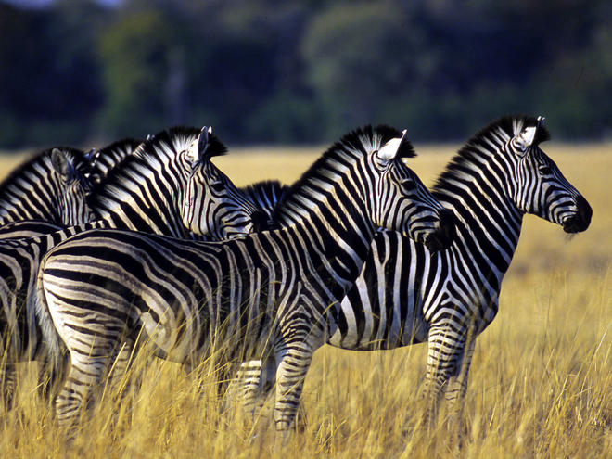
Source: http://www.worldwildlife.org/habitats/grasslands
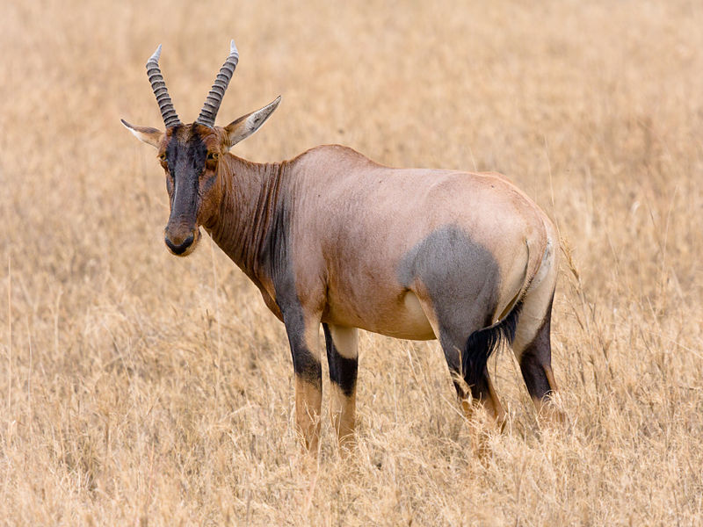
Source: http://www.skyenimals.com/browse_habitat.cgi?habitat=grassland
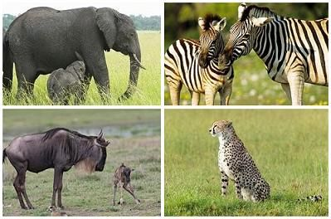
Source: Photograph, Elephants; Photograph, Zebra; Photograph, Wildebeest and newborn calf from Getty Images; Photograph, Cheetah,

Lesson 2  Days 3 and 4 | Creating Simple Wh- + H- Questions | Estimated Time: 60 minutes per day

Brief overview of lesson: Students will develop their understanding of question words, question formation, and how to inquire about a topic using questions. They will be introduced to the characteristics and inhabitants of a forest. Students will also begin learning about the inquiry process by using step 1: “Pose Real Questions,” from “The Inquiry Process” chart. Students will further develop their ability to Discuss by inquiring in order to build and present knowledge gathered through research. As you plan, consider the variability of learners in your class and make adaptations as necessary.

What students should know and be able to do to engage in this lesson:
- List animal names and names of some regions/habitats where animals live.
- Watch a video and listen to a read aloud to learn new information.
- Participate in pair and group discussions.
- Listen to and follow simple directions.
Write a simple sentence (or at least have some exposure to the process of writing simple sentences).
LESSON FOUNDATION
Unit-Level Focus Language Goals to Be Addressed in This Lesson |  | Unit-Level Salient Content Connections to Be Addressed in This Lesson
G.1 Discuss by inquiring in order to build and present knowledge gathered through research. |  | CCSS.ELA-LITERACY.L.1.6—Use words and phrases acquired through conversations, reading and being read to, and responding to texts, including using frequently occurring conjunctions to signal simple relationships.  CCSS.ELA-LITERACY.SL.1.4—Describe people, places, things, and events with relevant details, expressing ideas and feelings clearly.  CCSS.ELA-LITERACY.W.1.7—Participate in shared research and writing projects.
Language Objective |  | Essential Questions Addressed in This Lesson
Students will be able to inquire by asking and answering questions using wh- + h- question words (e.g., what, where, when, who, why, how). |  | Q.1 How can you use language in different ways?  Q.2 How do we use language to learn about new things?  Q.3 How do we learn where animals live?
Assessment
- Formative assessment: Assess students’ ability to ask and answer questions about images used in the gallery walk in the previous lesson.
- Formative assessment: Assess students’ ability to apply their knowledge to ask and answer questions about the forest region and forest animals.
- Formative assessment: Assess students’ ability to identify and organize key information about the forest region and forest animals using a bubble map.
- Self-assessment: Students will summarize what they learned in the lesson. Students will also articulate additional information that they would like to learn about the forest region.
Thinking Space: What Academic Language Will Be Practiced in This Lesson?
Discourse Dimension | Sentence Dimension |  | Word Dimension
Social instructional language; non-fiction informational text and/or short videos containing content area vocabulary and simple sentences; stating thoughts and opinions orally; asking and answering questions | Questions with wh- + h- words (what, why, when, where, who, how); simple sentences with present tense verbs |  | Content vocabulary related to forest habitat (habitat, forest, woods, etc.); additional academic vocabulary pertaining to texts/videos used in the lesson
Instructional Tips/Strategies/Suggestions for Teacher
- Post Lesson 1 charts and recorded student responses.
- When introducing “The Inquiry Process” chart, only show the first column to help students focus on it during this lesson. Reference the chart during the lesson to remind students they are learning how to use questions to inquire. Consider reading a book, such as You Are a Scientist! by Jennifer VanVoorst, to reinforce the concept of the inquiry process. This text can be revisited throughout the unit.
- During the image cue card activity, consider using animals the students are less familiar with so that more questions may be elicited.
- When introducing question words, consider using an anchor chart with visual support to scaffold student comprehension. If students show that they have not been exposed to simple sentences, provide them with sentence frames to fill in the blanks orally and later on when writing.
- Depending upon student familiarity with question words, you may wish to extend the practice with question words over an additional day. Introduce a few words each day as opposed to working with all of the wh- and h- questions in the same day. Also, depending upon student familiarity with answering questions, spend some time reviewing how to use words in a question to answer it (e.g., “Who is in the forest? The deer is in the forest.”) Please note: Answering questions in complete sentences is explicitly taught in subsequent lessons.
- For additional background information about the forest region, visit WorldWildLife.org.
- To build student understanding of zoos, consider viewing one of the San Diego Zoo live stream videos daily or another live stream.

STUDENT CONSIDERATIONS
Sociocultural Implications
- Various cultures place different levels of significance on animals. Some cultures consider animals sacred while others place little value on animals.
- Some students may be unfamiliar with forests and the animals that live there.
Anticipated Student Pre-Conceptions/Misconceptions
- Students may think all common animals live in forests.
- Some students may think that all animals in a forest are scary, or that all forest animals are friends with each other.
- Some students may have misconceptions about how animals feel—for example, they may think that all animals are furry, that scaly animals are slimy, etc.
- Some students may think that a question is the same as a statement.

THE LESSON IN ACTION

Day 3 Lesson Opening

Post and explain the lesson language objective: “Students will be able to inquire by asking and answering questions using wh- + h- question words (e.g., what, where, when, who, why, how).” To promote student ownership and self-monitoring of learning, consider having students record the objective in their notebooks or having students summarize the objective in their own words. At the end of the lesson, students can reflect on their learning in relation to the objective.

Introduce the lesson by explaining what students will be learning about.

Tell students they will be learning about forest animals in this lesson. For example, say: “We will be learning about the forest and forest animals today.”

Tell students that they will also begin learning language they can use to find out information about new things. Say: “Before we start talking about forest animals, we will learn some language to help us learn new things.” Let students know that one way to learn new things is by asking questions. You may wish to begin with a song, such as “Sesame Street—Questions” by Tracy Chapman, which can help students begin to think about how questions can be used to learn new things.

During the Lesson

Introduce wh- + h- question words (who, what, where, when, why, how) by showing them one word at a time.

Co-create a visually supported anchor chart with the question words. Include the word and examples of when to use the word. You may also wish to have students record question words in a notebook, learning log, or personal reference pocket chart. Teacher tip: Consider providing a visually supported anchor chart of question words posted as you introduce them.

Introduce who and where. Pre-teach the words or review them if students already know them.

For example, when introducing who, say: “If we ask who, we are asking someone to tell us the name of a person or an animal. We answer a who question by stating the name of a person or a type of animal that we were asked about. For example, if someone asks you ‘Who lives in the forest?,’ you can answer ‘Deer live in the forest.’”

For example, when introducing where, say: “When we ask where, we are asking about the location or the place where something is. The answer to a where question is a place. For example, if someone asks you ‘Where do deer live?,’ you can answer ‘Deer live in the forest.’”
Provide options for engagement, such as asking students to think about what they know about a specific question word before sharing what it means. That way students can think about a definition for the word, an example of each type of question, or an example of how to answer each question word before you present this information and activate their prior knowledge.
Provide options for engagement, such as having students turn and talk to share answers to sample who and where questions after the meanings of these words are introduced.

Pre-teach or review the words when and what.

For example, to introduce when, say: “If we ask when, we are asking about time. We answer a when question by stating a time. For example, if someone asks you ‘When do we have specials?,’ you can answer ‘We have specials after lunch.’ Or if someone asks you ‘When do raccoons sleep?,’ you can answer ‘Raccoons sleep during the day.’”

When introducing what, say: “When we ask what, we are asking someone to describe something. The answer to a what question is a description. For example, if someone asks you ‘What are we learning today?,’ you can answer ‘We are learning question words.’ Or if someone asks you ‘What color is the book?,’ you can answer ‘The book is blue’; if they ask you ‘What color is the owl?,’ you can say ‘The owl is brown.’”
Provide options for engagement, such as having students turn and talk to share answers to sample when and what questions after the meanings of these words are introduced.

Pre-teach or review the words why and how.

For example, to introduce why, say: “If we ask why, we are asking for the reason something happened or the reason something is the way it is. We answer a why question by stating a reason for something. We use the word because to explain reasons. For example, if someone asks you ‘Why are you excited?,’ you can answer ‘I am excited because we are learning about animals and where they live.’ Or, if they ask you ‘Why was the pond a good habitat for a frog?,’ you can say ‘The pond is a good habitat for a frog because it has water and food frogs like to eat.’”

When introducing how, say: “How has many uses. When we ask how, we are asking for specific characteristics about something, the quantity of something, in what way something is done, the reason for something, or information about the condition of something. For example, if someone asks you ‘How are you?,’ you can answer ‘I am good.’ Or, if they ask you ‘How do squirrels get ready for winter?,’ you can say ‘Squirrels collect and store a lot of food for the winter.’”
Provide options for engagement, such as having students turn and talk to share answers to sample why and how questions after the meanings of the words are introduced.

Explain what a simple question is and how to form it.

Create a second anchor chart for how to make a simple question. Teacher tip: color-coding the question words can help students see their proper placement in a question. Consider also color-coding the question mark (“?”) to help reinforce proper punctuation.

You may need to spend some additional time reviewing the verb do with students as many wh- questions are formed with it (e.g., “When do raccoons sleep?” “Where does the elephant live?” “Why does the frog live in a pond?”).

Model how to create a few questions, highlighting the structure of questions. Teacher tip: Reinforcing the structure of questions can help students begin to differentiate between questions and statements in oral discourse.

Invite students to create their own simple questions. Consider assigning students different question words, or have students pull a question word from a deck of question word cards. Students can then ask a question using the assigned question word.

Have students listen for questions. For example, make a statement and ask a question, then ask students to decide which one was the question with a partner.

Depending upon student familiarity with asking and answering questions, review how to use words in a question to answer it using a full sentence (i.e., where the answer is just added in place of the word who.) For example: “Who is in the forest? The deer is in the forest.”

Depending upon student familiarity and comfort with question words, you may wish to provide additional time to practice them with a game or another activity. For example, you can play a variation of “20 Questions” with students. One student picks a category (food, books, an object in the room) while the rest of the students take turns asking questions with who, what, where, when, and why to try to guess the object (e.g., “What do you use it for? Where is it? What color is it? Who used it last?”). The game can be played in small groups or together as a class. Make sure to model how to use questions to guess objects first before beginning the game.

Have students complete a question word activity where students use image cue cards to practice asking and answering questions with a partner. Use images from Lesson 1’s gallery walk or provide students with images of familiar contexts. During the activity, students will take turns asking and answering questions about the image. Partner A will ask a question about the image and partner B will answer the question. Partner B will then ask a different question about the image and Partner A will answer it. As students are working, circulate and offer specific feedback that is directly tied to their use of the question words.

Remind students about the inquiry process. Introduce step 1, “Pose Real Questions,” using “The Inquiry Process” chart (only show the first column). Remind students that they will learn how to use questions to learn more about animals and where they live throughout the unit.

Introduce the forest region/habitat, and how students will practice asking and answering questions about animals that live in the forest.

Post and pre-teach the word forest by providing a student-friendly definition, showing images of the forest, and describing the forest and its characteristics. You may wish to use a vocabulary teaching strategy such as the seven-step vocabulary teaching method and show a video such as “Habitat: Forests and Woodlands” or “Animal Forest.”
Provide options for engagement, such as asking students to share a time when they visited a forest. Students can describe, draw, or write about the forest and what they remember about it.
Provide options for perception, such as projecting the images, having students view the images on a computer, or providing students with printouts of the images.

Lesson Closing

Give students an image of the forest. Instruct them to ask one question about the forest and/or the forest habitat.
Provide options for physical action, such as writing, dictating, or orally asking questions.

Optional activity: Ask students to write questions about the forest, then take turns asking and answering these questions with a partner or small group.

Day 4 Lesson Opening

Review question words. Give students an image of the forest and one question word and tell them to ask a question about the image using question words taught in the previous day. Repeat this process for a few rounds.

Optional activity: Ask students to write questions about the forest, then take turns asking and answering these questions with a partner or small group.

During the Lesson

Revisit the definition and characteristics of a forest.

Introduce forest animals.

Show labeled images of the forest and forest animals to the class, introducing each forest animal by name.
Provide options for perception, such as projecting the images, having students view the images on a computer, or providing students with a printed version of the images.

Practice identifying animals that live in the forest. Ask students to name the animal when you show the image. Alternatively, give students an image or images of various forest animals and ask them to name the animal orally or write its name.

Remind students about the inquiry process. Review step 1, “Pose Real Questions,” using “The Inquiry Process” chart (only show the first column). Explain how students will learn more about forests and animals that live there by asking and answering questions.
Provide options for perception, such as providing students with printouts of the chart or having students view the chart on a computer.

Introduce the forest animal text to be used in the lesson by showing its cover. Show students the cover of the text you will use to learn about forest animals today.

Preview the text with students. Ask students to think of a question they would like to ask/something they would like to know about the book, the forest, or any of the animals discussed in the book. Have students record their question on a Post-It or whiteboard. Invite students to share their question with a partner. After students have had a chance to share, invite them to a class discussion, record student-generated questions on a forest anchor chart, and post the chart for reference while you read. Tell students to think about the questions while you are reading, and to say “STOP” when they hear the answer to any of the posted questions.

Read aloud a text about forests, such as A Bed for the Winter by Karen Wallace, Over in the Forest: Come and Take a Peek by Marianne Berkes, or Whose Tracks Are These? A Clue Book of Familiar Forest Animals by James Nail. Pause to have students make predictions/ask questions as you read. Also pause periodically to summarize information, modeling for students how to identify the main ideas and details used to compose a summary. Pause again when any of the student-generated questions are answered, and record the answers next to the forest anchor chart with questions.

Optional activity: Have students read a leveled reader about the forest region or forest animals independently, in a small group, or using a text-to-speech reader. Sample leveled readers include Reading A–Z’s The Forest or In the Forest by Judy Nayer.

Create a forest habitat bubble map. Students will make bubble maps for each habitat introduced throughout the unit, and these will be used as reference materials during the CEPA. Model how to create a bubble map in this lesson, then in subsequent lessons have students create the maps themselves in small groups, pairs, or individually. Please note: The purpose of the bubble maps is to help students gather and organize information pertaining to each habitat. If there is a better format to accomplish this purpose, feel free to substitute the bubble map for another similar tool.

Have students pretend they are different forest animals by making common animal sounds and motions (e.g., hoot like an owl and flap your arms). Discuss what students have learned by prompting them with questions, modeling how to use question words. Record questions asked and student answers.

Ask students to orally create their own simple questions with a partner. Provide question frames as needed (e.g., “Who lives ____?”; “Why does ____?”; “How does ____?”; “What does ____?”; “Where does ____?”; “When does ____?”).

Lesson Closing

Ask students to explain what they learned today by sharing with a partner first, and then debriefing as a whole class. Ask students to record their responses in a learning log or notebook, and/or record student responses on the class forest anchor chart.

Review the forest anchor chart with the students’ questions and information about the forest animals and where they live. Then model how to write a summary of the students’ information about forest animals and where they live. While drafting the summary, explain to students how you are selecting key pieces of information and putting them into your own words. Keep the summary posted for student reference.

Ask students to answer the following question: “What other things do you want to know about forest animals?”

Have students pause and think, then orally share a question (with a partner first, and then with the whole class) that includes a wh- word reflecting what they want to know about the forest or forest animals.
Provide options for physical action, such as using a computer, writing, or orally stating.

Ask students write down their question in an exit ticket. Add these questions to the forest chart paper and keep it as a reference.

Optional activity: Have students start a reflection journal where they write answers to teacher-provided prompts, such as: “Why is the forest a good home for … (deer, rabbit, bear, etc.)?” Students can dictate, draw, or write their responses.

Lesson 2 Resources
- Computer with Internet access
- Student notebooks, journals, learning logs, or personal reference pocket chart
- Post-Its
- Whiteboard
- Chart paper
- Markers
- Anchor charts
- Websites:
- WorldWildLife.org
- DK Find Out! (search for forest)
- Videos:
- San Diego Zoo live stream videos
- BrainPOP Jr. video on forests
- “Habitat: Forests and Woodlands”
- “Animal Forest”
- Books:
- You Are a Scientist! by Jennifer VanVoorst
- A Bed for the Winter by Karen Wallace
- Over in the Forest: Come and Take a Peek by Marianne Berkes
- Whose Tracks Are These? A Clue Book of Familiar Forest Animals by James Nail
- Song: “Sesame Street – Questions” by Tracy Chapman
- Seven-step vocabulary teaching method
- “The Inquiry Process” chart (available in Lesson 1)
- Images of the forest and forest animals (samples available in Lesson 1)
- Bubble map graphic organizer (sample available below)

Sample Bubble Map
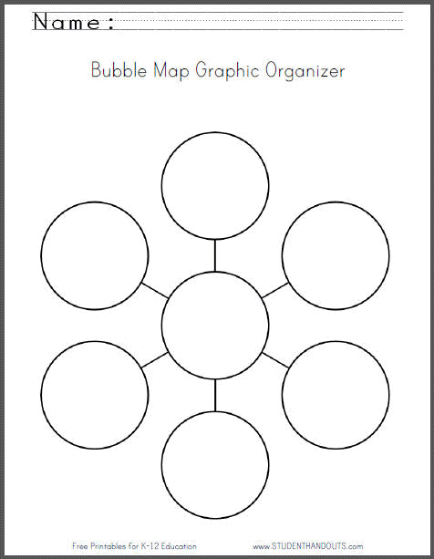
Source: http://www.studenthandouts.com/01-Web-Pages/2013-07/bubble-map-graphic-organizer-worksheet.htm

Lesson 3  Days 5 and 6 | Creating Simple Wh- + H- Questions and Using Prepositions | Estimated Time: 60 minutes per day

Brief overview of lesson: Students will continue to work with wh- + h- question words, developing their ability to inquire about a topic by asking questions and practicing step 1 of the inquiry process: “Pose Real Questions.” They will begin learning prepositions of place and continue building background knowledge about animals and their habitats by learning about the characteristics and inhabitants of oceans. Student knowledge of prepositions will be used in the culminating performance assessment to Explain by elaborating to build and present knowledge on a substantive topic. Students will also continue learning about summaries by co-creating a summary about oceans with the teacher. As you plan, consider the variability of learners in your class and make adaptations as necessary.

What students should know and be able to do to engage in this lesson:
- Write simple sentences (or at least exposure to how to write simple sentences).
- Previously taught wh- question words.
- Understanding of the forest region and animals that live there.
- Knowledge that some animals live in water.
- How to complete a bubble map.
Experience working with a partner and in small groups.
LESSON FOUNDATION
Unit-Level Focus Language Goals to Be Addressed in This Lesson |  | Unit-Level Salient Content Connections to Be Addressed in This Lesson
G.1 Discuss by inquiring in order to build and present knowledge gathered through research. |  | CCSS.ELA-LITERACY.L.1.6—Use words and phrases acquired through conversations, reading and being read to, and responding to texts, including using frequently occurring conjunctions to signal simple relationships.  CCSS.ELA-LITERACY.SL.1.4—Describe people, places, things, and events with relevant details, expressing ideas and feelings clearly.  CCSS.ELA-LITERACY.W.1.7—Participate in shared research and writing projects.
Language Objective |  | Essential Questions Addressed in This Lesson
Students will be able to describe oceans and ocean animals using prepositions of place (e.g., on, in, between, under). |  | Q.1 How can you use language in different ways?  Q.2 How do we use language to learn about new things?  Q.3 How do we learn about where animals live?
Assessment
- Formative assessment: Assess students’ ability to apply their knowledge to ask and answer questions about the ocean and ocean animals.
- Formative assessment: Assess students’ ability to use prepositions of place to label and describe images of the ocean and ocean animals.
- Formative assessment: Assess students’ ability to identify and organize key information about the ocean and ocean animals as evidenced by their completion of a bubble map.
Thinking Space: What Academic Language Will Be Practiced in This Lesson?
Discourse Dimension | Sentence Dimension |  | Word Dimension
Social instructional language; non-fiction informational text and/or short videos containing content area vocabulary and simple sentences; asking and answering questions | Questions with wh- words (what, why, when, where, who); simple sentences with present tense verbs |  | Content vocabulary related to ocean habitats (ocean, sea, salt water, etc.); additional academic vocabulary pertaining texts/videos used in the lesson; prepositions of place (above, on, under, near, in front, behind, between, in, over)
Instructional Tips/Strategies/Suggestions for Teacher
- Post previous lessons’ class anchor charts and webs for students to review.
- When showing “The Inquiry Process” chart, only show the first column to help students focus on it. Reference the chart during the lesson to remind students they are learning how to inquire.
- If students show that they have not been exposed to how to write simple sentences, provide sentence frames for students to fill in when speaking and/or writing.
- When introducing prepositions, consider writing them as labels for images where animals live in their habitat (e.g., under the rock, inside the coral reef).
- Consider adding magnets to printed images so they can be easily posted on whiteboards and moved around.
- For videos about oceans, see: “Magic School Bus Takes a Dive” (animated video) and/or live-streaming video of SeaWorld or an aquarium.
- For additional background knowledge on oceans and ocean animals, see WorldWildLife.org.

STUDENT CONSIDERATIONS
Sociocultural Implications
- Various cultures place different levels of significance on animals. Some cultures consider animals to be sacred.
- Students may be unfamiliar with the ocean and the animals that reside in the ocean.
Anticipated Student Pre-Conceptions/Misconceptions
- Some students may think that ocean animals can live outside the ocean.
- Some students may think that ocean animals don’t breathe air and/or that fish have lungs.
- Some students may not realize that ocean water is salty. Consider pre-teaching the difference between fresh water and ocean water.

THE LESSON IN ACTION

Day 5 Lesson Opening

Post and explain the lesson’s language objective: “Students will be able to describe oceans and ocean animals using prepositions of place (e.g., on, in, between, under).” To promote student ownership and self-monitoring of learning, consider having students record the objective in their notebooks or having students summarize the objective in their own words. At the end of the lesson, students can reflect on their learning in relation to the objective.

Review language learned in previous lessons. Using images from previous lessons, ask wh- questions about animals and their habitats. For example, ask: “What type of animal is this? What is the name of this habitat (while pointing to an image)? Where do deer live? What do deer eat? Why do deer live in the forest? Why is the pond a good habitat for frogs?” This review provides a formative assessment of student application of content language (e.g., vocabulary), as well as student understanding of question words and ability to answer questions.
Provide options for physical action, such as writing, labeling, pointing, or orally sharing answers.

Distribute student-generated questions from the previous lesson about forest animals and where they live written on index cards. Have students ask and answer these questions with a partner. This activity serves as a formative assessment of student ability to use content vocabulary, to ask/answer questions, and to summarize previously learned information.

During the Lesson

Introduce the ocean region, explaining how this lesson will focus on oceans and the animals that live in them. Review what makes a good habitat for an animal and ask students to predict what types of things that animals could want or need are present in an ocean (such as food, shelter, etc.).

Post and teach the word ocean by sharing a student-friendly definition, showing an image, and/or using a vocabulary teaching strategy such as the seven-step vocabulary teaching method.
Provide options for perception, such as projecting images, having students view the images on a computer, or providing students with printed copies of the images.
Provide options for engagement, such as asking students to share a time that they have been to an ocean. Ask students to describe orally, draw, or write about the ocean and what they remember about it.

Describe characteristics of the ocean.

Consider showing a video such as “The Ocean Song—Kids Ocean Movie—Ocean Products for Kids,” excerpts from National Geographic’s “Oceans Overview,” or using resource from PBS’s Wild Kratts.

Show labeled images of the ocean and ocean animals to the class, introducing each ocean animal by name.
Provide options for perception, such as projecting images, having students view the images on a computer, or providing students with a printed version of the images.
Have students practice identifying ocean animals from images. Ask students to name the animal when you show the image, or have them look at images of various ocean animals and name them orally to a partner or in writing.

Teach vocabulary related to oceans and ocean animals using the seven-step vocabulary teaching method or a similar vocabulary teaching strategy. Consider also creating a word wall and providing native language translations to help students explore these concepts further.

Remind students of the inquiry process. Review step 1, “Pose Real Questions,” using “The Inquiry Process” chart (only show the first column). Remind students of the role of questions in the inquiry process.

Preview the text that will be used in the lesson to learn more about ocean animals.

Show students the cover of the text or book. Ask students to think of a question they would like to ask/something they would like to know about the book, the ocean, ocean animals previously discussed in the lesson, or any of the animals they think will be discussed in the book. Have students record their question on a Post-It or whiteboard, then share it with a partner. After students have had a chance to share, invite them to share with the whole class.

Record student-generated questions on an ocean class anchor chart as students share and remind them to listen for answers to these questions as you read aloud. Tell students to say “STOP” when they hear the answer to any of the questions listed on the oceans anchor chart.

Read aloud a text about oceans and ocean animals, such as Life in an Ocean by Carol K. Lindeen, The Magic School Bus on the Ocean Floor by Joanna Cole, or ReadWorks.org’s “Life in the Ocean.” Pause to let students make predictions/ask questions as you read. Also pause periodically to summarize main ideas and details, modeling for students how to write a summary. Pause as answers to the questions are found and record them on the oceans anchor chart.

Have students complete a bubble map of the ocean and of the animals that live in the ocean with your help, a partner, or independently.
Provide options for physical action, such as using a computer to complete the bubble map.

Discuss what students have learned about oceans and ocean animals by prompting them with questions that include wh- question words. Record questions and student responses on the ocean class anchor chart.

Lesson Closing

Have students complete an exit ticket where they write simple questions about other things they want to learn about ocean animals with a partner. For example, the exit ticket prompt could be: “What other things do you want to know about ocean animals?” After partners are finished, invite students to share their questions with the whole class. Record them on the ocean class anchor chart, drawing attention to the question mark at the end of questions. This exit ticket can serve as a formative assessment of students’ ability to use content vocabulary and question words, and ability to form questions.
Provide options for physical action, such as writing, using a computer to complete, or dictating questions.

Consider asking students to record what they learned about oceans and ocean animals in a learning log or notebook.

Day 6 Lesson Opening

Show images of ocean animals. Ask students to take turns asking and answering questions about the animals shown.

Introduce today’s topic by explaining how students will continue learning language that will help them discuss animals and where they live. For example, say: “Today we will learn prepositions of place. Prepositions are words that help us give more details about animals and where they live. We can use prepositions to discuss the relationship between two words, like where things are. Prepositions also help us make our questions and answers more precise.”

During the Lesson

Teach prepositions of place that will be focused on during the lesson (e.g., on, in, under, above, on, under, near, in front, behind, between, in, over). Provide a variety of supports such as native language translations, a visually supported anchor chart, gestures, and total physical response to reinforce the meaning of prepositions.
Provide options for perception, such as projecting prepositions and/or the anchor chart, having students view prepositions and/or the anchor chart on a computer, or providing students with printed versions of the prepositions and/or anchor chart.

Provide additional practice identifying and using prepositions, such as a game or another activity.

For example, have students act out prepositions. Ask them to form a circle and draw from a deck of prepositions written on index cards. When a student draws a card, he/she has to place an object (a stuffed animal or another medium sized object) around the classroom in accordance with the preposition written on the card. For example, if the student drew above, he/she could hold the object above their head. Then the other students take turns trying to guess the preposition on the card based on where the object is placed and use it in a complete sentence (e.g., “The teddy bear is above his head”).

Another activity to practice prepositions could be to have students orally describe or describe in writing an image of an everyday scene. Ask students to label the image with appropriate prepositions, then ask questions such as “Where is the ____?” Have students answer using a preposition. This activity can serve as a formative assessment of students’ ability to use prepositions and answer wh- questions.
Provide options for perception, such as viewing the image on a computer, projecting the image, or providing students with a printout of the image.
Provide options for physical action, such as using a computer to complete, writing, labeling, or orally describing the image.

Introduce the next part of the lesson, where students use prepositions to talk about oceans and ocean animals.

Model how to describe an image of an ocean animal. Project or show the image, then say and write a description of where the animal is using a preposition (e.g., “The crab is on the rock”).

Ask students to describe an image and tell where an ocean animal is with a partner.
Provide options for perception, such as providing students with a labeled printed version of the images or using a shared file that students can view on a computer.

Give students one or a few images of the ocean and ocean animals individually or in pairs. Ask them to label the image/s with appropriate prepositions. While students are working, circulate and offer feedback directly tied to their use of prepositions to describe the image. Then have students share their descriptions orally with a partner (if working individually), or have pairs “square up” with another group.
Provide options for physical action, such as writing, using a computer to complete, or having students match images with preposition words written on index cards.

Optional activity: Ask students to write a sentence using a preposition to describe the image/s.

Read aloud a text about oceans and ocean animals, such as Life in an Ocean by Carol K. Lindeen, The Magic School Bus on the Ocean Floor by Joanna Cole, Clam-I-Am! All about the Beach by Tish Rabe, Wish for a Fish: All about Sea Creatures by Bonnie Worth, or ReadWorks.org’s “Life in the Ocean.” Pause to ask students to describe images in the text using prepositions.

Optional activity: Have students read leveled readers about ocean animals such as the Ocean Animals Collection (National Geographic Readers Series) by National Geographic Kids. Students can read these texts independently, with a partner, or using a text-to-speech reader. After reading, have students describe images of ocean animals and the ocean habitats in the texts using prepositions.

Using information gathered in the class ocean anchor chart, co-write a summary of main ideas and details gathered with students as a guided practice of how to summarize.

Ask students to share ideas about what should be included in the summary and remind them to include only key pieces of information.

Once completed, post the summary for student reference. Consider having students do a choral reading of the summary.

Lesson Closing

Have students ask and answer questions about the ocean and ocean animals with a partner. Circulate around the room listening to students’ responses, and use this information as a formative assessment of students’ ability to form questions using wh- + h- words, answer questions, and use prepositions.

Optional activity: Have students write answers to given prompts in a reflection journal. For example, students could respond to the following prompt: “Why is the ocean a good home for… (octopus, shark, lobsters, etc.)?”
Provide options for physical action, such as dictating, drawing, or writing responses.

Lesson 3 Resources
- Computer with Internet access
- Student notebooks or learning logs
- Index cards
- Whiteboard
- Chart paper
- Markers
- Websites:
- WorldWildLife.org
- DK Find Out! (search for ocean)
- Wild Kratts
- Videos:
- “The Ocean Song—Kids Ocean Movie—Ocean Products for Kids”
- “Magic School Bus Takes a Dive”
- “Oceans Overview”
- Live-streaming video of SeaWorld
- BrainPOP Jr. video on ocean habitats
- Texts:
- Life in an Ocean by Carol K. Lindeen
- The Magic School Bus on the Ocean Floor by Joanna Cole
- Clam-I-Am! All About the Beach by Tish Rabe
- Wish for a Fish: All About Sea Creatures by Bonnie Worth
- “Life in the Ocean” from ReadWorks.org
- Ocean Animals Collection by National Geographic Kids (optional text)
- Seven-step vocabulary teaching method
- Sentence frames
- “The Inquiry Process” chart (available in Lesson 1)
- Bubble map graphic organizer (sample available in Lesson 2)
- Visually supported preposition anchor charts (samples available below)
- Image for students to describe using prepositions of place (sample available below)
- Images of ocean animals to elicit preposition use (samples available below)
Sample Visually Supported Preposition Anchor Charts
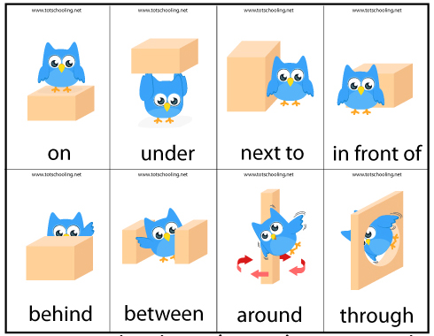
Source: http://www.totschooling.net/2014/05/motor-skills-preposition-game.html
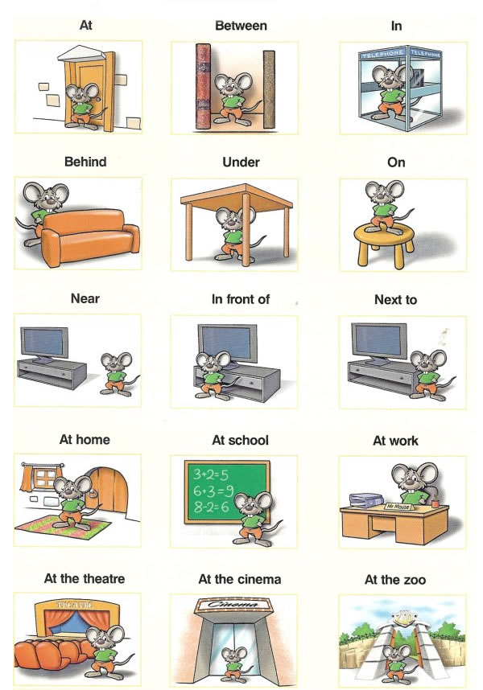
Source: http://www.easypacelearning.com/all-lessons/grammar/762-prepositions-of-place-learning-english

Sample Image for Students to Describe Using Prepositions of Place
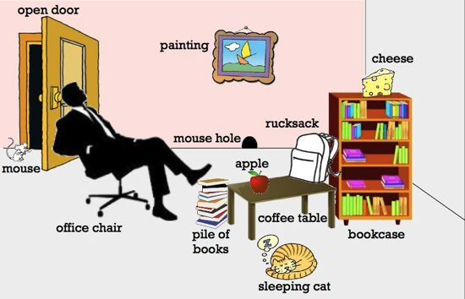
Source: http://efl-resource.com/wheres-my-cheese-iwb-lesson-plan-revising-some-prepositions-of-movement/

Sample Images of Ocean Animals to Elicit Preposition Use
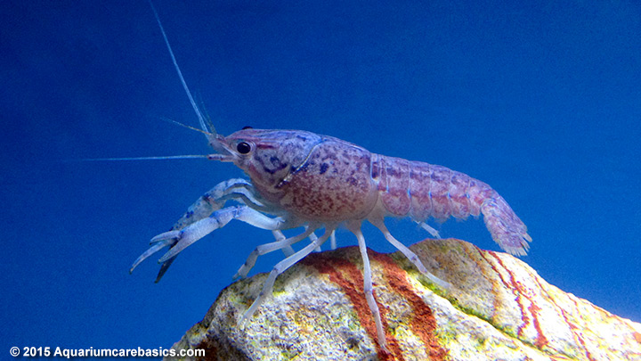
Source: http://www.aquariumcarebasics.com/aquarium-crayfish/hammers-cobalt-blue-lobster/
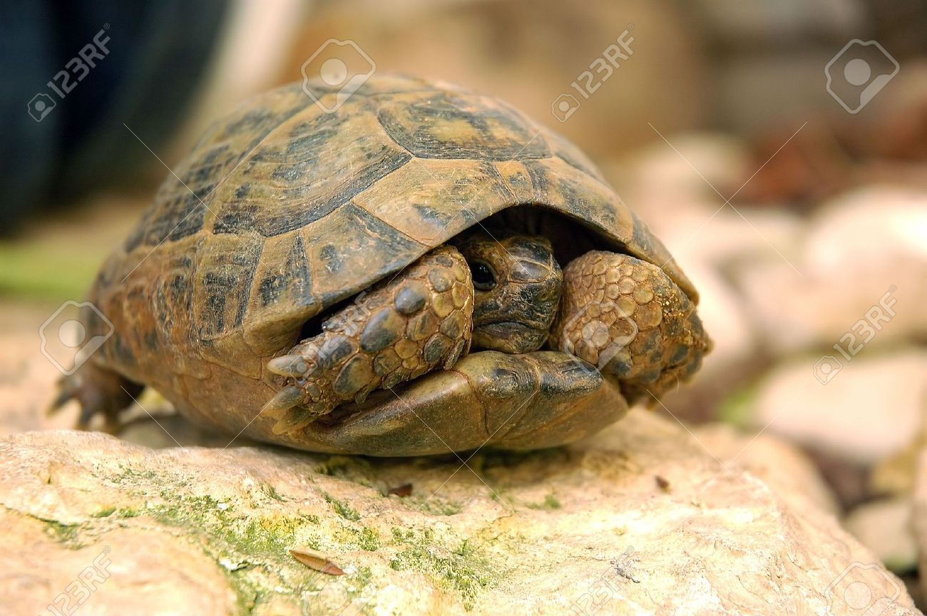
Source: http://www.123rf.com/photo_3232362_turtle-is-hiding-in-its-shell.html
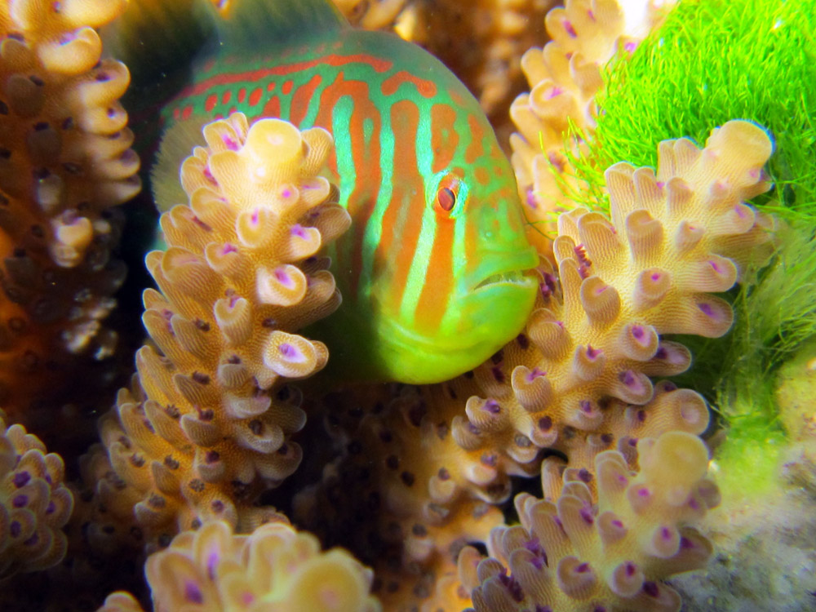
Source: https://student.societyforscience.org/article/threatened-coral-get-fishy-rescue
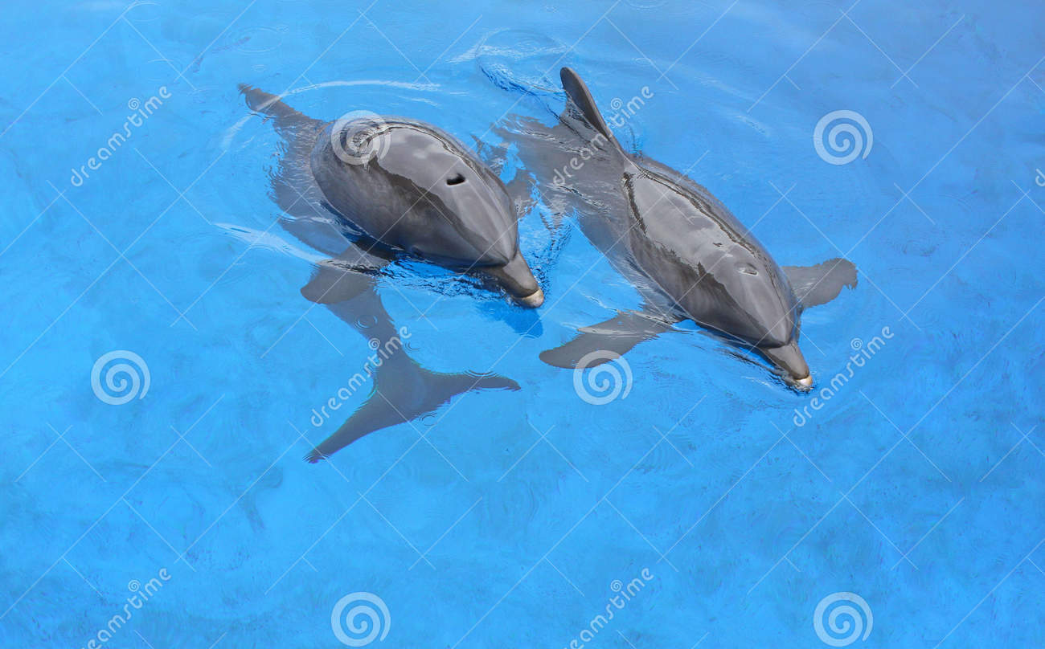
Source: http://www.dreamstime.com/royalty-free-stock-photos-two-dolphins-mother-calf-swimming-next-to-each-other-blue-water-image32293578

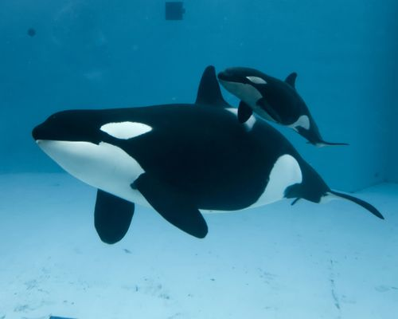
Source: http://www.zooborns.typepad.com/zooborns/whale/

Lesson 4  Day 7 | Using Wh- + H- Questions and Prepositions to Discuss the Desert | Estimated Time: 60 minutes

Brief overview of lesson: Students will continue to develop their understanding of and ability to use question words and prepositions of place. They will continue building background knowledge about animals and their habitats, and expand their ability to inquire by practicing step 1 of the inquiry process: “Pose Real Questions.” Students will also be introduced to the characteristics and desert inhabitants, and continue learning about summaries by co-creating a summary about deserts with the teacher. Student knowledge of questions and prepositions of place will be used in the culminating performance assessment to Explain by elaborating to build and present knowledge on a substantive topic. As you plan, consider the variability of learners in your class and make adaptations as necessary.

What students should know and be able to do to engage in this lesson:
- Prepositions of place and previously taught wh- + h- question words.
- Basic understanding of forests, oceans, and animals that live in these habitats.
- How to create a bubble map.
Experience working with a partner and small group.
LESSON FOUNDATION
Unit-Level Focus Language Goals to Be Addressed in This Lesson |  | Unit-Level Salient Content Connections to Be Addressed in This Lesson
G.1 Discuss by inquiring in order to build and present knowledge gathered through research.  G.2 Explain by elaborating to build and present knowledge on a substantive topic. |  | CCSS.ELA-LITERACY.L.1.6—Use words and phrases acquired through conversations, reading and being read to, and responding to texts, including using frequently occurring conjunctions to signal simple relationships.  CCSS.ELA-LITERACY.SL.1.4—Describe people, places, things, and events with relevant details, expressing ideas and feelings clearly.  CCSS.ELA-LITERACY.W.1.7—Participate in shared research and writing projects.
Language Objectives |  | Essential Questions Addressed in This Lesson
Students will be able to inquire about deserts and desert animals by asking and answering questions.  Students will be able to discuss deserts and desert animals using prepositions of place (e.g., on, in, between, under). |  | Q.1 How can you use language in different ways?  Q.2 How do we use language to learn about new things?  Q.3 How do we learn about where animals live?
Assessment
- Formative assessment: Assess students’ ability to ask and answer questions about the desert and desert animals.
- Formative assessment: Assess students’ ability to apply their knowledge to describe and label images of the desert and desert animals with prepositions of place and content-specific language.
- Formative assessment: Assess students’ ability to identify and organize key information about the desert and desert animals as evidenced by their completion of a bubble map.
- Observation: Assess students’ ability to orally ask and answer questions and use prepositions of place during the game “Where Is It?”
Thinking Space: What Academic Language Will Be Practiced in This Lesson?
Discourse Dimension | Sentence Dimension |  | Word Dimension
Social instructional language; non-fiction informational text and/or short videos containing content area vocabulary and simple sentences; asking and answering questions; reading and expressing ideas orally and in writing using complete sentences | Questions with wh- + h- words (what, why, when, where, who, how); simple sentences with present tense verbs |  | Content vocabulary related to desert habitats (desert, sand, cactus, cacti, heat, etc.); additional academic vocabulary pertaining texts/videos used in the lesson; prepositions of place (above, on, under, near, in front, behind, between, in, over)
Instructional Tips/Strategies/Suggestions for Teacher
- Post bubble maps, class anchor charts, and sentence frames used in previous lessons.
- When showing “The Inquiry Process” chart, only show the first column to help students focus on step 1: “Pose Real Questions.” Reference the chart during the lesson to remind students they are learning how to inquire.
- For additional teacher background knowledge about deserts, visit WorldWildLife.org.
- Consider showing students live-streaming video from the San Diego Zoo to build additional background knowledge about zoos.

STUDENT CONSIDERATIONS
Sociocultural Implications
- Various cultures place different levels of significance on animals. Some cultures consider animals sacred, while others place little value on animals.
- Some students may be unfamiliar with deserts and the animals that live in them.
Anticipated Student Pre-Conceptions/Misconceptions
- Students may think that any place that has sand is a desert, that nothing can live in the desert, that there is no water in the desert, and/or that the desert is hot during the day and the night.
- Some students may think that commas are needed after the conjunction and, instead of before.

THE LESSON IN ACTION

Lesson Opening

Post and explain the lesson’s language objectives: “Students will be able to inquire about deserts and desert animals by asking and answering questions,” and “Students will be able to discuss deserts and desert animals using prepositions of place (e.g., on, in, between, under).” To promote student ownership and self-monitoring of learning, consider having students record the objectives in their notebooks or having students summarize the objectives in their own words. At the end of the lesson, students can reflect on their learning in relation to the objectives.

Review prepositions of place introduced in the previous lesson. Have students play “Where Is It?” Ask one student (A) to stand facing the board while another student (B) hides an image of an animal. Then ask student A to turn around, face the class, and stay in the front while asking questions to try to figure out where the image was hidden (e.g., “Is it under the desk?”) until he/she guesses where it is. Student B (with the help of the class) can only answer “yes” or “no.” This activity can serve as a formative assessment of students’ ability to use prepositions of place.

Consider having students practice asking and answering questions about oceans and the animals that live there with a partner. Provide prepared questions written on index cards or have students generate their own. This activity can serve as a formative assessment of students’ ability to use wh- + h- question words, prepositions of place, and content vocabulary, as well as their ability to answer questions.

During the Lesson

Introduce the desert region/habitat. Review what makes a good habitat and ask students to predict what elements of a good habitat (such as food, shelter, etc.) will be present in the desert.

Post and teach the word desert using the seven-step vocabulary teaching method or another vocabulary teaching strategy.
Provide options for engagement, such as asking students to share a time they have been to a desert, have seen a desert in a movie or book, or what they already know about the desert. Allow students to orally describe, draw, or write about the desert and what they remember/know about it.
Provide options for perception, such as projecting images of deserts, having students view images of deserts on a computer, or providing students with printed images of deserts.

Describe the desert and the characteristics of the desert.

Show a video, such as “Exploring for Desert Animals!,” “Our Desert Habitat (School Science Project),” or excerpts from “Desert Animals.”

Show labeled images of the desert and desert animals, introducing each desert animal by name.
Provide options for perception, such as projecting the images, having students view the images on a computer, or providing students with printed images.

Have students describe desert images using prepositions of place individually or with partners. Ask students to label, orally describe, or write sentences, or have them match images and related prepositions of place written on index cards. This activity can serve as a formative assessment of students’ ability to use prepositions of place to describe images.

Teach additional vocabulary related to deserts and animals that live in them. Use the seven-step vocabulary teaching method or a similar vocabulary teaching strategy that incorporates more than just oral discussion of vocabulary words. Word walls and native language translations can help students explore these concepts further.

Remind students about the inquiry process. Review step 1, “Pose Real Questions,” using “The Inquiry Process” chart (only show the first column). Discuss the role of questions in the inquiry process, highlighting how questions help us gather information to answers questions and learn new information.

Preview the text that will be used to learn about deserts and desert animals.

Show students the cover of the text and ask them to think of a question they would like to ask or something they would like to learn about the book, the desert, or any of the desert animals previously introduced in the lesson. Have students record their question/s on a Post-It or whiteboard, share it with a partner, and then discuss as a whole class.

Record student-generated questions and write them on a desert class anchor chart. Remind students to listen for answers to their questions while the text is read. Tell students to say “STOP!” when they hear an answer to questions and record these answers in the desert class anchor chart.

Read aloud a text about deserts and desert animals, such as Guess Who’s in the Desert by Charline Profiri and Susan Swan, Desert Giant: The World of the Saguaro Cactus by Barbara Bash, Way Out in the Desert by T.J. Marsh and Jennifer Ward, Cactus Hotel by Brenda Guiberson, or Why Oh Why Are Deserts Dry? All About Deserts by Tish Rabe.

Pause to have students make predictions/ask questions as you read. Also pause periodically to summarize main ideas and details, modeling how to write a summary. Pause when answers to questions are found and record them in the desert class anchor chart.

Some students may prefer to read a text independently or with a small group. Provide leveled readers students can read on their own or with partners, such as Day and Night in the Desert by Jill Eggleton.

After reading, have students make a bubble map of the desert and a bubble map of the animals that live in the desert independently or together with you. Prompt students to use prepositions when possible.
Provide options for physical action, such as using a computer to complete the bubble maps.

Discuss what students have learned about deserts and desert animals by prompting them with questions.

Model how to form questions about deserts and desert animals first, then have students ask and answer questions.

Record questions and responses about what students have learned on chart paper.

Have students co-construct a summary about deserts and desert animals with you using the chart paper of questions and answers. Ask students to suggest sentences, phrases, or ideas for the summary. Write the summary on chart paper and post it for future reference.

Ask students to share other things they want to know about deserts and/or desert animals by turning and talking to a partner. Then have students share their questions and add them to the desert class anchor chart.

Lesson Closing

Give students another opportunity to practice writing and answering questions. This activity can serve as a formative assessment of students’ ability to use question words, prepositions, and content area vocabulary, and to answer questions.

Have students write their own simple questions about deserts and desert animals.
Provide options for physical action, such as dictating questions, using speech-to-text software, and scribing answers for students.

Pair students with a partner and have them ask and answer their questions.

Have students describe an image of the desert and/or desert animals using prepositions.
Provide options for physical action, such as using a computer, writing, or orally describing.

Discuss the CEPA. Review what students have learned so far and how they will be able to showcase it in their CEPA. Give students some time to review images and bubble maps created thus far, and begin to think about what they may wish to research further. This discussion provides an opportunity for students to measure their progress in relation to the culminating performance assessment.

Optional activity: Ask students to record what they learned about deserts and desert animals in a learning log or reflection journal. Have students respond to prompts such as: “Why is the desert a good home for… (pronghorns, Gila woodpeckers, burrowing owls, etc.)?” Allow students to dictate, draw, or write their responses.

Lesson 4 Resources
- Computer with Internet access
- Student notebooks
- Post-Its
- Whiteboard
- Anchor chart
- Chart paper
- Markers
- Index cards
- Websites:
- WorldWildLife.org
- DK Find Out! (search for desert)
- Videos:
- “Exploring for Desert Animals!”
- “Our Desert Habitat (School Science Project)”
- “Desert Animals”
- Live-streaming video from the San Diego Zoo
- BrainPOP Jr. video on deserts
- Books:
- Guess Who’s in the Desert by Charline Profiri and Susan Swan
- Desert Giant: The World of the Saguaro Cactus by Barbara Bash
- Way Out in the Desert by T.J. Marsh and Jennifer Ward
- Cactus Hotel by Brenda Guiberson
- Why Oh Why Are Deserts Dry? All About Deserts by Tish Rabe
- Day and Night in the Desert by Jill Eggleton
Previously used images of animals and habitats
Previously created bubble maps
Images of deserts and desert animals (samples available in Lesson 1)
“The Inquiry Process” chart (available in Lesson 1)
Bubble map graphic organizer (sample available in Lesson 2)

Lesson 5  Days 8 and 9 | Adjectives and Questioning | Estimated Time: 60 minutes

Brief overview of lesson: Students will learn about adjectives that describe forest, ocean, desert, and polar animals. They will continue building background knowledge about animals and their habitats, and will continue learning about the inquiry process by using step 1: “Pose Real Questions,” a core skill of the CEPA. Students will also begin learning how to elaborate, a skill which will be applied in the CEPA, about a specific topic using adjectives to provide more details. In addition, students will be introduced to the skill of conducting detailed research. Finally, students will continue expanding their knowledge about summaries by co-writing a summary about animals that live in the polar region with the teacher. As you plan, consider the variability of learners in your class and make adaptations as necessary.

What students should know and be able to do to engage in this lesson:
- Prepositions of place and previously taught wh- + h- question words.
- Basic knowledge of forests, oceans, deserts, and animals that live in each habitat.
- How to create a bubble map.
Experience working with a partners and small group.
LESSON FOUNDATION
Unit-Level Focus Language Goals to Be Addressed in This Lesson |  | Unit-Level Salient Content Connections to Be Addressed in This Lesson
G.1 Discuss by inquiring in order to build and present knowledge gathered through research.  G.2 Explain by elaborating to build and present knowledge on a substantive topic. |  | CCSS.ELA-LITERACY.L.1.6—Use words and phrases acquired through conversations, reading and being read to, and responding to texts, including using frequently occurring conjunctions to signal simple relationships.  CCSS.ELA-LITERACY.SL.1.4—Describe people, places, things, and events with relevant details, expressing ideas and feelings clearly.  CCSS.ELA-LITERACY.W.1.7—Participate in shared research and writing projects.
Language Objective |  | Essential Questions Addressed in This Lesson
Students will be able to describe animals and habitats orally and in writing using adjectives. |  | Q.1 How can you use language in different ways?  Q.2 How do we use language to learn about new things?  Q.3 How do we learn about where animals live?
Assessment
- Formative assessment: Show students images of previously studied animals and animal habitats and assess their ability to use adjectives and prepositions to describe the images. Also show students images of the polar region and polar animals and assess their ability to use adjectives and prepositions to describe the images.
- Formative assessment: Assess students’ ability to apply their knowledge to ask and answer questions using question words, prepositions of place, and adjectives.
- Formative assessment: Assess students’ ability to identify and organize key information about the polar region and polar animals using a bubble map.
- Self-assessment: Students will reflect on and summarize what they learned in the lesson.
- Observation: Assess students’ ability to orally ask and answer questions using adjectives and prepositions of place during the game “Guess Who?”
Thinking Space: What Academic Language Will Be Practiced in This Lesson?
Discourse Dimension | Sentence Dimension |  | Word Dimension
Social instructional language; non-fiction informational text and/or short videos containing content area vocabulary and simple sentences; asking and answering questions; reading and expressing ideas orally and in writing using complete sentences | Questions with wh- + h- words (what, why, when, where, who, how); simple sentences with present tense verbs |  | Content vocabulary related to polar habitats (polar, region, arctic, ice, iceberg, etc.); additional academic vocabulary pertaining texts/videos used in the lesson; prepositions of place (above, on, under, near, in front, behind, between, in, over); adjectives to describe animals and habitats (colors, how something looks, size, temperature)
Instructional Tips/Strategies/Suggestions for Teacher
- Post previous lessons’ bubble maps and charts for students to review.
- When showing “The Inquiry Process” chart, only show the first column of the chart to help students focus on step 1: “Pose Real Questions.” Reference the chart during the lesson to remind students that they are learning how to inquire.
- Consider allowing students to use sentence frames when making their questions as needed.
- For additional teacher background knowledge on the polar region, see WordWildLife.org.
- Consider showing students live-streaming video from the San Diego Zoo to build background knowledge about zoos.

STUDENT CONSIDERATIONS
Sociocultural Implications
- Various cultures place different levels of significance on animals. Some cultures consider animals sacred while others place little value on animals.
- Some students may be unfamiliar with the polar region, animals that reside in it, and whether people live in polar regions.
- Some students may be unfamiliar with snow and/or may think that any place that has snow is considered a polar region.
Anticipated Student Pre-Conceptions/Misconceptions
- Some students may think polar bears live in Antarctica and/or that penguins live in the Arctic.

THE LESSON IN ACTION

Day 8 Lesson Opening

Post explain the lesson’s language objective: “Students will be able to describe animals and habitats orally and in writing using adjectives.” To promote student ownership and self-monitoring of learning, consider having students record the objective in their notebooks or having students summarize the objective in their own words. At the end of the lesson, students can reflect on their learning in relation to the objective.

Review previously created bubble maps, summaries, and prepositions of place. Review prepositions by asking students to match prepositions written on index cards with an image illustrating it. Consider providing students with a preposition reference chart.

Ask students to practice asking and answering questions about the desert and desert animals with a partner using an A/B protocol. First, Partner A asks a question based on the desert bubble map and/or summary, and Partner B answers the question. Then Partner B asks the question and Partner A answers it. This activity can serve as a quick formative assessment of students’ ability to ask/answer questions, and to use prepositions of place.

During the Lesson

Introduce adjectives by telling students they will learn language to help them describe animals and where they live.

Show a few common adjectives and ask students to reflect on what they already know about adjectives. Students can think about the purpose of an adjective and/or additional examples of adjectives. Invite students to share their ideas with a partner first, then with the whole class.

Explain what adjectives are used for: “An adjective is a word used to describe a noun, or a word used to explain the characteristics of a person, place, or thing.” Tell students that they will learn how to use adjectives to make descriptions about animals and where they live more detailed. Consider creating an adjectives class anchor chart that includes a student-friendly definition of what an adjective is, sample adjectives, examples of when/how to use an adjective, and where to place an adjective in a sentence.
Provide options for perception, such as using a shared file so students can view the class anchor chart on a computer or providing students with personal reference sheets.

Pre-teach adjectives that students will focus on during the lesson using images, native language translations, and/or other vocabulary teaching strategies. Sample common adjectives to teach are colors, words for describing how animals look (e.g., dark, deep, dry), sizes (e.g., large, wide, small, tall), and words used to describe temperature (e.g., hot, cold, freezing). Invite students to share their own examples of adjectives.

Practice using adjectives taught to describe images from previously studied habitats. Model how to describe images using adjectives before asking students to do it. Then provide opportunities for students to practice describing images with adjectives orally or in writing with a partner or individually.

Introduce the polar region as a new habitat that students will explore during this lesson. Review what makes a good habitat and ask students to predict what characteristics of a good habitat they think are present in polar regions.

Teach what a polar region is. Post the term on the board and a few images showcasing its characteristics.
Provide options for perception, such as projecting the images, having students view the images on a computer, or providing students with printed images.
Provide options for engagement, such as asking students to share anything that they know about the polar region, a time that they have seen or heard about the polar region in a book or movie, or a time that they have been to the polar region. Ask students to orally describe, draw, or write about the polar region and what they remember/know about it.

Describe the polar region and its characteristics using adjectives and prepositions. Consider showing a video and working with a map to identify where polar regions are located.

Introduce polar animals.

Show labeled images of the polar region and polar animals to the class, introducing each polar animal by name.
Provide options for perception, such as projecting the images, having students view the images on a computer, or providing students with printed images. Consider showing a video/slideshow of images of animals that live in the polar region, such as “Arctic Animals.”

Ask students to pretend they are different polar animals and imitate animal sounds and motions (e.g., walk like a penguin).

Model how to describe a polar animal using various adjectives and then have students practice describing images of polar animals using adjectives and prepositions individually or with a partner. Allow students to label, orally describe, write descriptive sentences, or match adjectives and prepositions written on index cards to the images. This activity can serve as a formative assessment of students’ ability to use adjectives and prepositions to describe animals and their habitats.

Lesson Closing

Have students complete an exit ticket where they describe the polar region using adjectives and prepositions.
Provide options for physical action, such as writing, dictating, or orally describing the polar region.

Day 9 Lesson Opening

Show a video about the polar region or polar animals, such as “Emperor Penguin Families—Ep. 28.”

Ask students to look/listen for adjectives in the video. Consider having students take notes on the adjectives that they hear in the video.

After watching the video, have students turn and talk to discuss the video with a partner using adjectives and prepositions.

During the Lesson

Teach additional vocabulary related to polar regions and polar animals (e.g., ice, iceberg, arctic) using the seven-step vocabulary teaching method or another similar vocabulary teaching strategy. Word walls and native language translations can help students to explore these concepts further.

Remind students about the inquiry process. Review step 1, “Pose Real Questions,” using “The Inquiry Process” chart (only show the first column). Prompt students to discuss the role of questions in the inquiry process.

Preview the text that will be used to learn about the polar regions and polar animals.

Show students the cover of the text and ask them to think of a question they would like to ask or something they would like to know about the book, polar regions, or any of the polar animals previously introduced. Have students record their question on a Post-It or whiteboard, then share it with a partner.

Invite students to share their questions with the whole class. Record student-generated questions on a polar region class anchor chart.

Read aloud a text about the polar region and polar animals, such as If You Could Go to Antarctica by Fay Robinson, Polar Wildlife by Kamini Khanduri, and Polar Bears by Mark Newman.

While you read, pause to have students make predictions/ask questions as you read. Stop when you find answers to student-generated questions and record the answers on the polar region class anchor chart. Also pause periodically to summarize main ideas and details, modeling for students how to write a summary.

Some students may prefer to read a text independently or with a small group. Provide leveled readers such as Scholastic Reader Level 1: Polar Animals by Wade Cooper or National Geographic Readers: Polar Bears by Laura Marsh.
Provide options for physical action, such as letting students read independently or with a partner, or using a text-to-speech reader.

After reading, have students make a bubble map of the polar region and a bubble map of the animals that live in it with your help, with a partner, or independently. Ask students to use adjectives and prepositions when possible.
Provide options for physical action, such as using computer to complete the bubble map.

Review the polar region class anchor chart with questions and information about animals that live in polar regions. As a group, create a summary of this information. If students are comfortable, ask them to write their own sentence to contribute to the summary. Review previously created summaries, noting how you combine key information in your own words to create the summary. Then divide students into small groups and ask them to create a summary by combining group member sentences.

Optional activity: Have students come up with questions for other things they want to know about polar regions and animals with a partner. Then ask students to share their questions with the whole class and record them on the polar region class anchor chart.

Lesson Closing

Have students play animal “Guess Who?” This game can be played in pairs, small groups, or with the whole class.

Give each student an image of an animal from the polar region and tell them not to show it to anyone else. Ask students to individually think about adjectives that can be used to describe the animal they were given.

Have students take turns describing their animal without saying the name or type of animal they were given. While student A is sharing, the rest of the students listen carefully and write down the adjectives used to describe an animal. Then student A asks “Who am I?” The rest of the students take turns asking questions and guessing the animal that student A was given.

At the end of the game, consider asking students to write down their description of the animal they were given on an exit ticket.
Provide options for physical action, such as use of a computer to record, writing, or dictation.

This activity can serve as a formative assessment of students’ ability to ask questions to gain more information, answer questions, and use adjectives and prepositions of place.

Have students record what they learned about the polar region and polar animals in a learning log or their notebooks.

Optional activity: Ask students to respond to a prompt in a reflection journal, such as “Why is the polar region a good home for… (arctic foxes, polar bears, penguins, etc.)?” Have students dictate, draw, or write their responses.

Lesson 5 Resources
- Computer with Internet access
- Student notebooks or learning logs
- Index cards
- Whiteboard
- Chart paper
- Markers
- Anchor charts
- Websites:
- WordWildLife.org
- DK Find Out! (search polar animals)
- Videos:
- “Arctic Animals”
- “Emperor Penguin Families—Ep. 28”
- Live-streaming video from the San Diego Zoo
- BrainPOP Jr. video on arctic habitats
- Books:
- If You Could Go to Antarctica by Fay Robinson
- Polar Wildlife by Kamini Khanduri
- Polar Bears by Mark Newman
    - Scholastic Reader Level 1: Polar Animals by Wade Cooper
    - National Geographic Readers: Polar Bears by Laura Marsh
Previously used images of animals and habitats
Previously created bubble maps
Images of polar regions and polar animals (samples available in Lesson 1)
- “The Inquiry Process” chart (available in Lesson 1)
Bubble map graphic organizer (sample available in Lesson 2)
Sample preposition reference chart (available below)

Sample Preposition Reference Chart
Source: http://www.totschooling.net/2014/05/motor-skills-preposition-game.html

Lesson 6  Day 10 | Elaborating, Categorizing, and Questioning | Estimated Time: 60 minutes

Brief overview of lesson: Students will learn about adjectives that relate to forest, ocean, desert, polar, and grasslands animals. Students will continue to develop their ability to elaborate by using adjectives, and they will continue building background knowledge about animals and their habitats. Students will also continue learning about the inquiry process by practicing step 1: “Pose Real Questions.” Finally, students will begin categorizing animals introduced in previous lessons into their natural habitats to develop their ability to summarize information, a skill necessary for communicating research findings. As you plan, consider the variability of learners in your class and make adaptations as necessary.

What students should know and be able to do to engage in this lesson:
- Prepositions of place and previously taught wh- + h- question words.
- Basic knowledge of forest, ocean, desert and polar regions, and the animals that live in them.
- How to create a bubble map.
Experience working with a partner and small group.
LESSON FOUNDATION
Unit-Level Focus Language Goals to Be Addressed in This Lesson |  | Unit-Level Salient Content Connections to Be Addressed in This Lesson
G.1 Discuss by inquiring in order to build and present knowledge gathered through research.  G.2 Explain by elaborating to build and present knowledge on a substantive topic. |  | CCSS.ELA-LITERACY.L.1.6—Use words and phrases acquired through conversations, reading and being read to, and responding to texts, including using frequently occurring conjunctions to signal simple relationships.  CCSS.ELA-LITERACY.SL.1.4—Describe people, places, things, and events with relevant details, expressing ideas and feelings clearly.  CCSS.ELA-LITERACY.W.1.7—Participate in shared research and writing projects.
Language Objective |  | Essential Questions Addressed in This Lesson
Students will be able to describe animals orally and in writing using adjectives. |  | Q.1 How can you use language in different ways?  Q.2 How do we use language to learn about new things?  Q.3 How do we learn about where animals live?
Assessment
- Formative assessment: Provide students with images of the grasslands and grasslands animals. Assess their ability to label and describe the image using adjectives, prepositions, and content-specific vocabulary.
- Formative assessment: Assess students’ ability to apply their knowledge of learned language to ask and answer questions.
- Formative assessment: Assess students’ ability to apply their knowledge of learned language to summarize information about the grasslands and grasslands animals.
Thinking Space: What Academic Language Will Be Practiced in This Lesson?
Discourse Dimension | Sentence Dimension |  | Word Dimension
Social instructional language; non-fiction informational text and/or short videos containing content area vocabulary and simple sentences; asking and answering questions; reading and summarizing ideas orally and in writing using complete sentences | Questions with wh- + h- words (what, why, when, where, who, how); simple sentences with present tense verbs |  | Content vocabulary related to grasslands habitats (grasslands, savannah, plains, etc.); additional academic vocabulary pertaining texts/videos used in the lesson; prepositions of place (above, on, under, near, in front, behind, between, in, over); adjectives to describe animals and habitats (colors, how something looks, size, temperature)
Instructional Tips/Strategies/Suggestions for Teacher
- Post bubble maps and class anchor charts from previous lessons for students to review.
- When showing “The Inquiry Process” chart, only show the first column to help students focus on step 1: “Pose Real Questions.” Reference the chart during the lesson to remind students that they are learning how to inquire.
- Consider allowing students to use question frames to form questions when needed (e.g., “How does….? Why does……? When does….? Where is….?”).
- Consider providing articles or other media with information about a particular habitat for students to read or review.
- For additional teacher background knowledge on the grasslands, visit WorldWildLife.org.
- Consider showing students live-streaming video from the San Diego Zoo and asking them to take notes about what animals do (e.g., what the animal eats, what the animal’s housing at the zoo looks like).

STUDENT CONSIDERATIONS
Sociocultural Implications
- Various cultures place different levels of significance on animals. Some cultures consider animals sacred while others place little value on animals.
- Some students may be unfamiliar with grasslands animals.
Anticipated Student Pre-Conceptions/Misconceptions
- Students might think that only cows and animals that eat grass live in the grasslands.
- Students may think that the grass in the grasslands is like the short grass they have seen in their backyards, playgrounds, and parks.
- Students may not realize how large a grasslands area can be (not the same size as a yard or playground).

THE LESSON IN ACTION

Lesson Opening

Post and explain the lesson’s language objective: “Students will be able to describe animals orally and in writing using adjectives.” To promote student ownership and self-monitoring of learning, consider having students record the objective in their notebooks or having students summarize the objective in their own words. At the end of the lesson, students can reflect on their learning in relation to the objective.

Review key vocabulary introduced so far in the unit by playing a game like bingo. Play bingo with various animals, vocabulary related to animal habitats, adjectives, and prepositions of place. Visit ESLActivities.com for an online bingo card generator.

During the Lesson

Introduce the grasslands region.

Review what makes a good habitat and ask students to predict what features of a habitat they think are present in grasslands.

Teach what grasslands are by providing a student-friendly definition and images of grasslands.
Provide options for perception, such as projecting images, having students view images on a computer, or giving students printed images.
Provide options for engagement, such as asking students to share anything that they know about the grasslands region, a time that they have seen or heard about the grasslands region, or a time that they have been to a grasslands region. Have students describe, draw, or write about the grasslands and what they remember/know about it.

Describe the grasslands region and its characteristics using adjectives and prepositions of place. Show a video or images of grasslands and work with students to identify where grassland regions are located in the world.

Introduce grasslands animals. Show labeled images of grasslands animals and where they live to the class, introducing each grasslands animal by name.
Provide options for perception, such as projecting the images, having students view the images on a computer, or providing students with printed images.

Teach any additional adjectives and/or prepositions that will be used to describe the grasslands using a vocabulary teaching strategy such as the seven-step vocabulary teaching method.

Have students pretend they are different grasslands animals by imitating their motions and/or sounds (e.g., roar like a lion and expand your arms while roaring, walk around the room).

Remind students about the inquiry process. Review step 1, “Pose Real Questions,” using the “The Inquiry Process” chart (only show the first column). Remind students how questions can be used to learn new information about a topic.

Preview the text that will be used to learn more about grasslands.

Show students the cover of the text and ask them to think of a question they would like to ask/something they would like to know about the book, the grasslands region, or any of the grasslands animals previously introduced. Have students record their question on a Post-It or whiteboard, share it with a partner, and then share with the whole class.

Record student-generated questions and write them on a grasslands class anchor chart. Remind students to listen for answers to these questions and say “STOP” when they hear answers during the read-aloud.

Read aloud a text about grasslands and grasslands animals such as Animal Babies in Grasslands by Jennifer Schofield, A Grassland Habitat by Kelley MacAulay, or Explore the Grasslands by Kay Jackson.

Pause to have students make predictions/ask questions as you read. Have students say “STOP” when they hear/find answers to student-generated questions and record these answers on the class anchor chart. Also pause periodically to summarize main ideas and details, modeling for students the components of a summary.

Some students may prefer to read a text independently or with a small group. Provide leveled readers or other texts for students to read independently, with a partner or using a text-to-speech reader.

Have students practice describing images of grasslands and grasslands animals using adjectives and prepositions of place. Remind students that adjectives and prepositions of place can be used to elaborate or provide a more detailed description of an animal or habitat. Give each student an image to describe and ask them to first think about a description for their image. Then have them share their description with a partner. Ask students to label images, write descriptive sentences, orally describe, or match images with related adjectives and prepositions written on index cards. This activity can serve as a formative assessment of students’ ability to use adjectives and prepositions of place to describe animals and their habitats.

Have students complete a bubble map of the grasslands habitat and another one of grasslands animals. Ask them to use adjectives and prepositions of place.
Provide options for physical action, such as using a computer to complete the bubble map.

Review previously created summaries with students, highlighting the information included in the summary and how the summary was created. Ask students to write a summary about what grasslands are and what animals live there by creating phrases, a sentence, or a couple of related sentences using information posted in the grasslands class anchor chart. Have students work on the summary independently. Alternatively, ask students to write one to two phrases or sentences individually, then join a small group and combine each group member’s phrases or sentences into a summary.
Provide options for physical action, such as writing, dictating, or using a computer to write the summary.

Consider providing additional scaffolds, such as a model of a written summary about a different habitat and/or a summary paragraph frame.

Lesson Closing

Have students independently describe an image of a previously studied animal or animal habitat using adjectives and prepositions of place. Then have them share it with a partner. While students are paired up, have them ask each other a question about their partner’s image.
Provide options for physical action, such as writing the description, labeling the image, or dictating a description.

Optional activity: Have students write down their answer to a prompt, such as “Why is the grasslands regions a good home for… (plains bison, jaguar, African wild dog, etc.)?,” in a reflection journal.
Provide options for physical action, such as drawing, dictating, or writing responses.

Lesson 6 Resources
- Computer with Internet access
- Student notebooks or learning logs
- Index cards
- Whiteboard
- Chart paper
- Markers
- Anchor charts
- Websites:
- WorldWildLife.org
- ESLActivities.com
- DK Find Out! (search grasslands)
- Books:
- Animal Babies in Grasslands by Jennifer Schofield
- A Grassland Habitat by Kelley MacAulay
- Explore the Grasslands by Kay Jackson
Previously used images of animals and habitats
Previously created bubble maps
Images of grasslands and grasslands animals (samples available in Lesson 1)
- “The Inquiry Process” chart (available in Lesson 1)
Bubble map graphic organizer (sample available in Lesson 2)
- Bingo cards with vocabulary from previous lessons (sample card available below)

Bingo Cards with Vocabulary from Previous Lessons
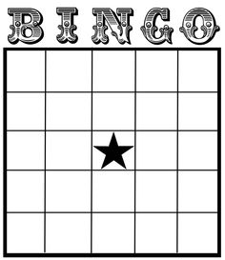
Source: https://s-media-cache-ak0.pinimg.com/236x/6f/4c/ab/6f4cab8cbf31c6e28323dcd69d050efd.jpg

Lesson 7  Day 11 | Elaboration, Categorizing, and Questioning | Estimated Time: 60 minutes

Brief overview of lesson: In this lesson, students will practice using adjectives describing forest, ocean, desert, polar, and grasslands animals and continue learning how to elaborate using adjectives. Students will continue building background knowledge about animals and their habitats by categorizing animals into their natural habitats, and they will continue practicing the inquiry process by using step 1: “Pose Real Questions.” In addition, students will continue to develop an understanding of how to summarize text and how to conduct research, skills central to the CEPA. As you plan, consider the variability of learners in your class and make adaptations as necessary.

What students should know and be able to do to engage in this lesson:
- Prepositions of place, wh- + h- question words, and adjectives.
- Basic knowledge of forest, ocean, desert, grasslands, and polar regions, and the animals that live in them.
- How to create a bubble map.
Experience working with partners and small groups.
LESSON FOUNDATION
Unit-Level Focus Language Goals to Be Addressed in This Lesson |  | Unit-Level Salient Content Connections to Be Addressed in This Lesson
G.1 Discuss by inquiring in order to build and present knowledge gathered through research.  G.2 Explain by elaborating to build and present knowledge on a substantive topic. |  | CCSS.ELA-LITERACY.L.1.6—Use words and phrases acquired through conversations, reading and being read to, and responding to texts, including using frequently occurring conjunctions to signal simple relationships.  CCSS.ELA-LITERACY.SL.1.4—Describe people, places, things, and events with relevant details, expressing ideas and feelings clearly.  CCSS.ELA-LITERACY.W.1.7—Participate in shared research and writing projects.
Language Objective |  | Essential Questions Addressed in This Lesson
Students will be able to describe animals orally and in writing using adjectives. |  | Q.1 How can you use language in different ways?  Q.2 How do we use language to learn about new things?  Q.3 How do we learn about where animals live?
Assessment
- Formative assessment: Assess students’ ability to listen for and identify prepositions and adjectives in a video. Assess their ability to use prepositions and adjectives to describe information learned in the video.
- Formative assessment: Assess students’ ability to apply learned language to ask and answer questions.
- Formative assessment: Assess students’ ability to use learned language to categorize and describe animals during the habitat sort.
- Observation: Assess students’ ability to apply learned language (e.g., content-specific language, prepositions, and adjectives) during the game “Who Lives Here?”
- Self-assessment: Students will be able to self-assess and self-monitor their learning through use of metacognitive/metalinguistic strategies while reading. Students will also self-monitor their learning as they summarize three things learned from their analysis of the text.
Thinking Space: What Academic Language Will Be Practiced in This Lesson?
Discourse Dimension | Sentence Dimension |  | Word Dimension
Social instructional language; non-fiction informational text and/or short videos containing content area vocabulary and simple sentences; asking and answering questions; stating thoughts and opinions orally and in writing using complete sentences | Questions with wh- + h- words (what, why, when, where, who, how); simple sentences with present tense verbs |  | Content vocabulary related to habitats previously introduced; additional academic vocabulary pertaining texts/videos used in the lesson; prepositions of place (above, on, under, near, in front, behind, between, in, over); adjectives to describe animals and habitats (colors, how something looks, size, temperature)
Instructional Tips/Strategies/Suggestions for Teacher
- Have the webs and charts from the previous lesson posted for students to review. When showing “The Inquiry Process” chart, only show the first column to help students focus on step 1: “Pose Real Questions.” Reference the chart during the lesson to remind students they are learning how to inquire. Consider allowing students to use sentence frames as needed when making their questions. When planning the lesson, consider other media for students to read or review such as articles about a particular habitat.

STUDENT CONSIDERATIONS
Sociocultural Implications
Students may be uncomfortable asking and answering questions.
Anticipated Student Pre-Conceptions/Misconceptions
- Some students may think that categorizing animals by characteristics (e.g., size, color, furry or not) is the same thing as categorizing animals by habitat.

THE LESSON IN ACTION

Lesson Opening

Post and explain the lesson’s language objective: “Students will be able to describe animals orally and in writing using adjectives.” To promote student ownership and self-monitoring of learning, consider having students record the objective in their notebooks or having students summarize the objective in their own words. At the end of the lesson, students can reflect on their learning in relation to the objective.

Review step 1 of the inquiry process using “The Inquiry Process” chart (only show the first column).

Go over the questions for step 1: “Pose Real Questions.”

Review questions asked so far and how students were able to answer them by gathering information from read-alouds, images, and videos. Review images, bubble maps, class anchor charts, and summaries from prior lessons.

Ask students to think about the regions that they have discussed, and have them practice asking and answering questions based on the class-generated anchor charts with a partner.

Ask students to think of any additional questions that they would like to ask about the regions, write them down, share them with a partner, and then share with the whole class. Record student-generated questions on the respective habitat class anchor charts.

During the Lesson

Show a video about animals and their habitats, such as “Discovery Ed: Adjectives in the Desert” available at Discovery Education or a video from the Wild Kratts video collection.

Before showing the video, ask students to look/listen for adjectives and prepositions of place in the video.

Afterwards, have students practice describing the habitats and animals showcased in the video using adjectives and prepositions of place. Give students time to brainstorm descriptive sentences or phrases about a particular habitat (or all habitats) that include adjectives and prepositions of place. Then have them write their responses in a notebook, learning log, or Post-Its. Finally, ask students to share their descriptions with a partner or small group.

Optional activity: Ask students to think about how the regions are similar (what they have in common) and how they are different, individually, with a partner, or with a small group. For example, similarities between habitats could meet the animal’s needs, provide food, provide shelter, etc. Differences between habitats could be temperature, conditions, access to water, and so forth.
Provide options for physical action, such as using a computer, writing, or dictation. Ask students to write, draw, or orally discuss the similarities and differences between the habitats.

Introduce the animal habitat sort activity.

Explain how students will use previously introduced habitat resources to categorize animal images by each animal’s habitat.

After sorting, tell students they will practice describing what they sorted and discussing why they categorized animals the way they did. Provide sentence frames for students, and model how to use them before the activity begins: “____ (animal) lives ____ (preposition) the ____ (region); I think ____ lives in the ____ because ____.” Have students work individually or with a partner or small group first, then share with the whole class.
Provide options for physical action, such as sorting images or writing descriptive sentences on a computer, writing sentences down, or orally sharing statements.

Have students read Who Lives Here? by Rozanne Lanczak Williams. Pre-teach and/or review specific metacognitive and metalinguistic strategies that students can use while reading (e.g., making predictions, stopping and summarizing the text in their own words, identifying key information, determining the meaning of unknown words).
Provide options for physical action, such as independent reading, mentor/mentee paired readings, or using text-to-speech readers.

Students can record three things that they learned in the book.
Provide options for physical action, such as using a computer or dictation.

Lesson Closing

Play a review game such as “Who Lives Here?” to practice using adjectives, prepositions of place, and wh- question words. This game can be played with a partner, a small group, or the whole class.

Go over game instructions: student 1 gets an image or card with a habitat word and has to give clues about that habitat to the rest of the class. The rest of the students ask questions to solicit more clues. Once students think they know the name of student 1’s habitat, they can say it to see if they are correct.

This activity can serve as a formative assessment of students’ ability to use question words, adjectives, prepositions of place, and content area vocabulary, as well as their ability to ask and answer questions.

Optional activity: Have students write a response to a given prompt in a reflection journal. For example, students could respond to a prompt such as: “What makes a habitat a good home for an animal?”
Provide options for physical action, such as dictating, drawing, or writing responses.

Lesson 7 Resources
- Computer with Internet access
- Student notebooks or learning logs
- Post-Its
- Anchor charts
- Websites:
- Wild Kratts
- DK Find Out!
- Videos:
- “Discovery Ed: Adjectives in the Desert” available at Discovery Education
- Books:
- Guess Who’s in the Desert by Charline Profiri and Susan Swan
- Who Lives Here? by Rozanne Lanczak Williams
- Sentence frames
- Images of previously studied animals and habitats
- “The Inquiry Process” chart (available in Lesson 1)

Lesson 8  Day 12 | Language Checkpoint | Estimated Time: 60 minutes

Brief overview of lesson: Students will have an opportunity to demonstrate academic language they have learned in the unit so far. This lesson provides an opportunity to assess student learning in relation to the Focus Language Goals. As you plan, consider the variability of learners in your class and make adaptations as necessary.

What students should know and be able to do to engage in this lesson:
- Ability to work in centers independently or with a small group.
Ability to create questions using question words, prepositions of place, adjectives, and content-specific vocabulary.
LESSON FOUNDATION
Unit-Level Focus Language Goals to Be Addressed in This Lesson |  | Unit-Level Salient Content Connections to Be Addressed in This Lesson
G.1 Discuss by inquiring in order to build and present knowledge gathered through research. |  | CCSS.ELA-LITERACY.L.1.6—Use words and phrases acquired through conversations, reading and being read to, and responding to texts, including using frequently occurring conjunctions to signal simple relationships.  CCSS.ELA-LITERACY.SL.1.4—Describe people, places, things, and events with relevant details, expressing ideas and feelings clearly.
Language Objective |  | Essential Questions Addressed in This Lesson
Students will be able to inquire about and discuss animals and their habitats using academic language learned so far in the unit (e.g., prepositions of place, adjectives, and question words). |  | Q.1 How can you use language in different ways?  Q.2 How do we use language to learn about new things?  Q.3 How do we learn about where animals live?
Assessment
- Formative assessment: Assess students’ ability to apply all learned language during the language checkpoint activities.
Thinking Space: What Academic Language Will Be Practiced in This Lesson?
Discourse Dimension | Sentence Dimension |  | Word Dimension
Social instructional language; non-fiction informational text and/or short videos containing content area vocabulary and simple sentences; asking and answering questions | Questions with wh- + h- words (what, why, when, where, who, how); simple sentences with present tense verbs |  | Content vocabulary related to habitats previously introduced; prepositions of place (above, on, under, near, in front, behind, between, in, over); adjectives to describe animals and habitats (colors, how something looks, size, temperature)
Instructional Tips/Strategies/Suggestions for Teacher
- Before the students complete the language checkpoint activity, walk them through each station, modeling what they will be doing.
- This language checkpoint serves as a formative assessment of student progress in relation to the unit’s Focus Language Goals. Use results to inform future instruction, making modifications as needed.
- Use the “Language Checkpoint” rubric to assess student work.

STUDENT CONSIDERATIONS
Sociocultural Implications
Some students may be new to center work and may need additional practice with centers.
Anticipated Student Pre-Conceptions/Misconceptions
- Some students may think that that the language checkpoint activity is a graded test. Review the purpose of the language checkpoint with students before it starts.
- Some students may think that sharing answers during the language checkpoint activity is okay.

THE LESSON IN ACTION

Lesson Opening

Post and explain the lesson’s language objective. “Students will be able to inquire about and discuss animals and their habitats using academic language learned so far in the unit (e.g., prepositions of place, adjectives, and question words).” To promote student ownership and self-monitoring of learning, consider having students record the objective in their notebooks or having students summarize the objective in their own words. At the end of the lesson, students can reflect on their learning in relation to the objective.

Point to language checkpoint centers around the room and give instructions.

Explain how students will go around the room, completing center work independently. Tell students to turn in the work completed at each station directly to the teacher or to a “done” bin before moving on to the next center.

Review expectations for each center and model what students will be doing at each one. Below is a quick description of the centers:
Center 1: Student identifies question words in questions.
Center 2: Student creates questions about animals and where they live using wh- + h- question words.
Center 3: Students answer questions orally or in writing using prepositions of place, adjectives, and content-specific vocabulary.

During the Lesson

Have students complete center work individually. Below is a full description of each center, with links to lesson resources listed in the next section:

Center 1: Students complete sentences by gluing a wh- question word into the correct place on a questions page with questions such as: “____ brown creature lives in the cave?” and “____ does the snake eat its furry prey?”

Center 2: Students will look at an image and ask or write a question using each of the wh- + h- words (who, what, when, where, why, how) in the “Questions” handout. For example, when given the following image, students could write questions such as: “Who lives in the forest? What is standing next to the mom? How does the deer survive?”
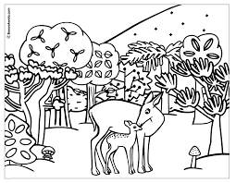

Center 3: (Facilitated by the teacher) Students look at an image of animals and their habitats and orally answer and/or write answers to the questions provided using adjectives and prepositions of place. Consider reading questions to students and have them answer orally, or have students use a text-to-speech reader. Sample questions/answers may include: “Who lives in the forest? The brown mother deer and her baby live in the forest. Where are the animals in the image? The animals are on the grass in the forest.” If asking students to write answers, use a worksheet such as the "Asking and Answering Questions” handout.

Lesson Closing

Show a video or read a text from a previous lesson. Ask students to summarize the main ideas and details from the video or text using prepositions of place, adjectives, and content area vocabulary learned.
Provide options for physical action, such as writing, orally summarizing, dictating, or using speech-to-text software.

Optional activity: Ask students questions to review ways they can research information. Have them think about their answers and then turn and talk to a partner. Sample questions may include:

“What are some ways that we can learn about where animals live?” (Possible answers include but are not limited to: reading a book, watching a video, posing questions, and talking to a specialist.)

“How have you been using the inquiry process to learn about animals and habitats?” (Possible answers include but are not limited to: reading books, watching videos, posing real questions, and finding resources.)

“How do we use language to learn about new things?” (Possible answers include but are not limited to: finding resources, posing real questions, interpreting information, and reporting findings.)

Depending on students’ work from the language checkpoint centers, consider adding another day to the instructional sequence to review learned academic language with students and give them opportunities to practice the concepts and skills for which they need reinforcement. Consider using activities from previous lessons and have students work in centers with these activities to reinforce learning.

Lesson 8 Resources
- Student notebooks
- Scissors
- Glue
- “Done” bin
- Student notebooks
- Language checkpoint rubric (available below)
- Language Checkpoint Center 1:
- Question words (available below)
- Questions page (available below)
- Language Checkpoint Center 2:
  - Sample image (available below)
- “Questions” handout (available below)
- Language Checkpoint Center 3:
  - “Asking and Answering Questions” handout (available below)

Language Checkpoint Rubric
(For G.1. Discuss by inquiring in order to build and present knowledge gathered through research)

Category | Emerging | Progressing | Proficient
Identifies question words appropriately. | Student rarely/does not identify(ies) question words in questions. | Student occasionally identifies question words in questions. | Student accurately identifies question words in questions.
Uses questions words with appropriate application. | Student rarely/does not create(s) questions using question words. | Student occasionally creates questions using question words. | Student accurately creates questions using question words.
Uses content vocabulary in context with appropriate application (orally and/or in writing). | Student rarely/does not use content vocabulary in context with appropriate application. | Student occasionally uses content vocabulary in context with appropriate application. | Student uses content vocabulary in context with appropriate application.
Uses prepositions of place to describe animals and where they live (orally and/or in writing). | Student rarely/does not describe animals and where they live using prepositions of place. | Student occasionally describes animals and where they live using prepositions of place. | Student describes animals and where they live using prepositions of place.
Uses adjectives to describe animals and where they live (orally and/or in writing). | Student rarely/does not elaborate using adjectives to describe animals and where they live orally and/or in writing. | Student occasionally elaborates using adjectives to describe animals and where they live orally and/or in writing. | Student elaborates using adjectives to describe animals and where they live orally and/or in writing.
Summarizes information by recounting main ideas and supporting details (orally and/or in writing). | Student rarely/does not summarize information by recounting main ideas and supporting details. | Student occasionally summarizes information by recounting main ideas and supporting details. | Student accurately summarizes information by recounting main ideas and supporting details.

Language Checkpoint Center 1
      - Question Words (Print and Cut Out)

Who | Who | Who | Who | Who | Who
What | What | What | What | What | What
When | When | When | When | When | When
Where | Where | Where | Where | Where | Where
Why | Why | Why | Why | Why | Why
How | How | How | How | How | How

      - Questions Page
Name: _______________________________ Date: ________________
Directions: Glue the question word that completes the question.

1. |  | color is a polar bear? | 4. |  | do bears hibernate?
2. |  | do birds build their nests? | 5. |  | lives in the desert?
3. |  | do dolphins live? | 6. |  | do fish swim?

Questions Page Answer Key
- What
- How, Why, or When
- Where
- When, How, or Why
- Who
- Why, When, or How

Language Checkpoint Center 2
      - Sample Image
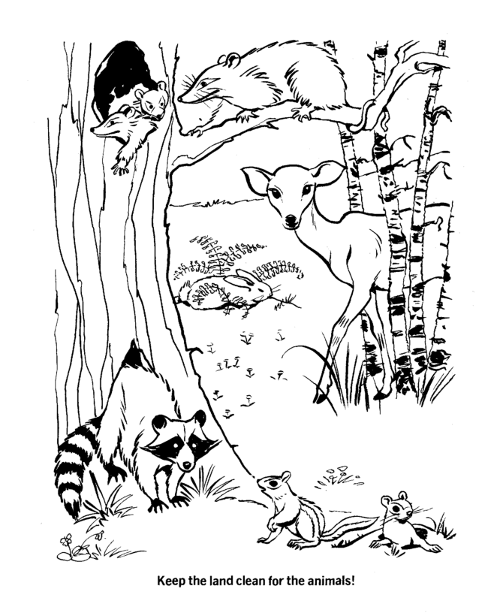
Source: azcoloring.com
      - Questions Handout

Name: ______________________________________ Date: ________________________

Directions: Look at the image and write a question for each of the question words.

- Who ___________________________________________________________________?
- What ___________________________________________________________________?
- When ___________________________________________________________________?
- Where ___________________________________________________________________?
- Why ___________________________________________________________________?
- How ___________________________________________________________________?

Language Checkpoint Center 3: Asking and Answering Questions Handout
Name: _________________________________ Date: _____________________

Directions: Use the image to help you answer the questions.

- Who lives in the forest? _________________________________________________________________________
_____________________________________________________________________________________________ .
- Where is the deer? ______________________________________________________________________________
_____________________________________________________________________________________________ .
- What does the rabbit eat? _______________________________________________________________________
_____________________________________________________________________________________________ .
- Why is the chipmunk looking at the raccoon? _______________________________________________________
_____________________________________________________________________________________________ .
- How does the opossum stay on the branch? _________________________________________________________
_____________________________________________________________________________________________ .
- When does the raccoon sleep? ___________________________________________________________________
_____________________________________________________________________________________________ .

Lesson 9  Days 13 and 14 | Creating Simple and Compound Sentences | Estimated Time: 60 minutes per day

Brief overview of lesson: Students will review the structure of a simple sentence and practice writing them. As students conduct research to learn more about animals and where they live, they will learn and use step 2 of the inquiry process: “Find Resources.” They will summarize information gathered from leveled readers using simple sentences, and will practice saying them using puppets. Students will continue to develop the skills needed to Discuss by inquiring in order to build and present knowledge gathered through research. As you plan, consider the variability of learners in your class and make adaptations as necessary.

What students should know and be able to do to engage in this lesson:
- Use adjectives and prepositions of place to provide more detailed descriptions.
- Ask simple questions.
- Basic familiarity with simple sentences.
Use content vocabulary related to the topic of animals and animal habitats orally and in writing.
LESSON FOUNDATION
Unit-Level Focus Language Goals to Be Addressed in This Lesson |  | Unit-Level Salient Content Connections to Be Addressed in This Lesson
G.1 Discuss by inquiring in order to build and present knowledge gathered through research.  G.2 Explain by elaborating to build and present knowledge on a substantive topic. |  | CCSS.ELA-LITERACY.L.1.6—Use words and phrases acquired through conversations, reading and being read to, and responding to texts, including using frequently occurring conjunctions to signal simple relationships.  CCSS.ELA-LITERACY.SL.1.4—Describe people, places, things, and events with relevant details, expressing ideas and feelings clearly.  CCSS.ELA-LITERACY.W.1.7—Participate in shared research and writing projects.
Language Objective |  | Essential Questions Addressed in This Lesson
Students will be able to describe animals and their habitats orally and in writing using simple and/or compound sentences. |  | Q.1 How can you use language in different ways?  Q.2 How do we use language to learn about new things?  Q.3 How do we learn about where animals live?
Assessment
- Formative assessment: Assess students’ use of simple/compound descriptive sentences.
- Formative assessment: Assess students’ ability to use language to research their assigned question. Also assess their ability to identify and organize key information on their CEPA planning sheet.
- Formative assessment: Assess students’ ability to summarize (orally and in writing) the key information identified from their research as evidenced by the puppet activity.
Thinking Space: What Academic Language Will Be Practiced in This Lesson?
Discourse Dimension | Sentence Dimension |  | Word Dimension
Social instructional language; non-fiction informational text and/or short videos containing content area vocabulary and simple sentences; asking and answering questions; reading and summarizing ideas using complete sentences | Questions with wh- + h- words (what, why, when, where, who, how); simple sentences with present tense verbs; compound sentences |  | Content vocabulary related to habitats previously introduced; prepositions of place (above, on, under, near, in front, behind, between, in, over); adjectives to describe animals and habitats (colors, how something looks, size, temperature); conjunctions (and, but, or, because, so); inquiry vocabulary (resources, valid)
Instructional Tips/Strategies/Suggestions for Teacher
- This lesson takes into account students at different levels. Depending upon student familiarity and comfort with drafting sentences, consider reviewing sentence order with all students and conducting targeted mini-lessons with small groups of students—focusing on various components of sentence drafting they might struggle with—while other students continue to work on activities independently.
- When showing “The Inquiry Process” chart, uncover the first and second columns to show steps 1 (“Pose Real Questions”) and 2 (“Find Resources”).
- Review and specify the difference between a statement and a question.
- Consider having students view San Diego Zoo live stream videos to build background knowledge on zoos, animals, and habitats. Have students observe animals and record their observations (e.g., what the animal is eating, what the animal’s zoo habitat looks like).
- Based upon student familiarity and comfort with punctuation, consider reviewing punctuation marks with students. For example, co-create an anchor chart on punctuation with students and give them time to practice adding periods and question marks to the end of sentences missing punctuation marks.

STUDENT CONSIDERATIONS
Sociocultural Implications
Sentence word order varies across languages. Consider learning basic word order for native languages of students in your class.
Anticipated Student Pre-Conceptions/Misconceptions
- Some students may confuse punctuation marks (periods, question marks, explanation marks, commas, etc.).

THE LESSON IN ACTION

Day 13 Lesson Opening

Post and explain the lesson’s language objective: “Students will be able to describe animals and their habitats orally and in writing using simple and/or compound sentences.” To promote student ownership and self-monitoring of learning, consider having students record the objective in their notebooks or having students summarize the objective in their own words. At the end of the lesson, students can reflect on their learning in relation to the objective.

Have students practice asking and answering questions about animals and where they live with a partner. Circulate around the room and observe students; use observations to informally assess their ability to answer questions in full sentences.

During the Lesson

Introduce the lesson by explaining how students will practice creating sentences. Consider showing a video about sentences, such as “First Grade How to Make a Sentence” or “Sentence Song Grade 1.”

Review simple sentence structure with students.

Write a simple sentence on the board or project it. For example, write: “The deer lives in the forest.”

Go over the structure of the sentence by pointing to and explaining each sentence component (noun, verb, preposition, etc.). Consider color-coding or labeling parts of speech in the sentence as a visual reinforcement of sentence structure.

Model how to create simple sentences using image cards.

Depending upon student familiarity and comfort with the simple present tense, you may wish to spend some time reviewing simple present tense verbs related to the topic of animals and habitats (e.g., to be, live, need).

Consider creating a simple present tense anchor chart with students. Then have students use images from the Lesson 7 sorting activity to orally construct simple sentences with you, a partner, or individually.

Have students practice creating sentences. Give students an image and have them create a sentence to describe it.
Provide options for physical action, such as writing, using a computer, re-ordering cut-up sentences, or dictating sentences.

Depending upon students’ level of comfort with creating simple sentences, consider introducing conjunctions (e.g., and, but, so, because, or) that can be used to combine sentences.

Model how to use conjunctions to combine sentences, noting the relationship between sentences being combined and the conjunction used. For example, explain how the conjunction and is used to combine like sentences and give an example: “The rabbit is white. The rabbit is furry. The rabbit is white and furry.” Be sure to highlight how the conjunction but is used to join together two contrasting ideas. For example: “The owl is nocturnal but squirrels are not.”

Lesson Closing

Ask students to write a descriptive sentence to describe a habitat or animal using information learned from a video or prior lesson’s text. Watching a video or reading a text again helps reinforce concepts and allows students to focus on sentence formation only, rather than on learning new information and sentence formation.
Provide options for physical action, such as writing sentences, using a computer, re-ordering cut-up sentences, or dictating sentences.

Optional activity: Have students revisit questions and answers recorded in class anchor charts from previous lessons and ask them to rewrite answers originally recorded as phrases and turn them into full sentences.

Day 14 Lesson Opening

Introduce and discuss step 2, “Find Resources,” of the inquiry process by showing columns 1 and 2 of the chart.

Ask students to think of any examples of research that they have done in the unit so far. Allow some time for quiet reflection before inviting students to share with a partner and then with the whole class.
Provide options for perception, such as having students view the chart on a computer or providing students with their own printed version of the chart.

Make connections to prior learning by explaining how students’ experience reading and watching videos about animals and habitats, asking questions, and finding out answers are ways of doing research. Refer to co-created habitat class anchor charts to reinforce this connection.

During the Lesson

Introduce the main purpose of the lesson by telling students that they will practice researching a question today.

Model how to pose a question about animals and their habitats and research its answer using the CEPA planning sheet. Highlight key steps and academic language involved, such as identifying information relevant to the question, using adjectives and prepositions of place to describe animals and habitats, and writing simple and/or compound sentences to communicate ideas gathered through research.

Keep this model posted for student reference.

Give students a question and ask them to research its answer. Notate for students the type of information that they will collect. For example, students could research a question such as: “What does the white-winged dove eat?”

Provide leveled readers and/or videos as research sources. Use books from previous lessons or from the suggested books in the unit resources section as research sources. Allow students to work with a partner or small group.
Provide options for physical action, such as using a video viewing station to watch the video, mentor/mentee paired reading, or using a text-to-speech reader.

Have students record the information from their research on the CEPA planning sheet and ask them to write their responses using simple or compound sentences, adjectives, and prepositions of place.
Provide options for physical action, such as using a computer, writing, or dictating information.

Help students make animal puppets or illustrations to share answers to their assigned questions.

Model how to use puppets or illustrations to summarize key information about the animal they researched (what the animal eats, where the animals lives, etc.) using first person point of view (or talking as if they are the animal they researched).

Ask students to orally share their answers with a partner. Tell them to describe themselves (as the animal) and their habitats in simple sentences, and to use prepositions of place and adjectives to recount the information learned in the text.

This activity can serve as a formative assessment of students’ ability to orally summarize information and apply learned language.

Lesson Closing

Review how students used step 2 of the inquiry process, “Find Resources,” during the lesson.

Have students write about their animal and its habitat using simple and/or compound sentences to summarize information learned through research.
Provide options for physical action, such as using a computer, writing, or dictation.

Optional activity: Have students use their puppets to present what they learned to the class.

Lesson 9 Resources
- Computer with Internet access
- Projector
- Student notebooks
- Whiteboard
- Image cards
- Chart paper
- Paper to make animal faces
- Paper bags
- Markers
- Anchor chart
- Website: DK Found Out!
- Videos:
- “First Grade How to Make a Sentence”
- “Sentence Song Grade 1”
- “Types of Sentences” from BrainPOP Jr.
- “Present Simple” ESL video (or similar) from BrainPOP Jr.
- San Diego Zoo live stream videos
- Leveled readers about animals and where they live
- Images of previously introduced animals and habitats
- Previously created bubble maps
“The Inquiry Process” chart (available in Lesson 1)
- CEPA planning sheet (available below)

CEPA Planning Sheet
Name: _____________________________

Part A:
Directions: Fill in the questions, draw and label the image, and use the information to practice writing a summary.

Region and animal: ________________________________________________________________________________________________

Question to answer about your animal and where it lives: _________________________________________________________________

One to five facts to answer your question (remember to include adjectives and prepositions):

- ______________________________________________________________________________________________________________
- ______________________________________________________________________________________________________________
- ______________________________________________________________________________________________________________
- ______________________________________________________________________________________________________________
- _______________________________________________________________________________________________________________

Written summary or notes for presentation summary:

______________________________________________________________________________________________________________
______________________________________________________________________________________________________________
______________________________________________________________________________________________________________
______________________________________________________________________________________________________________
_______________________________________________________________________________________________________________

Part B:
Draw an image of your habitat. Label the important details.

Lesson 10  Days 15 and 16 | Planning for the CEPA | Estimated Time: 60 minutes per day

Brief overview of lesson: This lesson provides an overview of the CEPA. Students will learn about the CEPA instructions, have opportunities to ask clarifying questions about it, and be assigned a region/habitat to research. Students will practice using step 3 of the inquiry process, “Interpret Information,” by gathering information for their CEPA using class anchor charts and other teacher-provided resources and recording this information on the CEPA planning sheet. Students will also practice step 4 of the inquiry process, “Report Findings,” by creating an illustration to share what they have learned through research. Finally, students will have opportunities to monitor their work with a small group and apply academic language learned throughout the lesson. Students will apply learned language in preparation for the final culminating performance assessment. As you plan, consider the variability of learners in your class and make adaptations as necessary.

What students should know and be able to do to engage in this lesson:
- Basic knowledge of how to write simple and/or compound sentences.
- Using adjectives and prepositions of place to describe an animal or habitat.
- Completion of a graphic organizer to organize information gathered through research.
- Experience working with a partner and small groups.
Background about the inquiry process.
LESSON FOUNDATION
Unit-Level Focus Language Goals to Be Addressed in This Lesson |  | Unit-Level Salient Content Connections to Be Addressed in This Lesson
G.1 Discuss by inquiring in order to build and present knowledge gathered through research.  G.2 Explain by elaborating to build and present knowledge on a substantive topic. |  | CCSS.ELA-LITERACY.L.1.6—Use words and phrases acquired through conversations, reading and being read to, and responding to texts, including using frequently occurring conjunctions to signal simple relationships.  CCSS.ELA-LITERACY.SL.1.4—Describe people, places, things, and events with relevant details, expressing ideas and feelings clearly.  CCSS.ELA-LITERACY.W.1.7—Participate in shared research and writing projects.  CCSS.ELA-LITERACY.W.1.8—With guidance and support from adults, recall information from experiences or gather information from provided sources to answer a question.
Language Objective |  | Essential Questions Addressed in This Lesson
Students will be able to summarize and discuss information gathered through research using academic language (e.g., adjectives, prepositions of place) and content vocabulary introduced in the lesson. |  | Q.1 How can you use language in different ways?  Q.2 How do we use language to learn about new things?  Q.3 How do we learn about where animals live?
Assessment
- Formative assessment: Assess students’ ability to apply learned language to summarize and discuss information gathered through research. Students will demonstrate their learning by identifying, organizing, and summarizing key information on their CEPA planning sheet.
- Self-assessment: Students will self-assess and self-monitor their learning through use of metacognitive strategies (e.g., activating prior knowledge in the exit ticket) and using the CEPA instructions and CEPA planning sheet to monitor their progress. Students will also self-assess their work.
Thinking Space: What Academic Language Will Be Practiced in This Lesson?
Discourse Dimension | Sentence Dimension |  | Word Dimension
Social instructional language; non-fiction informational text and/or short videos containing content area vocabulary and simple sentences; asking and answering questions; reading and summarizing ideas using complete sentences | Questions with wh- + h- words (what, why, when, where, who, how); simple sentences with present tense verbs; compound sentences |  | Content vocabulary related to habitats previously introduced; prepositions of place (above, on, under, near, in front, behind, between, in, over); adjectives to describe animals and habitats (colors, how something looks, size, temperature); conjunctions (and, but, or, because, so); inquiry vocabulary (interpret information, relevant, support, raise new questions)
Instructional Tips/Strategies/Suggestions for Teacher
- Post bubble maps from previous lessons for students to use as reference.
- When showing “The Inquiry Process” chart show the first (“Pose Real Questions”), second (“Find Resources”), and third column (“Interpret Information”) of the chart to help students focus. Reference the chart during the lesson to remind students they are learning how to inquire.
- Provide question frames for students to use when making questions as needed.
- Consider pre-selecting student groups before the lesson.
- Consider brainstorming potential topics with students and then having groups choose their topics.
- Consider setting up stations with each habitat where groups can keep their research.

STUDENT CONSIDERATIONS
Sociocultural Implications
- Some students may feel that confining animals is wrong and may feel uncomfortable working on a zoo exhibit.
- Some students may be uncomfortable working in a group.
Anticipated Student Pre-Conceptions/Misconceptions
- Some students may think that information can only be found in books.
- Some students may think they need to retell ALL of the information they read/listened to when communicating research findings.
- Some students may think that they have to copy information from books when researching.

THE LESSON IN ACTION

Day 15 Lesson Opening

Post and explain the lesson’s language objective: “Students will be able to summarize and discuss information gathered through research using academic language (e.g., adjectives, prepositions of place) and content vocabulary introduced in the lesson.” To promote student ownership and self-monitoring of learning, consider having students record the objective in their notebooks or having students summarize the objective in their own words. At the end of the lesson, students can reflect on their learning in relation to the objective.

Remind students about “The Inquiry Process” chart and Q.2: “How do you use language to learn about new things?” Revisit ways in which people can learn new things.
Provide options for perception, such as viewing the chart on a computer.

During the Lesson

Introduce step 3 of “The Inquiry Process” chart: “Interpret Information.”

Show columns 1, 2, and 3 of the chart and provide an explanation of step 3: “Interpret Information.” For example, say: “After we find the information, we interpret it or try to make sense of it so we can explain it.”
Provide options for perception, such as projecting the chart, providing students with a printed version of the chart, or having students view the chart on a computer.

Ask students to think about what step 3 means, and have them share with a partner before inviting them to a whole class discussion.

Ask students about their previous experience with zoos. For example, ask: “Who has been to the zoo? Who has seen an exhibit about forest animals at the zoo? What was in the exhibit? Where were the animals? What did you learn from this exhibit?” Allow some time for quiet reflection before inviting students to share with a partner and then with the whole class.
Provide options for perception, such as showing images or a video of a zoo (e.g., “Brief Tour of San Diego Zoo” or “We’re Going to the Zoo/Children Love to Sing Kids Animal Songs”).

Review the CEPA with students. Remind students that the class has been asked by zoo experts to help create some exhibits for a new zoo and go over task details:
The zoo experts want to make an exhibit about animals and where they live for each of these regions: polar region, forest region, grasslands region, desert region, and ocean region. The zoo experts will listen to presentations from our class about the animals that live in each region. The zoo experts really want to know what information children your age want to know about the animals that live in these regions. Students will begin by working in a small group to research one of the regions. Each group will focus on one region and will summarize key information about the region. Then each student will get a chance to present his or her proposed question(s) about an animal that lives in the region. The zoo experts want each presenter to pose a question that students would ask, information answering the question, and an image about the animal and where it lives.

Go over CEPA instructions.

Give students the “CEPA Student Instructions” handout and review the CEPA components. Consider posting the instructions for student reference through the next few lessons.

Model how to create a CEPA using a new CEPA planning sheet and student instructions. Explain each of the steps and necessary components. Remind students they will be working in small groups to gather research and describe a common habitat, and that afterwards each individual student will focus on a particular animal that lives in that habitat.

Assign CEPA groups and habitats.

Lesson Closing

Ask students to summarize, orally or in writing, step 3 of the inquiry process.

Ask students to write down their assigned region and to record information they already know about the region in an exit ticket. Then have students compare what they wrote with other members of their CEPA group.
Provide options for physical action, such as orally sharing, using a computer, or dictating.

Day 16 Lesson Opening

Review how to create a summary, highlighting summary components and showcasing summaries created in previous lessons.

During the Lesson

Explain the process for researching information using the CEPA planning sheet.

Tell each group to go over bubble maps and class anchor charts from previous lessons for their assigned region/habitat and orally discuss key information (such as types of animals, temperature, where the region is located, food sources, etc.). Ask them to use adjectives and prepositions of place.

After discussing the region, have students brainstorm what they would like to know about a particular region when they go to a zoo. For example, ask: “If you were going to the zoo what would you want to know about ____ region?” Prompt student thinking with questions such as: “What is life like in the ___ region? What kinds of things can animals eat in that region? Does it feel cold or hot in that region?” These questions can help students describe the characteristics of the region.

Have students record what they brainstormed on an individual CEPA planning sheet. Remind students to begin by writing a question that they think zoo visitors would like the exhibit to answer about the habitat or provide students with a question, such as: “What is life like in the ____ region?”

Give students time to research answers for their research question and record information on their CEPA planning sheet with their CEPA small group. Remind students to use bubble maps, class anchor charts, previously studied resources, or new teacher-provided resources related to their assigned region/habitat.
Provide options for physical action, such as using a computer.

Ask groups to create a summary of the information they researched. Provide students with a summary template as needed.

Model for students how to check their work to ensure that they have done step 3 of the inquiry process well. Keep the model posted for students to refer to as they are working. Have groups check that they have interpreted the information outlined in step 3 of “The Inquiry Process” chart using questions in the third column. While groups are working, circulate and offer specific feedback directly tied to their ability to interpret information researched.
Provide options for perception, such as using a computer to review the chart or providing students with printed versions of the chart.

Model for students how to check their summary to ensure that they have included all key information. While groups are working, circulate and offer specific feedback directly tied to their interpretation and summary of the researched information.
Provide options for perception, such as using a computer to review the chart or providing students with printed versions of the chart.

Lesson Closing

Review the model of a completed CEPA planning sheet and ask students to do a final review of their work, looking for instances where they used prepositions of place, adjectives, and content area vocabulary.

Show a sample labeled habitat illustration and ask students to illustrate and label their habitat as a group.

Lesson 10 Resources
- Computers with Internet access
- Student notebooks
- Graphic organizers
- Website: DK Find Out!
- Leveled books on animals and their habitats
- Videos:
- “Brief Tour of San Diego Zoo”
- “We’re Going to the Zoo/Children Love to Sing Kids Animal Songs”
- Images of previously studied animals and habitats
- Previously viewed videos
- Previously created bubble maps
- Previously created habitat class anchor charts
- “The Inquiry Process” chart (available in Lesson 1)
- CEPA planning sheet (available in Lesson 9)
- “CEPA Student Instructions” handout (available below)
- Exit ticket (available below)

CEPA Student Instructions
Dear Students,

You are experts in studying animals and knowing where they live. We need your help to create some exhibits for a new zoo. Think about how students your age learn from exhibits at the zoo. What images do want to see, what questions do students have, and what information do they want to read to learn about animals and where they live?
The zoo experts want to make an exhibit about animals and where they live for each of these regions:
- Polar region
- Forest region
- Grasslands region
- Desert region
- Ocean region

The zoo experts will listen to presentations from your class about the animals that live in each region. Each student will get a chance to present his or her expert knowledge about a question that students would ask, information answering the question, and an image about the animal and where it lives.
CEPA Steps:
- Complete a new planning sheet for the animal that lives in your region.

- Write a question about the animal that lives in your region that you would like to research.

- Research the question to find an answer. Then record three to five facts about the animal and where it lives.
- Be specific about where the animal lives.
- Use adjectives and use prepositions of place to describe animals and where they live.
- Connect your sentences with the right word.
- Use three to five animal vocabulary words we have learned in class.

- Practice your summary before presenting to the class. Use what we have learned about oral presentations.

- Present your summary to the panel of zoo experts!

Exit Ticket
Name: ___________________________________________________________________________________________

My region is: ___________________________________________________________________________________________________________________

Directions: Record what you already know about your assigned region.

___________________________________________________________________________________________________________________________________

___________________________________________________________________________________________________________________________________

___________________________________________________________________________________________________________________________________

___________________________________________________________________________________________________________________________________

___________________________________________________________________________________________________________________________________

___________________________________________________________________________________________________________________________________

___________________________________________________________________________________________________________________________________

___________________________________________________________________________________________________________________________________

___________________________________________________________________________________________________________________________________

___________________________________________________________________________________________________________________________________

Lesson 11  Days 17 and 18 | Drafting Summaries | Estimated Time: 60 minutes per day

Brief overview of lesson: Students will continue to work on the CEPA by researching individual question(s) for their proposed zoo exhibit using information collected as a class and other resources provided by the teacher. Students will practice completing step 3 (“Interpret Information”) and step 4 (“Report Findings”) of the inquiry process, summarizing and reporting their research findings. Students will have a chance to work with their groups to check their work and ensure it is aligned with what they have learned. As you plan, consider the variability of learners in your class and make adaptations as necessary.

What students should know and be able to do to engage in this lesson:
- Writing simple/compound sentences.
- Use of adjectives and prepositions of place to describe animals and animal habitats.
- Completion of a graphic organizer to collect information during research.
- Experience working in pairs and small groups.
- Basic knowledge about the inquiry process.
Experience creating an illustration depicting written ideas.
LESSON FOUNDATION
Unit-Level Focus Language Goals to Be Addressed in This Lesson |  | Unit-Level Salient Content Connections to Be Addressed in This Lesson
G.1 Discuss by inquiring in order to build and present knowledge gathered through research.  G.2 Explain by elaborating to build and present knowledge on a substantive topic.  G.3 Recount to summarize and record research findings. |  | CCSS.ELA-LITERACY.L.1.6—Use words and phrases acquired through conversations, reading and being read to, and responding to texts, including using frequently occurring conjunctions to signal simple relationships.  CCSS.ELA-LITERACY.SL.1.4—Describe people, places, things, and events with relevant details, expressing ideas and feelings clearly.  CCSS.ELA-LITERACY.W.1.7—Participate in shared research and writing projects.  CCSS.ELA-LITERACY.W.1.8—With guidance and support from adults, recall information from experiences or gather information from provided sources to answer a question.  CCSS.ELA-LITERACY.SL.1.5—Add drawings or other visual displays to clarify ideas, thoughts, and feelings.
Language Objective |  | Essential Questions Addressed in This Lesson
Students will be able to summarize information collected from research by writing simple and/or compound sentences. |  | Q.1 How can you use language in different ways?  Q.2 How do we use language to learn about new things?  Q.3 How do we learn about where animals live?
Assessment
- Formative assessment: Assess students’ use of learned language to identify and organize key information from their research on their CEPA planning sheet. Also assess their application of learned language in their research summary (oral and written).
- Self-assessment: Students will self-assess using the CEPA editing checklist.
Thinking Space: What Academic Language Will Be Practiced in This Lesson?
Discourse Dimension | Sentence Dimension |  | Word Dimension
Social instructional language; non-fiction informational text and/or short videos containing content area vocabulary and simple sentences; asking and answering questions; reading and summarizing ideas using complete sentences | Questions with wh- + h- words (what, why, when, where, who, how); simple sentences with present tense verbs; compound sentences |  | Content vocabulary related to habitats previously introduced; prepositions of place (above, on, under, near, in front, behind, between, in, over); adjectives to describe animals and habitats (colors, how something looks, size, temperature); conjunctions (and, but, or, because, so); inquiry vocabulary (report findings, main point, audience, connect, express my message); task-related vocabulary (illustration, diagram, labels/captions, oral presentation)
Instructional Tips/Strategies/Suggestions for Teacher
- Post previous lessons’ bubble maps and class anchor charts for students to review.
- Show all steps of “The Inquiry Process” chart and reference it during the lesson to remind students they are learning how to inquire.
- Provide question frames for forming questions when needed.
- Consider setting up stations with each habitat where the groups can keep their research.
- If there are no student illustration samples, consider creating your own hand-drawn illustration or find a diagram to show as a model.

STUDENT CONSIDERATIONS
Sociocultural Implications
- Students may be uncomfortable working with a group.
- Presentation norms vary from culture to culture (e.g., eye contact). Make sure to stress how presentation skills discussed in class reflect American presentation standards, instead of the only correct way to present orally.
Anticipated Student Pre-Conceptions/Misconceptions
- Students may not understand that writing is a process, and they may think their first draft is the final draft.
- Students may not understand that they need to consider the audience they will be presenting to when planning an oral presentation.

THE LESSON IN ACTION

Day 17 Lesson Opening

Post and explain the lesson’s language objective: “Students will be able to summarize information collected from research by writing simple and/or compound sentences.” To promote student ownership and self-monitoring of learning, consider having students record the objective in their notebooks or having students summarize the objective in their own words. At the end of the lesson, students can reflect on their learning in relation to the objective.

Introduce the focus of the lesson by telling students they will work on their individual presentations about one of the animals in their assigned habitat. Remind students of the individual component of the CEPA by explaining how they are researching habitats together with a small group, but that the next step is to come up with an individual question about an animal that lives in that habitat and research an answer.

Model how to work on the CEPA by sharing your completed CEPA planning sheet.

During the Lesson

Have students select an animal to research individually by analyzing bubble maps, class anchor charts, and resources from previous lessons and finding an animal that lives in their assigned habitat. Alternatively, have students brainstorm a list of animals from their assigned habitat and then assign them an animal to research.

Give students time to research their animal.

Give each student a new CEPA planning sheet and tell them they will be working independently.

Ask students to think about the kind of information they would like to know about an animal if they went to a zoo. Remind them to begin their research by writing a question that they think zoo visitors would like to know about when they visit an exhibit about their assigned animal. Help students refine their questions as needed.

Guide students to review bubble maps, class anchor charts, leveled readers, websites, videos, and/or previously used resources to research an answer for their question (see suggested texts in the Unit Resources). Tell them to record researched information on their CEPA planning sheets. Circulate and support student interpretation of the information.
Provide options for physical action, such as using a computer, writing, or dictation.

Model how to check to make sure one has interpreted information correctly using column 3 of “The Inquiry Process” chart. Have students independently check their work to make sure they have applied step 3 correctly, and then give them time to meet with their CEPA small group to check that each student has interpreted the information correctly and the interpretation corresponds to the questions.

Lesson Closing

Students will give suggestions to their peers and revise their graphic organizer as needed.

Day 18 Lesson Opening

Model how to create an oral summary to present research findings for the CEPA. Highlight language students need to use in their summary, such as adjectives, prepositions of place, complete sentences, and conjunctions. Refer to and provide students with a copy of the CEPA editing checklist.

Introduce oral presentation skills by modeling an effective and an ineffective presentation.

Briefly explain the purpose of oral presentations.
Provide options for engagement, such as having students share any experience they have listening to/giving oral presentations, giving students examples of everyday oral presentations (e.g., listening to a teacher explain something in class, watching an infomercial on TV) and having them raise their hands if they have participated in these activities).

During the Lesson

Model an ineffective oral presentation.

Ask students to individually think about what did not work well in your presentation and any suggestions for improvement that they have for you. Then ask them to share with a partner before discussing as a whole class. Create a T-chart listing characteristics of effective and ineffective presentations and record student-generated characteristics of what made the presentation poor.

Model an effective oral presentation. Before presenting, ask students to note your use of adjectives, prepositions of place, conjunctions, and content area vocabulary by writing down the targeted words they hear or circling them on a teacher-provided checklist. After the presentation, ask students to share how this presentation was different from the first one with a partner. Have partners share with the whole class, and record student-generated characteristics of this effective presentation on the T-chart.

Give students time to continue researching animals. Circulate and offer students specific feedback tied directly to their research.

Revisit the CEPA planning sheet model. Ask groups to check that they have interpreted information correctly and that the information gathered corresponds with the questions in column 3 of “The Inquiry Process” chart.

Review step 4, “Report Findings,” of “The Inquiry Process” chart. Highlight good ways to report findings and have students check their CEPA planning sheet as needed to make sure their findings are reported correctly.
Provide options for perception, such as a shared file to view the chart on a computer.

Ask students to practice giving an oral summary of their research findings by stating their question and the answer to the question. Provide sentence frames, such as: “My research question is …,” “I found out that …,” and “This information should be in the zoo exhibit because…”

Lesson Closing

Have students create illustrations for their research findings.
Provide options for physical action, such as using a computer to draw.

Lesson 11 Resources
- Computers with Internet access
- Student notebooks
- Graphic organizers
- Art supplies and drawing paper to create illustrations
- Website: DK Find Out!
- Leveled books on animals and their habitats
- Images of previously studied animals and habitats
- Previously viewed videos
- Previously created bubble maps
- Previously created habitat class anchor charts
- “The Inquiry Process” chart (available in Lesson 1)
- CEPA planning sheet (available in Lesson 9)
- CEPA editing checklist (available below)

CEPA Editing Checklist
Name ___________________

Write an X on each element you included in your CEPA.

Did I use:

Adjectives (colors, how something looks, size, temperature) to describe the animal and/or where it lives?

Prepositions of place (above, on, under, near, in front, behind, between, in, over) to describe the animal and/or where it lives?

Complete sentences?

OPTIONAL: Conjunctions (and, but, or, because, so) to combine sentences?

Did I:
Include a research question?
Answer my research question completely using information I found during my research?
Summarize my research findings by including main ideas and details?

Lesson 12  Day 19 | Editing, Revising, and Composing Final Drafts | Estimated Time: 60 minutes

Brief overview of lesson: Students will continue to work on the CEPA, using step 4, “Report Findings,” of the inquiry process. Students will also edit and revise their presentation materials with support from the teacher. Students will develop an understanding of how to prepare and present research findings. As you plan, consider the variability of learners in your class and make adaptations as necessary.

What students should know and be able to do to engage in this lesson:
- Writing simple/compound sentences.
- Use of adjectives and prepositions of place to describe animals and animal habitats.
- Completion of a graphic organizer to collect information during research.
- Experience working in pairs and small groups.
- Basic knowledge about the inquiry process.
- Experience creating an illustration depicting written ideas.
Experience editing and/or revising writing with teacher assistance.
LESSON FOUNDATION
Unit-Level Focus Language Goals to Be Addressed in This Lesson |  | Unit-Level Salient Content Connections to Be Addressed in This Lesson
G.1 Discuss by inquiring in order to build and present knowledge gathered through research.  G.2 Explain by elaborating to build and present knowledge on a substantive topic.  G.3 Recount to summarize and record research findings. |  | CCSS.ELA-LITERACY.L.1.6—Use words and phrases acquired through conversations, reading and being read to, and responding to texts, including using frequently occurring conjunctions to signal simple relationships.  CCSS.ELA-LITERACY.SL.1.4—Describe people, places, things, and events with relevant details, expressing ideas and feelings clearly.  CCSS.ELA-LITERACY.W.1.7—Participate in shared research and writing projects.  CCSS.ELA-LITERACY.W.1.8—With guidance and support from adults, recall information from experiences or gather information from provided sources to answer a question.  CCSS.ELA-LITERACY.SL.1.5—Add drawings or other visual displays to clarify ideas, thoughts, and feelings.
Language Objective |  | Essential Questions Addressed in This Lesson
Students will be able to summarize information gathered through research using simple and/or compound sentences. |  | Q.1 How can you use language in different ways?  Q.2 How do we use language to learn about new things?  Q.3 How do we learn about where animals live?
Assessment
- Formative assessment: Assess students’ ability to apply all learned language to edit and finalize their CEPA planning sheets.
- Self-assessment: Students will use the self-assessment checklist to edit their work with the support of the teacher.
Thinking Space: What Academic Language Will Be Practiced in This Lesson?
Discourse Dimension | Sentence Dimension |  | Word Dimension
Social instructional language; non-fiction informational text and/or short videos containing content area vocabulary and simple sentences; writing paragraphs and/or multiple connected sentences about a topic | Questions with wh- + h- words (what, why, when, where, who, how); simple sentences with present tense verbs; compound sentences |  | Content vocabulary related to habitats previously introduced; prepositions of place (above, on, under, near, in front, behind, between, in, over); adjectives to describe animals and habitats (colors, how something looks, size, temperature); conjunctions (and, but, or, because, so); inquiry vocabulary (report findings, main point, audience, connect, express my message); task-related vocabulary (illustration, diagram, labels/captions, edit, revise, final draft)
Instructional Tips/Strategies/Suggestions for Teacher
- Post previous lessons’ bubble maps and class anchor charts for students to review.
- Show all steps of “The Inquiry Process” chart and reference it during the lesson to remind students that they are learning how to inquire.
- Provide question frames for forming questions when needed.
- Be sure there is a clear difference between the editing draft and the final draft by marking the editing draft with suggested edits so that students understand that this is their copy to publish.
- Consider having students complete their CEPA checklists multiple times alone and with a partner to ensure they are not missing anything, especially if they have found there is something that needed to be fixed.
- Consider conferencing with each student individually for editing. If this is not possible, edit with small groups.

STUDENT CONSIDERATIONS
Sociocultural Implications
Presentation norms vary from culture to culture (e.g., eye contact). Make sure to stress how presentation skills discussed in class reflect American presentation standards, instead of the only correct way to present orally.
Anticipated Student Pre-Conceptions/Misconceptions
- Students may not understand that writing is a process, and they may think that their first draft is the final draft.
- Students may not understand that they need to consider the audience they will be presenting to when planning for oral presentations.
- Students may think that editing marks need to be included in final drafts.

THE LESSON IN ACTION

Lesson Opening

Post and explain the lesson’s language objective: “Students will be able to summarize information gathered through research using simple and/or compound sentences.” To promote student ownership and self-monitoring of learning, consider having students record the objective in their notebooks or having students summarize the objective in their own words. At the end of the lesson, students can reflect on their learning in relation to the objective.

Review elements of an effective oral presentation and a good summary.

Have students do a think-pair-share about the elements of an effective oral presentation and a good summary. As partners report out, show the T-chart created in Lesson 11 and/or record the elements students share. Consider adding gestures to each component to reinforce student understanding.

This activity can serve as a formative assessment of students’ understanding of the elements of an effective oral presentation and summary.

During the Lesson

Review step 4, “Report Findings,” of “The Inquiry Process” chart.
Provide options for perception, such as a shared file so students can view the chart on a computer.

Review CEPA work completed so far.

Model how to review a CEPA planning sheet using the CEPA editing checklist. Model how to edit to make sure there are appropriately used adjectives, wh- + h- question words, prepositions of place, and complete sentences.

Post the teacher model for student reference and give students time to review and edit/revise their work. Circulate while students are working and offer specific feedback directly tied to student editing.

Show an edited, final draft of a CEPA presentation sheet. Discuss the differences between the rough draft and the edited final two drafts (final draft doesn’t have editing marks; final draft is neatly written; final draft includes adjectives, prepositions of place, and question words, etc.).

Give students time to complete their CEPA presentation sheet.

Consider letting students dictate their final drafts.

Ask students to compare their rough draft and final draft to see how far they have come. Circulate and offer specific feedback based on their revisions.

Have the students draw their final illustration/diagram and label it.
Provide options for physical action, such as using a computer to draw.

Optional activity: Have students prepare presentation boards/posters or a PowerPoint to display their summaries and illustrations.

Lesson Closing

Have students practice delivering an oral presentation to a partner.

Optional activity: Have students record what they have learned about their animal and its habitat, researching, and/or giving oral presentations in a learning log or notebooks.

Lesson 12 Resources
- Computers with Internet access
- Student notebooks
- Graphic organizers
- Art supplies and drawing paper to create illustrations
- Website: DK Find Out!
- Leveled books on animals and their habitats
- Images of previously studied animals and habitats
- Previously viewed videos
- Previously created bubble maps
- Previously created habitat class anchor charts
- Individual and group CEPA planning sheets from previous lessons
- Final CEPA presentation sheet
- “The Inquiry Process” chart (available in Lesson 1)
- CEPA planning sheet (available in Lesson 9)
- CEPA editing checklist (available in Lesson 11)

Lesson 13  Day 20 | Completing the CEPA | Estimated Time: 60 minutes

Brief overview of lesson: Students will use step 4, “Report Findings,” of the inquiry process. They will also complete the CEPA by giving an oral presentation to show what they have learned throughout the unit and assessing their own performance. As you plan, consider the variability of learners in your class and make adaptations as necessary.

What students should know and be able to do to engage in this lesson:
- Writing simple/compound sentences.
- Use of adjectives and prepositions of place to describe animals and animal habitats.
- Completion of a graphic organizer to collect information during research.
- Experience working in pairs and small groups.
- Basic knowledge about the inquiry process.
- Experience creating an illustration depicting written ideas.
- Experience editing and/or revising writing with teacher assistance.
Some background knowledge about presenting in front of the class.
LESSON FOUNDATION
Unit-Level Focus Language Goals to Be Addressed in This Lesson |  | Unit-Level Salient Content Connections to Be Addressed in This Lesson
G.1 Discuss by inquiring in order to build and present knowledge gathered through research.  G.2 Explain by elaborating to build and present knowledge on a substantive topic.  G.3 Recount to summarize and record research findings. |  | CCSS.ELA-LITERACY.L.1.6—Use words and phrases acquired through conversations, reading and being read to, and responding to texts, including using frequently occurring conjunctions to signal simple relationships.  CCSS.ELA-LITERACY.SL.1.4—Describe people, places, things, and events with relevant details, expressing ideas and feelings clearly.  CCSS.ELA-LITERACY.W.1.7—Participate in shared research and writing projects.  CCSS.ELA-LITERACY.W.1.8—With guidance and support from adults, recall information from experiences or gather information from provided sources to answer a question.  CCSS.ELA-LITERACY.SL.1.5—Add drawings or other visual displays to clarify ideas, thoughts, and feelings.
Language Objectives |  | Essential Questions Addressed in This Lesson
Students will be able to discuss information researched by orally presenting their summaries and illustrations.  Students will be able to describe animals and their habitats using content vocabulary, prepositions of place, and complete sentences. |  | Q.1 How can you use language in different ways?  Q.2 How do we use language to learn about new things?  Q.3 How do we learn about where animals live?
Assessment
- Summative: Assess students’ ability to apply all learned language in the CEPA.
- Self-assessment: Students will self-assess using the CEPA editing checklist.
Thinking Space: What Academic Language Will Be Practiced in This Lesson?
Discourse Dimension | Sentence Dimension |  | Word Dimension
Social instructional language; non-fiction informational text written by peers; listening to and orally presenting multiple connected sentences about a topic | Questions with wh- + h- words (what, why, when, where, who); simple sentences with present tense verbs; compound sentences |  | Content vocabulary related to habitats previously introduced; prepositions of place (above, on, under, near, in front, behind, between, in, over); adjectives to describe animals and habitats (colors, how something looks, size, temperature); conjunctions (and, but, or, because, so); inquiry vocabulary (report findings, main point, audience, connect, express my message); task-related vocabulary (oral presentation)
Instructional Tips/Strategies/Suggestions for Teacher
- Post previously created bubble maps and class anchor charts for students to view. This will not hinder assessment but can encourage students to use strategies that they have learned.
- If using comment cards to give feedback to presenters, make sure to model how to write respectful feedback comments (e.g., thing you liked, one thing that could be improved).

STUDENT CONSIDERATIONS
Sociocultural Implications
- Some students may be uncomfortable presenting in front of the whole class.
- Some students may be unfamiliar with self-assessing.
Anticipated Student Pre-Conceptions/Misconceptions
- Students may not understand that they need to consider the audience they will be presenting to.
- Students may think that they should only address the teacher when they are presenting.

THE LESSON IN ACTION

Lesson Opening

Post and explain the lesson’s language objectives: “Students will be able to discuss information researched by orally presenting their summaries and illustrations,” and “students will be able to describe animals and their habitats using content vocabulary, prepositions of place, and complete sentences.” To promote student ownership and self-monitoring of learning, consider having students record the objective in their notebooks or having students summarize the objective in their own words. At the end of the lesson, students can reflect on their learning in relation to the objectives.

Review the unit essential questions and how students have engaged with them throughout the unit.

Review step 4, “Report Findings,” of the “The Inquiry Process” chart and show all columns. Ask students to share why reporting findings is an important piece of the inquiry process.
Provide options for perception, such as using a shared file so that students can view the chart on a computer or giving students a printed version of the chart.

Review how to give an effective presentation, referring back to the T-chart or notes from Lesson 11.

During the Lesson

Explain how to be an active listener and model active listening for students with a role play (where you show students how to actively listen while another student or teacher gives a presentation) or another similar activity.

Give students time to practice their oral summaries.

Introduce the audience and give them the role of zoo experts. Consider inviting other teachers or administrators, or just have students present to the class.

Introduce the presentations. Explain how each group will first summarize key information about their assigned region and show an illustration of the habitat. Then each student will present his/her proposed question, their answer gathered through research about an animal that lives in the region, and their illustration of the animal and where it lives.

Have students deliver their presentations by group.

Assess each student using the CEPA rubric after students have completed their presentations.

Lesson Closing

Explain how to self-assess, and model how to do it using the CEPA editing checklist. Ask students to self-assess using the checklist and share their answers.

Revisit the K-W-L chart started in Lesson 1. Ask students to share what they learned by writing their responses and then sharing with the class.

Lesson 13 Resources
- Sticky notes/index cards for student comments
- Optional tools:
- Microphone/amplifier
- “The Inquiry Process” chart (available in Lesson 1)
- CEPA editing checklist (available in Lesson 11)
- Differentiation of the CEPA using WIDA Performance Indicators (available below)
- CEPA rubric (available below)

Differentiation of the CEPA Using WIDA Performance Indicators
Teachers may adjust performance indicators as necessary based on student needs.
Model Performance Indicators
WIDA Standard: The Language of Language Arts/Science |  | WIDA PI Receptive Domain (Listening or Reading)
Level 1—Entering  X | Level 2—Emerging  Inquire by finding information related to animals and their habitats from various media in small groups with an adult’s assistance. | Level 3—Developing  Inquire by finding information related to animals and their habitats from various media in small groups. | Level 4—Expanding  X | Level 5—Reaching  X
WIDA Standard: The Language of Language Arts/Science |  | WIDA PI Productive Domain (Speaking or Writing)
Level 1—Entering  X | Level 2—Emerging  Describe characteristics of animals and their habitats gathered from various media in small groups with an adult’s assistance. | Level 3—Developing  Summarize characteristics of animals and their habitats gathered from various media in small groups. | Level 4—Expanding  X | Level 5—Reaching  X

CEPA Rubric
Category | Emerging | Progressing | Proficient
Uses content vocabulary in context with appropriate application (orally and/or in writing). | Student rarely/does not use content vocabulary in context with appropriate application. | Student occasionally uses content vocabulary in context with appropriate application. | Student uses content vocabulary in context with appropriate application.
Uses prepositions of place to describe animals and where they live (orally and/or in writing). | Student rarely/does not describe animals and where they live using prepositions of place. | Student occasionally describes animals and where they live using prepositions of place. | Student describes animals and where they live using prepositions of place.
Uses adjectives to describe animals and where they live (orally and/or in writing). | Student rarely/does not elaborate using adjectives to describe animals and where they live orally and/or in writing. | Student occasionally elaborates using adjectives to describe animals and where they live orally and/or in writing. | Student elaborates using adjectives to describe animals and where they live orally and/or in writing.
Summarizes information by recounting main ideas and supporting details (orally and/or in writing). | Student rarely/does not summarize information by recounting main ideas and supporting details. | Student occasionally summarizes information by recounting main ideas and supporting details. | Student accurately summarizes information by recounting main ideas and supporting details.

Unit Resources
Additional resources for each region:
Books:
  - Here is the African Savanna (Web of Life) by Madeleine Dunphy
  - A Savanna Habitat (Introducing Habitats) by Bobbie Kalman
  - Living in the Arctic (Rookie Read-About Geography) by Allan Fowler
  - Amazing Arctic Animals (Penguin Young Readers) by Jackie Glassman
  - National Geographic Readers: Penguins! by Anne Schreiber
  - National Geographic Readers: Dolphins by Melissa Stewart
  - National Geographic Readers: Cheetahs by Laura Marsh
  - National Geographic Readers: Tigers by Laura Marsh
  - National Geographic Readers: Lions by Laura Marsh
  - National Geographic Readers: Owls by Laura Marsh
  - National Geographic Readers: Red Pandas by Laura Marsh
  - National Geographic Readers: Wolves by Laura Marsh
  - The Arctic Habitat (Introducing Habitats) by Molly Aloian
  - National Geographic Readers: Weird Sea Creatures by Laura Marsh
  - National Geographic Readers: Sharks! by Anne Schreiber
  - The Magic School Bus: on the Ocean Floor by Joanna Cole
  - Life in the Oceans by Lucy Baker
  - What Do Sharks Eat for Dinner? by Gilda Berger and Melvin Berger
  - The Earth is Mostly Ocean by Allan Fowler
  - All About Turtles by Jim Arnosky
  - Splash! A Book About Whales and Dolphins by Gilda Berger and Melvin Berger

