ESL: Justice, Courage, and Fairness
Language of Social Studies and Language Arts, Grades 1–2—
English Language Proficiency Levels 1 and 2
For more information on the design process for the ESL MCUs, please see the Next Generation ESL Project: Curriculum Resource Guide
This unit is intended to deliver systematic, explicit, and sustained English language development in the context of the Massachusetts Curriculum Frameworks. The purpose of this unit is to help ELs develop the language necessary for academic success in the content area of English language arts and Social Studies. They will also develop language that will be used recurrently in and across various academic and social contexts.
The embedded language development of this unit centers on two of the Key Uses of Academic Language:
- Recount by sequencing events in stories to communicate context-specific messages.
Explain by describing how the actions of particular characters/historical figures contributed to increasing justice, courage, and fairness in our world, supported with reasoning and evidence.
These unit-level Focus Language Goals were created through an analysis of the driving language demands of an existing Model Curriculum Unit on ELA/history and social sciences (HSS) for grade 1: “Content Literacy: People Who Work for Justice.” However, this ESL unit is not the same as a sheltered ELA/HSS unit. It is intended to be taught by an ESL teacher, and collaboration with the content teacher is essential. It is also important to keep in mind that in addition to the dedicated, language-focused instruction outlined in this unit, English learners (ELs) must have access to all core academic content instruction.
This unit offers contextualized, extended practice with discourse, sentence, and word/phrase dimensions of the academic language targeted in the unit. Students will learn about historical figures and people who have worked to promote justice, courage, and fairness, as well as language useful for recounting and explaining these concepts. By the end of the unit, students will be equipped with language useful for presenting their knowledge about these concepts, and to explain how selected historical figures and characters have embodied them.

This document was prepared by the Massachusetts Department of Elementary and Secondary Education, Mitchell D. Chester, Ed.D., Commissioner.
The Massachusetts Department of Elementary and Secondary Education, an affirmative action employer, is committed to ensuring that all of its programs and facilities are accessible to all members of the public. We do not discriminate on the basis of age color, disability, national origin, race, religion, sex, or sexual orientation.
© 2016 under the terms of the Creative Commons Attribution-NonCommercial-ShareAlike 3.0 Unported License. Additionally, the unit may also contain other third party material used with permission of the copyright holder. Please see Image and Text Credits for specific information regarding third copyrights.
Every effort has been made to acknowledge copyright. Any omissions brought to our attention will be corrected in subsequent editions.
Image and Text Credits may be found at the end of the unit.

The contents of this Model Curriculum Unit were developed under a grant from the U.S. Department of Education. However, those contents do not necessarily represent the policy of the U.S. Department of Education, and you should not assume endorsement by the federal government.
Massachusetts Department of Elementary and Secondary Education, 75 Pleasant St, Malden, MA 02148-4906. Phone 781-338-3300, TTY: N.E.T. Relay 800-439-2370, www.doe.mass.edu

Table of Contents
Unit Plan 5
Lesson 1 12
Lesson 2 29
Lesson 3 42
Lesson 4 53
Lesson 5 60
Lesson 6 67
Lesson 7 72
Lesson 8 81
Lesson 9 89
Lesson 10 96
Lesson 11 101
Lesson 12 106
Lesson 13 112
Lesson 14 117

Unit Plan
Stage 1—Desired Results
ESTABLISHED FOCUS GOALS G  Focus Language Goals/Standards  G.1 Recount by sequencing events in stories to communicate context-specific messages.  G.2 Explain by describing how the actions of particular characters/historical figures contributed to increasing justice, courage, and fairness in our world supported with reasoning and evidence.  General Content Connections  The student is building toward:  HSS.1.8—After reading or listening to stories about famous Americans of different ethnic groups, faiths, and historical periods, describe their qualities or distinctive traits.  HSS.8—Give examples that show the meaning of the following words: politeness, achievement, courage, honesty, and reliability.  CCSS.ELA-Literacy.RL.1.1—Ask and answer questions about key details in a text.  CCSS.ELA-Literacy.SL.1.1—Participate in collaborative conversations with diverse partners about grade 1 topics and texts with peers and adults in small and larger groups.  CCSS.ELA-Literacy.SL.1.4—Describe people, places, things, and events with relevant details, expressing ideas and feelings clearly.  CCSS.ELA-Literacy.SL.1.5—Add drawings or other visual displays to descriptions when appropriate to clarify ideas, thoughts, and feelings. | Transfer
Students will be able to independently use their learning to… T
T.1 Communicate for social and instructional purposes within the school setting.
T.2 Communicate information, ideas, and concepts necessary for academic success in the content area of language arts.
T.3 Communicate information, ideas, and concepts necessary for academic success in the content area of social studies.
 | Meaning
 | UNDERSTANDINGS U  Students will understand that…  U.1 Using oral language effectively can help them speak up for themselves and others.  U.2 Supporting ideas/beliefs with reasoning and evidence helps persuade others of their ideas.  U.3 Sometimes stating one’s ideas/beliefs takes courage.  U.4 Young people can promote justice/fairness daily in small ways. | ESSENTIAL QUESTIONS Q  Q.1 How can we use oral language to convey a message?  Q.2 How can we use language to effectively covey our ideas/beliefs?  Q.3 How can we demonstrate courage when standing up for justice/fairness?  Q.4 How can we promote justice, fairness, and courage in our daily lives to make a difference in the world?
 | Language Acquisition in the Four Domains
 | KNOWLEDGE K  Students will know…  K.1 Simple present and past tense verb forms (e.g., walk/walked, is/was, speak/spoke).  K.2 Transitional words to indicate sequence (e.g., first, second, third, next, then, last, finally).  K.3 Frequently occurring topic-related adjectives (e.g., fair, unfair, right, wrong).  K.4 Structure of simple sentences and complex sentences with because.  K.5 Language for stating claims and supporting them with relevant evidence (e.g., I think, I believe, because, idea, belief).  K.6 Topic-related vocabulary (e.g., justice, fairness, courage).  K.7 Actions and words showcase character traits.  K.8 Comparative language (e.g., both, similar, compare, contrast, different).  K.9 Language to indicate fact and opinions (e.g., feel, believe, think).  K.10 Descriptive adjectives (e.g., fair, unfair, right, brave, wrong, emotions). | SKILLS S  Students will be skilled at…  S.1 Using simple present and past tense verb forms.  S.2 Recounting events in sequence using appropriate transition words.  S.3 Using language structures containing frequently occurring adjectives and/or adverbs.  S.4 Using simple sentences and complex sentences with because that incorporate topic-related vocabulary.  S.5 Stating ideas/beliefs supported with relevant evidence.  S.6 Identifying historical figures/characters’ actions/words demonstrating justice, fairness, and courage.
Stage 2—Evidence
EVALUATIVE CRITERIA | ASSESSMENT EVIDENCE: Language Development
Appropriate construction of simple sentences incorporating topic-related vocabulary (justice, courage, fairness).  Effective use of frequently occurring prepositions, adjectives, adverbs, present and past tense verbs, and sequencing transitional words (first, next, then, finally) to recount stories.  Effective use of evidence and the conjunction because to support claims.  - Engages in collaborative discussions to describe historical figures and characters and events in shared stories. | CURRICULUM EMBEDDED PERFORMANCE ASSESSMENT (Performance Tasks) PT  Task: Justice Everywhere Poster  Description: Students will create a poster to promote justice, fairness, and courage where they depict famous Americans or other children who demonstrate these character traits. Each student’s poster will contain an illustration and will include a caption, labels, and/or sentences. Students will present their posters to the class, explaining how the actions and/or words of historical figures and/or characters in their poster showcase justice, fairness, and courage.  Assessment methods: Both students and teachers will use the CEPA poster checklist and the CEPA presentation checklist to evaluate task performance and product.
OTHER EVIDENCE OE
Formative assessments: teacher observations, turn-and-talk, whole/small group and pair discussion (e.g., identifying facts and opinions about historical figures and characters, stating opinions supported by evidence), sentence frames (“I think _____”; “I think _____ because _____”; “This illustrates _____ because _____”; etc.), role-play
Student self-monitoring/Self-assessment thumbs up/down, student checklist
Stage 3—Learning Plan
Sociocultural Implications

Identity/social roles:
Students who are new to the United States may need to learn classroom norms (e.g., whole group/small group/partner and independent work norms, academic discussion norms), procedures, and expectations. This may require direct, specific instruction.
Topic:
Depending on the region from which the students are from, this topic may evoke strong emotional responses, as they may have had negative experiences (injustice, discrimination).
Task/situation:
- Some students may not feel comfortable presenting in front of the whole class.
Students may be more comfortable learning and/or expressing themselves in different ways: orally, in writing, by listening, by movement or touch, by looking at images of visual representations, by speaking, etc. Provide multiple ways for students to learn information and demonstrate their learning.
Summary of Key Learning Events and Instruction

Part 1: What Is Justice?

Lesson 1: Day 1—How Did Martin Luther King Jr. Work for Justice for All?
- Language objectives:
- Students will be able to orally discuss the meaning of key terms such as justice and fairness.
- Students will be able to recount key events from the text by drawing and writing words, phrases, and/or simple sentences that include key topic vocabulary (justice, fairness).
Brief overview of lesson: This lesson introduces the concepts of justice and fairness. Students will learn about key vocabulary terms and participate in an interactive read-aloud of National Geographic Kids: Martin Luther King, Jr. (pages 1–7). The teacher will read and discuss the text one portion at a time. Students will practice using key vocabulary terms introduced in the lesson to discuss the text with their peers. They will also draw and write words, phrases, and/or simple sentences about the key events discussed during the read-aloud.
Lesson 2: Day 2—Adjectives to Describe Justice and Fairness
- Language objective: Students will be able to describe historical figures using adjectives (fair, unfair, right, wrong).
Brief overview of lesson: Students will continue to develop an understanding of justice and fairness. They will learn about key vocabulary terms and participate in an interactive read-aloud of National Geographic Kids: Martin Luther King, Jr. (pages 8–15). Students will also learn about adjectives and practice using them to describe historical figures from the text. Students will draw and write words, phrases, and/or simple sentences about the text to demonstrate their ability to recount and describe key events.
Lesson 3: Day 3—Using Language to Sequence Events
- Language objectives:
- Students will be able to recount events in the text using sequencing words (first, next, then, last/finally).
- Students will be able to recount key events in the text using words, phrases, and/or simple sentences incorporating adjectives (fair, unfair, right, wrong).
Brief overview of lesson: Students will continue to develop an understanding of justice and fairness through participation in an interactive read-aloud of National Geographic Kids: Martin Luther King, Jr. (pages 16–23). Students will learn and be able to use sequence words to recount events in the text. They will draw an image and write words, phrases, and/or sentences to demonstrate their ability to recount key events from the story.
Lesson 4: Day 4—Verbs in the Past Tense
- Language objectives:
Students will be able to recount stories and discuss historical events using the past tense.
Students will be able to discuss historical events using justice and injustice.
Brief overview of lesson: Students will continue to develop an understanding of justice and fairness. They will participate in an interactive read-aloud of National Geographic Kids: Martin Luther King, Jr. (pages 24–33). They will learn about the past tense and use it to recount and describe historical events. They will recount key events from text by drawing and writing words, phrases, and/or simple sentences using the past tense, adjectives, and previously introduced vocabulary.
Lesson 5: Day 5—Using Language to State Facts and Opinions
- Language objective: Students will be able to identify and state facts and opinions using signal words (I think, I believe) and topic vocabulary (e.g., Martin Luther King Jr., protest).
Brief overview of lesson: Students will continue to develop an understanding of justice and fairness. They will participate in an interactive read-aloud of National Geographic Kids: Martin Luther King, Jr. (pages 34–43). Students will learn about facts and opinions, and use signal words to identify and state facts and opinions about historical events and historical figures from the text. They will draw and write words, phrases, and/or simple sentences to describe and recount key events from the text.
Lesson 6: Day 6—How Did Martin Luther King Jr. Work for Justice for All People?
- Language objectives:
- Students will be able to explain how Martin Luther King Jr. worked for justice using past tense verbs, adjectives (fair, unfair, etc.), and topic vocabulary (e.g., Martin Luther King Jr., protest).
- Students will be able to recount key events from text by drawing and writing words, phrases, and/or simple sentences incorporating topic vocabulary (e.g., Martin Luther King Jr., protest).
Brief overview of lesson: Students will review notes from the interactive read-aloud of National Geographic Kids: Martin Luther King, Jr. They will also review topic vocabulary introduced so far in the lesson. Students will answer the question “How did Martin Luther King Jr. work for justice for all?” by drawing an illustration and labeling it with words, phrases, and/or simple sentences incorporating language introduced in Lessons 1–6.
Part 2: Finding Courage

Lesson 7: Day 7—Discussing Courage
- Language objectives:
- Students will be able to recount events from text using sequencing words (first, next, then, finally).
- Students will be able to discuss historical figures’ actions using courage.
Brief overview of lesson: Students will develop an understanding of the concept of courage. They will participate in an interactive read-aloud of Let’s Read About… Rosa Parks by Courtney Baker. They will recount key events in the text using sequencing words and past tense verbs. They will also discuss ways in which Rosa Parks demonstrated courage and worked for justice.

Lesson 8: Day 8—Using Language to Compare and Contrast
- Language objective: Students will be able to compare and contrast two historical figures using comparative language (e.g., both, similar, compare, contrast, different).
Brief overview of lesson: Students will deepen their understanding of courage by learning more about Rosa Parks. Students will retell events learned in Lesson 7 and then role-play them. They will compare and contrast how Martin Luther King Jr. and Rosa Parks fought for justice for all using a Venn diagram.
Part 3: Courageous Child

Lesson 9: Day 9—Courageous Child
Language objectives:
- Students will be able to use targeted language (courage, brave) to describe historical figures orally and in writing.
- Students will be able to make opinion statements and support them with evidence using because.
Brief overview of lesson: Students will begin learning about another historical figure: Ruby Bridges. They will participate in an interactive read-aloud of Ruby Bridges Goes to School: My True Story by Ruby Bridges. They will recount events from the text in sequence. Students will also state their opinion about the story and support it with evidence based on the text.
Lesson 10: Day 10—Write about Major Events in Ruby’s Story (Language Checkpoint)
- Language objective: Students will be able to recount Ruby Bridges’ story using previously introduced language (topic vocabulary, sequencing words, adjectives, past tense, because).
Brief overview of lesson: Students will review previously studied key events in the life of Ruby Bridges. First, they will watch the teacher model a recount of Ruby’s story that includes details about how Ruby may have felt and connects to unit core concepts of justice, courage, and fairness. Then, students will create their own recount using unit targeted language. Finally, students will have an opportunity to share their work with the class. This lesson serves as the language checkpoint, where students are given opportunities to demonstrate what they have learned in relation to the unit’s Focus Language Goals.
Lesson 11: Day 11—Connecting Martin Luther King Jr., Rosa Parks, and Ruby Bridges
- Language objective: Students will be able to explain how selected images illustrate concepts of justice, fairness, and courage using because.
Brief overview of lesson: Students will review previously learned vocabulary and key events from the life of Ruby Bridges. They will then compare and contrast Martin Luther King Jr., Rosa Parks, and Ruby Bridges using a Venn diagram. Students will also select illustrations and images from texts about these historical figures that represent justice, fairness, and courage, and explain why they think these images represent these ideals.
Part 4: An Example Close to Home

Lesson 12: Day 12—Justice Everywhere (Character)
- Language objective: Students will be able to discuss what it means to treat people fairly.
Brief overview of lesson: Students will expand their understanding of justice and fairness. They will participate in an interactive read-aloud of Jamaica Tag-Along by Juanita Havill and discuss the events and characters’ emotions in relation to fairness and justice. Students will also relate their own lives and experiences to the text.
Lesson 13: Day 13—Imagine
- Language objective: Students will be able to explain what they would do to promote justice and fairness in a given situation using I would.
Brief overview of lesson: Students will imagine themselves in a scenario, incorporating ideas studied throughout the lesson to reflect on their own behavior. They will draw and write an example of what they would do in a scenario to demonstrate ideas of justice, fairness, and/or courage.
Lesson 14: Day 14—CEPA: Justice Everywhere Posters
- Language objectives:
- Students will be able to explain how an image demonstrates justice, fairness, or courage using topic vocabulary and because.
- Students will be able to describe historical figures/characters studied in class and recount some events from their lives using target language (past tense, adjectives, sequencing words, topic vocabulary).
- Students will be able to orally present their posters using target language (past tense, adjectives, sequencing words, topic vocabulary).
- Brief overview of lesson: Students will complete and present their CEPAs, demonstrating what they have learned throughout the unit. They will use their knowledge of Martin Luther King Jr., Rosa Parks, Ruby Bridges, and Jamaica to create posters with an image demonstrating a core concept from the unit: justice, fairness, or courage. They will orally present their posters, explaining the illustrations, captions, and labels; describing historical figures/characters represented; and recounting some key events from those historical figures/characters’ lives. Students will also explain why they chose to illustrate their assigned word with the image on their poster.
Adapted from Understanding by Design®. © 2012 Grant Wiggins and Jay McTighe. Used with Permission.

Part 1: What Is Justice?
Lesson 1  Day 1 | How Did Martin Luther King Jr. Work for Justice for All? | Estimated Time: 60 minutes

Brief overview of lesson: This lesson introduces the concepts of justice and fairness. Students will learn about key vocabulary terms and participate in an interactive read-aloud of National Geographic Kids: Martin Luther King, Jr. (pages 1–7). The teacher will read and discuss the text one portion at a time. Students will practice using key vocabulary terms introduced in the lesson to discuss the text with their peers. They will also draw and write words, phrases, and/or simple sentences about the key events discussed during the read-aloud. As you plan, consider the variability of learners in your class and make adaptations as necessary.

What students should know and be able to do to engage in this lesson:
- Follow procedures for an interactive read-aloud.
- Focus their attention on the teacher/text being read aloud.
- Turn and talk: turn to their assigned partner, facing them directly (knee-to-knee and eye-to-eye), and quietly talk with their partner on topic using sentence frames provided by the teacher.
- Share ideas with the whole class or a small group.
Basic understanding of the simple present tense.
LESSON FOUNDATION
Unit-Level Focus Language Goals to Be Addressed in This Lesson |  | Unit-Level Salient Content Connections to Be Addressed in This Lesson
G.1 Recount by sequencing events in stories to communicate context-specific messages.  G.3 Explain by describing how the actions of particular characters/historical figures contributed to increasing justice, courage, and fairness in our world supported with reasoning and evidence. |  | HSS.1.8—After reading or listening to stories about famous Americans of different ethnic groups, faiths, and historical periods, describe their qualities or distinctive traits.  HSS.8—Give examples that show the meaning of the following words: politeness, achievement, courage, honesty, and reliability.  CCSS.ELA-Literacy.RL.1.1—Ask and answer questions about key details in a text.  CCSS.ELA-Literacy.SL.1.1—Participate in collaborative conversations with diverse partners about grade 1 topics and texts with peers and adults in small and larger groups.  CCSS.ELA-Literacy.SL.1.4—Describe people, places, things, and events with relevant details, expressing ideas and feelings clearly.  CCSS.ELA-Literacy.SL.1.5—Add drawings or other visual displays to descriptions, when appropriate, to clarify ideas, thoughts, and feelings.
Language Objectives |  | Essential Questions Addressed in This Lesson
Students will be able to orally discuss the meaning of key terms such as justice and fairness.  Students will be able to recount key events from the text by drawing and writing words, phrases, and/or simple sentences that include key topic vocabulary (justice, fairness). |  | Q.1 How can we use oral language to convey a message?  Q.3 How can we demonstrate courage when standing up for justice/fairness?
Assessment
- Formative: Assess student application of key content-specific language (e.g., justice, fairness) during turn-and-talks and class discussions.
- Formative: Assess student application of learned language to recall key events/information from the text during the retelling in the lesson closing.
- Formative: Assess student application of learned language to define and/or provide examples of the terms justice and fairness in the lesson closing.
- Self-assessment: Students will self-assess and self-monitor learning using the self-assessment checklist.
Thinking Space: What Academic Language Will Be Practiced in This Lesson?
Discourse Dimension | Sentence Dimension |  | Word Dimension
Social, instructional language; listening to grade-appropriate brief narrative and informational texts composed of simple and some complex and compound sentences with limited cohesion; writing words, phrases, and/or sentences to describe an image; explaining own ideas/answering questions with limited detail. | Simple present and past tense grammatical structures; questions. |  | Topic-related vocabulary (e.g., fair, unfair, right, wrong, kind, friend, mean, afraid, scared, friendly, helpful, fear, law, speech, “black people,” “brown people,” “white people,” justice, courage, fairness, bravery, protest, protestors, segregation, boycott).
Instructional Tips/Strategies/Suggestions for Teacher
- Throughout the first few lessons, students will be learning about Martin Luther King Jr. Teachers are encouraged to start an anchor chart about his life to help students better understand how his actions exemplified/how he worked for justice, courage, and/or fairness. Therefore, it is not essential to record every single event in his life.
- After turn-and-talks, have a few students (two to four) share their ideas with the class to encourage student participation in pair conversation and reward their hard work.
- Preview materials, including optional videos, to determine best lesson pacing and content for your students.
- Consider reviewing the present tense with students during this first lesson of the unit, since they will work with the present and past tenses to discuss texts and characters throughout the unit. If providing a mini-lesson on the present tense, sample relevant verbs to focus on include think, feel, and to be.
- Depending upon student familiarity with key terms such as justice and fairness and Martin Luther King Jr., consider extending this lesson an additional day to practice more with vocabulary and to develop background knowledge.
- To complement/expand on the text used in Lesson 1, show a video, such as “Martin Luther King, Jr.”
- Use anchor charts to create other activities for students to demonstrate understanding. Pocket chart activities may easily be created, using some or all of the anchor charts, and based on students’ needs. Students may complete these individually or with partners.

STUDENT CONSIDERATIONS
Sociocultural Implications
- Students who are new to the United States may need to learn classroom norms (e.g., whole group/small group/partner and independent work norms, academic discussion norms), procedures, and expectations. This may require direct specific instruction.
- Depending on the region from which the students are from, this topic may evoke strong emotional responses, as they may have had negative experiences (injustice, discrimination).
- Students may be more comfortable learning and/or expressing themselves in different ways: orally, in writing, by listening, by movement or touch, by looking at images of visual representations, by speaking, etc. Provide multiple ways for students to learn information and demonstrate their learning.
- The text talks about “black people,” “brown people,” and “white people.” Students may be unfamiliar with these categories, so make sure to explain what they mean and discuss any implications with students.
Anticipated Student Pre-Conceptions/Misconceptions
- Students may think that skin color and nationality/heritage are the same thing.
- Students may not have any ideas about the strong relationship between race and inequality throughout American history, such as slavery and Jim Crow laws.
- Students may think that Martin Luther King Jr. was a former American president.

THE LESSON IN ACTION

Lesson Opening

Post and explain the lesson’s language objectives: “Students will be able to orally discuss the meaning of key terms such as justice and fairness,” and “Students will be able to recount key events from the text by drawing and writing words, phrases, and/or simple sentences that include key topic vocabulary (justice, fairness).” To promote student ownership and self-monitoring of learning, have students summarize and/or state the objective in their own words. At the end of the lesson, students can reflect on their learning in relation to the objective.

Introduce the student self-assessment checklist, explaining how students will use it at the end of the lesson to self-assess their learning. Review the checklist and expectations for how to complete it.

Teach the words justice, injustice, fairness, and law, and consider teaching fair/unfair, protest, protestor, and rule.

Use the seven-step vocabulary teaching method or a similar strategy to teach the words. Create a vocabulary anchor chart for these terms, and add additional vocabulary terms as the unit progresses. Consider pre-writing the words and student-friendly definitions on the chart and uncovering them as you go. Have students write the words and definitions in their notebooks, and/or read the definitions aloud, with students echoing afterwards.

Use images, concrete examples, native language translations, vocabulary journals, and/or word walls to help support student understanding of key vocabulary. For example, do a class simulation about the meaning of fairness with a simple activity. Give some students a toy or a ball and allow them to play with them in class; do not allow them to share with students who did not receive an object. After a little while, ask the students who did not get to play with a toy or ball how they felt. Use this example to illustrate the concept of fairness.

Depending upon student familiarity with these concepts, consider extending the lesson to provide more time to develop an understanding of these terms. For example, after introducing the term fairness, have students quietly reflect on the definition of fair and come up with an example of what is fair. Give students a common situation as context (e.g., “What is fair in the playground? What is fair when watching TV at home with your brother and/or sister?”). Have them turn and talk with a partner first, then share with the whole class. Debrief by asking students about additional situations such as: “Is it fair if I gave all the girls in class an extra five minutes for recess but not the boys? Is it fair if I give students who complete all of their work a sticker?”
Provide options for physical action, such as using whiteboards, Post-Its, or thumbs up/thumbs down to respond.

During the Lesson

Assess students’ background knowledge about Martin Luther King Jr. with a know–want to know–learned (K-W-L) chart or a simple brainstorm of what they know about the topic. If students need to build background knowledge, read a text such as The Story of Martin Luther King Jr. by Johnny Ray Moore (audio file available here) and/or Happy Birthday, Martin Luther King by Jean Marzollo (audio file available: here). Make these texts and/or audio files available for students to review throughout the unit.

Introduce the lesson’s text.

Display the front cover of National Geographic Kids: Martin Luther King, Jr. by Kitson Jazynka. Write the title and author’s name at the top of a piece of chart paper. Explain that Martin Luther King Jr. wanted justice for all people.

Define justice again (“everyone is treated fairly/the same; the same laws for everyone”).
Provide options for engagement, such as having students share their own examples of justice.

Preview the text. Show students the images from the book and ask them to predict what the book may be about.

Provide a purpose for the read-aloud. Tell students to think about the following questions as you read: “How did Martin Luther King Jr. work for justice?” Write this question below the title on the first piece of chart paper.
Provide options for perception, such as using a digital shared file that students can view on a computer, giving students a printed version of the questions and/or having students write the questions on their notebooks.

Read the text aloud with intonation, modeling proper reading.

Paraphrase any words and/or sections that may need clarification and consider asking students to act out parts of the text to aid student comprehension.

On page 4, stop to reflect and model how to answer one to two questions about what you have read so far, such as: “Can you imagine if laws kept black and white people apart today?” Then give students time to turn and talk to a partner about questions.

On page 6, stop after reading the first line: “Martin Luther King, Jr., worked hard to change rules so they would be the same for whites and blacks.” Explain that when Martin Luther King Jr. was growing up, “black people” (people with brown skin) couldn’t do the same things or go to the same places as “white people” (people with lighter colored skin). Have students turn and talk to discuss whether this was fair.
Provide options for perception, such as using images to show what black and white people look like.

Continue reading page 6. Stop to focus on: “He did it with his words.”
Sketch an image of Martin Luther King Jr. speaking (or paste an image of him speaking) below the book’s title on the chart paper and write: “He changed things with his words.” See sample Civil Rights Movement images in the Lesson 1 Resources below.
Ask: “What do you think it means that Martin Luther King Jr. changed things with his words?” Model how to respond to this question using a sentence frame such as “This means _____.” Allow students to reflect independently first, then turn and talk to a partner, before discussing as a whole class.
Provide options for physical action, such as writing, drawing, or describing responses. You may wish to provide students with sentence frames.
Provide options for perception, such as images of Martin Luther King Jr. speaking, and/or an anchor chart with additional images of different ways people can use words to make change.

Continue reading through page 7, stopping to focus on “protestors.” Define the word, and emphasize that many of the protests during the Civil Rights Movement used peaceful tactics. Help students understand this term by acting out a small protest. Using sketches and words, add protest/protestors to the chart paper with vocabulary terms.

Optional activity: Provide opportunities for students to discuss how they can change things with their words. Model answering a prompt (e.g., “How can you change things with your words?”) using a sentence frame such as “I can change things with my words by ________." Then have students discuss it with a partner. Listen to conversations, assessing students’ language production and understanding of texts. Alternatively, brainstorm ways in which people can use words to make changes as a whole class.
Provide options for physical action, such as writing, drawing, using a computer, or discussing orally.

Lesson Closing

Review the text.

Have students think about the main details of the text independently first, then turn and talk with a partner to recount details from the text/chart paper, before sharing as a whole group. Provide sentence frames for students to use if they want to, such as: “In the story, Martin Luther King Jr. ________”; “I liked when ________”; “I learned ________.” During partner work, listen to conversations, focusing on use of keywords in simple present sentences or the use of sentence frames. Record observations. Alternatively, chorally read what was recorded on the chart paper, do an echo reading, or invite students to read the chart paper.

Have students draw an image to illustrate a key event from the story. Students can then label the image with a word, phrase, and/or simple sentence using sentence frames and word banks to describe the key event. Provide sample sentence frames for labeling images, such as: “Martin Luther King Jr. is ________”; “The story is ________”; “This image shows ________.” Also provide a word bank that includes key terms introduced in the lesson (justice, fairness, law, etc.). Please note: students will create images in Lessons 1–6. The images can then be compiled to make student-created “books” about Martin Luther King Jr. The books will demonstrate student use of content vocabulary and ability to recall information from the text, and can demonstrate student language growth.
Provide options for physical action, such as using a computer, dictating, or using speech-to-text software.

Have students complete an exit ticket where they define justice and fairness, or provide an example of these concepts. Use the images and exit ticket as a formative assessment of students’ learning. Adjust instruction as needed.
Provide options for physical action, such as using a whiteboard, Post-Its, a computer, drawing, or orally sharing responses.

Model how to complete the student self-assessment checklist and then have students assess their learning with it.
Provide options for physical action, such as using a computer, pointing to ratings, orally sharing ratings, or writing on the checklist.

Lesson 1 Resources
- National Geographic Kids: Martin Luther King, Jr. by Kitson Jazynka (this text comes in two different levels; choose the level that is most appropriate for your classroom setting)
- Chart paper
- Pencils, markers, crayons
- Student partner groupings
- Paper, laptop, or tablet for recording student observations
- Student writing paper
- Student self-assessment checklist (available below)
- Seven-step vocabulary teaching method instructions (available below)
- Images from the Civil Rights Movement (samples available below)

Seven-Step Vocabulary Teaching Method
The seven-step vocabulary teaching method is a pre-reading vocabulary teaching strategy to help students understand texts by pre-teaching key terms. There should be 100% participation on all steps.

Key considerations:
- Complete all seven steps for the same word/phrase.
- Steps 1–7 must be completed in order and during the same session.
- Step 6 should be timed for one minute. Ping-pong style means students take turns using the target word in a sentence.
- Step 7 is the accountability step. Remind students that they will be using the words as they summarize orally what they read, as they discuss what they read, and later in their writing. There should be no writing at this point.

Before implementing this strategy, make sure to:
- Preview text(s) used in the lesson and choose words to teach. Choose three to five words taken directly from the text(s).
- Look up definitions of selected texts and craft student-friendly definitions.
- Create sentence frames for Step 6 as needed.

Instructions:
- Say the word/phrase. Students repeat.
- State the word in context from text(s) where students will encounter it.
- Provide a dictionary definition(s).
- Explain the meaning of the word using a student-friendly definition.
- Highlight features of the word, such as its multiple meanings (for polysemous words), any cognates, different verb forms, prefixes, suffixes (if applicable), etc.
- Engage students in activities to develop the word/concept knowledge, such as the one-minute turn-and- talk, where students use the word five to six times in complete thoughts or sentences, taking turns sharing so that no one partner dominates (ping pong style). Ask pairs to share what their partners said, etc.
- Remind/explain how the new word will be used in the lesson, such as how students should use this word in their homework, classwork, reading summaries, etc. There is NO writing of the word/phrase at this point.

Student Self-Assessment Checklist
This student self-assessment checklist incorporates all of the unit’s target language. During Lesson 1, tell students that by the end of the unit they will have practiced/used language in all the ways described in the checklist, but that in the first few lessons they may only use some of the language listed. At first, have students place a checkmark on the ways in which they used language. As the unit goes on, ask students to write down specific ways in which they used language. Toward the end of the unit, ask students to also include evidence supporting how they used language in the ways listed in the checklist.

 |  | Monday | Tuesday | Wednesday | Thursday | Friday
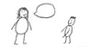  Teacher talking | I listened to the teacher.  I listened to the story.  I answered questions about the story.  I followed directions.
Student talking | I talked to the teacher.  I recalled one event from the story.  I recalled one event from the story using a descriptive adjective.  I recalled one event from the story using the past tense.  I recalled one fact from the story.  I stated one opinion about the story.  I stated one opinion about the story supported by evidence.
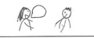  Partner talking | I listened to my partner.  I waited for my turn to talk.
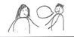  Talking to partner | I talked to my partner.  I recalled one event from the story.  I recalled one event from the story using a descriptive adjective.  I recalled one event from the story using the past tense.  I recalled one fact from the story.  I stated one opinion about the story.  I stated one opinion about the story supported by evidence.
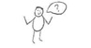  Asking for help | I asked for help when I needed it.  I asked questions when I was confused.  I asked for clarification when I was confused.

Sample Civil Rights Movement Images

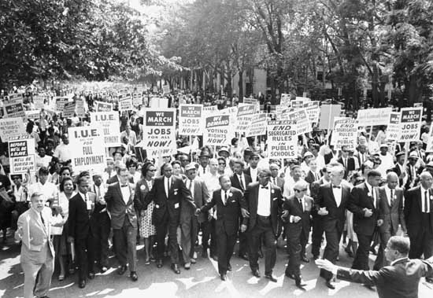
Source: http://media-2.web.britannica.com/eb-media/46/7546-004-7F54297C.jpg
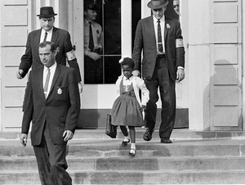
Source: http://photos.america.gov/galleries/amgov/39/civil_rights_07/001-CivilRights.jpg
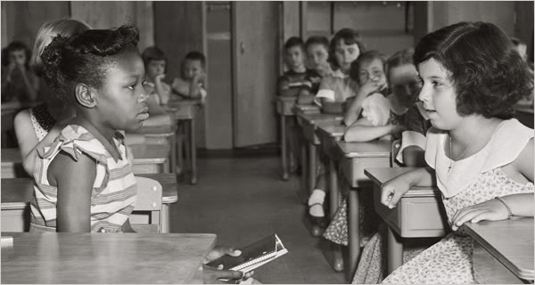
Source: http://steinhardt.nyu.edu/scmsAdmin/media/users/sl1716/Features/brown60front.jpg
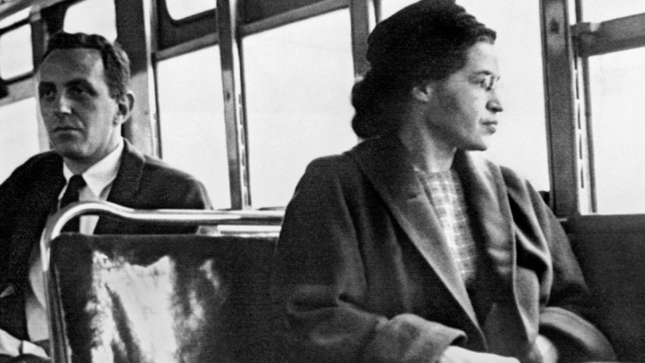
Source: Photograph, Rosa Parks on Bus, Getty Images
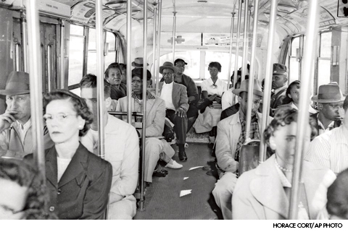
Source: http://d1by67ljd45m4v.cloudfront.net/media/BA086BE0-D91B-68BD-61D33775E6C0AB8E.jpg
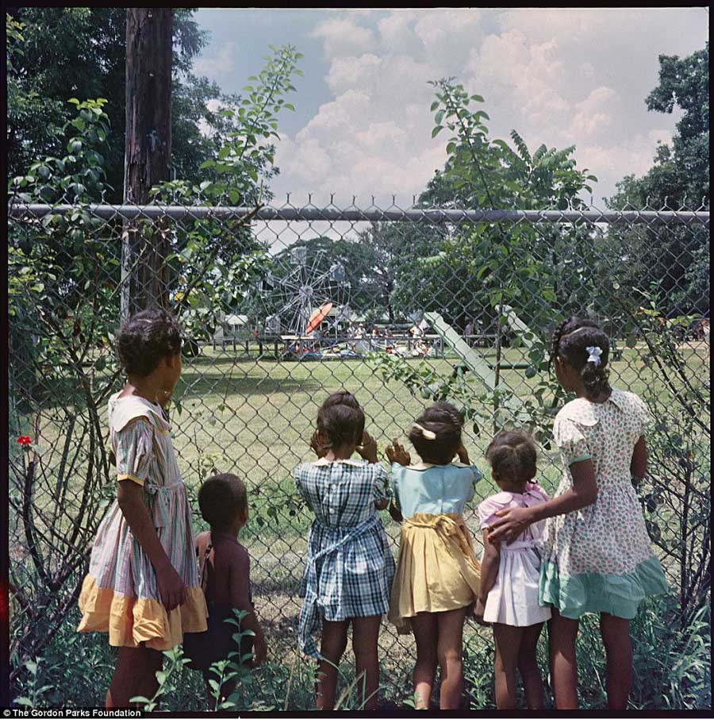
Source: http://all-that-is-interesting.com/20-photos-segregation-america-show-far-weve-come-much-farther-go

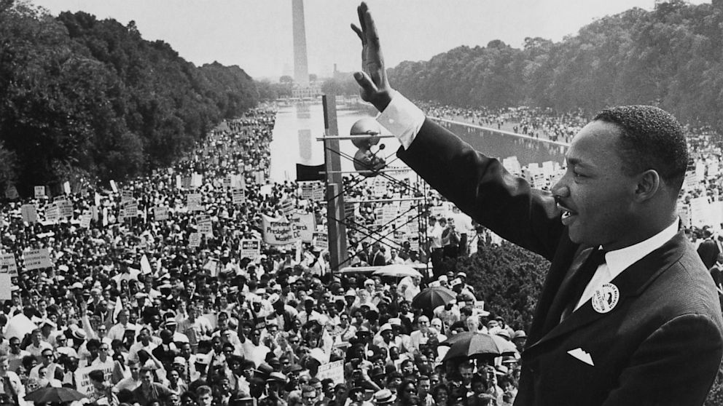
Source: http://a.abcnews.go.com/images/Politics/gty_march_on_washington_martin_luther_king_ll_130819_16x9_992.jpg

Lesson 2  Day 2 | Adjectives to Describe Justice and Fairness | Estimated Time: 60 minutes

Brief overview of lesson: Students will continue to develop an understanding of justice and fairness. They will learn about key vocabulary terms and participate in an interactive read-aloud of National Geographic Kids: Martin Luther King, Jr. (pages 8–15). Students will also learn about adjectives and practice using them to describe historical figures from the text. Students will draw and write words, phrases, and/or simple sentences about the text to demonstrate their ability to recount and describe key events. As you plan, consider the variability of learners in your class and make adaptations as necessary.

What students should know and be able to do to engage in this lesson:
- Follow procedures for an interactive read-aloud.
- Focus their attention on the teacher/text being read aloud.
- Turn and talk: turn to their assigned partner, facing them directly (knee-to-knee and eye-to-eye), and quietly talk with their partner on topic using sentence frames provided by the teacher.
Turn back toward the teacher to share their ideas with the group.
LESSON FOUNDATION
Unit-Level Focus Language Goals to Be Addressed in This Lesson |  | Unit-Level Salient Content Connections to Be Addressed in This Lesson
G.1 Recount by sequencing events in stories to communicate context-specific messages.  G.3 Explain by describing how the actions of particular characters/historical figures contributed to increasing justice, courage, and fairness in our world supported with reasoning and evidence. |  | HSS.1.8—After reading or listening to stories about famous Americans of different ethnic groups, faiths, and historical periods, describe their qualities or distinctive traits.  HSS.8—Give examples that show the meaning of the following words: politeness, achievement, courage, honesty, and reliability.  CCSS.ELA-Literacy.RL.1.1—Ask and answer questions about key details in a text.  CCSS.ELA-Literacy.SL.1.1—Participate in collaborative conversations with diverse partners about grade 1 topics and texts with peers and adults in small and larger groups.  CCSS.ELA-Literacy.SL.1.4—Describe people, places, things, and events, with relevant details, expressing ideas and feelings clearly.  CCSS.ELA-Literacy.SL.1.5—Add drawings or other visual displays to descriptions, when appropriate, to clarify ideas, thoughts, and feelings.
Language Objective |  | Essential Questions Addressed in This Lesson
Students will be able to describe historical figures using adjectives (fair, unfair, right, wrong). |  | Q.1 How can we use oral language to convey a message?  Q.3 How can we demonstrate courage when standing up for justice/fairness?
Assessment
- Formative: Assess student application of learned language (e.g., content-specific adjectives) to sort and describe images/scenarios.
- Formative: Assess student application of learned language (e.g., content-specific adjectives) to label their images.
- Self-assessment: Students will self-assess and self-monitor learning using the self-assessment checklist.
Thinking Space: What Academic Language Will Be Practiced in This Lesson?
Discourse Dimension | Sentence Dimension |  | Word Dimension
Social, instructional language; listening to grade-appropriate brief narrative and informational texts composed of simple and some complex and compound sentences with limited cohesion; writing words, phrases, and/or sentences to describe an image; explaining own ideas/answering questions with limited detail. | Simple present and past tense grammatical structures; questions. |  | Topic-related vocabulary (e.g., fair, unfair, right, wrong, kind, friend, mean, afraid, scared, friendly, helpful, fear, law, speech, “black people,” “brown people,” “white people,” justice, courage, fairness, bravery, protest, protestors, segregation, boycott); sequencing words (first, second, third, next, then, last, finally, etc.).
Instructional Tips/Strategies/Suggestions for Teacher
- See instructional tips/strategies discussed in Lesson 1.
- Depending upon student familiarity with parts of speech, consider reviewing nouns with students prior to discussing adjectives.
- To complement/expand on the lesson’s text, show the following video about an excerpt from Martin Luther King Jr.’s “I Have a Dream” speech.
- Depending upon student familiarity with Martin Luther King Jr., consider reading another text to support student understanding, such as My First Biography: Martin Luther King, Jr. by Marion Dane Bauer, or having students listen to a recorded version of the book in a listening station.

STUDENT CONSIDERATIONS
Sociocultural Implications
- Students who are new to the United States may need to learn classroom norms (e.g., whole group/small group/partner and independent work norms, academic discussion norms), procedures, and expectations. This may require direct specific instruction.
- Depending on the region from which the students are from, this topic may evoke strong emotional responses, as they may have had negative experiences (injustice, discrimination).
- Students may be more comfortable learning and/or expressing themselves in different ways: orally, in writing, by listening, by movement or touch, by looking at images of visual representations, by speaking, etc. Provide multiple ways for students to learn information and demonstrate their learning.
- The text talks about “black people,” “brown people,” and “white people.” Students may be unfamiliar with these categories.
Anticipated Student Pre-Conceptions/Misconceptions
- Students may think that skin color and nationality/heritage are the same thing.
- Students may not have any ideas about the strong relationship between race and inequality throughout American history, such as slavery and Jim Crow laws.
- Students may think that Martin Luther King Jr. was a former American president.

THE LESSON IN ACTION

Lesson Opening

Post and explain the lesson’s language objective: “Students will be able to describe historical figures using adjectives (fair, unfair, right, wrong).” To promote student ownership and self-monitoring of learning, have students summarize and/or state the objective in their own words. At the end of the lesson, students can reflect on their learning in relation to the objective.

Review the vocabulary chart created in Lesson 1. Have students turn and talk to share their own definitions of the words. This can serve as a formative assessment of students’ understanding of key vocabulary.

Introduce the lesson. For example, say: “Today, we are going to learn more language to help us discuss justice, courage, and fairness. We are going to learn words that can help us to describe; we are going to talk about adjectives.”

Introduce adjectives.

Ask students to think about what adjectives are, what their purpose is, and some examples. Give students time to think independently and then share with a partner, before discussing as a whole class.

Have students help you define adjectives or provide students with a definition of the term. For example: “Adjectives are words we use to describe—or tell more about—a person, place, or thing.” Consider creating an adjective anchor chart with a definition and examples to share with students at this point, as well as providing students with a pocket chart version of it for personal reference.

Review examples of adjectives used in sentences. For example, write the following sentences on the board, color-coding the adjectives to highlight proper placement in a sentence: “The boy is TALL; The dog is YELLOW; The Monkey is SILLY; The flower is PRETTY.” Add images of each sentence and explain how the adjectives describe the noun in each sentence.

Practice adjectives with a few manipulatives.

Hold up a stuffed animal and ask students to describe, or give details, about what the stuffed animal looks like. Record student responses on the board and highlight or underline the adjectives. Sample sentences: “The bear is blue”; “The bear is big”; “The bear is wearing a red shirt”; “The bear has a funny hat on”; etc. Explain how students used adjectives to describe the bear.

Have students describe images by labeling them with adjectives from a word bank, or have them add any appropriate adjectives they know individually, with a partner, in a small group, or as a whole class.

Pre-teach vocabulary.

Pre-teach or review key adjectives related to the text and/or lesson, such as: fair, unfair, right, brave, wrong. Allow time for native language translations as needed.
Provide options for engagement, such as asking students to add any additional adjectives to the list that they feel are important to include.

Teach the word segregation using the seven-step vocabulary teaching method. Using images, native language translations, and word walls can help further student understanding of the vocabulary. Add this word to the vocabulary anchor chart.

During the Lesson

Review Martin Luther King Jr.’s anchor chart(s) from Lesson 1.

Reread the title of the book and the question: “How did Martin Luther King Jr. work for justice?” Give students time to think independently and then share with a partner, before discussing as a whole class. Provide sentence frames, such as “I learned that Martin Luther King Jr._____”; “Martin was _____.” If necessary, display pages read during Lesson 1, briefly recapping any additional important information students may have omitted. As students are recalling the text, observe their use of the pre-taught adjectives.
Provide options for physical action, such as writing, using a computer, or orally discussing.

Highlight, underline, and/or color-code adjectives in the anchor chart.
Provide options for physical action, such as having students come up and help you identify adjectives.
Provide options for perception, such as showing a video (e.g., “Martin Luther King, Jr.”) to reinforce key events. Consider providing a video station where students can watch it independently, pausing as needed to ask clarifying questions.

Continue reading National Geographic Kids: Martin Luther King, Jr. by Kitson Jazynka. Read the text aloud with intonation, modeling proper reading.

Paraphrase any words and/or sections that may need clarification, and consider asking students to act out parts of the text to aid their comprehension.

Read pages 8–10 aloud, or play an audio version of the text. Discuss segregation, explaining the term further if needed. Ask students: “How do you think you might feel if our community/school were segregated?” Give students time to think independently and then share with a partner, before discussing as a whole class. Provide sentence frames (e.g., “I would be ______”; “I would feel ______”; “I feel ______”) and an illustrated emotion word bank or emotion cards. Explain that students used feeling words to describe themselves and to give details. Look for student use of content vocabulary and adjectives during the discussion.
Provide options for physical action, such as pointing towards a feelings anchor chart, using emotions cards, and/or writing responses.

Sketch an illustration of segregation or use an image to illustrate it on the vocabulary anchor chart.

Continue reading through page 12. Pose the question: “What does it mean when Martin’s mother tells him he was just as good as anybody else?” or “Why does Martin want to change the world?” Sketch Martin Luther King Jr. as a boy listening to his mother with “You’re just as good as anybody else” in a speech bubble, or post an image on the Martin Luther King Jr. chart. Model your own thinking in response to the question, and then ask students to think about how Martin might be feeling. Give students time to think independently and then share with a partner, before discussing as a whole class. Provide sentence frames for sharing, such as: “Martin is ______”; “Martin feels ______”; “Martin thinks ______.”

Lesson Closing

Practice adjectives again. Have students work with a partner or small group to sort images/scenarios as examples of fair and unfair.

Invite students to a whole class discussion. Discuss why students sorted images as being fair or unfair.

Recount key ideas from the text and/or chart paper by turning and talking with a partner. Circulate as students are speaking and look for use of adjectives to describe the historical figures and/or events. Share ideas as a whole class, and add any additional adjectives to the adjectives anchor chart.

Have students draw an image describing and/or recounting key information from the text, then label it with a word, phrase and/or simple sentence incorporating adjectives. Provide sentence frames and an adjective word bank. Sample sentence frames:
“My image shows _____________________.”
“Martin is _____________________.”
“Martin feels _____________________.”
“In the story _____________________.”
“My image shows _____________________.”
Provide options for physical action, such as using a computer to create.
Please note: students will create images in Lessons 1–5. The images can then be compiled to make student-created “books” about Martin Luther King Jr. The books will demonstrate student use of content vocabulary and ability to recall information from the text, and can demonstrate student language growth.

Have students complete the student self-assessment checklist.
Provide options for physical action, such as using a computer, pointing to ratings, orally sharing ratings, or writing on the checklist.

Lesson 2 Resources
- National Geographic Kids: Martin Luther King, Jr. by Kitson Jazynka
- Chart paper
- Pencils, markers, crayons
- Student partner groupings
- Paper, laptop, or tablet for recording student observations
- Student writing paper
- Student self-assessment checklist (available in Lesson 1 Resources)
- Previously created Martin Luther King Jr. and vocabulary anchor charts
- Emotion cards (available below)
- Images for fair/unfair sort (samples available below)

Emotion Cards

Happy: | Sad:
Excited: | Scared:
Proud: | Mad:
Sample Images/Scenarios for Fair/Unfair Sort

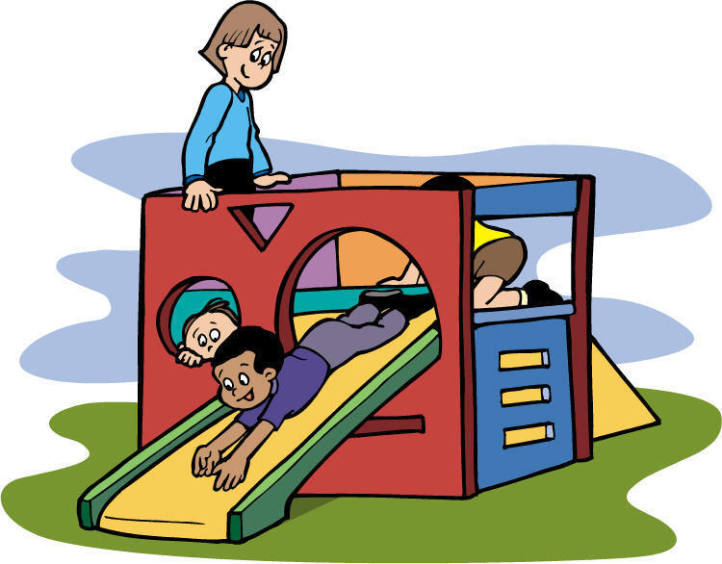
Only students who have a birthday in January may go out to recess.
Source: http://images.clipartpanda.com/kids-playing-at-recess-clipart-recess_time.jpg

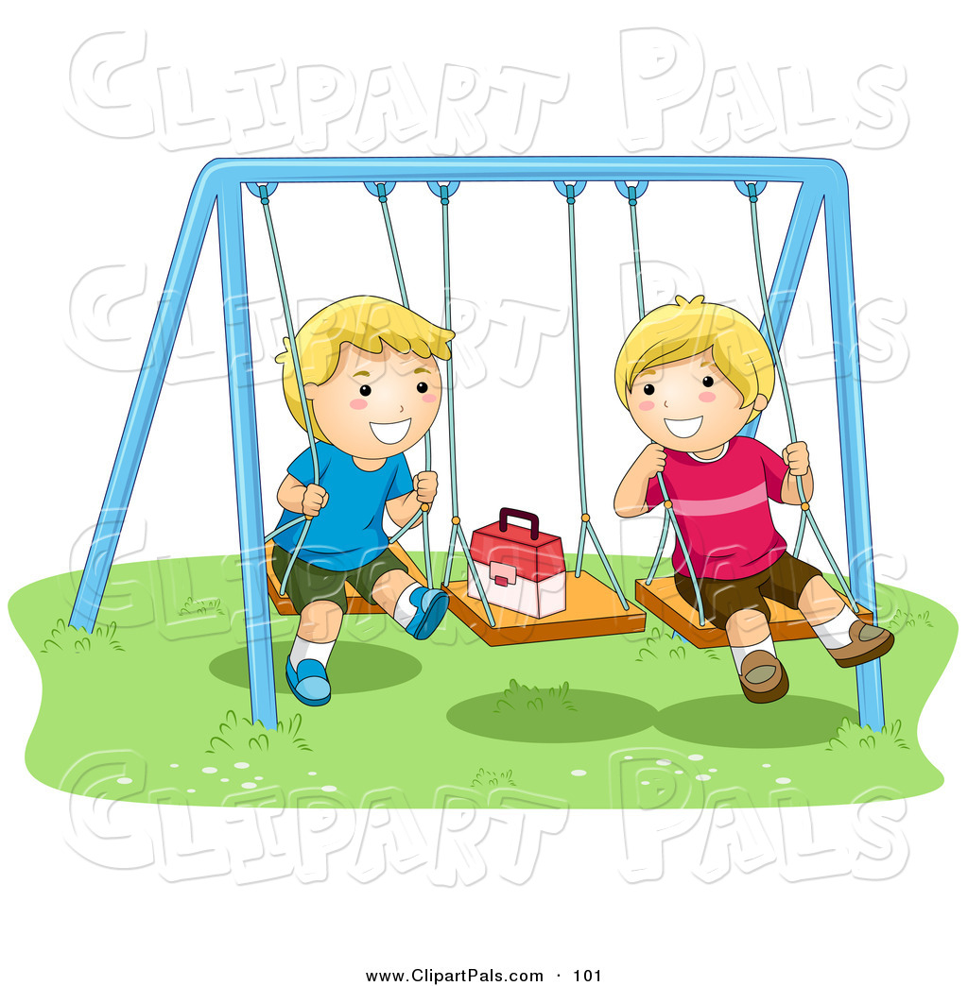
Boys get an extra five minutes for recess.
Source: http://clipartpals.com/1024/pal-clipart-of-a-pair-of-happy-boys-playing-on-swings-by-bnp-design-studio-101.jpg

Students who finish all of their work get stickers.
Source: http://cliparts.co/cliparts/Bcg/E88/BcgE88XLi.jpg

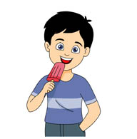
Any student who has a blue shirt on may have a popsicle. Any student who has a red shirt on may not have a popsicle.
Source: http://classroomclipart.com/images/gallery/Clipart/Food/Dessert_Clipart/TN_boy-eating-popsicle-icecream-415.jpg

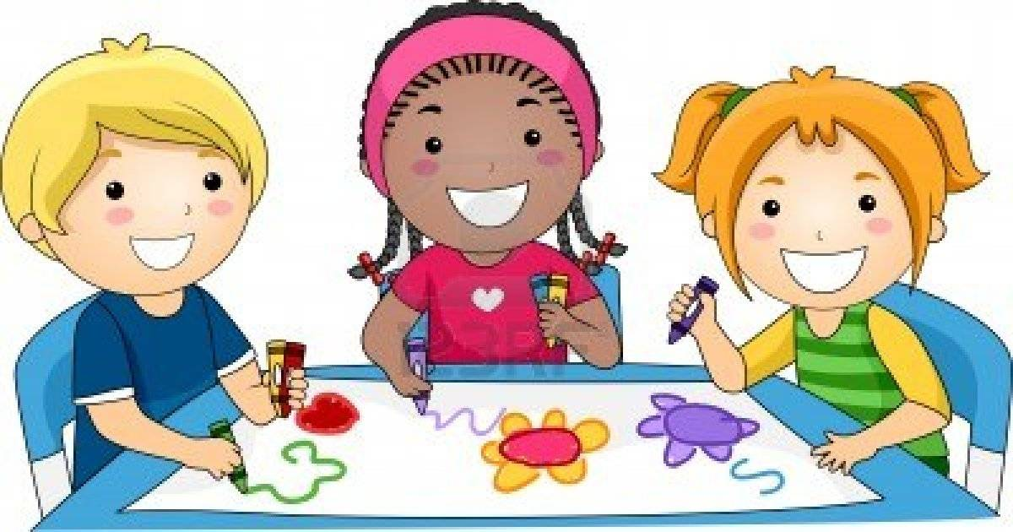
Students who can count up to 20 may go to free play.
Source: http://cliparts.co/cliparts/pTq/8dL/pTq8dLjT9.jpg

Lesson 3  Day 3 | Using Language to Sequence Events | Estimated Time: 60 minutes

Brief overview of lesson: Students will continue to develop an understanding of justice and fairness through participation in an interactive read-aloud of National Geographic Kids: Martin Luther King, Jr. (pages 16–23). Students will learn and be able to use sequence words to recount events in the text. They will draw an image and write words, phrases, and/or sentences to demonstrate their ability to recount key events from the story. As you plan, consider the variability of learners in your class and make adaptations as necessary.

What students should know and be able to do to engage in this lesson:
- Basic understanding of the words justice, fairness, and segregation.
How to turn and talk.
LESSON FOUNDATION
Unit-Level Focus Language Goals to Be Addressed in This Lesson |  | Unit-Level Salient Content Connections to Be Addressed in This Lesson
G.1 Recount by sequencing events in stories to communicate context-specific messages.  G.3 Explain by describing how the actions of particular characters/historical figures contributed to increasing justice, courage, and fairness in our world supported with reasoning and evidence. |  | HSS.1.8—After reading or listening to stories about famous Americans of different ethnic groups, faiths, and historical periods, describe their qualities or distinctive traits.  HSS.8—Give examples that show the meaning of the following words: politeness, achievement, courage, honesty, and reliability.  CCSS.ELA-Literacy.RL.1.1—Ask and answer questions about key details in a text.  CCSS.ELA-Literacy.SL.1.1—Participate in collaborative conversations with diverse partners about grade 1 topics and texts with peers and adults in small and larger groups.  CCSS.ELA-Literacy.SL.1.4—Describe people, places, things, and events, with relevant details, expressing ideas and feelings clearly.  CCSS.ELA-Literacy.SL.1.5—Add drawings or other visual displays to descriptions, when appropriate, to clarify ideas, thoughts, and feelings.
Language Objectives |  | Essential Questions Addressed in This Lesson
- Students will be able to recount events in the text using sequencing words (first, next, then, last/finally).  - Students will be able to recount key events in the text using words, phrases, and/or simple sentences incorporating adjectives (fair, unfair, right, wrong). |  | Q.1 How can we use oral language to convey a message?  Q.3 How can we demonstrate courage when standing up for justice/fairness?
Assessment
- Formative: Assess student application of learned language to sequence images of familiar events and/or routines.
- Formative: Assess student application of learned language to sequence images of events from the text read in class (e.g., during the lesson opening and during the lesson itself).
- Formative: Assess student application of learned language to recount key events from the story read in class as evidenced by the lesson closing.
- Self-assessment: Students will self-assess and self-monitor learning using the self-assessment checklist.
Thinking Space: What Academic Language Will Be Practiced in This Lesson?
Discourse Dimension | Sentence Dimension |  | Word Dimension
Social, instructional language; listening to grade-appropriate brief narrative and informational texts composed of simple and some complex and compound sentences with limited cohesion; writing words, phrases, and/or sentences to describe an image; explaining own ideas/answering questions with limited detail. | Simple present and past tense grammatical structures; questions. |  | Topic-related vocabulary (e.g., fair, unfair, right, wrong, kind, friend, mean, afraid, scared, friendly, helpful, fear, law, speech, “black people,” “brown people,” “white people,” justice, courage, fairness, bravery, protest, protestors, segregation, boycott); sequencing words (first, second, third, next, then, last, finally, etc.).
Instructional Tips/Strategies/Suggestions for Teacher
Based on the gradual release model (shown below), share much of the thinking and understanding of text read in this lesson. As students progress through the lessons in the unit and develop comprehension skills, scale back support.
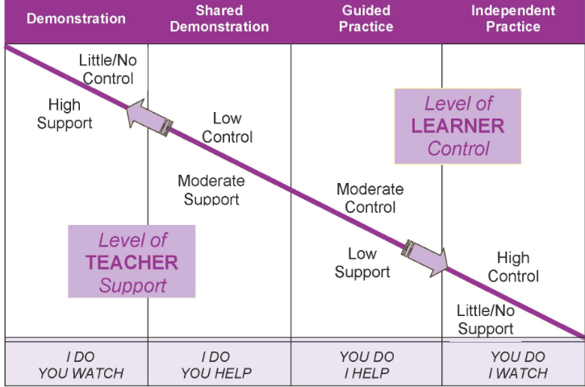

STUDENT CONSIDERATIONS
Sociocultural Implications
- Students who are new to the United States may need to learn classroom norms (e.g., whole group/small group/partner and independent work norms, academic discussion norms), procedures, and expectations. This may require direct specific instruction.
- Depending on the region from which the students are from, this topic may evoke strong emotional responses, as they may have had negative experiences (injustice, discrimination).
- Students may be more comfortable learning and/or expressing themselves in different ways: orally, in writing, by listening, by movement or touch, by looking at images of visual representations, by speaking, etc. Provide multiple ways for students to learn information and demonstrate their learning.
- The text talks about “black people,” “brown people,” and “white people.” Students may be unfamiliar with these categories; consider explaining what they mean and discuss any implications with students.
Anticipated Student Pre-Conceptions/Misconceptions
- Students may not know much about laws and/or that laws can be unfair.
- Students may think that skin color and nationality/heritage are the same thing.
- Students may not have any ideas about the strong relationship between race and inequality throughout American history, such as slavery and Jim Crow laws.
- Students may think that Martin Luther King Jr. was a former American president.

THE LESSON IN ACTION

Lesson Opening

Post and explain the lesson’s language objectives: “Students will be able to recount events in the text using sequencing words (first, next, then, last/finally),” and “Students will be able to recount key events in the text using words, phrases, and/or simple sentences incorporating adjectives (fair, unfair, right, wrong).” To promote student ownership and self-monitoring of learning, have students summarize and/or state the objective in their own words. At the end of the lesson, students can reflect on their learning in relation to the objective.

Review vocabulary anchor charts and the adjectives anchor chart created in previous lessons.

Pre-teach or teach the words speech, first, next, then, last/finally, using the seven-step vocabulary teaching method.

Go deeper into the meaning and use of transition words used for sequencing (or sequencing words).

Explain how these words can be used to tell the order of events.

Give students images of a familiar classroom routine or other familiar situation (such as morning routine) and sequence them using prepared sequencing cards (index cards with first, next, then, last/finally written on them). Have students chorally state the sequence of events using the sequencing words.

Give students images of the text (pages read so far) and ask them to sequence and label them with phrases and/or sentences incorporating sequencing words with a partner or small group. Provide sentence frames for labeling, such as: “First, Martin ________”; “Next, Martin ________”; “Then, Martin ________”; “Last/Finally, Martin ________.” This provides an informal assessment of students’ ability to use content vocabulary, adjectives, and sequencing words, as well as their ability to recall information from the text.

Alternatively, ask students to brainstorm events that they have learned about in the text so far on Post-Its. Then have them work with a partner or small group to sequence events and label each Post-It with sequencing words.

During the Lesson

Review Martin Luther King Jr.’s anchor chart(s) from Lesson 1.

Reread the title of the book and the question: “How did Martin Luther King Jr. work for justice?” Give students time to think independently and then share with a partner, before discussing as a whole class. Provide sentence frames, such as “I learned that Martin Luther King, Jr. ________”; Martin was ________.” If necessary, display pages read during Lessons 1–2, briefly recapping any additional important information students may have omitted. Encourage students to recall more than one fact/event. As they are recalling the text, observe their use of the pre-taught adjectives.
Provide options for physical action, such as writing, using a computer, or orally discussing.

Continue reading National Geographic Kids: Martin Luther King, Jr. by Kitson Jazynka aloud with intonation, modeling proper reading.

Paraphrase any words and/or sections that may need clarification, and consider asking students to act out parts of the text to aid student comprehension.

Read pages 16–19, focusing on Martin Luther King Jr.’s winning speech about people being treated fairly (justice) and how on his way home from winning an award for the speech, he had to stand so white people could sit down (injustice).
Provide options for perception, such as images.

Ask: “How might Martin Luther King Jr. have felt about winning? How might he have felt about having to give up his seat?” Give students time to think independently and then share with a partner, before discussing as a whole class. Provide sentence frames for sharing, such as “Martin was ________”; “I think Martin felt ________ because ________.” Please note: the use of because is explicitly taught in subsequent lessons.

Student responses may include that Martin was sad, angry, crying, etc. Ask additional probing questions, such as: “Why was Martin sad/angry/crying?” Provide sentence frames for sharing, such as: “Martin was sad/angry/crying because _________.” Relate these feelings back to how he felt when he could not play with his white friend.
Provide options for physical action, such as writing responses in a notebook, orally discussing, typing, or responding on a whiteboard.

Continue reading through page 23, stopping to discuss/explain key events (he went to college, married). Model the use of adjectives to provide a more detailed recall of events. Record the following key events on the Martin Luther King Jr. anchor chart (using sketches/images and words): Martin speaking and winning his prize, Martin giving up his seat, Martin learning in school, Martin with his wife.

Recount key events using sequencing words.

Give students four images from the text and ask them to sequence them independently or with a partner/small group.

Have students label ordered images with sequencing words (first, next, then, last/finally).

Ask students to use the sequenced images to orally retell key events to a partner. Remind them to use sequencing words.

Lesson Closing

Reread the question: “How did Martin Luther King, Jr. work for justice?”

Ask students to share about any instances where they think he has done something to work for justice and brainstorm these ways together as a whole class. Add responses to the Martin Luther King Jr. anchor chart.
Provide options for perception, such as giving students a printed version of the question or having students view it on a computer.
Provide options for physical action, such as writing ideas on Post-Its before sharing with the whole class.

As an extension, have students write, draw, or dictate their thoughts in response to the question “How did Martin Luther King Jr. work for justice?”

Alternatively, have students role-play Martin being told to stand so white people could sit down on the bus, and discuss how this is unfair and an example of injustice. This provides the teacher with the opportunity to assess student ability to recall and sequence events from the story.

Have students draw an image of a key event from the text to illustrate their ability to recall. Then ask them to label the image with words, phrases, and/or simple sentences using sentence frames and an adjective word bank to describe their image. Sample sentence frames include: “My image shows ______”; “Martin is ______”; “Martin feels ______”; “In the story ______.”
Provide options for physical action, such as using a computer.

Have students complete the student self-assessment checklist to assess their own learning.
Provide options for physical action, such as using a computer, writing, orally discussing, or drawing responses.

Optional activity: Read another text about Martin Luther King Jr. Have students read it independently, with a partner or small group, or with the teacher. Alternatively, have students practice reading the Martin Luther King Jr. anchor chart.

Lesson 3 Resources
- National Geographic Kids: Martin Luther King, Jr. by Kitson Jazynka
- Chart paper
- Pencils, markers, crayons
- Student partner groupings
- Paper, laptop, or tablet for recording student observations
- Student writing paper
- Mailing labels with printed question: “How did Martin Luther King Jr. work for justice?”
- Previously created anchor charts (adjectives, vocabulary, Martin Luther King Jr.)
- Student self-assessment checklist (available in Lesson 1 Resources)
- Sequencing images (available below)
- Sequencing cards

Sequencing Images
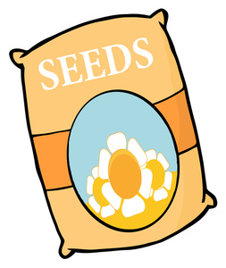
Source: http://www.gardenclipart.net/garden_clipart_images/clipart_illustration_of_a_bag_of_flower_seeds_0521-1103-1318-0446_SMU.jpg

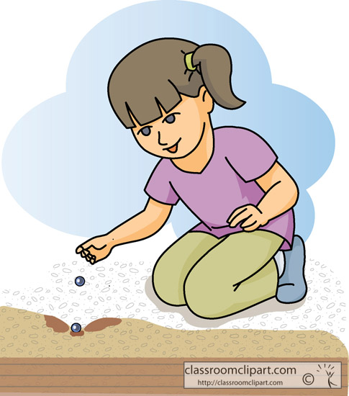
Source: http://classroomclipart.com/images/gallery/Clipart/Agriculture/young_girl_planting_seeds_in_garden.jpg

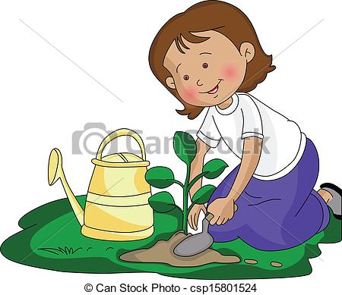
Source: http://comps.canstockphoto.com/can-stock-photo_csp15801524.jpg
Source: http://images.clipartpanda.com/sunflower-clip-art-Sunflower1.jpg

Lesson 4  Day 4 | Verbs in the Past Tense | Estimated Time: 60 minutes

Brief overview of lesson: Students will continue to develop an understanding of justice and fairness. They will participate in an interactive read-aloud of National Geographic Kids: Martin Luther King, Jr. (pages 24–33). They will learn about the past tense and use it to recount and describe historical events. They will recount key events from text by drawing and writing words, phrases, and/or simple sentences using the past tense, adjectives, and previously introduced vocabulary. As you plan, consider the variability of learners in your class and make adaptations as necessary.

What students should know and be able to do to engage in this lesson:
- Ability to turn and talk.
Basic ability to recount by sequencing events in stories using sentence frames.
LESSON FOUNDATION
Unit-Level Focus Language Goals to Be Addressed in This Lesson |  | Unit-Level Salient Content Connections to Be Addressed in This Lesson
G.1 Recount by sequencing events in stories to communicate context-specific messages.  G.3 Explain by describing how the actions of particular characters/historical figures contributed to increasing justice, courage, and fairness in our world supported with reasoning and evidence. |  | HSS.1.8—After reading or listening to stories about famous Americans of different ethnic groups, faiths, and historical periods, describe their qualities or distinctive traits.  HSS.8—Give examples that show the meaning of the following words: politeness, achievement, courage, honesty, and reliability.  CCSS.ELA-Literacy.RL.1.1—Ask and answer questions about key details in a text.  CCSS.ELA-Literacy.SL.1.1—Participate in collaborative conversations with diverse partners about grade 1 topics and texts with peers and adults in small and larger groups.  CCSS.ELA-Literacy.SL.1.4—Describe people, places, things, and events, with relevant details, expressing ideas and feelings clearly.  CCSS.ELA-Literacy.SL.1.5—Add drawings or other visual displays to descriptions, when appropriate, to clarify ideas, thoughts, and feelings.
Language Objectives |  | Essential Questions Addressed in This Lesson
Students will be able to recount stories and discuss historical events using the past tense.  Students will be able to discuss historical events using justice and injustice. |  | Q.1 How can we use oral language to convey a message?  Q.3 How can we demonstrate courage when standing up for justice/fairness?
Assessment
- Formative: Assess student use of learned language (e.g., content-specific language, adjectives, verbs in the past tense) during turn-and-talks about whole class discussion.
- Formative: Assess student application of learned language to discuss events from the text read in class in the lesson closing.
- Self-assessment: Students will self-assess and self-monitor learning using the self-assessment checklist.
Thinking Space: What Academic Language Will Be Practiced in This Lesson?
Discourse Dimension | Sentence Dimension |  | Word Dimension
Social, instructional language; listening to grade-appropriate brief narrative and informational texts composed of simple and some complex and compound sentences with limited cohesion; writing words, phrases, and/or sentences to describe an image; explaining own ideas/answering questions with limited detail. | Simple present and past tense grammatical structures; questions. |  | Topic-related vocabulary (e.g., fair, unfair, right, wrong, kind, friend, mean, afraid, scared, friendly, helpful, fear, law, speech, “black people,” “brown people,” “white people,” justice, courage, fairness, bravery, protest, protestors, segregation, boycott); sequencing words (first, second, third, next, then, last, finally, etc.).
Instructional Tips/Strategies/Suggestions for Teacher
- See instructional tips from Lesson 1.
- Prepare an anchor chart for the past tense that includes a definition of past tense, when to use it, how to form it, and sample sentences in past tense where the verbs are color-coded.
- Depending upon student familiarity with the parts of speech, begin the lesson by reviewing verbs. Ask students to think about what verbs are, what their function is in a sentence, and what they do. When introducing the past tense, explain how verbs change to help us specify when an action took place.

STUDENT CONSIDERATIONS
Sociocultural Implications
- Students who are new to the United States may need to learn classroom norms (e.g., whole group/small group/partner and independent work norms, academic discussion norms), procedures, and expectations. This may require direct specific instruction.
- Depending on the region from which the students are from, this topic may evoke strong emotional responses, as they may have had negative experiences (injustice, discrimination).
- Students may be more comfortable learning and/or expressing themselves in different ways: orally, in writing, by listening, by movement or touch, by looking at images of visual representations, by speaking, etc. Provide multiple ways for students to learn information and demonstrate their learning.
- Some languages form the past tense differently than English. It may be useful to acknowledge and explicitly address how students’ native languages may express actions in the past in different ways.
Anticipated Student Pre-Conceptions/Misconceptions
- Students may not know about laws and/or that some laws are unfair.
- Students may confuse the terms “piece” and “peace.” Review these vocabulary words with students.
- Students may think that skin color and nationality/heritage are the same thing.
- Students may not have any ideas about the strong relationship between race and inequality throughout American history, such as slavery and Jim Crow laws.
- Students may think that Martin Luther King Jr. was a former American president.

THE LESSON IN ACTION

Lesson Opening

Post and explain the lesson’s language objectives: “Students will be able to recount stories and discuss historical events using the past tense,” and “Students will be able to discuss historical events using justice and injustice.” To promote student ownership and self-monitoring of learning, have students summarize and/or state the objective in their own words. At the end of the lesson, students can reflect on their learning in relation to the objective.

Review the vocabulary chart created in Lessons 1–3.

Teach the word injustice and boycott using the seven-step vocabulary teaching method or a similar vocabulary teaching strategy. Use images, native language translations, and word walls to support student comprehension, and invite students to share their own examples of the terms.

Introduce the past tense.

Explain how the past tense is used to talk about events that happened, and finished, in the past/before this moment. Review a previously prepared past tense anchor chart or consider creating an anchor chart. Review when to use and how to form the past tense.

As a class, practice conjugating a few verbs in the past tense. Have students copy the “rules” of the past tense in their notebooks or pocket charts and use them to conjugate the past and present tense forms of topic-related verbs such as walk.
Present Tense |  | Past Tense
I walk | We walk | I walked | We walked
You walk | You walk | You walked | You walked
He/She/It walks | They walk | He/She/It walked | They walked
Provide options for physical action, such as working at their desks, using whiteboards, or having students orally discuss the past tense forms of the verbs.

During the Lesson

Review what students learned so far.

Reread the title of the book (National Geographic Kids: Martin Luther King, Jr. by Kitson Jazynka) and the question: “How did Martin Luther King Jr. work for justice?”

Ask students to tell their partner what they learned in the last few lessons and to use the past tense with a sentence frame, such as: “I learned _______”; “Martin was _______”; “I learned that Martin was _______.” Encourage students to recall more than one thing. As students share, look for their use of the past tense and descriptive adjectives.
Provide options for physical action, such as writing in notebooks, on whiteboards, or on Post-Its, or discussing orally.

Have pairs share with the whole class. If necessary, display any essential pages read during Lessons 1–3, briefly recapping any additional important information students may have omitted.

Read over the Martin Luther King Jr. anchor charts from Lessons 1–3. Invite students to help you highlight, underline, and/or color-code past tense verbs and adjectives. Then ask students to read, echo read, or chorally read the information on the chart paper.

Continue reading National Geographic Kids: Martin Luther King, Jr. by Kitson Jazynka aloud with intonation, modeling proper reading.

Paraphrase any words and/or sections that may need clarification, and consider asking students to act out parts of the text to aid student comprehension.

Read page 24, stopping to reflect on the image of the men. Focus on Martin Luther King Jr.’s desire for justice, emphasizing the idea of segregation being everywhere. Simulate segregation based on shirt color, hair color, and hair length, or by pulling student names from a hat, to help them develop an understanding of this concept.
Provide options for perception, such as images.

Continue reading through page 29. Discuss the bus boycott (to be discussed again in following lessons) and how both blacks and whites marched together to protest bad laws (or injustice). Explain that injustice is the opposite of justice. Add injustice to the vocabulary anchor chart, adding a sketch of unhappy faces to demonstrate unfairness/the negative connotation of the word.
Provide options for perception, such as images.
Provide options for engagement, such having students sort images illustrating examples of justice and injustice (such as Civil Rights Movement images) with a partner or small group, and labeling them with the correct term or sorting them into two columns. Consider adding these images to the vocabulary anchor chart for student reference.

Continue reading through page 31, focusing on “Peaceful Protests.” Ask: “Why did Martin want the protests to be peaceful?” Give students time to think independently and then share with a partner, before discussing as a whole class. Help students to understand he didn’t want arguing and fighting; he just wanted things better for everyone.
Provide options for physical action, such as writing on whiteboards or Post-Its, or orally discussing.

Role-play a peaceful protest versus arguing to help students feel and understand the emotions. After role-playing, ask students to think about which method they feel is more effective in convincing people that there is injustice and why.

After reading through page 31, ask students to think of an example of justice and an example of injustice from the text. Use this as a formative assessment of students’ use of the terms and past tense verbs. Adjust future instruction based on results. Consider providing sentence frames, such as: “One example is ______”; “I think ______”; “I think ______ because ______.”
Provide options for physical action, such as writing on notebooks, whiteboards, a computer, Post-Its, or orally discussing.

Lesson Closing

Reread the question: “How did Martin Luther King Jr. work for justice?” As a class, brainstorm ways they have seen Martin Luther King Jr. work for justice. Provide a sentence frame, such as: “Martin Luther King, Jr. worked for justice when he ______.” Add responses to the Martin Luther King Jr. anchor chart.
Provide options for physical action, such as writing, drawing, or orally discussing.

Have students draw an image of a key event from the text and describe it with a word, phrase and/or simple sentence using an adjectives and past tense word bank and sentence frames such as “My image shows ______”; “Martin was ______”; “Martin felt ______”; “In the story ______.” Consider asking students to illustrate an example of an injustice and an example of justice from the text. Use this as a formative assessment of students’ ability to recall and recount information, as well as their use of key vocabulary, adjectives, and past tense verbs. Adjust instruction accordingly.
Provide options for physical action, such as using a computer, dictating, or using speech-to-text software.

Have students complete the student self-assessment checklist to assess their own learning.
Provide options for physical action, such as pointing, writing, orally discussing, or using a computer.

Optional activity: Allow students to read additional texts, such as leveled readers about Martin Luther King Jr. (Please note: this text is geared for level M readers. Choose texts at the appropriate reading levels for your students.) Have students independently read, work with a partner or small group, use a text-to-speech reader, or review the text with teacher support. Alternatively, have students practice reading the Martin Luther King Jr. anchor chart.

Lesson 4 Resources
- National Geographic Kids: Martin Luther King, Jr. by Kitson Jazynka
- Chart paper
- Pencils, markers, crayons
- Student partner groupings
- Paper, laptop, or tablet for recording student observations
- Student writing paper
- Mailing labels with printed question: “How did Martin Luther King Jr. work for justice?”
- Student self-assessment checklist (available in Lesson 1 Resources)
- Previously created anchor charts (adjectives, past tense, Martin Luther King Jr., vocabulary)

Lesson 5  Day 5 | Using Language to State Facts and Opinions | Estimated Time: 60 minutes

Brief overview of lesson: Students will continue to develop an understanding of justice and fairness. They will participate in an interactive read-aloud of National Geographic Kids: Martin Luther King, Jr. (pages 34–43). Students will learn about facts and opinions, and use signal words to identify and state facts and opinions about historical events and historical figures from the text. They will draw and write words, phrases, and/or simple sentences to describe and recount key events from the text. As you plan, consider the variability of learners in your class and make adaptations as necessary.

What students should know and be able to do to engage in this lesson:
- Recount by sequencing events in stories using sentence frames.
Turn and talk: turn to their assigned partner, facing them directly (knee-to-knee and eye-to-eye), and quietly talk with their partner on topic using sentence frames provided by the teacher.
LESSON FOUNDATION
Unit-Level Focus Language Goals to Be Addressed in This Lesson |  | Unit-Level Salient Content Connections to Be Addressed in This Lesson
G.1 Recount by sequencing events in stories to communicate context-specific messages.  G.3 Explain by describing how the actions of particular characters/historical figures contributed to increasing justice, courage, and fairness in our world supported with reasoning and evidence. |  | HSS.1.8—After reading or listening to stories about famous Americans of different ethnic groups, faiths, and historical periods, describe their qualities or distinctive traits.  HSS.8—Give examples that show the meaning of the following words: politeness, achievement, courage, honesty, and reliability.  CCSS.ELA-Literacy.RL.1.1—Ask and answer questions about key details in a text.  CCSS.ELA-Literacy.SL.1.1—Participate in collaborative conversations with diverse partners about grade 1 topics and texts with peers and adults in small and larger groups.  CCSS.ELA-Literacy.SL.1.4—Describe people, places, things, and events, with relevant details, expressing ideas and feelings clearly.  CCSS.ELA-Literacy.SL.1.5—Add drawings or other visual displays to descriptions, when appropriate, to clarify ideas, thoughts, and feelings.
Language Objective |  | Essential Questions Addressed in This Lesson
Students will be able to identify and state facts and opinions using signal words (I think, I believe) and topic vocabulary (e.g., Martin Luther King Jr., protest). |  | Q.1 How can we use oral language to convey a message?  Q.3 How can we demonstrate courage when standing up for justice/fairness?
Assessment
- Formative: Assess student application of learned language to identify and sort facts and opinion statements on pre-labeled images.
- Formative: Assess student application of learned language to discuss facts and opinions about the text read in class.
- Formative: Assess student application of learned language to create fact and opinion statements in the lesson closing.
- Formative: Assess student application of learned language to recount a key event from the text and draw an image illustrating that event and labeling the image with fact and opinion statements.
- Self-assessment: Students will self-assess and self-monitor learning using the self-assessment checklist.
Thinking Space: What Academic Language Will Be Practiced in This Lesson?
Discourse Dimension | Sentence Dimension |  | Word Dimension
Social, instructional language; listening to grade-appropriate brief narrative and informational texts composed of simple and some complex and compound sentences with limited cohesion; writing words, phrases and/or sentences to describe an image; explaining own ideas/answering questions with limited detail. | Simple present and past tense grammatical structures; questions. |  | Topic-related vocabulary (e.g., fair, unfair, right, wrong, kind, friend, mean, afraid, scared, friendly, helpful, fear, law, speech, “black people,” “brown people,” “white people,” justice, courage, fairness, bravery, protest, protestors, segregation, boycott); sequencing words (first, second, third, next, then, last, finally, etc.); fact and opinion vocabulary and signal words (e.g., I think, I believe, fact, opinion).
Instructional Tips/Strategies/Suggestions for Teacher
- See instructional tips/strategies discussed in Lesson 1.

STUDENT CONSIDERATIONS
Sociocultural Implications
- Students who are new to the United States may need to learn classroom norms (e.g., whole group/small group/partner and independent work norms, academic discussion norms), procedures, and expectations. This may require direct specific instruction.
- Depending on the region from which the students are from, this topic may evoke strong emotional responses, as they may have had negative experiences (injustice, discrimination).
- Students may be more comfortable learning and/or expressing themselves in different ways: orally, in writing, by listening, by movement or touch, by looking at images of visual representations, by speaking, etc. Provide multiple ways for students to learn information and demonstrate their learning.
- The portion of the text read in Lesson 5 deals with Martin Luther King Jr.’s assassination. Sensitivity is needed in addressing this topic with young children.
Anticipated Student Pre-Conceptions/Misconceptions
- Students may think that skin color and nationality/heritage are the same thing.
- Students may not have any ideas about the strong relationship between race and inequality throughout American history, such as slavery and Jim Crow laws.
- Students may think that Martin Luther King, Jr. was a former American president.
- Some students may not know much about laws and/or realize that some laws can be unfair.

THE LESSON IN ACTION

Lesson Opening

Post and explain the lesson’s language objective: “Students will be able to identify and state facts and opinions using signal words (I think, I believe) and topic vocabulary (e.g., Martin Luther King Jr., protest).” To promote student ownership and self-monitoring of learning, have students summarize and/or state the objective in their own words. At the end of the lesson, students can reflect on their learning in relation to the objective.

Review the vocabulary chart created in Lessons 1–4.

Teach the words fact and opinion.

Teach the word fact.
Ask students to think about what a fact is and/or an example of a fact independently, recording their thoughts on a whiteboard, notebook, or Post-It. Have them share with a partner and then with the whole class.
Explain that a fact is something that is true—something that exists. Create a fact/opinion anchor chart with the definition and examples of fact, including some shared by students. Have students copy this information into their notebooks or pocket charts.

Teach the word opinion.
Ask students to think about what an opinion is and/or an example of an opinion independently, recording their thoughts on a whiteboard, notebook, or Post-It. Have them share with a partner and then with the whole class.
Explain that an opinion is what someone thinks, believes or feels about something—something that cannot be proven. Add this information to the fact/opinion anchor chart and have students copy this information into their notebooks or pocket charts.

During the Lesson

Introduce fact and opinion signal words.

Explain how people use different language to communicate facts and opinions, and how one can use this language to determine if something is a fact or an opinion.

Introduce signal words of fact and opinion, explaining their meaning and adding them to the anchor chart. Sample signal words for facts: proven, statistics, numbers. Sample signal words for opinions: I think, I believe, best, worst. Provide native language translations as needed.

Add this information to the fact/opinion anchor chart and have students copy this information into their notebooks or pocket charts.

Practice identifying fact and opinion statements.

Give pairs sample labeled images, such as an image of a yellow pencil with a caption (e.g., “This is a yellow pencil”) and an image of a strawberry ice cream cone with a caption (e.g., “Strawberry ice cream is the best ice cream”).

Ask students to sort assigned images into examples of facts and opinions.
Provide options for perception, such as viewing the images on a computer.

Have students practice identifying fact and opinion statements further with an app such as Fun Deck.

Review what students have learned so far.

Display the Martin Luther King Jr. chart papers from Lessons 1–4. Reread the title of the book (National Geographic Kids: Martin Luther King, Jr. by Kitson Jazynka) and the question: “How did Martin Luther King Jr. work for justice?” Give students time to think independently and then share with a partner, before discussing as a whole class. Provide sentence frames for sharing, such as: “Martin was _______”; “I learned _______ and _______”; “I learned that Martin was _______.” Encourage students to recall more than one fact/event. If necessary, display any essential pages read during Lessons 1–4, briefly recapping any additional important information students may have omitted.

Model how to identify a fact about Martin Luther King Jr. from the text read thus far (e.g., “Martin Luther King Jr. gave speeches”).

Ask students to record one fact that they have learned on a Post-It, whiteboard, or computer, then share them with a partner or small group before sharing with the whole class. Record these facts on the fact/opinion anchor chart. You may wish to model this for students.

Model how to write an opinion statement using opinion signal words and a fact that students identified. Have students do the same, recording their opinion statement on a Post-It, whiteboard, or computer independently. Sample opinion statement: “I think Martin Luther King Jr. was a very important person in American History.” Ask students to share with a partner or small group first then with the whole class, recording a few student answers. Highlight the differences between identified facts and opinion statements.

Continue reading National Geographic Kids: Martin Luther King, Jr. by Kitson Jazynka aloud with intonation, modeling proper reading.

Paraphrase any words and/or sections that may need clarification, and consider asking students to act out parts of the text to aid student comprehension.

Read pages 34–35, emphasizing how many people listened to his speeches. Add a sketch of Martin speaking to a large crowd on the Martin Luther King Jr. anchor chart. Consider showing students videos of Martin Luther King Jr. speaking, such as “Martin Luther King Jr.'s 'I Have a Dream Speech'” or “MLK I Have a Dream Speech.”
Provide options for perception, such as images.

Continue reading through page 37, focusing on “In His Own Words” (page 37). Explain or paraphrase as needed.

Continue reading through page 41, focusing on the change in laws and Martin Luther King Jr.’s death.

Add these events to the chart paper using sketches/images and words.

Lesson Closing

Have students create one fact and one opinion statement based on the text.
Provide options for physical action, such as using a computer; writing in notebooks, on whiteboards, or on Post-Its; or discussing orally.

Reread the question: “How did Martin Luther King Jr.” work for justice? Give students time to think independently and then share with a partner, before discussing as a whole class. If needed, help students make the connections between the protests and “working for justice.” Emphasize the fact Martin tried to be peaceful but that he wanted things to be fair/just. Add student responses to the Martin Luther King Jr. anchor chart.
Provide options for perception, such as printouts of the question.
Provide options for physical action, such as drawing; using a computer; writing in notebooks, on whiteboards; or on Post-Its; or discussing orally.

Have students draw an image recounting events from the reading, then describing/recounting it with a word, phrase, and/or simple sentence using an adjective and past tense word bank and sentence frames, such as: “My image shows _______”; “Martin was _______”; “Martin felt _______”; “In the story _______.” Consider asking students to label the image with one fact and one opinion (e.g., “My image shows Martin Luther King Jr. giving a speech. I think Martin Luther King Jr. was brave”).
Provide options for physical action, such as using a computer, dictating, or using speech-to-text software.

Have students complete the student self-assessment checklist to assess their own learning.
Provide options for physical action, such as using a computer, pointing, drawing, writing, or orally discussing.

Lesson 5 Resources
- National Geographic Kids: Martin Luther King Jr. by Kitson Jazynka
- Chart paper
- Pencils, markers, crayons
- Student partner groupings
- Paper, laptop, or tablet for recording student observations
- Student writing paper
- Student self-assessment checklist (available in Lesson 1 Resources)
- Anchor charts (adjectives, past tense, Martin Luther King Jr., fact/opinion)
- Sample images for fact and opinion sort (available below)

Sample Images for Fact/Opinion Sort
This is a yellow crayon. | Everyone loves ice cream. | 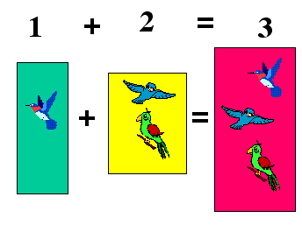  Math is a really fun subject.
Yellow crayons are the best. | Strawberry ice cream is the best. | Math is an easy subject to study.
I think that winter is the best season. | Ice cream is a cold dessert. | 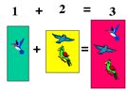  We study math in class.

Lesson 6  Day 6 | How Did Martin Luther King Jr. Work for Justice for All People? | Estimated Time: 60 minutes

Brief overview of lesson: Students will review notes from the interactive read-aloud of National Geographic Kids: Martin Luther King, Jr. They will also review topic vocabulary introduced so far in the lesson. Students will answer the question “How did Martin Luther King Jr. work for justice for all?” by drawing an illustration and labeling it with words, phrases, and/or simple sentences incorporating language introduced in Lessons 1–6. As you plan, consider the variability of learners in your class and make adaptations as necessary.

What students should know and be able to do to engage in this lesson:
- Develop understanding of the words segregate and assassinate.
Turn and talk: turn to their assigned partner, facing them directly (knee-to-knee and eye-to-eye), and quietly talk with their partner on topic using sentence frames provided by the teacher.
LESSON FOUNDATION
Unit-Level Focus Language Goals to Be Addressed in This Lesson |  | Unit-Level Salient Content Connections to Be Addressed in This Lesson
G.1 Recount by sequencing events in stories to communicate context-specific messages.  G.3 Explain by describing how the actions of particular characters/historical figures contributed to increasing justice, courage, and fairness in our world supported with reasoning and evidence. |  | HSS.1.8—After reading or listening to stories about famous Americans of different ethnic groups, faiths, and historical periods, describe their qualities or distinctive traits.  HSS.8—Give examples that show the meaning of the following words: politeness, achievement, courage, honesty, and reliability.  CCSS.ELA-Literacy.RL.1.1—Ask and answer questions about key details in a text.  CCSS.ELA-Literacy.SL.1.1—Participate in collaborative conversations with diverse partners about grade 1 topics and texts with peers and adults in small and larger groups.  CCSS.ELA-Literacy.SL.1.4—Describe people, places, things, and events, with relevant details, expressing ideas and feelings clearly.  CCSS.ELA-Literacy.SL.1.5—Add drawings or other visual displays to descriptions, when appropriate, to clarify ideas, thoughts, and feelings.
Language Objectives |  | Essential Questions Addressed in This Lesson
Students will be able to explain how Martin Luther King Jr. worked for justice using past tense verbs, adjectives (fair, unfair, etc.), and topic vocabulary (e.g., Martin Luther King Jr., protest).  Students will be able to recount key events from text by drawing and writing words, phrases, and/or simple sentences incorporating topic vocabulary (e.g., Martin Luther King Jr., protest). |  | Q.1 How can we use oral language to convey a message?  Q.3 How can we demonstrate courage when standing up for justice/fairness?
Assessment
- Self-assessment: Students will self-assess and self-monitor learning using the self-assessment checklist.
- Formative: Assess student application of learned language to answer the focus question “How did Martin Luther King Jr. work for justice for all people?” Assess student recounting of key information in their drawing and labeling their illustrations with words, phrases, and/or simple sentences incorporating content vocabulary, adjectives, and verbs in the past tense.
Thinking Space: What Academic Language Will Be Practiced in This Lesson?
Discourse Dimension | Sentence Dimension |  | Word Dimension
Social, instructional language; listening to grade-appropriate brief narrative and informational texts composed of simple and some complex and compound sentences with limited cohesion; writing words, phrases, and/or sentences to describe an image; explaining own ideas/answering questions with limited detail. | Simple present and past tense grammatical structures; questions. |  | Topic-related vocabulary (e.g., fair, unfair, right, wrong, kind, friend, mean, afraid, scared, friendly, helpful, fear, law, speech, “black people,” “brown people,” “white people,” justice, courage, fairness, bravery, protest, protestors, segregation, boycott); sequencing words (first, second, third, next, then, last, finally, etc.); fact and opinion vocabulary and signal words (e.g., I think, I believe, fact, opinion).
Instructional Tips/Strategies/Suggestions for Teacher
- See instructional tips/strategies discussed in Lesson 1.
- Print the lesson’s main question (“How did Martin Luther King Jr. work for justice for all people?”) and date on mailing labels and place them at the top of each student’s paper.

STUDENT CONSIDERATIONS
Sociocultural Implications
- Students who are new to the United States may need to learn classroom norms (e.g., whole group/small group/partner and independent work norms, academic discussion norms), procedures, and expectations. This may require direct specific instruction.
- Depending on the region from which the students are from, this topic may evoke strong emotional responses, as they may have had negative experiences (injustice, discrimination).
- Students may be more comfortable learning and/or expressing themselves in different ways: orally, in writing, by listening, by movement or touch, by looking at images of visual representations, by speaking, etc. Provide multiple ways for students to learn information and demonstrate their learning.
Anticipated Student Pre-Conceptions/Misconceptions
- Students may think that skin color and nationality/heritage are the same thing.
- Students may not have any ideas about the strong relationship between race and inequality throughout American history, such as slavery and Jim Crow laws.
- Students may think that Martin Luther King Jr. was a former American president.
- Some students may not know much about laws and/or realize that some laws can be unfair.

THE LESSON IN ACTION

Lesson Opening

Post and explain the lesson’s language objectives: “Students will be able to explain how Martin Luther King Jr. worked for justice using past tense verbs, adjectives (fair, unfair, etc.), and topic vocabulary (e.g., Martin Luther King Jr., protest),” and “Students will be able to recount key events from text by drawing and writing words, phrases. and/or simple sentences incorporating topic vocabulary (e.g., Martin Luther King Jr., protest).” To promote student ownership and self-monitoring of learning, have students summarize and/or state the objective in their own words. At the end of the lesson, students can reflect on their learning in relation to the objective.

Review what students have learned so far.

Review the vocabulary anchor chart.

Display the Martin Luther King Jr. chart papers from Lessons 1–5. Reread the title of the book (National Geographic Kids Martin Luther King, Jr. by Kitson Jazynka) and the question: “How did Martin Luther King, Jr. work for justice?”

Review key events in Martin Luther King Jr.’s life. Read, echo read, chorally read, or have students read the list of events. Ask students to determine if statements on the chart are facts or opinions. Reiterate/reinforce, as needed, that the events that occurred in Martin Luther King Jr.’s life are facts.

Highlight/underline or invite students to highlight/underline sequencing words, adjectives, and past tense verbs on the chart. Teacher tip: Consider color-coding words as visual reinforcement.

Ask students to think about the question: “How did Martin Luther King, Jr. work for justice?” Give students time to think independently and then share with a partner, before discussing as a whole class. Provide sentence frames for sharing, such as: “Martin was _______”; “I learned _______ and _______”; “I learned that Martin was _______.” Encourage students to recall more than one fact/event. If necessary, display any essential pages read during Lessons 1–5, briefly recapping any additional important information students may have omitted.

During the Lesson

Explain the focus of the lesson: answering the main question explored throughout Lessons 1–5. For example, say: “Today you will answer the question ‘How did Martin Luther King Jr. work for justice?’”

Model for students how you would answer that question and list multiple events or ideas you heard them discuss during the lesson opening.

Model how to sketch these ideas on paper.

Model how to say words, phrases, or sentences to match the sketches. Say each word, articulating each sound while writing the sounds in the words. Model sentence structure(s) most appropriate for students’ language proficiency levels.

Give students time to answer the question: “How did Martin Luther King Jr. work for justice for all people?”

Have students turn and talk with their partner and share what they are going to write about.

Ask them to answer the question by drawing and labeling illustrations with words, phrases and/or simple sentences incorporating, content vocabulary, adjectives, and verbs in the past tense. Provide sentence frames such as: “Martin Luther King Jr. worked for justice by ________”; “One way that Martin Luther King Jr. worked for justice was by ________”; “I think Martin Luther King Jr. worked for justice when he ________.” Leave anchor charts and the teacher model posted for students to use as reference and consider asking students to add one fact statement and one opinion statement to their illustrations.
Provide options for physical action, such as using a computer, dictating, or using speech-to-text software.

Circulate and confer with students as they write. Record students’ spoken language as much as possible. Provide specific feedback on student use of learned language while they are working.

Lesson Closing

Provide time for students to share their work.

Give students an opportunity to share their work with a partner/small group, then have students present their work in front of the group, displaying/explaining their illustrations and reading their writing.

Consider asking listeners to respond to each other student’s work, raising their hands to ask questions and/or writing feedback on Post-Its. Be sure to model this first.

Consider displaying students’ illustrations and writing on a bulletin board, along with the question: “How did Martin Luther King Jr. work for justice for all people?”

Have students complete the student self-assessment checklist to assess their own learning.
Provide options for physical action, such as using a computer, pointing, drawing, writing, or orally discussing.

Optional activity: Have students assemble their images from Lessons 1–6 into a “book.” The book assembly could be done in this lesson, or students could use the images in Lesson 7 to practice sequencing and then assemble the books after sequencing the images.

Lesson 6 Resources
- National Geographic Kids: Martin Luther King, Jr. by Kitson Jazynka
- Chart paper
- Pencils, markers, crayons
- Student partner groupings
- Paper, laptop, or tablet for recording student observations
- Student writing paper
- Mailing labels with printed question: “How did Martin Luther King Jr. work for justice?”
- Student self-assessment checklist (available in Lesson 1 Resources)
- Anchor charts (adjectives, past tense, Martin Luther King Jr., fact/opinion)

Part 2: Finding Courage
Lesson 7  Day 7 | Discussing Courage | Estimated Time: 60 minutes

Brief overview of lesson: Students will develop an understanding of the concept of courage. They will participate in an interactive read-aloud of Let’s Read About… Rosa Parks by Courtney Baker. They will recount key events in the text using sequencing words and past tense verbs. They will also discuss ways in which Rosa Parks demonstrated courage and worked for justice. As you plan, consider the variability of learners in your class and make adaptations as necessary.

What students should know and be able to do to engage in this lesson:
- Listen and participate actively in an interactive read-aloud.
- Use appropriate sentence frames in conversations and responses to questions.
- Basic understanding of justice/fairness.
Basic facts/events related to Martin Luther King Jr.’s efforts to promote justice.
LESSON FOUNDATION
Unit-Level Focus Language Goals to Be Addressed in This Lesson |  | Unit-Level Salient Content Connections to Be Addressed in This Lesson
G.1 Recount by sequencing events in stories to communicate context-specific messages.  G.3 Explain by describing how the actions of particular characters/historical figures contributed to increasing justice, courage, and fairness in our world supported with reasoning and evidence. |  | HSS.1.8—After reading or listening to stories about famous Americans of different ethnic groups, faiths, and historical periods, describe their qualities or distinctive traits.  HSS.8—Give examples that show the meaning of the following words: politeness, achievement, courage, honesty, and reliability.  CCSS.ELA-Literacy.RL.1.1—Ask and answer questions about key details in a text.  CCSS.ELA-Literacy.SL.1.1—Participate in collaborative conversations with diverse partners about grade 1 topics and texts with peers and adults in small and larger groups.  CCSS.ELA-Literacy.SL.1.4—Describe people, places, things, and events with relevant details, expressing ideas and feelings clearly.
Language Objectives |  | Essential Questions Addressed in This Lesson
- Students will be able to recount events from text using sequencing words (first, next, then, finally).  - Students will be able to discuss historical figures’ actions using courage. |  | Q.3 How can we demonstrate courage when standing up for justice/fairness?
Assessment
- Formative: Assess student application of learned language to sequence student-created images and recount the text read about Martin Luther King Jr.
- Formative: Assess student application of learned language to sequence key events from the text on Rosa Parks read in class.
- Formative: Assess student application of learned language to discuss the focus questions: “How did Rosa Parks work for justice?” and “Was Rosa Parks courageous?”
- Self-assessment: Students will self-assess and self-monitor learning using the self-assessment checklist.
Thinking Space: What Academic Language Will Be Practiced in This Lesson?
Discourse Dimension | Sentence Dimension |  | Word Dimension
Social, instructional language; listening to grade-appropriate brief narrative and informational texts composed of simple and some complex and compound sentences with limited cohesion; writing words, phrases, and/or sentences to describe an image; explaining own ideas/answering questions with limited detail. | Simple present and past tense grammatical structures; questions. |  | Topic-related vocabulary (e.g., fair, unfair, right, wrong, kind, friend, mean, afraid, scared, friendly, helpful, fear, law, speech, “black people,” “brown people,” “white people,” justice, courage, fairness, bravery, protest, protestors, segregation, boycott); sequencing words (first, second, third, next, then, last, finally, etc.); fact and opinion vocabulary and signal words (e.g., I think, I believe, fact, opinion).
Instructional Tips/Strategies/Suggestions for Teacher
- Listen to student conversations with partners, focusing on use of keywords, phrase/sentence structures, and sequence of events. Watch students as they role-play, focusing on their choice of words. Do they use only repeated words/phrases/sentences, or do they paraphrase? Are they able to construct new simple present or past tense sentences? Do they say their part with expression, indicating comprehension of story events and emotions of historical figures/characters? Record these observations for later use in scoring students’ language abilities.
- See instructional tips from Lesson 1.
- To expand students’ background knowledge on Rosa Parks and events discussed in the text, consider sharing additional information about these events using a resource such as the transcript of an interview with Rosa Parks.

STUDENT CONSIDERATIONS
Sociocultural Implications
- Students who are new to the United States may need to learn classroom norms (e.g., whole group/small group/partner and independent work norms, academic discussion norms), procedures, and expectations. This may require direct, specific instruction.
- Depending on the region from which the students are from, this topic may evoke strong emotional responses, as they may have had negative experiences (injustice, discrimination).
- Students may be more comfortable learning and/or expressing themselves in different ways: orally, in writing, by listening, by movement or touch, by looking at images of visual representations, by speaking, etc. Provide multiple ways for students to learn information and demonstrate their learning.
Anticipated Student Pre-Conceptions/Misconceptions
- Students are likely unaware of seating restrictions on public buses during the Civil Rights Movement era and reasons why people may have wanted to sit in the front of the bus at this time.
- Students may not know much about laws, and/or how some laws can be unfair.
- Students may not realize that school buses are different from city buses that you pay to ride on.
- Students may think that Martin Luther King Jr. and Rosa Parks were married.

THE LESSON IN ACTION

Lesson Opening

Post and explain the lesson’s language objectives: “Students will be able to recount events from text using sequencing words (first, next, then, finally),” and “Students will be able to discuss historical figures’ actions using courage.” To promote student ownership and self-monitoring of learning, have students summarize and/or state the objective in their own words. At the end of the lesson, students can reflect on their learning in relation to the objective.

Review previously taught vocabulary—justice, courage, fairness, brave, afraid and scared—with a game, such as charades and Pictionary. Have students take turns pulling a vocabulary word from a deck of index cards, then act out or draw something representing the word they drew without using the word. Meanwhile, the rest of the class takes turns guessing the vocabulary word. This can be done as a whole class or in small groups.

Connect to Lessons 1–6. For example, say: “Martin Luther King Jr. was an important American because he helped achieve justice. We learned how he _______.” Recap important events/ways he tried to achieve justice.
Provide options for engagement, such as having students begin with small group discussions about what they recall about Martin Luther King Jr. and ways in which he changed things and/or worked for justice, then sharing as a whole class.
Provide options for physical action, such as writing on whiteboards, Post-Its, notebooks, and computers, or discussing orally.

Practice sequencing events with student-created images from Lessons 1–5 with a partner. Please note: if students assembled their images in a book in the previous lesson, use photocopies of student-created images. If students have not assembled the images, have students sequence the images and then assemble the books.

Have students work with a partner to put the images in order first. Then have them use sentence frames to talk about their assembled books: “First, Martin ____________________. Next, Martin ________________________. Then, Martin ______________________. Finally, Martin ____________.” This provides a formative assessment of students’ ability to recall and use sequencing words, past tense verbs, and adjectives.

While students are working, circulate and provide specific feedback on student use of sequencing language, past tense verbs, and adjectives.

During the Lesson

Introduce a new historical figure: Rosa Parks. For example, say: “Today we are going to learn about another important American who worked hard for justice. Her name is Rosa Parks.”

Show an image or video of Rosa Parks, such as this student-created video.

Ask students to share anything they already know about Rosa Parks.

Introduce the new text featured in upcoming lessons and explain what students will be learning from it. For example, say: “As we read this book called Let’s Read About… Rosa Parks, I want you to think about: ‘How did Rosa Parks work for justice for all people?’”

Write this focus question on a new anchor chart about Rosa Parks: “How did Rosa Parks work for justice?”
Provide options for perception, such as giving students a printed version of the question or having them view it on a computer.

Introduce the word courage. For example, say: “While we learn about Rosa Parks, I also want you to think about a new word called courage. Courage is when you’re afraid to do something but you pretend you’re not scared and you do it anyway because it’s the right thing to do. It is being brave and doing what is right.” Add courage and its definition to the vocabulary chart paper from Lessons 1–5. Explain the term courageous and how it is related to courage. Add courageous and its definition to the vocabulary chart paper.
Provide options for engagement, such as allowing students to share their own examples of courage or bravery. Give students time to quietly reflect on a time they were courageous/brave or an example of being courageous or brave. Have them share it with a small group or partner, and then with the whole class.
Provide options for physical action, such a writing in notebooks, on whiteboards, or on Post-Its; using a computer; or orally discussing.

Introduce a second focus question, explaining how students should be thinking about ways Rosa Parks was courageous, while listening to the read-aloud. Leave several lines below the first question on the chart paper and write: “Is Rosa Parks courageous?”

Summarize focus questions to keep in mind while reading. For example, say: “As we read, we are going to be thinking about: ‘How did Rosa Parks work for justice?’ Was Rosa Parks courageous?” Teacher tip: Previewing a focus question prior to reading can help heighten engagement and focus student attention.

Read Let’s Read About… Rosa Parks by Courtney Baker aloud with intonation, modeling proper reading.

Paraphrase any words and/or sections that may need clarification, and consider asking students to act out parts of the text to aid their comprehension.

Pause after reading “Rosa was tired of being pushed around… she was doing the right thing,” and read these two pages again. Ask students: “What is Rosa feeling?” Give students time to think independently and then share with a partner before discussing as a whole class. Provide sentence frames for sharing, such as “Rosa feels _______”; “Rosa feels _______ because _______.” While students work in pairs, listen in to partner conversations, taking notes of student use of key vocabulary, adjectives, and past tense verbs. When discussing as a whole class, ask clarifying questions as needed to elicit more details from students.
Provide options for physical action, such as writing on Post-Its, typing, or orally discussing.

Continue reading the text until it is finished, pausing periodically to check for student comprehension.

Review key events in the text.

Have students recall at least three events from the text that occurred on the bus. Have them work with a small group and write the events on Post-Its, whiteboards, or their notebooks.

Record these on the Rosa Parks anchor chart using sketches/images and words. Alternatively, place students Post-It notes on the anchor chart. Sample key events to include (in order of occurrence): Rosa got on the bus and sat down. More people got on the bus. The bus driver told Rosa to move. Rosa said “no” and did not move. The bus driver called the police. The police took Rosa to jail.
Provide options for perception, such as images.

Optional activity: Ask students to determine whether these statements are facts or opinions.

Have students practice retelling these events in order.

Give students images for each key event. Have them work with a partner to sequence the images and then label them using a past tense, vocabulary, and adjective word bank and sentence frames such as: “First, Rosa _______ on the bus. Next, the bus driver told Rosa to _______. Then, Rosa said _______. Last, the police took Rosa to _______.”

Afterwards, ask students to practice retelling events to each other.

Alternatively, give students sequencing cards (index cards with sequencing words). Hold up an image representing what happened on the bus and ask students to write a sentence about the image using sequencing words, past tense verbs, and adjectives. Students can then orally share the statements with the class.

Lesson Closing

Direct students’ attention back to the focus questions on the Rosa Parks anchor chart.

Ask: “How did Rosa Parks work for justice?”
Give students time to think independently and then share with a partner. While students are working, listen in to partner conversations and take notes. Use this as a formative assessment of student use of the past tense and key vocabulary, as well as student ability to recall key details. Consider providing sentence frames such as: “Rosa Parks _______”; “I think _______”; “I think _______ because _______.”
Provide options for physical action, such as drawing, typing, or writing ideas on a Post-It.
Discuss as a whole class. Ask clarifying questions, as needed, to elicit language/details from students. Record students’ ideas on the Rosa Parks anchor chart below the first question. If students wrote their ideas on Post-Its, ask them to add those to the chart.
Alternatively, have students complete a write-around about the question.
Provide options for physical action, such as having students type information in a shared file and/or using Padlet to collaborate during the silent conversation.
As an extension, ask students if the statements they just made were statements of fact or opinion.

Ask: “Was Rosa Parks courageous?”
Give students time to think independently and then share with a partner. Provide sentence frames, such as: “Rosa Parks was courageous because _______”; “Rosa _______ (was/was not courageous).” While students are working, listen in to partner conversations and take notes. Use this as a formative assessment of student use of the past tense and key vocabulary, as well as student ability to recall key details.
Provide options for physical action, such as drawing, typing, or writing ideas on a Post-It.
Discuss as a whole class. Ask clarifying questions as needed, to elicit language/details from students. Record students’ ideas on the Rosa Parks anchor chart below the first question. If students wrote their ideas on Post-Its, ask them to add those to the chart.
Alternatively, have students complete a write-around about the question.
Provide options for physical action, such as having students type information in a shared file and/or using Padlet.
As an extension, ask students if the statements they just made were statements of fact or opinion.

Have students complete the student self-assessment checklist.
Provide options for physical action, such as using a computer, pointing to ratings, orally sharing ratings, or writing on the checklist.

Lesson 7 Resources
- Let’s Read About… Rosa Parks by Courtney Baker
- Anchor charts from Lessons 1–6
- Chart paper
- Pencils, markers, crayons
- Chairs and signs for role-playing
- Paper, laptop, or tablet for recording student observations
- Write-around procedure (available below)
- Student self-assessment checklist (available in Lesson 1 Resources)
- Additional resource: transcript of an interview with Rosa Parks

Write-Around Procedure
- Group students in groups of four; assign each student in the group a letter: A, B, C, or D.
- Ask students to think quietly about the book.
- Let students know that they are going to have a silent conversation about a discussion question.
- Ask students to think about the prompt: “How did Rosa Parks work for justice?” Remind students not to talk.
- Explain the procedure to students.
  - Student A will have two minutes to write their answer to the prompt. When time is called, they will pass the paper to student B without saying a word.
  - Student B will have one minute to read what student A wrote, and two minutes to “add to the conversation,” writing the whole time. When time is called, they will pass the paper to student C without saying a word.
  - Student C will have one to two minutes to read what student A wrote, and two minutes to “add to the conversation,” writing the whole time. When time is called, they will pass the paper to student D without saying a word.
  - Student D will have two to three minutes to read what student A wrote, and two minutes to “add to the conversation,” writing the whole time. When time is called, they will pass the paper to student A without saying a word.
  - Student A will then read the conversation aloud.
  - Provide time for students to continue the conversation orally.

Procedural tips:
- Be sure to model the write-around procedure for students. Model how to agree and expand upon a point. Model how to disagree with a point.
- While students are working, circulate and support student writing as needed.

Lesson 8  Day 8 | Using Language to Compare and Contrast | Estimated Time: 60 minutes

Brief overview of lesson: Students will deepen their understanding of courage by learning more about Rosa Parks. Students will retell events learned in Lesson 7 and then role-play them. They will compare and contrast how Martin Luther King Jr. and Rosa Parks fought for justice for all using a Venn diagram. As you plan, consider the variability of learners in your class and make adaptations as necessary.

What students should know and be able to do to engage in this lesson:
- Listen and participate actively in an interactive read-aloud.
- Use appropriate sentence frames in conversations and responses to questions.
- Basic understanding of justice/fairness.
Basic facts/events related to Martin Luther King Jr.’s efforts to promote justice.
LESSON FOUNDATION
Unit-Level Focus Language Goals to Be Addressed in This Lesson |  | Unit-Level Salient Content Connections to Be Addressed in This Lesson
G.1 Recount by sequencing events in stories to communicate context-specific messages.  G.3 Explain by describing how the actions of particular characters/historical figures contributed to increasing justice, courage, and fairness in our world supported with reasoning and evidence. |  | HSS.1.8—After reading or listening to stories about famous Americans of different ethnic groups, faiths, and historical periods, describe their qualities or distinctive traits.  HSS.8—Give examples that show the meaning of the following words: politeness, achievement, courage, honesty, and reliability.  CCSS.ELA-Literacy.RL.1.1—Ask and answer questions about key details in a text.  CCSS.ELA-Literacy.SL.1.1—Participate in collaborative conversations with diverse partners about grade 1 topics and texts with peers and adults in small and larger groups.  CCSS.ELA-Literacy.SL.1.4—Describe people, places, things, and events with relevant details, expressing ideas and feelings clearly.
Language Objective |  | Essential Questions Addressed in This Lesson
Students will be able to compare and contrast two historical figures using comparative language (e.g., both, similar, compare, contrast, different). |  | Q.3 How can we demonstrate courage when standing up for justice/fairness?
Assessment
- Formative: Assess student application of learned language to recount and discuss key events from the text read in class.
- Formative: Assess student application of learned language to make comparative statements about Martin Luther King Jr. and Rosa Parks.
- Self-assessment: Students will self-assess and self-monitor learning using the self-assessment checklist.
Thinking Space: What Academic Language Will Be Practiced in This Lesson?
Discourse Dimension | Sentence Dimension |  | Word Dimension
Social, instructional language; listening to grade-appropriate brief narrative and informational texts composed of simple and some complex and compound sentences with limited cohesion; writing words, phrases, and/or sentences to describe an image; explaining own ideas/answering questions with limited detail. | Simple present and past tense grammatical structures; questions; comparative sentences. |  | Topic-related vocabulary (e.g., fair, unfair, right, wrong, kind, friend, mean, afraid, scared, friendly, helpful, fear, law, speech, “black people,” “brown people,” “white people,” justice, courage, fairness, bravery, protest, protestors, segregation, boycott); sequencing words (first, second, third, next, then, last, finally, etc.); fact and opinion vocabulary and signal words (e.g., I think, I believe, fact, opinion); comparative language (e.g., similar, different, same).
Instructional Tips/Strategies/Suggestions for Teacher
- Listen to student conversations with partners, focusing on use of keywords, phrase/sentence structures, and sequence of events. Watch students as they role-play, focusing on their choice of words. Do they use only repeated words/phrases/sentences, or do they paraphrase? Are they able to construct new simple present or past tense sentences? Do they say their part with expression, indicating comprehension of story events and emotions of historical figures/characters? Record these observations for later use in scoring students’ language abilities.
- See instructional tips from Lesson 1.
- To expand students’ background knowledge on Rosa Parks and events discussed in the text, consider sharing additional information about these events using a resource such as the transcript of an interview with Rosa Parks.
- Post and explain the lesson’s language objective(s) at the start of the lesson. Use formative assessments to determine if students have successfully reached the objectives and adjust instruction as needed.
- To support student understanding of the events that led up to and during the bus boycott, consider providing a visually supported timeline of these key events.

STUDENT CONSIDERATIONS
Sociocultural Implications
- Students who are new to the United States may need to learn classroom norms (e.g., whole group/small group/partner and independent work norms, academic discussion norms), procedures, and expectations. This may require direct specific instruction.
- Depending on the region from which the students are from, this topic may evoke strong emotional responses, as they may have had negative experiences (injustice, discrimination).
- Students may be more comfortable learning and/or expressing themselves in different ways: orally, in writing, by listening, by movement or touch, by looking at images of visual representations, by speaking, etc. Provide multiple ways for students to learn information and demonstrate their learning.
Anticipated Student Pre-Conceptions/Misconceptions
- Students are likely unaware of seating restrictions on public buses during the Civil Rights Movement era and reasons why people may have wanted to sit in the front of the bus at this time.
- Students may not know much about laws, and/or how some laws can be unfair.
- Students may not realize that school buses are different from city buses that you pay to ride on.
- Students may think that Martin Luther King Jr. and Rosa Parks were married.

THE LESSON IN ACTION

Lesson Opening

Post and explain the lesson’s language objective: “Students will be able to compare and contrast two historical figures using comparative language (e.g., both, similar, compare, contrast, different).” To promote student ownership and self-monitoring of learning, have students summarize and/or state the objective in their own words. At the end of the lesson, students can reflect on their learning in relation to the objective.

Review previously taught vocabulary: courage, brave, afraid, and scared.

Review the Rosa Parks anchor chart created in Lesson 7.

Reread the title of the book, along with the questions and answers: “How did Rosa Parks work for justice? Was Rosa Parks courageous?”
Provide options for physical action, such as doing a choral reading, having students repeat after you, and/or having students read the anchor chart aloud.

Ask students to tell their partner what happened when Rosa was on the bus. Encourage them to recall more than one fact/event in sequence. Recount events as a whole class.

During the Lesson

Introduce the focus of the lesson. Tell students that today they are going to imagine what it was like to be there on the bus with Rosa. They are going to think about what Rosa, the bus driver, and the police officer could have said. For example, say: “I am going to reread some of the book we read yesterday. As I am reading, think about what it would have been like to be there on the bus with Rosa. Think about how the bus driver felt. Think about how you would have felt.”

Reread or summarize the key points of the last 11 pages of the text beginning with “When Rosa left work…”

Give students time to reflect on how Rosa might have been feeling and what she might have been thinking independently first, then have them share with a partner or small group.
Provide options for physical action, such as using a computer, writing on Post-Its, or discussing orally.

Discuss as a whole class.

Build additional background knowledge about what happened on the bus by reviewing key information from an interview with Rosa Parks or an additional text, such as Riding with Rosa Parks. This text can also be translated into additional languages and can be downloaded as an app via Riding with Rosa Parks—LAZ Reader [Level J–first grade] by Language Technologies, Inc. It can be used in a small group, with a text-to-speech reader, or with additional support from the teacher. Consider also showing a video of a Rosa Parks interview.

Co-create a script of the imagined conversation with you or provide students with a sample imagined conversation.

Scribe the imagined conversation on chart paper using a different colored marker for each historical figure and/or character’s words. Use black for any narration. A sample script of this conversation appears in the Lesson 8 Resources.
Provide options for perception, such as adding images, projecting the script, providing students with a printed version of the script, or having students view it on a computer.

Act out the scenes using chairs arranged like seats on a bus. Have students practice their lines, saying them with expression. Scenes may be acted out more than once (on the same or subsequent day) to allow more students to have a speaking part.

Optional activity: Have students reflect on how they would have felt if they were Rosa Parks.

Compare and contrast Rosa Parks and Martin Luther King Jr.

Ask students: “How is Rosa Parks like Martin Luther King Jr.? How are Rosa and Martin the same?” Give students time to think independently and then share with a partner, before discussing as a whole class. Sample student examples may be: “They both went to school, were black, thought segregation was wrong, wanted to change the laws, etc.”
Provide options for physical action, such as drawing, writing, or orally discussing.

Introduce a Venn diagram and explain how it can be helpful for organizing this information. Model how to complete a Venn diagram by comparing and contrasting two familiar objects, such as pizza and bananas.

Pre-teach comparative language such as both, similar, compare, contrast, and different.

Model how to use the language to make comparative statements about two familiar objects, such as pizza and bananas.
Provide options for perception, such as projecting the modeled diagram, having students view it on a computer, or having students complete it at their desks/tables.

Complete a Venn diagram about Martin Luther King Jr. and Rosa Parks with students’ help. Possible comparisons include: both gave speeches, but Martin Luther King Jr. used speeches to change laws and to talk about what Rosa Parks did; Rosa Parks gave speeches in a smaller way; both wanted justice; both showed courage; both did not fight.
Provide options for physical action, such as having students write similarities and differences on Post-Its and placing the Post-Its on a class Venn diagram, having students create a Venn diagram at their seats first and then sharing as a whole class, or having students sort pre-written information about Martin Luther King Jr. and Rosa Parks and place it on a Venn diagram.

Lesson Closing

Have students create one statement comparing and one statement contrasting Martin Luther King Jr. and Rosa Parks.
Provide options for physical action, such as using a computer, writing in notebooks, or orally sharing statements.

Have students complete the student self-assessment checklist.
Provide options for physical action, such as using a computer, pointing to ratings, orally sharing ratings, or writing on the checklist.

Lesson 8 Resources
- Let’s Read About… Rosa Parks by Courtney Baker
- Chart papers from Lessons 1–6
- Chart paper
- Pencils, markers, crayons
- Chairs and signs for role-playing
- Paper, laptop, or tablet for recording student observations
- Additional resources about Rosa Parks: transcript of an interview with Rosa Parks, Riding with Rosa Parks, and a video of a Rosa Parks interview
- Anchor charts (adjectives, past tense, Martin Luther King Jr., fact/opinion)
- Student self-assessment checklist (available in Lesson 1 Resources)
- Sample Rosa Parks Bus Boycott script (available below)
- Martin Luther King Jr. and Rosa Parks Venn diagram (available below)

Sample Rosa Parks Bus Boycott Script

Rosa was on the bus.
Bus driver: Get up. You need to move.
Rosa: No.
Bus driver: I will call the police.
Rosa: Okay.
Policeman: Why don’t you move?
Rosa: Why do you push us around?
Policeman: I don’t know, but you’re under arrest.
Rosa went to jail.
All of the black people stopped riding the bus.
Finally, the law was changed.
Black people can sit anywhere on the bus.

Rosa Parks and Martin Luther King Jr. Venn Diagram
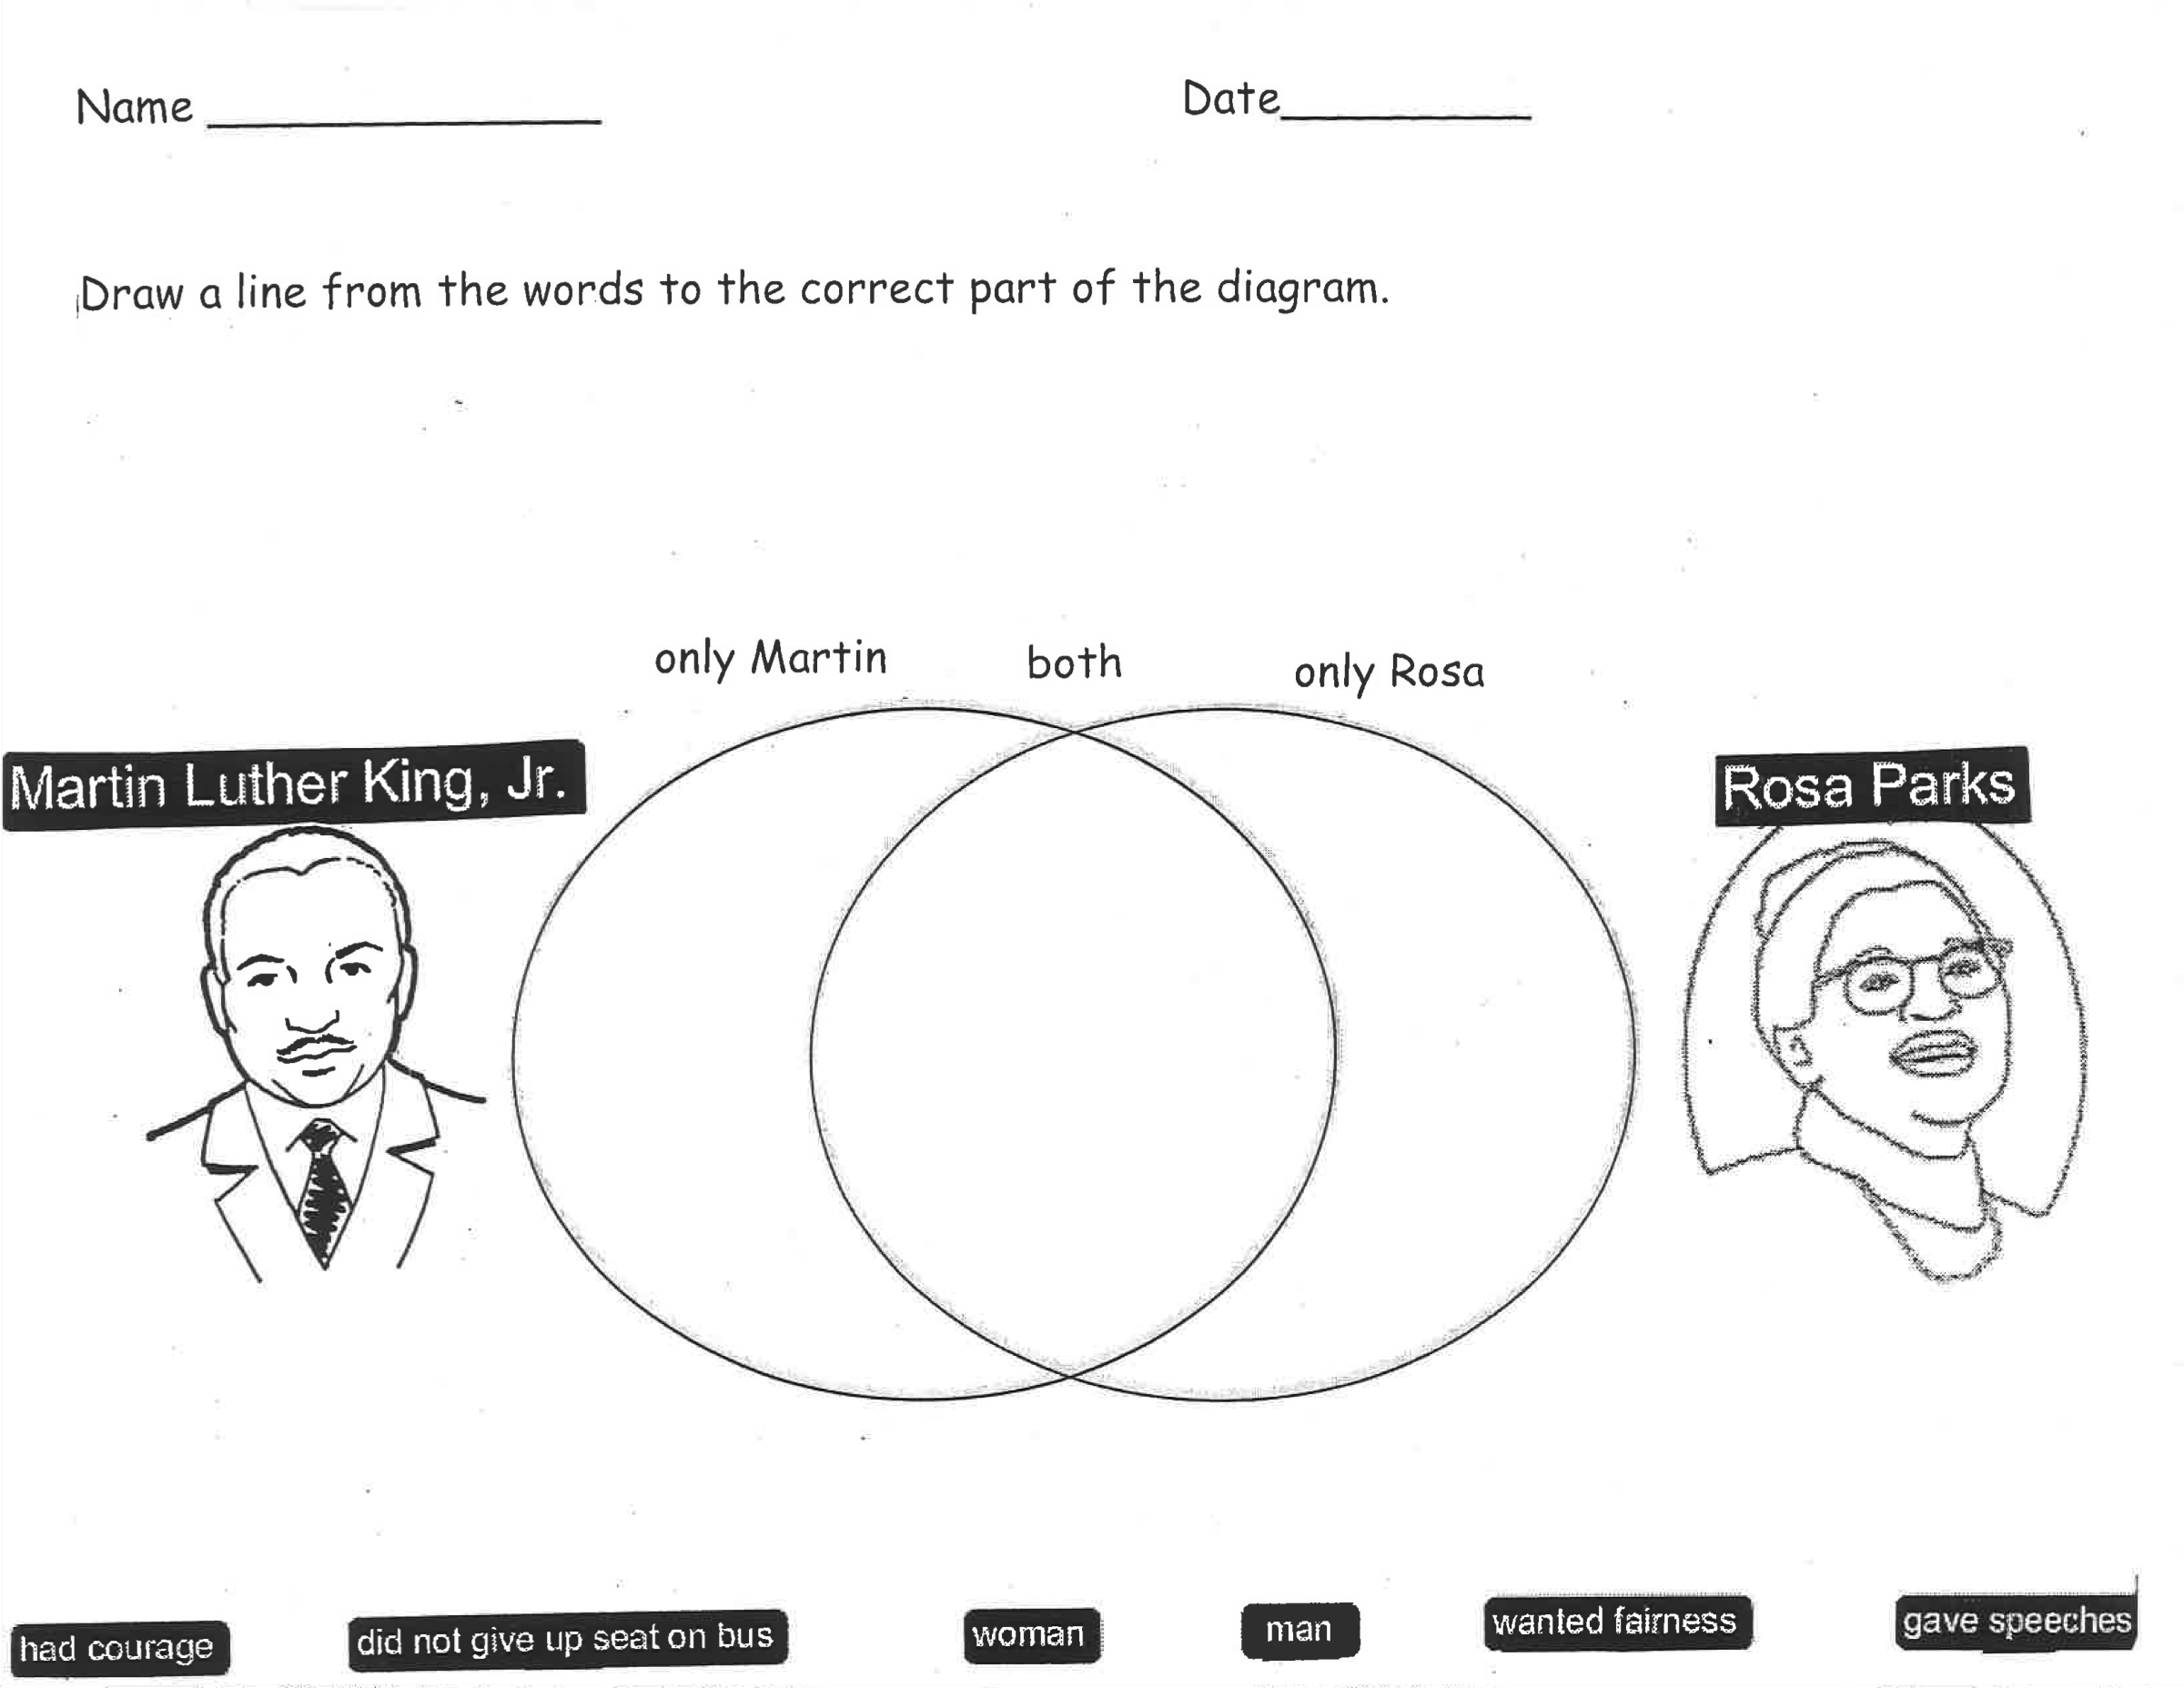

Part 3: Courageous Child
Lesson 9  Day 9 | Courageous Child | Estimated Time: 60 minutes

Brief overview of lesson: Students will begin learning about another historical figure: Ruby Bridges. They will participate in an interactive read-aloud of Ruby Bridges Goes to School: My True Story by Ruby Bridges. They will recount events from the text in sequence. Students will also state their opinion about the story and support it with evidence based on the text. As you plan, consider the variability of learners in your class and make adaptations as necessary.

What students should know and be able to do to engage in this lesson:
- Ability to actively participate in an interactive read-aloud.
- Write words, phrases, and/or simple sentences using targeted language to recount/retell stories.
Have basic knowledge of the major events and details in the lives of Martin Luther King Jr. and Rosa Parks.
LESSON FOUNDATION
Unit-Level Focus Language Goals to Be Addressed in This Lesson |  | Unit-Level Salient Content Connections to Be Addressed in This Lesson
G.1 Recount by sequencing events in stories to communicate context-specific messages.  G.3 Explain by describing how the actions of particular characters/historical figures contributed to increasing justice, courage, and fairness in our world supported with reasoning and evidence. |  | HSS.1.8—After reading or listening to stories about famous Americans of different ethnic groups, faiths, and historical periods, describe their qualities or distinctive traits.  HSS.8—Give examples that show the meaning of the following words: politeness, achievement, courage, honesty, and reliability.  CCSS.ELA-Literacy.RL.1.1—Ask and answer questions about key details in a text.  CCSS.ELA-Literacy.SL.1.1—Participate in collaborative conversations with diverse partners about grade 1 topics and texts with peers and adults in small and larger groups.  CCSS.ELA-Literacy.SL.1.4—Describe people, places, things, and events with relevant details, expressing ideas and feelings clearly.  CCSS.ELA-Literacy.SL.1.5—Add drawings or other visual displays to descriptions when appropriate to clarify ideas, thoughts, and feelings.
Language Objectives |  | Essential Questions Addressed in This Lesson
Students will be able to use targeted language (courage, brave) to describe historical figures orally and in writing.  Students will be able to make opinion statements and support them with evidence using because. |  | Q.1 How can we use oral language to convey a message?  Q.3 How can we demonstrate courage when standing up for justice/fairness?  Q.4 How can we promote justice, fairness, and courage in our daily lives to make a difference in the world?
Assessment
- Formative: Assess student application of learned language to identify and discuss facts and opinions about Rosa Parks.
- Formative: Assess student application of learned language to use evidence supported opinion/claim statements (orally and in writing) about Rosa Parks, Martin Luther King Jr., and Ruby Bridges.
- Self-assessment: Students will self-assess and self-monitor learning using the self-assessment checklist.
Thinking Space: What Academic Language Will Be Practiced in This Lesson?
Discourse Dimension | Sentence Dimension |  | Word Dimension
Social, instructional language; listening to grade-appropriate brief narrative and informational texts composed of simple and some complex and compound sentences with limited cohesion; writing words, phrases, and/or sentences to describe an image; explaining own ideas/answering questions with limited detail. | Simple present and past tense grammatical structures; questions; complex sentences with because. |  | Topic-related vocabulary (e.g., fair, unfair, right, wrong, kind, friend, mean, afraid, scared, friendly, helpful, fear, law, speech, “black people,” “brown people,” “white people,” justice, courage, fairness, bravery, protest, protestors, segregation, boycott); sequencing words (first, second, third, next, then, last, finally, etc.); fact and opinion vocabulary and signal words (e.g., I think, I believe, fact, opinion).
Instructional Tips/Strategies/Suggestions for Teacher
- Consider incorporating a discussion of fiction and nonfiction genres in the lesson. Have students analyze the text after you read it to decide if it is a work of fiction or nonfiction.
- Post and explain the lesson’s language objectives. Use formative assessments to determine if students have successfully reached the objectives and adjust instruction as needed.
- The lesson includes several opportunities for students to turn and talk. Turn-and-talks allow students to practice stating their opinion and supporting it with evidence from the text. Use them to formatively assess students’ use of evidence to support opinion statements, the past tense, content vocabulary (justice, courage, fairness), and sequencing words. Use information gathered from turn-and-talks to inform future instruction and modify it as needed. Turn-and-talks could also be extended to writing prompts.

STUDENT CONSIDERATIONS
Sociocultural Implications
- Students may have fear of authority and/or cultural differences.
- Students who are new to the United States may need to learn classroom norms (e.g., whole group/small group/partner and independent work norms, academic discussion norms), procedures, and expectations. This may require direct, specific instruction.
- Depending on the region from which the students are from, this topic may evoke strong emotional responses, as they may have had negative experiences (injustice, discrimination).
- Students may be more comfortable learning and/or expressing themselves in different ways: orally, in writing, by listening, by movement or touch, by looking at images of visual representations, by speaking, etc. Provide multiple ways for students to learn information and demonstrate their learning.
Anticipated Student Pre-Conceptions/Misconceptions
Students may think that only adults can work to promote justice and that children cannot fix or change things in their community.

THE LESSON IN ACTION

Lesson Opening

Post and explain the lesson’s language objectives: “Students will be able to use targeted language (courage, brave) to describe historical figures orally and in writing,” and “Students will be able to make opinion statements and support them with evidence using because.” To promote student ownership and self-monitoring of learning, have students summarize and/or state the objective in their own words. At the end of the lesson, students can reflect on their learning in relation to the objective.

Review previously taught vocabulary: justice, courage, fairness, brave, scared, and afraid with a game.

For example, give student pairs one topic to discuss (such as Martin Luther King Jr., Rosa Parks, justice, courage, or fairness) and a list of vocabulary words. Tell them they will have five minutes to talk about the topic, using as many words as possible from the vocabulary list.

As students are working, circulate and record as much of the spoken conversation as possible, noting the use of vocabulary. After time is called, partners can share with the class which vocabulary words they used in their conversation and how they used them. This review can serve as a formative assessment of students’ ability to use unit vocabulary in context. Consider including the past tense, adjectives, and sequencing terms in the review.

Revisit the fact/opinion anchor chart. Add information about Rosa Parks, modeling how to write fact and opinion statements using adjectives.
Provide options for engagement, such as having students record one fact about Rosa Parks, share the fact with a partner or small group, and create an opinion and a fact statement about Rosa Parks together. Then have students add this information to the anchor chart.
Provide options for physical action, such as discussing orally, writing on Post-Its, or typing up statements.

Explain what opinions are and how opinions can be strengthened by supporting them with evidence. Consider introducing the word claim.

Introduce the conjunction because and model a few examples of how to use it to support an opinion using a familiar context.

Have students practice using the conjunction because to state an opinion about a familiar context.

Model how to use the conjunction because to support an opinion about Rosa Parks. For example, write a fact and an opinion statement on the board (e.g., “Rosa Parks was tired of being pushed around. I think Rosa Parks was brave”). Then use the fact to support the opinion statement using because (e.g., “I think Rosa Parks was brave because she stood up for something she believed in. I think Rosa Parks was brave because she stood up for something that was right”).

Have students practice using the conjunction because to state opinions and support them with evidence using information from the Martin Luther King Jr. and Rosa Parks anchor charts. Provide sentence frames, such as: “I think it was unfair when Rosa Parks was asked to move because _______.”

During the Lesson

Introduce the new historical figure: Ruby Bridges. Tell students that today they will be working with someone else who stood up for what was right.

Read the title of the new book, Ruby Bridges Goes to School: My True Story by Ruby Bridges, and display its front cover. Write the title and author’s name at the top of a piece of new chart paper.

Explain that the girl on the cover, named Ruby Bridges, grew up and wrote this book to teach other children what it was like when she went to school. Explain that like Martin Luther King Jr. and Rosa Parks, Ruby also wanted justice for all people.
Provide options for perception, such as images of Ruby Bridges.

Build students’ background knowledge of Ruby Bridges by reviewing resources such as “Ruby the Brave” (interactive story); a Civil Rights Movement slide show; a video, such as “Civil Rights - Ruby Bridges”; and/or a leveled reader, such as Ruby Bridges (this leveled reader can be translated into different languages, used in a small group, used with a text-to-speech reader, or used with teacher support as needed).

Provide a focus question for reading, such as: “How was Ruby Bridges courageous?” Ask students to also think about justice, fairness and courage as they listen to the story and to identify examples of each in the story. Providing a question to consider can help heighten student engagement and focus student attention.

Read Ruby Bridges Goes to School: My True Story by Ruby Bridges aloud with intonation, modeling proper reading.

Paraphrase any words and/or sections that may need clarification, and consider asking students to act out parts of the text to aid their comprehension.

Stop after reading through “… black children and white children could not go to the same schools.”
Ask students to share any similarities they see in the words and images of the Ruby Bridges text to the Martin Luther King Jr. and Rosa Parks texts previously read in the unit.
Discuss/explain segregation in schools. Consider simulating segregation based on hair color, shirt color, or by drawing student names from a hat. Show images of segregation in schools.
Ask: “What would that be like? How would that make you feel?” Give students time to think independently and then share with a partner, before discussing as a whole class. Provide sentence frames such as: “I would feel _______ because ________”; “It would be ________ because ________.” Prompt students to use evidence to support their evidence.
Provide options for physical action, such as writing on Post-Its, drawing, orally discussing, or typing.

Continue reading through: “They yelled at me to go away.”
Reread “The Marshals came with us to make sure we were safe.” Please note: You may wish to define the term Marshals for students and/or use the term guards instead.
Ask: “Why did Ruby need the Marshals to make sure she was safe? What might happen if the Marshals weren’t there?” Model how to answer these questions. Give students time to think independently and then share with a partner, before discussing as a whole class. Provide sentence frames, such as: “I think Ruby is feeling _________ because _________”; “I think that Ruby needed the Marshals because _________”; “I think if the Marshals were not there __________”; “If I were Ruby, I would feel _________ because _________.” Prompt students to make connections to justice, fairness, and courage, as needed, and use evidence to support their answers.
Provide options for physical action, such as using a whiteboard, emotions cards, writing, or orally discussing.

Continue reading through: “…I wished the children would come back.” Ask: “How is Ruby feeling? What makes you think that?” Give students time to think independently and then share with a partner, before discussing as a whole class. Provide sentence frames, such as: “I think Ruby is feeling _________ because _________.” Prompt students to use evidence from the text to support their answers.
Provide options for physical action, such as using a whiteboard, emotions cards, writing, or orally discussing.

Continue reading through: “… I was very brave.” Ask: “Was Ruby brave? How do you know?” Give students time to think independently and then share with a partner, before discussing as a whole class. Provide sentence frames, such as: “I think Ruby was brave because ________”; “I do not think Ruby was brave because ________.” Prompt students to use evidence from the text to support their answers.
Provide options for physical action, such as using a whiteboard, emotions cards, writing, or orally discussing.

Optional activity: Ask students to think about a time they were brave and to draw, write, and/or talk about that experience with a partner.

Review key events from the text. Brainstorm key events with students and add them to the Ruby Bridges anchor chart using sketches/images. Sample events to include: “Ruby liked her school for black children. Ruby got to go to the school for white children. Marshals walked Ruby to school to keep her safe. Angry people yelled at her. No white kids went to school.”

Practice retelling events from the story. Ask students to turn and talk to their partner, recounting the story of Ruby Bridges and describing what historical figures and characters did/how they felt using sequencing words, the past tense, and adjectives. Ask students to also state an opinion about what they think about Ruby. Provide sentence frames such as the following:

Sequencing frames: “First, Ruby ________. Next, Ruby ________. Then, Ruby ________. Finally, Ruby ________.”

Other: "It was unfair when ________ because ________"; "Ruby felt ________ because ________"; “Ruby was ________ because ________”; “Ruby ________ because ________”; “I think ________ because ________”; “I feel ________ because ________.”
Provide options for physical action, such as using images to support the retelling, ordering images from the text, and/or using a computer or Post-Its.

Lesson Closing

Debrief the lesson. Have students discuss the following questions in small groups or as a whole class, or have them write answers: “What happened in this story about Ruby Bridges (recount sequence of events)?” “How was Ruby Bridges courageous (describe historical figures and/or characters)?” “How was Ruby like Martin Luther King Jr. and/or Rosa Parks (describe historical figures and/or characters)?”

Have students write an opinion statement about the story of Ruby Bridges and support it with evidence from the text using the conjunction because. Provide sentence frames, such as: “The story of Ruby Bridges was ________ because ________”; “I liked/did not like the story because ________”; “Ruby was ________ because ________.”
Provide options for physical action, such as using a computer, drawing, or orally dictating.

Have students complete the student self-assessment checklist to assess their own learning.
Provide options for physical action, such as using a computer, drawing, or orally dictating.

Lesson 9 Resources
- Ruby Bridges Goes to School: My True Story by Ruby Bridges
- Blank chart paper
- Pencils, markers, crayons
- Paper, laptop, or tablet for recording student observations
- Writing paper
- Student self-assessment checklist (available in Lesson 1 Resources)
- Anchor charts (adjectives, past tense, Martin Luther King Jr., Rosa Parks, vocabulary, fact/opinion)
- Additional resource about Ruby Bridges: “Ruby the Brave” (interactive story), Civil Rights Movement slide show, “Civil Rights - Ruby Bridges”(video), Ruby Bridges (leveled reader)

Lesson 10  Day 10 | Write about Major Events in Ruby’s Story (Language Checkpoint) | Estimated Time: 60 minutes

Brief overview of lesson: Students will review previously studied key events in the life of Ruby Bridges. First, they will watch the teacher model a recount of Ruby’s story that includes details about how Ruby may have felt and connects to unit core concepts of justice, courage, and fairness. Then, students will create their own recount using unit targeted language. Finally, students will have an opportunity to share their work with the class. This lesson serves as the language checkpoint, where students are given opportunities to demonstrate what they have learned in relation to the unit’s Focus Language Goals. As you plan, consider the variability of learners in your class and make adaptations as necessary.

What students should know and be able to do to engage in this lesson:
- Follow procedures and participate in an interactive read-aloud.
- Write words, phrases, and/or simple sentences using targeted language to recount/retell stories.
Basic knowledge of events/details about Martin Luther King Jr., Rosa Parks, and Ruby Bridges previously discussed in class.
LESSON FOUNDATION
Unit-Level Focus Language Goals to Be Addressed in This Lesson |  | Unit-Level Salient Content Connections to Be Addressed in This Lesson
G.1 Recount by sequencing events in stories to communicate context-specific messages.  G.3 Explain by describing how the actions of particular characters/historical figures contributed to increasing justice, courage, and fairness in our world supported with reasoning and evidence. |  | HSS.1.8—After reading or listening to stories about famous Americans of different ethnic groups, faiths, and historical periods, describe their qualities or distinctive traits.  HSS.8—Give examples that show the meaning of the following words: politeness, achievement, courage, honesty, and reliability.  CCSS.ELA-Literacy.RL.1.1—Ask and answer questions about key details in a text.  CCSS.ELA-Literacy.SL.1.1—Participate in collaborative conversations with diverse partners about grade 1 topics and texts with peers and adults in small and larger groups.  CCSS.ELA-Literacy.SL.1.4—Describe people, places, things, and events with relevant details, expressing ideas and feelings clearly.  CCSS.ELA-Literacy.SL.1.5—Add drawings or other visual displays to descriptions when appropriate to clarify ideas, thoughts, and feelings.
Language Objective |  | Essential Questions Addressed in This Lesson
Students will be able to recount Ruby Bridges’ story using previously introduced language (topic vocabulary, sequencing words, adjectives, past tense, because). |  | Q.1 How can we use oral language to convey a message?  Q.3 How can we demonstrate courage when standing up for justice/fairness?  Q.4 How can we promote justice, fairness, and courage in our daily lives to make a difference in the world?
Assessment
- Formative: Assess student application of learned language to recount and describe key events from Ruby Bridges’ story, orally and in writing.
- Self-assessment: Students will self-assess and self-monitor learning using the self-assessment checklist.
Thinking Space: What Academic Language Will Be Practiced in This Lesson?
Discourse Dimension | Sentence Dimension |  | Word Dimension
Social, instructional language; listening to grade-appropriate brief narrative and informational texts composed of simple and some complex and compound sentences with limited cohesion; writing words, phrases, and/or sentences to describe an image; explaining own ideas/answering questions with limited detail. | Simple present and past tense grammatical structures; questions; complex sentences with because. |  | Topic-related vocabulary (e.g., fair, unfair, right, wrong, kind, friend, mean, afraid, scared, friendly, helpful, fear, law, speech, “black people,” “brown people,” “white people,” justice, courage, fairness, bravery, protest, protestors, segregation, boycott); sequencing words (first, second, third, next, then, last, finally, etc.); fact and opinion vocabulary and signal words (e.g., I think, I believe, fact, opinion).
Instructional Tips/Strategies/Suggestions for Teacher
Use of sentence frames may support students’ speaking in complete sentences.

STUDENT CONSIDERATIONS
Sociocultural Implications
- Students may have fear of authority and/or cultural differences.
- Students who are new to the United States may need to learn classroom norms (e.g., whole group/small group/partner and independent work norms, academic discussion norms), procedures, and expectations. This may require direct, specific instruction.
- Depending on the region from which the students are from, this topic may evoke strong emotional responses, as they may have had negative experiences (injustice, discrimination).
- Students may be more comfortable learning and/or expressing themselves in different ways: orally, in writing, by listening, by movement or touch, by looking at images of visual representations, by speaking, etc. Provide multiple ways for students to learn information and demonstrate their learning.
Anticipated Student Pre-Conceptions/Misconceptions
Students may think that only adults can work to promote justice and that children cannot fix or change things in their community.

THE LESSON IN ACTION

Lesson Opening

Post and explain the lesson’s language objective: “Students will be able to recount Ruby Bridges’ story using previously introduced language (topic vocabulary, sequencing words, adjectives, past tense, because).” To promote student ownership and self-monitoring of learning, have students summarize and/or state the objective in their own words. At the end of the lesson, students can reflect on their learning in relation to the objective.

Review previously taught vocabulary using the vocabulary anchor charts.

Connect to Lesson 9.

Display the cover of Ruby Bridges Goes to School: My True Story the Ruby Bridges anchor chart.

Debrief what students did in the last lesson. For example, say: “During our last lesson, we read a book called Ruby Bridges Goes to School: My True Story. We learned about when Ruby went to first grade. Turn and tell your partner what you remember about Ruby Bridges’ story. Give students time to think independently and then share with a partner, before discussing as a whole class. Provide sentence frames for sharing, such as: “I learned ______”; “I remember ______”; “One thing I liked was ______.”
Provide options for physical action, such as writing, drawing, or using a computer.

During the Lesson

Introduce the focus of the lesson. For example, say: “Today, we are going to imagine what it was like to be Ruby.” Review the events listed on the Ruby Bridges anchor chart (e.g., Ruby in kindergarten with the other black children; Ruby walking into her new school with the Marshals through the angry crowd; Ruby in school with her new friends). Retell the events; read events from the chart; or have students read, echo read, or chorally read the events.

Have students write and draw about each one of these important events in Ruby’s story as a language checkpoint activity to measure their progress toward the unit’s Focus Language Goals.

Explain how you will show students how to include drawings and details about Ruby Bridges’ story as an example of what they will do next. Model how to look at events in the Ruby Bridges anchor chart and create images and sentences to retell the story using sequencing words, adjectives, past tense verbs, and because. Make sure to include information about what Ruby might have been feeling, and connect this information to the key unit concepts of justice, fairness, and courage. Draw and write on a piece of 6” × 18” construction paper folded into thirds (if using first, next, last/finally) or fourths (if using first, next, then, last/finally). Consider providing sentence frames for each component (sequencing, connections to key unit concepts, Ruby’s feelings).

Have students fold their construction paper into thirds or fourths, then begin drawing and writing. Remind students to use class-generated anchor charts as references while they work.
Provide options for physical action, such as using a computer, dictating, or selecting images from printed ones.

Lesson Closing

Give students opportunities to share their work with a partner or small group. Then invite students to share their work with the class. Students can share their work in front of the group, displaying/explaining illustrations and reading their writing. Allow students to respond to each other’s work by asking questions and/or making comments, as well as offering feedback on Post-Its. Be sure to model this for students.

Afterwards, display students’ work on the wall or bulletin boards, with a title related to the unit’s core concepts of courage, justice, and fairness.

Have students complete the student self-assessment checklist to assess their own learning.
Provide options for physical action, such as using a computer, drawing, or orally dictating.

Lesson 10 Resources
- Ruby Bridges Goes to School: My True Story by Ruby Bridges
- Previously created anchor charts
- Blank chart paper
- Pencils, markers, crayons
- Paper, laptop, or tablet for recording student observations
- Writing paper
- Construction paper
- Student self-assessment checklist (available in Lesson 1 Resources)

Lesson 11  Day 11 | Connecting Martin Luther King Jr., Rosa Parks, and Ruby Bridges | Estimated Time: 60 minutes

Brief overview of lesson: Students will review previously learned vocabulary and key events from the life of Ruby Bridges. They will then compare and contrast Martin Luther King Jr., Rosa Parks, and Ruby Bridges using a Venn diagram. Students will also select illustrations and images from texts about these historical figures that represent justice, fairness, and courage, and explain why they think these images represent these ideals. As you plan, consider the variability of learners in your class and make adaptations as necessary.

What students should know and be able to do to engage in this lesson:
- Follow procedures and participate in an interactive read-aloud.
- Write words, phrases, and/or simple sentences using targeted language to recount/retell stories.
Basic knowledge of events/details about Martin Luther King Jr., Rosa Parks, and Ruby Bridges previously discussed in class.
LESSON FOUNDATION
Unit-Level Focus Language Goals to Be Addressed in This Lesson |  | Unit-Level Salient Content Connections to Be Addressed in This Lesson
G.1 Recount by sequencing events in stories to communicate context-specific messages.  G.3 Explain by describing how the actions of particular characters/historical figures contributed to increasing justice, courage, and fairness in our world supported with reasoning and evidence. |  | HSS.1.8—After reading or listening to stories about famous Americans of different ethnic groups, faiths, and historical periods, describe their qualities or distinctive traits.  HSS.8—Give examples that show the meaning of the following words: politeness, achievement, courage, honesty, and reliability.  CCSS.ELA-Literacy.RL.1.1—Ask and answer questions about key details in a text.  CCSS.ELA-Literacy.SL.1.1—Participate in collaborative conversations with diverse partners about grade 1 topics and texts with peers and adults in small and larger groups.  CCSS.ELA-Literacy.SL.1.4—Describe people, places, things, and events with relevant details, expressing ideas and feelings clearly.  CCSS.ELA-Literacy.SL.1.5—Add drawings or other visual displays to descriptions when appropriate to clarify ideas, thoughts, and feelings.
Language Objective |  | Essential Questions Addressed in This Lesson
Students will be able to explain how selected images illustrate concepts of justice, fairness and courage using because. |  | Q.1 How can we use oral language to convey a message?  Q.3 How can we demonstrate courage when standing up for justice/fairness?  Q.4 How can we promote justice, fairness, and courage in our daily lives to make a difference in the world?
Assessment
- Formative: Assess student application of learned language to identify and describe images illustrating justice, courage, and fairness. Assess student application of learned language to state opinions/claims supported by reasoning/evidence about the images selected.
- Self-assessment: Students will self-assess and self-monitor learning using the self-assessment checklist.
Thinking Space: What Academic Language Will Be Practiced in This Lesson?
Discourse Dimension | Sentence Dimension |  | Word Dimension
Social, instructional language; listening to grade-appropriate brief narrative and informational texts composed of simple and some complex and compound sentences with limited cohesion; writing words, phrases, and/or sentences to describe an image; explaining own ideas/answering questions with limited detail. | Simple present and past tense grammatical structures; questions; complex sentences with because; comparative sentences. |  | Topic-related vocabulary (e.g., fair, unfair, right, wrong, kind, friend, mean, afraid, scared, friendly, helpful, fear, law, speech, “black people,” “brown people,” “white people,” justice, courage, fairness, bravery, protest, protestors, segregation, boycott); sequencing words (first, second, third, next, then, last, finally, etc.); fact and opinion vocabulary and signal words (e.g., I think, I believe, fact, opinion); comparative language (e.g., similar, different, both).
Instructional Tips/Strategies/Suggestions for Teacher
Use sentence frames to help students speak in complete sentences.

STUDENT CONSIDERATIONS
Sociocultural Implications
- Students may have fear of authority and/or cultural differences.
- Students who are new to the United States may need to learn classroom norms (e.g., whole group/small group/partner and independent work norms, academic discussion norms), procedures, and expectations. This may require direct, specific instruction.
- Depending on the region from which the students are from, this topic may evoke strong emotional responses, as they may have had negative experiences (injustice, discrimination).
- Students may be more comfortable learning and/or expressing themselves in different ways: orally, in writing, by listening, by movement or touch, by looking at images of visual representations, by speaking, etc. Provide multiple ways for students to learn information and demonstrate their learning.
Anticipated Student Pre-Conceptions/Misconceptions
Students may think that only adults can work to promote justice and that children cannot fix or change things in their community.

THE LESSON IN ACTION

Lesson Opening

Post and explain the lesson’s language objective: “Students will be able to explain how selected images illustrate concepts of justice, fairness, and courage using because.” To promote student ownership and self-monitoring of learning, have students summarize and/or state the objective in their own words. At the end of the lesson, students can reflect on their learning in relation to the objective.

Review previously taught vocabulary. For example, say and post a vocabulary word on the board and ask students to write down a definition or example of the word on a whiteboard, Post-It, or computer.

Review details about Ruby Bridges’ story. Ask students to share what they have learned, or read the Ruby Bridges anchor chart (teacher reads it, students read it independently, echoing teacher or chorally).

During the Lesson

Revisit the anchor chart comparing and contrasting Martin Luther King Jr. and Rosa Parks on a Venn diagram. Ask students to help you compare and contrast what they know about Ruby Bridges to what is on the chart. Then add this information to the chart.
Provide options for physical action, such as viewing and completing on a computer, using Post-Its to note similarities and differences, or orally sharing similarities and differences.

Have students discuss justice, fairness, and courage.

Divide up students into small groups. Give each group a series of images/illustrations from previously read texts.

Ask students to select one image to represent fairness, one image to represent justice, and one image to represent courage. Then, individually, have students write why they feel each image best represents the concept. Provide sentence frames such as:
    - “I think ________________________________________illustrates fairness because __________________________________.”
    - “I picked _______________________________________ to illustrate fairness because _______________________________.”
    - “I think ________________________________________illustrates justice because __________________________________.”
    - “I picked _______________________________________ to illustrate justice because _______________________________.”
    - “I think ________________________________________illustrates courage because __________________________________.”
    - “I picked _______________________________________ to illustrate courage because _______________________________.”
Provide options for physical action, such as using a computer, Post-Its, or speech-to-text software; dictating; or using Padlet.

Lesson Closing

Ask students to share their images and writing with a partner, and then with the whole class.

Have students complete the student self-assessment checklist to assess their own learning.
Provide options for physical action, such as using a computer, drawing, or orally dictating.

Optional activity: Discuss how Ruby Bridges is now an adult, and have students write her a letter.

Introduce the activity. For example, say: “Did you know that Ruby Bridges is now a grown up woman? She might like to know how much we have learned from her story. Today we are going to write Ruby a letter to let her know what we learned.”

Ask: “If Ruby were in our class right now, what would you tell her we learned from her story? What would you like to say to her?” Give students time to think independently and then share with a partner, before discussing as a whole class. Provide sentence frames for sharing, such as: “I learned ______ from the story.” While students work, listen to partner conversations.

Call on several students, with varied ideas, to share with the class. Co-construct a letter through shared writing. Compose the entire text in front of students, requesting their input and modeling your thinking as well as writing strategies. For example, reread the text from time to time to discuss what needs to be written next or to determine if the text conveys ideas clearly. Connect writing to the concepts of justice, courage, and fairness.

Read the completed letter with/to the students. Post it in an accessible spot in the classroom, and provide opportunities for students to read or use the text multiple times over the next several days or weeks.

Mail the class letter to:
Ruby Bridges
P.O. Box 870248
New Orleans, LA 70187

Lesson 11 Resources
- Ruby Bridges Goes to School: My True Story by Ruby Bridges
- Previously created anchor charts
- Blank chart paper
- Pencils, markers, crayons
- Paper, laptop, or tablet for recording student observations
- Writing paper
- Student self-assessment checklist (available in Lesson 1 Resources)

Part 4: An Example Close to Home
Lesson 12  Day 12 | Justice Everywhere (Character) | Estimated Time: 60 minutes

Brief overview of lesson: Students will expand their understanding of justice and fairness. They will participate in an interactive read-aloud of Jamaica Tag-Along by Juanita Havill and discuss the events and characters’ emotions in relation to fairness and justice. Students will also relate their own lives and experiences to the text. As you plan, consider the variability of learners in your class and make adaptations as necessary.

What students should know and be able to do to engage in this lesson:
- Follow procedures for an interactive read-aloud.
- Write words, phrases, and/or simple sentences using targeted language to recount/retell stories.
Have basic knowledge of the major events and details in the lives of Martin Luther King Jr., Rosa Parks, and Ruby Bridges.
LESSON FOUNDATION
Unit-Level Focus Language Goals to Be Addressed in This Lesson |  | Unit-Level Salient Content Connections to Be Addressed in This Lesson
G.1 Recount by sequencing events in stories to communicate context-specific messages.  G.3 Explain by describing how the actions of particular characters/historical figures contributed to increasing justice, courage, and fairness in our world supported with reasoning and evidence. |  | HSS.1.8—After reading or listening to stories about famous Americans of different ethnic groups, faiths, and historical periods, describe their qualities or distinctive traits.  HSS.8—Give examples that show the meaning of the following words: politeness, achievement, courage, honesty, and reliability.  CCSS.ELA-Literacy.RL.1.1—Ask and answer questions about key details in a text.  CCSS.ELA-Literacy.SL.1.1—Participate in collaborative conversations with diverse partners about grade 1 topics and texts with peers and adults in small and larger groups.  CCSS.ELA-Literacy.SL.1.4—Describe people, places, things, and events with relevant details, expressing ideas and feelings clearly.
Language Objective |  | Essential Questions Addressed in This Lesson
Students will be able to state opinions supported by evidence about what it means to treat people fairly. |  | Q.1 How can we use oral language to convey a message?  Q.4 How can we promote justice, fairness, and courage in our daily lives to make a difference in the world?
Assessment
- Formative: Assess student application of learned language to discuss the characters in the text and to articulate what it means to be treated fairly.
- Formative: Assess student application of learned language to state opinions about the characters in the text supported by evidence from the text.
- Self-assessment: Students will self-assess and self-monitor learning using the self-assessment checklist.
Thinking Space: What Academic Language Will Be Practiced in This Lesson?
Discourse Dimension | Sentence Dimension |  | Word Dimension
Social, instructional language; listening to grade-appropriate brief narrative and informational texts composed of simple and some complex and compound sentences with limited cohesion; writing words, phrases, and/or sentences to describe an image; explaining own ideas/answering questions with limited detail. | Simple present and past tense grammatical structures; questions; complex sentences with because. |  | Topic-related vocabulary (e.g., fair, unfair, right, wrong, kind, friend, mean, afraid, scared, friendly, helpful, fear, law, speech, “black people,” “brown people,” “white people,” justice, courage, fairness, bravery, protest, protestors, segregation, boycott); sequencing words (first, second, third, next, then, last, finally, etc.); fact and opinion vocabulary and signal words (e.g., I think, I believe, fact, opinion).
Instructional Tips/Strategies/Suggestions for Teacher
Consider incorporating a discussion of fiction and nonfiction genres in the lesson. Have students analyze the text after you read it to decide if it is a work of fiction or nonfiction.

STUDENT CONSIDERATIONS
Sociocultural Implications
- Students may have a fear of authority and/or cultural differences.
- Students who are new to the United States may need to learn classroom norms (e.g., whole group/small group/partner and independent work norms, academic discussion norms), procedures, and expectations. This may require direct, specific instruction.
- Depending on the region from which the students are from, this topic may evoke strong emotional responses, as they may have had negative experiences (injustice, discrimination).
- Students may be more comfortable learning and/or expressing themselves in different ways: orally, in writing, by listening, by movement or touch, by looking at images of visual representations, by speaking, etc. Provide multiple ways for students to learn information and demonstrate their learning.
Anticipated Student Pre-Conceptions/Misconceptions
- Students may think that only “black people” are treated unfairly and/or that people are treated unfairly only because of skin color.
- Some students may think that girls and boys/men and women are not equal.
- Students may think that they cannot learn anything from a girl close to their own age (Jamaica).
- Students may not know that Tag-Along is a game.

THE LESSON IN ACTION

Lesson Opening

Post and explain the lesson’s language objective: “Students will be able to state opinions supported by evidence about what it means to treat people fairly.” To promote student ownership and self-monitoring of learning, have students summarize and/or state the objective in their own words. At the end of the lesson, students can reflect on their learning in relation to the objective.

Review previously taught vocabulary.

Introduce the new text: Jamaica Tag-Along by Juanita Havill.

Display the book’s front cover and write the title and author’s name at the top of a piece of chart paper.

Explain that the characters in this story are different from previous characters studied because they are brother and sister. Highlight how they have the same color skin, but there is still a problem with being treated fairly.

Introduce a purpose for reading. For example, say: “As we read, we will be stopping to think about which characters might not be treating others fairly and what they could do that might be better.”

Explain what the terms fairly and unfairly mean, then write treat people fairly below the title on the chart paper. Ask students to think about what they think it means to treat people fairly and how we can be fair to each other. Give students time to think independently and then share with a partner, before discussing as a whole class. Co-create a list or chart of ways in which we can be fair to each other with students.

During the Lesson

Read Jamaica Tag-Along aloud with intonation, modeling proper reading.

Paraphrase any words and/or sections that may need clarification, and consider asking students to act out parts of the text to aid student comprehension. As text is read, record events on chart paper, using sketches, photocopied images from the text or other images, and words. Consider playing an audio recording of the text. Key events to record include: Jamaica wants to play, but Ossie said no. Jamaica followed him to the park and tries to play, but Ossie tells her to go away. Jamaica told Berto to go away because he accidently knocked down her sandcastle. Jamaica shows Berto how to build a sandcastle. They all play together.

Read through “… play serious ball.” Ask: “How is Jamaica feeling when Ossie doesn’t want her to play ball with him?” Give students time to think independently and then share with a partner, before discussing as a whole class. Encourage students to support their thinking with evidence from the text, and think about how they would feel. Provide sentence frames for sharing, such as: “Jamaica feels _____ because _____”; “I think Jamaica is _____ because _____”; “I would feel ______ because _____.”
Provide options for perception, such as giving students a printed version of the question or having students view it on a computer.
Provide options for physical action, such as writing, drawing, or using a computer.

Continue reading through “… Ossie and Jed against Buss and Maurice.” Then bring the students’ attention back to the lines, “That’s not fair, Jamaica thought. Maurice is shorter than I am.” Ask: “What is Jamaica thinking? What’s not fair? What makes you think that?” Give students time to think independently and then share with a partner, before discussing as a whole class. Encourage students to support their thinking with evidence from the text, and to think about how they would feel. Provide sentence frames for sharing, such as: “Jamaica thinks _____ because _____”; “I think _____ is unfair because _____”; “_____ is unfair because _____.” When discussing as a whole class, help students understand that Jamaica thinks her brother does not want to play with her because she is too small. They may also infer he does not want to play with her because she is a girl and he is playing with three other boys.
Provide options for perception, such as giving students a printed version of the question or having students view it on a computer.
Provide options for physical action, such as writing, drawing, or using a computer.

Continue reading through “… slowly over to the sandlot.” Ask: “What is Jamaica thinking? What’s not fair? What makes you think that?” Note: This is the same question as before; this provides an opportunity for students to confirm, change, or expand on their original ideas. Give students time to think independently and then share with a partner, before discussing as a whole class. Encourage students to support their thinking with evidence from the text, and share examples from their own lives. Provide sentence frames for sharing, such as: “Jamaica thinks _____ because _____”; “I think _____ is unfair because _____”; “_____ is unfair because _____.”
Provide options for perception, such as giving students a printed version of the question or having students view it on a computer.
Provide options for physical action, such as writing, drawing, or using a computer.

Continue reading through “… hurts my feelings.” Comment on the hurt feelings, connecting it to the students’ ideas.

Continue reading through the end. Ask: “What did Jamaica do that was different from the things that Ossie did?” and/or “How do Jamaica and Berto feel now?” Give students time to think independently and then share with a partner, before discussing as a whole class. Encourage students to support their thinking with evidence from the text, and share examples from their own lives. Provide sentence frames for sharing, such as:
- Jamaica ______________ but Ossie ______________.
- Jamaica was ______________ because ______________.
- Jamaica felt ______________ because _________________.
- Jamaica feels ____________ because _________________.
- Berto was ______________ because ______________.
- Berto felt _______________ because ________________.
- Berto feels _____________ because ________________.
Provide options for perception, such as giving students a printed version of the question or having students view it on a computer.
Provide options for physical action, such as writing, drawing, or using a computer.

Lesson Closing

Debrief the story by explaining how there is a problem with fairness in the book.

Discuss how Jamaica realizes she is treating Berto the same way Ossie treats her, and how she realizes that Berto does not like to be treated badly either so she changes her behavior. She decides to teach him how to build a sandcastle so they can play together.

Ask students to think about and then discuss how people were treated unfairly in the book.
Provide options for physical action, such as writing, using a computer, or drawing.

Help students notice how Jamaica, Ossie, and Berto are happy in the end because Jamaica was helpful, not hurtful. Connect to the idea that when we treat others fairly, we feel happy.

Have students complete the student self-assessment checklist.
Provide options for physical action, such as using a computer, pointing to ratings, orally sharing ratings, or writing on the checklist.

Have students complete an exit ticket where they complete the following sentence frame: “Jamaica shows ________________________ (justice, courage, fairness) because _____________________.” Then have them share their sentences with a partner, and finally report what their partner said to the whole class.
Provide options for physical action, such as using a computer.

Lesson 12 Resources
- Jamaica Tag-Along by Juanita Havill (and/or audio recording of the text)
- Anchor charts previously created
- Blank chart paper
- Pencils, markers, crayons
- Paper, laptop, or tablet for recording student observations
- Writing paper
- Student self-assessment checklist (available in Lesson 1 Resources)

Lesson 13  Day 13 | Imagine | Estimated Time: 60 minutes

Brief overview of lesson: Students will imagine themselves in a scenario, incorporating ideas studied throughout the lesson to reflect on their own behavior. They will draw and write an example of what they would do in a scenario to demonstrate ideas of justice, fairness, and/or courage. As you plan, consider the variability of learners in your class and make adaptations as necessary.

What students should know and be able to do to engage in this lesson:
- Recount stories by writing words, phrases, and/or simple sentences using targeted language previously introduced.
Basic knowledge of events/details about Martin Luther King Jr., Rosa Parks, Ruby Bridges, and Jamaica studied in class.
LESSON FOUNDATION
Unit-Level Focus Language Goals to Be Addressed in This Lesson |  | Unit-Level Salient Content Connections to Be Addressed in This Lesson
G.1 Recount by sequencing events in stories to communicate context-specific messages.  G.3 Explain by describing how the actions of particular characters/historical figures contributed to increasing justice, courage, and fairness in our world supported with reasoning and evidence. |  | HSS.1.8—After reading or listening to stories about famous Americans of different ethnic groups, faiths, and historical periods, describe their qualities or distinctive traits.  HSS.8—Give examples that show the meaning of the following words: politeness, achievement, courage, honesty, and reliability.  CCSS.ELA-Literacy.RL.1.1—Ask and answer questions about key details in a text.  CCSS.ELA-Literacy.SL.1.1—Participate in collaborative conversations with diverse partners about grade 1 topics and texts with peers and adults in small and larger groups.  CCSS.ELA-Literacy.SL.1.4—Describe people, places, things, and events with relevant details, expressing ideas and feelings clearly.
Language Objective |  | Essential Questions Addressed in This Lesson
Students will be able to explain what they would do to promote justice and fairness in a given situation using I would. |  | Q.1 How can we use oral language to convey a message?  Q.4 How can we promote justice, fairness, and courage in our daily lives to make a difference in the world?
Assessment
- Formative: Assess student application of learned language to explain what they would do to promote justice and fairness as articulated in their “ending” to the story.
- Self-assessment: Students will self-assess and self-monitor learning using the self-assessment checklist.
Thinking Space: What Academic Language Will Be Practiced in This Lesson?
Discourse Dimension | Sentence Dimension |  | Word Dimension
Social, instructional language; listening to grade-appropriate brief narrative and informational texts composed of simple and some complex and compound sentences with limited cohesion; writing words, phrases, and/or sentences to describe an image; explaining own ideas/answering questions with limited detail. | Simple present and past tense grammatical structures; questions. |  | Topic-related vocabulary (e.g., fair, unfair, right, wrong, kind, friend, mean, afraid, scared, friendly, helpful, fear, law, speech, “black people,” “brown people,” “white people,” justice, courage, fairness, bravery, protest, protestors, segregation, boycott); sequencing words (first, second, third, next, then, last, finally, etc.); fact and opinion vocabulary and signal words (e.g., I think, I believe, fact, opinion).
Instructional Tips/Strategies/Suggestions for Teacher
See instructional tips from Lesson 1.

STUDENT CONSIDERATIONS
Sociocultural Implications
- Students who are new to the United States may need to learn classroom norms (e.g., whole group/small group/partner and independent work norms, academic discussion norms), procedures, and expectations. This may require direct, specific instruction.
- Depending on the region from which the students are from, this topic may evoke strong emotional responses, as they may have had negative experiences (injustice, discrimination).
- Students may be more comfortable learning and/or expressing themselves in different ways: orally, in writing, by listening, by movement or touch, by looking at images of visual representations, by speaking, etc. Provide multiple ways for students to learn information and demonstrate their learning.
Anticipated Student Pre-Conceptions/Misconceptions
- Students may confuse the words would and wood. Consider explaining the differences between the two.
- Students may think that only “black people” are treated unfairly and/or that people are treated unfairly only because of skin color.
- Some students may think that girls and boys/men and women are not equal.
- Students may think that they cannot learn anything from a girl close to their own age (Jamaica).
- Students may not know that Tag-Along is a game.

THE LESSON IN ACTION

Lesson Opening

Post and explain the lesson’s language objective: “Students will be able to explain what they would do to promote justice and fairness in a given situation using I would.” To promote student ownership and self-monitoring of learning, have students summarize and/or state the objective in their own words. At the end of the lesson, students can reflect on their learning in relation to the objective.

Review previously taught vocabulary.

Review what students have learned about Jamaica. Ask them to share what they have learned using sentence frames, such as:

“I learned ______________________.”

“I remember __________________.”

“I liked when _________________.”

“Jamaica _____________________.”

“Jamaica showed __________________ when she ________________________.”

Introduce the focus of the lesson. For example, say: “Today, we are going to do something different. We are not going to read. We are going to imagine. We are going to imagine what it might be like to have courage and stand up for justice.”

During the Lesson

Give students a scenario related to justice, courage, and fairness.

For example, say: “Close your eyes and imagine this: You are at the park with a friend. There is another boy at the park trying to learn how to ride a bike. He is having a hard time and he keeps falling off. Your friend starts to laugh at him and call him names. Your friend says, ‘Only babies fall off bikes!’ You think to yourself, ‘Oh, no. I can’t ride a bike either. What if my friend finds out starts to make fun of me?’ The boy tries again to ride his bike. He falls off the bike again. Your friend keeps saying mean things to the boy. The boy looks like he is going to cry. What do you do?”
Provide options for perception, such as using images to support student comprehension.

Reread the story and have students act out the story.

Tell students that they will work on rewriting the end of the story. For example, say: “Today we are going to draw and write the end of this story to show what we would do and say.”

Model for students the creation of a same end of the story illustrating what you would do. Use the sentence frame “I would ______.”

Ask students to draw and/or write what they would do and say. Provide a sentence frame, such as: “I would ______.”
Provide options for physical action, such as having students individually act out what they might do to help them draw and write or having students use a computer to complete.

As students work, confer with them and offer specific feedback on student use of learned language. Record individual students’ spoken language as much as possible.

Lesson Closing

Give students a chance to share their work, displaying/explaining illustrations, reading what they wrote, and explaining their thinking to the class. Make connections whenever possible to justice, fairness, and courage.

As a class, brainstorm everyday ways that we can work for justice, courage, and fairness. Add this information to the anchor chart started in Lesson 12.
Provide options for physical action, such as writing, drawing, using a computer, and/or using Post-Its.

Have students complete the student self-assessment checklist.
Provide options for physical action, such as using a computer, pointing to ratings, orally sharing ratings, or writing on the checklist.

Optional activity: Have students work with an additional text, such as The Other Side by Jacqueline Woodson, Jamaica’s Find by Juanita Havill, or Each Kindness by Jacqueline Woodson. For example, you could read The Other Side by Jacqueline Woodson, and discuss how Clover and Annie got to be friends.

Students can make connections to Jamaica’s behavior of not copying her brother, then discuss how being nice is on the inside and has nothing to do with outward appearances. Students can also draw parallels between this text and Martin Luther King Jr.’s “I Have a Dream” speech.

Have students sort images of nice/fair and not nice/not fair behaviors. After sorting the images, discuss what students would do if they saw others not being nice/fair. Students could then draw and/or write about what they thought about in regards to what they could do to stand up for fairness for others.

Finally, have students share what they wrote with a partner, small group, or the whole class.

Lesson 13 Resources
- Jamaica Tag-Along by Juanita Havill
- Previously created anchor charts
- Blank chart paper
- Pencils, markers, crayons
- Paper, laptop, or tablet for recording student observations
- Writing paper
- 12” × 18” white construction paper
- Student self-assessment checklist (available in Lesson 1 Resources)

Lesson 14  Day 14 | CEPA: Justice Everywhere Posters | Estimated Time: 60 minutes

Brief overview of lesson: Students will complete and present their CEPAs, demonstrating what they have learned throughout the unit. They will use their knowledge of Martin Luther King Jr., Rosa Parks, Ruby Bridges, and Jamaica to create posters with an image demonstrating a core concept from the unit: justice, fairness, or courage. They will orally present their posters, explaining the illustrations, captions, and labels; describing historical figures/characters represented; and recounting some key events from those historical figures/characters’ lives. Students will also explain why they chose to illustrate their assigned word with the image on their poster. As you plan, consider the variability of learners in your class and make adaptations as necessary.

What students should know and be able to do to engage in this lesson:
- Understanding of characteristics of fairness, courage, and justice.
- Recount stories by writing words, phrases, and/or simple sentences using targeted language previously introduced.
Basic knowledge of events/details about Martin Luther King Jr., Rosa Parks, Ruby Bridges, and Jamaica studied in class.
LESSON FOUNDATION
Unit-Level Focus Language Goals to Be Addressed in This Lesson |  | Unit-Level Salient Content Connections to Be Addressed in This Lesson
G.1 Recount by sequencing events in stories to communicate context-specific messages.  G.3 Explain by describing how the actions of particular characters/historical figures contributed to increasing justice, courage, and fairness in our world supported with reasoning and evidence. |  | HSS.1.8—After reading or listening to stories about famous Americans of different ethnic groups, faiths, and historical periods, describe their qualities or distinctive traits.  HSS.8—Give examples that show the meaning of the following words: politeness, achievement, courage, honesty, and reliability.  CCSS.ELA-Literacy.RL.1.1—Ask and answer questions about key details in a text.  CCSS.ELA-Literacy.SL.1.1—Participate in collaborative conversations with diverse partners about grade 1 topics and texts with peers and adults in small and larger groups.  CCSS.ELA-Literacy.SL.1.4—Describe people, places, things, and events with relevant details, expressing ideas and feelings clearly.
Language Objectives |  | Essential Questions Addressed in This Lesson
Students will be able to explain how an image demonstrates justice, fairness, or courage using topic vocabulary and because.  Students will be able to describe historical figures and/or characters and recount some events from their lives studied in class using target language (past tense, adjectives, sequencing words, topic vocabulary).  Students will be able to orally present their posters using target language (past tense, adjectives, sequencing words, topic vocabulary). |  | Q.1 How can we use oral language to convey a message?  Q.2 How can we use language to effectively covey our ideas/beliefs?  Q.3 How can we demonstrate courage when standing up for justice/fairness?  Q.4 How can we promote justice, fairness, and courage in our daily lives to make a difference in the world?
Assessment
- Summative assessment: Assess student application of all language learned in the unit in student-created CEPA posters and poster presentations.
- Self-assessment: Students will self-assess and self-monitor learning using the self-assessment checklist.
Thinking Space: What Academic Language Will Be Practiced in This Lesson?
Discourse Dimension | Sentence Dimension |  | Word Dimension
Social, instructional language; listening to grade-appropriate brief narrative and informational texts composed of simple and some complex and compound sentences with limited cohesion; writing words, phrases, and/or sentences to describe an image; explaining own ideas/answering questions with limited detail. | Simple present and past tense grammatical structures; questions; complex sentences with because. |  | Topic-related vocabulary (e.g., fair, unfair, right, wrong, kind, friend, mean, afraid, scared, friendly, helpful, fear, law, speech, “black people,” “brown people,” “white people,” justice, courage, fairness, bravery, protest, protestors, segregation, boycott); sequencing words (first, second, third, next, then, last, finally, etc.); fact and opinion vocabulary and signal words (e.g., I think, I believe, fact, opinion).
Instructional Tips/Strategies/Suggestions for Teacher
See instructional tips from Lesson 1.

STUDENT CONSIDERATIONS
Sociocultural Implications
- Students may have a fear of authority and/or cultural differences.
- Students who are new to the United States may need to learn classroom norms (e.g., whole group/small group/partner and independent work norms, academic discussion norms), procedures, and expectations. This may require direct, specific instruction.
- Depending on the region from which the students are from, this topic may evoke strong emotional responses, as they may have had negative experiences (injustice, discrimination).
- Students may be more comfortable learning and/or expressing themselves in different ways: orally, in writing, by listening, by movement or touch, by looking at images of visual representations, by speaking, etc. Provide multiple ways for students to learn information and demonstrate their learning.
Anticipated Student Pre-Conceptions/Misconceptions
- Students may confuse the words would and wood. Consider explaining the differences between the two.
- Students may think that only “black people” are treated unfairly and/or that people are treated unfairly only because of skin color.
- Some students may think that girls and boys/men and women are not equal.
- Students may think that they cannot learn anything from a girl close to their own age (Jamaica).
- Students may not know that Tag-Along is a game.

THE LESSON IN ACTION

Lesson Opening

Post and explain the lesson’s language objectives: “Students will be able to explain how an image demonstrates justice, fairness, or courage using topic vocabulary and because,” “Students will be able to describe historical figures and/or characters and recount some events from their lives studied in class using target language (past tense, adjectives, sequencing words, topic vocabulary),” and “Students will be able to orally present their posters using target language (past tense, adjectives, sequencing words, topic vocabulary).” To promote student ownership and self-monitoring of learning, have students summarize and/or state the objective in their own words. At the end of the lesson, students can reflect on their learning in relation to the objective.

Display books and chart papers from each lesson in the unit. Summarize the learning using the charts as a guide.

Introduce the CEPA. Provide students with the CEPA student instructions. For example, say: “Today we are going to begin a project that will help all of the other students in our school know about justice, fairness, and courage. We are going to make posters to hang up in the hallway (cafeteria, library, etc.) for all of the other students to see. We are going to teach them what justice, fairness, and courage look and sound like.

Reread the meaning of justice, courage, and fairness from the vocabulary anchor chart or have students write or orally share their own definitions of each term.

During the Lesson

Explain CEPA details.

Show students the materials (construction paper, crayons, pencils, markers, etc.). Explain that each of them will receive one word (justice, fairness, or courage) and they will make a poster to teach others about that word.

Explain that they may draw the famous Americans they learned about (Martin Luther King Jr., Rosa Parks, or Ruby Bridges), or they may choose to draw an image showing any child working for justice/fairness or being courageous.

Review necessary components: drawings, the word, and an explanation of what the word means using adjectives, opinions supported by evidence, the conjunction because, and verbs in the past tense.

Model the CEPA.

Model creating a poster, highlighting the components. Explain to students that posters must have a drawing, that the word they were given must be clearly visible on the poster, and that they should also explain what the word means at the top or bottom of the poster so other students reading the poster can learn these new words.

Model how to present the poster, highlighting components of a good presentation: explaining illustrations, captions, and labels; using present and past tense verbs; describing historical figures and/or characters and events with adjectives; explaining why the illustrations showcase the given word with because; and using sequencing words to recount events in the person’s life. Provide sentence frames that students can use for each component. Also, highlight presentation components you would like students to focus on, such as eye contact, rate of speech, etc.

Model how to give and receive feedback on a poster and presentation.

Have students brainstorm ideas for what to draw for each word with three turn-and-talks.

First, say: “Tell your partner what you could draw if you get justice.” Provide sentence frames, such as: “If I get justice, I want to draw _____ because _____.” Give students time to share with their partner and then with the whole class.

Repeat this process with the other two words, fairness and courage.

Give students time and materials to work on their CEPA.

Provide students with a piece of paper with their word written down. As you hand students construction paper, ask them what they are going to draw. Pull aside any students unable to develop an idea to support them as needed.
Provide options for physical action, such as using a computer.

Confer with students while they are working. Record student’s spoken language as much as possible. If necessary, have students act out their ideas or locate ideas on the displayed charts to help them draw and write.

Present the CEPA.

Have students share their completed poster with a partner, to practice explaining what they have drawn and written. Then have partners suggest ways to make the presentation better. Consider having students record key points they would like to share during their presentations on index cards.

Have students present to the whole class. Depending on class size and the length of students’ presentations, this may need to be broken up into several shorter periods of time. Score presentations using the CEPA speaking rubric, presentation checklist, and poster checklist.

Lesson Closing

Have students complete the student self-assessment checklist.
Provide options for physical action, such as using a computer, pointing to ratings, orally sharing ratings or writing on the checklist.

Lesson 14 Resources
- Jamaica Tag-Along by Juanita Havill
- Pencils, markers, crayons
- Paper, laptop, or tablet for recording student observations
- Writing paper
- 12” × 18” white construction paper
- Student self-assessment checklist (available in Lesson 1 Resources)
- Anchor charts (adjectives, past tense, Martin Luther King Jr., fact/opinion)
- Performance indicators (available below)
- CEPA speaking rubric (available below)
- CEPA poster checklist (available below)
- CEPA presentation checklist (available below)
- CEPA student directions (available below)

Differentiation of the CEPA Using WIDA Model Performance Indicators
Teachers may adjust performance indicators as necessary based on student needs.
Model Performance Indicators
WIDA Standard: Social and Instructional Language – WIDA MPI Receptive Domain: Listening
Level 1—Entering  Follow along with classmates in role-play activities modeled and described orally (e.g., gestures for word prompts). | Level 2— Emerging  Role-play familiar, everyday activities modeled in illustrated books read by teacher in small groups. | Level 3—Developing  X | Level 4—Expanding  X | Level 5—Reaching  X
WIDA Standard: The Language of Language Arts – WIDA MPI Receptive Domain: Listening
Level 1—Entering  Point to the image that represents a fact or opinion given in present tense. | Level 2—Emerging  Use sentence frames to articulate facts/opinions using a word/image bank. | Level 3—Developing  X | Level 4—Expanding  X | Level 5—Reaching  X
WIDA Standard: The Language of Language Arts – WIDA MPI Productive Domain: Speaking
Level 1—Entering  Repeat new language related to story images or wordless picture books modeled by teacher. | Level 2—Emerging  Describe people or places depicted in shared texts in small groups or pairs. | Level 3—Developing  X | Level 4—Expanding  X | Level 5—Reaching  X
WIDA Standard: The Language of Social Studies – WIDA MPI Receptive Domain: Listening
Level 1—Entering  Match the word justice, fairness, or courage with illustrated scenes based on oral questions or directions. | Level 2—Emerging  Visualize, draw or construct based on visual representations and oral descriptions. | Level 3—Developing  X | Level 4—Expanding  X | Level 5—Reaching  X
CEPA Speaking Rubric

CATEGORY | Level 1/Entering | Level 2/Beginning | Level 3/Developing
Speaking | Single word utterances | Phrases, simple sentences | Simple and expanded sentences with details
Grammatical Structures | No evidence of verb tense | Many errors in present and past tense verb usage/may hamper understanding | Some errors in present and past tense verb usage/does not hamper understanding
Speaks Clearly | Mumbles or cannot be understood | Speaks clearly some of the time | Speaks clearly most of the time
Vocabulary Usage | No content-specific words | One content-specific word | Two or more content-specific words

CEPA Poster Checklist

 | Evident | Non-evident
Illustrations
Captions
Labels

CEPA Presentation Checklist

 | Evident | Non-evident
Explains poster
Recounts/sequences event(s)
Describes historical figure and/or character(s) and/or event(s)

Student Instructions for the CEPA
Performance task: You will make a “justice everywhere poster” using the word justice, fairness, or courage to teach others about it. You will listen to the teacher and follow the poster model that includes a drawing, the word given, and an explanation of the poster.

Goal: The goal is to show your understanding and be able to explain your poster to your classmates on the word justice, fairness, or courage using language learned in this unit.

Audience: Your poster will be shared with your classmates.

Directions: You will be thinking about justice, fairness, or courage. Think of how you will use your poster to teach your classmates about your assigned word. You may draw and write words on the poster. When you present your poster, you need to do the following:
  - Tell your classmates about your illustrations, captions, and labels.
  - Tell your classmates about the historical figure and/or character(s) and/or event(s) in your poster.
  - Use sentences as you tell all about it.

Image and Text Credits

Page 27 Photograph by Gordon Parks. © The Gordon Parks Foundation.
Page 28 Courtesy United Press International, http://www.upi.com/News_Photos/Archives/Remembering-Martin-Luther-King-Jr/4481/17/.
Page 36 Source: Clipart Panda
Page 36 Source: Cliparts.co
Page 36 Source: Clipart Panda
Page 36 Source: Clipart Panda
Page 36 Source: Cliparts.co
Page 37 Source: Clipart Panda
Page 38 Lorelyn Medina/Shutterstock
Page 40 classroomclipart.com
Page 41 Lorelyn Medina/Shutterstock
Page 44 Source: Literacy Leader
Page 49 HitToon/Shutterstock
Page 50 classroomclipart.com
Page 51 © Can Stock Photo/csp15801524
Page 52 Source: Clipart Panda
Page 65 Source: Clipart Panda
Page 65 Courtesy Neal Rosier.
Page 65 Source: https://www.fiverr.com/
Page 65 Creative Market/Sonya DeHart
Page 65 Courtesy Susan Brooks.
Page 86 Hulton Archive/Getty Images

