ESL: Describing and Explaining
Weathering and Erosion
Language of Science Grades 3–5—English Language Proficiency Levels 1 and 2

For more information on the design process for the ESL MCUs, please see the Next Generation ESL Project: Curriculum Resource Guide.

The “ESL: Describing and Explaining Weathering and Erosion” unit is intended to deliver systematic, explicit, and sustained English language development in the context of the Massachusetts Curriculum Frameworks. The purpose of this unit is to help ELs develop the language necessary for academic success in the content area of science. They will also learn language that will be used recurrently in and across various academic and social contexts.
These unit-level Focus Language Goals were created through an analysis of the driving language demands of the existing Science Model Curriculum Unit, “Weathering and Erosion,” a grade 4 science project-based learning unit. This ESL unit is not the same as the sheltered science unit. It is intended to be taught by an ESL teacher, and collaboration with the content teacher is essential. Please be mindful that, in addition to this dedicated, language-focused time, the student must also have access to all core academic content.
The embedded language development in this unit centers on two of the Key Uses of Academic Language as connected to the following key academic practices:
- Discuss by identifying evidence from a given landscape that includes simple landforms and rock layers to support a claim about the role of erosion or deposition in the formation of the landscape.
Explain by describing cause and effect supported with reasoning and ideas.
Throughout the unit, students get contextualized, extended practice with academic language features within discourse, sentence, and word/phrase dimensions. By the end of the unit, through a social justice lens, students will be equipped with the language to raise awareness about the effects of weathering and erosion on various landscapes. Students will also be able to use their learned language to state an opinion/claim, and offer supporting evidence via explanation of cause and effect. While learning about the real, complex issues of weathering and erosion, students will create a presentation to educate others. These embedded, authentic learning experiences provide opportunities to communicate with peers and adults about relevant social and academic topics.

This document was prepared by the Massachusetts Department of Elementary and Secondary Education, Mitchell D. Chester, Ed.D., Commissioner.
The Massachusetts Department of Elementary and Secondary Education, an affirmative action employer, is committed to ensuring that all of its programs and facilities are accessible to all members of the public. We do not discriminate on the basis of age color, disability, national origin, race, religion, sex, or sexual orientation.
© 2016 Massachusetts Department of Elementary and Secondary Education (ESE). ESE grants permission to use the material it has created under the terms of the Creative Commons Attribution-NonCommercial-ShareAlike 3.0 Unported License. Additionally, the unit may also contain other third party material used with permission of the copyright holder. Please see Image and Text Credits for specific information regarding third copyrights.
Every effort has been made to acknowledge copyright. Any omissions brought to our attention will be corrected in subsequent editions.
Image and Text Credits:

Page 14 | Copyright 2007 Department of Education. Courtesy Virginia Department of Education and Jarvits.
Pages 19, 23 | Richard Olsen/National Geographic Creative
Pages 20, 22 | Permissions forthcoming from The Permissions Group.
Page 23 | Courtesy Numi Thorvarsson.
Page 24 | Permissions forthcoming from The Permissions Group.
Page 30 | Courtesy Clenton Farquharson.
Page 30 | Courtesy Pass My Exams, www.passmyexams.co.uk.
Page 39 | Courtesy Bill Lindsey.
Page 39 | kvitka/Shutterstock
Page 39 | lineartespilot/Shutterstock
Page 40 | Used with permission of Steve Allen, Steve Allen Travel & Wildlife Photography, www.steveallenphotography.com.
Page 40 | urosr/Shutterstock
Page 40 | Courtesy Karrar Haidri, www.saltorosummits.com.
Pages 40, 115 | Source: R. Branham Photography
Page 48 | Permissions forthcoming from The Permissions Group.
Page 48 | Courtesy Mike Page, www.mike-page.co.uk.
Page 92 | Helen H. Richardson/Getty Images
Page 54 | Fotolia item number #115556865.
Page 54 | Peter Essick/Aurora Photos
Page 54 | AP Photo/Sean M. Fitzgerald
Page 54 | Melissa Farlow/National Geographic Creative
Page 54 | Permissions forthcoming from The Permissions Group.
Page 56 | Forthcoming from The Permissions Group
Page 89 | Antonio Scorza/Getty Images.
Page 92 | Licensed under the Creative Commons Attribution-Share Alike 2.5 Generic license.
Page 90 | AP Photo/Mukhtar Khan
Page 90 | 123rf. number 26494594. http://www.123rf.com/profile_lenm'>lenm / 123RF Stock Photo</a>
Page 90 | Courtesy Louis Schneider.
Page 89 | Image Source/Getty Images
Page 90 | Fotolia item number #116055323
Page 90 | Courtesy Kris Dutson, http://www.southernscenicphotography.co.uk/.
Page 90 | Forthcoming from The Permissions Group
Page 89 | Andraž Cerar/Shutterstock
Page 90 | stefanolunardi/Shutterstock
Page 90 | Courtesy The Baker Orange.
Page 90 | Karen Warren / © Houston Chronicle. Used with permission.
Page 91 | AP Photo/Ramon Espinosa
Page 91 | Juriah Mosin/Shutterstock
Page 91 | Courtesy Wendy Robards, www.caribousmom.com.
Page 91 | AP Photo/Anupam Nath
Page 91 | Forthcoming from The Permissions Group
Page 91 | Ross Whitaker/Getty Images
Page 91 | Forthcoming from The Permissions Group
Page 119 | Fotolia image number #116769874 , #113219551 (ocean), #95847409 and #107960718.
Page 120 | Courtesy Shawn Telford.
Page 120 | Courtesy Lesson Plan Diva.
Page 120 | aekikuis/Shutterstock
Page 123 | Source: Green Tree Resources
Page 123 | George Steinmetz/National Geographic Creative
Page 126 | Courtesy Alexey Kharitonov.
Page 121 | James L. Stanfield/National Geographic Creative
Page 121 | David Wall Photo/Getty Images
Page 121 | Permission granted under Creative Commons Attribution 2.0 Generic License (CC BY 2.0).
Page 122 | Pichugin Dmitry/Shutterstock
Page 122 | Permission granted under Creative Commons License Attribution-ShareAlike 2.0 Generic License.
Page 122 | Courtesy Native Village of Shishmaref.
Page 123 | Permission is granted under the terms of the GNU Free Documentation License, Version 1.2 or any later version published by the Free Software Foundation.
Page 124 | AP Photo/David McFadded, File
Page 125 | Courtesy Sumiko Scott Photography.
Page 126 | Courtesy Djauhari Noor.
Page 126 | © John Chedsey
Page 127 | Forthcoming from The Permissions Group
Page 127 | Courtesy Mauri S. Pelto.
Page 128 | Courtesy Trudy Kavanagh, Ph.D.
Page 128 | Source: Canyon Crest Academy
Page 128 | Courtesy K. Tenga-Gonzales/Marine Sea Grant.
Page 128 | Permission granted under the Creative Commons Attribution 2.0 Generic license.
Page 128 | Courtesy The Why Files.
Page 131 | Courtesy Stephen A. Nelson, Ph.D.

The contents of this Model Curriculum Unit were developed under a grant from the U.S. Department of Education. However, those contents do not necessarily represent the policy of the U.S. Department of Education, and you should not assume endorsement by the federal government.
Massachusetts Department of Elementary and Secondary Education, 75 Pleasant St, Malden, MA 02148-4906. Phone 781-338-3300, TTY: N.E.T. Relay 800-439-2370, www.doe.mass.edu
Table of Contents
Unit Plan 5
Lesson 1 11
Lesson 2 25
Lesson 3 33
Lesson 4 41
Lesson 5 49
Lesson 6 56
Lesson 7 67
Lesson 8 76
Lesson 9 84
Lesson 10 96
Lesson 11 101

Unit Plan
Stage 1—Desired Results
ESTABLISHED FOCUS GOALS G  Focus Language Goals/Standards  G.1 Discuss by identifying evidence from a given landscape that includes simple landforms and rock layers to support a claim about the role of erosion or deposition in the formation of the landscape.  G.2 Explain by describing cause and effect supported with reasoning and ideas.  Content Connections  The student is building toward:  STE.4-ESS1-1—Construct a claim with evidence that changes to a landscape due to erosion and deposition over long periods of time result in rock layers and landforms that can be interpreted today. Use evidence from a given landscape that includes simple landforms and rock layers to support a claim about the role of erosion or deposition in the formation of the landscape.  STE.4-ESS2-1—Make observations and collect data to provide evidence that rocks, soil, and sediments are broken into smaller pieces through mechanical weathering and moved around through erosion by water, ice, wind, and vegetation.  CCSS.ELA-LITERACY.W.4.8—Recall relevant information from experiences or gather relevant information from print and digital sources; take notes and categorize information, and provide a list of sources. | Transfer
Students will be able to independently use their learning to… T
T.1 Communicate for social and instructional purposes within the school setting.
T.2 Communicate information, ideas, and concepts necessary for academic success in the content area of science.
 | Meaning
 | UNDERSTANDINGS U  Students will understand that…  U.1 Signal words and phrases can be used when writing and speaking to clarify cause and effect relationships between ideas.  U.2 Effective claims are supported with facts and evidence.  U.3 Language can be used to describe the connection between weathering and erosion (cause/effect).  U.4 Scientists utilize a specific language register to communicate their ideas. | ESSENTIAL QUESTIONS Q  Q.1 How can we use our knowledge of the English language to inform others?  Q.2 How can we communicate our ideas about weathering and erosion?  Q.3 How can we use evidence to support a claim about weathering and erosion?
 | Language Acquisition in the Four Domains
 | KNOWLEDGE: Academic Language K  Students will know…  K.1 Prepositions indicate and describe location or position (e.g., between, on, in, out, off, down, up).  K.2 Adjectives describe and compare (e.g., taller, smaller, deeper, shallow).  K.3 Sequence signal words explain order (e.g., first, next, then).  K.4 Cause and effect signal words identify and clarify the relationship between a process and its results and make claims (e.g., because, therefore).  K.5 Coordinating conjunctions connect ideas in complex sentences (e.g., and, but).  K.6 Regular past tense verbs are formed by adding –d or –ed (e.g., weathered, eroded, moved, changed).  K.7 Effective presentations have certain characteristics (e.g., eye contact, register, speaking clearly, projecting, use of supporting images).  K.8 Effective claims are supported with evidence, and complex sentences with because can be used to present claims and related evidence.  K.9 Content and topic vocabulary related to weathering and erosion (e.g., weather, erode, wind, rain, rock, glacier). | SKILLS: Academic Language S  Students will be skilled at…  S.1 Describing the location and position of objects (e.g., between the rocks).  S.2 Describing the appearance of objects using comparative adjectives.  S.3 Using transition words (e.g., first, next, then) to put events or steps in order.  S.4 Using cause and effect signal words (e.g., because, therefore) to explain a process (cause) and its results (effect), and to make a claim.  S.5 Connecting simple sentences to create compound sentences using coordinating conjunctions (e.g., and, but).  S.6 Using regular past tense verbs (e.g., weathered, eroded, changed, moved) to describe a process.  S.7 Selecting, paraphrasing, organizing, and presenting information effectively.  S.8 Determining relevant evidence to make and support claims.  S.9 Determining the meaning of words and phrases used in a text, including vocabulary specific to domains related to science and academic vocabulary.

Stage 2—Evidence
EVALUATIVE CRITERIA | ASSESSMENT EVIDENCE: Language Development
- Support of claims with evidence (e.g., I think…because…).  - Appropriate use of content area vocabulary (e.g., weathering, erosion, glacier, wind, rain, water).  - Appropriate use of descriptive and comparative adjectives to discuss evidence of weathering and erosion (e.g., smaller, taller, shallow, deep).  - Appropriate use of prepositions of place to discuss evidence of weathering and erosion (e.g., in, between, on, off, down, up).  - Appropriate use of signal words of cause and effect to convey meaning (e.g., because, therefore).  - Appropriate use of sequencing words to convey meaning (e.g., first, next, then).  - Appropriate use of coordinating conjunctions used to connect ideas in sentences (e.g., and, but).  - Appropriate use of regular past tense verbs formed by adding –d or –ed (e.g., weathered, eroded, changed, moved).  - Use of language at the discourse, sentence, and word/phrase dimensions, at the targeted level of language complexity to present claims and evidence and to discuss and explain causes and effects of weathering and erosion. | CURRICULUM EMBEDDED PERFORMANCE ASSESSMENT (Performance Tasks) PT  Students will assume the role of a scientist and use their knowledge to describe the effects of weathering and erosion on a specific landform. They will be able to:  - Create a written presentation on the effects of weathering and erosion on a specific landform.  Present their claim and evidence orally in order to raise awareness among government officials and community members at a town hall meeting.  Presentation:  Goal—Raise awareness of the effects of weathering and erosion.  Role—Scientist explaining the changes caused to a landform by weathering and erosion.  Audience—Government officials and community members.  Situation—You have been asked to present the effects that weathering and erosion are creating on the environment.  Product performance and purpose—You are creating a written and visual presentation to be delivered orally to raise awareness about the effects of weathering and erosion on the environment.  Note:  Educators may wish to select local landforms to increase engagement and promote community awareness.
OTHER EVIDENCE OE
Formative assessments: exit ticket, think-pair-share, turn-and-talk, total physical response, know–want to know–learned charts, sorting and matching activities, cause/effect graphic organizers, language checkpoint

Stage 3—Learning Plan
SOCIOCULTURAL IMPLICATIONS
Register:
- Presenting scientific evidence and making a statement supported by evidence may be a new concept for ELs.
Some students may not know that claims made during academic conversations discussing scientific topics must include/be supported by observable evidence.
Topic:
- Some students may not be familiar with certain types of landforms and/or weathering and erosion agents.
- Some students or their families may have had first-hand experience with the varied effects of weathering and erosion from their native country and may be valuable contributors to discussions on the topic.
Some students or their families may have experienced the negative effects of weathering and erosion (such as from a natural disaster). If so, discussing the effects of weathering and erosion may evoke painful memories.

Task/situation:
- Some students may be more comfortable expressing themselves orally, rather than in writing. Give thoughtful consideration to both components.
- Some students may not be familiar with using scientific language in a presentation.
- Some students may need direct instruction reading scientific texts, selecting evidence, using technology, and creating a presentation.

Summary of Key Learning Events and Instruction

Lesson 1—Days 1 and 2: Developing Content Area Concepts and Vocabulary
- Language objective: Students will be able to identify and describe types of weathering and erosion using academic vocabulary (e.g., rock, soil, landform).
Brief overview of lesson: This lesson will develop students’ understanding of vocabulary and concepts of weathering and erosion. Students will learn about these key concepts, practice utilizing the vocabulary to describe images of weathered and eroded landscapes, and have multiple opportunities to use targeted academic language in context, both orally and in writing. A class-generated poster, word wall, or anchor chart will be created during this lesson and continued throughout the unit.
Lesson 2—Day 3: Describing Location and Position with Prepositions
- Language objective: Students will be able to indicate order, location, or position of objects moved or changed by weathering or erosion using prepositions (e.g., between, on, in, out, down, up).
Brief overview of lesson: Students will develop an understanding of the processes of weathering and erosion using prepositions and prepositional phrases to identify and describe evidence of erosion on landforms. Students will engage in multiple means of using targeted academic language in context, both orally and in writing, and post their work for their classmates to view in a gallery walk.
Lesson 3—Day 4: Describing and Comparing with Adjectives
- Language objective: Students will be able to describe the processes of weathering and erosion using comparative adjectives (e.g., small/smaller, shallow/deep, tall/taller, large/larger).
Brief overview of lesson: Students will use comparative adjectives to describe the changes to a landform from weathering and erosion that they can observe in images using descriptive language, prepositions, and academic vocabulary learned in previous lessons. Students will identify evidence of weathering and/or erosion using before and after images and describe the landscape changes that result from these processes.
Lesson 4—Day 5: Describing Cause and Effect by Sequencing
- Language objective: Students will be able to describe a process using sequence signal words (e.g., first, next, then).
Brief overview of lesson: Students will expand their understanding of sequencing vocabulary as a vehicle to explain causes and effects of erosion. Students will analyze and explain the weathering and erosion processes by ordering images of these processes and using sequencing language to describe them.
Lesson 5—Days 6 and 7: Describing Weathering and Erosion Using Past Tense
- Language objective: Students will be able to describe weathering and erosion processes and their results using regular verbs in past tense (e.g., weathered, eroded, broke).
Brief overview of lesson: This lesson will develop students’ knowledge and use of past tense vocabulary as a way to describe the processes of weathering and erosion. Students will analyze images and text and apply their knowledge of the past tense to describe the effects of weathering and erosion on various landscapes.
Lesson 6—Days 8 and 9: Making a Claim Using Cause and Effect Signal Words (Language Checkpoint)
- Language objective: Students will be able to use their knowledge of weathering and erosion to make a claim about causes and effects of these processes using because and therefore.
Brief overview of lesson: This lesson will develop students’ knowledge and use of cause and effect signal words because and therefore as a way to describe the processes of weathering and erosion. Students will analyze images and videos to discern some causes and effects of weathering and erosion. Students will then apply learned language to discuss the causes and effects of weathering and erosion, orally and in writing. This lesson is meant to serve as the unit’s language checkpoint, an opportunity for teachers to measure student progress in relation to the unit’s Focus Language Goals.
Lesson 7—Days 10 and 11: Organizing Information to Summarize
- Language objective: Students will be able to organize important information to summarize by identifying signal words (sequence and cause and effect) when reading.
Brief overview of lesson: This lesson will develop students’ knowledge and understanding of how to organize information that is read. Students will practice analyzing information to discern the causes and effects of weathering. Students will then organize this information and create a summary using all learned language. Learning strategies include graphic organizers, pair work, and whole group discussion.
Lesson 8—Day 12: Restating Information Using Compound Sentences and Linking Words
- Language objective: Students will be able to restate information about weathering and erosion using compound sentences with linking words (and, but).
Brief overview of lesson: This lesson will develop students’ knowledge and understanding of how to use linking words to combine ideas to make more complex sentences. Students will practice combining previously constructed sentences and practice creating new compound sentences about weathering and erosion.
Lesson 9—Days 13 and 14: Making a Claim Supported with Evidence
- Language objective: Students will be able to use cause and effect signal words to make a claim about the effects of weathering and erosion on a specific landform and support it with evidence.
Brief overview of lesson: This lesson will develop students’ understanding of constructing a claim by using cause and effect signal words to make a claim about weathering and erosion on a specific landform. Students will practice generating a claim based on their observations and supporting their claim with relevant evidence about familiar contexts. Students will then transfer their knowledge of learned language to create claims supported by relevant evidence about weathering and erosion. Learning strategies include oral and written practice in small groups and use of visuals to support discussion.
Lesson 10—Day 15: Communicating Effectively Using Presentation Skills
- Language objective: Students will be able to effectively communicate information about weathering and erosion in an oral presentation using content/topic vocabulary (e.g., erosion, weathering, rocks) and targeted academic language introduced in the unit (e.g., small/smaller, because, therefore, and, but).
Brief overview of lesson: Students will develop and practice their presentation skills. Students will analyze presentations to determine the characteristics of effective presentations. Students will then practice utilizing these skills to give a brief presentation. Students will apply the presentation skills learned in the culmination of this unit by presenting their claims using both oral and visual presentations.
Lesson 11—Days 16–20: Creating the Presentation (CEPA)
- Language objective: Students will be able to effectively identify and explain evidence of weathering and erosion on landforms, describe their causes and effects, and make claims supported by evidence to inform others about weathering and erosion.
Brief overview of lesson: These lessons comprise the unit’s curriculum embedded performance assessment (CEPA). The CEPA asks students to use their knowledge of weathering and erosion to create a presentation about the effects of weathering and erosion on a specific landform. Assuming the role of a scientist, students present their claim and supporting evidence orally in order to raise awareness about weathering and erosion among government officials and community members at a town hall meeting. Students will be working in cooperative learning groups of three. Each student will be responsible for completing all parts of the CEPA, and will orally present to their peers in a jigsaw format.
Adapted from Understanding by Design®. © 2012 Grant Wiggins and Jay McTighe. Used with permission.
Lesson 1  Days 1 and 2 | Developing Content Area Concepts and Vocabulary | Estimated Time: Two 60-minute periods

Brief overview of lesson: This lesson will develop students’ understanding of vocabulary and concepts of weathering and erosion. Students will learn about these key concepts, practice utilizing the vocabulary to describe images of weathered and eroded landscapes, and have multiple opportunities to use targeted academic language in context, both orally and in writing. A class-generated poster, word wall, or anchor chart will be created during this lesson and continued throughout the unit. As you plan, consider the variability of learners in your class and make adaptations as necessary.

What students should know and be able to do to engage in this lesson:
- Language: familiarity with identifying and differentiating between nouns and verbs and singular/plural nouns; familiarity with subject/verb agreement for the verb to be; ability to construct phrases and/or simple sentences.
- General or content knowledge: landforms and bodies of water vocabulary.
Skills: ability to participate in class discussions using accountable talk.
LESSON FOUNDATION
Unit-Level Focus Language Goals to Be Addressed in This Lesson |  | Unit-Level Salient Content Connections to Be Addressed in This Lesson
G.1 Discuss by identifying evidence from a given landscape that includes simple landforms and rock layers to support a claim about the role of erosion or deposition in the formation of the landscape. |  | STE.4-ESS2-1—Make observations and collect data to provide evidence that rocks, soil, and sediments are broken into smaller pieces through mechanical weathering and moved around through erosion by water, ice, wind, and vegetation.
Language Objective |  | Essential Questions Addressed in This Lesson
Students will be able to identify and describe types of weathering and erosion using academic vocabulary (e.g., rock, soil, landform). |  | Q.1 How can we use our knowledge of the English language to inform others?  Q.2 How can we communicate our ideas about weathering and erosion?  Q.3 How can we use evidence to support a claim about weathering and erosion?
Assessment
- Observation: Assess student language use during participation in class discussion. In this lesson, assess student oral discussion using sentence frames and application of content vocabulary to discuss weathering and erosion.
- Formative assessment: Assess student use and application of language to label image of eroded landform.
- Formative assessment: Use the exit ticket to assess student use of language (e.g., content vocabulary and use of sentence frames) to describe weathering and erosion.
- Self-assessment: Students will self-assess their learning in relation to the language objective, self-monitor during reading, and reflect on what they have learned.
Thinking Space: What Academic Language Will Be Practiced in This Lesson?
Discourse Dimension | Sentence Dimension |  | Word Dimension
Social/instructional language; brief texts/excerpts with short sentences composed of simple or predictable phrases and limited cohesion between sentences; short explanations of a topic with supporting details; spoken texts explaining content area concepts | This is/These are statements; simple sentences with verbs in present tense: The (noun) + (verb) |  | - Tier 1 and 2 content vocabulary words:  - Nouns: weathering, erosion, rock, shell, plant, water, river, soil, ice, wind, tree, landscape, layers, landforms, pieces, processes, time, cause, effect  - Verbs: flow, change, move, blow, weather, erode, collect
Instructional Tips/Strategies/Suggestions for Teacher
- In determining what scaffolds may be needed to help students access the curriculum, consider the following: supports in students’ native languages, partners, color-coding parts of speech, gestures, and/or sentence stems.
- When planning grouping and supports, consider student proficiency levels along with the objectives for the task at hand. Student groupings will likely vary depending on the objectives of the task.
- Prior to reading, pre-teach or review metacognitive and metalinguistic strategies to aid student analysis of text. For example, review using predictions and periodic summaries of the text while reading and highlight linguistic features of the text that the student should focus on.
- Students will benefit from opportunities to observe the effects of weathering and erosion first-hand. For a suggested method of simulating the effects of weathering and erosion, see “The Magic School Bus Rocks and Rolls”. For other hands-on activities to simulate weathering and erosion, visit Beyond Penguins and Polar Bears.
Instructional Tools
- Chart paper
- Vocabulary pre-assessment graphic organizers (Old Man of the Mountain and weathering and erosion)
- Sentence stems

STUDENT CONSIDERATIONS
Sociocultural Implications
- Some students or their families may have experienced the negative effects of weathering and erosion (such as from a natural disaster). If so, discussing the effects of weathering and erosion may evoke painful memories.
- Some students or their families may have had first-hand experience with the varied effects of weathering and erosion from their native country and may be valuable contributors to discussions on the topic.
Anticipated Student Pre-Conceptions/Misconceptions
Some students may think weathering and erosion are synonyms and produce the same changes.

THE LESSON IN ACTION

Day 1 Lesson Opening

Introduce the lesson’s language objective by posting and explaining it to students: “Students will be able to identify and describe types of weathering and erosion using academic vocabulary (e.g., rock, soil, landform, agent).” To promote student ownership and self-monitoring of learning, have students record the objective in their notebooks. At the end of the lesson, students can reflect on their learning in relation to the objective.

Introduce the new unit:

Show a “before” image of the Old Man of the Mountain posted on the board or the overhead and introduce this landform to students. For example, say: “Once upon a time there was something that looked like the face of an old man on the side of the mountain. Something has happened to the Old Man of the Mountain—he has gone missing.”
Provide options for perception, such as projecting the image, providing students with a printout of the image, or having students view the image on a computer.

Hold up an image of the Old Man of the Mountain as it looks today. Ask students: “What do you think happened to the Old Man of the Mountain?” or “Where do you think the Old Man of the Mountain went?” Ask students to record their answers individually in the Pre-Assessment Handout.
Provide options for perception, such as projecting the image, providing students with a printout of the image, or having students view the image on a computer.

Ask students to share with a partner using a sentence frame, such as “I think that the Old Man of the Mountain ______.”
Provide options for perception, such as projecting the question, providing students with a printout of the question, or having students view the question on a computer.
Provide options for physical action, such as using Post-Its, using a computer, drawing, writing, or taking oral dictation.

After students have had an opportunity to share with a partner, invite them to the group discussion. Having students share with a partner or small group first gives them time to build and share their own ideas before turning to the larger group where not all students are as comfortable sharing their ideas. As students respond, write their answers on a class anchor chart or shared file.

Finish introducing the unit by presenting Focus Language Goals. For example, say: “In this unit we will learn the language we need to discuss what happened to the Old Man of the Mountain; we will learn language to help us discuss weathering and erosion.” Connect to what students may be studying in their content area classrooms. For example, say: “In science class you are studying weathering and erosion. We will be learning the language that scientists use to communicate natural processes.” This reinforces for students the connection with the content area classroom.

During the Lesson

Introduce key vocabulary:

Post the words weathering and erosion in English and students’ native languages (when possible) in the classroom and pose questions to elicit vocabulary that students know about this topic. For example, ask: “What do you know about weathering and erosion? What happens during weathering and erosion? What causes weathering and erosion? Where do weathering and erosion occur?”
Provide options for perception, such as projecting the question(s), providing students with a printout, or having students view the question(s) on a computer.

Ask students to record or draw what they already know about these two concepts. Students can record their responses on the separate weathering and erosion graphic organizers or the combined weathering and erosion graphic organizer.
Provide options for physical action, such as using a computer.

Have students share their drawings or notes with a partner or small group before coming together as a whole class to discuss. Write down student responses on a class anchor chart or shared file that can be revisited throughout the unit.

Pre-teach the terms weathering and erosion. Depending upon student familiarity with these terms, only a review may be necessary. If students do not know these words, use the Seven-Step Vocabulary Teaching Method to teach these concepts. Other ideas to pre-teach these words include the following: semantic mapping, creating a word wall with the definitions of these words and related terms, native language translations, or vocabulary journals—which can encourage students to write, use images, or build their own conceptual examples of the vocabulary. Using an example to illustrate the concepts can also be helpful. For example, show an image of a road and ask students to discuss what they see. Then show an image of a road after erosion has taken place (use the same road if possible) and invite students to describe what has happened. This can help students to see how weathering and erosion can cause something that was there to “disappear.”

Pre-teach the lesson’s sentence frames: “This is (a/an) ______,” “These are ______,” and “The (noun) + (verb).” These can help students discuss the unit concepts.

When discussing weathering and erosion, it may be useful to reinforce the differences between the two concepts. For example:

Give students a copy of a brief excerpt from a text such as “What is the difference between weathering and erosion?”:
Weathering is the process of decomposing, breaking up, or changing the color of rocks. Weathering may be caused by the action of water, air, chemicals, plants, or animals. Chemical weathering involves chemical changes in the minerals of the rock, or on the surface of the rock, that make the rock change its shape or color. Carbon dioxide, oxygen, water, and acids may all cause chemical weathering. Mechanical weathering is the process of breaking a large rock into smaller pieces without changing the minerals in the rock. Mechanical weathering may be caused by frost, ice, plant roots, running water, or heat from the sun. Once the small pieces of rocks are changed or broken apart by weathering, they may start to be moved by wind, water, or ice. When the smaller rock pieces (now pebbles, sand or soil) are moved by these natural forces, it is called erosion. So, if a rock is changed or broken but stays where it is, it is called weathering. If the pieces of weathered rock are moved away, it is called erosion.

To support student understanding of the concepts, read the text aloud while students follow along, ask students to read the text in pairs and/or small groups, organize a jigsaw reading of the text by assigning excerpts to different students, and/or analyze sentences or modified excerpts from the text.

Show a video to build student understanding of the concepts. Suggested videos:
  - “Weathering and Erosion” from Scholastic Study Jams.
  - “Weathering and Erosion: Crash Course Kids #10.2” (This is a long video, but it might be useful to only use the end of this video as it shows changes to the Massachusetts coast line over time).
Consider setting up a video viewing station in the classroom where students can watch videos independently to use closed captioning, pause the videos to ask questions, or watch the videos several times.

Have students quietly reflect on what they learned and then do a turn-and-talk with a partner. While students take turns defining weathering and erosion, provide sentence frames for them to use, such as “Weathering is ______. Erosion is ______.”
Provide options for physical action, such as recording or drawing.

Debrief as a whole class. Add any new terms used in the discussion to the class vocabulary poster, word wall, or anchor chart.

Lesson Closing
Have students review images of landforms and decide if the images illustrate weathering or erosion. Lead a discussion about the images as a whole group, or group students in pairs or small groups.
Provide options for perception, such as projecting the images, providing students with printouts of the images, or having students view the images on a computer.
Provide options for physical action, such as recording on whiteboards, using Post-Its, holding up a card that says weathering or a card that says erosion, or using a program such as Padlet.
After students classify the images as examples of weathering or erosion, post them in the classroom for future reference. As an extension, ask students why they described an image as weathering or erosion and provide a sentence frame for sharing, such as “I think this image shows ______ (weathering/erosion). The ______ (noun) ______ (verb).”
THE LESSON IN ACTION

Day 2 Lesson Opening

Begin by telling students that they are going to continue working with the language needed to discuss the concepts of weathering and erosion.

Read a text about weathering and erosion, such as Erosion: Changing Earth's Surface (Amazing Science) by Robin Koontz, Cracking Up: A Story About Erosion (Science Works) by Jacqui Bailey, or Erosion and Weathering (Rocks: The Hard Facts) by Willa Dee.

Preview the text and ask students to make predictions about the story.

Read the text. You may wish to provide students with a question to consider prior to reading or a post-reading task. For example, tell students that they will record or draw one thing they learned from the text after reading it. This helps to direct student attention and can heighten student engagement and ownership of the learning process.

After reading the text, give students some time to quietly reflect on what they learned. Then ask them to record or draw one thing they learned from the text. You may wish to provide students with a sentence frame, such as “I learned_____”. Ask students to share what they learned with a partner or small group, then invite students to a class discussion.
Provide options for physical action, such as using a computer, Post-Its, or whiteboards.
Note: This opening could be adapted. For example, in place of a text, use a video, such as “Weathering and Erosion” from Scholastic Study Jams or BrainPOP’s “Slow Land Changes.”

During the Lesson

Project or post on the board an image of a weathered and eroded landscape. You may wish to select an image from a video, a local landscape, or the text.

Review vocabulary from yesterday using the images. Ask students to describe them using words they learned on Day 1. Pre-teach any additional vocabulary that comes up and/or review vocabulary that students do not bring up during this activity.
Provide options for perception, such as providing students with printouts of the images or having students view the images on a computer.

As a class, label the image of another weathered and eroded landscape using terms on the class-created anchor chart or word wall. First, model how to label the image. For example, post guiding questions: “What do you see? What changes do you see? What do you think happened? Why did these changes happen?” Share your thinking in response to some of these questions as you describe the image. Use sentence stems that students can later use during their partner and/or independent practice, such as “I see ______; I notice ______; I think ______; I think this changed because ______; It looks like ______.” Then ask students to help you finish labeling the image. Record student language and add any targeted academic language that may be appropriate to the class anchor chart or word wall.

After the class has finished labeling this image, introduce the concept of cause and effect. This should just be a brief introduction, since subsequent lessons will address the language of cause and effect more in depth. Guide students in categorizing terms used to describe the image of landscapes into causes and effects of weathering and erosion (e.g., causes= wind, water, ice; effects= erosion, weathering, pieces, change) by color-coding or sorting words in the anchor chart or word wall.

Give students a different image or photograph of a weathered and eroded landscape and ask them to identify and label features of the landscape individually or with partners.

Post guiding questions (such as the ones used above in the initial modeling) that students can refer to during their image analysis. While students are working, rotate and offer specific feedback in relation to student use of targeted content vocabulary. This provides an opportunity to informally assess student use of content vocabulary and students’ baseline use of cause and effect language.
Provide options for perception, such as a printout or viewing on a computer.
Provide options for physical action, such as using a computer to label.

Ask students to share their descriptions orally (with a partner if working individually or with the class) using sentence stems, such as “I see ______; I notice ______; I think ______; I think this changed because ______; It looks like ______.” While students share, ask partners or the class to actively listen to each other and raise their hands when they hear a vocabulary word from the class word wall or anchor chart.

Optional activity: Ask students to select one new vocabulary word they heard from classmates’ descriptions and use it in an original sentence and/or phrase to describe the image.
Lesson Closing
Exit ticket: Provide students with a piece of paper that has been folded in half. Pre-label one side “weathering” and one side “erosion.” Ask students to draw an example of a landscape that has experienced weathering and erosion, then label it with phrases and/or simple sentences. Consider asking students to share their illustration with one other student, explaining why they chose to illustrate the landscape in the way that they did.
Provide options for physical action, such as using a computer to draw and label drawings.

Lesson 1 Resources
Pre-Assessment: The Old Man of the Mountain
Name: ______________________ Date: ________________

What do you think happened to the Old Man of the Mountain? Where did the Old Man of the Mountain go? Record your answers.
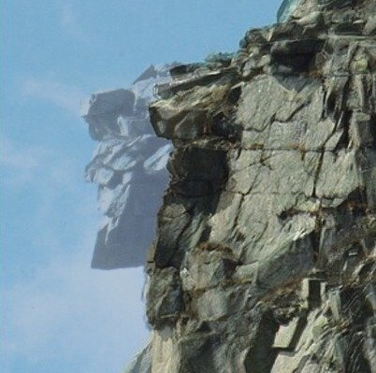

________________________________________________________________________

________________________________________________________________________

________________________________________________________________________

________________________________________________________________________

________________________________________________________________________

________________________________________________________________________

Vocabulary Pre-assessment 2
Name: ______________________ Date: ________________

Draw an image of what you know about weathering.

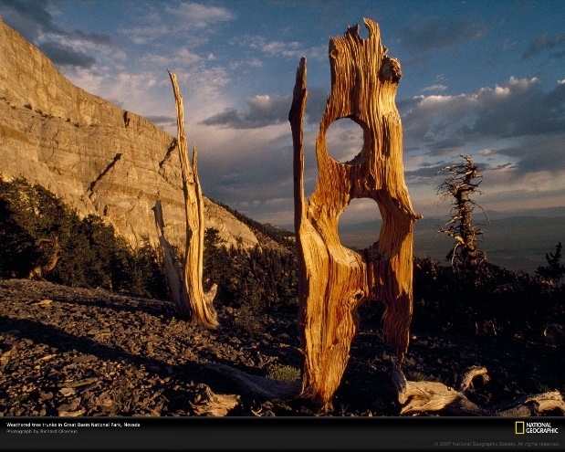

Write all the words you know about weathering.

Vocabulary Pre-assessment 2
Name: ______________________ Date: ________________

Draw an image of what you know about erosion.

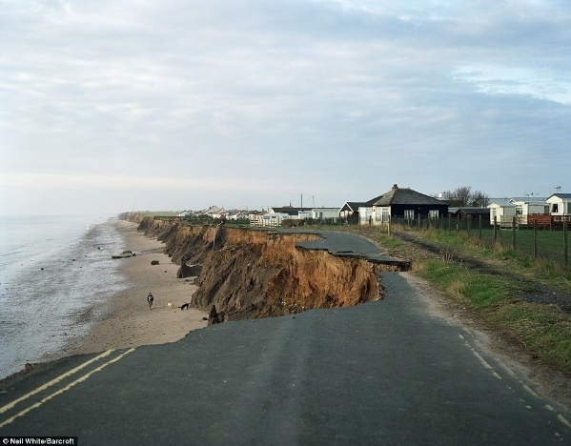

Write all the words you know about erosion.

Vocabulary Pre-assessment: Option B

Name: ______________________ Date: ________________

Draw an image of what you know about weathering and erosion.

Write all the words you know about weathering and erosion.

Seven-Step Vocabulary Teaching Method for Erosion
Procedure | Sample Teacher/Student Actions
PRESENT: Say the word and show an image/photo illustrating it. | Say the word erosion while displaying a visual representation of it on the board or Smart Board.
REPEAT: Have students repeat the word. | Say erosion three times and ask students to say it three times in different ways (e.g., shout it, whisper it, use gestures to describe it).
CONTEXTUALIZE: Read and show the word erosion in a sentence (context) from the text. | Read a sentence from the text, pointing to the text while reading or asking students to follow along in their own copies. For example, “This soil shows erosion. Part of the soil has moved away.”
DEFINE: Give a dictionary definition(s) of erosion. | Say: “According to the dictionary, erosion is a process that happens when the smaller rock pieces (now pebbles, sand, or soil) are moved by natural forces like wind, water, or ice.”
EXPLAIN: Give a student friendly definition and an example that students can relate to. | Say: “In other words, erosion happens when rocks or landscapes are destroyed by water, wind, or glacial ice. For example, erosion changed the face of the Old Man of the Mountain.”
ENGAGE: Have students practice using the word orally or in writing. | 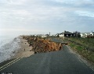  Post an image of erosion (see sample) and ask: “Do you see erosion? How can you tell? What do you see?” Have students think, then pair up and share their thoughts (think-pair-share).
ANALYZE: Highlight an aspect of the word that might create difficulty or point out a known phoneme, prefix, suffix, cognates, or different meaning (for polysemous words). | Post two sentences with different forms of the word on the board. Explain: “Erosion is a noun. It is the word for the whole process that happens, all of the changes.” For example, “Erosion destroyed the Old Man of the Mountain.” When you want to talk about the action, how things change, you say erode. For example, “Wind and water eroded the Old Man of the Mountain.”  Say: “The word erosion in English sounds a lot like the Spanish word erosión and the Portuguese word erosão.”

Seven-Step Vocabulary Teaching Method for Weathering
Procedure | Sample Teacher/Student Actions
PRESENT: Say the word and show an image/photo illustrating it. | Say the word weathering while displaying a visual representation of it on the board or Smart Board.
REPEAT: Have students repeat the word. | Say weathering three times and ask students to say it three times in different ways (e.g., shout it, whisper it, use gestures to describe it).
CONTEXTUALIZE: Read and show the word weathering in a sentence (context) from the text. | Read a sentence from the text, pointing to the text while reading or asking students to follow along in their own copies. For example, “This rock shows weathering. It has changed but stayed in the same place.”
DEFINE: Give a dictionary definition(s) of weathering. | Say: “According to the dictionary, weathering is the process of decomposing, breaking up, or changing the color of rocks.”
EXPLAIN: Give a student friendly definition and an example that students can relate to. | Say: “In other words, weathering happens when rocks are exposed to the weather and the weather breaks the rocks, changes their color, or breaks them down. For example, weathering changed the shape of the rocks.”
ENGAGE: Have students practice using the word orally or in writing. | Post images of rocks before and after weathering has occurred (see samples) and ask: “Do you think weathering happened? How can you tell? What do you see?” Have students think, then pair up and share their thoughts (think-pair-share).  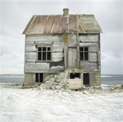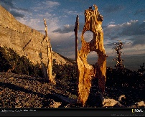
ANALYZE: Highlight an aspect of the word that might create difficulty or point out a known phoneme, prefix, suffix, cognates, or different meaning (for polysemous words). | Post two sentences with different forms of the word on the board. Explain: “Weathering is a noun. To weather is the verb. When you want to talk about the process of the weather changing rocks, you use the word weathering. For example, weathering changed the house. When you want to talk about the action of rain, water, or wind changing rocks, you use the word weathered. For example, the house was weathered by the rain and wind.”

Example of Road Erosion

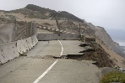

Lesson 2  Day 3 | Describing Location and Position with Prepositions | Estimated Time: One 60-minute period

Brief overview of lesson: Students will develop an understanding of the processes of weathering and erosion using prepositions and prepositional phrases to identify and describe evidence of erosion on landforms. Students will engage in multiple means of using targeted academic language in context, both orally and in writing, and post their work for their classmates to view in a gallery walk. As you plan, consider the variability of learners in your class and make adaptations as necessary.

What students should know and be able to do to engage in this lesson:
- Language: vocabulary for weathering and erosion. Nouns—river, water, rocks, ices, shell, plant, time, soil wind, tree, landscape, layers landforms, erosion, pieces. Verbs—to change, collect, to move, to blow, to weather, to flow.
- General or content knowledge: basic understanding of the weathering process and the ability to identify different types of landscapes and landforms.
Skills: labeling captions, reading a diagram, and using evidence from images and illustrations to support evidence of erosion.
LESSON FOUNDATION
Unit-Level Focus Language Goals to Be Addressed in This Lesson |  | Unit-level Salient Content Connections to Be Addressed in This Lesson
G.1 Discuss by identifying evidence from a given landscape that includes simple landforms and rock layers to support a claim about the role of erosion or deposition in the formation of the landscape. |  | STE.4-ESS2-1—Make observations and collect data to provide evidence that rocks, soil, and sediments are broken into smaller pieces through mechanical weathering and moved around through erosion by water, ice, wind, and vegetation.
Language Objective |  | Essential Questions Addressed in This Lesson
Students will be able to indicate order, location, or position of objects moved or changed by weathering or erosion using prepositions (e.g., between, on, in, out, down, up). |  | Q.1 How can we use our knowledge of the English language to inform others?
Assessment
- Observation: Student listening for prepositions and demonstrating proper object placement based on oral commands. Assess student use of prepositions to orally ask and answer questions about the position of objects in the classroom.
- Formative assessment: Written captions using prepositions to describe illustrations of weathering and erosion.
- Formative assessment: Description of the processes of weathering and erosion using prepositions based on text and/or video analysis.
Thinking Space: What Academic Language Will Be Practiced in This Lesson?
Discourse Dimension | Sentence Dimension |  | Word Dimension
Social/instructional language; information about an event, experience, and/or topic presented in short sentences composed of simple or predictable phrases and sentences with limited cohesion between sentences; brief sequence of events in order | Simple sentences with prepositions and prepositional phrases |  | Content vocabulary (e.g., landform, water, erosion) and prepositions (e.g., in, on, between)
Instructional Tips/Strategies/Suggestions for Teacher
- In determining what scaffolds may be needed to help students access the curriculum, consider the following: supports in students’ native languages, working with partners, including gestures while talking, providing sentence frames, providing illustrations of prepositions to match with the word.
- Depending upon student familiarity and comfort with prepositions, consider extending practice with prepositions over two days. On the first day, students can practice describing landforms orally using prepositions. On the second day, students can apply what they learned to describe landforms in writing. This allows for additional practice and opportunities for conceptual development.
- Pre-teach and/or review metacognitive and metalinguistic strategies prior to analyzing the text and/or video in the lesson closing.
Instructional Tools
- Sentence frames (“The ______ is ______ the ______.”)

STUDENT CONSIDERATIONS
Sociocultural Implications
Some students or their families may have experienced the negative effects of weathering and erosion (such as from a natural disaster). If so, discussing the effects of weathering and erosion may evoke painful memories.
Anticipated Student Pre-Conceptions/Misconceptions
Students may not realize that landforms are created over time and are a result of weathering and erosion.

THE LESSON IN ACTION

Lesson Opening

Post and explain the lesson’s language objective so students can see and understand it: “Students will be able to indicate order, location, or position of objects moved or changed by weathering or erosion using prepositions (e.g., between, on, in, out, down, up).” To promote student ownership and self-monitoring of learning, have students record the objective in their notebooks. At the end of the lesson, students can reflect on their learning in relation to the objective.
Provide options for engagement, such as asking students to explain what a preposition is and/or showing a visual representation of a preposition. Ask students to record their response on a Post-It, whiteboard, and to share them with a partner. Then invite students to share their ideas with the class. Consider writing down student responses on an anchor chart or shared file for student reference.

Define prepositions, incorporating student ideas. For example, say: “A preposition is a word that describes the location of things as they relate to other objects.” Ask students to contribute examples of prepositions of place to the anchor chart (orally or in writing). Add to the list additional prepositions of place not mentioned by the students. Review the prepositions of place with students and allow time for native language translations as needed.

Illustrate the use of prepositions in a familiar context. For example:

Tell students to demonstrate the position of their pencils relative to other objects based on your commands. Model the first one and then ask students to follow your instructions. Say: “Place your pencil over your head,” “Place your pencil on your hand,” “Place your pencil between your hands,” etc. It may be helpful to write or post these commands so students can have oral and written input at the same time.

Ask students to pass a ball around in a circle to music. When the music stops, whichever student has the ball has to place the ball somewhere. The student will then have to say where the ball is using a preposition of place (e.g., “The ball is on the desk”) from the class anchor chart and/or their own background knowledge. Students can then continue to pass the ball around to music, placing the ball in different locations when the music stops. This provides a quick formative assessment of students’ understanding of how to use prepositions to describe the location of objects.

Have students practice asking and answering questions about the location of something in the classroom. Model how to ask questions with where is/are and answer them using simple sentences (e.g., “Where is the flag? The flag is over the desk.”). Post sentence frames students can refer to, then ask students to work with a partner: one student asks the questions, and the other uses a preposition to answer them. Students can then reverse roles. Once pairs have had a chance to ask/answer questions, ask volunteers to share their questions and responses. This provides a quick formative assessment of students’ use of prepositions to describe the location of objects.

During the Lesson

After reviewing prepositions with students, show students images of different landforms. Sample images are provided in the lesson and unit resource sections.
Provide options for perception, such as printouts or having students view the images on a computer.
Ask students to scan the image and describe it using prepositions. Model how to do it first. For example, say: “I see a mountain next to a lake.” Remind students that prepositions can make descriptions more specific.

Transition to using prepositions to discuss images of weathered/eroded landscapes. Begin by asking students if they have ever seen an example of a weathered landscape and/or types of erosion, either in Massachusetts or their native countries. This can help to personalize the learning for students. Ask students to describe what happened to the landscape. While students are sharing, note student use of prepositions to describe the landscape (e.g., “The house fell into the ocean”; “The edge of the road broke off.”). Help students make the connection that as they were discussing what happened to the landscape, they were describing evidence of erosion. For example, the house falling into the ocean is evidence of the waves eroding the coastline. Consider defining what evidence is. (Note: using evidence to support a claim will be explicitly taught in subsequent lessons.)

After asking students to reflect on examples of weathering and/or erosion, use images from weathered and eroded landscapes to discuss the evidence of erosion students see in the image using prepositions. Remind students that weathering and erosion are ongoing processes and that the images are just a snapshot of one moment of the process. Let students know that they will analyze the images of weathered/eroded landscapes, looking for any evidence of erosion (e.g., broken rocks, dirt washed way, smaller coastline). Let students know that they will use prepositions to help describe the evidence of erosion that they notice in the image.

Model what students will do. Write sentences using prepositions that describe the evidence of weathering and/or erosion identified in an image on the board or sentence strips. During the modeling, note the evidence of erosion that you see in the image and describe it using prepositions.
Provide options for perception, such as a shared file, so that students may view the sentence strips on a computer.

Have students practice describing an additional image using prepositions in a think-pair-share. Ask students to brainstorm a caption for the images and write it on a Post-It or whiteboard. Provide a prompt, such as “How can we use prepositions to describe what happened to the weathered/eroded landscape?” Provide a sentence frame, such as “The ______ is ______ (preposition) the______; ______ moves ______ the ______; The ______ causes the ______ to move ______ the ______.”

After think-pair-share, ask pairs to share their captions and discuss student ideas until the class agrees on a caption together.
Provide options for perception, such as shared file so that students may be able to view the caption on a computer.

Review the weathering and erosion processes with students. If time permits, show the video from Lesson 1 again. Have students practice describing additional landscapes.

Divide students into small groups. Provide each group with a set of images that show changes because of weathering and erosion. Tell students that they will create a caption for their images. They must include prepositions in the description of the images. Provide supports, such as word banks, sentence frames, and illustrations as necessary.

Have each group present their images and read their captions. Ask each group questions about their images to see that they can add to their descriptions. Post images and descriptions around the room, and let students walk around and view the images and captions.

Ask students to orally make a statement about the changes that occurred to the landscape using prepositions.
Provide options for physical action, such as using a computer, drawing, or oral dictation.

Optional activity: Have students record phrases and/or simple sentences describing the image using prepositions.

Lesson Closing
Give students an excerpt from the book shared in class or replay a portion of one of the videos shown in class, along with a transcript of that section. Have students work with a partner or small group to identify prepositions of place in the text, then describe the changes that occurred to the landscape using the prepositions they identified.
Provide options for physical action, such as drawing an image and labeling it accordingly with prepositions, using a computer to complete the activity, and/or describing the changes orally or in writing.

Lesson 2 Resources
Sample Images to Describe and Potential Captions/Statements (as a class and/or small groups)
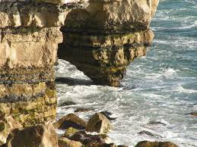  - The water is between the cliffs.  - The water made a hole in the rock.  - The waves are moving on top of the smaller rocks.  - Some rocks are under water.  - The smaller rocks are beside the cliff. | 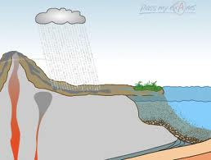  - The cloud is over the land.  - The plant is on the land next to the water.  - The river is flowing into the ocean.  - The water is moving over the land.

For additional sample images of erosion, see What Is the Difference Between Weathering and Erosion?

Illustration of Prepositions
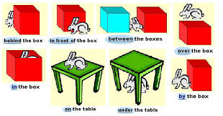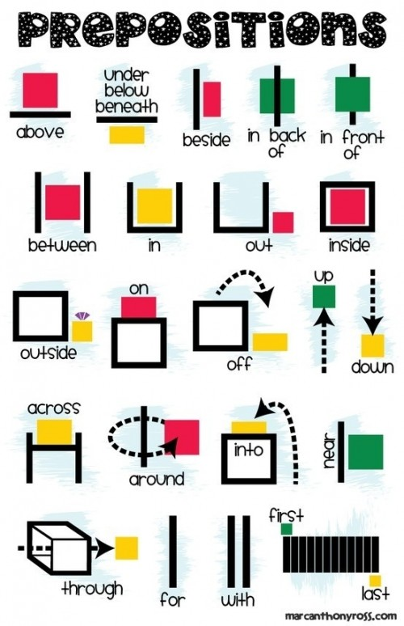

Sentence Frames
- The ________________ is _____________ the _________________.

- ________________ moves ________________ the _______________.

- The ____________________ causes the _____________________ to move ____________________ the _______________________.

Lesson 3  Day 4 | Describing and Comparing with Adjectives | Estimated Time: One 60-minute period

Brief overview of lesson: Students will use comparative adjectives to describe the changes to a landform from weathering and erosion that they can observe in images using descriptive language, prepositions, and academic vocabulary learned in previous lessons. Students will identify evidence of weathering and/or erosion using before and afterimages and describe the landscape changes that result from these processes. As you plan, consider the variability of learners in your class and make adaptations as necessary.

What students should know and be able to do to engage in this lesson:
- Language: prepositional phrases, simple sentences, using adjectives to describe what things look like.
- General or content knowledge: basic understanding of weathering and erosion and related academic vocabulary.
Skills: labeling images and identifying changes (before and after).
LESSON FOUNDATION
Unit-Level Focus Language Goals to Be Addressed in This Lesson |  | Unit-Level Salient Content Connections to Be Addressed in This Lesson
G.2 Explain by describing cause and effect supported with reasoning and ideas. |  | STE.4-ESS1-1—Construct a claim with evidence that changes to a landscape due to erosion and deposition over long periods of time result in rock layers and landforms that can be interpreted today. Use evidence from a given landscape that includes simple landforms and rock layers to support a claim about the role of erosion or deposition in the formation of the landscape.
Language Objective |  | Essential Questions Addressed in This Lesson
Students will be able to describe the processes of weathering and erosion using comparative adjectives (e.g., small/smaller, shallow/deep, tall/taller, large/larger). |  | Q.1 How can we use our knowledge of the English language to inform others?
Assessment
- Observation: Assess student oral production of learned language (e.g., comparative adjectives to describe changes, prepositions to identify evidence, content vocabulary) during class discussion, pair, and small group work.
- Formative assessment: Assess student written production of learned language (e.g., comparative adjectives to describe changes, prepositions to identify evidence, content vocabulary) to construct labels or captions describing changes to landforms using comparative adjectives and prepositions.
- Formative assessment: During lesson closing, assess student use of comparative adjectives to describe changes to the analyzed landscape.
- Self-assessment: Students will assess their learning in relation to the language objective and will self-monitor while reading.
Thinking Space: What Academic Language Will Be Practiced in This Lesson?
Discourse Dimension | Sentence Dimension |  | Word Dimension
Social/instructional language; information about an event, experience, and/or topic using short sentences composed of simple or predictable phrases or sentences with limited cohesion among sentences; spoken introduction of a topic with supporting details using multiple related simple sentences, frequently occurring linking words, and repeated words or phrases | Simple sentences with comparative adjectives |  | Comparative adjectives (e.g., small/smaller, shallow/deep, tall/taller, large/larger) and content vocabulary (e.g., glacier)
Instructional Tips/Strategies/Suggestions for Teacher
- In determining what scaffolds may be needed to help students access the curriculum, consider the following: supports in students’ native languages, working with partners, including gestures while talking, providing sentence frames, providing illustrations of prepositions to match with the word.
- Pre-teach and/or review metacognitive and metalinguistic strategies students may use to aid comprehension and understanding while analyzing text.
- For more information on glaciers, see How Glaciers Change the World and All about Glaciers.
- Depending upon student familiarity with adjectives and comparative adjectives, consider extending this lesson over two days to provide additional opportunities to reinforce student understanding and practice/apply concepts learned. Reinforce information on glaciers and how weathering and erosion affects them. For information on glaciers and ways to demonstrate the effects of weathering and erosion on them, see:
  - PBS Kids DragonFly TV resource: “Glaciers by Deborah and Brittani”
  - Red Orbit video: “What is a Glacier?”
  - CNN video: “See Glaciers Melt Before Your Eyes”
  - National Geographic video: “Glacier Melt”
  - Santa Ana Unified School District Common Core unit: The Changing Earth, pages 55–60 (images)
Instructional Tools
Sentence frames

STUDENT CONSIDERATIONS
Sociocultural Implications
Some students may not be familiar with certain types of landforms and/or weathering and erosion agents. When showing images of landscapes in the United States, be sure to show on a map where these locations exist relative to their community and describe the different weather conditions of these places, including temperature and seasonal trends.
Anticipated Student Pre-Conceptions/Misconceptions
Students may not understand the meaning of some of the comparison adjectives and how they relate to each other.

THE LESSON IN ACTION

Lesson Opening

Project or show an image of a weathered and eroded landscape.
Provide options for perception, such as using a computer to view the images or providing students with printouts of the images.
Ask students to describe the weathered and eroded landscape by creating a caption for the image using prepositions independently or with a partner. Give students the option of just sharing their caption orally. Then, give students an opportunity to share their work with the class as a quick formative assessment of student use of prepositions to describe an image, as well as a way to reinforce student understanding of using prepositions to provide more detailed descriptions.

Post and explain the lesson’s language objective with students: “Students will be able to describe the processes of weathering and erosion using comparative adjectives (e.g., small/smaller, shallow/deep, tall/taller, large/larger).” Introduce the focus of this lesson: learning additional language (comparative adjectives) to help describe the processes of weathering and erosion, or the changes that have occurred to a landscape. To promote student ownership and self-monitoring of learning, have students record the objective in their notebooks. At the end of the lesson, students can reflect on their learning in relation to the objective.

During the Lesson

Project an image of a tall young girl.
Provide options for perception, such as using a computer to view the image or providing students with printouts of the image.
Ask students to describe the image that they see. Write the word tall on the board. Ask students to repeat the word tall as you describe the girl, saying “This girl is tall.” Show students another image of a taller girl and describe her, saying “This girl is taller.” Write the sentence on the board, underlining the words tall and taller and using gestures to convey the difference in meaning between the words.
Provide options for perception, such as using a shared file so that students can view the sentence on a computer.

Show other images comparing objects that are small/smaller, large/larger, big/bigger.
Provide options for perception, such as using a computer to view the images, projecting the images, or providing students with printouts of the images.

Write sentences describing the images with these comparative adjectives and ask students to repeat them, copy them in their notebooks, and underline each of the comparison words.
Provide options for perception, such as using a shared file so that students can view the sentences on a computer.

If necessary, provide students with some time to translate the comparative adjectives into their native language. Go deeper into the meaning of the new words. For example, ask: “What do you notice about these words? How are they spelled? What do you notice about the sentences and the order of words that are used to compare one object with another?”

Introduce deep and shallow by showing images of deep and shallow water or by displaying two containers filled with water (one container should be shallow, such as a shallow pan, and the second container should be deeper, such as a bucket, to illustrate the difference in depth). Point out that these comparatives do not just add an –er at the end and that they will have to memorize their meanings. Point out how when talking about water, the words deep and shallow are used instead of tall/taller. If using images only:
Provide options for perception, such as projecting the images, using gestures, using a computer to view the images, or providing students with printouts of the images.

Explain how the words introduced (tall/taller, shallow/deep, etc.) are comparison words used to compare (or point out the difference) between things. Explain that we can also use comparison words to describe how things have changed over time. Create a visually supported anchor chart of comparative adjectives for students to reference. Invite students to share their own suggestions for comparative adjectives to include on the list.
Provide options for physical action, such as gesturing, acting out, drawing, and translation.
Provide options for perception, such as a game on comparative adjectives. For sample games using comparative adjectives, see Fun Practice for Comparative Adjectives at UsingEnglish.com.

Introduce glaciers. Use the Seven-Step Vocabulary Teaching Method or another similar vocabulary teaching strategy to teach the word glacier, along with other supports, such as word walls, images of glaciers, native language translations, and videos of glaciers (such as the ones listed under Instructional Tips/Strategies/Suggestions for Teacher above).

Practice describing images of glaciers.

Show students an image of a large glacier beside an image of a smaller glacier. Model via a think-aloud how to describe images using prepositions and comparative adjectives. Ask students to do it individually.
Provide options for perception, such as projecting images, providing students with printouts of the images, or having students view the images on a computer.
Provide options for physical action, such as writing on Post-Its or whiteboards, or orally describing the image.

After students have analyzed the images, ask them to do a turn-and-talk with a partner to describe how the second image compares with the first. Ask volunteers to share how they compared the two images.
Provide options for physical action, such as gesturing or labeling the images.

Write down the comparison words students used on the board and repeat what was said. Ask the class to show a thumbs up if they agree with the comparison or a thumbs down if they disagree, modeling with your hands how to do so. Invite students to share any different comparison that they observed between the two images.

Discuss how glaciers can cause weathering and erosion by breaking down rocks underneath, opening up a valley, etc.
Provide options for engagement, such as asking students to guess how glaciers might cause weathering and erosion before providing reasons.
Consider posting prepared sentences about glaciers using comparative adjectives on the board or overhead. Consider color-coding these sentences to showcase the placement of the comparative adjective. For example: “The glacier caused a wider valley.”

Tell students that they will use comparative adjectives to describe the changes in images provided. Divide students in pairs and give each pair before and after images of weathering and erosion examples.

Ask students to write a label or caption describing these changes using comparative adjectives.
Provide options for perception, such as using a computer to review the images.
Provide options for physical action, such as using a computer or Post-Its to label, and/or dictation.

After pairs have finished creating labels or captions, ask each pair to present their two images and share their sentences, describing how the landscape in their second image has changed.
Provide options for physical action, such as presenting to a small group prior to inviting students to share with the whole class. This provides students with time to build and present their ideas in a smaller group before coming together as a larger group, where not all students are as comfortable sharing.

Provide students with additional practice using comparative adjectives to describe images. Give them two additional images and have students independently create a label describing the changes.
Provide options for physical action, such as using Post-Its or a computer to label, and/or dictation.
This activity can be modified so that students can first think about how they would label the images and then work in partners or small groups to complete the label.

Use equity sticks, choose, or ask for volunteers to share their responses as you hold up the images.
Provide options for perception, such as viewing the images on a computer or providing students with printouts of the images.
You may wish to post the images for student reference.

After reviewing all images, ask: “Why do you think it might be important for us to notice these changes in landscapes?” Provide sentence frames for responding, such as “It is important to notice changes because ______.”
Provide options for physical action, such as drawing, writing, using a computer to type a response, or orally discussing the prompt.

Lesson Closing
Provide students with an excerpt about weathering and erosion from one of the texts read in class or select a few facts (from a resource such as All about Glaciers) and post them on the board for students to use.
- If students are working with a text that has been read in class, have students complete a cloze reading activity based on the text. The cloze should have blanks for prepositions and comparative adjectives that students can fill using a word bank or the class anchor chart.
If students are working with facts from an excerpt, create a few sentences that students would need to complete with comparative adjectives.
After reviewing the text, students could create statements of what they learned, using prepositions and comparative adjectives.

Optional activity: Consider having students quietly reflect on the landscapes that they have studied so far. Ask students to think about why it might be important to notice the effects of weathering and erosion on landscapes. Students can record their thoughts in a journal. Consider also having students think about if there is anything we can do to lessen the effects of weathering and erosion.

Lesson 3 Resources
- Comparison images and words (see Unit Resources for suggested images).
- For more information on glaciers, see How Glaciers Change the World and All about Glaciers.

Comparison Adjective Images
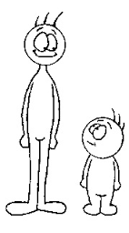 |  |  | 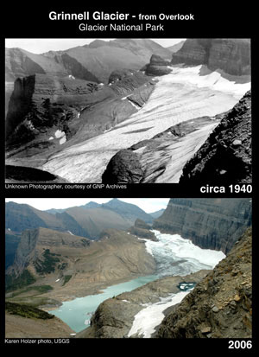
taller/tall | larger/large | small/smaller | bigger/big

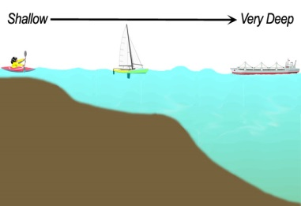  shallow deep | narrow wide
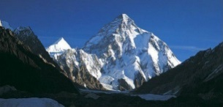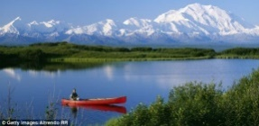  taller shorter | 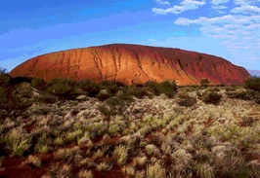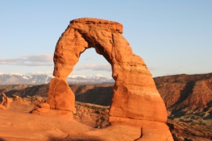  larger smaller

Lesson 4  Day 5 | Describing Cause and Effect by Sequencing | Estimated Time: One 60-minute period

Brief overview of lesson: Students will expand their understanding of sequencing vocabulary as a vehicle to explain causes and effects of erosion. Students will analyze and explain the processes of weathering and erosion by ordering images of these processes and using sequencing language to describe them. As you plan, consider the variability of learners in your class and make adaptations as necessary.

What students should know and be able to do to engage in this lesson:
- Language: familiarity with identifying and differentiating nouns/verbs and singular/plural nouns; familiarity with subject/verb agreement for the verb to be; adjectives and comparison vocabulary; constructing phrases and/or simple sentences.
- General or content knowledge: basic knowledge about landforms and bodies of water, and related vocabulary.
Skills: ability to participate in class discussions using accountable talk; ability to organize events in sequential order and match images to events.
LESSON FOUNDATION
Unit-Level Focus Language Goals to Be Addressed in This Lesson |  | Unit-Level Salient Content Connections to Be Addressed in This Lesson
G.1 Discuss by identifying evidence from a given landscape that includes simple landforms and rock layers to support a claim about the role of erosion or deposition in the formation of the landscape. |  | CCSS. ELA-LITERACY. W.4.8—Recall relevant information from experiences or gather relevant information from print and digital sources; take notes and categorize information, and provide a list of sources.
Language Objective |  | Essential Questions Addressed in This Lesson
Students will be able to describe a process using sequence signal words (e.g., first, next, then). |  | Q.1 How can we use our knowledge of the English language to inform others?
Assessment
- Observation: Assess student oral production of learned language (e.g., sequencing language, comparative adjectives to describe changes, prepositions to identify evidence, content vocabulary) during participation in class discussion.
- Formative assessment: Assess student production of learned language during the sequencing of images and completion of the corresponding graphic organizer.
Formative assessment: Use an exit ticket to assess student written production of learned language describing the sequence of events that cause erosion using sequential language: first, then, next, etc.
Thinking Space: What Academic Language Will Be Practiced in This Lesson?
Discourse Dimension | Sentence Dimension |  | Word Dimension
Social/instructional language; information about an event, experience, and/or topic composed of simple or predictable phrases or sentences with limited cohesion among sentences; brief sequence of events in order | Simple sentences with verbs in present tense using provided sentence frames: “This is (a) ______; These are ______; The (noun) + (verb)”; simple sentences with sequencing signal words |  | Content vocabulary (e.g. weathering, erosion, rock); comparative adjectives (e.g., bigger, smaller, taller); sequential signal words (e.g., first, next, then)
Instructional Tips/Strategies/Suggestions for Teacher
- In determining what scaffolds may be needed to help students access the curriculum, consider the following: native language support, working with partners, color-coding parts of speech, using gestures, sentence frames, matching images to words, and/or sequencing images and matching to simple sentences.
- Depending upon student familiarity and comfort with sequencing, you may wish to extend the lesson for an additional day.
- When talking about sequencing weathering and erosion processes, reinforce that weathering and erosion are ongoing processes; therefore, using the term finally is not necessarily appropriate.
- To support student analysis of the before and after images, it may be helpful to enlarge the images in the lesson resources section before printing.
Instructional Tools
- Sentence frames
- Graphic organizer

STUDENT CONSIDERATIONS
Sociocultural Implications
- Some students or their families may have experienced the negative effects of weathering and erosion (such as from a natural disaster). If so, discussing the effects of weathering and erosion may evoke painful memories.
- Some students may not be familiar with certain types of landforms and/or weathering and erosion agents.
Anticipated Student Pre-Conceptions/Misconceptions
Students may believe that erosion is only caused by rain or wind. They may think that erosion is only a direct result of natural disasters, rather than a process that occurs over time and impacts different landforms in different ways.

THE LESSON IN ACTION

Lesson Opening

Be sure to post and explain the lesson’s language objective: “Students will be able to describe a process using sequence signal words (e.g., first, next, then).” To promote student ownership and self-monitoring of learning, have students record the objective in their notebooks. At the end of the lesson, students can reflect on their learning in relation to the objective.

Revisit the anchor chart that was created in Lesson 1.

Ask students to do a think-pair-share about what new words/phrases they would like to add to the anchor chart. Consider posting texts and images from previous lessons to activate prior knowledge. Add to the anchor chart any information students bring up. Continue to color-code or sort any causes and effects of weathering and erosion that students mention. (Note: The language to discuss cause and effect will be studied in depth in subsequent lessons.)
Provide options for perception, such as using a shared file that students may view on a computer.

Reinforce language learned in previous lessons with a game. For example, students could take turns acting out or drawing different vocabulary words, prepositions, and comparative adjectives without using words, while others guess the vocabulary word, preposition, or comparative adjectives (as in the game Charades).
Provide options for engagement, such as whole class review, team review, or small group review.
Provide options for physical action, such as using whiteboards or Post-Its to guess, or orally stating answers.

Connect to the content area topic. For example, say: “We have been learning about erosion and how it changes landscapes. We are going to learn about the causes of erosion and the order in which things happen when there is erosion.”

During the Lesson

Introduce the focus of the lesson: using sequencing language to discuss processes such as weathering and erosion.

Ask students to describe how they brush their teeth (or substitute with another simple action, like washing hands) while showing an image of the action.
Provide options for physical action, such as acting out the action, orally describing the steps to complete the action, drawing the action, or writing steps out.

Ask students how they know when to do each step. For example, say: “Does it make a difference if you brush your teeth without putting toothpaste on the toothbrush first? How can we explain the order in which things happen?” Consider providing students with sentence frames and word banks to answer.
Provide options for perception, such as supporting questions with gesturing.
Provide options for physical action, such as orally discussing, or using a whiteboard or Post-Its.

Explain to students that in English there are certain words used to describe the order in which things happen. Write the words on the board as you describe the process of brushing teeth (or another action chosen above). For example: “First, you put toothpaste on your toothbrush. Then, ______. Next, ______.” Display images of each step along with the sentences. Consider providing students with an anchor chart or personal reference sheets with sequencing signal words.
Provide options for perception, such as native language translations of the vocabulary.

Practice using sequencing words to describe the order of a process. Ask a student to volunteer to model and describe how they enter the classroom using the sequencing words on the board. Tell students to do a turn-and-talk with a partner, taking turns describing the order of events of an everyday activity, such as what they do when they get home from school, going to bed at night, or checking out a library book.
Provide options for physical action, such as writing, drawing, gesturing, or acting out the order of events.

Connect the new language to the content topic. Explain how, just like all the tasks that they described, weathering and erosion are processes that happen over time as a result of other actions. Mention how students will learn more about the causes of erosion (what makes erosion happen) and the effects of weathering and erosion on landforms. Explain how in order to understand the causes and effects of erosion, students need to first understand the order of events that result in weathering and/or erosion.

Show time-lapse videos to build student understanding of the concept of erosion and the order of steps involved in the process. For example, show a video such as “Arctic Erosion.”

Set up the context for the video by explaining what has caused the changes: there was an increase in sea temperature, decrease in glaciers, etc.

Provide a focus question to consider while they are watching the video, such as “What changes do you see happening in the video?”

While watching the video, pause it and point out the glaciers moving away. Ask students to take notes responding to the focus question in their notebooks or an online notebook app such as Zoho Notebook.
Provide options for perception, such as a viewing station so students can independently watch the video, pausing to ask clarification questions as needed.

After the video, discuss the focus question.
Provide options for physical action, such as writing on whiteboards or Post-Its, orally explaining their answer to the question, and/or sharing with a partner before discussing as a whole class.
Invite students to share with a partner before having the class come together as a whole. Record student observations on the board or a shared file for student reference. Review what happened in the video using the sequencing words introduced earlier in the lesson.

Optional activity: Review different types of erosion (e.g., erosion caused by wind, erosion caused by water) using a previously read text from an earlier lesson or introducing a new text. For example, use an excerpt from a text such as Erosion: Changing Earth's Surface (Amazing Science) by Robin Koontz, Cracking Up: A Story About Erosion (Science Works) by Jacqui Bailey, or Erosion and Weathering (Rocks: The Hard Facts) by Willa Dee. Have students describe the process by asking questions such as: “What happens first? What happens next?” Then prompt students to incorporate sequencing words in their answers by pointing to the words on the board or providing sentence frames such as “This is (a/an) ______. These are ______. The (noun) + (verb). First, the (noun) + (verb). Next, the (noun) + (verb). Then, the (noun) + (verb).” Consider providing the sentence frames on a handout and/or a shared file that students can view on a computer.

Have students sequence images of an erosion process in groups.

Begin by modeling a few examples. Using before and after images, describe the erosion process using sequencing words, comparative adjectives, and content area vocabulary.

Divide the students into small groups of four students per group. Strategically group students to better differentiate or support their work (e.g., groups of students with a similar native language, groups based on reading level).

Distribute images of different stages of erosion, such as photographs from Coastline Change. This resource shows photographs of the Cape Code Coastline from 1984 to 2014, showing how the coastline changed from a solid strip of land to a series of islands over 20 years. Select only a few images from the photo timeline for students to arrange in the correct order in which they happened. To differentiate this activity, have some students order images and match phrases and/or sentences with each image, or order images and use a sentence frame to write complete sentences describing the order of events. For additional support, provide a sequencing graphic organizer to help students order the processes of weathering and erosion on the landscape.

After ordering the images, all students can paste the ordered images and captions on their notebooks, or create their own drawings illustrating the processes of weathering and erosion and write sentences/captions for their illustrations. Finally, ask students to orally describe the process in the images.

Have each group present the sequential order of erosion from the images they sequenced orally using sequential words.
Lesson Closing
Exit ticket: Ask students to describe an erosion process (either the erosion process from their group or the erosion process another group shared with the class) using sequencing words and vocabulary posted on the board or anchor chart/word wall. Students can do this orally or record their response and hand it in.

Lesson 4 Resources
The Process of Erosion on ________________________________________________ (landform)

Name: _________________________________________________ Date: ____________________

Order the images of the process of erosion on your assigned landform. Draw or paste the images in order. Then describe the process. Remember to write in complete sentences. The (noun) + (verb).

First, __________________________________________________________________
_________________________________________________________________________

Next, __________________________________________________________________
_________________________________________________________________________

Then, ____________________________________________________________________
___________________________________________________________________________

Before and After Images and Sentences Describing Sequence of Events

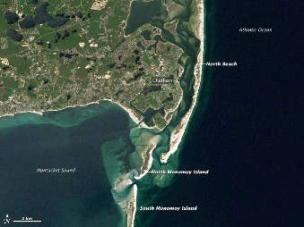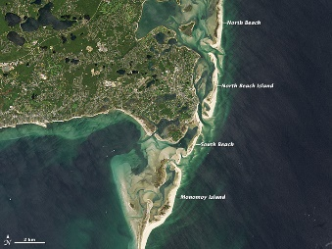  before after  First, the land was small. Next, the ocean was shallow. Then, the island was bigger. | 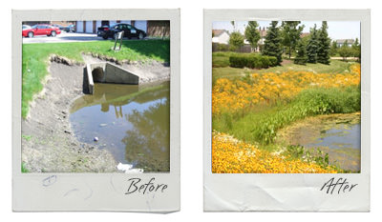  First, there was sand beside the water. Then, the grass and plants grew. Next, there was grass next to the water.
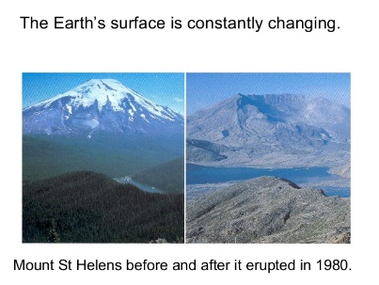  First, the river was small. Next, the mountain eroded. Then, the river was bigger.  OR  First, the mountain was tall. Next, the mountain eroded. Then, the mountain was shorter. | 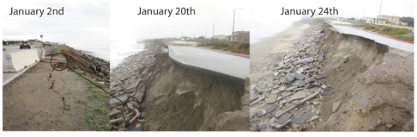  First, the road was wide. Next, the water eroded the sand. Then, the road was broken.
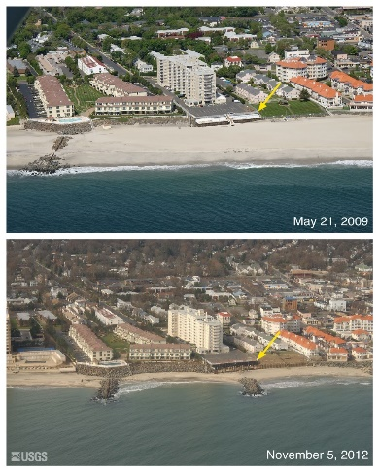  First, the beach was wide. Next, the waves eroded the sand. Then, the beach was narrow. | 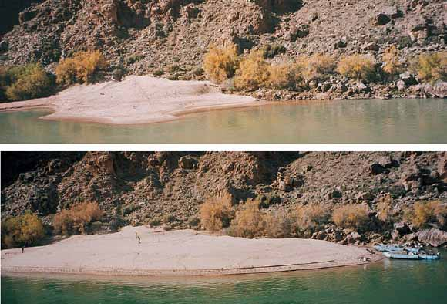  First, the sand was small. Next, the river rose. Then, the sand was bigger.
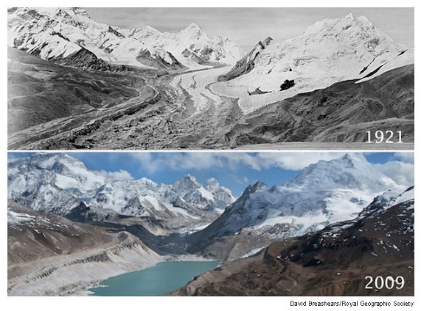  First, there was snow between the mountains. Next, the ice melted into water. Then, there was a river. | 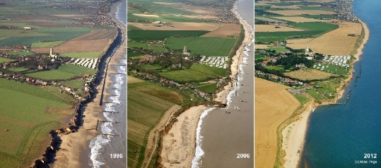  First, the sand was wide. Next, the water eroded the sand. Then, the sand was narrow.
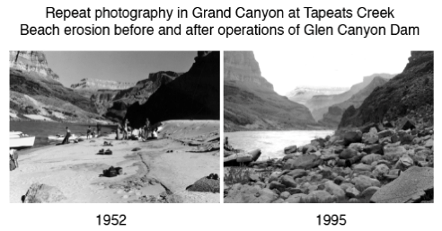
First, the sand was next to the river. Next, the mountain eroded. Then, the rocks were on top of the sand.
Lesson 5  Days 6 and 7 | Describing Weathering and Erosion Using Past Tense | Estimated Time: Two 60-minute periods

Brief overview of lesson: This lesson will develop students’ knowledge and use of past tense vocabulary as a way to describe the processes of weathering and erosion. Students will analyze images and text and apply their knowledge of the past tense to describe the effects of weathering and erosion on various landscapes. As you plan, consider the variability of learners in your class and make adaptations as necessary.

What students should know and be able to do to engage in this lesson:
- Language: ability to identify and differentiate nouns and verbs; ability to distinguish between singular and plural nouns; subject/verb agreement with verb to be; comparative adjectives; ability to use regular verbs to construct simple sentences in the present and past tenses; ability to use sequencing words to describe a process.
- General or content knowledge: knowledge and vocabulary of landforms and bodies of water.
Skills: ability to participate in class discussions using accountable talk; ability to arrange events in sequential order and match images to events; ability to describe the order of events using regular past and present tense verbs.
LESSON FOUNDATION
Unit-Level Focus Language Goals to Be Addressed in This Lesson |  | Unit-Level Salient Content Connections to Be Addressed in This Lesson
G.1 Discuss by identifying evidence from a given landscape that includes simple landforms and rock layers to support a claim about the role of erosion or deposition in the formation of the landscape. |  | STE.4-ESS2-1—Make observations and collect data to provide evidence that rocks, soil, and sediments are broken into smaller pieces through mechanical weathering and moved around through erosion by water, ice, wind, and vegetation.
Language Objective |  | Essential Questions Addressed in This Lesson
Students will be able to describe weathering and erosion processes and their results using regular verbs in past tense (e.g., weathered, eroded, broke). |  | Q.1 How can we use our knowledge of the English language to inform others?  Q.2 How can we communicate our ideas about weathering and erosion?
Assessment
- Observation: Assess student participation in class discussions. Assess oral production of sequential language to explain the process of erosion, application of content vocabulary, and use of past tense verbs to explain weathering and erosion.
- Formative assessment: Assess student oral and written production describing the sequence of events that cause erosion using sequential language (e.g., first, then, next) and past tense verbs (e.g., changed, moved, flowed, eroded, weathered). Use the exit ticket to assess student written production of learned language.
- Self-assessment: Students will use metacognitive strategies while reading and reflect on their progress in relation to the language objective.
Thinking Space: What Academic Language Will Be Practiced in This Lesson?
Discourse Dimension | Sentence Dimension |  | Word Dimension
Social/instructional language; explanations about an event, experience, and/or topic composed of simple or predictable phrases or sentences with limited cohesion among sentences | Simple sentences with sequential signal words; simple sentences with verbs in past tense |  | Content vocabulary (e.g., weathering, erosion, rock); comparative adjectives (e.g., bigger, smaller, taller); prepositions (e.g., in, on, between); sequential signal words (e.g., first, next, then); past tense verbs (e.g., flowed, eroded, weathered)
Instructional Tips/Strategies/Suggestions for Teacher
- In determining what scaffolds may be needed to help students access the curriculum, consider the following: supports in students’ native languages, working with partners, color-coding parts of speech, using gestures, using sentence frames, matching images with key vocabulary, and/or sequencing images and matching them to sentences.
- Depending upon student familiarity with parts of speech, consider spending additional time reviewing the purpose of verbs and the past tense.
Instructional Tools
- Vocabulary pre-assessment graphic organizer from Lesson 1
- Sentence frames

STUDENT CONSIDERATIONS
Sociocultural Implications
- Some students or their families may have experienced the negative effects of weathering and erosion (such as from a natural disaster). If so, discussing the effects of weathering and erosion may evoke painful memories.
- Some students may not be familiar with certain types of landforms and/or weathering and erosion agents.
Anticipated Student Pre-Conceptions/Misconceptions
Students may think that erosion is only a direct result of natural disasters, rather than a process that also occurs over time and impacts different landforms in different ways.

THE LESSON IN ACTION

Day 6 Lesson Opening

Post and explain the lesson’s language objective: “Students will be able to describe weathering and erosion processes and their results using regular verbs in past tense (e.g., weathered, eroded, broke).” To promote student ownership and self-monitoring of learning, have students record the objective in their notebooks. At the end of the lesson, students can reflect on their learning in relation to the objective.

Make connections to the content topic. For example, say: “We have been learning about weathering and erosion and how it changes landscapes. We learned about the causes of weathering and erosion. Today we are going to describe the order that things happen and how landforms changed in the past as a result of weathering and erosion.”

Hold up the image of the Old Man of the Mountain that students viewed in Lesson 1. Remind students how on the evening of May 3, 2003, the Old Man went missing!
Provide options for perception, such as having students view the image on a computer or providing students with a printout of the image.

During the Lesson

Introduce how to describe events in the past.

Ask students to describe how the Old Man of the Mountain changed while displaying before and after images of the landform. On the board, write: “How did this landform change?”
Provide options for physical action, such as using a computer and/or responding orally or in writing.
Discuss students’ responses as a whole class.

Write a sentence on the board describing how the landform changed; use a sentence students used in the previous discussion if possible. For example, write: “The landform changed.” Ask students what they notice about the verb changed, or how it is similar and different from the verb change used in the question. Point out that the verb is the same, but that changed describes something that already happened in the past. Consider providing an explanation of the term past if students are not familiar with it. Then ask a student volunteer to circle the part of the verb change that is different in the past tense (the -d suffix).

Point out that in order to change a verb to show something has already happened in the past, you add a –d or –ed ending to the verb.

Continue expanding students’ knowledge of regular past tense verbs.

Give students whiteboards and markers (or have them write on a piece of paper) and have them sit with a partner. Write the following verbs on the board: change, move, erode. Ask students to write a sentence using the verb move with their partner. Then, ask students to try to use the verb move to talk about something that already happened by changing it to the past tense form by adding –d to the ending of the verb. Provide examples of how to change sentences from present to past tense (e.g., “The sand moves with the water” to “The sand moved with the water”) and visuals if students need additional help. Allow for native language translations if needed.
Provide options for physical action, such as using a computer to type up the sentences.

Ask pairs to share their two sentences and the changes they made to the word move with the rest of the class. Record student-generated sentences on the board or in a shared file and underline the present and past tense verbs.

Repeat this activity with erode, weather, and flow (regular verbs). When going over the verbs flow and weather, point out that if the verb ends in –e (e.g., change, erode, move) students need to add –d to the verb to make it past tense, but if the verb does not end in –e, (e.g., flow, weather), then they need to add –ed to the verb to change it to past tense.

Provide additional practice with changing regular verbs from present to past tense, such as playing a game. For a selection of games to practice conjugating verbs in past tense, see ESLkidstuff.com.

Introduce irregular verbs.

Write the verb break on the board and ask a student to share a sentence using it. Write the sentence on the board and explain how break is an irregular verb, which means it does not follow the same rules for changing to past tense as the other verbs students have studied. Explain how irregular verbs have different forms in the past tense and that students will need to memorize the past tense forms. Show how break changes to broke in the past tense, then rewrite a present tense sentence on the board with broke to indicate past tense.

Teach the past tense forms of other common verbs describing weathering and erosion (e.g., blow, broke, wore, began, fell, grew, sank, brought, spread, took) by writing sentences in the present tense and changing them to the past tense to highlight the past tense forms. Make sure students know the meaning of the verbs, as well as the past tense forms. Provide time for native language translations and/or visual support as needed. Add the irregular verbs to the class word wall or anchor chart.

Revisit the sequencing activity from Lesson 4. Model how to write sentences describing what happened in each image using past tense verbs. Use sentence frames students can later use to write their own sentences. For example, “The ______ (noun) ______ (verb in past tense).” Then ask students to write one phrase and/or sentence describing what happened in the image using past tense verbs in small groups or pairs.
Lesson Closing
Ask students to explain what changes they made to verbs to make them past tense. For example, ask: “What did you do to change this verb to past tense? How did you know when to add a –d or –ed to the ending of a verb?” Allow students to share their answers orally or in writing.

THE LESSON IN ACTION

Day 7 Lesson Opening

Review how to create the past tense form of regular and irregular verbs with students by having them share what they did in the morning before coming to school. Provide sentence frames, such as “This morning I ___ (verb),” and word banks. Re-teach key concepts (e.g., when to add –d, when to add –ed, which are regular vs. irregular verbs) as needed.

Ask students to share two things that they did yesterday after school with a partner. Give students time to reflect quietly before sharing.
Provide options for physical action, such as having students record their answer on Post-Its, use a computer, or write their ideas before sharing.
Ask a few volunteers to share with the whole class, and write their ideas as sentences on the board. Then have students copy the sentences in their notebooks, identify the verbs in the sentences by highlighting them with a marker, and then explain how they know whether the verbs used are in past tense form to a partner.

During the Lesson

Review the past tense form of common verbs used to describe weathering and erosion from the previous day and write them on the board. Ask small groups from Day 6 to present the sentences they created for their assigned images of weathering and erosion. Have groups orally present each step of the weathering or erosion process using past tense verbs to describe what happened. Ask them to also explain how they changed their verbs to indicate that something happened in the past.
Provide options for physical action, such as having groups present to other groups or having groups present to the whole class.
This activity provides a formative assessment of the use of the past tense, prepositions, comparative adjectives, language used for sequencing, and content vocabulary. Use this formative assessment to inform instruction and adjust accordingly.

Students will read and analyze textual excerpts. Pre-teach and model metacognitive and metalinguistic strategies prior to having students begin working. Model how to identify key linguistic features such as sequence words, past tense verbs, noun + verb sentence structure, and use of content vocabulary. After analyzing the text, model how to orally summarize the text.

Have students read excerpts of texts describing weathering and erosion (e.g., Old Man of the Mountain Scrapbook) and ask students to identify key linguistic features such as sequence words, past tense verbs, noun + verb sentence structure, and use of content vocabulary. After analyzing the text, students can orally summarize the text or record their summary.
Lesson Closing
Exit ticket: Students will create an original phrase and/or sentences about erosion using one of the past tense verbs discussed in class. Provide a model of a phrase and/or sentence.
Provide options for physical action, such as writing, typing on a computer, or using speech-to-text software.
You may wish to have students box in the verb with a green marker.
Optional activity: Consider having students quietly reflect on the landscapes that they have studied so far. Ask students to think about why it might be important to notice the effects of weathering and erosion on landscapes. Students can record their thoughts in a journal. Consider also having students think about if there is anything we can do to lessen the effects of weathering and erosion.

Lesson 5 Resources
Present and Past Tense Forms of Common Verbs Used to Describe Weathering and Erosion
Present Tense | Past Tense | Sample Images
Melt | Melted | 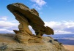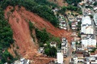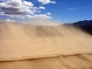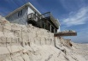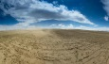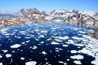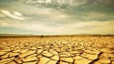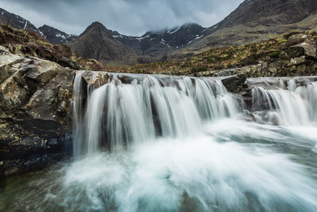
Change | Changed
Erode | Eroded
Weather | Weathered
Blow | Blew
Flows | Flowed

Lesson 6  Days 8 and 9 | Making a Claim Using Cause and Effect Signal Words (Language Checkpoint) | Estimated Time: Two 60-minute periods

Brief overview of lesson: This lesson will develop students’ knowledge and use of cause and effect signal words because and therefore as a way to describe the processes of weathering and erosion. Students will analyze images and videos to discern some causes and effects of weathering and erosion. Students will then apply learned language to discuss the causes and effects of weathering and erosion, orally and in writing. This lesson is meant to serve as the unit’s language checkpoint, an opportunity for teachers to measure student progress in relation to the unit’s Focus Language Goals. As you plan, consider the variability of learners in your class and make adaptations as necessary.

What students should know and be able to do to engage in this lesson:
- Language: familiarity with identifying and differentiating nouns/verbs and singular/plural nouns; familiarity with subject/verb agreement for the verb to be; adjectives and comparison vocabulary; ability to construct phrases and/or simple sentences; ability to describe events using past and present tense verbs; ability to describe causes and effects of erosion.
- General or content knowledge: basic knowledge about landforms and bodies of water, and related vocabulary; weathering and erosion vocabulary.
- Skills: ability to participate in class discussions using accountable talk; ability to arrange events in sequential order and match images to events.

LESSON FOUNDATION
Unit-Level Focus Language Goals to Be Addressed in This Lesson |  | Unit-Level Salient Content Connections to Be Addressed in This Lesson
G.2 Explain by describing cause and effect supported with reasoning and ideas. |  | STE.4-ESS2-1—Make observations and collect data to provide evidence that rocks, soil, and sediments are broken into smaller pieces through mechanical weathering and moved around through erosion by water, ice, wind, and vegetation.
Language Objective |  | Essential Questions Addressed in This Lesson
Students will be able to use their knowledge of weathering and erosion to make a claim about causes and effects of these processes using because and therefore. |  | Q.1 How can we use our knowledge of the English language to inform others?  Q.3 How can we use evidence to support a claim about weathering and erosion?
Assessment
- Observation: Assess student oral production of learned language during class discussions.
- Formative assessment: Assess student written production describing the causes and effects of weathering and erosion using because and therefore.
- Formative assessment: Use the language checkpoint to evaluate student application of learned language, past tense verbs, comparative adjectives, cause and effect vocabulary, and sequencing signal words.
Thinking Space: What Academic Language Will Be Practiced in This Lesson?
Discourse Dimension | Sentence Dimension |  | Word Dimension
Social/instructional language; brief introductions and/or explanations about a topic with supporting details using multiple, related, simple sentences with predictable phrases and limited cohesion among sentences | Simple sentences with verbs in present and past tense; short, structured complex sentences with because and therefore |  | Content vocabulary (e.g., weathering, erosion, rock); comparative adjectives (e.g., bigger, smaller, taller); prepositions (e.g., in, on, between); past tense verbs (e.g., flowed, eroded, weathered); cause and effect signal words (because, therefore)
Instructional Tips/Strategies/Suggestions for Teacher
- In determining what scaffolds may be needed to help students access the curriculum, consider the following: native language supports, working with partners, color-coding parts of speech, using gestures, sentence frames, matching images to sentences, and/or sequencing images and matching to sentences.
- Due to the fact that weathering and erosion are ongoing, there may not be documented images of every step of these processes. To support student understanding of the before stages of weathering and erosion, it may be helpful to familiarize students with the features of landforms before weathering and erosion and then examine various effects of weathering and erosion on a variety of landforms to distinguish the changes that have occurred.
- Note: The graphic organizer uses the terms claim, evidence, and conclusion. It may be helpful to review or pre-teach these terms for students. Stating a claim will be explicitly taught and practiced in subsequent lessons.
- Student construction of paragraphs during this lesson will serve as a language checkpoint for the unit. The language checkpoint is used to measure student progress in relation to the Focus Language Goals of the unit. Use the results of the language checkpoint as a formative assessment to gauge student progress and to inform instruction and make adjustments as needed.
Instructional Tools
- Class-generated vocabulary poster, anchor chart, or word wall
- Sentence and paragraph frames
- Graphic organizers (because and therefore)

STUDENT CONSIDERATIONS
Sociocultural Implications
- Some students or their families may have experienced the negative effects of weathering and erosion (such as from a natural disaster). If so, discussing the effects of weathering and erosion may evoke painful memories.
- Some students may not be familiar with certain types of landforms and/or weathering and erosion agents.
Anticipated Student Pre-Conceptions/Misconceptions
- Students may think that erosion is only a direct result of natural disasters, rather than a process that also occurs over time and impacts different landforms in different ways.
- Students may believe that rocks cannot break and/or that mountains cannot change shape.

THE LESSON IN ACTION

Day 8 Lesson Opening

Post and explain the lesson’s language objective: “Students will be able to use their knowledge of weathering and erosion to make a claim about causes and effects of these processes using because and therefore.” To promote student ownership and self-monitoring of learning, have students record the objective in their notebooks. At the end of the lesson, students can reflect on their learning in relation to the objective.

Review the causes and effects of weathering and erosion that students have identified on the class-generated anchor chart from previous lessons. During the discussion, ask students if there are any additional terms to add to the chart. Make connections to the content topic. For example, say: “We have been learning about weathering and erosion and how it changes landscapes. Skilled scientists use evidence to describe the causes and effects of weathering and erosion. Today we will continue learning about language that can help us explain what causes weathering and erosion. We will also learn about the effects of weathering and erosion.”

During the Lesson

Reintroduce the concepts of causes and effects with a familiar situation or common social situation. Provide visual supports for the meaning of the terms cause and effect to make sure students understand these concepts.

Show a video about cause and effect (e.g., “Cause and Effect Lesson” from TeacherTube.com).

Give students a quick overview of what the video is about (without telling them what will happen) to build background knowledge and prepare students. Then post and explain video focus questions, such as “What happened? Why do you think it happened?” Providing students with focus questions to consider during the video can heighten student engagement and focus student attention.

After the video, provide students with time for quiet reflection. Then ask them to discuss what happened (the effect or result) and why it happened (the cause) with a partner in a turn-and-talk.

Ask students to compose two simple sentences with their partners: one to describe what happened and another to describe why it happened. Model or provide an example of these sentences for students if necessary. Once students are finished, discuss sentence pairs as a whole class. Write the sentences on the board or in a shared file so students can view them on a computer.

Introduce because as a signal word for cause and effect by defining it in a student-friendly way (such as the definition provided in the Merriam Webster Learner’s Dictionary). Explain how because can be used to explain causes and effects in ONE sentence (as opposed to two sentences, like the students created from the video above).

Explain that because is used to explain why something happened, or the cause of an event, then use it in a sentence such as “The bridge fell because water flowed down from the mountain” or “The boy cried because the ice cream cone fell.” Post the sentence on the board and provide a visual for both the cause and effect to support student understanding. Ask students to identify the effect (what happened) and the cause (why it happened) in the sentence, then point out its structure with a sentence formula, EFFECT + because + CAUSE, and identify these components in your sample sentence: “The boy cried (EFFECT) + because + the ice cream cone fell (CAUSE).” Consider color-coding causes in red and effects in blue to visually reinforce sentence order. Highlight the use of past tense verbs (fell/ flowed, cried/fell) on both the cause and effect parts of the sentence to show how because is combining two separate sentences.

Co-create two or three additional sentences with because using some of the sentence pairs created about the video earlier in the lesson or by eliciting related causes and effects about everyday situations from students. Consider providing visual support by drawing or illustrating causes and effects, and/or preselecting images of causes and effects and having students match them for each situation before creating the sentences.

Connect target language to the content topic. Explain that scientists use their knowledge about weathering and erosion to explain causes and effects (why) of changes to the shape of landforms. Work with students to create cause and effect sentences about weathering and erosion.

Display images showcasing weathering and/or erosion on Plum Island or another landform, and ask students to describe what they see.
Provide options for perception, such as having students view the image on a computer or providing students with a printout of the image.

Ask students to think about how the landform changed throughout the images. Give them time to think quietly, then ask: “Why did this landform change?” Have students write their explanations in simple sentences on the board, a whiteboard, a computer, or a piece of paper. Then share sentences as a whole class.

Use these simple sentences to create a sentence with because that connects causes and effects. Have students create one or two sentences with because on their own on the board, a whiteboard, a computer, or a piece of paper. Ask for a few volunteers to share their sentences. Analyze them together as a class by writing them on the board and color-coding the causes (red) and effects (blue).

Explain how students can also use because to give reasons why they think something happened. Model how to create a sentence providing a statement (e.g., “I think the landform changed”) and the reason why it happened (“because ______”). Post the sentence frame, the sentence formula used to model the use of because (EFFECT + because + CAUSE), and your sample sentence on the board.
Sentence formula | EFFECT | because | CAUSE
Sentence frame | I think this landform changed | because | ….
Example | The landform changed | because | the rain moved the dirt.

Provide additional practice on describing the causes and effects of weathering and erosion on another landform using because, as well as before, during and after images . Ask students to orally explain the cause and effects of weathering and erosion on a given landform using cause and effect signal words with a partner. Give students a graphic organizer, such as the “Because Graphic Organizer” in the Lesson 6 Resources, to help scaffold their writing.
Provide options for perception, such as providing printouts of the images or viewing the images on a computer.
Lesson Closing
Ask a few students to share their cause and effect sentences about weathering or erosion with the word because. Ask them to identify the components of their sentences (the EFFECT, because, and the CAUSE). Then ask them to give their opinion about why they think the sentence is structured this way.

THE LESSON IN ACTION

Day 9 Lesson Opening

Review the lesson’s language objective and the cause and effect signal word introduced in Day 8: because. Review student descriptions of the changes they observed and why they think those changes happened in the images of landforms on Day 8.
Provide options for perception, such as having students view the images on a computer or at their desks with a printout.
Revisiting the same images from the previous day helps to reinforce the concept of cause and effect and illustrate how changing the order of a sentence with because to use therefore does not change the meaning or ideas expressed in the sentences.

Introduce the signal word therefore, explaining how this is another signal word that can be used to describe landform changes due to weathering and erosion in ONE sentence.

Provide a student-friendly definition of therefore (such as the one provided in Merriam Webster Learner’s Dictionary).

Explain how when using therefore to explain causes and effects, the order of the sentence changes. Use sentence pairs from Day 8 (e.g., “The bridge fell. Water flowed down from the mountain.”) to create new sentences explaining these same ideas with therefore: “Water flowed down from the mountain. Therefore, the bridge fell.” Provide a new sentence formula to use with therefore: CAUSE + therefore + EFFECT and identify each component; e.g., “Water flowed from the mountain” (CAUSE). Therefore, the bridge fell (EFFECT).” Continue color-coding causes in red and effects in blue. Give students a graphic organizer, such as the “Therefore Graphic Organizer” in the Lesson 6 Resources, to help scaffold their writing.

Highlight the change in the order of the sentence by comparing it with the because sentence showing the same ideas: “The bridge fell because water flowed down from the mountain” vs. “Water flowed down from the mountain. Therefore, the bridge fell.”

Ask students to analyze the two types of sentences and see if they can identify differences in punctuation. Ask: “How are periods and commas used differently in the because and the therefore sentence?” After students share, highlight the difference in punctuation between the because and therefore sentences: the because sentence is ONE sentence, whereas there are two sentences connected by therefore; there is a period (.) before therefore and there is a comma (,) after therefore.

During the Lesson

Co-construct cause and effect sentences using therefore, as well as before, during, and after images illustrating weathering and erosion. Examine images together, identifying what happened (effect) and why it happened (cause) first, then working with the sentence formula CAUSE + therefore + EFFECT to construct sentences. Continue highlighting the use of punctuation in therefore sentences.
Sentence formula | CAUSE | Therefore, | EFFECT
Sentence frame | ………………….. | Therefore, | ….
Example | The rain moved the dirt. | Therefore, | the bridge fell.

Provide additional practice with therefore. Ask students to work with a partner to explain the cause and effects of weathering and erosion on a given landform using therefore and the sentence formula CAUSE + therefore + EFFECT, as well as before, during, and after images.
Provide options for perception, such as printed images or a shared digital file that students can view on a computer.
Provide options for physical action and expression and communication, such as explaining causes and effects with therefore orally, or writing them in student notebooks, on whiteboards, or on a computer.

Introduce writing paragraphs to describe causes and effects of weathering and erosion.

Model how to write a sample paragraph using paragraph frames such as the ones below. While modeling explain what goes in each blank. Model how to refer to the word wall and/or anchor charts to complete the graphic organizer. Provide additional completed paragraphs for students as needed.
Sample Paragraph Frames | Sample Completed Paragraph
- This is (a) ______ (noun).  - These are ______ (plural noun).  - I think that the (agent) + (verb) + the (noun).  - I think this because the (noun) is (comparative adjective).  - Therefore, weathering and erosion from the (agent) + (verb) the (noun). | - This is a beach.  - These are the dunes.  - I think that the hurricane changed the beach.  - I think this because the dunes are smaller.  - Therefore, weathering and erosion from the hurricane changed the beach.

Give students before, during, and after images of weathering and erosion and have them complete paragraphs using the paragraph frames and graphic organizer provided in the Lesson 6 Resources. Before students begin, review the graphic organizer and expectations for the paragraph as presented in the sample completed paragraph. Review other key language studied in previous lessons (comparative adjectives, sequencing signal words, content/topic vocabulary) and/or point students to anchor charts or word walls they can use as references. This activity serves as a language checkpoint, an assessment to evaluate how students apply their knowledge of past tense verbs, comparative adjectives, cause and effect vocabulary and sequencing signal words.
Provide options for perception, such as posting the sample paragraph, giving students a printout of the sample paragraph, or having students view the sample paragraph on a computer.
Provide options for physical action, such as typing paragraphs on a computer, and/or using text-to-speech software.
Lesson Closing
Ask students to share their paragraphs orally with a partner, small group, or the whole class.

Lesson 6 Resources
Because Graphic Organizer

Name: _________________________________________________ Date: ________________________________________

 | EFFECT + | because | + CAUSE
I think | this landform changed | because | ….
I think | this landform changed | because | water broke the rocks.

Write sentences explaining why you think the landform in the images changed as a result of wreathing and/or erosion using because.

Teacher notes: Select before and after images for student analysis. For example, select:

Beachy Head (Sussex, England) before and after a landslide in 1999.  Available at: British Geological Survey: Landslides at Beachy Head, Sussex |  |  | Devil’s Chimney Cliff (Beachy Head in Sussex, England) before and after a landslide in 2001.  Available at: British Geological Survey: Landslides at Beachy Head, Sussex
- I think | this landform changed | because… | - I think | this landform changed | because…

Therefore Graphic Organizer

Name: _________________________________________________ Date: ________________________________________

 | CAUSE + | therefore | + EFFECT
I think | ………………………… | therefore | ….
I think | the river washed the dirt away. | Therefore, | the bridge fell.

Write sentences explaining why you think the landform in the images changed as a result of wreathing and/or erosion using therefore.

Teacher notes: Select before and after images for student analysis. For example, select:

Beachy Head (Sussex, England) before and after a landslide in 1999.  Available at: British Geological Survey: Landslides at Beachy Head, Sussex |  |  | Devil’s Chimney Cliff (Beachy Head in Sussex, England) before and after a landslide in 2001.  Available at: British Geological Survey: Landslides at Beachy Head, Sussex
- I think | ………………… | Therefore, … | - I think | ……………….. | Therefore, …

Paragraph Frames and Graphic Organizer

What landform is this? This is (a) ________________.
(Draw and label)

BEFORE weathering and erosion  (Draw and label) | AGENT of weathering and erosion  (Draw and label) | AFTER weathering and erosion  (Draw and label)
CLAIM:  I think that the (agent) + (verb) + the (noun). | EVIDENCE:  I think this because the (noun) is (comparative). | CONCLUSION:  Therefore, weathering and erosion from (noun) + (verb) the (noun).

Sentence frames (suggested):
This is (a) ______ (plural noun).
I think that the (agent) + (verb) + the (noun).
I think this because the (noun) is (comparative).
Therefore, weathering and erosion from (noun) + (verb) the (noun).

Example:
This is a beach.
These are the dunes.
I think that the hurricane changed this beach.
I think this because the dunes are smaller.
Therefore, weathering and erosion from the hurricane changed the beach.

Lesson 7  Days 10 and 11 | Organizing Information to Summarize | Estimated Time: Two 60-minute periods

Brief overview of lesson: This lesson will develop students’ knowledge and understanding of how to organize information that is read. Students will practice analyzing information to discern the causes and effects of weathering. Students will then organize this information and create a summary using all learned language. Learning strategies include graphic organizers, pair work, and whole group discussion. As you plan, consider the variability of learners in your class and make adaptations as necessary.

What students should know and be able to do to engage in this lesson:
- Language: familiarity with identifying and differentiating nouns/verbs and singular/plural nouns; familiarity with subject/verb agreement for the verb to be; adjectives and comparison vocabulary; ability to construct phrases and/or simple sentences; sequencing signal words vocabulary; cause and effect vocabulary.
- General or content knowledge: basic knowledge about landforms and bodies of water, and related vocabulary; basic knowledge about the weathering and erosion processes.
Skills: ability to participate in class discussions using accountable talk; ability to organize events in sequential order and match images to events; ability to describe causes and effects of erosion.
LESSON FOUNDATION
Unit-Level Focus Language Goals to Be Addressed in This Lesson |  | Unit-Level Salient Content Connections to Be Addressed in This Lesson
G.2 Explain by describing cause and effect supported with reasoning and ideas. |  | CCSS. ELA-LITERACY.W.4.8—Recall relevant information from experiences or gather relevant information from print and digital sources; take notes and categorize information, and provide a list of sources.
Language Objective |  | Essential Questions Addressed in This Lesson
Students will be able to organize important information to summarize by identifying signal words (sequence and cause and effect) when reading. |  | Q.3 How can we use evidence to support a claim about weathering and erosion?
Assessment
- Formative assessment: Use a completed learning log to assess student use of language to analyze and organize information.
- Formative assessment: Assess student application of learned language in student summaries and student-generated sentences describing causes and effects of weathering and erosion using because and therefore.
- Self-assessment: Students will use metacognitive strategies, as evidenced by annotations on text identifying causes and effects of weathering and erosion.
Thinking Space: What Academic Language Will Be Practiced in This Lesson?
Discourse Dimension | Sentence Dimension |  | Word Dimension
Social/instructional language; explanations about a topic composed of simple or predictable phrases or sentences with limited cohesion among sentences and supporting visuals | Simple sentences in present and past tense; simple sentences using provided frames: “This is (a) ______. These are ______. The (noun) + (verb).” |  | Content vocabulary (e.g., weathering, erosion, rock); comparative adjectives (e.g., bigger, smaller, taller); prepositions (e.g., in, on, between); past tense verbs (e.g., flowed, eroded, weathered)
Instructional Tips/Strategies/Suggestions for Teacher
- In determining what scaffolds may be needed to help students access the curriculum, consider the following: native language resources, working with partners, color-coding parts of speech, using gestures, sentence frames, matching images to sentences, and/or sequencing images and matching to sentences.
- This lesson may need to be extended for an additional day depending upon student familiarity and comfort with summarization. Teaching the skill of summarizing requires teaching both the linguistic component of identifying the information and writing it, as well as the cognitive component of deciding what information in a text is most important/should be included in a summary.
Instructional Tools
- Graphic organizer and chart
- Sentence frames

STUDENT CONSIDERATIONS
Sociocultural Implications
Some students may come from more agrarian communities and can relate more easily to the examples of weathering and erosion, while others may come from heavily populated urban areas and have little to no exposure to farming, gardening, or other outdoor activities in nature. This might make it more difficult for them to relate to the examples of erosion and weathering presented in the lesson.
Anticipated Student Pre-Conceptions/Misconceptions
- Students may think that erosion is only a direct result of natural disasters, rather than also a process occurring over time that impacts different landforms in different ways.
- Students may believe that rocks cannot break and that mountains cannot change shape. They may have a hard time believing that rain can cause changes to soil over time.

THE LESSON IN ACTION

Day 10 Lesson Opening

Post and explain the lesson’s language objective: “Students will be able to organize important information to summarize by identifying signal words (sequence and cause and effect) when reading.” To promote student ownership and self-monitoring of learning, have students record the objective in their notebooks. At the end of the lesson, students can reflect on their learning in relation to the objective.

Preview a text about weathering and erosion, such as Erosion: Changing Earth's Surface (Amazing Science) by Robin Koontz, Cracking Up: A Story About Erosion (Science Works) by Jacqui Bailey, Examining Erosion (Searchlight Books—Do You Dig Earth Science?) by Joelle Riley, or Erosion and Weathering (Rocks: The Hard Facts) by Willa Dee. Preview the text by asking questions about the images and/or diagrams in the text. For example, ask students to hypothesize about the type of weathering shown in the images or what they think is causing erosion or weathering (e.g., wind, water, waves, hurricanes). Provide sentence frames such as “I think the image shows ______.” After previewing the text, tell students they will be reading these texts and summarizing important details to gather information and learn more about weathering and erosion.

During the Lesson

Read a text about weathering and erosion aloud to the whole class. If possible, project the text or provide students with photocopied excerpts so they may follow along as you read. Pre-teach any additional cause and effect language that may be utilized in the text (e.g., if… then, so, as a result).

As you read, pause and ask students to identify the verbs in the sentences. For example, say: “Which words tell us the actions of erosion or weathering? Underline or circle those words.”

Have students identify cause and effect vocabulary. Ask students to explain why they think these changes happened or what caused these changes. For example, ask: “What caused these changes in the landform? How do you know?” and “What words tell us the effects of weathering? Which words tell us the effects of erosion?” Ask students to circle or underline cause and effect words in different colors (e.g., causes in red and effects in blue).

Optional activity: Instead of reading aloud to the class, have students read leveled texts, such as The Disappearing Mountain and Other Earth Mysteries: Erosion and Weathering by Richard Spilsbury and Louise Spilsbury, or teacher-created texts with excerpts from other texts and images, independently, with a partner, or in small groups. Ask students to identify the verbs and cause and effect vocabulary just as in the activity outlined above.
Provide options for perception, such as additional images to support comprehension.

After reading the text or a portion of the text, model how to summarize the important details in the learning log provided in the Lesson 7 Resources.

Display the learning log and demonstrate how you work through the process of reading the information, underlining important verbs and vocabulary and transferring the information into the log using a think-aloud. After modeling a few examples, ask students to help you decide where to write down the rest of the important information from the text. Complete the learning log accordingly, guided by students’ responses and directives. This can be done on the board, by projecting the log, or with a shared file so that students may be able to view it on a computer.

Have students read leveled texts or excerpts from the texts and complete the learning logs in pairs. Strategically vary the length of texts used by students to provide appropriate levels of challenge.
Lesson Closing
Provide students with a reflection question to consider such as: “How can you tell which information that you read is important? What words signal the cause and effect of something that happens?” Students can orally answer the prompt with a partner, or record the answer in a notebook, on a Post-It, or on a whiteboard. Invite students to share with the class.

THE LESSON IN ACTION
Day 11 Lesson Opening
Review the learning log from yesterday’s lesson. Write cause and effect signal words that students identified in their texts. Post this on the board, on an anchor chart, or in a shared file so that students may view it on a computer.

During the Lesson

Explain to students that they will use their learning log from the previous day to create a summary of the important details from the texts, identifying the relationship of the different events in weathering and erosion.

Provide a model of a summary, reviewing with students the necessary components and expectations for the summary (such as past tense verbs, prepositions, cause and effect signal words, and content area vocabulary). In reviewing the model, students could work to identify the components of the summary. Provide sentence frames, as needed, such as “This is (a) ______. These are ______. The (noun) + (verb).” Remind students to use the word wall/anchor chart.
Provide options for physical action, such as using a computer to complete.
As an extension: co-create a summary with students. As the class co-creates the summary, remind students to include the most important pieces of information.

Have students work with a partner to review a text excerpt and identify the causes and effects with two different colors. Then they can share with another group or with the class.

Ask students to independently create their summaries. While students are working, circulate and offer specific feedback tied directly to student-constructed summaries.

Optional activity: For students who may be less familiar/comfortable with constructing summaries, as an alternative, have them write three sentences about the reading (highlighting the causes and effects of weathering) and then illustrate a landform before weathering and erosion, an image of the agent, and an image after weathering and erosion.

Lesson Closing

Have students draw the causes and effects of weathering and erosion from their summary of the text.

Give students the “Describing Weathering and Erosion Chart” provided in the Lesson 7 Resources and go over instructions for each frame. In one frame, students draw the landscape before weathering and erosion. In the second frame, students draw the agent of weathering and erosions (the cause). In the last frame, students draw the landscape after weathering and erosion (the effect).

Ask students to label their drawing with phrases and/or sentences explaining them. Encourage students to use because and therefore in their sentences.
Provide options for physical action, such as using a computer to create images, using a program such as Microsoft Paint to draw, or selecting images for the frames from previously printed ones.

Lesson 7 Resources
Sample Images of Weathering and Erosion

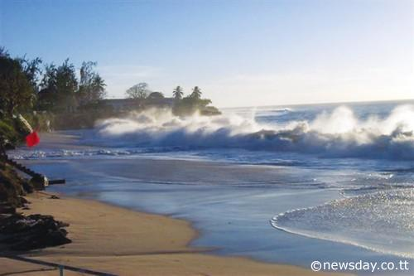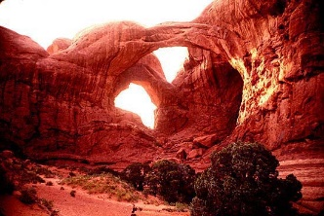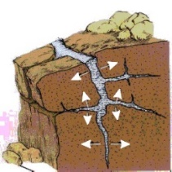

Organizing Information to Summarize Learning Log
Name: __________________________ Date: __________________

Identify key information from the text and write it in the correct row on the first column. Then draw images representing this information in the second column.

Nouns  (Landform, land features) | Draw
Adjectives
(Effect)

Verbs
(Cause)

Write a summary of the causes and effects of weathering and erosion:

Describing Weathering and Erosion Chart
Name: __________________________ Date: __________________

Before | Cause | Effect
Draw the landscape/landform before weathering and erosion. | Draw the agent of weathering and erosion (the cause). | Draw the landscape after weathering and erosion (the effect).

Lesson 8  Day 12 | Restating Information Using Compound Sentences and Linking Words | Estimated Time: One 60-minute period

Brief overview of lesson: This lesson will develop students’ knowledge and understanding of how to use linking words to combine ideas to make more complex sentences. Students will practice combining previously constructed sentences and practice creating new compound sentences about weathering and erosion. As you plan, consider the variability of learners in your class and make adaptations as necessary.

What students should know and be able to do to engage in this lesson:
- Language: familiarity with identifying and differentiating nouns/verbs and singular/plural nouns; familiarity with subject/verb agreement for the verb to be; adjectives and comparison vocabulary; ability to construct phrases and/or simple sentences.
- General or content knowledge: basic knowledge about landforms and bodies of water, and related vocabulary.
Skills: ability to participate in class discussions using accountable talk; ability to organize events in sequential order and match images to events; ability to summarize ideas from a text.
LESSON FOUNDATION
Unit-Level Focus Language Goals to Be Addressed in This Lesson |  | Unit-Level Salient Content Connections to Be Addressed in This Lesson
G.2 Explain by describing cause and effect supported with reasoning and ideas. |  | CCSS.ELA-LITERACY W.4.8—Recall relevant information from experiences or gather relevant information from print and digital sources; take notes and categorize information, and provide a list of sources.
Language Objective |  | Essential Questions Addressed in This Lesson
Students will be able to restate information about weathering and erosion using compound sentences with linking words (and, but). |  | Q.1 How can we use our knowledge of the English language to inform others?  Q.3 How can we use evidence to support a claim about weathering and erosion?
Assessment
- Formative assessment: Assess student construction of compound sentences using linking words and and but (e.g., revising previously created sentences and constructing new sentences).
Thinking Space: What Academic Language Will Be Practiced in This Lesson?
Discourse Dimension | Sentence Dimension |  | Word Dimension
Social/instructional language; explanations about a topic composed of simple or predictable phrases with supporting visuals and limited cohesion among sentences | Simple and compound sentences with and/but and verbs in past and present tense |  | Content vocabulary (e.g., weathering, erosion, rock); prepositions (e.g., in, on, between); comparative adjectives (e.g., bigger, smaller, taller); past tense verbs (e.g., flowed, eroded, weathered); linking words (and, but)
Instructional Tips/Strategies/Suggestions for Teacher
In determining what scaffolds may be needed to help students access the curriculum, consider the following: native language supports, working with partners, color-coding parts of speech, using gestures, sentence frames, matching images to sentences, and/or sequencing images and matching to sentences.
Instructional Tools
- Graphic organizer
- Learning logs/graphic organizer
- Sentence frames

STUDENT CONSIDERATIONS
Sociocultural Implications
- Some students or their families may have experienced the negative effects of weathering and erosion (such as from a natural disaster). If so, discussing the effects of weathering and erosion may evoke painful memories.
- Some students may not be familiar with certain types of landforms and/or weathering and erosion agents.
- Some students may come from more agrarian communities and can relate more easily to the examples of weathering and erosion, while others may come from heavily populated urban areas and have little to no exposure to farming, gardening, or other outdoor activities in nature. This might make it more difficult for them to relate to the examples of erosion and weathering presented in the lesson.
Anticipated Student Pre-Conceptions/Misconceptions
- Students may think that erosion is only a direct result of natural disasters, rather than a process that also occurs over time and impacts different landforms in different ways.
- Students may believe that rocks cannot break and that mountains cannot change shape. They may have a hard time believing that rain can cause changes to soil over time.

THE LESSON IN ACTION

Lesson Opening

Be sure to post and share the language objective with students: “Students will be able to restate information about weathering and erosion using compound sentences with linking words (and, but).” To promote student ownership and self-monitoring of learning, have students record the objective in their notebooks. At the end of the lesson, students can reflect on their learning in relation to the objective.

Begin with a think-pair-share about what students learned the day before. Students can use a sentence frame such as “I learned ______.” Add any new information that students discuss to the anchor chart and/or shared file. Consider also reinforcing the concepts of weathering and erosion with a few slides about the topic, such as the ones in the “5-Minute Refresher: Weathering and Erosion” PowerPoint presentation. If using the “5-Minute Refresher: Weathering and Erosion” PowerPoint, focus on slides 2, 3, 4, and 7.
Provide options for perception, such as projecting the slides, having students view the slides on a computer, or providing students with printouts of the slides.
Have students record important information from the slides in their notebooks, then share with the class what they recorded. Include any additional information on the anchor chart and/or shared file.

During the Lesson

Explain how linking words like and can be used to paraphrase and summarize information. Project and provide students with a sample text that utilizes compound sentences about concrete, everyday processes. Ask students to read the text and to analyze how and when to use and and when to use but. Students can work independently, with a partner, or with a small group. Students can record their observations about the linguistic features. Ask students to share their observations with the class. Record student responses.

Model how to use and to combine sentences about an everyday topic.

Ask students to tell you about what they ate for breakfast or lunch. Write down the sentences on the board (e.g., “I ate a sandwich. I ate an apple. I drank milk.”)
Provide options for perception, such as viewing images about the activity, using a shared file to view the sentences, or projecting the sentences.

Identify sentences about the same idea that could be combined with the word and have students brainstorm ways to combine these sentences into one sentence or thought—making the connection to student observations from the text analyzed. For example, ask: “What could be a good word to combine these sentences?”
Provide options for physical action, such as using a whiteboard to record or doing a think-pair-share to discuss student responses.

Discuss students’ ideas as a whole class and introduce the word and by writing on the board. Explain how and can be used to combine similar ideas and use a think-aloud to model how to combine two sentences from the board using and. Again, connect to student observations about the text analyzed in class.

Introduce but as another linking word that can be used to combine sentences. Explain how but is different from and: and is used to combine similar ideas; but is used to combine opposite ideas. You may have to explain what opposite means using everyday examples of things that are opposite.

Model how to combine sentences about a common idea or topic with but. Ask students to name something they like to eat and write the sentences on the board (e.g., “I like to eat ______.”). Then ask them to name something they don’t like to eat (e.g., “I don’t like to eat ______.”) and write the sentence on the board next to the previous sentence.

Model how to combine the using but (e.g., “I like to eat ______, but I don’t like ______.”). Highlight punctuation (adding a comma [,] before but) and deleting repeated words after combining the sentences (e.g., “I like to eat pizza, but I don’t like to eat ice cream.”). Again, connect to student observations from the text analyzed.

Practice combining sentences about weathering and erosion using and.

Ask students to quietly review the information from the learning logs in Lesson 7, where students identified causes and effects of weathering and erosion.

Choose one of the weathering and erosion processes that was analyzed in Lesson 7 to describe. Project before and after images of the weathered and eroded landscape. Ask students to read the sentences they wrote about this process in their learning logs/graphic organizer.

Write student-generated sentences on sentence strips, on the board, or in a shared file and ask students to identify sentences about the same idea. If using sentence strips, reorganize them so that they are grouped together based on similarity. If writing on the board, circle the sentences that could be combined in the same color marker. If working with a shared file, color-code the sentences that could be combined in the same color font.

Ask students to brainstorm ways to combine these sentences to state something that they have learned about weathering and erosion. Allow for native language translation as needed.

Discuss students’ ideas for combining sentences. Some students may have tried combining sentences with and. If so, analyze what they did together as a class and offer feedback as needed. If not, ask a student volunteer to combine the sentences using and orally or in writing and record it on the board. Or, take sentence strips and place them next to each other, writing and between them (if using sentence strips), rewriting sentences on the board with and using the same color marker, or combining sentences with and using the same color font (if using a shared file).

Ask partners to combine two more sentences from their learning logs/graphic organizer (or from the board) to make a compound sentence using and. Have partners share the sentences out loud with the whole class afterwards.

Ask students to look at the information in their learning logs/graphic organizer and identify any statements about the processes of weathering or erosion that are different (e.g., “The boulders are big, but the water breaks them into smaller pieces.”). It may be helpful to have some sample statements that are different prepared ahead of time for students. Ask partners to combine two or more sentences from their graphic organizer (or from the board) to make a compound sentence using but.
Provide options for physical action, such as recording their definitions on whiteboards or Post-Its, or having students think-pair-share.

Extend practice combining sentences by having students create sentences about a new image of a weathered or eroded landscape. Project the image, have students view the image on a computer, or have students view printouts of the image at their desk. Once sentences are created, ask students to combine similar sentences with and, as well as sentences about opposite or different ideas with but. Students can record their sentences in their notebooks or on a graphic organizer.
Discuss student generated compound sentences orally. Ask students to share their sentences and explain how they decided which sentences to combine and which linking words to use.
Provide options for physical action, such as sharing with a partner, small group, or the class.
Lesson Closing
Ask students to create sentences about weathering and erosion using linking words. Have them create at least one sentence with and and another with but.
Provide options for physical action, such as writing, using speech-to-text software, or using a computer to record.

Lesson 8 Resources
Sample Text to Analyze

Dear Mary,

I had a great summer vacation. I did a lot of fun things. I played soccer with my friends, went to the movies, and went to the beach. I really liked the beach. At the beach, I made a sandcastle, went swimming, and went for a walk. I had a lot of fun, but I did not like when I got a sunburn. I also went camping with my cousins. I really liked hiking in the woods, but I did not like all the bugs in the woods. Hiking was really fun, but I was so tired at the end of the day. We even cooked our dinner over a campfire. We had hotdogs and s’mores. It was a fun summer.

Your Friend,

Sally
Graphic Organizer for Linking Words
Name: ________________________________________ Date: ____________________

Write sentences about the images provided. Once sentences are created, look for sentences that are similar. Highlight the similar sentences with a blue highlighter. Look for sentences that are opposite/different. Highlight those sentences with a yellow highlighter. Remember to use complete sentences. For example: “This is (a) ______. These are ______. The (noun) + (verb). Refer to the word wall and anchor chart to help complete your sentences.

1.

2.

3.

Combine similar sentences with and, and sentences about opposite or different ideas with but. Rewrite the sentences below.

Combined sentences (and):

Combined sentences (but):

Lesson 9  Days 13 and 14 | Making a Claim Supported with Evidence | Estimated Time: Two 60-minute periods

Brief overview of lesson: This lesson will develop students’ understanding of constructing a claim by using cause and effect signal words to make a claim about weathering and erosion on a specific landform. Students will practice generating a claim based on their observations and supporting their claim with relevant evidence about familiar contexts. Students will then transfer their knowledge of learned language to create claims supported by relevant evidence about weathering and erosion. Learning strategies include oral and written practice in small groups and use of visuals to support discussion. As you plan, consider the variability of learners in your class and make adaptations as necessary.

What students should know and be able to do to engage in this lesson:
- Language: basic knowledge of prepositions of location, comparative adjectives, sequencing signal words, past tense, cause and effect signal words, and linking words previously studied in the unit.
- General or content knowledge: basic understanding of topic vocabulary from the unit.
Skills: ability to construct simple sentences and combine them into compound sentences using and/but.
LESSON FOUNDATION
Unit-Level Focus Language Goals to Be Addressed in This Lesson |  | Unit-Level Salient Content Connections to Be Addressed in This Lesson
G.2 Explain by describing cause and effect supported with reasoning and ideas. |  | STE.4-ESS1-1—Construct a claim with evidence that changes to a landscape due to erosion and deposition over long periods of time result in rock layers and landforms that can be interpreted today. Use evidence from a given landscape that includes simple landforms and rock layers to support a claim about the role of erosion or deposition in the formation of the landscape.
Language Objective |  | Essential Questions Addressed in This Lesson
Students will be able to use cause and effect signal words to make a claim about the effects of weathering and erosion on a specific landform and support it with evidence. |  | Q.3 How can we use evidence to support a claim about weathering and erosion?
Assessment
- Formative assessment: Assess student oral and written production of claims supported by evidence about familiar topics (with a partner).
- Formative assessment: Assess student oral and written production of claims supported by evidence about weathering and erosion (individual).
Thinking Space: What Academic Language Will Be Practiced in This Lesson?
Discourse Dimension | Sentence Dimension |  | Word Dimension
Social/instructional language; short arguments (claim and supporting evidence) about a topic composed of simple or predictable phrases or sentences with limited cohesion among sentences. | Simple and compound sentences with and/but and provided sentence frames: “I think that ______. I think this because ______. Therefore, ______.” |  | Content vocabulary (e.g., weathering, erosion, rock); cause and effect signal words (because, therefore); comparative adjectives (e.g., bigger, smaller, taller); prepositions (e.g., in, on, between); past tense verbs (e.g., flowed, eroded, weathered); argument vocabulary (e.g., claim, evidence)
Instructional Tips/Strategies/Suggestions for Teacher
- In determining what scaffolds may be needed to help students access the curriculum, consider the following: native language supports, working with partners, using gestures, and/or sentence and paragraph frames.
- Depending upon student familiarity and comfort with stating claims, consider extending the lesson over several days to provide additional practice. If extending the lesson, it may be helpful to begin with additional practice stating claims based on images and then transition to stating claims about familiar contexts without images. Finally, students can practice stating claims about weathering and erosion. Consider also having students create claims supported by evidences first before reviewing the structure of the claims and student use and application of learned language (e.g., comparative adjectives, content vocabulary, cause and effect language, past tense verbs).
Instructional Tools
- Sentence and paragraph frames (“I know that ______. I know this because ______. Therefore, ______.”)
- “Making a Claim with Evidence” handout

STUDENT CONSIDERATIONS
Sociocultural Implications
Some students or their families may have experienced the negative effects of weathering and erosion (such as from a natural disaster). If so, discussing the effects of weathering and erosion may evoke painful memories.
Anticipated Student Pre-Conceptions/Misconceptions
- Students may believe that a claim is automatically true without being proven. Be explicit about the importance of basing claims on relevant evidence. Be sure to model how to select relevant evidence (i.e., evidence that supports the claim/proves the claim).
- Students may confuse statements of causality when there is a claim.

THE LESSON IN ACTION

Day 13 Lesson Opening

Post and explain the lesson’s language objective: “Students will be able to use cause and effect signal words to make a claim about the effects of weathering and erosion on a specific landform and support it with evidence.” To promote student ownership and self-monitoring of learning, have students record the objective in their notebooks. At the end of the lesson, students can reflect on their learning in relation to the objective.

Make connections to previous lessons. For example, say: “We have been learning language used to describe weathering and erosion. But how can you prove, or show that what you observe is true? Using evidence. Today we are going to practice creating a claim about a situation and supporting it with evidence.”

Consider doing a quick review of statements using because and therefore.

During the Lesson

Introduce the process of stating a claim supported by evidence by practicing making claims about a familiar topic or social context. Tap into student prior knowledge of working with this structure in Lesson 6. Depending upon student familiarity and comfort with creating claims supported by evidence, you may wish to define the term claim, review what a claim is (e.g., can be argued, answers a question, can be supported with reasoning and evidence, your opinion based on analysis), and review what a claim is not with students. Consider creating an anchor chart of what a claim is/is not for student reference.

Project an image of a familiar topic or social context labeled with a caption (e.g., an image of a boy crying next to a soccer ball in a playground and a caption that says “Carlos is crying at recess”).
Provide options for perception, such as having students view the image on a computer, view printouts of the image at their desk, or using a video instead of images.

Discuss the image, asking students to describe what they think happened. Provide sentence frames, such as “I think ______,”and record students’ responses on the board or a shared file.

Explain how you will model how to make a claim, or a statement of what you think happened based on students’ responses. Write a claim on the board (e.g., “I think that a soccer ball hit Carlos”). After creating the claim statement, ask students if they agree or disagree with the claim by showing a thumbs up (agree) or thumbs down (disagree). If students disagree, create a new claim with their input.

Then explain how you have ideas that can prove this claim, or evidence to support your claim, based on what seems to be happening in the image. Brainstorm ideas of why things happened in the image (e.g., “there is a soccer ball, so maybe they were playing and a ball hit Carlos,” “Carlos seems to have a skinned knee,” “other children in the image are laughing”). Decide as a class what seems to be the most convincing evidence to support the claim already stated, then write a couple of sentences to support it (e.g., “I think this happened because there is a soccer ball and other students next to Carlos. Therefore, Carlos is crying because a soccer ball hit him”). Point out how you used a paragraph frame (several sentence frames put together) to state your claim and support it with evidence by underlining or highlighting the frames within your example: “I think that a soccer ball hit Carlos. I think this happened because there is a soccer ball and other students next to Carlos. Therefore, Carlos is crying because a soccer ball hit him”). Post this paragraph frame on the board or somewhere visible for student reference. Consider making an anchor chart on what evidence is and how to select relevant evidence to support a claim.

Give students time to practice creating claims and supporting them with evidence. This activity allows students to practice making a claim orally and in writing while describing a situation they know well in preparation for creating claims about weathering and erosion and sharing them with a larger group.

Pair up students and ask them to examine another image of a familiar situation and practice making their own claims about it. Consider creating an emotions anchor chart as a support while students create their claims. Give each pair a different image and thinking prompts, such as “What do you think is happening in the image? Why do you think this happened?” Tell them to orally discuss these prompts before recording their thoughts in their notebooks using posted paragraph frames. While students are working, circulate and offer students specific feedback on their creation of claims supported by evidence.
Provide options for physical action, such as using a computer to type up sentences.

Ask students to share their claims orally in small groups (or two sets of partners meeting up). This activity allows students to practice making a claim orally and in writing while describing a situation they know well. This will prepare them to create a claim about weathering and erosion and share it with a larger group.

Lesson Closing

Invite students to share their images and sentences stating a claim supported by evidence with the whole class.

One partner can show the image to all students. After all students see the image, the other partner can read the pairs’ claim and evidence sentences.

After each pair is done, consider asking students to share what else they think is going on in the image—or to state their own claim and evidence about the images—using the paragraph frames as extra practice.

Provide time to reflect on the activity by asking students to explain what they thought/felt about the exercise. Provide a sentence frame, such as “I felt like this was ______” or “I think this was ______.” This reflection can validate the fact that creating claims is difficult and can help reassure students of their hard work. Finally, point out that these claims will be used in later lessons, also validating student work.

Exit ticket: Ask students to summarize what a claim is and what evidence is. Use this formative assessment to inform instruction and make any modifications that may be needed.

Optional activity: Consider having students quietly reflect on the landscapes that they have studied so far. Ask students to think about why it might be important to notice the effects of weathering and erosion on landscapes. Students can record their thoughts in a journal. Consider also having students think about if there is anything we can do to lessen the effects of weathering and erosion.

THE LESSON IN ACTION

Day 14 Lesson Opening

Review the class-generated anchor chart, word wall, or vocabulary poster. Review what a claim is/is not and how to write a claim supported by evidence. Refer to the student created claims from yesterday.

During the Lessons

Model creating evidence-supported claims about weathering and erosion.

Project a before and after image of a weathered and eroded landscape and invite students to think about what happened and why, and then share their observations.
Provide options for perception, such as having students view the image on a computer or providing students with printouts of the image.

Model how to create a claim and supporting sentences using the “Making a Claim with Evidence” handout and the class-generated anchor chart, word wall, or vocabulary poster as support. While modeling the use of the graphic organizer, explain each component to students, reviewing the necessary components. Remind students what evidence is/is not and how to select relevant evidence.
Provide options for perception, such as writing on the board or using a shared file.

Provide a second model using a different set of images and the “Making a Claim with Evidence” handout. This time, ask students to help create the claim and supporting sentences.
Provide options for physical action, such as having students record their observations on a whiteboard or having students think-pair-share.
Provide options for perception, such as writing the class-created sentences on the board or using a shared file for students to view.

Consider having students analyze written claims about weathering and erosion that do not include evidence. Ask students to analyze the claims and think about what they notice. As students point to the fact that the claims do not have evidence, ask students how they could strengthen and fix the claims. Ask students to fix the claims by adding evidence.

Give students time to practice creating evidence-supported claims about weathering and erosion.

Distribute new before and after images and ask partners to examine them to formulate a claim and supporting evidence using the “Making a Claim with Evidence” handout, and the class anchor chart, vocabulary poster, or word wall. For example, let students know that they will be analyzing images of a beach before and after a hurricane. Students will create claims supported by evidence based on the images. For example: “I think that a hurricane changed this beach. I think this because the beach is smaller. Therefore, I think that erosion from the hurricane changed this beach.” For students more comfortable with creating claims supported by evidence, consider providing them with textual excerpts to support the image analysis.
Provide options for engagement, such as having students reflect on the images individually before coming together as partners to share.
Provide options for physical action, such as using a computer to complete.

Have students post their sentences and images on the wall. Then have everyone walk around the room with a partner, reviewing images and claims (a gallery walk). During the gallery walk, have students discuss what they think happened in the images and offer their own claims. After the walk, ask students to reflect using prompts such as “How did you prove what you saw using evidence? Did you communicate your claims effectively?”

Lesson Closing

Have students create a claim supported by evidence independently using the paragraph frames used throughout this lesson and a new set of before and after images.
Provide options for physical action, such as use of student notebooks, exit ticket, a computer or speech-to-text software.

This final activity can serve as a formative assessment for the lesson. Analyze student work to make instructional changes in future lessons as needed.

Lesson 9 Resources
Sample Images for Practicing Making Evidence-Supported Claims
*
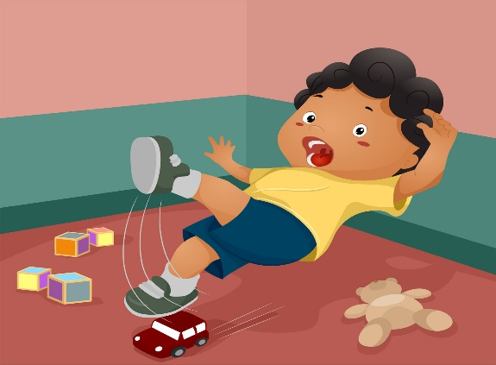

Source: Photograph Child Falling Copyright: <a href='http://www.123rf.com/profile_lenm'>lenm / 123RF Stock Photo</a>

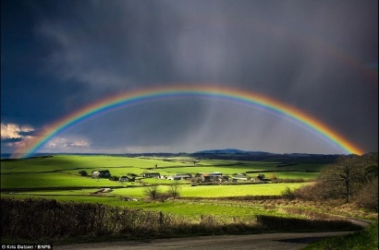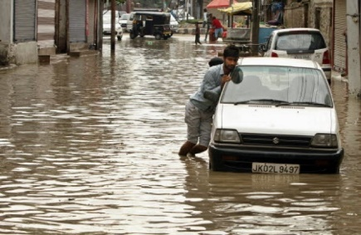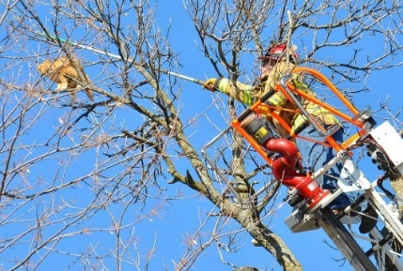
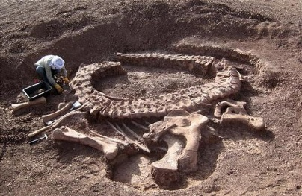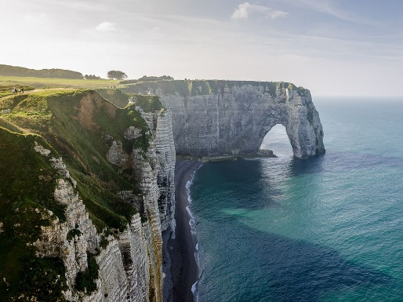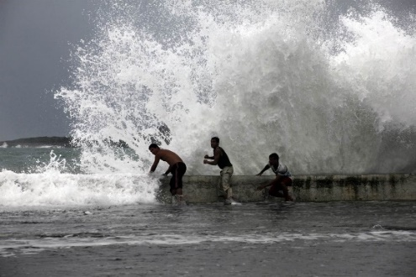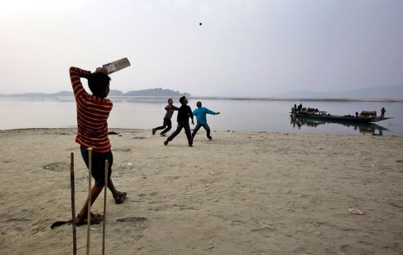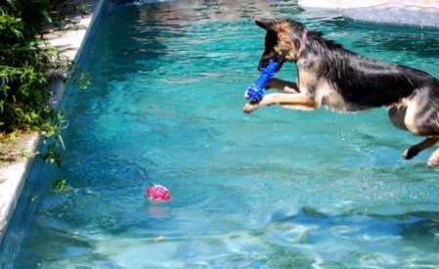

Sample Paragraph Frames for Modeling: Making a Claim Supported with Evidence
Analyze the images. Based on your analysis, what do you think happened to the landscape? Write your claim. In the middle draw an image of the evidence to support your claim.

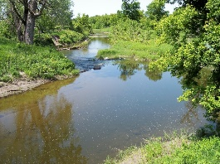
This is a river.
I think that ___________________________________________________________________.

I think this because __________________________________________________________.

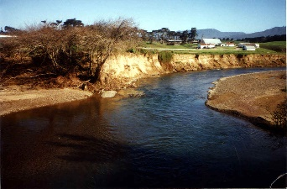
Therefore, I think that ___________________________________________________________.

Making a Claim with Evidence
Name: __________________________ Date: __________________

Analyze the before and after images of the weathered and eroded landscape. While analyzing the images, complete the graphic organizer.

- What do you think happened?

Claim: I think __________________________________________________________________________.

- Why do you think so?

Evidence:

- Claim supported with evidence:

I think that ____________________________________________________________________________________________________________________.

I think this because ___________________________________________________________________________________________________________.

Therefore, I think that________________________________________________________________________________________________________.

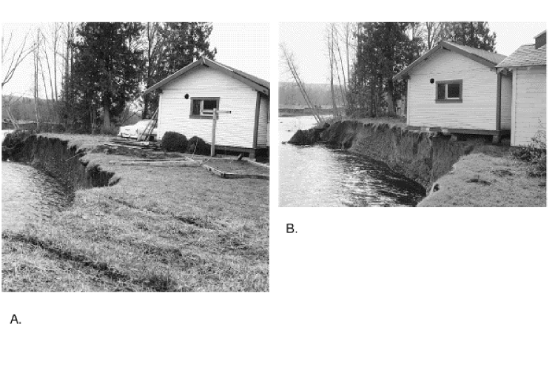
This is an image of a river bank before erosion. | This is an image of a river bank after erosion. What do you think happened? How do you know?

Lesson 10  Day 15 | Communicating Effectively Using Presentation Skills | Estimated Time: One 60-minute period

Brief overview of lesson: Students will develop and practice their presentation skills. Students will analyze presentations to determine the characteristics of effective presentations. Students will then practice utilizing these skills to give a brief presentation. Students will apply the presentation skills learned in the culmination of this unit by presenting their claims using both oral and visual presentations. As you plan, consider the variability of learners in your class and make adaptations as necessary.

What students should know and be able to do to engage in this lesson:
- Language: basic knowledge of prepositions of location, comparative adjectives, sequencing signal words, past tense, cause and effect signal words, and linking words previously studied in the unit.
- General or content knowledge: basic understanding of topic vocabulary from the unit; accurate information describing the effects of weathering and erosion.
Skills: ability to construct simple sentences and combine them into compound sentences using and/but.
LESSON FOUNDATION
Unit-Level Focus Language Goals to Be Addressed in This Lesson |  | Unit-Level Salient Content Connections to Be Addressed in This Lesson
G.2 Explain by describing cause and effect supported with reasoning and ideas. |  | STE.4-ESS1-1—Construct a claim with evidence that changes to a landscape due to erosion and deposition over long periods of time result in rock layers and landforms that can be interpreted today. Use evidence from a given landscape that includes simple landforms and rock layers to support a claim about the role of erosion or deposition in the formation of the landscape.
Language Objective |  | Essential Questions Addressed in This Lesson
Students will be able to effectively communicate information about weathering and erosion in an oral presentation using content/topic vocabulary (e.g., erosion, weathering, rocks) and targeted academic language introduced in the unit (e.g., small/smaller, because, therefore, and, but). |  | Q.3 How can we use evidence to support a claim about weathering and erosion?
Assessment
- Formative assessment: Have students analyze a teacher presentation to assess their ability to identify and explain the components of an effective presentation.
- Formative assessment: Assess student use of effective presentation skills during oral presentation of claim about weathering and erosion.
Thinking Space: What Academic Language Will Be Practiced in This Lesson?
Discourse Dimension | Sentence Dimension |  | Word Dimension
Social/instructional language; short explanations and arguments (claim and supporting evidence) about a topic composed of simple or predictable phrases or sentences with limited cohesion among sentences | Simple and compound sentences with and/but and provided sentence frames: “I think that ______. I think this because ______. Therefore, ______.” |  | Content vocabulary (e.g., weathering, erosion, rock); cause and effect signal words (because, therefore); comparative adjectives (e.g., bigger, smaller, taller); prepositions (e.g., in, on, between); past tense verbs (e.g., flowed, eroded, weathered); argument vocabulary (e.g., claim, evidence)
Instructional Tips/Strategies/Suggestions for Teacher
- In determining what scaffolds may be needed to help students access the curriculum, consider the following: native language supports, working with partners, using gestures, and/or sentence frames.
- Consider creating a visual presentation anchor chart with information about effective presentation skills for each point. Post it in the classroom as an additional support for students.
Instructional Tools
- Paragraph frames (“I think that ______. I think this because ______. Therefore, ______.”)
- T-Chart
- Rubric

STUDENT CONSIDERATIONS
Sociocultural Implications
- Some students or their families may have experienced the negative effects of weathering and erosion (such as from a natural disaster). If so, discussing the effects of weathering and erosion may evoke painful memories.
- Students may not adhere to American standards for effective presenting skills (e.g., eye contact, voice level) due to cultural norms that may contradict those used in American schools. When explaining presentation skills, mention how these are expectations in the United States and not necessarily the only way to present information effectively.
Anticipated Student Pre-Conceptions/Misconceptions
Students may believe that a claim is automatically true without being proven. Be explicit about the importance of basing claims on relevant evidence.

THE LESSON IN ACTION

Lesson Opening

Be sure to post and explain the lesson’s language objective: “Students will be able to effectively communicate information about weathering and erosion in an oral presentation using content/topic vocabulary (e.g., erosion, weathering, rocks) and targeted academic language introduced in the unit (e.g., small/smaller, because, therefore, and, but).” To promote student ownership and self-monitoring of learning, have students record the objective in their notebooks. At the end of the lesson, students can reflect on their learning in relation to the objective.

Explain how skilled scientists present their claims about what happens in nature (processes like weathering and erosion) using visual and written evidence. Probe students to think about the type of visual evidence scientists use to support their claims. For example, ask: “What sorts of visual evidence do you think scientists may use in their presentations? Why are these effective forms of visual evidence?”

Make connections to previous lessons. For example, say: “We have been learning language used to describe weathering and erosion and have learned to support our claims with evidence. Today we will learn about what makes an effective presentation. During our final project, we will give effective presentations.”

During the Lesson

Tell the class that you are going to present a claim supported by evidence explaining why you think it’s important to have healthy meals at school. Ask students to take notes about what parts of the presentation seem effective (communicate ideas well) or ineffective (do not seem to communicate ideas well).

Model an ineffective oral presentation (e.g., one where you don’t make eye contact; have poor body language, such as fidgeting and slumping; speak in a low, monotone voice; and show no visuals). Ask students to take notes on what they noticed did/did not work well in the presentation. Notes can be recorded in student notebooks, on Post-Its, or in an online notebook such as Zoho Notebook).

Ask students to pair up and share their notes about the presentation. Then debrief as a whole class and write down what students say on the board.

Ask students to give their opinion about whether the presentation was effective (communicated ideas clearly) or ineffective (did not communicate ideas clearly). Point out that you demonstrated a poor, or ineffective presentation. Ask students to identify characteristics of this presentation that made it ineffective with prompts such as “Why do you think my presentation was ineffective? Why do you think it did not do a good job of giving you the information I wanted to share?”

Make connections between the poor presentation skills and good presentation skills by changing statements shared by students with a solution or alternative to make the presentation better.

Explain how students will be creating and delivering their own presentations about weathering and erosion as their final unit task. Review and explain the CEPA with students. Review the presentation rubric, providing explanations and examples for each criteria.
Provide options for perception, such as using a computer, adding visual supports and gestures for each piece of the rubric, projecting the rubric, and providing students with their own copies.

Redo the initial presentation, applying students’ suggestions. Ask students to reflect on the changes you made with prompts such as “What made this presentation better? Why?” Then, have them rate this new presentation using the rubric.
Provide options for physical action, such as using a computer or Post-Its to rate the presentation, scoring directly on the rubric, or quietly reflecting before sharing with a partner.

Create a list with the characteristics of good presentation skills and ask students to copy them in their notebooks. Consider creating a class T-chart with characteristics of effective and ineffective presentations to have as a reference.

Consider having students analyze additional examples of effective and ineffective presentations. The presentations analyzed could be recorded teacher and/or student-created samples.

Model and review with students the steps for designing a good presentation. Use one of the sets of images analyzed in Lesson 9 as a model.

Have students practice creating a brief presentation for the evidence-supported claims they created in Lesson 9. Students can use the images analyzed as visuals during their presentations. Pair students and ask them to listen to each other deliver presentations, then offer feedback using the rubric. While students are working, circulate and offer specific feedback on student performance in relation to the rubric.
Lesson Closing
Debrief the presentation process by asking a couple of discussion questions such as “Why is it important to have good presentation skills when you are presenting a claim?” and “What things might you need to prepare to strengthen your presentation?” Invite students to share their thoughts with the class.
Provide options for perception, such as projecting the questions, having questions posted on the board, having students view the question on a computer, or providing students with a handout with questions printed.
Provide options for physical action, such as using computers to type answers, orally discussing, and using Post-Its or whiteboards to record answers.

Lesson 10 Resources
Presentation Rubric
 | Always | Sometimes | Never
Eye contact: Looks at the audience and makes eye contact
Volume: Not too loud, not too soft. Just right!
Body language: Stands up straight and does not slump or fidget
Monotone register: Does not present like a robot!
Visuals: Uses visuals to support presentation
Speaks clearly and comprehensibly
Image Source: ClipArtPanda

Lesson 11  Days 16–20 | Creating the Presentation (CEPA) | Estimated Time: Five 60-minute periods

Brief overview of lesson: These lessons comprise the unit’s curriculum embedded performance assessment (CEPA). The CEPA asks students to use their knowledge of weathering and erosion to create a presentation about the effects of weathering and erosion on a specific landform. Assuming the role of a scientist, students present their claim and supporting evidence orally in order to raise awareness about weathering and erosion among government officials and community members at a town hall meeting. Students will be working in cooperative learning groups of three. Each student will be responsible for completing all parts of the CEPA, and will orally present to their peers in a jigsaw format. As you plan, consider the variability of learners in your class and make adaptations as necessary.

What students should know and be able to do to engage in this lesson:
- Language: basic knowledge of prepositions of location, comparative adjectives, sequencing signal words, past tense, cause and effect signal words, and linking words previously studied in the unit.
- General or content knowledge: basic understanding of topic vocabulary from the unit; accurate information describing the effects of weathering and erosion.
Skills: ability to construct simple sentences and combine them into compound sentences using and/but; oral presentation skills.
LESSON FOUNDATION
Unit-Level Focus Language Goals to Be Addressed in This Lesson |  | Unit-Level Salient Content Connections to Be Addressed in This Lesson
G.1 Discuss by identifying evidence from a given landscape that includes simple landforms and rock layers to support a claim about the role of erosion or deposition in the formation of the landscape.  G.2 Explain by describing cause and effect supported with reasoning and ideas. |  | STE.4-ESS1-1—Construct a claim with evidence that changes to a landscape due to erosion and deposition over long periods of time result in rock layers and landforms that can be interpreted today. Use evidence from a given landscape that includes simple landforms and rock layers to support a claim about the role of erosion or deposition in the formation of the landscape.  STE.4-ESS2-1—Make observations and collect data to provide evidence that rocks, soil, and sediments are broken into smaller pieces through mechanical weathering and moved around through erosion by water, ice, wind, and vegetation.  CCSS.ELA-LITERACY.W.4.8—Recall relevant information from experiences or gather relevant information from print and digital sources; take notes and categorize information, and provide a list of sources.
Language Objective |  | Essential Questions Addressed in This Lesson
Students will be able to effectively identify and explain evidence of erosion on landforms, describe their causes and effects, and make claims to inform others about weathering and erosion. |  | Q.1 How can we use our knowledge of the English language to inform others?  Q.2 How can we communicate our ideas about weathering and erosion?  Q.3 How can we use evidence to support a claim about weathering and erosion?
Assessment
- Summative assessment: Use oral and written CEPA presentations to assess student application of all learned language. Consider student use of oral and written language at the discourse, sentence, and word/phrase dimensions.
- Self-assessment: Students will self-assess using the student self-assessment rubric.
Thinking Space: What Academic Language Will Be Practiced in This Lesson?
Discourse Dimension | Sentence Dimension |  | Word Dimension
Social/instructional language; short explanations and arguments (claim and supporting evidence) about a topic composed of simple or predictable phrases or sentences with limited cohesion among sentences | Simple and compound sentences with and/but and provided sentence frames: “I think that ______. I think this because ______. Therefore, ______.” |  | Content vocabulary (e.g., weathering, erosion, rock); cause and effect signal words (because, therefore); comparative adjectives (e.g., bigger, smaller, taller); prepositions (e.g., in, on, between); past tense verbs (e.g., flowed, eroded, weathered); argument vocabulary (e.g., claim, evidence)
Instructional Tips/Strategies/Suggestions for Teacher
- In determining what scaffolds may be needed to help students access the curriculum, consider the following: native language supports, working with a partner, using gestures, and/or sentence frames.
- Group students strategically for the CEPA. Design presentation groups to maximize language development and provide students with support as needed.
- Some students may prefer to complete the CEPA independently.
- Consider extending Day 16 to provide students with additional time to gather and organize pertinent information.
- Consider identifying local landscapes to have students analyze. For example, students could analyze images of the eroded coastline in Massachusetts. Students could also read text about coastal erosion to inform their analysis of the images.
- Pre-teach or review metacognitive and metalinguistic strategies that students can use to analyze the texts.
Instructional Tools
- “CEPA Steps” handout

STUDENT CONSIDERATIONS
Sociocultural Implications
- Some students or their families may have experienced the negative effects of weathering and erosion (such as from a natural disaster). If so, discussing the effects of weathering and erosion may evoke painful memories.
- Some students may be uncomfortable presenting in front of a group. Consider ways to help them practice and ease their anxiety.
- Students may not adhere to American standards for effective presenting skills (e.g., eye contact, voice level) due to cultural norms that may contradict those used in American schools. When explaining presentation skills, mention how these are expectations in the United States and not necessarily the only way to present information effectively.
Anticipated Student Pre-Conceptions/Misconceptions
Students may believe that a claim is automatically true without being proven. Be explicit about the importance of basing claims on relevant evidence.

THE LESSON IN ACTION

Day 16 Lesson Opening

Post and explain the lesson’s language objective: “Students will be able to effectively identify and explain evidence of weathering and erosion on landforms, describe their causes and effects, and make claims to inform others about weathering and erosion.” To promote student ownership and self-monitoring of learning, have students record the objective in their notebooks. At the end of the lesson, students can reflect on their learning in relation to the objective.

Review class-generated anchor charts, word wall, vocabulary poster, or illustrated lists and any other resources related to the topic of weathering and erosion. Consider revising items in the Lesson 9 gallery walk.

Go over CEPA details. Provide students with the “CEPA Steps” handout and review each step.

Tell the students that they will assume the role of a scientist and use their knowledge of the formation of landforms to create a visual and written representation of the effects of weathering and erosion on a specific landform. They will present their claim and evidence orally in order to raise awareness among government officials and community members at a town hall meeting. Explain how they will be working in cooperative learning groups of three. Each student will be responsible for completing all parts of the CEPA, and will orally present to their peers in a jigsaw format. Each group will be assigned a different landscape to analyze. Preview what students will be working on for the next five days:
- Day 16: Review all language and vocabulary and read a text about a weathered and eroded landscape to identify evidence of erosion and organize important information.
- Day 17: Paraphrase/summarize important information from the text and write a claim about weathering and erosion based on evidence from the text (including images).
- Day 18: Design a presentation and create a labeled visual to support the claim using targeted academic language.
- Day 19: Practice presentations with CEPA small group.
- Day 20: Deliver presentations as scientists to other small groups representing citizens at a town hall meeting.

Review the CEPA rubric with students. Highlight the necessary components of the task and showcase an example of the CEPA, explaining how it is a good example of each rubric component.

During the Lesson

Briefly review the targeted academic language by revisiting the class created anchor chart/word wall. Consider having students play a game to review the targeted academic language.

Model for students each step that they will be doing today (e.g., reviewing/analyzing the text, identifying the causes and effects of weathering, collecting and organizing information using the graphic organizer, and creating cause and effect statements). Refer students to the “CEPA Steps” handout.

Introduce the reading activity by explaining how students will identify causes and effects of weathering and erosion on a landscape as described in a text and then use that information to make claims for their presentation (see sample text in the CEPA resources below).

Ask students to identify causes and effects of weathering and erosion, and to pay attention to prepositions, sequencing of events, comparative adjectives, and cause and effect language used as they read by marking the text using an annotating guide (e.g., marking causes=blue, effects= green; numbering the order of events; underlining prepositions; and circling comparative language).
Provide options for perception, such as using a text-to-speech reader, reading the text on a computer or a printed version, and/or partner reading.
Provide options for physical action and expression and communication, such as taking notes on a graphic organizer or notebook instead of annotating the text.

Have students collaboratively organize important information in a graphic organizer using class-generated anchor charts, word walls, or illustrated vocabulary lists and native language supports as needed.
Provide options for physical action, such as using a computer to complete.

Optional activity: This activity can be adapted by using images in place of text, adding visuals to support text, or using videos. If students are analyzing images, ask them to collect evidence based on the images of the causes and effects of weathering and erosion. Students can organize the information in the graphic organizer and then use it create claims. If using a visually supported text, modify the text to include visuals to aid comprehension. If using videos, provide a video viewing station where students can view the video independently. The video viewing station allows students to pause the video and ask clarifying questions as needed.
Lesson Closing
Have students write one cause and effect statement about their assigned landscape/text. Provide sentence frames such as “The (noun) + (verb) ______ because ______; The (noun) + (verb) ______. Therefore, ______.” This is a quick formative assessment for teachers to gauge student understanding of the reading.
Provide options for physical action, such as using a computer, writing on notebooks, or using speech-to-text software.

THE LESSON IN ACTION

Day 17 Lesson Opening

Direct students’ attention to the sequence of instruction for the CEPA. Refer students to the “CEPA Steps” handout. Explain how students read about their landscape on Day 16, and today they will work on paraphrasing information that they learned from the text.

Explain what it means to paraphrase, providing a student-friendly definition of paraphrasing along with several examples. Go over key components of a paraphrase, and model paraphrasing for students, highlighting the necessary components within the example produced. Be sure to keep the examples posted or provide students with a copy to revisit as needed.

Consider having students co-construct a paraphrase with you.

During the Lesson

Have students work with their CEPA groups to review graphic organizers from Day 16, adding any missing information. Then, ask them to collaboratively paraphrase the text using their graphic organizer, sentence frames (e.g., “This is a ______. The [noun] + [verb] ______. According to ______. First, the [noun] + [verb] ______. Next, the [noun] + [verb] ______. Then, the [noun] + [verb] ______.”), and the paraphrase model demonstrated by the teacher.
Provide options for physical action, such as conferencing with the teacher to support paraphrasing.

Model how to use a paraphrased version of the information about a particular landform to create a claim with supporting evidence about what happened to the landform as a result of weathering and erosion. Use modified versions of the paragraph frames from Lesson 9 to help students create evidence-supported claims for their presentations (e.g., “This is a ______. I think that ______. I think this because ______. Therefore, ______.”).
Lesson Closing
Ask students to individually write a claim with evidence about weathering and erosion based on the text they read using sentence frames.

THE LESSON IN ACTION

Day 18 Lesson Opening

Review the sequence of instruction for the CEPA. Refer students to the “CEPA Steps” handout. Explain how students have already read about their landscape and paraphrased information that they learned. This can help students measure their progress in relation to the assignment. Explain how, in addition to text, scientists use images as evidence to support their claims. Tell students that today they will create labeled visuals to support their presentations.

Have CEPA groups review graphic organizers and paraphrases from previous days.

During the Lesson

Go over key components of designing a presentation and creating a useful visual for a presentation. Model a brief paraphrase of your landscape and then model creating and labeling a visual for students. Remind students that effective visuals depict key pieces of information and support the presentation. Examples of labeled visuals may include an image with caption, a diagram, or a slideshow. Keep this model posted for student reference.

Ask students to create three images/illustrations/visuals: one of the landscape before weathering and erosion, one of the agent of weathering and erosion, and one of the effects on the landscape of weathering and erosion.
Provide options for physical action, such as creating a poster, or making a PowerPoint with their scanned drawings or images created in a program such as Microsoft Paint. Remind students of the components of a good visual (e.g., depicts key pieces of information, directly ties to the claim) so they can produce useful products regardless of the format chosen.
Lesson Closing
Organize students in pairs with students from other CEPA groups and ask them to share how their images support their claim. While pairs are sharing, circulate and ask students to explain how their images support their claim.

THE LESSON IN ACTION

Day 19 Lesson Opening

Direct students’ attention to the sequence of instruction for the CEPA. Refer students to the “CEPA Steps” handout. Explain how students have already read about their landscape, paraphrased information that they learned, and created visuals to support their claims. Explain that today students will practice their presentations.

Revisit the characteristics of an effective presentation from Lesson 10. Model a presentation using the information and visuals you have created throughout the lesson.

Consider presenting twice, one modeling an ineffective way to present and another showcasing a good presentation to review presentation skills.

Ask students to assess your presentation using the presentation rubric introduced in Lesson 10, which will also be used to assess students’ final presentations. Model what useful positive and improvement feedback comments look like.
Provide options for physical action, such as using a computer to complete, scoring the rubric on the rubric, or using Post-Its to provide feedback.
Reinforce each component of the rubric by providing specific examples. If using gestures, review the gestures with students.

During the Lesson

Have students rehearse their presentations within their CEPA group of three.

Assign student roles for the presentation/feedback process. For example, one student can be responsible for presenting a description of the landform before weathering and erosion, a second student presents a description of the causes of the weathering and erosion, and a third student presents the effects of weathering and erosion on the landform. Tell students that while each student presents, the other students in the group should listen carefully. Then, after each person is finished presenting, the students listening can provide feedback using the presentation rubric.

Circulate to provide specific feedback on student presentations and support as needed.
Lesson Closing
Ask students to write a sentence describing which part of the CEPA they will present. Ask student to write feedback on how their group members did on their presentation practice. Students can provide feedback on what their group members did well and any suggestions for improvement.

THE LESSON IN ACTION

Day 20 Lesson Opening

Review the CEPA presentation rubric with students (this is the same rubric students have been working with throughout the creation of the CEPA). Remind them of the CEPA details (e.g., acting as scientists, raising awareness, presenting at a town hall meeting).

Review listening norms with students (such as respectful listening, raising hands when they have a question, no laughing, and so forth).

Explain how the presentations will occur. CEPA groups of three will be divided so that each team member presents information about their landform to other groups (jigsaw groups).

Give students time to gather all the materials they need and prepare for the presentations.

During the Lesson

Have students present their claim to raise awareness about the group’s weathered and eroded landscape to the class.
Provide options for physical action, such as having groups present to another small group prior to sharing with the class.
Also consider if some students may feel comfortable presenting individually.

After each presentation, classmates can ask questions about the landscape. Ask students to provide feedback about what each presenter did well and helpful suggestions for improved writing using Post-Its. Remind students to share respectfully, as practiced during the teacher demonstration on Day 19.

Lesson Closing

Model for students how to self-assess using the CEPA rubric. Showcase how to look at one’s performance honestly and not just give oneself the highest mark.

Ask students to self-assess using the CEPA rubric.
Provide options for physical action, such as using a computer, writing on notebooks or whiteboards, or orally describing.

Optional activity: Consider having students quietly reflect on the landscapes that they have studied so far. Ask students to think about why it might be important to notice the effects of weathering and erosion on landscapes. Students can record their thoughts in a journal. Consider also having students think about if there is anything we can do to lessen the effects of weathering and erosion?

Lesson 11 Resources
CEPA Steps
Step 1: Review the material on your assigned landscape.
- What was the landscape like BEFORE weathering and erosion?
- What happened to the landscape? Use sequencing language (e.g., first, next, then).
- Identify the CAUSES and EFFECTS of weathering and erosion on a landscape. Look for signal words of cause and effect such as BECAUSE and THEREFORE.
- Use COMPARATIVES to DESCRIBE the landscape BEFORE and AFTER weathering and erosion (e.g., bigger, smaller, taller, shallow, deeper).
- Use PREPOSITIONS to DESCRIBE what happened to the landscape (e.g., on, in, under, down, up; water got IN the rocks).

Step 2: Create a claim using “I think ______. I think this because ______. Therefore, ______.”
Use the PAST TENSE form of the verb (e.g., eroded, weathered, flowed, blew, melted, moved, broke, changed) to show something that already happened.

Step 3: Create 3 images.
- Illustrate the landscape BEFORE weathering and erosion. Label the image. Use the word wall to help you.
- Illustrate the agent of weathering and erosion. Label the image. Use the word wall to help you.
- Illustrate the effects of weathering and erosion on the landscape. Label the image. Use the word wall to help you.

Step 4: Practice your presentation.
- Remember to LOOK.
- Remember to PROJECT.
- Remember to SPEAK CLEARLY.

Step 5: Present to the class.

Presentation Rubric
 | Always | Sometimes | Never
Eye contact: Looks at the audience and makes eye contact
Volume: Not too loud, not too soft. Just right!
Body language: Stands up straight and does not slump or fidget
Monotone register: Does not present like a robot!
Visuals: Uses visuals to support presentation
Speaks clearly and comprehensibly
Image Source: ClipArtPanda

Differentiation of the CEPA Using WIDA Performance Indicators
Teachers may adjust performance indicators as necessary based on student needs.

Model Performance Indicators
WIDA Standard: The Language of Science |  | WIDA MPI Receptive Domain: Reading (Related to G.1)
Level 1—Entering  Recount by sequencing images with captions (including prepositions, adjectives, past tense, signal words for sequencing) of a specific landform during the processes of weathering and erosion with a partner. | Level 2—Emerging  Discuss by identifying evidence of the processes of weathering and erosion on a specific landform using a visually supported text, sentence frames (including prepositions, adjectives, past tense, signal words for sequencing) with a partner. |  | Level 3— Developing  X | Level 4— Expanding  X | Level 5— Reaching  X
WIDA Standard: The Language of Science |  | WIDA MPI Productive Domain: Speaking (Related to G.2)
Level 1—Entering  Describe the causes and effects of weathering and erosion on a specific landform using before, during, and after images; an illustrated word bank; and sentence chunks (sequence words, adjectives, past tense) with a partner. | Level 2—Emerging  Explain the causes and effects of weathering and erosion on a specific landform using before, during, and after images; an illustrated word bank; and sentence frames (sequence words, past tense) with a partner. |  | Level 3— Developing  X | Level 4— Expanding  X | Level 5— Reaching  X
WIDA Standard: The Language of Science |  | WIDA MPI Productive Domain: Writing (Related to G.3)
Level 1—Entering  Generate a claim about weathering and erosion on a specific landform using before, during, and after images with captions, as well as sentence chunks (signal words for cause and effect, adjectives, past tense), with a partner. | Level 2—Emerging  Make a claim about weathering and erosion on a specific landform using before, during, and after images with captions; sentence frames (signal words for cause and effect, adjectives, past tense); and a word bank. |  | Level 3— Developing  X | Level 4— Expanding  X | Level 5— Reaching  X

Sample CEPA Rubric
CEPA Rubric | 4 | 3 | 2 | 1
Accurate use of vocabulary  (word/expression dimension)  Accurate use of vocabulary to convey meaning | Student used all Tier 1 and Tier 2 vocabulary accurately to describe their weathered and eroded landscape. | Student used most Tier 1 and Tier 2 vocabulary accurately to describe their weathered and eroded landscape. | Student used some Tier 1 and Tier 2 vocabulary accurately to describe their weathered and eroded landscape. | Student did not use any Tier 1 and Tier 2 vocabulary accurately to describe their weathered and eroded landscape.
Accurate use of grammatical forms (sentence dimension)  Accurate use of grammatical forms to convey meaning (discourse dimension) | Student used all grammatical forms accurately to describe their weathered and eroded landscape. | Student used most grammatical forms accurately to describe their weathered and eroded landscape. | Student used some grammatical forms accurately to describe their weathered and eroded landscape. | Student did not use any grammatical forms accurately to describe their weathered and eroded landscape.
Support of claim with evidence | Student made an accurate claim about their weathered and eroded landscape and provided relevant evidence. | Student made an accurate claim about their weathered and eroded landscape but provided weak evidence. | Student made a weak claim about their weathered and eroded landscape but provided accurate evidence. | Student made an inaccurate claim about their weathered and eroded landscape and did not provide evidence.
Presentation skills (comprehensibility) | Student consistently projected his/her voice, spoke clearly, and demonstrated appropriate body language. Student was comprehensible at all times. | Student somewhat projected his/her voice, spoke clearly, and demonstrated appropriate body language. Student was comprehensible most of the time. | Student attempted to project his/her voice, speak clearly, and demonstrate appropriate body language. However, student was hardly comprehensible. | Student did not project his/her voice, speak clearly, or demonstrate appropriate body language. Student was not comprehensible.
Support of concepts with visuals | Student created an accurate and detailed visual with descriptive labels to support their claim. | Student created an accurate visual with labels to support their claim. | Student created a partially accurate visual with some labels to support their claim. | Student created an inaccurate visual with little to no labels. Visual did not support claim.
Note: This rubric can be modified to include specific language forms and functions. Please see the following sample.
Sample CEPA Rubric with Language Forms and Functions
Category | 4 | 3 | 2 | 1
Accurate use of vocabulary  (word/ expression dimension)  Accurate use of vocabulary to convey meaning | Student used all Tier 1 and Tier 2 vocabulary accurately to describe their weathered and eroded landscape.  For example: weathering, erosion, process, wind, water, rock, glacier result  Sequencing signal words (first, next, then)  Cause and effect signal words (because, therefore) | Student used most Tier 1 and Tier 2 vocabulary accurately to describe their weathered and eroded landscape. | Student used some Tier 1 and Tier 2 vocabulary accurately to describe their weathered and eroded landscape. | Student did not use any Tier 1 and Tier 2 vocabulary accurately to describe their weathered and eroded landscape.
Accurate use of grammatical forms (sentence dimension)  Accurate use of grammatical forms to convey meaning (discourse dimension) | Student used all grammatical forms accurately to describe their weathered and eroded landscape.  For example:  Use of past tense verb forms  Use of compound sentences (and and but)  Use of prepositional phrases (between, on, in)  Use of comparative adjectives (smaller, shorter) | Student used most grammatical forms accurately to describe their weathered and eroded landscape. | Student used some grammatical forms accurately to describe their weathered and eroded landscape. | Student did not use any grammatical forms accurately to describe their weathered and eroded landscape.
Support of claim with evidence | Student made an accurate claim about their weathered and eroded landscape and provided relevant evidence.  (I think because______.) | Student made an accurate claim about their weathered and eroded landscape but provided weak evidence. | Student made a weak claim about their weathered and eroded landscape but provided accurate evidence. | Student made an inaccurate claim about their weathered and eroded landscape and did not provide evidence.
Presentation skills (comprehensibility) | Student consistently projected his/her voice, spoke clearly, and demonstrated appropriate body language. Student was comprehensible at all times. | Student somewhat projected his/her voice, spoke clearly, and demonstrated appropriate body language. Student was comprehensible most of the time. | Student attempted to project his/her voice, speak clearly, and demonstrate appropriate body language. However, student was hardly comprehensible. | Student did not project his/her voice, speak clearly, or demonstrate appropriate body language. Student was not comprehensible.
Support of concepts with visuals | Student created an accurate and detailed visual with descriptive labels to support their claim. | Student created an accurate visual with labels to support their claim. | Student created a partially accurate visual with some labels to support their claim. | Student created an inaccurate visual with little to no labels. Visual did not support claim.

Sample Landscape for CEPA
Choose appropriate text for students based on their language/reading levels. The following image is a sample of a landscape that could be analyzed. Students could analyze information on how arches are formed.
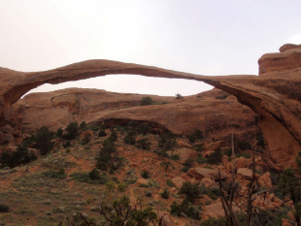
Landscape Arch

Landscape Arch is 289 feet tall. It is the longest natural arch in Arches National Park, Utah. Many geologists believe that it is the longest natural arch in the world. Landscape Arch was formed by the processes of weathering and erosion.

Other sample images can be found in the unit resources section.

Graphic Organizer
What landform is this? This is (a) ______.
(Draw and label)

BEFORE weathering and erosion  (Draw and label) | AGENT of weathering and erosion  (Draw and label) |  | AFTER weathering and erosion  (Draw and label)
CLAIM:  I think that the (agent) + (verb) + the (noun). | EVIDENCE:  I think this because the (noun) is (comparative). |  | CONCLUSION:  Therefore, weathering and erosion from (noun) + (verb) the (noun).
Sentence frames (suggested):  This is (a) ______ (noun).  These are ______ (plural noun).  I think that the (agent) + (verb) + the (noun).  I think this because the (noun) is (comparative).  Therefore, weathering and erosion from (noun) + (verb) the (noun). |  | Example:  This is a beach.  These are the dunes.  I think that the hurricane changed this beach.  I think this because the dunes are smaller.  Therefore, weathering and erosion from the hurricane changed the beach.

Unit Resources
Unit Targeted Academic Language
Genres/Text Types (Discourse Dimension)
Presentation, discussion, forum, informational texts, images, diagrams, online articles. Students will work with simple information about an event, experience, and/or topic using short sentences composed of simple or predictable phrases or sentences with a limited (i.e., initial) cohesion among sentence structures. Students will work with a brief sequence of events in order and/or introduction of a topic with supporting details using multiple, related, simple sentences containing content-area descriptions in grade-appropriate text or word problems with a loose cohesion of information and/or ideas using frequently occurring linking words, accomplished by repetition of words or phrases.

Grammatical Forms (Sentence Dimension)
Simple present and simple past, simple and compound sentences (and, but), prepositional phrases, common social and instructional patterns or forms, and comparatives.

Vocabulary (Word/Expression Dimension)
- Sequence signal words (first, then, next, finally, etc.)
- Cause and effect signal words (because, if, then, therefore, etc.)
- Claims and evidence vocabulary (I know because ______.)
- Linking words (and, or, but)
- Tier 1/sight words:
  - Nouns: rock, mineral, shell, plant, animal, water, salt, time, river, soil, ice, wind, tree, etc.
  - Verbs: to change, to collect, to move, to blow, to break, etc.
- Tier 2/multiple meaning words:
  - Nouns: weathering, erosion, landscape, layers, surface, acid, landforms, agents, formation, bottom, pieces, bits, sediment, process, result, climate, cause, effect, claim, evidence, etc.
  - Verbs: to deposit, to erode, to weather, to wedge, to flow, to dissolve, to transport, etc.

Resources Providing Background Information about Weathering and Erosion
- Overview of different kinds of weathering and deposition:
- “Erosion, deposition” slideshow
- “What Causes the Landscape to Be Different? Weathering, Erosion, Deposition” slideshow
- “Weathering” and “Erosion” (National Geographic Online Encyclopedia)
- “Earth's Processes: Weathering, Erosion, and Deposition Prezi” (LiveBinders Super Science Resources and Links for 4th Grade)

- Videos of weathering and erosion:
- “Weathering and Erosion” (United Streaming)
- “Drew Point, AK Time-Lapse Photography of Coastal Erosion” (USGS)
- “Vetiver and the Case of Eroding Soil—animation”
- “Heyelan-Land Slide 2”
- “AN BE AN TOPRAK KAYMASI” (video of Swiss landslide)

- Suggested sites with text and images of weathering and erosion:
- Photo Gallery: Erosion and Weathering (National Geographic)
- What is the Difference between Weathering and Erosion? (Virginia Department of Education)
- Weathering and Erosion (One Geology Kids)
- Photos of Weathering and Erosion (MarliMillerPhoto)

Useful Diagrams and Images
Agents of Weathering and Erosion
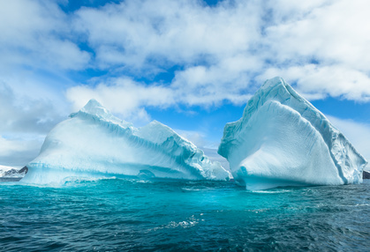
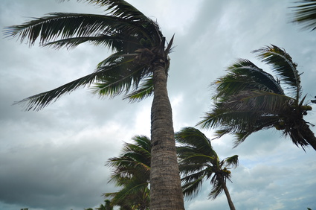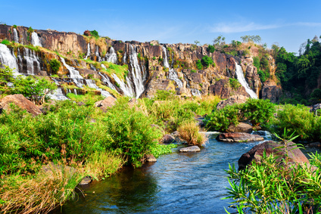
Ice
Wind
Water
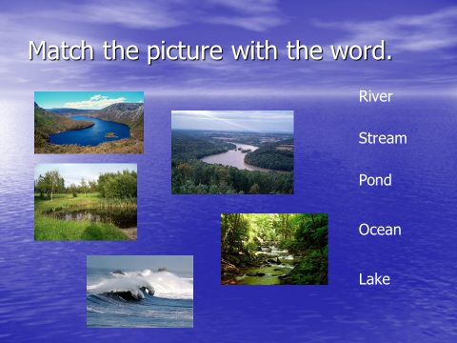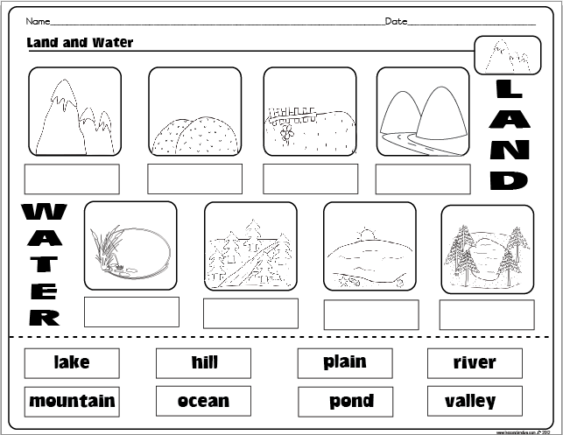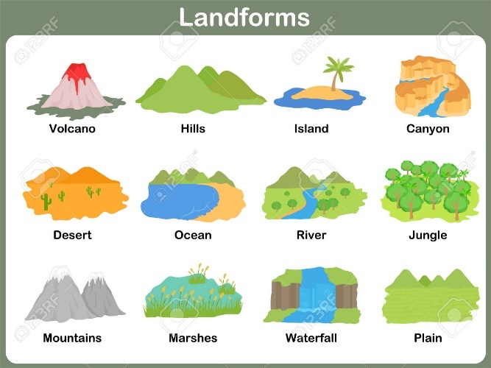
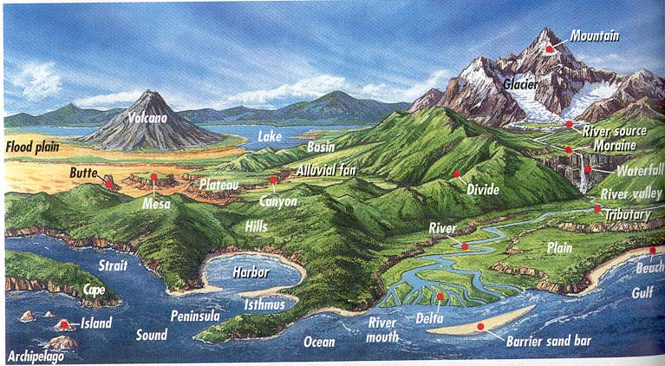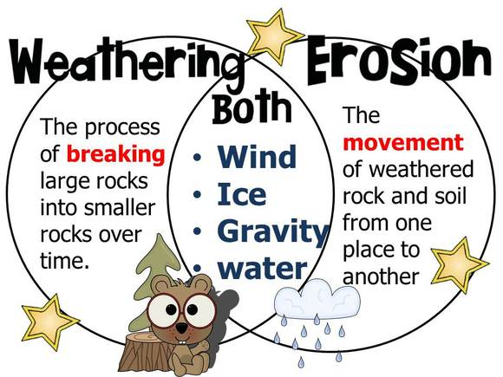

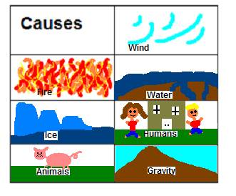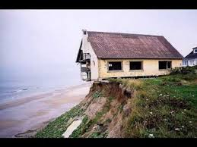

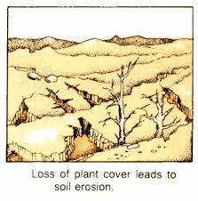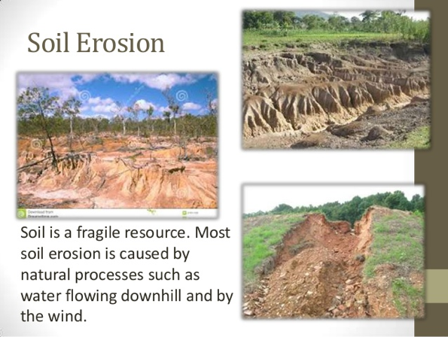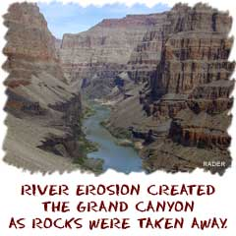

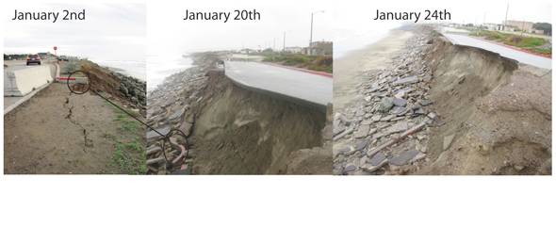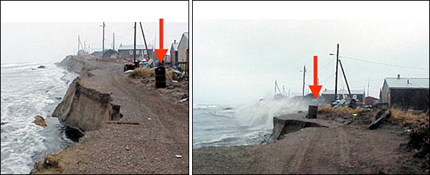
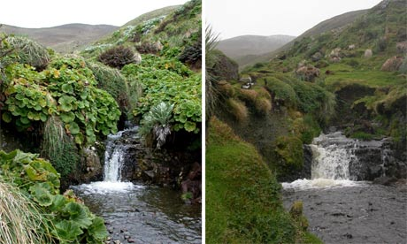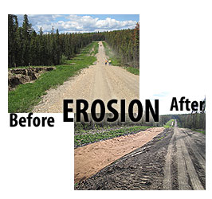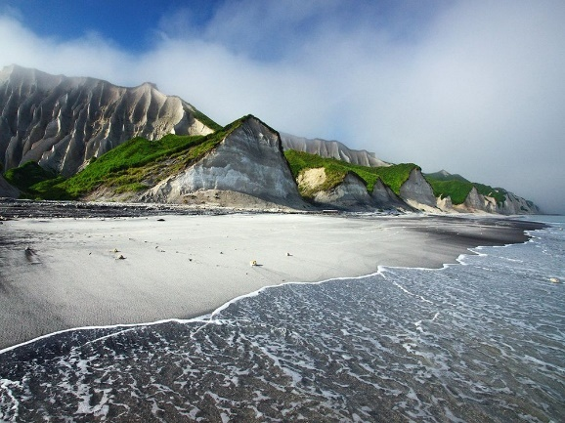
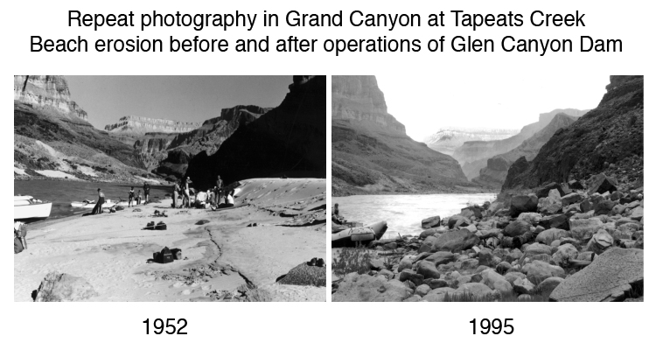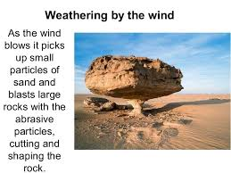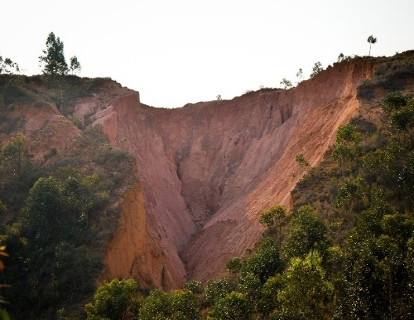
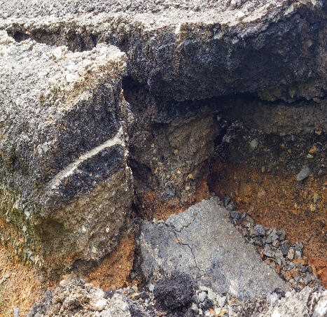* 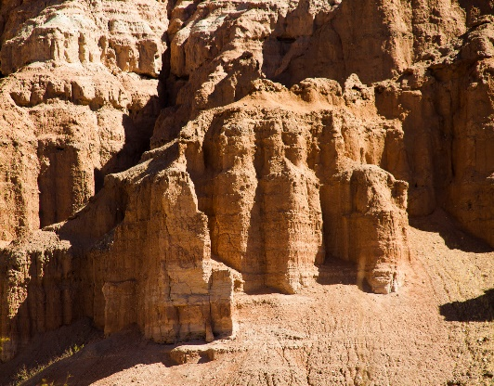 * 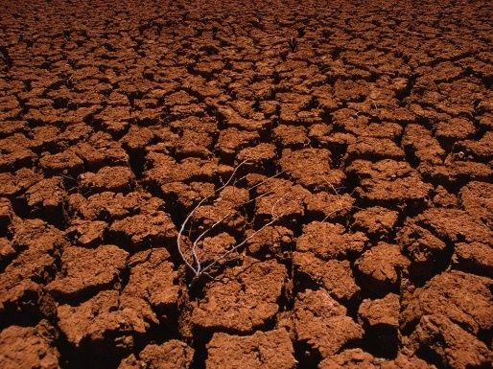

*Source: Photograph: Close up the hole in the side of the asphalt road collapsed because of rain erosion: Copyright: <a href='http://www.123rf.com/profile_keantian'>keantian / 123RF Stock Photo</a>

* Source: Photograph, Geological formation through centuries of wind erosion was constructed: Copyright: <a href='http://www.123rf.com/profile_hdcap'>hdcap / 123RF Stock Photo</a>

