ESL: Exploring Topics in African American Civil Rights
Social Instructional Language, Grades 9–12—English Language Proficiency Levels 1 and 2
For more information on the design process for the ESL MCUs, please see the Next Generation ESL Project: Curriculum Resource Guide.
This unit is intended to deliver systematic, explicit, and sustained English language development in the context of the Massachusetts Curriculum Frameworks. The purpose of this unit is to help ELs develop social and instructional language, as well as the language necessary for academic success in and in the content area of social studies. They will also learn language that will be used recurrently in and across various academic contexts.
The embedded language development of this unit centers on two of the Key Uses of Academic Language:
- Explain the causes and effects of key events of the Civil Rights Movement.
- Discuss by building upon ideas of others and articulating your own claims.
These unit-level Focus Language Goals were created through an analysis of the driving language demands of an existing Model Curriculum Unit on history and social science for grades 9–12: “African American Civil Rights Movement.” However, this ESL unit is not the same as a sheltered history and social science unit. It is intended to be taught by an ESL teacher, and collaboration with the content teacher is essential. It is also important to keep in mind that in addition to the dedicated, language-focused instruction outlined in this unit, English learners (ELs) must have access to all core academic content.
This unit offers students contextualized, extended practice with discourse, sentence, and word/phrase dimensions of academic language targeted in the unit. By the end of the unit, students will have had an opportunity to develop academic language they can use to discuss, explain causes and effects of, and argue about the importance of key Civil Rights Movement events. While learning about the real, complex issues of the Civil Rights Movement, students will create museum displays to educate others about this important period of American history.
This document was prepared by the Massachusetts Department of Elementary and Secondary Education, Mitchell D. Chester, Ed.D., Commissioner.
The Massachusetts Department of Elementary and Secondary Education, an affirmative action employer, is committed to ensuring that all of its programs and facilities are accessible to all members of the public. We do not discriminate on the basis of age color, disability, national origin, race, religion, sex, or sexual orientation.
© 2016 under the terms of the Creative Commons Attribution-NonCommercial-ShareAlike 3.0 Unported License. Additionally, the unit may also contain other third party material used with permission of the copyright holder. Please see Image and Text Credits for specific information regarding third copyrights.
Every effort has been made to acknowledge copyright. Any omissions brought to our attention will be corrected in subsequent editions. Image and text credits are cited at the end of the unit.

The contents of this Model Curriculum Unit were developed under a grant from the U.S. Department of Education. However, those contents do not necessarily represent the policy of the U.S. Department of Education, and you should not assume endorsement by the federal government.
Massachusetts Department of Elementary and Secondary Education, 75 Pleasant St, Malden, MA 02148-4906. Phone 781-338-3300, TTY: N.E.T. Relay 800-439-2370, www.doe.mass.edu

Table of Contents
Unit Plan 4
Lesson 1 11
Lesson 2 33
Lesson 3 47
Lesson 4 69
Lesson 5 81
Lesson 6 99
Lesson 7 117
Lesson 8 128
Lesson 9 133
Lesson 10 146

Unit Plan
Stage 1—Desired Results
ESTABLISHED FOCUS GOALS: G  Focus Language Goals/Standards:  G.1 Explain the causes and effects of key events of the Civil Rights Movement.  G.2 Discuss by building upon ideas of others and articulating your own claims.  Content Connections  The student is building toward:  CCSS.ELA-LITERACY.W.9-10.2. B—Develop the topic with well-chosen, relevant, and sufficient facts, extended definitions, concrete details, quotations, or other information and examples appropriate to the audience's knowledge of the topic.  CCSS.ELA-LITERACY.WHST.11-12.1.C—Use words, phrases, and clauses as well as varied syntax to link the major sections of the text, create cohesion, and clarify the relationships between claim(s) and reasons, between reasons and evidence, and between claim(s) and counterclaims.  CCSS.ELA-LITERACY.W.9-10.7—Conduct short as well as more sustained research projects to answer a question (including a self-generated question) or solve a problem; narrow or broaden the inquiry when appropriate; synthesize multiple sources on the subject, demonstrating understanding of the subject under investigation.  CCSS.ELA-LITERACY.SL.9-10.1. A—  Come to discussions prepared, having read and researched material under study; explicitly draw on that preparation by referring to evidence from texts and other research on the topic or issue to stimulate a thoughtful, well-reasoned exchange of ideas.  CCSS.ELA-LITERACY.L.11-12.3—Apply knowledge of language to understand how language functions in different contexts, to make effective choices for meaning or style, and to comprehend more fully when reading or listening.  USII.25—Analyze the origins, goals, and key events of the Civil Rights Movement. | Transfer
Students will be able to independently use their learning to… T
T.1 Communicate for social and instructional purposes within school setting.
T.2 Communicate information, ideas, and concepts necessary for academic success in the content area of social studies.
 | Meaning
 | UNDERSTANDINGS U  Students will understand that...  U.1 How we use language can clarify the relationship between events and ideas.  U.2 The style of language used (informal vs. formal) depends upon the situation.  U.3 We can use language to articulate our own opinion and to build upon the ideas of others.  U.4 Individual people, events, speeches, and protests can cause powerful change. | ESSENTIAL QUESTIONS Q  Q.1 How can I use language to clarify the relationship between events and ideas?  Q.2 How can I use language to illustrate and present my opinion?  Q.3 How can I build upon the ideas of others in a discussion?  Q.4 How can individual people and events change history?
 | Language Acquisition in the Four Domains
 | KNOWLEDGE K  Students will know…  K.1 Signal words used to identify cause and effect (e.g., because, as a result, then, due to, this led to, since, in order to, for this reason).  K.2 Modifiers to describe the Civil Rights Movement, such as adjectives (e.g., unfair, fair, equal, powerful, inspiring, wrong, separate, brave, courageous, bad, right).  K.3 Past tense of regular and irregular verbs related to the Civil Rights Movement (e.g., march/marched, walk/walked, talk/talked, speak/spoke, sit/sat, ride/rode, is/was, throw/threw, go/went, hit/hit).  K.4 Content-specific vocabulary pertaining to the Civil Rights Movement (e.g., equality, rights, segregation, freedom).  K.5 Simple sentence structure.  K.6 Structure of short informational paragraphs composed of multiple, simple sentences that incorporate frequently used linking words.  K.7 Common academic discussion norms (e.g., building on ideas of others, stating opinions respectfully).  K.8 How individuals can cause change.  K.9 Argument-related language (e.g., claim, reason, evidence, agree, disagree, opinion) | SKILLS S  Students will be skilled at…  S.1 Describing causes and effects about Civil Rights Movement events using the past tense.  S.2 Discussing claims about Civil Rights events and leaders.  S.3 Participating in collaborative academic discussions.  S.4 Summarizing information about key Civil Rights Movement events and leaders using the past tense.  S.5 Orally stating a claim and supporting it relevant with evidence.
Stage 2—Evidence
EVALUATIVE CRITERIA | ASSESSMENT EVIDENCE: Language Development
- Effective use of modifiers such as adjectives (e.g., unfair, fair, equal, powerful, inspiring, wrong, separate, brave, courageous, bad, right) to describe Civil Rights Movement events and leaders.  - Appropriate use of past tense to describe historical events (e.g., march/marched, walk/walked, talk/talked, speak/spoke, sit/sat, ride/rode, is/was, throw/threw, go/went, hit/hit).  - Effective use of cause and effect signal words (e.g., because, as a result, then, due to, this led to, since, in order to, for this reason). to describe causes and effects, state claims, and summarize events.  - Accurate use of argument-related language (e.g., claim, reason, evidence, agree, disagree, opinion) to state claims/opinions and build on/evaluate the ideas of others during academic discussions.  - Appropriate use of social instructional language (e.g., I learned, I wonder) to respond to presentations observed. | CURRICULUM EMBEDDED PERFORMANCE ASSESSMENT (Performance Tasks) PT  As a result of:  - Summarizing events using cause/effect language  - Reading and summarizing abridged texts about Civil Rights Movement protests and leaders  - Articulating ideas and building on others’ ideas via discussion  - Discussing claims about Civil Rights Movement leaders and events  Students will create museum displays explaining causes and effects of the Civil Rights Movement and summarizing research they have conducted about its events and leaders individually and/or in small groups. Museum displays will include appropriate use of adjectives, past tense, cause and effect signal words, and argument-related language to summarize information and form claims about the Civil Rights Movement. Each museum display will include:  - Information about the event (facts)  - Statements describing cause(s) of the event  - Statements describing effect(s) of the event  - Explanation summarizing what happened and stating an evidence-supported claim about the event’s importance (individual work, illustrating a student’s own perspective on the event)  Students will showcase their displays in a class exhibition about the Civil Rights Movement where they will present their individual work and listen to other students’ presentations. During the exhibition, students will engage in constructive academic conversations about each other’s’ displays.
OTHER EVIDENCE OE
Formative assessments: table discussions, class summary, describing images using adjectives, responding to texts, using vocabulary in context, dialogue frames, graphic organizers
Stage 3—Learning Plan
SOCIOCULTURAL IMPLICATIONS:
Register:
Delivering an oral presentation may be a new concept for some students.
Topic:
- Students may have experienced discrimination in their home countries or in the United States. Discussing the Civil Rights Movement may evoke painful memories.
- Some students may bring biases toward different cultures/races/religions from various groups they identify with. It may be important to highlight that insults toward any group of people are not acceptable or appropriate in the classroom.
Task/situation:
- Students may be unfamiliar with museums (their structure, setup, displays, etc.).
- Students may be unfamiliar with academic conversations and collaborative group norms. Students may follow different social norms from those expected in American classrooms such as speaking out of turn, taking turns by standing up, asking follow-up questions, expecting all participants to participate at every turn, etc.
- Identity and social role: Being a presenter (especially presenting on their own) may be a new role for some students.
- Students may come from cultures where expressing one’s opinion and/or challenging the opinions of others is not encouraged or is seen as disrespectful.
- Identity and social role: some students may identify with more violent forms of protest because of their own cultural or historical backgrounds, and may balk at or disapprove of non-violent protesting methods used by Civil Rights Movement leaders.
SUMMARY OF KEY LEARNING EVENTS AND INSTRUCTION
Lesson 1: Day 1—Building Background Knowledge about Key Topics and Concepts
- Language objective: Students will be able to orally discuss the Civil Rights Movement using equality, freedom, rights, and segregation.
- Brief overview of lesson: Students will be introduced to some of the key vocabulary and concepts of the Civil Rights Movement, including equality, freedom, rights and segregation. Through a class discussion, students will begin to familiarize themselves with and practice basic collaborative discussion skills. The lesson will conclude with students creating visual representations of the key vocabulary and concepts.
Lesson 2: Day 2—Describing the Civil Rights Movement with Adjectives
- Language objective: Students will be able to describe images from the Civil Rights Movement orally and in writing using adjectives.
- Brief overview of lesson: Students will learn adjectives that can be useful for describing the Civil Rights Movement. Students will use these adjectives to describe images about the topic during a gallery walk. They will continue to develop collaborative discussion skills and the language they will need to successfully complete the CEPA. The lesson will conclude with an opportunity for students to write a brief description of selected images from the Civil Rights Movement using adjectives.
Lesson 3: Days 3 and 4—Learning about the Past Tense
- Language objective: Students will be able to discuss historical events using verbs in the past tense and adjectives.
- Brief overview of lesson: Students will learn about the past tense and how it can be used to discuss historical events. They will learn past tense rules for regular and irregular verbs, apply this knowledge to conjugate verbs in the past tense, and practice identifying verbs in the past tense in first-hand accounts describing life during Jim Crow America and the years before and after Brown v. Board of Education. Students will also practice writing their own phrases and/or sentences in the past tense. These experiences will help students develop an understanding ability to use a verb tense necessary for completing the CEPA. Finally, students will begin learning about summarizing.
Lesson 4: Days 5 and 6—Making Evidence-Supported Claims
- Language objective: Students will be able to articulate and discuss evidence-based claims and opinions about the Civil Rights Movement using argument-related language (e.g., claim, reason, evidence, agree, disagree, opinion).
- Brief overview of lesson: Students will learn how to support claims and opinions with relevant evidence. During day 5, they will practice differentiating between facts and opinions; on day 6, they will create statements supported by evidence and discuss their opinions with peers using discussion frames. This lesson will also help students continue developing collaborative discussion skills. These learning experiences will help students develop skills essential to creating the CEPA. Day 6 can serve as the language checkpoint for the unit, giving teachers an opportunity to measure student progress toward unit Focus Language Goals.
Lesson 5: Day 7—Exploring Cause and Effect Signal Words
- Language objective: Students will be able to discuss causes and effects of Civil Rights Movement events using related signal words (e.g., because, as a result, then, due to, this led to, since, in order to, for this reason).
- Brief overview of lesson: Students will learn to identify signal words of cause and effect, and what these words mean. They will also identify causes and effects in a text and apply their knowledge of cause and effect language to learn about the Montgomery bus boycott. This lesson will also provide students opportunities to develop the language needed to discuss relationships between events and/or ideas.
Lesson 6: Days 8 and 9—Using Cause and Effect Language
- Language Objective: Students will be able to summarize and discuss causes and effects of Civil Rights Movement events using related signal words (e.g., because, as a result, then, due to, this led to, since, in order to, for this reason).
- Brief overview of lesson: Students will apply what they learned about signal words of cause and effect. They will revisit prior texts to identify cause and effect statements, then apply this technique to new texts. These experiences will help students develop an understanding of how language can illustrate relationships between events. Students will also practice writing cause and effect statements about civil eights events to summarize what happened, a foundational skill for the CEPA.
Lesson 7: Day 10—Museum “Field Trip”
- Language Objective: Students will be able to orally discuss a teacher-created museum display using sentence frames.
- Brief overview of lesson: Students will examine a teacher-created museum display, and listen to the teacher present it. The presentation will include an introduction of the event and a summary of what happened during the event, a discussion of causes and effects of the event, and an explanation of the event’s significance. Afterwards, students will have an opportunity to discuss causes and effects presented and why the event was important. They will also have a chance to use discussion frames to ask questions about the event. These will serve as a model for how students should present and discuss museum displays during the CEPA.
Lesson 8: Day 11—Summarizing a Shared Experience
- Language Objective: Students will be able to summarize their experience viewing a museum display and listening to a related presentation in writing.
- Brief overview of lesson: The teacher will model writing a summary of the museum “field trip” from Lesson 7, highlighting verbs in the past tense, adjectives, causes and effects, summary of the event, and explanation of the event’s importance. Then students will do a choral reading of the teacher-prepared summary before writing their own summary of the visit using provided paragraph frames and sharing it with the whole class. The summary writing process gives teachers an opportunity to check students’ ability to use targeted language and skills introduced so far in the unit. It also allows students to practice essential skills they will use when creating their own museum displays. This lesson also helps students prepare for the CEPA and work toward achieving unit goals as they practice orally using learned language; explaining and listening to claim, cause, and effect statements; and engaging in a discussion about the topic.
Lesson 9: Days 12, 13, and 14—Creating Museum Displays (CEPA Part 1)
- Language Objectives:
  - Day 12: Students will be able to identify and summarize information about a Civil Rights Movement event.
  - Day 13: Students will be able to describe causes and effects of a Civil Rights Movement event in writing.
  - Day 14: Students will be able to argue about the significance of a Civil Rights Movement event by stating a claim and supporting it with relevant evidence in writing.
- Brief overview of lesson: Students will collaborate to create their museum display over three days. On Day 12, they will collect and organize information regarding one event from the Civil Rights Movement from teacher provided resources, identifying facts about their focus event. On Day 13, they will collaboratively draft cause and effect statements about their event and match visuals to the statements, incorporating this information into their displays. On Day 14, each student will write an explanation summarizing what happened in the event and stating an evidence-supported claim about the event’s importance using sentence and/or paragraph frames, teacher models, and word banks. Students will also practice presenting their opinions to peers. Throughout this three-day lesson, teachers will be able to assess students’ ability to form verbs in the past tense.
Lesson 10: Day 15—Museum Exhibit (CEPA Part 2)
- Language Objective: Students will be able to orally discuss causes and effects of a Civil Rights Movement event and argue about its significance.
- Brief overview of lesson: Students will present their museum displays, creating a full exhibit about the Civil Rights Movement. They will summarize the event, describe its causes and effects, and explain its significance. Students will then answer questions about their displays. Through student presentations, teachers will be able to assess student progress toward unit goals.
Adapted from Understanding by Design®. © 2012 Grant Wiggins and Jay McTighe. Used with permission.

Lesson 1  Day 1 | Building Background Knowledge about Key Topics and Concepts | Estimated Time: 60 minutes
Brief overview of lesson: Students will be introduced to some of the key vocabulary and concepts of the Civil Rights Movement, including equality, freedom, rights and segregation. Through a class discussion, students will begin to familiarize themselves with and practice basic collaborative discussion skills. The lesson will conclude with students creating visual representations of the key vocabulary and concepts. As you plan, consider the variability of learners in your class and make adaptations as necessary.

What students should know and be able to do to engage in this lesson:
- Familiarity with simple present tense.
- Familiarity with question words.
- Familiarity with whole-class discussions.
LESSON FOUNDATION
Unit-Level Focus Language Goals to Be Addressed in This Lesson |  | Unit-Level Salient Content Connections to Be Addressed in This Lesson
G.2 Discuss by building upon ideas of others and articulating your own claims. |  | CCSS.ELA-LITERACY.L.11-12.3—Apply knowledge of language to understand how language functions in different contexts, to make effective choices for meaning or style, and to comprehend more fully when reading or listening.  USII.25—Analyze the origins, goals, and key events of the Civil Rights Movement.
Language Objective |  | Essential Questions Addressed in This Lesson
Students will be able to orally discuss the Civil Rights Movement using equality, freedom, rights, and segregation. |  | Q.3 How can I build upon the ideas of others in a discussion?  Q.4 How can individual people and events change history?
Assessment
- Formative assessment: Draw on students’ use of the basics of collaborative discussion and their use of content-specific language (e.g., equality, freedom, rights, segregation) during class discussion and partner discussions.
- Formative assessment: Use student-created visual representations of key vocabulary to assess student identification of and application of language to summarize key vocabulary.
Thinking Space: What Academic Language Will Be Practiced in This Lesson?
Discourse Dimension | Sentence Dimension |  | Word Dimension
Social instructional language; listening to, reading, and producing single statements or sentences providing basic information; listening and responding to others during collaborative discussions | Simple sentences in present tense |  | Content-specific vocabulary (equality, rights, segregation, freedom, civil, movement)
Instructional Tips/Strategies/Suggestions for Teacher
- Have a collection of images from the Civil Rights Movement posted in the room. Sequence images chronologically (for example, Jim Crow, segregated schools, Brown v. Board of Education, Montgomery bus boycott, Little Rock Nine, sit-ins, civil rights protest in Birmingham, March on Washington [1963], passage of the Civil Rights Act [1964], Selma march [1965], passage of the Voting Rights Act [1965]) to create a visual timeline. This visual timeline can help preview key concepts students will discuss in the unit, help activate any prior knowledge students may have about the topic, and heighten student engagement and interest in the unit.
- Freedom, equality, and rights are abstract concepts. Consider spending additional time providing concrete examples of these concepts.
- Students’ background knowledge about the Civil Rights Movement may vary. This lesson may need to be extended to help students develop a deeper understanding of key unit vocabulary and concepts introduced in this lesson.
- Use formative assessments to inform future instruction. For example, if assessments reveal the need for a concept to be reviewed or discussed further, make necessary adjustments to upcoming lessons.

STUDENT CONSIDERATIONS
Sociocultural Implications
Some students may bring biases toward different cultures/races/religions from various groups they identify with. It may be important to highlight that insults toward any group of people are not appropriate or acceptable in the classroom.
Anticipated Student Pre-Conceptions/Misconceptions
- Students may already know about the Civil War and think that African American civil rights were achieved earlier in American history.
- Students may think that, since there is freedom in the United States today, there was never any racial segregation.
- Students may think that keeping people of different races separate does not interfere with racial equality (that separate can be equal).

THE LESSON IN ACTION

Lesson Opening

Post and explain the lesson’s language objective so students can see and understand it: “Students will be able to orally discuss the Civil Rights Movement using equality, freedom, rights, and segregation.” To promote student ownership and self-monitoring of learning, consider having students record the objective in their notebooks or having students summarize the objective in their own words. At the end of the lesson, students can reflect on their learning in relation to the objective.

Post the words “The Civil Rights Movement” on the board and introduce the unit. For example, say: “Today we are starting a new unit. In this unit we will learn language to help us to discuss the Civil Rights Movement. Today we are going to study key vocabulary and concepts to help us discuss the Civil Rights Movement.” Make connections to social studies/history classes about this topic that students may have participated in.

Set up a visual timeline with images from the Civil Rights Movement and display the teacher-created museum display showcasing the unit’s CEPA. For sample Civil Rights Movement images, see the lesson resources.

Draw student attention to the timeline. For example, say: “Let’s take a look at some images from the Civil Rights Movement. Look closely at each image. Look for details that tell you what was happening during this time.”

Model how to describe what students notice in the images using sentence frames, such as “I think…” and “I notice …”

Give students with some time to view timeline images and the museum display, allowing them to preview the culminating performance task ahead of time.

Circulate around the room as students are reviewing the timeline and exhibit. Prompt student thinking with questions such as: “What do you see?” “What do you notice?”
Provide options for physical action, such as pointing, answering orally, writing, or drawing.
Provide options for perception, such as providing students with printed images to view at their desks or having students view the images on a computer. For a sample digital collection of Civil Rights Movement images, see CNN’s “Civil Rights Movement in Photos” gallery.

During the Lesson

Revisit the posted phrase “The Civil Rights Movement” and activate prior knowledge and interest by eliciting students’ input about what they already know and what they want to learn about the topic.

Post two pieces of chart paper, one titled “Know” and the other titled “Want to Know.” Give students time to reflect quietly and think about what they already know and what they want to know about the Civil Rights Movement.

Ask students to turn and talk about their ideas with a partner. Post sentence frames for sharing such as “I know…”; “I remember…”; “I want to know…”; “I wonder…”; “I think…” and model how to use them when talking to partners. Explicitly model the basics of collaborative discussion (e.g., turn-taking, building on others’ ideas, clarifying, agreeing). Working with a partner or in a small group allows students time to build and share their own ideas before turning to the whole group, where not all students are as comfortable sharing.

Invite the whole class to a discussion about what students know/want to know using a know–want to know–learned (K-W-L) chart. Ask partners to report out what they discussed and record information on the K-W-L chart.
Provide options for engagement, such as printed images that students can hold up while they share.

Explain the purpose of the unit further.

Go over Focus Language Goals. For example, say: “Through the course of this unit, we will be studying language to help us discuss the Civil Rights Movement. By the end of the unit, you will be able to use adjectives to describe events that occurred during the Civil Rights Movement. You will also be able to describe causes and effects of events that occurred during the Civil Rights Movement. In addition, you will be able to state opinions supported by evidence and discuss your opinions with others.

Introduce the CEPA by showcasing the sample museum display. For example, say: “By the end of the unit, you will be able to create and present your own museum display.” Showing the exhibit ahead of time helps to increase student engagement and excitement.

Teach unit vocabulary. For example, say: “Let’s learn some vocabulary that we will use throughout the unit.”

Teach key vocabulary such as equality, rights, segregation, and freedom. You may also wish to teach the meaning of discrimination, civil, and movement. Use the seven-step vocabulary teaching method or another similar comprehensive vocabulary teaching strategy. Create a word wall. Consider having students create vocabulary journals to encourage students to write, use images, or build their own contextual examples of target vocabulary.
Provide options for recruiting interest, such as the use of native language dictionaries, drawing or selecting images for definitions, and visual dictionaries such as Shahi or Visuwords.
Provide options for perception, such as using concrete examples to illustrate the vocabulary. For example, to teach the concept of equality, use popcorn or candy. Give more to some students, less to others, and none to some students; then ask them if the popcorn/candy distribution was fair. When students say no, ask them to describe what would be fair and why. When students suggest handing the candy out equally, connect this experience to the concept of civil equality by highlighting how civil liberties can often be distributed in different ways to different people based on their characteristics (race, socioeconomic status, gender, etc.).

After defining vocabulary, provide options for engagement, such as having students come up with their own examples of each word. This helps to make the terms relevant to students and their experiences.

Optional activity: Ask students to create a foldable of key vocabulary.

Review background information about the Civil Rights Movement using the K-W-L chart to confirm what students already know. Depending on their familiarity with the Civil Rights Movement, consider:

Showing a video clip such as “Segregation” (from Locked Out: The Fall of Massive Resistance). The first four minutes of this video can help reinforce for students what life was like in segregated America before the Civil Rights Movement and contextualize the movement’s events.
Provide options for perception, such as providing a video transcript for students, enabling closed captioning on the video, adjusting the speed of the video, and showing the video several times if necessary.

Reading excerpts from a text such as Miles to Go for Freedom: Segregation and Civil Rights in the Jim Crow Years by Linda Barrett Osborne.

Showing a map of locations where different segregation laws were enforced, such as this sixties segregation map (available below).

Provide options for perception, such as giving students a printed version of the map or having students view the map on a computer.

Revisiting the timeline to contextualize events students reviewed and/or learned about during the lesson. Point out key events that will be discussed in the unit.

While reviewing background information about the Civil Rights Movement, help students to begin to think about how the movement’s leaders and events helped to change the nation and shape history. Ask students to think about how life is different today because of the Civil Rights Movement. Students can turn and talk with a partner or record their thoughts in a notebook or journal.

Lesson Closing

Ask students to create a visual representation of one of the key vocabulary words (equality, rights, segregation, or freedom). This could be an illustration of what the student thinks of when they hear the word, an image to illustrate the concept, or a word splash of all the words and concepts that they associate with the word. Give students time to create their visual representations individually.
Provide options for perception, such as drawing or using Microsoft Paint.

Alternate activity: Provide images related to the words/topic and ask students to place vocabulary words written on Post-Its on an image they think illustrates the word.

Optional activity: Have students explain their illustrations, telling why they illustrated the concept the way they did to a partner or the whole class.

After students create their visual representations, have them to share their image with a partner, making “I wonder…” and “I think…” statements about the vocabulary and each other’s visual representations. Prompt students to use the basics of collaborative discussion.

Post students’ visual representations by the class word wall.

Optional activity: Prompt student thinking with reflective questions such as “What does equality mean to you?” “What does freedom mean to you?” Have students answer the questions orally, in writing, by drawing, or by starting a reflection/reaction journal of their reactions to the Civil Rights Movement to be used throughout the unit.

Lesson 1 Resources
- Whiteboard or computer with projector
- Student notebooks
- Chart paper
- Student-friendly dictionaries
- Word walls
- Optional resources:
  - Video: “Segregation” segment from Locked Out: The Fall of Massive Resistance
  - Book: Miles to Go for Freedom: Segregation and Civil Rights in the Jim Crow Years, by Linda Barrett Osborne
  - Map: sixties segregation map (also available below)
- Images of the Civil Rights Movement for posting in the classroom, available at the Library of Congress’s “Voices of Civil Rights” online exhibition, or in CNN’s “The Civil Rights Movement in Photos” gallery (samples also available below)
- Seven-step vocabulary teaching method (examples available below)
- Sentence frames for discussing images (available below)

Sentence Frames for Discussing Images
Print and provide students with the sentence frames for discussion as needed.

I know…
I remember…
I want to know…
I wonder…
I wonder…… because……
I think…
I think……. because……
So you are saying…
More than anything else, I think…
Can you elaborate?
Sample Timeline Images
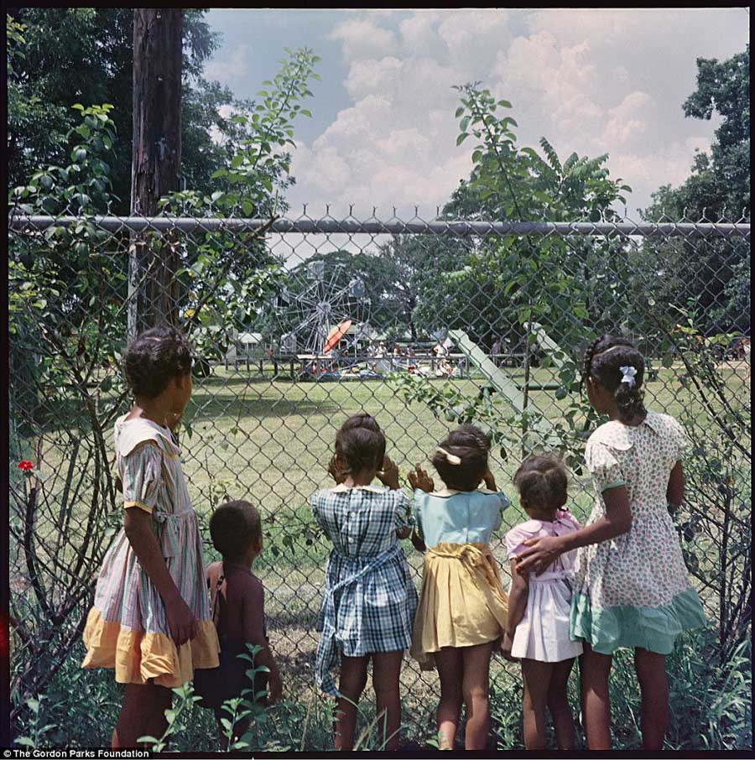
Source: The Gordon Parks Foundation
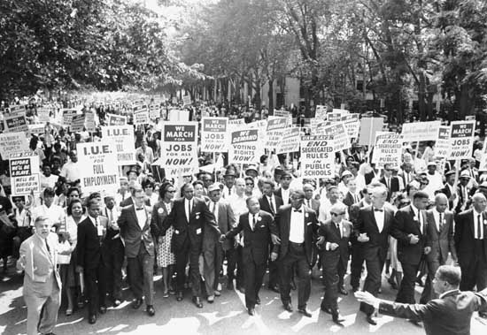
Source: March on Washington for Jobs and Freedom, Martin Luther King, Jr. and Joachim Prinz pictured, United Press International
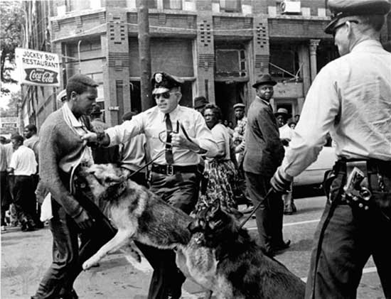
Source: Associated Press/Bill Hudson

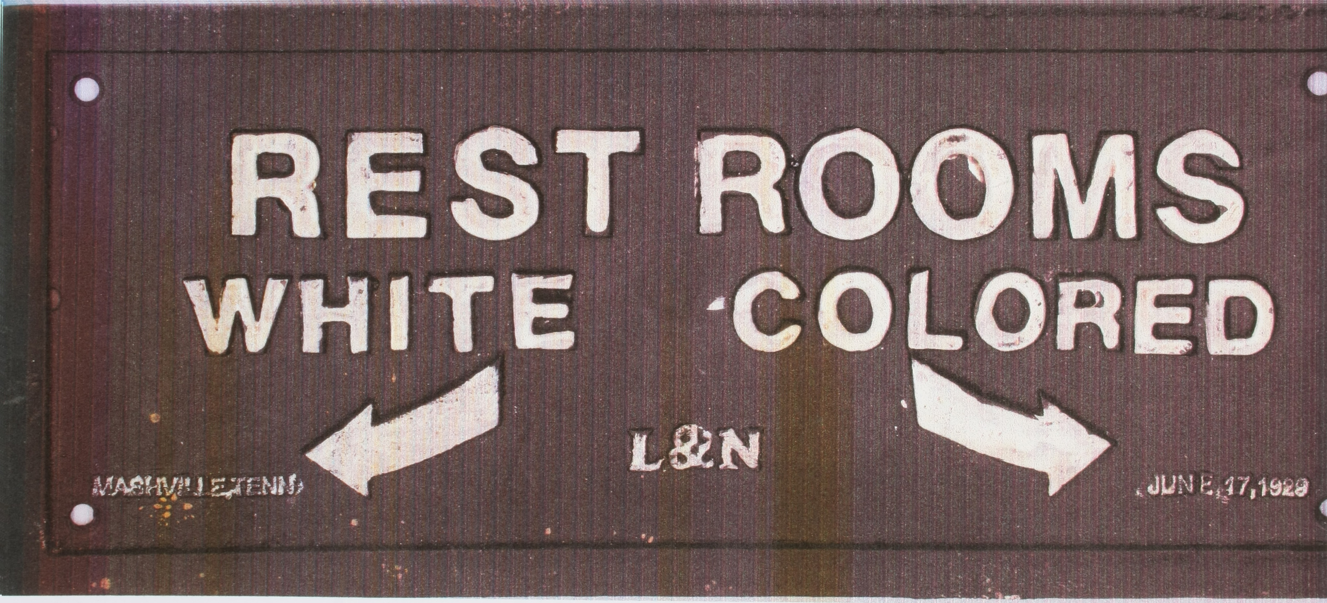
Source: Photograph, Restroom sign, The Louisville & Nashville Railroad Historical Society

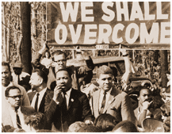
Source: Photograph, We Shall Overcome
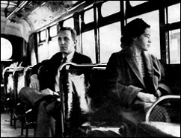
Source: United Press International
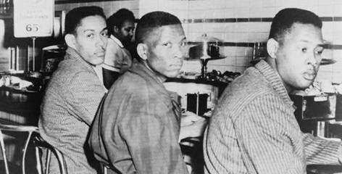
Source: Ronald Martin, Robert Patterson, and Mark Martin stage sit-down strike after being refused service at a F.W. Woolworth luncheon counter, Greensboro, N.C., United Press International, 1960. Courtesy United Press International
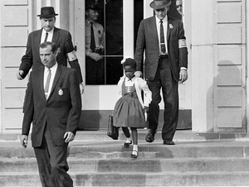
Source: Associated Press
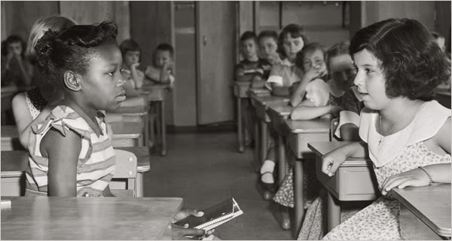
Source: Photograph, First Day of Desegregation 1954

Seven-Step Vocabulary Teaching Method Examples
1. Equality

Steps | Example
Teacher says the word. Student repeats. | Equality, equality, equality
Teacher states the word in context from the mentor text. | (Based on lesson mentor text.)
Teacher provides the dictionary definition(s). | According to Merriam-Webster’s Collegiate Dictionary, equality means “the quality or state of being equal: the quality or state of having the same rights, social status, etc.”
Teacher explains meaning with student-friendly definitions. | Equality means that everyone is treated the same.
Teacher highlights features of the word (polysemous meanings, cognate, tense changes, common prefixes, other forms of the word, etc.). | - Equality is a noun. It is a thing or an idea.  - When I want to say there is equality, I can say things are equal. Equal is an adjective that describes or gives more information about a thing, person, animal, or idea.  - Another related word is inequality. It has the prefix in-, meaning “the opposite of.” So inequality is the opposite of equality—or when there is no equality.
Teacher engages students in activities to develop word/concept knowledge. | - A one-minute TTYP (turn to your partner), in which partners use the word five or six times in complete thoughts or sentences. Each partner goes right after the other, ping pong style, so sharing is equal. To make sure partners are working well, teachers can check in once in a while by asking: “Who wants to tell me what your partner said?”  - A think-pair-share with a prompt and sentence frames:  Prompt: What do you think it means to be treated equally?  Sentence frames: “I think being treated equally means…”; “I believe being treated equally means…”; “I wonder…”
Teacher reminds and explains to students how new words will be used. There is no writing by students at this time. | In this unit we will be learning about the Civil Rights Movement. We will be discussing whether or not there was equality in the United States. We will be talking about whether all people were treated the same, with the same rights.

2. Freedom

Steps | Word: Freedom
Teacher says the word. Student repeats. | Freedom, freedom, freedom
Teacher states the word in context from the mentor text. | (Based on lesson mentor text.)
Teacher provides the dictionary definition(s). | According to Merriam-Webster’s Collegiate Dictionary, freedom means: “the quality or state of being free…”
Teacher explains meaning with student-friendly definitions. | Freedoms means that you can do what you want (with limits).
Teacher highlights features of the word: polysemous, cognate, tense, prefixes, etc. | Freedom is a noun—it is a thing or an idea.
Teacher engages students in activities to develop word/concept knowledge. | - A one-minute TTYP (turn to your partner), in which partners use the word five or six times in complete thoughts or sentences. Each partner goes right after the other, ping pong style, so sharing is equal. To make sure partners are working well, teachers can check in once in a while by asking: “Who wants to tell me what your partner said?”  - Translation of the word.  - A think/pair/share with a prompt and sentence frames:  Prompt: What does freedom mean to you?  Sentence frames: “I think…”; “I believe…”; “I wonder…”
Teacher reminds and explains to students how new words will be used. There is no writing by students at this time. | You will be learning about the Civil Rights Movement. You will be discussing whether there was freedom in the nation.

3. Segregation

Steps | Word: Segregation
Teacher says the word. Student repeats. | Segregation, segregation, segregation
Teacher states the word in context from the mentor text. | (Based on lesson mentor text.)
Teacher provides the dictionary definition(s). | According to Merriam-Webster’s Collegiate Dictionary, segregation means “the practice or policy of keeping people of different races, religions, etc., separate from each other”
Teacher explains meaning with student-friendly definitions. | Segregation means that people from certain groups are kept away from other groups.
Teacher highlights features of the word: polysemous, cognate, tense, prefixes, etc. | Segregation is a noun—it is a thing or an idea.
Teacher engages students in activities to develop word/concept knowledge. | - A one-minute TTYP (turn to your partner), in which partners use the word five or six times in complete thoughts or sentences. Each partner goes right after the other, ping pong style, so sharing is equal. To make sure partners are working well, teachers can check in once in a while by asking: “Who wants to tell me what your partner said?”  - A think/pair/share with a prompt and sentence frames:  Prompt: Show images from segregated America.  Sentence frames: “I think…”; “I believe…”;” I wonder…”
Teacher reminds and explains to students how new words will be used. There is no writing by students at this time. | You will be learning about the Civil Rights Movement. You will be discussing whether how life was segregated and what the impact of segregation was.

4. Rights

Steps | Word: Rights
Teacher says the word. Student repeats. | Rights, rights, rights
Teacher states the word in context from the mentor text. | (Based on lesson mentor text.)
Teacher provides the dictionary definition(s). | According to Merriam-Webster’s Collegiate Dictionary, the word rights means “… something that a person is or should be morally or legally allowed to have, get, or do.”
Teacher explains meaning with student-friendly definitions. | Rights mean that you have things to which you are entitled or allowed; freedoms that are guaranteed.
Teacher highlights features of the word: polysemous, cognate, tense, prefixes, etc. | Right is a noun—it is a thing or an idea.  Right is a multiple-meaning word.
Teacher engages students in activities to develop word/concept knowledge. | - A one-minute TTYP (turn to your partner), in which partners use the word five or six times in complete thoughts or sentences. Each partner goes right after the other, ping pong style, so sharing is equal. To make sure partners are working well, teachers can check in once in a while by asking: “Who wants to tell me what your partner said?”  - Teacher can have an anchor chart of rights that are federally protected. The chart could include the rights protected by the Reconstruction Amendments (e.g., voting, freedom, equal protection). Students can think/pair/share about other rights they may add using sentence frames such as: “I think…”; “I believe…”; “I wonder…”
Teacher reminds and explains to students how new words will be used. There is no writing by students at this time. | You will be learning about the Civil Rights Movement. You will be discussing if what rights are.

Segregation Map
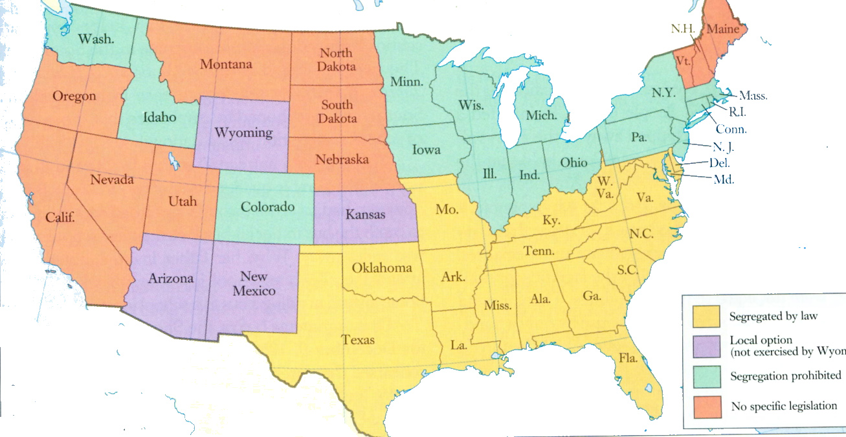
Source: http://www.mrose.longwoodteachers.com/8th%20Civil%20Rights%20and%20the%20Sixties/segregation_map2.jpg

Lesson 2  Day 2 | Describing the Civil Rights Movement with Adjectives | Estimated Time: 60 minutes

Brief overview of lesson: Students will learn adjectives that can be useful for describing the Civil Rights Movement. Students will use these adjectives to describe images about the topic during a gallery walk. They will continue to develop collaborative discussion skills and the language they will need to successfully complete the CEPA. The lesson will conclude with an opportunity for students to write a brief description of selected images from the Civil Rights Movement using adjectives. As you plan, consider the variability of learners in your class and make adaptations as necessary.

What students should know and be able to do to engage in this lesson:
- Basic understanding of Lesson 1 vocabulary.
- Familiarity with present tense.
- Familiarity with whole-class discussions.
LESSON FOUNDATION
Unit-Level Focus Language Goals to Be Addressed in This Lesson |  | Unit-Level Salient Content Connections to Be Addressed in This Lesson
G.1 Explain the causes and effects of key events of the Civil Rights Movement.  G.2 Discuss by building upon ideas of others and articulating your own. |  | CCSS.ELA-LITERACY.L.11-12.3—Apply knowledge of language to understand how language functions in different contexts, to make effective choices for meaning or style, and to comprehend more fully when reading or listening.  USII.25—Analyze the origins, goals, and key events of the Civil Rights movement.
Language Objective |  | Essential Questions Addressed in This Lesson
Students will be able to describe images from the Civil Rights Movement orally and in writing using adjectives. |  | Q.3 How can I build upon the ideas of others in a discussion?  Q.4 How can individual people and events change history?
Assessment
- Formative assessment: Assess students’ oral use of adjectives to describe images in discussion.
- Formative assessment: Assess application of content-specific language (including use of adjectives) while labeling the images during the gallery walk.
- Formative assessment: Assess students’ application of language (content-specific vocabulary, use of adjectives) to write phrases and/or sentences used to describe images.
- Observation: Assess students’ use of the basics of collaborative discussion (e.g., turn-taking, building on the ideas of others) during discussions.
- Self-assessment: Students will self-assess and self-monitor their learning in relation to the objective and in the exit ticket, summarizing what they learned.
Thinking Space: What Academic Language Will Be Practiced in This Lesson?
Discourse Dimension | Sentence Dimension |  | Word Dimension
Social instructional language; listening to, reading and producing single statements or sentences providing basic information about the Civil Rights Movement orally and in writing; listening and responding to others during collaborative discussions | Simple phrases/sentences in present tense incorporating adjectives |  | Content-specific vocabulary (equality, rights, segregation, freedom, civil, movement); adjectives to describe images of Civil Rights Movement events (e.g., fair, unfair, equal, powerful, inspiring)
Instructional Tips/Strategies/Suggestions for Teacher
- Revisit the K-W-L chart from the day before (only columns K and W will have information).
- Explain what formal and informal registers are. As students discuss the Civil Rights Movement, model formal language use by rephrasing students’ informal statements into more formal ones.
- Revisit discussion sentence frames from Lesson 1.
- Use the same images from Lesson 1 to help reinforce content and help students see connections between Civil Rights Movement events.
- Strategically pair students. For example, use mentor/mentee pairings.
- Use formative assessments to inform future instruction. For example, if assessments reveal the need for a concept to be reviewed or discussed further, make necessary adjustments to upcoming lessons.

STUDENT CONSIDERATIONS
Sociocultural Implications
Some students may bring biases toward different cultures/races/religions from various groups they identify with. It may be important to highlight that insults toward any group of people are not appropriate or acceptable in the classroom.
Anticipated Student Pre-Conceptions/Misconceptions
- Students may already know about the Civil War and think that African American civil rights were achieved earlier in American history.
- Students may think that, since there is freedom in the United States today, there was never any racial segregation.
- Students may think that keeping people of different races separate does not interfere with racial equality (that separate can be equal).
- Students may think that “all” the people from one group discriminated against “all” the people of another group.

THE LESSON IN ACTION

Lesson Opening

Post and explain the lesson’s language objective so students can see and understand it: “Students will be able to describe images from the Civil Rights Movement orally and in writing using adjectives.” To promote student ownership and self-monitoring of learning, consider having students record the objective in their notebooks or having students summarize the objective in their own words. At the end of the lesson, students can reflect on their learning in relation to the objective.

Begin by reviewing the key vocabulary learned yesterday.

For example, project an image such as a child wanting a cookie. Ask students a focus question such as “Does this image show us a right people have?” Allow for quiet reflection time, then have students turn and talk to discuss their answers with a partner. Working with a partner or in a small group allows students time to build and share their own ideas before turning to the whole group, where not all students are as comfortable sharing their ideas.

Show other images that highlight freedom, equality, segregation, etc.; have students think on their own, then turn and talk with a partner. For sample images, see the lesson resources.

Discuss partners’ answers as a whole class. To prompt student thinking, ask questions such as “Why did you say this was/was not a right?” “Why did you say this was/was not an example of freedom?” “Why did you say this was/was not an example of segregation?” “Why did you say this was/was not an example of equality?”
Provide options for physical action, such as using whiteboards, thumbs up/thumbs down to say whether an image represents a vocabulary word, or using Plickers to anonymously vote on teacher prompts.
Provide options for engagement, such as asking students to come up with their own examples of each vocabulary word. This personalizes the learning and makes it relevant for students.

During the Lesson

Introduce today’s lesson and introduce adjectives. For example, say: “Today we will continue to learn language that will help us to discuss the Civil Rights Movement. Today we will learn language that can help us to describe the Civil Rights Movement. We will focus on adjectives.”

Consider pre-assessing what students know about adjectives. For example, ask students to think about what an adjective is, share ideas with a partner and come up with a definition of adjectives to share with the class. As a whole class, create a definition for adjectives using what partners shared and teacher input.

Create an adjective anchor chart and include a definition. For example, adjectives are words used to describe (or tell more about) a person, place, or a thing.

Have students quietly reflect on an example of an adjective, then turn and talk with a partner and come up with an example of an adjective. Have students share their definitions with the class.
Provide options for physical action, such as using a computer and writing.

Depending upon student familiarity with adjectives, consider showing a video to illustrate the purpose of adjectives (such as the first 2:20 minutes of Schoolhouse Rock’s “Unpack Your Adjectives” or Melissa Corbett’s “Adjectives” song).
Provide options for perception, such as printing the video transcript for students, enabling closed captioning on the video, adjusting the speed of the video, and/or showing the video multiple times if necessary.

Model for students how to create statements with adjectives. Have sentences prepared for the overhead or on the board with the adjectives color-coded to model how to create sentences using adjectives.

If students need more practice, have them create original statements and/or sentences describing images with common adjectives provided in a word bank.

Teach adjectives that can be used to describe the Civil Rights Movement (e.g., unfair, fair, equal, powerful, inspiring, wrong, separate, brave, courageous, bad, right). For example, say: “Let’s learn some adjectives that can help us to describe the Civil Rights Movement.” Use a word wall, vocabulary journals, or another vocabulary teaching strategy.
Provide options for recruiting interest, such as using native language dictionaries, providing images for definitions, and/or using visual dictionaries such as Shahi or Visuwords. (Word walls or vocabulary journals can encourage students to write, use images, or build their own contextual examples.)
Provide options for engagement, such as asking students to add their own adjectives to word wall or list of adjectives. Ask students to orally state, gesture, or translate adjectives to contribute to the list.

Introduce language practice using adjectives to describe the Civil Rights Movement. For example, say: “We are going to use the adjectives we just learned to describe images from the Civil Rights Movement.”

Model describing an image using a think-aloud, adjectives related to the topic from the word wall, and an image from the Civil Rights Movement. For example, say: “I think this image is powerful.”

Have students walk through the visual timeline of the Civil Rights Movement or a new gallery walk with a partner. Ask students to look at the image, and use the class-created adjectives list to identify an adjective they feel best describes the image. Then they can use sentence frames to orally discuss the images with their partners and label the images with Post-Its listing the adjectives, and/or phrases or sentences using the adjectives. Remind students to use the basics of collaborative discussions. Students will rotate through the timeline images.
Provide options for perception, such as giving students printed versions of the images to view at their desks, or sharing a digital file students can view on a computer.
Provide options for physical action, such as using a computer to label, using Padlet to choose adjectives, or matching the correct adjectives to images.

While students are working, circulate and give them specific feedback on their use of adjectives to describe the images and of their use of the basics of collaborative discussions.

After each group has labeled each image, discuss the images and the adjectives students used to describe them during the gallery walk as a whole group. During this discussion, model the use of formal language by restating students’ informal statements using formal language as needed. Also, address any issues related to the correct use of adjectives (such as any improperly placed adjectives).
Provide options for perception, such as using speech-to-text software.

Optional activity: Ask students to explain why they selected a particular adjective for an image.

Lesson Closing

Ask students to individually create phrases and/or simple sentences using adjectives to describe two or three new images from the Civil Rights Movement using word banks. Through this activity, you can assess students’ use of civil rights vocabulary and adjectives introduced so far. You can also use this as an informal assessment of students’ use of sentence structure to identify areas of challenge. Since the goal of this closing activity is to ensure proper use of adjectives to describe an image, students can complete this task in a variety of ways such as typing, writing, labeling images with Post-Its, orally stating phrases/sentences, or matching images to adjectives written on notecards. Once finished, students can share their description of the images with a partner or small group. While students are working, circulate and provide specific feedback on students’ use of adjectives to describe the images.

Have students complete an exit ticket individually. Have students discuss one thing they learned from the lesson orally and/or in writing using the sentence frame “I learned…” Add their responses to the K-W-L chart.

Optional activity: Have students chronicle their reactions to the lesson in a reflection log. Consider giving students a prompt to consider such as: “How did the leaders and events of the Civil Rights Movement change history? How is life different today because of the Civil Rights Movement?”

Lesson 2 Resources
- Whiteboard or computer with projector
- Student notebooks
- Chart paper
- Post-It notes
- Student dictionaries
- Images of the Civil Rights Movement and posted Lesson 1 visual timeline
- Posted Lesson 1 K-W-L chart
- Sentence frames
- Media:
- The first 2:20 minutes of Schoolhouse Rock’s “Unpack Your Adjectives”
- Melissa Corbett’s “Adjectives” song
- “Segregation in the Southern USA” (video montage of Jim Crow–era photos)
- Sample images for lesson opening (available below)
- Sample sentences with adjectives (available below)
- Vocabulary and adjectives word wall and/or word banks (example available below)
- Sample images for lesson closing (available below)

Sample Images for Lesson Opening
Is this a right?
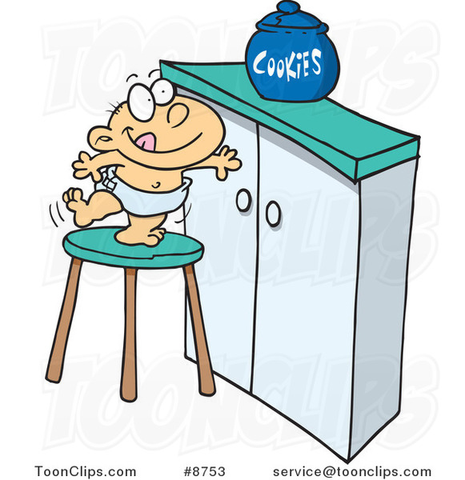
Source: ToonClips.com

Is this segregation?
Source: Male Witch/Shutterstock

Is this freedom?
Source: Photograph, Flying Eagle; Deposit Photos/Riedochse
Sample Sentences with Adjectives

I like the blue shirt.
The book for English class is easy to read.
The French fries are too hot to eat.
The storm is powerful.
The movie is interesting.
Class is fun.

Gallery Walk Adjectives Word Bank
Gallery Walk Adjectives:

Unfair Wrong Separate
Fair Brave Courageous
Equal Bad Right
Powerful Unequal Inspiring

My adjectives:

Sample Images for Lesson Closing Activity
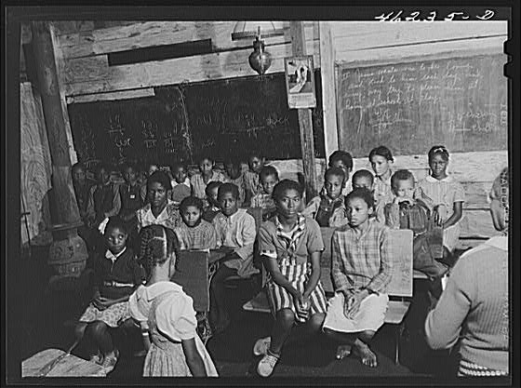
Source: Photograph of Black Schoolroom, Circa 1930 retrieved from America’s Black Holocaust Museum
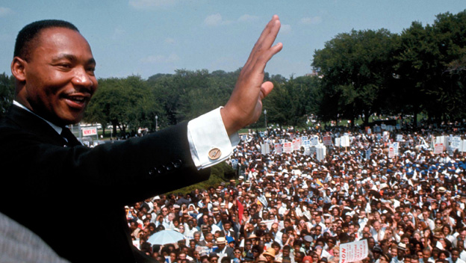
Source: MLK Jr. still

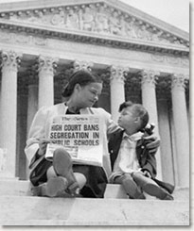
Source: High Court Bans Segregation in Schools/Corbis Images
Lesson 3  Day 3 and 4 | Learning about the Past Tense | Estimated Time: 60 minutes per day

Brief overview of lesson: Students will learn about the past tense and how it can be used to discuss historical events. They will learn past tense rules for regular and irregular verbs, apply this knowledge to conjugate verbs in the past tense, and practice identifying verbs in the past tense in first-hand accounts describing life during Jim Crow America and the years before and after Brown v. Board of Education. Students will also practice writing their own phrases and/or sentences in the past tense. These experiences will help students develop an understanding ability to use a verb tense necessary for completing the CEPA. Finally, students will begin learning about summarizing. As you plan, consider the variability of learners in your class and make adaptations as necessary.

What students should know and be able to do to engage in this lesson:
- Familiarity with the present tense.
- Basic understanding of previously introduced content-specific vocabulary, such as equality, rights, segregation, and freedom.
- Basic understanding of previously introduced adjectives that can be used to describe the Civil Rights Movement, such as unfair, fair, equal, powerful, inspiring, wrong, separate, brave, courageous, bad, right.
- Experience working in cooperative groups.
LESSON FOUNDATION
Unit-Level Focus Language Goals to Be Addressed in This Lesson |  | Unit-Level Salient Content Connections to Be Addressed in This Lesson
G.1 Explain the causes and effects of key events of the Civil Rights Movement.  G.2 Discuss by building upon ideas of others and articulating your own. |  | CCSS.ELA-LITERACY.L.11-12.3—Apply knowledge of language to understand how language functions in different contexts, to make effective choices for meaning or style, and to comprehend more fully when reading or listening.  USII.25—Analyze the origins, goals, and key events of the Civil Rights Movement.
Language Objective |  | Essential Questions Addressed in This Lesson
Students will be able to discuss historical events using verbs in the past tense and adjectives. |  | Q.1 How can I use language to clarify the relationship between events and ideas?  Q.3 How can I build upon the ideas of others in a discussion?  Q.4 How can individual people and events change history?
Assessment
- Formative assessment: Assess student conjugation of verbs from present tense to past tense and statements using verbs in the past tense.
- Formative assessment: Assess student application of collaborative discussion norms during turn-and-talks, partner work, and class discussion. During collaborative discussions also assess student use of verbs in the past tense, adjectives, and content-specific language.
- Formative assessment: Assess student analysis of text to identify verbs in the present tense and revise using verbs in the past tense appropriately in context. Also assess student application of learned language (e.g., content-specific language, adjectives, and verb structures) to make statements (orally and/or written) about analyzed texts.
Thinking Space: What Academic Language Will Be Practiced in This Lesson?
Discourse Dimension | Sentence Dimension |  | Word Dimension
Social instructional language; reading narrative and/or informational short excerpts of adapted first-hand accounts and secondary sources; providing basic information about the Civil Rights Movement using single sentences orally and in writing | Simple sentences in present and past tense that include verbs related to the Civil Rights Movement (e.g., march/marched, walk/walked, talk/talked, speak/spoke, sit/sat, ride/rode, is/was, throw/threw, go/went, hit/hit) |  | Content-specific vocabulary and adjectives related to the Civil Rights Movement (e.g., unfair, fair, equal, powerful, inspiring, wrong, separate, brave, courageous, bad, right, equality, rights, segregation, freedom)
Instructional Tips/Strategies/Suggestions for Teacher
- Color-code verb endings to reinforce past tense conjugation rules.
- Consider creating an anchor chart on verbs in the past tense.
- Rewordify can be used to modify and adapted text as needed.
- Depending upon student familiarity with the past tense, consider providing additional practice with this tense by extending the lesson over an additional day.
- Post and explain the lesson’s objective so students can see and understand it.
- Use formative assessments to inform future instruction. For example, if assessments reveal the need for a concept to be reviewed or discussed further, make necessary adjustments to upcoming lessons.

STUDENT CONSIDERATIONS
Sociocultural Implications
Some students may bring biases toward different cultures/races/religions from various groups they identify with. It may be important to highlight that insults toward any group of people are not appropriate or acceptable in the classroom.
Anticipated Student Pre-Conceptions/Misconceptions
Students may over-generalize past tense rules for regular verbs, adding –d and –ed to all verbs, even irregular ones.

THE LESSON IN ACTION

Day 3 Lesson Opening

Post and explain the lesson’s language objective so students can see and understand it: “Students will be able to discuss historical events using verbs in the past tense and adjectives.” To promote student ownership and self-monitoring of learning, consider having students record the objective in their notebooks or having students summarize the objective in their own words. At the end of the lesson, students can reflect on their learning in relation to the objective.

Introduce the lesson. For example, say: “Today we will continue to learn language to help us discuss the Civil Rights Movement. We will begin by thinking about what we did yesterday.”

Post the following question on the board: “What did we do yesterday?” Consider giving students a printed version of the question. Allow for some quiet reflection time, then ask students to turn and talk with a partner and discuss what was done in class the day before.

Invite pairs to report out ideas with the whole class, and write responses on the board.
Provide options for perception, such as using speech-to-text software or typing into a Google Doc shared with students.
Provide options for expression and communication, such as pointing, using gestures, and/or translating ideas.

During the Lesson

Introduce the past tense.

Point out that everything students just shared happened yesterday, or in the past. For example, say: “We can use language to tell us when something happened. Today we are going to focus on the verb—or the action of the sentence—and how we can use the verb to determine when something happened.”

Underline the verbs in student statements. Change any present tense verbs to the past tense. For example, if students said they “look at images” during the gallery walk, change look to looked. Highlight how the class did these activities in the past (the actions were started and ended in the past) and how changing the form of the verb tells readers or listeners that actions happened in the past.

Do a choral reading of the new statements incorporating verbs in the past tense.

Ask students to brainstorm other things they did the day before. Model how to do it using verbs in past tense. Reiterate for students the connection that these all occurred in the past. Record student responses and switch any present tense verbs to the past tense.
Provide options for engagement, such as having students say, write on a Post-It, or act out something they did yesterday.

Introduce how to conjugate verbs in past tense. For example, say: “Now that we know what the past tense is for, let’s talk about how we can form the past tense of verbs.” Explain rules for forming the past tense, and write them in a past tense anchor chart for student reference.

Start with regular verbs. Tell students that regular verbs are called regular because they follow specific “rules.” Go over regular verb rules (adding -d or -ed; changing -y to -i and adding -ed). Provide some topic related examples for students such as looked, walked, talked, marched.

Explain irregular verb rules. Tell students that not all verbs follow this pattern, and that verbs that do not follow the pattern are called irregular verbs. Explain how some irregular verbs completely change from present to past and others just stay the same. For example, say: “Let’s look at the verb sit. In the present tense we say sit. To change this verb to past tense we changed the -I to an -a and the word became sat. Now, the verb hit stays the same. I can say ‘I hit the ball’ to describe something I do today and ‘She hit the ball yesterday’ to describe something that happened in the past.”

Provide other opportunities for learning about the past tense. For example:

Show a video such as “Learn the Past Tense—Regular and Irregular Verbs in English.”
Provide options for perception, such as showing a video about past tense conjugation, printing the video transcript for students, enabling closed captioning on the video, adjusting the speed of the video and showing the video multiple times.

Have students review/watch online tutorials such as those on ESLCafe.com (“Past Forms” and “Irregular Past Forms”).

Connect to the social studies classroom, explaining how the past tense is useful for discussing historical events that started and finished in the past.

Introduce specific verbs that can be used to discuss the Civil Rights Movement. For example, say: “Now that we know how to form the past tense, let’s learn some specific verbs that we can use when discussing the Civil Rights Movement.”

Teach verbs that can be used in discussing the Civil Rights Movement, such as march/marched, walk/walked, talk/talked, speak/spoke, sit/sat, ride/rode, is/was, throw/threw, go/went, hit/hit.

Provide options for engagement such as having students review images from the Lesson 2 gallery walk, identifying actions they see in the images using verbs in the past tense. Students could point to, gesture, say, or translate the actions they see.

Add these verbs to the class anchor chart.

Have students practice conjugating verbs in the past tense with a partner. Give each pair an image from the Civil Rights Movement labeled with a related verb in present tense above the image. Ask students to change the verb to the past tense and create one statement about the image using the verb in the past tense and an adjective.

Optional activity: As a lesson extension, or for students who are more comfortable with the past tense, have students identify and highlight verbs used in statements or texts narrating first-hand accounts of life in segregated America. Then they can change present tense verbs to the past tense. This could be done with a partner, with a small group, or as a whole class.

Lesson Closing

Ask students to report on the image and/or first-hand account the group worked with using verbs in the past tense. Each group can share one of their statements with the class. Reframe student statements with formal language as necessary, and record them on a class anchor chart. Then ask students to highlight the verbs in past tense.

Have students complete an exit ticket where they discuss what they have learned using sentence frames, such as “I learned…” and “I practiced...” Model how to share with a partner using these sentence frames, then have students share orally or in writing. Prompt students to use the basics of collaborative discussions. Add student responses to the K-W-L chart.

Optional activity: Have students chronicle their reactions to the lesson on a reflection log. Consider providing students with a prompt such as: “Based on the first-hand accounts analyzed today, what was life like before the Civil Rights Movement? How is life different today?”

Day 4 Lesson Opening

Review the previous day’s activities and connect it to today’s work. For example, say: “Yesterday, we learned how to identify and conjugate verbs in the past tense. Today we will continue to practice using the past tense.”

Have students read first-hand accounts of life in segregated America, identify verbs, and change them to the past tense.

Explain what students will do. For example, say: “Let’s begin by looking at some first-hand accounts of what life was like in segregated America. You will practice changing the verb from the present tense to the past tense to tell your reader/listener that these events happened in the past.”

Give students sentence strips from first-hand accounts of life in segregated America. Instruct them to identify verbs, change them to the past tense, then rewrite the sentence in the past tense. Focus sentence strips on segregation in schools to help students see the origins of the Brown v. Board of Education case. Make sure sentence strip verbs are in present tense form so students can practice changing them to past tense. Allow students to work independently or with a partner. For sample adapted sentence strips, see the lesson resources.
Provide options for perception, such as using text-to-speech readers, mentor/mentee pairings, and/or using a computer to review the sentence strips.
Provide options for physical action, such as using a computer to rewrite statements and/or matching a sentence strip to an index card with the correct past tense form of the verb.

Invite the class to share their rewritten sentences in the past tense with the whole class.

Optional activity: After all students have shared, do a choral reading of an excerpt of a first-hand account of life in segregated America or a text on segregation in schools on the overhead or board. Consider using authentic first-hand accounts or adapted first-hand accounts. For sample adapted first-hand accounts, see the lesson resources.

As the class reads the passage, stop and underline each verb or have students underline the verbs (if they are provided printed copies). Ask students to identify whether the verb is in the present or past tense.
Provide options for perception, such as posting the excerpt on the board, projecting the excerpt, using a computer to view the text and/or providing students with a hard copy of the excerpt.
Provide options for physical action, such as holding up color-coded cards to indicate if a verb is in the present tense or the past tense, responding on whiteboards, and/or using a computer to highlight.

Have students practice changing any present tense verbs to the past tense.

As a class summarize the passage using verbs in the past tense by paraphrasing the main ideas and details.
Provide options for engagement, such as having students work in a small group to read the text and to summarize the passage in the past tense.

During the Lesson

Continue building background knowledge about the topic. Depending on student familiarity with the segregation of schools before the Civil Rights Movement, consider showing a video about it such as the first segment (from 3:51 to 8:09) of Locked Out: The Fall of Massive Resistance. This portion of the video focuses on segregation in schools and can reinforce for students what life was like in segregated America before the Civil Rights Movement. It can also help contextualize the Civil Rights Movement for students. Or show a slideshow of segregation-era photos such as “Segregation in the Southern USA.”
Provide options for perception, such as printing out the video transcript for students, enabling closed captioning on the video, and adjusting the speed of the video. Students could have the option to view the video multiple times in a video viewing station, if necessary.

Ask and debrief reflective questions such as: “Do you think what was happening at this time was fair? Why or why not?” and “What would you do?”

Allow for quiet reflection time and ask students to draw, gesture, write, or use a computer to respond. Then have them turn and talk to discuss their response with a partner. Model and prompt students to use the collaborative discussion norms. Working with a partner or in a small group allows students time to build and share their own ideas before turning to the whole group, where not all students are as comfortable sharing their ideas.

Debrief reflective questions as a whole class and record student responses on chart paper. Use this debriefing activity as a formative assessment of students’ ability to use of content vocabulary, the past tense, and adjectives.

Introduce the Brown v. Board of Education decision as a major Civil Rights Movement event. Begin by introducing the idea of challenging school segregation of schools. Explain what it means to challenge and connect it to previous student comments suggesting they would have challenged segregation laws if they had lived during this time period. Introduce Oliver Brown and explain how he and his daughter challenged segregation laws.

Depending on student familiarity with the Brown v. Board of Education decision, provide opportunities to reinforce student background knowledge on the topic. For example:

Show “Separate But Not Equal,” which focuses on life in segregated schools and the origins of the Brown v. Board of Education case.

Pre-teach any relevant topic vocabulary from the video that has not been introduced in the unit so far such as desegregation. Use a vocabulary teaching strategy such as the seven-step vocabulary teaching method.
Give students a focus question before watching the video, such as “What was the impact of the Brown v. Board of Education decision? How did the Brown v. Board of Education decision make a difference in history?” This can help focus students’ attention on key information while they watch the video.
Review key information about the Brown decision and have student take notes using guided notes and word banks, taking notes on a computer or using an online notebook such as Zoho Notebook. For background information about the case and its impact, see PBS’s “Beyond Brown” website.

Use images to help build background knowledge. See the lesson resources section for suggested images about the case.

Provide opportunities for students to practice discussing the Brown v. Board of Education case using verbs in the past tense.

Introduce the purpose of the activity. For example, say: “Now that we have reviewed what the Brown v. Board of Education decision is, let’s practice using verbs in the past tense to discuss the case.” Have students analyze images or a brief text about the case, then practice making statements about the decision using verbs in the past tense and topic vocabulary. Allow students to work individually or collaborate.
Analysis of images: Give students a few images illustrating different aspects of the Brown case and decision. Ask students to review the images and create statements in the past tense based on the images (e.g., “Schools were desegregated”). Consider asking students to create an additional statement describing each image with an adjective. Circulate while students are working and offer specific feedback on student use of verbs in the past tense.
Provide options for perception, such as viewing images on a computer.
Provide options for physical action, such as using a computer, writing, and/or using speech-to-text software.
Circulate while students are working and offer process-based feedback.
Analysis of text, Option A: Give students a short text about the Brown decision such as an excerpt from“10 Things You Should Know about Brown v. Board of Education.” You may wish to give students the same excerpt, different texts, and/or several short texts to analyze. Ask students to highlight verbs in the text, using a different color for verbs in the present and past tenses, then create past tense statements about ideas in the text. Consider asking students to create another statement describing each image with an adjective. Model and pre-teach any metacognitive or metalinguistic strategies to help students analyze text (e.g., making predictions, periodically stopping and summarizing the text in their own words, using context clues to determine the meanings of unknown words, identifying the main idea and supporting details). As students work, circulate and ask students to explain how they know verbs are in past or present tense.
Provide options for perception, such as viewing the text on a computer or using text-to-speech readers.
Provide options for physical action, such as using a computer, writing, and/or using speech-to-text software.
Analysis of text, Option B: If some students are more comfortable with textual analysis, give them short, adapted excerpts from the actual decision. Ask students to highlight the verbs, change any verbs in the present tense verbs to verbs in the past tense, and create past tense statements about the decision. For excerpts from the decision, see resources from ReadingWorks.org and Teaching Tolerance. For the decision’s full text, see Cornell University's resources. Model and pre-teach any metacognitive or metalinguistic strategies to help students analyze text (e.g., making predictions, periodically stopping and summarizing the text in their own words, using context clues to determine the meaning of unknown words, identifying the main idea and supporting details).

Lesson Closing

Ask students to independently create phrases or simple sentences about the decision using verbs in past tense. This activity can serve as a formative assessment of students’ ability to use adjectives, verbs in the past tense, and content vocabulary.

Ask students to discuss how Brown v. Board of Education made a difference in the nation and in history and/or how individuals can change history by standing up for what is right.

Have students complete an exit ticket where they explain what they learned using sentence frames such as “I learned…” and “I practiced...” Ask students to respond orally or in writing. Add student responses to the K-W-L chart.

Optional activity: Have students chronicle their reactions to the lesson on a reflection log. Consider providing students with a prompt such as: “How is life different today because of the Brown v. Board of Education decision? How did Oliver Brown make a difference in the nation and in history?”

Lesson 3 Resources
- Whiteboard or computer with projector
- Student notebooks
- Chart paper
- Images depicting the Civil Rights Movement
- Past tense resources:
  - “Learn the Past Tense—Regular and Irregular Verbs in English”
  - ESLCafe.com online references/tutorials such as “Past Forms” and “Irregular Past Forms”
- First-hand accounts of life in segregated America:
  - PBS’s Jim Crow narratives
  - The Library of Congress’s “Jim Crow and Segregation”
  - American Public Media’s “Children of Jim Crow”
  - “Segregation” (segment one of Locked Out: The Fall of Massive Resistance)
  - “Segregation in the Southern USA” (video montage of Jim Crow–era photos)
- Brown v. Board of Education resources:
  - Video: “Separate But Not Equal”
  - Text: “10 Things You Should Know about Brown v. Board of Education,” Cornell University’s “Brown v. Board of Education”
  - Excerpts: resources from Readworks.org and Teaching Tolerance
- For other possible videos about the Civil Rights Movement, see History.com or PBS’s Eyes on the Prize
- Verb conjugation cards (available below)
- Sample excerpts for textual analysis on day 3 (available below)
- Sample sentences for Day 4 Lesson Opening sentence strips (available below)
- Sample text for Day 4 Lesson Opening (available below)
- Images of segregated schools (available below)

Verb Conjugation Cards
Print and cut out the cards. Give each group one or more verb conjugation cards. Students will change the verb from the present tense to the past tense. Students will then create statements in the past tense about the images.

March  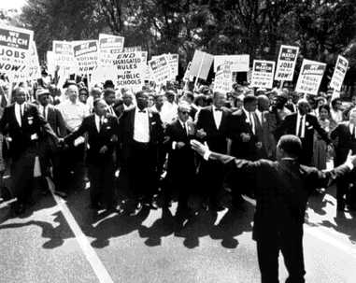 | Sit
Ride | Speak  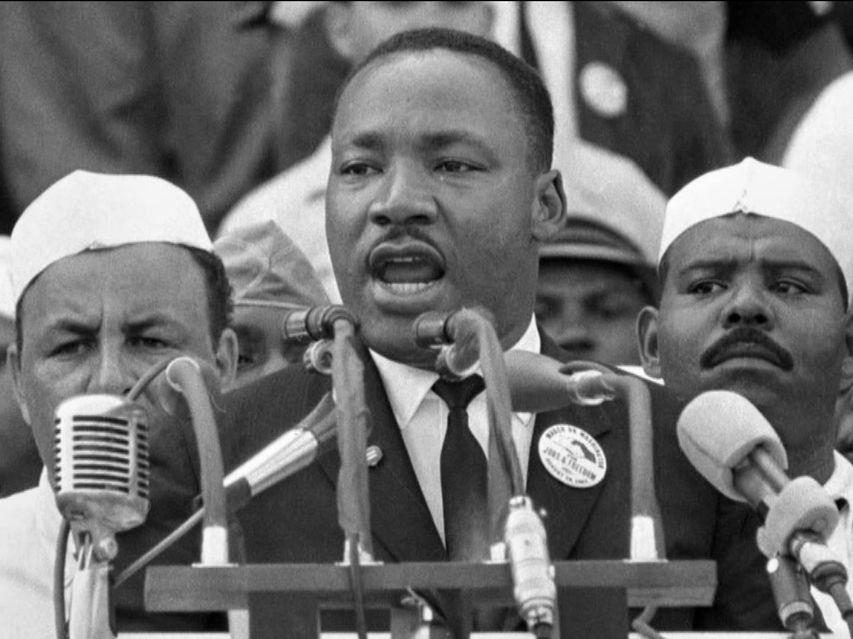
Is  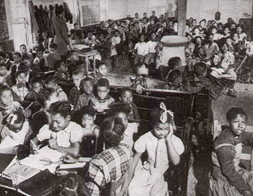 | Attack  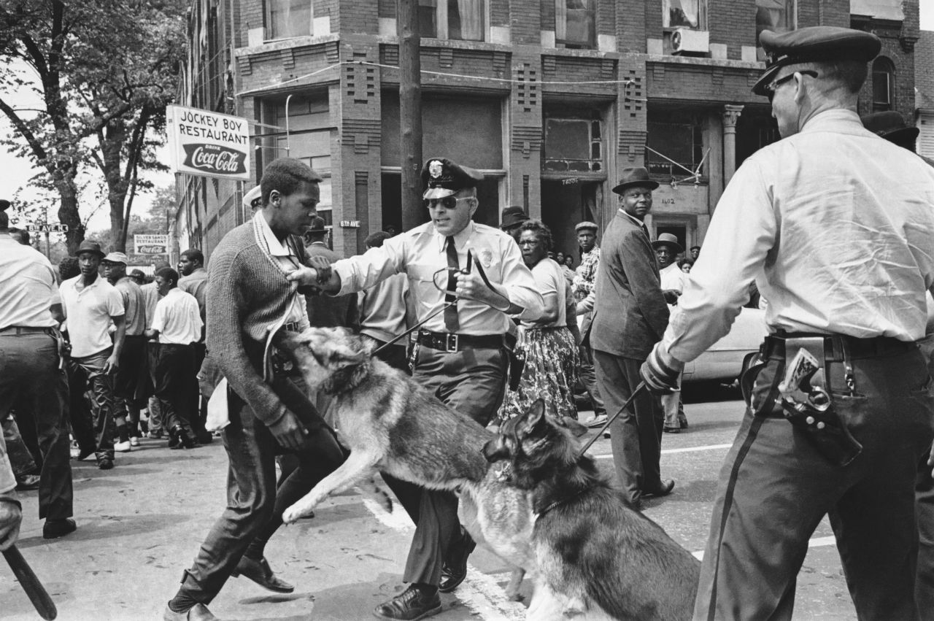
Hit
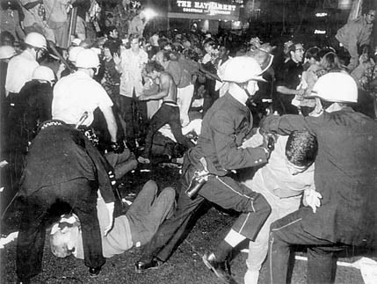

Sample Excerpts for Textual Analysis on Day 3

Shiny Plastic Letters
The following excerpt is an adapted version, with some verbs changed to present tense so students can practice changing verbs to past tense:

The Shiny Plastic Letters
…We went on the required tour of the facility and at the end, we were taken to the lunchroom. Or should I say lunchrooms. There are two doors, both with signs. On one door the sign reads "White Lunch." The second door is labeled "Colored Lunch." What really stood out are the shiny plastic letters. "White Lunch" is in white letters on a black background. "Colored Lunch" is in multi-colored letters, also on a black background.

Thomas Lanier
Nashville, Tennessee

Original text from American Public Radio:

The Shiny Plastic Letters
I remember a first grade field trip to the Beaman Bottling Plant in Nashville, Tennessee back in 1960 or 1961. We went on the requisite tour of the facility and at the end, we were taken to the lunchroom. Or should I say lunchrooms. There were two doors, both with signs. On one door the sign read "White Lunch." The second door was labeled "Colored Lunch." What really stood out were the shiny plastic letters. "White Lunch" was in white letters on a black background. "Colored Lunch" was in multi-colored letters, also on a black background. Our school didn't have any African American students so we really didn't understand the way things were. It didn't make sense then, and it certainly doesn't now.

Thomas Lanier
Nashville, Tennessee

Bridgeport Library
The following excerpt is an adapted version, with some verbs changed to present tense so students can practice changing verbs to past tense:

Bridgeport Library Branch, Chicago, Illinois, circa 1963
Two friends and I visited the Bridgeport Library Branch in Chicago, Illinois.
Bridgeport is the neighborhood of former Mayor Richard J. Daly and is all white. We are three Black young men of 11 and 12 years old. We visited the Bridgeport Branch because we cannot find the books we needed at the Oakland branch, in the Black neighborhood. We cross the color line to the other side of the tracks. We are young and do not know.
After we get our books, we start to walk back home. We had no particular problems at the library other than strange looks (e.g., like "what are you…doing here"). Half way back to our neighborhood we are chased by a mob of white youths. They are out for blood…
We split up and run in panic. One makes it back to the library, one gets caught in a storefront, and I run like hell back to the neighborhood. I do not make it…We are attacked by a white mob for our brazen boldness to use the white library branch…
Kenneth M. Stone, CPA
St. Louis, Missouri

Excerpts from the original text from American Public Radio:

Bridgeport Library Branch, Chicago, Illinois, circa 1963
Two friends and I visited the Bridgeport Library Branch in Chicago, Illinois.
Bridgeport was the neighborhood of former Mayor Richard J. Daly and is all white. We were three Black young men of 11 and 12 years old. We visited the Bridgeport Branch because we couldn't find the books we needed at the Oakland branch, in the Black neighborhood. We crossed the color line to the other side of the tracks. We were young and didn't know. We were more afraid of avoiding the Black street gangs on the other side of the projects (Stateway Gardens).
After we got our books, we started to walk back home. We had no particular problems at the library other than strange looks (e.g., like "what are you…doing here"). Half way back to our neighborhood we were chased by a mob of white youths. They were out for blood…
We split up and ran in panic. One made it back to the library, one got caught in a storefront, and I ran like hell back to the neighborhood. I didn't make it.
One of the mob members crashed his bike in front of me, a few hundred yards in front of the rest of the mob. We prepared to duke it out, before the rest of the mob arrived. I remember an old white man stopped his car and boomed, "leave that boy alone." I was surely saved from a severe beating. I was literally saved by a stranger. The mob held back and I suffered no more than a few scrapes and bruises.
As I reached the overpass on the Dan Ryan highway at 35th Street, I stopped and waited for my buddies. To my surprise, one stepped off a CTA bus (the one who returned to the library). He was escorted to the bus by the librarian. More surprising was that my other buddy was being escorted by the store owner and a few more white adults to the overpass. He only suffered a bruised jaw from a sucker punch.
I was never so scared in all of my life. We were attacked by a white mob for our brazen boldness to use the white library branch. My mother had to return my books.
Epilogue. I read a few years ago that another Black youth was attacked by a white mob in Bridgeport for playing on a softball field. He suffered severe head trauma and last I heard he was in a coma. I was lucky, he wasn't. The more things change, the more they stay the same.
Kenneth M. Stone, CPA
St. Louis, Missouri

For more first-hand accounts, see PBS’s Jim Crow narratives.

Sample Sentences for Day 4 Lesson Opening Sentence Strips
Adapted from American Public Radio

Print and cut out the sentence strips; give each student one or more. Students will identify the verb, change the verb from present tense to past tense, and rewrite the sentence. They will then use verbs in the past tense to present the first-hand accounts.
- This is a "white only" sign above the only bus or train depot entrance.
- We have a shoebox full of food because restaurants serve "white only.”
- To go to the dentist's office, we walk to the rear to the "colored" waiting room. The waiting room is a back porch and wooden benches.
- The "white only" public school throws out their outdated books to the "colored" schools, instead of in the trash.
- All hotel rooms are "white only.”
- We watch movies from the segregated "colored" balcony of the theaters.
- People are beaten and killed or just disappear because voting is for "whites only."
- A "white only" ambulance cannot respond to a "colored" emergency.
- My father fights discrimination in his churches.
- [My father] said that he knows that God wants him to fight this injustice however he can.

Sample Text for Day 4 Lesson Opening
Adapted from “The Education of Black Children in the Jim Crow South”

Provide students with the following excerpt from a first-hand account about life in segregated America. Some of the verbs have been changed to allow students to practice differentiating between verbs in the present and past tense. Students will identify the verbs, change verbs in the present tense to the past tense, and summarize the text in their own words.
- Many school buildings for African Americans have leaking roofs, sagging floors, and windows without glass. Schools range from messy to filthy, according to a study from 1917.
- If black children have any books at all, they are hand-me-downs from white schools.
- Black schools were overcrowded, with too many students per teacher. More black schools than white had only one teacher to handle students from toddlers to 8th graders. Black schools were more likely to have all grades together in one room.
- There are not enough desks for the over-crowded classrooms.
- There were limits on what blacks could be taught in school.

Images of Segregated Schools
Source: Photograph of Black Schoolroom, Circa 1930 retrieved from America’s Black Holocaust Museum

Source: http://www.blackpast.org/files/blackpast_images/Segregated-School-in-West-M.jpg
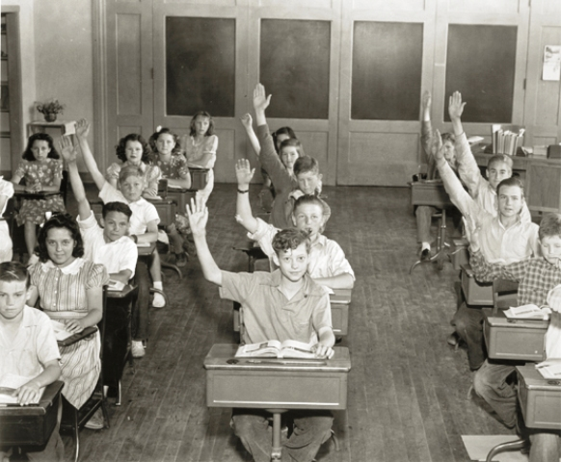
Source: Photograph of White schoolroom, Circa 1935 retrieved from America’s Black Holocaust Museum

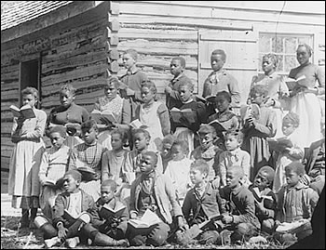
Source: Cook Collection, The Valentine

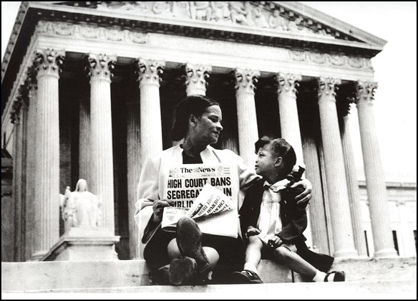
Source: High Court Bans Segregation in School/Corbis
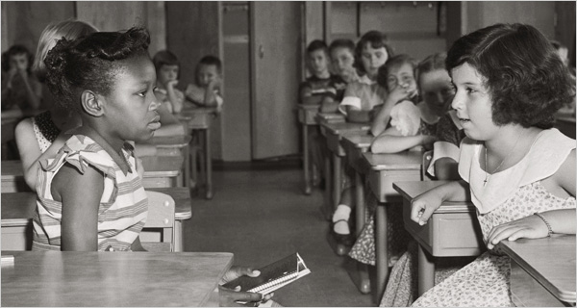
Source: Photograph, First Day of Desegregation 1954

Lesson 4  Day 5 and 6 | Making Evidence-Supported Claims | Estimated Time: 60 minutes

Brief overview of lesson: Students will learn how to support claims and opinions with relevant evidence. During day 5, they will practice differentiating between facts and opinions; on day 6, they will create statements supported by evidence and discuss their opinions with peers using discussion frames. This lesson will also help students continue developing collaborative discussion skills. These learning experiences will help students develop skills essential to creating the CEPA. Day 6 can serve as the language checkpoint for the unit, giving teachers an opportunity to measure student progress toward unit Focus Language Goals. As you plan, consider the variability of learners in your class and make adaptations as necessary.

What students should know and be able to do to engage in this lesson:
- Basic understanding of adjectives, content vocabulary, and present and past tense verb formation introduced previously in the lesson.
- Ability to translate words and phrases and to search for definitions in dictionaries.
LESSON FOUNDATION
Unit-Level Focus Language Goals to Be Addressed in This Lesson |  | Unit-Level Salient Content Connections to Be Addressed in This Lesson
G.1 Explain the causes and effects of key events of the Civil Rights Movement.  G.2 Discuss by building upon ideas of others and articulating your own. |  | CCSS.ELA-LITERACY.L.11-12.3—Apply knowledge of language to understand how language functions in different contexts, to make effective choices for meaning or style, and to comprehend more fully when reading or listening.  USII.25—Analyze the origins, goals, and key events of the Civil Rights Movement.
Language Objective |  | Essential Questions Addressed in This Lesson
Students will be able to articulate and discuss evidence-based claims and opinions about the Civil Rights Movement using argument-related language (e.g., claim, reason, evidence, agree, disagree, opinion). |  | Q.1 How can I use language to clarify the relationship between events and ideas?  Q.2 How can I use language to illustrate and present my opinion?  Q.3 How can I build upon the ideas of others in a discussion?  Q.4 How can individual people and events change history?
Assessment
- Formative assessment: Assess students’ analysis of text, identifying and organizing factual information and opinion statements.
- Formative assessment: Assess students’ creation of fact and opinion statements supported by evidence. Assess student application of all learned language (e.g., fact/opinion language structures, use of evidence to support statements, content-specific language, descriptive adjectives, verbs in the past tense).
- Formative assessment: Assess students’ use and application of collaborative discussion norms and learned language during the class discussions (e.g., pair, small, and teacher conference discussions).
Thinking Space: What Academic Language Will Be Practiced in This Lesson?
Discourse Dimension | Sentence Dimension |  | Word Dimension
Social instructional language; reading narrative and/or informational short excerpts of adapted first-hand accounts and secondary sources; providing basic information about the Civil Rights Movement using single sentences orally and in writing; discussing the Civil Rights Movement orally by sharing ideas/opinions and listening to those of others | Simple sentences in present and past tense that include verbs related to the Civil Rights Movement (e.g., march/marched, walk/walked, talk/talked, speak/spoke, sit/sat, ride/rode, is/was, throw/threw, go/went, hit/hit); sentences with because |  | Content-specific vocabulary and adjectives related to the Civil Rights Movement (e.g., unfair, fair, equal, powerful, inspiring, wrong, separate, brave, courageous, bad, right, equality, rights, segregation, freedom); argument-related language (e.g., fact, opinion, claim, evidence)
Instructional Tips/Strategies/Suggestions for Teacher
- Use previously introduced text.
- Employ different strategies for pairing students based on their specific needs. For example, create homogenous or heterogeneous language proficiency level groups, allow students to select their first partner but then assign the second one, etc.
- Depending on students’ familiarity with fact and opinion concepts, consider providing additional practice with fact and opinion language. (If students are comfortable using this language, provide a brief review and go deeper into textual analysis.)
- Depending on students’ familiarity with creating evidence-supported claims, consider pre-teaching what a claim is and what a claim is not.
- Use formative assessments to inform future instruction. For example, if assessments reveal the need for a concept to be reviewed or discussed further, make necessary adjustments to upcoming lessons.

STUDENT CONSIDERATIONS
Sociocultural Implications
Some students may bring biases toward different cultures/races/religions from various groups they identify with. It may be important to highlight that insults toward any group of people are not appropriate or acceptable in the classroom.
Anticipated Student Pre-Conceptions/Misconceptions
- Students may not know the difference between formal and informal registers.
- Students may not know the difference between just stating an opinion and supporting an opinion with relevant evidence.

THE LESSON IN ACTION

Day 5 Lesson Opening

Post and explain the lesson’s language objective so students can see and understand it: “Students will be able to articulate and discuss evidence-based claims and opinions about the Civil Rights Movement using argument-related language (e.g., claim, reason, evidence, agree, disagree, opinion).” To promote student ownership and self-monitoring of learning, consider having students record the objective in their notebooks or having students summarize the objective in their own words. At the end of the lesson, students can reflect on their learning in relation to the objective.

Begin with a review of the language learned so far. For example, say: “We have studied a lot of new language that we can use to discuss the Civil Rights Movement. Let’s start today’s lesson with a review of some of the language we have learned with a game.” Possible review games include Tic-Tac-Toe, What Do You Know? and bingo.

During the Lesson

Focus student attention on the objective for the day. For example, say: “Today we are going to continue to learn language to help us discuss the Civil Rights Movement. Today we will practice identifying facts about the Civil Rights Movement and making opinion statements about the Civil Rights Movement. We will start by learning about what a fact is.”

Have students quietly think about the definition of the term fact, then turn and talk to a partner before sharing with the whole class.
Discuss the definition of fact and create a fact vs. opinion anchor chart for the unit by adding a definition of the term. Key details about facts to discuss: facts can be proven; they are true statements about things that exist.
Ask students to think of an example of a fact on their own, then share it with a partner, then with the whole class. Add these examples to the chart.
Provide options for physical action, such as orally stating ideas, using a computer to type ideas, or writing on a notebook or whiteboard.

Have students quietly think about the definition of the term opinion, then turn and talk to a partner before sharing with the whole class.
Discuss the definition of opinion and add it to the fact vs. opinion anchor chart. Key details about opinions to discuss: opinions are thoughts, beliefs, feelings about a topic or idea; they can’t be proven.
Ask students to think of an example of an opinion on their own, then share it with a partner, then with the whole class. Add these examples to the chart.
Provide options for physical action, such as orally stating ideas, using a computer to type ideas, or writing on a notebook or whiteboard.

Introduce fact and opinion language. For example, say: “We can use language to help us figure out if a statement is a fact or an opinion.” Teach potential fact and opinion signal words (e.g., numbers, statistics, according to the text… for facts; believe, think, feel, like, best, worst, always, never, every, statements with personal pronouns for opinions). Verbal discussion is not the only way to explore this vocabulary. Word walls or vocabulary journals can encourage students to write, use images, or build their own contextual examples of the vocabulary.
Provide options for recruiting interest, such as using native language dictionaries, providing images for definitions, and using visual dictionaries such as Shahi or Visuwords.

Provide opportunities to practice fact and opinion language with familiar topics, such as an image of your town.

Have students scan the image for factual information such as the numbers of buildings in the image, the numbers of people in the image, cars on the street, etc., and quietly reflect on factual information in the image. Ask students to share observations with a partner before discussing with the whole class. Record student responses on the board.
Provide options for perception, such as giving students printed images or having them view images on a computer.

Model statements of opinion related to the image, such as “I think our town is the best.” Have students create an opinion statement about the image on their own, then share it with a partner before discussing as a whole class. Record student responses on the board.
Provide options for physical action, such as writing, typing, and/or using speech-to-text software.

Provide opportunities to practice fact and opinion language with Civil Rights Movement topics. Project an image from the Civil Rights Movement (you may wish to use the images from the previous lesson).

Have students scan the image for factual information and quietly reflect on factual information in the image. Ask students to share observations with a partner before discussing with the whole class. Record student responses on the board.
Provide options for perception, such as giving students printed images or having them view images on a computer.

Model statements of opinion related to the image, such as “I think desegregation is a good idea because it gives more opportunities to African American children.” Have students create an opinion statement about the image on their own, then share it with a partner before discussing as a whole class. Record student responses on the board.
Provide options for physical action, such as writing, typing, and/or using speech-to-text software.

Continue practicing fact and opinion language by having students identify fact and opinion statements in texts and sorting them.

Go over activity instructions. For example, say: “Now that we have practiced making fact and opinion statements, let’s practice identifying facts and opinions in texts. We will sort fact and opinion statements about Brown v. Board of Education. Read each statement. Look for signal words of fact or opinion. Circle any signal words you see. Place the statements on a fact/opinion T-chart.”
Pair students and have them complete the activity, adding statements to a graphic organizer such as a T-chart. Circulate while students are working and provide specific feedback about student analysis of facts and opinions.
Provide options for perception and physical action, such as using computers, text-to-speech readers, and/or speech-to-text software.

After students have finished sorting sentences, debrief the activity as a whole class. Highlight any opinion statements supported by evidence.

Lesson Closing

Ask students to independently write one original factual statement and one opinion statement about the Brown v. Board of Education decision. Then have them share their statements with a partner.
Provide options for physical action, such as using speech-to-text software and/or a computer.

Day 6 Lesson Opening

Introduce the lesson. For example, say: “Yesterday we practiced using language to identify and state facts and opinions. Today we will continue to practice facts and opinion language. We will practice using evidence to support our opinions and using evidence to make evidence-supported claims.” Depending on student familiarity with creating evidence-supported claims/opinions, consider explaining the difference between just stating an opinion and making a claim/opinion and supporting it with relevant evidence.

Practice identifying fact and opinion statements in text.

Post an excerpt from a newspaper article. (This could be a contemporary article from a local newspaper or an article from a news source such as Newsela.) Read it sentence by sentence, pausing after each sentence to ask students if the sentence contains facts and/or opinions. With student help, highlight facts in one color and opinions in another.

Ask students to make observations about the highlighted opinion statements individually, then share with a partner. After students have shared, invite them to discuss opinion statements. Students may notice that statements of opinion often contain facts as well. Explore this further by explaining how supporting opinions with evidence can help to strengthen our opinions and pointing out the structure of the statements (noting where the opinion is and where the evidence is). Explain that it is okay to share opinions without supporting evidence in other settings, but not in academic settings: here, opinions are expected to be supported by relevant evidence in order to be considered “valid” or pertinent to the discussion. Explain the difference between relevant/logical evidence (e.g., directly tied to the opinion) and irrelevant evidence (e.g., no logical connection). Consider creating a T-chart with students, highlighting the difference between relevant and irrelevant evidence.

During the Lesson

Teach the meaning of the conjunction because as a word that can be used to form opinion statements supported by evidence.

Explain what the word because means and model how to create an opinion statement supported by evidence using because.

Ask students to create an opinion statement about the news article they read and then have them add evidence to support their statements. Consider providing students with a graphic organizer.

Have students practice identifying and highlighting facts and opinions in an excerpt from Brown v. Board of Education articles such as Teaching Tolerance’s “An American Legacy” or “Brown v. Board Is…”

Model how to identify supporting evidence in opinion statements, then have students practice doing so with a partner.

Model creating an opinion statement supported by evidence, such as “I think the Brown v. Board of Education decision was important because it desegregated the schools.”

Ask students to form opinion statements about the Brown v. Board of Education decision, then add evidence to support their statements.

Provide opportunities for students to discuss the topic using fact and opinion statements.

Introduce the activity. For example, say: “Now that we have practiced identifying opinions supported by evidence, let’s practice creating and discussing our own statements supported by evidence.”

Depending on student familiarity and comfort with creating evidence-supported claim, you may wish to define the term claim or review what a claim is (e.g., can be argued, answers a question, can be supported with reasoning and evidence, is your opinion based on analysis) and is not. Consider creating an anchor chart of what a claim is/is not for student reference.

Model an academic conversation with a student or another teacher. If modeling with another student, work with a prepared script to illustrate turn-taking, building on each other’s ideas, and using the sentence frames to support the discussion. Sample statements to use: “I think this image is powerful because it shows school desegregation”; “The Brown v. Board of Education decision is important because it desegregated the schools.”

Debrief this modeling and co-create a chart of academic conversation norms with students. Review sentence frames that will be used and post them for student reference: “______ is inspiring because ______”; “______ is important because ______”; “______ is powerful because ______”; “I think ______ because ______”; “I believe ______ because ______”; “In my opinion, ______”; “______ was important because ______”; “I agree with ______ because ______”; I disagree with ______ because ______.”

Instruct students to view images and/or statements about the Civil Rights Movement and use the sentence frames to create opinion statements supported by evidence. Model how to scan the image for relevant evidence to support statements.

Consider using a traveling partner model for discussion. Explain the pairing protocol: students will be paired up, and each pair will travel to meet with another pair and build ideas. Model and explain these expectations.
Provide options for physical action, such as using a computer and/or text-to-speech software.

Conference individually with students as they work. Observe and assess students’ use of verbs in the present and past tenses, descriptive adjectives, content-specific vocabulary, and ability to create opinions supported by evidence and apply collaborative discussion skills and content-specific vocabulary. Use this formative assessment to inform and adjust instruction. Use questions to prompt the discussion. For example: “How would you describe this image?” “Why was the Brown v. Board of Education decision so important?” “How did the Brown v. Board of Education decision change history?” “How is life different today because of the Brown v. Board of Education decision?”

Lesson Closing

Ask partners to report out what their partner said to the whole class using the following sentence frame: “One thing I agreed with was ______, because ______.”

Ask students to turn and talk with a partner. Students will discuss standing up for what is right in the context of Brown v. Board of Education (supporting integration). Ask students to also discuss how people can make a difference by standing up for what is right.

Optional activity: Ask students to individually reflect on standing up for what is right in the context of Brown v. Board of Education (supporting integration) in a reflection log. Ask students to reflect on how people can make a difference by standing up for what is right.

Lesson 4 Resources
- Whiteboard or computer with projector
- Student notebooks
- Chart paper
- Collection of photos depicting the Civil Rights Movement
- Guided notes page
- First-hand accounts of life in segregated America (such as those listed in the Lesson 3 resources)
- Articles and/or excerpts about the Brown v. Board decision (such as those listed in the Lesson 3 resources)
- Fact and opinion sort (available below)
- Fact and opinion graphic organizer, or T-chart (sample available below)
- Opinions supported by relevant evidence graphic organizer (sample available below)
- Sample sentence frames (available below)

Fact and Opinion Sort
Directions:
- Read each statement.
- Define any unfamiliar words.
- Look for signal words of fact or opinion.
- Circle any signal words you see.
- Place the statements on a fact/opinion T-chart.

- The U.S. Supreme Court stated that “Separate educational facilities are inherently unequal.”
- I think Brown v. Board of Education is the most important Supreme Court case in history.
- The court desegregated schools because most people thought segregation was bad.
- The Brown v. Board of Education decision was a unanimous verdict.
- The U.S. Supreme Court stated that desegregation needed to happen with “with all deliberate speed.”
- I feel that the Brown v. Board of Education decision was the right thing to do.
- Before the Brown v. Board of Education decision, 17 states had laws that required segregated schools.

Sample Fact and Opinion Graphic Organizer
FACT: A fact can be PROVEN; it exists, can be observed/seen and is real. | OPINION: What a person thinks, believes, or feels; opinions CAN’T be PROVEN.

Opinions Supported by Relevant Evidence

Name: ______________________________________________________________

Use the sentence frames provided to create statements supported by relevant evidence.
Sentence Frame: I think + (my opinion) + because + (relevant evidence to support}.

Example: I think this image is powerful because it shows school desegregation.

Sentence Frame: _______________ was (adjective) because + (relevant evidence to support).

Example: The Brown v. Board of Education decision was important because it desegregated the schools.

Remember, relevant evidence directly supports your opinion statement.

1. I think_____________________________________________________________________________________________________________________________________
because ___________________________________________________________________________________________________________________________________.

2. Based on the article, ____________________________________________________________________________________________________________________
because ___________________________________________________________________________________________________________________________________.

3. _____________________________________________________________was ___________________________________________________________________________

because ___________________________________________________________________________________________________________________________________.

Sample Sentence Frames
Print and provide students with the sentence frames.

Sentence frames:
______ is inspiring because ______________.
______ is important because _____________.
______ is powerful because ______________.
I think ________ because __________.
I believe_______ because __________.
In my opinion ___________ was important because __________.
I agree because__________.
I disagree because __________.

Lesson 5  Day 7 | Exploring Cause and Effect Signal Words | Estimated Time: 60 minutes

Brief overview of lesson: Students will apply what they learned about signal words of cause and effect. They will revisit prior texts to identify cause and effect statements, then apply this technique to new texts. These experiences will help students develop an understanding of how language can illustrate relationships between events. Students will also practice writing cause and effect statements about civil eights events to summarize what happened, a foundational skill for the CEPA. As you plan, consider the variability of learners in your class and make adaptations as necessary.

What students should know and be able to do to engage in this lesson:
- Basic understanding of previously introduced content-specific vocabulary and adjectives to describe the Civil Rights Movement.
- Familiarity with present and past tense verb forms.
- Ability to create opinion statements with relevant evidence.
LESSON FOUNDATION
Unit-Level Focus Language Goals to Be Addressed in This Lesson |  | Unit-Level Salient Content Connections to Be Addressed in This Lesson
G.1 Explain the causes and effects of key events of the Civil Rights Movement.  G.2 Discuss by building upon ideas of others and articulating your own. |  | CCSS.ELA-LITERACY.L.11-12.3—Apply knowledge of language to understand how language functions in different contexts, to make effective choices for meaning or style, and to comprehend more fully when reading or listening.  USII.25—Analyze the origins, goals, and key events of the Civil Rights Movement.
Language Objective |  | Essential Questions Addressed in This Lesson
Students will be able to discuss causes and effects of Civil Rights Movement events using related signal words (e.g., because, as a result, then, due to, this led to, since, in order to, for this reason). |  | Q.1 How can I use language to clarify the relationship between events and ideas?  Q.2 How can I use language to illustrate and present my opinion?  Q.3 How can I build upon the ideas of others in a discussion?  Q.4 How can individual people and events change history?
Assessment
- Formative assessment: Assess student application of learned language to analyze text and identify causes and effects.
- Formative assessment: Assess student application of learned language to create cause and effect statements.
Thinking Space: What Academic Language Will Be Practiced in This Lesson?
Discourse Dimension | Sentence Dimension |  | Word Dimension
Social instructional language; reading narrative and/or informational short excerpts of adapted first-hand accounts and secondary sources; providing basic information about the Civil Rights Movement using single sentences orally and in writing; discussing the Civil Rights Movement orally by sharing ideas/opinions and listening to those of others | Simple sentences in present and past tense that include verbs related to the Civil Rights Movement (e.g., march/marched, walk/walked, talk/talked, speak/spoke, sit/sat, ride/rode, is/was, throw/threw, go/went, hit/hit); sentences with because |  | Content-specific vocabulary and adjectives related to the Civil Rights Movement (e.g., unfair, fair, equal, powerful, inspiring, wrong, separate, brave, courageous, bad, right, equality, rights, segregation, freedom); argument-related language (e.g., fact, opinion, claim, evidence); cause and effect signal words (e.g., because, as a result, then, due to, this led to, since, in order to, for this reason)
Instructional Tips/Strategies/Suggestions for Teacher
- Consider providing additional supports for vocabulary and concept learning, such as:
- Using sign language: Model how to say cause and effect in sign language while saying the word aloud. Then have students practice the signs while repeating the words. Use resources for teaching signs from SignSavvy.com: sign for effect and sign for cause.
- Listening to a cause and effect song.
- Pairing students with a tutor that speaks their native language.
- Providing mini-lessons to reinforce concepts/address similar mistakes to small groups of students.
- Recording a teacher explanation of cause and effect concepts incorporating sign language, modeling how to use the target vocabulary, and providing close captions or a transcript that is made available for students outside of class.
- In addition to using the sample graphic organizers provided, consider using a source such as Exploratree for completing and printing out graphic organizers, including ones for cause and effect in different configurations.
- Provide differentiated readings and/or supports based on student needs. For example, share text on digital files so students can enlarge font, translate it, and or listen to it read aloud; include images along with text so ELs at lower proficiency levels can access meaning more easily.
- Use formative assessments to inform future instruction. For example, if assessments reveal the need for a concept to be reviewed or discussed further, make necessary adjustments to upcoming lessons.

STUDENT CONSIDERATIONS
Sociocultural Implications
Some students may bring biases toward different cultures/races/religions from various groups they identify with. It may be important to highlight that insults toward any group of people are not appropriate or acceptable in the classroom.
Anticipated Student Pre-Conceptions/Misconceptions
- Students may think that an event can only have one cause or one effect.
- Some students may be confused about the relationship between causes and effects in statements.
- Some students may struggle with writing grammatically correct cause and effect statements that incorporate cause and effect language introduced in the unit.

THE LESSON IN ACTION

Lesson Opening

Post and explain the lesson’s language objective so students can see and understand it: “Students will be able to discuss causes and effects of Civil Rights Movement events using related signal words (e.g., because, as a result, then, due to, this led to, since, in order to, for this reason).” To promote student ownership and self-monitoring of learning, consider having students record the objective in their notebooks or having students summarize the objective in their own words. At the end of the lesson, students can reflect on their learning in relation to the objective.

Project an image from Brown v. Board of Education (use one of the images from a previous lesson). Provide students with a reflection question to consider, such as: “After the court orders the desegregation of schools, what do you think will happen?” Have students reflect quietly first, then share with a partner, and then with the whole class. As students report out, write down what students say on the board. Asking students to think about and predict what will happen next helps to increase student engagement. This also ties to using language to describe causes and effects—the focus of the lesson.
Provide options for perception, such as printing out the prompt, projecting the prompt, and/or having students view the prompt on a computer.
Provide options for physical action, such as writing, typing, and/or using text-to-speech readers.
Give students some time for quiet reflection. Students can then turn and talk with a partner and discuss what they think will happen next. After students have had time to share with a partner, invite them to the class discussion. As students report out, you may wish to write what students say on the board.

During the Lesson

Introduce cause and effect as the focus of the lesson. For example, say: “We are going to continue to learn language to help us discuss the Civil Rights Movement. Today we will learn language to help us describe the causes and effects of the events we are discussing.”

Stage a cause and effect simulation. For example, have dominoes lined up and touch one so they all fall. Ask students: “What happened? Why did it happen?” Highlight the relationship between the two events: you caused the dominoes to fall when you touched them; the effect of you touching the dominoes was that dominoes fell.

Introduce cause and effect language by explaining how students can use language to determine and describe the relationship between events, or how two events are connected. For example, say: “When we talk about why things happened and what the results of events are, we are talking about a cause and effect relationship. We can use language to help us determine and describe the causes and effects of something.”

Ask students to brainstorm what they know about cause and effect and try to come up with definitions of these terms. Have students quietly reflect first, then turn and talk to a partner to come up with definitions. Ask them to share their definitions with the class and create a cause and effect anchor chart incorporating their responses into a class definition of cause and effect. Have students quietly reflect on an example of a cause and an effect. If using an anchor chart, you may wish to add these examples.

Ask students to repeat this process, this time brainstorming examples of causes and effects. When students report out, record their responses on the anchor chart.

Teach cause and effect signal words such as because, as a result, then, due to, this led to, since, in order to, and for this reason. Consider creating a word wall or using vocabulary journals, which can encourage students to write, use images, or build their own contextual examples.
Provide options for recruiting interest, such as providing images for definitions and using visual dictionaries such as Shahi or Visuwords.
Provide options for perception, such as using a computer to view the signal words, using native language dictionaries, or providing students with a printout of the signal words.

Depending upon student familiarity with cause and effect language, consider reinforcing understanding of these concepts by showing a video such as “Cause and Effect.” Give students a focus question before watching the video to help focus their attention. For example, ask students to focus on different sentence structures that can be used to create cause and effect statements.
Provide options for perception, such as providing a video transcript for students, enabling closed captioning on the video, adjusting the speed of the video, and showing the video multiple times if necessary.

Explain how students will learn to identify causes and effects next. For example, say: “We are going to practice identifying causes and effects. We will review facts about segregation that we already learned and sort the information into causes and effects.”

Give students a list of previously discussed/learned facts about segregation. Students can refer to the K-W-L chart as well. Ask them to identify and underline any signal words of cause or effect in the text, then sort the statements as causes or effects in a graphic organizer, either individually or with a partner.
Provide options for perception, such as viewing on a computer or using a text-to-speech reader.
Provide options for physical action, such as writing or typing.

Consider letting students revisit previously watched videos to identify causes and effects. For example, watch the “Separate But Not Equal” video and write down causes and effects of segregation in schools in the graphic organizer. Alternatively, have students sort images instead of working with text.

Explain how students will continue practicing cause and effect language as they learn about a new Civil Rights Movement event. For example, say: “We are going to continue to use the language we are learning to discuss the Civil Rights Movement. We will now practice identifying and describing causes and effects of the Montgomery bus boycott.” Depending upon student familiarity and comfort with the Civil Rights Movement, consider using previously studied information instead of introducing the Montgomery bus boycott.

Review key background information about the Montgomery bus boycott. Read or discuss key information using texts and interviews with Rosa Parks, such as those available at Achievement.org and ZinnedProject.org. Ask students to take notes and write down causes and effects of the bus boycott during this review or provide guided notes for students to complete. Afterwards, share causes and effects as a whole class.

Show a video about the Montgomery bus boycott, such as History.com’s “Rosa Parks and the Montgomery Bus Boycott.” Give students a focus question before watching the video to focus their attention. For example, ask them to focus on writing down the causes and effects of the Montgomery bus boycott that they hear/see in the video. Afterwards, share causes and effects as a whole class.
Provide options for perception, such as providing a video transcript for students, enabling closed captioning on the video, adjusting the speed of the video, and showing the video multiple times if necessary.

Give students images from the boycott. Have pairs of students sort visuals into two categories, causes and effects, and place them in a graphic organizer. Model how to write cause and effect statements about this event, using sentence frames such as “One cause of the bus boycott was ______. One effect of the bus boycott was ______”; “______ because ______”; “______ as a result ______.” Next, ask students to create cause and effect statements based on the images. Prompt students to use verbs in the past tense and descriptive adjectives.
Provide options for physical action, such as typing, writing, or using speech-to-text software.

Optional activity: Have two pairs of students join and take turns stating a claim about the bus boycott and responding to each other’s claims using sentence frames such as “One cause of the bus boycott was ______. One effect of the bus boycott was ______”; “______ because______”; “______ as a result ______”; “______ then ______”; “______ due to ______”; “This led to ______”; “______ since _____; “In order to ______”; “For this reason ______.”

Lesson Closing

Ask students to individually create cause and effect statements based on the bus boycott. Remind students to write statements in the past tense and to incorporate adjectives where possible.
Provide options for physical action, such as typing, writing, or using speech-to-text software.

Have students create evidence-supported claim statements about the Montgomery bus boycott incorporating adjectives and the past tense. This could serve as a formative assessment of students’ ability to use adjectives and the past tense, and to create an opinion supported by evidence.

Ask students to turn and talk with a partner. Students can discuss how a person can change history by standing up for what is right and/or how is life different today because of the bus boycott.

Ask students to complete an exit ticket orally or in writing, instructing them to discuss what they learned using the following sentence frames: “I learned ______” and “I practiced ______.” Add student responses to the K-W-L chart.

Optional activity: Ask students to reflect on the bus boycott in a reflection log. Allow them to draw, write, or describe their thoughts on the boycott. Consider providing students with a prompt such as: “How did the Montgomery bus boycott change history? How is life different today because of the bus boycott? How can a person change history by standing up for what is right?
”

Lesson 5 Resources
- Whiteboard or computer with projector
- Chart paper
- Word walls
- Images from the Civil Rights Movement
- Images from the Montgomery bus boycott (samples available below)
- Texts about the Montgomery bus boycott, such as Rosa Parks interviews available from Achievement.org and ZinnedProject.org
- “Cause and Effect” video
- Civil Rights Movement videos such as “Separate But Not Equal” and “Montgomery Bus Boycott”
- Sample facts for identifying and sorting causes and effects of Civil Rights Movement events (available below)
- Cause and effect vocabulary words
- Cause and effect graphic organizers (available below)
- Cause and effect sentence frames (available below)
- K-W-L chart

Sample Facts for Identifying and Sorting Causes and Effects of Civil Rights Movement Events
Read and analyze each statement. Identify and underline any signal words of cause or effect in the text. Sort the statements as causes or effects accordingly in a graphic organizer.

Because lunch counters were segregated, African Americans could not go to any restaurant that they wanted to.

Due to the “separate but equal” doctrine, most public places were segregated.

As a result of the Brown v. Board of Education decision, schools needed to desegregate.

Since southern black schools received less funding than white schools, black schools often lacked books, desks, and running water.

As a result of state laws, 17 states required segregation in schools.

Because of Jim Crow laws, buses were segregated.

Suggested Bus Boycott Images
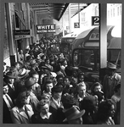
Source: Farm Security Administration-Office of War Information/Esther Bubley
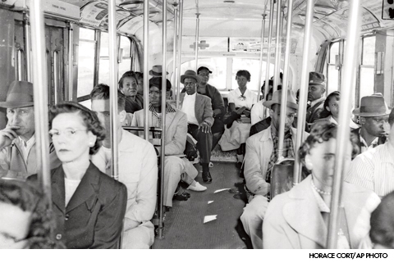
Source: Associated Press/Horace Cort
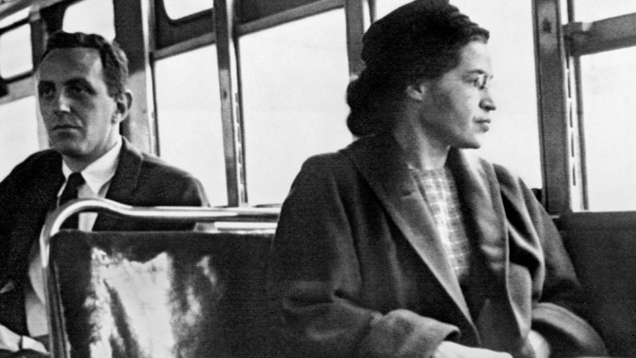
Source: Rosa Parks on Bus

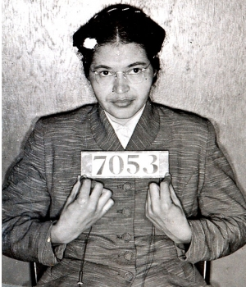
Source: Photograph, Rosa Parks Booking Photo,

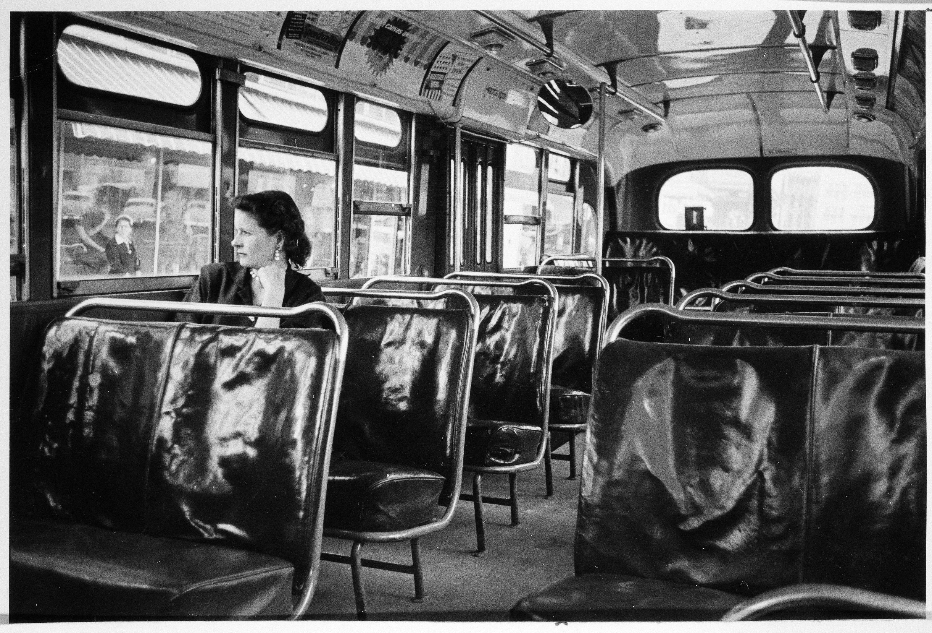
Source: Photograph, Montgomery, Alabama Bus During Day boycott, December 55-56/ Courtesy National Archives, photo no. 306-PSD-68-11200.

Sample Cause and Effect Graphic Organizers
Multiple Causes and Effects Related to an Event

Event

Causes

Effects

One Cause and One Effect
Cause
Effect

More Than One Cause Related to an Effect
Cause 1

Cause 2

Effect

One Cause with Multiple Effects
Cause
Effect 1
Effect 2
Effect 3

Cause and Effect Sentence Frames:
Effect + because + cause.

Cause + as a result + effect.

Cause + then + effect.

Effect + due to + cause.

This led to + effect.

Effect + because of + cause.

Effect + since + cause.

In order to + effect, + cause.

For this reason, + effect.

Lesson 6  Days 8 and 9 | Using Cause and Effect Language | Estimated Time: 60 minutes per day

Brief overview of lesson: Students will apply what they learned about signal words of cause and effect. They will revisit prior texts to identify cause and effect statements, then apply this technique to new texts. These experiences will help students develop an understanding of how language can illustrate relationships between events. Students will also practice writing cause and effect statements about civil eights events to summarize what happened, a foundational skill for the CEPA. As you plan, consider the variability of learners in your class and make adaptations as necessary.

What students should know and be able to do to engage in this lesson:
- Basic understanding of cause and effect signal words, verbs in the past tense, adjectives, and content-specific vocabulary previously introduced.
- Ability to write claims using lesson-specific adjectives.
- Ability to use dictionaries and translators to figure out the meaning of words and phrases.
- Experience working with multiple partners during a lesson.
LESSON FOUNDATION
Unit-Level Focus Language Goals to Be Addressed in This Lesson |  | Unit-Level Salient Content Connections to Be Addressed in This Lesson
G.1 Explain the causes and effects of key events of the Civil Rights Movement.  G.2 Discuss by building upon ideas of others and articulating your own. |  | CCSS.ELA-LITERACY.L.11-12.3—Apply knowledge of language to understand how language functions in different contexts, to make effective choices for meaning or style, and to comprehend more fully when reading or listening.  USII.25—Analyze the origins, goals, and key events of the Civil Rights Movement.
Language Objective |  | Essential Questions Addressed in This Lesson
Students will be able to summarize and discuss causes and effects of Civil Rights Movement events using related signal words (e.g., because, as a result, then, due to, this led to, since, in order to, for this reason). |  | Q.1 How can I use language to clarify the relationship between events and ideas?  Q.2 How can I use language to illustrate and present my opinion?  Q.3 How can I build upon the ideas of others in a discussion?  Q.4 How can individual people and events change history?
Assessment
- Formative assessment: Assess student application of learned language in their written cause and effect statements about the Brown v. Board of Education decision.
- Formative assessment: Assess student application of learned language during oral discussions and written statements articulating causes and effects of school desegregation in Little Rock, Arkansas.
Thinking Space: What Academic Language Will Be Practiced in This Lesson?
Discourse Dimension | Sentence Dimension |  | Word Dimension
Social instructional language; reading narrative and/or informational short excerpts of adapted secondary sources; providing basic information about the Civil Rights Movement using single sentences orally and in writing; discussing the Civil Rights Movement orally by sharing ideas/opinions and listening to those of others | Simple sentences in present and past tense that include verbs related to the Civil Rights Movement (e.g., march/marched, walk/walked, talk/talked, speak/spoke, sit/sat, ride/rode, is/was, throw/threw, go/went, hit/hit); sentences with because and other cause and effect signal words |  | Content-specific vocabulary and adjectives related to the Civil Rights Movement (e.g., unfair, fair, equal, powerful, inspiring, wrong, separate, brave, courageous, bad, right, equality, rights, segregation, freedom); argument-related language (e.g., fact, opinion, claim, evidence); cause and effect signal words (e.g., because, as a result, then, due to, this led to, since, in order to, for this reason)
Instructional Tips/Strategies/Suggestions for Teacher
- Post and explain the lesson’s objective so students can see and understand it.
- Use formative assessments to inform future instruction. For example, if assessments reveal the need for a concept to be reviewed or discussed further, make necessary adjustments to upcoming lessons.

STUDENT CONSIDERATIONS
Sociocultural Implications
Some students may bring biases toward different cultures/races/religions from various groups they identify with. It may be important to highlight that insults toward any group of people are not appropriate or acceptable in the classroom.
Anticipated Student Pre-Conceptions/Misconceptions
- Some students may think that there is only one cause and one effect related to each event.
- Some students may be confused about the relationship between causes and effects in statements.
- Some students may struggle with writing grammatically correct cause and effect statements that incorporate cause and effect language introduced in the unit.

THE LESSON IN ACTION

Day 8 Lesson Opening

Post and explain the lesson’s language objective so students can see and understand it: “Students will be able to summarize and discuss causes and effects of Civil Rights Movement events using related signal words (e.g., because, as a result, then, due to, this led to, since, in order to, for this reason).” To promote student ownership and self-monitoring of learning, consider having students record the objective in their notebooks or having students summarize the objective in their own words. At the end of the lesson, students can reflect on their learning in relation to the objective.

Introduce the lesson and the first activity: a review of cause and effect language and the Montgomery bus boycott. For example, say: “We will continue working with cause and effect language. Today we will start by reviewing information about the Montgomery bus boycott.”

Have students identify causes and effects in sentence strips with statements about the Montgomery bus boycott with a partner. Ask them to highlight the causes and the effects in each sentence, using a different color for cause and effect signal words. If some students are more comfortable with textual analysis, have them read a short piece about the Montgomery bus boycott instead of working with sentence strips.

While reviewing information, ask students to sort causes and effects into a graphic organizer.
Provide options for physical action, such as using a computer to complete.

While students are working, circulate and provide specific feedback on student construction of cause and effect statements. Prompt student thinking by asking questions such as: “What is the signal word?” “Why is this a cause statement?” and “Why is this an effect statement?”

Finally, ask students to individually write cause and effect statements based on the bus boycott using related signal words.
Provide options for physical action, such as using a computer to complete.

During the Lesson

Introduce the focus of the lesson and the next activity: additional practice identifying cause and effect statements and relationships between ideas. For example, say: “We will continue working with cause and effect language. We will review some events that we have already discussed to look for causes and effects.” Project an article or previously read document. With student assistance, highlight and/or label cause, effect, and claim vocabulary in the text. Review claim vocabulary as needed.
Provide options for perception, such as projecting the article, providing a printed version, or having students view it on a computer.
Provide options for engagement, such as having the students highlight or label cause, effect, and claim language in the article individually, with a partner, or in a small group.

Have students continue practicing identifying causes and effects of the Brown v. Board of Education decision in previously studied texts and writing them on a graphic organizer. Reviewing previously studied information can help reinforce the information for students, as well as help them see connections between events and how language can be used to describe these connections.

Before beginning, explain how one event may have multiple causes and/or effects.

Have students revisit previously learned information about the decision from Lesson 3 and Lesson 4. Ask them to identify what they think are causes and effects of the decision with a partner, and write them in a cause and effect graphic organizer.

Next, ask students to revisit an article about the decision and look for any additional causes and effects, then add them to their graphic organizer.

Ask students to create cause and effect statements about the decision and match them with visuals illustrating their statements. Consider providing sentence frames as needed.
Provide options for physical action, such as using a computer.

Lesson Closing

Ask students to individually create cause and effect statements about the Brown v. Board of Education decision using cause, effect, and claim language; past tense; and any relevant adjectives.
Provide options for physical action, such as using a computer to complete.

Have students complete an exit ticket where they discuss what they have learned using sentence frames, such as “I learned …” and “I practiced ...” Model how to share using these sentence frames, then have students share orally or in writing. Add student responses to the K-W-L chart.

Day 9 Lesson Opening

Introduce the focus of the lesson and the next activity: discussing school desegregation in Little Rock, Arkansas, using language learned so far. For example, say: “We are going to continue to practice with all the language we have learned so far. We are going to use the language to discuss a new event that occurred during the Civil Rights Movement. The event is known as the Little Rock Nine.”

Pre-teach additional content-specific vocabulary, such as integration. Facilitate a choral reading of a teacher-created text about the Little Rock Nine.

Instruct students to hold up color-coded cards after each sentence that includes cause and effect signal words. Ask them to identify the word and categorize it as a cause or an effect signal word.

Begin reading and pause after every sentence to have students identify targeted language. Record student responses on a graphic organizer.
Provide options for engagement, such as having students work collaboratively with the text and write down identified signal words in the graphic organizer first, then share with the whole class.
Provide options for perception, such as reading excerpts from first-hand accounts or watching video footage of the Little Rock Nine, such as those from Facing History and the History Channel.

During the Lesson

Ask students to respond to the following questions using information learned from the previous activity: “What was a cause of school integration? What was an effect of school integration? What is your opinion about school integration?” Model for students how to respond and provide sentence frames such as: “I think a cause of school integration was …”; “I think an effect of school integration was …”; “I think school integration …”

Have students create cause and effect statements and an evidence-supported statement about the Little Rock Nine. Review relevant language studied in the lesson (adjectives; past tense; cause, effect, and claim language) and model for students how to incorporate this language into the statements before they begin working (e.g., “Courts ordered school desegregation. As a result, African American students in Little Rock changed schools”). Consider providing sentence frames and/or a graphic organizer to help students use targeted language.

Pair students to discuss causes and effects of school integration in Little Rock. Ask them to take turns stating causes and effects, and stating their opinions about school integration using sentence frames, such as “I agree with school integration because …”and “I disagree with school integration because …” Before students begin, model how to support opinions with relevant evidence.

Lesson Closing

Provide students with images depicting either a cause or an effect of key Civil Rights Movement events discussed so far and divide them into groups of three.

Ask students to orally describe what the images illustrate, using sentences/frames such as: “This image shows a cause,” “This image shows an effect,” “One cause of _______ was _______,” and “One effect of _______ was _______.”

After discussing orally, instruct students to write cause and effect statements using relevant language (cause and effect signal words, past tense, etc.) in a graphic organizer. This organizer should have two columns: one for cause statements and one for effect statements, and could also contain a word bank with cause and effect signal words and sentence frames to assist students as they work.

Circulate and provide specific feedback on student application of learned language.

Ask students to individually create cause and effect statements and an evidence-based opinion statement about the Civil Rights Movement. As students are working, assess their ability to use adjectives, content area vocabulary, past tense verbs, and cause and effect language. Also assess their ability to create cause and effect statements and evidence-based opinions (or claim statements supported by facts).
Provide options for physical action, such as using a computer to complete.

Have students complete an exit ticket where they discuss what they have learned using sentence frames, such as “I learned…” and “I practiced...” Model how to share using these sentence frames, then have students share orally or in writing. Add student responses to the K-W-L chart.

Optional activity: Have students chronicle their reactions to the Little Rock Nine event on a reflection log.

Lesson 6 Resources
- Whiteboard or computer with projector
- Chart paper
- Sentences (available below) and images (samples available below) representing causes and effects of the Civil Rights Movement
- Adapted excerpts from texts about the Little Rock Nine, such as those from Facing History and the History Channel
- Claim vocabulary words
- Cause and effect vocabulary words
- Cause and effect sentence strips for Montgomery bus boycott (available below)
- Sentence frames (available below)
- Cause and effect graphic organizer (available below)
- Teacher-created text about the Little Rock Nine

Cause and Effect Sentence Strips for Montgomery Bus Boycott
- Rosa Parks got on the bus because she “wanted to go home.”
- Rosa Parks was arrested because she did not give up her seat on the bus.
- Rosa Parks’ conviction was one of the factors that led to a bus boycott.
- Because African Americans refused to ride the bus, the bus company lost money.
- As a result of the bus boycott, the buses were desegregated.
- Because Rosa Parks was “tired of being pushed around,” she did not give up her seat.
- Since there were not enough seats, Rosa Parks was asked to move.
- Since more people got on the bus, there were not enough seats.
- Due to Martin Luther King Jr’s involvement in the bus boycott, he received threats.
- The Montgomery bus boycott led to other boycotts and protests.

Causes and Effects of the Little Rock Nine

Name: _____________________________________________________________________________

- What was a cause of school integration? A cause of school integration was________________________________________
____________________________________________________________________________________________________________________________.

- What was an effect of school integration? An effect of school integration was_____________________________________
____________________________________________________________________________________________________________________________.

- What is your opinion about school integration? I think ______________________________________________________________
_____________________________________________________________________________________________________________________________

Create cause and effect statements about the Little Rock Nine. Refer to the sentence frames:
_________________________________________________________________________________________________________________________________
_________________________________________________________________________________________________________________________________
_________________________________________________________________________________________________________________________________
_________________________________________________________________________________________________________________________________

Create an opinion statement supported by evidence about the Little Rock Nine. Underline or highlight your evidence: _________________________________________________________________________________________________________________________________
_________________________________________________________________________________________________________________________________
_________________________________________________________________________________________________________________________________

Sample Sentence Frames for Student Discussion
Print and cut out the sentence frames for student discussion. Provide students with the sentence frames.

I agree… because…
I disagree… because…

I agree… because…
I disagree… because…

I agree… because…
I disagree… because…

I agree… because…
I disagree… because…

Sample Cause and Effect Graphic Organizers

Multiple Causes and Effects Related to an Event

Event

Causes

Effects

One Cause and One Effect

Cause
Effect

More Than One Cause Related to an Effect
Cause 1

Cause 2

Effect

One Cause with Multiple Effects
Cause
Effect 1
Effect 2
Effect 3
Sample Images to Discuss Causes and Effects of Civil Rights Movement Events

Source: Associated Press/Montgomery County Sheriff's Office
Source: Associated Press/Horace Cort

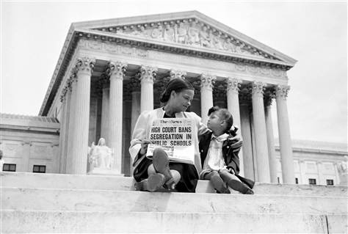
Source: High Court Bans Segregation in Schools/ Corbis Images

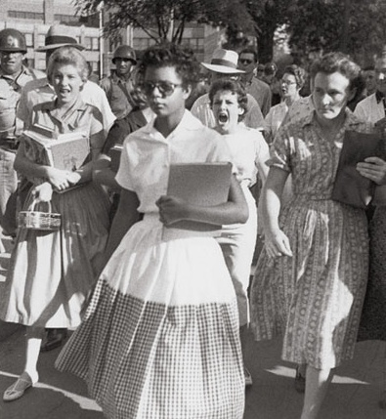
Source: Photograph, Black Students Integrate Little Rock’s Central High School

Lesson 7  Day 10 | Museum “Field Trip” | Estimated Time: 60 minutes

Brief overview of lesson: Students will examine a teacher-created museum display, and listen to the teacher present it. The presentation will include an introduction of the event and a summary of what happened during the event, a discussion of causes and effects of the event, and an explanation of the event’s significance. Afterwards, students will have an opportunity to discuss causes and effects presented and why the event was important. They will also have a chance to use discussion frames to ask questions about the event. These will serve as a model for how students should present and discuss museum displays during the CEPA. As you plan, consider the variability of learners in your class and make adaptations as necessary.

What students should know and be able to do to engage in this lesson:
- Basic understanding of previously introduced language such as adjectives, past tense, content-specific vocabulary, cause and effect signal words, and argument/claim language.
- Familiarity with creating evidence-supported claims.
- Familiarity with question words and question formation.
LESSON FOUNDATION
Unit-Level Focus Language Goals to Be Addressed in This Lesson |  | Unit-Level Salient Content Connections to Be Addressed in This Lesson
G.1 Explain the causes and effects of key events of the Civil Rights Movement.  G.2 Discuss by building upon ideas of others and articulating your own. |  | CCSS.ELA-LITERACY.WHST.11-12.1.C—Use words, phrases, and clauses as well as varied syntax to link the major sections of the text, create cohesion, and clarify the relationships between claim(s) and reasons, between reasons and evidence, and between claim(s) and counterclaims.  USII.25—Analyze the origins, goals, and key events of the Civil Rights Movement.
Language Objective |  | Essential Questions Addressed in This Lesson
Students will be able to orally discuss a teacher-created museum display using sentence frames. |  | Q.1 How can I use language to clarify the relationship between events and ideas?  Q.2 How can I use language to illustrate and present my opinion?  Q.3 How can I build upon the ideas of others in a discussion?  Q.4 How can individual people and events change history?
Assessment
- Formative assessment: Assess student application of learned language and collaborative discussion norms.
- Formative assessment: Assess student ability to listen to and analyze the teacher presentation as evidenced by student completion of the CEPA checklist.
- Formative assessment: Assess student ability to apply learned language to create of statements of fact, cause and effect, and evidence-supported claims about the event.
Thinking Space: What Academic Language Will Be Practiced in This Lesson?
Discourse Dimension | Sentence Dimension |  | Word Dimension
Social instructional language; reading narrative and/or informational short excerpts of adapted secondary sources; providing basic information about the Civil Rights Movement using single sentences orally and in writing; discussing cause and effect relationships between Civil Rights Movement events orally and in writing; asking and answering questions | Simple sentences in present and past tense that include verbs related to the Civil Rights Movement (e.g., march/marched, walk/walked, talk/talked, speak/spoke, sit/sat, ride/rode, is/was, throw/threw, go/went, hit/hit); sentences with because and other cause and effect signal words; questions |  | Content-specific vocabulary and adjectives related to the Civil Rights Movement (e.g., unfair, fair, equal, powerful, inspiring, wrong, separate, brave, courageous, bad, right, equality, rights, segregation, freedom); argument-related language (e.g., fact, opinion, claim, evidence); cause and effect signal words (e.g., because, as a result, then, due to, this led to, since, in order to, for this reason)
Instructional Tips/Strategies/Suggestions for Teacher
- Set up the museum display in the library prior to the lesson. Use the CEPA Graphic Organizer to help plan the exhibit.
- Possible events to use for the museum display include: Brown v. Board of Education decision, Montgomery bus boycott, Little Rock Nine, sit-ins, civil rights protest in Birmingham, March on Washington (1963), Selma march (1965), passage of the Civil Rights Act (1964), and/or passage of the Voting Rights Act (1965).
- Use formative assessments to inform future instruction. For example, if assessments reveal the need for a concept to be reviewed or discussed further, make necessary adjustments to upcoming lessons.
Instructional Tools

STUDENT CONSIDERATIONS
Sociocultural Implications
- Some students may bring biases toward different cultures/races/religions from various groups they identify with. It may be important to highlight that insults toward any group of people are not appropriate or acceptable in the classroom.
- Visiting the library and/or a museum display may be a new experience for many ELs, especially newcomers.
Anticipated Student Pre-Conceptions/Misconceptions
- Some students may be confused about the relationship between causes and effects in statements.
- Some students may struggle with writing grammatically correct cause and effect statements that incorporate cause and effect language introduced in the unit.

THE LESSON IN ACTION

Lesson Opening

Post and explain the lesson’s language objective so students can see and understand it: “Students will be able to orally discuss a teacher-created museum display using sentence frames.” To promote student ownership and self-monitoring of learning, consider having students record the objective in their notebooks or having students summarize the objective in their own words. At the end of the lesson, students can reflect on their learning in relation to the objective.

Consider delivering a presentation about a common topic such as your school and/or places you like to visit in the summer. Deliver the same presentation twice. The first time, give an ineffective presentation; the second time, give an effective presentation. After each presentation, have students reflect on the presentation and think about what worked well and what did not work well. Then have them turn and talk to a partner and share their ideas, before discussing as a whole class. After the first presentation, give students a chance to offer ideas for improving the presentation before you deliver the second, effective presentation. After both presentations, go over the Presentation Rubric, highlighting elements of an effective presentation in the rubric and those brought up by students.

During the Lesson

Introduce the museum “field trip” experience.

If students will view the display in the library, review library norms by brainstorming them with students.

Review the structure and purpose of museums. Depending upon student familiarity with museums, consider showing a virtual tour of a museum display. For example, students could analyze exhibits or go on a virtual tour of the National Civil Rights Museum online. Give students focus questions to think about while the review the online exhibit, such as: “What do you see? What do you notice? What was the event? What happened during the event? What were the causes? The effects? What do you think should be included in a museum display?”

Explain how students will go on a “field trip” to tour a museum display created by their teacher, and what students are expected to do during and after the presentation. For example, say: “Now we are going to tour my museum display. I will present my display to you. We will practice the language that we have learned. We are going to use the past tense, adjectives, content vocabulary, cause and effect language, and practice stating evidence-supported claims. While I present, identify causes and effects of the event I present. Afterwards, use the CEPA Checklist to note which components are in my presentation. You will also use the CEPA Rubric to score my presentation. You can ask me questions about the event after I present.” Consider recording the presentation (audio or video) so students can listen to it several times if they need to in order to identify causes and effects.

Review the graphic organizer, CEPA Checklist, CEPA Rubric, and discussion starters and sentence frames. Consider going over the checklist and rubric to make sure students understand all criteria and elements of an effective oral presentation. Possible discussion starters include:

Discussion Starters for Questioning  and Asking for Clarification | Sentence Frames for Responding
- “Why is … important?”  - “What is the cause of…?”  - “What is the effect of…?”  - “Can you expand upon…?”  - “So, you’re saying…?”  - “Can you clarify…?” | - “I agree with … because…”  - “I disagree with … because…”  - “I see what you’re saying, but…”  - “Another related point is…”  - “A connection to what you’re saying is…”
Provide options for perception, such as giving students printed-version discussion starters and using a computer to view the graphic organizer and sentence frames.

Present your museum display.

Introduce the event, summarize what happened, and explain causes and effects of the event and your opinion about its importance.

Have students complete their graphic organizers to identify causes and effects of the event.

Give students time to reflect on the presentation and review the exhibit individually, and then share their thoughts with a partner or small group. Consider providing reflection prompts, such as: “Why is… important? What is the cause of…? What is the effect of…? What is one thing you learned from the exhibit? What is one thing that you would still like to know/still have questions about?” Allowing time for students to discuss their thoughts with a small group ahead of time can help them form their ideas and practice using the language in a smaller setting where they may be more comfortable.

Invite students to a whole class discussion about the event presented, and ask them to use discussion starters and sentence frames to discuss and ask questions about the event. Post discussion starters and sentence frames or give students a card or handout with printed starters to use during the discussion.
Provide options for perception, such as using speech-to-text software.

Lesson Closing

Ask students to state one fact about the event and create cause and effect statements about it. Consider also asking students to make evidence-based opinion statements about the event using adjectives and verbs in the past tense.
Provide options for physical action, such as using a computer to complete, working individually, or working with a partner/small group.

Have students complete an exit ticket where they discuss what they have learned using sentence frames, such as “I learned…” and “I practiced...” Model how to share using these sentence frames, then have students share orally or in writing. Add student responses to the K-W-L chart.

Optional activity: Have students chronicle their reactions to the museum display and presentation on a reflection log. Consider asking students to reflect on the following questions: “Why was the event important? How did the event impact/change history? What about creating a museum display are you excited about and why? What about creating a museum display are you nervous about and why?”

Lesson 7 Resources
- Teacher-created museum display
- Word walls
- Cause and effect graphic organizer
- Discussion starters and sentence frames (available below)
- Sample CEPA rubric (available below)
- Sample CEPA checklist (available below)
- Sample CEPA graphic organizer (available below)

Sample CEPA Graphic Organizer
Image of the event:

Facts about the event (text): with fact signal words and verbs in past tense:
Image of the effect(s) of the event:

Effects of the event (text) with cause, effect, and fact signal words, and verbs in past tense:
Image of the cause(s) of the event:

Cause(s) of the event (text) with cause, effect, and fact signal words, and verbs in past tense:

facts

Summary paragraph about the event and its importance (with vocabulary, adjectives, verbs in past tense and a claim supported by evidence).

Discussion Starters and Sentence Frames
Print and provide students with the following discussion starters and sentence frames

Discussion starters for questioning your peers about their opinions and asking for clarification:
- Why is … important?
- What is the cause of …?
- What is the effect of …?
- Can you expand upon …?
- So, you’re saying …?
- Can you clarify …?

Sentence frames for responding:
- I agree with … because …
- I disagree with … because …
- I see what you’re saying, but …
- Another related point is …
- A connection to what you’re saying is …

Sample Presentation Rubric
Presentation Rubric | 3 | 2 | 1
VOLUME | Student consistently speaks loud enough for me to hear | Student often speaks loud enough for me to hear | Student yells or speaks so softly I cannot hear
EYE CONTACT | Student consistently makes eye contact most of the time | Student often makes eye contact | Student does not make eye contact
EXPLANATIONS | Student explains each piece of the display | Student explains some pieces of the display | Student does not explain most of the pieces of the display
PACE | Student consistently speaks at an appropriate pace | Student sometimes speaks at an appropriate pace | Student goes through the presentation too fast or too slowly

Sample CEPA Checklist
Name: _________________________________________________________________________________

While listening to the presentation, take notes on each of the following:

1. What are the causes of the event? _______________________________________________________________________________________
_________________________________________________________________________________________________________________________________
_________________________________________________________________________________________________________________________________
2. What are the effects of the event? _______________________________________________________________________________________
_________________________________________________________________________________________________________________________________
_________________________________________________________________________________________________________________________________
3. Facts about the event: _____________________________________________________________________________________________________
_________________________________________________________________________________________________________________________________
_________________________________________________________________________________________________________________________________
4. Cause and effect statement with signal words: _________________________________________________________________________
_________________________________________________________________________________________________________________________________
_________________________________________________________________________________________________________________________________
5. Are the visuals provided clear and connected to the events discussed? ______________________________________________
_________________________________________________________________________________________________________________________________
_________________________________________________________________________________________________________________________________
6. Summary of the event (including opinion statement supported by evidence): _________________________________________________________________________________________________________________________________
_________________________________________________________________________________________________________________________________
Sample CEPA Rubric
CEPA Rubric
Criteria | Description | Evidence in Student Work
Adjectives | Student frequently and appropriately uses adjectives to describe the Civil Rights Movement, such as inspiring, powerful, fair, unfair.
Cause and Effect | Student frequently and appropriately identifies and explains causes and effects.  Students frequently and appropriately identifies and uses signal words of cause and effect.
Past Tense | Student frequently and appropriately uses the past tense (orally and in writing).
Opinion Supported by Evidence | Student clearly states opinion and supports their opinion with at least one piece of evidence (fact).
Discussion | Student frequently and appropriately uses the discussion frames to discuss their opinions and build upon the ideas of others.

Lesson 8  Day 11 | Summarizing a Shared Experience | Estimated Time: 60 minutes

Brief overview of lesson: The teacher will model writing a summary of the museum “field trip” from Lesson 7, highlighting verbs in the past tense, adjectives, causes and effects, summary of the event, and explanation of the event’s importance. Then students will do a choral reading of the teacher-prepared summary before writing their own summary of the visit using provided paragraph frames and sharing it with the whole class. The summary writing process gives teachers an opportunity to check students’ ability to use targeted language and skills introduced so far in the unit. It also allows students to practice essential skills they will use when creating their own museum displays. This lesson also helps students prepare for the CEPA and work toward achieving unit goals as they practice orally using learned language; explaining and listening to claim, cause, and effect statements; and engaging in a discussion about the topic. As you plan, consider the variability of learners in your class and make adaptations as necessary.

What students should know and be able to do to engage in this lesson:
- Familiarity with previously introduced language, cause and effect signal words, adjectives, and past tense.
- Familiarity with expressing cause and effect relationships in oral and written statements.
- Stating a claim or opinion supported by evidence.
- Using adjectives to describe the Civil Rights Movement.
- Familiarity with conventions of academic collaborative discussions such as turn-taking, asking for clarification, etc.
LESSON FOUNDATION
Unit-Level Focus Language Goals to Be Addressed in This Lesson |  | Unit-Level Salient Content Connections to Be Addressed in This Lesson
G.1 Explain the causes and effects of key events of the Civil Rights Movement.  G.2 Discuss by building upon ideas of others and articulating your own. |  | CCSS.ELA-LITERACY.W.9-10.2. B—Develop the topic with well-chosen, relevant, and sufficient facts, extended definitions, concrete details, quotations, or other information and examples appropriate to the audience's knowledge of the topic.  CCSS.ELA-LITERACY.SL.9-10.1. A—Come to discussions prepared, having read and researched material under study; explicitly draw on that preparation by referring to evidence from texts and other research on the topic or issue to stimulate a thoughtful, well-reasoned exchange of ideas.  USII.25—Analyze the origins, goals, and key events of the Civil Rights Movement.
Language Objective |  | Essential Questions Addressed in This Lesson
Students will be able to summarize their experience viewing a museum display and listening to a related presentation in writing. |  | Q.1 How can I use language to clarify the relationship between events and ideas?  Q.2 How can I use language to illustrate and present my opinion?  Q.3 How can I build upon the ideas of others in a discussion?  Q.4 How can individual people and events change history?
Assessment
- Observation: Assess student use of language during partner discussions.
- Formative assessment: Have students provide written explanation of why the leader or event is inspiring based on the trip to the museum.
Thinking Space: What Academic Language Will Be Practiced in This Lesson?
Discourse Dimension | Sentence Dimension |  | Word Dimension
Social instructional language; summarizing information about the Civil Rights Movement using single sentences orally and in writing; discussing Civil Rights Movement events orally and in writing; stating evidence-supported claims orally and in writing | Simple sentences in present and past tense that include verbs related to the Civil Rights Movement (e.g., march/marched, walk/walked, talk/talked, speak/spoke, sit/sat, ride/rode, is/was, throw/threw, go/went, hit/hit); sentences with because and other cause and effect signal words; questions |  | Content-specific vocabulary and adjectives related to the Civil Rights Movement (e.g., unfair, fair, equal, powerful, inspiring, wrong, separate, brave, courageous, bad, right, equality, rights, segregation, freedom); argument-related language (e.g., fact, opinion, claim, evidence); cause and effect signal words (e.g., because, as a result, then, due to, this led to, since, in order to, for this reason)
Instructional Tips/Strategies/Suggestions for Teacher
- Teacher-created summary of the museum “field trip” experience to use as a guide when modeling summarization.
- Use formative assessments to inform future instruction. For example, if assessments reveal the need for a concept to be reviewed or discussed further, make necessary adjustments to upcoming lessons.

STUDENT CONSIDERATIONS
Sociocultural Implications
- Some students may bring biases toward different cultures/races/religions from various groups they identify with. It may be important to highlight that insults toward any group of people are not appropriate or acceptable in the classroom.
- Some students may not have any previous experience with museums beyond the shared experience in class.
Anticipated Student Pre-Conceptions/Misconceptions
In writing summaries, students may think that every detail is important.

THE LESSON IN ACTION

Lesson Opening

Post and explain the lesson’s language objective so students can see and understand it: “Students will be able to summarize their experience viewing a museum display and listening to a related presentation in writing.” To promote student ownership and self-monitoring of learning, consider having students record the objective in their notebooks or having students summarize the objective in their own words. At the end of the lesson, students can reflect on their learning in relation to the objective.

Introduce the lesson. For example, say: “Today we will reflect on our trip to the museum.”

Have your museum display set up so that students can revisit it as needed.

Have students review the graphic organizer they used during the “field trip” in Lesson 7 and discuss the event presented with a partner using sentence frames, such as: “_______ caused _______,” “_______ was an effect of_______,” “I think _______ was important because _______,” and “I think _______ was inspiring because_______.”

During the Lesson

Model writing a summary.

Have sentences for the summary already prepared. Have each sentence written in a different sentence strip, and color-code them to highlight cause and effect signal words, causes, effects, basic facts summarizing what happened in the event, verbs in the past tense, evidence-supported claims, and the event’s significance so students can clearly see the different components of the summary.

Assemble the sentences into a paragraph summarizing the experience with the students’ help. For example, say: “Which sentence on the board gives us a summary of facts about the event? Which sentence tells us causes of the event?” and so on. Correct any errors that come up as necessary and model your thinking behind sentence order decisions. Explain how to identify what information is considered a main idea and what information is a supporting detail. Once the summary is finished, leave it posted for student reference.
Provide options for perception, such as viewing the summary on a computer.
Provide options for physical action, such as using a text-to-speech reader.

Do a choral reading of the summary. Model correct pronunciation and have students repeat after you. Provide additional practice for words that are confusing to pronounce. Have students discuss the importance of the event presented by the teacher in the museum display.

Ask students to create their own explanation summarizing the event’s importance (or how it changed the nation). Remind students to state a claim supported by relevant evidence, use adjectives, and use verbs in the past tense. Consider providing a paragraph frame or cloze.
Provide options for physical action, such as having students create the summary with a partner.

Have students discuss their opinion about the event’s significance (how it was important, how it impacted the nation or how it was inspiring to them) with a partner, then share their ideas with the class. Allow students who are reluctant to speak to the whole class to write their statements on a whiteboard and show it to the class.

Lesson Closing
Revisit the Civil Rights Movement visual timeline from Lesson 1. While reviewing the timeline, focus on the events that student CEPAs will involve and explain how students will create museum displays about these events. Possible events to use for the museum displays include: Brown v. Board of Education decision, Montgomery bus boycott, Little Rock Nine, sit-ins, civil rights protest in Birmingham, March on Washington (1963), Selma march (1965), passage of the Civil Rights Act (1964), and/or passage of the Voting Rights Act (1965).

Lesson 8 Resources
- Vocabulary list with vocabulary (content-specific words, cause and effect language, claim/argument language, adjectives and verbs in past tense form)
- Teacher-created and color-coded sentences
- Paragraph frames

Lesson 9  Days 12, 13, and 14 | Creating Museum Displays  (CEPA Part 1) | Estimated Time: 60 minutes per day

Brief overview of lesson: Students will collaborate to create their museum display over three days. On Day 12, they will collect and organize information regarding one event from the Civil Rights Movement from teacher provided resources, identifying facts about their focus event. On Day 13, they will collaboratively draft cause and effect statements about their event and match visuals to the statements, incorporating this information into their displays. On Day 14, each student will write an explanation summarizing what happened in the event and stating an evidence-supported claim about the event’s importance using sentence and/or paragraph frames, teacher models, and word banks. Students will also practice presenting their opinions to peers. Throughout this three-day lesson, teachers will be able to assess students’ ability to form verbs in the past tense. As you plan, consider the variability of learners in your class and make adaptations as necessary.

What students should know and be able to do to engage in this lesson:
- Familiarity with cause and effect signal words of cause and effect and familiarity expressing cause and effect relationships.
- Ability to state a claim/opinion supported by evidence.
- Ability to use adjectives and past tense to describe Civil Rights Movement events.
- Familiarity with conventions of academic discussions such as turn-taking.
LESSON FOUNDATION
Unit-Level Focus Language Goals to Be Addressed in This Lesson |  | Unit-Level Salient Content Connections to Be Addressed in This Lesson
G.1 Explain the causes and effects of key events of the Civil Rights Movement.  G.2 Discuss by building upon ideas of others and articulating your own. |  | CCSS.ELA-LITERACY.W.9-10.2. B—Develop the topic with well-chosen, relevant, and sufficient facts, extended definitions, concrete details, quotations, or other information and examples appropriate to the audience's knowledge of the topic.  CCSS.ELA-LITERACY.WHST.11-12.1.C—Use words, phrases, and clauses as well as varied syntax to link the major sections of the text, create cohesion, and clarify the relationships between claim(s) and reasons, between reasons and evidence, and between claim(s) and counterclaims.  CCSS.ELA-LITERACY.W.9-10.7—Conduct short as well as more sustained research projects to answer a question (including a self-generated question) or solve a problem; narrow or broaden the inquiry when appropriate; synthesize multiple sources on the subject, demonstrating understanding of the subject under investigation.  USII.25—Analyze the origins, goals, and key events of the Civil Rights Movement.
Language Objectives |  | Essential Questions Addressed in This Lesson
- Day 12: Students will be able to identify and summarize information about a Civil Rights Movement event.  - Day 13: Students will be able to describe causes and effects of a Civil Rights Movement event in writing.  - Day 14: Students will be able to argue about the significance of a Civil Rights Movement event by stating a claim and supporting it with relevant evidence in writing. |  | Q.1 How can I use language to clarify the relationship between events and ideas?  Q.2 How can I use language to illustrate and present my opinion?  Q.3 How can I build upon the ideas of others in a discussion?  Q.4 How can individual people and events change history?
Assessment
- Day 12 formative assessment: Assess students’ completed graphic organizer (showcasing student ability to organize information and apply learned language to identify facts, opinions, causes, and effects). Also assess student use of learned language and collaborative group norms during group discussions.
- Day 13 formative assessment: Assess student application of learned language to create written cause and effect statements. Also assess student use of learned language and collaborative group norms during group discussions.
- Day 14 formative assessment: Assess student application of learned language to write an explanation summarizing what happened in the event and stating an evidence-supported claim about the event’s importance. In student written summaries, assess student use of adjectives; content-specific vocabulary; verbs in the past tense; and cause, effect, and claim language.
- Self-assessment: Students will self-assess and self-monitor by using the CEPA Planning Sheet to monitor their progress in relation to the culminating performance assessment.
Thinking Space: What Academic Language Will Be Practiced in This Lesson?
Discourse Dimension | Sentence Dimension |  | Word Dimension
Social instructional language; summarizing information about the Civil Rights Movement using single sentences orally and in writing; discussing Civil Rights Movement events orally and in writing; stating evidence-supported claims orally and in writing; asking and answering questions | Simple sentences in present and past tense that include verbs related to the Civil Rights Movement (e.g., march/marched, walk/walked, talk/talked, speak/spoke, sit/sat, ride/rode, is/was, throw/threw, go/went, hit/hit); sentences with because and other cause and effect signal words; questions |  | Content-specific vocabulary and adjectives related to the Civil Rights Movement (e.g., unfair, fair, equal, powerful, inspiring, wrong, separate, brave, courageous, bad, right, equality, rights, segregation, freedom); argument-related language (e.g., fact, opinion, claim, evidence); cause and effect signal words (e.g., because, as a result, then, due to, this led to, since, in order to, for this reason)
Instructional Tips/Strategies/Suggestions for Teacher
- Post the paragraph model online so students can enlarge the font, translate it, and/or listen to it if they prefer.
- Provide differentiated supports, such as paragraph frames and/or more challenging cause and effect vocabulary.
- Consider recording an explanation of cause and effect concepts and related language, including a brief demonstration of how to use the target vocabulary and form statements and closed captions. Share this video with students, allowing them to access the video individually if they need additional reinforcement about these concepts.
- In addition to the CEPA Planning Sheet, consider providing students with a research graphic organizer.
- Consider adapting texts for students. Use a tool such as Rewordify.
- Provide short video clips with background information about events students are working with and allow students to watch them during and/or after class as needed. Consider also providing students with short video clips about the event they are working with.
- Use formative assessments to inform future instruction. For example, if assessments reveal the need for a concept to be reviewed or discussed further, make necessary adjustments to upcoming lessons.

STUDENT CONSIDERATIONS
Sociocultural Implications
- Some students may bring biases toward different cultures/races/religions from various groups they identify with. It may be important to highlight that insults toward any group of people are not appropriate or acceptable in the classroom.
- Students may be unfamiliar with museum displays (how they are structured, the type of information they include, etc.) Provide several models of museum displays for students to analyze.
Anticipated Student Pre-Conceptions/Misconceptions
In writing summaries, students may think that every detail is important.

THE LESSON IN ACTION

Day 12 Lesson Opening

Post and explain the lesson’s language objective so students can see and understand it: “Students will be able to identify and summarize information about a Civil Rights Movement event.” To promote student ownership and self-monitoring of learning, consider having students record the objective in their notebooks or having students summarize the objective in their own words. At the end of the lesson, students can reflect on their learning in relation to the objective.

Review the components of the CEPA.

Go over the CEPA Rubric and CEPA Checklist with students, using the model museum display and corresponding paragraph. Explain each rubric indicator/criterion and make sure students understand them.

Provide time for students to review the visual timeline that has been posted during the entire unit, previewing the events that the class will focus on for their museum displays.

Divide students into groups and/or assign individuals the events they will be working on.

During the Lesson

Have students research their event by reading texts and/or short excerpts and watching videos about it with a partner or in a small group.

Ask students to highlight facts, opinions, causes, and effects about their event.

Provide each group with access to a short video clip about their event.
Provide options for perception, such as using a computer to review the information.

While students work, circulate and provide specific feedback on student collection and organization of information.

Provide opportunities for students to discuss their event.

Group students into groups of three (if not already working in small groups).

Ask students to discuss their event with each other using the following prompts and sentence frames: “What is your opinion about the event?” “My opinion is ...”; “What was a cause of the event?” “A cause of the event was...”; “What was an effect of the event?” “An effect of the event was...”; “Do you think this event changed history? Why?” “I think this event changed history because...”

Circulate and offer specific feedback on student use of collaborative discussion norms and learned language.

Lesson Closing

Instruct students to begin completing the CEPA Planning Sheet. Go over each step in the CEPA Planning Sheet and explain which ones students should focus on now (steps 1–3).
Provide options for physical action, such as using a computer to complete.

Have students complete an exit ticket where they discuss what they have learned using sentence frames, such as “I learned…” and “I practiced...” Model how to share using these sentence frames, then have students share orally or in writing. Add student responses to the K-W-L chart.

Day 13 Lesson Opening

Post and explain the lesson’s language objective so students can see and understand it: “Students will be able to describe causes and effects of a Civil Rights Movement event in writing.” To promote student ownership and self-monitoring of learning, consider having students record the objective in their notebooks or having students summarize the objective in their own words. At the end of the lesson, students can reflect on their learning in relation to the objective.

Revisit the teacher-created museum display and its components. Highlight and focus on the pieces the students will be working on today (the facts about the event, the causes, the effects, and the visuals).

During the Lesson

Give students time to work on steps 2–4 of the CEPA Planning Sheet with their group.

Have students discuss event facts, causes, and effects using prompts and sentence frames: “What is your opinion about the event?” “My opinion is ...”; “What was a cause of the event?” “A cause of the event was...”; “What was an effect of the event?” “An effect of the event was...”; “Do you think this event changed history? Why?” “I think this event changed history because...”

After discussing, tell students to select facts, causes, and effects to include in their presentation, then create cause and effect statements in their CEPA Planning Sheet.

Give students time to work on step 5: “Select or create visuals for the causes of the event, the event, and the effects of the event.” Provide a few visuals about each event from which students can select images they want to use to represent the event, its causes, and its effects. While students work, circulate and provide specific feedback on student completion of steps 2–5.
Provide options for physical action, such as having students create the images.

Optional activity: Have students explain why they chose the images.

Lesson Closing

Give students time to begin creating their display. Students can use the CEPA graphic organizer as a model.
Provide options for physical action, such as creating a poster board, creating a PowerPoint, or creating a brief documentary of the event.

Have students complete an exit ticket where they discuss what they have learned using sentence frames, such as “I learned…” and “I practiced...” Model how to share using these sentence frames, then have students share orally or in writing.

Day 14 Lesson Opening

Post and explain the lesson’s language objective so students can see and understand it: “Students will be able to argue about the significance of a Civil Rights Movement event by stating a claim and supporting it with relevant evidence in writing.” To promote student ownership and self-monitoring of learning, consider having students record the objective in their notebooks or having students summarize the objective in their own words. At the end of the lesson, students can reflect on their learning in relation to the objective.

Review the teacher-created paragraph for the museum display and its components.

During the Lesson

Model for students how to use the CEPA Planning Sheet to check their work.

Ask students to review their display so far using the CEPA Planning Sheet. While students check their work, offer specific feedback on the components of the CEPA.

Give students time to create their display paragraph using sentence and/or paragraph frames (step 6 of the CEPA Planning Sheet)

Explain how students should provide a brief description of the event, list causes and effects of the event, and then state an evidence-based claim about the event’s significance. Provide a paragraph frame, such as: “_______ (event) is ______ (adjective). One cause of the event is _______. The event also happened because _______. As a result of this event, _____________ (effect). Another consequence of the event was ____. I think _______ (event) is important because _____.”
Provide options for physical action, such as using a computer to complete.

Lesson Closing

Have students practice discussing the event with a partner using discussion prompts, such as: “Who is your leader? What is your event? What is your claim? What are the causes? What are the effects? How did this person or event change history?”

Model how to use the prompts do discuss an event.

Tell students to listen carefully to their partners first, then offer feedback about how they responded using sentence frames, such as: “I liked how you …” and “I’m still wondering about …”

Have students complete an exit ticket where they discuss what they have learned using sentence frames such as “I learned…” and “I practiced...” Model how to share using these sentence frames, then have students share orally or in writing. Add student responses to the K-W-L chart.

Lesson 9 Resources
- Teacher-created museum display and corresponding paragraph
- Word wall
- Images of Civil Rights Movement events
- Teacher-selected resources about each event assigned to students
- Dialogue prompts
- Paragraph frames
- Paragraph models
- CEPA planning sheet (available below)
- Sample graphic organizer for creating museum displays (available below)
- Sample CEPA rubric (available below)
- Sample Performance Indicators (available below)

CEPA Planning Sheet

Step 1: Pick an event.

My event is: ____________________________________________________________________________________________________________

Step 2: Gather facts about the event.

Who was involved?

When did it happen?

Where did it happen?

Why did it happen?

How did it happen? OR
How did it impact the Civil Rights Movement?

Step 3: Identify the causes and effects of the event.

The causes of the event are … | The effects of the event are…

Step 4: Write cause and effect statements about the event. You can use one or several of the following sentence frames to help you.

For causes:  - One cause of the event is _______.  - The event also happened because _______. | For effects:  - As a result of this event, _____________ (effect).  - Another consequence of the event was ______.

______________________________________________________________________________________________________________________________________________________________
_____________________________________________________________________________________________________________________________________________________________________________________________________________________________________________________________________________________________________________________________________________________________________________________________________________________________________________________________________________________________________________________________________________________________________________________________________________________________________________________________________________________________________________________________________________________
_________________________________________________________________________________________________________________________________________________
Step 5: Select or create visuals for the causes of the event, the event, and the effects of the event.

Step 6: Create your paragraph. Use the following paragraph frame:

“_______ (event) is ______ (adjective). One cause of the event is _______. The event also happened because _______. As a result of this event, _____________ (effect). Another consequence of the event was ____. I think _______ (event) is important because _____.”

______________________________________________________________________________________________________________________________________________________________
_____________________________________________________________________________________________________________________________________________________________________________________________________________________________________________________________________________________________________________________________________________________________________________________________________________________________________________________________________________________________________________________________________________________________________________________________________________________________________________________________________________________________________________________________________________________
___________________________________________________________________________________________________________________________________________________________________________________________________________________________________________________________________________________________________________________________________________________________________________________________________________________________________________________
Sample Graphic Organizer for Creating Museum Displays

Image of the event:

Facts about the event (text): with fact signal words and verbs in past tense:
Image of the effect(s) of the event:

Effects of the event (text) with cause, effect, and fact signal words, and verbs in past tense:
Image of the cause(s) of the event:

Cause(s) of the event (text) with cause, effect, and fact signal words, and verbs in past tense:

facts

Summary paragraph about the event and its importance (with vocabulary, adjectives, verbs in past tense, and a claim supported by evidence).

Differentiation of the CEPA Using WIDA Performance Indicators
Teachers may adjust performance indicators as necessary based on student needs.
Model Performance Indicators
WIDA Standard: The Language of ELA |  |  | WIDA PI Receptive Domain (Listening or Reading): G.1. Explain the causes and effects of key events of the Civil Rights Movement.
Level 1—Entering  Match cause and effect images to cause and effect statements after reading with a small group and graphic organizer. | Level 2—Emerging  Identify causes and effects after reading or watching a video using a graphic organizer with a word bank of cause and effect signal words/phrases. | Level 3—Developing  X |  | Level 4—Expanding  X | Level 5—Reaching  X
WIDA Standard: The Language of ELA |  |  | WIDA PI Productive Domain (Speaking or Writing): G.1. Explain the causes and effects of key events of the Civil Rights Movement.
Level 1—Entering  Describe causes and effects of Civil Rights Movement events using word banks, sentence frames, and models in small groups. | Level 2—Emerging  Describe causes of Civil Rights Movement events using word banks and sentence frames in small groups. | Level 3—Developing  X |  | Level 4—Expanding  X | Level 5—Reaching  X

Sample CEPA Rubric
Criteria | Description | Evidence in Student Work
Adjectives | Student frequently and appropriately uses adjectives to describe the Civil Rights Movement, such as inspiring, powerful, fair, unfair.
Cause and Effect | Student frequently and appropriately identifies and explains causes and effects.  Students frequently and appropriately identifies and uses signal words of cause and effect.
Past Tense | Student frequently and appropriately uses the past tense (orally and in writing)
Opinion Supported by Evidence | Student clearly states opinion and supports their opinion with at least one piece of evidence (fact).
Discussion | Student frequently and appropriately uses the discussion frames to discuss their opinions and build upon the ideas of others.

Lesson 10  Day 15 | Museum Exhibit (CEPA Part 2) | Estimated Time: 60 minutes

Brief overview of lesson: Students will present their museum displays, creating a full exhibit about the Civil Rights Movement. They will summarize the event, describe its causes and effects, and explain its significance. Students will then answer questions about their displays. Through student presentations, teachers will be able to assess student progress toward unit goals. As you plan, consider the variability of learners in your class and make adaptations as necessary.

What students should know and be able to do to engage in this lesson:
- Familiarity with cause and effect signal words and familiarity expressing cause and effect relationships.
- Ability to state a claim/opinion supported by evidence.
- Ability to use adjectives and past tense to describe Civil Rights Movement events.
- Familiarity with conventions of academic discussions, such as turn-taking.
- Familiarity with oral presentation characteristics and presenter skills.
LESSON FOUNDATION
Unit-Level Focus Language Goals to Be Addressed in This Lesson |  | Unit-Level Salient Content Connections to Be Addressed in This Lesson
G.1 Explain the causes and effects of key events of the Civil Rights Movement.  G.2 Discuss by building upon ideas of others and articulating your own. |  | CCSS.ELA-LITERACY.W.9-10.2. B—Develop the topic with well-chosen, relevant, and sufficient facts, extended definitions, concrete details, quotations, or other information and examples appropriate to the audience's knowledge of the topic.  CCSS.ELA-LITERACY.WHST.11-12.1.C—Use words, phrases, and clauses as well as varied syntax to link the major sections of the text, create cohesion, and clarify the relationships between claim(s) and reasons, between reasons and evidence, and between claim(s) and counterclaims.  CCSS.ELA-LITERACY.W.9-10.7—Conduct short as well as more sustained research projects to answer a question (including a self-generated question) or solve a problem; narrow or broaden the inquiry when appropriate; synthesize multiple sources on the subject, demonstrating understanding of the subject under investigation.  USII.25—Analyze the origins, goals, and key events of the Civil Rights Movement.
Language Objective |  | Essential Questions Addressed in This Lesson
Students will be able to orally discuss causes and effects of a Civil Rights Movement event and argue about its significance. |  | Q.1 How can I use language to clarify the relationship between events and ideas?  Q.2 How can I use language to illustrate and present my opinion?  Q.3 How can I build upon the ideas of others in a discussion?  Q.4 How can individual people and events change history?
Assessment
- Summative assessment: Assess student application of all learned language during oral presentations (use of past tense, adjectives, cause/effect vocabulary, and statements supported by evidence).
- Formative assessment: Assess student application of all learned language during questions and answers.
Thinking Space: What Academic Language Will Be Practiced in This Lesson?
Discourse Dimension | Sentence Dimension |  | Word Dimension
Social instructional language; summarizing information about the Civil Rights Movement using single sentences orally and in writing; discussing Civil Rights Movement events orally and in writing; stating evidence-supported claims orally and in writing; asking and answering questions | Simple sentences in present and past tense that include verbs related to the Civil Rights Movement (e.g., march/marched, walk/walked, talk/talked, speak/spoke, sit/sat, ride/rode, is/was, throw/threw, go/went, hit/hit); sentences with because and other cause and effect signal words; questions |  | Content-specific vocabulary and adjectives related to the Civil Rights Movement (e.g., unfair, fair, equal, powerful, inspiring, wrong, separate, brave, courageous, bad, right, equality, rights, segregation, freedom); argument-related language (e.g., fact, opinion, claim, evidence); cause and effect signal words (e.g., because, as a result, then, due to, this led to, since, in order to, for this reason)
Instructional Tips/Strategies/Suggestions for Teacher
- Review teacher model presentation before students present their displays.

STUDENT CONSIDERATIONS
Sociocultural Implications
Some students may bring biases toward different cultures/races/religions from various groups they identify with. It may be important to highlight that insults toward any group of people are not appropriate or acceptable in the classroom.
Anticipated Student Pre-Conceptions/Misconceptions
Students may think that events only have one cause and one effect.

THE LESSON IN ACTION

Lesson Opening

Post and explain the lesson’s language objective so students can see and understand it: “Students will be able to orally discuss causes and effects of a Civil Rights Movement event and argue about its significance.” To promote student ownership and self-monitoring of learning, consider having students record the objective in their notebooks or having students summarize the objective in their own words. At the end of the lesson, students can reflect on their learning in relation to the objective.

Give students time to set up their presentations and review different displays.

During the Lesson

Review the graphic organizer for presentations.

Review effective oral presentation strategies.

Have students present their museum displays. Consider having students present to the whole class or having students present in small groups.

After each presentation, allow listeners to ask questions about the display and have the presenter answer them. Consider positing a list of questions students can ask, and related response sentence frames, such as: “What is your opinion about the event?” “My opinion is...”; “What was a cause of the event?” “A cause of the event was...”; “What was an effect of the event?” “An effect of the event was...”; “Do you think this event changed history? Why?” “I think this event changed history because...”

After listening to the presenter, ask listeners to give feedback: “I liked…”; “I wonder…”
Provide options for physical action, such as presenting to a small group.

Lesson Closing
Revisit the K-W-L chart created in Lesson 1 after all students have presented. Ask students to think about what they learned and practiced throughout the unit. Add student responses to the “Learned” column.

Lesson 10 Resources
- Presentation question prompts and response frames
- Note-taking CEPA checklist
- Graphic organizers
- Sentence frames
- Discussion frames
- Word banks

Unit Resources
Websites with Images and Videos of Civil Rights Leaders and Events

- Library of Congress

- Voices of Civil Rights

- Civil Rights Digital Library

- Eyes on the Prize video series

Tools for Student Support

- Rewordify—Paste text into this website and it gives you simplified text with interactive vocabulary.

- Thinglink—Upload images or videos and insert text such as cause/effect vocabulary and claims for student reference throughout unit.

- Signing Savvy—Resource for translating words into American Sign Language. It can be useful to pair new vocabulary words (such as cause and effect signal words) with gestures to help students remember.

Unit Text and Image Citations
Page 19, AP Photo/Bill Hudson, File;
Page 17 , Photograph by Gordon Parks. © The Gordon Parks Foundation.
Page 21, AP Photo
Page 22, Underwood Archives/Getty Images
Page 23, Courtesy United Press International, http://www.upi.com/.
Page 25, Bettmann/Getty Images
Page 26, Definition of "equality" reprinted by permission. From Merriam-Webster’s Collegiate® Dictionary, 11th Edition ©2016 by Merriam-Webster, Inc. (www.Merriam-Webster.com).
Page 27, Definition of "freedom" reprinted by permission. From Merriam-Webster’s Collegiate® Dictionary, 11th Edition ©2016 by Merriam-Webster, Inc. (www.Merriam-Webster.com).
Page 28, Definition of "segregation" reprinted by permission. From Merriam-Webster’s Collegiate® Dictionary, 11th Edition ©2016 by Merriam-Webster, Inc. (www.Merriam-Webster.com).
Page 29, Definition of "right" reprinted by permission. From Merriam-Webster’s Collegiate® Dictionary, 11th Edition ©2016 by Merriam-Webster, Inc. (www.Merriam-Webster.com).
Page 30, Source: http://www.mrose.longwoodteachers.com
Page 37, www.clipartof.com.
Page 38, MaleWitch/Shutterstock
Page 39, Depositphotos, Inc./riedochse
Page 42 , Source: America's Black Holocaust Museum
Page 43, The LIFE Picture Collection/Francis Miller/Getty Images
Page 44, Bettmann/Getty Images
Page 54, AP Photo/File
Page 54, Courtesy United Press International, http://www.upi.com/News_Photos/Archives/Remembering-Martin-Luther-King-Jr/4481/17/.
Page 54, Bettmann/Getty Images
Page 54, Bettmann/Getty Images
Page 56, Source: American Radio Works
Page 57, From "Bridgeport Library Branch" in "Children of Jim Crowe", American Radio Works, http://americanradioworks.publicradio.org/. Reprinted by permission of Dr. Kenneth M. Stone, CPA, CGMA.
Page 60, From "The Education of Black Children in the Jim Crown South", http://abhmuseum.org/2012/09/education-for-blacks-in-the-jim-crow-south/. Reproduced by permission of the America's Black History Museum.
Page 63, Source: America's Black Holocaust Museum
Page 64, Cook Collection, The Valentine.
Page 90, 110, Universal Images Group/Getty Images
Page 91, Courtesy National Archives, photo no. 306-PSD-68-11200.
Page 111, AP Photo/Horace Cort, file
Page 113, Bettmann/Getty Images

By permission. From Merriam-Webster’s Collegiate® Dictionary, 11th Edition, ©2016 by Merriam-Webster, Inc.
By permission. From Merriam-Webster’s Collegiate® Dictionary, 11th Edition ©2016 by Merriam-Webster, Inc.
By permission. From Merriam-Webster’s Collegiate® Dictionary, 11th Edition ©2016 by Merriam-Webster, Inc.
By permission. From Merriam-Webster’s Collegiate® Dictionary, 11th Edition ©2016 by Merriam-Webster, Inc.

