 | 
Office of Language Acquisition
2024-2025 Professional Learning Calendar
Please note that these dates are for planning purposes but may be subject to change. OLA will notify you of changes to these projected dates.

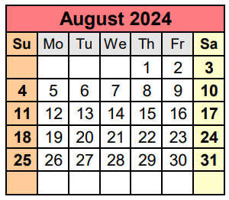 | Wed, 8/14  Thu, 8/15  Until 8/31 | New Directors’ Orientation (Zoom, 9:00-12:30)  Monthly ELE Policy Office Hour (Zoom Q&A, 2:00–3:00) Register  2023-24 WIDA self-paced workshops available (WIDA portal)
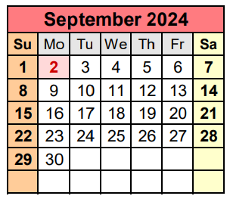 | Thu, 9/12  Thu, 9/19  Tues, 9/24  Ongoing | State Reporting for English Learning Education (webinar, 2:30–3:30) Register  Monthly ELE Policy Office Hour (Zoom Q&A, 2:00–3:00) Register  SLIFE Community of Practice #1 (CoP) (Zoom, 10:00-12:00)  2024-25 WIDA self-paced workshops available (WIDA portal)
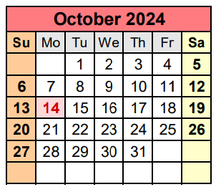 | Wed, 10/9  Thu, 10/17  Tues, 10/22  Wed, 10/23  Ongoing | OLA Network Meeting: Multilingualism for All! (Zoom, 12:30-3:30) Register  Monthly ELE Policy Office Hour (Zoom Q&A, 2:00–3:00) Register  SLIFE Community of Practice #2 (CoP) (Zoom, 10:00-12:00)  ELBAC Meeting (Zoom, 1:00–3:00)  2024-25 WIDA self-paced workshops available (WIDA portal)
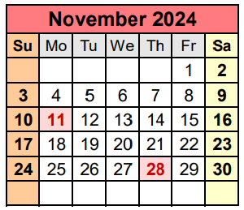 | Thu, 11/7 OR  Fri, 11/8  Tues, 11/19  Thu, 11/21  Ongoing | OLA Advisory Meeting #1A (Zoom, 3:30-4:30)  OLA Advisory Meeting #1B (Zoom, 9:30-10:30)  SLIFE Community of Practice #3 (CoP) (Zoom, 10:00-12:00)  Monthly ELE Policy Office Hour (Zoom Q&A, 2:00–3:00) Register  2024-25 WIDA self-paced workshops available (WIDA portal)
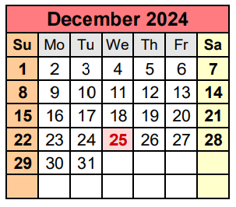 | Tues, 12/10  Thu, 12/19  Ongoing | SLIFE Community of Practice #4 (CoP) (Zoom, 10:00-12:00)  Monthly ELE Policy Office Hour (Zoom Q&A, 2:00–3:00) Register  2024-25 WIDA self-paced workshops available (WIDA portal)
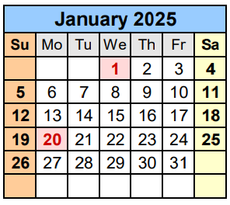 | Wed, 1/8  Thu, 1/30 OR  Fri, 1/31  Ongoing | TFM Self-Assessment training for SY2025-26 districts (Zoom, 2:00-3:00) Register  OLA Advisory Meeting #2A (Zoom, 3:30-4:30)  OLA Advisory Meeting #2B (Zoom, 9:30-10:30)  2024-25 WIDA self-paced workshops available (WIDA portal)
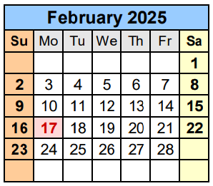 | Tues, 2/11  Wed, 2/12  Ongoing | SLIFE Community of Practice #5 (CoP) (Zoom, 10:00-12:00)  ELBAC Meeting (Zoom, 1:00–3:00)  2024-25 WIDA self-paced workshops available (WIDA portal)
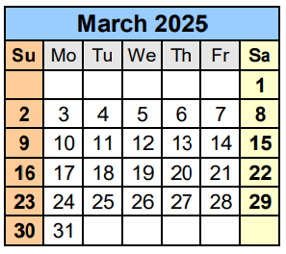 | Tues, 3/11  Wed, 3/19  Thu, 3/27 OR  Fri, 3/28  Ongoing | SLIFE Community of Practice #6 (CoP) (Zoom, 10:00-12:00)  OLA Network Meeting: Access to grade-appropriate, culturally, and linguistically sustaining instruction for all (Zoom, 12:30-3:30)  OLA Advisory Meeting #3A (Zoom, 3:30-4:30)  OLA Advisory Meeting #3B (Zoom, 9:30-10:30)  2024-25 WIDA self-paced workshops available (WIDA portal)
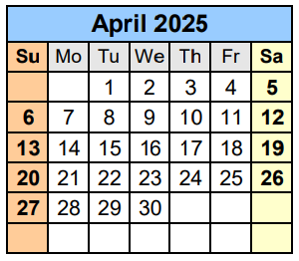 | Tues, 4/8  Ongoing | SLIFE Community of Practice #7 (CoP) (Zoom, 10:00-12:00)  2024-25 WIDA self-paced workshops available (WIDA portal)
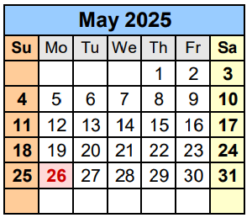 | Tues, 5/6  Wed 5/14  Thu, 5/22 OR  Fri, 5/23  Ongoing | SLIFE Community of Practice #8 (CoP) (Zoom, 10:00-12:00)  ELBAC Meeting (Zoom, 1:00–3:00)  OLA Advisory Meeting #4A (Zoom, 3:30-4:30)  OLA Advisory Meeting #4B (Zoom, 9:30-10:30)  2024-25 WIDA self-paced workshops available (WIDA portal)
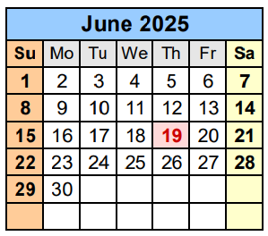 | Fri, 6/6  Ongoing | OLA Network Meeting: Celebrating all Multilingual Learners (in-person, 8:00-3:00)  2024-25 WIDA self-paced workshops available (WIDA portal)

NOTE: 2024-25 WIDA self-paced workshops are available through August 31, 2025, to all MA educators via the WIDA portal. These are a great resource for summer professional development.

Contact Us:
EL Education | el@doe.mass.edu | https://www.doe.mass.edu/ele/
World Languages | worldlanguages@mass.gov | https://www.doe.mass.edu/worldlanguages/
Seal of Biliteracy | MAStateSealofBiliteracy@mass.gov | https://www.doe.mass.edu/scholarships/biliteracy/
Our Team:
Allison Balter, Director
Sibel Hughes, Assistant Director
David Valade, Language Acquisition Support Lead
Judith Magloire, Language Acquisition Support Lead
Andy McDonie, Language Acquisition Support Lead - World Languages
Samantha Kodak, Language Acquisition Compliance Specialist
David Parker, Continuous Improvement Manager for Language Acquisition
Dr. Elenita Irizarry-Ramos, Senior Strategist for Multilingual Learning & Dual Language Education
Moira Connolly, Expanded Learning Time Coordinator
Diana Gentile, Management Analyst

