How to Download and Upload the End of Year Financial Report

All school business officials and any other district staff who have been assigned access to the finance files on the security portal have the ability to download and upload the End of Year Financial Report from the security portal.

Follow these steps

Step 1: Login to the security portal at https://gateway.edu.state.ma.us/.

Step 2: Select Application List, then Drop Box Central from the list of applications.

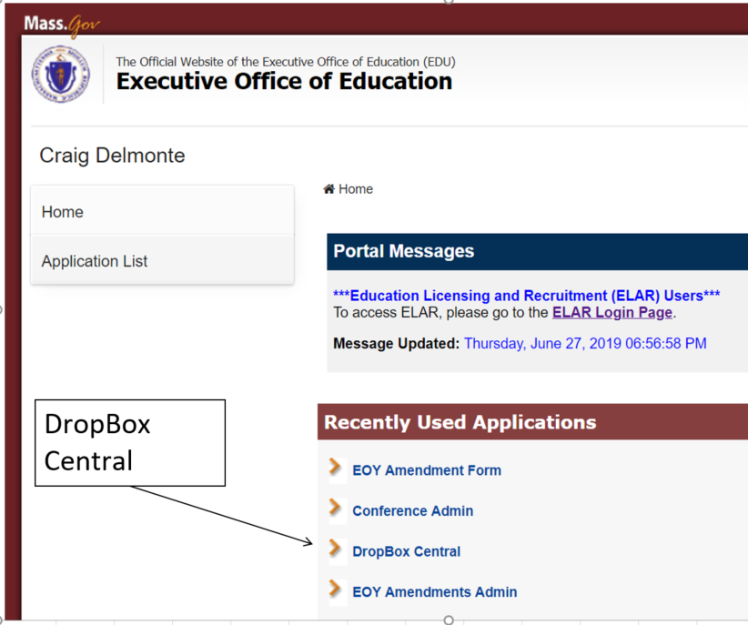

Step 3: Select EOY Financial Report.

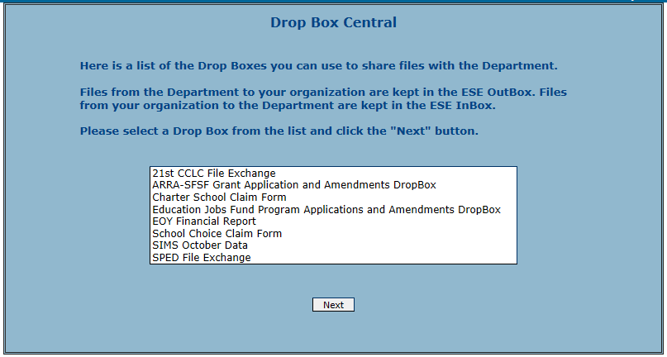

Step 4: Select your district from the organizations list.

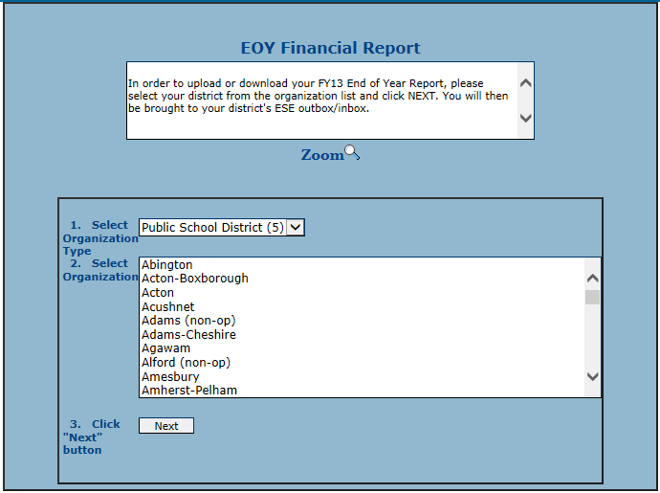

Step 5: Download the file by right clicking on the filename in the ESE Outbox and selecting “save target as”.
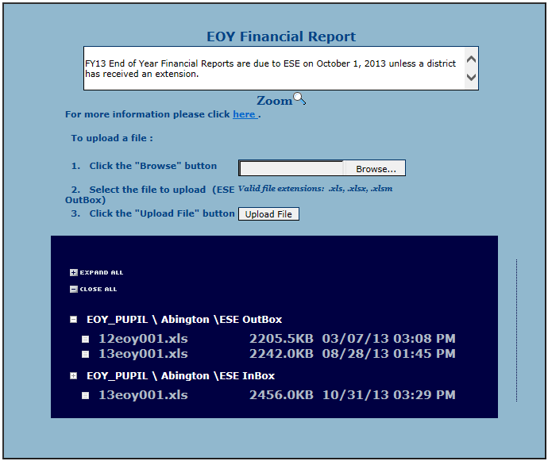

Step 6: Upload the file by following steps 1, 2, and 3.
If you have any questions, contact Rob O’Donnell at (781) 338-6512 or Robert.F.O’Donnell@mass.gov.

