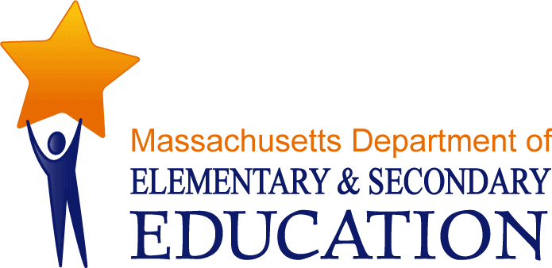

A Pathway to Regionalization:

Improving School Districts through Consolidation

A Step-by-Step Process to Form/Expand/Enlarge

Regional School Districts in Massachusetts

Prepared for:

Massachusetts Department of Elementary and Secondary Education

Prepared by:

Massachusetts Association of Regional Schools

