|  |
| --- |
| Race To The To Logo ESE Star Logo  Experimenting with Congruency Transformations in Geometry |
| High School Geometry Unit  (Updated February 2019) |
|  |
| In this unit, students will explore in further depth, and develop a more fluent understanding, of congruence and transformations, building on knowledge from earlier grades. They will go beyond recognizing and identifying congruency transformations to constructing, predicting, and creating their own transformations. They will explore transformations using functions solidifying related learning in Algebra. Students will transfer their learning to real-world applications of art and textiles. The performance task engages students in designing, and describing with specificity, a unique pattern consisting of multiple transformations.  *These Model Curriculum Units are designed to exemplify the expectations outlined in the MA Curriculum Frameworks for English Language Arts/Literacy and Mathematics incorporating the Common Core State Standards, as well as all other MA Curriculum Frameworks. These units include lesson plans, Curriculum Embedded Performance Assessments, and resources. In using these units, it is important to consider the variability of learners in your class and make adaptations as necessary.* |

This document was prepared by the Massachusetts Department of Elementary and Secondary Education

Mitchell D. Chester, Ed.D., Commissioner

The Massachusetts Department of Elementary and Secondary Education, an affirmative action employer, is committed to ensuring that all of its programs and facilities are accessible to all members of the public. We do not discriminate on the basis of age color, disability, national origin, race, religion, sex, or sexual orientation.

© 2015 Massachusetts Department of Elementary and Secondary Education (ESE).ESE grants permission to use the material it has created under the terms of the Creative Commons Attribution-NonCommercial-ShareAlike 3.0 Unported License. Additionally, the unit may also contain other third party material used with permission of the copyright holder. Please see Image and Text Credits for specific information regarding third copyrights.

The contents of this Model Curriculum Unit were developed under a grant from the U. S. Department of Education. However, those contents do not necessarily represent the policy of the U. S. Department of Education, and you should not assume endorsement by the Federal Government.

Massachusetts Department of Elementary and Secondary Education, 75 Pleasant St, Malden, MA 02148-4906. Phone 781-338-3300, TTY: N.E.T. Relay 800-439-2370, [www.doe.mass.edu](http://www.doe.mass.edu)

Table of Contents

Stage 1 Desired Results 4

Stage 2 - Evidence 6

Stage 3 – Learning Plan 9

Lesson 1: Introduction to Transformations 11

Lesson 2 – Describing and Defining Transformations 26

Investigating Transformations 35

Lesson 3 – Constructing Transformations 47

Lesson 4 – Applications of Transformations 60

Curriculum-Embedded Performance Assessment (CEPA) 70

|  |  |  |
| --- | --- | --- |
| Stage 1 Desired Results | | |
| **ESTABLISHED GOALS**  **G.CO.A.2** Represent transformations in the plane using, e.g., transparencies and geometry software; describe transformations as functions that take points in the plane as inputs and give other points as outputs. Compare transformations that preserve distance and angle to those that do not (e.g., translation versus horizontal stretch).  **G.CO.A.3** Given a rectangle, parallelogram, trapezoid, or regular polygon, describe the rotations and reflections that carry it onto itself.  **G.CO.A.4** Develop definitions of rotations, reflections, and translations in terms of angles, circles, perpendicular lines, parallel lines, and line segments.  **G.CO.A.5** Given a geometric figure and a rotation, reflection, or translation, draw the transformed figure using, e.g., graph paper, tracing paper, or geometry software. Specify a sequence of transformations that will carry a given figure onto another.  **G.CO.B Understand congruence in terms of rigid motions.**  **G.CO.B.6** Use geometric descriptions of rigid motions to transform figures and to predict the effect of a given rigid motion on a given figure; given two figures, use the definition of congruence in terms of rigid motions to decide if they are congruent.  **Mathematical Practices**  **SMP. 4** Model with mathematics  **SMP.5** Use appropriate tools strategically.  **SMP.6** Attend to precision.  **Literacy Standards**  **R.7** Integrate and evaluate content presented in diverse formats and media, including visually and quantitatively, as well as in words.  **R.8** Delineate and evaluate the argument and specific claims in a text, including the validity of the reasoning as well as the relevance and sufficiency of the evidence.  **WCA.4** Produce clear and coherent writing in which the development, organization, and style are appropriate to task, purpose, and audience. | ***Transfer*** | |
| ***Students will be able to independently use their learning to…***  **MA.T.3** Apply mathematical knowledge to analyze and model mathematical relationships in the context of a situation in order to make decisions, draw conclusions, and solve problems. | |
| ***Meaning*** | |
| **UNDERSTANDINGS**  ***Students will understand that…***   * A sequence of transformations carries a given figure onto another or itself. * A rigid transformation is a function which retains the size and shape of a figure by taking the input points of the original and creating an equivalent image as an output. * When identifying, describing, and performing a transformation, one must use appropriate tools strategically and attend to precision. | **ESSENTIAL QUESTIONS**  How does a shape or figure change but stay the same?  How do transformations influence design?  How do transformations help us compare and analyze figures and shapes? |
| ***Acquisition*** | |
| ***Students will know…***   * Precise definitions of the terms related to the plane and to transformations * Different transformations of a pre-image can result in the same image * Which transformations are rigid and which are not * Generalizations of transformations of coordinates on the Cartesian plane * Connections to transformations as functions that take points in a plane as inputs and give other points as outputs | ***Students will be skilled at…***   * Using geometry-specific language and the proper order of instructions in describing the way in which a figure is mapped onto another figure * Using a variety of tools to construct transformations * Distinguishing among rotation, reflection and translation * Using English language and mathematical terms with precision, in both the context of geometry and everyday life |

|  |  |
| --- | --- |
| Stage 2 - Evidence | |
| **Evaluative Criteria** | **Assessment Evidence** |
| * Illustrative use of unit concepts * Accurate application of transformations * Plausible design to be reproduced as a fabric pattern * Detailed, concise, and thorough explanation of design * Accurate and effective use of content vocabulary * Correct explanation of a transformation * Mechanically correct procedure used to produce a congruent figure * Supported claims about results or decisions * Precise and mechanically correct procedure written | **CURRICULUM EMBEDDED PERFORMANCE ASSESSMENT (PERFORMANCE TASKS)**    You are a fashion designer who has been commissioned by a celebrity musician to create a unique fabric design for a formal outfit. The formal outfit will be worn at an upcoming event to benefit a charity foundation, which supports youth programs and scholarships across the country for students aspiring to careers in math, science, and technology. The musician wants the formal attire to represent the foundation’s theme, finding beauty in math and science through art.  Your task is to design an original fabric pattern for an elegant formal outfit that represents the foundation’s theme, by using transformations to demonstrate the ways that math comes alive through art. Your original design should be a unique pattern that is composed of each of the three congruency transformations, using two or more shapes. Your design must include at least one figure that can be mapped onto itself. Your final product must include the sample, a written explanation of the fabric’s design including why it is isometric, a set of instructions on how to reproduce it, and a presentation to your client. |
| Connections made between transformations in space vs. on the Cartesian plane  Proficient explanation of results of transformations on the Cartesian plane  Organized and supported claims  Precise and mechanically correct procedure written  Well-crafted story  Engaging use of figures to create “Planeland” | **OTHER EVIDENCE:** Assessments   1. **Traditional Quiz:** (**G.CO.5, G.CO.4**) Students identify and map the three major congruence transformations (or transformations). 2. **Writing Prompt:** Have students define the three major transformations. Give students one or more sets of figures in which a transformation is present. Writing Prompt:“Identify what composition of transformations mapped one figure onto another. Then, describe the details of the transformation using appropriate vocabulary.” Also, provide a figure for the students to transform using a ruler and protractor.  *Suggested timing: After lesson 1* 3. **Where do Transformations appear in art?** **(G.CO. 6 and G.CO.2)** Provide students with an M.C. Escher drawing. Writing Prompt: “Identify a figure and its corresponding congruent image or images under a transformation or composition of transformations. Describe the details of the transformation using appropriate vocabulary. If applicable to the drawing selected, describe any images that are the results of a transformation but are NOT congruent to the original figure.” *Suggested timing: During/after lesson 2* 4. **Transformations on the Cartesian Plane: (G.CO.2)** Provide students with points to graph on the Cartesian Plane. Instruct them to perform reflections and compositions of reflections over the *x* and *y* axes and lines parallel to the axes (e.g. y = 2). Also instruct them to perform reflections and compositions of reflections over other lines (e.g. y = 3, y= 3x, and y=3x+1). Then, instruct them to: 1) generalize their findings for any point (*x*, *y*)   2) predict what the composition of reflections over the axes will result,  3) describe the type(s) of transformation(s) they named in #2  Differentiations:   * + 1. Have students predict what the composition of reflections over other intersecting perpendicular lines will look like for a point (*x*, *y*).     2. use perpendicular lines that are not parallel to the two axes     3. use one axis and *y* = *x* (creating a 45° angle)     4. If students have knowledge of trigonometry, vary the angle at which the lines intersect   *Suggested timing: after lesson 3*   1. Extension activities for use with Lesson 3   **Symmetry** (G.CO.3) Provide students with the definition of “Reflection Symmetric” and “Rotation Symmetric” (assuming they have not seen these previously) and with three to five polygons that are reflection symmetric, rotation symmetric, or both. For each polygon ask students to do the following: “Determine what type or types of symmetry each figure has. Justify your decision with definitions from the unit.”   1. Peer Assessment/Collaborative Work for use with Lessons 1, 2, and 3   Instruct students to create (in symbols and/or words) but do not draw* a composition of transformations that maps a polygon onto itself (i.e. an identity). Pass it to a classmate and have them predict the result, then draw/perform the composition to verify their prediction and that it works.  *Students may draw/check their work on scrap paper.   1. Sharing with younger learners for use at end of unit   **Creative Writing**. Tell students that they are to write a story to help younger students understand transformations. Use “Joe Rectangle” and “Suzy Pentagon” and relevant vocabulary to describe their journey through “Planeland” – a universe populated by figures and their images under transformations.   1. Pre-Assessment: Assess vocabulary knowledge within the first two days on the terms listed in **G.CO.1** 2. Assess knowledge of transformations: do students know difference between “congruent” and “similar”? |

|  |
| --- |
| Stage 3 – Learning Plan |
| ***Summary of Key Learning Events and Instruction***  **NOTE: This list represents a brief synopsis of the array of learning experiences featured in this unit. Refer to specific lesson plans (Lessons 1 – 4) for more detail, teacher tips, accompanying handouts, and related resources.**   1. Play a round of *Transformation Golf* without telling the students anything specific. Alternatively, play *Tetris* as a class (e.g. on a projector) and ask students to describe how it works. 2. Use discussion to introduce unit terminology, vocabulary, and concept of “change.” Pose first essential question to the class as a “Think, Pair, Share”, a class discussion, or a writing prompt (this will be revisited throughout the unit). 3. Have students make predictions about the position and orientation of a figure and then model the transformation for the students using the relevant and available tools (PBS Learning Media, graph paper, Patty Paper, cut out shapes, Geometer’s Sketchpad, straightedge, compass, and/or protractor).   Option 1: Ask students to develop a set of instructions to actually perform the construction themselves.  Option 2: Choose a transformation game like “Transformation Golf”, “Post the Shapes”, “or “Tetris” and challenge the students to get a certain score. Describe why the game is a transformation game, what transformations are there and which are absent.   1. Bring in relevant and available tools to construct some transformations. Teacher will need to provide specific instructions. This will take a few class sessions. 2. Play a “transformation game” for a 2nd time to monitor progress on uptake of vocabulary usage and understanding of the transformations. Give students a writing prompt to have them explain how/why the game “works” or how it is played with respect to transformations. 3. Use the website <http://www.clarku.edu/~djoyce/wallpaper/> (credit to Prof. David E. Joyce at Clark University who developed these images and this site) to show students examples of wallpaper patterns developed solely using transformations. Have them discuss the details of the pattern and how to recreate them.    1. Strongly encouraged: Before doing the activity, ask students to describe what they will ultimately identify as a “glide reflection.”    2. Students should be able to identify geometric patterns in textiles (when they exist). 4. Homework: Give pairs of students Escher drawings and ask them to describe what they see and/or do not see in terms of transformations. 5. Optional: Formally introduce concept of dilation (if it hasn’t been discussed before). 6. Algebra Link: Doing some graphing and discussion using coordinate mapping notation.    1. Given the graph of a function from Algebra 1 and a transformation, students will be asked to predict the final product of the given transformation OR they will be asked to transform the graph but preserve its shape and describe that transformation. 7. Introduce Final Assessment (Transfer Task above) and its rubric. Invite discussion and idea generation as a class before students go off individually. 8. Revisit Essential Questions as a class.    1. Option 1: Have a discussion about what they learned.    2. Option 2: Develop a writing prompt for students to do an individual reflection. |
| Template adapted from Understanding by Design 2.0 © 2011 Grant Wiggins and Jay McTighe Used with Permission July 2012 |

# Lesson 1: Introduction to Transformations

**Brief Overview of Lesson:**

In this lesson students will draw on their prior knowledge of transformation and the difference between similarity and congruence to formalize their understandings on rotations, reflections and translations. They will use mathematically precise language (SMP.6: Attend to precision.) in their definitions and recognize that context determines the definition and the appropriate use of words such as “transformation”, “translation”, “mapping”, “rotation,” and “reflection.”

As you plan, consider the variability of learners in your class and make adaptations as necessary.

**Prior Knowledge Required:**

1. Familiarity with using and relating geometric figures in middle school and earlier grades (refer to standard 7.G “Draw, construct, and describe geometrical figures and describe the relationships between them”)
2. Familiarity with vocabulary terms reflection (flip), rotation (turn), and translation (slide) in the context of mathematics
3. Familiarity with geometry terms listed in standard G.CO.1
4. Understanding the difference between congruence and similarity

**Estimated Time (minutes):** 90

**Resources:**

Geometer’s Sketchpad, Graphing Calculator, and/or iPad OR if not available, use free online tools such as <http://www.shodor.org/interactivate/activities/Graphit/> , [www.geogebra.com](http://www.geogebra.com) , or [www.desmos.com](http://www.desmos.com)

Graph paper, patty paper, protractor, ruler/straightedge, compass, cut-out shapes

PBS Learning Media

*Transformation Golf*: <http://www.hoodamath.com/mobile/games/transformationgolf2.html>

**Lesson 1 – Introduction to Transformations**

**Content Area/ Course:** Mathematics/Geometry **Grade(s):** 9-11 **Time (minutes or hours):** 90 minutes

**Unit Title:** Experimenting with Transformations in Geometry

**Lesson 1 Title:** Introduction to Transformations

**Essential Question(s):** How does a shape or figure change but stay the same?

**Standard(s)/Unit Goal(s) to be addressed in this lesson:**

**G.CO.A.4** Develop definitions of rotations, reflections, and translations in terms of angles, circles, perpendicular lines, parallel lines, and line segments

**SMP.6** Attend to precision

**R.7** Integrate and evaluate content presented in diverse formats and media, including visually and quantitatively, as well as in words

**W.4** Produce clear and coherent writing in which the development, organization, and style are appropriate to task, purpose, and audience

**Assumptions about what students know and are able to do coming into this lesson (including language needs):**

1. Familiarity with using and relating geometric figures in middle school and earlier grades (refer to standard 7.G “Draw, construct, and describe geometrical figures and describe the relationships between them”)
2. Familiarity with vocabulary terms reflection (flip), rotation (turn), and translation (slide) in the context of mathematics
3. Familiarity with geometry terms listed in standard G.CO.1
4. Understanding the difference between congruence and similarity

* **NOTE:** The amount of time for this lesson is a rough estimate. Teacher should use his/her judgment to either extend or break up this lesson over multiple days, based on school schedule and students’ needs.

***By the end of this lesson students will know and be able to:***

* Use geometry-specific language and the proper order of instructions to describe the way in which a figure is mapped onto another figure
* Describe the difference among the three rigid transformations
* Use terms in both the context of geometry and everyday life (specifically but not limited to “transformation,” “mapping”, and “reflection”)
* Make verbal/written predictions about the position and orientation of the image of a transformed figure

**Instructional Resources/Tools**

Geometer’s Sketchpad, Graphing Calculator, and/or iPad OR if not available, use free online tools such as <http://www.shodor.org/interactivate/activities/Graphit/> , [www.geogebra.com](http://www.geogebra.com) , or [www.desmos.com](http://www.desmos.com)

Graph paper, patty paper, protractor, ruler/straightedge, compass, cut-out shapes

PBS Learning Media

*Transformation Golf*: <http://www.hoodamath.com/mobile/games/transformationgolf2.html>

**Anticipated Student Preconceptions/Misconceptions**

The center of rotation can be any point on the plane.

The transformation of a figure is the transformation of each and every point that determines the figure individually.

The instructor should lead students to explain how context determines the definition and appropriate use of words such as “transformation”, “translation”, “mapping”, “rotation,” and “reflection”.

* **Pre-assessment/ Formative Assessment**
* Ongoing discussion regarding prior knowledge of rigid transformations and associated vocabulary (such as examples used, descriptions, applications or analogies) will allow teacher to informally assess level of understanding.
* See “Lesson Sequence and Description” for details:
  + Students develop a set of instructions to perform a construction. Have them partner up and give each other their instructions, and see if partner can reproduce transformations.
* Exit ticket in which students predict the result of a specific transformation from a given set of instructions (written or verbal). For advanced students, ask them to predict the result of a composition (series) of two or more transformations.

|  |  |
| --- | --- |
| **Lesson Sequence and Description** | **Teacher Notes**  Online Warm-up is intended as an introductory exercise and quick formative assessment of students’ prior knowledge from earlier grades. Don’t spend more than 15 minutes unless serious gaps emerge. If technology is not available then modeling with tangrams or other solids on a coordinate grid or a set of images (screen shots) from a Tetris game could be used.  Four-Square Vocabulary activity will be particularly useful for ELL students, but also for all students in relating transformations to life beyond math examples. Generate a discussion about ideas that students contribute, and use the discussion to emphasize and more clearly distinguish examples from non-examples. Note: This activity is designed to provide a visual and different perspective, but the main goal and emphasis should be to clarify vocabulary. Not all of the given life-like examples may be clear to all students; they are just examples, don’t get bogged down in them. **Use them simply as a starting point;** if you (teacher) or the students provide examples that resonate better with students, use them. Using the samples included may require some vocabulary review, for example “if and only if” bi-conditional sentence structure, perpendicular bisector, etc. Include life-like examples that are culturally relevant and accessible to your students.  Specificity in students’ explanations is key to this unit (SMP.6: Attend to precision). Foreshadow the importance of attending to precision in language. In earlier grades, students may have become familiar with terms “slide,” “flip,” and “turn.” This unit shifts the expectation to using the mathematical terms, and in more sophisticated ways. Introduce *image, pre-image* vocabulary.  For ELL or struggling learners, help students develop greater specificity in language with sentence stems (i.e., First I ___ [insert verb]___, Next I ______, The result looks like _____, My shape is located at ____).  Use graph paper and patty paper to give visual and tactile learners more opportunities to visualize the transformations. Have students use the position on the paper (number of units or squares) to aid them in developing greater specificity in their instructions.  Ask advanced students to articulate how they achieved a high score in the Post the Shapes game with multiple transformations *before* the formative assessment at the end. |
| **Present objectives for the lesson=**  **Online Warm-up (no more than 10-15 minutes)**   1. (In computer lab or in classroom) Have students play *Transformation Gol*f, in pairs (see link in Instructional Resources above). Students should describe, as specifically as possible, the three moves that the game allows. 2. Have a follow-up discussion about the game’s moves and the three image-preserving transformations. How did they play the game? What did they find out? What aspects of the game remind them of prior learning in math, from earlier grades? Q & A as needed…   **Formalize vocabulary (30 minutes or more, as needed)**   1. Pose the first essential question, *how does a shape or figure change but stay the same?* to the class as a “think, pair, share”, a class discussion, or a writing prompt 2. Discuss concept of “change” in many contexts both math-related (e.g., slope as rate of change, change in dimensions or angles, changing signs in expressions) and non-math-related (change of clothing, growth in height or body, change of personality traits, move to a new residence, etc.) 3. Communicate & review essential vocabulary for this unit (uses a method of your choice –hand out, word wall, etc.)   Introduce vocabulary with *Four-Square Vocabulary* activity **(See Vocabulary Handouts 1-4).** Have students work in pairs. There are two sets of handouts for each term related to transformations, one blank sheet and one completed with examples. Students can either share initial ideas/thoughts using blank handout for each term and then compare to completed handout, or begin with the completed 4-square chart for each term and use it to generate their own ideas on the blank sheets.  **Math Note:** There are two types of transformations, rigid and non-rigid. The “Transformation” vocabulary handout launches the notion, in general, as an introductory brainstorm and welcomes all related student ideas. Feel free to bring out the differences in introductory conversation, but the focus of this unit from here is on rigid transformations. Ask students which examples appear to be rigid and why. As a follow-up, introduce the definition of Rigid Transformation (or congruency transformation) – ONLY the location of the object is changed; both its shape AND size are preserved; the new image is congruent to the original image. (All examples in the completed handout represent rigid transformations.)    Elicit and discuss responses. Ask students to share similarities and differences between their own responses and completed handouts, discuss any surprises, any that seemed obvious, and any that seemed difficult to grasp. Ask students their opinions about the usefulness of examples (both their own and the ones provided on handouts) to help visualize/conceptualize meanings of key terms.   * Ask students to consider why the examples and non-examples are important, and how they are helpful/not helpful. Discuss why it’s important to be precise in interpreting what the different types of transformations are and are not (SMP.6: Attend to precision).  1. Additional Discussion Questions: Are your hands reflections of each other? What about your feet? What’s the difference between “reflecting” and “a reflection or “rotating” and “a rotation”? 2. Q & A as needed…   **Suggestion: Introduction to Curriculum-Embedded Performance Assessment**  **(5-10 minutes)**  This unit concludes with a culminating assessment, to be conducted after Lesson 4. It is a Fashion Design performance task **(See CEPA)**. Here in the middle of Lesson 1, students have been warmed up to the ideas of this unit, would be a good time to inform students of the task, and to engage students in a discussion that gives them the opportunity to define the criteria for quality work.  **Making predictions (40 minutes)**  Have students make predictions about the position and orientation of a figure and then model the transformation for the students using the relevant and available tools.   1. Suggested activity: 2. Ask students to choose figure of their choice and develop a set of instructions (verbal and written) to actually perform the construction themselves. Have them pair up, switch instructions, and see if their partners can reproduce the transformation based on the instructions. Have students refine their instructions if the transformation does not produce the intended result. 3. Q & A as needed…   **Exit activity/formative assessment (10 minutes)**  Students make a prediction about the result of a specific transformation from a given set of instructions (written and verbal). For advanced students, ask them to predict the result of a composition (series) of two or more transformations. |

**Extended Learning/Practice (homework)**

Options from earlier in the lesson could be included as HW.

Vocabulary activities begun in class could be completed at home.

Assign readings from Internet and follow-up guided questions.

**Teacher Reflection (to be completed after lesson)**

What went well in this lesson?

Did all students accomplish the outcome(s)?

What evidence do I have?

What would I do differently next time?

**Resources for Lesson 1**

**Lesson 1 Vocabulary Handout 1: Transformation**

|  |  |
| --- | --- |
| **Definition**  The **transformation** of an object performs a change to the object’s size, shape, OR location.  **Transformation** | **Picture** |
| **Examples**   1. Moving a chair from one side of a table to another side 2. Spinning Wheel 3. Lowercase “b” and lowercase “d” 4. Side lunges (exercise move) | **Non-Examples**   1. Putting a cushion on a chair 2. Capital “A” and lowercase “a” |

**Lesson 1 Vocabulary Handout 1: Transformation**

|  |  |
| --- | --- |
| **Definition**  **Transformation** | **Picture** |
| **Examples** | **Non-Examples** |

**Lesson 1 Vocabulary Handout 2: Translation**

|  |  |
| --- | --- |
| **Definition**  A transformation is a **translation** if and only if every point on the object undergoes the same horizontal and/or vertical shift.  Mathematically, it is the composite of reflections over parallel lines. Or, figure B is the translated image of figure A if and only if every segment connecting corresponding points on A and B defines the same vector.  **Translation** | An illustration of a tranlated quadilateral after it was reflected over a line of symmetry then reflected again over a second  line of symmetry parallel to the first line of symmetry **Picture** |
| **Examples**   1. Stars on the American flag 2. Rectangular tiles on a floor 3. Parallel shelves of the same dimensions on a typical bookshelf 4. A hockey puck as it travels along the ice (if it travels in an unobstructed path) 5. Window panes (usually) 6. Rungs on a ladder | **Non-Examples**   1. A plant as it grows 2. Rungs on a bookshelf (when the shelves are different sizes) 3. The teeth in your mouth (they’re not all in a perfect line and they’re not the same shape) |

**Lesson 1 Vocabulary Handout 2: Translation**

|  |  |
| --- | --- |
| **Definition**  **Translation** | **Picture** |
| **Examples** | **Non-Examples** |

**Lesson 1 Vocabulary Handout 3: Reflection**

|  |  |
| --- | --- |
| **Definition**  A transformation is a **reflection** if and only if the line of reflection is the perpendicular bisector of any point on the pre-image and its image. In other words, the line of reflection must be equidistant from the figure and its reflection, and the line of reflection forms a 90° angle with any segment connecting a point on the figure with a point on its reflection.  **Reflection** | **An illustration of a figure refected over a line of symmetryPicture** |
| **Examples**   1. Looking at yourself in a mirror 2. Folding a paper in half and cutting out a shape (one side of the shape is the reflection of the other) 3. Identical back pockets on a pair of jeans (the seam of the jeans is the line of reflection) | **Non-Examples**   1. Looking at yourself in water (pond or lake) 2. Cutting a heart shape out of a piece of paper without folding it first 3. Front pockets on a pair of jeans (one pocket usually has a smaller coin pocket) |

**Lesson 1 Vocabulary Handout 3: Reflection**

|  |  |
| --- | --- |
| **Definition**  **Reflection** | **Picture** |
| **Examples** | **Non-Examples** |

**Lesson 1 Vocabulary Handout 4: Rotation**

|  |  |
| --- | --- |
| **Definition**  A transformation is a **rotation** if and only if every point on the object forms a congruent angle with its pre-image using the point of reflection as its vertex.  Mathematically, it is the composite of reflections over intersecting lines. Or, figure B is the rotated image of figure A if and only if every arc connecting all points on A to all points on B lies on one of a set of concentric circles.  **Rotation** | **Picture**  a right triangle being rotated about the y axis |
| **Examples**   1. Seats on a ferris wheel 2. A person sitting on a merry-go-round 3. A logo on a frisbee as the frisbee is thrown 4. Laces on all baseball pitches (except a knuckleball pitch) 5. Tetris pieces as the game is being played  (before they land) | **Non-Examples**   1. Running in circles (the pattern often does not trace a perfect circle) 2. A knuckleball pitch (the only pitch in which the ball doesn’t rotate) 3. A “Tetris” piece that just “drops” to the bottom without rotating |

**Lesson 1 Vocabulary Handout 4: Rotation**

|  |  |
| --- | --- |
| **Definition**  **Rotation** | **Picture** |
| **Examples** | **Non-Examples** |

# Lesson 2 – Describing and Defining Transformations

**Brief Overview of Lesson:**

In this lesson students will learn to distinguish among rotation, reflection and translation. They will plan, identify, and use suitable tools (SMP.5: Use appropriate tools strategically) to perform a series of transformation that will map a given figure onto another. They will continue to use mathematically precise language (SMP.6: Attend to precision), particularly the terms related to the transformations. Finally, students will learn to make generalizations of transformations of coordinates on the plane. As you plan, consider the variability of learners in your class and make adaptations as necessary.

**Prior Knowledge Required:**

1. Performing transformations on geometric figures
2. Observing and identifying characteristics of images in relation to their pre-images
3. Definitions and applications of transformations in everyday life and in the coordinate plane
4. Prime notation for labeling images resulting from transformations

**Estimated Time (minutes):** 90 minutes plus time for assessments

**Resources:**

Geometer’s Sketchpad, Graphing Calculator, and/or iPad OR if not available, use free online tools shodor.org/graphit or geogebra.com

Graph paper, patty paper, protractor, ruler/straightedge, compass, cut-out shapes

Geometer’s Sketchpad accompanying documentation and workbooks (*Exploring Geometry with Geometer’s Sketchpad*

Web links to assist with instruction of this topic:

<http://caccssm.cmpso.org/geometry-task-force/geometry-resources>

<http://jwilson.coe.uga.edu/emt668/EMAT6680.Folders/Maddox/Transformational.Geo.html>

<http://www.keycurriculum.com/>

**Content Area/ Course:** Mathematics/Geometry **Grade(s):** 9-11

**Time (minutes or hours):** 90 minutes plus time for assessments

**Unit Title:** Experimenting with Transformations in Geometry

**Lesson 2 Title:** Describing and Defining Transformations

**Essential Question(s) to be addressed in this lesson:**

How does a shape or figure change but stay the same?

How do transformations help us compare and analyze figures and shapes?

**Standard(s)/Unit Goal(s) to be addressed in this lesson:**

**G.CO.A.3** Given a rectangle, parallelogram, trapezoid, or regular polygon, describe the rotations and reflections that carry it onto itself.

**G.CO.A.5** Given a geometric figure and a rotation, reflection, or translation, draw the transformed figure using, e.g., graph paper, tracing paper, or geometry software. Specify a sequence of transformations that will carry a given figure onto another.

**G.CO.A.4** Develop definitions of rotations, reflections, and translations in terms of angles, circles, perpendicular lines, parallel lines, and line segments.

**G.CO.A.5** Given a geometric figure and a rotation, reflection, or translation, draw the transformed figure using, e.g., graph paper, tracing paper, or geometry software. Specify a sequence of transformations that will carry a given figure onto another.

**M.P.5** Use appropriate tools strategically.

**M.P.6** Attend to precision.

**Assumptions about what students know and are able to do coming into this lesson (including language needs):**

Performing transformations on geometric figures

Observing and identifying characteristics of images in relation to their pre-images

Definitions and applications of transformations in everyday life and in the coordinate plane

Prime notation for labeling images resulting from transformations

* **NOTE:** Amount of time for this lesson is a rough estimate. Teacher should use his/her judgment to either extend or break up this lesson over multiple days, based on school schedule and students’ needs.

***By the end of this lesson students will know and be able to:***

* Precise definitions of the terms related to the plan and to transformations
* Generalizations of transformations of coordinates on the plane
* Use a variety of tools to construct transformations
* Distinguish among rotation, reflection and translation

**Instructional Resources/Tools**

Geometer’s Sketchpad, Graphing Calculator, and/or iPad OR if not available, use free online tools shodor.org/graphit or geogebra.com

Graph paper, patty paper, protractor, ruler/straightedge, compass, cut-out shapes

Geometer’s Sketchpad accompanying documentation and workbooks (*Exploring Geometry with Geometer’s Sketchpad*

Web links to assist with instruction of this topic:

<http://caccssm.cmpso.org/geometry-task-force/geometry-resources>

<http://jwilson.coe.uga.edu/emt668/EMAT6680.Folders/Maddox/Transformational.Geo.html>

<http://www.keycurriculum.com/>

**Anticipated Student Preconceptions/Misconceptions**

* The center of rotation can be any point on the plane.
* The transformation of a figure is the transformation of each and every point that determines the figure individually.

The instructor should lead students to explain how context determines the definition and appropriate use of words such as “transformation”, “translation”, “mapping”, “rotation,” and “reflection”.

**Assessment**

**Pre-assessment/ Formative**

1. Warm up: Students are asked to define in their own words a transformation term from the previous lesson, verbal and written. Option for ELL students: Describe using related words and add a drawing.
2. Have students define the three major transformations (or transformations). Give students one or more sets of figures in which a transformation is present. Writing Prompt: “Identify what composition of transformations mapped one figure onto another. Then, describe the details of the transformation using appropriate vocabulary.”
3. On-going check-ins with students to monitor progress.

**Assessment 1, Parts A & B** should be administered upon completion Lesson 2.

|  |  |
| --- | --- |
| **Lesson Sequence and Description** | **Teacher Notes**  If initial examples of constructions are demonstrated using Geometer’s Sketchpad, also demonstrate using a compass/protractor to break down the steps for paper-and-pencil work at desks.  Verbal explanation, listening, and discussion are critical to helping students process their thinking and develop understanding (SMP.6: Attend to precision). Emphasize specificity and verbal-written connections in pairs, by having one student speak and the other write exactly what s/he says, review and refine the writing together to make sure the description accurately represents what the speaker meant, and then switch roles and repeat with a different example.  For tactile learners, as well as struggling, visual, and other learners, use **Handout 1** as a paper activity. Have students cut out shapes, place them on a coordinate plane (graph paper), and move the paper cutouts in movements representing a variety of transformations. Have students communicate, verbally and in writing, what they are doing with their hands and what they are visualizing as a result. Have students pair up and write instructions for each other, for their partners to carry out and determine the type of transformation.  Visually impaired students can perform all the transformations in this lesson. However, they will need the aid of tools (Braille ruler, felt board, Velcro figures) and possibly the aid of another student or adult. Working together with a student is an ideal way to check understanding of both students during this process. Visually impaired students benefit greatly from performing transformations on the coordinate plane first, and then generalizing the results to the plane.  Keep in mind that the first composition of transformations should NOT be a composition of reflections over parallel lines or over intersecting lines.  These compositions yield translations and rotations respectively. Option: Save these for later, and use them to make connections back to the Transformation Golf activity from Lesson 1.  The “Investigating Transformations” activity can be made accessible to all learners by using paper cutouts of shapes for tactile learners, using Geometer’s Sketchpad or online alternative to engage students using technology, or drawing figures in different colors on graph paper to help visual and struggling learners make connections between the shapes and the coordinates. A combination of all three of these approaches may also be used.  Technology Tip: If Geometer’s Sketchpad is available, have students learn and use the specific functions in the software that perform the particular transformations. They can also use online alternatives, such as GeoGebra. |
| **Present objectives for the lesson**  **Warm-up (5-25 minutes)**   1. Formative assessment (see above, Assessment 1A) 2. Review assessment and homework   **Modeling Transformations (Congruence Transformations) (40-50 minutes)**  While technology is strongly encouraged throughout this unit, sometimes it is just as appropriate NOT to use technology (SMP.5: Use appropriate tools strategically.). The use of tools, paper-and-pencil AND Geometer’s Sketchpad (or online equivalent) is important in this lesson for students’ development of the conceptual ideas, while supporting different learning styles. Before using Geometer’s Sketchpad for teacher demonstration and student practice, give students preparation and practice with the tool itself, to avoid potential confusion with concepts which might actually stem from using the tool **(See Handout 1: Introduction to Transformations).**  Teacher models a variety of transformations (of your choice) using one or more of a variety of tools available to him/her (see Instructional Resources above). Based on the language of the standards (in particular, G.CO.3), use polygons when modeling/assigning transformations. Include at least one demonstration of an identity transformation. (See note below about the use of technology.)   1. Perform one construction at a time. 2. Have students practice constructions based on teacher’s modeling aloud and with technology. 3. Check for understanding through student practice or Q & A. 4. Have students pair up to work together and check their work. 5. Scaffold student practice by providing appropriate materials ahead of time (e.g., instead of having students copy a figure from the board, provide a photocopied template or pre-image with a corresponding line of reflection or center of rotation. 6. For student constructions, provide step-by-step instructions on how to draw each transformation with a pencil, straightedge, and/or protractor. 7. The instructor should formalize the accompanying notation and discuss: 8. T(ABC) 🡪 A’B’C’ 9. What is “prime”? 10. Under what circumstances a point might not be labeled prime? (i.e., When is a point its own image?)   Guiding Questions (for discussion with pairs while they work and/or whole class discussion after students have had some time to practice multiple examples). During the guided questions, lead students to conclusions about area and perimeter of transformed figures. Encourage all students to consistently use content vocabulary in context.   1. How is the image similar to and different from the pre-image? 2. How is this transformation similar to and different from the previous transformation(s)? 3. Given an image and its pre-image (of your choice), describe the transformation from the pre-image to the image. Explain your reasoning with specificity (SMP.6: Attend to precision.).   Discussion Ideas/Questions for Visual/Tactile Learners(see note at right):   1. Have students use a shape of their choice, do a series of transformations (for example, 2 or 3 or 4 or 5 rotations), and observe/record results each time. 2. What patterns do you notice? 3. Have students trace the shape each time on grid paper/coordinate plane. Observe how many times it takes for the shape to map back onto itself. 4. Repeat a few times with different variations. Predict (without doing it) how many times are needed to map shape back to itself, and explain why.   Q & A as needed…  **Comparing and Contrasting Transformations (10 minutes)**  This vocabulary exercise could be done either before, after, or in-between the Modeling activity described above. Using a Venn Diagram **(See Handout 2: Venn Diagram)**, and referring to previous vocabulary handouts, can assist all learners with class work, homework, and writing.   1. Distribute blank Venn Diagram for Reflections/Rotations/Translations. 2. In small groups, students discuss and record similarities and differences of the three types of congruence transformations.   T(ABC) 🡪 A’B’C’   * 1. What is “prime”?   2. Under what circumstances a point might not be labeled prime? (i.e., when is a point its own image?)   Guiding Questions (for discussion with pairs while they work and/or whole class discussion after students have had some time to practice multiple examples). During the guided questions, lead students to conclusions about area and perimeter of transformed figures. Encourage all students to consistently use content vocabulary in context.   * 1. How is the image similar to and different from the pre-image?   2. How is this transformation similar to and different from the previous transformation(s)?   3. Given an image and its pre-image (of your choice), describe the transformation from the pre-image to the image. Explain your reasoning with specificity (SMP.6: Attend to precision).   Discussion Ideas/Questions for Visual/Tactile Learners(see note at right):   1. Have students use a shape of their choice, do a series of transformations (for example, 2 or 3 or 4 or 5 rotations), and observe/record results each time. 2. What patterns do you notice? 3. Have students trace the shape each time on grid paper/coordinate plane. Observe how many times it takes for the shape to map back onto itself. 4. Repeat a few times with different variations. Predict (without doing it) how many times are needed to map shape back to itself, and explain why.   Q & A as needed…  **Comparing and Contrasting Transformations (10 minutes)**  This vocabulary exercise could be done either before, after, or in-between the Modeling activity described above. Using a Venn Diagram **(See Handout 2: Venn Diagram)**, and referring to previous vocabulary handouts, can assist all learners with class work, homework, and writing.   1. Distribute blank Venn Diagram for Reflections/Rotations/Translations. 2. In small groups, students discuss and record similarities and differences of the three types of congruence transformations. 3. As a class, review responses (distribute completed Venn Diagram). Have students make modifications/corrections on their handouts.   **Developing Rules for Transforming Figures (30 minutes)**  Choose a method of choice for this exercise: group work, individual, etc.   1. Students write rules using the correct mathematical language and notation for performing a reflection, rotation, and translation of their choice. They include drawings for each. 2. Students investigate the effects of rigid motion in a variety of figures **(See Handout 1: Investigating Transformations)**. 3. Students write rules for performing transformations, using the correct notation if that has been taught. They pair up and switch with a classmate. Partners first predict each other’s results, and then draw/perform the composition to verify their prediction. Students explain/justify to each other how their composition worked (i.e. how is order determined?).   Examples of notation:  Ta, b (x, y) = (x + a, y + b) Translation of a units left or right, b units up or down  rO (x, y) = (-x, -y) Reflection about the Origin  ry-axis (x, y) = (-x, y) Reflection about the y-axis  rx-axis (x, y) = (x, -y) Reflection about the x-axis  R60 (x, y) Rotation of 60°  Rx-axis (x, y) Rotation about the x-axis  Discussion Questions:   1. What similarities and differences exist between the three rigid transformations Explain your reasoning verbally, in writing, and using diagrams. 2. What kind of transformations can be observed in a Ferris wheel? Justify your thinking.   Q & A as needed…  **Exit Ticket**  To conclude a lesson (or to break up this lesson over multiple periods in your school schedule), consider any suggested discussion questions above as exit tickets. |
| **Extended Learning/Practice (homework)**  Give pairs of students M.C. Escher drawings and ask them to describe what they see and/or do not see in terms of transformations. Encourage them to find additional examples of transformations in art, and bring pictures to share.  [www.shodor.org](http://www.shodor.org)  <http://www.readwritethink.org/> |

**Teacher Reflection (to be completed after lesson)**

* What went well in this lesson?
* Did all students accomplish the outcome(s)?
* What evidence do I have?
* What would I do differently next time?

**Administer Assessments 1A & 1B**

**Resources for Lesson 2**

# Name __________________________________ Date _______________________________

# Lesson 2 Handout 1

# Investigating Transformations

This activity is a “structured exploration.” The instructions will guide you through a series of steps, in which you will investigate and make important observations about the characteristics of rigid transformations. Use Geometer’s Sketchpad, GeoGebra (online), and/or paper.

A *Rigid Transformation* is a change in the location of a figure; the resulting image is congruent to the pre-image.

### Investigation A: Irregular Figure

A

B

C

D

E

F

G

H

1. Construct the irregular shape shown above and label all of the vertices as points (as shown).

2.Translate the image in any direction. Shade the new image in a different color. Measure the distance between the original image and the translated image.

* How did you determine your measurement? What is the importance of the vertices in a transformation?
* What was the result of the translation on line segment FE?

 3. Label the irregular figure.

### Investigation B: Regular Trapezoid

**1.** Construct the regular trapezoid shown above, and label all of the vertices with letters of your choice.

**2.** (Use graph paper or technology) Reflect the image and shade the new image in a different color.

If you are using software, which tool did you use to perform the reflection?

How would you describe the reflection in a way that someone else could replicate it? Be as specific as possible.

Are there other ways to reflect this image? Experiment.

**3**. Place the trapezoid on the coordinate plane, in a location of your choice. Reflect the image about the *x*-axis.

How is the resulting image related to the pre-image?

### Investigation C: Design

1.Construct a design similar to the one shown above, or a design of your choice. Your design should be closed and composed of straight lines.

2. Rotate the design as many degrees as you wish. Use a protractor (or technology) to measure the number of degrees.

What do you notice about the vertices in a rotation?

How do the locations of the vertices in the reflected image relate to the locations of the vertices in the pre-image? Why?

**Conclusion**

What new observations did you make about transformations in this investigation?

What characteristics or ideas about transformations are still unclear, or do you have questions about?

Name ______________________________________________ Date __________________________

**Lesson 2 Vocabulary Handout 2: Venn Diagram**

**Comparing/Contrasting Types of Transformations**

**Reflection**

Flip (mirror image)

Line of reflection

**Rotation**

Turn

Angle of rotation

**Translation**

Slide

Preserves orientation

Moves distance & direction

(vector)

Same size & shape

(rigid transformation)

Makes new image

from pre-image

Name ______________________________________________ Date __________________________

**Lesson 2 Vocabulary Handout 2: Venn Diagram** *Geometry Transformations*

**Comparing/Contrasting Types of Transformations**

**Reflection**

**Rotation**

**Translation**

Name ___________________________________ Date _______________________________

**Assessment 1A**

1. Refer to the diagram at the right. Δ VAS is a reflection of Δ MDS.
   1. Draw , the line of reflection, at the right.
   2. The reflection of M over  is ____.

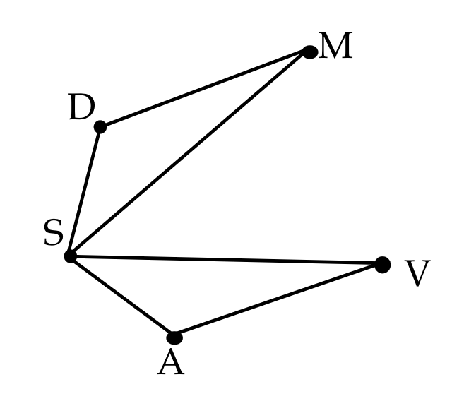

* 1. The reflection of  over  is ____.
  2. m∠MDS = m∠ ? _____

1. Refer to the diagram below.

An illustration of a non-regular quadrilateral MATH between two parallel lines- lines k and j. 



* 1. Reflect the shape MATH over *k* to form M’A’T’H’. Then reflection M’A’T’H’ over line *j* to form M”A”T”H”. Draw both images below, M’A’T’H’ and M”A”T”H”.

Refer to your transformation in problem #2.

* 1. Name the type of transformation from MATH to M”A”T”H”.
  2. How does the orientation of the pre-image relate to the orientation of the final image?
  3. Let TT” = 4.7 cm, which represents the distance between point T and point T’’.  
     What is the distance between lines *j* and *k*? Explain your reasoning.
  4. Let MH = 1.4 cm. What is the value of M”H”? _____________
  5. Let m∠H”M”A” = 28°. What is the measure of ∠HMA? ______________

1. Refer to the diagram below. m∠ZRZ” = 125°. Note: Z’E’R’O’ is not shown.

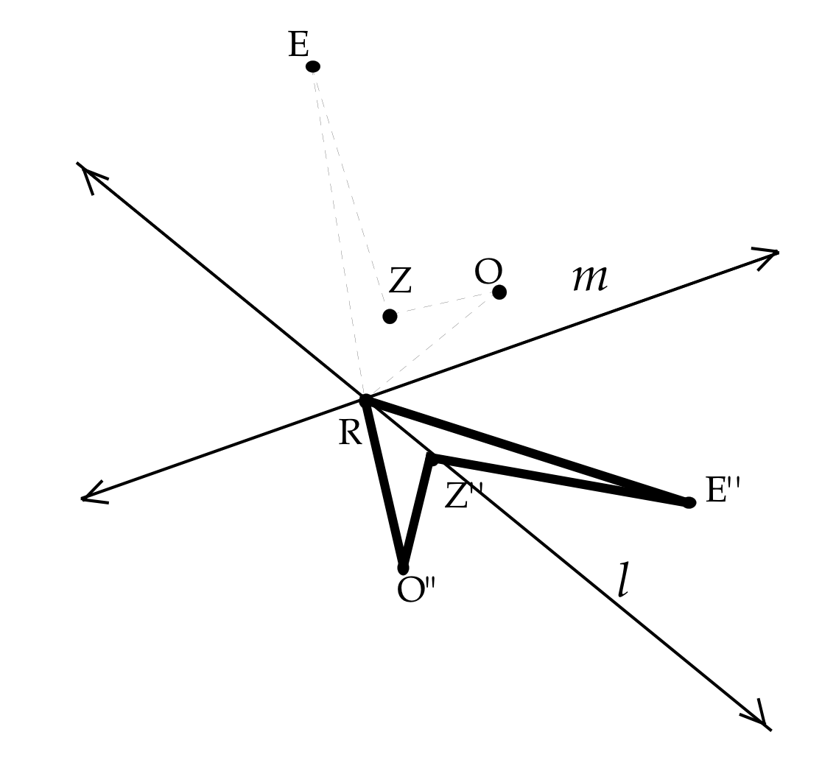

* 1. Describe the transformation that would map Z”E”R”O” onto ZERO.   
     Be as specific as possible.
  2. Let RO = 2 cm. What is the length of RO’? Explain your reasoning.

**Assessment 1A**

**Answer Key**

1. Answers: 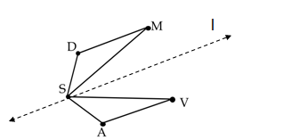

a. See dotted line at right.

b. V

c. 

d. m∠VAS

2. Answers:

a. See figures below, labeled M’A’T’H’ and M”A”T”H”. d. 2.35 cm

b. Translation (specific descriptions may vary). e. 2.8 cm

c. same orientation, to the right of *j* f. 28°

An illustration  showing non-regular quadrilateral MATH showing it reflected over line k to form non-regular quadrilateral M'A'T'H' and also reflected  over line j (parallel to line k) to form non-regular quadrilateral M"A"T"H".

3. Answers:

a. Rotation of 125°; side lengths and angles of Z”E”R”O” are preserved.

b. 2 cm; the dimensions of the shape are preserved during rigid motion transformation.

Name __________________________________ Date _______________________________

**Assessment 1B**

**Application: Where Do Transformations Appear in Art?**

M.C. Escher was a 20th century Dutch artist best known for his works that seem to transform one figure into another. For that reason, his work is very useful as we explore where transformations appear in the world around us.

On the following page(s) is a collection of drawings that showcase some of the ways that Escher used transformations in his work. For each drawing:

1. Identify a figure and its corresponding congruent image or images in a transformation or composition of transformations.
2. Describe the details of the transformation using appropriate vocabulary.
3. Describe any images that are the results of a transformation but are NOT congruent to the original figure.

Criteria for quality:

* Accurate identification(s) of transformations
* Accurate and effective use of content vocabulary
* Accurate and specific descriptions of the transformations displayed in the artwork

You may want to highlight or color-code the figures you choose so that you can refer to them in your descriptions.

1. Design your own illustration that incorporates repeated translation, rotation, or reflection. Identify the figure you used to develop the transformation theme in your artwork and describe the details of your transformation using appropriate vocabulary.

**Assessment 1B Answer Key**

**Application: Where Do Transformations Appear in Art?**

Note to Teacher:

Choices of appropriate drawings are on the next page.

Drawing A: Translations, Glide Reflections

Possible solutions:

* Bird/fish reflect over a vertical line and then translate down
* Bird/fish translate to right across row alternating color (white/black)
* Bird/fish translate down colors stays same

Drawing B: Translations

Possible solutions:

* Bird/fish translates across each row
* Bird/fish translates down and to the right

Drawing C: Rotations, Reflection-symmetric figures, Reflections, Dilations

Possible solutions:

* Start in center, bat/angel rotates 120 degrees twice
* Bat/angel dilate (reduce) and translate to outer edge of circle
* 2nd layer – bat/angel rotate 90 degrees and dilate (reduce size) producing a pair of symmetric bats or angels

Drawing A

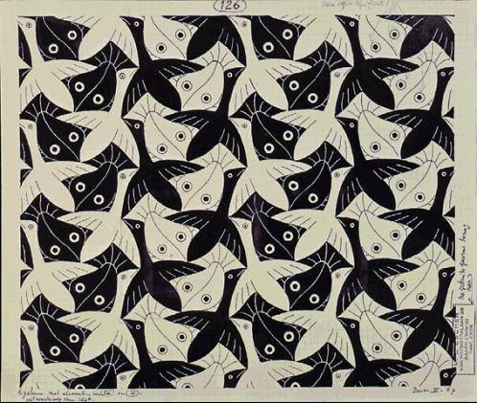

Retrieved from <http://www.mcescher.com/gallery/recognition-success/no-126-fishbird/> 7/1/12

Drawing B

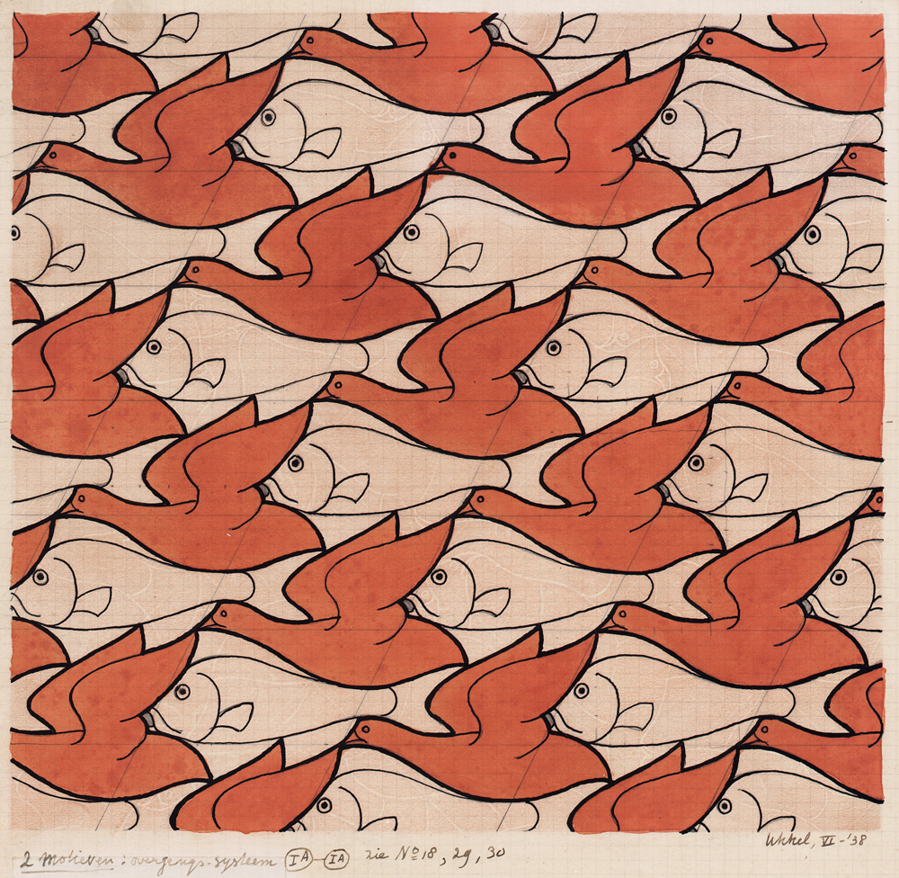

Retrieved from <http://www.mcescher.com/gallery/switzerland-belgium/no-22-birdfish/> 7/1/12

Drawing C

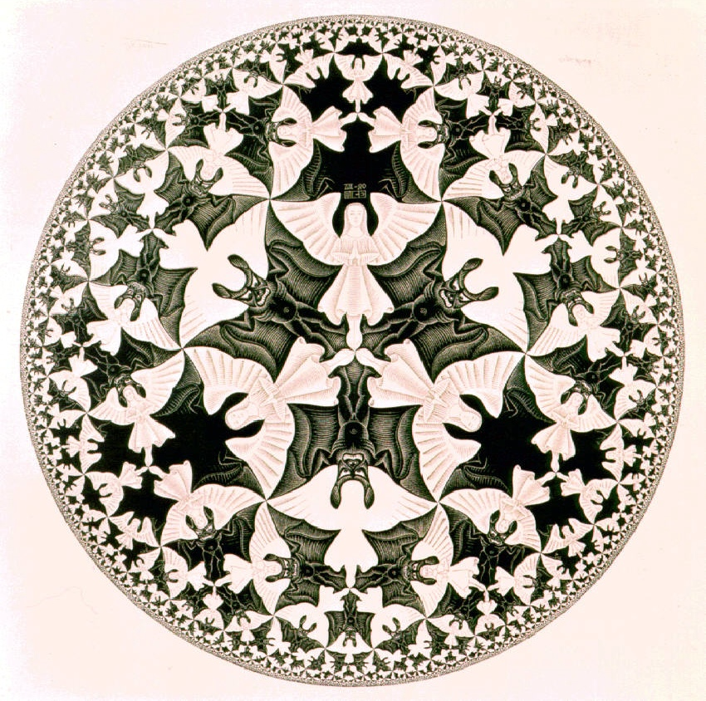

Retrieved from <http://www.mcescher.com/gallery/recognition-success/circle-limit-iv/> 7/1/12

# Lesson 3 – Constructing Transformations

**Brief Overview of Lesson:**

In this lesson students will construct a variety of transformations of given asymmetrical geometric figures using graph paper, tracing paper or a geometry software program. (SMP.5: Use appropriate tools strategically.) Students will articulate the proper sequence of instructions to describe figures mapping onto another and the resulting images for all of the constructed transformations using precise mathematical language (SMP.6: Attend to precision). As you plan, consider the variability of learners in your class and make adaptations as necessary.

**Prior Knowledge Required:** Familiarity with basic transformations (reflection, rotation, translation), their graphs in the coordinate plane

**Estimated Time (minutes):** 90

**Resources:**

Geometer’s Sketchpad, Graphing Calculator, and/or iPad OR if not available, use free online tools shodor.org/graphit or geogebra.com

Graph paper, patty paper, protractor, ruler/straightedge, compass, cut-out shapes

Geometer’s Sketchpad accompanying documentation and workbooks (*Exploring Geometry with Geometer’s Sketchpad*)

Web sites that assist teachers with instruction of this topic:

<http://caccssm.cmpso.org/geometry-task-force/geometry-resources>

<http://jwilson.coe.uga.edu/emt668/EMAT6680.Folders/Maddox/Transformational.Geo.html>

<http://www.keycurriculum.com/>

<http://MathForum.org>

**Content Area/ Course:** Mathematics/Geometry **Grade(s):** 9-11 **Time (minutes or hours):** 90 minutes

**Unit Title:** Experimenting with Transformations in Geometry

**Lesson 3 Title:** Constructing Transformations

**Essential Question(s) to be addressed in this lesson:**

How does a shape or figure change but stay the same? How do transformations help us compare and analyze figures and shapes?

**Standard(s)/Unit Goal(s) to be addressed in this lesson:**

**G.CO.A.5** Given a geometric figure and a rotation, reflection, or translation, draw the transformed figure using, e.g., graph paper, tracing paper, or geometry software. Specify a sequence of transformations that will carry a given figure onto another.

**M.P.5** Use appropriate tools strategically.

**M.P.6** Attend to precision.

**W.4** Produce clear and coherent writing in which the development, organization, and style are appropriate to task, purpose, and audience.

**Assumptions about what students know and are able to do coming into this lesson (including language needs):**

Familiarity with basic transformations (reflection, rotation, translation), their graphs in the coordinate plane

* **NOTE:** Amount of time for this lesson is a rough estimate. Teacher should use judgment to either extend or break up this lesson over multiple days, based on his/her school schedule and students’ needs.

***By the end of this lesson students will know and be able to:***

* Construct a variety of transformations
* Generalizations of transformations of coordinates on the plane
* Use geometry-specific language and the proper order of instructions to describe figures mapping onto another
* Use a variety of tools to construct transformations
* Distinguish among rotation, reflection and translation

**Instructional Resources/Tools**

Geometer’s Sketchpad, Graphing Calculator, and/or iPad OR if not available, use free online tools shodor.org/graphit or geogebra.com

Graph paper, patty paper, protractor, ruler/straightedge, compass, cut-out shapes

Geometer’s Sketchpad accompanying documentation and workbooks (*Exploring Geometry with Geometer’s Sketchpad*)

Web sites that assist teachers with instruction of this topic:

<http://caccssm.cmpso.org/geometry-task-force/geometry-resources>

<http://jwilson.coe.uga.edu/emt668/EMAT6680.Folders/Maddox/Transformational.Geo.html>

<http://www.keycurriculum.com/>

<http://MathForum.org>

**Anticipated Student Preconceptions/Misconceptions**

The center of rotation can be any point on the plane.

The transformation of a figure is the transformation of each and every point that determines the figure individually.

Teacher note: The instructor should lead students to explain how context determines the definition and appropriate use of words such as “transformation”, “translation”, “mapping”, “rotation,” and “reflection”. In addition, with complex transformations, students may construct transformations out of sequence.

**Assessment**

|  |  |
| --- | --- |
| Pre-assessment/ Formative | Summative (optional) |
| **Assessment 1, Parts A & B**  should be completed before Lesson 3.   1. Warm up: Given a pre-image and image, students describe the (single) transformation. Option for ELL students: Demonstrate the transformation with “cut-outs,” verbalize, and write with related words or provide sentence stems for them to complete. 2. Constant/on-going check-ins with students to monitor their progress.   **Assessment 1C** should be completed after Lesson 3. | Given a pre-image and image list the individual transformations that cause the pre-image to become the image.  Given a pre-image and sequenced list of transformations, determine if the resulting transformation could have been a single transformation of the original pre-image. |

|  |  |
| --- | --- |
| **Lesson Sequence and Description** | **Teacher Notes**  In this lesson, Geometer’s Sketchpad (or online equivalent) provides different perspectives on the content by helping to foster predictions and show each step of multiple transformations. Provide pencil-and-paper options for tactile learners and for all students to solidify their thinking from multiple perspectives. For visually impaired students, consult your school’s specialist to prepare tactile materials.  Revisit the Concept Map throughout the unit to solidify students’ grasp and usage of the terms (SMP.5: Use appropriate tools strategically.)  *At first, avoid using a figure with a line of symmetry, like a regular polygon, because it will map onto itself and results will not be as visible for demonstration*. Introduce polygons with symmetry afterward, and discuss the differences.  For visual and tactile learners, have students cut out shapes and use graph paper or patty paper to physically move the figures, specify the number of units, and express their work verbally and in writing based on each step of the process.  Notation can be confusing, sometimes clouding what students may already understand by using new forms of expression. Discuss and point out the correlations between each element of the notation and the figures, while having students verbalize as they write. Making connections between diagrams, symbols, and words (both verbal and written) will help visual learners, ELL students, SPED students, and any advanced students who tend to feel more comfortable keeping complex ideas in their heads.  Help students use tools strategically to help them visualize the concepts (SMP.5: Use appropriate tools strategically.) Both while using technology and on paper, have students keep track of compositions of transformations by labeling the pre-image, the intermediate step image, and the final image with dotted lines (on paper) or dotted or faded figures (Geometer’s Sketchpad and online equivalents).  If time permits or for advanced students, expand the composition of reflections over parallel and intersecting lines. The teacher or the student could develop the rules associated with these transformations as they relate to rotations and translations (e.g., the magnitude of a rotation is twice the measure of the angle formed by the intersecting lines). |
| **Present objectives for the lesson**  **Warm-up (5-15 minutes)**   1. Formative assessment (see above, Assessment 1B) 2. Review homework and assessment. Have students share their own examples of transformations they found in art. 3. Homework art that students share and in Assessment 1B, ask students to describe what they would identify as a “glide reflection.” 4. In Assessment 1B, the first two pictures incorporate rigid transformations, but the third includes dilation, which will not be defined here. Foreshadow future learning for students.   **Vocabulary Review/Reinforcement (10 minutes)**  Use the Concept Map **(See Handout 1: Concept Map)** to gather students’ ideas about emerging vocabulary throughout the unit, to reinforce vocabulary already learned in Lessons 1 and 2, and to foreshadow new terms. Have them work in small groups to input initial ideas on the blank version, and then compare their ideas to the completed version.  **Composition of Transformations (40-60 minutes)**  Teacher models a variety of compositions of different transformations (of your choice). Based on the language of the standards (in particular, G.CO.5), use polygons when modeling/assigning transformations (also see note at right).   1. Start with any point, for example, (3, 5), then move into shapes (see below). 2. Given a pre-image and its image, model a composition of transformations that maps the pre-image onto its image. Start with a scalene triangle and show a reflection over a line; then repeat with another asymmetric figure. 3. Perform the same for rotation and translation. 4. Repeat for figures with symmetry, and determine if there are multiple transformations (i.e. reflection, translation) that result in the same image.   Here are more details:   1. Ask students to articulate the sequence of transformations and the resulting images each time. 2. Lead students through a discussion, while demonstrating, of . 3. If students have difficulty seeing A’B’C’, lead them to this intermediate step. Start with scalene triangle ABC in quadrant 2, reflected in quadrant 1 as A’B’C’, then reflected into quadrant 4 as A”B”C”. 4. Repeat this activity with another asymmetric figure using other transformations. 5. Finally, draw asymmetric figures ABCDE and A”B”C”D”E” (of your choice). Ask students to identify the composite transformations that take the pre-image to the image.   Examples of notation:  Ta, b (x, y) = (x + a, y + b) Translation of a units left or right, b units up or down  rO (x, y) = (-x, -y) Reflection about the Origin  ry-axis (x, y) = (-x, y) Reflection about the y-axis  rx-axis (x, y) = (x, -y) Reflection about the x-axis  R60 (x, y) Rotation of 60°  Rx-axis (x, y) Rotation about the x-axis  Guiding Questions (for discussion during the demonstrations and practice opportunities with compositions of transformations). Also, emphasize precision in language and expression (symbolic, verbal, written, and diagrams). SMP.6: Attend to precision.   1. Does the order of the transformations in the composition matter? Why? 2. How can the diagram help us understand the notation? How can the notation help us visualize the diagram? How might one change in the notation affect the resulting image and overall meaning of the transformation? 3. Can a reflection ever be a rotation?   Q & A as needed…  **Developing Rules for Transforming Figures (20 minutes)**  Choose a method of choice for this exercise: group work, homework, individual, etc.   * Students write rules for compositions of transformations, using the correct notation. They pair up and switch with a classmate. Partners first predict each other’s results based on the notation, and then draw/perform the composition to verify their prediction. Students explain/justify to each other how their composition worked (i.e. how is order determined?).   Lesson Resource (interactive examples of compositions):  https://www.mathwarehouse.com/transformations/compositions/reflections-in-math.php  Examples of transformation notation for compositions:  : Translation 3 left and 4 up (x + 3, y + 4) followed by Rotation about x-axis  (x, y): T1 (first transformation) followed by T2 (second transformation)  Q & A as needed…  **Exit Ticket**  To conclude a lesson (or to break up this lesson over multiple periods in your school schedule), consider using any suggested discussion questions above as exit tickets. |

**Extended Learning/Practice (homework)**

Lesson 3 Homework **(See Handout 2: Composition of Transformations )**

Extension for advanced students (refer to the last paragraph of teacher notes for this lesson)

Extension: Symmetry (G.CO.3) Give students the definition of “Reflection Symmetric” and “Rotation Symmetric” (assuming they have not seen these previously). Provide three to five polygons that are reflection symmetric, rotation symmetric, or both. For each polygon, have students determine what type of types of symmetry each figure has, and explain/justify their decisions using the vocabulary from this unit.

**Teacher Reflection (to be completed after lesson)**

What went well in this lesson?

Did all students accomplish the outcome(s)?

What evidence do I have?

What would I do differently next time?

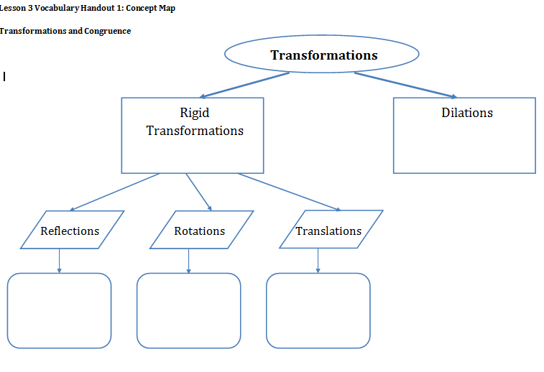

Name ___________________________________ Date _______________________________

**Lesson 3 Handout 2: Homework**

**Composition of Transformations**

**1.** Start with the point M (2, 6) as the pre-image. Graph the images that result from the following transformations, and label them.

1. Reflect about the *x*-axis
2. Reflect about the *y*-axis
3. Reflect about the line *y* = *x*
4. Reflect about the line *y* = −*x*
5. Rotate 180° about the origin
6. Rotate 90° clockwise about the origin
7. Rotate 90° counterclockwise about the origin

**2.** Start with the point (*x*, *y*) as the pre-image. List the coordinates of the images that would result from the following transformations.

1. Reflect about the *x*-axis
2. Reflect about the *y*-axis
3. Reflect about the line *y* = *x*
4. Reflect about the line *y* = −*x*
5. Rotate 180° about the origin
6. Rotate 90° clockwise about the origin
7. Rotate 90° counterclockwise about the origin

**Lesson 3 Handout 2: Homework**

**Answer Key**

**Composition of Transformations**

**1.** See graph below. 2.

a. N (2, -6) e. R (-2, -6) a. (*x*, -*y*) e. (-*x*, -*y*)

b. O (-2, 6) f. S (6, -2) b. (-*x*, *y*) f. (*y*, -*x*)

c. P (6, 2) g. T (-6, 2) c. (*y*, *x*) g. (-*y*, *x*)

d. Q (-6, -2) d. (-*y*, -*x*)

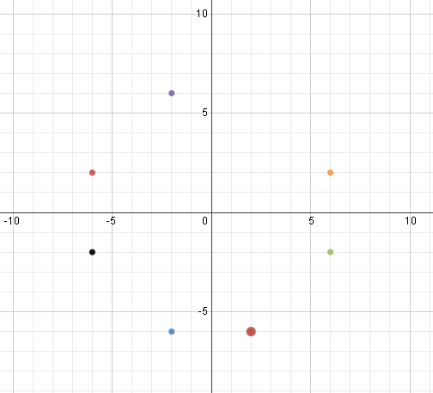

N (2, -6)

O (-2, 6)

P (6, 2)

Q (-6, -2)

R (-2, -6)

S (6, -2)

T (-6, 2)

Name ___________________________________ Date ______________________________

**Assessment 1C**

**Transformations on the Cartesian Plane**

**Part 1: Performing Transformations**

Use the coordinate plane below to graph the transformations below. Record the resulting coordinate/image next to its pre-image (on the graph provided). Label each point on the coordinate plane using the given letter (pre-image) and resulting image (e.g., A and A’).

|  |  |  |  |  |  |  |  |  |  |  |  |  |  |  |  |  |  |  |  |  |
| --- | --- | --- | --- | --- | --- | --- | --- | --- | --- | --- | --- | --- | --- | --- | --- | --- | --- | --- | --- | --- |
|  |  |  |  |  |  |  |  |  |  |  |  |  |  |  |  |  |  |  |  |  |
|  |  |  |  |  |  |  |  |  |  |  |  |  |  |  |  |  |  |  |  |  |
|  |  |  |  |  |  |  |  |  |  |  |  |  |  |  |  |  |  |  |  |  |
|  |  |  |  |  |  |  |  |  |  |  |  |  |  |  |  |  |  |  |  |  |
|  |  |  |  |  |  |  |  |  |  |  |  |  |  |  |  |  |  |  |  |  |
|  |  |  |  |  |  |  |  |  |  |  |  |  |  |  |  |  |  |  |  |  |
|  |  |  |  |  |  |  |  |  |  |  |  |  |  |  |  |  |  |  |  |  |
|  |  |  |  |  |  |  |  |  |  |  |  |  |  |  |  |  |  |  |  |  |
|  |  |  |  |  |  |  |  |  |  |  |  |  |  |  |  |  |  |  |  |  |
|  |  |  |  |  |  |  |  |  |  |  |  |  |  |  |  |  |  |  |  |  |
|  |  |  |  |  |  |  |  |  |  |  |  |  |  |  |  |  |  |  |  |  |
|  |  |  |  |  |  |  |  |  |  |  |  |  |  |  |  |  |  |  |  |  |
|  |  |  |  |  |  |  |  |  |  |  |  |  |  |  |  |  |  |  |  |  |
|  |  |  |  |  |  |  |  |  |  |  |  |  |  |  |  |  |  |  |  |  |
|  |  |  |  |  |  |  |  |  |  |  |  |  |  |  |  |  |  |  |  |  |
|  |  |  |  |  |  |  |  |  |  |  |  |  |  |  |  |  |  |  |  |  |
|  |  |  |  |  |  |  |  |  |  |  |  |  |  |  |  |  |  |  |  |  |
|  |  |  |  |  |  |  |  |  |  |  |  |  |  |  |  |  |  |  |  |  |
|  |  |  |  |  |  |  |  |  |  |  |  |  |  |  |  |  |  |  |  |  |
|  |  |  |  |  |  |  |  |  |  |  |  |  |  |  |  |  |  |  |  |  |
|  |  |  |  |  |  |  |  |  |  |  |  |  |  |  |  |  |  |  |  |  |

1. A: *r*y-axis(3, -1) = __________

2. B: *r*y-axis(-5, 4) = __________

3. C: *r*y-axis(2, 7) = __________

4. D: *r*x-axis(-4, -8) = __________

1. E: *r*x-axis(0, 1) = __________

6. F: *r*x-axis(8, -3) = __________

7. G: *r*y=2(1, 6) = __________

8. H: *r*y=2(0, -2) = __________

9. I: *r*x=-1(2, 1) = __________

10. J: *r*x=-1(-6, -5) = __________

**Part 2: Making Generalizations**

11. Refer to your results for problems # 1 - 3 (points reflected over the *y*-axis) on the graph. Generalize your results for any point (*x*, *y*) on the coordinate plane. Justify your solution.

*r*y-axis(*x*, *y*) = __________

12. Refer to your results for problems # 4 - 6 (points reflected over the *x*-axis) on the graph.

Generalize your results for any point (*x*, *y*) on the coordinate plane. Justify your solution.

*r*x-axis(*x*, *y*) = __________

**Part 3: Making Predictions**

13. a. Predict the result of reflecting the point (4, 7) first over the *y*-axis and then over the *x*-axis.

b. Use the coordinate plane above to test your prediction. Were you correct? Explain.

14. Describe the composition of reflections in problem # 13 as a transformation.

Be as specific as possible in your explanation, using appropriate vocabulary.

**Assessment 1C Answer Key** *Geometry Transformations Unit*

**Transformations on the Cartesian Plane**

Problems # 1 – 10.

|  |  |  |  |  |  |  |  |  |  |  |  |  |  |  |  |  |  |  |  |  |
| --- | --- | --- | --- | --- | --- | --- | --- | --- | --- | --- | --- | --- | --- | --- | --- | --- | --- | --- | --- | --- |
|  |  |  |  |  |  |  |  |  |  |  |  |  |  |  |  |  |  |  |  |  |
|  |  |  |  |  |  |  |  |  |  |  |  |  |  |  |  |  |  |  |  |  |
|  |  |  |  |  |  |  |  |  |  |  |  |  |  |  |  |  |  |  |  |  |
|  |  |  |  |  |  |  |  |  |  |  |  |  |  |  |  |  |  |  |  |  |
|  |  |  |  |  |  |  |  |  |  |  |  |  |  |  |  |  |  |  |  |  |
|  |  |  |  |  |  |  |  |  |  |  |  |  |  |  |  |  |  |  |  |  |
|  |  |  |  |  |  |  |  |  |  |  |  |  |  |  |  |  |  |  |  |  |
|  |  |  |  |  |  |  |  |  |  |  |  |  |  |  |  |  |  |  |  |  |
|  |  |  |  |  |  |  |  |  |  |  |  |  |  |  |  |  |  |  |  |  |
|  |  |  |  |  |  |  |  |  |  |  |  |  |  |  |  |  |  |  |  |  |
|  |  |  |  |  |  |  |  |  |  |  |  |  |  |  |  |  |  |  |  |  |
|  |  |  |  |  |  |  |  |  |  |  |  |  |  |  |  |  |  |  |  |  |
|  |  |  |  |  |  |  |  |  |  |  |  |  |  |  |  |  |  |  |  |  |
|  |  |  |  |  |  |  |  |  |  |  |  |  |  |  |  |  |  |  |  |  |
|  |  |  |  |  |  |  |  |  |  |  |  |  |  |  |  |  |  |  |  |  |
|  |  |  |  |  |  |  |  |  |  |  |  |  |  |  |  |  |  |  |  |  |
|  |  |  |  |  |  |  |  |  |  |  |  |  |  |  |  |  |  |  |  |  |
|  |  |  |  |  |  |  |  |  |  |  |  |  |  |  |  |  |  |  |  |  |
|  |  |  |  |  |  |  |  |  |  |  |  |  |  |  |  |  |  |  |  |  |
|  |  |  |  |  |  |  |  |  |  |  |  |  |  |  |  |  |  |  |  |  |
|  |  |  |  |  |  |  |  |  |  |  |  |  |  |  |  |  |  |  |  |  |

11. *r*y-axis(x, y) = (-x,y)

The *y*-axis is a vertical line passing through the origin. A reflection over this line will retain the *y*-value and result in the opposite of the *x*-value.

12. *r*x-axis(x, y) = (x,-y)

The *y*-axis is a horizontal line passing through the origin. A reflection over this line will retain the *x*-value and result in the opposite of the *y*-value.

13. Answers will vary. Prediction: (-4, -7)

14. Possible answers:

Reflection over the line *y* = *x*

Rotation of 180o about the origin

# Lesson 4 – Applications of Transformations

**Brief Overview of Lesson:** In this lesson students through constructing transformations using graph paper, geometry construction software, etc. intentionally (SMP.5: Using appropriate tools strategically.) will learn that different transformations of a pre-image can result in the same image. They will learn to discern which transformations are rigid and which are not and explain why.

As you plan, consider the variability of learners in your class and make adaptations as necessary.

**Prior Knowledge Required:**

Relevant vocabulary for rigid (congruence) transformations

Practice with performing rigid transformations

Familiarity and comfort with Geometer’s Sketchpad (or if not available, online tools, refer to web links listed in lessons)

**Estimated Time (minutes):** 90

**Resources:**

Geometer’s Sketchpad, Graphing Calculator, and/or iPad OR if not available, use free online tools shodor.org/graphit or geogebra.com

Graph paper, protractor, and rulers

Dynamic tool to show relationships between symbolic and graphical representations of functions: <http://seeingmath.concord.org/sms_interactives.html> -- Click “Linear Transformer” (uses Java)

<https://www.desmos.com> is an on-line graphing calculator.

**Content Area/ Course:** Mathematics/Geometry **Grade(s):** 9-11

**Time (minutes or hours):** 90 minutes

**Unit Title:** Experimenting with Transformations in Geometry

**Lesson 4 Title:** Applications of Transformations

**Essential Question(s) to be addressed in this lesson:** How do transformations influence design?

**Standard(s)/Unit Goal(s) to be addressed in this lesson:**

**G.CO.A.5** Given a geometric figure and a rotation, reflection, or translation, draw the transformed figure using, e.g., graph paper, tracing paper, or geometry software. Specify a sequence of transformations that will carry a given figure onto another.

**G.CO.B.6** Use geometric descriptions of rigid motions to transform figures and to predict the effect of a given rigid motion on a given figure; given two figures, use the definition of congruence in terms of rigid motions to decide if they are congruent.

**M.P.5** Use appropriate tools strategically.

**M.P.6** Attend to precision.

**Assumptions about what students know and are able to do coming into this lesson (including language needs):**

Relevant vocabulary for rigid (congruence) transformations

Practice with performing rigid transformations

Familiarity and comfort with Geometer’s Sketchpad (or if not available, online tools, refer to web links listed in lessons)

* **NOTE:** Amount of time for this lesson is a rough estimate. Teacher should use his/her judgment to either extend or break up this lesson over multiple days, based on school schedule and students’ needs.

*By the end of this lesson students will know and be able to:*

Different transformations of a pre-image can result in the same image.

Which transformations are rigid and which are not.

Use a variety of tools to construct transformations.

**Instructional Resources/Tools**

Geometer’s Sketchpad, Graphing Calculator, and/or iPad OR if not available, use free online tools shodor.org/graphit or geogebra.com

Graph paper, protractor, and rulers

Dynamic tool to show relationships between symbolic and graphical representations of functions: <http://seeingmath.concord.org/sms_interactives.html> -- Click “Linear Transformer” (uses Java)

<https://www.desmos.com> is an on-line graphing calculator.

**Anticipated Student Preconceptions/Misconceptions**

Algebraic connections to translations in geometry may be confusing to students because of notation (ex. Horizontal shift, y=|x+2| shifts to left rather than right, whereas y=|x|+2 shifts vertically up as is expected due to + sign).

**Assessment**

**Assessment 1C** should be completed before Lesson 4.

1. Opening Activity- reflect image; repeat; compare images; compare to rotation
2. Sketchpad - Confirm Transformation Congruence
3. **CEPA** should be completed after Lesson 4.

|  |  |
| --- | --- |
| **Lesson Sequence and Description** | **Teacher Notes**  ELL students should continue to use vocabulary diagrams and/or concept map from prior lessons.  For visually impaired students and tactile learners, continue practicing constructions by hand or provide prepared transformations, in both space and coordinate plane, and have students describe them using proper content vocabulary and notation.  If technology is not available, teacher can project onto the board and students should make predictions. Graph paper, ruler, and protractors are also recommended for all students so that they can determine results on their own and solidify their thinking through multiple representations (M.P.5). This can be especially useful for visual and tactile learners, struggling learners, often-times ELL learners, and visually impaired learners.  Extra Lesson Resource: Carousel Activity  <https://www.teachingchannel.org/video/carousel-activity-math-lesson>  In this lesson, students are reflecting polygons over lines other than the x- or y-axis for the first time, and then, progressing in complexity to reflecting lines (linear functions) themselves.  This activity uses students’ emerging understanding of transformations to “see” prior algebraic concepts from a different perspective and solidify their learning. Emphasis is also on exploring multiple representations and developing fluency in going from one to another (M.P.4 and M.P.7, modeling and structure).  Students with visual impairments find transformations of lines very difficult, as they have difficulty separating lines unless the lines are represented in different textures. For example, one function could be represented with a solid segment and another with a dotted segment. A better option would be for students to find points on the functions and reflect the points individually. After performing the transformations of the points, they can describe the results of the entire graph.  The absolute value function is used here because of its unique shape, which gives students the opportunity to clearly observe properties of rigid transformations.  For tactile and visual learners, have them cut out the V-shape and move it along the coordinate plane, while recording the changes in the function notation incrementally. Also, shodor.org/graphit online tool shows the interplay between graph and equation dynamically.  Emphasize specificity in language (M.P.6). Making the connection to “rigid motion” and “preserving shape” will help students better understand what constitutes a rigid transformation and what does not. Foreshadow future learning by mentioning another type of transformation based on similarity rather than congruence (dilations).  Advanced learners may enjoy trying additional examples using abstract symbolic expressions.  Struggling learners also need to build these skills of abstraction and generalization. Scaffold their learning with more examples and literally connecting each element of the notation to corresponding elements of the diagrams (use color-coding, dotted lines to map corresponding parts of the image to the expression, and paper cut-outs as needed). Also use online tools that show symbolic and graphical connections dynamically (See Instructional Resources above). |
| **Present objectives for the lesson**  **Warm-up (5-15 minutes)**   1. Formative assessment (see above, Assessment 1C) 2. Review homework and assessment.  * While reviewing Lesson 3 Homework,demonstrate in table form all transformation descriptions as headings with examples underneath. Apply students’ learning by asking them how the same transformations performed on another point would look. Ask them to express the list of transformations using appropriate notation (from prior lessons).   **Making Conjectures (10 minutes)**   1. Have students draw a polygon in Quadrant I of a Cartesian plane. Direct students to reflect it over the y-axis and write the new coordinates. 2. Now students reflect the original image over the x-axis and write the new coordinates.   Discussion Questions:   1. Compare the three images – How are they alike and different? 2. Make a conjecture – How does each type of reflection alter the coordinates from the original? 3. What effect would a rotation of 180° (or 90°) have on the original image?   **Congruence of Transformations: (20-30 minutes)**  Demonstration using Geometer’s Sketchpad (or online equivalent – See Instructional Resources section).   1. Construct a polygon using straightedge tool. Construct a line as a mirror. Double-click on line of reflection. Select the entire polygon. Using Transform menu, Select Reflect. Use measuring tools to measure all angles and sides of both pre-image and image. 2. Lead class in a discussion (option: have students work in pairs): Confirm properties of an transformation (congruent corresponding angles and sides). List pairs of congruent corresponding angles and sides and conclude that image and pre-image are congruent, with a congruent statement (ex. ΔABC ≅ ΔA’B’C’ ) Why is this important? How are transformations and congruence related?   Writing Prompt  Students recall Essential Question 1 (How does a shape or figure change but stay the same?). They write their thoughts about this question now, and how their thinking may have changed since they were first asked to consider it at the beginning of the unit. Have students share their responses and discuss.  **Connections to Algebra: Reflections Over Lines (30 minutes)**  Using the coordinate plane, have students reflect a triangle over the x-axis and y-axis. See if they can make the connection to the equations of the lines, y = 0 and x = 0. As an extension, have students reflect a triangle over other lines, such as y=3, y=3x, and y=3x+1 and make comparisons of the coordinates of the original triangle to its image. Have students explain in writing and through discussion any patterns they notice and how expanding to lines other than the x- or y-axis feels similar or different to their prior work in this unit.  Using a graphing calculator (or online software), begin with y = x as the original function. One at a time, ask students to describe how each graph changed from the original graph, using the vocabulary of transformations. For example, graph y = x + 2 and compare it to the original (y = x). Then graph y = x – 2. Then y = -x. Each time, compare to original and note observations. Students should be able to generalize in words and symbols the change to the graph, without having to plot a table each time. This is a prelude to the next step, and may be review for many students from Algebra 1.  Based on those generalizations, have students re-state each of the functions as images of the original function using function notation. For example, f(x) = x, then f’(x) = f(x) + 2, then f’(x) = f(x) – 2, then f’(x) = - f(x).  Discussion Questions (emphasis here is on precision, justifying conclusions based on observations, and using tools to help visualize and make connections between geometric and algebraic concepts, M.P.5 and M.P.6):   1. Describe in words and predict what the graph of f(x + 3) – 1 would look like… How about – f(x + 1)? Continue discussion with more examples. Assign different groups of students different examples to work on and compare their ideas. 2. How do you know your predictions are correct? 3. How does an understanding of transformational geometry help us make sense of relationships/functions algebraically?   Now try having students think backwards. Have students look at the graph of a given function and its transformed image, and describe the transformation in words and write it symbolically using function notation. Discuss:   1. How could we generalize our observations? Have students write an expression for a function and its image in function notation for a reflection or translation of any function. 2. As an extension, try generalizing for a rotation.   **Reflecting and Translating Other Functions (40 minutes)**  (Teachers may use graphing calculator, TI emulator, computer lab graphing software, iPad, and/or online graphing tool [www.shodor.org/graphit](http://www.shodor.org/graphit)) <https://www.desmos.com>  Model a function such as f(x) = |x| on a projector as the pre-image. Have students predict what the function f(x) = -|x| would look like on the coordinate plane as compared to the original function (image). How would they describe this in transformational terms? Repeat each of the following functions as images (by transforming the pre-image) one at a time. Given the following graphs, have students describe the changes using both transformation vocabulary and function notation. [Sample answer: Translate left 1 unit and reflect over the x-axis, then translate down 2 units. f ‘ (x) = - f(x + 1) – 2]  f '(x) = |-x|  f '(x) =|x – 1|  f '(x) = |x| – 1  f '(x) = |x + 1| +1  Predict what the graph of the transformation from the pre-image f(x) = |x| to the image f ‘(x) = |2x| would look like. Discuss:   1. How does the type of transformation shown here differ from the variety of transformations we have been studying? How do you know? 2. (SMP.6: Attend to precision.) Elicit specificity in students’ descriptions, for example, What can we say about the shape (is it preserved)? Is the transformation rigid? Why or why not?   In pairs, students use a different type of function. From this equation, create at least three new equations that illustrate different types of transformations. For each, describe the type of transformation and its direction, and graph the result. For example, given: f(x) = *x*2 + 3 translates f(x) = *x*2 up 3 units; f(x) = (x – 1)2 + 4 translates f(x) = *x*2 right 1 and up 4; f(x) = -(x + 1)2 translates f(x) = *x*2 left 1 and then reflects over x-axis.  Extend learning by having students generalize their observations for any function:  Given g(x) as the pre-image, express any function as a transformed image translated h units to the right, k units down, and reflected over the x-axis. Discuss how students are approaching this problem; ask students to be precise with their language in describing how each part of the symbolic expression (equation) of the function relates to the graph. [Answer: g’(x) = - g(x + h) – k]. (SMP.6: Attend to precision.)  **Curriculum-Embedded Performance Assessment (CEPA)**  This unit concludes with a culminating assessment, to be conducted after Lesson 4. It is a Fashion Design performance task **(See CEPA)**. |
| **Extended Learning/Practice (homework)**   1. Lesson 4 Homework **(See Handout 1: Connection to Function)** 2. Assessment 4: Creative Writing. Tell students that they are to write a story to help younger students understand transformations. Use “Joe Rectangle” and “Suzy Pentagon” and relevant vocabulary to describe their journey through Planeland – a universe populated by figures and their images under transformations. |

**Teacher Reflection (to be completed after lesson)**

|  |
| --- |
| What went well in this lesson?  Did all students accomplish the outcome(s)?  What evidence do I have?  What would I do differently next time? |

**Resources for Lesson 4**

Name ___________________________________ Date _______________________________

**Lesson 4 Handout 1: Homework**

**Connection to Function**

Given the function ,

1. Describe (in words) the transformation(s) necessary to produce the graph of each function, AND
2. Express the transformation(s) in general terms using function notation.

**1.**  **2.** 

**3.**  **4.** 

**Lesson 4 Handout 1: Homework**

**Answer Key**

**Connection to Function**

1. a. Translate down 2 units

b. 

2. a. Reflect about x- axis, translate down 4 units

b. 

3. a. Translate right 3 units, translate up 1 unit

b. 

4. a. Translate left 1 unit, reflect about x-axis, translate down 1 unit

b. 

Name ___________________________________ Date _______________________________

# Curriculum-Embedded Performance Assessment (CEPA)

**Fashion Design Assessment Task**

This is an end-of-unit summative performance assessment, for which students should be prepared after Lesson 4. The assessment should be introduced earlier **(see Lesson 1)**, so that students have the opportunity to become familiar with the task and contribute their ideas to the development of criteria for quality work and rubric.

**Massachusetts Curriculum Frameworks**

**G.CO.A.3** Given a rectangle, parallelogram, trapezoid, or regular polygon, describe the rotations and reflections that carry it onto itself.

**G.CO.A.5** Given a geometric figure and a rotation, reflection, or translation, draw the transformed figure using, e.g., graph paper, tracing paper, or geometry software. Specify a sequence of transformations that will carry a given figure onto another.

**G.CO.B.6** Use geometric descriptions of rigid motions to transform figures and to predict the effect of a given rigid motion on a given figure; given two figures, use the definition of congruence in terms of rigid motions to decide if they are congruent.

**Materials Required**

Students may choose from a variety of options: paper, fabric, foam or felt, construction paper, glue, rulers, graph paper, technology applications.

**Overview of Task**

You are a fashion designer who has been commissioned by a celebrity musician to create a unique fabric design for a formal outfit. The formal outfit will be worn at an upcoming event to benefit a charity foundation, which supports youth programs and scholarships across the country for students aspiring to careers in math, science, and technology. The musician wants the formal attire to represent the foundation’s theme, finding beauty in math and science through art.

Your task is to design an original fabric pattern for an elegant formal outfit that represents the foundation’s theme, by using transformations to demonstrate the ways that math comes alive through art. Your original design should be a unique pattern that is composed of each of the three congruency transformations, using two or more shapes. Your design must include at least one figure that can be mapped onto itself. Your final product must include the sample, a written explanation of the fabric’s design including why it is isometric, a set of instructions on how to reproduce it, and a presentation to your client.

**Criteria for Original Design**  
Your original fabric design should be a unique pattern that is composed of each of the three congruency transformations using two or more shapes. Your product must include at least one figure that can be mapped onto itself.

**The Product: What You Must Provide to Your Client (the celebrity musician)**

1. A drawing of your pattern on graph paper, showing clearly labeled coordinates and demonstrating congruence with appropriate notation.

* Your design must not be drawn freehand. Your design must be made from clearly defined figures using at least two of the following: rectangle, parallelogram, trapezoid, or regular polygon, at least one of which has been mapped onto itself and you must use tools to display your pattern (i.e., ruler, protractor, technology, etc.).

1. A fabric sample (drawing or fabric) of the pattern you have designed
   * You may design your sample as a black and white drawing, a color drawing, an original design using computer software or online tools (that YOU designed, NOT taken from Internet), or an actual piece of fabric.
   * Your fabric sample (or drawing) should be at least 6 inches by 6 inches.
2. A written explanation of your design (2 or more paragraphs)
   * Your explanation should include a justification of why your design involves congruence transformations, what transformations are included, and a sequence of instructions for reproducing it. The figure that was mapped onto itself is identified and the rotations and reflections that carried it onto itself are described.
   * Include verbal (words) and symbolic (using appropriate notation for transformations) representations in your explanation, and refer to corresponding parts of your diagram.
   * Congruency is demonstrated by comparing corresponding parts of the pre-images and resulting images. The definition of congruence in terms of rigid motions is used to show and explain the congruence of figures in the design.
3. A presentation (oral) to your client
   * The goals of your presentation should be to show, explain, and justify your work (see above, #1-3); to convince your client that your pattern meets her criteria; and to share why you think your design represents her foundation’s theme (bringing math and science to life through art).

**Ideas for Inspiration**

The following website provides ideas for isometric (rigid transformation) patterns. Of course, you may not copy one of these to use it as your own. <http://www.clarku.edu/~djoyce/wallpaper/>

**Rubric for Quality Work**

The following rubric provides details on how your design and presentation will be evaluated (see next page).

**Rubric for Fashion Design Assessment Task**

|  |  |  |
| --- | --- | --- |
| **Product** | **Criteria for Quality** | **Points** |
| Design | Original design meets client’s criteria:  contains three or more transformations, using at least two of the following: rectangle, parallelogram, trapezoid, or regular polygon at least one of which has been mapped onto itself. | 20 |
| Drawing on Graph Paper and Fabric Sample (or drawing) | Fabric sample (or drawing of fabric sample) is an accurate representation of the drawing on graph paper. Graph paper drawing and fabric sample make appropriate and accurate use of tools (i.e., ruler, protractor, technology, etc.). | 20 |
| Written Explanation | Written description contains details about the transformations used in the pattern and how the pattern was developed.   * A complete and accurate set of instructions for reproducing the design are included which describe the sequence for each of the transformations used. The figure that was mapped onto itself is identified and the rotations and reflections that carried it onto itself are described. * The transformations used are also described as functions that take points in the drawing as inputs and give other points as outputs. * All geometric terms are used in appropriate context with precise language. Appropriate notation is used throughout . Explanation and drawings show connections between graphical, symbolic, and verbal explanations of the sequence of transformations used. * Congruency is demonstrated by comparing corresponding parts of the pre-images and resulting images. The definition of congruence in terms of rigid motions is used to show and explain the congruence of figures in the design. | 9  9  9  9 |
| Presentation | * Oral presentation shows, explains, and justifies the design and the mathematical reasoning that went into creating the design. * Connections between different representations of the design (verbal, words, graphical, and symbolic notation) are clear and logical. * Appropriate vocabulary is used correctly in context. | 9  9  6 |