The Effects of Wind and Water Movement on Earth’s Landscape
Earth Science, Grade 2
(Revised July 2018)
Standards addressed in unit:
2-ESS2-1 Investigate and compare the effectiveness of multiple solutions designed to slow or prevent wind or water from changing the shape of the land.*Clarification statement: Solutions to be compared could include different designs of dikes and windbreaks to hold back wind and water, and different designs for using shrubs, grass, and trees to hold back the land. Solutions can be generated or provided.
2-ESS2-4(MA) Observe how blowing wind and flowing water can move Earth materials from one place to another and change the shape of a landform. Clarification statement: Examples of types of landforms can include hills, valleys, river banks, and dunes.

Students investigate how blowing wind and flowing water can move earth materials and change the shape of landforms. They compare the effectiveness of solutions to slow or prevent such changes.

This Model Curriculum Unit is designed to illustrate effective curriculum that lead to expectations outlined in the 2016 Science and Technology/Engineering Curriculum Frameworks (www.doe.mass.edu/STEM/STE) as well as the MA Curriculum Frameworks for English Language Arts/Literacy and Mathematics. This unit includes lesson plans, a Curriculum Embedded Performance Assessment (CEPA), and related resources. In using this unit it is important to consider the variability of learners in your class and make adaptations as necessary.

This document was prepared by the Massachusetts Department of Elementary and Secondary Education. Mitchell D. Chester, Ed.D., Commissioner
The Massachusetts Department of Elementary and Secondary Education, an affirmative action employer, is committed to ensuring that all of its programs and facilities are accessible to all members of the public. We do not discriminate on the basis of age color, disability, national origin, race, religion, sex, or sexual orientation.

© 2015 Massachusetts Department of Elementary and Secondary Education (ESE). ESE grants permission to use the material it has created under the terms of the Creative Commons Attribution-NonCommercial-ShareAlike 3.0 Unported License. Additionally, the unit may also contain other third party material used with permission of the copyright holder. Please see Image and Text Credits for specific information regarding third copyrights.

Every effort has been made to acknowledge copyright. Any omissions brought to our attention will be corrected in subsequent editions.

The contents of this Model Curriculum Unit were developed under a grant from the U.S. Department of Education. However, those contents do not necessarily represent the policy of the U.S. Department of Education, and you should not assume endorsement by the Federal Government.

Massachusetts Department of Elementary and Secondary Education, 75 Pleasant St, Malden, MA 02148-4906. Phone 781-338-3300, TTY: N.E.T. Relay 800-439-2370, www.doe.mass.edu

Table of Contents
Unit Assumptions and Comments on Sequence 4
Unit Plan 7
Lesson 1: What do we know about how water and wind shape the land? 11
Lesson 2: Effects of moving water and wind in our world 15
Lesson 3: Observation & scientific exploration centers 19
Lesson 4: Schoolyard investigation 24
Lesson 5: Wind and water video/photo study 28
Lesson 6: Natural solutions to prevent or slow wind and water from changing the land 32
Lesson 7: Human-made solutions to prevent or slow the effects of wind and water 37
Curriculum Embedded Performance Assessment (CEPA): 41
Unit Resources 46

Unit Assumptions and Comments on Sequence
Sequence
The unit begins by introducing students to the idea that water and wind move materials in the environment. Students fill out the “K” and “W” of a KWL chart through group discussion and writing in their science journal to activate prior knowledge about how water and wind can shape the land. They add to the “L” throughout the unit through the use of nonfiction resources and scientific investigations. Students then deepen their knowledge about how wind and water change the landscape by examining solutions and barriers to prevent the land from changing. They end the unit by testing and designing their own solution to preventing wind and water from eroding a hillside.

Throughout the unit there is an emphasis on the science practices. The lessons highlight the science practices of asking questions, planning and carrying out investigations (with a particular focus on making and recording observations), analyzing data and communicating information. These practices are meant to help the students develop and build their science content.

Assumptions
This unit addresses standards 2-ESS2-1, 2-ESS2-4(MA), W .2.7 and SL .2.3.
Before starting this unit, students should understand that:
- Wind and water exist in different places in the environment.
- Wind blows things around.
- Water makes things wet and can cause things to move or float.
- A science journal is a place to document their work and ideas.

[Continues on following page]

Students should also have the following skills to:
- Work cooperatively and collaboratively
- Have an academic science discussion
- To write informational text
- Make scientific observations and inferences about why things happened
- Use the five senses in a scientific investigation
- Compare designed objects to determine which works best for a specific purpose

Notes about instructional model used in this unit and teacher supports:
- This unit follows a consistent instructional model each for each lesson:
  - Activate Prior Knowledge
  - Model Activity
  - Guided Instruction
  - Collaborative Activity
  - Preview Next Lesson
- Throughout the unit, notes to the teacher are noted as such and written in parentheses.
- All handouts are located at the end of the unit in the unit resources section.
- Lesson 4 encourages the teacher to take students outside and explore their local environment. An alternative plan is suggested in the lesson if the teacher is not able to take the students outside.
- See the strand map, next page, for an overview of the standards that precede this unit and subsequent standards that contribute to students learning in later grades.
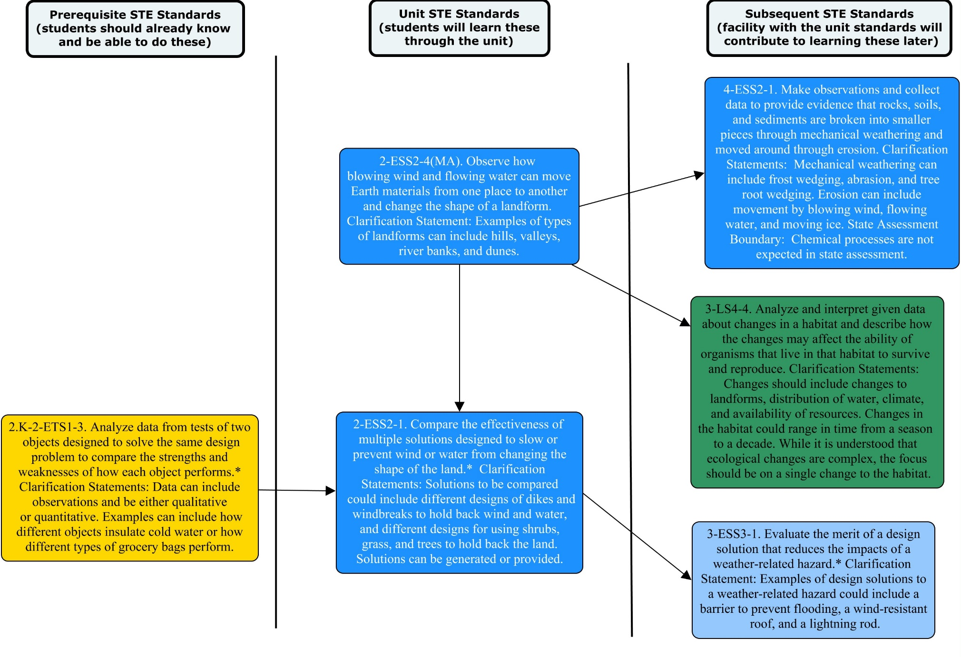

Unit Plan
Stage 1 Desired Results
ESTABLISHED GOALS G  2-ESS2-1 Investigate and compare the effectiveness of multiple solutions designed to slow or prevent wind or water from changing the shape of the land.* Clarification statement: Solutions to be compared could include different designs of dikes and windbreaks to hold back wind and water, and different designs for using shrubs, grass, and trees to hold back the land. Solutions can be generated or provided.  2-ESS2-4(MA) Observe how blowing wind and flowing water can move Earth materials from one place to another and change the shape of a landform. Clarification statement: Examples of types of landforms can include hills, valleys, river banks, and dunes.  English Language Arts/Literacy  W .2.7. Participate in shared research and writing projects (e.g. read a number of books on a single topic to produce a report; record science observations).  SL .2.3. Ask and answer questions about what a speaker says in order to clarify comprehension, gather additional information, or deepen understanding of a topic or issue. | Transfer
Students will be able to independently use their learning to… T
T1 Engage in sustained, complex and successful scientific inquiry.
T2 Engage in public discourse of scientific and technical issues in the news or the community.
T3 Analyze the implications of earth as a set of interconnected systems--atmosphere, hydrosphere, geosphere, and biosphere--when making personal and civic decisions.
 | Meaning
 | UNDERSTANDINGS U  Students will understand that…  U1 Wind and water can change the shape of land by moving Earth materials.  U2 The more Earth material moved, the bigger the change in the land.  U3 When one place loses Earth materials, another place gains Earth materials.  U4 Movement of Earth materials is determined by weight, size, shape of materials and can change how far and how fast the materials move. | ESSENTIAL QUESTIONS Q  Q1 How can wind and water change the shape of the land?  Q2 When is it necessary or desirable to prevent wind or water from changing the land?
 | Acquisition
 | Students will know… K  K1 Types of existing solutions (human-made and natural) that prevent wind/water from changing shape of land.  K2 Earth materials and systems vocabulary words.  K3 There are human-made and natural solutions which can prevent wind or water from changing the land.  K4 Pros and cons of different methods for slowing/preventing changes in the land’s shape.  K5 Examples of how wind and water change the shape of the land. | Students will be skilled at… S  S1 Observing and reporting on how wind and water move earth materials and impact the land.  S2 Demonstrating how wind and water change the shape of the land.  S3 Testing design ideas for the best prevention solution.  S4 Conducting a scientific observation (process and note-taking).  S5 Using graphic organizers to observe and report on solutions for preventing wind/water from changing the land.  S6 Constructing explanations and designing solutions; and obtaining, evaluating and communicating information.  S7 Using evidence from firsthand account and nonfiction resources and to make observations and inferences about how wind and water change the shape of the land  S8 Asking questions and clarifying questions for more information about how wind and water change the land.  S9 Working with a group to record observations and notes  S10 Participating in group scientific discussions
Stage 2 - Evidence
Evaluative Criteria | Assessment Evidence
(see CEPA rubric) | CURRICULUM EMBEDDED PERFORMANCE ASSESSMENT (PERFORMANCE TASKS) PT  Goal: Students create two models that demonstrate multiple solutions that can prevent or slow the impact of wind and/or water movement on the land’s shape.  Role: Students act as coastal engineers to test prototypes and decide on the best solution for controlling erosion for a town and will submit their report to the town conservation committee  Audience: Students create a report to give to the town conservation committee.  Situation: Students model a local landscape (2 hills) using milk cartons cut on a diagonal and filled with potting soil. They model the effects of water and wind on the hills. Then design a solution to prevent the land on the hill from changing. They propose two solutions and compare the effectiveness of each by measuring the amount of dirt that moved out of each of their cartons.  Product: Students complete a report which includes a diagram of each hill with the barrier designs and the effects of the wind and/or water on each and a written explanation of how and why one of the solutions was better for the town conservation committee to consider.
OTHER EVIDENCE: OE
- Graphic organizers
- Observational notes, inferences, and predictions.
- Classroom and schoolyard investigations
- Effective interactive diorama that show desired results
- Oral and written responses about essential questions in journal using key vocabulary and diagrams/drawings
- Accurate predictions to each and subsequent activities/investigations.
- Quality of asking questions and answering responses to fellow students

Stage 3 – Learning Plan
Summary of Key Learning Events and Instruction
1. What do we know about how water and wind shape the land? (20 min)
This lesson introduces students to idea that water and wind move materials in the environment. Students begin to fill out the “K” and “W” of a KWL chart through group discussion and writing in their science journal to activate prior knowledge about how water and wind can shape the land.

2. Effects of moving water and wind in our world (20 min)
Students explore how water and wind move earth materials through research using non-fiction resources.

3. Observation & scientific exploration centers (2 x 30 min)
Students explore what it means to observe like a scientist. Students rotate through two centers and investigate how earth materials are moved by water and wind and link the simulations to incidences seen in nature. Students use sand, pebbles, and soil to test how wind and water can change a landscape. Their explorations will help nurture their understanding that the earth is dynamic and constantly changing (slowly or quickly).

4. Schoolyard investigation (30 min)
Students take a nature walk and look for examples of earth materials being moved by water and/or wind. When scientists observe, they use all of their senses to create an accurate picture of what they’re observing. Students make notes on what they see happening to the earth materials in relation to wind and water, including solutions to prevent wind or water from changing the landscape.

5. Wind and water video/photo study (20 min)
Students watch several videos and look for examples of earth materials being moved by water and/or wind. Students make observations and inferences about what they see happening to the earth materials in relation to wind and water.

6. Natural solutions to prevent or slow the effects of wind and water from changing the land (20 min)
Students explore photographs of natural barriers in the environment. They discuss and explain how these barriers prevent or slow wind and water from changing the shape of the land. Then, in partners students write their explanations on about the photos and identify what barriers would be helpful if one is not present.

7. Human-made solutions to prevent or slow the effects of wind and water from changing the land (20 min)
Students will explore photographs of human-made barriers in the environment. They will discuss and explain how these barriers prevent or slow wind and water from changing the shape of the land. Then, in partners students will write their explanations about the photos and identify what barriers would be helpful if one is not present.

CEPA: Barrier solutions (2 x 40 min)
This CEPA is designed to ensure that all students understand that wind and water movement change the shape of the land and move earth materials around. Additionally, it is to assess the students’ understanding of multiple solutions that can be created to prevent or slow the impact of wind and water movement on the land’s shape. In groups, students will be creating two models that demonstrate multiple solutions that can prevent or slow the impact of wind and/or water movement on the land’s shape.

Adapted from Understanding by Design 2.0 © 2011 Grant Wiggins and Jay McTighe Used with Permission

Lesson 1: What do we know about how water and wind shape the land?
Brief Overview of Lesson: This lesson introduces students to idea that water and wind move materials in the environment. Students begin to fill out the “K” and “W” of a KWL chart through group discussion and writing in their science journal to activate prior knowledge about how water and wind can shape the land.
Estimated Time: 20 minutes
Standard(s)/Unit Goal(s) to be addressed in this lesson:
- 2-ESS2-4(MA) Observe how blowing wind and flowing water can move Earth materials from one place to another and change the shape of a landform. Clarification statement: Examples of types of landforms can include hills, valleys, river banks, and dunes.
- SL.2.3. Ask and answer questions about what a speaker says in order to clarify comprehension, gather additional information, or deepen understanding of a topic or issue.

Essential Question(s) addressed in this lesson:
- How can wind and water change the shape of the land?

Objectives
- Students will be able to make observations about pictures that show that water and wind move Earth materials in the environment.
- Students will be able to ask and answer questions of classmates based on their observations.

Language Objectives
- Ask questions about water and wind using question words (who, what, when, where, why, how).

Targeted Academic Language
- wind, water, land, earth, environment, blowing, flowing, change, shape

What students should know and be able to do before starting this lesson:
- Wind and water exist in different places in the environment.
- Wind blows things around.
- Water makes things wet and can cause things to move or float.
- How to have an academic science discussion
- Have a working knowledge of a science journal/notebook

Anticipated Student Preconceptions/Misconceptions
- Students may believe that the earth has always looked the way it does now or that the earth does not change.

Instructional Materials/Resources/Tools
- Science journal
- Large chart paper with a whole class KWL chart to be completed after discussion of individual charts.
- Visuals of wind and water in the environment. Places to find images here:
  - Geography for Kids covers all types of non-extreme weather with brief explanation and pictures.
    - Wind Movement: http://www.kidsgeo.com/geography-for-kids/0087-wind-movement.php
    - Precipitation: http://www.kidsgeo.com/geography-for-kids/0111-precipitation.php
  - Broken Tree Branch (scroll towards bottom of page): http://www.climate.washington.edu/stormking/December2006.html
  - Weather Channel, Winter storm: http://wap.weather.com/news/winter/storms/2012/nemo
  - Geography for Kids, Wind: https://kidsgeo.com/geography-for-kids/wind-movement/
  - Live Science, Flood: https://www.livescience.com/23913-flood-facts.html
  - Winter Storms: http://www.newsweek.com/winter-storm-skylar-pictures-blizzard-dumps-snow-boston-and-new-england-843875
  - NOAA National Severe Storms Laboratory, Thunderstorms: http://www.nssl.noaa.gov/education/svrwx101/thunderstorms/

Instructional Tips/Strategies/Suggestions for Teacher
- Set up pictures and whole group KWL chart; have student KWL charts ready for their science journal.
- Make the KWL chart an active part of the lesson and unit overall. Continually add to the chart after each lesson.
- To support development of academic language, have a word wall that will be added to throughout the unit for targeted vocabulary.
- Use pictures of water and wind in the environment to show students. Use a variety of pictures that include both water and wind events.
- During the lesson emphasize science practices of asking questions as well as obtaining and communicating information.

Assessment
- Students should give accurate ideas on how water and wind move earth materials on the environment based on class discussion and their writing in science journal.

Lesson Details:

Lesson Opening
Activate prior knowledge: (3 minutes)
- Show photographs of the effects of wind and rain on the environment. Think aloud about what happened in each picture (i.e., “look at that tree on the ground! I wonder what made it fall over like that.”) Ask students to think about their own experiences.

Focus Activity “I Do It”: (2 minutes)
- Model filling out “K” and “W” of KWL chart for students. Teacher thinks aloud, “What do I know about wind? Well, I know wind blows leaves on the trees. So under the ‘K’ column I’ll write ‘Wind blows leaves around.’ This is something I know is true, so it’s a good thing to write down.”
- Next think aloud writing a question, “Remember when I was looking at the picture of the tree that fell down? I wondered what made that happen. That would be a good question to write under my ‘W’ column, ‘What makes trees fall down?’ That’s a good wonder question because I want to know more about that.”
- Model asking questions about water and wind using question words (who, what, when, where, why, how) that students should be practicing with each other.
- Post pictures from the modeling (“I Do It”) next to the KWL chart for students to look at while they write their own.

During the Lesson
Guided Instruction “You Do It”: (10 minutes)
Teacher Note: As the students are working, circulate around looking for key ideas that you would like brought up to the class during group share. Make sure students are asking clarifying questions of each other about their ideas.
- With a partner, students will discuss and write a few items into the “K” and “W” sections of their charts.
- Each pair of students will agree on 1 item from each column to share with the class that will go on the anchor chart created by the teacher.
- Optional: Have students write down one question they asked each other about the pictures.

Lesson Closing
Collaborative Activity “We Do It” (5 minutes)
Teacher Note: Have a large KWL chart ready to record student ideas.
- Each pair of students shares their 1 item to add to the chart (be sure to check for accuracy and understanding).
- Introduce academic language (wind, water, land, earth, and environment) and write in a bold color onto the chart. Have a visual for each vocabulary term and use it in a sentence; ask students questions to relate to the language as necessary.
- Encourage students to comment or ask questions of each other in order to clarify ideas. Model appropriate science talk as needed.

Preview outcomes for the next lesson:
Students will take a more in depth look at where wind and water exist in our world.

Lesson 2: Effects of moving water and wind in our world
Brief Overview of Lesson: Students explore how water and wind move earth materials through research using non-fiction resources.

Estimated Time: 20 minutes

Standard(s)/Unit Goal(s) to be addressed in this lesson:
- 2-ESS2-4(MA) Observe how blowing wind and flowing water can move Earth materials from one place to another and change the shape of a landform. Clarification statement: Examples of types of landforms can include hills, valleys, river banks, and dunes.
- 2.W.7 Participate in shared research and writing projects (e.g. read a number of books on a single topic to produce a report: record science observations).

Essential Question(s) addressed in this lesson:
- How can wind and water change the shape of the land?

Objectives
- Use texts (books, internet, and articles) to research and obtain examples of places where wind and water move Earth materials.

Language Objectives
- Write two sentences using sentence starters that describe the effect of moving wind and water.

Targeted Academic Language
- research, wind, water, land, earth, environment, interaction, resources, blowing, flowing, change, shape

What students should know and be able to do before starting this lesson:
- Wind and water exist in different places in the environment.
- Wind blows things around.
- Water makes things wet and can cause things to move or float.
- Have a working knowledge of a science journal/journal
- Writing informational text

Anticipated Student Preconceptions/Misconceptions
- Students may believe that the earth has always looked the way it does now or that the earth does not change.

Instructional Materials/Resources/Tools
- Science journals
- Non-fiction books or other resources about water/wind
- Book suggestions:
  - How Water Shapes the Earth by Jared Siemens
  - How Wind Shapes the Earth by Megan Cuthbert and Katie Gillespie
  - Down Comes the Rain (Let's-Read-and-Find-Out Science 2) by Franklyn M. Branley, James Graham Hale (Illustrator)
  - Weather Words and What They Mean by Gail Gibbons
  - Feel the Wind (Let's-Read-and-Find-Out Science 2) by Arthur Dorros (Author, Illustrator)
  - Wind by Marion Dane Bauer and John Wallace
  - Follow the Water from Brook to Ocean (Let's-Read-and-Find-Out Science 2) by Arthur Dorros (Author, Illustrator)
- Other Resources:
  - A PowerPoint about erosion. http://star.spsk12.net/science/k3/Erosion.ppt
  - One Geology for Kids website. Link provides information about weathering and erosion. http://www.onegeology.org/extra/kids/earthprocesses/weathering.html
Instructional Tips/Strategies/Suggestions for Teacher
- Provide a graphic organizer for students to record their facts on.
- Through this lesson emphasize the science practice of obtaining, evaluating and communicating information.
- Have your own science journal to demonstrate how to record facts from reading.

Assessment
- Students successfully find facts and record relevant information about wind and water and how they affect our environment.

Lesson Details:

Lesson Opening
Activate prior knowledge: (3 minutes)
- Refer back to the KWL chart from the prior lesson. Encourage students to add new ideas to the chart.
- Read aloud one of the books on wind or water to the students.

Focus Activity “I Do It”: (2 minutes)
Teacher note: Have your own science journal to demonstrate how to record facts from reading
- Think aloud how to identify a piece of information from the book and use a sentence starter to write a sentence in their journal about something they saw in their book involving wind or water.
Example sentence starters:
- Wind can be found…
- Wind can cause…
- Water can be found…
- Water can cause…
An example sentence the teacher may provide: “Wind can cause a windmill to spin.”
- Model completion of the assignment in science journal.

During the Lesson
Guided Instruction “You Do It”: (10 minutes)
Teacher note: ESL Modification-Lower language level students may benefit from time with academic terms and multiple meaning words instead of finding facts in books (i.e. earth-the planet, earth-the ground/soil). Have students listen, read, write & discuss the terms, possibly recording and sketching in science journal.
- In partners or small groups, students will find examples of wind and/or water in books and use 2 of the sentence starters above to write 2 sentences in their science journal.

Lesson Closing
Collaborative Activity “We Do It” (5 minutes)
- Each pair of students shares a sentence (be sure to check for accuracy and understanding).
- Review/discuss vocabulary (wind, water, land, earth, and environment) and write in a bold color onto the chart.
- Encourage students to comment or ask questions of each other in order to clarify ideas. Model appropriate science talk as needed.

Preview outcomes for the next lesson:
Students will add to the class KWL chart under “L” through testing how wind and water move.

Lesson 3: Observation & scientific exploration centers
Brief Overview of Lesson: Students explore what it means to observe like a scientist. Students rotate through two centers and investigate how earth materials are moved by water and wind and link the simulations to incidences seen in nature. Students use sand, pebbles, and soil to test how wind and water can change a landscape. Their explorations will help nurture their understanding that the earth is dynamic and constantly changing (slowly or quickly).
Estimated Time: 2 x 30-minute sessions (60 minutes)
Standard(s)/Unit Goal(s) to be addressed in this lesson:
- 2-ESS2-4(MA) Observe how blowing wind and flowing water can move Earth materials from one place to another and change the shape of a landform. Clarification statement: Examples of types of landforms can include hills, valleys, river banks, and dunes.

Essential Question(s) addressed in this lesson:
- How can wind and water change the shape of the land?

Objectives
- Make scientific observations about how blowing wind and flowing water can move earth materials from one place to another using evidence from multiple senses.
- Use observations to compare Earth materials and make predictions.

Language Objectives
- State the observed differences/similarities between pebbles and sand using comparative language in a complete sentence, i.e. this pebble is smooth whereas these pieces of sand are grainy, or this pebble is larger than sand.
- State a prediction for their experiment using the sentence starter: I predict that ________ because ________.
- Write labels for diagrams that demonstrate the observations made during an experiment.

Targeted Academic Language
- prediction, process, observation, results, compare, evaluate, diagram, label, senses, sight, smell, touch, sound, taste, pebbles, sand, soil, wind, water, land, earth, environment

What students should know and be able to do before starting this lesson:
- Make scientific observations
- Make predictions
- Discuss in partners and guide their own completion of a worksheet
- Familiarity with the five senses.

Anticipated Student Preconceptions/Misconceptions
- Students may believe that the earth does not change or that wind and water do not change or move things.
- Students may use terms incorrectly, such as using “sight/see” in a sentence incorrectly or using “touch/feel” in context.

Instructional Materials/Resources/Tools
- Use images of pebbles/sand/water below to highlight the different types of sand and pebbles around the world.
  - Image of pebbles https://ww2.kqed.org/quest/2011/03/03/geological-outings-around-the-bay-pebble-beach/
  - Image of stones/rocks/water: http://upload.wikimedia.org/wikipedia/commons/f/f5/Valuga_Beach.png
  - Images of sand from around the world: http://www.scienceofsand.info/
  - Images of sand dunes:
    - http://www.arkive.org/habitats/sandy-shores-uk/image-H278
    - http://education.nationalgeographic.com/education/encyclopedia/dune/?ar_a=1
- Science journal/observation sheet
- Landslide Experiment:
  - 4 plastic cups per station
  - soil
  - water (for spray bottle)
  - spray bottle
  - plates/ pan/trays (to place soil mounds on)- 1-2 per station
  - straws
  - safety goggles or sunglasses of some kind

- Sand and Pebbles Experiment:
  - 3 plastic cups per station
  - plastic trays/pans (to place sand/pebble mounds on) -1-2 per station
  - cardboard boxes (plastic trays can fit inside so sand does not blow out)- copier paper box tops work well.
  - sand
  - pebbles
  - straws
  - big rocks or barriers (to place in shoe boxes as obstructions to the wind & sand)
  - safety goggles or sunglasses of some kind
  - water (for spray bottle)
  - spray bottle

Instructional Tips/Strategies/Suggestions for Teacher
- Split class into groups ahead of time.
- Set up materials ahead of time in separate sections of the room.
- Have clear expectations ready for students to minimize “mess” during experimentation.
- Throughout the lesson emphasize the science practices of planning and carrying out investigations (with a particular focus on making and recording observations) and communicating information.
- To support the language objective provide sentence frames.
- To support development of academic language and help ESL students, create an adjective word bank to help describe objects or brainstorm ideas prior to releasing students to work independently. The word bank could be one used from writing generally or specific to scientific observations. For example:
  - sight: grey, white, spotted, bumpy, shiny, dull
  - touch: bumpy, smooth, hard,
  - taste: salty (not recommended)
  - sound: silent
  - smell: smoky
Assessment
- Written scientific observation notes, diagrams and explanations.

Lesson Details:

Lesson Opening
Activate prior knowledge: (5 minutes)
Use example images of sand/water/pebbles to model how to make a good observation. Ask students to think about their own experiences.

Focus Activity “I Do It”: (5 minutes)
Teacher note: Be explicit on how you want your students to record observations. Modifications: some students may just draw diagrams of observations & write using word boxes for support or sentence frames to help them complete the sheet.
Suggestion: Place investigation directions on each table to help guide students on how to conduct the experiment.

- Teacher explains to the students that for each center, they will make a prediction about how water and wind could affect earth materials, conduct an experiment, and record their observations.
- Teacher models how to make comparative observations about pebbles and sand (smooth, rough, etc.) and think aloud about why the pebbles and sand are smooth or rough while observing.
- Model how to use a straw to blow on the sand, pebbles and soil.
- Model how to make observations about what happened. (Example observation: “I notice the sand moves.”)
- Teacher gives students an overview of expectations and guidelines for completing observation sheet.
- Put students in groups.

During the Lesson
Guided Instruction “You Do It”: (15 minutes)
Teacher Note: Teacher models how to rotate through (previously set up) centers, explaining that each group will only complete one center per day, over two days. Students should wear goggles for these activities. Circulate through the centers and assist as needed. Ask probing questions to help students access the concepts and transfer their understandings to erosion on a greater scale.

- For each center, give students time to use their senses to explore the sand /pebbles/soil and discuss them.
- Students should record their findings in their science journals/observation sheets.
- Directions for experiments below:
- Landslide Experiment Steps:
  - On a tray, fill 4 cups with soil.
  - Use the spray bottle to wet 2 cups of soil (do not over water).
  - On the trays, make 4 mounds or “sandcastles” with the soil.
  - Write a prediction of what will happen to the soil when water is poured on it and when wind blows it.
  - Use the spray bottle to pour water on two of the mounds and see what happens.
  - Put on goggles and use the straws to blow the other 2 soil mounds and see what happens.
  - Write down observations and complete scientific process observation sheet.

- Sand and Pebble Experiment Steps:
  - Put on goggles
  - On a tray, fill 2 cups with sand and 1 cup with pebbles.
  - Wet 1 cup of sand (do not over water).
  - On the trays, make 3 mounds or “sandcastles” with the sand pebbles.
  - Write a prediction of what will happen to the sand and pebbles when wind blows it and when water is poured on it.
  - Use the straws to create wind. Blow the 2 mounds of sand and 1 mound of pebbles. See what happens.
  - Use the spray bottle to pour water on the mounds and see what happens.
  - Add rock barriers then blow again. (Note: remind students to be aware of the change in the movement of the earth materials after the barriers were placed)
  - Write down observations and complete scientific process observation sheet.

Lesson Closing
Collaborative Activity “We Do It”: (5 minutes)
- Teacher leads discussion on how these concepts relate to earth wind and water movement on a greater scale. Facilitate a conversation with the groups on what they saw and how that relates to their learning about earth changing thus far.
- Each group of students share a prediction, observation and result (be sure to check for accuracy and understanding).
- Add their information to the “L” on the KWL chart.
- Encourage students to comment or ask questions of each other in order to clarify ideas. Model appropriate science talk as needed.

Preview outcomes for the next lesson:
Students will continue center exploration, rotation and discussion. In the next lesson, students will be going outside to look for examples of earth materials being moved by wind and water and solutions.

Lesson 4: Schoolyard investigation
Brief Overview of Lesson: Students take a nature walk and look for examples of earth materials being moved by water and/or wind. When scientists observe, they use all of their senses to create an accurate picture of what they’re observing. Students make notes on what they see happening to the earth materials in relation to wind and water, including solutions to prevent wind or water from changing the landscape.
Estimated Time: 30 minutes
Standard(s)/Unit Goal(s) to be addressed in this lesson:
- 2-ESS2-1 Investigate and compare the effectiveness of multiple solutions designed to slow or prevent wind or water from changing the shape of the land.* Clarification statement: Solutions to be compared could include different designs of dikes and windbreaks to hold back wind and water, and different designs for using shrubs, grass, and trees to hold back the land. Solutions can be generated or provided.
- 2-ESS2-4(MA) Observe how blowing wind and flowing water can move Earth materials from one place to another and change the shape of a landform. Clarification statement: Examples of types of landforms can include hills, valleys, river banks, and dunes.
- 2.SL.3. Ask and answer questions about what a speaker says in order to clarify comprehension, gather additional information, or deepen understanding of a topic or issue.

Essential Question(s) addressed in this lesson:
- How can wind and water change the shape of the land?

Objectives
- Make scientific observations about changes wind or water may have had on earth’s materials.
- Make inferences about how wind or water may have changed earth’s materials.
- Ask and answer questions of classmates about their observations made in the school yard.
- Identify areas of the schoolyard that have been designed to slow or prevent the landscape from changing.

Language Objectives
- Write/draw examples on a chart of apparent wind or water effects on earth’s materials.

Targeted Academic Language
- wind, water, earth materials, human-made materials, observation, change, barriers, erosion, solutions, design, prevent, storm drain, curb, landscape

What students should know and be able to do before starting this lesson:
- Make observations/inferences and know how to write an observation and inference.
- The difference between earth materials and human-made materials.

Anticipated Student Preconceptions/Misconceptions
- Students may need clarification on identifying whether or not something is an earth material

Instructional Materials/Resources/Tools
- Science journal or schoolyard observation worksheet
- Clipboards/pencils
- Digital camera or tablet (optional)

Instructional Tips/Strategies/Suggestions for Teacher
- You may want to do this on a windy/rainy day or the day after it has rained heavily.
- Go outside ahead of time (that morning before school) and find an example that can be used as a model before students go looking on their own for examples.
  - storm drains
  - curb leading into storm drain
  - water run-off on road/hills
  - puddles
  - streams
  - items that physically move as a result of wind
  - items that show wind direction
- Technology integration: Bring a tablet or digital camera and take pictures/video of the examples that students find.
- Throughout this lesson emphasize the science practices of planning and carrying out investigations, analyzing and interpreting data, and constructing explanations.
- Suggestions if students cannot go outside:
  - Take pictures of the schoolyard to show students in classroom
  - Show a video: 3 Minute Video A Walk in Nature: http://vimeo.com/43338103

Assessment
- Written observation notes and inferences.

Lesson Details:

Lesson Opening
Activate prior knowledge: (5 minutes)
Explain to the students that they will be taking a nature walk outside to look for examples where earth materials may have been changed by blowing wind or flowing water. Give an example of what they will be looking for in the schoolyard.

Focus Activity “I Do It”: (5 minutes)
- On the walk, take students to your predetermined example. Model how to make a good observation and inference. (i.e. “The soil on this hill has grooves in it, maybe flowing water caused the soil to move and that caused grooves.”)
Teacher Note: Examples to look for with students:
-Curb leading into storm drain (Look at all the leaves/sand/items that are near the drain. What could have brought these here?)
-Water run-off on road/hills (Notice how the dirt appears to have grooves or lines in it. What could have caused those?)
-Puddles (Why is there water in just this spot? How did it get here?)
-Streams (Which direction is the water moving? Let’s put a leaf in to check the direction. What is causing it to move?
-Items that physically move as a result of wind. (Look at that leaf. Where did it come from? How did it end up here?)
-Items that show wind direction. (Look at the flagpole. Why is the flag moving that way/direction?)

During the Lesson
Guided Instruction “You Do It”: (15 minutes)
Teacher note: The walk could be as a group or let students pair off and walk around the school yard/playground to look more independently. If students have not found something within 5 minutes, assign an example. Have students work in small groups.
- Students look for an example where wind or water may have changed earth’s materials.
- Students write down the example in science journals and make an inference about how wind or water may have caused the change. Example: I think wind moved these leaves here because they are far away from the tree.
- Students look for solutions to slow or prevent erosion and write down their observations in their journal.
- Students should share their information with their group and each group member should practice asking a question about each other’s observations.

Lesson Closing
Collaborative Activity “We Do It”: (5 minutes)
- Ask students/pairs to share their examples with the whole class. Each time an example is shown ask probing questions. (i.e., “What earth material did you observe? How do think it was changed by wind or water? What do think it looked like before it changed? What types of solutions did you observe that could prevent erosion?”)
- Encourage students to comment or ask clarifying questions of each other in order to clarify ideas. Model appropriate science talk as needed.
- Add additional information to the “L” in the KWL chart.

Preview outcomes for the next lesson:
Students will watch videos where wind and water has affected earth materials in other places. Optional: Explain: “Now that we have seen some wind and water effects within a very small area of the school yard, can anyone think of another example that you did not see here but you have seen somewhere else?”

Lesson 5: Wind and water video/photo study
Brief Overview of Lesson: Students watch several videos and look for examples of earth materials being moved by water and/or wind. Students make observations and inferences about what they see happening to the earth materials in relation to wind and water.
Estimated Time: 20 minutes
Standard(s)/Unit Goal(s) to be addressed in this lesson:
- 2-ESS2-1 Investigate and compare the effectiveness of multiple solutions designed to slow or prevent wind or water from changing the shape of the land.* Clarification statement: Solutions to be compared could include different designs of dikes and windbreaks to hold back wind and water, and different designs for using shrubs, grass, and trees to hold back the land. Solutions can be generated or provided.
- 2-ESS2-4(MA) Observe how blowing wind and flowing water can move Earth materials from one place to another and change the shape of a landform. Clarification statement: Examples of types of landforms can include hills, valleys, river banks, and dunes.
- 2.W.7 Participate in shared research and writing projects (e.g. read a number of books on a single topic to produce a report: record science observations).

Essential Question(s) addressed in this lesson:
- How can wind and water change the shape of the land?

Objectives
- Make scientific observations about changes to Earth materials from blowing wind or flowing water.
- Use information from observations to construct an initial explanation about how blowing wind or flowing water changes earth materials.
- Make observations about solutions designed to slow or prevent wind or water from changing the shape of the land.

Language Objectives
- Record examples of wind and water effects on Earth’s materials.

Targeted Academic Language
- wind, water, Earth materials, observation, change, damaging, prediction

What students should know and be able to do before starting this lesson:
- Make observations.
- Make inferences about why things happened.
- Write a sentence containing an inference i.e. I think rain water moved the soil here because __________________.

Anticipated Student Preconceptions/Misconceptions
- Student may need clarification on identifying whether or not something is an earth material

Instructional Materials/Resources/Tools
- Science journal
- Nature walk back up 3 Minute Video: http://vimeo.com/43338103
- Photos -Erosion and Weathering”: http://www.pbslearningmedia.org/resource/ess05.sci.ess.earthsys.erosion/erosion-and-weathering/
- Video #1 Making Rivers-from Peep and the Big Wide World (1:28 min.) http://www.pbslearningmedia.org/resource/rtttec13.ela.fdn.privers/making-rivers/

- Video #2 “Flood: Farming and Erosion” (play only 0-1:37) http://www.pbslearningmedia.org/resource/ess05.sci.ess.earthsys.flooderosion/flood-farming-and-erosion/
- Video #3 “River” (play only 1:00 -2:04) http://www.pbslearningmedia.org/resource/idptv11.sci.ess.stru.d4kriv/rivers/

Instructional Tips/Strategies/Suggestions for Teacher
- If you took pictures or video in the prior lesson have them ready to be viewed.
- Throughout this lesson emphasize science practices of constructing explanations.
- The purpose of showing the video during the lesson is to make observations/predictions. The audio content in the video is not part of the lesson so leave the volume off.

Assessment
- Written observation notes and inferences.

Lesson Details:

Lesson Opening
Activate prior knowledge: (3 minutes)
- Refer back to the prior lesson and review how to make a good observation. Show pictures/videos from yesterday or other videos/pictures, if desired.
- Explain to the students that they will be watching several videos and will need to make observations about the effects of blowing wind or flowing water on earth materials.

Focus Activity “We Do It”: (2 minutes)
- Choose one of the videos to show again and discuss. Ask: “What do you think happened? Could flowing water cause this? How? Could blowing wind cause this? How?”
- Model how to write some observations in journal about the effects of blowing wind or flowing water on earth materials.

During the Lesson
Instruction “You Do It”: (10 minutes)
Teacher Note: The purpose of showing the video is to make observations/inferences. The audio content in the video is not part of the lesson so leave the volume off.
- Play Video #1 (Making Rivers-from Peep and the Big Wide World) to activate prior knowledge.
- Play Video #2 (“Flood: Farming and Erosion” (play only 0-1:37) Talking points:
  - 0-25 sec: Point out how rivers spread across U.S.
  - 25-30 sec: Pause; What is happening here? What damage could it cause to land and human-made objects?
  - 30-48 sec: What other damages do you notice happening?
  - 48-1:07: How would the wind and water impact these houses?
  - 1:07 -1:15: Pause after the tree falls; What caused the tree to fall? Predict what will happen next to the tree.
  - 1:15 –1:36: Pause; How is the water changing the land shape?
- Play Video #3 (“River” (play only 1:00 -2:04). Talking points:
    - Start at 1:15 paused: How are these rocks protecting the land?
    - 1:15 – 1:20: Pause; Look at how the land is flat all around except for the valley with a river running through it—What caused this valley to form? Do you think it took a long time? Why or why not?
    - 1:20-1:31: Pause; Did this land form slowly or quickly?
    - Play out to 2:05
- Students will record observations about what they saw in their science journal.
- Students write down an example with an explanation about how wind or water may have caused the change.
- Ask students to also think about whether the things seen in the videos could have been slowed/prevented/stopped and record one idea in their journals.

Lesson Closing
Collaborative Activity “We Do It”: (5 minutes)
- Ask several students/pairs to share their examples with the whole class. Each time an example is discussed ask probing questions. (i.e. “What caused the change in this earth material? How do you think it was changed by wind or water? What do you think it looked like before it was changed?”)
- Have students write down their ideas to the questions before sharing out.
- Encourage students to comment or ask clarifying questions of each other in order to clarify ideas. Model appropriate science talk as needed.

Preview outcomes for the next lesson:
Students will explore photographs of natural barriers in the environment.

Lesson 6: Natural solutions to prevent or slow wind and water from changing the land
Brief Overview of Lesson: Students explore photographs of natural barriers in the environment. They discuss and explain how these barriers prevent or slow wind and water from changing the shape of the land. Then, in partners students write their explanations on about the photos and identify what barriers would be helpful if one is not present.
Estimated Time: 20 minutes
Standard(s)/Unit Goal(s) to be addressed in this lesson:
- 2-ESS2-1 Investigate and compare the effectiveness of multiple solutions designed to slow or prevent wind or water from changing the shape of the land.* Clarification statement: Solutions to be compared could include different designs of dikes and windbreaks to hold back wind and water, and different designs for using shrubs, grass, and trees to hold back the land. Solutions can be generated or provided.
- 2.SL.3. Ask and answer questions about what a speaker says in order to clarify comprehension, gather additional information, or deepen understanding of a topic or issue.

Essential Question(s) addressed in this lesson:
- When is it necessary or desirable to prevent wind or water from changing the land?

Objectives
- Use information from media to construct an evidence-based explanation for how natural barriers prevent or slow wind and water from changing the shape of the land.
- Ask and answer questions of classmates based on observations.

Language Objectives
- Use a sentence frames to explore ideas about what can/cannot happen when a natural barrier is or is not present and why:
  - “If _____________ is present then ________________ will/will not happen because…”
  - “If _____________ is not present then ________________ will/will not happen because…”

Targeted Academic Language
- impact, barriers, solutions, analyze, prevent, natural, shrubs, cliff, valley, mountains, caves, forests, marshes, dunes

What students should know and be able to do before starting this lesson:
- Water and wind move earth materials and can change the land’s shape
- Ways in which water and wind move earth materials (positive and negative ways)
- Compare/contrast photos
- Work/discuss effectively in partners

Anticipated Student Preconceptions/Misconceptions
- Students may think that wind and water movement is always bad and causes disasters

Instructional Materials/Resources/Tools
- science journal
- variety of photos (suggested in the unit resources section) that represent different types of natural barriers--shrubs, grass, trees, mountains, rocks, cliffs, valleys, caves, forests, marshes, dunes, etc. - and some without
- Photo Suggestions:
  - Coastline during a storm—ocean crashing up against plants that are acting as a natural barrier, protecting the land:
http://wattsupwiththat.com/2013/07/18/invest-in-nature-not-infrastructure-for-storm-abatement/
  - Beach coastline—cliff protects land above where homes are built: http://montereybay.noaa.gov/resourcepro/resmanissues/coastal.html
  - Hurricane Sandy and Tsunami in Japan:
    - Hurricane Sandy:http://commons.wikimedia.org/wiki/File:121030-F-AL508-159_Aerial_views_during_an_Army_search_and_rescue_mission_show_damage_from_Hurricane_Sandy_to_the_New_Jersey_coast,_Oct._30,_2012.jpg
    - Tsunami in Japan (shows before after photos): http://www.mirror.co.uk/news/world-news/japan-tsunami-two-years-on-1741794

- Video Suggestions:
Natural barriers
  - Sand Dune animation from National Public Radio (NPR)- watch the first 1:22. The second half talks about building human-made dunes: http://www.npr.org/2013/02/15/170459890/after-sandy-not-all-sand-dunes-are-created-equal
  - Death Valley rain shadow, several 1:00 videos: http://www.pbslearningmedia.org/resource/nat08.earth.clim.geog.lpcandie/you-can-die-here-death-valley-california/
  - Floods and natural levee formation, graphics; 1:15 https://www.youtube.com/watch?v=persGpc6-Dw
  - Beavers build a dam; 3:25 from PBS: http://www.pbs.org/wnet/nature/leave-it-to-beavers-video-how-beavers-build-dams/8847/ or https://www.youtube.com/watch?v=yJjaQExOPPY
  - Beaver dam, live footage, graphics, time lapse; 3:07 from Animal Planet:
https://www.youtube.com/watch?v=Na2HYq11yuM

Observe how wind moves & affects the land:
- Phoenix dust storm whole segment http://www.youtube.com/watch?v=8W4Cx44XKZ4
- Arizona dust storm from BBC; 0:38: http://www.bbc.com/news/world-us-canada-28164436

Instructional Tips/Strategies/Suggestions for Teacher
- Prepare ahead of time a set of pictures, some with natural barriers, and some without for activity. Examples are located in the unit resources section.
- Throughout this lesson emphasize science practices of analyzing and interpreting data and engaging in arguments from evidence.

Assessment
- Written explanations of photo sets and partner discussions and share outs.

Lesson Details:

Lesson Opening
Activate prior knowledge: (3 minutes)
Teacher Note: Suggestions for pictures and videos provided above.
- Teacher begins conversation, “Now that we’ve learned that water and wind move earth materials and can change the land’s shape, let’s explore how this might impact us. Sometimes water and wind moving is a good thing, they help us. What are some ways water and wind moving help us/are good?” Students turn and talk, then share out.
- Teacher continues, “Other times we need protection from water and wind. Like during hurricanes and tsunamis.” (Show picture of Hurricane Sandy and Japan tsunami--maybe pass around newspaper clippings or show old video clips to show on these events). Briefly explain, “Yes! Water and wind can be bad, but we still do need them!”

Focus Activity “I & We Do It”: (2 minutes)
- Teacher explains that for times when wind and water are too strong we need solutions (things/barriers) that protect us, things like fences. Today, however, we’re focusing on natural solutions that slow or stop wind and water from changing the land.
- This serves as a model for the partner activity in “I Do It”. Teacher shows a picture/video that has a natural barrier (like a mountain) protecting the land and a picture without a natural barrier. Model/think aloud comparing and contrasting the two photos/images from a video: What is the natural barrier that is protecting the land’s shape? How is it protecting the land shape? Students turn and talk, then share out.
- Teacher leads discussion on why that barrier is important to the land and how it’s helping slow or prevents wind/water from changing the land.
- Now it’s your turn to analyze some pictures and find the natural barriers. Once you have found the natural barriers, explain to your partner why they are necessary and how they help stop the land from changing shape. Some of the pictures may have a natural barrier, some might not.

During the Lesson
Guided Instruction “You Do It”: (10 minutes)
Teacher’s Note: Types of natural barriers--shrubs, grass, trees, mountains, rocks, cliffs, valleys, caves, forests, marshes, dunes, etc. Make sure pictures represent a variety of natural barriers, not just mountains. As the students are working, circulate around looking for key ideas that you would like brought up to the class during group share. Make sure students are asking clarifying questions of each other about their ideas.

- In partners, students receive a set of pictures, some with natural barriers, and some without. Students circle the natural barrier, discuss the purpose of the barrier & what it is protecting, they then flip the picture over and write their discussed response as to how the barrier is slowing or preventing the land from changing shape. If the photo does not have a natural barrier, students should write on the back what barrier should be there and how it would work. Suggestion: Students can write their observations, inferences, and ideas in their science journals rather than writing on back of pictures.

Lesson Closing
Collaborative Activity “We Do It”: (5 minutes)
- Ask several students/pairs to share their examples with the whole class. Each time an example is discussed ask probing questions and check for accuracy.
- Encourage students to comment or ask clarifying questions of each other in order to clarify ideas. Model appropriate science talk as needed.

Preview outcomes for the next lesson:
Students explore human-made solutions and why we build them.

Lesson 7: Human-made solutions to prevent or slow the effects of wind and water

Brief Overview of Lesson: Students explore photographs of human-made barriers in the environment. They discuss and explain how these barriers prevent or slow wind and water from changing the shape of the land. Then, in partners students write their explanations about the photos and identify what barriers would be helpful if one is not present.
Estimated Time: 20 minutes
Standard(s)/Unit Goal(s) to be addressed in this lesson:
- 2-ESS2-1 Investigate and compare multiple solutions designed to slow or prevent wind or water from changing the shape of the land.
- 2.W.7 Participate in shared research and writing projects (e.g. read a number of books on a single topic to produce a report: record science observations).

Essential Question(s) addressed in this lesson:
- When is it necessary or desirable to prevent wind or water from changing the land?

Objectives
- Use information from media to construct an evidence-based explanation for how human-made barriers prevent or slow wind and water from changing the shape of the land.
- Use photographs to record scientific observations.

Language Objectives
- Use a sentence frames to explore ideas about what can/cannot happen when a natural barrier is or is not present and why:
  - “If _____________ is present then ________________ will/will not happen because…”
  - “If _____________ is not present then ________________ will/will not happen because…”
- Write an explanation that suggests a human-made barrier that would help stop the land’s shape from changing using a sentence frame.

Targeted Academic Language
- human-made, barriers, impacted, solution, analyze, prevent, dikes, dams, fences, retaining walls

What students should know and be able to do before starting this lesson:
- Water and wind move earth materials and can change the land’s shape
- Ways in which water and wind move earth materials (positive and negative ways)
- Compare/contrast photos
- Work/discuss effectively in partners

Anticipated Student Preconceptions/Misconceptions
- Students may think that wind and water movement is always bad and causes disasters

Instructional Materials/Resources/Tools
- Science journal
- variety of photos (suggested in unit resources section) that represent different types of human-made barriers - dikes, dams, fences, retaining walls, human-made mountains, etc.-and some without for activity
- Human-made Videos
  - Tsunami and seawall 1:59: https://www.youtube.com/watch?v=5-zfCBCq-8I
  - Seawalls: these 0:30 videos can be downloaded and used. See terms and agreement. http://www.geography.learnontheinternet.co.uk/video_coastal_management_seawall.html
  - Check video section of same website for erosion examples http://www.geography.learnontheinternet.co.uk/video_coastal_erosion.html
  - Breakwater 1:27: https://www.youtube.com/watch?v=fbgAomgNMAU
  - New Orleans rebuilding of the levees, construction, flooding from the Science Channel; 2:16 https://www.sciencechannel.com/tv-shows/build-it-bigger/videos/rebuilding-the-levees
  - Sand Dune animation from National Public Radio (NPR)- watch after 1:22. The second half shows building human-made dunes http://www.npr.org/2013/02/15/170459890/after-sandy-not-all-sand-dunes-are-created-equal
  - Snow fences: https://www.youtube.com/watch?v=NiQXNujxmUw
Instructional Tips/Strategies/Suggestions for Teacher
- Prepare ahead of time a set of pictures, some with human-made barriers, and some without for activity. Examples are located in the unit resources section.
- Throughout this lesson emphasize the science practices of analyzing and interpreting data and engaging in arguments from evidence.

Assessment
- Written explanations of photo sets and partner discussions and share outs.

Lesson Details:

Lesson Opening
Activate prior knowledge: (3 minutes)
Teacher Note: Review: Even though water and wind can be bad, we still do need them!
- Teacher begins conversation, “Yesterday we discussed how water and wind move earth materials and can change the land’s shape, let’s continue to explore how this might impact us. Remember that sometimes water and wind moving is a good thing, they help us. Let’s review, what are some ways that moving water and wind help us?” Students turn and talk, then share out.
- Teacher continues, “Remember, other times we need protection from water and wind. Like during hurricanes and tsunamis.” (Make sure pictures from yesterday are displayed--such as Hurricane Sandy and Japan tsunami).

Focus Activity “I & We Do It”: (2 minutes)
- Teacher explains that for times when wind and water are too strong we need solutions (things/barriers) that protect us. Yesterday, we focused on natural barriers (grass, shrubs, and trees). Today, we’re focusing on human-made solutions that slow or stop wind and water from changing the land.
- Teacher shows a picture that has a human-made barrier (like a dike) protecting the land and a picture without a dike. Turn and talk: How is the water affecting the land differently in each photo? Students turn and talk, then share out. Sentence frame for discussion: In the first picture, the water is _______. However, in the second picture, the water is ______ because ______.
- Debrief Responses: What is the human-made barrier that is protecting the land’s shape? (Note: You do not need to explicitly teach dike, allow answers such as wall, hill, etc. After students share out, briefly explain that it is called a dike.) Call on students for ideas. Teacher says: How do you think that hill got there? How can you tell? (Note: Lead a discussion on human-made elements that look like natural barriers--hills, tunnels, ponds, valleys and how you can tell the difference between human-made & natural.)
- Teacher leads discussion on why that barrier is important to the land and how it’s helping slow or prevents wind/water from changing the land.
- Now it’s your turn to analyze some pictures and find the human-made barriers. Once you have found the human-made barriers, explain to your partner why they are necessary and how they help stop the land from changing shape. Some of the pictures may have a human-made barrier, some might not.
Sentence frame for partner discussion: In this picture, I notice ______. This is necessary because _______.

During the Lesson
Instruction “You Do It”: (10 minutes)
Teacher’s Note: Types of human-made barriers-dikes, dams, fences, retaining walls, human-made mountains, etc. Make sure pictures represent a variety of human-made barriers, not just dikes. As the students are working, circulate around looking for key ideas that you would like brought up to the class during group share. Make sure students are asking clarifying questions of each other about their ideas.

- In partners, students receive three picture cards with human-made barriers and one picture card without a human-made barrier (i.e. a flooded house, mudslide, or tornado area). Students circle the human-made barrier, discuss the purpose of the barrier & what it is protecting, they then flip the picture over and write their discussed response as to how the barrier is slowing or preventing the land from changing shape using sentence frames provided. For the one photo that does not have a human-made barrier, students brainstorm barriers and decide upon one barrier that could prevent what happened in the picture and how it would prevent it. Write answer on the back of the card: A barrier that could prevent the (water/wind/mud) from changing the landform is a ______. It would prevent the change by ______.
Suggestion: Students can write their observations, inferences, and ideas in their science journals rather than writing on back of pictures.

Lesson Closing
Collaborative Activity “We Do It”: (5 minutes)
- Ask several students/pairs to share their examples with the whole class. Each time an example is discussed ask probing questions and check for accuracy.
- Encourage students to comment or ask clarifying questions of each other in order to clarify ideas. Model appropriate science talk as needed.

Preview outcomes for the next lesson:
Introduce the CEPA. Students will be experimenting with different solutions to prevent water and wind from changing the shape of the land.

Curriculum Embedded Performance Assessment (CEPA):
Barrier Solutions

Brief Overview: This CEPA is designed to ensure that all students understand that wind and water movement change the shape of the land and move earth materials around. Additionally, it is to assess the students’ understanding of multiple solutions that can be created to prevent or slow the impact of wind and water movement on the land’s shape. In groups, students will be creating two models that demonstrate multiple solutions that can prevent or slow the impact of wind and/or water movement on the land’s shape.

Estimated Time: 2 x 40-minute sessions (80 minutes)

Standard(s)/Unit Goal(s) to be assessed in this lesson:
- 2-ESS2-1 Investigate and compare the effectiveness of multiple solutions designed to slow or prevent wind or water from changing the shape of the land.* Clarification statement: Solutions to be compared could include different designs of dikes and windbreaks to hold back wind and water, and different designs for using shrubs, grass, and trees to hold back the land. Solutions can be generated or provided.
- 2-ESS2-4(MA) Observe how blowing wind and flowing water can move Earth materials from one place to another and change the shape of a landform. Clarification statement: Examples of types of landforms can include hills, valleys, river banks, and dunes.
- 2.W.7 Participate in shared research and writing projects (e.g. read a number of books on a single topic to produce a report: record science observations).

Instructional Materials/Resources/Tools
- trays/cookie sheets (2 per station)
- empty small milk cartons (2 per station)
- small clear plastic cups (2 per station)
- potting soil
- sand/rocks/sticks/leaves etc.
- straws/craft sticks/toothpicks/pipe cleaners/etc. (suggestions)
- clear measuring cups (2 per station)
- water
- spray bottle (1 per station)
- straws
- safety goggles
- stop watch or clock with a second hand

Instructional Tips/Strategies/Suggestions for Teacher
- A hair dryer or small hand-held fan may be substituted for straws for stronger wind. Place both on lowest setting to avoid soil from blowing across the room.
- Teacher can decide if students use water and wind on both “hills” or use water on one and wind on the other.
- Pre-cut milk cartons on a diagonal before class.
- Split class into groups ahead of time.
- Set up materials ahead of time in separate sections of the room.
- Have clear expectations ready for students to minimize “mess” during experimentation.
- The science practices of planning and carrying out investigations (with a particular focus on making and recording observations) and communicating information should be assessed.

Explanation of CEPA
- Goal: Students create two models that demonstrate multiple solutions that can prevent or slow the impact of wind and/or water movement on the land’s shape.

- Role: Students act as coastal engineers to test prototypes and decide on the best solution for controlling erosion for a town and will submit their report to the town conservation committee

- Audience: Students create a report to give to the town conservation committee.

- Situation: Students model a local landscape (2 hills) using milk cartons cut on a diagonal and filled with potting soil. They model the effects of water and/or wind on the hills. Then design a solution to prevent the land on the hill from changing. They propose two solutions and compare the effectiveness of each by measuring the amount of dirt that moved out of each of their cartons.

- Product: Students complete a report which includes a diagram of each hill with the barrier designs and the effects of the wind or water on each and a written explanation of how and why one of the solutions was better for the town conservation committee to consider.
  - Product Modifications:
    - Illustrations to demonstrate the steps and outcomes with an oral explanation of their findings.
    - Video recording of the process with an oral explanation of their findings.

- Extension: The information could be presented to the whole class and graphed on a class graph.

CEPA: Class Instructions

Your town’s main road is being blocked by the eroding hillside! The water and wind have been wearing away the hill in town. The land is moving towards homes and blocking the road. The town conservation commission has asked citizens to help them design a solution to the problem.

Directions:
In groups, you will be designing two solutions to prevent the hillside from eroding. You will build your hillside in one class period and construct your design in another and then create a report to give to the town conservation commission.

Materials for your station:
- Report sheet (1 per person)
- 2 trays
- 2 small milk cartons cut on a diagonal
- 2 cups filled with potting soil
- 2 measuring cups
- 1 spray bottle full of water
- 2 straws
- Safety goggles
- Marker
- Miscellaneous bin (could contain -sand/rocks/sticks/leaves, straws/craft sticks/toothpicks/pipe cleaners/etc.)
- Stopwatch

Day 1:
Task 1: Construct your hillside
- Place each milk carton on a separate tray.
- Use the marker to label your milk cartons. Write A on one and B on the other.
- Fill your milk cartons with potting soil. Don’t overfill!

Task 2: What is the effect of the water and wind on the hill?
- On your report sheet, draw your milk carton with the soil in it.
- Put your goggles on!
- Choose a group member to be the time keeper.
- Taking turns, make it rain on each hill for 20 seconds. Watch what happens.
- Taking turns again, use the straws to blow the soil on the hill. Each person takes a turn blowing for 10 seconds. Watch what happens.
- Take all the soil that has fallen out of the milk cartons and place it in the measuring cups. On your paper color and label how much soil came down the hill for each carton.

Day 2: Build and Test your Design!
- Work with your group to come up with a design that will prevent the wind and water from coming down the hillside. Use the miscellaneous bin for materials for your design.
- Work as a team to build 2 different designs.
- Once you have finished your design, test them!
- Choose a group member to be the time keeper.
- Taking turns, make it rain on each hill for 20 seconds. Watch what happens.
- Taking turns again, use the straws to blow the soil on the hill. Each person takes a turn blowing for 10 seconds. Watch what happens.
- Take all the soil that has fallen out of the milk cartons and place it in the measuring cups. On your paper color and label how much soil came down the hill for each carton.
- Once you have tested your designs, complete your report sheet.

CEPA Rubric
 | 4 | 3  (Proficient) | 2 | 1
Solutions | Successfully creates two types of solutions designed to slow or prevent wind or water from changing the shape of the land. | Successfully creates two types of solutions designed to slow or prevent wind or water from changing the shape of the land. | Successfully creates one type of solution designed to slow or prevent wind or water from changing the shape of the land. | Unsuccessfully creates solutions designed to slow or prevent wind or water from changing the shape of the land.
Participation | Participates fully in shared research and recording of a scientific observation report. | Participates adequately in shared research and recording of a scientific observation report. | Participates occasionally in shared research and recording of a scientific observation report. | Participates minimally or not at all in shared research and recording of a scientific observation report.
Scientific Observation Report | Scientific observation report has a detailed diagram that conveys complete understanding of how blowing wind and flowing water can move earth materials from one place to another (includes all labels correctly placed). Report is detailed and complete. | Scientific observation report has a general diagram that conveys understanding of how blowing wind and flowing water can move earth materials from one place to another (includes some labels, all labels are correctly placed). Report is complete, but may lack some details. | Scientific observation report has a diagram that conveys a minimal understanding of how blowing wind and flowing water can move earth materials from one place to another (could include some labels but may be incorrectly placed or written). Report is incomplete, lacks details. | Scientific observation report does not have a diagram that demonstrates their understanding of how blowing wind and flowing water can move earth materials from one place to another. Incomplete or no report.
Solution Effectiveness | Report compares the effectiveness of the best solution based on the erosion measurements and gives three reasons as to why one method was more effective than the other. Explanation reflects an understanding of unit concepts. | Report compares the effectiveness of the best solution based on the erosion measurements and gives two relevant reasons as to why one method was more effective than the other | Report does not compare the effectiveness of the best solution based on the erosion measurements and gives one reasons as to why one method was more effective than the other. | Fails to compare the effectiveness of the best solution based on the erosion measurements or give any reasons as to why one method was more effective than the other.

Unit Resources

Lesson 1: What do we know about how water and wind shape the land?

Lesson 2: Effects of moving water and wind in our world

Lesson 3: Observation & scientific exploration centers
- Landslide observation sheet
- Sand and pebbles observation sheet

Lesson 4: Schoolyard investigation
- Schoolyard observations sheet

Lesson 5: Wind and water video/photo study

Lesson 6: Natural solutions to prevent or slow wind and water from changing the land
- Photographs of natural solutions

Lesson 7: Human-made solutions to prevent or slow the effects of wind and water
- Photographs of human-made solutions

CEPA: Barrier Solutions
- Barrier solutions report

Lesson 3: Landslide Station Observation
Name: _____________________________________________ Date: ______________________
Water and Soil | Wind and Soil
Make a prediction of what will happen to the soil when the water is poured on it? Draw and write.  Dry Soil-  Wet Soil- | Make a prediction of what will happen to the soil when the wind blows it? Draw and write.  Dry Soil-  Wet Soil-
Observe the soil. Circle the senses you used to write your observations.
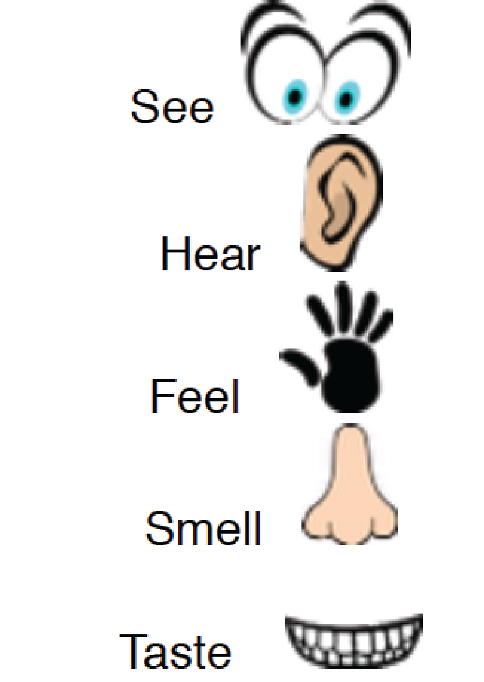
Write down your observations for water and soil.  ________________________  ________________________  ________________________  ________________________ | Write down your observations for wind and soil.  _______________________  _______________________  _______________________  _______________________
Results: What happened and why?  ________________________  ________________________  ________________________  ________________________  ________________________ | Results: What happened and why?  ________________________  ________________________  ________________________  ________________________  ________________________
Draw what happened to the soil when the water was poured on it. Don’t forget to label.  Dry Soil-  Wet Soil- | Draw what happened to the soil when the wind blew it. Don’t forget to label.  Dry Soil-  Wet Soil-

Lesson 3: Sand and Pebbles Station Observation
Name: _____________________________________________ Date: ______________________
Pebbles | Sand
Make a prediction of what will happen to the pebbles when the wind blows? Draw and write.  I think _________________ ________________________________________________ will happen to the pebbles when WATER is poured on them. | Make a prediction of what will happen to the sand when the wind blows? Draw and write.  Dry Sand-  Wet Sand-  I think _________________ ________________________________________________ will happen to the sand when WATER is poured on them.
Observe the pebbles. Circle the senses you used to write your observations. | Observe the sand. Circle the senses you used to write your observations.
Write down your observations.  ________________________  ________________________  ________________________  ________________________ | Write down your observations.  _______________________  _______________________  _______________________  _______________________
Results: What happened and why?  ________________________  ________________________  ________________________  ________________________ | Results: What happened and why?  _______________________  _______________________  _______________________  ________________________
Draw what happened to the pebbles. Don’t forget to label. | Draw what happened to sand. Don’t forget to label.  Dry Sand-  Wet Sand-

Lesson 4: Schoolyard Observations

Name: ___________________________________________________________ Date: __________________________________
Directions: As you walk around the schoolyard, observe the wind and water in the environment. Write and diagram (draw and label the drawing) what you see! Look for examples of places where wind or water has slowed down or prevented the land to change.
Observations | I think  _______________________________  was moved here by _________________________________.
 | Example of a design meant to slow down or prevent the land to change.

Use the back of the paper to write or draw other observations or questions you may have.

Lesson 6- Natural barriers
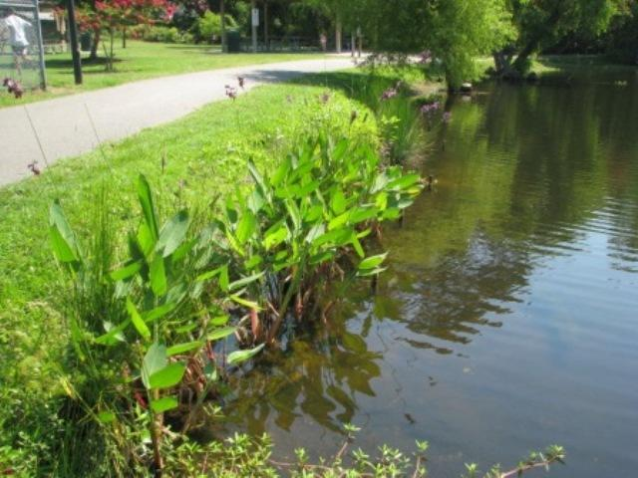
http://www.clemson.edu/extension/natural_resources/water/stormwater_ponds/problem_solving/shoreline_erosion/

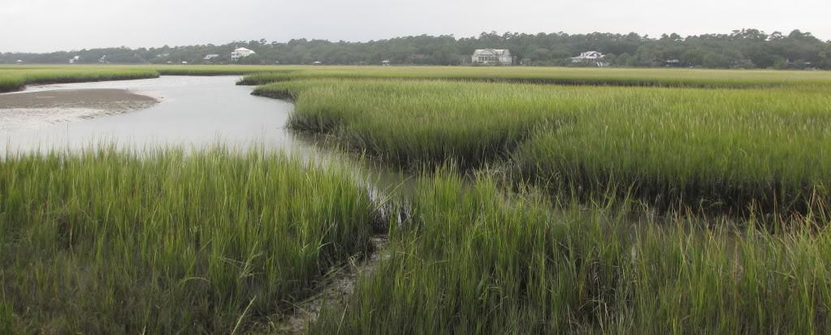
http://www.geocaching.com/geocache/GC20EVF_pawleys-island-salt-marsh-earthcache

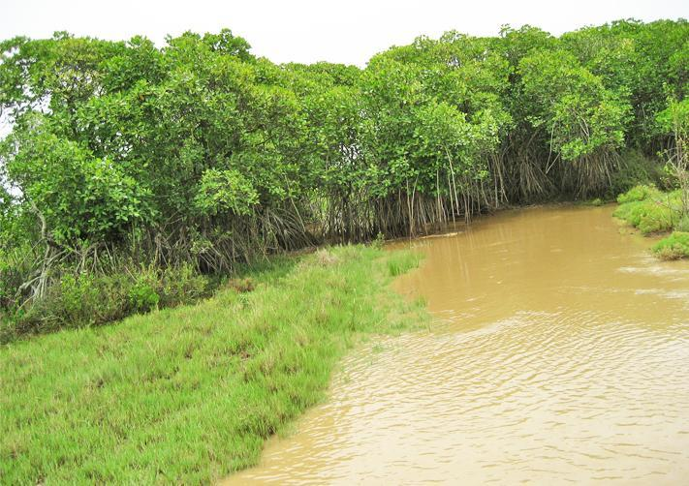
http://www.sagarsandesh.in/wp-content/uploads/2013/06/3-Mangrove-barrier-to-block-tidal-waves-arrest-sea-erosion.jpg

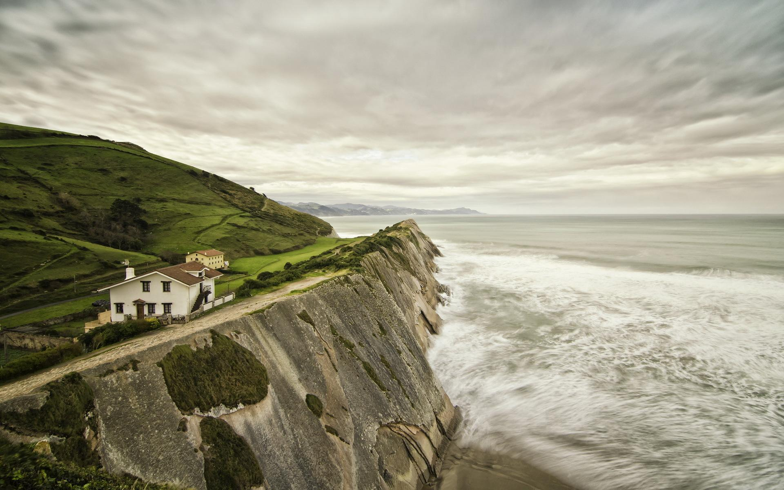
http://miriadna.com/preview/natural-cliff-barrier

Lesson 7: Human-made barriers
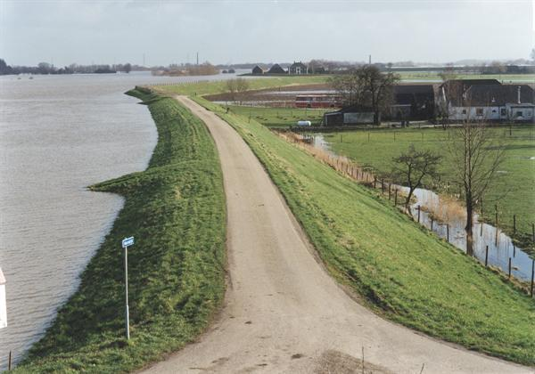
http://upload.wikimedia.org/wikipedia/commons/2/2c/De_dijk_tussen_Kesteren_en_Opheusden_tijdens_extreem_hoogwater_van_de_Neder_Rijn_344320s.jpg

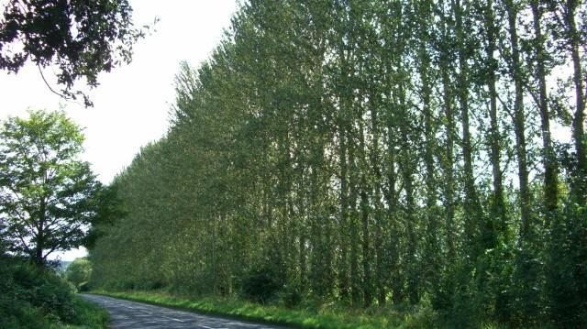
http://upload.wikimedia.org/wikipedia/commons/b/b6/Orchard_barrier_trees_A360_near_Black_Dog_Farm_-_geograph.org.uk_-_938054.jpg

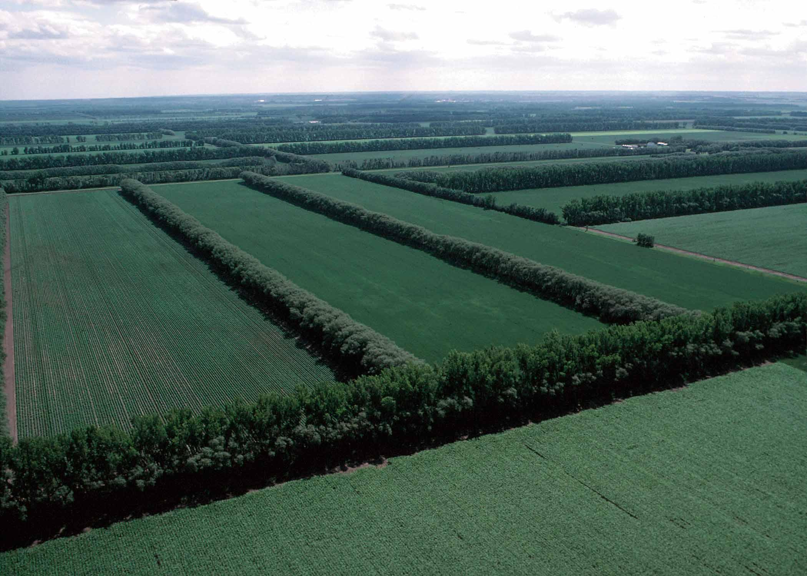

http://en.wikipedia.org/wiki/Windbreak

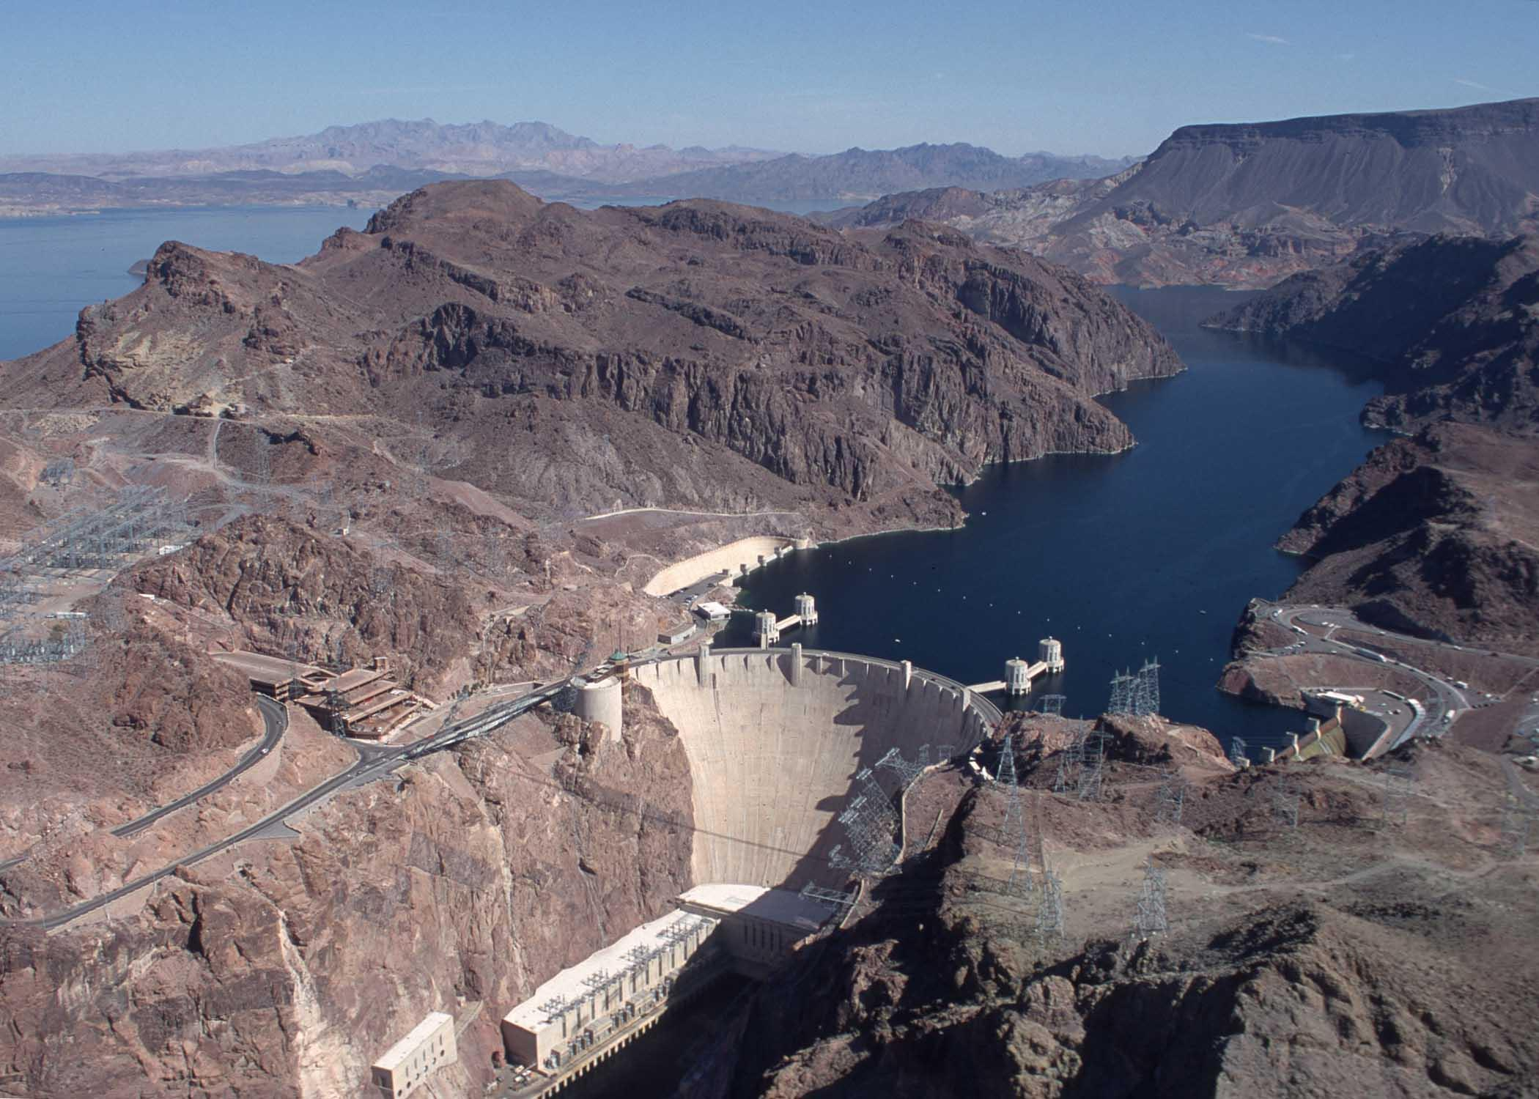
http://travelinnate.com/wp-content/uploads/2014/05/Hoover-Dam-4.jpg

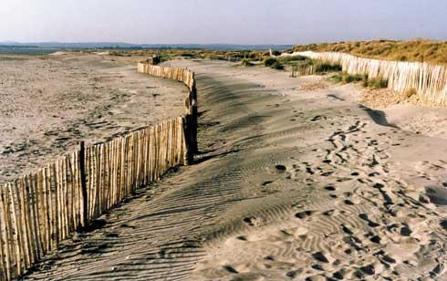
http://www.snh.org.uk/publications/on-line/heritagemanagement/erosion/appendix_1.4.shtml

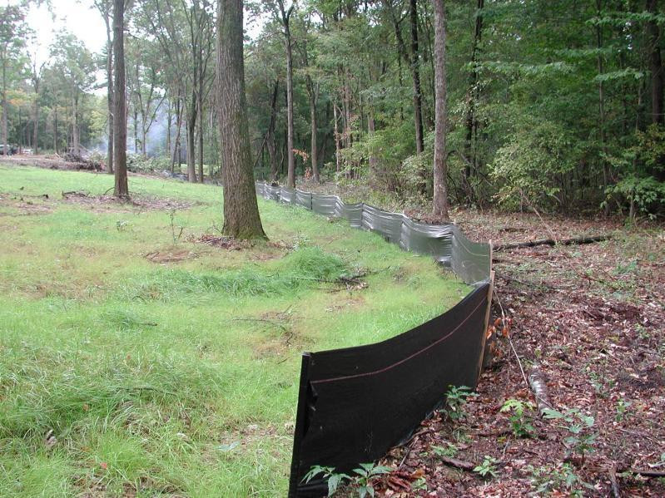
http://www.fostersupply.com/Products/Erosioncontrol/SiltFence.aspx

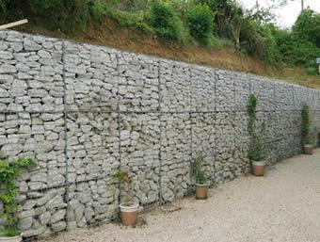
http://www.gabionwall.org/application/gabion-retaining-wall.html

No Barrier

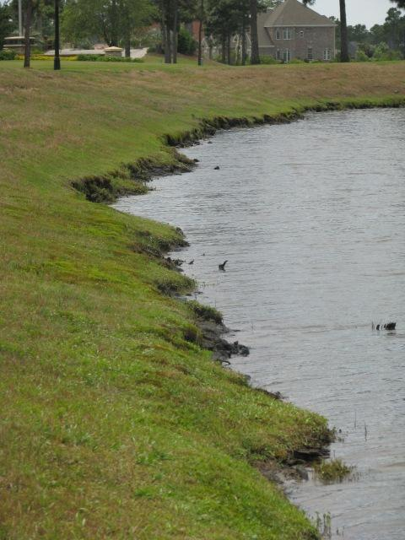

http://www.clemson.edu/extension/natural_resources/water/stormwater_ponds/problem_solving/shoreline_erosion/

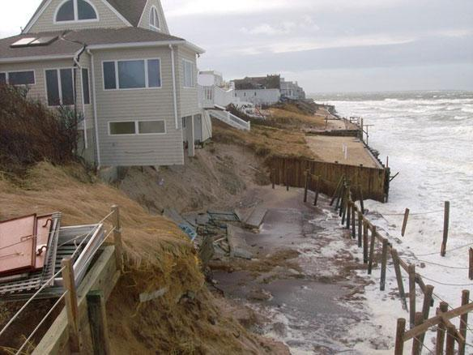
http://coastalcare.org/2011/02/jetties-blamed-for-beach-erosion-montauk-ny/

CEPA: Barrier Solutions
Name ___________________________________ Date ___________________
Directions: Diagram your experiment. Draw your milk carton and what happened before a solution has been designed. Draw each barrier for Carton A and Carton B. Draw the dirt from your measuring cup in the cup below. Don’t forget to label!!
Hill before barrier:
Carton A:  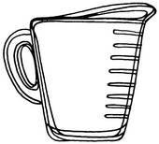 | Carton B:

Hill after barrier:
Carton A: | Carton B:

List your materials. The two barriers I experimented with are:
Carton A

Carton B

Which barrier prevented the land from changing most?
_____________________________________________________________
_____________________________________________________________
_____________________________________________________________

How could you tell that barrier worked best?
_____________________________________________________________
_____________________________________________________________
_____________________________________________________________

Why do you think that barrier work best?
____________________________________________________________
____________________________________________________________
____________________________________________________________

Which barrier solution would you recommend to the conservation commission? Explain why using evidence from your investigations.

_________________________________________________________
_________________________________________________________
_________________________________________________________
_________________________________________________________

