Shaping Natural Systems Through Evolution
Life Science, Grade 8
(Revised July 2018)
Standards addressed in this unit:
8. MS-LS4-4. Use a model to describe the process of natural selection, in which genetic variations of some traits in a population increase some individuals’ likelihood of surviving and reproducing in a changing environment Provide evidence that natural selection occurs over many generations. Clarification Statements: The model should include simple probability statements and proportional reasoning. Examples of evidence can include Darwin’s finches, necks of giraffes, and peppered moths. State Assessment Boundary: Specific conditions that lead to natural selection are not expected in state assessment.
8 .MS-LS4-5. Synthesize and communicate information about artificial selection, or the ways in which humans have changed the inheritance of desired traits in organisms. Clarification Statement: Emphasis is on the influence of humans on genetic outcomes in artificial selection (such as genetic modification, animal husbandry, and gene therapy).

In this unit, students learn about the foundational principles of evolutionary theory, grounded in evidence-based research and featuring examples of California and Massachusetts flora and fauna. They also explore the process of natural selection and the roles of variation and the environment in the evolutionary process. In addition, they examine the ways in which human actions can play a role in altering these processes in natural systems. Through their study of this unit, students encounter a wide variety of examples in order to understand how human activities and the evolutionary processes interact.

This Model Curriculum Unit is designed to illustrate effective curriculum that lead to expectations outlined in the 2016 Science and Technology/Engineering Curriculum Frameworks (www.doe.mass.edu/STEM/STE) as well as the MA Curriculum Frameworks for English Language Arts/Literacy and Mathematics. This unit includes lesson plans, a Curriculum Embedded Performance Assessment (CEPA), and related resources. In using this unit it is important to consider the variability of learners in your class and make adaptations as necessary.

This document was prepared by the Massachusetts Department of Elementary and Secondary Education. Mitchell D. Chester, Ed.D., Commissioner
The Massachusetts Department of Elementary and Secondary Education, an affirmative action employer, is committed to ensuring that all of its programs and facilities are accessible to all members of the public. We do not discriminate on the basis of age color, disability, national origin, race, religion, sex, or sexual orientation.

© 2015 Massachusetts Department of Elementary and Secondary Education (ESE). ESE grants permission to use the material it has created under the terms of the Creative Commons Attribution-NonCommercial-ShareAlike 3.0 Unported License. Additionally, the unit may also contain other third party material used with permission of the copyright holder. Please see Image and Text Credits for specific information regarding third copyrights.

Every effort has been made to acknowledge copyright. Any omissions brought to our attention will be corrected in subsequent editions.

Image and Text Credits:

See page 5 for details on the sources for this document.

The contents of this Model Curriculum Unit were developed under a grant from the U.S. Department of Education. However, those contents do not necessarily represent the policy of the U.S. Department of Education, and you should not assume endorsement by the Federal Government.

Massachusetts Department of Elementary and Secondary Education, 75 Pleasant St, Malden, MA 02148-4906. Phone 781-338-3300, TTY: N.E.T. Relay 800-439-2370, www.doe.mass.edu

Table of Contents

Unit Assumptions and Comments on Sequence 4
Unit Plan 7
Lesson 1: Natural Selection and Evolution 12
Lesson 2: Evidence of Evolution 19
Lesson 3: Simulating Variation and Natural Selection 25
Lesson 4: Massachusetts’ Diversity: Environmental Factors and Evolution 34
Lesson 5: From Bananas to Prairie Chickens: How Humans Influence Evolution 42
Lesson 6: Revisiting the Pupfish: Human Activities and Evolution 49
Curriculum Embedded Performance Assessment (CEPA) 55
Unit Resources: Additional Instructional Materials/Resources/Tools 58

Unit Assumptions and Comments on Sequence
Before starting this unit, students should have a basic understanding of:
Students should know about:
- Many characteristics of an organism are inherited from their parents. Some characteristics are caused or influenced by the environment.
- Biotic and abiotic factors determine survivability; as the environment changes, species change, move, or die out.
- Sexual reproduction produces offspring that inherit half their genes from each parent.
- How to infer what animals eat from the shapes of their teeth (for example, sharp teeth: eats meat; flat teeth: eats plants).
- Living things cause changes in the environment in which they live; some of these changes are detrimental to the organism or other organisms, and some are beneficial.
- When the environment changes, some plants and animals survive and reproduce; others die or move to new locations.
- Producers and consumers (herbivores, carnivores, omnivores, and decomposers) are related in food chains and food webs and may compete with each other for resources in an ecosystem.
- Different kinds of organisms may play similar ecological roles in similar biomes.
- Many characteristics of an organism are inherited from the parents. Some characteristics are caused or influenced by the environment.
- There is variation among individuals of one kind within a population.
- Evolution is a natural process that usually happens over generations.
- The number and types of organisms an ecosystem can support depends on the resources available and on abiotic factors, such as quantities of light and water, range of temperature, and soil composition.

Students should be able to define:
- abiotic, biotic, gene, organism, species, and trait

Notes about this unit:
- Throughout the unit, notes to the teacher are either noted as such or written in parentheses, and distinguished with italics. All handouts are located at the end of the unit in the Unit Resources section. The last handout is the Unit Glossary.
- See Unit Resources: Additional Instructional Materials/Resources/Tools section at the end of this unit for resources that provide additional background information, as well as support the teaching of this unit.
- See Requirements section at end of unit for information on computer Java Runtime Environment requirements to run Concord Consortium activity in Lesson 4.
- A list of handouts are located at the end of the unit in the Unit Resources section. Due to large file sizes, handouts are split up by lesson and some may need to be downloaded separately from the DESE website.
- See the strand map, page five, for an overview of the science standards that precede this unit and how the standards learned in this unit contribute to students learning in later grades.

Sources and Credits:
This curriculum is based largely upon the California Education and the Environment Initiative (EEI) Curriculum, which was developed by the State of California and copyrighted 2010. The California Department of Resources Recycling and Recovery (CalRecycle) granted permission to the State of Massachusetts to use select content from the EEI Curriculum in this publication. This unit is modified from the EEI middle school unit Shaping Natural Systems through Evolution developed by the California Education. The original Shaping Natural Systems through Evolution unit, along with other EEI curriculum units and resources, may be accessed and downloaded free-of-charge on the EEI webpage http://www.californiaeei.org/Curriculum/.
Lesson 4 has been modified to include Massachusetts examples and information is from the Mass.gov website for Energy and Environmental Affairs - http://www.mass.gov/eea/agencies/dfg/dfw/natural-heritage/species-information-and-conservation/mesa-list/list-of-rare-species-in-massachusetts.html.

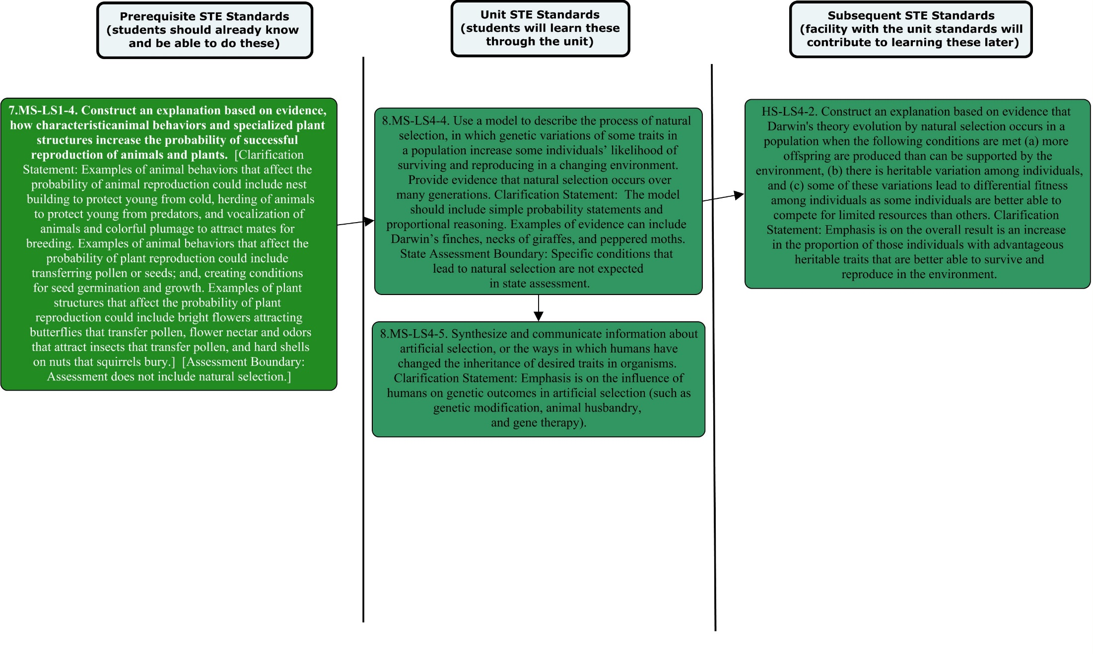

Unit Plan
Stage 1 Desired Results
ESTABLISHED GOALS G  Science Technology and Engineering  8. MS-LS4-4. Use a model to describe the process of natural selection, in which genetic variations of some traits in a population increase some individuals’ likelihood of surviving and reproducing in a changing environment Provide evidence that natural selection occurs over many generations. Clarification Statements: The model should include simple probability statements and proportional reasoning. Examples of evidence can include Darwin’s finches, necks of giraffes, and peppered moths. State Assessment Boundary: Specific conditions that lead to natural selection are not expected in state assessment.  8 .MS-LS4-5. Synthesize and communicate information about artificial selection, or the ways in which humans have changed the inheritance of desired traits in organisms. Clarification Statement: Emphasis is on the influence of humans on genetic outcomes in artificial selection (such as genetic modification, animal husbandry, and gene therapy).  ELA/Literacy –  RCA.9-10.1 - Cite specific textual evidence to support analysis of science and technical texts, attending to the precise details of explanations or descriptions.  WHST.6-8.8 - When conducting research, gather relevant information from multiple print and digital sources; assess the credibility of each source; and quote or paraphrase the data and conclusions of others while avoiding plagiarism and providing basic bibliographic information for sources. | Transfer
Students will be able to independently use their learning to… T
- Engage in sustained, complex and successful scientific inquiry.
- Use principles of the physical world and genetic programming to analyze living systems
- Analyze mechanisms of cause and effect in natural and designed systems based on physical and chemical principles.
 | Meaning
 | UNDERSTANDINGS U  Students will understand that…  - Two populations of the same species in different environments can evolve to become separate species. (Lessons 1 & 2)  - Genetic variations of traits in a population increase some individual’s probability of surviving and reproducing in a specific environment, which tends to increase these traits and suppress other traits in the population. (Lessons 1, 3 & 4)  - Natural selection over many generations results in changes within species in response to environmental conditions that tend to increase or decrease specific traits in a population. (Lessons 1, 3 & 4)  - The technologies have changed the way humans influence the inheritance of desired traits in organisms. (Lesson 5 & 6)  - Researching a topic can play a role in the understanding of content material (gathering relevant information, assessing the credibility of a source, and citing appropriately). (Lesson 6 and CEPA) | ESSENTIAL QUESTIONS Q  Lesson 1, 2, 3 & 4: How do different environments influence changes in a species over time?  Lessons 5 & 6: Can humans influence evolution? If so, how?
 | Acquisition
 | Students will know… K  - Evolution is the process by which species develop as a result of natural selection for beneficial adaptations.  - Evolution occurs over many generations.  - Members of the same species can have different traits.  - Differences among environments in which populations of an organism occupy, can favor different variants of a given trait. These differences can, over time, lead to adaptations within a particular population.  - A new mutation can be either beneficial or harmful, depending on environmental factors.  - A model is a representation of something.  - Inheritance is the passage of traits from parent to offspring.  - Human activities can influence genetic variation in a species, as well as alter the environment in which a species lives.  - Adaptation, natural selection, environmental change, and genetic variation play a role in evolution.  10. To use these vocabulary words in context:  adaptation, genes, natural selection,  heritable trait, variation, sexual  reproduction, speciation, evolution,  extinction.  11. To cite textual evidence to support an  analysis of scientific and technical texts.  12. To gather evidence from both print and  digital sources and avoid plagiarism by  referencing the sources in a bibliography. | Students will be skilled at… S  - Annotating text when reading.  - Summarizing text for “the gist”.  - Using maps to gain information about the relationship between environment and evolution.  - Citing specific textual evidence from science informational text to support a claim in writing and discussions.  - Gathering relevant information from multiple print and digital sources.  - Assessing the credibility of a source.  - Quoting or paraphrasing information to avoid plagiarism.  - Using models and simulations to support explanations.  - Conducting an investigation through models/simulations.  - Summarizing readings to share with peers.  - Constructing explanations.  - Communicating research to their peers.  - Taking notes by capturing key points and avoiding copying word for word.  - Making a graph from data.
Stage 2 – Evidence
Evaluative Criteria | Assessment Evidence
See CEPA Rubric on Assessment of Learning Directions and Rubric handout in Unit Resources section. | CURRICULUM EMBEDDED PERFORMANCE ASSESSMENT (PERFORMANCE TASKS) PT  Human Influence on Evolution News Article  Students select a species they have studied in Lessons 2 or 4 for analysis. Using flowcharts, students independently examine how people and their activities have changed the diversity and evolution of their chosen species. By the conclusion of the CEPA, students recognize not only the basics of the process of evolution, but also the ways in which human actions can alter this process in natural systems.  Goal: Students construct an explanation for how humans have influenced genetic variations of traits in a population, thereby increasing some individual’s probability of surviving and reproducing in a specific environment, which tends to increase these traits and suppress other traits in the population.  Role: News Reporter/Journalist  Audience: Readers of Science News for Kids  Situation: The editor of the Science News for Kids has given you an assignment to educate the website’s readers about a species whose evolution has been influenced by humans. As a journalist, research information about the organism of your choice (Northern Mountain Ash, Diamond-back Terrapin, Kauai field crickets, Northeastern Beach Tiger Beetle, or Purple pitcher plant mosquitoes). Focus your research on information about how humans have influenced this organism’s genetic traits over time. Use this information to write a short article to educate the public about your findings.  Product Performance and Purpose: News article
OTHER EVIDENCE: OE
Interactive Word Wall (Lesson 1)
Jigsaw small group discussion (Lesson 2)
Volleyball – Not Ping Pong! group discussions (Lesson 3)
Formative Assessments embedded within each lesson include daily Exit Tickets (Lessons 1, 2, 3, 4, 5 and 6) and group discussions (Lessons 2, 3).

Stage 3 – Learning Plan
Summary of Key Learning Events and Instruction

Lesson 1: Natural Selection and Evolution (Days 1 & 2; 2 – 50-minute instructional periods)
Students explore the mechanism of natural selection in order to understand the process of evolution. Students examine the evolution of the several species of California pupfish, all of which have evolved from a common ancestor that once thrived in ancient inland lakes. Students read about pupfish and then participate in a natural selection simulation, visualizing and predicting how the traits of pupfish populations are affected in different isolated environments.

Lesson 2: Evidence of Evolution (Days 3 & 4; 2 – 50-minute instructional periods)
Students refine their understanding of evolution and its causes. By the conclusion of this lesson, students appreciate how scientists conduct experiments and analyze evidence to draw conclusions about the mechanisms of evolution and reflect on the role of natural selection in this process.

Lesson 3: Simulation Variation and Natural Selection (Days 5 & 6; 2 – 50-minute instructional periods)
Students look at examples of variation in traits. Students preface this activity by examining variation first in the human species and then in Darwin’s finches. Students use origami to create a variety of bird beak sizes, highlighting the idea that a single trait can show variation in a single species. Using their handmade beaks like finger puppets, students compete against one another in different simulated environments to experience how natural selection acts on different variations of a trait and how natural selection is dependent upon the environment that the organism finds itself in. They also explore how a new mutation, modeled with a different-sized beak, can be either beneficial or harmful, depending on environmental factors.

Lesson 4: Massachusetts’ Diversity: Environmental Factors and Evolution (Days 7 & 8; 2 – 50-minute instructional periods)
Students explore the connections between environmental factors, adaptations, and the evolution of Massachusetts species. Students review examples about the environment’s influence on evolution. They then examine a collection of animal and plant species in Massachusetts, identifying how different environmental conditions throughout the state have influenced species’ evolution and diversity. Students develop descriptions of several different locations in Massachusetts using a series of maps that show differences in geography and climate within the state. Keeping these different geographic sites in mind, students then read about and discuss different Massachusetts species, examining their different genetic traits and matching which species’ traits are most suited to which environments.

Lesson 5: From Bananas to Prairie Chickens: How Humans Influence Evolution (Days 9 & 10; 2 – 50-minute instructional periods)
This lesson focuses on the roles that humans play in the rate of evolutionary change. Students first dissect a banana, noting the absence of seeds or observing remnants of seeds. Students are asked to consider how bananas grow without viable seeds. This leads into a discussion of how different agricultural practices suppress genetic variation within a species and the effects this lack of variation has in the natural selection process. Students separate into small groups to read about an example of a human activity influencing a species’ environment and genetic variation. In this jigsaw cooperative learning activity, students become experts on their topic and then join new groups of students to share their expertise with and learn from their peers.

Lesson 6: Revisiting the Pupfish: Human Activities and Evolution (Day 11; 1- 50-minute instructional period)
Students read the remainder of California Connections: Pupfish from Lesson 1. They discuss the influence of human activities on pupfish evolution and use flowcharts to summarize and analyze their findings. They describe the evolution of another species using the same framework.

CEPA: Human Influence on Evolution News Article (Day 12; 1- 50-minute instructional period, plus additional time in class if needed for CEPA)
Students select a species they have studied in Lessons 2 or 4 for analysis. Using flowcharts, students independently examine how people and their activities have changed the diversity and evolution of their chosen species. By the conclusion of the CEPA, students recognize not only the basics of the process of evolution, but also the ways in which human actions can alter this process in natural systems.

Adapted from Understanding by Design 2.0 © 2011 Grant Wiggins and Jay McTighe Used with Permission
July 2012

Lesson 1: Natural Selection and Evolution

Brief Overview of Lesson: Students explore the mechanism of natural selection in order to understand the process of evolution. Students examine the evolution of the several species of California pupfish, all of which have evolved from a common ancestor that once thrived in ancient inland lakes. Students read about pupfish and then participate in a natural selection simulation, visualizing and predicting how the traits of pupfish populations are affected in different isolated environments.

Prior Knowledge Required:
Students should know about:
- Many characteristics of an organism are inherited from their parents. Some characteristics are caused or influenced by the environment.
- Biotic and abiotic factors determine survivability; as the environment changes, species change, move, or die out.
- Sexual reproduction produces offspring that inherit half their genes from each parent.

Estimated Time:
- Instructional Time - 2 lessons at 50 minutes each; Preparation Time – 25 min

Resources for Lesson:
A-V Equipment:
- projection system and screen
Class Supplies:
- card stock
- drawing paper
- pencils or pens
- scissors
- tape or thumbtacks
Handouts (All handouts are located at the end of the unit.):
- California Connections: Pupfish
- Key Unit Vocabulary
- Evolution and Diversity Journal 1
- Evolution of Pupfish
- Sample Pupfish
- Environment Cards
- Interactive Word Wall Cards
Visual Aids (can be projected or printed out in color):
- Pupfish

Standard(s)/Unit Goal(s) to be addressed in this lesson:
- 8. MS-LS4-4. Explain the mechanism of natural selection, in which genetic variations of some traits in a population increase some individuals’ likelihood of surviving and reproducing in a changing environment. Provide evidence that natural selection occurs over many generations. [Clarification Statement: Explanations should include simple probability statements and proportional reasoning.]
- RCA.6-8.1 - Cite specific textual evidence to support analysis of science and technical texts, attending to the precise details of explanations or descriptions.

Essential Question(s) addressed in this lesson:
- How do different environments influence changes in a species over time?

Objectives:
Students will be able to…
- Create a model to show pupfish adaptations
- Explain how populations of the same species in different environments have evolved to become separate species.
- Read informational text and make predictions about the information.

Language Objectives:
Students will be able to…
- Read informational text and discuss key ideas in small groups
- Write a summary of how speciation happened in a specific population of pupfish based on discussions in groups and as a class.

Targeted Academic Language
- Content Specific: gene, organism, specie, genus, trait, natural selection, evolution, population, adaptation, evaporation, habitat, and extinct
- Academic Specific: prediction, summarize, gist, text annotation, model, simulation

What students should know and be able to do before starting this lesson:
- See “Prior Knowledge Required” above.

Anticipated Student Preconceptions/Misconceptions
- Misconceptions: Students may believe organisms can individually evolve; evolution occurs within a very short time frame; organisms “choose” to evolve.

Instructional Materials/Resources/Tools
- See “Resources for Lesson (list resources and materials)” above.

Instructional Tips/Strategies/Suggestions for Teacher
- See end of unit resources for descriptions of Think-Pair-Share, No-Hands Questioning, Interactive Word Wall, and Exit Tickets.
- When asking students to discuss the “gist” of the reading, explain that the “gist” of something is a basic summary, what the reading is mainly about.
- Explain to students that text annotations are short summaries of what they have read written in the margins of the page of reading.
- Cut Environment Cards and Sample Pupfish cards ahead of class for each group.
- Either collect or have students save the California Connections: Pupish article as it will be used again in Lesson 6.

Assessment
- Formative assessment:
- Interactive Word Wall – used to assess student assumptions, misconceptions, and connections between concepts. Students will identify how the lesson vocabulary connects with one another (see Unit Resources for more details and the word cards).
- Exit Ticket – a quick write used to assess student knowledge and next-steps in instruction (see Unit Resources for more details). Exit Ticket Question - “Summarize the series of events that occurred in which one common population of the same species of pupfish changed into different populations of pupfish with different traits. In other words, what happened to the pupfish over time?”

Lesson Details:
Lesson Opening
Step 1 (Engage) Est. 10 minutes - Day 1 of 2 day 50-minute lessons
Post and read aloud from the lesson objective on the board, “I can describe how two populations of the same species in different environments have evolved to become separate species.”

Underline the phrase, “have evolved.” Explain that “evolution” is the process by which species develop as a result of natural selection for beneficial adaptations. Stress the fact that evolution occurs over many generations.
Handout to students the Evolution and Diversity Journal 1 worksheet. Project Pupfish-VISUAL AID. Explain to students that these are all different species of a genus of fish known as pupfish (Cyprinodon). Ask students, “How do these fish differ from one another, in terms of color, size, markings, and shape?” and give them five minutes to write a response based on what they observed. (Some of the fish are striped and others are not; some have lines on the ends of their fins and others do not; some have differently shaped fins.) Explain to students that all of these different species did not exist 25,000 years ago. Inform them that today they will learn how these relatively new species developed over time, and how natural selection played a role in making them different.
During the Lesson
Step 2 (Explore) Est. 10 minutes - Day 1 of 2 day 50-minute lessons
Distribute the reading California Connections: Pupfish to each student. Tell students that this reading focuses on the evolution of pupfish. Have students individually read the first four paragraphs “California’s Changing Environment”. After students finish reading this section, ask them to turn to a class partner and quickly discuss the “gist” of what they’ve read (explain to students that the “gist” of something is a basic summary, what the reading is mainly about). Ask for a few student volunteers to share their ideas, and model for students how to write a “gist” statement in the margin of the text (For the first section, gist statements may be something like, “Over the past 25,000 years, California’s large inland lakes evaporated and formed many smaller ponds.”). Explain to students that notes in the margin of a text are called “text annotations” and it’s a technique that readers often use.
Continue reading through “Pupfish Adaptations” (paragraphs 5 and 6) while students follow along silently. Ask students, “What adaptations have pupfish evolved to survive in these smaller, saltier ponds?” (Hatch in springtime, leave eggs in algae.). Again, have students make text annotations in the margin of the text to summarize what they have read. Use No Hands Questioning to check for understanding and to elicit full participation.
Step 3 (Explain) Est. 15 minutes - Day 1 of 2 day 50-minute lessons
Organize students into three groups and assign each group to an Environment Table. Inform them that they will create a class model of pupfish living in these lakes, imagining that the class floor and tables are the inland lakes of 25,000 years ago. Explain that this activity simulates “natural selection,” the process by which individuals with advantageous variations survive and reproduce. Write the term “natural selection” and the corresponding definition on the board. Distribute one set of Sample Pupfish to each group and instruct students to lay their fish out on their environment table. In addition, distribute the fish cards from one set of Sample Pupfish in the floor space in between the groups, informing students that these pupfish are “swimming” throughout the larger “classroom lake.”
Handout to students the Evolution of Pupfish worksheet. Have each group of students work together to complete Part 1 of the Evolution of Pupfish, describing the different traits of the pupfish in their section of the lake. Ask for volunteers from each group to report their answers (Teacher Note: consider using No-Hands Questioning to ensure full participation).
Ask students the following questions:
- Do the pupfish in your environment have all the same traits or characteristics? (No. They have a variety of characteristics.)
- Do all members of a species have to have the exact same traits? Can you think of an example where this is not the case? (Species do not have to have all the same characteristics. For example, dogs are all members of one species that have different hair color and body shapes; one species of cats can have members with different hair color and body shapes; the students themselves are all one species with many variations.)
Tell students that they will now act like scientists by using the information that they have to make predictions about what happens to the pupfish when the environment changes.
Tell students how the lakes and streams in California changed following the evaporation of the inland lakes. Explain that the remaining rivers and streams that still exist in the desert of California. Model this evaporation in the classroom by explaining that all areas of the floor in between the groups now represent parts of the inland lakes that evaporated. Use Think-Pair-Share to ask students, “What may have happened to the pupfish in places where the lakes evaporated?” (The pupfish died; the pupfish followed the remaining water.) Reinforce the process of making predictions by encouraging responses that include sound reasoning to support a prediction.
Remove the pupfish from the floor to represent their deaths. Inform students that pupfish now only live in the isolated groups in front of them, disconnected from other pupfish, and that each group may now live in an environment different from that of the others. Ask students to set aside California Connections: Pupfish. Mention to students that the larger habitat, before evaporation, also had environmental variations. The difference after the evaporation was that the pupfish could no longer travel among the different areas and exchange genes with fish in the other areas.
Step 4 (Elaborate) Est. 35 minutes - Day 1 and 2 of 2 day 50-minute lessons
Use the internet to find a political map of California. Project the map and point to the general location of the pupfish environments now represented at the three Environment Tables (Environment #1, Armargosa River; Environment #2, Ash Meadows National Wildlife Preserve; and Environment #3, Salt Creek in Death Valley). Distribute one of the Environment Cards to each group. Explain to students that they will examine how pupfish will survive and reproduce in three different environments; that each group currently has a card describing the environment at their table. Instruct groups to read their card and complete Part 2 of Evolution of Pupfish for the environment corresponding to their table. Give groups 10 minutes to complete this task.
When time is up, have groups move to the next table representing a different environment, leaving the Sample Pupfish and Environment Cards behind. Have students complete Part 2 of Evolution of Pupfish for the next environment, using the new Sample Pupfish and Environment Cards. Give students 10 minutes to complete this task. When time is up, have groups rotate to the last table and complete Part 2 for that environment. Give students 10 minutes to complete this task. When time is up, have students return to their original environment tables. (Teacher Note: Not all groups will visit the environments in numerical sequence. Some groups may begin with Environment #2, then move to Environment #3, and finish with Environment #1.)
Ask student volunteers to share their answers to Part 2 of Evolution of Pupfish. Use No-Hands Questioning to ensure full participation. Ask students:
- What characteristics did the pupfish that lived in each pool at the beginning of this simulation display? (They had a variety of traits; some could tolerate high salinity, but others could not; some could lay eggs at a range of temperatures, but others could not; some lay eggs year-round, but others lay eggs only in the wet spring.)
- After the fish live in their different environments, do they all have the same traits? Why or why not? (No. Some fish could survive better in some environments; some fish could reproduce more successfully in some environments.)
Step 5 (Explain Round II) – Est. 10 minutes - Day 2 of 2 day 50-minute lessons
Explain to students that they have just explored a simulation of natural selection.
Ask all students to stand in a circle around a cleared space on the floor. Randomly lay the Interactive Word Wall Cards on the floor and tell students that all of these words are important for the current lesson. Explain to students that you know that many of these words will be familiar to them, and you’d like to learn about the ideas that they currently have about how these words relate to the pupfish. Explain to students the steps of an Interactive Word Wall, and model this process for them. Then ask students to take turns moving words and explaining connections related to the pupfish in the Interactive Word Wall. Listen carefully to students’ ideas, being sure not to correct or judge any misconceptions that might arise, but using the activity as an assessment of students’ prior knowledge.
Distribute the Key Unit Vocabulary to each student. Review the following terms “adaptation,” “evolution,” “natural selection,” and “species” with the students. Explain that traits, such as surviving high salinity or laying eggs at a variety of temperatures, are adaptations that allowed certain fish to survive in their particular environments. Also explain to students that the kinds of changes seen in the pupfish are an example of evolution.
Step 6 (Explain Round III) – Est. 10 minutes - Day 2 of 2 day 50-minute lessons
Tell students to return to California Connections: Pupfish. Read aloud from the last paragraph in the “Pupfish Adaptations” section on the Tecopa pupfish as students read along silently. Using Think-Pair-Share, ask students:
- What is one adaptation that helped the Tecopa pupfish to survive? (It could tolerate high temperatures.)
- Why did the Tecopa pupfish become extinct? (Its environment changed. The pupfish now lived in fast-flowing water and had new predators. It had never had these things in its environment before, and no variations in the fish population were traits that could help any of the pupfish survive or reproduce enough in the new environment.)
- If a pupfish can survive in an environment, will it always pass on its traits? (Not necessarily. A pupfish needs to both survive and successfully reproduce in order to pass on its genes to the next generation. A pupfish that survives but cannot lay or fertilize eggs will not pass on its traits.)
Lesson Closing
Step 7 (Evaluate) Est. 10 minutes - Day 2 of 2 day 50-minute lessons
Remind students that the objective of the lesson was, “I can describe how two populations of the same species in different environments have evolved to become separate species.”

Ask students to take out a blank piece of paper. Write the following Exit Ticket prompt on the board, “Summarize the series of events that occurred in which one common population of the same species of pupfish changed into different populations of pupfish with different traits. In other words, what happened to the pupfish over time?” (Student answers should include that over time the pupfish species adapted to varying environments that caused them to develop different traits. Also, if pupfish could not travel long distances and were forced to stay in one environment, due to evaporation of the water, than the variation of the genetics within the species diminishes.)
Gather readings, Sample Pupfish, and Environment Cards. Collect handouts and Exit Tickets. Use Exit Tickets as a formative assessment of practice and content.

Lesson 2: Evidence of Evolution

Brief Overview of Lesson: Students refine their understanding of evolution and its causes. By the conclusion of this lesson, students appreciate how scientists conduct experiments and analyze evidence to draw conclusions about the mechanisms of evolution and reflect on the role of natural selection in this process.

Prior Knowledge Required:
Students should know about:
- Many characteristics of an organism are inherited from the parents, but some characteristics are caused or influenced by the environment.
- There is variation among individuals of one kind within a population.
- Different kinds of organisms may play similar ecological roles in similar biomes.

Students should be able to:
- Recognize whether evidence is consistent with a proposed explanation.

Estimated Time:
- Instructional Time - 2 lessons at 50 min. each; Preparation Time - 15 min.

Resources for Lesson:
A-V Equipment:
- projection system, screen
Class Supplies:
- pencils and pens
Handouts (All handouts are located at the end of the unit.):
- Notes About the Tegula Snail
- Evolution Research Project #1
- Evolution Research Project #2
- Evolution Research Project #3
- Evolution Research Project #4
- Evolution and Diversity Journal 2
- Evidence of Evolution
Visual Aids (can be projected or printed out in color):
- Tegula Snail Research
- Evolution Notes #1-3

Standard(s)/Unit Goal(s) to be addressed in this lesson:
- 8. MS-LS4-4. Use a model to describe the process of natural selection, in which genetic variations of some traits in a population increase some individuals’ likelihood of surviving and reproducing in a changing environment Provide evidence that natural selection occurs over many generations. [Clarification Statements: The model should include simple probability statements and proportional reasoning. Examples of evidence can include Darwin’s finches, necks of giraffes, and peppered moths.] [State Assessment Boundary: Specific conditions that lead to natural selection are not expected in state assessment.]”
- RCA.6-8.1 - Cite specific textual evidence to support analysis of science and technical texts, attending to the precise details of explanations or descriptions.
Essential Question(s) addressed in this lesson:
- How do different environments influence changes in a species over time?

Objectives:
Students will be able to…
- Explain how two populations of the same species in different environments have evolved to become separate species.

Language Objectives:
Students will be able to…
- Read informational text and orally share key information with classmates.

Targeted Academic Language
- Content Specific: gene, genetics, organism, specie, trait, natural selection, evolution, predator, population, environment, adaptation, habitat, niche, and variation
- Academic Specific: hypothesize, summarize, evidence, and scenario

What students should know and be able to do before starting this lesson:
- See “Prior Knowledge Required” above.

Anticipated Student Preconceptions/Misconceptions
- Misconceptions: Students may believe organisms can individually evolve; evolution occurs within a very short time frame; organisms “choose” to evolve.

Instructional Materials/Resources/Tools
- See “Resources for Lesson (list resources and materials)” above.

Instructional Tips/Strategies/Suggestions for Teacher
- See end of unit resources for descriptions of Think-Pair-Share, No-Hands Questioning, Jigsaw, and Exit Tickets.
- For Jigsaw Activity - if the resulting size of each group is more than four or five students, then set up eight groups for this activity – two groups per topic.
- A great tool for helping students to visualize predator influence on specie adaptation is the following simulation: Sex and the Single Guppy http://www.pbslearningmedia.org/resource/tdc02.sci.life.evo.sexguppy/sex-and-the-single-guppy/

Assessment
- Formative Assessment:
  - Jigsaw small group discussions – assesses student learning from reading and communicating to peers. Students will read different articles, becoming “experts” and share with their peers what they have learned (see Unit Resources for more details).
  - Exit Tickets – a quick write used to assess student knowledge and next-steps in instruction (see Unit Resources for more details). Exit Ticket Question - “Define ‘evolution’ in your own words. Explain how one organisms from today’s readings and discussions has evolved over time.”

Lesson Details:
Lesson Opening
Step 1 (Engage) Est. 5 minutes - Day 1 of 2 day 50-minute lessons
Post and read aloud from the lesson objective on the board, “I can describe how two populations of the same species in different environments have evolved to become separate species.”

Remind students that they made progress on this same objective in the previous lesson. Prompt students to Think-Pair-Share about what it means for a species to “have evolved.” After hearing a few responses, remind students that “evolution” is the process by which species develop as a result of natural selection for beneficial adaptations. Stress the fact that evolution occurs over many generations.

During the Lesson
Step 2 (Explore) Est. 15 minutes - Day 1 of 2 day 50-minute lessons
Distribute a copy of the Notes About the Tegula Snail to each student. Project Tegula Snail Research-VISUAL AID.
Ask students to read along silently as you read aloud from Notes About the Tegula Snail. At the end of Part 1, hand out to students the Evolution and Diversity Journal 2 worksheet and ask them to respond to the prompt. Explain that they will hypothesize why these snails live in different places and what might be causing these differences. Remind students to consider: food resources, habitat, predators, and niche (what snails do, eat, and where they live).
Next, have students share their ideas with their neighbors or in groups. Then ask each group to share an idea with the class. (Perhaps preferred food is located in different places depending on whether the coast is in northern or Southern California, and the snails live where the food is; perhaps birds live in northern California that eat the snails on the land, but these birds do not live in Southern California.)
Continue reading aloud from Part 2 of Notes About the Tegula Snail as students read along silently. Then, ask them the following questions (consider using No-Hands Questioning to ensure full participation):
- How would predator threat affect what traits get passed down in each of these populations of snails? (Traits that help a snail get away from a predator would be favorable in Southern California snails. These traits might not be found in northern California snails.)
- What do you think might have happened? (Southern California snails climbed higher on the shore. Northern California snails did not, so they were eaten by predators and did not survive or reproduce.)
- What genetic adaptation did the Southern California snails have? (They start moving sooner and travel faster when predators are around.)
- Why did the northern California snails not move as soon and as fast? (They live in a place with fewer predators. Those traits are not genetic adaptations in their environment.)
Step 3 (Explain) Est. 30 minutes - Day 1 of 2 day 50-minute lessons
Project Evolution Notes #1-VISUAL AID. Tell students that taking notes does not mean copying word for word, but means capturing key points. Tell students to return to Evolution and Diversity Journal 2. Model for all students how they should complete the “Notes on Variation” section as you read aloud the text about “Variation” from the visual aid. Ask students for methods they might use to summarize text or to take notes, and clarify that taking notes is different from copying. Elicit the idea of using bullets or tables in their notes, and tell students that using a table sometimes requires reading first then deciding on the categories for a table, and then rereading to fill the table in. Continue to read aloud from the text, and check that all students have appropriate notes on their worksheets.
Then, ask students the following questions (consider using No-Hands Questioning to ensure full participation):
  - What kind of natural variation was observed in the two populations of Tegula snails? (The Tegula snails varied in their speed.)
  - What kind of natural variation was observed between populations of pupfish? (They vary in their tolerance to salt, their tolerance to different temperatures, and egg-laying habits.)
Project Evolution Notes #2-VISUAL AID. Remind students that taking notes does not mean copying word for word, but means capturing key points. Tell students to complete the “Notes on Environment” section as you read aloud the text about “Environment” from the visual aid. Then have students share their notes with a partner and come to agreement about what notes to include. Use No-Hands Questioning to check what students decided to include in their notes, and provide suggested revisions to notes as needed. Then, ask students:
- How are the coasts in northern California and Southern California different in terms of snail predators? (Northern California has fewer predators near the shore than Southern California.)
    - How are the environments in the springs, rivers, and creeks where pupfish live different in terms of water qualities? (They vary in salinity, temperature range, and water supply.)
Project Evolution Notes #3-VISUAL AID. Tell students to independently complete the “Notes on Natural Selection” section as you read aloud the text about “Natural Selection” from the visual aid. Use No-Hands Questioning to check what students decided to include in their notes, and provide suggested revisions to notes as needed. Then, ask students:
    - How has natural selection affected the evolution of the northern and Southern California Tegula snails? (In Southern California, snails that start to move quickly and travel fast escape predators. They survive and reproduce, passing these adaptive traits to their offspring. Slow snails do not survive, so they do not reproduce and pass on this trait. In northern California, there are fewer predators in the waters where Teluga snails live. Snails that have the “slow gene” are still able to survive and reproduce.)

Step 4 (Elaborate) Est. 35 minutes - Day 2 of 2 day 50-minute lessons
Explain to students that they will spend the rest of the lesson acting as evolutionary biologists, or scientists who study evolution. Tell the class that scientists often get together and share their research at conferences, where scientists or teams of scientists give presentations that summarize their research. Inform students that today they will attend such a conference, examining the research conducted by four different teams of scientists studying evolution.
Divide the class into four groups for the first part of a Jigsaw activity. (Option: If the resulting size of each group is more than four or five students, then set up eight groups for this activity – two groups per topic.) Tell students that these are their “expert groups” where they will help each other become experts in a particular area that they will later need to present to others. Assign each group to read one of the following: Purple Pitcher Plant Mosquito, Kauai Field Cricket, Eschericia coli (E. coli), or Guppies. Tell students to work with their “expert group” to fill in the chart on the Evidence of Evolution worksheet for the organism they are assigned. Remind students that they will be responsible for sharing this information with others in class.
Rearrange the groups of students into “mixed groups” so that each new group has at least one student from each of the four “expert groups” above. (Optional: Use “mixed groups” with two students from each “expert group” to provide extra support during presentations.) Have students take turns presenting their scenarios to their “mixed groups” and hold a small group discussion on the information studied for each scenario. Hand out and have all students complete Evidence of Evolution worksheet.
Ask for a few student volunteers to share highlights from their small group discussions with the whole class.

Lesson Closing
Step 5 (Evaluate) Est. 10 minutes - Day 2 of 2 day 50-minute lessons
Remind students that the objective of the lesson was, “I can describe how two populations of the same species in different environments have evolved to become separate species.”

Ask students to take out a blank piece of paper. Write the following Exit Ticket prompt on the board, “Define ‘evolution’ in your own words. Explain how one organisms from today’s readings and discussions has evolved over time.” (Student answers should include change over time or adaptation to environmental factors as part of their definition of evolution. Answers for second part of question will vary based on the organism the student chooses to write about.)
Gather readings. Collect handouts and Exit Tickets. Use Exit Tickets as a formative assessment of practice and content.

Lesson 3: Simulating Variation and Natural Selection

Brief Overview of Lesson: Students look at examples of variation in traits. Students preface this activity by examining variation first in the human species and then in Darwin’s finches. Students use origami to create a variety of bird beak sizes, highlighting the idea that a single trait can show variation in a single species. Using their handmade beaks like finger puppets, students compete against one another in different simulated environments to experience how natural selection acts on different variations of a trait and how natural selection is dependent upon the environment that the organism finds itself in. They also explore how a new mutation, modeled with a different-sized beak, can be either beneficial or harmful, depending on environmental factors.

Prior Knowledge Required:
Students should know about:
- How to infer what animals eat from the shapes of their teeth (for example, sharp teeth: eats meat; flat teeth: eats plants).
- Living things cause changes in the environment in which they live; some of these changes are detrimental to the organism or other organisms, and some are beneficial.
- When the environment changes, some plants and animals survive and reproduce; others die or move to new locations.
- Producers and consumers (herbivores, carnivores, omnivores, and decomposers) are related in food chains and food webs and may compete with each other for resources in an ecosystem.
- Different kinds of organisms may play similar ecological roles in similar biomes.

Students should be able to:
- Recognize whether or not evidence is consistent with a proposed explanation.
- Fold paper by following visual instructions.

Estimated Time:
- Instructional Time - 2 lessons at 50 min. each; Preparation Time - 45 min.

Resources for Lesson:
Activity Supplies:
- cups: 6 oz.; one per student
- marbles or beads: 180
- re-sealable bags: gallon size; three
- rice: dry (uncooked); 3⁄8 cup, divided
- timer or stopwatch
- towels: bath size; three (to prevent the marbles or beads from rolling)
A-V Equipment:
- projection system, screen
Class Supplies:
- drawing paper: 11" x 14" and 8 ½” x 11"
- pencils or pens
- scissors
- tape: masking or clear; six rolls
Handouts (All handouts are located at the end of the unit.):
- How to Make an Origami Bird Beak
- Evolution and Diversity Journal 3
- Variation and Natural Selection
Visual Aids (can be projected or printed out in color):
- Darwin’s Finches

Standard(s)/Unit Goal(s) to be addressed in this lesson:
- 8. MS-LS4-4. Use a model to describe the process of natural selection, in which genetic variations of some traits in a population increase some individuals’ likelihood of surviving and reproducing in a changing environment Provide evidence that natural selection occurs over many generations. [Clarification Statements: The model should include simple probability statements and proportional reasoning. Examples of evidence can include Darwin’s finches, necks of giraffes, and peppered moths.] [State Assessment Boundary: Specific conditions that lead to natural selection are not expected in state assessment.]”
- RCA.6-8.1 - Cite specific textual evidence to support analysis of science and technical texts, attending to the precise details of explanations or descriptions).

Essential Question(s) addressed in this lesson:
- How do different environments influence changes in a species over time?

Objectives:
Students will be able to…
- Using evidence from an investigation, explain how genetic variations of traits in a population increase some individual’s probability of surviving and reproducing in a specific environment, which tends to increase these traits and suppress other traits in the population.
- Reference textual information to answer questions and apply their knowledge.

Language Objectives:
Students will be able to…
- Read and reference textual information to answer questions in oral and written format

Targeted Academic Language
- Content Specific: gene, genetic, organism, specie, trait, natural selection, evolution, adaptation, heritable, variation, population, common ancestor, environment, offspring, gene pool, reproduce, mutation, and DNA
- Academic Specific: hypothesize, summarize, model, predict, simulation, probability, observation, data, frequencies, and graph

What students should know and be able to do before starting this lesson:
- See “Prior Knowledge Required” above.

Anticipated Student Preconceptions/Misconceptions
- Misconceptions: Students may believe organisms can individually evolve; evolution occurs within a very short time frame; organisms “choose” to evolve.

Instructional Materials/Resources/Tools
- See “Resources for Lesson (list resources and materials)” above.

Instructional Tips/Strategies/Suggestions for Teacher
- See end of unit resources for descriptions of Think-Pair-Share, No-Hands Questioning, Jigsaw, and Exit Tickets.
- Activity to make Origami Bird Beaks may distract students from the learning objective of the simulation. Anticipate excitement and distraction with origami, and hold high expectations for focus on science content once simulation begins.
- Cut paper for Origami Bird Beaks ahead of time. Each class needs 18 small (3") squares of paper, 18 large (8 ½”) squares of paper (6 of 3” and 6 of 8 ½” for each group – three groups per class). Adjust numbers to meet class size.
- Prepare two very large beaks to use for Round 4 (“mutation” beak) from the 11” square piece of paper.
- Prepare Food Supply Bags ahead of class. Each bag includes: marbles of beads (180/# of groups) & 3/8 cups dried, uncooked rice
- Create the graphs from Step 2 on chart paper or newsprint so they can be easily accessible for Day 2 of the lesson.

Assessment
- Formative assessment:
  - Volleyball – Not Ping Pong! group discussions – used to assess student learning (see Unit Resources for more details).
  - Exit Tickets – a quick write used to assess student knowledge and next-steps in instruction (see Unit Resources for more details). Exit Ticket Question - “Explain what can happen over time to different populations of finches in one environment if the populations have different beak sizes. Use the terms “evolution” and “natural selection” in your explanation.”

Lesson Details:
Lesson Opening
Step 1 (Engage) Est. 15 minutes - Day 1 of 2 day 50-minute lessons
Play the PBS video clip on evolution: http://www.pbs.org/wgbh/evolution/library/11/2/quicktime/e_s_4_56.html . Show this video to build schema for students, but don’t delve into analysis of the video at this time.

Post and read aloud from the lesson objective on the board, “I can explain how genetic variations of traits in a population increase some individual’s probability of surviving and reproducing in a specific environment, which tends to increase these traits and suppress other traits in the population.”

Handout a copy of the Evolution and Diversity Journal 3 worksheet to each student. Ask students to respond to the prompt in their journal: “Think about the many different people in our class. What are three examples of genetic variation in humans?” Have volunteers share their answers with the class. (Hair texture, attached vs. free earlobes, “widow’s peak” hairline, second toe longer than big toe, ability to “roll” tongue) Remind students that even though they are all of the same species, the population of the class still has variation in each single trait (for example, some have attached ear lobes and some have free hanging earlobes, some have naturally coarse hair while others have fine hair).
Project Darwin’s Finches-VISUAL AID. Ask students:
- What examples of variation in heritable characteristics do you see in these finches? (Answers should include: beak size, beak shape.)
- What might make a large beak an adaptation for a particular environment? (It could allow a finch to eat bigger or harder food located in that environment.)
- What might make a pointed beak an adaptation? (It could allow a bird to reach into something to get food.)
Explain to students that these photographs are all different species of finches, but that they came from a common ancestor. Today they will participate in a simulation to understand how these different species evolved, by examining the effect of natural selection on a trait, such as beak size.
Prompt students to Think-Pair-Share about how to re-word the day’s learning objective so that it is specific to the example of finch beaks. (I can explain how different shaped beaks in a population of finches increase some finch’s probability of surviving and reproducing, which tends to increase the number of finches with these types of beaks.)

During the Lesson
Step 2 (Explore) Est. 35 minutes - Day 1 of 2 day 50-minute lessons
Organize students into three groups. Distribute 6 small (3") squares of paper, 6 large (8 ½”) squares of paper, and 2 or more rolls of tape to each group. Give six students the large paper so they can make large beaks and six students the small paper so they can make small beaks. (Note: Adjust numbers to meet class size. You may choose to do this as a teacher-only demonstration if necessary.)
Distribute to students a copy of the How to Make an Origami Bird Beak handout and review the steps as each student makes a bird beak for use during the simulation. Tell students to follow the instructions and complete their beaks.
When students have completed their beaks, ask the following questions (consider using No-Hands Questioning throughout the simulation to ensure full participation):
Write on the board and tell students that “A model is a representation of something.” Ask students for some examples of models, things that represent other things. Write down students suggested ideas so that all students have a visual to reference. Prompt students to Think-Pair-Share about why it is helpful to use models. Then ask, “How are the origami beaks a good model of the bird beaks? Where do they fail as a model?”
- What is one way in which these beaks vary? (Some beaks are large and some beaks are small.)
- What environmental factor might make a big beak an adaptation? (Perhaps it could eat big food. It might survive best in an environment with big food.)
- What environmental factor might make a little beak an adaptation? (Perhaps it could eat little food better than the birds with the big beaks, and survive in an environment with smaller food.)
- Would birds with these two beak sizes compete for the same food resources in a habitat? (No, larger beaks would be more suitable for big pieces of food, whereas the birds with the smaller beaks could not eat the big pieces of food.)
Round 1: Begin the simulation by telling students that their birds will be “eating” some food. Those that are successful will survive. Those that are very successful will reproduce. Those that do not eat enough will die.
- Select four students from each group to participate in the simulation: two students with big beaks and two students with small beaks.
- Inform non-participants that they will be observers in this round, but that they will get a chance to participate in future rounds.
- Have students gather in their large groups at one of three tables, with those participating seated and those observing gathered around the edges.
- Distribute one Food Supply Bag to each table, along with one cup per student.
- Have students pour the food onto the towel on the table and spread it out so that all participants can reach it. Inform all participants that they will have 30 seconds to “eat.” They may only “eat” with their bird beak; they may not use their other hand or any other tools. They may only pick up one piece of food at a time, and they must pick it up with their beak (they may not scoop piles of food or roll or push the food off the table). Once they have picked up a piece of food, they must put it in their cup, which acts as their stomach. Food that is not in the cup when time is called will not be counted. When all students are ready, tell students to “begin feeding.”
- Using a stopwatch, call time after 30 seconds have passed.
Distribute to students the Variation and Natural Selection worksheet. Have each participant count out how much food they ate and report their data to the group. Have every student record the data for Round 1 for each “bird” in their group and create a graph on the front board that also captures this data as it is reported.
Point to the graph on the board and inform students that if their bird ate 6 pieces of food, it survived; if their bird ate 12 pieces of food, it had one offspring; and if it ate 18 pieces of food, it had two offspring. Have students complete the last two columns of their charts for each participant. Ask volunteers for their observations about what happened in this first round by asking, “What did you notice?” (The big beak could eat the marbles easier than the small beak; rice was very difficult to pick up with the paper beak; sometimes the beak size was not the only important factor—a bird’s success also depended on the student’s skill.)
Round 2: Inform students that the environment for these birds has changed. The birds have just experienced a very rainy season, resulting in many more small pieces of food than large ones. Have students leave six marbles and the rice on the table, and put the rest of the marbles back into the Food Supply Bags. If a student’s bird did not survive in Round 1, have them stand up to be an observer. If a student’s bird reproduces, have them select another group member with the same sized beak to be their offspring. Have this “offspring” take a cup and a seat at the table. Ask students to predict what will happen in this round. Time students for 30 seconds as they “eat.” Have students record their data on Variation and Natural Selection under Round 2 and add to the graph on the front board. Point out to students that this graph is also a model. Prompt students to Think-Pair-Share about why this graph is a model.
Again, have students who did not survive step aside, and have groups add students to represent offspring. Next, inform students that all of the birds that started in Round 1 have now become so old that they have died. Have these students step aside. Explain to students that if they did not have offspring, even though they survived through two rounds, their genes are no longer in the gene pool. Have students trade or make new bird beaks if there are not enough beaks of the correct size to go around as they adjust their population’s trait frequencies.
Round 3: Inform students that the environment for these birds has changed again. The birds have just lived through a drought. The main food that is available is large food. This is similar to what happens in a real drought on the Galapagos Islands, where only large, tough, dry seeds are available. Ask students to predict what will happen to the population now. Have students leave six grains of rice and all the marbles on the table, and put the rest of the rice back into the Food Supply Bag. At the same time, have students put all of the marbles back on the table. Time students for 30 seconds as birds feed. Have students record their data on Variation and Natural Selection under Round 3 and add to the graph on the front board.
Ask volunteers for their observations about what happened in the second and third rounds. Ask the class, “What did you notice?” (The small-beaked birds survived and reproduced in the wet season. The big-beaked birds survived and reproduced in the dry season. But if no big-beaked birds survived the wet season in the first place, neither they nor their offspring would be around to try to survive the drought.)
Have “birds” who did not survive Round 3 step aside, and have groups add “birds” to represent their offspring. Have students trade or make new bird beaks if there are not enough beaks of the correct size to go around. Review the term “mutation,” a change to an organism’s DNA sequence, with the students. Inform students that one of the new baby “birds” in their group has a mutation that changed its beak size. Select one new baby “bird” from each group and replace its beak with a very large beak pre-made from the 11” square piece of paper.
Ask students to predict what will happen to this new “bird.” (Students should note that what happens will depend on what kind of environment the bird is in. The big-beaked “bird” will eat marbles well, but not rice.) Inform students that each group will be experiencing a different environment. Instruct the first group to use everything in the Food Supply Bag, which at this point should contain only rice. Instruct the second group to use all of the rice remaining out of the bag and six of the marbles. Instruct the third group to use all of the remaining marbles and six grains of rice. Ask students to record on their copies of Variation and Natural Selection what kind of environment they will be experiencing in Round 4.
Round 4: Time students for 30 seconds as the “birds” eat. Have students record their data on Variation and Natural Selection under Round 4 and complete the graph on the front board. Ask a volunteer from each group, “How did the “bird” with the mutation fare in Round 4? Did it survive? Did it reproduce? Why or why not?” (The mutant “bird” likely fares best in a dry environment where there are plenty of marbles; its beak is too large to eat rice very well; this new, variant trait can be either beneficial or harmful, depending on the features of the environment the organism lives in.) Then ask students about the simulation itself. How does the simulation do a good job modeling reality? Where does the simulation fail to represent the real thing? (In reality, there were 3 beak sizes that are optimum in the Galapagos and of course there were a range of sizes and shapes-some finches are nectar feeders.)
Ask students to clean up the food and return the supplies.
Step 3 (Explain) Est. 20 minutes - Day 2 of 2 day 50-minute lessons
Begin the second half of this two-day lesson by prompting students to describe the simulation from the previous day. Then ask for volunteers to describe the graph representing the simulation that is still visibly posted. Remind students that the simulation and graph were both examples of models, representations of something else.
Project Darwin’s Finches again and also project the PBS resource on the following website: http://mass.pbslearningmedia.org/resource/tdc02.sci.life.evo.adraddarfinch/adaptive-radiation-darwins-finches/.
Point out to students that the birds pictured here have each evolved different beak sizes and shapes. Prompt students to engage with each other in a Volleyball - Not Ping-Pong! format to develop an explanation for how these finches evolved over time. Consider posting the prompt, “EXPLAIN how these finches evolved over time. Be specific in your explanation. Build on each other’s’ ideas.”
Monitor the conversation, listening for student explanations about dependence on the birds’ environment and what type of food is available. (Some eat insects, some eat fruit or nectar, and some eat seeds. Some live on the ground, and some live in trees.)
Summarize the discussion by explaining that, depending on their environment, different traits have evolved, creating different species of finches from a common ancestral species.
Step 4 (Elaborate) Est. 20 minutes - Day 2 of 2 day 50-minute lessons
Have students answer the questions on the Variation and Natural Selection worksheet. Review these questions as a class, using Volleyball – Not Ping Pong! to support full participation.

Lesson Closing
Step 5 (Evaluate) Est. 10 minutes - Day 2 of 2 day 50-minute lessons
Remind students that the objective of the lesson was, “I can explain how genetic variations of traits in a population increase some individual’s probability of surviving and reproducing in a specific environment, which tends to increase these traits and suppress other traits in the population.”

Ask students to take out a blank piece of paper. Write the following Exit Ticket prompt on the board, “Explain what can happen over time to different populations of finches in one environment if the populations have different beak sizes. Use the terms “evolution” and “natural selection” in your explanation.” (Student answers should include information on the size of beak and the possible food the bird might consume. When students use the terms “evolution” and “natural selection” they should be indicating that the change in beak size based on the environment and food sources would allow the finches most suited for that environment to go through natural selection and to evolve.)

Gather readings, Food Supply Bags, cups, and towels. Collect worksheets and Exit Tickets. Use Exit Tickets as a formative assessment of practice and content.

Lesson 4: Massachusetts’ Diversity: Environmental Factors and Evolution

Brief Overview of Lesson: Students explore the connections between environmental factors, adaptations, and the evolution of Massachusetts species. Students review examples about the environment’s influence on evolution. They then examine a collection of animal and plant species in Massachusetts, identifying how different environmental conditions throughout the state have influenced species’ evolution and diversity. Students develop descriptions of several different locations in Massachusetts using a series of maps that show differences in geography and climate within the state. Keeping these different geographic sites in mind, students then read about and discuss different Massachusetts species, examining their different genetic traits and matching which species’ traits are most suited to which environments.

Prior Knowledge Required:
Students should know about:
- The number and types of organisms an ecosystem can support depends on the resources available and on abiotic factors, such as quantities of light and water, range of temperature, and soil composition.
Students should be able to:
- Explain and use the coordinate grid system of latitude and longitude to determine the absolute locations of places in Massachusetts and on Earth.
- Read maps to determine climate factors in different geographic regions.
Estimated Time:
- Instructional Time - 2 lessons at 50 min. each; Preparation Time - 10 min.

Resources for Lesson:
A-V Equipment:
- projection system, screen
- student computer access, if possible
Class Supplies:
- pencils or pens
- tape or thumbtacks

Handouts (All handouts are located at the end of the unit.):
- Massachusetts’ Climate Zones
- Massachusetts Species Descriptions
- Evolution and Diversity Journal 4
- Traits for Survival
Visual Aids (can be projected or printed out in color)
- Massachusetts Political Map
- Massachusetts Longitude and Latitude Map

Standard(s)/Unit Goal(s) to be addressed in this lesson:
- MS-LS4-4. Use a model to describe the process of natural selection, in which genetic variations of some traits in a population increase some individuals’ likelihood of surviving and reproducing in a changing environment Provide evidence that natural selection occurs over many generations. [Clarification Statements: The model should include simple probability statements and proportional reasoning. Examples of evidence can include Darwin’s finches, necks of giraffes, and peppered moths.] [State Assessment Boundary: Specific conditions that lead to natural selection are not expected in state assessment.]”
- RCA.6-8.1 - Cite specific textual evidence to support analysis of science and technical texts, attending to the precise details of explanations or descriptions.

Essential Question(s) addressed in this lesson:
- How do different environments influence changes in a species over time?

Objectives:
Students will be able to…
- Explain of how natural selection over many generations results in changes within species in response to environmental conditions that tend to increase or decrease specific traits in a population.

Language Objectives:
Students will be able to…
- Read informational text and orally share key information with classmates.

Targeted Academic Language
- Content Specific: genetic, organism, species, trait, natural selection, biotic, abiotic, evolution, elevation, environment, population, survivorship, latitude, longitude, climate, and ecosystem
- Academic Specific: model, graph, data, simulation, gist, text annotation, and summarize

What students should know and be able to do before starting this lesson:
- See “Prior Knowledge Required” above.

Anticipated Student Preconceptions/Misconceptions
- Misconceptions: Students may believe organisms can individually evolve; evolution occurs within a very short time frame; organisms “choose” to evolve.

Instructional Materials/Resources/Tools
- See “Resources for Lesson (list resources and materials)” above.

Instructional Tips/Strategies/Suggestions for Teacher
- See end of unit resources for descriptions of Think-Pair-Share and Exit Tickets.
- Complete the Concord Consortium simulation on your own first so that you know what to expect when students are completing the simulation (http://concord.org/activities/natural-selection). See requirements for this program in the Unit Resources section.

Assessment
- Formative Assessment
- Exit Tickets – a quick write used to assess student knowledge and next-steps in instruction (see Unit Resources for more details). Exit Ticket Question - “What did the graphs on the ‘natural selection’ web activity explain about how changes to the environment (building a dam and its impact on water and plant life) relate to changes in specific traits in a population (the types of rabbits in the population)? In other words, describe how the graphs changed and why this is relevant to natural selection. Include an explanation about the rabbits’ different sizes in your response.”

Lesson Details:
Lesson Opening
Step 1 (Engage) Est. 10 minutes - Day 1 of 2 day 50-minute lessons
Post and read aloud from the lesson objective on the board, “I can use mathematical models to support the explanation of how natural selection over many generations results in changes within species in response to environmental conditions that tend to increase or decrease specific traits in a population.”

Remind students that during the previous lesson, they learned about survivorship, beak size and food supply in finches. Ask students to Think-Pair-Share about what mathematical models were used in that lesson. Clarify that the graph of data from the simulation was a mathematical model and point out the phrase “mathematical model” in this lesson’s objective.

Hand out a copy of the Evolution and Diversity Journal 4. Read the following prompt to students and have them answer it independently in their journal: “We have seen how species evolve differently depending on environmental conditions over time. Different features of an environment make particular variations of a trait adaptive for a species. What is one example of this principle from our unit so far?”
Allow students to work independently, then have volunteers share with the class. (The wetness or dryness of the environment was an added selection pressure for beak size in Darwin’s finches. Having a gene for moving fast favored Tegula snails in environments with predators. The salinity of the water in desert streams exerted selection pressures favoring those pupfish with a tolerance for salinity.) Make a list of the environmental factors on the board as students offer them, and have students copy the environmental factors list into their journals.
During the Lesson
Step 2 (Explore) Est. 15 minutes - Day 1 of 2 day 50-minute lessons
Inform students that today they will be examining the ways in which different “environmental factors” (the biotic and abiotic components of the environment) in Massachusetts have influenced the evolution of species in different areas over time. Organize students into groups of four. Distribute a copy of Massachusetts Political Map-VISUAL AID, Massachusetts Climate Zones handout, and the Massachusetts Longitude and Latitude Map-VISUAL AID to each student or group. Ask students to work in their groups to find the latitude and longitude of different towns (Boston, Worcester, Springfield, and Hyannis).
Have student volunteers use the Massachusetts Political Map-VISUAL AID (projected) to point out the latitude and longitude of these different locations.
Ask students to next determine the elevation of these four towns (Boston, Worcester, Springfield, and Hyannis). Do not define elevation; allow students to figure this out by using the contextual clues on the Massachusetts Climate Zones handout (Topographical Map of Massachusetts) student map. Have students work as a group to find the legend for the map, which shows how the colors of the map match elevation. After students have found an answer, ask for a volunteer to define the term “elevation.” (Elevation is the height of land compared to sea level.) Ask students, “What clues on the map can help you find that definition?” (The words “feet” appear in the legend, so it must be a measurement. The tan color is in the mountains, and tan stands for a high measurement.)
Ask new volunteers for the elevation of the four towns. (For example, the color of the map around Boston is dark green, and this corresponds to an elevation of 0–150 feet.)
Refer students to the Massachusetts Climate Zones handout. Point out to students, by holding up a copy of the map in front of you, the western part of the state. Ask students if all land in Western Massachusetts is mountainous. (No, not all of the land. Some of the land in these geographic areas are valleys or flatlands. To understand the geography, we need to look at the elevation.)
Again referring to the Massachusetts’ Climate Zones handout, use a Think-Pair-Share, ask students to describe the climate for Massachusetts. Use Massachusetts’ Climate Zones to give visual cues to students about how to find this information. Move around the room to ensure that all pairs have an answer to your question. Provide students with the answer and have them reflect on how close their description of the Massachusetts climate was. (Answer – Massachusetts has a humid continental climate in which there are hot summers and cold winters. http://www.britannica.com/EBchecked/topic/276210/humid-continental-climate)
Step 3 (Explain) Est. 40 minutes - Day 1 and 2 of 2 day 50-minute lessons
Handout a copy of Traits for Survival to each student. Have students read the instructions for Part 1 and answer any questions about the instructions. Have students work together in groups of four to share the maps and complete Part 1 of Traits for Survival with their group, using the Massachusetts Political Map-VISUAL AID, Massachusetts Climate Zones handout, and the Massachusetts Longitude and Latitude Map-VISUAL AID.
When time is up, have each group break into pairs. Hand out to each student a copy of the Massachusetts Species Descriptions. Explain to students that Massachusetts’ range of elevation, geologic formations, and soils and sands result in Massachusetts’ high level of natural “diversity,” (the variation of life forms at the genetic, species, or ecosystem levels). Tell students that they will be reading descriptions and quickly summarizing the traits of each species that allows the species to survive in its particular ecosystem. Remind students to use text annotations for “the gist” like they did in the first lesson, and inform them that in order to complete their class work, they will need to accurately summarize each of the readings.
Have pairs work together for 10 minutes to complete Part 2 of Traits for Survival. (Optional: If time allows, ask pairs of students to share their responses with their original group.)
When students have completed Parts 1 and 2 of Traits for Survival, review the answers as a class. When reviewing Part 2, ask students to provide a rationale for their answers by using the word “because.” (For example, Northern Mountain Ash live near Location A & G because Northern Mountain Ash need to live in the mountains where the soil is moist.)
Direct students to complete Part 3 of Traits for Survival.
Step 4 (Elaborate) Est. 20 minutes - Day 2 of 2 day 50-minute lessons
Assign students to computers connected to the internet, if possible. If not, project the internet on a screen for the whole class.
Tell students that now that they have studied how different environmental conditions throughout Massachusetts have influenced species’ evolution and diversity in that state, they can use mathematical models to support an explanation of how natural selection works over time. Introduce students to the website: http://concord.org/activities/natural-selection
Read the instructions on the website aloud to students, and have all students start the simulation by adding “rabbits” and adding “grasses” without “building the dam.” Let the simulation play, and ask students to Think-Pair-Share about what they notice about the population of rabbits (Small, medium, and large rabbits continue to live in the ecosystem in similar numbers.) and the population of grasses (small, medium and large grasses continue to grow in the ecosystem in similar numbers.) Be sure to also probe students’ understanding of the simulation. How much time is passing in the simulation? How many generations of rabbits are being represented? (See screen shots on this page and the following page).
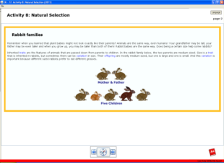 Screen shot showing Rabbit families.
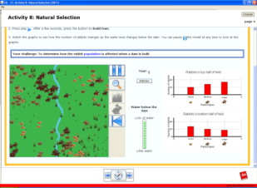 Screen shot before damn is built
Now prompt students to “build the dam” and ask students to Think-Pair-Share about what they notice about what happens to the grasses in the dry area below the dam (Only large grasses grow along the river.) and the rabbits in this area (The number of small rabbits declines.)
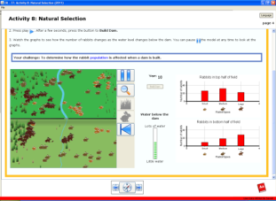 Screen shot after damn is built

Lesson Closing
Step 5 (Evaluate) Est. 10 minutes - Day 2 of 2 day 50-minute lessons
Remind students that the objective of the lesson was, “I can use mathematical models to support the explanation of how natural selection over many generations results in changes within species in response to environmental conditions that tend to increase or decrease specific traits in a population.”

Ask students to take out a blank piece of paper. Write the following Exit Ticket prompt on the board, “What did the graphs on the ‘natural selection’ web activity explain about how changes to the environment (building a dam and its impact on water and plant life) relate to changes in specific traits in a population (the types of rabbits in the population)? In other words, describe how the graphs changed and why this is relevant to natural selection. Include an explanation about the rabbits’ different sizes in your response.” (Student answers should include reference to the graphs created in the online simulation tool. Their answers should also describe how the various sizes of rabbits were affected by the dam that built.)

Gather worksheets and visual aids. Collect Exit Tickets. Use Exit Tickets as a formative assessment of practice and content.

Lesson 5: From Bananas to Prairie Chickens: How Humans Influence Evolution

Brief Overview of Lesson: This lesson focuses on the roles that humans play in the rate of evolutionary change. Students first dissect a banana, noting the absence of seeds or observing remnants of seeds. Students are asked to consider how bananas grow without viable seeds. This leads into a discussion of how different agricultural practices suppress genetic variation within a species and the effects this lack of variation has in the natural selection process. Students separate into small groups to read about an example of a human activity influencing a species’ environment and genetic variation. In this jigsaw cooperative learning activity, students become experts on their topic and then join new groups of students to share their expertise with and learn from their peers.

Prior Knowledge Required:

Students should know about:
- Many characteristics of an organism are inherited from the parents. Some characteristics are caused or influenced by the environment.
- There is variation among individuals of one kind within a population.
- Evolution is a natural process that usually happens over generations.

Estimated Time:
- Instructional Time - 2 lessons at 50 min. each; Preparation Time - 10 min.

Resources for Lesson:
Activity Supplies:
- bananas: 2–3 per class – one slice per each student
- knife
- paper towels: one per student
- toothpicks: one per student
A-V Equipment:
- projection system, screen

Class Supplies:
- pencils or pens
Handouts (All handouts are located at the end of the unit.):
- Resource Readings
- Evolution and Diversity Journal 5
- Mini-lecture Notes
- Human Activities and Evolution

Standard(s)/Unit Goal(s) to be addressed in this lesson:
- 8. MS-LS4-4. Explain the mechanism of natural selection, in which genetic variations of some traits in a population increase some individuals’ likelihood of surviving and reproducing in a changing environment. Provide evidence that natural selection occurs over many generations. [Clarification Statement: Explanations should include simple probability statements and proportional reasoning.]
- 8. MS-LS4-5. Synthesize and communicate information about artificial selection, or the ways in which humans have changed the inheritance of desired traits in organisms. [Clarification Statement: Emphasis is on the influence of humans on genetic outcomes in artificial selection (such as genetic modification, animal husbandry, and gene therapy).]
- RST.6-8.1 - Cite specific textual evidence to support analysis of science and technical texts, attending to the precise details of explanations or descriptions.
Essential Question(s) addressed in this lesson:
- Can humans influence evolution? If so, how?

Objectives:
Students will be able to…
- Use bananas to model natural selection and adaptations.
- Describe how humans have influenced the inheritance of desired traits in organisms.

Language Objectives:
Students will be able to…
- Read informational text and orally share key information with classmates.

Targeted Academic Language
- Content Specific: gene, genetic, organism, specie, trait, natural selection, evolution, inheritance, offspring, adaptations, environment, genetic engineering, fertilize, sexual reproduction, DNA, mutation, clones, variation, gene pool, and population
- Academic Specific: summarize, predict, gist, and text annotations

What students should know and be able to do before starting this lesson:
- See “Prior Knowledge Required” above.

Anticipated Student Preconceptions/Misconceptions
- Misconceptions: Students may believe organisms can individually evolve; evolution occurs within a very short time frame; organisms “choose” to evolve.

Instructional Materials/Resources/Tools
- See “Resources for Lesson (list resources and materials)” above.

Instructional Tips/Strategies/Suggestions for Teacher
- See end of unit resources for descriptions of Think-Pair-Share, No-Hands Questioning, Jigsaw, and Exit Tickets.
- When asking students to discuss the “gist” of the reading, explain that the “gist” of something is a basic summary, what the reading is mainly about.
- Explain to students that text annotations are short summaries of what they have read written in the margins of the page of reading.

Assessment
- Formative assessment:
  - Jigsaw small group discussions – assesses student learning from reading and communicating to peers. Students will read different articles, becoming “experts” and share with their peers what they have learned. (see Unit Resources for more details)
  - Exit Tickets – a quick write used to assess student knowledge and next-steps in instruction (see Unit Resources for more details). Exit Ticket Question - “Describe how humans have influenced the inheritance of desired traits in one of the organisms discussed in class today: Bananas, Prairie Chicken, Lumper Potatoes, Northern Elephant Seal or Sweet Vernal Grass.”

Lesson Details:
Lesson Opening
Step 1 (Engage) Est. 10 minutes - Day 1 of 2 day 50-minute lessons
Post and read aloud from the lesson objective on the board, “I can describe how humans have influenced the inheritance of desired traits in organisms.”
Underline the term “inheritance” and have students Think-Pair-Share about the meaning of this word. Reinforce that inheritance is the passage of traits from parent to offspring.
Remind students that, as they saw in Lesson 4, environmental factors influence plants’ and animals’ unique adaptations for survival in those environments, even if conditions are extreme. However, humans can also influence evolution of plants and animals through genetic engineering.
Inform students that normally, when pollen lands on a flower, it can fertilize the seeds located in the flower’s ovary. This combination of pollen and seed (sexual reproduction) provides “genetic variation” (the differences in the genetic makeup within a population or species) for the plants that will grow from these seeds. This occurs because the pollen and seed contain DNA from two different plants and combine to form a new, genetically distinct plant. Eventually the flower’s ovary becomes a fruit, and at that point, the seeds are usually inside. Since the banana is a fruit, we should expect to find seeds in the banana.
Distribute a paper towel and a toothpick to each student. Circulate and place a banana slice on each student’s paper towel. Ask students to examine the banana to see if they can find the seeds. After two minutes, ask students to share their observations. (There are no seeds. We found tiny brown flecks in the flesh of the banana.)
Then, ask them the following questions (consider using No-Hands Questioning to ensure full participation):
- What is the advantage to the banana of not having any seeds? (None)
- What is the advantage to humans of the banana not having any seeds? (Easier to eat)
- Can you think of other fruits where seeds have been selectively minimized or deleted? (Seedless watermelons and grapes)

During the Lesson
Step 2 (Explore) Est. 10 minutes - Day 1 of 2 day 50-minute lessons
Distribute to students the Evolution and Diversity Journal 5 worksheet. Call their attention to the three prompts on the journal page. Tell students to add to the last prompt on the page, “Explain your reasoning.” Then tell students to take notes on the answers to these questions during a mini-lecture (handout Mini-lecture Notes to accompany this mini-lecture for all students or distribute to students in need of additional support.)
Mini-lecture:
Inform students that bananas in the wild do indeed have seeds (might be helpful to find a picture of a wild banana with seeds on the internet). Tell students that wild banana plants often grow alongside many different kinds of plants, including different kinds of bananas. Birds transfer pollen from one banana flower to another so that seeds can be fertilized. This pollination mixes the genes from different banana plants.
Inform students that farmers have grown bananas for over 1,000 years. Explain that during that time, farmers have done two things to help create the kind of bananas that we are accustomed to eating today. First, they selected banana plants that produced fruit with a mutation that caused them not to make seeds (because people preferred to buy/eat the fruit without seeds). Second, without seeds, farmers created new plants by cutting parts of the roots of a parent plant and growing a new plant from these roots. Tell students that this means that all the new banana plants have the same genes as the parent plant; in other words, the new banana plants are clones.
Explain to students that the banana at their table is a Cavendish banana, the most common banana in the world. Tell students that this kind of banana is grown, distributed, and eaten all around the world. Cavendish bananas are all almost identical genetically, which makes this species less likely to survive environmental changes. Inform students that in the 1960s, the most common banana was a variety called the Gros Michel. It, too, had very little genetic variation in the gene pool. Tell students that in the 1950s the Gros Michel bananas were infested with a fungus called the “Panama Disease,” which attacks the roots of the plant. Large plantations of Gros Michel bananas were destroyed. As a result, the once large plantations of Gros Michel, which some say is a better tasting banana, now grow the Cavendish variety.
Step 3 (Explain) Est. 10 minutes - Day 1 of 2 day 50-minute lessons
After the mini-lecture, provide students with time to complete their answers to the three questions in the journal. Have volunteers share their answers with the class (consider using No-Hands Questioning to ensure full participation).
- How did humans affect the reproduction process of bananas? (Humans selected which bananas to grow, choosing ones without seeds that would not normally reproduce; they grew them by cutting roots instead of by pollination.)
- How did human activity affect the genetic variation of the banana? (The genetic variation declined, since all of the bananas came from the same parent plants. In fact, the newly grown banana plants are almost genetically identical.)
- Which population of banana would be more likely to survive a change in the environmental conditions? Wild bananas or the type of banana at your table? Explain your reasoning: (The wild banana would be more likely to survive since it may have the traits to help it adapt to changing environmental conditions. The non-wild variety are all clones of the parent so if disease hits one it will affect all the others.)
Step 4 (Elaborate) Est. 50 minutes - Day 1 and 2 of 2 day 50-minute lessons
Inform students that today they will study the ways in which people’s activities can alter both the environment and the genetic variation in different species. Distribute a copy of the Resource Readings to each student. Divide the class into eight groups, A through H, for the first part of a Jigsaw activity. Tell students that these are their “expert groups” where they will help each other become experts in a particular area that they will later need to present to others. Assign the readings as follows:
- Resource Reading: Greater Prairie Chicken: Groups A and E
- Resource Reading: Lumper Potatoes: Groups B and F.
- Resource Reading: Northern Elephant Seal: Groups C and G
- Resource Reading: Sweet Vernal Grass: Groups D and H
(Teacher Note: The reading on Sweet Vernal Grass is designed for below-level readers. The reading on Lumper Potatoes is designed for above-level readers.)
Distribute to students the Human Activities and Evolution worksheet. Have students read their assigned Resource Reading with their groups and encourage then to use text annotations to summarize “the gist” as they read. Instruct students to use their reading and to work together to complete the chart for their species, and mention how this chart is an example of a graphic organizer that is designed to help students pick out important details. Give students 20 minutes to complete the task. As students work, collect the banana samples, and then circulate through the class to provide support and clarify misconceptions. (For example, some students may think an individual organism adapts to an environment. The theory of evolution proposes that gene frequencies are altered in populations over time, and that expressed traits change, due to natural selection, depending on environmental circumstances. Students need to learn that evolution does not occur in one generation or to individuals, but rather that it is a gradual process that happens to populations over multiple generations.)
When time is up, assemble groups of four made up of one student from each Resource Reading. Have students in Groups A, B, C, and D count off within their group from one to four. Have all the students who share the same number meet together as a group. Repeat this procedure with students in Groups E, F, G, and H.
Have students use information that they recorded on Human Activities and Evolution to present a summary of their reading to their new group members. Give students 15 minutes to complete this task. Remind students that they should summarize their findings rather than read off the information in their chart to demonstrate understanding. Tell students to ask questions of their peers if they do not understand a concept.
Lesson Closing
Step 5 (Evaluate) Est. 10 minutes - Day 2 of 2 day 50-minute lessons
Remind students that the objective of the lesson was, “I can describe how humans have influenced the inheritance of desired traits in organisms.”

Ask students to take out a blank piece of paper. Write the following Exit Ticket prompt on the board, “Describe how humans have influenced the inheritance of desired traits in one of the organisms discussed in class today: Bananas, Prairie Chicken, Lumper Potatoes, Northern Elephant Seal or Sweet Vernal Grass.” Ask several students to share their response verbally before dismissing class. (Student answers should include reference to the evidence in the mini-lecture on Bananas or textual evidence from the readings. Student answers will vary depending on the organism they chose and the evidence they utilize.)

Gather Resource Readings. Collect worksheets and Exit Tickets. Use Exit Tickets as a formative assessment of practice and content.

Lesson 6: Revisiting the Pupfish: Human Activities and Evolution

Brief Overview of Lesson: Students read the remainder of California Connections: Pupfish from Lesson 1. They discuss the influence of human activities on pupfish evolution and use flowcharts to summarize and analyze their findings. They describe the evolution of another species using the same framework.

Prior Knowledge Required:
Students should know about:
- The number and types of organisms an ecosystem can support depends on the resources available and on abiotic factors, such as quantities of light and water, range of temperature, and soil composition.

Students should be able to:
- Define evolution and identify its causes.
- Describe the influence of genetic variation on the evolution and diversity of organisms.
- Identify the role of environmental factors on the evolution and diversity of organisms, and the long-term functioning and health of natural systems.
- Provide examples of how human population growth and human activities (for example, expansion of communities, production and consumption of natural resources, the operation and expansion of human communities, and generation of byproducts) can affect both genetic variation and environmental factors.

Estimated Time (minutes):
- Instructional Time - 50 min.; Preparation Time - 10 min.

Resources for Lesson:
A-V Equipment:
- projection system, screen
Class Supplies:
- chart paper
- colored markers
- pencils or pens
- tape or thumbtacks

Handouts (All handouts are located at the end of the unit.):
- Evolution and Diversity Journal 6
- Summary: Human Influence on Evolution Part 1
Visual Aids (can be projected or printed out in color):
- Human Influence on Evolution-VISUAL AID
Additional Materials
- Sample News Article: http://www.sciencenewsforkids.org/2010/01/a-global-warming-flap-2/ (to be printed by teacher)

Standard(s)/Unit Goal(s) to be addressed in this lesson:
- 8. MS-LS4-4. Use a model to describe the process of natural selection, in which genetic variations of some traits in a population increase some individuals’ likelihood of surving and reproducing in a changing environment Provide evidence that natural selection occurs over many generations. [Clarification Statements: The model should include simple probability statements and proportional reasoning. Examples of evidence can include Darwin’s finches, necks of giraffes, and peppered moths.] [State Assessment Boundary: Specific conditions that lead to natural selection are not expected in state assessment.]”
- 8. MS-LS4-5. Synthesize and communicate information about artificial selection, or the ways in which humans have changed the inheritance of desired traits in organisms. [Clarification Statement: Emphasis is on the influence of humans on genetic outcomes in artificial selection (such as genetic modification, animal husbandry, and gene therapy).]
- RCA.6-8.1 - Cite specific textual evidence to support analysis of science and technical texts, attending to the precise details of explanations or descriptions.
- WHST.6-8.8 - When conducting research, gather relevant information from multiple print and digital sources; assess the credibility of each source; and quote or paraphrase the data and conclusions of others while avoiding plagiarism and providing basic bibliographic information for sources.

Essential Question(s) addressed in this lesson:
- Can humans influence evolution? If so, how?

Objectives:
Students will be able to…
- Describe how humans have influenced the inheritance of desired traits in organisms.
- Evaluate how humans have influenced the evolution of a specie or species.
- Summarize textual information in a flow chart.
- Identify how authors cite information in their writing.

Targeted Academic Language
- Content Specific: gene, organism, specie, trait, natural selection, evolution, inheritance, and environment
- Academic Specific: summarize, predict, flow chart, synthesize, text annotations, and gist

What students should know and be able to do before starting this lesson:
- See “Prior Knowledge Required” above.

Anticipated Student Preconceptions/Misconceptions
- Misconceptions: Students may believe organisms can individually evolve; evolution occurs within a very short time frame; organisms “choose” to evolve.

Instructional Materials/Resources/Tools
- See “Resources for Lesson (list resources and materials)” above.

Instructional Tips/Strategies/Suggestions for Teacher
- See end of unit resources for descriptions of Think-Pair-Share and No-Hands Questioning.
- When asking students to discuss the “gist” of the reading, explain that the “gist” of something is a basic summary, what the reading is mainly about.
- Explain to students that text annotations are short summaries of what they have read written in the margins of the page of reading.
- Remind students that they will be using the California Connections: Pupfish article from Lesson 1 (it was either collected or saved by students based on teacher discretion).
- Only Part 1 of Summary: Human Influence on Evolution handout will be used in Lesson 6. Part 2 of this four page packet will be used next instructional period to begin the CEPA.

Assessment
- Formative assessment:
  - Exit Tickets – a quick write used to assess student knowledge and next-steps in instruction (see Unit Resources for more details). Exit Ticket Question - “Describe how humans have influenced the evolution of Pupfish or other species we’ve studied in this unit.”
Lesson Details:
Lesson Opening
Step 1 (Engage) Est. 10 minutes
Post and read aloud from the lesson objective on the board, “I can describe how humans have influenced the inheritance of desired traits in organisms.” Remind students that this is the same lesson objective as the prior lesson, so they’ll be building on their prior knowledge.
Distribute to students the Evolution and Diversity Journal 6 worksheet and read the prompt: “Think about all the species we have studied in this unit. Select one that has been affected by human activity. Describe the activity. What effect did this activity have on the evolution of the species?” Have students write independently, and then share their answer with the person sitting next to them. Call on pairs to share one of their answers aloud. (Introducing flies to Hawaii led to the evolution of silent crickets; human activities that have contributed to global climate change influenced the evolution of purple pitcher plant mosquitoes to hibernate later than they did before climate change; agricultural cloning of bananas has reduced variation in this species; hunting has reduced variation in elephant seals; habitat destruction has reduced variation in prairie chickens, making them less able to successfully reproduce.) Inform students that today they will be revisiting some of the species they have learned about to identify the role human activities have played in the evolution of these species.
During the Lesson
Step 2 (Explore) Est. 20 minutes
Hand out to students a copy of the California Connections: Pupfish reading (if they did not keep it from Lesson 1). Post the chart paper with the three pupfish questions in a location visible to all students. Have students think silently about these questions for one minute, then call on volunteers to share answers with the class (consider using No-Hands Questioning to ensure full participation).
- What is a pupfish? (Pupfish are tiny fish that live in deserts in California.)
- What are some characteristics of the environments that pupfish live in? (Some pupfish live in very salty environments; some live in environments that get very hot; some live in environments that dry up during part of the year; different pupfish live in different environments.)
- What kinds of adaptations have evolved in pupfish over time? (Some pupfish can tolerate high temperatures; some can tolerate high salinity; some bury their eggs during the summer to survive the drying out of water supplies.)
Distribute to students the Summary: Human Influence on Evolution worksheet. Read the instructions for Part 1 of Summary: Human Influence on Evolution. Instruct students to reread California Connections: Pupfish with the person sitting next to them, starting with the section titled “Devil’s Hole” and continuing to the end of the article. Remind students to focus their reading on examples of human activities that have affected the two kinds of pupfish: the Tecopa pupfish and the Devil’s Hole pupfish. When they are done reading, turn their attention to Part 1 of Summary: Human Influence on Evolution. First, point out to students how the flow chart is organized and what kind of information goes in each box. Then remind students that they’ve practiced different strategies for summarizing from texts and tell them that flow charts can help readers organize important concepts. Give students 15 minutes to complete Part 1 of Summary: Human Influence on Evolution. When time is up, project Human Influence on Evolution-VISUAL AID, and review the answers as a class.
Step 3 (Explain) Est. 15 minutes
Briefly introduce students to the Unit CEPA, which requires each of them to synthesize and summarize their understandings about evolution by completing a short piece of writing. Tell students that this writing takes the form of a news article (Do not distribute CEPA assignment in this lesson, use this class to have students complete the following reading and Think-Pair-Share activity in order to become familiar with writing a news article).
Distribute copies of the Sample News Article. Prompt students to read along silently as you read aloud from this article. Encourage students to use text annotations to make notes of “the gist” of the article as they read. Then ask students to re-read the article with the following question in mind, “How does the author organize the writing to hook the reader into the story? What does the author do to make the article engaging?” “How does the author cite information that is not his/her work?” (Write these prompts on the board as a visual reminder). After all students have re-read the article with that question in mind, ask them to Think-Pair-Share about the prompt. As students share out their ideas, create a chart of “Tips for Writing a News Article” from their suggestions. (For example, students might notice that the author starts the article with the perspective of one person.)
Lesson Closing
Step 4 (Evaluate) Est. 5 minutes
Remind students that the objective of the lesson was, “I can describe how humans have influenced the inheritance of desired traits in organisms.”
Ask students to take out a blank piece of paper. Write the following Exit Ticket prompt on the board, “Describe how humans have influenced the evolution of Pupfish or other species we’ve studied in this unit.” Ask several students to share their response verbally before dismissing class. (Student answers should include information about how human activity, either artificial selection or changes to the organism’s environment can greatly affect the growth of a specie. If the specie is not able to adapt to the changing environment they will not evolve.)

Gather readings and collect worksheets and Exit Tickets. Be sure to save the Summary: Human Influence on Evolution handout, as Part 2 will be used next instructional period to begin the CEPA. Use Exit Tickets as a formative assessment of practice and content.

Curriculum Embedded Performance Assessment (CEPA)
Human Influence on Evolution News Article

Summary: Students select a species they have studied in Lessons 2 or 4 for analysis. Using flowcharts, students independently examine how people and their activities have changed the diversity and evolution of their chosen species. By the conclusion of the CEPA, students recognize not only the basics of the process of evolution, but also the ways in which human actions can alter this process in natural systems.

Materials (handouts located in the Unit Resources section per Lesson and rubric is located at the end of Unit Resources section before the Unit Glossary):
- Computers with internet access (one per student if available) for additional research on chosen species.
- Assessment of Learning Directions and Rubric (one per student)
- Summary: Human Influence on Evolution Part 2 (one per student) – from Lesson 6
- Evolution and Diversity Journal 6 (one per student) – from Lesson 6
- Evolution Research Project #1 and #2 (one per student) – from Lesson 2
- Massachusetts Species Descriptions (one per student) – from Lesson 4
- Sample News Article: http://www.sciencenewsforkids.org/2010/01/a-global-warming-flap-2/

Explanation of CEPA:
Goal: Students construct an explanation for how humans have influenced genetic variations of traits in a population, thereby increasing some individual’s probability of surviving and reproducing in a specific environment, which tends to increase these traits and suppress other traits in the population.
Role: News Reporter/Journalist
Audience: Readers of Science News for Kids
Situation: The editor of the Science News for Kids has given you an assignment to educate the website’s readers about a species whose evolution has been influenced by humans. As a journalist, research information about the organism of your choice (Northern Mountain Ash, Diamond-back Terrapin, Kauai field crickets, Northeastern Beach Tiger Beetle, or Purple pitcher plant mosquitoes). Focus your research on information about how humans have influenced this organism’s genetic traits over time. Use this information to write a short article to educate the public about your findings.
Product Performance and Purpose: News article.
Criteria for Evaluating Student Products and Performances
- See “How You Will Be Graded” on Assessment of Learning Directions and Rubric.
- Additional Scoring Notes: Consider more explicit reading instruction to assist students with Common Core RST.6-8.1. Cite specific textual evidence to support analysis of science and technical texts, attending to the precise details of explanations or descriptions.
CEPA Lesson Details:
- Read the following statement to students as you introduce the CEPA:
  - “The editor of the Science News for Kids has given you an assignment to educate the website’s readers about a species whose evolution has been influenced by humans. As a journalist, research information about the organism of your choice (Northern Mountain Ash, Diamond-back Terrapin, Kauai field crickets, Northeastern Beach Tiger Beetle, or Purple pitcher plant mosquitoes). Focus your research on information about how humans have influenced this organism’s genetic traits over time. Use this information to write a short article to educate the public about your findings.”
- Distribute the CEPA Assessment of Learning Directions and Rubric to each student. (Note: Students may benefit from additional support during this independent work. Consider establishing a one-on-one conference with each student to review notes for accuracy and clarity.)
- Review the Assessment of Learning Directions and Rubric and prompt students to focus on the “format” of the assignment, listed as a “news article” (page 1 of 2).
- Point students to the assignment’s Rubric (page 2 of 2) and ask them to focus on the rubric for how they will be graded. Ask a student volunteer to read aloud from the criteria for Accomplished and the criteria for Exemplary. Prompt students to discuss with a partner how they would grade the Sample News Article from Lesson 6 using this rubric.
- Have students examine the list of species in Part 2 of Summary: Human Influence on Evolution from Lesson 6 and select one species they would like to focus on. Tell students selecting purple pitcher plant mosquitoes to use Evolution Research Project #1 for information. Students choosing field crickets should refer to Evolution Research Project #2. Tell students selecting any other species to use the Massachusetts Species Descriptions for information.
- Provide class time for students to begin researching their specie. Students will need access to computers with internet. At the end of the 50 minute period assess the amount of additional time students need to complete the CEPA and plan accordingly.
- When all students have completed their research & writing, consider closing the unit with a Volleyball – Not Ping-Pong! discussion using the following prompts:
- How did human activity affect the evolution and diversity of your species? (Students will provide different answers based on the specie they researched.)
- Of the five species studied, which ones evolved unique adaptations to cope with human intervention? (Kauai field crickets or Purple pitcher plant mosquitoes)
- What is your prediction for extinction of the other species? (Northern Mountain Ash – at risk (Endangered in MA), Diamond-back Terrapin – moderately hopeful (Threatened in MA), Northeastern Beach Tiger Beetle – at risk (Endangered in MA)) [Source: Mass.gov – Energy and Environmental Affairs]

Unit Resources: Additional Instructional Materials/Resources/Tools

Additional instructional materials included in this section:

- Lesson 1 Handouts
- California Connections: Pupfish
- Key Unit Vocabulary
- Evolution and Diversity Journal 1
- Evolution of Pupfish
- Sample Pupfish
- Environment Cards
- Interactive Word Wall Cards
Visual Aids (can be projected or printed out in color):
- Pupfish

- Lesson 2 Handouts
- Notes About the Tegula Snail
- Evolution Research Project #1
- Evolution Research Project #2
- Evolution Research Project #3
- Evolution Research Project #4
- Evolution and Diversity Journal 2
- Evidence of Evolution
Visual Aids (can be projected or printed out in color):
- Tegula Snail Research

- Lesson 3 Handouts
    - Evolution Notes #1-3
    - How to Make an Origami Bird Beak
    - Evolution and Diversity Journal 3
    - Variation and Natural Selection
Visual Aids (can be projected or printed out in color):
    - Darwin’s Finches

- Lesson 4 Handouts
    - Massachusetts’ Climate Zones
    - Massachusetts Species Descriptions
    - Evolution and Diversity Journal 4
    - Traits for Survival
Visual Aids (can be projected or printed out in color)
- Massachusetts Political Map
- Massachusetts Longitude and Latitude Map

- Lesson 5 Handouts
    - Resource Readings
    - Evolution and Diversity Journal 5
    - Mini-lecture Notes
    - Human Activities and Evolution

- Lesson 6 Handouts
    - Evolution and Diversity Journal 6
    - Summary: Human Influence on Evolution
Visual Aids (can be projected or printed out in color):
    - Human Influence on Evolution

- CEPA Handouts
    - Assessment of Learning Directions and Rubric

- Unit Glossary

Technology Requirements
- Lesson 4 requires use of a computer lab (one computer per each student is best) with the Java Runtime Environment version 5 (sometimes referred to as 1.5) or later with Java Webstart is required to run the Concord Consortium activity. You can download it at: java.com. The download for this activity will require 35.5 MB of disk space.

Unit Sources
- Draft Revised Science and Technology/Engineering Standards (www.doe.mass.edu/STEM/review.html)
- MA Curriculum Frameworks for English Language Arts/Literacy and Mathematics
- Shaping Natural Systems through Evolution unit developed by the California Education and the Environment Initiative (EEI). http://www.californiaeei.org/Curriculum/.
- Mass.gov website for Energy and Environmental Affairs - http://www.mass.gov/eea/agencies/dfg/dfw/natural-heritage/species-information-and-conservation/mesa-list/list-of-rare-species-in-massachusetts.html
- PBS, Evolution, http://www.pbs.org/wgbh/evolution/library/11/2/quicktime/e_s_4_56.html
- PBS, Darwin’s Finches, http://mass.pbslearningmedia.org/resource/tdc02.sci.life.evo.adraddarfinch/adaptive-radiation-darwins-finches/.
- The Concord Consortium, Natural Selection, http://concord.org/activities/natural-selection
- PBS, www.pbslearningmedia.org
- Science News for Kids, Sample News Article, http://www.sciencenewsforkids.org/2010/01/a-global-warming-flap-2/
- Keeley, Page. “Science Formative Assessment.” 2008: Corwin Press, California.
- Expeditionary Learning materials, http://www.elschools.org
- Sex and the Single Guppy http://www.pbslearningmedia.org/resource/tdc02.sci.life.evo.sexguppy/sex-and-the-single-guppy/
- Britannica Library Reference Center, http://library.eb.com/levels/referencecenter
- National Geographic Society: Pupfish-VISUAL AID

Additional Resources for Teachers
- Natural Selection - Crash Course #14, http://www.pbslearningmedia.org/resource/23219bb6-6a10-46e6-8a14-614156a8519e/natural-selection-crash-course-biology-14/
- Chasing Beetles, Finding Darwin, http://www.pbslearningmedia.org/resource/kqedq11.sci.chasingbeetles/chasing-beetles-finding-darwin/
- Different Breeds of Cattle. http://www.pbslearningmedia.org/resource/nat08.living.gen.geneng.breeds/different-breeds-of-cattle/
- Speciation: Of Ligers and Men – Crash Course #15, http://www.pbslearningmedia.org/resource/eef601b2-8867-4ab7-8209-50983a50cb2f/speciation-of-ligers-men-crash-course-biology-15/

Tools - Unit Strategy Descriptions:
- THINK-PAIR-SHARE
  - Think-Pair-Share combines thinking with communication. The teacher poses a question and gives individual students time to think about the question. [Consider prompting students to write their thoughts in a variation called Write-Pair-Share.] Students then pair up with a partner to discuss their ideas. After pairs discuss, students share their ideas in a small-group or whole-class discussion. (Keeley, Page. “Science Formative Assessment.” 2008: Corwin Press, California. Pg. 192.)

- NO-HANDS QUESTIONING
  - Students typically raise their hands when they wish to respond to a teacher’s question. With No-Hands Questioning, students do not put their hands up to respond to a teacher’s question. The teacher poses a question, practices wait time, and calls on a student randomly. This FACT [Formative Assessment Classroom Technique] acknowledges that everyone needs to be ready to share his or her ideas. It reinforces the notion that everyone’s response is important, not just the students who show they know the answer by raising their hand. (Keeley, Page. “Science Formative Assessment.” 2008: Corwin Press, California. Pg. 141.)

- INTERACTIVE WORD WALL
  - Explain to students that you know that many of these words will be familiar to them and you’d like to learn about the ideas that they currently have about how these words relate to the subject/topic. Lay out the cards on the floor and have students stand in a circle surrounding the cards. Ask students to move one card next to another card that they believe has a connection with regards to the subject/topic. Decide how you will have students take turns using the Interactive Word Wall (a go-round, random selection, student-led, etc.). Listen carefully to students’ ideas. Be sure not to correct or judge any misconception that might arise. Use this activity as an assessment of students’ prior knowledge. (Expeditionary Learning materials, http://www.elschools.org)

- JIGSAW
  - Purpose: This protocol allows small groups to engage in an effective, time-efficient comprehension of a longer text. Having every student read every page or section may not be necessary. Students can divide up the text, become an expert in one section and hear oral summaries of the others and still gain an understanding of the material.
  - Materials: Copies of a textbook chapter or longer article for each student.
  - Procedure:
    - Divide the text into manageable sections.
    - Arrange the students into groups so there are the same number of people in each group as sections to read. Assign the sections to each member.
    - Students read their section independently looking for key points, new information, or answers to questions brainstormed earlier.
    - Each member in turn shares their important points or summaries of the text.
    - Have students independently write/reflect on their own understanding after the discussion.
  - Debrief: Have groups or individuals share insights and discoveries. Did the group process help members gain an understanding of the whole text? What worked well for the group? Are there discussion skills the group could improve? Are there any lingering questions or misconceptions about the topic? (Expeditionary Learning materials, http://www.elschools.org)

- EXIT TICKET
  - Purpose: At the end of class, students write on note cards or slips of paper an important idea they learned, a question they have, a prediction about what will come next, or a thought about the lesson for the day. Alternatively, have students turn-in such a response at the start of the next day–either based on the learning from the day before or the previous night’s homework. These quick writes can be used to assess students’ knowledge or to make decisions about next teaching steps or points that need clarifying. This reflection helps students to focus as they enter the classroom or solidifies learning before they leave.
  - Procedure:
- For 2–3 minutes at the end of class (or the start of the next one) have students jot responses to the reading or lesson on 3 x 5 note cards.
- Keep the response options simple–“One thing you learned and one question you have.” If you have taught particular thinking strategies–connecting, summarizing, inferring–ask students to use them.
- A variation is known as 3-2-1: Have students write three of something, two of something, then one of something. For example, students might explain three things they learned, two areas in which they are confused, and one thing about which they’d like to know more or one way the topic can be applied. The criteria for listing items are up to the needs of the teacher and the lesson, but it’s important to make the category for three items easier than the category for listing one item.
- Don’t let the cards become a grading burden. Glance over them for a quick assessment and to help you with planning for next learning needs. These are simply quick writes, not final drafts.
- After studying the “deck” you might pick-out a few typical/unique/thought-provoking cards to spark discussion.
- Cards could be typed up (maybe nameless) to share with the whole group to help with summarizing, synthesizing, or looking for important ideas. It is a good idea to let students know ahead of time as they may put more effort into the write-up. When typing, go ahead and edit for spelling and grammar. (Expeditionary Learning materials, http://www.elschools.org)

- VOLLEYBALL - NOT PING-PONG!
  - Volleyball – Not Ping-Pong! Describes a technique that changes the nature of the question-and-answer interaction pattern in the classroom from a back-and-forth teacher-to-student exchange to one of teacher to Student A to Student B to Student C, D, or so on…then back to the teacher. The ping-pong metaphor represents the typical rapid-fire, back-and-forth cycle of questions and responses that typically take place between teacher and students. The volleyball metaphor represents the teacher asking a question, a student responding, and other students building off the response until the teacher “serves” another question. (Keeley, Page. “Science Formative Assessment.” 2008: Corwin Press, California. Pg. 211.)

California Connections: Pupfish
Lesson 1 │ page 1 of 3
Pupfish
The team of divers meets at the bottom of a rocky desert hill. They climb up to a limestone cave and look down at a deep blue pool. In fact, this pool is so deep that no one has ever found the bottom. Devil’s Hole is the home of the endangered Devil’s Hole pupfish (Cyprinodon diabolis).
California’s Changing Environment
The strange scene looks like something out of a science fiction movie. Twice every year, desert fish biologists meet to count the number of pupfish in Devil’s Hole. They lower themselves into the warm water. They adjust their masks and scuba tanks. After descending to a depth of 80 feet, the divers slowly rise past a series of limestone shelves. They count the tiny pupfish all the way up.
Pupfish are tiny desert fishes that look a little like minnows. Most of them are about one inch long. Females are yellowish-brown on their backs, and males are blue and brown with violet-colored gills. Biologists believe that the ancestors of today’s pupfish appeared 20,000 years ago. They occupied the deep inland lakes that once covered much of California. Here is how biologists believe the pupfish appeared.
Twenty-five thousand years ago, an intense uplifting and tilting of the Sierra Nevada mountain range began. Volcanoes and earthquakes thrust the existing range higher and higher. The peaks grew so high that they blocked much of the rainfall from reaching the east side of the Sierras. Over time, the large inland lakes east of the Sierras began to evaporate, and many species did not have enough habitat to survive and became extinct.
As the lakes evaporated, they formed many smaller ponds, resulting in small populations of pupfish that were physically isolated from each other. Only organisms that had the adaptive trait to deal with the now-harsh environment survived. These individuals reproduced, passing on their survival features to the next generation of pupfish. Because each desert environment was different, or because the individuals had different traits that allowed them to survive, these groups of pupfish evolved (speciated) into different species with unique traits.
Pupfish Adaptations
Today, several species of pupfish are found in a few isolated ponds, creeks, and pools. Salt Creek pupfish (Cyprinodon salinus salinus) live in the shallow water of Salt Creek in Death Valley National Park. They are able to live in water that is three times saltier than any ocean. These pupfish hatch in the springtime, when rains fill the creek. They grow to adulthood in two to three months. When they breed, they leave their eggs in the algae of the streambed. Many of the pupfish die in the summertime, when Salt Creek dries out.
California Connections: Pupfish
Lesson 1 │ page 2 of 3

A few miles south and east of Death Valley, near Tecopa, California, the Tecopa pupfish (Cyprinodon nevadensis calidae) lived in the salty, warm pools. They had survived by eating algae in the 108° F water with no predators for thousands of years. Unfortunately, the owner of the hot springs in the area built canals and bathhouses for visitors in the 1940s. He brought in mosquito fish to eat the Insects that might otherwise have bothered his guests. After he built the canals, the pupfish began washing downstream, out of their unique habitats. The mosquito fish ate the pupfish that did not wash away. As result, in 1970, the Tecopa pupfish was listed as endangered; by 1978, it was extinct.

Devil’s Hole
Devil’s Hole is 35 miles east of Death Valley, in the Amargosa Valley. From the mouth of the cavern, you look down on Ash Meadows National Wildlife Refuge. The refuge was established in 1984 to protect 13 threatened and endangered species, including the Devil’s Hole pupfish. The National Wildlife Refuge also provides a habitat for at least 24 other pupfish species found nowhere else in the world.
There is an abundance of water in Ash Meadows. An ancient desert aquifer stretches for 100 miles just below the surface. It feeds seven major springs in the area. An underground fault acts as a dam and forces the water to the surface. This water is called fossil water, because geologists believe that it entered the ground around 10,000 years ago.
Human Intervention
In the 1960s and 1970s, farmers, ranchers, and developers made a plan to use this precious desert water. They planted and irrigated crops by pumping water from the aquifer. They diverted the natural springs. All these changes influenced the natural systems in the area. Native plants, fish, and wildlife disappeared.
The tiny pupfish helped to create public awareness about the problem of water diversion. The pupfish are dependent on algae to live. In Devil’s Hole, they feed and deposit their eggs on a small limestone shelf where algae grow. When the water was pumped out of the aquifer for irrigation, the water level in Devil’s Hole fell below the shelf. The algae dried up and the pupfish began to die.
In 1967, the Devil’s Hole pupfish was declared an endangered species. In 1969, the Desert Fishes Council brought the issue to the people. The Save the Pupfish slogan could be seen everywhere, from bumper stickers to store windows. In 1972, the people of the United States brought a lawsuit against land developers and the State of Nevada. The case went all the way to the Supreme Court. Eventually the Court ruled in favor of the pupfish. It established a minimum water level that had to be maintained in the pools in the area.

California Connections: Pupfish
Lesson 1 │ page 3 of 3

Pupfish Population Now
Until 2005, the population of pupfish in Devil’s Hole had either grown or remained stable. The divers counted 300 to 500 pupfish in 1995. In the fall of 2005, however, the count suddenly dropped to 85. By the next spring, it was under 40. What happened to the pupfish? Fish biologists do not know. They are still studying the environment to understand why the population decreased.
Biologists know that genetic variation in the pupfish allowed it to survive geological changes 10,000 years ago. Since then, however, this very small population of pupfish has existed in complete isolation and has had few predators. There was little change in the pupfish’s environment until the late 1960s. For all these reasons, biologists think that this small, isolated population may have very little genetic variation. If this is correct, then it may be that no individuals have the inherited traits that would enable them to survive changes in the environment.
The divers slowly return to the surface of Devil’s Hole. They push up their masks and talk to one another about how many pupfish they found. One of the fish experts is still leaning over the spawning shelf, counting the fish one last time. When the verdict is in, there are 38 pupfish in the warm clear pool. This is the same number as last year. Even though the number is low, the divers sigh with relief. They are expecting that the pupfish count will be higher in the fall.
Pupfish provide an excellent example of how evolution occurs, especially in isolated populations. The disappearing pupfish at Devil’s Hole are causing experts to ask how changing environmental factors affect species that are thousands of years old. This year, they will be checking water quality, nutrients, and studying the way that the angle of the Sun affects the growth of algae in the pool. They are also looking at raising Devil’s Hole pupfish in the laboratory, in order to protect this rare little fish from extinction.

Key Unit Vocabulary
Lesson 1 │ page 1 of 2

Adaptation: A change in the body or
behavior of a species in response to a new
environmental condition. Adaptation occurs
over several generations.

Byproduct: Something, such as waste
materials or chemicals, produced when
something else is manufactured or consumed.

Climate: The prevailing, average weather
conditions of a particular area over time.

Clone: An organism that is genetically identical
to its parent.

Diversity: A measure of the variation of life forms at the genetic, species, or ecosystem level.

DNA: Deoxyribonucleic acid, the molecule
that carries all of the genetic information in a
living organism.

Elevation: Height above sea level.

Endemic: (noun) Something that is only found
in a specified geographic region. (adjective)
Occurring naturally in a particular region.

Endemic species: An organism that is only
found in a specified geographic region.
Environmental factors: The biotic and abiotic
components of the environment.

Evolution: The process by which species
develop as a result of natural selection for
beneficial adaptations. Evolution occurs over
many generations.

Extinct: No longer existing as a species or
subspecies.

Extinction: The death of all members of a
species or other taxa.

Gene: A portion of a DNA molecule that
instructs the cell to make a specific protein.

Gene pool: The variety of genes found within
a population of organisms.

Genetic variation: Differences in the genetic
makeup within a population or species.

Habitat: The place where an organism lives
and meets its needs.

Heritable: The types of traits that can be passed
from parent to offspring through the genes.

Human activities: The things that individual
people, communities, and societies do, such
as the harvesting or extracting of materials and
the production of goods.

Inheritance: The process by which genetic
traits are passed from parents to offspring.

Microclimate: The climate of a small, specific
place as contrasted within a larger area.

Mutation: A change to an organism’s DNA
sequence.

Natural selection: The process by which
individuals with advantageous variations
survive and reproduce.

Organism: A living thing, such as a plant,
animal, or other life form, capable of metabolic
activity and reproduction.

Key Unit Vocabulary
Lesson 1 │ page 2 of 2

Population: The number of individuals of a Vegetative propagation: Asexual
species in an area. reproduction of plants involving the use of
spores, to produce new plants.
Protective coloration: An adaptation by
which an organism’s color makes it less Viable: Having the potential to live, grow,
noticeable to predators. stems, roots, or leaves, rather than seeds or
develop, and function adequately.
Purebred: Organisms that result from
selective breeding for specific characteristics Wild-type: An organism that has genes and
over many generations. traits very similar to those of other members of
the species that live in the wild.
Reproduction: The process an organism
goes through to produce new individuals of
its own kind.

Sexual reproduction: The type of
reproduction whereby offspring inherit genes
from both parents.

Speciation: The process through which new
species are formed.

Species: Genetically related organisms
that resemble one another and can
successfully reproduce.

Subspecies (abbreviation, ssp.): A group
of organisms within a species that has distinct
characteristics from other populations of
that species.

Trait: A distinguishing characteristic, such
as color, or behavior, such as the ability to
run quickly.

Variation: Differences in genetic or behavioral
traits within a species.

Evolution and Diversity Journal 1
Lesson 1 │ page 1 of 1

Name: _________________________________
Instructions: Read and respond to the prompt as directed during the lesson.
Topic: What is natural selection?
Prompt: How do these fish differ from one another, in terms of color, size, markings, and shape?
_____________________________________________________________________________________________________________________________________________________________________________________________________________________________________________________________________________________________________________________________________________________________________________________________________________________________________________________________________________________________________________________________________________________________________________________________________________________________________________________________________________________________________________________________________________________________________________________________________________________________________________________________________________________________________________________________________________________________________________________________________________________________________________________________________________________________________________________________________________________________________________________________________________________________________________________________________________________________________________________________________________________________

Evolution of a Pupfish
Lesson 1 │ page 1 of 5

Name: _________________________________
Part 1
Instructions: Read the prompts below and complete the tasks in the spaces provided. (2 points each)
The fish on your table represent different members of one species of pupfish. These fish lived
25,000 years ago.

- List three different traits that can be used to describe a pupfish.

_____________________________________________________________________________________________________________________
_____________________________________________________________________________________________________________________
_____________________________________________________________________________________________________________________
- Human beings are all members of the same species, but individuals of the species have different traits. List three inherited traits that a person might have that can be different in another individual in this species.

_____________________________________________________________________________________________________________________
_____________________________________________________________________________________________________________________
_____________________________________________________________________________________________________________________
Part 2
Instructions: Use your Environment Card and Sample Pupfish to help answer the questions below. (2 points each)

Environment #1:

- What is the name of the environment?

_____________________________________________________________________________________________________________________
- Describe this environment.

_____________________________________________________________________________________________________________________
_____________________________________________________________________________________________________________________

Evolution of a Pupfish
Lesson 1 │ page 2 of 5

Name: _____________________________________
- Which fish will not survive in this environment, if any? Why?

_____________________________________________________________________________________________________________________
_____________________________________________________________________________________________________________________
- Of the fish that will survive, which will be the most successful at reproducing? Why?

_____________________________________________________________________________________________________________________
_____________________________________________________________________________________________________________________
- A fish that survives and reproduces passes on its traits to its offspring. What trait or traits are most likely to be passed on to the next generation in this environment?

_____________________________________________________________________________________________________________________
_____________________________________________________________________________________________________________________

Environment #2:
- What is the name of the environment?

_____________________________________________________________________________________________________________________
- Describe this environment.

_____________________________________________________________________________________________________________________
_____________________________________________________________________________________________________________________
_____________________________________________________________________________________________________________________
- Which fish will not survive in this environment, if any? Why?

_____________________________________________________________________________________________________________________
_____________________________________________________________________________________________________________________

Evolution of a Pupfish
Lesson 1 │ page 3 of 5

Name: _____________________________________

- Of the fish that will survive, which will be the most successful at reproducing? Why?

_____________________________________________________________________________________________________________________
_____________________________________________________________________________________________________________________
- A fish that survives and reproduces passes on its traits to its offspring. What trait or traits are most likely to be passed on to the next generation in this environment?

_____________________________________________________________________________________________________________________
_____________________________________________________________________________________________________________________
_____________________________________________________________________________________________________________________

Environment #3:
- What is the name of the environment?

_____________________________________________________________________________________________________________________
- Describe this environment.

_____________________________________________________________________________________________________________________
_____________________________________________________________________________________________________________________
- Which fish will not survive in this environment, if any? Why?

_____________________________________________________________________________________________________________________
_____________________________________________________________________________________________________________________
_____________________________________________________________________________________________________________________
_____________________________________________________________________________________________________________________
_____________________________________________________________________________________________________________________

Evolution of a Pupfish
Lesson 1 │ page 4 of 5

Name: _________________________________
- Of the fish that will survive, which will be the most successful at reproducing? Why?

_____________________________________________________________________________________________________________________
_____________________________________________________________________________________________________________________
_____________________________________________________________________________________________________________________
- A fish that survives and reproduces passes on its traits to its offspring. What trait or traits are most likely to be passed on in this environment?

_____________________________________________________________________________________________________________________
_____________________________________________________________________________________________________________________
_____________________________________________________________________________________________________________________

Part 3
Instructions: Complete the following tasks in the spaces provided. (2 points each)

- Define “adaptation” in your own words.

_____________________________________________________________________________________________________________________
_____________________________________________________________________________________________________________________
- What is an example of an adaptation in one of the pupfish from Part 2?

_____________________________________________________________________________________________________________________
_____________________________________________________________________________________________________________________
_____________________________________________________________________________________________________________________
- Define “natural selection” in your own words.

_____________________________________________________________________________________________________________________

Evolution of a Pupfish
Lesson 1 │ page 5 of 5

Name: _________________________________
- Define “evolution” in your own words.

_____________________________________________________________________________________________________________________
_____________________________________________________________________________________________________________________
- What makes a trait become more common in future generations?

_____________________________________________________________________________________________________________________
_____________________________________________________________________________________________________________________
- If a trait makes an organism more likely to survive, will it always be passed on to future generations? Why or why not?

_____________________________________________________________________________________________________________________
_____________________________________________________________________________________________________________________
_____________________________________________________________________________________________________________________
_____________________________________________________________________________________________________________________
_____________________________________________________________________________________________________________________
_____________________________________________________________________________________________________________________
_____________________________________________________________________________________________________________________

Sample Pupfish
Lesson 1 │ page 1 of 2
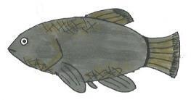
Fish A | Fish B
Salinity: Can survive in low to high salinity.  Temperature for laying eggs: Can survive and lay eggs at low and high temperatures.  Breeding habits: Lays eggs in the spring.  These eggs can remain in algae when water  levels go down and hatch when water levels return the next year. | Salinity: Can survive in low to high salinity.  Temperature for laying eggs: Can lay  eggs only at 75–86° F (24–30° C).  Breeding habits: Lays eggs year-round.
Fish C | Fish D
Salinity: Can survive in low to medium salinity.  Temperature for laying eggs: Can lay  eggs at low and high temperatures.  Breeding habits: Lays eggs year-round. | Salinity: Can survive in low to medium salinity.  Temperature for laying eggs: Can lay  eggs only at 75–86° F (24–30° C).  Breeding habits: Lays eggs in the spring.  These eggs can remain in algae when water  levels go down and hatch when water levels return the next year.

Sample Pupfish
Lesson 1 │ page 2 of 2
Fish E | Fish F
Salinity: Can survive in fresh water with  low salinity.  Temperature for laying eggs: Can lay  eggs at low and high temperatures.  Breeding habits: Lays eggs year-round. | Salinity: Can survive in fresh water with  low salinity.  Temperature for laying eggs: Can lay  eggs at low and high temperatures.  Breeding habits: Lays eggs in the spring.  These eggs can remain in algae when water levels go down and hatch when water levels return the next year.
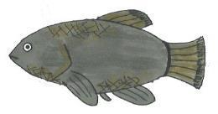 | 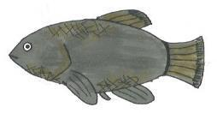
Fish G | Fish H
Salinity: Can survive in fresh water with  low salinity.  Temperature for laying eggs: Can lay  eggs only at 75–86° F (24–30° C).  Breeding habits: Lays eggs year-round. | Salinity: Can survive in fresh water with  low salinity.  Temperature for laying eggs: Can lay  eggs only at 75–86° F (24–30° C).  Breeding habits: Lays eggs in the spring.  These eggs can remain in algae when water levels go down and hatch when water levels return the next year.

Environment Cards
Lesson 1 │ page 1 of 1

Environment #1: Amargosa River
The Amargosa River runs through a canyon east of Death Valley. Its name is a bit
misleading, as this “river” is actually a small stream less than 2 meters wide and about
2.5 meters deep. The water in this part of the river is in constant motion year-round.
Water temperatures in the Amargosa River range from 35–112° F (2–44° C) during the
year. The temperature also changes significantly during a single day. Water at night can
be over 60 degrees cooler than it is in the morning. The salinity (amount of salt in the
water) is moderate.

Environment #2: Big Spring
Big Spring is located in the Ash Meadows National Wildlife Preserve in Nevada. It is just
across the state border from California. Here, water rises up from underground to form a pool. The size of this spring is relatively stable. The salinity (amount of salt in the water) is very low. Big Spring stays at a mostly constant temperature, around 80–90° F (27–32° C).

Environment #3: Salt Creek

Salt Creek is a small stream on the floor of Death Valley. Part of the stream dries up
during summer and fall. Salt Creek is two to three times saltier than ocean water. Water
temperature varies greatly in the creek, from freezing to temperatures over 110° F (43° C).

Interactive Word Wall Cards
Lesson 1 │ page 1 of 2

Adaptation

Evolution

Interactive Word Wall Cards
Lesson 1 │ page 2 of 2

Natural Selection

Species

Pupfish – VISUAL AID
Lesson 1 │ page 1 of 1

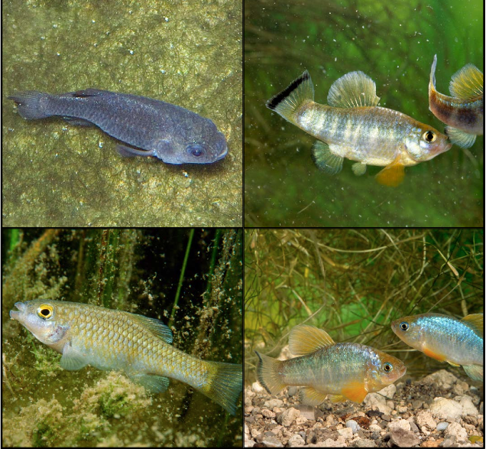

Source: National Geographic Society
http://voices.nationalgeographic.com/2008/10/13/pupfish/

Notes About the Tegula Snail
Lesson 2 │ page 1 of 1

Part 1
The Tegula funebralis snail, also known as the black turban snail, lives in tide pools along the coast of California. The Tegula snail eats algae which grows on the rocks in the tide pools. Tegula snails can live above the tide line for short periods.
Octopi, sea stars, and crabs eat Tegula snails. Octopi, sea stars, and crabs are generally found in deeper areas in tide pools. There are more of these predators in southern California tide pools than in northern California tide pools.
Tegula snails in northern California behave differently from the snails in southern California. In northern California, these snails prefer to live in deeper areas of the tide pools. In southern California, these snails tend to live in shallower areas of the tide pools.
Part 2
Scientists wanted to know if the difference in behavior between the northern and southern California Tegula snails was an inherited behavior or a learned behavior.
They conducted an experiment by placing a sample with both northern and Southern Tegula snails in a deep area within a tide pool.
During the experiment, the scientists observed that when predators were in the tide pool with the snails, both the northern and southern California snails moved to shallower areas in the tide pool. The difference they discovered was that the southern California snails moved more quickly and to higher areas in the tide pool than the northern California snails. The scientists concluded that the predators were more likely to eat the northern California snails.
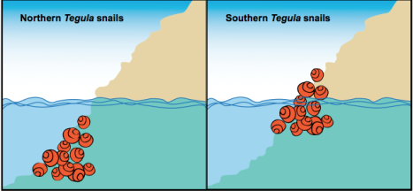

Evolution Research Project #1
Lesson 2 │ page 1 of 1

Purple Pitcher Plant Mosquito:

This non-biting mosquito lives its entire life on a purple pitcher plant. These mosquitoes are found in the northeastern United States, and they hibernate during the winters, which can be quite cold in that part of the country. Several genes control the timing of the onset of hibernation in mosquitoes. The length of the day, not temperature, is the cue for hibernation to begin. The timing of the onset of hibernation is critical to the mosquito’s survival; if hibernation is begun too early, the mosquito will not have enough nutrients stored in its body to last throughout the winter. On the other hand, if it delays the beginning of hibernation for too long, it will freeze to death. The mosquito most likely to survive and reproduce is the one whose hibernation begins at just the right time— the one that has the most time to eat before hibernating, but does not freeze to death.

What the Scientists Found:

Christina Holzapfel and her husband William Bradshaw are biologists. They have been collecting and examining mosquitoes from New England for over 30 years. They noticed two important changes during that time. In New England, winter temperatures went up by an average of 4.4° F (2.4° C). That means that mosquitoes could eat and reproduce later into the year. The behavior of the mosquitoes also changed: they began to hibernate, on average, nine days later.

Evolution Research Project #2
Lesson 2 │ page 1 of 1

Kauai Field Cricket:

Field crickets live on the island of Kauai in Hawaii. Male crickets have small scrapers on their wings. Rubbing the wings together makes a chirping sound that attracts female crickets to mate; but the chirping also attracts flies. A deadly fly called Ormia ochracea recently arrived in Kauai from North America. It lays its eggs on the bodies of the field crickets, and the eggs develop into maggots (the larvae of the fly). The maggots burrow into the body of the cricket to eat, killing the cricket in the process.

What the Scientists Found:

Marlene Zuk is a Professor of Biology at the University of California, Riverside. In 1991, she began studying field crickets in Kauai, and she found that the size of their population dropped every year. By 2001, there were hardly any crickets left, because most of them had been eaten by the maggots of the fly that had been introduced onto the island. However, a new mutation appeared in the cricket population that resulted in some male crickets having flat wings. These wings could not make a chirping sound. Male crickets depend upon “singing,” the chirping sound made by their wings, to attract females during mating season. But even though this mutation and new trait made it more difficult to mate, it protected these silent male crickets from the flies by making it more difficult for the flies to find them. By 2003, over 90% of male crickets had flat, silent wings. Scientists believe that mutant males gather near male crickets that can still sing so that females can find and mate with them.
Evolution Research Project #3
Lesson 2 │ page 1 of 1

Escherichia coli (E. coli):

E. coli is a kind of bacteria that grows in the lower intestines of animals. It can also be grown easily in Petri dishes in laboratories, and it reproduces rapidly. In a laboratory setting, E. coli eat glucose, a kind of sugar. Other kinds of nutrients are also put in Petri dishes, though E. coli usually cannot use them. | 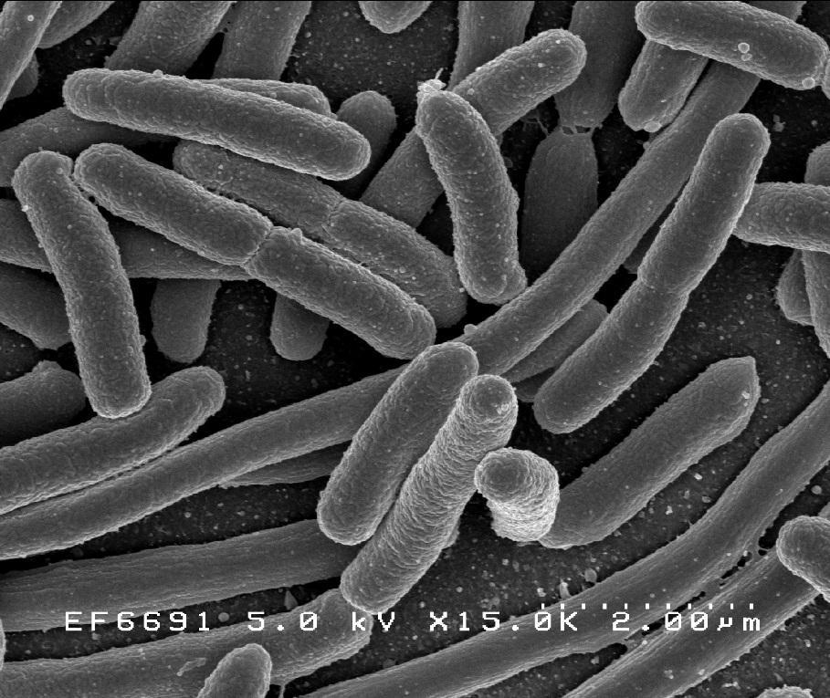  E. coli  NIAID – National Institute of Allergy and Infectious Diseases  http://www.niaid.nih.gov/SiteCollectionImages/topics/biodefenserelated/e_coli.jpg

What the Scientists Found:

Richard Lenski is a Biologist at Michigan State University. Twenty years ago, he took a single E. coli cell, fed it, and watched it reproduce. He paid attention to what kinds of food the bacteria could use. He continued to feed the next generation of bacteria, and the next. From that first cell, he has now grown over 44,000 generations of bacteria. Each generation exhibited new genetic mutations. In the 31,500th generation, Lenski noticed something new about his bacteria. Some of them had a genetic mutation that allowed them to use a nutrient called citrate. His first E. coli could not use citrate, but these new bacteria could. The bacteria with this trait began to increase in his laboratory population.

Evolution Research Project #4
Lesson 2 │ page 1 of 1

Guppies:

Some guppies live in pools and streams on the island of Trinidad. Different parts of each stream contain different-looking guppies. Some pools are full of fish with bright colors or spots that stand out against the bottom of the pool. Others contain rather drab guppies that are camouflaged against the bottom of the pool. Guppies that are brightly colored or show up well in their pool are more likely to attract mates. Guppies that do not stand out are less likely to be eaten by predators.

What the Scientists Found:

Biologist John Endler studies guppies in the wild and in the laboratory. Endler thought that guppies with spots that were noticeable against the colors of the pool would have more success in attracting mates. He also realized that noticeable spots would probably make the guppy more visible to predators. But in pools with an absence of predators, he wondered if guppy populations would have a higher number of individuals with those spots, because of the advantage the spots would give the guppy at mating time. In order to answer this question, he conducted an experiment.

Evolution and Diversity Journal 2
Lesson 2 │ page 1 of 1

Name: _________________________________
Instructions: Read and respond to the prompt as directed during the lesson.

Topic: Evolution notes

Prompt: Hypothesize why the Tegula snails seem to live in different places and what might be causing this difference.

______________________________________________________________________________________________________________________________________________________________________________________________________________________________________

Instructions: Summarize what you learned, based on the Evolution Notes visual aids.
Notes on Variation:
_______________________________________________________________________________________________________________________________________________________________________________________________________________________________________

Notes on Environment:
_______________________________________________________________________________________________________________________________________________________________________________________________________________________________________

Notes on Natural Selection:
__________________________________________________________________________________________________________________________________________________________
_________________________________________________________________________________________________________________________

Evidence of Evolution
Lesson 2 │ page 1 of 1

Name: _________________________________
Instructions: Use the information in Evolution Research Projects #1–4 to complete the chart below. (1 point for each cell)

 | Research Project #1: Purple Pitcher Plant Mosquitoes | Research Project #2: Kauai Field Crickets | Research Project #3: E. coli Bacteria | Research Project #4: Guppies
What trait did the researchers study?
How did this trait vary in the population?
What
environmental
condition or
environmental
change put selection pressure on this trait?
Which version
of the trait is
most adaptive
for this
environment?
Why is this
variation of the trait considered an
adaptation?
How has the
population evolved over time?
Tegula Snail Research-VISUAL AID
Lesson 2 │ page 1 of 1

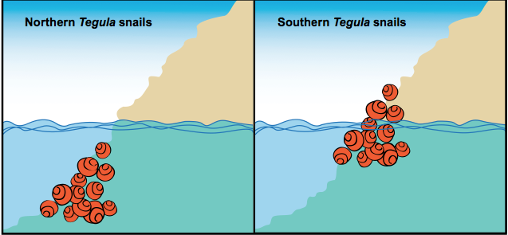

Evolution Notes - #1
Lesson 2 │ page 1 of 1

Name: _________________________________

Variation…
A species of organisms displays variety in inherited traits.
If the genes for a trait do not exist in a population, that trait cannot be selected.
Genetic mutations result in different new traits (some beneficial, some detrimental, some with no effect).
Mutations are random, but selection of their traits expressed in a population is not random.

… allows for Natural Selection.

Evolution Notes - #2
Lesson 2 │ page 1 of 1

Name: _________________________________

Environment…
In certain environments, some traits are more useful than others.

Those traits that are favorable in that environment are adaptations.
Adaptations allow an organism to survive and reproduce in a particular environment. When an environment changes (due to human activities, natural disasters, and more), the traits that are adaptive and get “selected” may change.

… results in Natural Selection.

Evolution Notes - #3
Lesson 2 │ page 1 of 1

Name: _________________________________

Variation Environment

Natural Selection

A trait is more likely to be passed on to the next generation when it helps the organism to:
- Survive (avoid predators; find food)
- Find a mate
- Reproduce

Traits that help an organism to do these three things (survive, find a mate, and reproduce) are more likely to be found in more offspring in subsequent populations.

How to Make an Origami Bird Beak
Lesson 3 │ page 1 of 1
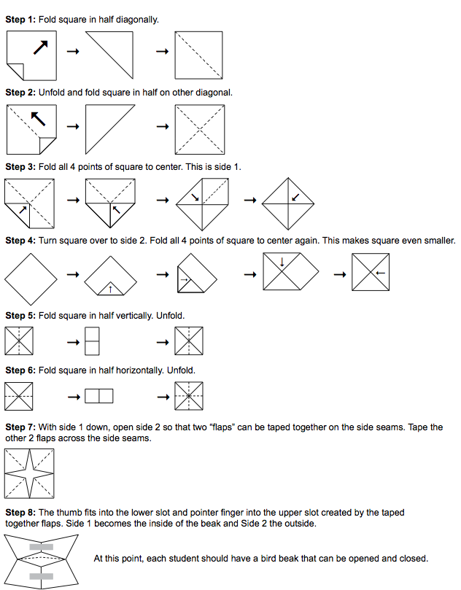

Evolution and Diversity Journal 3
Lesson 3 │ page 1 of 1

Name: _________________________________
Instructions: Read and respond to the prompt as directed during the lesson.

Topic: Genetic variation

Prompt: Think about the many different people in our class. What are three examples of genetic variation in humans?
__________________________________________________________________________________________________________________________________________________________________________________________________________________________________________________________________________________________________________________________________________________________________________________________________________________________________________________________________________________________________________________________________________________________________________________________________________________________________________________________________________________________________________________________________________________________________________________________________________________________________________________________________________________________________________________________________________________________________________

Variation and Natural Selection
Lesson 3 │ page 1 of 4

Name: _________________________________
Instructions: Play Rounds 1 to 4 and record your findings in the charts below.

Round 1
Environmental factors: It has been an average weather season in Origami Bird Land. There has been a mix of food types, both large (marbles) and small (rice).
Name of bird (student) | Small or large beak? | Number of rice grains eaten | Number of marbles eaten | Did it survive? | How many offspring did it have?
After Round 1, there were: _________ small-beaked birds _________ large-beaked birds

Round 2
Environmental factors: It has been a very wet season in Origami Bird Land. Small food (rice) are very plentiful. There is less large food (marbles).
Name of bird (student) | Small or large beak? | Number of rice grains eaten | Number of marbles eaten | Did it survive? | How many offspring did it have?
After Round 2, there were: _________ small-beaked birds _________ large-beaked birds

Variation and Natural Selection
Lesson 3 │ page 2 of 4

Name: _________________________________
Round 3
Environmental factors: It has been a very dry season in Origami Bird Land. There is mainly large-size food (marbles); almost all of the small-sized food (rice) is gone.
Name of bird (student) | Small or large beak? | Number of rice grains eaten | Number of marbles eaten | Did it survive? | How many offspring did it have?
After Round 3, there were: _________ small-beaked birds _________ large-beaked birds

Round 4
Environmental factors: ______________________________________________________________________________________________
Name of bird (student) | Small or large beak? | Number of rice grains eaten | Number of marbles eaten | Did it survive? | How many offspring did it have?
After Round 4, there were: ______ small-beaked birds ______ large-beaked birds ______ very large-beaked birds

Variation and Natural Selection
Lesson 3 │ page 3 of 4

Name: _________________________________
Instructions: Using information from today’s lesson, answer the following questions. (2 points each)

- What kinds of birds survived and reproduced in a rainy climate? Which reproduced the most?
____________________________________________________________________________________________________________________________________________________________________________________________________________________________________________________________________
_________________________________________________________________

- What kinds of birds survived and reproduced in a dry climate? Which reproduced the most?
____________________________________________________________________________________________________________________________________________________________________________________________________________________________________________________________________
_________________________________________________________________

- What would happen if there were only small-beaked birds in a dry climate? Why?
___________________________________________________________________________________________________________________________________________________________________________________________________
_________________________________________________________________

Variation and Natural Selection
Lesson 3 │ page 4 of 4

Name: _________________________________
- If the only kinds of food available were very large (larger than the marbles), what would happen to the bird population that existed at the end of Round 2? Why?

____________________________________________________________________________________________________________________________________________________________________________________________________________________________________________________________________
_________________________________________________________________

- If the only kinds of food available were very large (larger than the marbles), what would happen to the bird population after Round 4? Why?

____________________________________________________________________________________________________________________________________________________________________________________________________________________________________________________________________

- Is there a “best” kind of bird beak? Why or why not?

____________________________________________________________________________________________________________________________________________________________________________________________________________________________________________________________________
_________________________________________________________________

Darwin’s Finches-VISUAL AID
Lesson 3 │ page 1 of 1
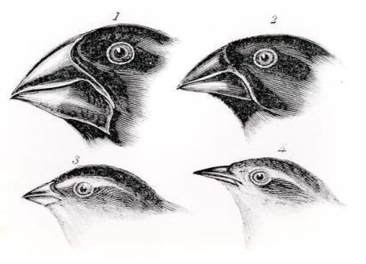
Darwin’s Bird Observations
PBS Learning Media: Image Provided by The Bridgeman Art Library
http://www.pbslearningmedia.org/resource/xjf271660eng/darwins-bird-observations-xjf271660-eng/

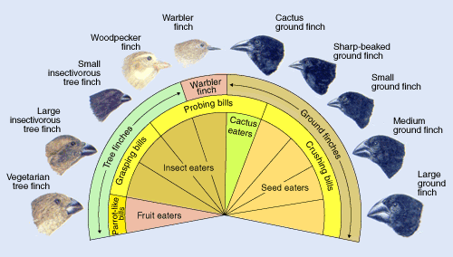
Adaptive Radiation: Darwin’s Finches
PBS Learning Media: Image Provided by Evolution Series
http://www.pbslearningmedia.org/resource/xjf271660eng/darwins-bird-observations-xjf271660-eng/

Massachusetts’ Climate Zones
Lesson 4 │ page 1 of 3

Topographical Map of Massachusetts:
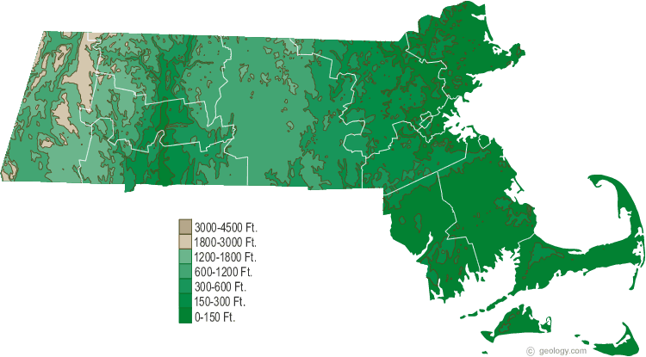
Source: http://geology.com/topographic-physical-map/massachusetts.shtml

Mean Annual Precipitation
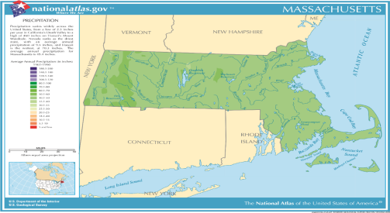
Source: file:///C:/Users/User/Desktop/JP/DESE%20MCUs/pageprecip_ma3.pdf

Lesson 4 │ page 2 of 3

Mean Annual Daily Maximum Temperature

Source: http://nationalmap.gov/small_scale/printable/images/pdf/climate/max_temp_6.pdf
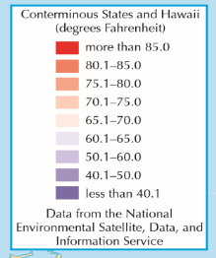
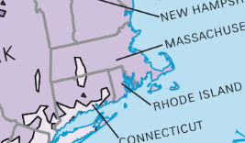

Mean Annual Daily Minimum Temperature

Source: http://nationalmap.gov/small_scale/printable/images/pdf/climate/min_temp_5.pdf
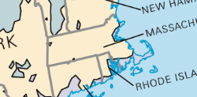
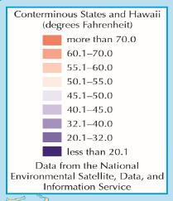

Massachusetts’ Climate Zones
Lesson 4 │ page 3 of 3

Medium Annual Length of Freeze Free Period

Source: http://nationalmap.gov/small_scale/printable/images/pdf/climate/freeze_free_2.pdf
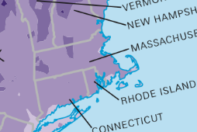
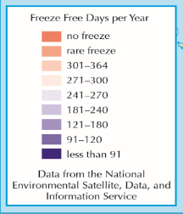

Massachusetts Species Descriptions
Lesson 4 │ page 1 of 4

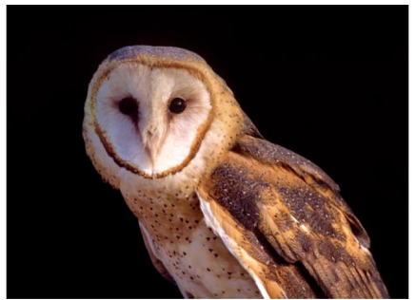
Barn Owl
Tyto alba

The barn owl has a unique heart-shaped face with darken eyes. These birds have long wings and a short tail. Barn Owls are medium-sized owls and are 13-14 inches in height and have a wing-span of 38-44 inches. This specie lives in grassy habitats where they can forage for food. Often they are found living near fresh and salt water marshes, as wells crop fields. The Barn Owl tends to avoid deep snow and prolonged cold. It tends to nest in hollow trees and cavities in cliffs or riverbanks. Often these birds prefer to stay put in the winter and avoid migrating to warmer climates. Photo by Bill Byrne, MassWildlife
Source: Mass.gov – Energy and Environmental Affairs
Natural Heritage Endangered Species Program
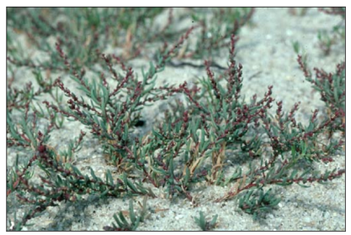
American Sea-blite
Suaeda calceoliformis

This annual plant flowers red and purple tips. It grows best in sandy areas and 20-30 cm tall. The American Sea-blite is found in salty habitats, such as salt ponds, boarders of salt marshes and estuaries, beaches, and tidal flats. Sometimes this plant is found on the protected side of a low dune.

Photo by Bruce Sorrie
Source: Mass.gov – Energy and Environmental Affairs
Natural Heritage Endangered Species Program

Massachusetts Species Descriptions
Lesson 4 │ page 2 of 4

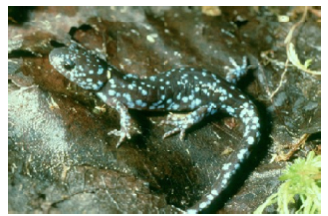
Blue-spotted Salamander
Tyto alba

The Blue-spotted Salamander is a visually unique specie. It is dark blue
to black with “brilliant sky-blue” spots. It a slender specie with short limbs. These salamanders live in moist, moderately shaded habitat. They tend to live in forest areas, but need a water source, such as a pond, to reproduce. The water source must have grass or dead/decaying leaves in order for the salamander to deposit its eggs.

Photo by Bill Byrne
Source: Mass.gov – Energy and Environmental Affairs
Natural Heritage Endangered Species Program

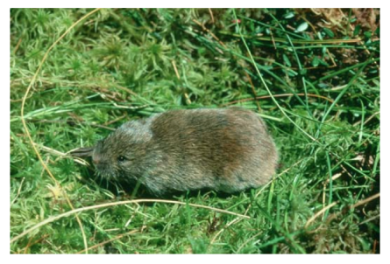
Southern Bog Lemming
Synaptomys cooperi

Southern Bog Lemmings have small eyes and ears that are almost hidden by its long, loose, shaggy fur. The rodent is small (11.5-13.5 cm long) and with a short tail. Interestingly, the front feet of this specie has four toes and the back feet have five toes. This specie has varying habitats, ranging from bogs, clear-cut forests, open grasslands, orchards, and cornfields.

Source: Mass.gov – Energy and Environmental Affairs
Natural Heritage Endangered Species Program

Massachusetts Species Descriptions
Lesson 4 │ page 3 of 4

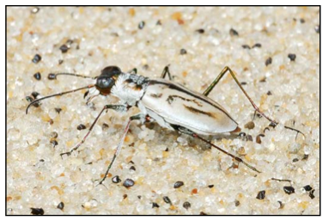
Northeastern Beach Tiger Beetle
Cicindela dorsalis dorsalis

This endangered beetle is a predator in coastal regions. The Northeastern Beach Tiger Beetle is 13-15 mm long with a bronze body. They were named for their “tiger-like” tendencies of chasing down and capturing their prey. This specie is typically found in expansive beaches that have little human disturbance.

Photo by M. W. Nelson
Source: Mass.gov – Energy and Environmental Affairs
Natural Heritage Endangered Species Program
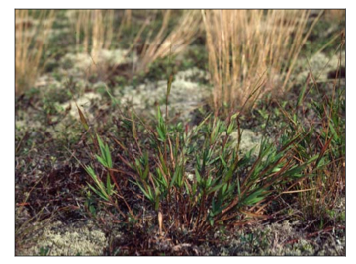
Commons’s Panic-grass
Dichanthelium ovale

This plant is a short perennial that is hairy spikes. The height of the Commons’s Panic-grass ranges from 15-60 cm. It is part of the Grass family and grows in clumps throughout the summer. The grass is usually found in dry, sandy habitats along the coast. The grass has also been known to grow in dry pine-woods.

Photo by Bruce Sorrie
Source: Mass.gov – Energy and Environmental Affairs
Natural Heritage Endangered Species Program

Massachusetts Species Descriptions
Lesson 4 │ page 4 of 4

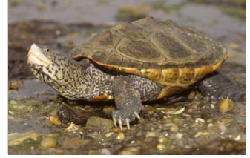
Diamond-back Terrapin
Malaclemys terrapin

The Diamond-back Terrapin specie is a medium-sized salt marsh turtle. The top shell of this specie varies in color from grays and black to greens and light browns. Their skin is grayish to black with dark green flecks. They live in marshes that surround quiet salt or brackish tidal waters. They have also been known to live in shallow bays and tidal estuaries. Although they need water, the Diamond-back Terrapin also needs to live near sandy dry upland areas that provide a nesting site. Photo by Bill Byrne Source: Mass.gov – Energy and Environmental Affairs
Natural Heritage Endangered Species Program

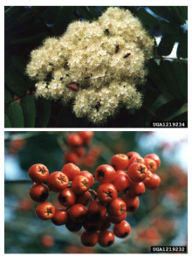
Northern Mountain Ash
Sorbus decora

The Northern Mountain Ash is either a small
tree or a tall shrub. It can grow up to
10 m high. The leaves are long and dark-
blue in color. The flowers are small, white petals. The Northern Mountain Ash bares bright reddish-orange
fruit. This plant grows on mountain slopes. They
need moist or dry rocky soils in order to grow.
The Northern Mountain Ash are found in northern
hardwood-spruce or spruce-fir forests.

Photo by Bill Cook, Michigan State University, Bugwood.org
Source: Mass.gov – Energy and Environmental Affairs
Natural Heritage Endangered Species Program

Evolution and Diversity Journal
Lesson 4 │ page 1 of 1

Name: _________________________________________

Instructions: Read and respond to the prompt as directed during the lesson.

Topic: Environmental Factors and Evolution

Prompt: We have seen how species evolve differently depending on environmental conditions over time. Different features of an environment make particular variations of a trait adaptive for a species. What is one example of this principle from our unit so far?
________________________________________________________________________________________________________________________________________________________________________________________________________________________________________________________________________________________________________________________________________________________________________________________________________________________________________________________________________________________________________________________________________________________________________________________________________________________________________________________________________________________________________________________________________________________________________________________________________________________________________________________________________________________________________________________________________________________________________________________________________________________________________________________________________________________________________________________________________________________________________________________________________________________________________________________________________________
Traits for Survival
Lesson 4 │ page 1 of 3

Name: _________________________________________
Part 1
Instructions: Use the chart below to describe different environments in Massachusetts. For each row:

- Use the latitude and longitude to find the location on the Massachusetts Political map.
- Use the colors on the Topographical Map of Massachusetts to find the elevation at this location. Describe the elevation using the categories “low,” “medium,” “high,” or “very high.”
- Use the Massachusetts Political map and the Topographical Map of Massachusetts to describe whether the geology of this region contains mountains, valleys, or whether it is on the coast.
- Use Massachusetts’ Climate Zones, to find the climatic zone for this location. Describe the climatic in your own words.

Location | Elevation:  Low = 0–1,000 feet  Medium = 1,000–5,000 feet  High = 5,000–10,000 feet  Very High = over 10,000 feet | Geographical Region:  Describe the geology of region – mountains, valleys, or coast. | Climate:  Describe the climate.
New Bedford
(41.6° N, 70.9° W)

Nantucket Island
(41.3° N, 70.1° W)

Pittsfield
(42.5° N, 73.2° W)

Provincetown
(42.1° N, 70.2° W)

Adams
(42.6° N, 73.1° W)

Lowell
(42.6° N, 71.3° W)

Gloucester
(42.6° N, 70.7° W)

Fitchburg
(42.6° N, 71.8° W)

Traits for Survival
Lesson 4 │ page 2 of 3

Name: _________________________________________
Part 2
Instructions: Read the description of each plant or animal on the Massachusetts Species
Descriptions. Look at the adaptations these species have. Think about what environmental factors would cause these adaptations to be selected over time. Match each species with its possible environment. Put the letter of the matching location next to the correct species.
A. Adams
B. Fitchburg
C. Gloucester
D. Lowell
E. Nantucket Island
F. New Bedford
G. Pittsfield
H. Provincetown
Barn Owl live near Location _________________
American Sea-blite live near Location ______________
Blue-spotted Salamander live near Location _____________
Southern Bog Lemming live near Location________
Northeastern Beach Tiger Beetle live near Location _______________
Commons’s Panic-grass live near Location _________________
Diamond-back Terrapin lives near Location___________
Northern Mountain Ash live near Location ______________

Part 3
Instructions: Answer the following questions in the spaces provided. (2 points each)

- Pick a species from the list above and answer the questions below about that species.
__________________________________________________________________________
What is an adaptation that this species has?
____________________________________________________________________________________________________________________________________________________________________________________________________________________________________________________________________________________________________________
What kind of environmental factor would exert selection pressure for this trait and make the trait adaptive?
__________________________________________________________________________________________________________________________________________________________________________________________________________________________________________

Traits for Survival
Lesson 4 │ page 3 of 3

Name: _________________________________________
- Why does Massachusetts have such a diversity of species?
______________________________________________________________________________________________________________________________________________________________________________________________________________________________
____________________________________________________________________________________________________________________________________________________

Instructions: Many of the species you studied today live in environments that are changing. Read about each change below. Think about what you know about evolution, and predict what you think could happen to this species in response to this change. (2 points each)

- Temperatures at very high elevations have been getting warmer. How do you think this could affect the evolution of the Northern Mountain Ash?
______________________________________________________________________________________________________________________________________________________________________________________________________________________________
______________________________________________________________________________________________________________________________________________________________________________________________________________________________

- Scientists have been planting more coastal buckwheat on beaches. How do you think this could affect the American Sea-blithe?
______________________________________________________________________________________________________________________________________________________________________________________________________________________________
____________________________________________________________________________________________________________________________________________________

Massachusetts Political Map – VISUAL AID
Lesson 4 │ page 1 of 1
Massachusetts Political Map: Cities and Towns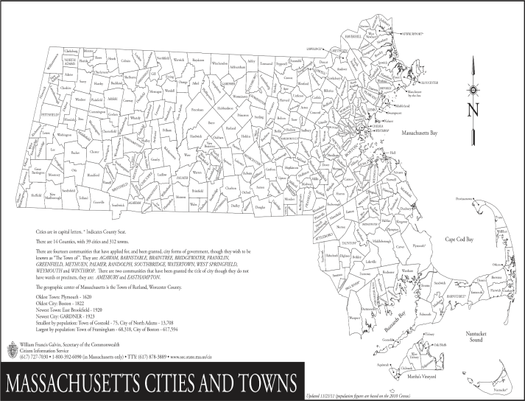
Source: http://www.sec.state.ma.us/cis/cispdf/City_Town_Map.pdf

Massachusetts Longitude and Latitude Map – VISUAL AID
Massachusetts Political Map Cities and Towns
Lesson 4 │ page 1 of 1

Massachusetts Longitude and Latitude Map: City and Town Boundaries

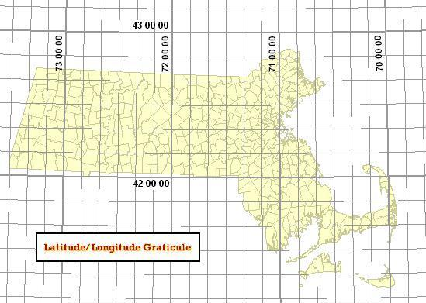

Source: http://www.mass.gov/anf/images/itd/massgis/datalayers/minll.jpg

Resource Reading
Lesson 5 │ page 1 of 4

Greater Prairie Chicken
The greater prairie chicken was once very common in North America. These prairie chickens are not the same as chickens that people raise for food. They are a wild species that live in the tall grasses of the prairies. Male birds have distinctive golden pouches on the sides of their necks. They inflate these pouches to attract females. The population of prairie chickens has disappeared in Canada and dropped significantly in the United States over the past 100 years.
Tall grass prairies used to cover 400,000 square miles of land in the United States. This is equivalent to 15% of the land in the lower 48 states. Since the 19th century, farmers have cleared these prairies to create farms. Only 5% of the tall grass prairies still exist in the United States.
As tall grass prairies have disappeared, so have prairie chickens. Lack of habitat has forced birds into smaller geographic areas. Small populations of these birds still exist, though they are isolated from one another. One study of prairie chickens in Illinois highlights this. In 1933, 25,000 prairie chickens lived in Illinois. By 1962, 2,000 birds lived in one of three groups. By 1994, fewer than 50 birds remained. All of the offspring in present-day populations have come from those remaining 50 birds. With so few birds reproducing, there is a smaller variety of genes to be passed on. As a result, offspring have very similar traits.
Having such a small gene pool has posed a problem for this bird species. If a harmful gene exists in one bird, it often exists in others, because all of the birds are genetically similar. Two mating birds can both pass on copies of this harmful gene to offspring. Inheriting the harmful gene from both parents can prevent eggs from hatching. This causes populations of prairie chickens to have lower hatch rates.
(A hatch rate is the percentage of eggs that hatch successfully.) In 1990, the hatch rate in the prairie chicken populations was only 38%. Looking at it another way, 62% of the eggs that the birds laid had harmful combinations of genes and could not survive.
Scientists predicted that the prairie chickens in Illinois could not survive without introducing a greater variety of genes into the gene pool. They brought birds from Kansas and Minnesota to add to the three groups in Illinois. After this intervention, the hatch rate increased. The population of prairie chickens in Illinois has started to grow again.

Resource Reading
Lesson 5 │ page 2 of 4

Lumper Potatoes

In the early 1800s, Ireland’s population grew rapidly. In order to feed increasing numbers of people, farmers began to change the way they farmed. A type of potato known as the “lumper” became very popular. While this potato was one of the worst-tasting potatoes around, it was very fertile. An entire family could feed itself for a year on just a small plot of lumpers. The poor people of Ireland did not have much land for farming. They used the little land they did have to grow lumper potatoes. For millions of people in Ireland, the lumper potato became the main source of food. Before 1800, many kinds of potatoes, as well as grains and vegetables, were grown in Ireland for everyone. By 1800, 90% of Ireland’s people lived almost entirely off of lumper potatoes.
In the wild, hundreds of different kinds of potatoes grow together. Bumblebees carry pollen from one potato plant to another to help them reproduce. But farmers grow potatoes differently. Farmers take a potato and cut out a small section. They then plant this section to grow a new potato plant. This produces potatoes that are genetically identical to their parents. The new potatoes are actually clones of the ones they grew from. By 1845, identical lumper potatoes filled the fields of Ireland.
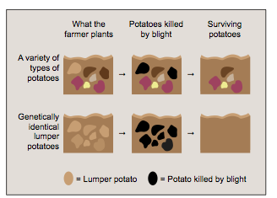
In 1845, a fungus from North America called “late blight” accidentally arrived in Ireland. This fungus grew on the lumper potatoes. Farmers dug the potatoes out of the ground, and within a few days, the potatoes turned into a slimy, black mess. Other varieties of potatoes have genes that resist blight. Because the lumper potatoes were genetically identical to one another, none of them had the genes to resist the fungus. Mutation would still provide some genetic variation in the potato population; however, in 1845, 40% of the potato crop failed, and by 1846, blight destroyed 100% of the lumper crop. In Ireland, this period of time is known as “The Great Hunger.” An estimated 1.5 million people died of starvation and disease because of the blight. This represented one out of every eight people in Ireland.
Other countries experienced blight, too. In the United States, Canada, and in other parts of Europe, blight killed lumper potato crops. These places did not experience severe starvation, because farmers there grew other potato species. Other species survived because they still had enough genetic variation, including some potatoes with a genetic trait that could resist blight.
Susceptibility to blight diagram
Resource Reading
Lesson 5 │ page 3 of 4

Northern Elephant Seal

The northern elephant seal lives in the North Pacific Ocean, from Baja, Mexico, to the Gulf of Alaska. This seal is the second largest seal in the world. Adult males can grow to over 13 feet long and weigh up to 4,500 pounds. These seals spend their breeding season on a few remote beaches and islands in California and Mexico. During the rest of the year, they live in the open ocean.
In the 1700s and 1800s, hunters killed thousands of elephant seals. They mainly used their blubber, or fat, as lamp oil. By 1892, there were only 20 to 100 elephant seals left in the world. These seals had bred on just one island off the coast of Mexico. The Mexican and United States governments began to protect these seals. Those few seals that were left reproduced. The population of elephant seals grew rapidly.
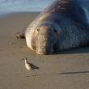
There are now over 150,000 elephant seals. All of these seals came from those few ancestors who were protected—the 20 to 100 seals that lived in 1892. This means that the current population of seals have very little genetic variation, because they all came from such a small number of parents. Even though there are many seals alive today, some scientists are concerned that they could become extinct. With the small amount of genetic variability in the gene pool that random mutations provide, these seals do not have as many potential adaptations available. Scientists worry that a change in the environment, such as a new disease, could kill all the seals. If one seal does not have the genes to fight a new disease, other seals are also unlikely to have them.
Northern Elephant Seal

NOAA Picture Library https://search.usa.gov/search/images?utf8=✓&affiliate=photolib.noaa.gov&query=northern+elephant+seal

Resource Reading
Lesson 5 │ page 4 of 4

Sweet Vernal Grass
Sweet vernal grass has a vanilla-like smell when it is cut. Because of this pleasant scent, many people like to plant it. This grass originally grew in Europe and Asia, but now has spread throughout the Americas and Africa. Sweet vernal grass can be found in many counties in California. Scientists have studied this grass because it seems to survive in a wide variety of environments.
In the 1800s, miners in the United Kingdom mined lead and zinc at the Trelogan mine. In the process, miners left piles of mine tailings. Tailings are a byproduct of mining; they are the materials that remain after miners have finished processing the metals they take out of the ground. These tailings are still around today, and as a result, the soil near the mine has high levels of zinc and lead. Farther away from the mine, the soil does not have these metals. Sweet vernal grasses grow in both of these places.
Scientists have studied the sweet vernal grass that grows at the Trelogan mine, as well as at other mines. They have discovered some amazing differences in the grasses. The grasses that grow on the tailings have a high tolerance for metals. These grasses actually die when they are grown in soil without metals. In contrast, the grasses that grow away from the tailings cannot tolerate metals in the soil.
These two populations of grasses have changed over time in another way. They produce flowers at different times of the year. Pollen from grasses is spread by the wind. Pollen blows from the flowers of one plant to the flowers of another in order to reproduce. Now that the two populations of grasses develop flowers at different times of the year, pollen cannot spread between the type that lives near the mines and the type that lives far away. This means the two types of grasses can no longer reproduce together. Reproducing at different times might be a favorable adaptation for the grass. Because each population can only survive well in its own kind of soil, breeding with the other population would bring the genes into the population that would prevent offspring from surviving. Over time, these populations of grasses may evolve into two separate species.

Evolution and Diversity Journal 5
Lesson 5 │ page 1 of 1

Name: _________________________________
Instructions: Read and respond to the prompts as directed during the lesson.

Topic: Human Activities and Evolution

Prompt 1: How did humans affect the reproduction process of bananas?
________________________________________________________________________________________________________________________________________________________________________________________________________________________________________________________________________________________________________________________________________________________________________________________________________________________________
________________________________________________________________________________________________________

Prompt 2: How did human activity affect the genetic variation of the banana?
________________________________________________________________________________________________________________________________________________________________________________________________________________________________________________________________________________________________________________________________________________________________________________________________________________________________
________________________________________________________________________________________________________

Prompt 3: Which population of banana would be more likely to survive a change in the environmental conditions? Wild bananas or the type of banana at your table?
________________________________________________________________________________________________________________________________________________________________________________________________________________________________________________________________________________________________________________________________________________________________________________________________________________________________
________________________________________________________________________________________________________
Mini-lecture Notes
Lesson 5 │ page 1 of 1

Name: _________________________________
Wild Bananas
- wild bananas do indeed have seeds
- wild banana plants often grow alongside many different kinds of plants, including different kinds of bananas
- birds transfer pollen from one banana flower to another so that seeds can be fertilized - this pollination mixes the genes from different banana plants.
Farmers and Bananas
- farmers have grown bananas for over 1,000 years
- farmers have done two things to help create the kind of bananas that we are accustomed to eating today:
  - first, they selected banana plants that produced fruit with a mutation that caused them not to make seeds (because people preferred to buy/eat the fruit without seeds)
  - second, without seeds, farmers created new plants by cutting parts of the roots of a parent plant and growing a new plant from these roots
- this means that all the new banana plants have the same genes as the parent plant; in other words, the new banana plants are clones
The Bananas in Front of You
- the banana at their table is a Cavendish banana, the most common banana in the world
- this kind of banana is grown, distributed, and eaten all around the world
- Cavendish bananas are all almost identical genetically, which makes this species less likely to survive environmental changes
- in the 1960s, the most common banana was a variety called the Gros Michel - it, too, had very little genetic variation in the gene pool.
- in the 1950s the Gros Michel bananas were infested with a fungus called the “Panama Disease,” which attacks the roots of the plant - Large plantations of Gros Michel bananas were destroyed
- as a result, the once large plantations of Gros Michel, which some say is a better tasting banana, now grow the Cavendish variety

Human Activities and Evolution
Lesson 5 │ page 1 of 2

Name: _________________________________
Instructions: Complete the chart below with information from Resource Readings. (1 point per cell)
 | Greater Prairie Chickens | Lumper Potatoes
List the human activities
that have affected this
species.
How did human actions
cause this species’
environment to change?
Did human actions cause
genetic variation in this
species to change? How?
What was the effect of these
changes on the evolution of
this species?

Human Activities and Evolution
Lesson 5 │ page 2 of 2

Name: _________________________________
Instructions: Complete the chart below with information from Resource Readings. (1 point per cell)
 | Northern Elephant Seal | Sweet Vernal Grass
List the human activities
that have affected this
species.
How did human actions
cause this species’
environment to change?
Did human actions cause
genetic variation in this
species to change? How?
What was the effect of these
changes on the evolution of
this species?

Evolution and Diversity Journal 6
Lesson 6 │ page 1 of 1

Name: _________________________________
Instructions: Read and respond to the prompts as directed during the lesson.

Topic: More on Human Activities and Evolution

Prompt: Think about all the species we have studied in this unit. Select one that has been affected by human activity. Describe the activity. What effect did this activity have on the evolution of the species?
___________________________________________________________________________________________________________________________________________________________________________________________________________________________________________________________________________________________________________________________________________________________________________________________________________________________________________________________________________________________________________________________________________________________________________________________________________________________________________________________________________________________________________________________________________________________________________________________________________________________________________________________________________________________________________________________________________________________________________________________________________________________________________________________________________________________________________________________________________________________________________________________________

Summary: Human Influence on Evolution
Lesson 6 │ page 1 of 4

Name: _________________________________
Part 1
Instructions: Complete the two flowcharts below, one for each species of pupfish (Tecopa pupfish and Devil’s Hole pupfish). (5 points each flowchart)
- In the first section, describe the kinds of human activities that have affected these fish. Think about how these activities have affected the species.
- In the second section, describe how the species’ environment has changed.
- In the third section, describe how the species’ chances of surviving and reproducing have changed.
- In the fourth section, describe the species’ level of genetic variation. If humans altered this level of variation, how did that happen?
- In the fifth section, summarize how human activity has affected the evolution of each species of pupfish. Use the word “adaptation” in your paragraph.

The Tecopa Pupfish
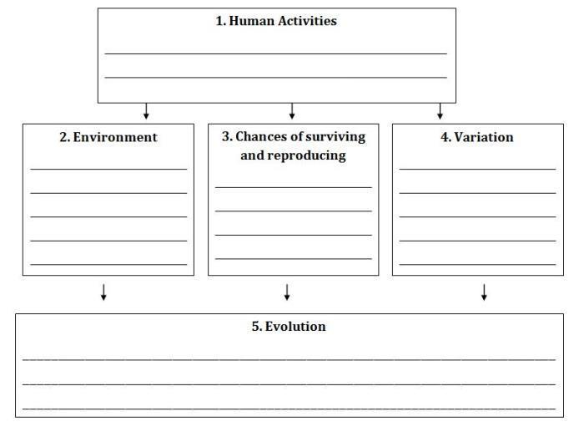

Summary: Human Influence on Evolution
Lesson 6 │ page 2 of 4

Name: _________________________________
The Devil’s Hole Pupfish
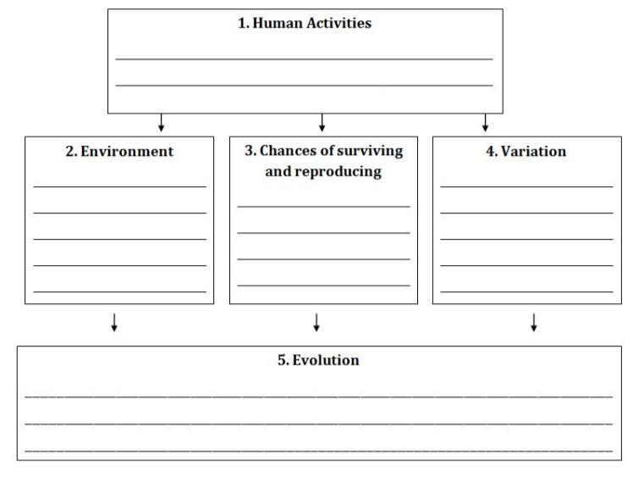

Summary: Human Influence on Evolution
Lesson 6 │ page 3 of 4

Name: _________________________________
Part 2

Instructions: Read the following list of species and human activities that have influenced their evolution. Circle one of these to use for the flowchart on the next page.

Species | Human Activity
Northern Mountain Ash | Many activities, including driving cars and running factories, have put gases, such as carbon dioxide into the air. These gases have caused the temperature on Earth to increase. People also drive off-road vehicles in the mountains. These can crush plants and damage trees.
Diamond-back Terrapin | Human air and land pollution can affect the environments in which the Diamond-back Terrapin lives.
Kauai field crickets | Humans brought the fly, Ormia ochracea, to Kauai.
Northeastern Beach Tiger Beetle | Costal environments are often destroyed by human use or development. The Northeastern Beach Tiger Beetle is endangered due to the use of beaches by humans.
Purple pitcher plant  mosquitoes | Many activities, including driving cars and running factories, have put gases, such as carbon dioxide into the air. These gases have caused the temperature on Earth to increase.

Instructions: Complete the flowchart on the next page for the species you selected. (2 points per section, 10 total)
- In the first section, describe the kinds of human activities that have affected the species. Think about how these activities have affected the species.
- In the second section, describe how the species’ environment has changed.
- In the third section, describe how the species’ chances of surviving and reproducing have changed.
- In the fourth section, describe the species’ level of genetic variation. If humans altered this level of variation, how did that happen?
- In the fifth section, summarize how human activity has affected the evolution of this species. Use the word “adaptation” in your answer.

Summary: Human Influence on Evolution
Lesson 6 │ page 4 of 4

Name: _________________________________
Species: __________________

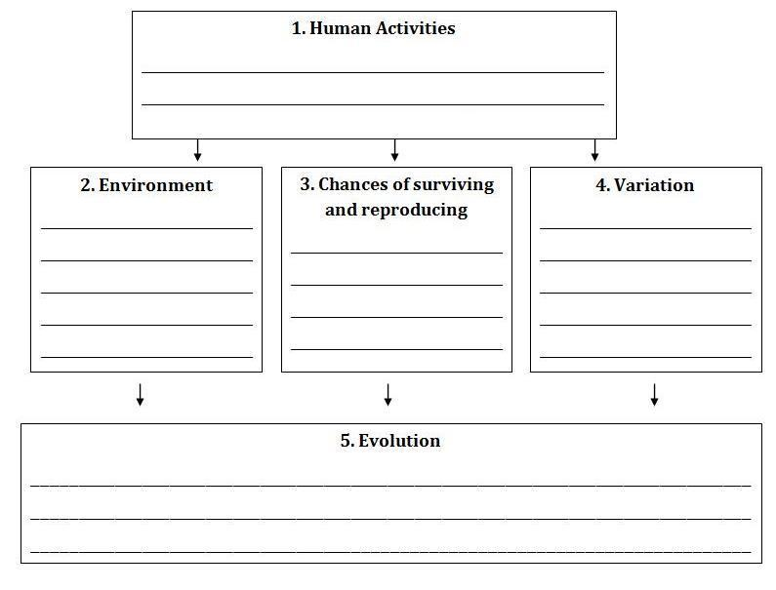

Human Influence on Evolution-VISUAL AID
Lesson 6 │ page 1 of 1

Name: _________________________________
Species: ________________________________

Assessment of Learning Directions and Rubric
CEPA │ page 1 of 2

Name: _________________________________
SHAPING NATURAL SYSTEMS THROUGH EVOLUTION
ASSESSMENT OF LEARNING

How do humans influence changes in a species over time?
The editor of the Science News for Kids has given you an assignment to educate the website’s readers about a species whose evolution has been influenced by humans. As a journalist, research information about the organism of your choice (Northern Mountain Ash, Diamond-back Terrapin, Kauai field crickets, Northeastern Beach Tiger Beetle, or Purple pitcher plant mosquitoes). Focus your research on information about how humans have influenced this organism’s genetic traits over time. Use this information to write a short article to educate the public about your findings.
Directions:
- Select one of the species whose evolution has been influenced by human activity:
- Northern Mountain Ash
- Diamond-back Terrapin
- Kauai field crickets
- Northeastern Beach Tiger Beetle
- Purple pitcher plant mosquitoes

- Read about this species from the class materials. Research about this species using the internet.

- Identify evidence from this reading and research about the human activities (1), environment (2), chances of surviving and reproducing (3), variation (4), and evolution (5) related to this species. Write these details in the Summary: Human Influence on Evolution graphic organizer.

- Draft a news article in which you educate the readers about how this species’ evolution has been influenced by humans. Write this first draft on the Evolution and Diversity Journal 6.

HOW YOU WILL BE GRADED
Goal: I can construct an explanation for how humans have influenced genetic variations of traits in a population, thereby increasing some individual’s probability of surviving and reproducing in a specific environment, which tends to increase these traits and suppress other traits in the population.
See next page for Rubric.

Assessment of Learning Directions and Rubric
CEPA │ page 2 of 2
Rubric
 | Exemplary (4) | Accomplished (3) | Developing (2) | Beginning (1)
8. MS-LS4-4. Use a model to describe the process of natural selection, in which genetic variations of some traits in a population increase some individuals’ likelihood of surving and reproducing in a changing environment Provide evidence that natural selection occurs over many generations. | In addition to the criteria for Accomplished, the article includes clear reasoning in the explanation of the genetic variation of the species. | The article includes accurate information about changes to the environment (2), chances of surviving and reproducing (3), variation (4), and evolution (5) related to this species. | The article includes information about changes to the environment (2), chances of surviving and reproducing (3), variation (4), OR evolution (5) related to this species, but some of the information is not complete or accurate. | The article includes information about changes to the environment (2), chances of surviving and reproducing (3), variation (4), OR evolution (5) related to this species, but most of the information is not complete or accurate.
8 .MS-LS4-5. Synthesize and communicate information about artificial selection, or the ways in which humans have changed the inheritance of desired traits in organisms. | In addition to the criteria for Accomplished, the article includes clear reasoning in the explanation of the impact of human activity on the genetic variation of the species. | The article includes accurate information about how human activity (1) relates to the evolution of this species. | The article includes information about how human activity (1) relates to the evolution of this species, but some of the information is not complete or accurate. | The article includes information about how human activity (1) relates to the evolution of this species, but most of the information is not complete or accurate.
ELA/Literacy –  RCA.6-8.1 - Cite specific textual evidence to support analysis of science and technical texts, attending to the precise details of explanations or descriptions (MS-LS4-5) | In addition to the criteria for Accomplished, the article includes clear explanation and analysis of textual evidence. | The article uses central ideas and conclusions of the various texts, graphs, and other information gathered during this unit. The information provided is accurate and distinct from prior knowledge or opinions. | The article uses central ideas and conclusions of the various texts, graphs, and other information, but some of the information is based on prior knowledge and opinion. | The article uses central ideas and conclusions of the various texts, graphs, and other information, but most of the information is based on prior knowledge and opinion.
ELA/Literacy –  WHST.6-8.8 -When collecting research, gather relevant information from multiple print and digital sources; assess the credibility of each source; and quote or paraphrase the data and conclusions of others while avoiding plagiarism and providing basic bibliographic information for sources. | In addition to the criteria for Accomplished, the article includes journalist assessment of sources in the article. | This article uses appropriate citation and bibliographical information for sources. The article uses paraphrasing and quotes that are accurately referenced from multiple print and digital sources. | The article uses appropriate citation and bibliographical information for sources, but some of the evidence has not been referenced accurately. | The article uses appropriate citation and bibliographical information for sources, but most of the evidence has not been referenced accurately.

Unit Glossary
Glossary │ page 1 of 2

Unit Glossary

Abiotic – Non-living or composed of non-living things.

Adaptation – Adjusting to environmental conditions; as inherited modification of an organism that increases its chances for survival in its environment.

Biotic – Of, related to or caused by living organisms.

Climate – A region with specified weather conditions.

Clone – The collection of genetically identical cells or organisms asexually produced by or from a single ancestral cell or organism.

Common ancestor – One or more organisms sharing similar traits or genetics.

DNA – Deoxyribonucleic Acid; the molecular basis for heredity.

Ecosystem – A complex system composed of an ecological community of organisms interacting with their environment especially under natural conditions.

Elevation – The height to which something is raised; the height above sea level.

Environment – The whole complex of factors (as soil, climate, and living things) that determine the form and survival of an organism or ecological community.

Evaporation – To change into vapor.

Evolution – A theory that the various types of animals and plants have their origin in other preexisting types and that the distinguishable differences are due to changes in successive generations.

Extinct – No longer existing.

Fertilize – To unite within the process of fertilization.

Gene – A specific sequence of nucleotides in DNA that is expressed by a particular protein.

Gene pool – The collection of genes in an interbreeding population.

Genetic engineering – The artificial manipulation, modification, and recombination of DNA or other nucleic acid molecules in order to modify an organism or population of organisms.

Genetics – A branch of biology that deals with heredity and variation of organisms.

Unit Glossary
Glossary │ page 2 of 2

Genus – A category of biological classification ranking between the family and the species, comprising structurally or genetically related species.

Habitat – The place or environment where a plant or animal naturally or normally lives or grows.

Heritable – Capable of being inherited.

Inheritance – Transmission of genes.

Natural selection – Darwin’s theory of survival of the fittest.

Niche – A habitat supplying the factors necessary for the existence of an organism or species.

Latitude – Angular distance north or south from the earth's equator measured in degrees.

Longitude – Distance measured by degrees or time east or west from the prime meridian.

Mutation – A relatively permanent change in hereditary material involving either a change in the position of the genes on the chromosomes or a fundamental change in the chemical structure of the genes themselves.

Offspring – The product of the reproductive processes of an animal or plant.

Organism – An individual constituted to carry on the activities of life by means of organs separate in function but mutually dependent: a living person, plant, or animal.

Population – The organisms inhabiting a particular area or habitat.

Predator – An animal that obtains food primarily by killing and consuming animals.

Reproduce – To give rise to (new individuals of the same kind) by a sexual or asexual process.

Sexual reproduction – The reproduction by organisms that involves the fusing of two separate sex cells.

Species – A category of biological classification ranking below the genus, comprising related organisms or populations potentially capable of interbreeding.

Survivorship – The ability to survive.

Trait – An inherited characteristic.

Variation – Divergence in the characteristics that are typical or usual for a species or group.
Britannica Library Reference Center: http://library.eb.com/levels/referencecenter

