Curriculum Frameworks Key Shifts:

ELA/Literacy (2017), Mathematics (2017), and Science and Technology/Engineering (2016)

The Massachusetts Curriculum Frameworks provide teachers, students and families with clear and shared expectations for what all students should know and be able to do at the end of each year. They represent a promise of equitable education for all students. They formalize the expectation that all students in the Commonwealth have access to the same academic content, regardless of their zip code, background, or abilities.

Massachusetts has recently adopted the 2016 Science and Technology/Engineering and revised the 2017 ELA/Literacy and Mathematics Frameworks. Each of these Frameworks include key shifts regarding curriculum, assessment, and instruction that impact the work of educators and administrators.

Science and Technology/Engineering (STE) Key Shifts

The STE standards are intended to drive engaging, relevant, rigorous, and coherent instruction that emphasizes student mastery of both disciplinary core ideas (concepts) and application of science and engineering practices (skills) to support student readiness for citizenship, college, and careers. The key shifts identified in the standards are:
- A focus on conceptual understanding and application of concepts;
- Integration of disciplinary core ideas and practices to reflect the discipline of science and technology/engineering;
- Coherent progressions of STE core ideas and practices from Pre-K to High School; and
- Inclusion of each discipline in grade-level standards Pre-K to grade 8

1. The standards focus on conceptual understanding and application of concepts.
The standards are focused on a limited set of disciplinary core ideas that build across grades and lead to conceptual understanding and application of concepts. They are written to both articulate the broad concepts and key components that specify expected learning. In particular, the disciplinary core ideas emphasize the principles students need to analyze and explain natural phenomena and designed systems they experience in the world.
2. Integration of disciplinary core ideas and practices reflects the interconnected nature of science and engineering.
The standards integrate disciplinary core ideas with scientific and engineering practices. The integration of disciplinary core ideas and practices reflects how science and engineering are applied and practiced every day. It is shown to enhance student learning of both and results in rigorous learning expectations aligned with similar expectations in mathematics and ELA standards.

3. The standards emphasize preparation for postsecondary success for citizenship, college, and careers.
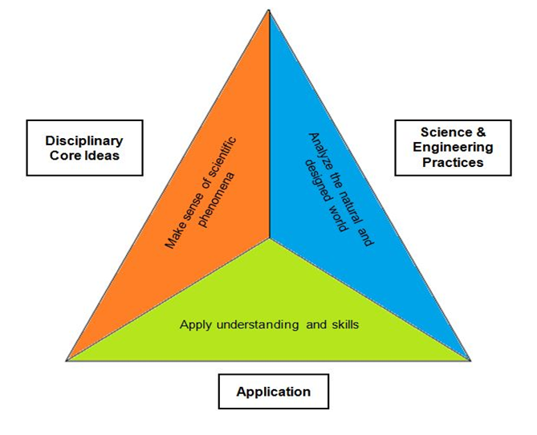
The standards include science and engineering practices necessary to engage in scientific and technical reasoning, a key aspect of civic participation as well as college and career readiness. The standards articulate core ideas and practices students need to succeed in entry-level, credit-bearing science, engineering, or technical courses in college or university; certificate or workplace training programs requiring an equivalent level of science; or comparable entry-level science or technical courses, as well as jobs and postsecondary opportunities that require scientific and technical proficiency to earn a living wage.
The STE standards are designed to include three interrelated components necessary for such preparation: conceptual understanding of disciplinary core ideas, science and engineering practices, and application to the natural and designed world. These components are illustrated in this graphic:

4. STE core ideas and practices progress coherently from pre-K to high school.
The standards emphasize a focused and coherent progression of concepts and skills from grade span to grade span, allowing for a dynamic process of knowledge and skill building throughout a student’s scientific education. The progression gives students the opportunity to learn more sophisticated material and reconceptualize their understanding of how the natural and designed world work, leading to the scientific and technical understanding and reasoning skills needed for postsecondary success.
5. Each discipline is included in grade-level standards for pre-K to grade 8.
To achieve consistency across schools and districts and to facilitate collaboration, resource sharing, and effective education for transient populations, the pre-K to grade 8 standards are presented by grade level. All four disciplines (earth and space science, life science, physical science, and technology/engineering) are included in each grade to encourage integration across the year and through curriculum. This reflects the nature of science and engineering as experienced in every-day life and allows attention to crosscutting concepts that aid analysis of the world.
6. The STE standards are coordinated with the Commonwealth’s ELA and mathematics standards.
The STE standards require the use and application of ELA and mathematics to support STE learning. The three sets of standards overlap in meaningful and substantive ways, particularly in regard to practices that are consistent across all three, and offer an opportunity for all students to better apply and learn STE.

Mathematics Key Shifts

The 2017 standards draw from the best of prior Massachusetts standards, and represent the input of hundreds of the Commonwealth’s K–12 and higher education faculty. The 2017 standards reflect the Commonwealth’s commitment to providing all students with a world-class education. This revision of the Framework retains the strengths of previous frameworks and includes these key shifts:

Clarity
The Standards for Mathematical Practice describe what students do to successfully learn and apply mathematical concepts and procedures. The 2017 Mathematics Curriculum Framework includes revised definitions of the Standards for Mathematical Practice for specific grade spans; Pre-K - 5, 6 - 8, and 9 - 12. Additionally, clear expectations for student mastery and fluency of basic addition, subtraction, multiplication, and division facts and algorithms are now included. This includes definitions for key terms such as:
Fluency in the grades 1–6 standards is the ability to carry out calculations and apply numerical algorithms quickly and accurately. Fluency in each grade involves a mixture of knowing some answers from memory (instant recall), knowing some answers from patterns (e.g., “adding 0 yields the same number”), and knowing some answers from the use of other strategies. The development of fluency follows a specific progression in these grades that begins with conceptual understanding and eventually requires students to “know from memory their math facts,” use various strategies to arrive at answers, and develop proficiency using the standard algorithm for each operation. (See standards 1.OA.B.3, 2.OA.B.2, 3.OA.B.5, 3.OA.C.7 and 3.NBT.A.2, 4.NBT.B.4, 5.NBT.B.5, 6.NS.B.2 and 6.NS.B.3.)
Know from memory: To instantly recall single-digit math facts to use when needed. Note: In the early grades, students develop number sense and fluency in operations. Students are expected to commit single digit math facts to memory by the end of: a) grade 2 for addition and related subtraction facts (see standard 2.OA.B.2); and b) grade 3 for multiplication and related division facts (see standard 3.OA.C.7).

Coherence
The 2017 Mathematics Curriculum Framework strengthens the coherent progression of content from Pre-K through Grade 12. For example, the coherent progressions of Pre-K - 5 standards in Number and Operations in Base Ten and Fractions prepare for learning the standards within the Ratios and Proportional Relationships and The Number System domains in grades 6 through 8. Additionally, the term “rate” was added to the Grade 6 Framework to explicitly ensure that instruction is focused on the connections between and the individual concepts of ratio and rate. Focusing on rates allows for the development of proportional reasoning to solve real world problems and is key in the progression to Algebra.
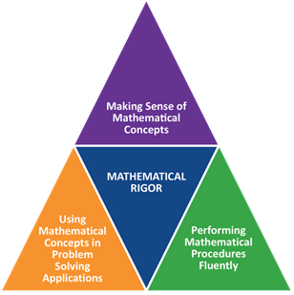
Rigor
The 2017 Mathematics Curriculum Framework defines mathematical rigor as a balance of Conceptual Understanding, Procedural Fluency, and Application. Mathematical rigor challenges students to develop understanding of mathematical concepts as they develop procedural skills and then apply those understanding and skills to solve real world and mathematical problem-solving situations. Mathematical rigor ensures students have the opportunity to learn concepts and practices needed for College and Career Readiness. The 2017 Mathematics Curriculum Framework maintains the expectation that all students will develop mathematical understanding of concepts, procedural skills and fluencies, and context based problem solving abilities.

To achieve mathematical understanding, students should be actively engaged in meaningful mathematics. The content and practice standards focus on developing students in the following areas:
- Conceptual understanding – make sense of the math, reason about and understand math concepts and ideas
- Procedural fluency – know mathematical facts, compute and do the math
- Capacity – solve a wide range of problems in various contexts by reasoning, thinking, and applying the mathematics they have learned.

English Language Arts and Literacy Key Shifts

To achieve a well-rounded curriculum at all grade levels, the standards in this Framework are meant to be used with the standards of the Massachusetts Curriculum Frameworks for Mathematics, History and Social Science, Science and Technology/Engineering, the Arts, Comprehensive Health and Physical Education, Foreign Languages, Digital Literacy and Computer Science, and, in grades 9–12, Career/Vocational Technical Education.

An Integrated Model of Literacy
Although the standards are divided into Reading, Writing, Speaking and Listening, and Language strands for conceptual clarity, the processes of communication are closely connected, as reflected throughout the document. There are cross-references among the standards for Reading, Writing, Speaking and Listening, and Language, as well as numerous examples that show how standards may be combined in effective instruction. The standards emphasize the importance for all students (and particularly English learners) of learning general academic vocabulary, sometimes called “Tier Two” words, such as affect, analyze, argue, average, compose, conclude, contradict, culture, effect, explain, foundation, image, integrate, method, percent, region, research, translate, transpose, or vision. These abstract concepts are broadly used across disciplines and sometimes have different meanings depending on the academic context.
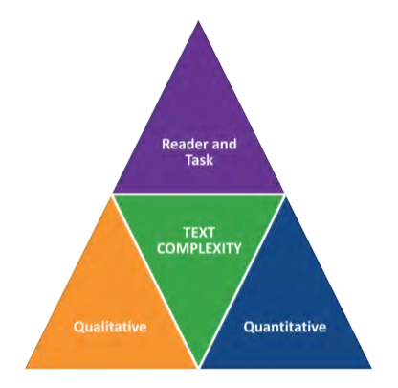
The key shifts are:

- Regular practice with complex texts and their academic language
Rather than focusing solely on the skills of reading and writing, the ELA/literacy standards highlight the growing complexity of the texts students must read to be ready for the demands of college, career, and civics preparation. The Reading Standards place equal emphasis on the sophistication of what students read and the skill with which they read. Standard 10 defines a grade-by-grade “staircase” of increasing text complexity that rises from beginning reading to the college and career readiness level. The standards also outline a progressive development of reading comprehension so that students advancing through the grades are able to gain more from what they read Whatever they are reading, students must also show a steadily growing ability to discern more from and make fuller use of text, including making an increasing number of connections among ideas and between texts; considering a wider range of textual evidence; and becoming more sensitive to inconsistencies, ambiguities, and poor reasoning in texts.

Closely related to text complexity and inextricably connected to reading comprehension is a focus on academic vocabulary: words that appear in a variety of content areas (such as ignite and commit). The standards call for students to grow their vocabularies through a mix of conversation, direct instruction, and reading. They ask students to determine word meanings, appreciate the nuances of words, and steadily expand their range of words and phrases. Vocabulary and conventions are treated in their own strand not because skills in these areas should be handled in isolation, but because their use extends across reading, writing, speaking, and listening.

2. Reading, writing, and speaking grounded in evidence from texts, both literary and informational
The standards emphasize using evidence from texts to present careful analyses, well-defended claims, and clear information. Rather than asking students questions they can answer solely from their prior knowledge and experience, the standards call for students to answer questions that depend on their having read the texts with care.

The reading standards focus on students’ ability to read carefully and grasp information, arguments, ideas, and details based on evidence in the text. Students should be able to answer a range of text-dependent questions, whose answers require inferences based on careful attention to the text.

3. Building knowledge through content-rich nonfiction
Students must be immersed in information about the world around them if they are to develop the strong general knowledge and vocabulary they need to become successful readers and be prepared for college, career, and life. Informational texts play an important part in building students’ content knowledge. Further, it is vital for students to have extensive opportunities to build knowledge through texts so they can learn independently.

In K-5, fulfilling the standards requires a 50-50 balance between informational and literary reading. Informational reading includes content-rich nonfiction in history/social studies, sciences, technical studies, and the arts. In grades 6-12, there is much greater attention on the specific category of literary nonfiction, which is a shift from traditional standards. To be clear, the standards pay substantial attention to literature throughout K-12, as it constitutes half of the reading in K-5 and is the core of the work of 6-12 ELA teachers. Also in grades 6-12, the standards for literacy in mathematics, history/social studies, science, and technical subjects ensure that students can independently build knowledge in these disciplines through reading and writing. Reading, writing, speaking, and listening should span the school day from K-12 as integral parts of every subject.

