Massachusetts Department of
Elementary and Secondary Education
Grants Management

75 Pleasant Street, Malden, Massachusetts 02148-4906 Telephone: (781) 338-6595
TTY: N.E.T. Relay 1-800-439-2370

Grants Management December Update

- December 2019 Payment Request window is now available
- FY2018 Increases to Awards: Title I (FC:305) and Title II-A (FC: 140)
- FY2019 ISAs to state entities including colleges
- Changes to Award / Payment Notices
- Requesting Funds Reminders & FAQs
- Final Reports (FR1)
- User Request Form / EdGrants Webinars

December Payment Request is now available

This is a courtesy reminder that the December Payment Request window is open now through December 31st. This window is open for all approved FY2019 grants as well as FY2018 Multi-Year grants that are currently in year 2. (FY2018 Multi-Year grants are only Fund Codes: 140, 141, 180, 186, 305, 309, 240).

To request grant funds, log into EdGrants with your DESE provided user name and password. If you are new to EdGrants, please review the Requesting Funds Reminders & FAQs. Don’t have a login? Please review the http://www.doe.mass.edu/grants/edgrants/user-security-controls.html information which explains how to get connected.
BACK TO THE TOP

FY2018 Increases to Awards: Title I (FC: 305) and Title II-A (140)

In August, Districts and Charters received a Federal Grant Programs update from the Resource Allocation and Strategic Planning (RASP) team that included information regarding FY2018 Title I and Title II-A award increases. Increases were available to claim by submitting an increase amendment in EdGrants from November 1st through November 14th. If you did not file an increase amendment during the November timeframe, you have forfeited the increase as these funds are being reallocated.

Most of the increase amendments have been processed internally at DESE an should be available to draw now in the December window.

District Business office personnel as well as district Title I and Title II-A program staff should communicate to each other regarding these increases. Final Reports should not be filed until you request your final payment, receive the funds, and reconcile your expenses. If the final report has already been filed, you will need to submit a revised FR-1.

BACK TO THE TOP

FY2019 ISAs to State Colleges

Starting in FY2019, state and community colleges (except UMASS Schools) must use MMARS for their DESE grants and will be issued an ISA.

Applicants should submit their grant via EdGrants as normal. Once approved by program staff, an ISA will be generated based on the EdGrants approved budget. Please be responsive and get the ISA signed and sent back to DESE as soon as possible as this is required to set up your MMARS account.

The fringe rate for those receiving state grants is 1.73% of AA and CC payroll (D09). Federal/trust accounts are 36.62% of AA payroll and 1.73% of CC payroll (D09). Please review the approved rates with the MA Comptroller’s Office. If you are required to contribute to D08, please add that separately on the ISA. We have been and will continue to will reach out and work with you to complete this process.
BACK TO THE TOP

Changes to Award / Payment Notices

The Office of Management and Budget (OMB) requires all pass-through entities (DESE) to provide additional information to sub-recipients regarding their federal awards. You will now see this information at the bottom of the payment notice, with a link to the Federal Awards letters as provided by USED.

In FY2019 we are deploying additional changes to the top of the award / payment notice including the Federal Awarding Agency as well as the Federal Award Number (FAIN).

BACK TO THE TOP

Requesting Funds Reminders & FAQs

Sherriff / State Agency Departments / Colleges who receive grant funds (all fund codes) directly through MMARS accounts via ISAs do NOT need to request grant funds using EdGrants.
-----
Funds can only be requested if your grant has been programmatically approved, processed and an automatic Initial Payment has been issued by DESE.

http://www.doe.mass.edu/Grants/edgrants.html
http://www.doe.mass.edu/Grants/edgrants.html
http://www.doe.mass.edu/Grants/edgrants.html
http://www.doe.mass.edu/Grants/edgrants.html

http://www.doe.mass.edu/grants/edgrants/requesting-funds.docx outlines step by step how to make your payment request as well as how to view your Project Record Card.

Please find all EdGrants user documents here.
BACK TO THE TOP

Filing Final Financial Reports (FR1)

FY2018 Final Reports are available in EdGrants. Please make sure that all expenses have been accounted for and bills reconciled before you file a Final Report. If yo9u do not see an FY18 final report available for a particular project, please email EdGrants@doe.mass.edu and include the project number in the email. You can also call the main grants line at 781-338-6595, again please have the project number ready.

Before filing an FY2018 Title I (FC: 305) and/or Title II-A (FC: 140) Final Report, please see the section above re: FY2018 increases to awards.

Please note: There is a known glitch with the FY2018 final report form in EdGrants. If the line item is overspent by a small amount, it throws the “Balance Unexpended” and the percentage columns off. We are working to correct this error. In the meantime you can submit the final report; the “Cash Balance” section at the bottom of the report form does calculate correctly.

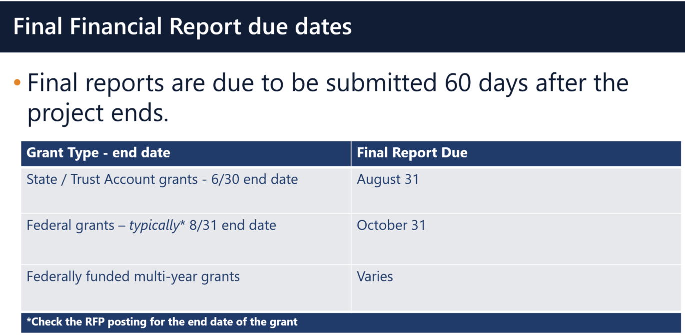

Multi-Year grants: DESE expects that Applicants will spend down their funds in full and not return money as FY2018 multi-year grants now have an end date of 6/30/2019 as long as you filed a multi-year form in May or left a Year 1 balance unclaimed which rolled into Year 2.

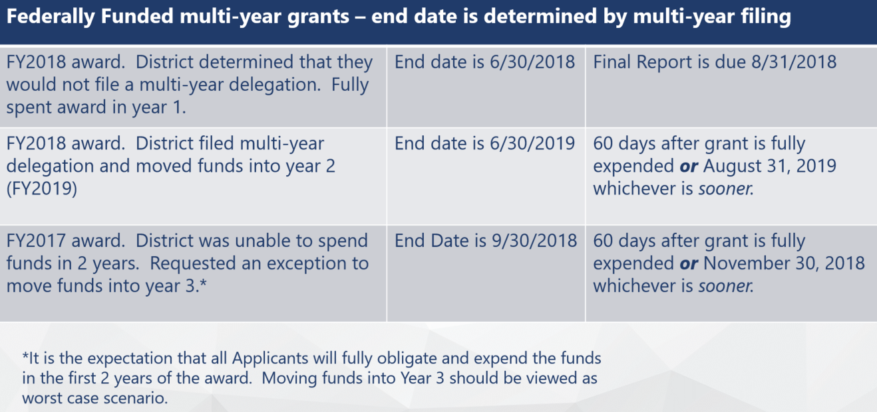

Applicants should use FY2018 Year 2 grant funds up before charging FY2019 grants.

DESE expects that before you try to file a final report, fiscal and programmatic staff will coordinate to ensure all funds have been expended appropriately and are in agreement on the total expected award amount.
BACK TO THE TOP

User Request Form / EdGrants Webinars
DESE requires a user request form be submitted for all new users and edits to existing users. Please review http://www.doe.mass.edu/grants/edgrants/user-security-controls.html for more information and a copy of the Front Office User Request Form.

EdGrants Front Office user webinars are available with ongoing sessions being added as needed. Please click here to review the sessions offered and to register.
BACK TO THE TOP
_ _ _ _ _

If you need assistance please contact Grants Management at 781-338-6595 or email EdGrants@doe.mass.edu. Please reference your grant project number or fund code and Applicant number (LEA Code) when you call and/or email.

This email content below is also attached in word document form in case there is trouble viewing this email.

Thank you,
Grants Management

