Massachusetts Department of

Elementary and Secondary Education

Grants Management

75 Pleasant Street, Malden, Massachusetts 02148-4906 Telephone: (781) 338-6595 TTY: N.E.T. Relay 1-800-439-2370

Grants Management February Update

- February Payment Request window is now available
- Grant Amendments
- Multi-Year is coming!
- FY2019 ISAs to State Entities Including Colleges
- Changes to Award / Payment Notices
- Final Reports (FR1)
- User Request Form / EdGrants Webinars
- Requesting Funds Reminders & FAQs

February Payment Request is now available

This is a courtesy reminder that the February Payment Request window is open February 20th through February 28th. This window is open for all approved FY2019 grants as well as FY2018 Multi-Year grants that are currently in year 2 with balances left to draw down. (FY2018 Multi-Year grants are only Fund Codes: 140, 141, 180, 186, 305, 309, 240*).

*Grantees with FY18 year two balances should be using those balances for FY19 expenditures before charging FY19 expenses to the new FY19 award. If you need to amend your FY18 grant to accommodate these charges, please be sure to contact your program liaison to request an amendment for you to complete in EdGrants.

To request grant funds, log into EdGrants with your DESE provided user name and password. If you are new to EdGrants, please review the Requesting Funds Reminders & FAQs. Don’t have a login? Please review the http://www.doe.mass.edu/grants/edgrants/user-security-controls.html information which explains how to get connected.

Locked out of EdGrants? Grants Management staff periodically checks and unlocks those who are locked out throughout the day. If you continue to find that you are locked out, please call the Grants Management main line at 781-338-6595 for assistance.

BACK TO THE TOP

Grant Amendments

It’s good to have a practice of assessing grant spending on a quarterly basis to determine if you need to request an amendment.

Amendments are Required When:
- there is any significant change in program objectives; or
- there is any increase or decrease in the total amount of the grant; or
- an increase in a line of the budget exceeds $100 or 10% of the line (whichever is greater) or exceeds $10,000.
Amendments should be submitted at least thirty (30) days prior to the desired change and must be submitted thirty (30) days before the conclusion of the project. The maximum number of amendments to any grant may not exceed three (excepting any required by the Department). Exceptions to this limit may be allowed. The EdGrants Front Office User Guide: Amending the Application Submission has detailed instructions as to how to how to amend your grant submission in EdGrants.
Multi-Year is coming!
What is multi-year? The multi-year option exists for certain grant fund codes to extend the end date of the grant into the next fiscal year. This eliminates the need to return unexpended funds after the first year and eliminates the need for a final report submission until the funds have been fully expended (within the 24-month* grant period).

May 1, 2019 – May 14, 2019 the multi-year form will be available in EdGrants in the Submissions menu for all grant funds codes that have the multi-year option.
FY2019 fund codes 140 (Title II-A), 180 / 186 (Title III), 218 (High-Quality Instruction – Summer Planning), 240 (Special Ed), 262 (Early Childhood Special Ed), 305 (Title I), and 309 (Title IV) have the multi-year feature available in EdGrants.

If you are unsure how much money to roll into year 2 (FY2020) of your grant, please request a conservative estimate be rolled. As long some small amount is moved using the multi-year form in EdGrants, any unclaimed balances left in year 1 will roll into Year 2 automatically. If nothing is moved, you could be opening yourself up to a break in service should you decide you need the extended end date after the fact. It is always better to move some small amount to be covered for the extended end date. You will have access to draw any moved funds on 7/1 and those funds can be applied back to services through 6/30 if necessary.

*Fund Code 218 – High-Quality Instruction – Summer Planning grantees should use the multi-year feature to receive an 8/31/2019 end date on this state funded grant. This is not available for 24-month grant period as the other multi-year grants are.

Stay tuned for Multi-year webinars which will be scheduled for March and April 2019.

BACK TO THE TOP

FY2019 ISAs to State Entities Including Colleges

Starting in FY2019, state and community colleges (except UMASS) must use MMARS for their DESE grants and will be issued an ISA.

We are more than halfway through the state’s fiscal year. This is a good time to assess spending and determine if an amendment to your EdGrants submission or your ISA (or both) is needed. Information regarding how to amend was sent out to all ISA contacts last week.

The fringe rate for those receiving state grants is 1.73% of AA and CC payroll (D09). Federal/trust accounts are 36.62% of AA payroll and 1.73% of CC payroll (D09). Please review the approved rates with the MA Comptroller’s Office. If you are required to contribute to D08, please add that separately on the ISA. We have been and will continue to will reach out and work with you to complete this process.

If you have any questions regarding amending your ISA, please contact your Grants Management liaison.
BACK TO THE TOP

Changes to Award / Payment Notices

The Office of Management and Budget (OMB) requires all pass-through entities (DESE) to provide additional information to sub-recipients regarding their federal awards. You will now see this information at the bottom of the payment notice, with a link to the Federal Awards letters as provided by USED.
BACK TO THE TOP

Filing Final Financial Reports (FR1)

FY2018 Final Reports are available in EdGrants. Please make sure that all expenses have been accounted for and bills reconciled before you file a Final Report. If yo9u do not see an FY18 final report available for a particular project, please email EdGrants@doe.mass.edu and include the project number in the email. You can also call the main grants line at 781-338-6595, again please have the project number ready.

Before filing an FY2018 Title I (FC: 305) and/or Title II-A (FC: 140) Final Report, please see the section above re: FY2018 increases to awards.

Please note: There is a known glitch with the FY2018 final report form in EdGrants. If the line item is overspent by a small amount, it throws the “Balance Unexpended” and the percentage columns off. We are working to correct this error. In the meantime, you can submit the final report; the “Cash Balance” section at the bottom of the report form does calculate correctly.

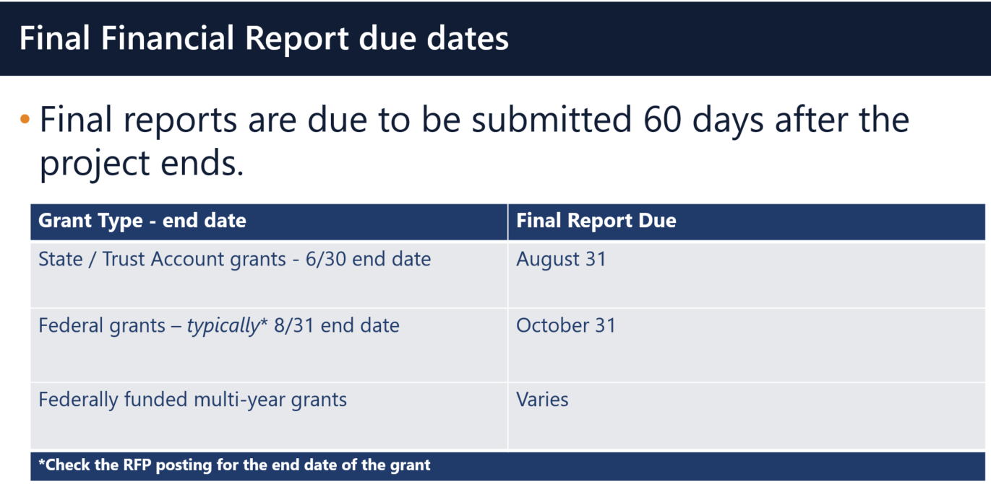

Multi-Year grants: DESE expects that Applicants will spend down their funds in full and not return money as FY2018 multi-year grants now have an end date of 6/30/2019 as long as you filed a multi-year form in May or left a Year 1 balance unclaimed which rolled into Year 2.

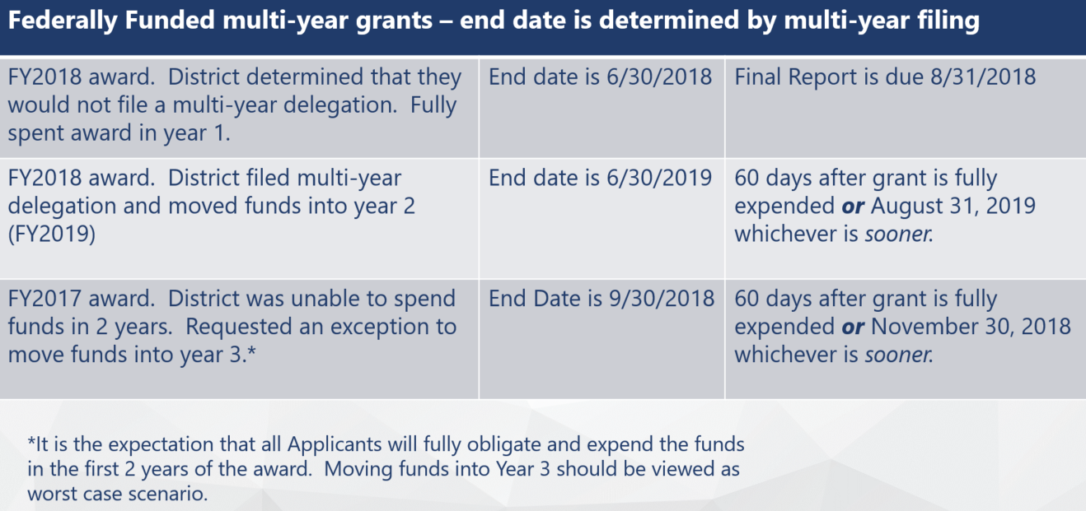

Applicants should use FY2018 Year 2 grant funds up before charging FY2019 grants.

DESE expects that before you try to file a final report, fiscal and programmatic staff will coordinate to ensure all funds have been expended appropriately and agree on the total amounts.
BACK TO THE TOP

User Request Form / EdGrants Webinars
DESE requires a user request form be submitted for all new users and edits to existing users. Please review http://www.doe.mass.edu/grants/edgrants/user-security-controls.html for more information and a copy of the Front Office User Request Form.

EdGrants Front Office user webinars are available with ongoing sessions being added as needed. Please click here to review the sessions offered and to register.
BACK TO THE TOP

Requesting Funds Reminders & FAQs

Sherriff / State Agency Departments / Colleges who receive grant funds (all fund codes) directly through MMARS accounts via ISAs do NOT need to request grant funds using EdGrants.
-----
Funds can only be requested if your grant has been programmatically approved, processed and an automatic Initial Payment has been issued by DESE.

http://www.doe.mass.edu/Grants/edgrants.html
http://www.doe.mass.edu/Grants/edgrants.html
http://www.doe.mass.edu/Grants/edgrants.html
http://www.doe.mass.edu/Grants/edgrants.html

http://www.doe.mass.edu/grants/edgrants/requesting-funds.docx outlines step by step how to make your payment request as well as how to view your Project Record Card.

Please find all EdGrants user documents here.
BACK TO THE TOP

_ _ _ _ _

If you need assistance, please contact Grants Management at 781-338-6595 or email EdGrants@doe.mass.edu. Please reference your grant project number or fund code and Applicant number (LEA Code) when you call and/or email.

Thank you,
Grants Management

