Massachusetts Department of

Elementary and Secondary Education

Grants Management

75 Pleasant Street, Malden, Massachusetts 02148-4906 Telephone: (781) 338-6595 TTY: N.E.T. Relay 1-800-439-2370

Grants Management June Update

- June Payment Request window is now available
- Final Payment Request Windows for FY2019
- FY2020 Federal Grant Assurances
- Monthly Updates posted on the Grants Management website
- Multi-Year Grants
- Grant Amendments
- ISAs to State Entities Including Colleges
- Final Reports (FR1)
- User Request Form / EdGrants Webinars
- Requesting Funds Reminders & FAQs

June Payment Request is now available

This is a courtesy reminder that the June Payment Request window is open now through June 30th. This window is open for all approved FY2019 grants as well as FY2018 Multi-Year grants that are currently in year 2 with balances left to draw down. (FY2018 Multi-Year grants* are only Fund Codes: 140, 141, 180, 186, 305, 309, 240).

*Grantees with FY18 year two balances should be using those balances for FY19 expenditures before charging FY19 expenses to the new FY19 award. If you need to amend your grant(s) to accommodate these charges, please be sure to contact your program liaison to request an amendment for you to complete in EdGrants.

The final FY2019 payment request window will be July 20th – 31st. See the chart enclosed in this update for more info.

To request grant funds, log into EdGrants with your DESE provided user name and password. If you are new to EdGrants, please review the Requesting Funds Reminders & FAQs. Don’t have a login? Please review the http://www.doe.mass.edu/grants/edgrants/user-security-controls.html information which explains how to get connected.

Locked out of EdGrants? Grants Management staff periodically checks and unlocks those who are locked out throughout the day. If you continue to find that you are locked out, please call the Grants Management main line at 781-338-6595 for assistance.
BACK TO THE TOP

Final FY2019 Payment Request Windows

Grant Type | Award Year | Payment Request Window
State / Federal / Trust – All Fund Codes*  This includes Federal grants ending 8/31/2019  *except multi-year fund codes | 2019 | July 20th – July 31st  Final opportunity to request funds including grants that end 8/31/2019.
Multi-Year (State/PAC)  Fund Code: 218 | 2019 | August 20th – 24^{th*}  Final opportunity to request year 1 funds.
Multi-Year (Federal/Entitlement)  Fund Codes: 140, 180, 186, 305, 309, 262, 240 ONLY | 2019 (year 1)  2018 (year 2) | August 20th – 24th*  Final opportunity to request year 1 and/or year 2 funds.
Multi-Year (State/PAC)  Fund Code: 218 | 2019 | July 1st – 10th  First opportunity to request year 2 funds moved via multi-year delegation into FY2020.
Multi-Year (Federal/Entitlement)  Fund Codes: 140, 180, 186, 305, 309, 262, 240 ONLY | 2019 (year 2)  2018 (year 3) | July 1st – 10th  First opportunity to request year 2 and/or year 3 funds moved via multi-year delegation into FY2020.
Multi-Year grants  Fund Codes: 140, 180, 186, 305, 309, 262, 240 and 218 ONLY | 2019 (year 2) 2018 (year 3) | August 1st – 10th  Next opportunity to request year 2 and/or year 3 funds moved via multi-year delegation into FY2020.
*Balances left unclaimed on the multi-year grant fund codes only will roll into FY20 (Year 2) in September and will be available to draw in October 2019.
**DESE expects that all FY2018 multi-year grants will have fully obligated their funds by 6/30/2019. Applicants should shift FY2019 expenses to charge against their FY2018 award and amend the grants as needed to prioritize expending these funds.

BACK TO THE TOP

FY2020 Federal Grant Assurances

The FY20 Federal Grant Assurances document can be found on Resource Allocation Strategy and Planning (RASP). The Grant Assurances need to be uploaded with the district’s Title I application which is a change in the past method of submission. Please contact RASP at federalgrantprograms@doe.mass.edu or call 781-338-6230 with any questions regarding the FY20 Federal Grant Assurances.

Monthly Updates

These Grants Management Updates are posted each month on the grants website under Grants Notifications and Alerts. Previously posted monthly updates are always available in the Grants News Archives.

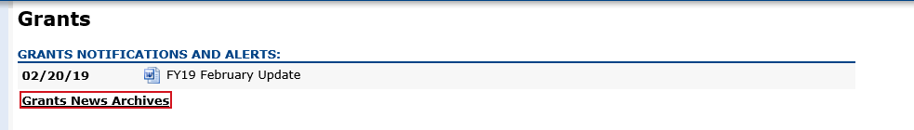
BACK TO THE TOP
Multi-Year grants
The only FY2019 grant fund codes that have multi-year available in EdGrants are:
- 140 (Title II-A)
- 180 / 186 (Title III)
- 218* (High-Quality Instruction – Summer Planning)
- 240 (Special Ed)
- 262 (Early Childhood Special Ed)
- 305 (Title I)
- 309 (Title IV)

If the multi-year delegation form was not submitted in EdGrants, or if $0 was moved into Year 2, the grant end date is 6/30/2019. If multi-year was submitted moving any funds into Year 2, the grant end date is now 6/30/2020.

Unclaimed balances left in year 1 will roll into Year 2 automatically in September, and the grant end date will be extended to 6/30/2020 at that time.

*Fund Code 218 – High-Quality Instruction – Summer Planning grantees have a grant end date of 8/31/2019, provided a multi-year delegation form was submitted moving some funds into Year 2. This grant is not available for the 24-month grant period as the other multi-year grants are.

FY2018 Multi-Year Year 3 (7/1/2019 – 9/30/2019):

Very few FY2018 Multi-Year 2-3 delegation forms were submitted in EdGrants requesting that a year 3 be added (FY2020). This is good news as Year 3 should be viewed as an exception and only utilized if the alternative would be returning grant funds. DESE expects that applicants will assess expenditures and shift FY19 charges over to the FY18 award where necessary and appropriate. In some cases, this will require an amendment to the FY18 or FY19 (or both!) grant budgets.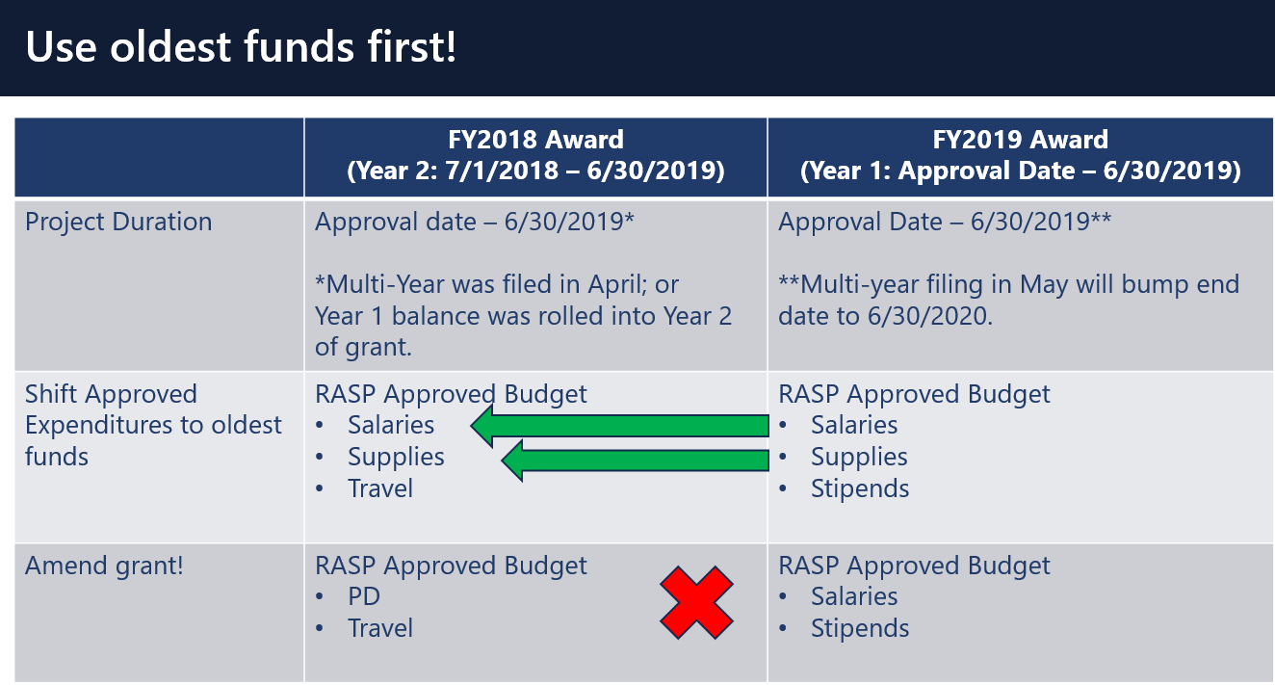
If you’d like to request an amendment, please contact your federal grants group liaison.

BACK TO THE TOP

Grant Amendments

Amendments are Required When:
- there is any significant change in program objectives; or
- there is any increase or decrease in the total amount of the grant; or
- an increase in a line of the budget exceeds $100 or 10% of the line (whichever is greater) or exceeds $10,000.
Amendments should be submitted at least thirty (30) days prior to the desired change and must be submitted thirty (30) days before the conclusion of the project. The maximum number of amendments to any grant may not exceed three (excepting any required by the Department). Exceptions to this limit may be allowed. The EdGrants Front Office User Guide: Amending the Application Submission has detailed instructions as to how to how to amend your grant submission in EdGrants.
BACK TO THE TOP

ISAs to State Entities Including Colleges

Amending your ISA
Information regarding how to amend was sent out to all ISA contacts in mid-January. All FY2019 state-funded ISAs can no longer be amended as the deadline to do so has passed.

FY2019 federally funded ISAs may still be amended if needed, but please assess your expenditures after July 1st to ensure the accuracy of your carry-forward funds.
Fringe Information
FY19 Fringe Rate on State grants is 1.73% of AA and CC payroll (D09).
FY19 Fringe Rate on Federal/trust accounts is 36.62% of AA payroll and 1.73% of CC payroll (D09).
Please review the approved rates with the MA Comptroller’s Office.

Proposed Fringe Rates for FY20
Fringe Rate on State grants is 2.44% of AA and CC payroll (D09).
Fringe Rate on Federal/trust accounts is 37.99% of AA payroll and 1.73% of CC payroll

You can also view that on the MA Comptrollers. We will also notify you about the rate changes for FY20 once approved.

Indirect Cost Rates
We have received word from the Comptroller’ s Office that E16 will now be available to the community colleges to use and to recoup indirect costs in FY20. If colleges are unsure where to allocate their approved indirect cost funds, they can leave it in EE object class and not worry about direct charges for non-program related costs.

Colleges Using D08
Earlier this month we were alerted that colleges cannot use D08 for grants.

If you have any questions regarding amending your ISA, please contact your Grants Management liaison.

BACK TO THE TOP

Filing Final Financial Reports (FR1)

FY2019 Final Reports will be available in EdGrants the day after the grant project duration ends.
- FY2019 grants that end 6/30/2019 will be available on 7/1/2019.
- FY2019 grant that end 8/31/2019 will be available on 9/1/2019.

Final Reports should not be submitted until final obligations and draw-downs are complete. Please make sure that all expenses have been accounted for and reconciled before you file a Final Report. If you do not see an FY2019 final report available for a specific grant project in the Submissions menu, please email EdGrants@doe.mass.edu and include the project number in the email. You can also call the main grants line at 781-338-6595; please have the project number ready.

Please note: There is a known glitch with the final report form in EdGrants. If the line item is overspent by a small amount, it throws the “Balance Unexpended” and the percentage columns off. We are working to correct this error. In the meantime, you can submit the final report; the “Cash Balance” section at the bottom of the report form does calculate correctly.

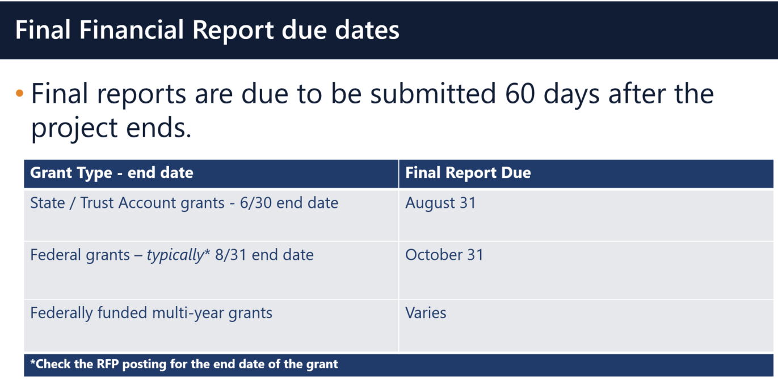

Multi-Year grants: DESE expects that Applicants will spend down their funds in full and not return money now that the multi-year feature is available in EdGrants for specific grant fund codes.

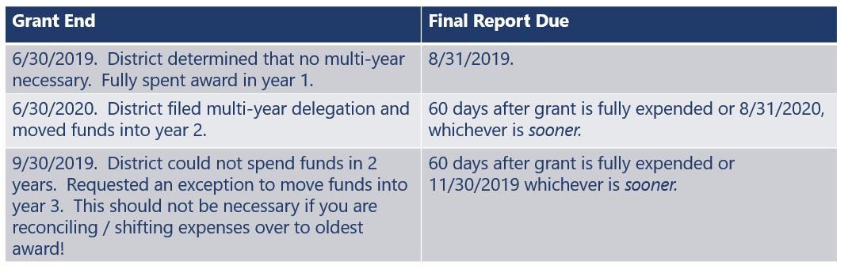

DESE expects that before you try to file a final report, district fiscal and programmatic staff will coordinate to ensure all funds have been expended appropriately and agree on the award total.
BACK TO THE TOP

User Request Form / EdGrants Webinars
DESE requires a user request form be submitted for all new users and edits to existing users. Please review http://www.doe.mass.edu/grants/edgrants/user-security-controls.html for more information and a copy of the Front Office User Request Form.

EdGrants Front Office user webinars will be available with ongoing sessions being added as needed. Please click here to review the sessions offered and to register.
BACK TO THE TOP

Requesting Funds Reminders & FAQs

Sherriff / State Agency Departments / Colleges who receive grant funds (all fund codes) directly through MMARS accounts via ISAs do NOT need to request grant funds using EdGrants.
-----
Funds can only be requested if your grant has been programmatically approved, processed and an automatic Initial Payment has been issued by DESE.

http://www.doe.mass.edu/Grants/edgrants.html
http://www.doe.mass.edu/Grants/edgrants.html
http://www.doe.mass.edu/Grants/edgrants.html
http://www.doe.mass.edu/Grants/edgrants.html

http://www.doe.mass.edu/grants/edgrants/requesting-funds.docx outlines step by step how to make your payment request as well as how to view your Project Record Card.

Please find all EdGrants user documents here.
BACK TO THE TOP

_ _ _ _ _

If you need assistance, please contact Grants Management at 781-338-6595 or email EdGrants@doe.mass.edu. Please reference your grant project number or fund code and Applicant number (LEA Code) when you call and/or email.

Thank you,
Grants Management

