Massachusetts Department of
Elementary and Secondary Education
Grants Management

75 Pleasant Street, Malden, Massachusetts 02148-4906 Telephone: (781) 338-6595
TTY: N.E.T. Relay 1-800-439-2370

Grants Management September Update

- September 2019 Payment Request window is now available
- FY2018 Title I (FC:305) and Title II-A (FC: 140) Year 2 Increase to Award Amounts
- FY2019 ISAs to state entities including colleges
- FY2019 Grant Statement of Assurances – ACTION REQUIRED
- FY2019 – Early Childhood Special Education grant
- Changes to Award / Payment Notices
- Requesting Funds Reminders & FAQs
- Final Reports (FR1)
- User Request Form / EdGrants Webinars

September Payment Request is now available

This is a courtesy reminder that the September Payment Request window is open now through September 30th. This window is open for all approved FY2019 grants as well as FY2018 Multi-Year grants that are currently in year 2. (FY2018 Multi-Year grants are only Fund Codes: 140, 141, 180 / 186, 305, 309, 240).

FY2017 Multi-Year Year 2 unclaimed grant balances are currently being rolled into Year 3. Applicants with balances were contacted recently to determine whether the funds would be obligated in full or not. DESE will be in touch regarding how to claim these funds, once the balance roll is complete.

DESE had a large number of FY2017 grants with balances. A reminder that if you are reconciling and using funds appropriately, there should never be a need for a Year 3 balance roll. We expect you will fully obligate these funds by 9/30/2018 and have no grant returns. Please do journal entries to shift expenses over as needed and appropriate to use up this money in full.

In order to request funds for FY2019, there must be an approved grant in EdGrants and an initial payment received of 10% of your grant award. If initial payment has not yet been received, then the next available payment request window will be in October.

To request grant funds, log into EdGrants with your DESE provided user name and password. If you are new to EdGrants, please review the Requesting Funds Reminders & FAQs. Don’t have a login? Please see the User Request Form information.

BACK TO THE TOP

FY2018 Title I (FC: 305) and Title II-A (140) Year 2 – Increase to Award Amounts

FY2018 Title I and Title II-A grants will have award increases available in November. Please stay tuned for information regarding how to amend your FY2018 grants to accept these increases. Please refrain from filing Final Reports until it is determined whether or not you will claim the increase in these funds.
BACK TO THE TOP

FY2019 ISAs to State Colleges

Starting in FY2019, state and community colleges (except UMASS Schools) must use MMARS for their DESE grants and will be issued an ISA.

Applicants should submit their grant via EdGrants as normal. Once approved by program staff, an ISA will be generated based on the EdGrants approved budget. Please be responsive and get the ISA signed and sent back to DESE as soon as possible as this is required to set up your MMARS account.

The fringe rate for those receiving state grants is 1.73% of AA and CC payroll (D09). Federal/trust accounts are 36.62% of AA payroll and 1.73% of CC payroll (D09). Please review the approved rates with the MA Comptroller’s Office. If you are required to contribute to D08, please add that separately on the ISA. We will reach out and work with you to complete this process.

BACK TO THE TOP

FY2019 Grant Statement of Assurances – ACTION REQUIRED

The FY2019 Grant Statement of Assurances was posted and due to Grants Management on August 3, 2018. If you have not sent this signed and scanned document via email, please do so ASAP as we must certify to the federal government that we received assurances from all grant recipients which receive entitlement funds. Not having this document on file with DESE could delay your grant funding.

All Local Education Agencies (LEAs) that receive funds from the following grant programs:
- ESEA: Title I, Title II, Title III, Title IV, Title V
- IDEA and
- Carl D. Perkins Career and Tech Ed

Must review, sign and email the signed PDF copy of the entire 19-page document to: edgrants@doe.mass.edu with "FY19 SOA (Applicant Number/LEA Code)" in the subject line (i.e., FY19 SOA Boston 0035).
BACK TO THE TOP

FY2019 – Early Childhood Special Education grant

The Early Childhood Special Education grant (Fund Code: 262) has been administered by the Department of Early Education and Care (EEC) for the past 13 years. In FY2019 the 262 grant is being administered by DESE. The 262 application and requesting funds process is happening via EdGrants: Front Office just like all other DESE funded grants.

The Early Childhood Special Education (Fund Code: 262) RFP posting is available on DESE grants management website.

Please note that a grant start date cannot be before it is submitted into the system.

All 262 grants prior to FY2019 will continue to be administered by EEC. This includes any FY2018 carryover funds until those funds are fully expended and/or closed out.

BACK TO THE TOP

Changes to Award / Payment Notices

The Office of Management and Budget (OMB) requires all pass through entities (DESE) to provide additional information to sub-recipients regarding their federal awards. You will now see this information at the bottom of the payment notice, with a link to the Federal Awards letters as provided by USED.

In FY2019 we are deploying additional changes to the top of the award / payment notice including the Federal Awarding Agency as well as the Federal Award Number (FAIN).

BACK TO THE TOP

Requesting Funds Reminders & FAQs

Sherriff / State Agency Departments / Colleges who receive grant funds (all fund codes) directly through MMARS accounts via ISAs do NOT need to request grant funds using EdGrants.
-----
Funds can only be requested if your grant has been programmatically approved, processed and an automatic Initial Payment has been issued by DESE.

http://www.doe.mass.edu/Grants/edgrants.html
http://www.doe.mass.edu/Grants/edgrants.html
http://www.doe.mass.edu/Grants/edgrants.html
http://www.doe.mass.edu/Grants/edgrants.html

http://www.doe.mass.edu/grants/edgrants/requesting-funds.docx outlines step by step how to make your payment request as well as how to view your Project Record Card.

Please find all of our EdGrants user documents here.
BACK TO THE TOP

Filing Final Financial Reports (FR1)

FY2018 Final Reports are available in EdGrants. Please make sure that all expenses have been accounted for and bills reconciled before you file a Final Report.

Please note: There is a known glitch with the FY2018 final report form in EdGrants. If the line item is overspent by a small amount, it throws the “Balance Unexpended” and the percentage columns off. We are working to correct this error, but in the meantime you can submit the final report; the “Cash Balance” section at the bottom of the report form does calculate correctly.

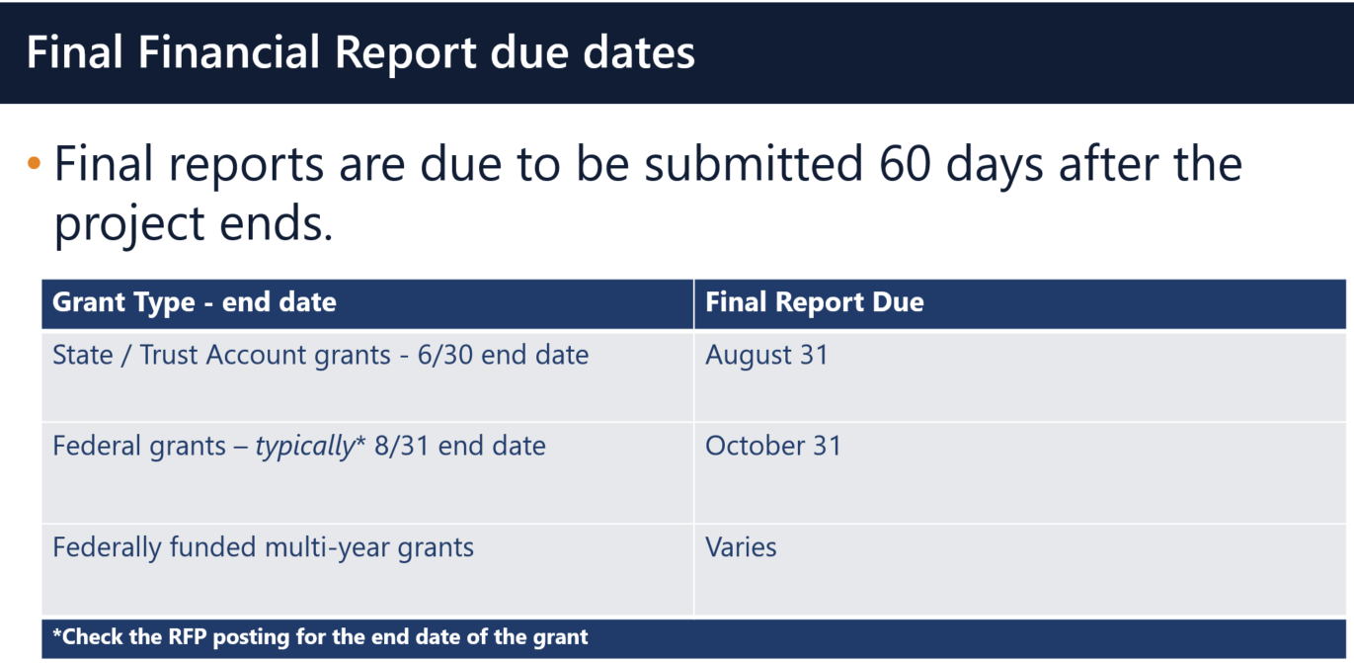

Multi-Year grants: DESE expects that Applicants will spend down their funds in full and not return money as FY2018 multi-year grants now have an end date of 6/30/2019 as long as you filed a multi-year form in May or left a Year 1 balance to roll into Year 2.

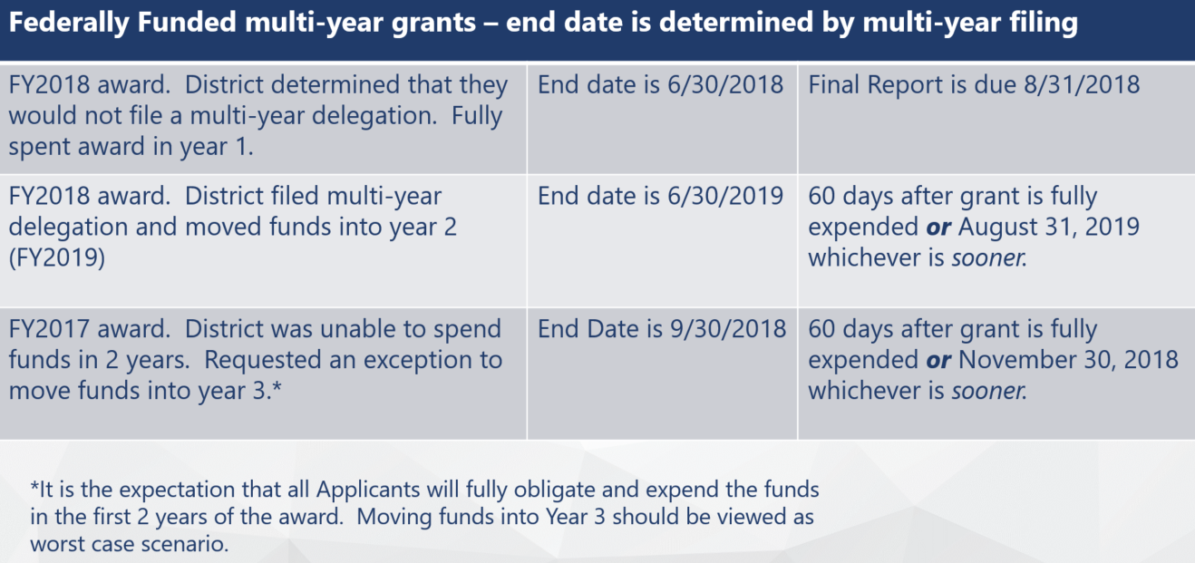

Applicants should use FY2018 Year 2 grant funds up before charging FY2019 grants.

DESE expects that before you try to file a final report, fiscal and programmatic staff will coordinate to ensure all funds have been expended appropriately and are in agreement on the total expected award amount.
BACK TO THE TOP

User Request Form / EdGrants Webinars
DESE requires a user request form be submitted for all new users and edits to existing users. Please review http://www.doe.mass.edu/grants/edgrants/user-security-controls.html for more information and a copy of the Front Office User Request Form.

EdGrants Front Office user webinars are available with ongoing sessions being added as needed. Please click here to review the sessions offered and to register.
BACK TO THE TOP
_ _ _ _ _

If you need assistance please contact Grants Management at 781-338-6595 or email EdGrants@doe.mass.edu. Please reference your grant project number or fund code and Applicant number (LEA Code) when you call and/or email.

This email content below is also attached in word document form in case there is trouble viewing this email.

Thank you,
Grants Management

