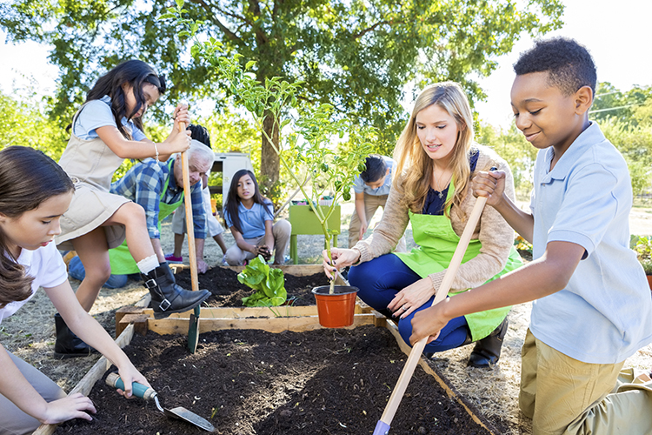

Our Vision
We believe that high quality service-learning instruction engages and motivates students and teaches important science concepts and collaborative skills. Students who participate in service-learning gain the knowledge, attitudes and skills needed to become an engaged citizen and solve environmental challenges that lie ahead. We strive to support teachers' science instruction, boost students’ collaborative skills, and spark students’ interest in future civic work.

Overview

Purpose
Students will investigate the concepts of energy transfer, transformation and natural resources; recognize energy in the world around them; explore how electricity is produced; and uncover related needs and problems in their school, home or community.
Students will apply their learnings to analyze ways to address problems related to energy and resource use. Using collaborative decision-making, they will engage in a high-quality service-learning project to impact authentic problems in their community.

Grade Level

Fourth Grade

Timeframe

Project-Based Learning
Approximately 12 weeks of 30-60 minute daily lessons with students.
Teachers may customize the calendar in ways to match their class schedule and needs.

Overview of the Connect Science Program

Students learn new concepts and skills through service-learning.

Service-Learning involves 8 steps:
- Step 1: Define service-learning.
- Step 2: Discover needs and problems.
- Step 3: Investigate problems.
- Step 4: Research solutions.
- Step 5: Decide on a project.
- Step 6: Plan the project.
- Step 7: Implement the plan.
- Step 8: Evaluate impacts.

Connect Science Schedule

Participants Attend Trainings:
- 4-day training January 17-18 & January 31-February 1, 2020 (Fridays/Saturdays) Location TBD
- 1 day of follow-up professional development and reflection (Late Winter/Early Spring)
- Individual consultation and coaching with Tracy Harkins during implementation (Spring 2020)
- Reflection Session (Summer 2020)

Participants Receive:
- Sequenced lessons that target science, social and emotional and civic concepts and skills as they enact a successful service-learning project
- A set of materials needed to teach science lessons
- Read-aloud books to supplement the curriculum

Expectations for Participation:
- Participating teachers will implement the Connect Science Energy curriculum with students during the spring of 2020
- Teachers will attend all professional development opportunities (see above)

Essential Understandings
Systems thinking can be useful in understanding interactions in the world and designing solutions to challenging problems.
Energy is present in different forms as it moves through natural and human-made systems.
Limited amounts of natural resources are available on earth. Each decision we make about our use of natural resources can have positive or negative impacts on the environment and other people.
Every citizen has a responsibility to find creative solutions to problems they notice in the world around them.
The best solutions arise when people with different knowledge and perspectives listen to each other, communicate respectfully, and collaborate to solve problems.
Kids can use their skills and knowledge to improve their community and our world by engaging in a service-learning project.

Science Knowledge and Skills

Massachusetts Science Curriculum Framework Grade 4 Standards:
- Make observations to show that energy can be transferred from place to place by sound, light, head, and electric currents. (4-PS3-2)
- Apply scientific principles of energy and motion to test and refine a device that converts kinetic energy to electrical energy or uses stored energy to cause motion or produce light or sound. (4-PS3-4)
- Obtain information to describe that energy and fuels humans use are derived from natural resources and that some energy and fuel sources are renewable and some are not. (4-ESS3-1)

Massachusetts Grade 3-5 Science and Engineering Practices:
Science and engineering practices are embedded in the explorations. Some of the specific skills students will be utilizing include:
- Developing and Using Models
- Planning and Carrying out Investigations
- Analyzing and Interpreting Data
- Obtaining, Evaluating and Communicating Information
- Constructing Explanations

Crosscutting Concepts:
In order to build a cohesive story, two Crosscutting Concepts will be woven through the learning experiences:
- Systems and system models
- Energy and matter: Flows, cycles and conservation

Literacy
RI.4.3 Explain events, procedures, ideas, or concepts in a historical, scientific, mathematical, or technical text, including what happened and why, based on specific information in the text.
W.4.2 Write informative/explanatory texts to examine a topic and convey ideas and information clearly.
W.4.7 Conduct short research projects that build knowledge through investigation of different aspects of a topic.
SL.4.1 Engage effectively in a range of collaborative discussions (one-on-one, in groups, and teacher-led) with diverse partners on grade 4 topics and texts, building on others' ideas and expressing their own clearly.
SL.4.3 Identify the reasons and evidence a speaker provides to support particular points.
SL.4.4 Report on a topic, text, procedure, or solution to a mathematical problem, tell a story, or recount an experience in an organized manner, using appropriate facts and relevant, descriptive details to support main ideas or themes; speak clearly at an understandable pace and use appropriate vocabulary.

Collaborative Skills Instruction

Social and Emotional Skills:
Students listen to one another, communicate respectfully, resolve conflict, give and receive feedback and understand that people have different perspectives.
Students create and implement a plan, manage stress, make decisions effectively, persevere when work gets difficult, stay motivated and measure progress toward goals.

Our Source Materials
Collaborative for Academic, Social and Emotional Learning (2017). Core social and emotional learning competencies. Retrieved from www.casel.org/social-and-emotional-learning/core-competencies/

KIDS Consortium (2011). KIDS as planners: A guide to strengthening students, schools and communities through service-learning (3rd ed.). Waldoboro, ME: Harkins Consulting.

National Research Council (2012). A framework for K-12 science education: Practices, crosscutting concepts, and core ideas. Washington, DC: The National Academies Press, doi:10.17226/13165.

