Massachusetts Department of

Elementary and Secondary Education

Grants Management

75 Pleasant Street, Malden, Massachusetts 02148-4906 Telephone: (781) 338-6595 TTY: N.E.T. Relay 1-800-439-2370

Grants Management July Update

- July FINAL FY2019 Payment Request window is now available
- Final Payment Request Windows
- FY2020 Initial Payments
- FY2020 Federal Grant Assurances
- Monthly Updates posted on the Grants Management website
- Multi-Year Grants
- Grant Amendments
- Changes to Community College ISA process
- Final Reports (FR1)
- User Request Form / EdGrants Webinars
- Requesting Funds Reminders & FAQs

July FINAL FY2019 Payment Request is now available

This is a courtesy reminder that the July Payment Request window is open now through July 31st.

This is the final payment request window for all FY2019 grants, including those that have a project end date of 8/31/2019.

Specific fund codes that are considered Multi-Year grants in EdGrants have an additional payment request window for year 1. See Payment request windows chart below for more info.

To request grant funds, log into EdGrants with your DESE provided user name and password. If you are new to EdGrants, please review the Requesting Funds Reminders & FAQs. Don’t have a login? Please review the http://www.doe.mass.edu/grants/edgrants/user-security-controls.html information which explains how to get connected.

Locked out of EdGrants? Grants Management staff periodically checks and unlocks those who are locked out throughout the day. If you continue to find that you are locked out, please call the Grants Management main line at 781-338-6595 for assistance.
BACK TO THE TOP

Final FY2019 Payment Request Windows

Grant Type | Award Year | Payment Request Window
State / Federal / Trust – All Fund Codes*  This includes Federal grants ending 8/31/2019  *except multi-year fund codes | 2019 | July 20th – July 31st  Final opportunity to request funds including grants that end 8/31/2019.
Multi-Year (State/PAC)  Fund Code: 218 | 2019 | August 20th – 24^{th*}  Final opportunity to request year 1 funds.
Multi-Year (Federal/Entitlement)  Fund Codes: 140, 180, 186, 305, 309, 262, 240 ONLY | 2019 (year 1)  2018 (year 2) | August 20th – 24th*  Final opportunity to request year 1 and/or year 2 funds.
Multi-Year grants  Fund Codes: 140, 180, 186, 305, 309, 262, 240 and 218 ONLY | 2019 (year 2) 2018 (year 3) | August 1st – 10th  Next opportunity to request year 2 and/or year 3 funds moved via multi-year delegation into FY2020.
*Balances left unclaimed on the multi-year grant fund codes only will roll into FY20 (Year 2) in September and will be available to draw in October 2019.
**DESE expects that all FY2018 multi-year grants will have fully obligated their funds by 6/30/2019. Applicants should shift FY2019 expenses to charge against their FY2018 award and amend the grants as needed to prioritize expending these funds.

BACK TO THE TOP

FY2020 Initial Payments

Once grants management receives a programmatically approved grant from the program unit administering the grant, an encumbrance is set up via EdGrants and MMARS (the state’s accounting system). When that encumbrance clears MMARS to final status, we can issue an initial payment in the amount of 10% of the budgeted amount of the grant. In order to ensure smooth initial payment, we ask that grantees hold off on requesting line item amendments to make budget changes until October. Amending your grant can delay encumbrance setup and initial payment release.
BACK TO THE TOP

FY2020 Federal Grant Assurances

The FY20 Federal Grant Assurances document can be found on Resource Allocation Strategy and Planning (RASP). Grant Assurances need to be uploaded with the district’s Title I application which is a change in the past method of submission. Please contact RASP at federalgrantprograms@doe.mass.edu or call 781-338-6230 with any questions regarding the FY20 Federal Grant Assurances.

Monthly Updates

These Grants Management Updates are posted each month on the grants website under Grants Notifications and Alerts. Previously posted monthly updates are always available in the Grants News Archives.
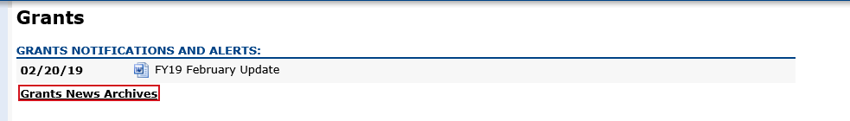
BACK TO THE TOP
Multi-Year grants
The only FY2019 grant fund codes that have multi-year available in EdGrants are:
- 140 (Title II-A)
- 180 / 186 (Title III)
- 218* (High-Quality Instruction – Summer Planning)
- 240 (Special Ed)
- 262 (Early Childhood Special Ed)
- 305 (Title I)
- 309 (Title IV)

If the multi-year delegation form was not submitted in EdGrants, or if $0 was moved into Year 2, the grant end date is 6/30/2019. If multi-year was submitted moving any funds into Year 2, the grant end date is now 6/30/2020.

Unclaimed balances left in year 1 will roll into Year 2 automatically in September, and the grant end date will be extended to 6/30/2020 at that time.

*Fund Code 218 – High-Quality Instruction – Summer Planning grantees have a grant end date of 8/31/2019, provided a multi-year delegation form was submitted moving some funds into Year 2. This grant is not available for the 24-month grant period as the other multi-year grants are.

FY2018 Multi-Year Year 3 (7/1/2019 – 9/30/2019):

Very few FY2018 Multi-Year 2-3 delegation forms were submitted in EdGrants requesting that a year 3 be added (FY2020). This is good news as Year 3 should be viewed as an exception and only utilized if the alternative would be returning grant funds. DESE expects that applicants will assess expenditures and shift FY19 charges over to the FY18 award where necessary and appropriate. In some cases, this will require an amendment to the FY18 or FY19 (or both!) grant budgets.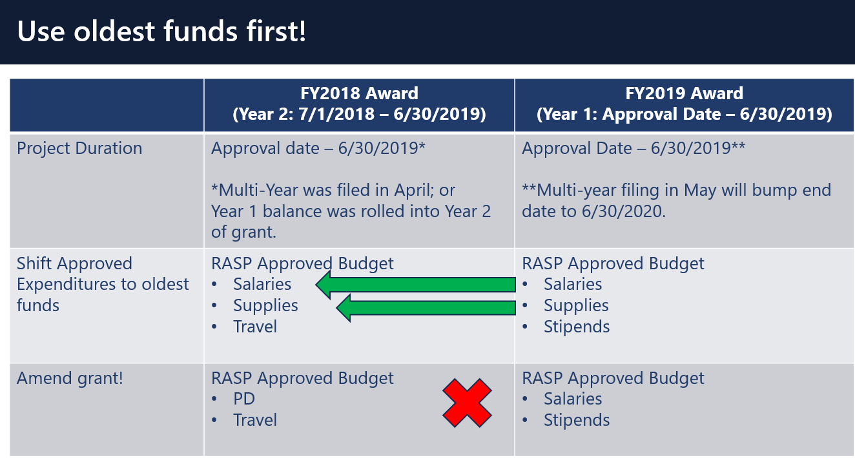
If you’d like to request an amendment, please contact your federal grants group liaison.

BACK TO THE TOP

Grant Amendments

In order to ensure a smooth start to FY2020, we ask that grantees hold off on requesting line item amendments on FY2020 grants until October. Amending your grant right after you submit it in EdGrants can delay encumbrance setup and initial payment release.

BACK TO THE TOP

Changes to Community College ISA Process

After some discussion with the Comptroller’s Office, we are happy to announce that for FY20 grants, state community colleges no longer will be required to setup BGCS / BGCNs on MMARS to access grant funds. As in years past, ISA paperwork will still be required and maintained on file here at DESE, but EdGrants should be used to draw down grant funds.

Colleges are still required to do the monthly reporting in MMARS for grant funds. We have an ISA training set up if you’d like to register to learn more you can do so HERE.

Thank you for your patience and time during this past year as we sorted this out.

Proposed Fringe Rates for FY20
Fringe Rate on State grants is 2.44% of AA and CC payroll (D09).
Fringe Rate on Federal/trust accounts is 37.99% of AA payroll and 1.73% of CC payroll

You can also view that on the MA Comptrollers. We will also notify you about the rate changes for FY20 once approved.

BACK TO THE TOP

Filing Final Financial Reports (FR1)

FY2019 Final Reports will be available in EdGrants the day after the grant project duration ends.
- FY2019 grants that end 6/30/2019 will be available on 7/1/2019.
- FY2019 grant that end 8/31/2019 will be available on 9/1/2019.

Final Reports should not be submitted until final obligations and draw-downs are complete. Please make sure that all expenses have been accounted for and reconciled before you file a Final Report. If you do not see an FY2019 final report available for a specific grant project in the Submissions menu, please email EdGrants@doe.mass.edu and include the project number in the email. You can also call the main grants line at 781-338-6595; please have the project number ready.

Please note: There is a known glitch with the final report form in EdGrants. If the line item is overspent by a small amount, it throws the “Balance Unexpended” and the percentage columns off. We are working to correct this error. In the meantime, you can submit the final report; the “Cash Balance” section at the bottom of the report form does calculate correctly.

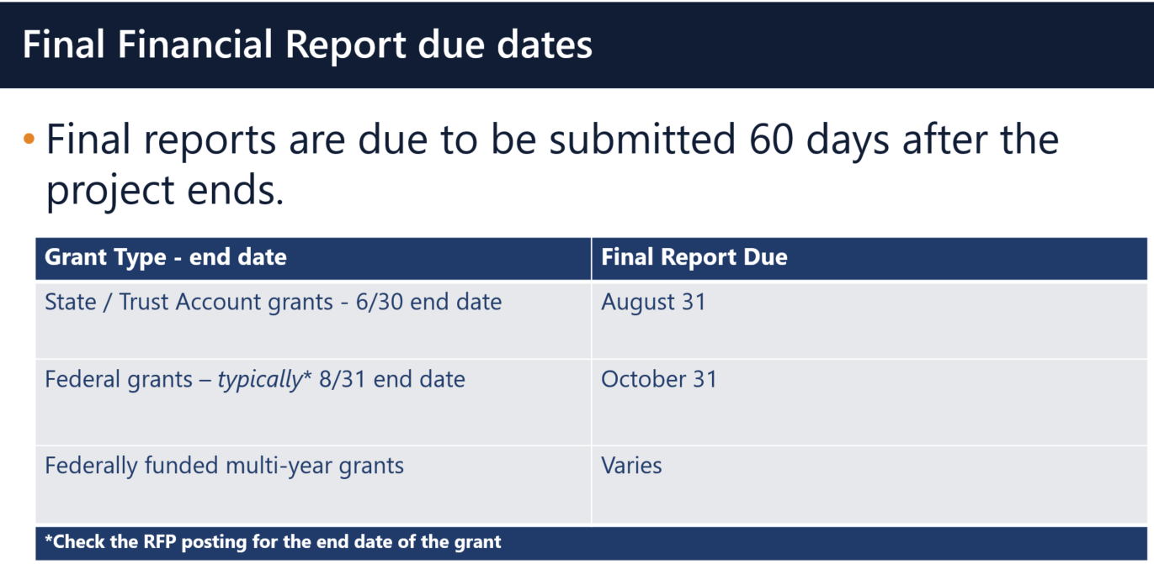

Multi-Year grants: DESE expects that Applicants will spend down their funds in full and not return money now that the multi-year feature is available in EdGrants for specific grant fund codes.

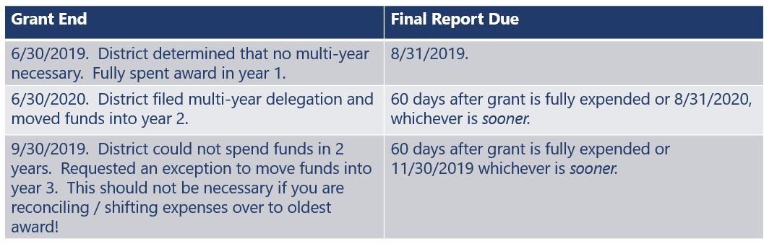

DESE expects that before you try to file a final report, district fiscal and programmatic staff will coordinate to ensure all funds have been expended appropriately and agree on the award total.
BACK TO THE TOP

User Request Form / EdGrants Webinars
DESE requires a user request form be submitted for all new users and edits to existing users. Please review http://www.doe.mass.edu/grants/edgrants/user-security-controls.html for more information and a copy of the Front Office User Request Form.

EdGrants Front Office user webinars will be available with ongoing sessions being added as needed. Please click here to review the sessions offered and to register.
BACK TO THE TOP

Requesting Funds Reminders & FAQs

Sherriff / State Agency Departments who receive grant funds (all fund codes) directly through MMARS accounts via ISAs do NOT need to request grant funds using EdGrants.
-----
Funds can only be requested if your grant has been programmatically approved, processed and an automatic Initial Payment has been issued by DESE.

http://www.doe.mass.edu/Grants/edgrants.html
http://www.doe.mass.edu/Grants/edgrants.html
http://www.doe.mass.edu/Grants/edgrants.html
http://www.doe.mass.edu/Grants/edgrants.html

http://www.doe.mass.edu/grants/edgrants/requesting-funds.docx outlines step by step how to make your payment request as well as how to view your Project Record Card.

Please find all EdGrants user documents here.
BACK TO THE TOP

_ _ _ _ _

If you need assistance, please contact Grants Management at 781-338-6595 or email EdGrants@doe.mass.edu. Please reference your grant project number or fund code and Applicant number (LEA Code) when you call and/or email.

Thank you,
Grants Management

