Massachusetts Department of

Elementary and Secondary Education

Grants Management

75 Pleasant Street, Malden, Massachusetts 02148-4906 Telephone: (781) 338-6595 TTY: N.E.T. Relay 1-800-439-2370

Grants Management April Update

- April Payment Request window is now available
- Important Changes due to COVID-19: FY20 Multi-Year Delegation
- FY20 Entitlement Grant Allocation Adjustments
- Required Forms for FY2021 Grant Applicants — Action Required
- Monthly Updates posted on the Grants Management website
- Community College / Sherriff’s Department ISAs
- Final Reports (FR1)
- EdGrants User Access Request
- Requesting Funds Reminders & FAQs

April Payment Request window is now available

This is a courtesy reminder that the April Payment Request window is open now through April 30, 2020.

This includes any FY2020 grants where an initial payment has been received, as well as Multi-Year grants for FY2019 Year 2.

Multi-Year Grants: Please check FY19 Project Record Cards (Front Office/submissions menu) on multi-year grants to see if there is an available balance to draw. FY2019 funds should be expended before utilizing FY2020 awards.

To request grant funds, log into EdGrants with your DESE provided user name and password. If you are new to EdGrants, please review the Requesting Funds Reminders & FAQs. Don’t have a login? Please review the http://www.doe.mass.edu/grants/edgrants/user-security-controls.html information which explains how to get connected.

Locked out of EdGrants? Grants Management staff periodically checks and unlocks those who are locked out throughout the day. If you continue to find that you are locked out, please call the Grants Management main line at 781-338-6595 for assistance.
BACK TO THE TOP

Important Changes due to COVID-19: FY20 Multi-Year Delegation

Due to the ongoing COVID-19 pandemic, and related school closures which may impact the ability to spend down funds in both FY2019 Year 2 and FY2020 Year 1 entitlement grants, DESE will be submitting and processing Multi-year Delegation forms on behalf of Applicants with balances remaining. Applicants do not need to take any action to obtain the multi-year extension from FY2020 to FY2021.

These are the only grants with Multi-Year provision getting extended by DESE:
Grant Program | Federal Award Year
Title I (FC: 305) | FY2019 & FY2020
Title II-A (FC: 140) | FY2019 & FY2020
Title III (FC: 180 and 186) | FY2019 & FY2020
Title IV (FC: 309) | FY2019 & FY2020
IDEA (FC: 240) | FY2019 & FY2020
Early Childhood Special Ed (FC: 262) | FY2019 & FY2020
Civics Teaching and Learning (FC: 589)* | FY2020

DESE will activate the multi-year extension for grantees that have active entitlement grants with unclaimed balances. This will extend the end date from 6/30/2020 to 6/30/2021 for both FY2019 and FY2020 grants.

In May, DESE will begin entering in multi-year delegation forms for all applicants who receive the above grants that have balances left to claim. Grantees will still see the Multi-Year delegation form appear in the Submissions section of EdGrants: Front Office, but do not need to take any action.

* FC: 589 is a Trust funded grant, not a federal award.

Other DESE discretionary grant programs, do NOT utilize the multi-year feature in EdGrants. In some cases, discretionary funds can be decreased to what will be spent through 6/30/2020 in order to re-apply for the balance in FY2021. Many program staff have already reached out to their grantees if this is an allowable provision, as not all grant accounts will allow for extensions. If this does apply, decrease amendments must be submitted in EdGrants by May 15, 2020 in order to free up the funds to re-apply in FY2021 for summer only funds (state) or FY2021 full year funding (federal or trust). If you are unsure whether this pertains to a particular grant, please contact your DESE program contact posted with the RFP to find out more information.

BACK TO THE TOP

FY20 Entitlement Grant Allocation Adjustments

In February, the Federal Grants group notified federal entitlement grantees that the mid-year adjustments would be available to claim via increase amendment between 3/5 and 3/16. Many districts were not able to respond to claim their increase. The federal grants group has pushed through any increases on behalf of the districts that did not decline the funds. The increase was added to the Supplies & Materials line to get them expedited quickly.

- Federal grants group Title I/IIA increase guidance
- Federal grant group IDEA increase guidance

All increases have been processed and should be available for draw down in April.

Required Forms for FY2021 Grant Applicants — Action Required

DESE is asking all agency partners who receive grant funding to complete a revised Commonwealth of Massachusetts – Standard Contract Form (SCF) which will take effect July 1, 2020. This form is published and issued jointly by the Executive Office for Administration and Finance (ANF), the Office of the State Comptroller (CTR), and the Operational Services Division (OSD) for use by all commonwealth Departments for New Grants/Contracts and Grant/Contract Agreements or Renewals. The policies, procedures, and legal references outlines therein, have been incorporated by reference in the Office of the Comptroller regulations, 815 CMR 2.00: Grants and Subsidies.

Please review the information here and kindly respond by returning the required forms outlined within by January 31, 2020. DESE must have this documentation in place before we can release any FY2021 grants to applicants. If you have any questions, please contact grants management at 781-338-6595.

Please note: The Commonwealth of Massachusetts Contractor Authorized Signatory Listing (CASL) Form states that it is optional. DESE is opting in and requiring this form along with notary authentication.

All documents must be signed and in place for your entity prior to DESE being able to issue any FY2021 funds.

Monthly Updates

These Grants Management Updates are posted each month on the grants website under Grants Notifications and Alerts. Previously posted monthly updates are always available in the Grants News Archives.
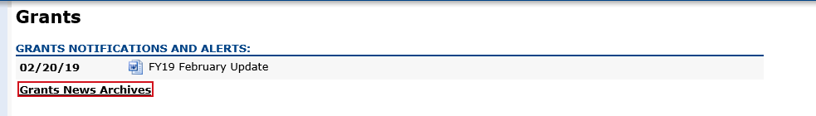
BACK TO THE TOP

Community College / Sherriff’s Department ISAs

Fringe Rates for Correctional Facilities:
Approved FY20 Fringe Rate on State grants is 2.43% of AA and CC payroll (D09).
Fringe Rate on Federal/trust accounts is 37.91% of AA payroll and 2.43% of CC payroll
Proposed FY21 Fringe Rate on State grants is 1.85% of AA and CC payroll (D09).
Fringe Rate on Federal/trust accounts is 38.88% of AA payroll and 1.85% of CC payroll
Fringe Rates for State Colleges/ Universities:
Approved FY20 Fringe Rate on State/Federal/trust accounts is 37.91% of AA payroll and 2.43% of CC payroll
Proposed FY21 Fringe Rates on State/Federal/trust accounts is 38.88% AA payroll and 1.85% of CC payroll

The state sets these rates, not the Department. Rates and charge backs can be reviewed at MA Comptrollers. We will also notify you about the rate changes for FY21 once approved.

Please do not forget to file a Final Financial Report (FR-1) for any grant funds issued.

BACK TO THE TOP

Filing Final Financial Reports (FR1)

Final Reports should not be submitted until all expenses have been accounted for and reconciled.

FY2019 Final Reports will be available in EdGrants the day after the grant project duration ends.
- FY2019 grants that end 6/30/2019 were available as of 7/1/2019.
- FY2019 grant that end 8/31/2019 were available as of 9/1/2019.

If you do not see an FY2019 final report available for a specific grant project in the Submissions menu, please email EdGrants@doe.mass.edu and include the project number in the email. You can also call the main grants line at 781-338-6595; please have the project number ready.

Please note there are a couple of known glitches with the final report form in EdGrants:
- If the line item is overspent by a small amount that is within the allowable thresholds, it throws the “Balance Unexpended” and the percentage columns off. We are working to correct this error. In the meantime, you can submit the final report; the “Cash Balance” section at the bottom of the report form does calculate correctly.
- If your Final Report shows a balance to return less than $1, you do not need to return the funds.

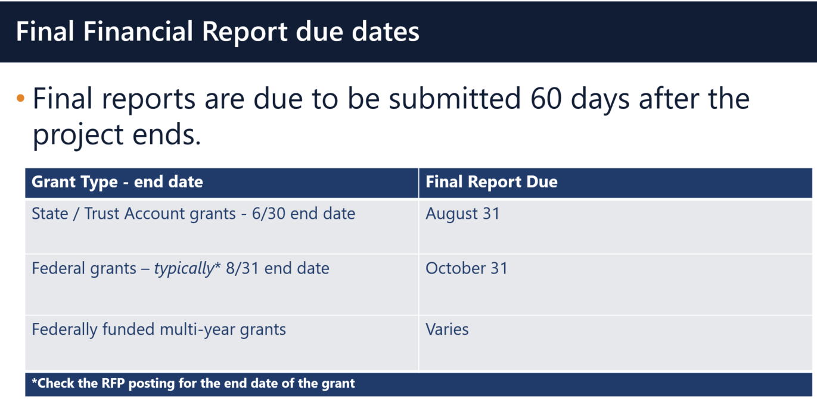

Multi-Year grants: DESE expects that Applicants will spend down their funds in full and not return money now that the multi-year feature is available in EdGrants for specific grant fund codes.

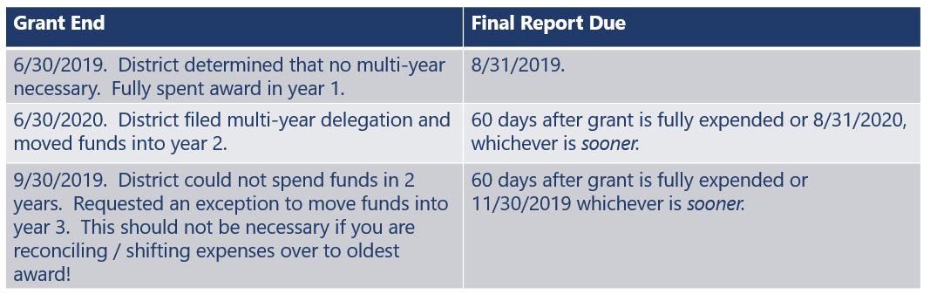

DESE expects that before you try to file a final report, district fiscal and programmatic staff will coordinate to ensure all funds have been expended appropriately and agree on the award total.

BACK TO THE TOP

EdGrants User Access Request
DESE requires a user request form be submitted for all new users and edits to existing users. Please review http://www.doe.mass.edu/grants/edgrants/user-security-controls.html for more information and a copy of the Front Office User Request Form.

BACK TO THE TOP

Requesting Funds Reminders & FAQs

Sherriff / State Agency Departments who receive grant funds (all fund codes) directly through MMARS accounts via ISAs do NOT need to request grant funds using EdGrants.
-----
Funds can only be requested if your grant has been programmatically approved, processed and an automatic Initial Payment has been issued by DESE.

http://www.doe.mass.edu/grants/edgrants
http://www.doe.mass.edu/grants/edgrants
http://www.doe.mass.edu/grants/edgrants
http://www.doe.mass.edu/grants/edgrants

http://www.doe.mass.edu/grants/edgrants/requesting-funds.docx outlines step by step how to make your payment request as well as how to view your Project Record Card.

Please find all EdGrants user documents here.
BACK TO THE TOP

_ _ _ _ _

If you need assistance, please contact Grants Management at 781-338-6595 or email EdGrants@doe.mass.edu. Please reference your grant project number or fund code and Applicant number (LEA Code) when you call and/or email.

Thank you,
Grants Management

