Massachusetts Department of

Elementary and Secondary Education

Grants Management

75 Pleasant Street, Malden, Massachusetts 02148-4906 Telephone: (781) 338-6595 TTY: N.E.T. Relay 1-800-439-2370

Grants Management March Update

- March Payment Request window is now available
- FY20 Allocation Adjustments – In Process/Payment Window Impacts
- Required Forms for FY2021 Grant Applicants — Action Required
- New to EdGrants?
- Monthly Updates posted on the Grants Management website
- Federal/Entitlement Multi-Year Grants
- Community College / Sherriff’s Department ISAs
- Final Reports (FR1)
- User Request Form / EdGrants Webinars
- Requesting Funds Reminders & FAQs

March Payment Request window is now available

This is a courtesy reminder that the March Payment Request window is open now through March 31, 2020.

This includes any FY2020 grants where an initial payment has been received, as well as Multi-Year grants for FY2019 Year 2.

Multi-Year Grants: Please check FY19 Project Record Cards (Front Office/submissions menu) on multi-year grants to see if there is an available balance to draw. FY2019 funds should be expended before utilizing FY2020 awards.

To request grant funds, log into EdGrants with your DESE provided user name and password. If you are new to EdGrants, please review the Requesting Funds Reminders & FAQs. Don’t have a login? Please review the http://www.doe.mass.edu/Grants/edgrants.html information which explains how to get connected.

Locked out of EdGrants? Grants Management staff periodically checks and unlocks those who are locked out throughout the day. If you continue to find that you are locked out, please call the Grants Management main line at 781-338-6595 for assistance.
BACK TO THE TOP

FY20 Entitlement Grant Allocation Adjustments – In Process/Payment Window Impacts

In February, the Federal Grants group notified federal entitlement grantees that the mid-year adjustments would be available to claim via increase amendment between 3/5 and 3/16. Many districts were not able to respond to claim their increase. The federal grants group is currently working to push through the remaining increases on behalf of the districts and adding the increase to the Supplies & Materials line just to get the increased awards onto the system.

- Federal grants group Title I/IIA increase guidance
- Federal grant group IDEA increase guidance

As these amendments are being processed internally, you may get a message in EdGrants stating that you currently cannot draw down funds. This is the typical way that EdGrants works when a grant is open under amendment. Until the grant amendment has completed the workflow internally, and the increase clears the state’s accounting system, you will not be able to draw funds. If you get this message check back a few days later to request.

We appreciate your patience as we get through processing about 1,200 increase amendments. We will certainly extend out the payment window case by case as needed in order to mitigate the impact this has on applicants trying to draw funds.

Required Forms for FY2021 Grant Applicants — Action Required

DESE is asking all agency partners who receive grant funding to complete a revised Commonwealth of Massachusetts – Standard Contract Form (SCF) which will take effect July 1, 2020. This form is published and issued jointly by the Executive Office for Administration and Finance (ANF), the Office of the State Comptroller (CTR), and the Operational Services Division (OSD) for use by all commonwealth Departments for New Grants/Contracts and Grant/Contract Agreements or Renewals. The policies, procedures, and legal references outlines therein, have been incorporated by reference in the Office of the Comptroller regulations, 815 CMR 2.00: Grants and Subsidies.

Please review the information here and kindly respond by returning the required forms outlined within by January 31, 2020. DESE must have this documentation in place before we can release any FY2021 grants to applicants. If you have any questions, please contact grants management at 781-338-6595.

Please note: The Commonwealth of Massachusetts Contractor Authorized Signatory Listing (CASL) Form states that it is optional. DESE is opting in and requiring this form along with notary authentication.

All documents have to be signed and in place for your entity prior to DESE being able to issue FY2021 funds.

New to EdGrants?

EdGrants is the DESE grants financial system. When you apply for a DESE grant outside of EdGrants, at some point you will be notified to enter an application into EdGrants in order to receive any grant funds from DESE. EdGrants is a workflow-based system where each grant project follows the same path of Application Submission, Program Review, Project Approval, Grants Management/Award, and Post Award Reporting. Once grants management receives a programmatically approved grant within EdGrants from the program unit administering the grant, an encumbrance is set up via EdGrants and MMARS (the state’s accounting system). When that encumbrance clears MMARS to final status, we will issue an initial payment in the amount of 10% of the budgeted amount of the grant. Once that initial payment is received, you will then have access to the monthly draw-down windows which are open from the 20th of the month through the last day of the month.

It can sometimes take a few weeks between Application submission, program approval and GM setup, so it is important that you enter your grant into EdGrants as soon as you are notified that it is available. If you believe you have submitted a grant and have been waiting a very long time for that initial payment to be sent, please contact Grants Management at 781-338-6595.

To get familiar with the Department’s grants system, please take advantage of attending an EdGrants Webinar and take a minute to review User Request Form / Webinars as well as the EdGrants Guidance Documents for all of your EdGrants navigation needs.

BACK TO THE TOP

Monthly Updates

These Grants Management Updates are posted each month on the grants website under Grants Notifications and Alerts. Previously posted monthly updates are always available in the Grants News Archives.
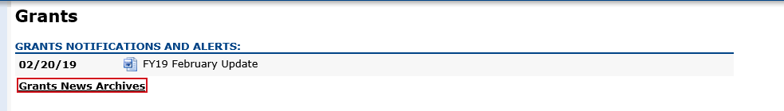
BACK TO THE TOP

Federal/Entitlement Multi-Year grants
The purpose of the multi-year grants in EdGrants is to allow continuous spending of funds resulting in no grant returns.

FY2019 Award: If the multi-year delegation form was not submitted in EdGrants, if $0 was moved into Year 2, and/or no unclaimed funds were left to roll, the grant end date was 6/30/2019. Final Reports should be filed.

If multi-year was submitted moving funds into Year 2, the grant end date is now 6/30/2020.
No Final Report is expected until funds are fully drawn down and reconciled.

Unclaimed balances left in year 1 should be reflected on your Year 2 payment request forms, as any unclaimed Year 1 balances have rolled. The project end date has been extended to 6/30/2020.

Grantees should assess expenditures and shift charges over to the oldest active award where possible. In some cases, this will require an amendment to the FY19/FY20 grant budgets.
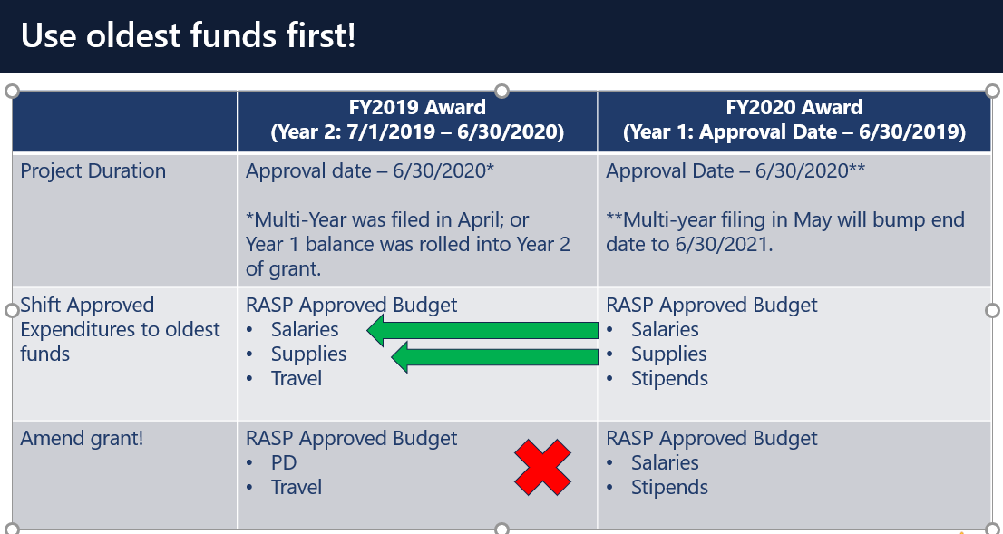

FY2018 Award: These federal entitlement awards are now closed. Grantees should have filed their Final Financial Reports (FR-1) on these FY2018 multi-year awards if they have not done so already.

If you’d like to request an amendment, please contact your federal grants group liaison.

BACK TO THE TOP

Community College / Sherriff’s Department ISAs

Fringe Rates for Correctional Facilities:
Approved FY20 Fringe Rate on State grants is 2.43% of AA and CC payroll (D09).
Fringe Rate on Federal/trust accounts is 37.91% of AA payroll and 2.43% of CC payroll
Proposed FY21 Fringe Rate on State grants is 1.85% of AA and CC payroll (D09).
Fringe Rate on Federal/trust accounts is 38.88% of AA payroll and 1.85% of CC payroll
Fringe Rates for State Colleges/ Universities:
Approved FY20 Fringe Rate on State/Federal/trust accounts is 37.91% of AA payroll and 2.43% of CC payroll
Proposed FY21 Fringe Rates on State/Federal/trust accounts is 38.88% AA payroll and 1.85% of CC payroll

The state sets these rates, not the Department. Rates and charge backs can be reviewed at MA Comptrollers. We will also notify you about the rate changes for FY21 once approved.

Please do not forget to file a Final Financial Report (FR-1) for any grant funds issued.
BACK TO THE TOP

Filing Final Financial Reports (FR1)

Final Reports should not be submitted until all expenses have been accounted for and reconciled.

FY2019 Final Reports will be available in EdGrants the day after the grant project duration ends.
- FY2019 grants that end 6/30/2019 were available as of 7/1/2019.
- FY2019 grant that end 8/31/2019 were available as of 9/1/2019.

If you do not see an FY2019 final report available for a specific grant project in the Submissions menu, please email EdGrants@doe.mass.edu and include the project number in the email. You can also call the main grants line at 781-338-6595; please have the project number ready.

Please note there are a couple of known glitches with the final report form in EdGrants:
- If the line item is overspent by a small amount that is within the allowable thresholds, it throws the “Balance Unexpended” and the percentage columns off. We are working to correct this error. In the meantime, you can submit the final report; the “Cash Balance” section at the bottom of the report form does calculate correctly.
- If your Final Report shows a balance to return less than $1, you do not need to return the funds.

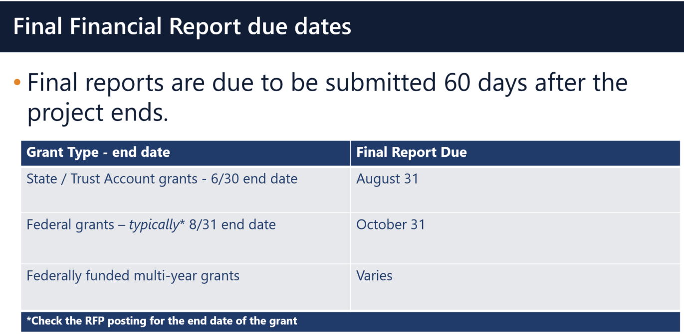

Multi-Year grants: DESE expects that Applicants will spend down their funds in full and not return money now that the multi-year feature is available in EdGrants for specific grant fund codes.

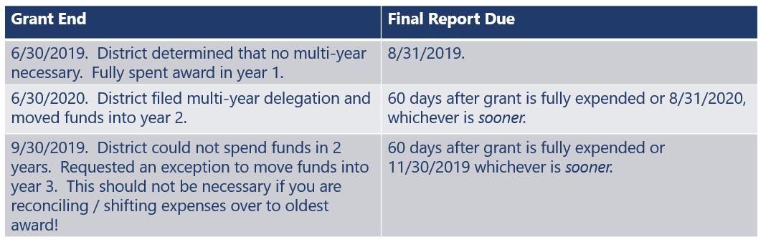

DESE expects that before you try to file a final report, district fiscal and programmatic staff will coordinate to ensure all funds have been expended appropriately and agree on the award total.
BACK TO THE TOP

User Request Form / EdGrants Webinars
DESE requires a user request form be submitted for all new users and edits to existing users. Please review EdGrants: User Security Controls for more information and a copy of the Front Office User Request Form.

EdGrants Front Office user webinars will be available with ongoing sessions being added as needed. Please click here to review the sessions offered and to register.
BACK TO THE TOP

Requesting Funds Reminders & FAQs

Sherriff / State Agency Departments who receive grant funds (all fund codes) directly through MMARS accounts via ISAs do NOT need to request grant funds using EdGrants.
-----
Funds can only be requested if your grant has been programmatically approved, processed and an automatic Initial Payment has been issued by DESE.

http://www.doe.mass.edu/Grants/edgrants.html
http://www.doe.mass.edu/Grants/edgrants.html
http://www.doe.mass.edu/Grants/edgrants.html
http://www.doe.mass.edu/Grants/edgrants.html

http://www.doe.mass.edu/grants/edgrants/requesting-funds.docx outlines step by step how to make your payment request as well as how to view your Project Record Card.

Please find all EdGrants user documents here.
BACK TO THE TOP

_ _ _ _ _

If you need assistance, please contact Grants Management at 781-338-6595 or email EdGrants@doe.mass.edu. Please reference your grant project number or fund code and Applicant number (LEA Code) when you call and/or email.

Thank you,
Grants Management

