Massachusetts Department of

Elementary and Secondary Education

Grants Management

75 Pleasant Street, Malden, Massachusetts 02148-4906 Telephone: (781) 338-6595 TTY: N.E.T. Relay 1-800-439-2370

Grants Management May Update

- Required Forms for FY2021 Grant Applicants — Time Sensitive Action Required
- May Payment Request window is now available
- An Important Note Regarding Issues with the FY20 Title IV (FC: 309) Payment Window
- Important Changes due to COVID-19: FY20 Multi-Year Delegation
- FY2020 Final Payment Request Windows
- Monthly Updates posted on the Grants Management website
- Community College / Sherriff’s Department ISAs
- Final Financial Reports (FR1)
- EdGrants User Access Request
- Requesting Funds Reminders & FAQs

Required Forms for FY2021 Grant Applicants — Time Sensitive Action Required

In October 2019, Grants Management notified all applicant lead agencies regarding state requirements needed before FY21 grants can be issued. DESE is still missing documentation from about one-third of the applicants. Click here to review the memo and required forms.

Please review the Missing Standard Contract Forms list to determine if your entity needs to send in the required forms. Not having this documentation on file means we cannot issue any FY21 grants to the effected applicants until it is received. This can impact grant start dates. This list will be updated online weekly as we get responses.

If you are not on the list, it means we have all the documentation needed.

A reminder that DESE is “opting in” for the notary on the CASL form, but we realize that during this time it may be difficult to obtain a notary seal. We can accept CASL forms without the notary, temporarily, provided it accompanies a signed original Standard Contract Form. The notary can be sent in later when access to such things becomes available. If able to obtain the notary seal now, please do so. The CASL form is used any time pertinent secure information is changed in the applicant’s vendor profile setup, such as bank account information, so it is important that we have the CASL form with a notary seal and sign off when possible.

All documents must be signed and in place for your entity prior to DESE being able to issue any FY2021 funds.

May Payment Request window is now available

This is a courtesy reminder that the May Payment Request window is open now through May 31, 2020.

This includes any FY2020 grants where an initial payment has been received, as well as Multi-Year grants for FY2019 Year 2.

Multi-Year Grants: Please check FY19 Project Record Cards (Front Office/submissions menu) on multi-year grants to see if there is an available balance to draw. FY2019 funds should be expended before utilizing FY2020 awards.

To request grant funds, log into EdGrants with your DESE provided user name and password. If you are new to EdGrants, please review the Requesting Funds Reminders & FAQs. Don’t have a login? Please review the User Security Controls information which explains how to get connected.

Locked out of EdGrants? Grants Management staff periodically checks and unlocks those who are locked out throughout the day. If you continue to find that you are locked out, please call the Grants Management main line at 781-338-6595 for assistance.
BACK TO THE TOP

An Important Note Regarding Issues with the FY20 Title IV (FC: 309) Payment Window

Please note an issue with the FY2020 Title IV (FC: 309) payment window. The Funding Opportunity was inadvertently set up making the May and June Year 1 payment windows available at the same time as the May and June Year 2 payment windows. This is an error.

If you are requesting FY2020 Title IV fund this month, you must use the FY20 309 – Title IV – 11 May Payment Request and NOT the May Year 2 Payment Request.

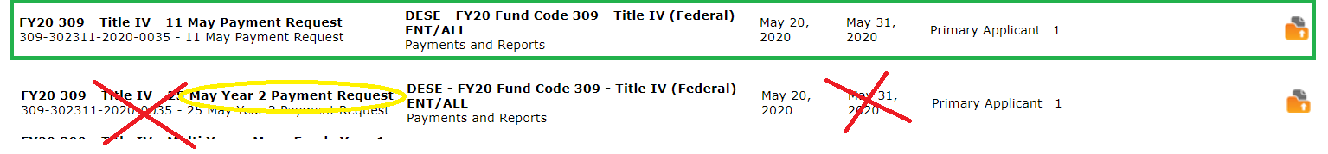

Title IV (FC: 309) grants with balances left to claim over $100, will see the $100 as available to draw on this Year 2 form. As FY21 has not opened yet, we cannot issue any payments against year 2 at this time. Anyone who uses the Year 2 form, will get those funds issued to them in July.

BACK TO THE TOP

Important Changes due to COVID-19: FY20 Multi-Year Delegation

Due to the ongoing COVID-19 pandemic, and related school closures which may impact the ability to spend down funds in both FY2019 Year 2 and FY2020 Year 1 entitlement grants, DESE has submitted and processed Multi-year Delegation forms on behalf of Applicants with balances remaining over $100. Applicants do not need to take any action to obtain the multi-year extension from FY2020 to FY2021.

These are the only grants with Multi-Year provision getting extended by DESE:
Grant Program | Federal Award Year
Title I (FC: 305) | FY2019 & FY2020
Title I Part D (FC: 306/307)** | FY2019 & FY2020
Title II-A (FC: 140) | FY2019 & FY2020
Title III (FC: 180 and 186) | FY2019 & FY2020
Title IV (FC: 309) | FY2019 & FY2020
IDEA (FC: 240) | FY2019 & FY2020
Early Childhood Special Ed (FC: 262) | FY2019 & FY2020
Civics Teaching and Learning (FC: 589)* | FY2020
** Funds extended through an ISA. Communication to grantees has gone out please contact: jennyfer.cabral@mass.gov for questions regarding your ISA

This has extended the end date for both FY2019 and FY2020 grants as follows:
Grant Program | Federal Award Year | New End Date
Title I (FC: 305) | FY2019 & FY2020 | 6/30/2021
Title I Part D (FC: 306/307) | FY2019 & FY2020 | 6/30/2021
Title II-A (FC: 140) | FY2019 & FY2020 | 6/30/2021
Title III (FC: 180 and 186) | FY2019 & FY2020 | 6/30/2021
Title IV (FC: 309) | FY2019 & FY2020 | 6/30/2021
IDEA (FC: 240) | FY2019 | 9/30/2020
IDEA (FC: 240) | FY2020 | 6/30/2021
Early Childhood Special Ed (FC: 262) | FY2019 | 9/30/2020
Early Childhood Special Ed (FC: 262) | FY2020 | 6/30/2021
Civics Teaching and Learning (FC: 589) | FY2020 | 6/30/2021

Other DESE discretionary grant programs, do NOT utilize the multi-year feature in EdGrants.

BACK TO THE TOP

Final FY2020 Payment Request Windows

Grant Type | Award Year | Payment Request Window
State / Federal / Trust – All Fund Codes*  This includes Federal grants ending 8/31/2019  *except multi-year fund codes | 2020 | July 20th – July 31st  Final opportunity to request funds including grants that end 8/31/2019.
FY2019 and FY2020 Multi-Year Payment Request Windows
Fund Codes: 305 (Title I), 140 (Title II-A), 180 & 186 (Title III), 309 (Title IV), 240 (IDEA), 262 (Early Childhood Special Ed) and 589 (Civics Teaching and Learning)

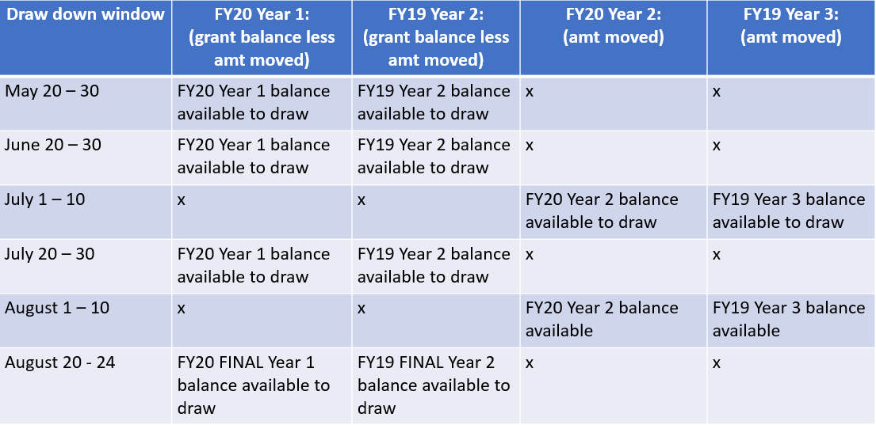
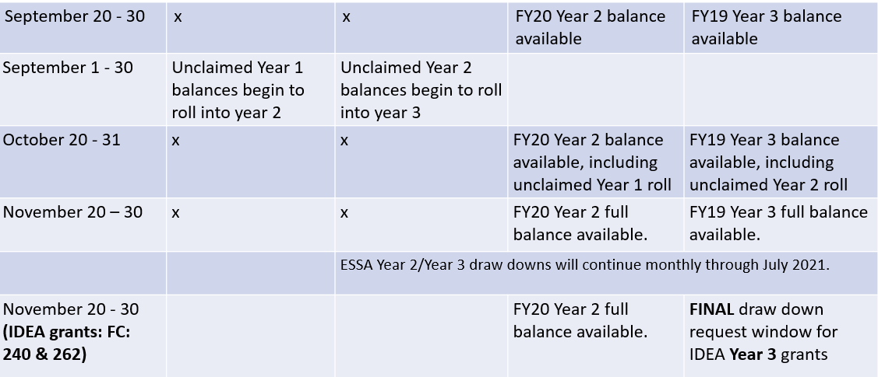

BACK TO THE TOP

Monthly Updates

These Grants Management Updates are posted each month on the grants website under Grants Notifications and Alerts. Previously posted monthly updates are always available in the Grants News Archives.
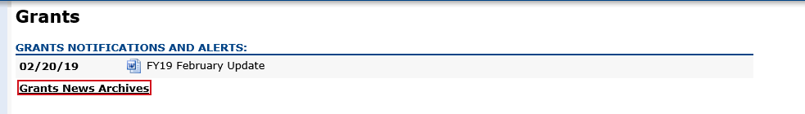
BACK TO THE TOP
Community College / Sherriff’s Department ISAs

Fringe Rates for Correctional Facilities:
Approved FY20 Fringe Rate on State grants is 2.43% of AA and CC payroll (D09).
Fringe Rate on Federal/trust accounts is 37.91% of AA payroll and 2.43% of CC payroll
Proposed FY21 Fringe Rate on State grants is 1.85% of AA and CC payroll (D09).
Fringe Rate on Federal/trust accounts is 38.88% of AA payroll and 1.85% of CC payroll
Fringe Rates for State Colleges/ Universities:
Approved FY20 Fringe Rate on State/Federal/trust accounts is 37.91% of AA payroll and 2.43% of CC payroll
Proposed FY21 Fringe Rates on State/Federal/trust accounts is 38.88% AA payroll and 1.85% of CC payroll

The state sets these rates, not the Department. Rates and charge backs can be reviewed at MA Comptrollers. We will also notify you about the rate changes for FY21 once approved.

Please do not forget to file a Final Financial Report (FR-1) for any grant funds issued.

BACK TO THE TOP

Filing Final Financial Reports (FR-1)

Final Financial Reports should not be submitted until all expenses have been accounted for and reconciled.

FY2020 Final Reports will be available the day after the grant project duration ends.
- FY2020 grants that end 6/30/2020 will be available 7/1/2020 and are due 8/31/2020
- FY2020 grants that end 8/31/2020 will be available 9/1/2020 and are due 10/31/2020
- Please do not file your FR-1 until you have drawn down and reconciled all funds spent and all expected invoices.

FY2019 Final Reports should be submitted by now. The exception being FY2019 multi-year grants still active with funds available to draw down and obligate. See due date chart below for more info.

If you do not see a final report available for a specific grant project in the Submissions menu, please email EdGrants@doe.mass.edu and include the project number in the email. You can also call the main grants line at 781-338-6595; please have the project number ready.

Please note there are a couple of known glitches with the final report form in EdGrants:
- If the line item is overspent by a small amount that is within the allowable thresholds, it throws the “Balance Unexpended” and the percentage columns off. We are working to correct this error. In the meantime, you can submit the final report; the “Cash Balance” section at the bottom of the report form does calculate correctly.
- If your Final Report shows a balance to return less than $1, you do not need to return the funds.

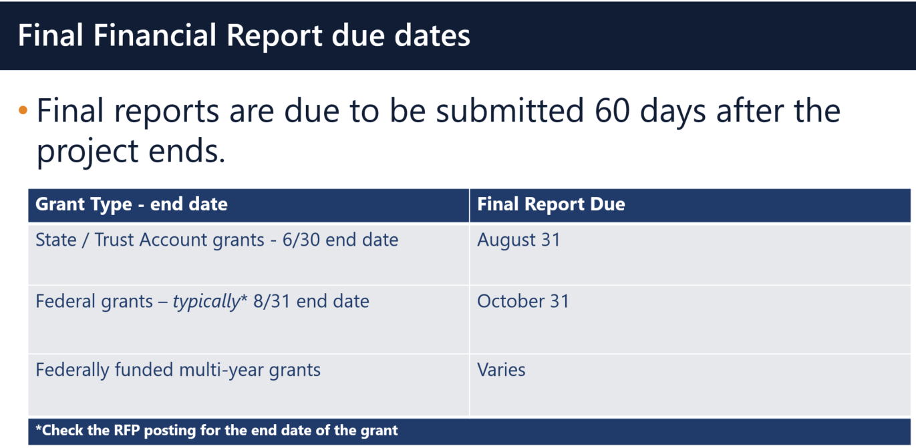

Multi-Year grants: DESE expects that Applicants will spend down their funds in full and not return money now that the multi-year feature is available in EdGrants for specific grant fund codes.

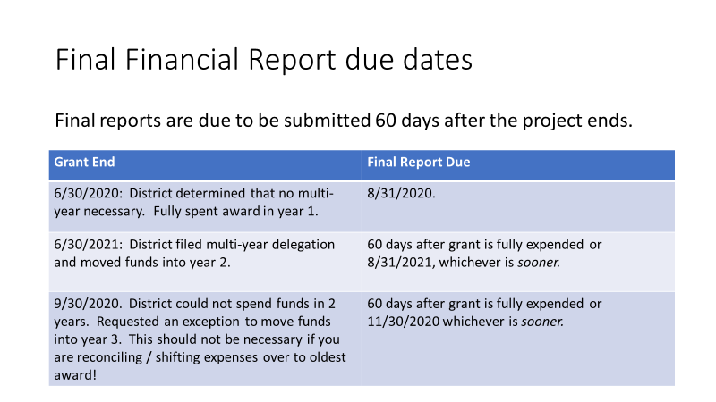

DESE expects that before you try to file a final report, district fiscal and programmatic staff will coordinate to ensure all funds have been expended appropriately and agree on the award total.

BACK TO THE TOP

EdGrants User Access Request
DESE requires a user request form be submitted for all new users and edits to existing users. Please review EdGrants: User Security Controls for more information and a copy of the Front Office User Request Form.

BACK TO THE TOP

Requesting Funds Reminders & FAQs

Sherriff / State Agency Departments who receive grant funds (all fund codes) directly through MMARS accounts via ISAs do NOT need to request grant funds using EdGrants.
-----
Payment Request windows will only be available once your grant has been programmatically approved, processed and an automatic Initial Payment has been issued by DESE.

If you cannot see a Project Record Card or a Payment Request available during the draw-down window, it is likely because your grant has not yet finished processing and an initial payment has not yet been sent.

How to check the Project Record Card to view payments and payment notices
How to Request Funds
Please find all EdGrants user documents here.
BACK TO THE TOP

If you need assistance, please contact Grants Management at 781-338-6595 or email EdGrants@doe.mass.edu. Please reference your grant project number or fund code and Applicant number (LEA Code) when you call and/or email.

Thank you,
Grants Management

