FC208 Appleseeds Materials and Professional Development Grant
Questions and Answers

Budgeting
How do I calculate costs for materials?
On the grant page, FY2024 Fund Code 208: Appleseeds Materials and Professional Development Grant - Grants and Other Financial Assistance Programs (mass.edu), you can find the budget worksheet under the Required Documents. On the budget worksheet, you should go to the “Start Here” tab (press the three dots to the left to see it). There will be blue columns where you can input how many students and teachers you have for each material you are requesting to automatically calculate it for you. See image below.
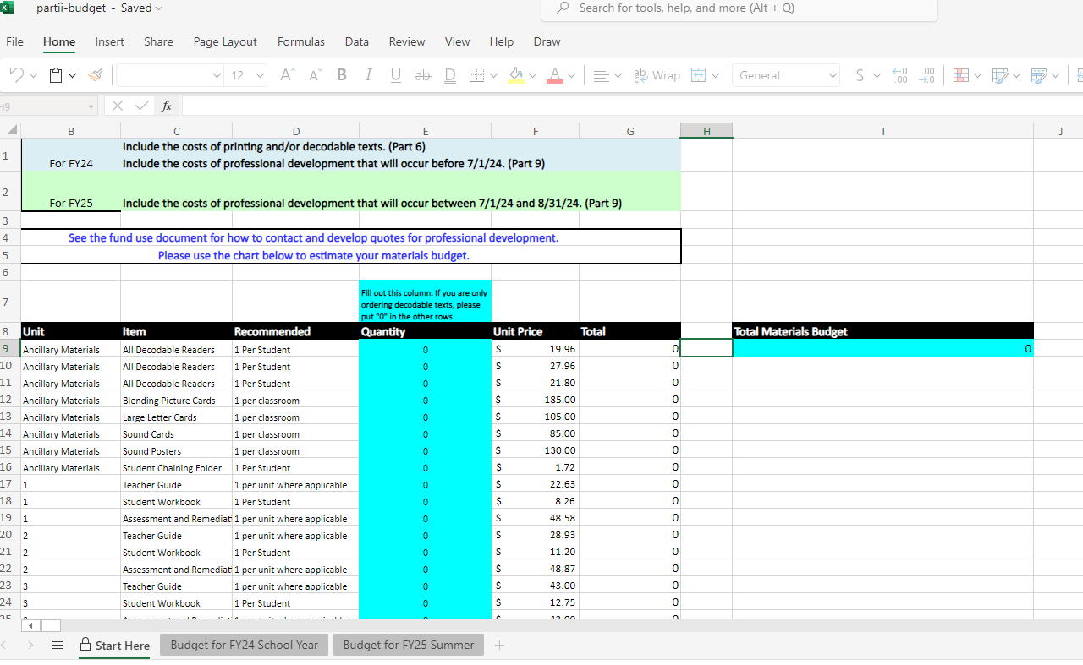
Professional Development
Can we apply if we don’t want to get professional development?
You do not have to apply for professional development. You can apply for materials and/or professional development. In your narrative, applicants should plan to describe how they plan to support implementation with in-district staff or partners.

Can I apply for Track 2 without professional development?
You do not have to apply for professional development. You can apply for materials and/or professional development. In your narrative, applicants should plan to describe how they plan to support implementation with in-district staff or partners.

