Instructions for Submitting Final Financial Reports (FR-1)

At the conclusion of grant activities, recipients must submit a final financial report (FR-1) to the Department, accounting for the expenditure of funds received.

The FR1 form should be submitted to Grants Management within sixty (60) days of the end date of the grant. Applicants should file their reports after carefully reconciling all figures with their city auditor, town accountant, or agency business manager. Applicants should have drawn all funds needed to cover expenditures before they file their FR-1. The FR-1 is meant to reflect actual final expenditures. Grant applicants have 60 days from program end to finalize billing and reconcile accounts to file a true and correct FR-1s.

Grants ending 6/30: FR-1 due 8/31
Grants ending 8/31: FR-1 due 10/31
Multi-Year grants (specific fund codes only) ending 9/30: Due 11/30 OR 60 days after final payment request whichever comes sooner.

- Log into EdGrants
- Go to “Submissions”
- Select from the drop-down list the project ready for FR-1 completion
- The Final Report is labeled as such if there is a date that is an indication that it is submitted. If Date Submitted is blank, then the final report has not been completed.

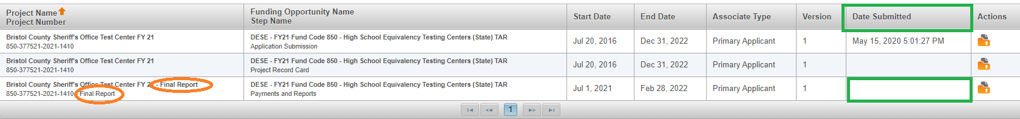

- Under “Actions” in the far right-hand column, click on the orange folder and complete the report.
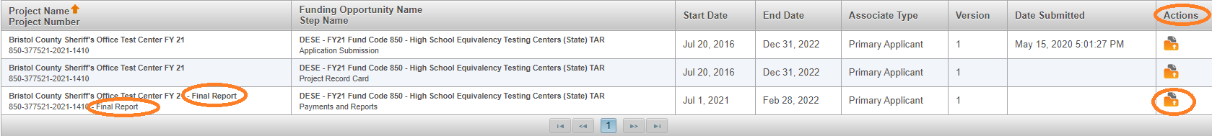

Please Note: If the dates of the FR-1 have expired (End Date next to the FR-1 has passed), this means the FR-1 will be blank when it is opened, and it will not be able to be completed without contacting Grants Management or the grant program manager of the grant to open it back up.
If the FR-1 end date has passed this means the FR-1 is delinquent and this could affect the ability to draw down current grant funds.

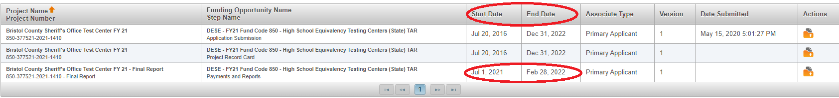

- If the Final Financial Report opens and the top section BLANK (Name of Grant Program, etc.), this could mean it is delinquent. Contact Grants Management so we can extend it open for you. If it has expired, it means it is WELL OVERDUE because they are set up to remain open beyond the 60-day due dates.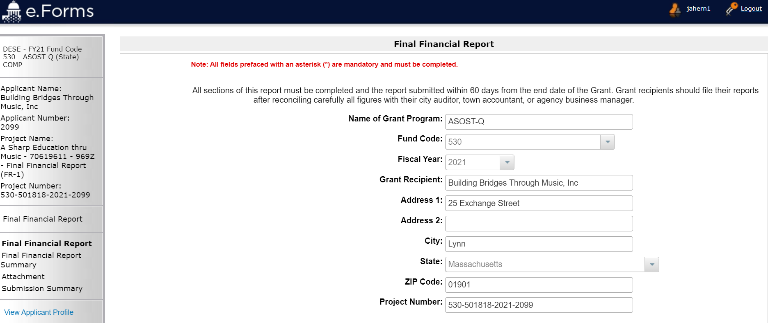

- Report expenditures by line item in the report in the Expenditure Grid.

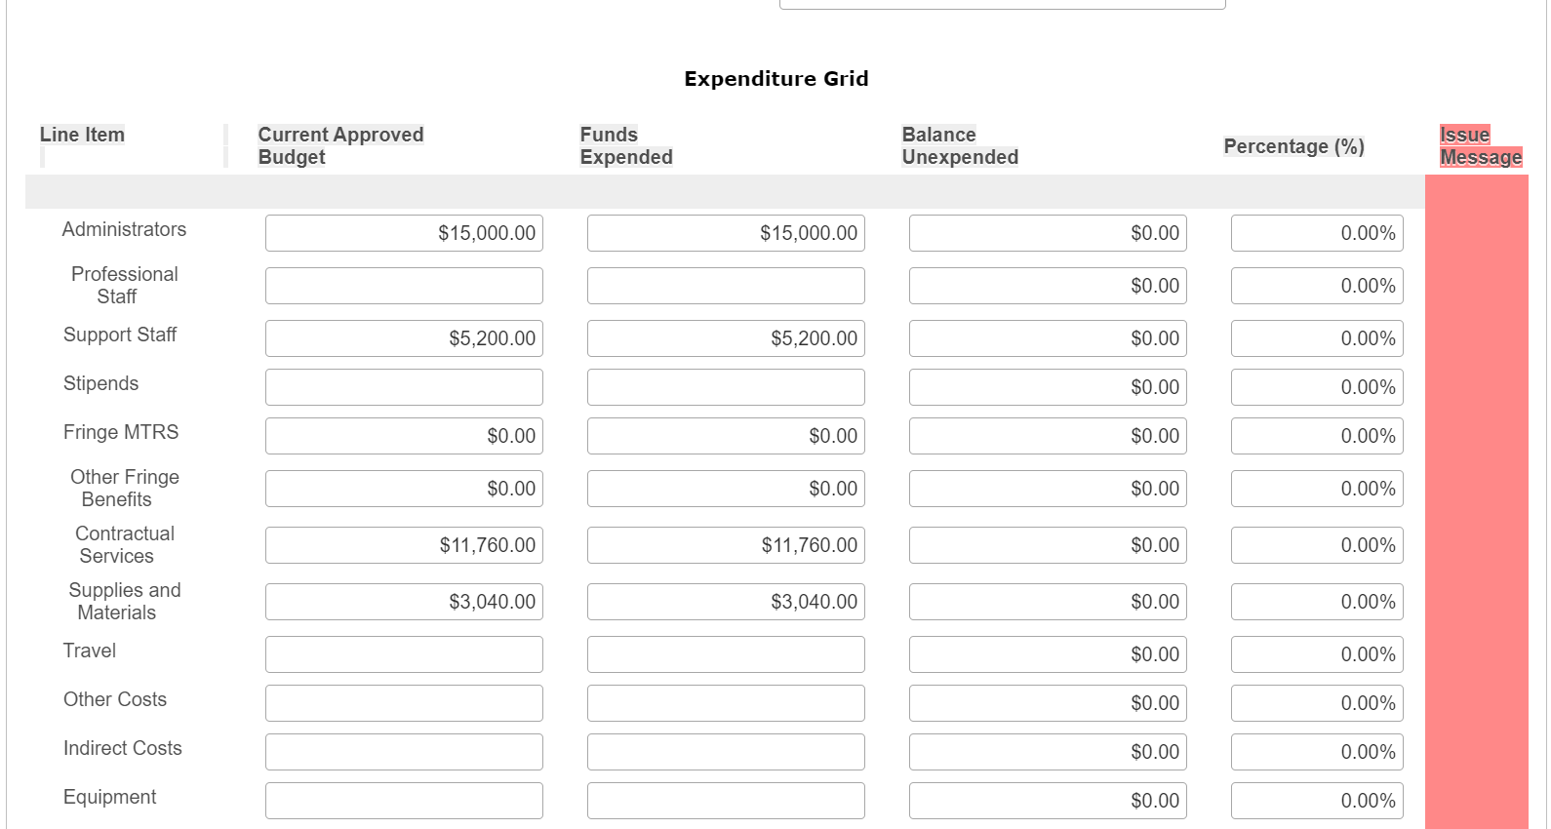

- If an expenditure amount over the approved budgeted line item is reported, even when it is within the allowable thresholds, the Funds Expended and Balance Unexpended columns will calculate incorrectly. This is a known glitch. If the Cash Balance section looks correct, this can be ignored. Allowable thresholds would be a reported expenditure that is over the approved budget line amount but does not exceed $100 or 10% of the line (whichever is greater) or does not exceed $10,000.

- If an expenditure amount over the approved budgeted line item is reported, when it is NOT within the allowable thresholds, the Issue Message (red column) will populate the word “Issue” next to the affected line. This signifies that an amendment must be filed and approved before the FR-1 can be completed. Please review the Issue Message column before you submit the FR-1 and if you see “Issue” on any reported line item DO NOT submit the FR-1.

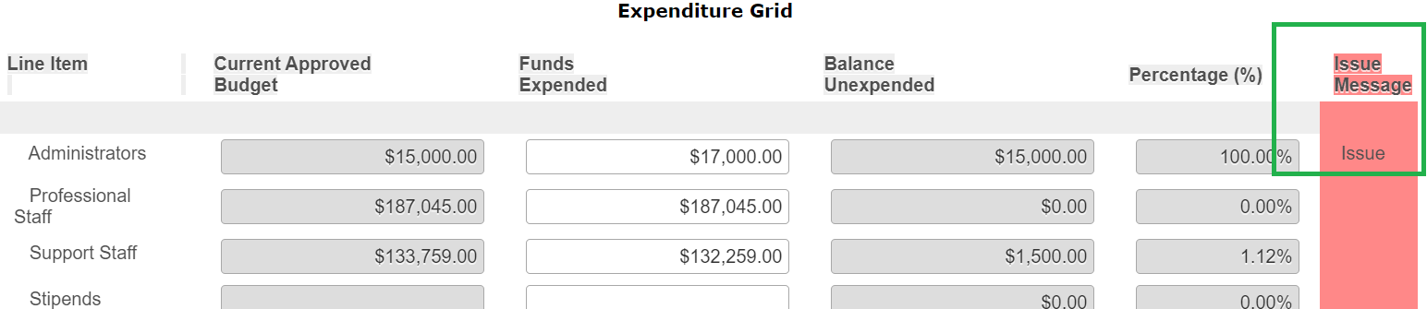

Note that over-expenditures that fall at or below the $100, 10%- or $10,000-line item increase thresholds specified in the Department's amendment policy will be allowed and the final report will be filed. Increases in line items, without approved amendments, that exceed these thresholds, will be subject to possible audit exceptions and the required return of any funds that were expended inappropriately.

Waiting until the FR-1 is due to request and file an amendment will result in delays submitting the FR-1 as the FR-1 form will not update with the revisions until it has fully completed the amendment cycle within the DESE workflow. Program staff managing the grants have the authority to not approve the requested amendment. Best practice is to complete and file all amendments on a grant project 30-days prior to the grant program end. An amendment will be required when there has been an increase in a line of the budget exceeds $100 or 10% of the line (whichever is greater) or exceeds $10,000.

- A note about Mass Teacher’s Retirement System (MTRS) paid by DESE: typically, between December and February all federally funded grants are assessed, and it is determined how much funding must be sent to MTRS on behalf of each grant project. DESE sends MTRS in one lump sum by funded account to MTRS and provides a backup report showing contributions by grant project number. The MTRS amount paid is 80% of the MTRS amount budgeted on the approved budget at the time when analysis has begun for each fund code.

If a grant amendment has been submitted and approved which changes the MTRS contribution amount, DESE can seek reimbursement on behalf of the district once we see an approved amendment showing the change. The reimbursement, once approved and verified by DESE, is between MTRS and the Applicant. The FR-1 will always show the amount we paid to MTRS, because we have a transaction and a backup report showing the payment was made. Applicants should maintain records showing MTRS reimbursement expenditures that happen after the payment is made and should not apply these expenditures to unapproved budget lines on their grant.

Changing MTRS while we are analyzing the accounts is a hardship for DESE as too many subsequent forms in EdGrants can reflect the wrong information post MTRS payment. It is better to under-estimate MTRS (i.e., contributing salaries), and any changes where Applicant would owe more than the 20% originally budgeted would simply mean cutting a higher check to MTRS once the grant is done and no need to request reimbursement from DESE and MTRS.

Once MTRS is paid, the project record card, subsequent payment requests and FR-1 will all show the amount DESE paid on that grant project.

MTRS is not applicable to state funded grants.

- Click SAVE so the form calculates and saves entries.

- Once saved, the Cash Balance section will show the overall information in terms of funds received, ESE Portion MTRS, Funds Expended (based on what has been entered into the expenditure grid), and Unexpended Cash Balance.

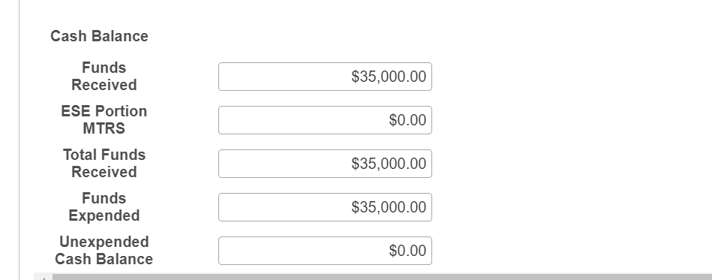

- Fill out the Person Completing Report section. Be sure to include up to date information in case DESE needs to call about an issue with the report as it is reviewed.
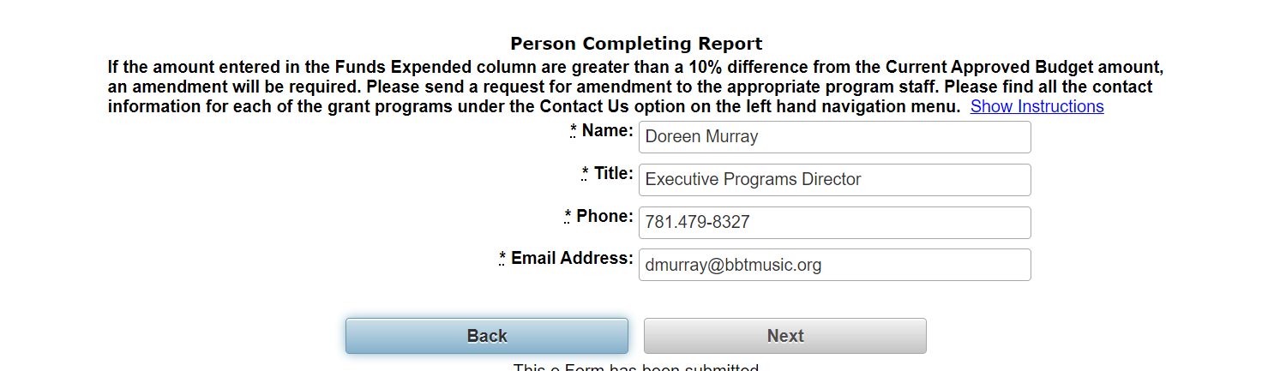
- Click Save & Next.
- Next is the Final Financial Report Summary which again displays what has been awarded, expended, and displays any unexpended cash which needs to be returned to DESE.

- Complete the Authorized Representative Approving Report section. This would typically be the name of the Superintendent, Executive Director or other Applicant personnel listed as an Authorized Signatory for the Applicant.

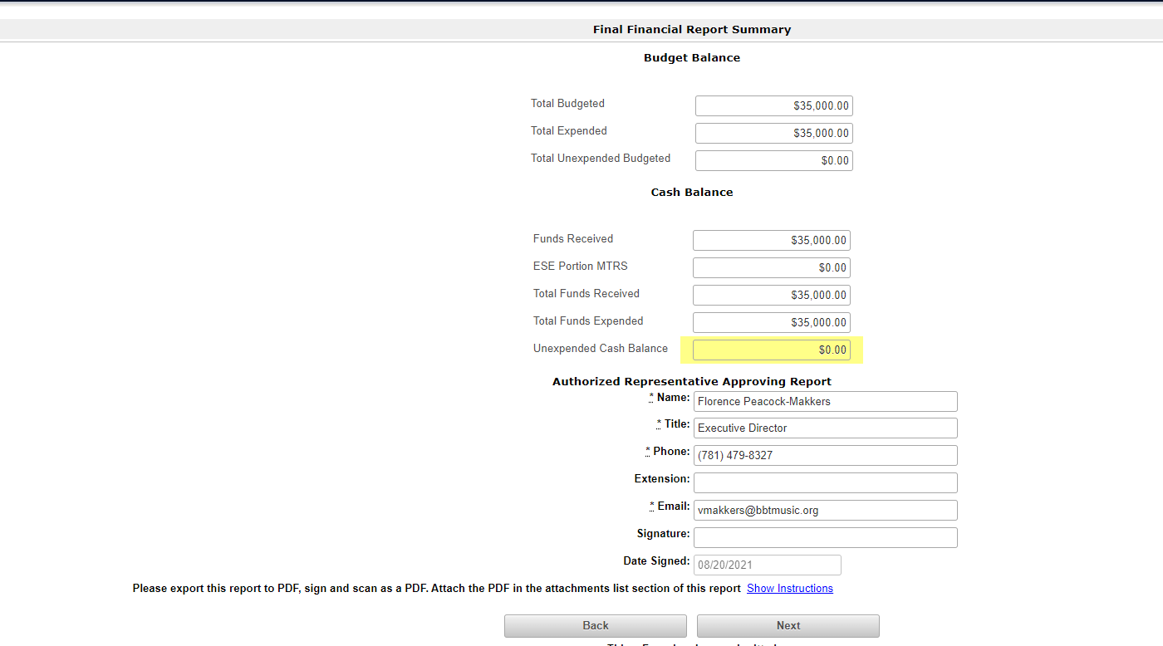

- Once the Authorized Representative Approving Report is filled out, click SAVE.
- Then, export this formlet to PDF by click Export to PDF on the left-hand navigation menu.
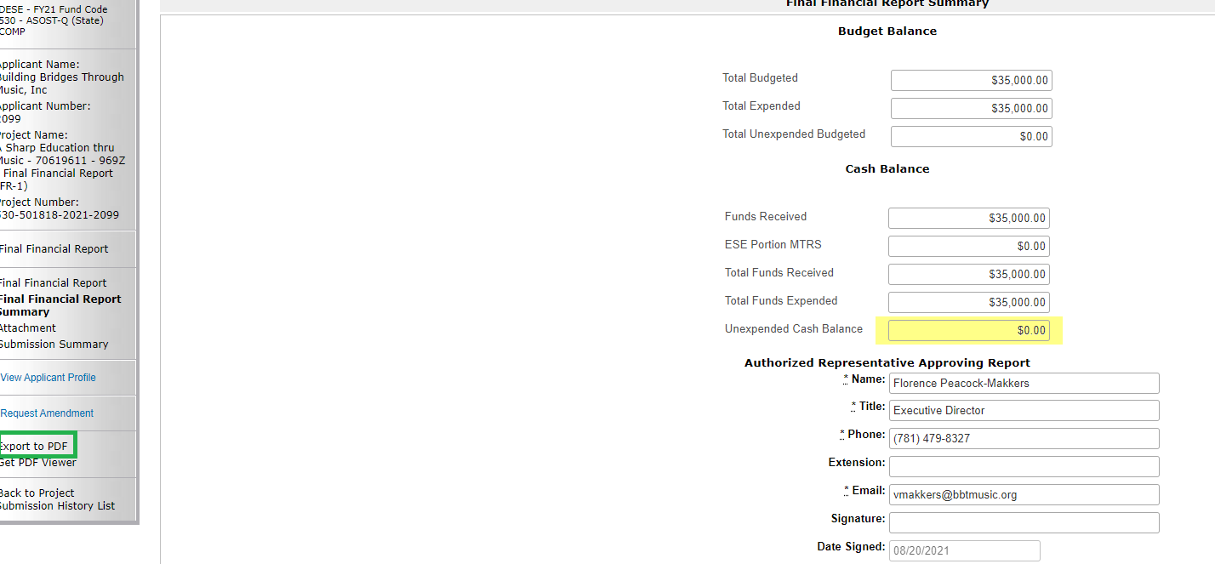

- Print out and sign the PDF. Scan the signed PDF. Please scan as a “single page” in your scan settings, if you scan it as a “book” it will be too large for you to attach. If size limit error message appears when trying to attach, please re-scan as “single page.”
- Click Save & Next.
- Upload the signed/scanned PDF as an attachment in the Attachment formlet by clicking the Final Report link under Document Type.
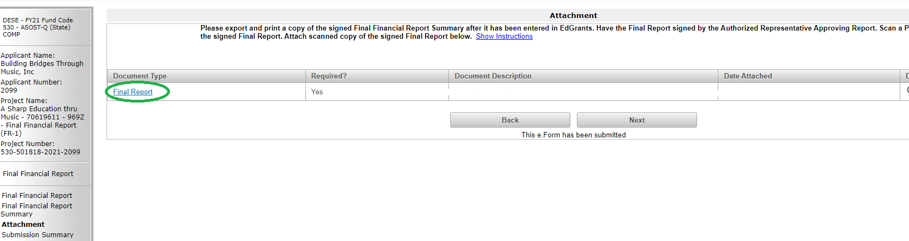

- Follow the prompts to attach the signed FR-1 scan. Name the Document by filling in the Document Description and choose the file to attach it.
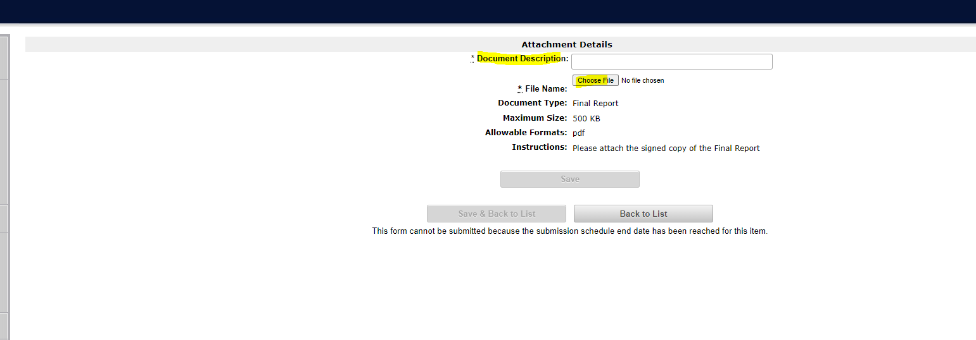

- Click Save & Back to List.
- Once back at the Attachment formlet, click Save & Next.
- If Unexpended Cash Balance is $0, then click Submit. The FR-1 has been completed.
- The Submissions menu will show a date/time stamp of the completed report. If the Submissions menu does not show a date/time stamp of submission, go back into the report, and click Submit. The screen shot below is showing an example of a submitted report.

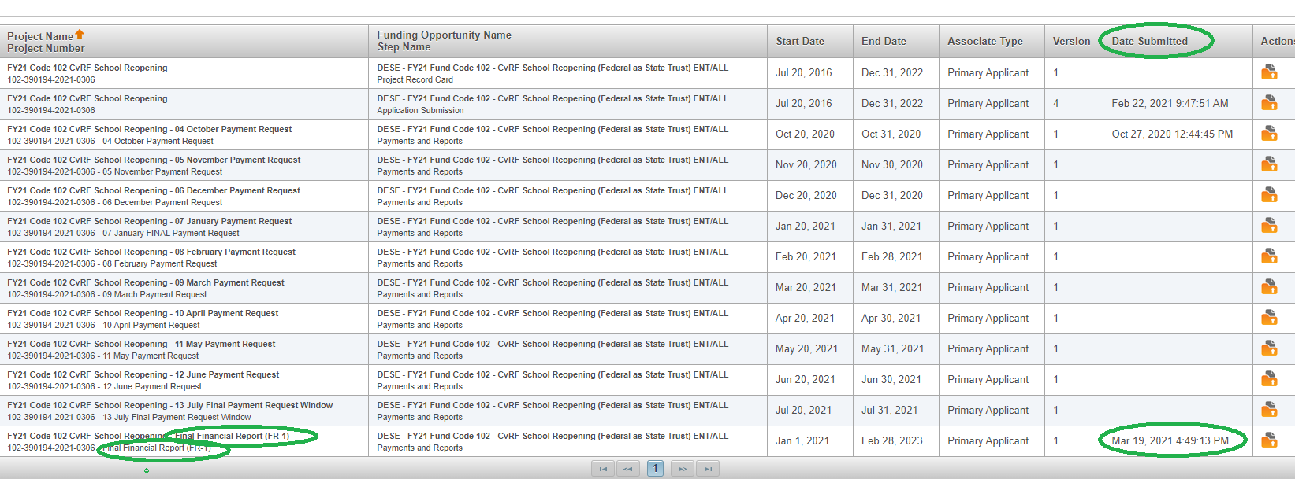

Filing FR-1 when there is an Unexpended Cash Balance:

- If Unexpended Cash Balance is not $0, after the Attachment formlet, the system will navigate to the Return Checks formlet. The Return Checks formlet will only appear if funds received by applicant exceeds the funds reported as expended.
- If Unexpended Cash Balance is less than $1 no need to return funds. The Return Checks formlet will appear and the check box should be marked and submitted as normal. DESE will not expect a return for anything less than $1.
- The Return Checks formlet will display the amount of funds needing to be returned to DESE, based on the amount received by the Applicant and the amount that was reported as expended in the expenditures grid. If this number looks off, check the entries in the expenditure grid.
- Check the box to indicate a check will be returned to DESE in the expected amount.
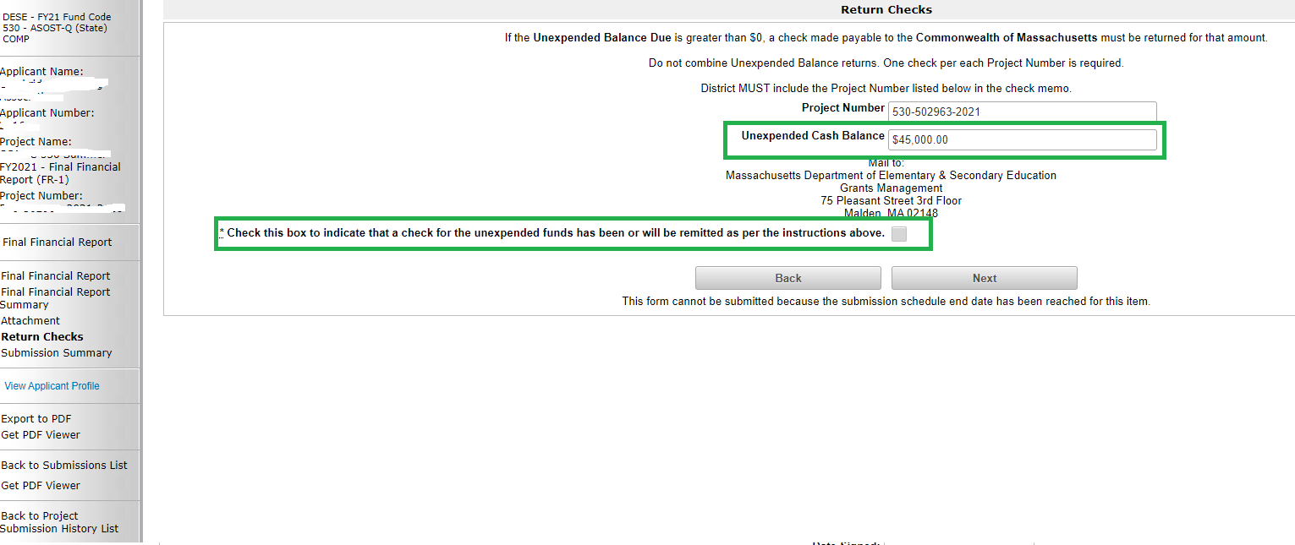

- Click Save & Next. Once at Submission Summary formlet, click Submit. The submit button must be pressed for the FR-1 to show as submitted.
- If funds are being returned, one check must be sent for each grant project. Please do not combine checks. If your city/town issues these checks and combines them, please ask them to be separated.
- The project number for the grant return must be included on the Check.
- A copy of the FR-1 should be mailed with the return check.
- As stated in the Return Checks formlet, all returns should be sent to:

Massachusetts Department of Elementary & Secondary Education
Grants Management
75 Pleasant St.
Malden, MA 02148

Modifying the FR-1 post-submission:

Since the FR-1 is due 60 days after the grant program ends, allowing applicants to report actual expenditures, DESE expects that there will be limited need to re-file or correct FR-1s. However, we do know that in some cases unexpected refunds from vendors occur outside of the reconciliation process or errors do occur when reporting. In these instances, you will need to revise and re-submit your FR-1 to return the unexpended funds/vendor reimbursement. To re-file, you must contact grants management and ask to amend the FR-1 submission. Please include the full 17-digit project number of the grant when making these requests (i.e., 317-580569-2022-0046).

Applicants should claim all funds needed to cover expenditures before they file their FR-1. If the FR-1 is filed and then additional funds are requested due to the timing of the payment request windows and when the Applicant chose to file the FR-1, the Applicant is responsible for modifying the original FR-1 submission so that all funds received, and all expenditures are reflected in what is reported.

Filing FR-1s for Multi-Year grants:

Multi-year grants are specific fund codes in EdGrants where a multi-year delegation form is available to be submitted. For a list of current Multi-Year grants, please review the May or June GM Update for that Fiscal Year.

Multi-Year grants have approximately 27-months to spend down funding, depending on when there is an approved grant submission. For this reason, DESE expects that all funds will be utilized and spent down and anticipates NO returns on this funding. Grantees should review their oldest multi-year balances and always use their oldest awards first to avoid reverting funds back to the federal government. When we revert funds to the feds, we make it look as though MA allocation for those given program is too high/not needed and we could be in jeopardy of not receiving level-funding.

Always actively assess the prior year balances on the multi-year grants and see where there is opportunity to shift all balances to the salary line to get them absorbed up and spent down first. Many DESE program units send out a monthly list of unclaimed balances for prior multi-year awards. In Addition, Applicants can review the project record card for each multi-year grant to review any unclaimed balances.

The How to Request Funds document explains how to draw down all grant funds and describes where to find the Project Record Card for each grant project. The Project Record Card shows all payments made on a grant project and shows any remaining balances.

Filing the FR-1 for multi-year grants is the same process described in this document. However, since most multi-year grants end 9/30 of year 3 of the award, they are due 11/30 of that year OR 60 days after the final draw-down for these funds, whichever is sooner. The final draw down in this scenario is referring to when the district claims the final payment on the multi-year grant. Applicant then has 60 days to pay out, reconcile and submit the FR-1.

Examples of Multi-Year FR-1 due dates:

FY2021 Multi Year Award – ends 9/30/2022.
FR-1 due 11/30/2022 OR 60 days after the Applicant draws down the final balance.

Applicant A draws their final balance on 2/20/2022.
Applicant A should file FR-1 by 4/20/2022.

Applicant B leaves an unclaimed balance post 9/30/2022.
DESE contacts Applicant B in November 2022 to see if they have obligations incurred through 9/30/2022 as a last chance effort to claim these funds. Applicant B confirms that yes, they do have obligations that align with the 9/30/2022 end date.
DESE opens a payment adjustment for Applicant B to go in and claim the funding to apply to expenditures through 9/30/2022.

Applicant B must file an FR-1 by 11/30/2022, regardless of when they receive the payment as the payment adjustment was done after the grant end date of 9/30/2022 and 11/30/2022 is the latest and final due date for this award year FR-1.

To avoid the Applicant B scenario, DESE expects all grantees will actively assess and have a plan for their oldest funds to be utilized and spent down so they can file a timely FR-1 and close out the grant award. Ideally, all applicants will have spent down all multi-year awards in Year 2 of the grant, and not need to extend into Year 3 (7/1/ - 9/30).

