**How to Verify EdGrants Front Office Users for an Applicant / LEA.**

**Background:** In EdGrants, **Applicant** is the LEA or Organization name. People registered as users associated with the Applicant are referred to as “Front Office Users” by DESE but within the EdGrants software, they are labeled as **Children Registrants** of the Applicant.

1. Log into [EdGrants Front Office](https://edgrants.eoe.mass.edu/grantium/index.jsf)
2. Click on **Applicants** on the left hand navigation menu
3. Once in the **Applicants** menu, click the Children Registrants Icon/symbolsymbol under **Children Registrants**

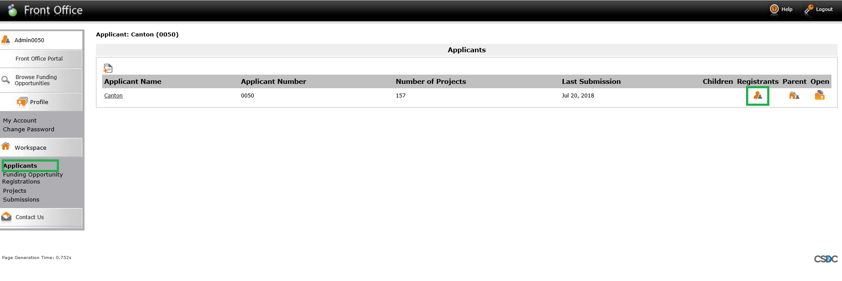

1. Review the Front Office Users / Children Registrants associated with your Applicant. Verify that names and emails and assigned group are accurate. Grants Management sends out monthly EdGrants updates via email that are sent to the email addresses listed here. If an email is incorrect, that user will not receive the EdGrants emails. **The Admin user listed is DESE so do not worry about that user/email.**

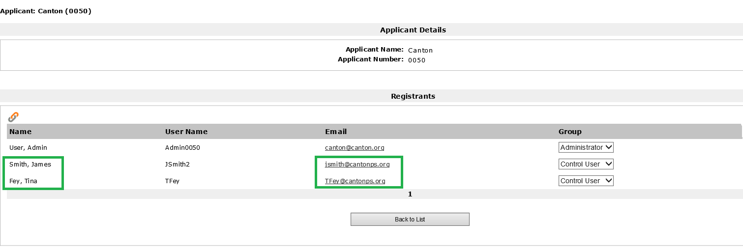

1. Once the Front Office Users are verified, please sign and send back a pdf of the ***EdGrants User Certification Form*** to [Edgrants@doe.mass.edu](mailto:Edgrants@doe.mass.edu). If modifications to existing users are needed, please also fill out and return the ***EdGrants Front Office User Request*** form with all required changes reflected.
2. When assigning or modifying EdGrants Front Office Users, please make sure to review and understand the [EdGrants: User Security Controls](http://www.doe.mass.edu/news/news.aspx?id=24371). As with all EdGrants user requests, we expect that this certification as well as any modifications will come from the finance director / business office manager of the Applicant / LEA. We will also accept the certification from Superintendents, Assistant Superintendents and / or Executive Directors.