Federal ISA Grant Amendment Process (MMARS budget tables)

Before submitting any EdGrants and ISA amendment to DESE to move ISA budget from current fiscal year to the next, you must check BQ89 Central Expense (Level 2) table in MMARS to confirm that you have sufficient uncommitted estimated receipts in the current fiscal year to transfer out to the next fiscal year.
For example, the amendment request is to move $10,000 of FY20 ISA budget into FY21. Since the current FY20 uncommitted estimated receipts in the example below is $5,825.92 , the ISA amendment is not possible unless you first reduce encumbrance balance ($31,312.83) in MMARS to free up more FY20 uncommitted estimated receipts.
If the amendment request is to move $5,000 from FY20 to FY21, then there is sufficient uncommitted estimated receipts balance ($5,825.92) for the amendment.
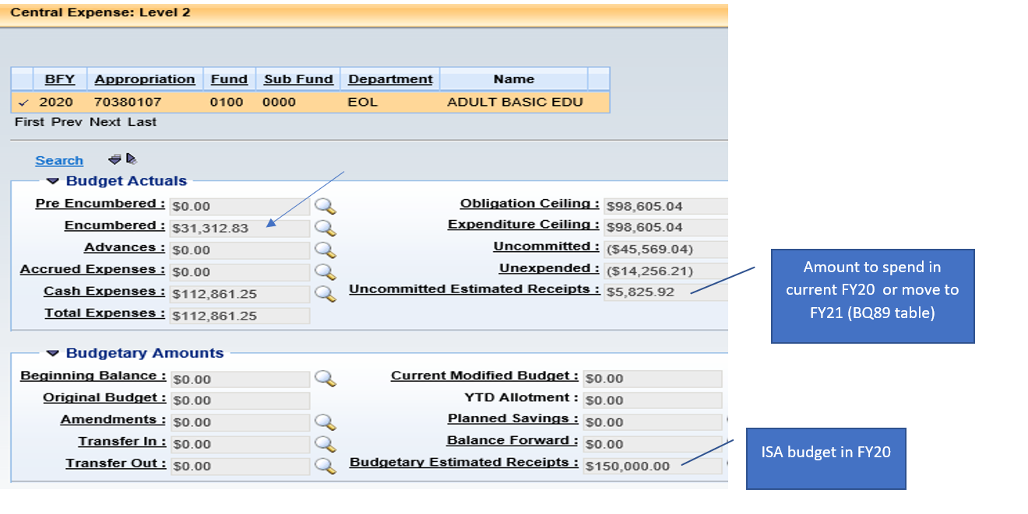
BQ89 Budgetary Estimated Receipts = the current fiscal year ISA total budget (this amount may include multiple ISA budgets on different program codes for the same account #).
BQ89 Uncommitted Estimated Receipts = the balance of current fiscal year ISA budget to spend and/or move into the following fiscal year.
The BQ88 Reimbursable Grants table shows the total ISA budget (Obligation Ceiling of $150,000) by federal program code which can be spent across multiple fiscal years depending on the ISA start and end dates. Uncommitted is the balance of ISA to spend or to amend down.
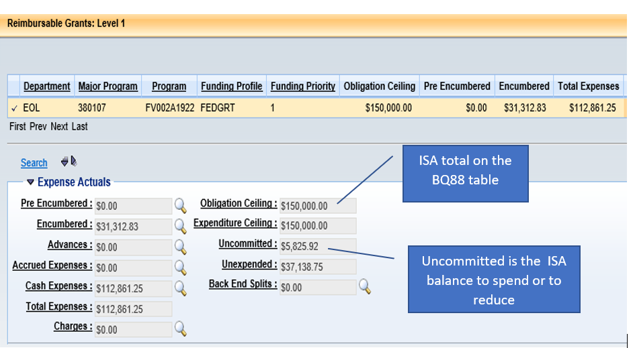

If you are amending down an ISA, you must have sufficient BQ88 Uncommitted amount to be equal or greater than the ISA reduction amount.
So if the ISA is reduced by $10,000, then there isn’t enough balance ($5,825.92) to process the reduction.
If the ISA is reduced by $5,000, then there is enough balance ($5,825.92) to process the reduction.
Sample ISA: 