State ISA Grant Amendment Process
Before submitting any EdGrants and ISA amendment to DESE, you must check BQ81 Central Subsidiary Expense (Level 3) table in MMARS to confirm that your department has sufficient uncommitted balance to transfer out to another object class.
For example, if the amendment request is to move $1,000 from UU to EE object class. Since the current uncommitted balance in UU is $640.44, the ISA amendment is not possible unless you reduce encumbrance balance ($8,091.57) in MMARS to free up more UU balance.
If the amendment request is to move $500 from UU to EE object class, then there is sufficient balance ($640.44) for the amendment.
If the amendment request involves multiple object classes, you must check every object class that is being moved to another object class to confirm current BQ81 uncommitted balance is equal or greater than the amendment amount.
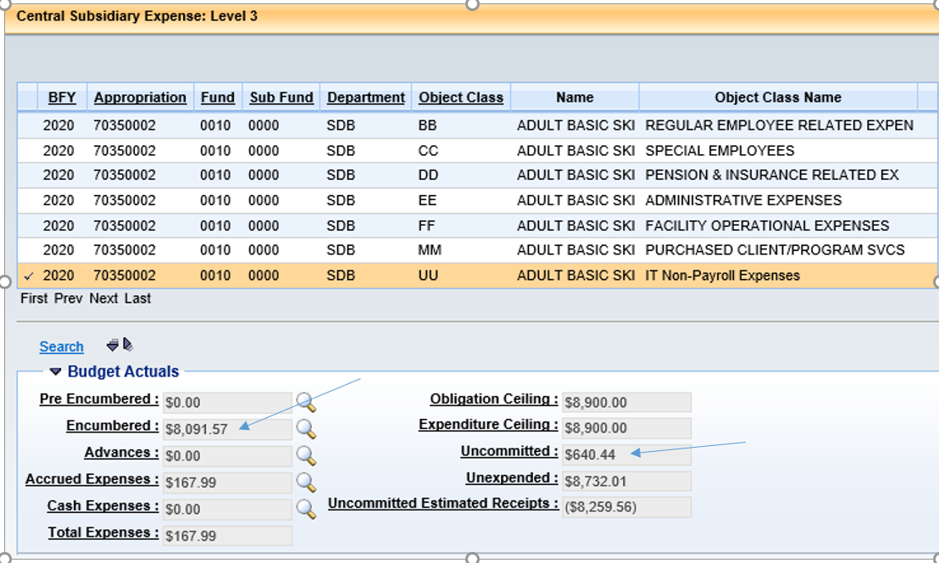

ISA Budget Amendment
Every amendment budget must have the last approved ISA budget/amendment as the starting total.
Original Budget sample (taken from FY19 ISA)

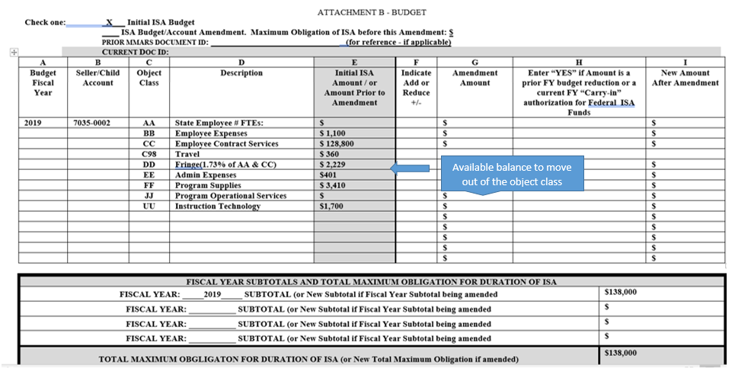

1st Amendment Budget sample: Start with the last budget (blue box) and indicate changes under the Amendment Amount (green box).
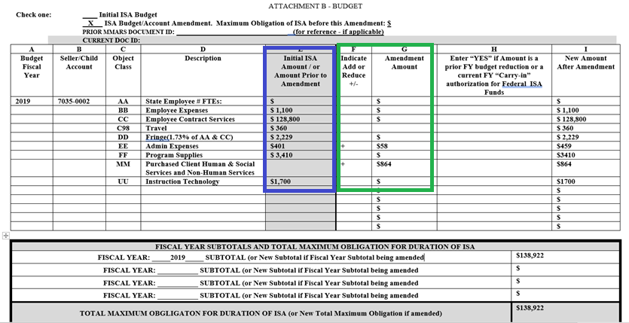

2nd Amendment sample: Start with the approved Amendment 1 budget as the Initial ISA Amount and list amendment changes against them: Confirm the BQ81 uncommitted balance for BB, CC, DD and FF to verify there are sufficient balance matching or exceeding Amendment Amount to move to EE, KK and UU.
Because EdGrants crosswalk doesn’t allow decimal points (cents), you should use the rounded up budget totals for the ISA budget wherever possible. Double check the math so that the Initial ISA Amount + or – the Amendment Amount = the Final Amount after Amendment.
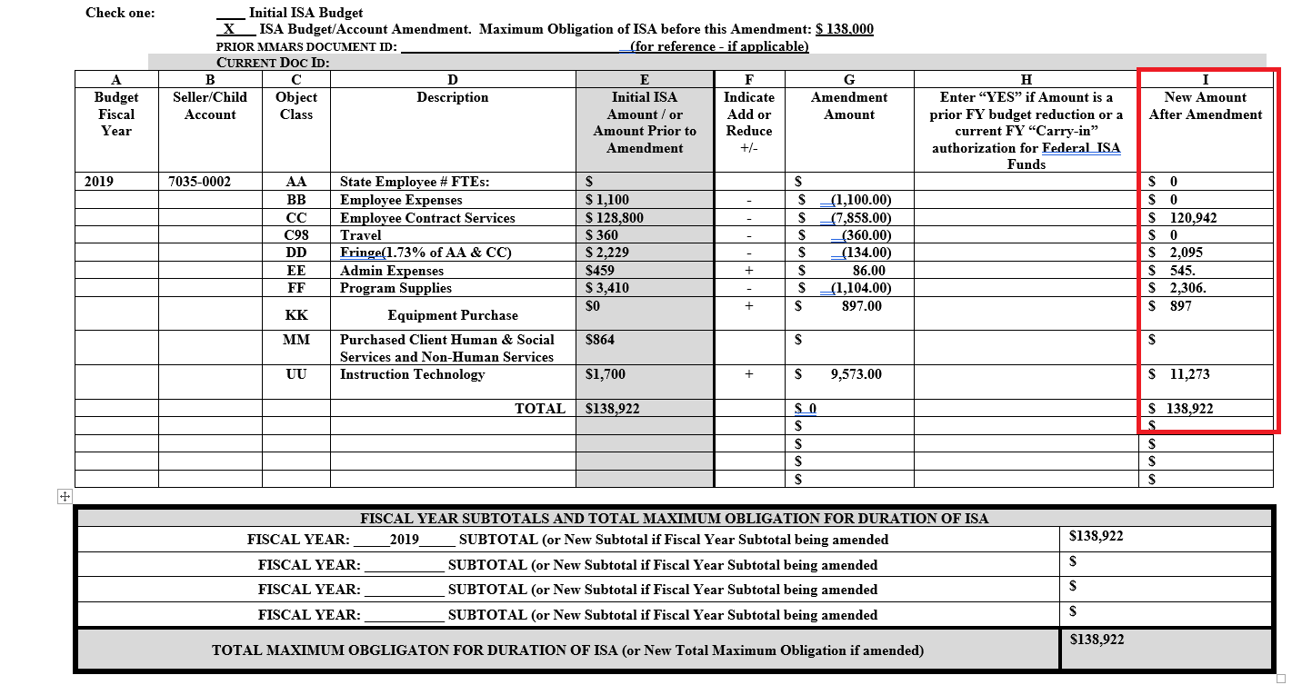

BGTS Process:
Once the ISA amendment is signed by DESE and returned to you, each child agency must prepare the BGTS document in MMARS because the funds have already been transferred to each child agency already based on the original ISA budget. Check BQ81 table in MMARS again and make sure the uncommitted balance the object classes being reduced still have sufficient uncommitted balance to cover the decrease amounts.
- Enter the BGTS document in MMARS using the recommended naming format: BGTS DOE (replace with your 3 digit MMARS ID) 70350002 (account #) and today’s date and end with ANSP: BGTS DOE 70350002070220ANSP is how we name our BGTS document in MMARS.

- Complete Header Page once BGTS is created: enter today’s date, enter the current fiscal year and budget fiscal year. Always use 7/1/XX and 6/30/XX as the start and end dates of current fiscal year (7/1/20 and 6/30/21 for FY21 BGTS) regardless of when the BGTS is created. Enter the Period matching the current month of the fiscal year: 1 is for July, 6 is for December etc..

- Start with Budget Level 3 to enter the transfer amounts (amendment amounts). Based on the Amendment 2 sample above: enter the following information in Level 3. All the transfer in amounts (increase) must equal the transfer out amounts (decrease) as well as the Allotment Amounts. Enter Action as Modify if amending existing object class and New if adding a new Object Class. Always use Increase for both transfers in and out amounts.
Use BG07 event type for transfer out amounts (decrease)
BB $1,100
CC $8,218 (CC+C98)
DD $134
FF $1,104
Use BG06 event type for transfer in amounts (increase)
EE $86
UU $9,573

- Allotment amount must be entered for each transfer request in Budget Level 3. Allotment is normally loaded for 2 months at a time (2/12th) when the state budget is signed and increased by 2/12th every 2 months afterwards until April when 100% allotment is available. So if the BGTS for the BB line is processed in August, then the allotment is $183.33. If the BGTS is processed in late April, then the allotment equal the BGTS amount of $1,100. Go to BQ81 Level 3 table to find the latest allotment amount.

- Go to Allotment screen and enter the same allotment amount to match the allotment amount in Budget Level 3

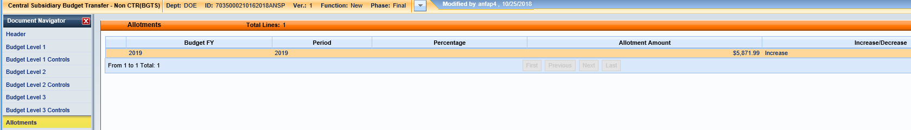

- Once all the transfer in and transfer outs are entered by object class along with the Allotment information, click Save so all the information from Header tab will load in Budget Level 3. Then click on Smart Budget Rollup to populate the data in Budget Levels 1 and 2.
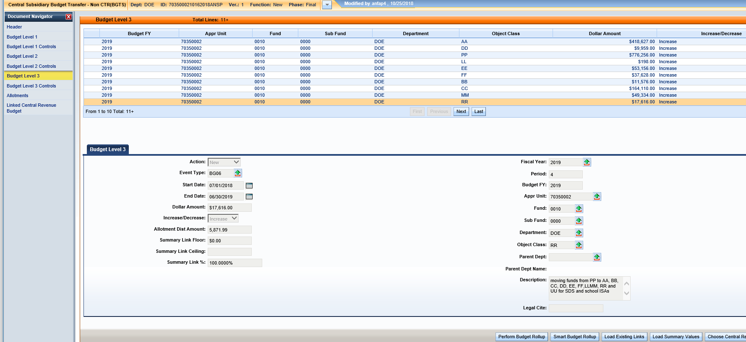

- Send an email to your ANF Analyst with your BGTS Document ID number and attach the approved ISA amendment and ask him/her to approve the BGTS based on the DESE approved ISA amendment. Please note, the BGTS amounts (transfer in and out) MUST match the ISA amendment amounts or else ANF will not approve the BGTS. BGTS must be completed with the correct information including the most current allotment for Header page, Budget Levels 1, 2 and 3 and Allotment tab before ANF can approve it. Detailed job aid for BGTS is available on the Comptroller’s Office website: Enter A Intersubsidiary Transfer (BGTS)

