This document contains the following information. Click the links below to skip to the desired section.

How to complete the Multi-Year delegation form in EdGrants
Multi-Year FAQ

How to complete the Multi-Year delegation for in EdGrants

Log in to EdGrants: Front Office using your user name and password.

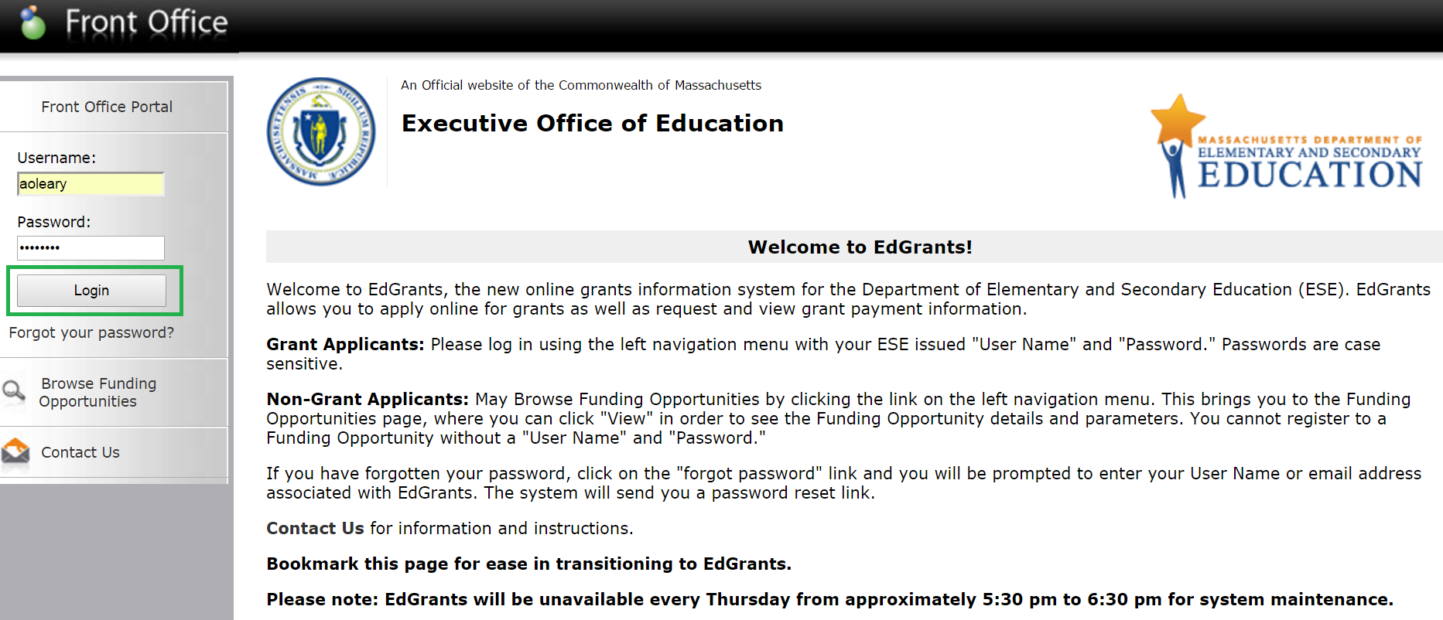

Click the Submissions link on the left-hand navigation menu.

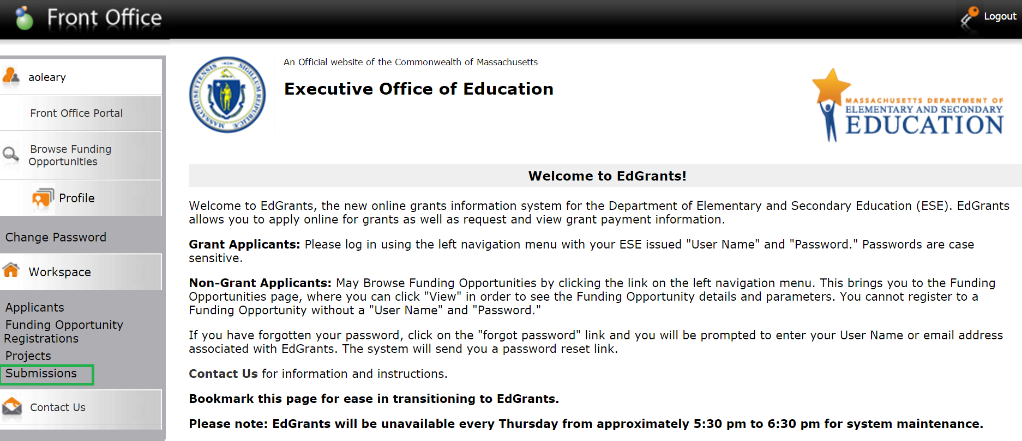

Once you are in the Submissions menu, Submissions will be in bold print on the left-hand navigation menu and Submissions will be displayed at the top middle of the screen. (As shown in blue boxes below.)

Select the project you wish to complete the Multi-Year delegation form for in the Applicant Project Name dropdown.
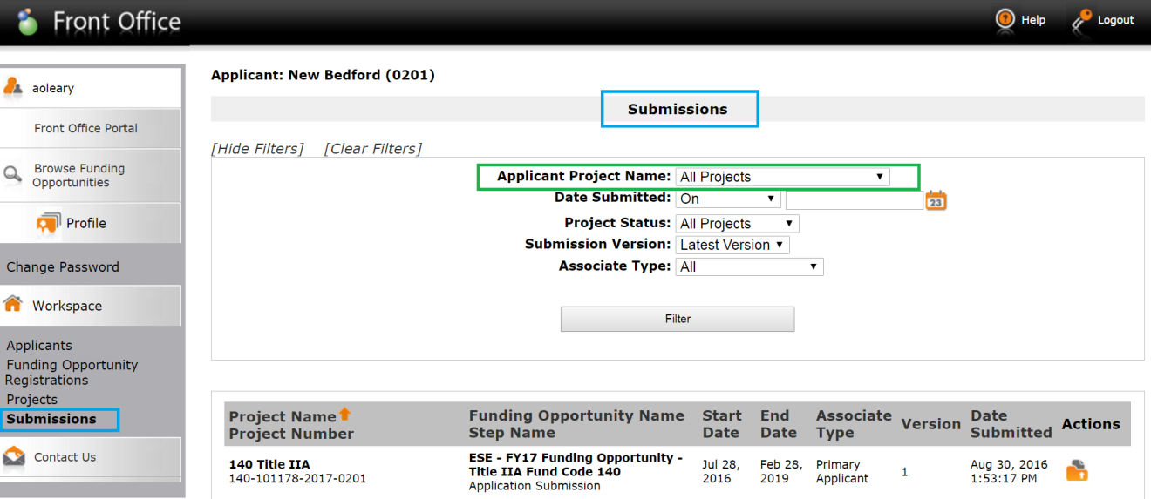

Once selected, click Filter.

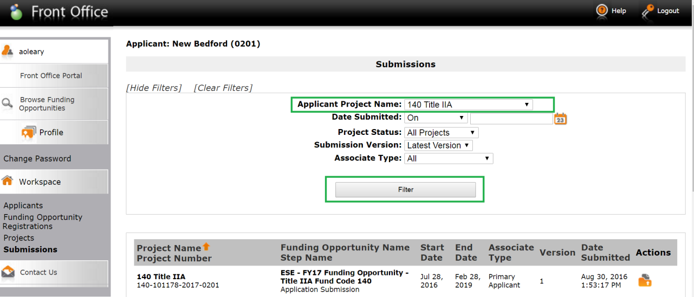

All the grant project submissions will display. Please note: user may have to click onto a page 2 at the bottom of the page (blue box in picture below) to see the Multi-Year delegation form. The example below shows only one page.

Click the orange folder under the Actions column next to the Project_Name* – Multi-Year – Move Funds Year 1 to Year 2

*Project Name is the name the district user gave the project at the beginning of the Fiscal Year, when creating a project in EdGrants in order to apply for the grant.
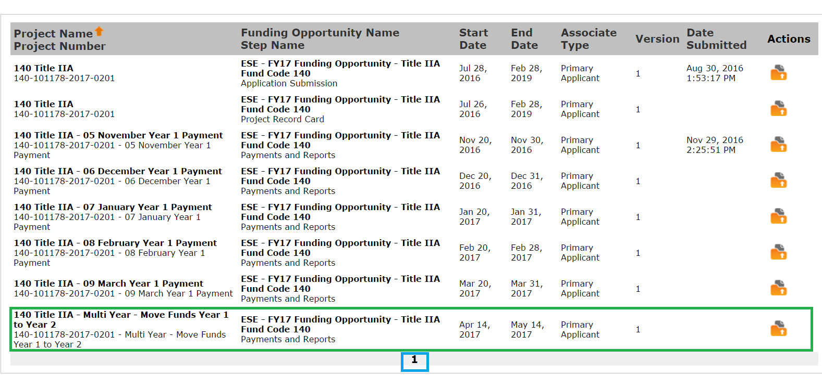

The Multi-Year delegation form will pull in your most up to date grant project information. Recipient Name, Project Number, Total Grant Budget Amount, Total Requested to Date, ESE portion MTRS (this is the portion of MTRS that ESE has paid on your behalf form this grant based on your budget at the time of ESE MTRS payment) and the Balance remaining to draw.

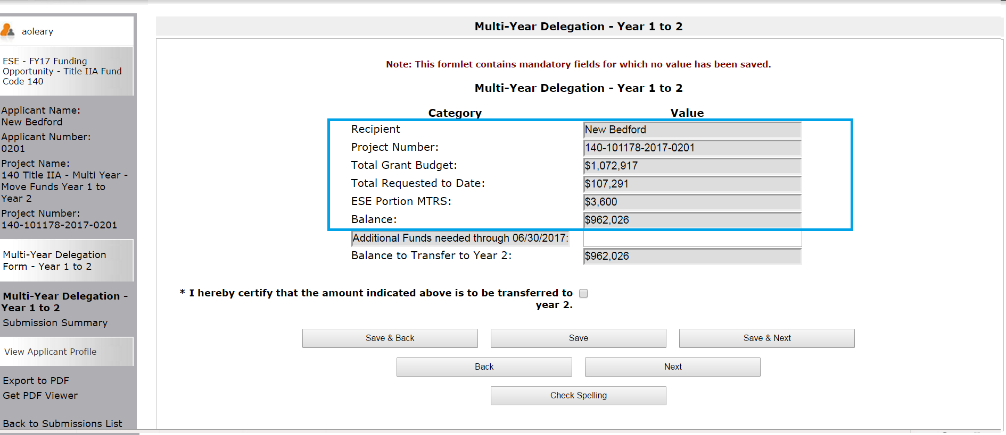

Review the Balance left to draw on the grant. The system will prevent submission of this form if you try to move MORE than what is available to move into Year 2. In this example, there is $962,026 left to draw. The balance to Transfer to Year 2 amount should NOT exceed that amount.

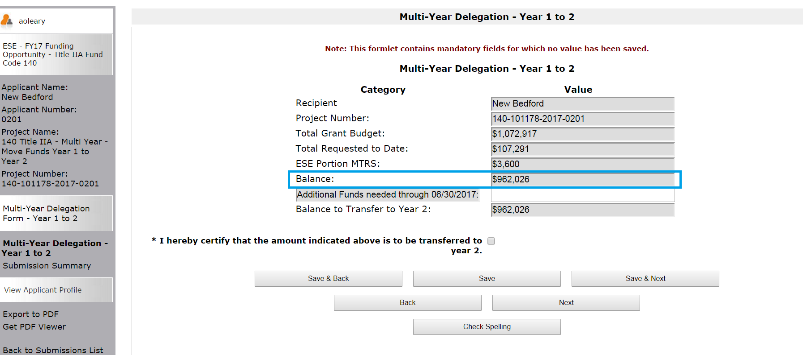

Enter the Additional Funds needed through 6/30/2019 in the space provided.

In this example, we have entered $800,000 as funds needed through 6/30.

Click Save (not Save & Next) so that the Balance to Transfer to Year 2 calculates.

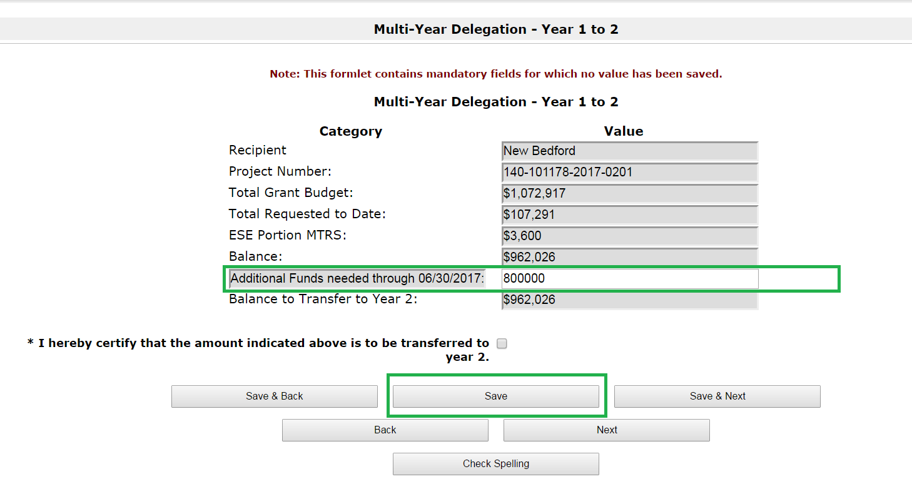

After hitting Save, the Balance to Transfer to Year 2 will be calculated. Make sure the amount needed to remain in Year 1 (Additional Funds needed through 6/30/2019) is accurate and make sure that the Balance to Transfer to Year 2 is accurate based on your needs.
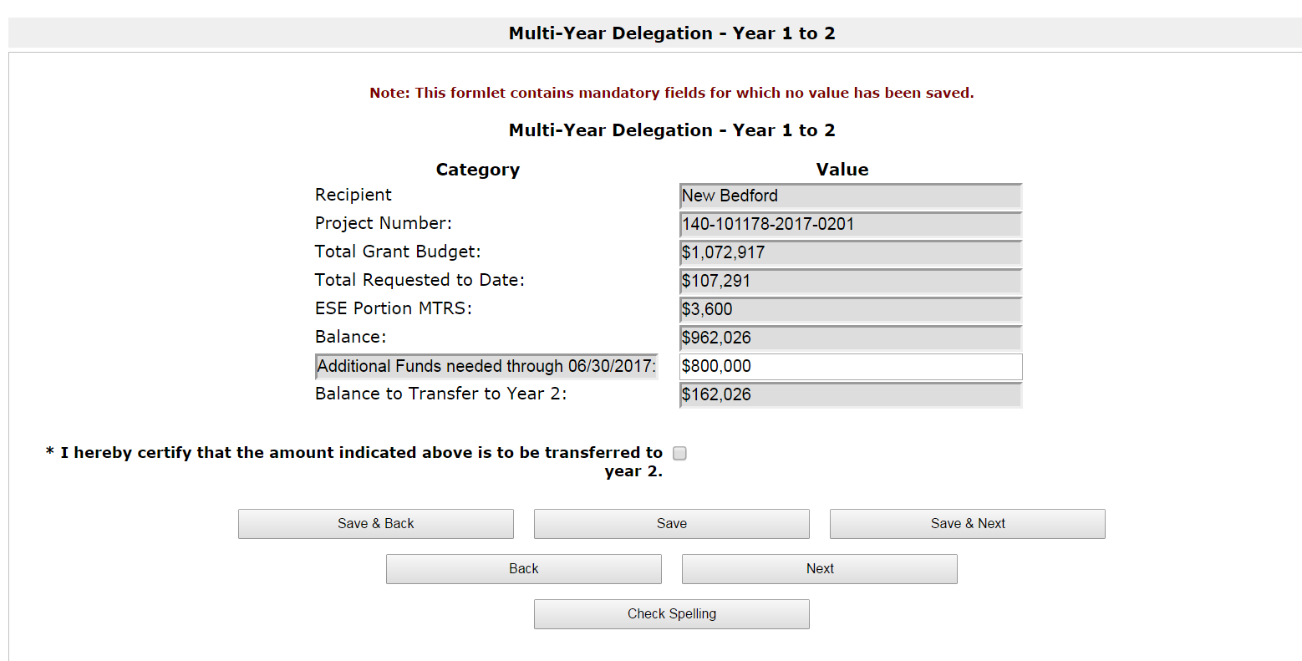
Click the certification box to certify that the numbers you reviewed above are correct.
Click Save & Next.
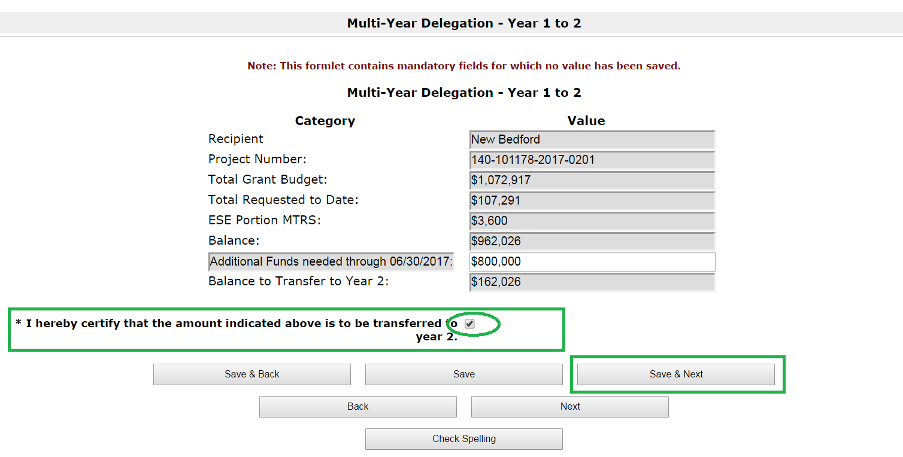
Clicking Save & Next both saves the information as well as brings you to the Submissions Summary page.

Click Submit.
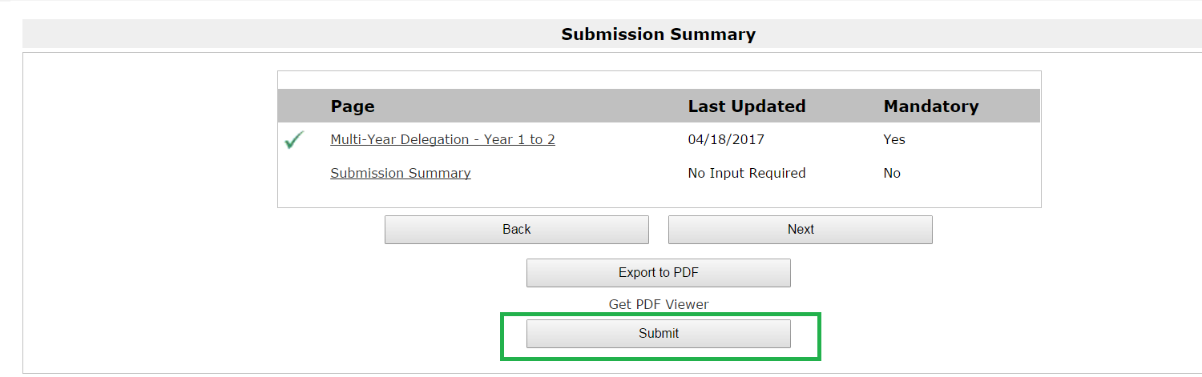

If you do not click submit, the form is not submitted. Once submitted, it will bring you back to the Submissions menu of Front Office. You will see a date and time stamp next to the Multi-Year delegation form as long as you have submitted it.

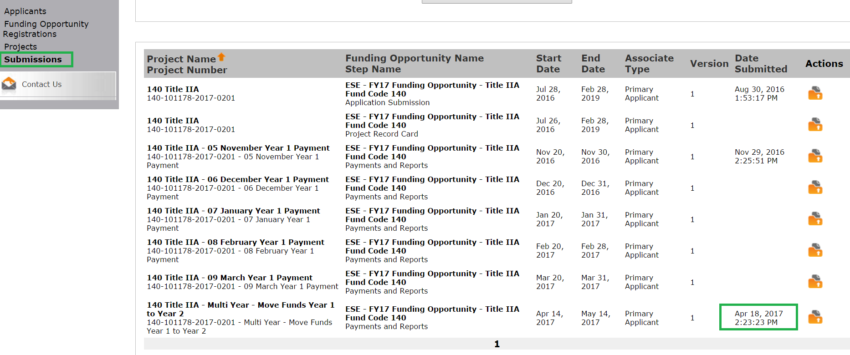

If you notice that there is no date and time stamp next to the form, go back in and submit the form. (Open the form by clicking the Orange folder, click the Submissions Summary formlet and click Submit).

No date and time stamp means it is NOT submitted.

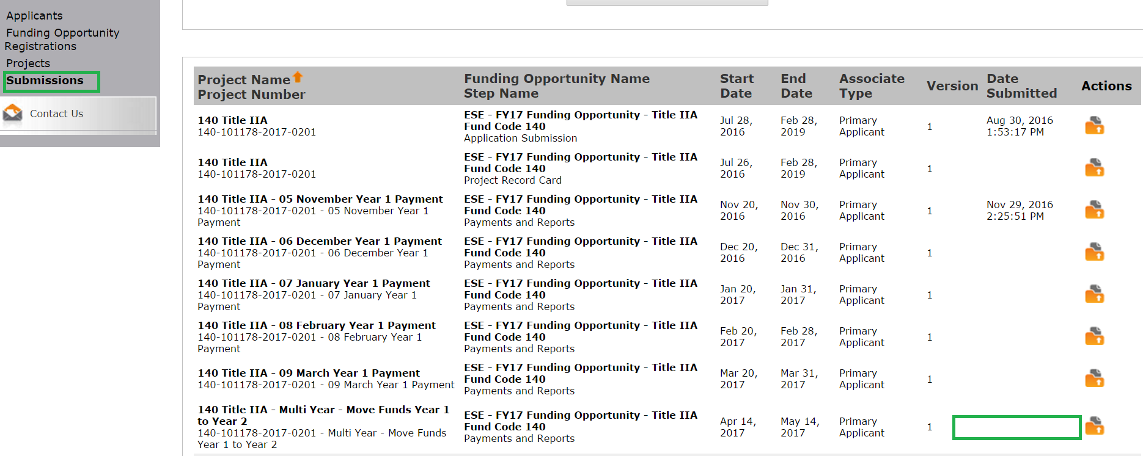

Funds that are moved into Year 2 using the Multi-Year delegation form will be available to draw:
- July YEAR 2 Payment Request window (July 1, 2019 – July 10, 2019) and the
- August YEAR 2 Payment Request window (August 1, 2019 – August 10, 2019).

Funds not moved and left in Year 1, will be available to draw:
- July Year 1 Payment Request window: July 20, 2019 – July 31, 2019
- August Year 1 Payment Request window: August 20, 2019 – August 24, 2019 (final Year 1 request window for multi-year grants only)

Funds left unclaimed in Year 1 after the final August Year 1 Payment Request window will roll into Year 2 in September. These funds will be added to your Year 2 balance and will be available to draw during the October Year 2 Payment Request window (20th of the month through end of month). These funds will be available to draw throughout FY2020 with an expectation that you will be drawing final balances mid-year (January 2020).

Districts with Year 2 roll balances should always use these funds up first before charging against the new award. Reconcile and file amendment requests if necesarry to spend down old funds before charging new funds.

Multi-Year FAQs:

Q: Which grants have access to utilize the multi-year feature in EdGrants?
A: For FY2019, multi-year eligible grants are the following programs and fund codes:
- Title I (Fund Code: 305)
- Title II-A (Fund Code: 140)
- Title III (Fund Codes: 180 / 186)
- Title IV (Fund Code: 309)
- IDEA (Fund Code: 240)
- Early Childhood Special Education (Fund Code 262) and
- High-Quality Instruction — Summer Planning (Fund Code: 218* only)

*Fund Code 218 – High-Quality Instruction – Summer Planning grantees should use the multi-year feature to receive an 8/31/2019 end date on this state funded grant. This is not available for the same full year extension as the other multi-year grants are.

Grants that are not associated with the fund codes listed above are not eligible to access the multi-year feature in EdGrants.

Grantees with ISAs (community colleges, other state agencies) will use the ISA amendment process ion order to roll their grant funds.

Q: What if too little (or too much) is moved into Year 2?

A: If you move too little into Year 2, you can draw what you have moved as well as what you left in Year 1 during the appropriate draw-down windows. If you moved too much into Year 2, you will have immediate access to those funds on July 1. Year 2 funds can be applied back to Year 1 expenditures and Year 1 funds can be applied to Year 2 expenditures as the start date of the grant remains what it was in Year 1, and your end date is now 6/30/2020. The only reason the Year 1 / Year 2 distinction matters is because of the draw-down windows during the accounts payable period (July 1 – August 31). The state’s accoutning system cannot issue payments against both years simultaneously, they must be staggered.

Q: What if I do not complete the multi-year form, but then discover that Year 2 spending will be required?

A: If you do not submit the multi-year delegation form, then your grant ends on 6/30/2019. If you leave funds unclaimed in Year 1, then that balance will roll into Year 2 in September, extending your end date to 6/30/2020 at that time. Please be aware that if this happens, there will be a risk of a small break in service from July until September when the funds roll. If you are not sure, it is always best to roll a small amount into Year 2, just to get the extension.

Q: What if I move money into Year 2, but then discover that the funds are fully expended at the end of Year 1 (6/30/2019)?

A: Year 2 funds can be drawn as of July 1, and can be applied back to year 1 expenditures if needed. It is always best to er on the side of caution and move some small amount of funds just to get the extended end date of the grant. Once the funds have been fully expended down and reconciled, a final report can be filed to close out the grant.

Q: Can I have an extension on submitting multi-year if the 5/14 deadline is missed?

A: No. DESE has a deadline issued by the State Comptroller for all roll funds transactions to be entered, approved and processed. We are giving grant applicants as much time as is possible to get these forms completed before we have to finalize our end.

Q: How is summer salary handled in terms of multi-year?

A: Any salary paid out in July / August for services completed by 6/30/2019 should remain in the Year 1 balance, regardless of when the salary charges hit. Salary for services that occur 7/1 or after, should be rolled into the Year 2 balance.

Q: Is there a limit to how much money can be rolled into Year 2?

A: No, there is no limit to how much you can roll into year 2 other than you can only roll what still remains to be drawn on the grant. Title I has regulations that require 85% of the grant funds to be spent in Year 1, but applicants have until 9/30/2019 to meet that requirement for their FY2019 award. If more than 15% of funds is rolled into Year 2 on Title I, it will not be stopped because there is an assumption that those funds will be spent down to the 85% requirement by 9/30.

Q: For ESSA grant funds (Fund Codes: 305, 140, 180/186 309), can funds from one Title be rolled into Year 2 and then the grant workbook amended later to utilize the flex capabilities?

A: Yes. A district can roll funds into Year 2 and then file an amendment in the fall to be approved by the program office staff to ensure that the flexing is allowable and appropriate.

Q: How soon can I draw funds that I move into Year 2 using the Multi-Year delegation form?

A: Funds moved into Year 2 using the multi-year delegation form will be available to draw on July 1st if needed. The Year 2 draw windows during the summer months are: July 1st – 10th and August 1st – 10th.

Q: Can I use Year 2 funds to cover Year 1 obligations/expenditures?

A: Yes. Multi-year extends the end date on the grant. The Year 1 / Year 2 dollar amount is only relevant during the summer months because of Accounts Payable. As long as you know which payment request form to use to access which “year” of funding you can apply the funds backwards and forwards on expenditures as needed. This is why it is ok to estimate what is needed in Year 2.

Q: Can I Use Year 1 funds to cover Year 2 obligations / expenditures?

A: Yes. As long as a Multi-Year delegation form is submitted in EdGrants. You are not tied to Year 1 / Year 2 dollar amounts once the date is extended out. As long as you know which payment request form to use to access which “year” of funding you can apply the funds backwards and forwards on expenditures as needed.

For example, FY2019 305 grant project duration for a particular Applicant: 10/5/2018 – 6/30/2019. Once multi-year is complete, the project duration for that grant is now 10/5/2018 – 6/30/2020. The original start date does not change.

