Student Claiming User Guide

**Version: 1.0**

**Authored by:**

Rockell Landry, EOE IT Senior Technical Project Manager

Hiro Sakiyama, EOE IT Business Analyst

Melissa Marino, DESE Data Collections Business Product Owner

**Contents**

What is Student Claiming? 3

What is Changing with Student Claiming? 3

Student Claiming User Guidance 3

I. Continuous Claiming and Near Real-Time Processing 3

II. A Student Can Be Pre-Claimed and/or Claimed 4

III. A Student Can Be Claimed or Pre-Claimed by More Than One District at a Time 5

IV. Claims by Collaboratives or Private Special Education Agencies 5

V. Relaxed Criteria to Claim or Pre-Claim a Student 5

VI. Claiming: Create New, Update, End or Delete 6

VII. New and/or Improved Student Claiming Folder and Reports 7

VIII. Security Role Access 13

IX. New Legacy Claiming Application 14

X. Guide to Claiming Validation Error Codes 21

Claiming Support 24

# What is Student Claiming?

Student Claiming allows districts and associated schools in Massachusetts to indicate that a student is currently or will be enrolled and attending school in their district. Districts are able to access the complete state education data history of students whom they have claimed.

# What is Changing with Student Claiming?

* Districts can claim and/or pre-claim continuously at any time throughout the year, and SIF claims are processed in near real-time.
* A district can pre-claim a student for a future school year(s).
* More than one district at a time can claim and/or pre-claim the same student.
* A student claimed by both a district and a Collaborative or Private SPED program will have two claims.
* Matching criteria to claim a student has been relaxed to SASID only.
* While matching criteria is for SASID only, input is required in all fields except for Exit Date and Middle Name. See section X for details.
* Creating a new claim, updating an existing claim and ending claims is easier.
* A new Student Claiming folder and new and/or improved reports provide easier navigation and visibility into claims.
* Security role access requirements are consistent with other EOE applications and reports access.
* A new Legacy Claiming application for manual claiming replaces the old Data Warehouse File Exchange DropBox application.
  + The Legacy file structure has four new required fields (see section IX for details).
* Guide to Claiming Validation Error Codes

# Student Claiming User Guidance

### Continuous Claiming and Near Real-Time Processing

Districts are now enabled to claim, pre-claim and un-claim continuously throughout the year. With this capability, the concept of SIMS claiming goes away, and there is no longer a need for EOE to modify data from the end-of-year SIMS collections in order to baseline for the next year.

We have ended the practice of bulk deletions and rollovers at the end of each school year which was done in order to populate reports for the next school year. That practice is no longer needed because districts are now able to pre-claim and then view their pre-claims in near real-time.

Additionally, SIF claims are now processed in near real-time instead of only once every 24 hours which means that a change to a district claim submitted via SIF will be viewable in the appropriate report within 30 minutes from the time it is received.

Claims submitted via the Legacy Claiming application will also be viewable in the appropriate report(s) as soon as a valid Student Claiming File is uploaded. Claims for newly registered students, however, will not appear in reports until the next day.

### A Student Can Be Pre-Claimed and/or Claimed

EOE now supports Student Pre-Claiming which allows districts in Massachusetts to indicate that a student *will* *be* enrolled in their district in the future and gain access to the Student Profile PR600 and Assessment History Summary PE613 reports for the student as well as a new summary of all district claims.

**Entry Date:** Whether a record is a Claim and a Pre-Claim is determined by the ***Entry Date***:

* Claim: Entry Date ≤ today and Exit Date ≥ today or null
  + Entry Date = prior to or up through today’s date. Entry Date = after Entry Date or blank
* Pre-Claim: Entry Date > today and Exit Date > Entry Date or null
  + Entry Date = after today’s date/future. Entry Date = after Entry Date or blank

**School Year:** School Year = July 1st to June 30th

* Regardless of Entry Date, a record will be accepted only if the School Year meets one of the following two requirements:
  + School Year is the current, active School Year in progress
  + School Year is no more than one School Year into the future

This means that a claim or a pre-claim with a School Year prior to the current year or with a School Year beyond one future year will *not* be accepted.

* For example, claims and pre-claims with the 2018 School Year and the 2019 School Year will be accepted until 6/30/2018, but on 7/1/2018, only claims and pre-claims with the 2019 and 2020 School Year will be accepted.
* From July 1st and August 31st, all claiming reports (except for Validation Error reports) will display claims that have the prior School Year.
* From September 1st to June 30th, claiming reports will *not* show claims and pre-claims with a prior School Year.
* For example, on 8/30/2018, districts can view 2018 School Year claims, but on 9/1/2018, districts will see only 2019 and 2020 claims and pre-claims in reports.

**Districts are in control of the accuracy of their own data.**

Here are a few key scenarios of which to be aware. For more information on data requirements, see sections V. Relaxed Criteria to Claim or Pre-Claim a Student and X. Guide to Claiming Validation Error Codes.

* If a district submits a record with an Entry Date in the past, an Exit Date blank or in the future, but with School Year one year into the future, then the record will be accepted but treated as a Claim, not a Pre-Claim, per the Entry Date, and be displayed in the “Claimed” report.
* If a district submits a record on 5/1/2018 (i.e., the current School Year is 2018) with an Entry Date of 7/2/2018 but with a past School Year of 2017, the record will *not* be accepted.
* Likewise, if a district submits a record on 5/1/2018 (i.e., the current School Year is 2018) with an Entry Date of 7/2/2018 but with a future School Year of 2020, the record will *not* be accepted because School Year is more than one year into the future.
* If a district submits a record on 5/1/2018 (i.e., the current School Year is 2018) with an Entry Date of 4/2/2017 and with a past School Year of 2017, the record will *not* be accepted because School Year is in the past. (The record would be accepted with the same Entry Date if the School Year were 2018.)

For each of the last three examples, if the record was submitted via SIF, the record will *not* show as an error on the SIF Claiming Error Report. However, if the record was submitted via the Legacy (Manual) application, the file will be not be accepted (see section IX for file validation details).

* If a district submits more than one record via SIF for the same SASID, District, School, School Year and Entry Date but *different* Exit Dates, SIF will extract the appropriate record in the following priority according to the Exit Date:
  1. Exit Date is blank, or
  2. Exit Date is the greatest/furthest future date
  3. If Exit Dates are identical, SIF will extract the record with the newest Update date.
  4. If Update dates are identical or are not present, SIF will extract the record with the newest Create date.

### A Student Can Be Claimed or Pre-Claimed by More Than One District At A Time

EOE no longer prevents districts from claiming or pre-claiming a student who is also claimed by another district.

Allowing a student to be claimed by more than one district is intended to address the challenge for Data Collections encountered when a district that had submitted a valid claim for a student was prevented from claiming that student due to an existing claim from another district; the other district often being the student’s former district or a district to which the student had applied or registered.

Districts are still expected to perform due diligence to identify and un-claim students who have left their district, correct claim date inaccuracies and reconcile duplicate student enrollments as part of certifying their SIMS collections.

### Claims by Collaboratives or Private Special Education Agencies

When a district claims a student but enters a collaborative or private special education program in the school/program field, that student is automatically claimed by both the sending district and the receiving organization.

However, when a district claims a student but enters a DYS/SEIS program in the school/program field, that student will be claimed only by the sending district. Due to privacy requirements governing sensitive information, the DYS/SEIS program must claim the student separately in order to gain access to a student’s record.

See section VII. for how non-traditional schools will be displayed in reports.

### Relaxed Criteria to Claim or Pre-Claim A Student

Districts can claim a student as long as:

1. the SASID matches a SASID in EOE’s Student Directory
2. the other values submitted for the student meet format requirements (i.e., First and Last Name fields are not blank/null, Date fields, excluding Exit Date, are not null and contain valid dates, etc.)

For manual claims, EOE no longer requires a student’s demographic details in a Student Claiming File (First Name, Middle Name, Last Name, or Birth Date) to match the existing demographic details for the student in the Student Directory in order to claim the student.

**Important:** The demographics (Last Name, First Name, Middle Name and Birth Date) displayed in Student Claiming Reports are drawn from a given SASID’s demographics stored in EOE’s Student Directory, not from what is submitted by the district via the new Student Claiming application or SIF.

### VI. Claiming: Create New, Update, End or Delete

**Creating a New Claim**

A new claim for a SASID is created in the Student Claiming database when the incoming claim does *not* contain the same data as an existing record in all of the following fields:

* SASID
* District
* School
* School Year
* Entry Date

Note: This means that the incoming claim has a combination of SASID, District, School, School Year and Entry Date that does not already exist.

**Updating an Existing Claim**

An existing claim is updated when one or more of the following fields of the incoming claim *do* contain the same data as an existing record:

* SASID
* District
* School
* School Year
* Entry Date

Note: These fields will not be updated, but Exit Date and Grade Level will be updated with the new data.

**Ending an Existing Claim**

SIF districts can end a valid claim on a student by entering an Exit Date for the existing claim in their SIS that does *not* equal Entry Date.

Non-SIF districts can manually end a valid claim on a student by uploading a Student Claiming File that contains an Exit Date in the currently claimed student record that the district wishes to un-claim.

Note: Claims are considered to be active up to and including the specified Exit Date.

**Deleting a Claim**

SIF districts can delete a claim submitted in error or when a student was expected to attend the school but did not (e.g., the student enrolled in another school or left the state). Deleting a claim erases the claim from the Student Claiming database.

To delete a claim via SIF, the district enters an Exit Date in their SIS that is the same as the Entry Date of the existing claim.

Non-SIF districts can manually delete a claim or pre-claim on a student by uploading a Student Claiming File that contains an Exit Date for a student record that is equal to the Entry Date of the claim.

### New and/or Improved Student Claiming Folder and Reports

EOE has created a new Student Claiming Reports folder (Public Folders > SIF > Student Claiming > Reports) for easier user navigation with five reports to support the student claiming experience:

1. Claimed Students
2. Pre-Claimed Students
3. Search Claims and Pre-Claims by SASID
4. SASIDs with Multiples Claims
5. SIF Claiming Error Report

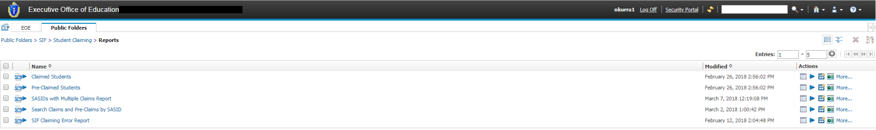

All reports, except for the Search Claims and Pre-Claims by SASID Report and the SIF Claiming Error Report, allow for results to be filtered by up to four fields:

* SASID
* School Code
* Grade Level – minimum two numbers or two Capital letters (e.g., “05” or “PK”)
* School Year

The Search Claims and Pre-Claims by SASID Report can be filtered but only by SASID as the name implies. The SIF Claiming Error Report cannot be filtered.

To filter results:

* Enter the required information in the applicable field(s), and click **Filter**.
* To clear one filter at a time, click the small “**X**” at the far right inside the applicable **Filter by** box, and click **Filter**. Results will revert to all records for that report.
* To clear all of the filters at once, click **Reset** and then **Filter**. Results will revert to all records for that report.
* If the filters applied exclude all of the logged-in district user’s claimed students, the report displays “No Data Available” in place of results.
* To view only claims and pre-claims for Private Special Education and/or DYS/SEIS programs, type “Out Of District” (every word capitalized) in the School Code filter box, and click **Filter**.

All reports can be exported to Excel or PDF formats.

**Claimed Students Report**

Once the claiming process is complete, a district user can confirm the district’s list of claimed students by running the Claimed Students report available in Public Folders > SIF > Student Claiming > Reports folder.

* Select your district
* Click *Finish*

Students are listed in alphabetical order by last name, and the *Inserted by* column identifies how the student was claimed.

Students claimed to a Collaborative or Private Special Education Agency including DYS/SEIS by the sending district will have the *Sending District* in the Claiming District column.

If a student appears in the Claimed Students report, all of the student’s historical MCAS records can be obtained by selecting *Claimed Students* in any of the 600-level reports. To obtain a student’s entire MCAS history, run the **Assessment History Summary** (**PE613)** report. This report also provides a *SASID List Prompt* option which enables a student to be queried on their SASID alone without matching on any other fields.

**Important:** If more than one record has been submitted for the same SASID, District, School and School Year but with different Entry Dates, only the record with *the most recent past Entry Date* will be displayed on the Claimed Students Report.

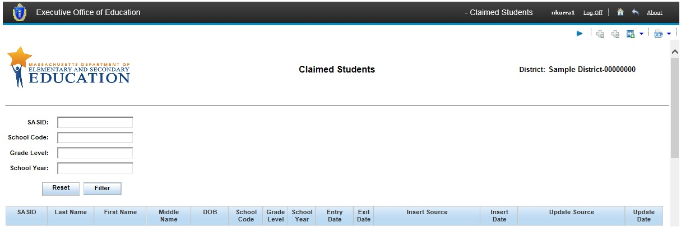

**Pre-Claimed Students Report**

A district user can view the district’s list of Pre-Claimed students by running the **Pre-Claimed Students** report available in Public Folders > SIF > Student Claiming > Reports folder. This report has the same layout and information as the Claimed Students report but includes only those students with Entry Dates in the future.

If a student appears in the **Pre-Claimed Students** report, a district can generate the **Student Profile PR600** and **Student Assessment History Summary PE613** reports for them.

These PR600 and PE613 reports were enhanced to support Pre-Claimed Students to provide districts with enough information about an incoming student to adequately plan for their enrollment (i.e., review the student’s academic history and assign them to the appropriate courses, sections, etc.).

Important:

* A Pre-Claim will not appear in the Pre-Claimed Students Report if there is already an active claim in the Claimed Students Report for the same SASID, District, School and School Year.
* If more than one record has been submitted for the same SASID, District, School and School Year but with different Entry Dates, only the *most recently updated* *record* will be displayed on the Pre-Claimed Students Report.

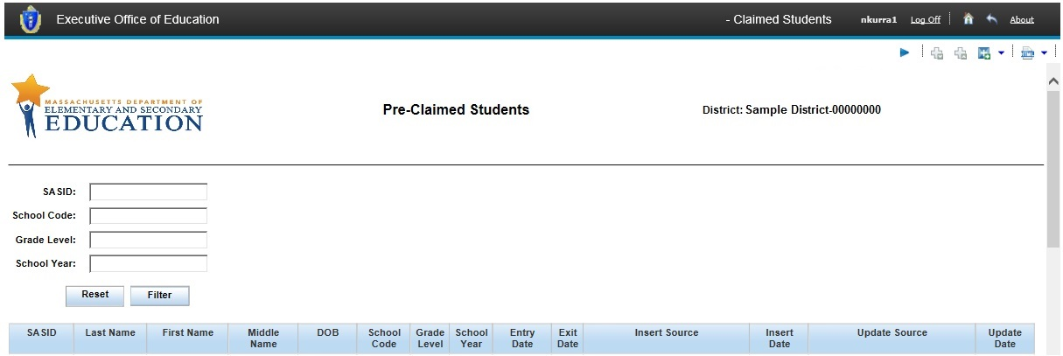

**SASIDs with Multiple Claims Report**

The **SASIDs with Multiple Claims Report**, by default, shows a logged-in district user all of their currently claimed and pre-claimed students who are also claimed or pre-claimed by another public district or Charter school.

By default, records are always sorted numerically by SASID.

If a student is claimed by a public district, but the student is also attending a non-traditional school (Private Special Ed or DYS/SEIS), the report displays “Out Of District” in place of the non-traditional school’s code. Collaborative school code is displayed because Collaboratives are public organizations.

When a SASID is claimed by the logged-in user’s district and at least one other district, the report displays the logged-in district user’s claims or pre-claims in one row and claims from other districts immediately below.

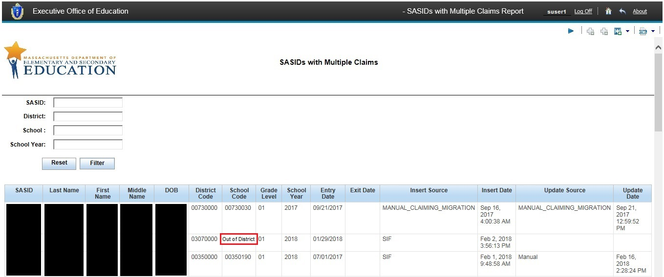

**Search Claims and Pre-Claims by SASID Report**

A district user can search for all claims and pre-claims (except for DYS/SEIS) for a single student SASID using the **Search Claims and Pre-Claims by SASID report** to determine if the student is claimed or pre-claimed by any other district(s).

* Provides claim information only on a single SASID that is claimed or pre-claimed by the district associated with ther users’s log-in.
* Does not provide any claim information about a student attending a DYS or DYS/SEIS program

By default, records will be sorted numerically by SASID.

If the SASID is claimed or pre-claimed not only by the logged-in user’s district, but also one or more other districts, the report will display as follows:

* The logged-in user will see their own district name and code and own school name and code.
* If a student is attending a Private Special Education or DYS/SEIS program, the logged-in user will see their own district name and code and “Out Of District” instead of the school name and code of the Private SPED or DYS/SEIS program. However, Collaborative school codes will be displayed as they are public organizations.

If the SASID is not claimed by the logged-in user’s district, the following message will display:

“SASID # is not Claimed or Pre-Claimed by your District.”

“Please Claim and Pre-Claim the SASID and re-run the report to view other Districts that have claimed or pre-claimed this SASID.”

For Private Special Education and DYS/SEIS school claims and pre-claims, district users will be able to see the School Code and School Name for claims and pre-claims submitted by their own district but will see only “Out Of District” in place of School Code and School Name for claims submitted by other districts.

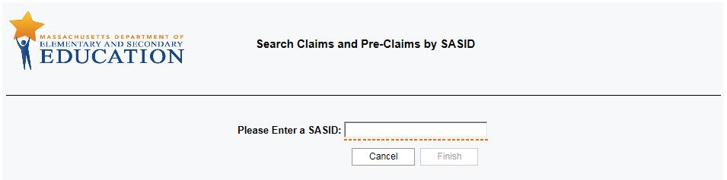

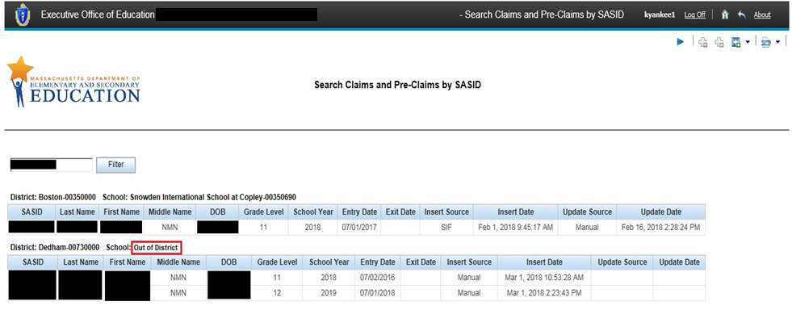

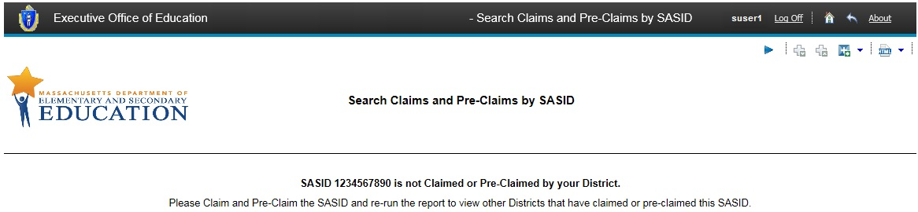

**SASIDs with Multiple Claims Report**

The **SASIDs with Multiple Claims Report**, by default, shows a logged-in district user all of their currently claimed and pre-claimed students who are also claimed or pre-claimed by another public district or Charter school.

By default, records are always sorted numerically by SASID.

If a student is claimed by a public district, but the student is also attending a non-traditional school (Private Special Ed or DYS/SEIS), the report displays “Out Of District” in place of the non-traditional school’s code. Collaborative school code is displayed because Collaboratives are public organizations.

When a SASID is claimed by the logged-in user’s district and at least one other district, the report displays the logged-in district user’s claims or pre-claims in one row and claims from other districts immediately below.



**SIF Claiming Error Report**

The SIF Claiming Error Report allows districts that exchange student personal and student school enrollment data with EOE to see whether any of the records they have published to EOE contain errors that would prevent a claim or pre-claim from being processed.

This is a SIF-only report. Districts that claim only via the new Legacy Claiming application will not find any records in this report. There is a separate in-application error report for the Legacy Claiming application.

Click on the Error Count in the summary in order to see details of each error.

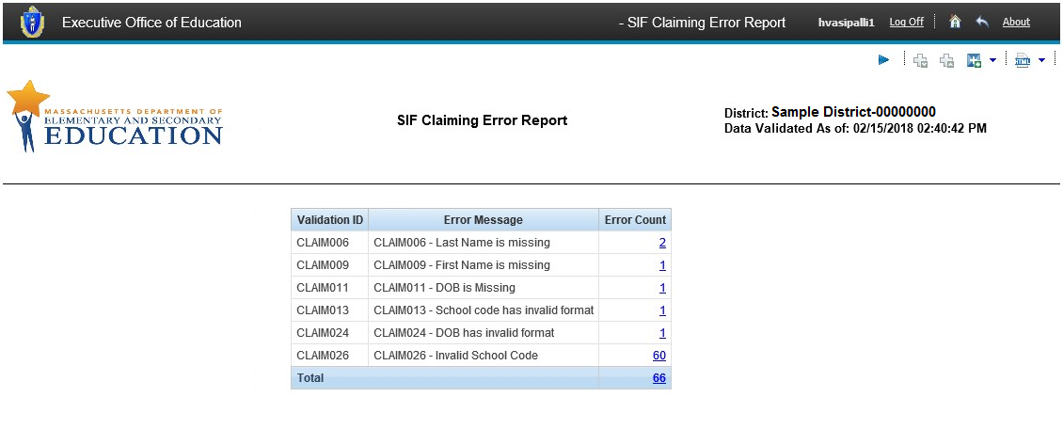

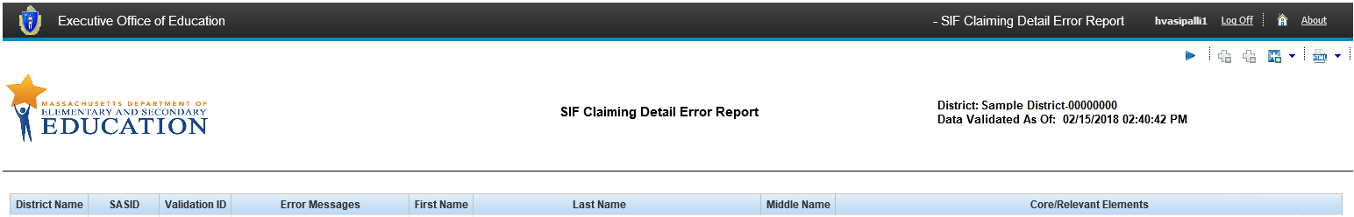

**Note: The Legacy (Manual) application error report** is embedded in the application’s user interface. See section IX for details.

### Security Role Access

The same security role that was used to access the Data Warehouse File Exchange DropBox has been renamed to **Student Claiming**. The membership and attributes of this security role have not changed.

**Security Role Access to Upload a Student Claiming File**

Consistent with access to the Data Warehouse File Exchange, district users must have the **Student Claiming** role in order to:

1. access the link for **Student Claiming** on the Application List
2. access the link **Upload Student Claiming / Pre-Claiming File** andlaunch the manual **Student Claiming** application

**Security Role Access to View Student Claiming Reports**

To be consistent with the security role access structure for other EOE end user experiences, two (2) security roles are required for district users to access and generate Student Claiming reports in the **SIF >** **Student Claiming > Reports** folder:

1. Student Claiming role \****AND\****
2. SIF Ad Hoc District

### New Legacy Claiming Application

EOE IT developed a new Student Claiming application to replace the existing Data Warehouse File Exchange Drop Box application with improved navigation and a more user-friendly interface. Following are a few changes to be aware of:

* A Student Claiming file must pass all validations, or the file will not be uploaded.
* A Student Claiming File that passes all validations will be submitted to EOE without any further user action. Users are no longer required to click ‘Accept’ for the application to upload a file that has passed all validations.
* If any claiming record in a submitted file fails any validation, the entire file will not be accepted, and the application will display an error report. A new claiming file can be resubmitted when all claiming record errors have been fixed.

**Legacy Claiming Process**

If you are not a SIF district, student claiming is a three-step process with several tasks to complete under each step. The three major steps are:

1. Create a Student Claiming File that meets EOE’s file specifications
2. Upload the Student Claiming File to EOE’s Data Warehouse Secure Portal
3. Pass file validations

**Step 1: Create A Student Claiming File**

Create a Student Claiming File that meets EOE’s file specifications

1. Include four new fields

* STU_ENROLL_GRADELEVEL
* STU_ENROLL_SCHOOLYEAR
* STU_SCH_ENROLL_ENTRYDATE
* STU_SCH_ENROLL_EXITDATE

1. The file extension can be .txt or .csv.
2. The fields in each row within the Student Claiming File must be comma-separated.
   1. Each field should either be enclosed within a set of quotation marks (at the beginning and end of each field), or should not have any quotation marks in the row at all.
   2. Unclosed quotation marks in a field will cause the Student Claiming application to lose track of where one field ends and another begins. If there is only one set of quotation marks in a field, the record will fail and the following generic error message will be displayed.

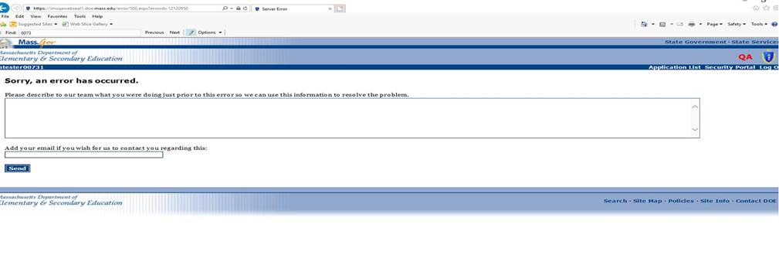

1. The first row is a header row and must contain all 11 columns (10 commas)
2. Each column must be named and appear in the same order as the table below and in the sample file.
3. The Student Claiming File does *not* need to be named a particular way in order to be processed.
4. The Student Claiming File must be:

* *Windows* format with CR/LF line endings.
* *Unix* and *Mac* OS don’t generate CR/LF line endings.

| ***Column Name*** | ***Data Type*** | ***Description*** |
| --- | --- | --- |
| **STU_ID** | NUMBER(10) | Student’s SASID |
| **STU_LAST_NAME** | CHAR(50) | Student’s last name |
| **STU_FIRST_NAME** | CHAR(32) | Student’s first name |
| **STU_MIDDLE_NAME** | CHAR(32) | Student’s middle name |
| **STU_BIRTH_DT** | DATE mm/dd/yyyy | Student’s date of birth. |
| **CUR_AUTH_SCHL** | NUMBER(8) | 8 digit school code |
| **CUR_AUTH_DIST** | NUMBER(8) | 8 digit district code |
| **STU_ENROLL_GRADELEVEL** | VARCHAR2(2 CHAR) | This is the grade that the student is in for this entry date, the following are valid values; 01, 02, 03 ,04 ,05 ,06 ,07 ,08 ,09 ,10 ,11 ,12 ,13 ,99 ,KF ,KP ,KT ,PG ,PK ,SP ,UN. |
| **STU_ENROLL_SCHOOLYEAR** | VARCHAR2(4 CHAR) | This is the 4 digit year school year that the student is enrolled in. |
| **STU_SCH_ENROLL_ENTRYDATE** | DATE mm/dd/yyyy | This is the start date of the student’s enrollment in that particular district and school. |
| **STU_SCH_ENROLL_EXITDATE** | DATE mm/dd/yyyy | Exit date is the end of the students enrollment in this particular district and school.  If this date is the same as the Entry Date then this record should be marked for deletion. |

1. The number of records per file cannot exceed 37,750 or the upload session will result in an error (see screenshot above in #3). If more than 37,750 records need to be submitted, it is recommended that the number of records be split across multiple files with no more than 30,000 records in each, and then uploaded one at a time. Performance time may exceed one minute/60 seconds if the number of records per file is greater than 30,000.

**Step 2: Upload Student Claiming File to the EOE Data Warehouse Security Portal**

1. Log in to the security portal and select **Student Claiming** from the application list to reach the Student Claiming landing page.

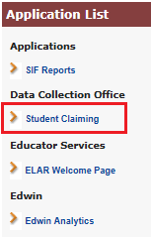

1. From the Student Claiming landing page, select **Upload Student Claiming / Pre-Claiming File**.

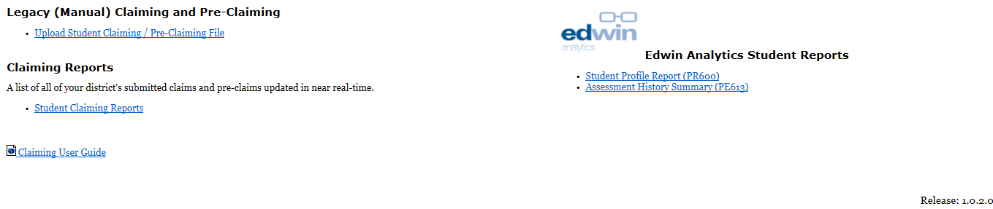

1. Select District from the **Select Organization** screen:

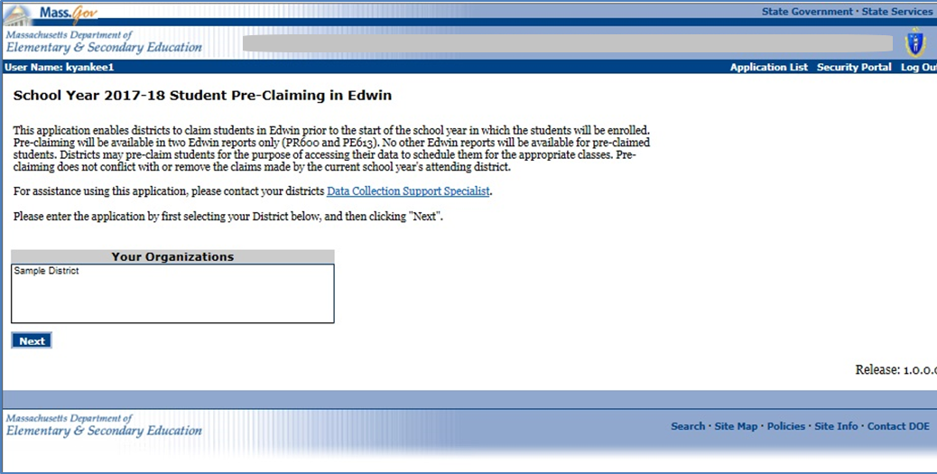

1. Click **Browse**, select the **Student Claiming File** to be uploaded, and click **Upload**:

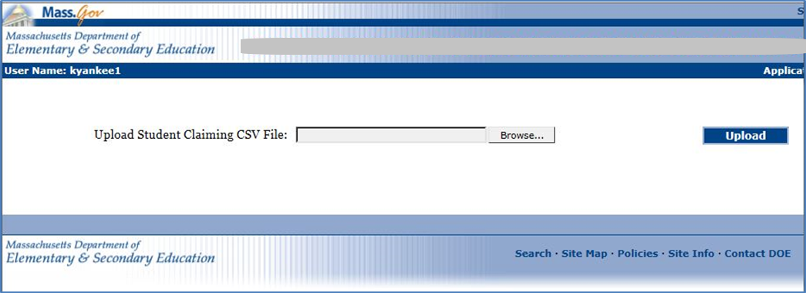

**Step 3: Pass File Validations**

1. **Primary Validations** – Errors found for the following will be displayed
2. is .txt or .csv file format
3. contains 11 required columns
4. columns are labeled and in the correct order

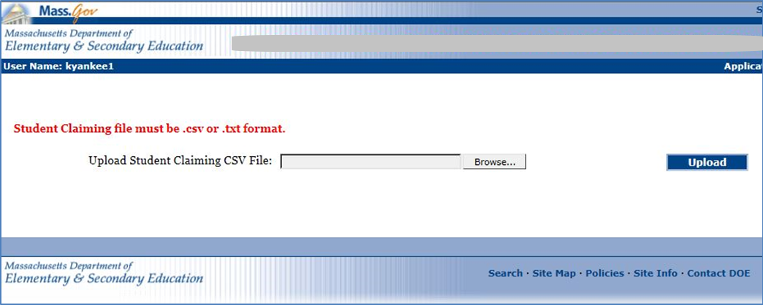

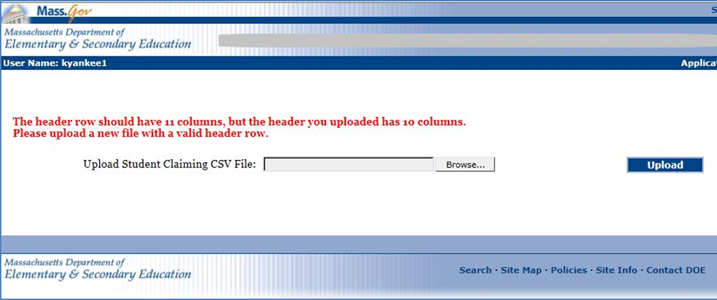

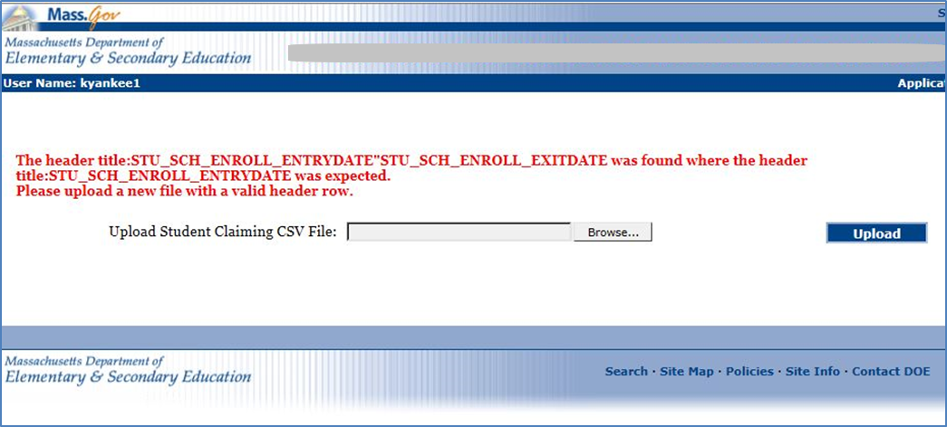

1. **Secondary Validations** – Errors found will be displayed grouped by Error Code, Error Description, and count of records that triggered the error. *See section X for error codes*.
2. **SASID** is not missing.
3. **SASID** is 10 digits in length.
4. **SASID** exists in the Student Directory.
5. **Last Name** is not missing.
6. **Last Name** only contains alphanumeric characters, hyphen, apostrophe, period, space or comma.
7. **First Name** is not missing.
8. **First Name** only contains alphanumeric characters, hyphen, apostrophe, period or space.
9. **Middle Name**, if included in file, only contains alphanumeric characters, hyphen, apostrophe, period or space.
10. **Student Birth Date** is formatted mm/dd/yyyy.
11. **Current Authorized School** code is not missing.
12. **Current Authorized School** code is 8 digits long.
13. **Current Authorized School** code is valid.
14. **Current Authorized District** code is not missing.
15. **Current Authorized District** code is 8 digits long.
16. **Current Authorized District** code is valid.
17. **Student Grade Level** is not missing.
18. **Student Grade Level** must be one of the following values: 01, 02, 03, 04, 05, 06, 07, 08, 09, 10, 11, 12, PK, KP, KF, KT or SP / Invalid format.
19. **School year** must be formatted yyyy.
20. **Student School Enroll EntryDate** is not missing.
21. **Student School Enroll EntryDate** is formatted as mm/dd/yyyy.
22. **Student School Enroll ExitDate** is not missing.
23. **Student School Enroll ExitDate** is formatted as mm/dd/yyyy..
24. **Student School Enroll ExitDate** is greater than or equal to EntryDate.

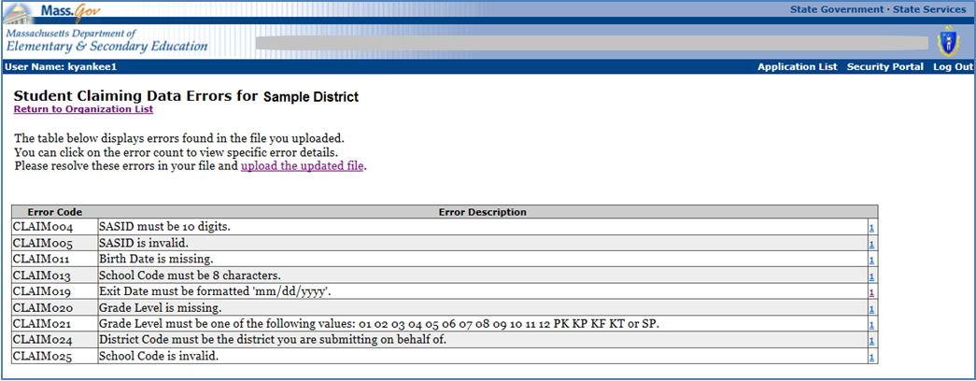

The user can click on the count for a given Claiming Data Error to view details of the specific record(s) that triggered the error.

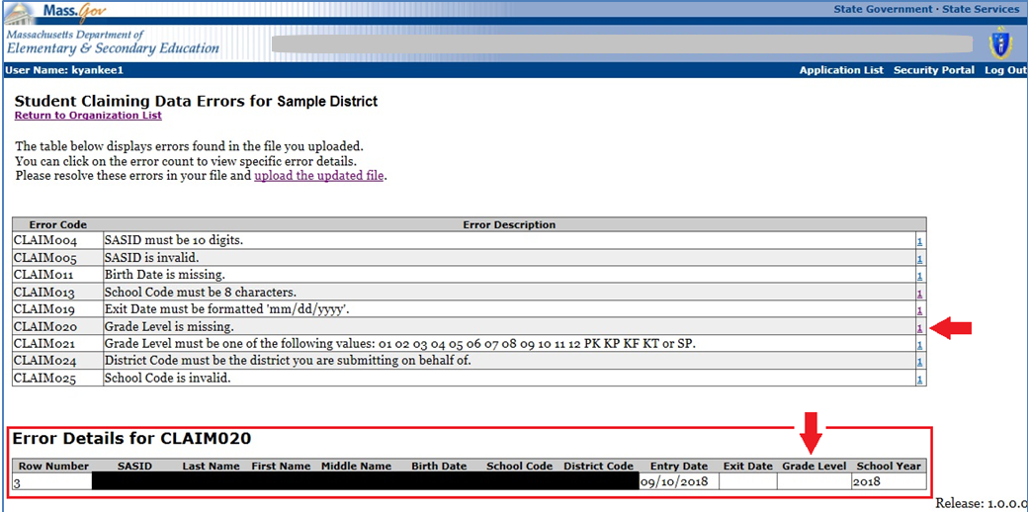

1. **Correct Errors** - The user corrects any validation errors found in the file and re-uploads the file to the Student Claiming application.
2. **Successful File Upload** - The Student Claiming application displays the following success message when a Student Claiming File passes all validations:

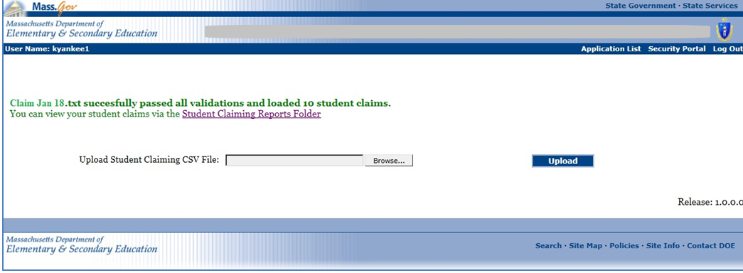

Note: A district’s error report in the Legacy (Manual) Claiming application will be available to the user as long as the user’s login session is active. The error report will not be available after a user logs out of the application.

### Guide to Claiming Validation Error Codes

Validation error codes and descriptions will be available for users to determine which claiming records failed during submission via SIF or the Legacy (Manual) application. Error codes are reported to the district user in two ways:

* SIF Validation Error Report in the Student Claiming Reports folder
* Legacy errors will be displayed within the Legacy (Manual) Claiming user interface

Following are the respective SIF and Legacy (Manual) Claiming Validation Error Codes.

**SIF Claiming Validation Error Codes**

| **SIF Error Code** | **Trigger** | **Error Description** |
| --- | --- | --- |
| CLAIM003 | A record without a SASID, SASID field is null. | Student SASID is missing |
| CLAIM004 | A record with a SASID that is not 10 digits long | Student SASID has invalid format |
| CLAIM005 | A record with a SASID that is not a recognized SASID | Invalid SASID |
| CLAIM006 | A record without a Last Name | Last Name is missing |
| CLAIM009 | A record without a First Name | First Name is missing |
| CLAIM012 | A record without a School Code | School Code is missing |
| CLAIM013 | A record with a School Code that is not 8 characters long | School code has invalid format |
| CLAIM016 | A record without an Entry Date | Entry Date is missing |
| CLAIM017 | A record with an Entry Date not formatted as mm/dd/yyyyy | Entry Date has invalid format |
| CLAIM018 | A record with an Exit Date that is later than the Entry Date | Exit Date must be greater than or equal to Entry Date |
| CLAIM019 | A record with an Exit Date not formatted as mm/dd/yyyy | Exit Date has invalid format |
| CLAIM020 | A record without a Grade Level | Grade Level is missing |
| CLAIM021 | A record with a Grade Level that is not recognized by EOE | Grade Level has invalid format |
| CLAIM022 | A record without a School Year | School year is missing |
| CLAIM023 | A record with a School Year that is not 4 digits | School year has invalid format |
| CLAIM024 | A record with a Date of Birth not formatted as mm/dd/yyyyy | DOB has invalid format |
| CLAIM025 | A record without a valid Org Code | Invalid Org Code |
| CLAIM026 | A record without a valid School Code | Invalid School Code |

**Legacy (Manual) Claiming Validation Error Codes**

| **SIF Error Code** | **Trigger** | **Error Description** |
| --- | --- | --- |
| CLAIM003 | File includes a record without a SASID; SASID field is null. | Row # *n* : SASID is missing. |
| CLAIM004 | File includes a record with a SASID that is not 10 digits long. | Row # *n* : SASID must be 10 digits / Invalid format |
| CLAIM005 | File includes a record with an invalid SASID (district has provided a 10 digit number that is not a recognized SASID). | Row # *n* : SASID is invalid (district has provided a 10 digit number that is not a recognized SASID) |
| CLAIM006 | File includes a record without a Last Name. | Row # *n* : Last Name is missing. |
| CLAIM007 | File includes a record with a Last Name that contains invalid characters. | Row # *n* : Last Name contains invalid characters. |
| CLAIM008 | File includes a record with a Middle Name that contains invalid characters. | Row # *n* : Middle Name contains invalid characters. |
| CLAIM009 | File includes a record without a First Name. | Row # *n* : First Name is missing. |
| CLAIM010 | File includes a record with a First Name that contains invalid characters. | Row # *n* : First Name contains invalid characters. |
| CLAIM011 | File includes a record without a Birth Date. | Row # *n* : Birth Date is missing. |
| CLAIM012 | File includes a record without a School Code. | Row # *n* : School Code is missing. |
| CLAIM013 | File includes a record with a School Code that is not 8 characters long. | Row # *n* : School Code must be 8 characters / Invalid format |
| CLAIM014 | File includes a record without a District Code. | Row # *n* : District Code is missing. |
| CLAIM015 | File includes a record with a School Code that is not 8 characters long. | Row # *n* : District Code must be 8 characters. |
| CLAIM016 | File includes a record without an Entry Date. | Row # *n* : Entry Date is missing. |
| CLAIM017 | File includes a record with an Entry Date not formatted as ‘mm/dd/yyyy’. | Row # *n* : Entry Date must be formatted mm/dd/yyyy / Invalid format |
| CLAIM018 | File includes a record with an Exit Date that is later than Entry Date. | Row # *n* : Exit Date must be greater than or equal to Entry Date. |
| CLAIM019 | File includes a record with an Exit Date not formatted as mm/dd/yyyy | Row # *n* : Exit Date, if provided, must be formatted mm/dd/yyyy / Invalid format |
| CLAIM020 | File includes a record without a Grade Level. | Row # *n* : Grade Level is missing. |
| CLAIM021 | File includes a record with a Grade Level that is not a recognized by EOE. | Row # *n* : Grade Level must be one of the following values: 01, 02, 03, 04, 05, 06, 07, 08, 09, 10, 11, 12, PK, KP, KF, KT or SP / Invalid format |
| CLAIM023 | File includes a record with a School Year that is not 4 digits. | Row # *n* : School year must be formatted yyyy / Invalid format |
| CLAIM024 | File includes a record with a District Code that the user did not select on the Select Organization screen. | Row # *n* : District Code must be the district the user is submitting on behalf of. |
| CLAIM025 | Invalid Org code. | Organization code is invalid. |
| CLAIM027 | DOB has invalid format | Row # *n* : Birth Date must be formatted mm/dd/yyyy |
| CLAIM028 | SASID contains invalid characters. | Row # *n* : SASID contains invalid characters. |
| CLAIM029 | File contains two or more records with the same SASID, District, School and School Year. | Student Claiming File contains two (or more) records for the same SASID, District, School and School Year.  Please submit one record per SASID, District, School and School Year in the Student Claiming File. |
| CLAIM030 | School year must be either the current active school year or the next future school year. | Row # *n*: File includes a record with a school year that is either not the current active school year or the next future school year. |

# Claiming Support

For any questions or assistance with the claiming process, please visit the [Data Collection Support page](http://www.doe.mass.edu/infoservices/data/fts.html) to locate your district’s support specialist.