ARTS & CULTURAL VITALITY INDEX
FOR SCHOOL COMMUNITIES
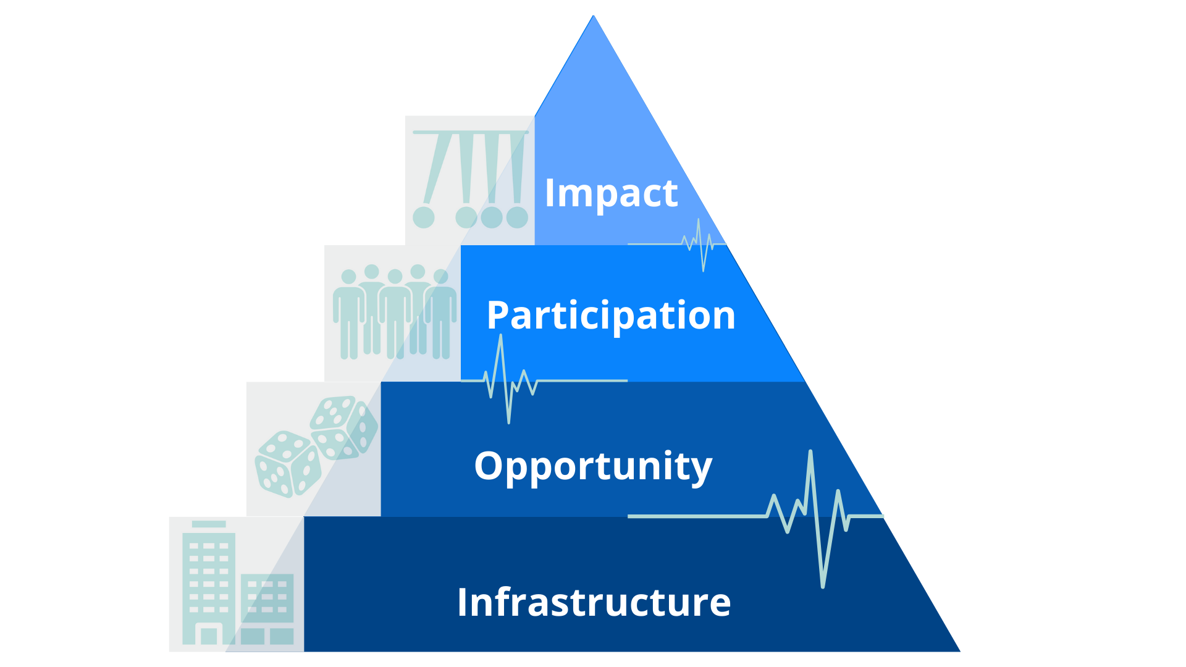

A voluntary, self-evaluative arts resource for developing and sustaining an inclusive school climate.
Revised March 2024.
Table of Contents
What is DESE’s Arts & Cultural Vitality Index? 4
What does ‘Arts and Culture’ mean for the purposes of this resource? 4
How can a school determine if and how its arts and culture is thriving? 4
Why is it important for schools to do this self-evaluation? 4
How is DESE’s ACV Index organized? 5
Lever One: Infrastructure 5
Lever Two: Opportunity 5
Lever Three: Participation 5
Lever Four: Impact 5
How is each indicator rated? 6
Attempting 6
Effective 6
Supported 6
Sustaining 6
How should school communities conduct a self-evaluation using DESE’s ACV Index? 7
What are the phases of the self-evaluation? 7
Phase 1. Plant the Seed 7
Phase 2. Make a Commitment 7
Phase 3. Structure the Experience 7
Phase 4. Reviewing the Artifacts 8
Phase 5. Celebrate! Then Create an Action Plan for Continuous Improvement 8
Links to Each Lever’s Rubric 10
Lever One Rubric: Infrastructure 10
Lever Two Rubric: 10
Opportunity 10
Lever Three Rubric: Participation 10
Lever Four Rubric: Impact 10
Why should schools use ratings and scores to obtain Arts & Cultural Vitality designations? 11
How are DESE’s ACV Index scores used to obtain ‘Vitality’ designations? 11
Review Team Scoring Instructions* 11
Potential Artifacts for Reviewing Arts & Cultural Vitality 12
Link to Helpful Resources 13
DESE’s Arts & Cultural Vitality Index Helping Hands 13
DESE Contributors and Reviewers 13
Noteworthy Contributors and Reviewers 13
References 14

What is DESE’s Arts & Cultural Vitality Index?
In support of developing and sustaining a creative and inclusive school climate, the Arts & Cultural Vitality (ACV) Index is a voluntary self-evaluation tool that provides schools and districts with a scoring mechanism to improve the understanding of their unique arts and cultural assets as part of their school climate. The Index details a structure for identifying areas of strength, and pinpointing opportunities to advance arts and culture within the school community. The Department does not collect any school/district information about this self-evaluation.

What does ‘Arts and Culture’ mean for the purposes of this resource?
- The Arts refer to the five creative disciplines practiced in cultures around the world. These disciplines are represented in the 2019 Arts Curriculum Framework: dance, media arts, music, theatre, and visual arts.
- Culture refers to the cohesion that embraces the diversity of histories, identities, perspectives, and values of all individuals represented in a social group (UNESCO, para. 3). This also includes rituals and practices common within this group. For the purposes of the ACV Index, this social group is defined as an individual school building and the community connected to it, while acknowledging that a school will encompass various cultures within its social group.
- These terms taken together and used as one entity in the Arts and Culture economic sector is typically examined as a prominent feature in neighborhood planning and development, where all aspects of a residential community are considered. For further information on arts and culture in neighborhood planning, visit Cultural Vitality in Communities. It should be noted that DESE’s ACV Index is unique because it focuses on arts and culture exclusively in service of school communities.

How can a school determine if and how its arts and culture is thriving?
Using the ACV Index, all schools can evaluate the quality of their arts and cultural assets and climate. The Arts and Culture Indicators Project (ACIP) defines ‘arts and cultural vitality’ as the “evidence of creating, disseminating, validating, and supporting arts and culture as a dimension of everyday life in communities” (Jackson et al., 2006, p. 7). Understanding this ‘vitality’ provides all schools with useful information for continuous improvement. Resources to support this work in school arts programs are linked at the end of this document.

Why is it important for schools to do this self-evaluation?
“Culture is an important aspect of student experience to consider in efforts to create a meaningfully multicultural curriculum and a more equitable school. The challenge is to retain principles of equity as central… especially if—it feels easier or safer to home in on more simplistic notions of culture” (Gorski & Swalwell, 2013, p.36). The arts play a critical role in creating a school climate that fully values, embraces, and supports the history, culture, and values of the wide range of students who attend. Through ensuring high-quality and equitable arts education programs, students learn through a powerful and empowering sense of agency to celebrate their own and a diverse range of other cultures. The entire school community can benefit from the arts' authentic ability to elevate equity, cultural diversity, and culturally and linguistically sustaining practice in curriculum and instruction (as demonstrated in the Guidebook of Culturally Diverse Artists & Artworks.) The ACV Index supports strengthening educational structures that infuse culturally and linguistically sustaining practices “as a student-centered approach to teaching that includes cultural references and recognizes the importance of students’ cultural backgrounds and experiences in all aspects of learning” (Ladson-Billings, 1995). Learn more about Culturally and Linguistically Sustaining Practices.

How is DESE’s ACV Index organized?
This Index is loosely adapted from a framework for measurement developed by ACIP (2003). DESE’s ACV Index evaluates the artistic and cultural vitality of schools according to four overarching and dynamic levers: Infrastructure, Opportunity, Participation, and Impact. Levers are used because each represents a separate metric that is unique and changing within a school community. Each of the four levers in this Index is unpacked within a rubric of specific indicators. Artifacts that address the designated indicator should be strategically selected and analyzed. A list of potential artifacts (see page 12) that may indicate relevant arts and cultural assets is provided at the end of the Index, but this should not be considered an exhaustive resource.

Lever One:

Infrastructure

Schools with Arts & Cultural Vitality examine systems and structures in place for implementing culturally and linguistically sustaining practices, routine procedures, policies, and provisioning for successful and equitable arts and culture programming and services, as well as processes in place to remove historically inequitable barriers to learning.

Lever Two: Opportunity

Schools with Arts & Cultural Vitality offer students, families, and staff rich opportunities to learn and engage through arts and culture. They ensure that all school members have access and equity in arts and culture programming and services both in and out of school.

Lever Three: Participation

Schools with Arts & Cultural Vitality have a high level of engagement, and active and equitable participation in arts and culture programming and services by all members of the school community.

Lever Four:

Impact

Schools with Arts & Cultural Vitality evaluate arts and culture programming and services by the effect they have on the community, particularly on student learning, educator growth, and school climate outcomes, and have evidence of significant, positive, and equitable impact.

How is each indicator rated?
The indicators for each lever are rated according to four possible proficiency levels- Attempting, Effective, Supported, or Sustaining. These ratings are determined according to the following criteria:

Attempting
The arts and culture asset exists without established supporting structures or commitments; may be considered a one-time, seldom, or sporadic occurrence, or has been ineffective in practice and/or inconsistently implemented (i.e., not regularly recurrent, or not addressing the same objectives on each repetition).

Effective
The arts and culture asset represents a one-time, seldom, or sporadic occurrence without structures or commitments, but may be considered to have resulted in favorable outcomes and has potential for continued success and growth in future occurrences.

Supported
The arts and culture asset has an established system for creating a successful experience that recurs over time. The asset is made possible through the collective efforts of both arts-specific and other entities. Adequate resources (financial, in-kind, organizational, and human) are generally provided for ensuring the success of the asset, with a general commitment to ongoing repetition though variances in implementation may often occur.

Sustaining
The arts and culture asset meets the ACV Index ‘Supported’ criteria and shows maintenance or growth over multiple fiscal years. It is considered regularly recurring with the ability to assess trends from it over a period of time. Note: Review the section about scoring on page 11 for additional information in how these ratings can be used to inform school growth.

How should school communities conduct a self-evaluation using DESE’s ACV Index?
The ACV Index is useful to both individual schools and entire school districts. Every school has unique characteristics, and hence, arts and cultural assets. Therefore, DESE recommends using the Index to analyze individual schools. However, it is highly encouraged that entire school districts benefit from this exercise either by involving every school in the district, or by engaging a sample of representative schools in large districts.

What are the phases of the self-evaluation?

Phase 1. Plant the Seed
Generate awareness and momentum by engaging in conversations about potential benefits with school stakeholders who may have an invested interest in this work. Align the potential benefits of the ACV Index review to current and future school goals and initiatives whenever possible, while also acknowledging when work around equity and the arts should be prioritized over other initiatives.

Phase 2. Make a Commitment
Review the finer points of the ACV Index with stakeholders who have expressed an interest to conduct this review. Determine feasibility of undertaking the review, then form a SMART goal that formalizes the commitment to action.

Phase 3. Structure the Experience
Determine When and How the Review will Be Conducted
Working with decision-making school/district leadership, compose a timeline of work for each phase of the review. Consider who and how many individuals may serve best to conduct the review. Plan how the work of the review might best be broken into parts, delegated, and supported. Before the review process formally begins, provide review team members with an opportunity to reflect on the current status of equity in their school community. Learn more about sample questions to ask reviewers.
Form a Review Team
People are also arts and cultural assets. Therefore, schools should assemble a committee consisting of internal and external stakeholders, such as: arts educators, non-arts educators, administrators, curriculum and instructional leaders, school board members, students, families, and community members who represent the diverse make-up of the school community. It is important to have a team member who has decision-making capability so as to affect equitable infrastructure changes that may be needed. A school or district administrator would serve best in this capacity, but in circumstances where one is not available, the Department recommends soliciting a school board member to serve on the team. Including a representative from the school’s guidance department, when applicable, is helpful for enacting changes that directly impact students. Inviting a school or district data specialist onto the team is another helpful way to ensure the review encompasses relevant data in the arts. Including student voices in the process is also crucial for understanding their experience within the arts and cultural offerings in the school. Certain elements of the levers have higher relevance for student voice to be included. A gray star [] placed beside a rubric indicator demonstrates where students may best find an entry point to offer their viewpoints during the process. All team members should be selected for their general understanding of school practices and commitment to racial equity and cultural responsiveness while reviewing school practices objectively for alignment to the ACV Index.
Considerations
- The ACV Index self-evaluation review does not need to be conducted during the school day or school year, which allows flexibility in scheduling around reviewers who work in or attend the school.
- DESE encourages schools to provide in-service contact hours for engaging in this review work which promotes individual and community growth and job-embedded professional learning.
- Time investment:
  - Review facilitators will need to apply time to: advocate, recruit, structure the review process, compile artifacts for review, lead the team during meetings, and finally compile and analyze/share-out results after the process is complete. This time commitment will vary greatly depending on what mechanisms are already in place to support arts programming.
  - The panel of Review Team members will spend approximately four to six hours to review artifacts and form a consensus on ratings in team meetings during the review process. This can vary depending on the number of review team members involved in the process and the number of artifacts compiled to review.

Phase 4. Reviewing Data and Artifacts
Calibrate Understanding
When planning for the review, allow time for team calibration at the start of the process. This will ensure team members create a shared understanding of the different components of the Index, define terminology similarly, and generate familiarity with content-specific ideas within the Index. Calibration will also involve creating a shared understanding of expectations for and components of the evaluation process itself.
Artifact selection
The review committee will use both formal and informal school artifacts, traditions, policies, data, etc. to calibrate on a consensus rating for each indicator so that each rating is supported objectively. Note: Review the Artifact section at the end of this resource for potential artifacts.
Consensus Building
Team members first find their own ratings using the selected school artifacts and practices. Then, as a team, identify reasons why ratings vary from team member to team member. Discuss each’s rationale based on the artifact content until a consensus rating is agreed upon.
Scoring
Scoring may be delegated to a person(s) on the team for computing the final designations by following the instructions on page 11.

Phase 5. Celebrate! Then Create an Action Plan for Continuous Improvement
The review team should make time to share findings with other school stakeholders. Publicly celebrating the strengths of the school’s arts and cultural assets is an empowering opportunity for reinforcing the school climate. The team should also compile specific, actionable recommendations for addressing areas where the school may need continuous improvement. See the Helpful Resources at the end of the document for additional guidance on steps to take following the review process, such as developing action plans for improvement.

Links to Each Lever’s Rubric

Lever One Rubric: Infrastructure
Schools with Arts & Cultural Vitality examine systems and structures in place for implementing culturally and linguistically sustaining practices, routine procedures, policies, and provisioning for successful and equitable arts and culture programming and services, as well as processes in place to remove historically inequitable barriers to learning.

Lever Two Rubric:

Opportunity

Schools with Arts & Cultural Vitality offer students, families, and staff rich opportunities to learn and engage through arts and culture. They ensure that all school members have access and equity in arts and culture programming and services both in and out of school.

Lever Three Rubric: Participation

Schools with Arts & Cultural Vitality have a high level of engagement, and active and equitable participation in arts and culture programming and services by all members of the school community.

Lever Four Rubric: Impact

Schools with Arts & Cultural Vitality evaluate arts and culture programming and services by the effect they have on the community, particularly on student learning, educator effectiveness, and school climate outcomes, and have evidence of significant, positive, and equitable impact.

Why should schools use ratings and scores to obtain Arts & Cultural Vitality designations?
The greatest benefit of a review with the ACV Index for a school community is to inform reflection, discussion, advocacy, and decision-making by educators, leaders, advocates, and community members in service of students. Therefore, using ratings and scores can generate a calibrated, objective understanding of the school’s Arts & Cultural Vitality in the following ways:
- The overall designation of a school’s Arts & Cultural Vitality is determined to provide a holistic, big picture.
- The strength or untapped potential of each lever can be scored for understanding its own status, then used to examine how one lever affects another.
- Each lever is unpacked through ratings of specific, weighted indicators to pinpoint areas of strength and untapped potential.

How are DESE’s ACV Index scores used to obtain ‘Vitality’ designations?
Review Team Scoring Instructions*
Indicator Level
Examining the rating for each indicator assists schools with identifying nuanced arts and cultural assets and pinpointing specific areas for growth. Arts & Cultural Vitality scores are obtained at the indicator level by assigning 0 to 4 points that are weighted as indicated by a (X3) or (X2) where appropriate, dependent on the indicator’s consensus rating of Attempting (1 point), Effective (2 points), Supported (3 points), or Sustaining (4 points), or if the indicator is Not Yet present (0 points).

Lever Level

Overarching Level
To find the overall Arts & Cultural Vitality designation at the overarching level as a percentage, add all lever percentages together and divide by four.

Designations

Each lever receives its own Arts & Cultural Vitality score at the lever level as a percentage, which assists in understanding these parts separately and in relation to one another. In the table to the right, Capital X= the sum of all indicator rating points a review team has identified for each lever. Divide X by the total possible rating points for that lever. Multiply the resulting number by 100 to receive the lever’s percentage. Levers are not weighted for these calculations, although variations in the numbers of indicators per lever do create a natural prioritization of scores.
Lever | Arts & Vitality %
One: Infrastructure | X/116x100=__%
Two: Opportunity | X/96x100=__%
Three: Participation | X/96x100=__%
Four: Impact | X/44x100=__%

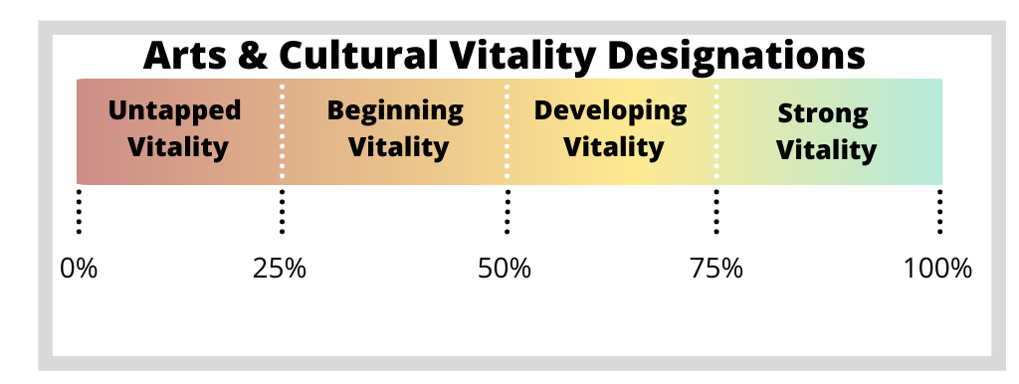

Use the table to the right to assign the generated overall and lever-specific percentages a vitality designation on a continuum from Untapped to Strong Arts & Cultural Vitality. These designations should be used for investing in how a school/district can grow in continuous improvement for equity and cultural responsiveness through the arts.

*These instructions are provided to ensure transparency for school/district stakeholders in how designations are calculated from the consensus ratings of the review team.

Potential Artifacts for Reviewing Arts & Cultural Vitality
This chart provides a list of potential artifacts that can be selected by the ACV Index review team. It should not be considered an exhaustive list, and schools may also use more informal practices and policies, also known as “traditions,” that may be established as part of the school culture. In cases where the review team cannot identify artifacts, whether informal (such as traditions) or formal (such as collected quantitative data), a consensus rating of “Unknown” may be identified for the specific indicator. If excessive quantities of missing artifacts emerge as the review team examines school practices, the review process should be postponed until the school community has collected information aligned to those specific indicators. The collection of information about arts program and services should be considered best practices because it ensures informed decision-making, and is a necessary pre-requisite of using the ACV Index. Potential aligned lever(s) for each artifact listed are provided, but are also potentially dependent on the manner in which these artifacts are composed at the local level in a given school.

Artifact/Practice/Policy | Potential Aligned Levers
Teacher/Student Schedules | Infrastructure
Class Rosters | Infrastructure, Opportunity
Facilities/Equipment Inventories | Infrastructure
Allocated Budgets (e.g., per pupil/per school/department) | Infrastructure
Chart of Organizational Structure | Infrastructure
Program of Studies (course offerings, graduation credits/requirements) | Infrastructure, Opportunity
Curriculum/Instructional Materials (curriculum maps, course syllabi, units, etc.) | Infrastructure, Opportunity, Participation, Impact
Student and Faculty Handbooks (e.g., written equity policies) | Infrastructure
Established Funding Sources (e.g., school budget, donations, etc.) | Infrastructure
Written Arts Policies and Guidelines | Infrastructure
List Events and Opportunities (e.g., school concerts/exhibits, field trips, after school clubs) | Opportunity, Participation
Arts/Culture-related Professional Development Opportunities and Outcomes | Infrastructure, Opportunity, Participation, Impact
Established Partnerships with Arts and Cultural organizations/Institutions | Opportunity, Participation
Enrollment in Arts Offerings (e.g., disaggregated data for underserved populations) | Participation
Family and Community Engagement (e.g., newsletters) | Opportunity, Participation
Established Arts Advocacy and Support groups and specific activities/initiatives | Opportunity, Participation
Student Achievement and Growth Outcomes, Formal and Informal (e.g., arts scholarships) | Impact
Student/School Climate Surveys | Impact
Student Drop-out Rates/Attendance/Suspensions | Participation, Impact
Arts Common Assessment Data | Impact
Student demographics | Infrastructure, Opportunity, Participation, Impact
Student work | Impact

Link to Helpful Resources
As Review Teams engage with the process of this self-evaluation, a need for further examination on the components of the Index may be required. Additionally, upon the completion of the review process, school arts programs may find it necessary to locate resources that can assist with the “Action Plan” phase. Use this link to find a curated list of helpful resources.

DESE’s Arts & Cultural Vitality Index Helping Hands

DESE Contributors and Reviewers
Lead Developer: Dawn Benski, Arts Content Support Lead
Stephen Garschina-Bobrow, Mathematics Content Support Specialist
Shannon Clancy, Educator Effectiveness Specialist
Coleen Thomas-Debari, ELA Content Support Specialist
Katherine Tarca, Director of Literacy and Humanities
Grace Wang, Instructional Support Lead
Taciane Santos, Educator Effectiveness Specialist

Noteworthy Contributors and Reviewers
BESE’s Arts Education Advisory Council Members
Steve Aldeus, Lynn Public Schools
Diane Daily, Massachusetts Cultural Council
Lisa Donovan, Brainworks
Julie Jaron, Springfield Public Schools
Richard King, Newton Public Schools
Lisa Leach, Worcester Public Schools
Jorge Rodriguez, School District here
June Krinsky-Rudder, Revere Public Schools
Lauren Saracino, Weymouth Public Schools
Kim Smith, Wakefield Public Schools (Retired)
Lynn Souza, New Bedford Public Schools
Alan Strauss, Weymouth Public School (Formerly)
Hannah Tollah, Andover Public Schools
Sean Walsh, Andover Public Schools

References
Americans for the Arts (2018). Americans Speak Out About The Arts in 2018: An In-Depth Look at Perceptions and
Attitudes About the Arts in America. Retrieved from: https://www.americansforthearts.org/sites/default/files/Public%20Opinion%20National%202018%20Report.pdf

Betancourt, S. (2019). In Holyoke, arts education takes front seat: Non-profit helps integrate creativity into regular
curriculum. Retrieved from: https://commonwealthmagazine.org/arts-and-culture/in-holyoke-arts-education-takes-front-seat/

Bowen, D.H., & Kisida, B. (2021). The arts advantage: Impacts of arts education on Boston students. EdVestors. Retrieved May 14, 2021:
https://www.edvestors.org/wp-content/uploads/2021/04/The-Arts-Advantage-Impacts-of-Arts-Education-on-BostonStudents

Gorski, P.C., & Swalwell, K. (2013). Equity literacy for all. Educational Leadership, 34-40. Retrieved May 12, 2021:
http://edchange.org/publications/Equity-Literacy-for-All.pdf

Jackson, M.R., Herranz, J., & Kabwasa-Green, F. (2003). Art and culture in communities: A framework for measurement. The Urban Institute,
Washington DC. Retrieved February 1, 2021, from https://www.issuelab.org/resources/6948/6948.pdf

Jackson, M.R., Kabwasa-Green, F., & Herranz, J. (2006). Cultural vitality in communities: Interpretation and Indicators. The Urban Institute.
Retrieved February 1, 2021, from http://webarchive.urban.org/UploadedPDF/311392_Cultural_Vitality.pdf

Ladson-Billings, G., (1995). But that’s just good teaching! The case for culturally relevant pedagogy. Theory into Practice, 34(3), 159-165.

President’s Committee on the Arts and the Humanities (2011). Reinvesting in Arts Education: Winning America’s Future
Through Creative Schools. Retrieved from: https://files.eric.ed.gov/fulltext/ED522818.pdf

United Nations Educational Scientific and Cultural Organization (n.d.). Arts education. Retrieved December 31, 2019:
http://www.unesco.org/new/en/culture/themes/creativity/arts-education/

