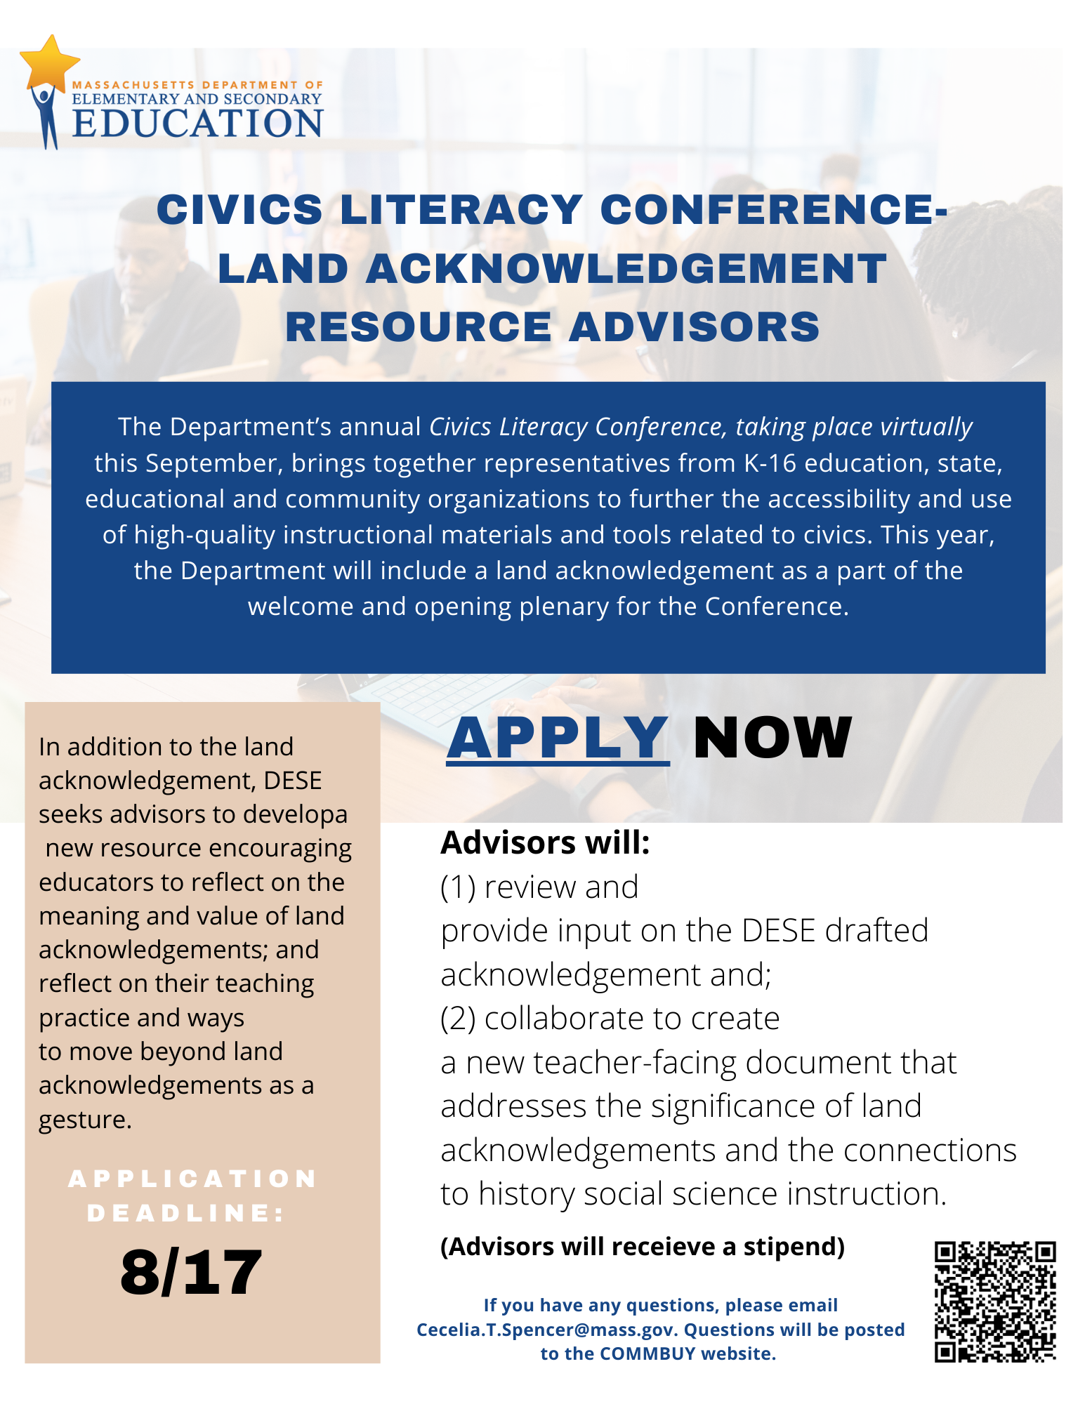
Civics Literacy Conference- Land Acknowledgement Resource Advisors
Background: The Department’s annual Civics Literacy Conference, taking place virtually this September, brings together representatives from K-16 education, state, educational and community organizations to further the accessibility and use of high-quality instructional materials and tools related to civics. This year, the Department will include a land acknowledgement as a part of the welcome and opening plenary for the Conference. Three to four Advisors will (1) review and provide input on the DESE drafted acknowledgement and (2) collaborate to create a new teacher-facing document that addresses the significance of land acknowledgements and the connections to history social science instruction.
Land acknowledgements are used in the introduction of public events and convenings as a “a simple, powerful way of showing respect and a step toward correcting the stories and practices that erase Indigenous people’s history and culture” (U.S. Department of Arts and Culture). The 2018 MA History Social Science Framework present a renewed mission of education for civic life in a democracy, including “knowledge[e] of local, state, and national politics and policies, and understand[ing] the current condition of the world.” This land acknowledgement for the Civics Literacy Conference aligns with that priority and offers an opportunity for reflection on our current condition.
Land acknowledgements are a beginning or first step; an important additional step is taking action and building relationships. The goal of the teacher-facing document is to provide educators an opportunity to consider the potential role of land acknowledgements in their classroom, deepen their awareness of Native Peoples in MA, and to consider ways to take learnings from the land acknowledgement to better center Native Peoples in their practice, school, and community. The content of the document will be informed by the advisors, but may encourage educators to reflect on the meaning and value of land acknowledgements; and reflect on their teaching practice and ways to move beyond land acknowledgements as a gesture.

The resource may include the following:
- prompts to further thinking;
- correct pronunciations of tribes;
- connections to the MA History Social Science Frameworks;
- resources for further learning and relationship building;
- and tools for crafting land acknowledgements with their students.

Summary of Advisors Role:
- Create: Advisors will create a brief teacher-facing document providing educators with key reflections, tools, and resources listed above.
- Collaborate: Advisors will collaborate with peers and DESE in the review of the statement and the creation of the teacher-facing document.
- Advise: Advisors will review the land acknowledgement state drafted by DESE that may include the Native Peoples to whom the land belongs, the history of the land and any related treaties, and correct pronunciation of any tribes, people and places mentioned.

Compensation
- Fellows will receive a stipend of $500 for time, intellectual, and emotional labor. Expected time commitment is 4-5 hours during August and September.

For information on the application process, preferred qualifications and to apply, click the link HERE.
Applications are due August 17 by 3:00 PM EST and can be submitted to the link posted above.

