Guidance for Oral Language Interpretation
Strong family-school partnerships are an essential lever for students to feel supported and thrive in an academic environment. Families have a civil right to equal participation in their students’ educational experience, including families who speak a language other than English. To fulfill this obligation, school districts must have systems in place to provide translation and interpretation services so that all families can participate in the educational system. Data from the 2022-23 school year indicates that 25 percent of Massachusetts students speak a language other than English as their first language; suggesting that a significant proportion of families may benefit from interpretation and translation services in schools. This need has been growing each year. The Department of Elementary and Secondary Education (DESE or the Department) seeks to support educators, schools, and districts to fully and equitably communicate with families that speak a language other than English and support parents/guardians in participating in critical choices impacting their children.
The Massachusetts Legislature, as provided in Chapter 154 of the Acts of 2018, Section 81, directed the Department to establish a Task Force “to study and develop recommendations on the training and certification of language interpreters in educational settings to improve language access for limited English proficient parents.” In 2019, the Commissioner of Elementary and Secondary Education (Commissioner) convened a Task Force that released the School Interpreters Task Force (Task Force) Recommendations. The state legislature earmarked $1,000,000 from the 2021 ARPA funding to operationalize the Task Force Recommendations. In response, DESE has released this guidance for districts in providing equitable language access for all families. Further, DESE has created pathways to train individuals as interpreters in the school setting (details below).
The following guidance is meant to support districts in providing oral language interpretation for families. Additional information is forthcoming that will provide guidance on developing Language Access systems, which include both translation and interpretation services.

Federal Requirements for Foreign Language Interpretation Services
Schools are required to provide oral language interpretation services to Limited English Proficient (LEP) families.
Under Title VI of the Civil Rights Act of 1964, public schools must ensure that language barriers do not impede any student from equal participation in school programming. This civil right to equal participation extends to families who speak a language other than English. Joint guidance from the U.S. Department of Justice and the U.S. Department of Education states that “schools must communicate information to limited English proficient parents in a language they can understand about any program, service, or activity that is called to the attention of parents who are proficient in English.” Further, “schools must provide translation or interpretation from appropriate and competent individuals and may not rely on or ask students, siblings, friends, or untrained school staff to translate or interpret for parents” (emphasis added). The Equal Education Opportunity Act of 1974 confirms that school districts cannot discriminate against students or families through the failure to provide ways to overcome barriers that impede equal participation, including language differences.
The Individuals with Disabilities Education Act (IDEA) Section 300.322 (e) requires that “the public agency must take whatever action is necessary to ensure that the parent understands the proceedings of the IEP Team meeting, including arranging for an interpreter for parents with deafness or whose native language is other than English.”
Failing to ensure language access can be a form of discrimination based on national origin (Lau v. Nichols, 414 U.S. 563 (1974)). Districts who do not have systems in place to provide interpretation services may be liable under federal law.

State Monitoring of Interpretation Services
DESE’s Office of Public School Monitoring (PSM) engages in a Tiered Focused Monitoring (TFM) review of each school district. Through this process, PSM monitors the implementation of special education and civil rights requirements in public school districts.
The requirement to provide an interpreter for LEP families is reflected in the following standards (most salient elements are in bold):
- SE 29: Communications are in English and primary language of home
  - Communications with parents are in clear and commonly understood words and are in both English and the primary language of the home if such primary language is other than English. Any interpreter used in fulfilling these requirements is fluent in the primary language of the home and familiar with special education procedures, programs, and services. If the parents or the student are unable to read in any language or are blind or deaf, communications required by these regulations are made orally in English and with the use of a foreign language interpreter, in Braille, in sign language, via TTY, or in writing, whichever is appropriate, and all such communications are documented.
  - If the district provides notices orally or in some other mode of communication that is not written language, the district keeps written documentation (a) that it has provided such notice in an alternative manner, (b) of the content of the notice and (c) of the steps taken to ensure that the parent understands the content of the notice.
- CR 7: Information to be translated into languages other than English
  - Important information and documents, e.g., handbooks and codes of conduct, being distributed to parents are translated into the major languages spoken by parents or guardians with limited English skills; the district has established a system of oral interpretation to assist parents/guardians with limited English skills, including those who speak low-incidence languages.
  - School or program recruitment and promotional materials being disseminated to residents in the area served by the school or program are translated into the major languages spoken by residents with limited English skills.
  - Information in notices such as activities, responsibilities, and academic standards provided to all students is provided to Els in a language and mode of communication that they understand.
  - Information provided to students about extracurricular activities and school events is provided to Els and to their parents/guardians in a language they understand.

Guidance for Providing Interpretation Services
DESE offers the following guidance and resources to schools and districts throughout the Commonwealth in providing access to interpreters who are trained in the education setting, based on the Task Force recommendations.

Lay the Foundation for Oral Interpretation
Districts should inform families of their right to interpretation services and have resources that support them in requesting the service. Additionally, ensure staff members understand families’ rights to interpretation services.
Resources:
- Poster: We Can Help You in Your Language
- English LEP Parent Fact Sheet (ed.gov)
- Have an “I Speak” chart available to allow families to express their language needs
- Fact Sheets for Families: What to Expect from an Interpreter
- English EL DCL Fact Sheet (ed.gov)
- Chapter 10 Tools and Resources for Ensuring Meaningful Communication With Limited English Proficient Parents
Districts should implement a system to track the preferred language of all families. This includes having families fill out a home language survey, as well as integrating that information into the Student Information System of the district. Districts should also ensure that school-based staff know how to identify families who need an interpreter and who to contact when the service is needed.
Resource:
  - Home language survey: ELE Program Resources: District-Family Communications - English Language Learners (mass.edu)
Districts should provide training for school-based staff in how to navigate meetings where an interpreter is present. DESE’s Language Ambassador video is appropriate for all staff members to learn about the legal right to interpretation, its importance for families, and how to approach meetings where interpretation is required. DESE recommends that all staff members watch the Language Ambassador video or otherwise receive training on how to work with interpreters to support a high-quality experience for families. In the resources section, Family Feedback forms are available in eight (8) languages. DESE recommends that districts collect feedback from families on the interpretation services provided in order to support continuous improvement.
Resources:
  - Language Ambassador Training (see DESE website)
  - Guidelines for School Personnel Collaborating with Interpreters
  - Interpretation Feedback Forms

Train or Hire Interpreters for the Education Setting
Districts should develop a system to provide oral interpretation services to families, using interpreters that are trained for the education setting. It is important to note that the ability of a person to speak two languages does not necessarily produce the skills or knowledge necessary to provide high-quality interpretation. DESE recommends developing a system to provide for family language needs in three types of interactions, and utilize interpreters with the necessary training for each:
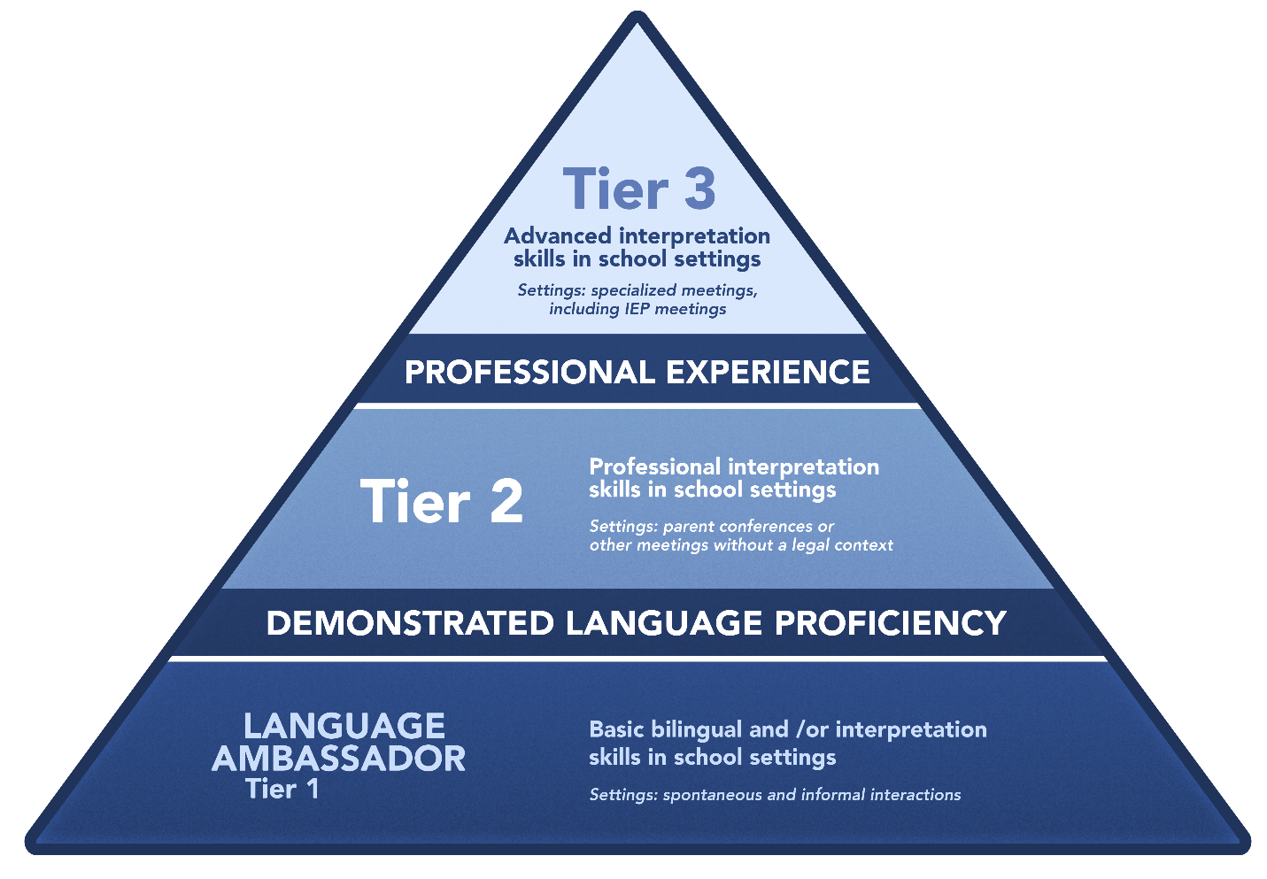

Informal or Spontaneous Interactions (Tier 1)
Examples: Informal interactions at the front office or in the school parking lot with dialogue about basic school information, such as a student absence, field trip, or bus information.
To accommodate these needs, districts may:
- Train all bilingual staff members, especially those whom families may regularly come into contact with, as “Language Ambassadors”. Language Ambassador training provides staff with foundational information about interpretation, including Ethics and Standards of Practice. Language Ambassadors who support informal interactions do not need to demonstrate language proficiency through formal assessments. This training includes guidance for when the content of an interaction requires a more highly trained interpreter.
  - DESE Language Ambassador video (forthcoming)
- Procure a contract with a telephonic interpretation service to assist families when there is not a staff member available that speaks the preferred language of the family. Districts should require or give preference to vendors who train their interpreters for the education setting.
  - MA Statewide Contract: Foreign Language Translation & Interpretation Services

General Parent Conferences or School Community Meetings (Tier 2)
Examples: General parent/guardian-teacher conferences, family gatherings at schools, “back to school” nights, meetings without a legal context or where simultaneous interpretation is not required.
To accommodate these needs, districts may:
- Train (or hire and train) bilingual staff members with demonstrated proficiency (see chart below) as Tier 2 Interpreters in the Education Setting
  - Districts or other approved vendors can apply through Pathway A on DESE’s Departmental Master Service Agreement (MSA) to become an Approved Provider to train participants as Interpreters in the Education Setting using DESE-created course materials.
  - Districts may also utilize other organizations that offer courses to train individuals as Interpreters in the Education Setting. Districts should ensure that any other organization’s courses for interpreters in the education setting have been approved by DESE through Pathway B on the MSA.
- Procure a contract with an outside agency to provide interpretation services
  - A standing contract with an outside agency may allow districts to support families who speak a language that no other district staff member speaks fluently or handle high-volume events, such as parent-teacher nights. Districts should require or give preference to vendors who train their interpreters for the education setting.

Specialized Meetings (Tier 3)
Examples: Individual Education Plan (IEP) meetings, 504 Plan meetings, English Learner Education (ELE) program placement, disciplinary hearings, bullying complaints, etc.
To accommodate these needs, districts may:
- Train (or hire and train) bilingual staff members with demonstrated proficiency (see chart below) as Tier 3 Interpreters in the Education Setting. Tier 3 interpreters are meant to have the highest level of knowledge and skill as interpreters in education. Tier 3 coursework includes specialized content and terminology, such as content related to special education, and simultaneous interpretation. In some districts, Tier 3 interpreters may serve in the role of interpreter in a full-time capacity.
  - Districts or other approved vendors can apply through Pathway A on DESE’s MSA to become an Approved Provider to train participants as interpreters in the education setting using DESE-developed course materials.
  - Districts may also utilize other organizations that offer courses to train individuals as interpreters in the education setting. Districts should ensure that any other organization’s courses for interpreters in the education setting have been approved by DESE through Pathway B on the MSA.
- Procure a contract with an outside agency to provide interpretation services
  - A standing contract with an outside agency may allow districts to support families who speak a language that no other district staff member speaks fluently or high-volume events where additional interpreters are needed. Districts should require or give preference to vendors who train their interpreters for the education setting. For specialized meetings, districts should ask the agency to send an interpreter who is trained or has experience in specialized education settings (Tier 3 training).

Maintain a Database of In-district Interpreters
Districts should maintain a database of all in-district staff who have been trained as Interpreters in the Education Setting. The database should include a record of individuals who are qualified as Interpreters in the Education Setting (Tier 2 training) and Advanced Interpreters in the Education Setting (Tier 3 training). DESE recommends that qualified interpreters are defined as follows:

Qualified Tier 2 Interpreter in the Education Setting | - At least 18 years old  - Demonstrated spoken language proficiency in English and another language(s).  - Successfully passed Tier 2 Interpreter Training coursework (DESE or other DESE-approved training program) that prepares them to interpret in the education setting
Qualified Tier 3 Interpreter in the Education Setting | - All requirements for Tier 2 interpreters  - Successfully passed Tier 3 Interpreter Training coursework (DESE or other DESE-approved training program) that prepares them to interpret in the education setting, with a focus on special education terminology  - At least 50 hours of practice interpreting in specialized meetings, with feedback from a trained interpreter on an encounter that is at least 30 min in length (feedback can be provided after observing a live or recorded interaction)  - Interpreters who demonstrate language proficiency and passed coursework can be listed with “interim” status until the 50 hours of practice obligation is fulfilled
Pathways to demonstrate English proficiency | - A high school diploma, or its equivalent, from an English-speaking country (diploma or transcript as long as the country of origin can be established)  - Successful completion of at least 24 degree credit hours at the post-secondary level with the majority of classes conducted in English  - Attainment of a Seal of Biliteracy from a U.S. high school  - Successfully passing any English language proficiency test from a reputable testing organization (see below)  - Certification from an interpreter training program that may be outside of the educational context (e.g., medical or court interpreting)
Pathways to demonstrate target language/s proficiency | - A high school diploma, or its equivalent, with classes taught in the target language (diploma or transcript as long as the country of origin can be established)  - Successful completion of at least 24 degree credit hours at the post-secondary level with the majority of classes conducted in the target language  - Attainment of a Seal of Biliteracy from a U.S. high school in the target language  - Successfully passing any language proficiency test in the target language from a reputable testing organization (see below)  - Certification from an interpreter training program that may be outside of the educational context (e.g., medical or court interpreting) in the target language
Language Proficiency Tests | - For individuals who have not served as professional interpreters, a minimum score of “Advanced-Mid” on the American Council on the Teaching of Foreign Languages (ACTFL) Oral Proficiency Interview (OPI) earned within the prior 5 years or one of the following:  o TOEFL (Test of English as a Foreign Language): 570+ on paper; 230+ on computer version; 90+  on iBT  o ELPT (English Language Proficiency Test): 950+  o MELAB (Michigan English Language Assessment Battery) 80+  o ECPE (Examination for the Certificate of Proficiency in English): PASS  o FCE (First Certificate in English, Level 3): A  o CAE (Certificate in Advanced English, Level 4): B  o CPE (Certificate of Proficiency in English, Level 5): B  o IELTS (International English Language Testing System): 7.0

Resource:
- Example database (forthcoming)

Other Resources
Glossaries of Education Terms
These glossaries may be a useful resource for any interpreter or translator working in districts and schools.
- Glossary of Education Terms- Chinese
- Glossary of Education Terms- French
- Glossary of Education Terms-Korean
- Glossary of Education Terms- Punjabi
- Glossary of Education Terms- Russian
- Glossary of Education Terms- Somali
- Glossary of Education Terms- Spanish (1)
- Glossary of Education Terms- Spanish (2)
- Glossary of Education Terms- Vietnamese (1)
- Glossary of Education Terms- Vietnamese (2)
- Glossary of Special Education Terms- Hmong
- Glossary of Special Education Terms- Somali

Appendix
Overview of Tiered System: Skills & Competencies of Interpreters
Tier 1 / Language Ambassador | Tier 2 Interpreter | Tier 3 Interpreter
All levels must have the following skills & competencies:
- Understanding of the role of interpreter in school settings
- Understanding of and appropriate response to dual role issues specific to school settings
- Knowledge of ethics, confidentiality, and standards of practice related to interpretation
- Cultural competency to negotiate across cultural differences
In addition to the Language Ambassador competencies, Tier 2 & 3 interpreters should also:
- Knowledge of basic education terminology used in school settings
- Skilled in consecutive interpretation
- Formally assessed and demonstrated language proficiency in English and another language (Advanced level)

In addition, Tier 3 interpreters should also:
- Knowledge of terminology associated with specialized meetings in schools and those with a legal context (ex. IEP meetings, disciplinary hearings, ELE placement)
- At least 50 hours of successful school interpretation experience with feedback from a trained interpreter

Session Law - Acts of 2018 Chapter 154 (malegislature.gov)
Task Force Recommendations: https://malegislature.gov/Reports/8750/DESE%20-%20Recommendations%20of%20Interpreter%20Task%20Force_Legislative%20Report.pdf
Districts are also required to provide interpreters for speakers of American Sign Language; this guidance is for speakers of a foreign language.
DESE will refer to families who need interpretation as families who speak a language other than English or families whose preferred language of communication is not English. When doing so, it should be taken to refer to the federal requirements for Limited English Proficient individuals.
English EL DCL Fact Sheet (ed.gov) ; English LEP Parent Fact Sheet (ed.gov)
Sec. 300.322 (e) - Individuals with Disabilities Education Act
Confronting Discrimination Based on National Origin and Immigration Status (justice.gov)
Reference in this website to any specific commercial products, processes, or services, or the use of any trade, firm, or corporation name is for the information and convenience of the public, and does not constitute endorsement or recommendation by the Massachusetts Department of Elementary and Secondary Education (DESE). Our office is not responsible for and does not in any way guarantee the accuracy of information in other sites accessible through links herein. DESE may supplement this list with other services and products that meet the specified criteria. For more information contact: Breanna.higgins@mass.gov or 781-870-0014.
Large districts may hire full-time interpreters on staff while smaller districts may need to utilize current staff members in a dual role.
These glossaries have been produced by other states or organizations and are not specific to MA nor have they been vetted by DESE. They are provided as a resource to interpreters and translators.

