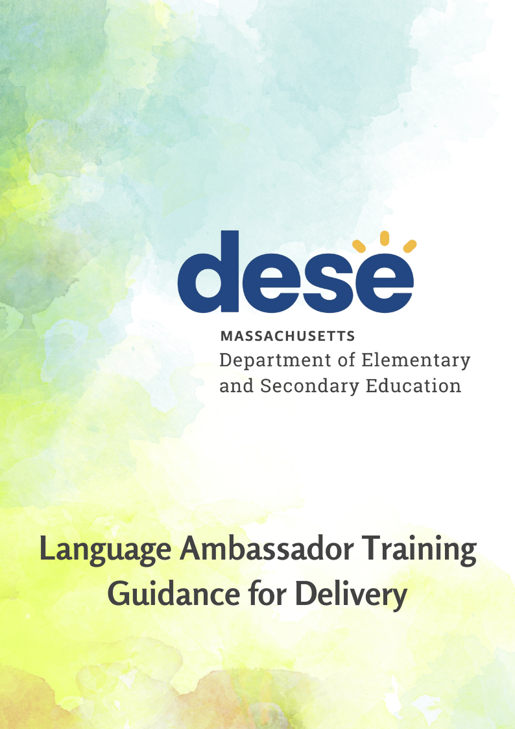

Language Ambassador Training
Guidance for Delivery

Introduction

The Massachusetts General Legislature Acts (2018), section 81, directed the Department of Elementary and Secondary Education (DESE or the Department)) to establish a Task Force “to study and develop recommendations on the training and certification of language interpreters in educational settings to improve language access for limited English proficient parents.” In 2019, the Commissioner of Elementary and Secondary Education (Commissioner) convened a Task Force that released the School Interpreters Task Force (Task Force) Recommendations.
The Task Force recommended districts use a tiered approach to train and identify interpreters in the education setting. DESE has operationalized these recommendations by releasing recommended guidance for utilizing trained interpreters in schools. The first tier of language support for families are known as Language Ambassadors. Language Ambassadors are defined as bilingual individuals with basic language proficiency or knowledge in interpretation (see graphic).
This guidance is meant for school and district leaders and offers recommendations for how the Language Ambassador training video could be delivered effectively to school-based staff. It also provides guidance on which staff members should participate in this training.
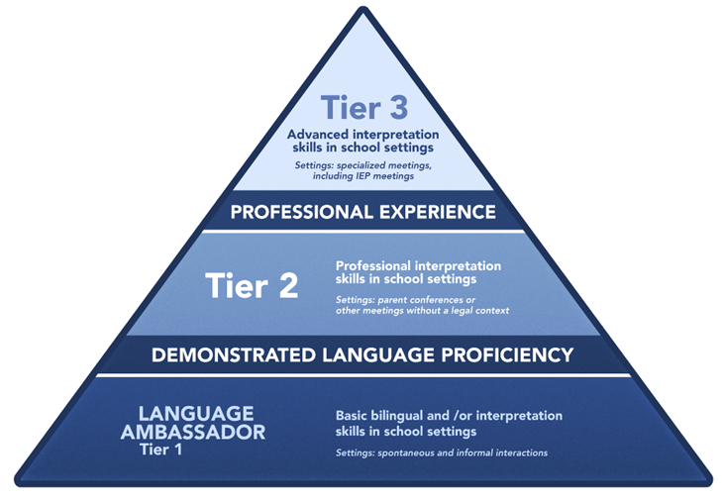
The Language Ambassador training has been created to support high-quality interactions between school-based staff and families who speak a language other than English. The training is designed to serve a dual purpose:
- To prepare bilingual school employees to become Language Ambassadors. As a Language Ambassador, they can assist family and community members who speak a language other than English with basic communication about school-related matters.
- To inform educators and administrators about best practices for collaborating with Language Ambassadors and other trained interpreters to promote successful interactions with families.
As such, DESE recommends that bilingual individuals and educators who may interact with families who speak a language other than English, including building administrators, watch this training video.

Objectives

Participants who complete the training successfully will be able to:
- differentiate the roles and responsibilities of Language Ambassadors, Tier 2 interpreters, and Tier 3 interpreters;
- provide examples of each standard of ethical practice for educational interpreters: confidentiality, accuracy, impartiality, respect, professional boundaries, advocacy, cultural responsiveness, professionalism, and professional development;
- recognize situations where cultural differences may impede communication and respond appropriately;
- identify components of conducting successful interpretation at meetings;
- identify successful practices when collaborating with interpreters.

Training Components

Video Content:
Six video clips, ranging from approximately 7 to 20 minutes each, comprise the following content:

Introduction. Jeffrey C. Riley, Department of Elementary & Secondary Education, Commissioner
Part 1. Introduction to Educational Interpreting
Part 2. Roles and Responsibilities
Part 3. Code of Ethics/Standards of Practice
Part 4. Cultural Responsiveness
Part 5. Conducting the Interpreting Session
Part 6. Collaborating with Interpreters
Ending Comments

Accompanying Materials:
Each section of the video includes optional reflection and/or discussion prompts. The training also includes resources for extended learning and exploration.

Assessment:
Parts 1-6 include a brief quiz that helps prepare participants for the final assessment. The final assessment is a series of multiple-choice questions and requires a score of 80 percent for successful completion of the training. The assessment may be taken multiple times until the criterion is reached.

Options for Presentation

Independent Web-based Training
This delivery model is appropriate for situations where participants are in different locations and will complete the training on various days and times. This delivery model was used in DESE pilot training and participants commented how they appreciated being able to stop and then easily return to the training at times that were convenient. Suggestions include sending a detailed letter of explanation to potential participants (see attached) and providing a time frame for completing the training. To provide a more personalized experience and encourage communication on this topic among participants, individual schools or districts could add a required or optional web-based group discussion where individuals could respond to selected questions from the training materials and/or discuss future plans and practices.
Participants should plan on 1 ½ to 2 hours to view the clips and take the quizzes if they are completing the training independently online.
Examples:
- Educators participate in this training independently as part of their “back to school” professional development
- New staff hired throughout the year take the course as part of their on-boarding
- Support staff are provided time during the workday to participate in the training
Live Group Training
This delivery model, which requires a group facilitator, is appropriate for smaller groups of participants who are in the same location or can be easily scheduled to attend in the same location. The facilitator may wish to begin the training by discussing why the training is important and how Language Ambassadors and those who work with interpreters at all levels can enhance language access for school community members. The facilitator will need to navigate to the course website to play the clips. There are optional questions for discussion after each video clip.
There are several ways to handle the self-quizzes: After each clip, the group leader can allow time for members to complete the quizzes independently on their own devices or the quizzes may be taken as a group activity. In addition, since the final quiz is an independent activity that group members may wish to review for, the self-quizzes could be completed as independent practice. In any case, participants should be provided with a time frame for completing the final quiz. An advantage of this option is that training can be more personalized to the needs of the school or districts if discussions are included.
Two 45-minute sessions are recommended for the live group training option. Ending activities may include a closer look at the suggested resources listed on the course website and related discussion. Sending a detailed letter of explanation to participants prior to the start of the training is suggested (see Appendix).
Examples:
- Educators participate in the training as part of a whole group session during professional development time
- Educators participate in the training in small group PLCs

Certificates of Completion and Additional Training

Upon successful completion of the training, bilingual participants will receive a certificate of completion from DESE, indicating that have completed Language Ambassador Training. Language Ambassadors with well-developed oral and written skills in English and another language may choose to pursue additional training to become qualified interpreters. Information about requirements and advanced interpreter training may be accessed through DESE’s website.

Regardless of which delivery option is used, it is highly recommended that administrators complete the training prior to staff training so that messaging is consistent and any technical difficulties can be resolved.

Appendix

Sample Letter to Bilingual Staff

Dear ,

As a bilingual staff member in the district, we are appreciative of your language skills and support of school community members who are multilingual.
Please consider becoming a Language Ambassador. Language Ambassadors are bilingual individuals prepared to provide assistance to family and school community members with basic communication about school-related issues. Language Ambassadors play a critical role in language access and are needed for interactions including helping parents enroll students, making phone calls home about field trips, and answering questions about school events. Language Ambassadors may not be proficient in their target language or may not wish to be an interpreter but will have basic language and interpretation skills to support families in informal situations.
DESE’s Language Ambassador Training is a video-based program that consists of six brief sections, ranging from approximately 7 to 20 minutes. Each section addresses an important aspect of educational interpreting designed to make you a more effective bilingual communicator.

Part 1: Intro to Educational Interpreting
Part 2: Roles and Responsibilities
Part 3: Code of Ethics / Standards of Practice
Part 4: Cultural Responsiveness
Part 5: Conducting the Interpreting Session
Part 6: Collaborating with Interpreters

Each part of the training includes a brief self-quiz that helps prepare you for the final quiz. The final quiz requires a score of 80% and may be taken multiple times until criterion is reached. Successful participants receive a Certificate of Completion as a Language Ambassador from DESE.
Our district/school is offering this training… [INCLUDE DETAILS HERE]

Sample Letter to Monolingual Staff
Dear ,

Our school community is fortunate to have a multitude of languages and cultures represented. We are committed to ensuring that all students and families feel a sense of belonging in our community and their cultures, languages, and perspectives are known, valued, and sustained.
As a way to ensure that families who speak a language other than English are welcome in our schools and receive equitable language access, please consider taking the Language Ambassador training offered by the Department of Elementary & Secondary Education. This training prepares bilingual individuals as Language Ambassadors that are prepared to provide assistance to family and school community members with basic communication about school-related issues. Language Ambassadors play a critical role in language access and are needed for interactions including helping parents enroll students, making phone calls home about field trips, and answering questions about school events. It is important that all staff member within the school that may participate in a meeting with an interpreter present also participates in this training so they know what to expect and how best to collaborate with interpreters to best serve families.
DESE’s Language Ambassador Training is a video-based program that consists of six brief sections, ranging from approximately 7 to 20 minutes.

Part 1: Intro to Educational Interpreting
Part 2: Roles and Responsibilities
Part 3: Code of Ethics / Standards of Practice
Part 4: Cultural Responsiveness
Part 5: Conducting the Interpreting Session
Part 6: Collaborating with Interpreters

Each part of the training includes a brief self-quiz that helps prepare you for the final quiz. The final quiz requires a score of 80% and may be taken multiple times until criterion is reached. Successful participants receive a Certificate of Completion as a Language Ambassador from DESE.
Our district/school is offering this training… [INCLUDE DETAILS HERE]

Session Law - Acts of 2018 Chapter 154 (malegislature.gov)
Task Force Recommendations: https://malegislature.gov/Reports/8750/DESE%20-%20Recommendations%20of%20Interpreter%20Task%20Force_Legislative%20Report.pdf
Link to DESE’s guidance
Language Ambassadors are not considered trained interpreters as they have not demonstrated language proficiency nor completed an extensive interpreter training course.

