Zaretta Hammond, MA: Expert presenter on culturally responsive practices

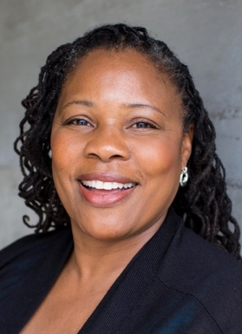
Zaretta presented her work on making culturally responsive pedagogy understandable and practical for educators at the LEAP Convening: Building Inclusive and Equitable Learning Opportunities on March 16, 2018. Zaretta is the author of Culturally Responsive Teaching and the Brain: Promoting Authentic Engagement and Rigor Among Culturally and Linguistically Diverse Students. She uses the lens of neuroscience to help teachers see the connection between student relationships, academic mindset, and processing rigorous content that leads to higher achievement for diverse students. She is a former English teacher and has been consulting with school districts and non-profit organizations around issues of equity, literacy, and culturally responsive teaching for the past 21 years.

Culturally Responsive Teaching and The Brain: Promoting Authentic Engagement and Rigor Among Culturally and Linguistically Diverse Students

Hammond, Zaretta. Culturally Responsive Teaching and The Brain: Promoting Authentic Engagement and Rigor Among Culturally and Linguistically Diverse Students. Thousand Oaks, CA: Corwin, 2015. Print.

The achievement gap remains a stubborn problem for educators of culturally and linguistically diverse students. With the introduction of the rigorous Common Core State Standards, diverse classrooms need a proven framework for optimizing student engagement and facilitating deeper learning.
Culturally responsive pedagogy has shown great promise in meeting this need, but many educators still struggle with its implementation. In this book, Zaretta Hammond draws on cutting-edge neuroscience research to offer an innovative approach for designing and implementing brain-compatible culturally responsive instruction.
The book includes:
- Information on how one’s culture programs the brain to process data and affects learning relationships
- Ten “key moves” to build students’ learner operating systems and prepare them to become independent learners
- Prompts for action and valuable self-reflection
With a firm understanding of these techniques and principles, teachers and instructional leaders will confidently reap the benefits of culturally responsive instruction.
More information about Zaretta can be found on her website: Zaretta Hammond’s Website

