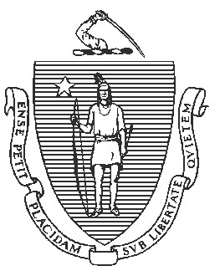
Massachusetts Department of Elementary and Secondary Education

135 Santilli Highway, Everett, Massachusetts 02149-1962 Telephone: (781) 338-3000
TTY: N.E.T. Relay 1-800-439-2370

Jeffrey C. Riley
Commissioner

February 2, 2024

Honorable Mayor Joshua Garcia
City of Holyoke
536 Dwight Street
Holyoke, MA 01040

Dear Mayor Garcia:

I am writing in response to your letter petitioning the Massachusetts Department of Elementary and Secondary Education (Department) to terminate the receivership of Holyoke Public Schools (HPS), pursuant to 603 CMR 2.06(14). Consistent with the regulation, Receiver Anthony Soto submitted written arguments and supporting documentation in a letter dated December 21, 2023.

I commend Receiver Soto for his thoughtful response to the Holyoke School Committee’s petition, which both celebrates the progress that HPS has made under receivership and clearly identifies remaining areas for systemic improvement. Collaboration between the School Committee and Receiver Soto is essential to sustaining the improvements made by the district.

In reviewing both your and Receiver Soto’s submissions, it is clear that HPS has made progress under receivership. Of course, challenges remain, as Receiver Soto identifies in his letter. Continuing concerted investments in the district’s teaching and learning systems and continuing prioritization of student attendance will be key to sustaining this progress.

As we discussed last fall, state receivership is a temporary status, with a return to local control as the ultimate goal. In light of the progress to date, the Department would like to further confer with the Receiver and the School Committee about how to sustain and build upon the district’s progress as we make plans for returning the district to local control. To allow for those conversations to proceed, at this time I am deferring a formal determination on your petition.

Thank you for your work on behalf of Holyoke students, and I look forward to our continued collaboration.

Sincerely,

Jeffrey C. Riley
Commissioner of Elementary and Secondary Education

Cc: Anthony Soto, Receiver, Holyoke Public Schools
Erin Brunelle, Vice Chair, Holyoke School Committee
Russell Johnston, Deputy Commissioner, Department of Elementary and Secondary Education
Lauren Woo, Director, Department of Elementary and Secondary Education

