Amendment to the UP Academy Holland Turnaround Plan, pages 72-75

II. PROFESSIONAL COMPENSATION SYSTEM

As part of the Turnaround Plan, UP Education Network and the Holland school leaders will continue to utilize the revised compensation system with the following components.

For information about the compensation system in prior school years, please see the Holland Revisions to the Compensation Section of Appendix A (January 2015, April 2017, November 2019): https://www.doe.mass.edu/level5/schools/holland.html

CAREER LADDER

Definitions:
Novice teachers are typically first-year teachers entering teaching directly from college.

Developing teachers are early career educators, typically with one to two years of experience. There are two levels within the Developing tier.

Career teachers have been recognized as excellent educators. Career teachers serve as role models to less-experienced educators and proactively drive their own professional growth.

Advanced teachers are outstanding educators who serve as school-wide models of excellence. Advanced teachers have at least five years of experience and possess deep expertise in their craft.

Expert teachers are exceptional educators who serve as district-wide models of excellence. Expert teachers have at least five years of experience, possess deep expertise in their craft, and are capable of elevating the practice of already-gifted educators. Expert teachers will assume additional roles and responsibilities to support the district’s improvement.

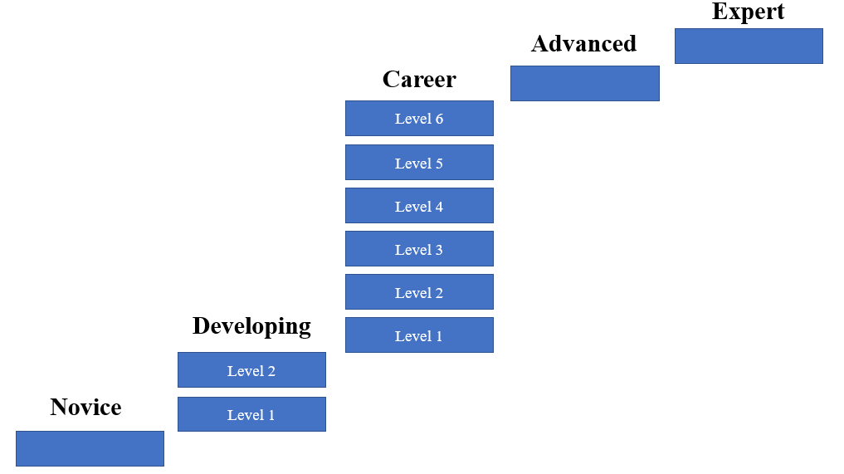

The career ladder schedule is modified beginning in school year 2022-2023 as follows:

Career Level | Compensation Level
Novice | $65,000
Developing Level I | $73,500
Developing Level II | $80,000
Career Level I | $86,500
Career Level II | $94,000
Career Level III | $98,500
Career Level IV | $104,000
Career Level V | $109,000
Career Level VI | $114,000

Transition to the Career Ladder

Effective July 1, 2015, teachers who were selected to remain at the Holland were assigned to one of the career ladder levels based on the teacher’s salary placement on the previous salary schedule as of June 30, 2015, without regard to the teacher’s rating on the end-of-year evaluation, as described below. No returning teacher received less compensation than they received in 2014-15 (BTU salary plus career awards plus ELT stipend).

Newly hired teachers will be placed on the career ladder as determined by the Receiver. The Receiver will review and may adjust the salary schedule periodically.
The annual base salary for an “Advanced” teacher is modified to $118,000 beginning in school year 2022-2023. Advanced teachers must possess an initial or professional license.

The annual base salary for a “Expert” teacher is modified to $123,000 beginning in 2022-2023. Teachers selected for this position will receive a stipend differential based on their annual base salary in order to reach the amount specified for the year the position is held. These stipend compensation amounts shall be included in the teacher’s base pay or otherwise considered as part of the teacher’s annualized salary for retirement purposes. Expert teachers must possess a professional license.

The Receiver will establish a process for eligible teachers to apply for Advanced or Expert Teacher levels. Teachers selected for these roles will be compensated at the salary levels for these positions for the duration of their assignments. Upon leaving these assignments, teachers will return to their most recent compensation levels.

Advancement on the Career Ladder

A Novice teacher shall advance to Developing I and a Developing I teacher shall advance to Developing II annually provided that the teacher does not receive an end-of-year overall evaluation rating of “unsatisfactory.”

A Developing II teacher shall advance to Career I and all Career level teachers shall advance a level annually provided that an end-of-year overall evaluation rating of “proficient” or “exemplary” is received, with “proficient” or better ratings on all four standards. A teacher with an end-of-year overall rating of “proficient” who has achieved less than “proficient” ratings on all four standards may still advance to the next level with the recommendation of the building principal and the approval of the Receiver. The Receiver may adjust the progression rules in future years to include student data as a one criterion for advancement.

Effective beginning in school year 2020-2021, a Career VI teacher who has been employed as a Career VI teacher for at least one school year and who receives an end-of-year overall evaluation rating of “proficient” or “exemplary,” with “proficient” or better on all four standards shall receive an additional $2,500 added to their base salary annually.

A teacher may advance on the salary scale more rapidly than described above with the recommendation of the school principal, subject to the approval of the Receiver.

Novice, Developing, and Career teachers who continue in employment shall not have their salary reduced based on their performance evaluation.

Consistent with the Turnaround Plan, based on past experience and performance, a newly-hired teacher may be hired by the Receiver above the Novice level.

The categories of Advanced and Expert teachers will be established effective July 1, 2015. The roles, expectations, and selection criteria for these teachers will be developed by the Receiver.

A teacher who has attained the status of Career III or higher and received “proficient” or “exemplary” overall end-of-year ratings the previous two years can apply to become an Advanced teacher through a cumulative career portfolio. The portfolio may include 1) student growth data over time; 2) endorsements from peers, parents, students, and administrators; 3) and evidence of effective instruction.

A teacher who has attained the status of Career III and above and received “exemplary” overall end-of-year ratings the previous two years can apply to become an Expert teacher through a cumulative career portfolio. The portfolio may include 1) student growth data over time; 2) endorsements from peers, parents, students, and administrators; 3) and evidence of effective instruction.

In addition to teacher advancement as outlined above, if the Receiver determines that the payment of additional compensation to a bargaining unit member is necessary to better serve the needs of the students, the Receiver, with approval from the Commissioner, may authorize the additional payment.

