
Massachusetts Department of

Elementary and Secondary Education

75 Pleasant Street, Malden, Massachusetts 02148-4906 Telephone: (781) 338-3000 TTY: N.E.T. Relay 1-800-439-2370

Jeff Wulfson
Acting Commissioner

April 4, 2018

Dear John Avery Parker School students, families, educators, staff, partners, community members, and officials:

I am pleased to announce that I have appointed School & Main Institute (SMI), a highly collaborative non-profit organization working with schools and districts across Massachusetts to be the next receiver for the John Avery Parker School in New Bedford. Dr. Fran Roy, former assistant superintendent of Fall River and a seasoned educator, will be working with SMI at the Parker.

As you know, Dr. Pia Durkin announced her resignation from the district effective June 30, 2018. In October 2013, Commissioner Chester selected Dr. Durkin to work with him to create the turnaround plan for the Parker, and to be responsible for the implementation of the turnaround plan. We are tremendously grateful for her dedication and relentless focus on improving the education provided to students in New Bedford, and we wish her good luck in her next endeavors.

On July 1, 2018, School & Main Institute, assisted by Dr. Fran Roy, will assume the official role as receiver for the Parker school. Until then, SMI and Dr. Roy will serve in an advisory capacity to Dr. Durkin through the transition.

Dr. Roy has been an educator since she graduated from college and has worked in districts in Massachusetts, Rhode Island and Wisconsin for the length of her career. She started as a middle school mathematics teacher and later served as an assistant professor of education and assistant superintendent who worked with teachers and district staff to align curriculum, provide mathematics professional development and increase student achievement.
As assistant superintendent of Fall River Public Schools, her efforts focused on district and school turnaround, a redesign of district systems of support to schools, and enhanced professional development to narrow achievement gaps, particularly in the areas of English Learners. Over the last year, Dr. Roy has provided consulting services to New Bedford in the areas of social emotional learning, middle school redesign, and mathematics support.
Dr. Roy holds a bachelor of science degree in mathematics from University of Massachusetts Dartmouth, a master’s degree in mathematics from Rhode Island College and a doctorate in education in curriculum and instruction from the University of Wisconsin-Madison.
School & Main Institute (SMI), founded in 1985 at Brandeis University’s Heller School of Social Policy and Management, is now an independent non-profit based in Boston working with communities across the Commonwealth and country to improve education and the lives of young people, particularly youth in vulnerable settings and situations. SMI staff have been principals, teachers, youth program staff, school designers and organizational leaders. They have deep experience in school improvement and are passionate about creating learning communities that work for students and the adults that support them.
Although Dr. Roy will be working with SMI at the Parker, she will not be the school's principal. Dr. Roy and SMI will work with Dr. Durkin during the next few months to select a new principal for the school.
Dr. Durkin will remain responsible for the Parker until School & Main Institute’s appointment takes effect on July 1, 2018. I hope you will join me in welcoming School & Main Institute and Dr. Roy to the Parker and New Bedford community.
Sincerely,
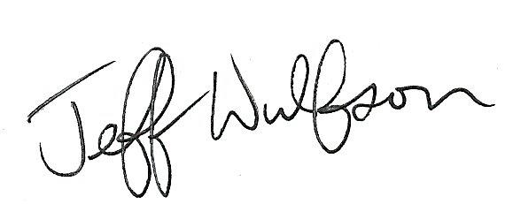
Jeff Wulfson
Acting Commissioner of Elementary and Secondary Education

