Jeffrey C. Riley
Commissioner

November 22, 2019

Massachusetts Department of Elementary and Secondary Education

75 Pleasant Street, Malden, Massachusetts 02148-4906 Telephone: (781) 338-3000
TTY: NET. Relay 1-800-439-2370

Veronica Conforme
Chief Executive Officer, UP Education Network 90 Canal Street, Suite 610
Boston, MA 02 1 14

Dear Ms. Conforme:

Lauren Woo and Manuel Monteiro have briefed me on the work done by members of your staff and Department of Elementary and Secondary Education staff to review the salary amounts in the career ladder compensation plan included in the Turnaround Plan of UP Academy Holland. As anticipated, this review has resulted in proposed salary adjustments , which will attract, retain, and reward effective teachers in order to better serve the needs of students at the school. I have approved the adjustments to the salary scal e and am authori zing UP Education Network to implement the changes, J anuary I , 2020. The revised Appendix A of the UP Academ y Holland Turnaround Plan i s attached for your reference.

You should plan to communicate the new career ladder scale and individual salary expectations to teachers in UP Academy Holland and to implement the new salary schedules in recruiting and hiring new teachers.

I appreciate all of your efforts to improve the academic performance of students at UP Academy Holland.

If you need further assistance, please contact Lauren Woo (lwoo@doe.mass.edu) or Russell Johnston
(rjohnston@doe.mass.edu).

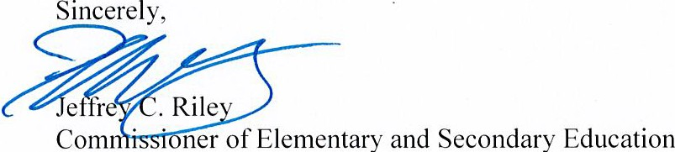

Cc: Russell Johnston , Senior Associate Commissioner , Department of Elementary and Secondary
Education
Lauren Woo, Director of the Strategic Transformation Region , Department of Elementary and Secondary Education
Mike Bower, Chief Operating Officer , UP Education Network
Victoria Thompson , Principal , UP Academy Holland

Enclosure

